Topic 2 – Analytical methods for determination of stable operation of IBRs in a future power system
  - 2023/24 CSIRO GPST Research
Commonwealth Scientific and Industrial Research Organisation
15 December 2023
Team:
Sushrut Thakar, Stavros Konstantinopoulos, Mobolaji Bello, Deepak Ramasubramanian (EPRI)
Jingzhe Xu, Weihua Zhou, Jaleel Mesbah, Behrooz Bahrani (Monash University)

Contents
1. Introduction 1
2. Research completed 1
3. Outstanding activities 4
4. Progress against the Roadmap 5
5. Research relevance 5
6. Recommendations 5

Introduction
The Australian power system has experienced a large growth in the share of inverter based resources (IBRs) and the share of IBRs is expected to grow in the near future. One aspect important for ensuring stable operation of the Australian power system is evaluating the system stability and stability margin in the small signal domain, considering the IBRs connected to the system. When evaluating the small signal stability involving IBRs, there are commonly two approaches that are possible: a linear system analysis using the IBR control structure, which can yield an insight into the IBR states participating in different oscillatory/unstable modes, thus providing key understanding into the potential pathways to ensure stability. On the other hand, such approach is often not possible with the blackbox models made available to the network operators by the IBR original equipment manufacturers, where the detailed control structure is not available. In such a case, a frequency domain scan/model fitting approach can be used to incorporate the IBR model in small signal stability evaluation. However, in either case, the small signal model depends on the system operating point, and may vary as the operating point shifts through the day/year. Hence, this project aims to assess the potential pathways to evaluate the change in system small signal stability margin when moving across different operating points. In this Stage 3 work, the project aims to tackle two critical topics (stability margin evaluation and small signal stability screening methods) from the original topics identified in the research plan submitted to CSIRO in 2021.
In the previous stage of this project, a time series power flow analysis of the synthetic network of the National Electricity Market (NEM) area was performed, where the network voltage profile was optimized for 24 power flow cases representing future high penetration of IBRs to assess the impact of the system operating point on the stability in the form of short circuit assessment and dynamic simulation involving IBRs. At the same time, two different methods for estimating the IBR impedance characteristics at any operating point were developed and these estimated impedances were used in a small network to evaluate stability.
In this stage of the project, the two methods developed to estimate the IBR impedance characteristics at any operating points were planned to be extensively tested/compared for different IBR topologies and choose one method for the rest of the analysis. This method was planned to be tested for a blackbox IBR model, and improvements were planned in the form of identifying the minimum number of operating points required for the impedance prediction technique and identifying the key operating points that can be used for training the prediction model. In addition, a goal of this stage is to study the stability of a large network (such as synthetic NEM network) using blackbox IBR models and multi-frequency representation of the network. Such stability evaluation can be useful for system planning as well as operation purposes. Lastly, the project plan also includes assessing the role of IBR unit constraints such as current limit on the stable operation and stability margin of the system.

Research completed
2.1 Black box model
Testing the impedance prediction algorithms with a blackbox IBR model will provide useful feedback and help improve the robustness of the impedance prediction algorithm. Hence, a blackbox model was developed by the EPRI team to be used for the impedance prediction algorithm. This is a C-code based model developed according to the IEEE/Cigre DLL Modeling Standard that is currently being developed. The code for a previously developed blackbox model for PSCAD was utilized to create a consistent model for Simulink. Starting from the PSCAD model, a C-code based control block was used in Simulink with the same inputs, outputs and parameters as the original PSCAD model, and the actual control code was imported as a DLL, resulting in a blackbox model. A good match was obtained when testing the model for disturbances such as frequency or voltage step change, as shown in Figure 1. The added benefits to this approach include seamless model transfer across different simulation platforms (PSCAD and Simulink) used by different project team members. This consistency across the simulation platforms will also be useful when comparing and utilizing results from the frequency domain impedance prediction method to assess network stability.
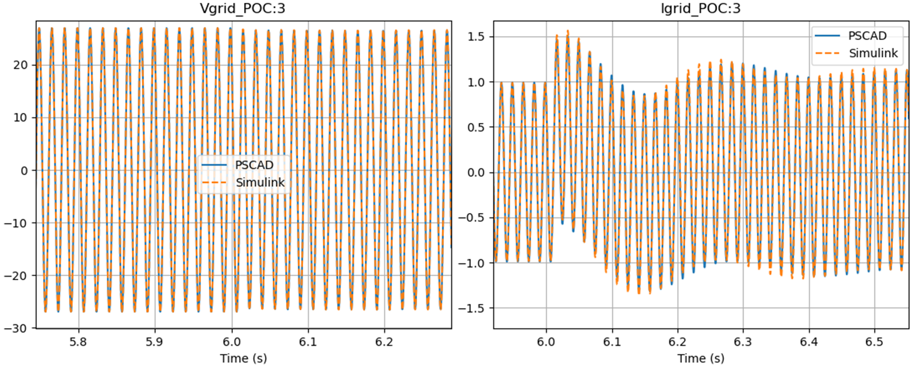
Figure 1 Comparison between the PSCAD and Simulink models with IBR in GFM mode for a voltage step applied at 6.01s. This test was performed at SCR=6.0 and X/R=10.0 for the source.
2.2 Efficient inverter admittance prediction across operating points
The stability of Inverter Based Resource (IBR) systems, crucial for effective grid management, can be addressed through impedance-based analysis methods. However, due to the Operating Point (OP) dependent nature of the impedance in IBRs, this analysis becomes complex, making the prediction of stability a challenging task. Without efficient prediction methods, a practical use case involving black-box EMT IBR models would necessitate a time consuming scanning procedure for each OP of interest. This part of the work is led by the Monash University team. An IEEE PES conference paper was developed around this research effort and was submitted in November 2023.

The research conducted within this workstream involved two such methods for the prediction of inverter admittance across OPs. The first method was the Analytical Prediction Method (APM), based on fitting the parameters of a unified admittance model, and the second was the Data Driven Method (DDM), based on the machine learning Gaussian Process Regression algorithm. The research carried out involved:
- Initial comparison of the performance of the APM and DDM using theoretical IBR models to determine which method to progress for further investigation. The outcome of this assessment was to enhance the APM.
- Further investigation of the impact of control structure and parameter sensitivities on the performance of the APM using theoretical models. The outcome was that 19 training data points were adequate for the models studied, the control structure had a greater influence on the prediction accuracy and required number of training OPs compared to the variation in parameters.
- Testing of the APM using a black-boxed model. The outcome was that whilst there are positive prediction results, the accuracy was observed to be dependent on the specific selected training data for a number of cases.

An example of the predicted admittance traces are shown in Figure 2Error! Reference source not found.. When presented with the same training data, the APM performs significantly better than the data-driven method, since the goodness of fit results are consistently less for the former.
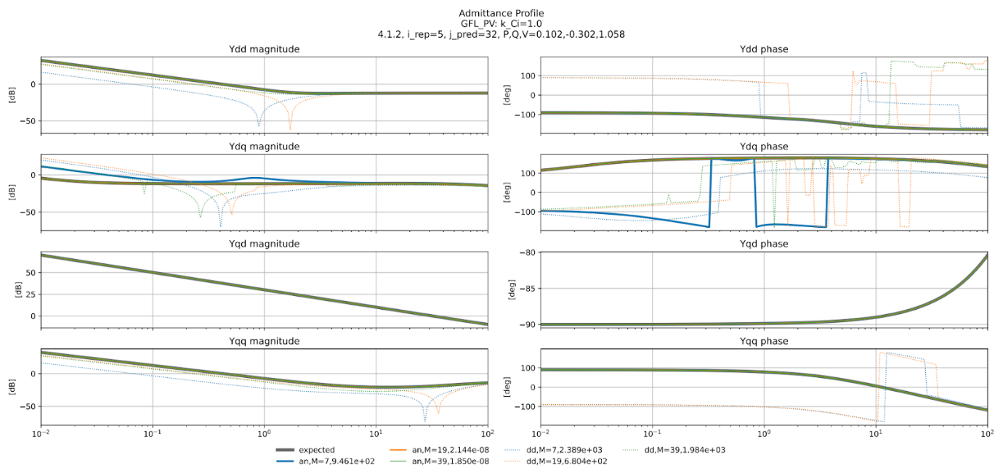
Figure 2 Comparison of predicted and expected admittance results with APM and DDM. In the legend “an” refers to the APM, “dd” refers to the DDM, “M” is the training data size and the right most number is the goodness of fit for that curve.
Several IBR control structures and parameter variations were also tested to ensure the robustness of the APM. A selection of results are presented in Figure 3 which show that the parameter sensitivities have some influence on the prediction accuracy.
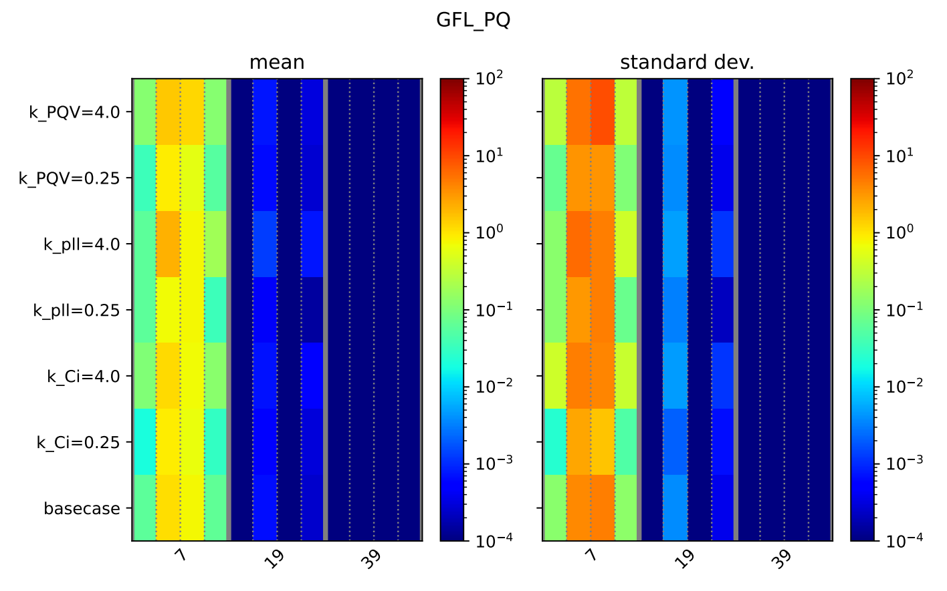 | 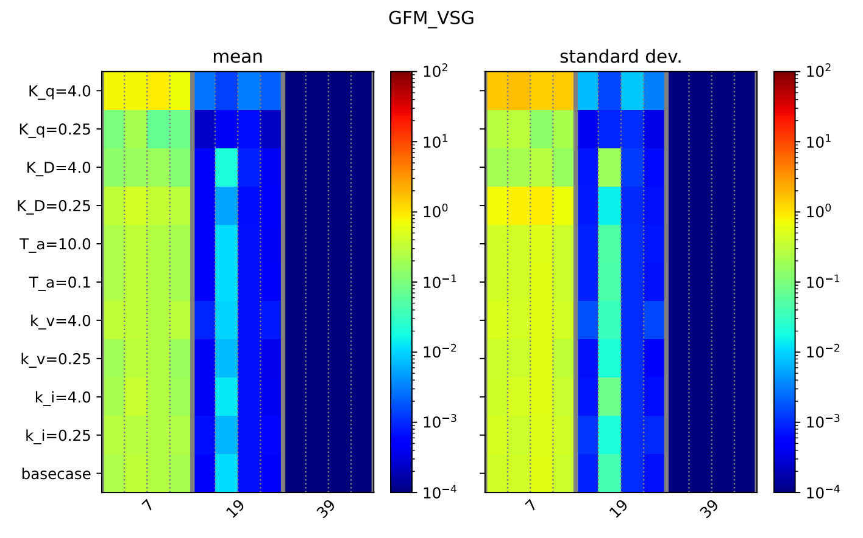
Figure 3 A comparison of goodness of fit statistics for various data sizes (columns) and control parameter variations (rows). The colour of each cell shows the value for that data point. Results for two IBR control structures are shown.
Preliminary evaluation of the APM against the developed black-box model was performed, where its admittance can only be measured (rather than calculated from a theoretical model). The aim is to check whether the prediction results are accurate when using measurement data. From a total set of 215 OPs, 30 OPs are randomly selected to form the test group and the remaining 185 OPs constitute a pool from which random sets of training OPs can be formed. Separate tests with varying training group sizes (19 and 39) are created to test the influence of training data size. The ratio of successful predictions of the repetitive tests for each test OP is shown in Figure 4. Increased training data significantly increases the prediction accuracy. For a large number of test OPs (70%), a very good prediction accuracy is observed regardless of the training OPs selected. However, for the remaining 9 cases, the prediction accuracy is observed to be much more dependent on the specific OPs selected for training. Further, it is observed that the prediction is more successful for the diagonal admittances (dd and qq) rather than the off-diagonal (dq and qd) admittance. Further work is required to investigate the cause of the observed error dependence on the training data and its potential impact to stability analysis.
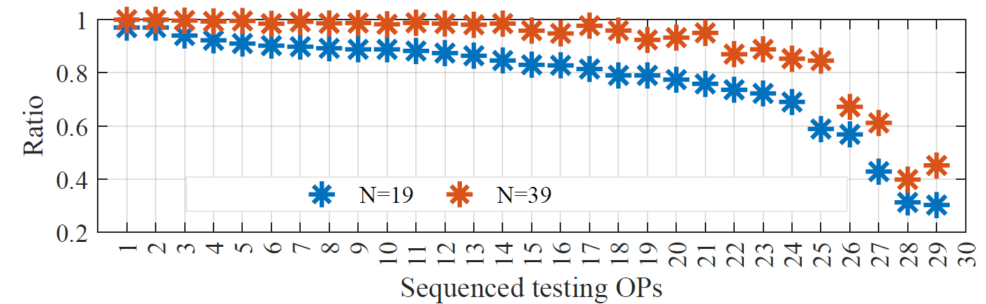
Figure 4 The successful prediction ratio of APM of the OP dependent admittance from a black-box inverter model in simulation. N is the number of OPs feeding into the APM algorithm.
2.3 Network small signal stability assessment
In this stage of the project, small-signal analysis of smaller systems was conducted, in order to test the methodology in simpler examples, compare them with time-domain simulations and establish most of the procedure necessary for the full study of the NEM system. The network level small signal analyses is led by the EPRI team.
In the initial stages, the two-area Kundur system was investigated. In particular, the analysis focused on comparing a fundamental frequency and an EMT scale linearized model of the systems. The aim was to capture if there are discrepancies between the models and understand if the dominant angle dynamics are affected by network dynamics. In particular, the EMT formulation assumes that transmission lines are modelled by two T-sections, while transformers are modelled by their series reactance. Loads are also modelled as passive RLC elements. Generators are modelled by the sub-transient models, with first order exciters and a lead-lag speed-based power system stabilizer. As noted in Figure 5, the two formulations of the network, yield very similar eigenvalues in the lower frequency range.
The majority of the eigenvalues, appear to be identical, with a slight difference in the location of the mode around 9 r/s. In particular, that mode appears to move slightly to the right in the EMT case, but the shift is very small and the mode remains well-damped. Finally, the interarea mode, between areas 1 and 2, in the frequency range around 4 r/s, appears to remain in the same location across formulations. In higher frequencies, oscillatory modes are introduced by the network dynamics, but they are very well-damped.
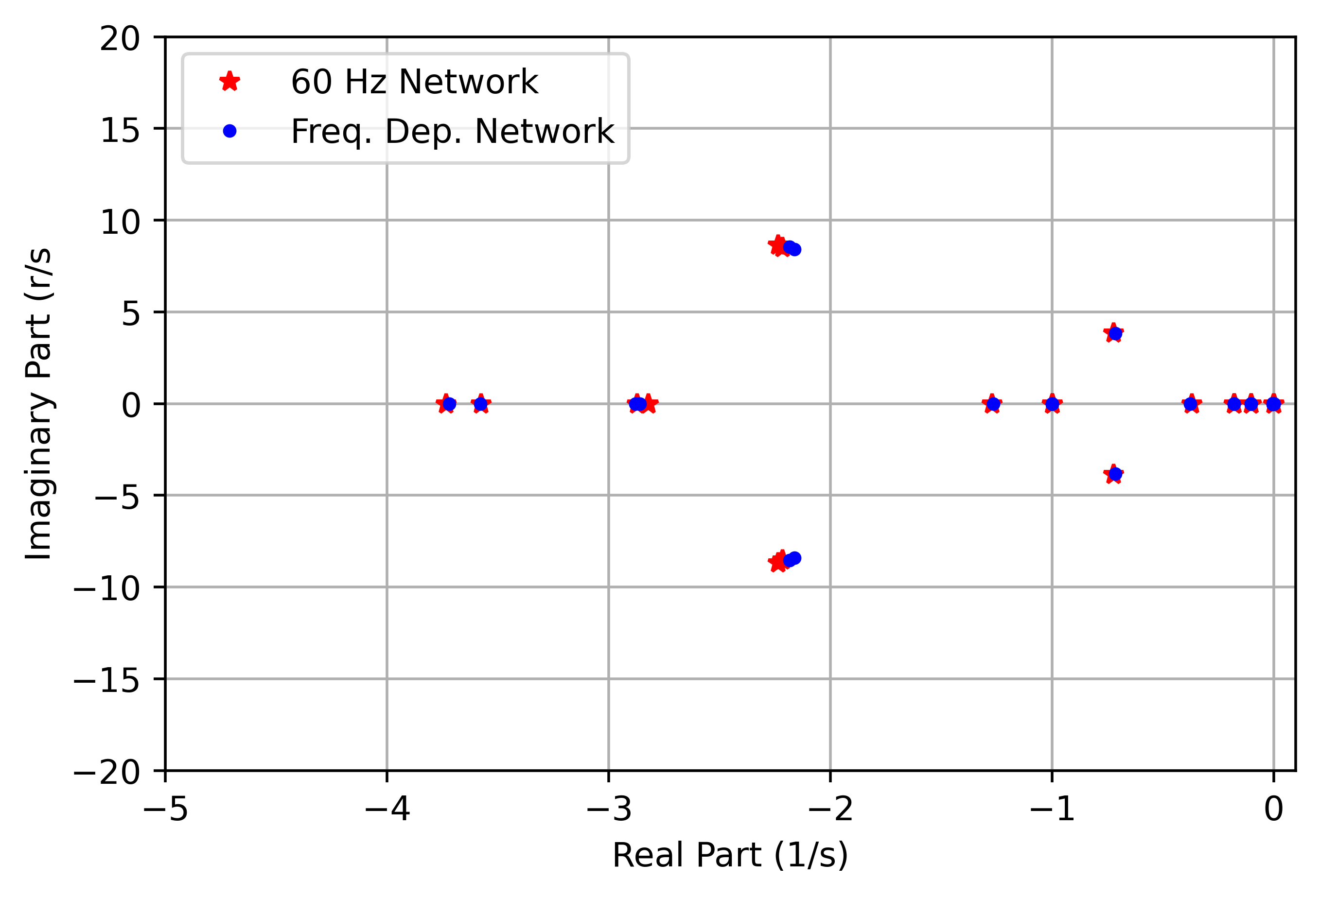
Figure 5 Fundamental Frequency and EMT System Eigenvalue Comparison
The next step of the research process involved the extension of the analysis of slightly larger systems in the fundamental frequency domain. For that purpose, the IEEE 39 Bus benchmark system is utilized. That system represents the New England power system with 10 aggregated machines modelled.
Finally, work has been carried out in the small-signal analysis of the NEM system. The small-signal model has been developed. Presently, debugging of the developmental method is being carried out and the next step will be to benchmark it against time domain simulations.

Outstanding activities
For testing and improving the impedance prediction algorithm, further investigation into the performance of the analytical prediction method for a blackbox model is planned. One of the next steps for the small signal analysis perspective is finishing the ongoing debugging and benchmarking of the synthetic NEM network small signal model against time domain simulations. Another important step is to add IBR models (both whitebox and blackbox) to the small signal analysis – for a small two area system, the detailed EMT and fundamental frequency linearized models will be compared for a system with IBRs to assess the accuracy of the fundamental frequency linearized model when IBRs exist in the network. In the subsequent efforts, the team plans to utilize the network small signal model to identify critical nodes of the network by evaluating the proximity to a stability margin boundary, and study/develop the associated metrics. The analysis will then be extended to characterize the behaviour of the network across a variety of operating points, and the approaches for stability assessment using the model of the entire network and two-port network equivalent will be compared. Finally, the impact of IBR current limit over a 24-hour period will be identified and its impact on the performance of the impedance prediction algorithm as well as the small signal stability will be assessed.

Progress against the Roadmap
The work continues to align with the roadmap. Per the initial roadmap, the second year of a total three-year effort would firm up impedance prediction methods and incorporation of the analysis into large system stability evaluations. The work done so far in this stage of the work is on track with the roadmap. It is estimated that approximately 50% of the work to be done under the two critical relevant tasks (i.e., stability margin evaluation (Critical Task 1 in the roadmap) and small signal stability screening methods(Critical task 2 in the roadmap)) has been carried out.

Research relevance
The Australian power system is recognized to have had a tremendous increase in the shares of IBRs and distributed energy resources (DERs), and such increase is expected to continue in the near future. With the increased penetration of IBRs in a power system, the oscillatory behaviour of the system is expected to change. The change in the oscillatory characteristics can be fundamentally related to the change in modes in the network. A network with rotating machines has electromechanical modes that dominate. Whereas with an increase in IBRs, the modes can tend towards electromagnetic range. This can bring about interactions on a much faster time scale. Thus, to allow for efficient operation of the network, it will be beneficial to characterize the oscillation characteristics at any operating point, especially with the increased uncertainty of variable generation.
Through this research effort, overall system stability assessment and accurate plant level IBR impedance prediction model can allow the network operators to have a clearer picture about the system stability for each operating point. The added insights from the small signal stability and oscillation modes for a network as a result of this research can potentially also shorten the connection cost for a new IBR, thereby encouraging more IBR integration. While these issues are relevant for the global energy sector as a whole, the pioneering nature of Australia’s energy transition informed by its high scale and speed, leads these to have added relevance for the Australian scenario. The results of these efforts would align with progression on Critical Tasks 1 and 2 of the roadmap.

Recommendations
In this stage of the project, a small signal stability analysis of a large network across multiple operating points is expected to be performed, with a representation of IBR models using estimated impedances from blackbox IBR models. This stage of project also aims to investigate the impact of current limit on the operating points and stability. In the next stage, the impedance estimation algorithms may be improved by identifying such nonlinear limits/regions of operation and corresponding operating points needed for an accurate impedance model. Further, the features of IBRs critical to be represented in a blackbox model for obtaining a near-accurate estimated impedance may be studied. Further, a fundamental frequency network equivalent is used in this stage of the project for the large network, a comparison of using a multiple-frequency network equivalent to fundamental frequency network equivalent for a large network such as the synthetic NEM network may be made in the next stage.
Future discussions on the topic can also bring in inverter OEMs and commercial software vendors to help streamline the process of industry adoption.

P. Kundur, Power System Stability and Control, New York:Mc Graw-Hill, 1994.
M. A. Pai, Energy function analysis for power system stability, Boston: Kluwer Academic Publishers, 1989.

