Control Room of the Future Research Roadmap (Topic 3)

Australian Research Planning for Global Power Systems Transformation

  - Electric Power Research Institute

10/09/2021

Authors:
- Adrian Kelly (EPRI)
- Sean McGuinness (EPRI)
- Matt Pellow (Pellow Energy Insights)
- Barry O’Connell (Smarter Power Solutions)

Executive Summary
As the Australian power system undergoes significant transitions in the coming years – including increasing shares of inverter-based resources and distributed energy resources and decreasing synchronous generation capacity – enhanced monitoring and control capability will be required in transmission system control rooms of the future. Transitioning from the systems in the control rooms of today to the systems in the control room of the future requires a rethink of how the elements of the control are configured, based on a redefined purpose and vision for the future. The objective of this research roadmap is to develop a model for considering the 15 key pillars within control room of the future, and chart the course for advances in these pillars towards 2030. The projected advances are both realistic and are aligned with current developments in Australian control rooms but also are ambitious in the scope of the research and development roadmap towards 2030.
The research topics and themes of the control room of the future model identified in this roadmap were developed by the Electric Power Research Institute’s (EPRI) Transmission Operations and Planning (TO&P) group, based on an initial set of questions (provided by CSIRO) based on work carried out by the Global Power System Transformation (G-PST) Consortium. The topics are also informed by consultations with transmission network service providers (TNSPs), distribution network service providers (DNSPs) and the Australian Energy Market Operator (AEMO).
First, a functional model is developed that links with the control room of the future model and describes at various levels of abstraction what the system should be designed to achieve. The functional model will help in the development of a future reference architecture for system operators, advanced in the companion CSIRO research roadmap for Power Systems Architecture (Topic 7). The research roadmap uses innovative, but easily understandable, colour-coded approaches for engaging with the 15 pillars, grouped into five roadmap visualisations with information summarised in tables. The report addresses the research questions directly with links to the functional model, roadmap pillars, and other CSIRO workstream research roadmaps and topic areas.
This document summarises extensive engagement with the most critical control room stakeholders in Australia, as well as advanced EPRI research to address the CSIRO GPST research questions. Its aim is to inform the research community, of Australia and the world, of the structure of a future control room and the needs for the transmission control room of the future. With investment, collaboration, and commitment, the milestones in the roadmap can be realised to help enable a safe, secure, economic reliable and sustainable power system in Australia.

Table of Contents
Executive Summary 2
Glossary 6
1. Introduction 7
1.1. Traditional Approach to Control Room Design 7
1.2. Background to Australian System Transition 8
1.2.1. Energy Transition Goals 9
1.2.2. Energy Sources 10
1.2.3. Network Assets and Technology 11
1.2.4. Demand Response 11
1.2.5. Market reform / New market functions 11
2. Methodology 13
2.1. CROF Foundations – Functional and Capability Model and Architecture 14
2.2. CROF Pillars – Data and Software Applications 15
2.2.1. Data – Models and Streaming 16
2.2.2. EMS / SCADA 17
2.2.3. MMS / NEMDE 17
2.2.4. Control Room Tools 18
2.2.5. Operations Planning Support Tools 18
2.3. CROF Pillars – Human Factors and Operator Interaction 19
2.3.1. System Control, User Interfaces and Data Visualisation 19
2.3.2. Operator Situational Awareness Optimisation and Decision Support Framework 20
2.3.3. Simulator / Operations Readiness Centers 20
2.3.4. Operator Training 21
2.3.5. Building and Facility Design 21
2.3.6. Hardware and Ergonomics 21
2.4. CROF Vision and Purpose 22
2.4.1. CROF Purpose 22
2.4.2. CROF Vision 22
3. Roadmap Development and the CROF Functional Model 24
3.1. Process 24
3.2. Stakeholder Engagement and Industry Activities – Existing States and Current Solutions 24
3.3. The Functional Model 29
3.4. Functional Model of Australian Real Time Control Room Operations 31
3.4.1. Purposes 31
3.4.2. Priorities and Key Performance Indicators (KPIs) 31
3.4.3. Functions 33
3.4.4. Sub Functions 33
3.4.5. Processes 34
3.4.6. Tools 36
3.4.7. Physical Objects / Models and Data 38
3.4.8. Complete Functional Model 38
3.5. Two Models for the Control Room of the Future 40
3.6. Key Research Questions 40
4. The Research Plan 51
4.1. Roadmap for the CROF 51
4.2. Roadmap Structure and Format 51
4.3. Roadmap for the CROF – The Functional and Capability Model and Architectures 1
4.4. Roadmap for the CROF - Data Models and Streaming 1
4.5. Roadmap for the CROF – EMS / SCADA and MMS / NEMDE 1
4.6. Roadmap for the CROF – Control Room and Operations Engineering Tools 1
4.7. Roadmap for the CROF – Operator and Human Factors 6
4.8. Roadmap for the CROF – Buildings, Facilities and Hardware 9
4.9. Existing AEMO Control Room Projects and initiatives 12
5. Recommendations 13
References I

Glossary
AAR | Ambient Adjusted Ratings | G-PST | Global Power System Transformation | RAS | Remedial Action Scheme
AEMO | Australian Energy Market Operator | HVAC | High Voltage Alternating Current | R&D | Research and Development
AI | Artificial Intelligence | HVDC | High Voltage Direct Current | RoCoF | Rate of Change of Frequency
BESS | Battery Energy Storage Systems | IBR | Inverter Based Resource | RL | Reinforcement Learning
CIM | Common Information Model | ICT | Information Communication Technology | RT | Real Time
CROF | Control Room of the Future | IEC | International Electrotechnical Commission | RTU | Remote Terminal Unit
CIGRE | International Council on Large Electric Systems | IED | Intelligent Electronic Device | SCADA | Supervisory Control and Data Acquisition
CSIRO | Commonwealth Scientific and Industrial Research Organisation | ISP | Integrated System Plan | SCR | Short Circuit Ratio
DER | Distributed Energy Resource | ML | Machine Learning | SE | State Estimation
DLR | Dynamic Line Rating | MMS | Market Management System | SEC | Saudi Electric Company
DNSP | Distribution Network Service Provider | NEM | National Electricity Market | SG | Synchronous Generators
DSA | Dynamic Security Assessment | NEMDE | NEM Dispatch Engine | SPS | Special Protection Schemes
EMS | Energy Management System | NMM | Network Model Management | STATCOM | Static Synchronous Compensator
EMT | Electromagnetic Transient | ORC | Operations Readiness Centre | SVC | Static Var Compensator
EPRI | Electric Power Research Institute | OTS | Operator Training Simulator | TCSC | Thyristor Controlled Series Compensator
ERCOT | Electric Reliability Council of Texas | PMU | Phasor Measurement Unit | TNSP | Transmission Network Service Providers
ESB | Energy Security Board | PST | Phase Shifting Transformer | TO&P | Transmission Operations & Planning
FACTS | Flexible Alternating Current Transmission Systems | RA | Resource Adequacy | WAMS | Wide Area Monitoring System
 |  |  |  | WAMPAC | Wide Area Monitoring Protection and Control

Introduction
As power systems across the world are undergoing transformative changes with regards to changes in resource mix, end-use load and transmission technologies, advanced methods and tools are required in the control room of the entities tasked with transmission system monitoring and control. Given the high reliability requirements, regulation, and pace of innovation the transmission control rooms have evolved slowly, in tandem with the evolution of the transmission grid.
The rapidity of change of transmission systems is leading to previously unforeseen system risks and challenges. In systems with high renewables penetrations (such as Australia), in some cases the monitoring and control technology and tools in the control are not adequate for assessing and addressing the risks that are posed to the system.
While there are some existing solutions available, much more research is required to be carried out to help bring new data, tools, and processes into the real time control center environment.
This research roadmap will lay out avenues for future research that are targeted towards an enhanced control room for system operators. The roadmap covers all aspects of the control room from data points to facility design. It is informed by years of research with other similarly challenged TSOs and Mos and TNSPs across the world, with particular focus in recent years from the Global Power System Transformation (GPST) initiative.

Traditional Approach to Control Room Design
Control rooms traditionally had rooms dominated by large overview pictures of the system under control. This design concept began as a mimic panel (often called a “map board”) with bulbs, meters and drawn lines shown interconnecting stations. It was traditionally the center of the room and an area for people to gather around to assess and monitor the system. In the 1970s with the advent of Supervisory Control and Data Acquisition (SCADA), EMS and improved visualization technologies, the mimic panels were replaced with dynamic representations of the system under control.
Though the system, and tools to monitor and control it, has evolved in recent decades, the traditional approach to control room design has endured, until recently. The control rooms of 2021 look like the control rooms of 1980 and – only replacing the videowall for a mimic panel - todays control centers are ostensibly like the control centers of the 1950s or earlier.
The roadmap document addresses what tools need to be developed and deployed in the control rooms across Australia before 2030, to monitor and assess the future system risks.

Background to Australian System Transition
The power system and market systems (here after referred to as the “system”) in Australia is developing and evolving at a rapid pace as outlined in the AEMO’s Integrated System Plan (ISP) and Renewable Integration Study (RIS) and in the work of the Energy Security Board (ESB). Over the next decade, the system is likely to continue evolving with:
- More numerous large scale energy generators and market participants
- Increasing decentralisation as behind the meter distributed renewable energy generation increases which is decreasing dispatchability and predictability.
- Reduced synchronous sources online which have been relied upon to keep the system stable
- Increased variability and uncertainty introduced by renewable generation
- Increasing complexity for security analysis associated with power electronics
- Adoption of technology and increasing demand response, utility scale and decentralised storage integration, electrification of vehicles
- More frequent and severe weather events
- Need for change to existing and introduction of new market structures to support the system of the future
among many other issues to be monitored, assessed, and controlled.
As a result of these transformational changes, it is likely that the existing systems in the control room of 2021 will not be adequate to manage the system of the future. This implies that the way the system is operated, and the way power system operators interact with the system, will have to adapt at a rapid pace.
Australian TNSPs and AEMO have been innovative and advanced on this topic, by identifying and mitigating challenges to real time operation as they have arisen. Some requirements have resulted in EMS upgrades, new monitoring equipment, and assessment and monitoring of new system parameters, particularly in relation to grid strength. The efforts in Australia are not isolated, and many of the most innovative transmission system operators (especially system operators associated with GPST) are making strides in transforming their control room to monitor and control the system of the future.
The goal of this control room of the future roadmap is to highlight the relevant functions, processes tools, and data required for the control room of the future (CROF). The roadmap is intended to build on and complement various existing projects ongoing in TNSP operations departments across Australia and align the industry on key needs for CROF.
Roadmaps are typically static “point in time” documents, highlighting a pathway forward to achieve specific goals. This roadmap will be an adaptive framework, to be updated in the coming years as the Australian power systems evolve because of the ongoing rapid energy transition and wide-spread digitalization.
By structuring the project to develop the roadmap in this way, a roadmap vision and purpose emerges based on the needs of the Australian system of the future and the technology horizon. Additionally, the gap analysis and needs assessment to progress between technology maturity stages for data, software, hardware, training, etc. are clearly defined.

Energy Transition Goals
The Control Room of the Future roadmap enables both AEMOs and TNSPs as they adapt to manage the rapidly changing power system.
For AEMO, the CROF roadmap supports the “Real Time Operations” and “Operational Planning” roles. These roles are situated within the context of AEMO’s other roles, and within the context of other power system stakeholders, in AEMO’s Engineering Framework (Figure xx). The CROF supports the Real Time Operations role by ensuring that the control room capabilities and environment are fit for purpose for the future power system, characterized by the developments described in the previous section. It supports the Operational Planning role by, for example, defining the specific control room elements and capabilities to ensure suitable situational awareness and suitable functionality for effective contingency management; and also by aligning planning scenarios with real operational data by planning for model alignment and data integration.

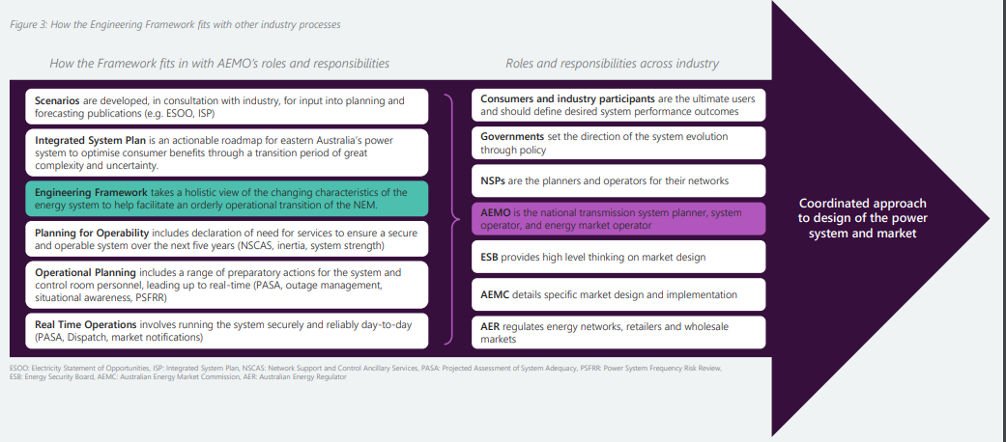
Figure 1. Roles and responsibilities of AEMO and other power system stakeholders. (Source: AEMO Engineering Framework [1])
Several individual aspects of development anticipated to impact the Australian power system in the coming years are briefly discussed below.

Energy Sources
AEMO’s 2020 Integrated System Plan (ISP) [2] projects that the capacity of distributed energy resources may triple in the National Electricity Market (NEM) over the next two decades. This would include both distributed generation and load management at the residential and commercial/industrial level. This increase in capacity is projected to provide up to 22% of the total annual energy consumption in the NEM in 2040 (in the High distributed energy resource (DER) scenario). Further, the ISP projects a midrange estimate of 45 GW of new transmission connected renewable generation by 2040 (in the “Central” scenario), with upper-bound projection of 64 GW (in the “Step Change” scenario). In all scenarios, about half of the new renewable generation capacity is expected to be inverter-connected solar generation. In parallel, 60% of the coal-fired generation in NEM is expected to retire over the same period.

Network Assets and Technology
To support this large build out of renewable energy, AEMO’s roadmap acknowledges that management of services required by the power system such as voltage control, system strength, and frequency control will be required to increase. Additionally, network upgrades (both HVAC and HVDC) have been identified to transfer power to load centres and improve reliability of the network. It is anticipated that power electronic based control devices will proliferate as well as Special Protection Schemes and wide area monitoring and control.

Demand Response
While generation sources are expected to become more variable, the demand is also expected to become more variable because of behind the meter distributed renewables, smart metering, smart devices, and the electrification of society. Daily demand and load patterns may no longer be as predictable in times past and ramps for balancing may be more severe.
The Australian control rooms will need technology, facilities, processes, tools, and data sources and most importantly training for human operator to manage this rapidly shifting system in real time with adequate forecast capability and decision support.

Market reform / New market functions
The need for enhanced system security in the emerging high-IBR power system is prominently recognized in the Energy Security Board’s (ESB) market reforms options paper, which proposes several market reform pathways to ensure the NEM meets the needs of Australia’s transition to a high-renewables grid [3]. “Essential system services and ahead scheduling” is one of the four pillars of proposed reforms highlighted by the ESB’s April 2021 options paper. Notably, the ESB prioritized for immediate reform:
- refining frequency control arrangements and addressing the potential need for enhanced arrangements for primary frequency control and a new market for fast frequency response.
- developing structured procurement arrangements, including for system strength; and
- considering the need to explicitly value operating reserves. The current provision of reserves in operational timeframes is implicitly valued through the energy spot market. New products and services may be required to manage growing forecast uncertainty and variability in net demand over timescales of minutes to hours. A new reserve service market could provide an explicit value for flexible capacity to be available to meet these net demand ramps spanning multiple dispatch intervals.

Methodology

EPRI have an established methodology and framework when developing roadmaps and research associated with transmission system control rooms of the future (CROF). The methodology and approach to the CROF is visually shown in Figure 2-1. This is a complex, interconnected model, with four foundations, and eleven pillars all supporting the purpose and vision for the CROF. This was modified developed in consultation with key stakeholders during the development process. This model and color code are used throughout this document and for the roadmaps in section 4. The following sections explain in detail the elements of the model.
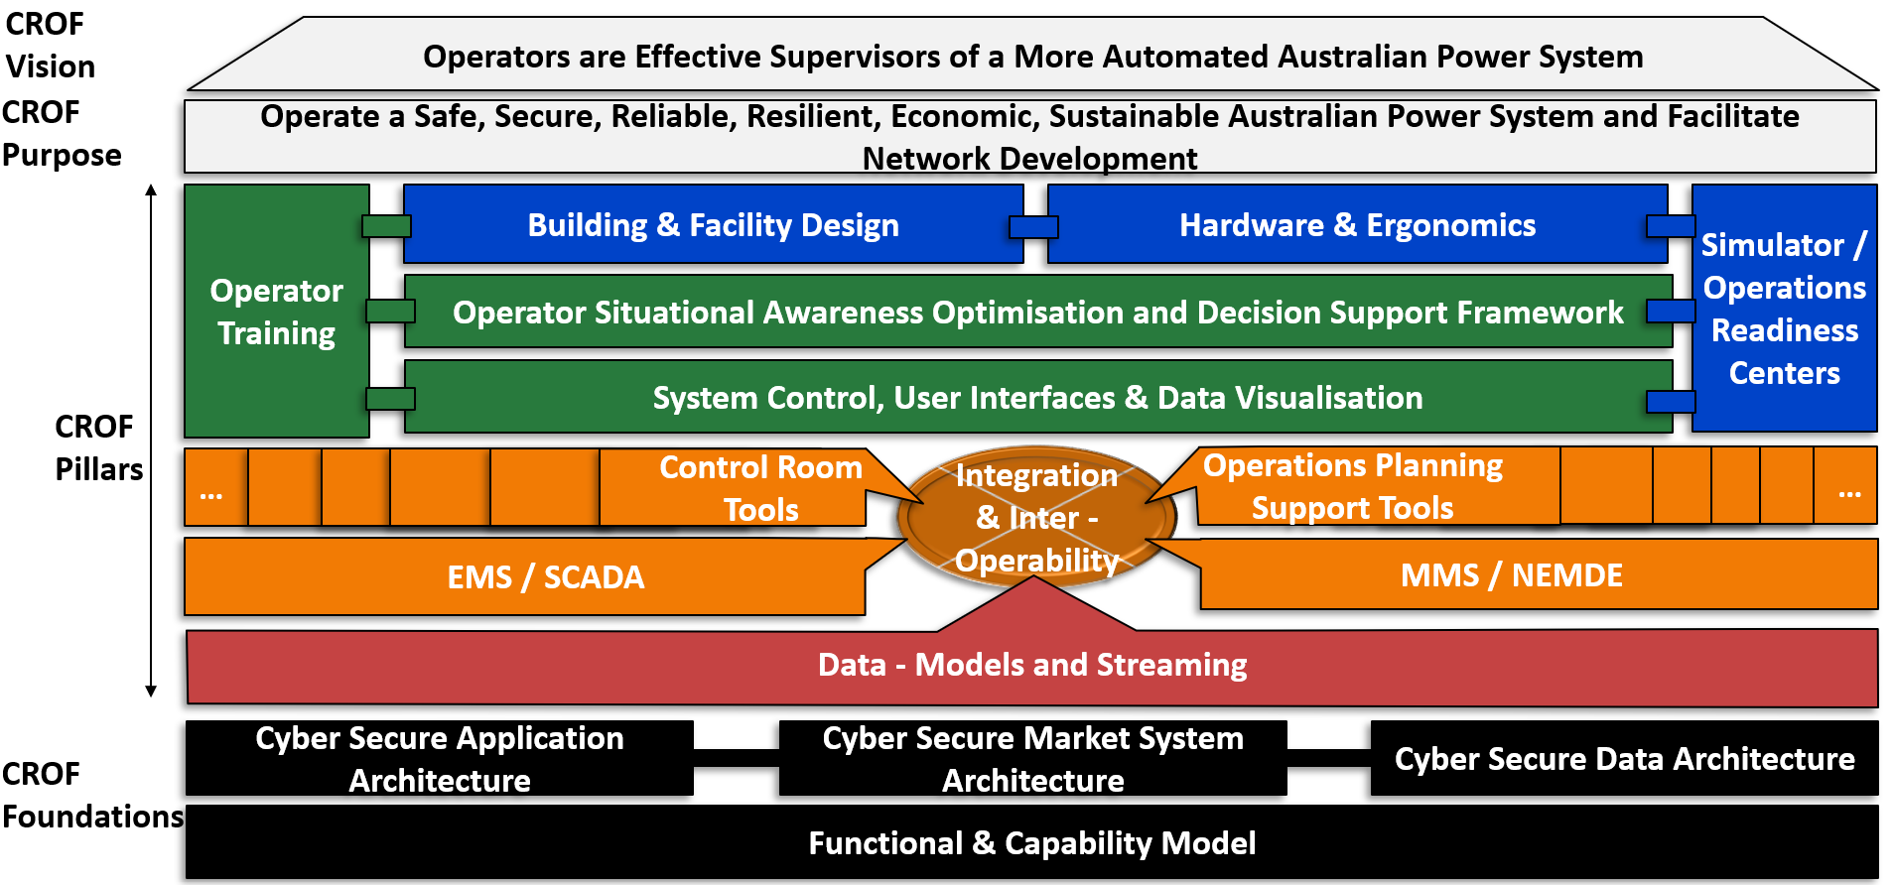
Figure 2-1 EPRI Model of aspects of the control room of the future, applied to the Australian context. Includes the CROF vision, purpose, pillars, and foundations.

CROF Foundations – Functional and Capability Model and Architecture

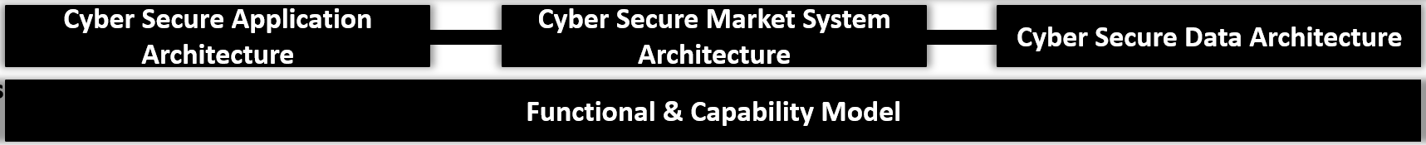
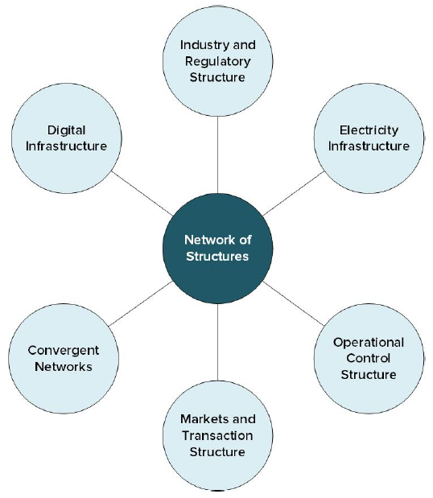
Figure 2-3 The foundations of Australian CROF model
Figure 2-2: Concept of the power system architecture network of structures in the Power Systems Architecture (Topic 7) research roadmap [5]
The CROF is supported by foundational enabling capabilities and technology, which are definitions of precisely what the control room is designed to do (functional model) and how data, IT applications, and market systems link together - in cyber secure architectures.
This is probably the most important aspect of the CROF roadmap: a well-designed functional model and architectures are key dependencies for well-designed data flows and software systems in control rooms. Without these foundational elements in place, the CROF is destined to become disjointed and incoherent, with different elements and systems not properly aligned and diverging as the system evolves. The CROF roadmap begins with the development of the functional model in Chapter 3.
A capability model goes together with the functional model, outlining the capabilities required in the company to achieve the requisite functions from the functional model. This includes human resources, hardware and facilities and IT resources and so on.
Design of a reference architecture for the CROF is not within scope of this research roadmap, however the architecture research roadmap is documented by Strategen in the companion research roadmap for Power Systems Architecture (Topic 7) [4]. The basis for architecture roadmap resolves around the concept of a “Network of Structures” [5], i.e., interlinking structures that are co-dependent and should be co-optimised.
From Figure 2-2, the operational control, markets and transaction and digital infrastructure are important architecture and structural considerations for the architectures for the CROF. There are equivalences between the Topic 3 CROF model Figure 2-1 and Topic 7 power system architecture model Figure 2-2;
Digital Infrastructure = Cyber Secure Data Architecture
Operational Control Structure = Cyber Secure Application Architecture
Markets and Transactions Structure = Cyber Secure Market Architecture
As outlined by Strategen in the companion research roadmap for Power Systems Architecture (Topic 7) – “A systems architecture is foundational to its capability. The structure or architecture of any complex systems is critical to what that system can reliably and cost-effectively do. For power systems, this is especially critical given the expanding range of functions required to enable the dynamic coordination of VRE, DER, EVs, flexible load.” [4]
An important consideration is the interconnection and interoperability between the DNSPs, TNSPs and AEMO. These areas of responsibilities, functions, data exchange etc should be incorporated in the architecture design – most likely in the Operational Control Structure / Cyber secure Application Architecture implementations. For further insight into the future power system architecture, refer to the companion research roadmap for Power Systems Architecture (Topic 7) [4].

CROF Pillars – Data and Software Applications
The eleven CROF pillars shown in Figure 2-1 and Figure 2-4 are built from the foundations, discussed above with the aim of support the CROF vision. These are the elements that make up an effective, efficient control room operation, depending on its function (as defined in the functional and capability model).
The first five pillars addressed are deeply interconnected and rely on an operational nexus of integration and interoperability. These include the monolithic systems such as Energy Management Systems (EMS) and Market Management Systems (MMS) as well as control and support operations, tools, and firstly, data. Some pillars are more relevant to some control rooms than others. For example, MMS/NEMDE may only be relevant as an IT application primarily to AEMO, but the data and information to decision support is shared and required to be viewed across all the TNSPs, hence it is included as a CROF pillar for the roadmap.

Data – Models and Streaming
Figure 2-4 The five of the 11 CROF pillars as defined for the CRD roadmap, associated with data and interoperable control room software application systems
The data pillar of the CROF is obviously critical to all aspects of control room operation. Without data there is no need for a control room. It is visually shown as an output of the architectures, flowing into the control room software applications - EMS, NEMDE/MMS, and control room and operations engineering / planning support tools via an interoperable integration (which is linked to the architecture design).
In the roadmap, data is abstracted further into data models, and streaming data since both elements are inherently different. The data model should be a representation of the system and objects under control of system operators. In an idealised world there is one single model that all entities use and is interoperable with all CROF systems. Since the models are never perfect, they should be regularly validated and updated with data from real world events.
Standardised dynamic models exist for generators, loads and devices. These can be parameterised by the vendors, based on their proprietary information. The model should be securely held with a single expert team with broad responsibility for model data update across functional entities.
Streaming data refers to data that is fed to control rooms in real time from physical objects on the system. Traditionally this has been from SCADA data, but more recently, more granular data from phasor measurement units (PMUs), substations Intelligent Electronic Devices (IEDs) assets (IEC 61850) is available to system operators. In general, while this might be useful data, careful consideration should be given to how this data is organised, governed, and structured, to improve decision making and avoid information overload.
Exchange of model and streaming data from DNSPs and generators is also an important consideration for future system observability and control.
The management of streaming and model data will be the key enabler for machine learning and data analytics techniques to be used in the CROF.
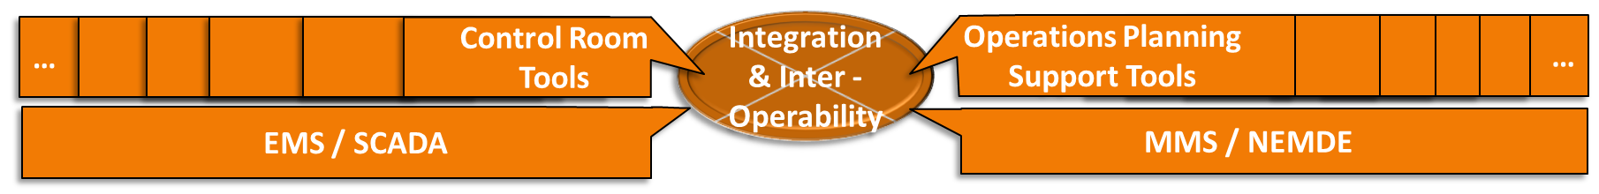
Figure 2-5 Graphic showing control center tools together as interoperable pieces of the same system

EMS / SCADA
The EMS/SCADA system is a key part of all control rooms around the world. EMS/SCADA are “monolithic” system, developed by a range of major energy infrastructure and software vendors. Each TNSP and AEMO have their own EMS/SCADA to process and analyse real time information. Each EMS/SCADA vendor has their own product roadmap incorporating their own research and development. These are not available to the wider industry and community, due to intellectual property restrictions, so broadly these are not interoperable and are not aligned in terms of development direction. EMS/SCADA typically are in place for at least five years, before they require an upgrade or replacement, which are major, resource intensive, ICT projects.
For the CROF, the EMS/SCADA is required to be interoperable with other CROF tool and operations planning support tools and the NEMDE/MMS. This should be primarily enabled through data exchange standards governed by common information model (CIM)

MMS / NEMDE
The Market Management System (MMS) is the NEM wholesale system determining the cost of energy. MMS provides such functions as ancillary services, dispatch, market information, NEM reports, offers and submissions, settlements and prudentials, and trading facilities [6].
The NEM dispatch engine (NEMDE) is the software developed and used by AEMO to ensure that the central dispatch process maximises value of trade subject to the various constraints. Under some circumstances, it may not be possible to satisfy all constraints that need to be considered in each dispatch interval. Under these circumstances, the solution would, if not catered for, cause NEMDE to fail to solve. Such a failure is unacceptable, so AEMO has procedures to ensure dispatch and pricing continue. These procedures are referred to as constraint relaxation procedures [7]. The constraints data entry and processing in NEMDE is manual and resource intensive.
While AEMO operates and runs the MMS and NEMDE, it is important that other stakeholders in the energy system can access appropriate data and information from the market and NEMDE within their control centers to aid operator decision support for the challenges of the future network.

Control Room Tools
Associated with the MMS and the EMS are the other control room tools that are not in the monolithic systems but are required to operate the system. These could be software applications or platforms or even software as a service from external vendors. In general, they are linked with customised data connections to the data from the monolithic systems. Control center tools can include voltage dispatch system, demand forecast, renewable forecast, wide area monitoring system, but also logging applications, workforce management and asset monitoring. It should be noted that some of these can be applications or modules within the EMS/SCADA system and do not necessarily have to be separate IT systems.
The required control room tools for AEMO and TNSPs to carry out the processes and tasks should be derived from the functional and capability model. The first iteration of the required control room tools is presented below (derived in Chapter 3). Note the list of control center tools includes both EMS/SCADA and MMS.
- Energy Management System / SCADA
- Congestion Management Tool
- Voltage Control Reactive Power Optimisation Tool
- Asset Health Alarm Root Cause Analysis / Disturbance Investigation Tool
- Dynamic Security Assessment (Includes Inertia, Voltage, Frequency, Transient, Small Signal Stability)
- Power Quality, EMT & WAMS
- System Strength Evaluation Tool
- Protection, Short Circuit & SPS Coordination Tool
- Blackstart & Restoration Enhancements Including RES
- Market Management System
- Demand Forecasting
- Renewable Energy Forecasting
- Reserve, Ramping and Flexibility Assessment
- Balancing, Dispatch & Load Frequency Control
- Outage Management, Reporting and Workforce Management
- Environmental (Fire and Weather) Forecasting

Operations Planning Support Tools
The operations planning (sometimes called operations engineering or operations support or near time operations) teams in AEMO and TNSPs study the network at a longer time horizon than real time system operators, usually weeks or months out. For the most part, the engineers in these teams utilise a similar if smaller set of the 16 tools used by the control room operators, working in real time. Some examples might be that powerflow or voltage stability tools or simulation software, outage documentation, switching plan documentation and processing, asset health analytics etc. The operations planning support tools should be interoperable with the control room tools and the EMS and MMS, utilising a consistent model of the system under control and identical streaming system data for example, outages should be studied with demand and renewable forecasts and market schedules that are as relatable as possible to real-time operations.

CROF Pillars – Human Factors and Operator Interaction
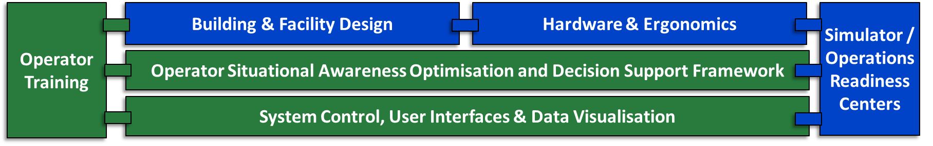
Figure 2-6 The six CROF pillars as defined for the CROF model associated with human factors and operator interaction with the software systems and data in the control room.
On top of the five pillars associated with data and software applications are the six pillars that encompass the human factors and operator aspects of interaction between the control room operator and the software systems and data that enable monitoring and control of the system.
These 6 pillars define how operators interact with the information in the control room once it is processed and resented by the interoperable tools and systems. Each are described in detail below.

System Control, User Interfaces and Data Visualisation
This multi-faceted pillar is intended to encompass the control of elements of the power system from the future control room. This builds on the fact that much of the modern power system is automatically controlled such as generation, demand and reclosing on overhead lines and special protection schemes. This trend is expected to continue in the future, to the point that all elements of the power system will be automatically controlled, with operators likely to only intervene when the automation is disrupted or for major system events.
Some applications of the present control room are manual and labour intensive and do not add to situational awareness. These menial tasks such as workforce management and ex-post report logging should be automated where possible.
Operators require streamlined, optimised interfaces of the software applications they interact with and information should be presented in the clearest, most unambiguous, and most actionable format. Display design should be standardised and follow best practice guidelines [8]. Since the control rooms are homes to vast quantities of streaming analog and alarm data, presenting this in a clear, concise manner to improve situational awareness is a key focus of the CROF roadmap. The control rooms of today do not utilise best practice in data visualisation, and lessons can be learned from other industries.

Operator Situational Awareness Optimisation and Decision Support Framework
While the system of the future will likely become more automated, operators must be able to maintain their situational awareness for events on the system that require operator intervention – much like a pilot relying on autopilot to fly a plane. The electricity industry can learn from the approaches of other industries as part of the roadmap. Monitoring of mental workload and situational awareness may be required in future. Structured decision-making models have long been a part of aviation and other similar industries but not always applied to electricity control. Existing structured decision making, and support models can be adapted for transmission, including the Rasmussen Decision Ladder [9]. These will not only benefit the operator in their real time decision making but are a good proxy for automation of manual tasks.
In the control room of the future, control center tools, EMS and MMS will all interact to perform tasks and processes. However, sometimes these may be in conflict. For example, a voltage optimisation and control tool may optimise the system for voltage, but this may exacerbate a congestion issue, or a system strength issue. If not properly optimised, the tools may “hunt” with cascading effects.
An idealised end state would have an intelligent decision support system that takes the output of the interconnected tools and optimises on the appropriate action, based on a hierarchy or order. There are ongoing early-stage experiments with the development of digital assistants for control center operations [10].

Simulator / Operations Readiness Centers
The output of the control center tools requires a simulator environment for the testing of scenarios and the training of operators. At present most control centers have an operator training simulator (OTS) for operators but this is used primarily for training operators on specific tasks such as blackstart and is generally underutilised for normal business as usual, despite significant investment.
In the control room of the future, all software applications should have a simulator environment and there should be a pristine model of the system that is used by the simulator environment. The OTS should be upgraded to become an “operations readiness centers”, for user acceptance testing of all software tools; for training with operators pre deployment; and for testing new user interface designs and hardware, as well as providing their core function of training and testing operators managing the power system. It is probable that none of the ambitions of the CROF roadmap are achievable without an effective simulator environment to test new technology and train the operators of the future.

Operator Training
Operators will be required to be trained to control the systems that monitor and control the power network of the future, not just for major system events. The key new training scenarios may be training on all software applications and data flows, cyber security processes of interaction with automated system, process for countering out-of-the loop effect, learning when to intervene when automation breaks and how, joint, multi-domain training with neighbouring TNSPs, AEMO, DNSPs, Gas and generator suppliers.
Of course, blackstart and restoration training will always be the key system scenario training event, but there should also be developments towards a standardised certification for operators in Australian control rooms, allowing interchangeability and consistent standards across the country. The key tool for operator training is the simulator / operations readiness centre, discussed above.

Building and Facility Design
The control rooms of today and the future should be housed within cyber physical secure facilities. The facilities should be pandemic and major event-resilient, with lessons learned in facility design from the 2020-21 pandemic [11]. There should be adequate redundancy and a replica backup for the primary control room. Control rooms that operate on the same transmission footprint or have similar functions should have video enabled interactive systems.

Hardware and Ergonomics
The hardware equipment and ergonomic design used in the control room of the future should be optimised with best practice adopted from other industries, if necessary.
This CROF pillar includes reference to desks, screens, videowalls, keyboard, mouse, paper, voice control and how an operator interacts physically with the systems under their control. This pillar is closely related to the building and facility design pillar and the operations readiness center since it is recommended that new ergonomic approaches should be tested in the ORC before deployment in the real time control room.

CROF Vision and Purpose
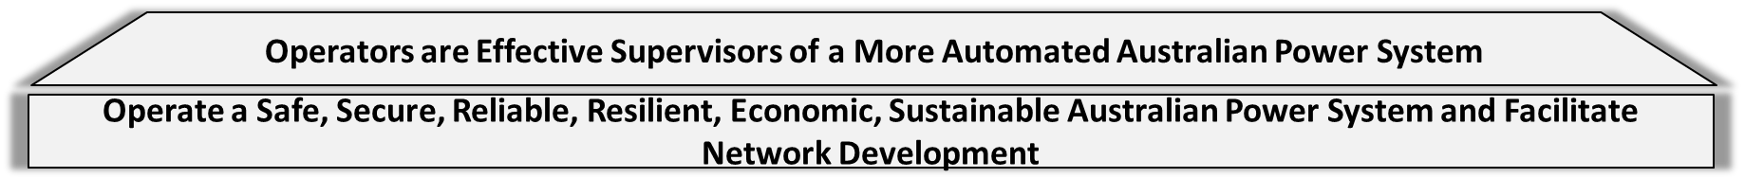
Figure 2-7 The Australian CROF Purpose and Vision

CROF Purpose
The purpose defines what the control room of today and the future is fundamentally intended to achieve. The purpose is not intended to change drastically in the coming years. The CROF should be empowered to ensure that the power system is:
- Safe for the public, operators, field crew and physical assets
- Secure from a load flow and stability perspective
- Reliable, in that it is expected to be secure for the loss of any single element or multiple elements depending on the risk
- Resilient in that it is expected to fail gracefully, and be easily restorable if required
- Economic in that is expected to drive value to the public and end consumers of electricity by minimising costs
- Sustainable in that it is intended to limit environmental damage in line with government regulations and polices.
- Facilitate network development means that outages for new capital projects for the expansion of the network, and new generation and demand resources, are facilitated. It also means that there is a link between operations and the planning of the network, whereby gaps are identified by planners through data analysis.

CROF Vision
All the pillars that underpin the CROF vision are aiming to fulfil the purpose and to drive the vision of the CROF to become a reality.
This can be an expansive vision of the future that may not exist (yet) but focuses attention on what the ongoing work and future system research is aiming to achieve. In the CSIRO CROF roadmap, the CROD vision is defined as:
Operators are Effective Supervisors of a More Automated Australian Power System.
The modifier of “more” is intended to imply the monitoring and control systems of today are highly automated as-is, but that this is expected to increase in future as the underlying system and control room tools evolve or are developed.
The vision implies that operators will always be the key component of the control room in the future, but that through enhanced software tools, training with simulators and the right hardware and facilities – situational awareness can be optimised to make operators effective supervisors of the more automated systems.

Roadmap Development and the CROF Functional Model

Process
The development of the research plan first started with roundtable discussions with the various network service providers and system operators in Australia. These one-on-one interviews with key management and senior engineering and operations personnel allowed for an establishment of the current state and the state of the art, in addition to bringing in input about challenges and problems to be addressed. Further, the substantial expertise and experience of the Electric Power Research Institute (EPRI) Transmission Operations and Planning (TO&P) group is leveraged towards understanding system-specific control room technology, innovations, and practices around the world and to communicating how these are applied in practice.
EPRI is at the forefront of developing research roadmaps, control room designs, reference guides, study methods and software tools for assessing system security for decades with a strong history of responding to the needs and challenges faced by utilities. Due to the nature of combination of elements in the power system, research items identified in this roadmap document may have to complemented by research items from the other topical areas for which research roadmaps are being developed.
The first step was development of the model and vision for the CROF (Chapter 2). Once this was established and documented, a functional model, using work domain analysis, was developed and which is detailed in this section. Once the functional model was established the roadmap for each of the CROF pillars could be developed (Chapter 4). At various stages of the process feedback on the research roadmap was sought from CSIRO, AEMO, the TNSPS and wider GPST community.

Stakeholder Engagement and Industry Activities – Existing States and Current Solutions
To determine the state of the art in the control rooms of the Australia companies, consultations were held with the following organisations:
- AEMO NEM
- AEMO (Western Australia)
- AusNet Services (Victoria)
- Electranet (South Australia)
- Powerlink (Queensland)
- South Australia Power Networks (as a representative DNSP)
- Transgrid (New South Wales)
Separate workshops with a consistent line of questioning, focussed on the pillars and gaps was established and notes taken. Clarifications were sought and received as required. The consultation workshops with AEMO and the TNSPs are summarised in Table 3-1.
Table 3-1 Summary table of output of the workshops with AEMO and TNSPs on status and gaps in capabilities
CROF Pillar | Current Status AEMO | Current Status TNSP | Gaps (EPRI Project Team Preliminary Assessment)
Functions | See Functional model 3.4 | See Functional model in section 3.4 | - Demarcation between AMEO, TNSPs, DNSPs to be defined with oversight.  - System management complexity will increase.  - Asset monitoring teams working closer to real time.  - Workload assessments to inform functions  - Potential for dedicated renewables, demand response desks  - Potential for security management desk in coordination with AEMO (reliability coordinator)
Data Models and Streaming Data | ICCP to TNSPs, Synchrophasor systems | EMS models updated with new connections as required.  Some have alarm philosophy and structured processes around alarm integration | - Visibility of DER in some areas especially DNSP networks areas  - Alignment with EMT models for real time EMS systems and tools  - Single source of truth for models and data  - Efficient way to model new elements of network across systems  - Standardised approach to alarm management with philosophy categorisation.  - Standardised structure for alarm and data points in power system to allow AI/ML analytics  - Modelling of protection, SPS, RAS in control centre tools  - Standardised structure for asset data points on system for AI/ML analytics  - Data management and governance on real time system data. Schema for what alarms go to control room.  - Standardised approach to outage management data across all companies
EMS / SCADA | Tool for RTCA, SE, Alarming DSA integration, manual studies for Ops Planning | 3 of 4 are in process of upgrading.  Primarily switching, monitoring, alarm management | - Faster study capability,  - Stronger engineering capability especially load flow, contingency analysis  - Interoperability between systems  - System strength assessments,  - Automation of manual processes,  - Alarm intelligence,  - Asset monitoring intelligence,  - Cyber security  - Integration of outage information with EMS and system information  - Integration of market data with EMS as required
MMS / NEMDE | MMS system is operated and managed from AEMO | Receive some data feeds from market in control centre, alarms and displayed as appropriate or as linked with KPIs | - Co-optimised financial and system constraints.  - Coefficient based limit equations.  - Automation of manual market reporting.  - Increased in trust and in interoperability of systems.  - MO/TNSP/DNSP dispatch platforms.  - Automation of constraint equation deployment.  - Need to model interaction between new and existing resources, co-optimise gas, renewables, water, demand etc.
Control Room Tools | FCAS monitoring, VDS, lightning detection, bush fire detection monitoring, generation compliance monitoring | Range of outage management and work order tools.  Range of asset monitoring and analytics tools.  Offline engineering analysis using PSS/E other tools  Weather, lightning, fires monitoring systems.  Security monitoring with CCTV | - Enhanced outage management systems, including optimisation of outage plan  - increased automation of manual, laborious tasks e.g., reporting logging, workforce management and switch preparation.  - Continuous improvement in Voltage dispatch scheduler.  - EMT RTDS integration closer to real time  - Inertia calculation, perhaps as part of system strength tool or integrated with DSA or in EMS  - Demand and renewable forecast enhancements – measurable KPIs on forecast performance  - Digital assistant for real time operations  - Restoration navigator, guiding switching and response to major restoration events  - Special protection scheme coordination, collation  - Wide area monitoring protection and control elements  - Power quality monitoring DNSP level with renewables  - Closer integration between customer relationship manager systems and other CR systems.  - Automated switching in certain circumstances  - Enhanced reserve capability forecast, monitoring, deployment  - Critical infrastructure monitoring  - Intelligent alarm processing, root cause analysis, asset health monitoring
Visualisation / Control |  | Ad hoc display design creation doesn’t follow standards. | - Visibility of DER in areas especially DNSP areas but perhaps without controllability.  - Correlation between market and physical system data points.  - Standard approach to HMI/EMS’s tool display design look and feel and configurability. Standard display design philosophy  - Early stage augmented reality use cases for certain specific data points  - Increase, improvement in synchrophasor deployment and CROF visualisations for defined use cases.  - Innovative ways to present clear, concise information  - Visualisation of system constraints associated with market or system, distribution system
Building and Facility Design | 2 control rooms operated in parallel. | Combination of remote primary and backup and dual rooms in primary facility.  Some backup and primary facilities undergoing development / renovation | - Facility must be resiliently designed, location optimised for potential future business continuity risks  - Quickly implementable, agile flexible plans for lodging, kitchen, entertainment either on site, mobile or hotel for sequestered staff  - Decentralised data centres from control site.
Simulator | Simulator in control room | Simulator in each control room facility, used as backup during pandemic. Manual task of setting scenarios and configuring training. | - More accurate real time simulator replicating system dynamics.  - Simulator should replicate protection performance, reduce manual training overhead n scenario modelling and execution.  - Testbed, sandbox environment for software testing and simulation.  - Segregated environment for cyber security monitoring  - Segregated environment for software upgrade, maintenance, testing and commissioning  - Real time digital simulator integration
Hardware and Ergonomics | Flexible controllable smaller overhead displays removed large videowall. Surface hubs for interactive comms. | Mix of large videowall and elimination of large video wall for more flexible overhead displays | - 4 k/8 k display technology with bezel less screens  - Flexibility of operators to change rearrange displays  - Single interface for integrating with displays  - Single telecommunications interface  - Interactive voice recording system for queuing and filtering calls  - Interactive display monitors between control centres allowing real time video calling and information sharing  - Sit/stand ergonomically efficient desks  - Exercise facilities / rest areas if appropriate.  - Paperless environment, digitised workspace  - Disaster recovery communications, digital radio etc.
Operator Training | Standard operator training protocols | Standard operator training protocols, focussed on switching, safety, and access. Usually, 2 years | - National standardised certification process for operators especially skills that can be transferred between companies.  - Dual process engineering / switching, safety  - More frequent communication, coordination. Communication protocols between system operators. Common terminology  - Multi-operator training exercise  - Risk assessment and monitoring. Training in uncertainty, probability.  - Multi domain training exercises (gas, renewables, demand, regulators)  - Pipeline of qualified, trained control room operators
Human factors Advances | Engineering staff with ability to troubleshoot issues with systems, assess risk | Mostly staff from field who are licenced switchers progressing to control room with training and certification.  Some mix shift teams regularly to prevent practice divergence | - Intelligent decision support across multiple systems, combining outputs to get correct response.  - Voice control for logging and reporting  - Mix of skills/needs between familiarity with switching and transmission system rules, safety etc and engineering capability, the ability to analyse system parameters and detect and respond to system risks  - Ability to intervene in autonomous systems exhibits abnormal behaviour,  - Training on out of the loop effect  - Structured decision-making protocols linked to decision trees in procedures  - Mental workload and situational awareness monitoring  - Best practice for crew assignments  - Operator shift schedules may change with renewable prevalence  - Communication protocols during emergencies or disaster recovery.  - Approaches to help fatigue

The Functional Model

As discussed in Section 2.1. the first stage in development of the research roadmap and plan is to establish what are the purposes, functions, processes, and tools for the control room and system operators of Australia. The functional model is a top-down, bottom-up model of all aspects of the system and its control. The methodology used was a modified work domain analysis [12], which establishes how the system operates via interlinked levels are shown in Figure 3-1. At the top of the hierarchy are the purposes, which are measured by KPIs (and established in Section 2.4.1). These are defined by regulators and executives and monitored by managers, supervisors etc. The priorities on level 2 define a way for the purposes to be measured and monitored, via physical descriptions. KPIs would be monitorable and viewable from the control centre.
The middle levels are the important pivot point for defining what the operators do in the control room in real time. These are the functions and sub-functions. Linked to sub functions are processes, which are the actions taken to execute the function. Process usually has tools to execute the tasks via the physical objects. Tools used in real time to monitor and control the system as well as affect control both manually and automatically. At the bottom of the hierarchy are the actual physical assets of the system under control (or a model of them) which feed the with streaming data into the tools in the control room.
Work Domain Analysis Definition – Neelam Naikar [12]
Work domain analysis focusses on the constraints associated with the functional structure of the physical, social, or cultural environment or actors. The structural properties of actors’ environments define the fundamental reasons and resources for their behaviour, these properties include a systems purposes as well as its physical objects.

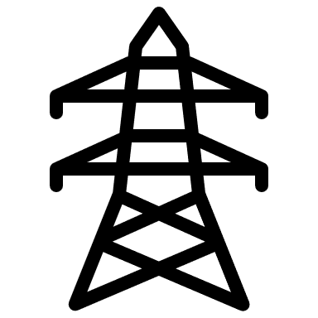
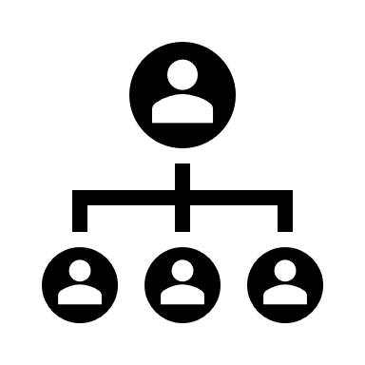
Why?
What?
How?
What?
How?
Assets, models are defined. Field crews and EMS engineers operate at this level
Tasks, procedures, and tools are defined at these levels. Operators work at this level
Why?
How?
What?
Why?
How?
What?
Why?
How?
What?
Why?
Managers engage with operations at this level Dashboards, videowalls used.
Regulators and executives define the purposes
Roles and responsibilities. Desk assignments defined at these levels
Figure 3-1 Functional Model of the Control Room
If defined correctly, the functional model should be a complete representation of the work domain that operators, engineers, managers, and specialists work with. It clarifies where applications, tasks, and data fit within the control room architecture and display visualizations and reporting. Anything that is not on the agreed functional model should not be considered critical to control centre operations now or in the future.
Note: The functional model of the control room is not a complete model of the market operator or TNSP business and its focus is on the control room of today and the future. However, it could be expanded in future to encompass more business units or aspects of the business as required.
Note also that the draft presented in this section, may not be a complete representation, due to project scope limits for feedback and engagement, but it can be considered a good approximation, given previous experience developing similar models. It can be refined as part of the functional and capability model roadmap.

Functional Model of Australian Real Time Control Room Operations
For this research roadmap, the project team have developed a proposed functional model for model for Australia transmission system and market operators.

Purposes
The purposes of transmission system operations are listed below:
- Operate the system safely for people and assets
- Operate the system securely
- Operate the system reliably
- Operate the system resiliently
- Operate the system sustainably
- Operate the system economically
- Facilitate network development
The Facilitate network development purpose involves the process of supporting outages for capital projects for network expansion. It can also serve the purpose of informing network planning of gaps in the network, although this is not a direct purpose of control rooms and can be carried out by analysis of the system data offline.
These purposes should stay relatively static through the energy transition and are not expected to change dramatically for the CROF. The purposes are impacted by external drivers, such as the energy transition goals outlined in section 1. The model is adaptable and scalable so that new or refined purpose can eb easily accommodated.

Priorities and Key Performance Indicators (KPIs)
The second level of the functional model hierarchy, which lies below and is directly linked to the purposes, is the Priorities and KPI level. The elements at this level give a way for the purposes to be measurable and tracked either on an ongoing basis in real time or at set intervals. Each purpose must have at least one KPI, and some of the purposes are linked to many KPIs.
The priorities and KPIs identified for the CROF and transmission system operations are:
- Optimise operation of assets within electrical limits
- Optimise operation of assets operated within physical limits
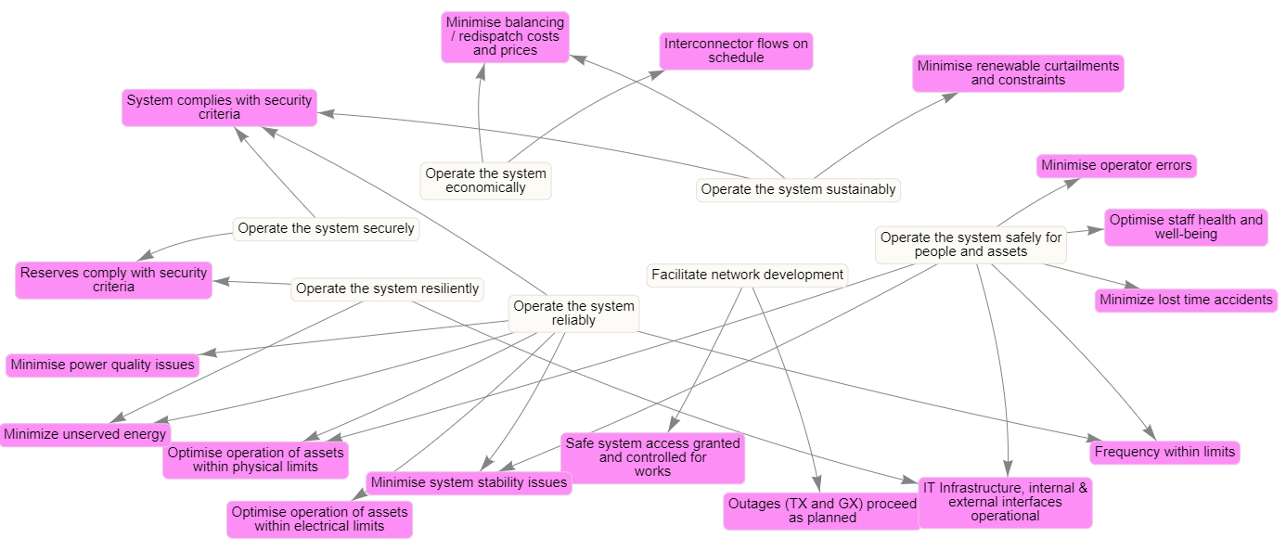
- Minimise power quality issues
- Minimise system stability issues
- System complies with security criteria
- Reserves comply with security criteria
- Frequency within limits
- IT Infrastructure, internal & external interfaces operational
- Minimize balancing / redispatch costs and prices
- Minimize unserved energy
- Minimise renewable curtailments and constraints
- Interconnector flows on schedule
- Safe system access granted and controlled for works
- Outages (Trans and Gen) proceed as planned
- Minimize lost time accidents
- Minimize operator errors
Priorities/KPI
Purposes
Figure 3-2 Link between the purposes and KPIs of CROF
- Optimise staff health and well being

Error! Reference source not found. shows the link between the CROF purposes and KPIs. Note this includes purposes and KPIs for both AEMO and the TNSPs. Separate views can also be created based on control room. The priorities and KPIs are likely to change or have new additions to the list throughout the energy transition. For example, it is likely stability metrics and renewable energy use will adjust over time as resources change and new market system services will also require new priorities and KPIs.

Functions
Considering the current arrangements of the responsibilities in AEMO and the TNSPs with an assessment of the needs for the CROF, four main functions are proposed for real time operations:
- Transmission Operations
- Balancing and Market Operations
- Transmission Asset and Interconnector Management
- Reporting, ICT Systems and Resource Management

Sub Functions
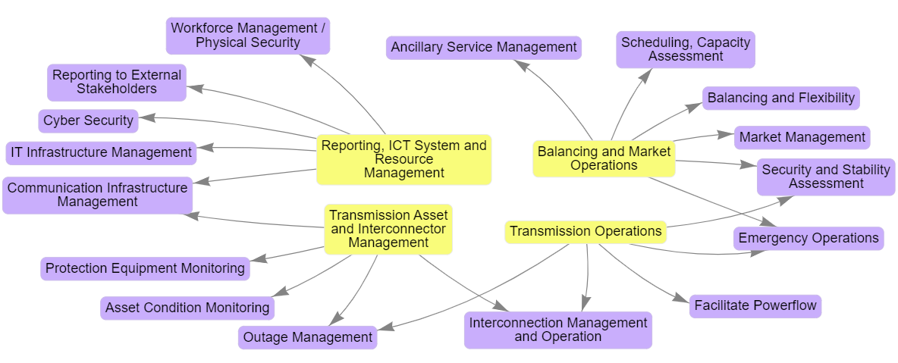
Each of the main functions in the CROF has associated sub functions, which are a more granular definition of what operations departments and in the control room staff are required to do to execute on the purposes via the KPIs. There are 16 sub functions associated with the Australian CROF. Some are shared between different functions and so will be shared between AEMO and TNSP control rooms. The subfunctions are:
- Facilitate Powerflow
- Security and Stability Assessment
- Interconnection Operations
- Outage Management
- Emergency Operations
- Market management
- Balancing and Flexibility
- Ancillary Service Management
- Scheduling, Capacity Assessment
- Asset Condition Monitoring
- Protection Equipment Monitoring
- Workforce management
- Reporting to external stakeholders
- IT infrastructure management
- Communication infrastructure management
- Cyber security monitoring
Figure 3-3 Link between the Functions and Sub Functions for the Australian CROF
Sub Function
Function

Processes
The process level in the functional model hierarchy details the tasks, actions, or controls that operators make in operations planning and in real time to fulfil the functions and sub-functions. These are intended to be distinct “tasks” and are characterized in the model with an action or verb (such as “mitigate,” “monitor,” “schedule,” etc.). There is some close coordination, and some processes are shared between more than one sub-function, which is to be expected in such a complex system. For example, log incident might be associated with outage management and emergency operations. Some of these are carried out in the ops planning time horizon and some at or near real time. Some of these are mostly manual and some are mostly automated, by a software tool, with operator performing a supervisory role. The processes are detailed in the table below.
Table 3-2 Table showing the CROF processes from the functional model, the time frame the are operated under and whether it is manual ro automatic process
Process | Timeframe | Manual or Automatic Process
Manage Personnel on the Network | Real Time | Manual
Coordinate with TNSPs/AEMO/DNSP/Market Participant | Planning and Real Time | Manual
Log Incidents | Ex-Post | Manual
Monitor EMS and MMS Status | Real Time | Automatic
Monitor Cyber Activity and Threats | Real Time | Automatic
Protection Alarm Mitigation/Dispatch | Real Time | Manual
Asset Condition Alarm Mitigation/Dispatch | Real Time | Manual
Monitor Transient, Voltage, Small Signal and Frequency Stability and System Strength | Planning and Real Time | Automatic
Restore Unplanned Outages | Real Time | Automatic and Manual
Monitor Power Quality | Real Time & Ex-Post | Automatic
Coordinate Planned Outages | Planning and Real Time | Manual
Manage Power Transmission | Planning and Real Time | Automatic and Manual
Blackstart and Restoration | Real Time | Manual
Manage Voltage | Planning and Real Time | Automatic and Manual
Dispatch Generation, Demand, Service Providers | Real Time | Automatic
Contingency Risk Mitigation | Planning and Real Time | Manual
Manage Reserves and Ancillary Services | Planning and Real Time | Automatic
Schedule Market Participants | Planning | Automatic
Forecast Demand | Planning | Automatic
Forecast Renewable Energy | Planning | Automatic
Testing and Commissioning Market Participants | Real Time and Ex-Post | Manual

Figure 3-4 Graphical interpretation of time frame of processes. Red are processes which are mostly manual, Orange are processes that are manual and/or automatic and black are processes that are mostly automatic

Tools
For the CROF roadmap the most important level of the functional model is the tools level. The tools level is linked above to the processes level, and below to the physical object, i.e., the model and data level. It specifies the tools in the control room required to carry out the processes above to monitor and control for the risks on the system. “Tool” is a catch-all term to incorporate software applications, platforms, modules of larger applications, algorithms, methodologies, and hardware devices. It includes EMS, MMS as well as demand forecasting, DSA etc. Each tool is linked to a process as defined above, so the processes (verbs/actions) require a tool to carry out that process. 16 control center tools (14 + EMS and MMS) were identified that are, or may be, required in the Australian control rooms of the future. There are also three hardware tools that aid operators to perform their roles. Some of these are elements of EMS and MMS systems already deployed, others are separate software applications or software or data services.
- Energy Management System / SCADA
- Congestion Management Tool
- Voltage Control Reactive Power Optimisation Tool
- Asset Health Alarm Root Cause Analysis / Disturbance Investigation Tool
- Dynamic Security Assessment (Includes Inertia, Voltage, Frequency, Transient, Small Signal Stability)
- Power Quality, EMT & WAMS
- System Strength Evaluation Tool
- Protection, Short Circuit & SPS Coordination Tool
- Blackstart & Restoration Enhancements Including RES
- Market Management System
- Demand Forecasting
- Renewable Energy Forecasting
- Reserve, Ramping and Flexibility Assessment
- Balancing, Dispatch & Load Frequency Control
- Outage Management, Reporting and Workforce Management
- Environmental (Fire and Weather) Forecasting

- Phone Systems
- Inter Control Center Communication
- Email, Instant Messaging Services

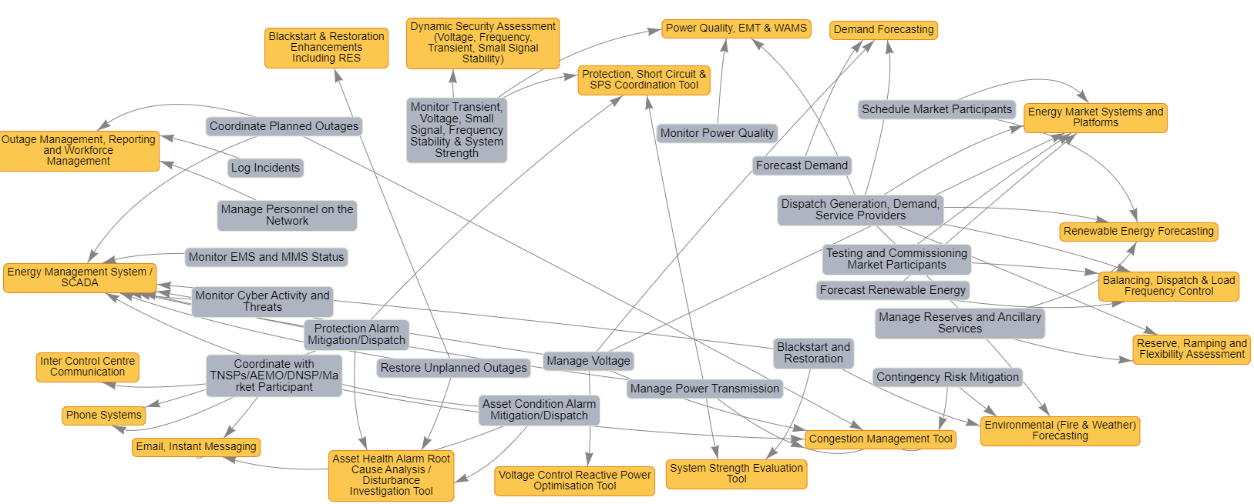
Process
Tool
Figure 3-5 Graphical image of the processes and tools levels of the functional model hierarchy showing interdependencies

Physical Objects / Models and Data
The underlying, foundational level of the functional model and of the tools themselves is the actual physical objects that are being controlled and make up the transmission system. This is a level that is intended to be a representation of the combination between the actual assets (e.g., lines, generators) as well as the model of those assets in the software tools and the streaming data that come directly from them to the control centre. In the Australian context. Physical objects can also include people, computers, weather, and the categories of demand. The preliminary list of physical objects that make up the power system in Australia are:
Table 3-3 List of the physical objects in the CROF functional model
Personnel | Utility Renewable Generation | Phasor Measurement Unts | Transformers | Statcoms
Servers and Computers | Hydro Generation | PST | HVDC | Battery Energy Storage Systems
RTUs | Rooftop Solar | Breakers / Switches | Pumped Storage | Thermal Generation
Substation Secondaries | Domestic Power Consumers | Transmission Lines and Cables | Capacitors | Demand Response
Rotating Stabilizers / Sync Compensators | Industrial Power Consumers | Busbars | Reactors | Weather
Relays & Intelligent Electronic Devices | Commercial Power Consumers | Distribution Lines and Cables | SVC | Fire

Complete Functional Model
The complete functional model is shown in Figure 3-6 below. This is a complex diagram of interdependencies but clearly lays out in granular detail the purposes, functions, processes, tools, and data required to operate the system from the control room of today and into the future.

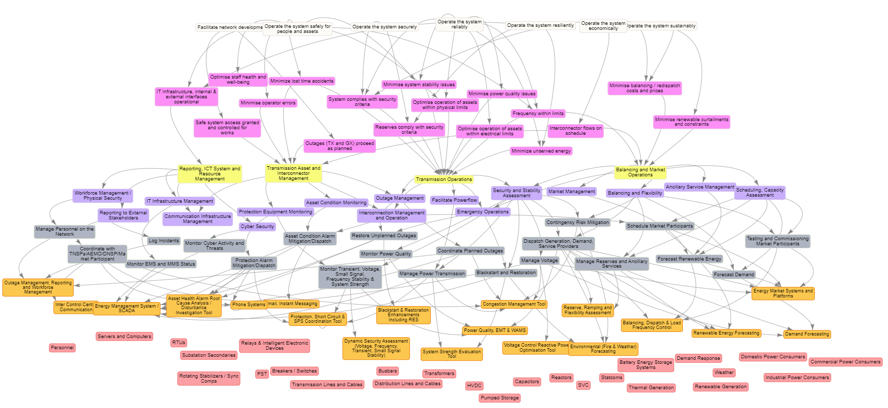
Figure 3-6 Complete CROF functional model showing linkages between all serve levels for purposes to objects. Note this is applicable to both AEMO and the TNSPs.
Object/Data
Purposes
Priorities/KPI
Function
Sub Function
Process
Tool

Two Models for the Control Room of the Future
There are now two established ways to model and think about the CROF, the CROF model Chapter 2 and the functional model Chapter 3. These two models will be used to develop the research roadmap for the CROF in the following chapters. Note the colour coding in the models which is consistent throughout the document and the roadmaps.

Figure 3-7 The two aligned models for thinking about the CROF

Key Research Questions
An initial set of research questions, detailed below, were initially formulated through the Global Power System Transformation (G-PST) Consortium [13] control room of the future Research agenda. The questions are answered from 1 to 17 (a – q in the tables below), with reference to how they are interpreted in the CROF model pillars and the functional model, as well as an answer detailing the latest thinking and research on the topic.
Table 3-4 Response to research question a.
a. How can operators identify critical stability situations in real-time and optimize system security?
CROF Model Pillars | Functional Model | Answer
- Control Center Tools  - System Control, User Interfaces & Data Visualisation  - Operator Situational Awareness Optimisation and Decision Support Framework  - SCADA / EMS | - Tools Level – Dynamic Security Assessment  - Tools Level - Power Quality, EMT & WAMS  - Tools Level – EMS/SCADA | There are numerous vendor applications available in EMS and other software applications for the assessment of dynamic security. Some of these now include the look-ahead security assessment incorporating forecasts and transfers.  Data visualisation, integration between EMS and external tools and decision support – pointing to the cause and potential solutions needs some further research.

Table 3-5 Response to research question b.
b. How can system operators get relevant real-time visibility and situational awareness of the state of the power system with increasing penetrations of IBR and DER?
CROF Model Pillars | Functional Model | Answer
- Cyber secure application architecture  - Cyber secure data architecture  - Data – Models and streaming  - SCADA / EMS  - System Control, User Interfaces & Data Visualisation | - Tools Level – EMS/SCADA  - Tools Level – Energy Market Systems and Platforms  - Functions Level – Facilitate Power Flow | In general utility scale IBR and DER in the market with locational capacity above 5-10 MW should be observable and controllable to the TNSPS and AEMO. If necessary, changes to grid code and testing regimes are required. An interoperable reference architecture for the industry would an innovative approach, as shown in the CROF model.  Issues arise with distributer behind the meter and rooftop DER. Ideally one entity would take responsibility capturing the observability and control and share this with their stakeholders. This requires clear regulations on the sharing of data and the span of control. Single platforms for the observability of BTM DER is advisable so that all entities with responsibility are viewing the same data. With increases in data load, the ability to visualise this optimally in control centers is critical.

Table 3-6 Response to research question c.
c. How can system strength, inertia and limits of stable frequency range be monitored in real-time in high IBR systems?
CROF Model Pillars | Functional Model | Answer
- Control Center Tools  - Operations Planning Support Tools  - Data – Models and streaming  - SCADA / EMS | - Tools Level – EMS/SCADA  - Tools Level – System Strength Evaluation Tool  - Tools Level – Protection, short circuit, SPS coordination tool  - Tools Level – Dynamic Security Assessment  - Tools Level - Power Quality, EMT & WAMS  - Physical Objects Level – Generators, Load, Transmission System models | System strength is a measure of the short circuit ratio and power and rate of change of frequency at a given point in time. Provided there are good models of the system, the X/R ratio and short circuit level at all transmission buses should be easily calculatable in EMS/SCADA or other analysis tools in real time.  Inertia is a proxy measure for the rate of change of frequency, which is a proxy measure for the frequency stability of a system. Provided there are good dynamic models, dynamic security assessment tools to measure the frequency stability and the response of online units are available. Modelling and verification is key. All major events should be back validated with WAMS, EMT simulation and parameters tuned. Inertia can be measured and forecast in numerous ways given the demand and RES forecast, using WAMS or with small scale load devices on the system that can measure frequency response, as being trialed with NGESO right now.

Table 3-7 Response to research question d.
d. What are the appropriate methodologies to visualize and interpret relevant information for improved decision support for fast real-time control actions?
CROF Model Pillars | Functional Model | Answer
- System Control, User Interfaces & Data Visualisation  - Operator Situational Awareness Optimisation and Decision Support Framework  - Hardware & Ergonomics | - Priorities and KPI Level  - Functions and Sub Functions Level  - Processes level | Visualisation requires a consistent philosophy for data visualisation. All TNSPs and AEMO should have a visualisation philosophy and also could adopt a single standard framework for visualisation in Australia, despite differences in approach at present. Colour in displays should be minimised and used only to attract attention for abnormal operations. A Level 1,2,3,4 approach is recommended. Level 1 providing overview situational awareness and KPI visibility. Level 2 providing function or task level overview, level 3 providing control and in-depth analysis visuals, and level 4 are back-end database displays for trouble shooting. The screens in the control center can be laid out in this format.  Decision support improvements comes from structured decision making models such as Rasmussen’s decision ladder or Klein’s naturalistic decision making models or a combination of structured and naturalistic thinking as proposed by Kahneman.  Future control rooms will need operators with engineering mindset comfortable assessing risk, probability, and comfortable intervening in automated systems. In the future, tools should be integrated and interconnected with an overarching decision support system guiding operator decisions and interactions based on optimisation of tool outputs.

Table 3-8 Response to research question e.
e. What quantities must be monitored, screened, and validated in real-time to ensure that there will be adequate flexibility availability from uncertain system resources in the near-term?
CROF Model Pillars | Functional Model | Answer
- Data Streaming and Models  - EMS / SCADA  - MMS / NEMDE  - Control Center Tools | - Tools Level - Reserve, Ramping and Flexibility Assessment  - Tools Level - Renewable Energy Forecasting  - Tools Level – Demand Forecasting  - Tools Level – Energy Market Systems and Platforms  - Tools Level - Congestion Management Tool  - Physical Objects Level – All, especially FACTS and generation. | Accurate renewable energy forecast and demand forecast primarily co-optimised with ancillary service and reserve provision via the energy market systems and platforms to get the optimal resource allocation across the network is essential.  The functional model identifies the development of a Reserve, Ramping and Flexibility which, in theory would assess the current system and the ramping needs to the system peaks and valleys and notify the operator and market systems if deficits exist.  There are likely other inbuilt flexibilities in the distribution system, also the development of a congestion management tool with TNSP/DNSP optimisation will be essential.  Smarter devices on the system will proliferate to manage system strength and flexibility, such as FACTS, sync comps etc. These will have to be monitored and controllable via EMS or other platforms. The smart device observability and control optimisation should be available the congestion management tool.

Table 3-9 Response to research question f.
f. How can control capabilities for IBR-based system assets (FACTS, Line Impedance adjusters, etc.) and network flexibility more generally be maximized to enhance reliability and/or reduce costs.
CROF Model Pillars | Functional Model | Answer
- Data Streaming and Models  - EMS / SCADA  - Control Center Tools  - Operations Planning and Support Tools | - Tools Level - Congestion Management Tool  - Physical Objects Level – All, especially FACTS and generation. | See response to (e) above. Control of FACTS for powerflow and congestion management is a key area of focus of the congestion management tool. This tool optimises the redispatch of power in the event of a contingency in real time or for problems on the horizon. This is an emerging area of research across the world.  May involve some elements of machine/ reinforcement learning and requires accurate simulation environment and data generation for agent training.  The control of the devices should be cyber secure and interoperable with all other control centre tools and systems.

Table 3-10 Response to research question g.
g. Are their sufficient flexibilities available in the near-term to compensate variations in load and generation (fast changes as well as long lasting extreme situations such as prolonged periods of no solar and wind)?
CROF Model Pillars | Functional Model | Answer
- Data Streaming and Models  - EMS / SCADA  - Control Center Tools | - Tools Level - Congestion Management Tool  - Tools Level - Reserve, Ramping and Flexibility Assessment  - Physical Objects Level – All, especially FACTS and generation. | For this specific CROF research roadmap project, with the question related to the Australian system, this is out of scope, since detailed technical studies of the system or existing studies was not carried out.  However, refer to answers to question e and f. If there are adequate data models and new tool development for ramping, reserve, and flexibility, then assessments can be made in real time. Refer to EirGrid Ireland ramping tool.

Table 3-11 Response to research question h.
h. How do control rooms address uncertainties in weather conditions that impact loads and renewable energy output, both as a capacity resource and for ramping? How can probabilistic forecasting techniques be better incorporated into real-time operations?
CROF Model Pillars | Functional Model | Answer
- Data Streaming and Models  - EMS / SCADA  - Control Center Tools  - Operations Planning Support Tools  - System Control, User Interfaces & Data Visualisation  - Operator Situational Awareness Optimisation and Decision Support Framework  - Operator Training | - Tools Level - Renewable Energy Forecasting  - Tools Level – Demand Forecasting  - Tools Level - Reserve, Ramping and Flexibility Assessment  - Physical Objects – All special customer demand data, data from generation sources | - Through the functional model identify the data sources that are uncertain (weather, demand, renewables, plant outages)  - Identify the control room and operations planning/support tools that utilise these variable data sources and implement a process to track accuracy of the forecasts over a time period. Demand and RES forecasts are easy examples of this.  - Understand forecast inaccuracy, why and when it occurs. Introduce confidence on forecasts based on previous accuracy.  - If forecasts are externally provided, incentivise vendors on precise accuracy metrics based on long term analysis.  - Build probabilistic ranges into forecast information being fed to control room tools where possible.  - Develop a probabilistic operations framework around contingency and congestion management, building on existing risk based contingency evaluation in Australian system and existing research in Europe.  - Train operators on assessing risk in forecasts and real time information.
Table 3-12 Response to research question i.
i. How can data be best utilized to ensure system operations include the ability to detect and mitigate a range of uncertain disturbances?
CROF Model Pillars | Functional Model | Answer
- Data Streaming and Models  - EMS / SCADA  - Control Center Tools  - Operations Planning Support Tools  - System Control, User Interfaces & Data Visualisation  - Operator Situational Awareness Optimisation and Decision Support Framework  - Operator Training | - Tools Level - Protection, Short Circuit & SPS Coordination Tool  - Tools Level - Asset Health Alarm Root Cause Analysis / Disturbance Investigation Tool  - Tools Level – EMS / SCADA  - Tools Level - Outage Management, Reporting and Workforce Management  - Physical Objects – All special customer demand data, data from generation sources | Alarm overload and noise is and will become a great problem to system operators and engineers. Existing tools present data sequentially but with few tools to analyse and determine what the root causes of alarms are.  In the functional model this issue was identified, and proposed mitigations include the development of an alarm root cause detection tool to automatically distil large quantities of information into a manageable chunk. This will require alarm philosophies and well-structured alarm and real time asset data for this to be accurate.  Alarm root causes are generally associated with protection operation, so the development of an automatic protection coordination tool to assess the root cause, linked with the alarm data is a promising area of research and potential development. This should also be linked to the real time outage data and information, to get an accurate picture of the system at the time of the disturbance.  Machine learning techniques may be useful in the development of these tools.

Table 3-13 Response to research question j.
j. What quantities must be monitored, screened, and validated to ensure reliable service provision from aggregated flexibility resources in distribution systems, supporting stable system operation?
CROF Model Pillars | Functional Model | Answer
- Data Streaming and Models  - EMS / SCADA  - Control Center Tools  - Operations Planning Support Tools | - Tools Level – EMS / SCADA  - Physical Objects – All special customer demand data, data from generation sources | AEMO and TNSPs need visibility of DNSP DER and consumer demand data in real time, potentially via a single operational platform for data monitoring across the operational boundary, building on existing tools and processes and governed by secure data exchange standards.  As inverters and virtual power plants on behind the meter solar panels become more advanced with internet connections and dispatchability, at least the following will require to be monitored:  - Accurate availability market horizon  - Locational availability  - Manifest of services for flexibility and reserve etc  - Monitoring and validation capability  - Controllability of VPP and aggregators as required for market and transmission service.  - Dynamic operating envelops (DOE) exchange and validation (for DNSPs)  - Localised weather services (if possible)

Table 3-14 Response to research question k.
k. What type of digital architecture is necessary to enable the variety of software required to operate a control room in real-time, near real-time and in auto pilot mode?
CROF Model Pillars | Functional Model | Answer
- Cyber Secure Application Architecture  - Cyber Secure Market System Architecture  - EMS / SCADA  - Cyber Secure Data Architecture  - Control Center Tools  - Operations Planning Support Tools | - Tools Level – All Elements  - Physical Objects Level – All Elements | Generally, a modular architecture integrated via integration layers with API to software services and data platform is becoming more favoured in the industry. The focus should be on interoperability between applications, data exchange and market architecture.  While very integrated with CROF research and the model above, the topic is covered more extensively in the companion CSIRO research roadmap on Power Systems Architecture (Topic 7). These two roadmaps are closely related and should be considered together.

Table 3-15 Response to research question l.
l. How can grid topology be flexibly adapted at various operating conditions?
CROF Model Pillars | Functional Model | Answer
- Cyber Secure Application Architecture  - EMS / SCADA  - Cyber Secure Data Architecture  - Control Center Tools  - Operations Planning Support Tools  - Operator Situational Awareness Optimisation and Decision Support Framework | - Tools Level – Congestion Management tool  - Tools Level - All elements  - Physical Objects Level – All Elements | The CROF proposal is for a congestion management tool, utilising market redispatch, flexibility in the transmission and distribution grids and FACTS and control devices for optimisation. There are ongoing, advanced research initiatives in Europe with RTE to develop a control center digital assistant through reinforcement learning. At present EMS systems would not have this capability and there are few viable vendor systems on the market.  This solution is very dependent on accurate simulation model, controllability, and interoperability with other tools, as well as machine learning expertise and advanced computing resources.
Table 3-16 Response to research question m.
m. What is a suitable data architecture for DER monitoring & modelling? Once DER resources have been aggregated spatially and temporally, how should this information be provided to the control room? Can DER categories be developed that allow groupings based on their ensemble response to system level events? What is the appropriate data architecture required to monitor/predict and control DER in real-time?
CROF Model Pillars | Functional Model | Answer
- Cyber Secure Application Architecture  - Cyber Secure Market System Architecture  - EMS / SCADA  - Cyber Secure Data Architecture  - Control Center Tools  - Operations Planning Support Tools | - Tools Level – All Elements  - Physical Objects Level – All Elements | Generally, a modular architecture integrated via integration layers with API to software services and data platform is becoming more favoured in the industry. The focus should be on interoperability between applications, data exchange and market architecture.  While very integrated with CROF research and the model above, the topic is covered more extensively in the companion CSIRO research roadmap on Power Systems Architecture (Topic 7). These two roadmaps are closely related and should be considered together.
Table 3-17 Response to research question n.
m. What is the communication capability needed to support monitoring and control of DER? What is the suitability of existing communications infrastructure – in terms of reliability, latency, bandwidth, (cyber)security – relative to investing in a bespoke system? For DER control purposes, what 2-way communication protocols are necessary?
CROF Model Pillars | Functional Model | Answer
- Cyber Secure Application Architecture  - Cyber Secure Market System Architecture  - EMS / SCADA  - Cyber Secure Data Architecture  - Control Center Tools  - Operations Planning Support Tools  - MMS / NEMDE | - Tools Level – All Elements  - Physical Objects Level – All Elements | To be addressed as part of detailed implementation plan associated with the control room of the future. This question may not be relevant for the roadmap and has some dependencies with the topic 7 in terms of architecture design.  Some advanced knowledge is available from industry collaborations, but this can be difficult to home in one specific answer without a detailed architecture and design framework.  In general, communication protocols should always align with IEC and IEE standards and have cyber security principles built-in by design.
Table 3-18 Response to research question o.
o. What are the relative merits of different control architectures for DER? What might an efficient distributed control architecture be for DER which: (1) makes use of appropriate device characterizations and real-time monitoring data; (2) accounts for practical constraints around device-level communication; and (3) accounts for heterogeneous subgroup controls of DER and various existing DSO/TSO control schemes?
CROF Model Pillars | Functional Model | Answer
- Cyber Secure Application Architecture  - Cyber Secure Market System Architecture  - EMS / SCADA  - Cyber Secure Data Architecture  - Control Center Tools  - Operations Planning Support Tools  - MMS / NEMDE | - Tools Level – All Elements  - Physical Objects Level – All Elements | While very integrated with CROF research and the model above, the topic is covered more extensively in the companion CSIRO research roadmap on Power Systems Architecture (Topic 7). These two roadmaps are closely related and should be considered together.
Table 3-19 Response to research question p.
p. What is the best way to integrate large data sets, streaming information, and historical system performance to create actionable operational insights?
CROF Model Pillars | Functional Model | Answer
- Cyber Secure Application Architecture  - Cyber Secure Market System Architecture  - EMS / SCADA  - Cyber Secure Data Architecture  - Control Center Tools  - MMS / NEMDE  - System Control, User Interfaces & Data Visualisation  - Data - Models and Streaming | - Tools Level – All Elements  - Physical Objects Level – All Elements | A modern modular architecture with integration layers between systems. Operational insights and decision supports are key. System design should begin with the question: what information does the user need to see? Standard visualisation philosophy should be applied and standardised across all systems. The designs and development of visualisations, need to move from tendency to display all data at once (with allowing operators to create their own charts) to operators who may get overwhelmed with data overload to showing actionable information and insights based on analysis with confidence in predictions.  Look-ahead capability is important also with access to forecast demand and renewable information.  Adopting data visualisation innovations from other fields will be an important enabler for control room of the future system.

Table 3-20 Response to research question q.
q. How can the status (generation output, state of charge, etc.) of each key category of DER be monitored/estimated in real-time? What are appropriate DER categories and the appropriate spatial and temporal resolution to monitor DER effectively? What are the appropriate technical means of achieving this level of aggregation?
CROF Model Pillars | Functional Model | Answer
- Data - Models and Streaming  - Cyber Secure Application Architecture  - Cyber Secure Market System Architecture  - EMS / SCADA  - Cyber Secure Data Architecture  - Control Center Tools  - MMS / NEMDE | - Tools Level – All Elements  - Physical Objects Level – All Elements especially the elements associated with generation nodes. | Forecasting for DER, utility scale RES, and behind the meter solar will become a critical enabler for tools and systems to operate seamlessly, with decision support for operators on confidence intervals.  Improvements and accuracy in forecasting is necessary. Although these enhancements are usually outside the control of system operators, the validation and quality control can be improved.  There are some innovations in forecasting being developed worldwide, such as vehicles feeding information on cloud cover to improve forecasts, and weather stations in homes to improve cloud cover tracking.

The Research Plan

Roadmap for the CROF
Based on the existing research, workshops, response to the questions and the CROF model pillars identified in the previous chapter, a high-level sunray roadmap for each of the pillars is developed in this chapter. Some additional details on research opportunities, research specialists and risks are also collected in tables at that immediately follow each roadmap. They should be read in parallel with each other, with the sunray giving a visual, concise representation of more detailed elements in the tables.

Roadmap Structure and Format
Future State: Adaptive, Scalable Network of Structures
The CROF roadmaps have a similar format, to allow ease of readability. The roadmaps use a sunray format, starting at the bottom left with the theme and rising along a five-stage trajectory to the projected future state for each group of pillars. For ease of understanding, the 15 CROF pillars have been grouped into a logical five categories, each with their own roadmap.
The five stages begin in 2021 and run through 2030+, with an indicative year of 2025 for stage 3, after which there is a review stage built into the roadmap. Stage 1 is intended to encapsulate the current system activities that can be immediately be carried out for researchers or utility companies. The 2021 to 2030 + timeline transitions from the present to the probable (2025, stage 3) and on to the possible to 2030+. This formulation is intended to capture the uncertainty in roadmapping as the time horizon moves beyond five years.
Review

While most of the roadmap actions and milestones are targeted at the research community some require extensive interaction with the TNSPS and AEMO and so are more suited to the actual electricity utility companies. The obvious research areas are identified with the icon: on the roadmaps. This is to clearly identify where research resources should be focussed.
Some actions will also have interdependencies. These are shown with a dual arrow:
Interdependency

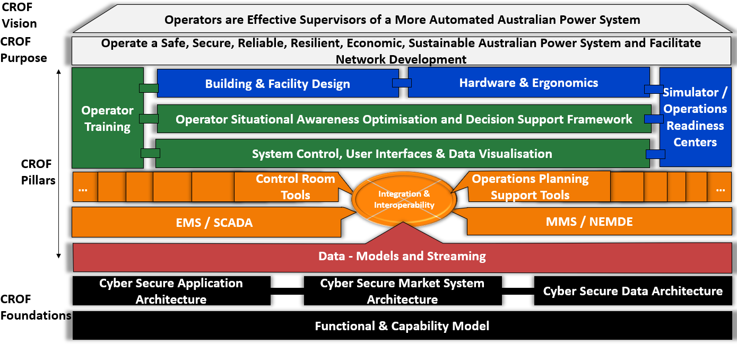
Figure 4-1 CROF model indicating the pillars and foundations. Note the color coding which is used the following maps as a way of differentiating the category groupings.

Roadmap for the CROF – The Functional and Capability Model and Architectures
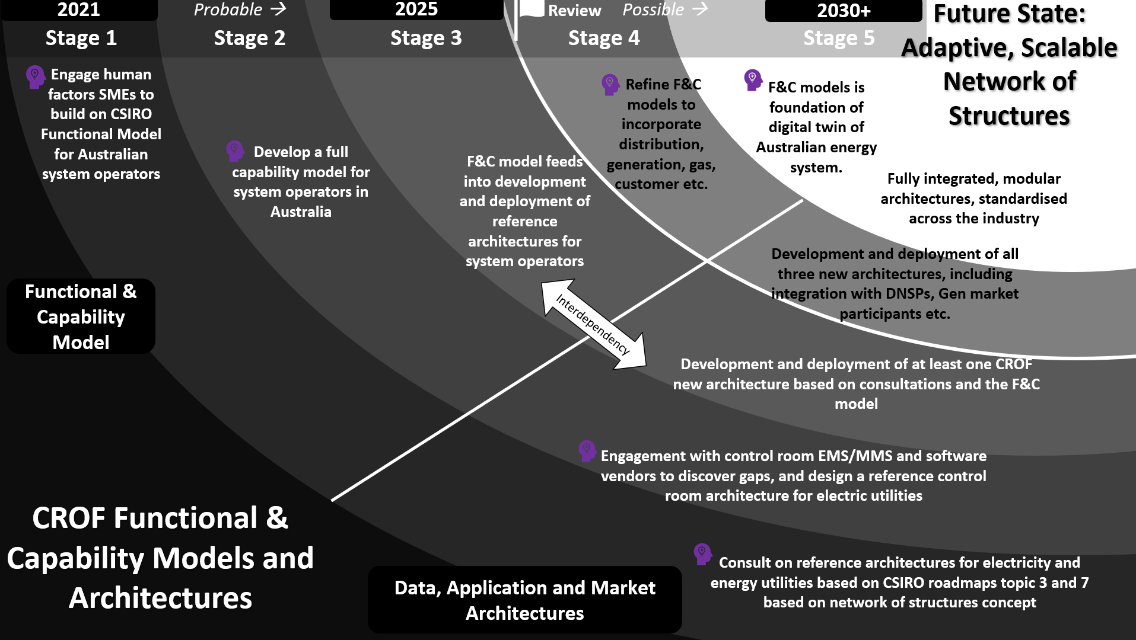
Figure 4-2 CROF Foundations – Functional & Capability Models and Architectures Roadmap

Table 4-1 CROF Foundational Elements – Functional & Capability Models and Architectures -key points for research roadmap
Research Opportunities | - Build on the functional model developed in this roadmap (topic 3) and the power system architecture (topic 7).  - Engagement with human factors and IT specialists and experts is recommended to develop an agreeable, fully formed functional and capability model for the industry.  - All electricity network service providers should work off the same or similar functional & capability model and architectures. This will have to be developed by industry with engagement with academic specialists and researchers. This way all entities are aligned, and functions, processes and tasks are correctly assigned.  - A digital twin of the energy system is a pre-existing vision, but his requires a standard architecture and capability model.  - In line with the topic 7 network of structures approach to development of a structure or architecture for the future power system including the incorporation of interactions between the systems of AEMO, TNSPs and DNSPs  - Development of an industry standard and agreeable reference architecture for the CROF (Operational control)  - The architecture should be fully aligned with the functional and capability model for the industry  - The market architecture should be developed to account for NEM market evolution based on regulations and the evolving system.  - The architectures can be split into data architecture showing data flows encompassing models and streaming data and application architecture showing interconnections between systems.  - The reference architectures can encompass open-source frameworks, in line with existing research in the area by LF Energy RTE France and EPRI  - The architectures should account for relevant cyber security principles, designs, and standards
Research Resources | - Developing functional and capability models and architectures is not IT resource intensive and requires mapping software such as ArchiMate®. The main resource required is in people’s time, engagement, and design resources, which should not be underestimated.  - Deployment of the systems are major IT projects but will be more associated with the system operators
Key Stakeholders | - Australian TNSPS, DNSPs, AEMO  - EMS, MMS, control room software vendors
Research Specialists | - EPRI USA and Europe  - Center for Human Factors Socio Technical Systems. University Sunshine Coast (Australia)  - Centre for Cognitive Work and Safety Analysis, Defence Science & Technology Organisation (Australia)  - Center for Cognitive Science Macquarie University (Australia)  - Strategen (Australia)  - Linux Foundation Energy (LF Energy - Global)  - RTE International (France)  - DNV (Netherlands)  - ENTSO-E (Europe)  - Control center software vendors, EMS vendors (ABB, GE, OSI, PSI, Schneider, Siemens, and many others)
Risks | - Not developing a functional capability model will lead a disjointed, incoherent approach to control room evolution, there is a risk of wasted and duplicated resources and services unless roles are properly defined.  - If capabilities requirements are not identified at an early stage, with value added for needed resources, there is a risk that the companies will lack resources in highly competitive labour markets.  - Not developing a suitable architecture model will lead a disjointed, incoherent approach to control room evolution, there is a risk of wasted and duplicated resources and services unless roles are properly defined.  - Discrete independent vendor architectures risk vendor lock-in, leading to slower developments in innovation and development
Links with other GPST Roadmaps | - Power Systems Architecture (Topic 7)

Roadmap for the CROF - Data Models and Streaming
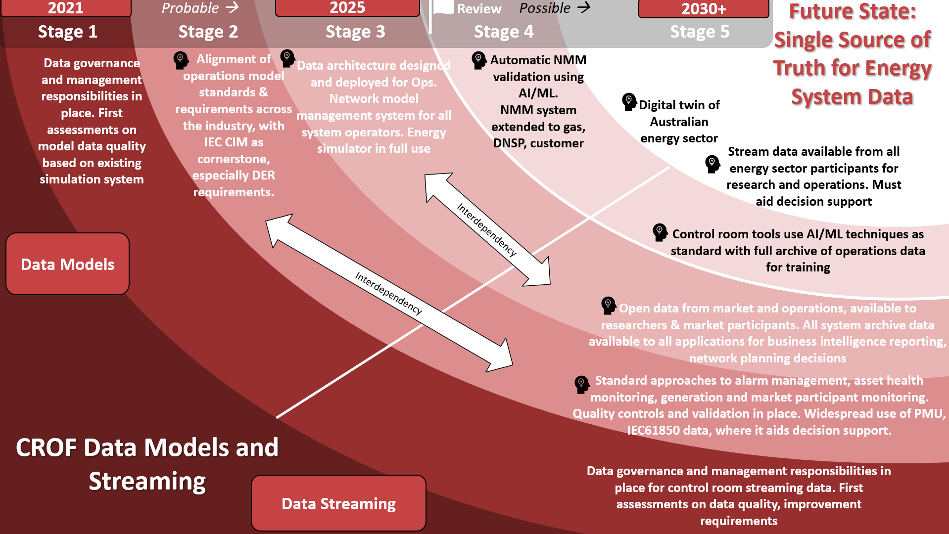
Figure 4-3 CROF Roadmap for Data Models and Streaming

Table 4-2 CROF Roadmap identified issues for Data Models and Streaming
Research Opportunities | - Electricity asset model standardisation process  - Common Information model (CIM) applications across Australian energy system  - DER model and data flow standarization across transmission and distribution boundary.  - Model data governance processes in place  - Network model management systems and innovations  - Model and streaming Data quality control  - Model creation for “new” system devices and parameters.  - Data validation manual and automatic using AI/ML  - Automation of data management process and digitization of workflows, processes.  - Development of a digital twin for the energy sector in Australia. Development of open data platforms for entire energy sector.  - Governance, validation, and quality control of data from PMU, SCADA, assets and protection and control devices.
Research Resources | - Model development, standardisation is a resource intensive activity, requiring specialist expertise to develop and maintain models, major IT infrastructure projects with network model management systems.  - Assess to data from the system operators to researchers in a seamless way will be useful to researchers, but there may be some data quality, cleaning activities required which are slow and labour intensive.  - Software tools such as for power flow, EMT, WAMS, protection will be required for creating and validating data models.  - Access to AEMO energy simulator may be required for model validation.
Key Stakeholders | - Australian TNSPS, DNSPs, AEMO  - EMS, MMS, control room software vendors  - Power system engineering specialists with modelling and model validation capabilities.  - Regulator or government agencies, in relation to availability and openness of data.  - AI/ML specialists when developing AI/ML systems and training on datasets.  - DNSP, gas, market and customer stakeholders when developing the digital twin.
Research Specialists | - EPRI USA  - PEACE LLC - USA  - Monash University  - Grid Digit (Hungary )  - Smart Grid Center - Texas A&M University (USA)  - Fraunhofer (Germany)  - NREL (USA)
Risks | - Modelling the system parameters is a requirement as the system becomes weaker and observability and control is limited. Simulators and software systems require pristine models constantly validated. Failure to implement correct models will result in unpredictable major events on the system with catastrophic consequences for the power system  - There is a risk in making data open to all, of misinterpretation of data by the uninitiated and the spreading of incorrect information. Unless proper governance and security is applied, personal and critical energy system information may become available to the public and used for malfeasance  - Data overload is a risk, unless properly structured with data governance and data quality control.  - Development of AI algorithms should be carried out with adherence to ethical codes and standards, to prevent malfeasance or mis operations.
Links with other GPST Roadmaps | - Inverter Design (Topic 1)  - Stability Tools and Methods (Topic 2)  - Distributed Energy Resources (Topic 8)  - Planning (Topic 4)

Roadmap for the CROF – EMS / SCADA and MMS / NEMDE
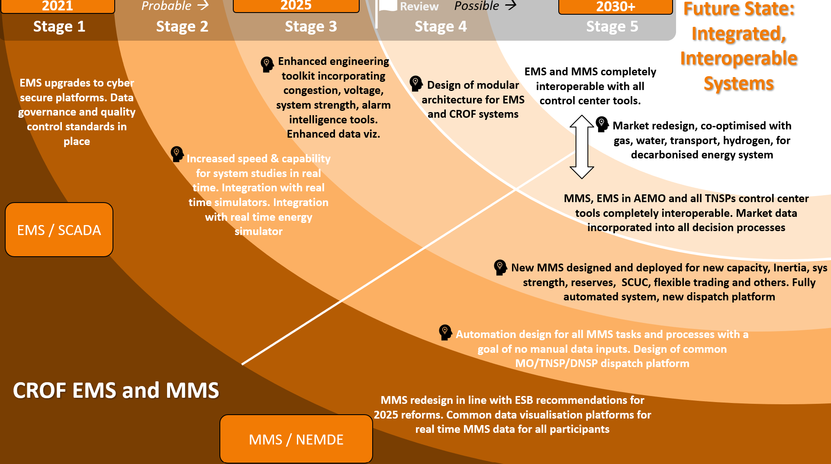
Figure 4-4 CROF Roadmap for EMS / SCADA and MMS / NEMDE

Roadmap for the CROF – Control Room and Operations Engineering Tools
There were 16 (14 + EMS and MMS) control room and operations engineering support tools identified in section 3.4.6 as part of the development of the functional model. An individual five-stage roadmap for each tool is unnecessary in this report but the tools are summarised in Table 4-3 below. Note: EMS and MMS are not included in the table below, since their five-stage roadmap is detailed in Figure 4-4 above.
Table 4-3 Summary of the 14 control room tools and operations planning engineering support tools
Control Room or Operations Planning and Support Tool | Inputs | Outputs | Ideal Future State | GPST Roadmap Link
Congestion Management Tool  (RT&OP) | SE solution, market data, forecasts, DNSP data, device setpoints | Visually presents a solution for congestion on TX and DX system. Visualisation of congestion and suggested mitigations. | An automated OPF and control solution for real time and look ahead that mitigates congestion on Tx and Dx system. Likely to use ML. | Topic 4 - Planning
Voltage Control Reactive Power Optimisation Tool  (OP) | SE solution, market data, Demand forecast RES forecasts, device setpoints | Issues setpoints for all buses on the network for real time and look ahead. Visualisations and ability to issues commands to devices. | An automated control tool for optimised and look ahead voltage setpoint tool based on forecast trajectories. | Topic 2 - Stability
Asset Health Alarm Root Cause Analysis / Disturbance Investigation Tool  (RT) | SCADA alarm data, asset health data, previous disturbances and logs, weather data, protection data | Visually presents concise message indicating root cause of disturbance with mitigation. | Umbrella tool for all alarm data that instantly identifies alarm & disturbance root cause and directs operator’s attention to issues and solutions. Likely to use ML. | Topic 5 Restoration and Blackstart
Dynamic Security Assessment  (Including Voltage, Frequency, Inertia, Transient, Small Signal Stability)  (RT&OP) | SE solution, dynamic model of the system, forecasts, simulator | Visually identifies stability and security in real time and look ahead. | The DSA is interoperable with EMS, MMS and all tools running look-ahead security assessment and suggested mitigation. Potential for automated control actions. Link to PQ EMT and System Strength Evaluation Tool. | Topic 2 - Stability
Power Quality, EMT & WAMS  (RT) | EMT model of system, RT simulator, PMU data, harmonics, and power quality data | Visual reporting and identification if there are power quality issues on the system. | Assesses power quality in real time with suggested mitigation actions – potential for automatic control. Link to system strength evaluation and DSA. | Topic 2 - Stability
System Strength Evaluation Tool | SE solution, outage plan, market data, forecast data, RT simulator | A visual assessment of the current system strength relative to grid limits. Some suggested control actions | Online tool to monitor system strength in real time and look-ahead based on forecast data – potential for automatic control. Link to DSA and PQ EMT. Link to market systems | Topic 2 - Stability
Protection, Short Circuit & SPS Coordination Tool | SE solution, protection grid model, outage data, forecast data, market schedules, SPS device status | A visual assessment determining if the protection on the system is coordinated in real time, for the outages ahead and for a look-ahead horizon | A tool that seamlessly integrates with EMS, and asset health tool to determine protection coordination. Feeds data to DSA for transient stability analysis. | Topic 2 – Stability  Topic 5 – Restoration& Blackstart
Blackstart & Restoration Enhancements Including RES | SE model, protection model, outage data, market schedules. | Tool to guide the process of both blackstart resource optimisation including DER and restoration pathways | Online that works in the case of a blackout to guide through the process. | Topic 5 – Restoration& Blackstart
Demand Forecasting | Archive demand data, weather & environmental data, DNSP, smart meter data | Forecast of system demand with confidence ranges to feed into all CR tools. | Continuous tracking of forecast accuracy, continuous improvement in forecast with increased customer data. | Topic 4 - Planning
Renewable Energy Forecasting | Weather data, generator availability and location | Forecast of RES with confidence ranges to feed into all CR tools. | Continuous tracking of forecast accuracy, continuous improvement in forecast algorithms with increased RES penetrations in future. | Topic 8 - DER
Balancing, Dispatch & Load Frequency Control | Market data, generator status, frequency | Continuous dispatch instructions to all market participants the market output | Optimised for market schedule, frequency control, interconnection flow or other. Interaction with VPP and market participants on distribution system as required. | Topic 6 - Services
Outage Management, Reporting and Workforce Management | Outage data, SE solutions, market schedules, archive system data | Study results and schedule of outages with switching plans, reporting, and a tool to manage workforce. | Automated study of near term and long-term outages with various realistic market, generation scenarios. Links to protection and stability tools.  Automated logging of field workforce personnel and automated logging of reporting.
Environmental (Fire and Weather) Forecasting | Weather and fire data from publicly available resources | As assessment of weather by location, integrated with system and market data where possible. | All weather data is integrated into all control center tools with forecast confidence ranges. Congestion management, protection coordination and stability tools. | Topic 4 - Planning

Table 4-4 CROF Roadmap identified issues for Data Models and Streaming
Research Opportunities | - While most of the research is in the purview of major system vendors for EMS and MMS, there are opportunities on the margins for the research communities as detailed in the sunray.  - There are ample research opportunities in the development and enhancement of the control room tools based on the inputs, outputs, and ideal end state in Table 4-3  - Task automation design for MMS for data entry is a key immediate need.  - Task automation design for logging, reporting and manual administrative tasks in control rooms (See outage management, reporting and workforce management description).  - Development of improved speed in power system studies linked with future real time simulator is a key immediate need but will take a long gestation period.  - Design of common MO/TNSP/DNSP dispatch platform  - New MMS and market design for 2025 ESB reform recommendations  - Long term market and MMS design for op-optimised energy, system service, gas, water, transport systems for a fully decarbonised system  - Design of modular architecture for EMS / MMS and CROF tools.
Research Resources | - Design and concepts form the basis of most of the opportunities in MMS space, meaning human resource bandwidth and expertise in electricity and energy markets  - Access to EMS/MMS are limited for external research, but licence agreements may be possible requiring investment in ICT resources.  - Design of control room tools requires significant software development resources and computing power resources, especially when associated with a simulator.  - Access to company’s real time energy simulator would be advantageous.
Key Stakeholders | - Australian TNSPS, DNSPs, AEMO  - EMS, MMS, control room software vendors  - Regulator or government agencies, in relation to availability and openness of data.  - DNSP, gas, market and customer stakeholders when developing future market concepts
Research Specialists | - EPRI (USA)  - EMS and MMS and control center tool software vendors research departments. (Global)  - Pacific Northwest National Labs (USA)  - RTE International (France)  - Smart Grid Center - Texas A&M University (USA)  - Fraunhofer (Germany)  - NREL (USA)  - University of Melbourne  - University of New South Wales – Collaboration on Energy and Environmental Markets  - Griffith University  - Monash University
Risks | - The quantity of data and tools to be developed pose a risk to resource allocation and capital management. There should be a structured approach to the allocation of resources to manage and prioritise project workloads.  - Development of tools with conflicting algorithms and for EMS/MMS and control centre tools, that they hunt if trying to control the system for different purposes. The development of tools should be aligned with decision support and human factors research to ensure optimal outcomes from tool design.  - With the development of control room tools and EMS/MMS developments and enhancements in separate silos, there is a risk that the user interface and decision support elements will be disjointed and incoherent. To mitigate, this workstream should align with the output, controls and data visualisation and decision support workstreams  - The systems involved are major monolithic systems in the control room that are system critical. R&D is generally piecemeal due to criticality and increasingly because of cyber security risks. Access by researchers to theses system is usually strictly limited
Links with other GPST Roadmaps | - Power Systems Architecture (Topic 7)  - Services (Topic 6)  - Stability Tools and Methods (Topic 2)  - Distributed Energy Resources (Topic 8)

Roadmap for the CROF – Operator and Human Factors
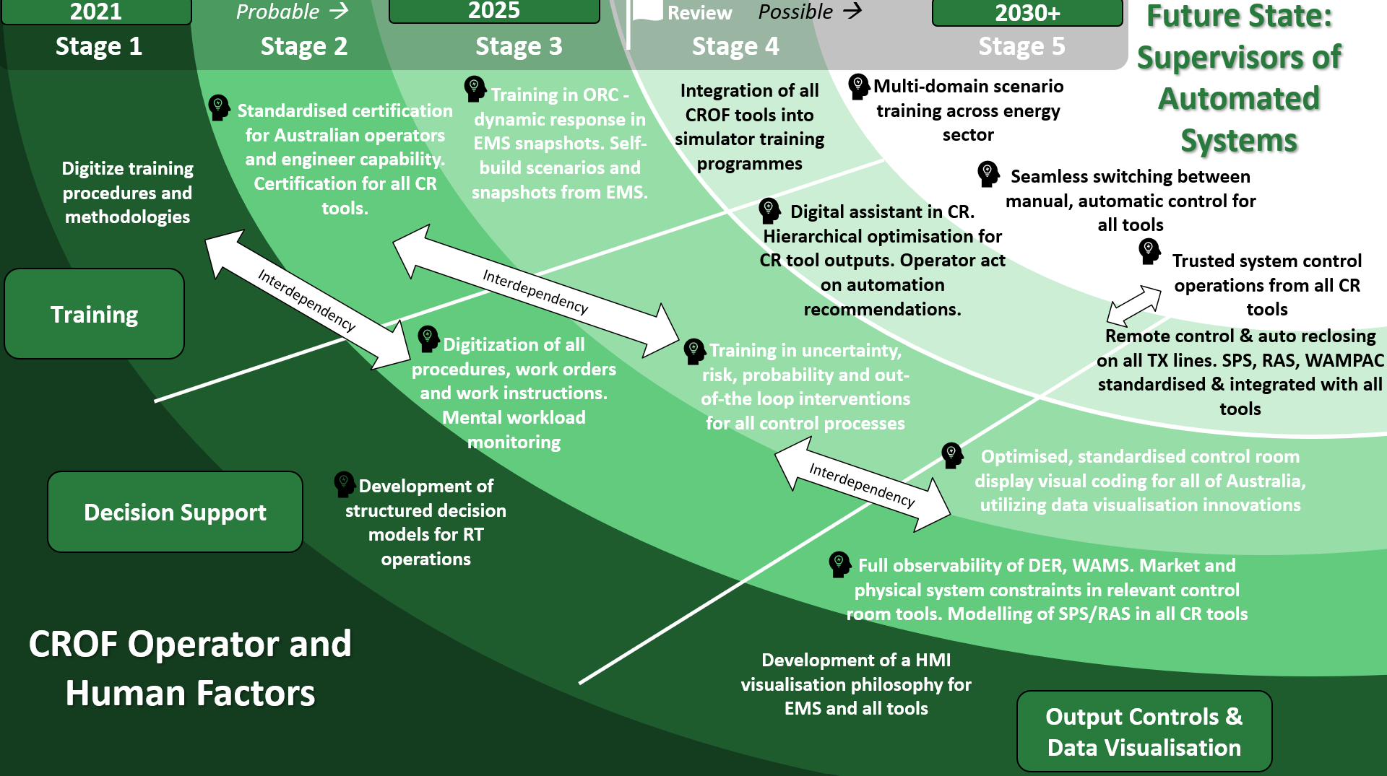
Figure 4-5 CROF Roadmap for Operator and Human Factors innovations
Table 4-5 CROF Roadmap identified issues for Data Models and Streaming
Research Opportunities | - Working with AEMO and TNSPs to develop standardised certification for system operators and engineers  - New enhancements and developments in operator simulators to incorporate, RES, HVDC, SPS, dynamic response and protection  - Development of plans, technology, and procedures for multi domain training, multi scenario training exercises between electricity gas, distribution, generation, water, suppliers, government for business continuity, cyber and major incidents.  - Development of structured decision-making techniques for system operations.  - Uncertainty in decision making and risk-based operations. Operator out-of-the-loop and fatigue mitigation training, aligned with aviation, military industries  - Reinforcement learning / machine learning developments with simulator for the control room digital assistant. This tool should act to take the output of the control centre tools and synthesize the most appropriate information for the operator based on optimisation.  - Natural language processing interaction between humans and tools in control room  - Automated control of systems and digital assistant interactions  - Techniques for visualisation of the vast quantities of DER on the system. Streamlining of data sources into useable decision support materials.  - Integration and reliability of automation in real time control including reclosing, SPS, RAS and WAMPAC.  - Mental workload monitoring for operators, to assess situational awareness and cognitive workload.  - Incorporation of SPS, remote control, RAS, WAMPAC into all control center tools.
Research Resources | - Design of hardware is resource intensive including hardware on the system such as devices for SPS, reclosing, voice activation and training simulators.  - Decision support and human factors innovations will require human resources within research institutions and SMEs and operators within the system operators and AEMO, so extensive interactions will be required.  - Digital assistant development will require high performance computing and AI/ML algorithm development and the development of a language dictionary for electricity.
Key Stakeholders | - Australian TNSPS, DNSPs, AEMO especially their system operators and managers  - Regulator or government agencies for training simulation exercises and research on scenario planning  - Power system hardware device (intelligent electronic devices) manufacturers and designers.  - AI/ML scientists  - Human factors specialists
Research Specialists | - EPRI (Europe)  - Center for Human Factors Socio-Technical Systems. University Sunshine Coast (Australia)  - Centre for Cognitive Work and Safety Analysis, Defence Science & Technology Organisation (Australia)  - Center for Cognitive Science Macquarie University (Australia)  - Cognitive Edge / Dave Snowden (Global)  - Shadow Box Training / Gary Klein (USA)  - Smart Grid Center - Texas A&M University (USA)  - Queensland AI Hub (Australia)  - RTE International (France)  - Pacific North West National Lab (USA)  - TU Delft (Netherlands)  - University College London (UK)  - Fraunhofer (Germany)  - Baidu (China)  - KAIST (South Korea)  - State Grid of (China)
Risks | - Significant risks to the system posed by inadequate situational awareness, deficient decision support and cognitive overloads but measurement of this is difficult to quantify and poses questions as to how it should be mitigated  - There are several conflicting techniques, ideas, methodologies for human factors innovations in high reliability organisations. There is a risk that honing one technique may limit examination of other techniques.  - Development of AI/ML/RL methods for real time operations poses inherent AI safety and ethical risks. These should be mitigated during design phases and have constant assessment and feedback of risks.
Links with other GPST Roadmaps | - Power Systems Architecture (Topic 7)

Roadmap for the CROF – Buildings, Facilities and Hardware
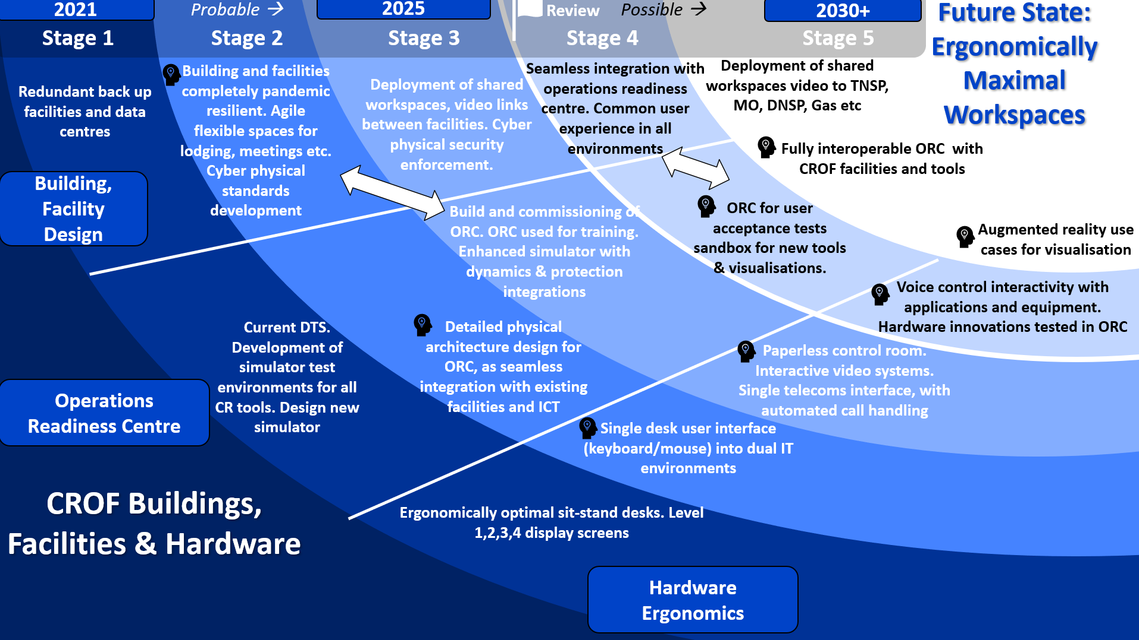
Figure 4-6 CROF Roadmap for Operator and Human Factors innovations
Table 4-6 CROF Roadmap identified issues for Data Models and Streaming
Research Opportunities | - Pandemic resilience for facilities including redundancy, business continuity and function definitions.  - Development of cyber physical security standards, like NERC CIP based on best available standards, regulations, and standards.  - Design architecture both virtual ICT and physical for an operations readiness center to mimic simulators in other industries.  - Sandbox environment for control room tools, visualisation design, hardware innovations, to mimic control room sandbox environments in other industries and learn from similar developments in the electric industry.  - Development of single interfaces for interacting with control room tools, EMS/MMS, ensuring enhanced cyber security.  - Digitisation of control center processes and procedures moves to paperless control rooms.  - Development of voice control interactivity with control room tools and potentially digital assistant in the control room.  - Development of augmented reality innovations for specific use cases in the control room, to enhance situational awareness.
Research Resources | - Design and innovations of buildings and operations readiness centers are resource intensive and requires specialist engineering and architecture design expertise  - Equipment design and  - For the cyber/physical standard development engagement with cyber security regulatory bodies and experts in research/academia will be necessary. Existing standards and codes in other countries can be leveraged as part of this research.  - For voice activation, natural language processing techniques will require high performance computing and AI/ML algorithm development and the development of a language dictionary for electricity.
Key Stakeholders | - Australian TNSPS, DNSPs, AEMO especially their system operators and managers  - Control center device hardware development companies.  - Telecommunication experts  - Augmented reality specialists  - Cyber security specialist from government entities  - AI/ML scientists, particularly focussed on natural language processing
Research Specialists | - EPRI (Europe)  - TU Delft (Netherlands)  - Smart Grid Center - Texas A&M University (USA)  - Australian Cyber Security Centre (Australia)  - CYBER SECURITY COOPERATIVE RESEARCH CENTRE (Australia)  - NERC (USA)  - vStream (Ireland)
Risks | - Cyber security is, of course, a major risk so standard development, testing, resilience must be adhered to all times during research development  - Single interfaces for control room tool human machine interaction have some in-built risks, due to having one entry point for interaction with operational technology (EMS) and other corporate applications  - Change management within system operations among operators is difficult.
Links with other GPST Roadmaps | - Power Systems Architecture (Topic 7)

Existing AEMO Control Room Projects and initiatives
AEMO have several existing projects and initiatives in relation to operations and the CROF that have begun or are in development. These are shown in a similar roadmap format to the CROF model for CSIRO. As part of the research and development and next phases of the projects in AEMO and the TNSPs should take account and align with ongoing projects. Note: These are not linear, time bund or sequential and are shown for information purposes only.
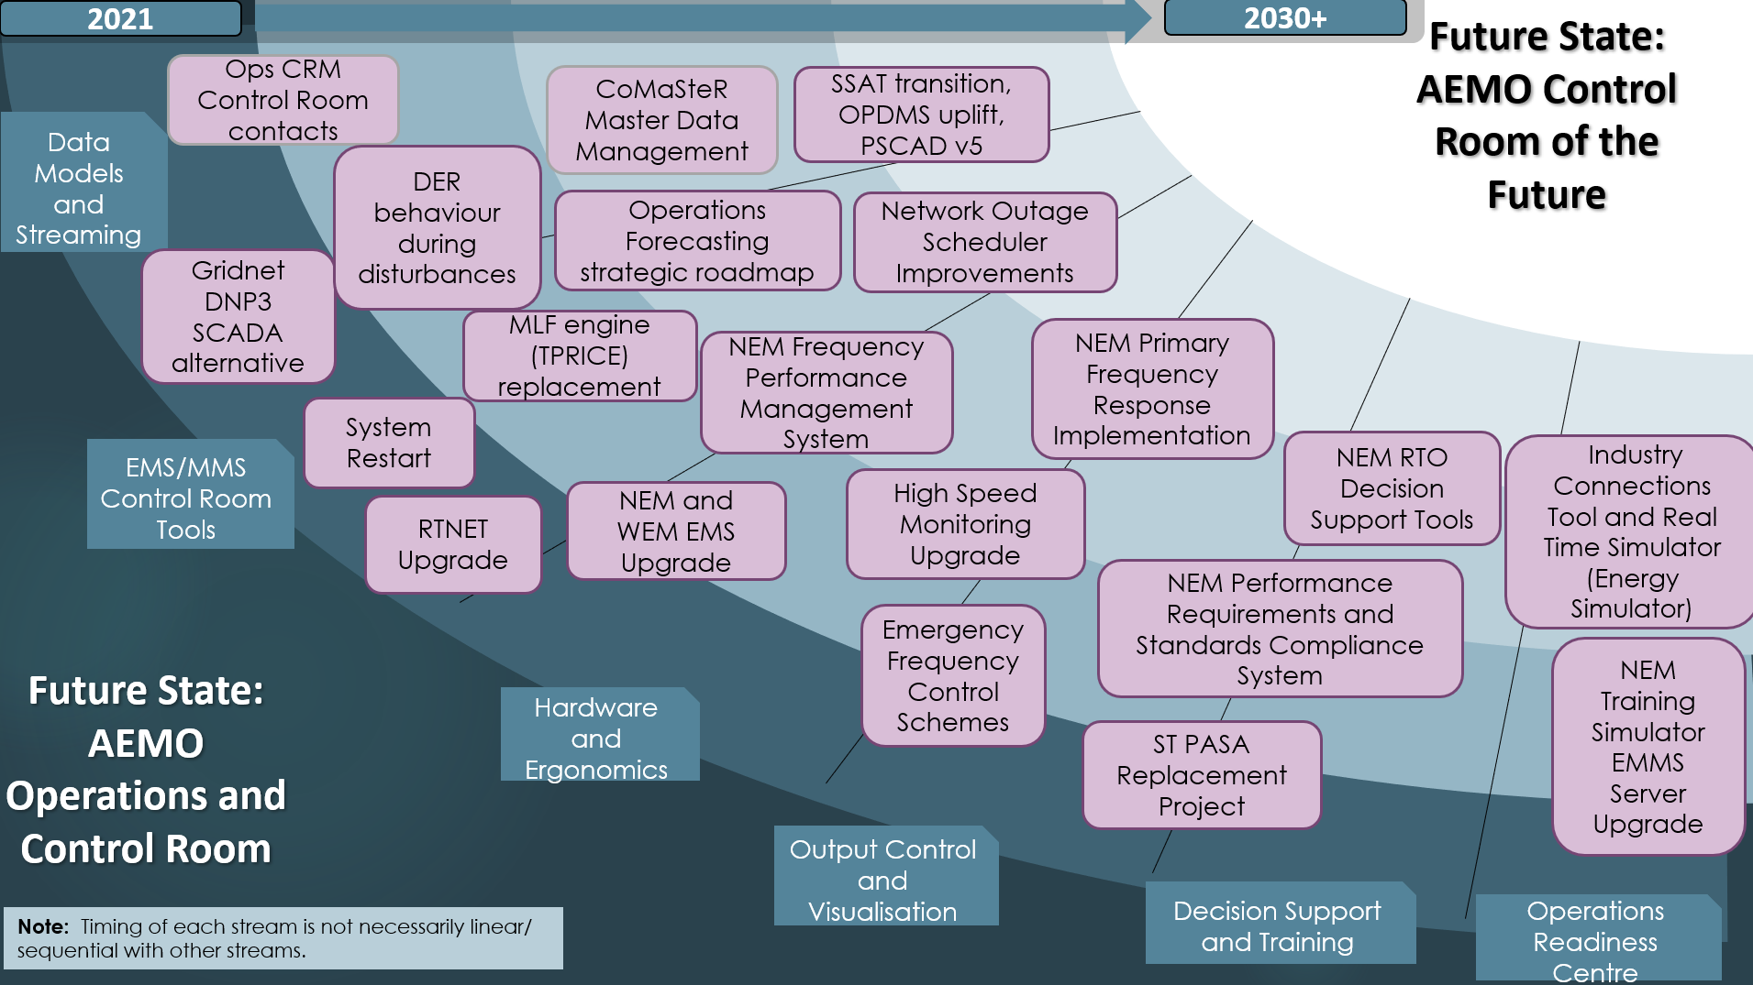
Figure 4-7 AEMO control room of the future and operations projects high-level strategic roadmap of existing projects to align with CROF model

Recommendations

Following development of the CROF roadmaps in Chapter 5 to align with the CROF model and CROF functional model, the recommendations are as follows:
- Dissemination of this report and document to the research community and stakeholders: AEMO and the TNSPs, the GPST stakeholders and the wider CSIRO research community. Note feedback on content and indicative milestones and timelines.
- For AEMO and system operators, review roadmaps to ensure alignment with existing initiatives. If there is wide divergence then both should be assessed for suitability to the relevant system.
- If the roadmaps meet expectations, it is advised to develop a more detailed, company-specific roadmap incorporating existing projects and initiatives.
- A detailed roadmap implementation plan can be developed from these roadmaps, including resource allocation, project teams, infrastructure, timelines, and risks.
- An initial development and refinement of the functional and capability model as documented in Chapter 3 and section 4.3 is a good first step in the research pathway. This sets the stage for development of the reference architectures and the tool development.
- It is not recommended to begin with tool development, or specific technologies to try fit the need. It is recommended to start with the functional model and work towards technologies.
- As a follow-on project, an assessment could be carried out comparing the CROF roadmap developed for CSIRO to existing innovative control room roadmapping projects in other system operators.
- Early engagement with the Australian and international research community on the aspects of the roadmap that are most relevant or achievable is essential.

References

[1] | AEMO, “NEM Engineering Framework: March 2021 Report,” March 2021. [Online]. Available: https://aemo.com.au/-/media/files/initiatives/engineering-framework/2021/nem-engineering-framework-march-2021-report.pdf. [Accessed 7 September 2021].
[2] | Australian Energy Market Operator, “2020 Integrated System Plan,” Australian Energy Market Operator, Melbourne, Australia, 2020.
[3] | Post 2025 Market Design Options - A paper for consultation (Part A), Energy Security Board. Online: https://esb-post2025-market-design.aemc.gov.au/32572/1619564199-part-a-p2025-march-paper-esb-final-for-publication-30-april-2021.pdf, April 2021.
[4] | Strategen, CSIRO Roadmap for Power System Architecture (Topic 7), Canberra: CSIRO, 2021.
[5] | Feller, Ultra Large Scale Systems: The Software challenge of the Future, CM Punlishing, 2022.
[6] | AEMO, “AEMO Market Managment System MMS,” AEMO, [Online]. Available: https://aemo.com.au/en/energy-systems/electricity/national-electricity-market-nem/data-nem/market-management-system-mms-data. [Accessed 31 August 2021].
[7] | AEMO, “AEMO Dispatch Information,” AEMO, [Online]. Available: https://aemo.com.au/en/energy-systems/electricity/national-electricity-market-nem/system-operations/dispatch-information. [Accessed 31 August 2021].
[8] | EPRI, “Human Machine Interface Display Design Best Practices: Reference Guide for Distribution, Generation, and Transmission Control Centers (3002019194),” EPRI, California, 2021.
[9] | D. Jenkins, N. Stanton and P. S. e. al, “Using the Decision-Ladder to Add a Formative Element to Naturalistic Decision-Making Research,” International Journal of Human-Computer Interaction, pp. 132-146, 2010.
[10] | A. Marot, B. Donnot, G. Dulac-Arnold, A. Kelly, A. O'Sullivan, J. Viebahn, M. Awad, I. Guyon, P. Panciatici and C. Romero, “Learning to run a Power Network Challenge: a Retrospective Analysis,” Paris, 2020.
[11] | EPRI, “Powering Through Together: Identifying COVID-19 Transmission and Distribution Operations Practices,” EPRI, Palo Alto CA, 2020.
[12] | N. Naikar, Work Domain Analysis, New York: CRC Press, 2013.
[13] | Global PST Consortium, “Inaugural Research Agenda,” Global PST Consortium, USA, 2021.

