CSIRO Australian Research for the GPST
  - Task 6 – Services
  - Quantifying the technical service requirements of future power systems to maintain the supply-demand balance reliably and at least cost
  - Final Report

  - RMIT University │ ABN 49 781 030 034 

03/09/2021

Authors:
- Ali Moradi Amani
- Xinghuo Yu
- Lasantha Meegahapola
- Mahdi Jalili
- Brendan McGrath
- Peter Sokolowski

Executive Summary

Global warming caused by greenhouse gas emissions is the greatest challenge of mankind in recent history [1]. The largest share of these emissions is contributed by the energy sector [2]. Therefore, there has been a political and social movement towards reducing energy-related emissions using renewable energy sources and energy saving technologies. Australia has had an extensive renewable promotion program during the recent decade. In 2020, renewable energy was responsible for 27.7 per cent of Australia's total electricity generation, where solar has the largest share thanks to Australian homes’ rooftop panels. However, transition of the power system towards renewable generation has its own social and technical challenges which are mainly caused by their unpredictable and variable nature.
CSIRO and AEMO has shaped all these challenges into 9 research topics by adding three questions to the Global Power System Transition (G-PST) agenda. At the heart of these challenges are “services” that need to evolve with the changing characteristics of the power system and are fundamental to supporting the socio-technical objective of “reliably maintaining supply-demand balance, at all points in time, at all locations, at least cost, equitably, and with minimum impact on the environment”. The thought-starter questions about Services from both a system and technology perspective are shown in figure ex1.
Figure ex1. CSIRO research topics and research questions about “Services” in future power grids
The Services for future Australian grids need separating out to match i) customer needs; ii) system preparedness for sufficient or necessary resilience, creating a bridge to detailed electricity market designs as they emerge. This includes mapping to essential system services planned by the ESB’s post-2025 market design but should not be limited by existing thinking. We believe that both ‘economic’ and ‘technical’ aspects impact the speed of penetration of renewables in the Australian grid. Uncertainty about when and where the “investments” may happen in the market, as well as ‘reliability’ as the main requirement of the grid shows that a comprehensive techno-economic framework for services is required for Australia. “Topic-6: services” of this project contributes in developing such a framework by proposing a number of fundamental research questions about Australian strategy in improving flexibility of the grid, which may result in introducing markets for new services.
In parallel with developing such a framework and identifying its technical and operational requirements, urgent requirements for services such as voltage and frequency support in the Australian grid have to be addressed. AEMO has recently issued a fast frequency response rule change which is planned to be revised in late 2022 when detailed operational requirements are required. A Network Support and Control Ancillary Services (NSCAS) review will be conducted by AEMO by the end of 2021, which requires a short-term research activity on voltage support services. Considering the rapid penetration of renewables in the Australian power grid, necessity and requirements of expanding services to the distribution level is a mid-term research activity which requires the aforementioned techno-economic framework revision to be finalised first.
These social, technical and technological concerns about “Services” in power grid are categorised into the following five “Open Question” groups related to financial, technical, frequency and voltage support, and required metrics.

- What services are needed to achieve the technical requirements of Australia’s future power grid to maintain the supply-demand balance while keeping the grid under control at least cost?
  - The necessity for and the requirements of expanding frequency and voltage support services to VRE and DER, i.e. in both generation and distribution sides, in Australia need further studies.
  - There is an appetite to unlock flexibility, either by way of matching customer needs with VRE, or providing a new level of system preparedness through applications such as virtual power plants (VPPs). Both approaches are a matter of research to uncover their advantages and disadvantages for the vast, chain-link network of Australia.
  - Flexibility, an attribute on top of all services, needs standalone research in the Australian grid.

- Are frequency support services suitably configured to achieve the long-term interests of electricity stakeholders including reliability, affordability, flexibility and zero emission?
  - What type of resources and configurations are more efficient for FFR provision?
- Virtual inertia in existing (or future) wind farms
- Energy Storage Systems (ESSs) in PV/wind plants (considering costs).
- Deloaded operation of wind and solar-PV plants.
  - The operational requirements for FFR resources, such as deployment condition and time of dispatch, and duration after deployment should be fully quantified.

- Are voltage support services suitably configured to achieve the long-term interests of electricity stakeholders?
  - How should voltage support services be differentiated across the generation, transmission and distribution sectors of the grid? This must account for the different physical factors that cause voltage fluctuations in each sector (e.g. weather changes or transmission faults).
  - What opportunities for voltage support services arise through the uptake of new disruptive technologies (e.g. electric vehicles and battery energy storage systems)?

- What metrics should be used to define services in inverter-based resources (IBR)-dominated grids?
  - How should current metrics be re-defined to measure the impact of new technologies and services, such as ESS and HVDC.
  - What new metrics should be introduced to assess quality of service of IBR driven distributed supply and demand on frequency and voltage control, and black-start performance.
  - How flexibility measures, such as the flexibility chart and Insufficient Ramping Resource expectation, can help in dynamic monitoring of the Australian grid flexibility?
  - Is there a requirement to introduce an inertia market in Australia? If yes, requirements, including inertia assessment processes, should be introduced.

- What [Essential System] services are needed to maximise the benefits of stakeholders and to achieve an at least cost transition, given the non-steady state nature of investments and emerging technologies in the power grid?
  - How should services be coordinated across the transmission and distribution levels?
  - What wholesale market framework can support a sustainable power grid transformation, promoting demand response mechanisms and encouraging peak load mitigation?

Figure ex2 summarises the relationship between these open questions, the research questions in the contract and other research topics of this project.
Figure ex2. Relationship between CSIRO research topics, CSIRO research questions for “Topic 6 – Services” and our proposed open questions

Table of Contents
Executive Summary ii
1. Introduction 1
1.1. Background 2
1.2. Energy Transition Goals 3
2. Methodology 4
3. Plan Development and Preliminary Recommendations 4
3.1. A general technical view 4
3.2. Flexibility of the power gird 6
3.2.1. Flexibility measurements 8
3.3. Frequency support services 11
3.4. Voltage support services 14
3.5. Measures 15
3.6. Financial domain 16
3.7. Industry Activities 17
3.8. Key Research Questions 18
4. The Research Plan 20
4.1. Short-term plan (< 2 years) 20
4.2. Mid-term (3-5 years) and long-term (> 5 years) plans 20
Appendices III
Appendix A – Thought-starter Services Research Topic Questions III
Appendix B – Services in HVDC systems in a European context IV
Acknowledgements V
References VI

List of Figures
Figure 1. Contour profile of frequency with total installed renewable energy sources capacity (orange line) as a function of time. 3
Figure 2. Share of each element of a power grid in flexibility in order to accommodate more RES. 7
Figure 3. Dynamic range of net electricity demand for different RES penetration levels. 7
Figure 4. Flexibility charts with wind penetration ratio. 9
Figure 5. ERCOT ancillary services framework. 11
Figure 6. a) Implementation of virtual inertia in wind power plants, and b) Impact of virtual inertia on frequency oscillations. 12
Figure 7. Ancillary services provided by BESS. 13
Figure 8. Possible services from ESS. 16

List of Tables
Table 1. Recommendations for research activities in the technical domain. 6
Table 2: Frameworks to measure grid flexibility [27] 10
Table 3. Recommendations for the frequency support services. 13
Table 4. Recommendations for voltage support services. 15
Table 5. Recommendations for review or define new metrics. 16
Table 6. Recommendations for research activities in the financial domain. 17
Table 7. Review of key research questions. 19
Table 8. Research plan. 23

Glossary

AEMC | Australian Energy Market Commission
AEMO | Australian Energy Market Operator
AGC | Automatic Generation Control
BESS | Battery Energy Storage System
CCGT | combined cycle gas turbines
CHP | Combined heat and power
CSC | Current Source Converter
CSCR | Composite SCR
CSIRO | Commonwealth Scientific and Industrial Research Organisation
DER | Distributed Energy Resource
ERCOT | Electric Reliability Council of Texas
ENTSO-E | European Network of Transmission System Operators for Electricity
ESB | Energy Security Board
FACTS | Flexible AC Transmission System
FCAS | Frequency Control Ancillary Service
FFR | Fast Frequency Response
GPST | Global Power System Transition consortium
HVDC | High-Voltage DC
LCC | Line Commutated Converter
IAEA | International Atomic Energy Agency
IEA | International Energy Agency
IIER-A | Institute for Integrated Economic Research – Australia
IRRE | Insufficient Ramping Resource Expectation
ISP | Integrated System Plan
NER | National Electricity Rules
NFI | Normalised Flexibility Index
NLCAS | Network Loading Control Ancillary Service
NREL | National Renewable Energy Laboratory
OLTC | On-Load Tap Changer
PHS | Pumped Hydro Storage
PSS | Power System Stabiliser
PV | Photovoltaics
RoCoF | Rate of Change of Frequency
RES | Renewable Energy Sources
SARS | System Restart Ancillary Service
SCR | Short Circuit Ratio
STATCOM | Static Synchronous Compensator
SVC | Static VAR Compensator
TOSAS | Transient and Oscillatory Stability Ancillary Service
VCAS | Voltage Control Ancillary Service
VPP | Virtual Power Plant
VRE | Variable Renewable Energy
VSC | Voltage Source Converters

Introduction
Australia is in a commanding position to lead change to the world owing to its availability of vast renewable energy sources because of where it is geographically positioned, and its fast growth in renewables (almost double the global average). Furthermore, owing to its population’s attraction to living in coastal areas, Australia possesses one of the world’s longest interconnected power systems [3], which presents its own technical challenge. Australia should be prepared for a future robust power supply and use in the increasingly renewable dominated energy scenario as well as meeting its target to cut greenhouse gas emissions to net zero by 2050. To this end, new and existing services require lowering barriers and removing boundaries for competitive entry of new technical solutions and the provision for encouraging development of innovative technologies to maintain the supply-demand balance while keeping the grid under control (at least cost).
The Services research plan aims to unlock assumed technical limitations of power system operation through building a holistic Australian picture. These technical limitations may be initiated from the topological properties and structure of the grid. In general, some of features of the Australian grid which impact services are:
- A fast growth in renewables in both generation and demand sides,
- A vast land with the world’s longest interconnections,
- Aged infrastructure,
- A highly regulated energy market.
Services in Australia’s future power grids should be provided in an adaptable approach, yet robust against technical, operational and financial uncertainties, during short-, mid- and long-term of the transition. The services should properly accommodate challenges, such as uneven distribution of renewable generators over the grid and massive presence of disruptive technologies, e.g. batteries and electric vehicles, on the demand side.
Australia has had a Frequency Control Ancillary Services (FCAS) market to maintain the system frequency within the specified limit. It includes regulating services for normal operation of the grid as well as services for contingency events. Two regulating services, i.e. regulating raise and lower, are centrally controlled by the Australian Energy Market Operator (AEMO) and deal with the minor imbalance between generation and consumption. There are also six contingency services for large supply-demand imbalances. They are fast, slow and delayed raise and lower services and are locally controlled and triggered by the frequency deviation following a contingency event [4].
The Network control ancillary services available in the Australian grid which include Voltage Control Ancillary Service (VCAS), Network Loading Control Ancillary Service (NLCAS) and Transient and Oscillatory Stability Ancillary Service (TOSAS). All of these are non-market services, contracted directly by AEMO where there is a technical requirement. In the VCAS, generators contribute to the voltage through control of reactive power. There are also synchronous condensers and static reactive plants to control the voltage locally [5]. AEMO uses the NLCAS service to control the flow on inter-connectors between any two regions, by sending appropriate commands for Automatic Generation Control (AGC) or Load Shedding [5]. TOSAS services such as Power System Stabilisers (PSS) and fast regulating voltage services are designed to fast-regulate the impact of a transient ‘spike’, that normally happens after faults, on the network voltage [5].
Finally, the System Restart Ancillary Service (SRAS) enables the power grid to restart after a black-out. Restarting can happen using generators which can start and supply energy without any external energy source, or those who can fold back their generation to their internal use and wait for AEMO’s command to get connected again. Since “Topic 5 - Restoration & Black starting” of the GPST agenda focuses on system restart, we will not pursue this topic in detail in this report.

Background
Increasing the penetration of Variable Renewable Energy (VRE) is leading to a set of increasingly difficult challenges: these are
- weather dependent, leading to variability and uncertainty that must be managed at a sub hourly and seasonal timescale;
- interfaced to the power system by inverters, driving a variety of system challenges; and
- inherently more distributed, posing a challenge to system operators tasked with monitoring them.
Other changes, including increasing energy storage deployment and more actively varied demand driven by Distributed Energy Resources (DER), can pose additional challenges independent of, or compounded by large scale VRE.
At the heart of these research challenges are Services that need to evolve with the changing characteristics of the power system. They are fundamental to supporting the socio-technical objective of reliably maintaining supply-demand balance, at all points in time, at all locations, at least cost, equitably, and with minimum impact on the environment (the GPST definition). These services determine the operation and planning of the electricity grid across all time scales; the required characteristics of the technologies connected to the power system; and, through commercial mechanisms, the incentives to innovate and invest and to do so equitably. Current state-of-the-art services (e.g., capacity adequacy, ancillary services, etc.) fall far short of future service requirements; there is a danger of developing electricity grids that are costly, unreliable, inequitable, and not resilient and will therefore not deliver the step-change needed for the energy transition.
Services are the functions that work to maintain the supply-demand balance while keeping the grid under control at least cost. Unpacking, these services include,
- Frequency support services. These services are responsible to keep the power system frequency at its nominal value, 50 Hz in Australia. Frequency is a metric to show the balance between generation and consumption. When the demand overtakes the generation, a frequency reduction occurs in the grid which is sensed using frequency meter equipment in power plants. They start to increase their supply to compensate for this lack; thus, to keep frequency at 50Hz. In other words, all frequency control action is performed on the supply side.
The operation of power distribution is shifting from the time distribution networks originated, owing to the emergence of DER, such as photovoltaics (PVs), batteries and electric vehicles. They were designed as a one-way delivery of power to consumers. However, in the presence of DERs, they are facing individuals that can be both generators and consumers (so-called prosumers) at different times of a day. Advancement of smart metering infrastructure in the distribution grids brings new monitoring and control facilities. Regarding frequency control, this advancement raises the question that “Can we share the frequency control task between both generation units and consumers?”. For example, running demand-response algorithms help to improve the balance between generation and consumption in distribution grids, and contribute to the load balance of the power system. In this research we review all load balancing and frequency control techniques in the presence of DER and VRE in the power system.
- Voltage support services. To ensure the safety of equipment and consumption devices, voltage should be kept in an acceptable range. Conventional voltage control services were implemented based on the reactive power regulation. Penetration of VRE in the grid result in more uncertainty and fluctuations in voltage than before. Therefore, adequate reactive power reserve is required to ensure a stable and reliable power grid.
Voltage control in distribution grids is a new possibility thanks to DERs. The physics of voltage support in distribution grids is different from the generation side. Despite VAR control in the generation section for voltage support, voltage in distribution grids can be controlled using active power. This raises a lot of technical issues in coordinating these services over the whole grid. A new monitoring and control regime for the national power dispatch centres needs to be developed.
- System restart services. These services are responsible for reconstruction of supply, as quickly as possible, after a power failure. This duty is carried out by a power plant which can start up without external power supply, the feature not available in thermal or nuclear powerplants which mainly generate the base load. Conventionally, this task was performed by hydro powerplants. Electricity storage facilities are also an option. However, answering the question of “how can DER be used to restore the grid in unlikely events” requires further research.
System flexibility is a requirement on top of all these services. The flexibility of the system represents its ability to accommodate the variability and uncertainty in the load-generation balance while maintaining satisfactory levels of performance for any time scale. For example, spinning reserve, the amount of power generated by the power plant, has been conventionally used to provide operational flexibility. To keep the supply-demand balance under uncertain and intermittent RE sources, controllable energy sources should be more flexible in the ramp responses. In this case, the flexibility may come either from flexible generation technologies or from alternative sources of flexibility, such as flexible demand and storage systems.

Energy Transition Goals
Figure 1 shows the frequency deviation in the Australian power grid while penetration of renewables was increasing. Based on the figure, the installed renewable capacity in the Australian grid has been increased from 3GW in 2012 to about 9GW in late 2019. In parallel, the frequency contours show more variation in the frequency as the installed capacity increases. AEMO reacted responsibly to these frequency deviations by proposing the “mandatory primary frequency response (PFR) rule change” in Sep. 2019 which primary results on reducing frequency deviations are promising. Although PRF is an obligation, not a service, this process shows that opportunities for re-defining available services, or issuing new ones, may emerge with higher penetration of renewables.
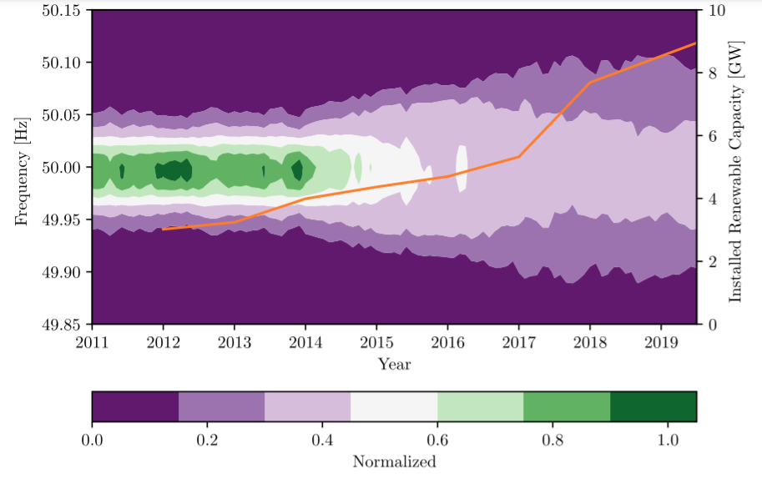
Figure 1. Contour profile of frequency with total installed renewable energy sources capacity (orange line) as a function of time [6].
If this strategy is translated into Services in the Australian power grid, we are almost in the pain-point of lack of appropriate services.
Revising services for the IBR-rich power grid has also been started in other countries. The National Renewable Energy Laboratory (NREL) of the U.S. Department of Energy [7] and the European Network of Transmission System Operators for Electricity (ENTSO-E) [8], have categorised these services based on their time scales. The structure for FCAS looks almost similar in all grid codes. There are
- Inertial and very fast frequency service in the scale of msec. to sec.
- Fast frequency service in the sec. time scale
- Slow frequency response in the range of sec. to min.
- Delayed frequency response in the scale of more than a min.
Different operational requirements are also introduced for service providers considering different technologies; for example, deployment time for the FFR service provider. However, developing a voltage control ancillary services market in an IBR-rich grid is more challenging, especially when the transmission grid is weak [9]. Limitations of RE powerplants in reactive power support, especially in the case of faults, has been in the focus of defining voltage support services in all grid codes. In addition, developing a voltage service market in the distribution grid looks to be a great opportunity [9] although it is not well addressed in NREL [9, 10]. More details about these services are provided in the related section in this report.
There are two main concerns during the transition of power grids to a VRE-rich environment. The first one is financial which includes uncertainty on ‘when’ and ‘where’ investments and incentives should be placed. It is worth noting that a large portion of investments in VRE and DER, such as those on EVs or residential batteries, are out of control of the electricity market, but results uncertainties in electricity rules. The second concern is reliability of the grid which has indeed a technical root. Indeed, any rule change during the transition should be efficient and flexible enough considering both financial uncertainties and reliability requirements.

Methodology
The approach used to develop the plan is multi-pronged. The approach concurrently discovered the state-of-the-art through literature review as well as conversations to share knowledge through internal and external meetings. These meetings were with other academic institutions involved in the GPST and key industry stakeholders required to advance Australia’s electricity services. Assuming there are no right technologies that achieve the technical requirements to maintain the supply-demand balance while keeping the grid under control at least cost (described in the tender document), this kicked-off the discovery of relevant and important research questions for Australia.
Both GPST and CSIRO’s posed research questions show a common concern: Without understanding ‘what to do’ and why, it is difficult (if not impossible) to guarantee an at least cost approach that reliably maintains supply-demand balance while keeping the grid under control. Research questions that form any part of a plan to achieve quantifying the technical requirements require a full understanding of the physics and controls of a power system. This understanding will unlock delivery of the services required for Australia.
Given the timeline of the project, an adaptable approach of stakeholder engagement and literature review was used, with the goal of achieving what’s needed for Australia. Challenges and future views are collected from stakeholders in generation, transmission and distribution sections. In parallel, best international practices about services in IBR-rich grids in both industry and academia are surveyed. We have always kept an eye on the rule changes issued by AEMC and put those which are under development in section 3.8. Services are a very dynamic environment these days. For example, the Fast Frequency Response rule was issued by the AEMC on 15 July 2021 while we have been working on this project.

Plan Development and Preliminary Recommendations

A general technical view
Today we are at a pinch point, requiring new thought into the adequacy of achieving the functions of electricity supply at least cost given the changing nature of the electricity supply, and new technologies are available that can inform supply, demand and embedded supply ends of the power system. Renewable energy resources are penetrating very fast in both generation and distribution sections, which adds a lot of uncertainties to the grid. Emergence of new disruptive technologies, such as batteries and electric vehicles, in the distribution grid has made the conventional distribution management strategies questionable causing several new problems such as voltage rise and reverse power flow. Virtual Power Plants are also new local demand-supply management in the market.
The GPST-proposed services are confined to the definition of reliably maintaining supply-demand balance, at all points in time, at all locations, at least cost, equitably, and with minimum impact on the environment. Through sharing the needs of any future power systems with key stakeholders to date, there is an appetite to unlock flexibility in the grid. Despite variability and uncertainty in VRE and new disruptive technologies in the grid, they can bring flexibility features to the grid. For example, in the distribution grid, an electric vehicle may be connected to the grid during the whole night (let’s say 8 hours) while it needs only 3 hours of charging to get fully charged. This means that charging time can be flexibly chosen any time during that 8-hour period. Flexibility helps either by matching customer needs with VRE, or providing a new level of system preparedness through applications such as virtual power plants (VPPs). Both approaches need to be adaptable but also robust providing resilience at all necessary locations. There are technical and operational challenges on the way. Considering the approach of defining new services in the distribution grid, how these new services should be coordinated with those of generation and distribution sections? What are the requirements to expand AEMO’s monitoring and control capabilities into distribution grid to make sure about security of the grid?
There is also a big concern about the system strength and inertia in IBR-rich power grids. System strength contribution and inertia are design and operational characteristics of synchronous generation technology that have not been easily replicated in IBR, as yet. In the National Electricity Rules (NER), the system strength is expressed using fault levels and the Short Circuit Ratio (SCR) while inertia is related to the rate of change of frequency (RoCoF) [11]. The larger the number and capacity of IBR connected in close proximity to each other, the greater system strength required at that location to maintain stability. This would become more serious in weak grids when voltage is very sensitive to deviation of active and reactive power values. Many inverter manufacturers specify a minimum SCR for stable operation of their inverter [7]. Managing stability in low system strength conditions often requires a combination of network support in conjunction with coordinated tuning of power electronic control systems of existing and new equipment [7].
The above discussion sets the scene of a strategic open research question that could unlock new ways of operating Australia’s power grid while keeping the grid under control at least cost. This question mainly takes into account engineering and technical aspects of revision in services. “Services” may also include an economic aspect that need to be considered; any new service should be economically viable in order to be successfully implemented Since the economic aspects are out of the scope of this work, it is only briefly touched in section 3.6.
Table 1. Recommendations for research activities in the technical domain.

Flexibility of the power gird
Flexibility is a key attribute in defining new services for future power grids. Conventionally, a power system was defined as flexible if its generation units can react successfully to unexpected load changes (i.e., fast ramp up/down capability) [12]. More precisely, a flexible power system can respond quickly to any fluctuation in supply and demand, i.e. ramping down (or up) a generation unit when demand decreases (or increases), as per the IEA (International Energy Agency) definition. In other words, this definition considers uncertainties only in the demand side and applies control strategies only on the supply units of the power system. There are also several operational constraints. For example, if the conventional generators (e.g. open-cycle gas turbines) are employed for providing the generation flexibility, then that would result in increased maintenance cost and down times due to the wear and tear. Therefore, robust generation sources are necessary to cope up with the increasing renewable power penetration levels.
These days we are facing large penetration of variable, and sometimes harder to predict, renewable resources in generation sides, in the form of wind and solar power plants, as well as the demand sides in the form of DERs. This means that uncertainty is now present in both supply and demand sides. On the other hand, control actions can be performed on batteries, hydrogen-electrolysers/fuel-cells or electric vehicles, all on the demand side. Similarly, some industrial loads have large ranges of flexibility, if programmed to respond accordingly to make use of the cheapest electricity (which may even take advantage of negative pricing to generate revenue). Aggregated loads through peer-to-peer trading [13] also provide new ways of flexibility considering the complex cyber-physical-social systems available [14]. This concludes that the definition of flexibility should be transformed to cover uncertainties and control actions on both supply and demand sides. In this context, the flexibility of a power system is defined as its ability to modify generation or consumption in response to expected and unexpected variability [15]. The following items negatively impact flexibility of a power system,
- Generation from variable RES,
- Load variations,
- Weather forecast errors, and
- Outages in generation units connected to the transmission system.

Figure 2 shows how different elements of a power grid can contribute to the flexibility.
Figure 2. Share of each element of a power grid in flexibility in order to accommodate more RES [16].

Conventional power systems could have an acceptable level of flexibility by providing enough reserves and appropriate generation planning. There were a number of high capacity thermal (e.g. Coal and Combined-Cycle Power Plants) or nuclear power plants to provide the baseload. The fast acting (pumped-storage) hydro power plants and gas turbines were used to compensate for variations in the demand side. The pumped-storage hydro units worked as consumers when generation exceeds the demand and worked as generation in the opposite case. However, the definition of base load and the quantity required in a grid with high VRE penetration is challenging.
Figure 3 shows results of a German study on the number of hours for which the net demand, i.e. total consumption minus generation, is larger than a specific value. It shows that, in conventional power systems, i.e. without VRE, the net demand is always more than 35 GW. Therefore, the base load generators should provide 35 GW of power while other generators compensate for the extra (variable) demand. As the penetration of RES increases, the amount of the baseload decreases as shown in figure 3. Therefore, the baseload value may become even negative in grids with very high RES penetration, which does not practically make any sense. Conventional power plants with the lower minimum power output can better mitigate this case without the necessity to be shut down. The variation of the baseload impacts the amount of reserve power and generation planning. Besides, a study in Scandinavian countries show that 10% more penetration of wind power in their grids requires the reserve power to be increased by 1.5%-4% of the installed wind power [17].
Figure 3. Dynamic range of net electricity demand for different RES penetration levels [18].

To improve operational flexibility in this case, different countries have different experiences. Although coal-fire, gas and nuclear power plants are conventionally designed as baseload plants, new research results show that they can increase the grid's flexibility the presence of variable RES (VRES). In this context, the flexibility of the generation side can be achieved by increasing the ramp rate of these power plants. A German study [19] shows that the ramp rate of 7%/min in the 50%-90% load range is achievable in coal-fired power plants. New technologies can even ramp up or down by 500 MW in 15 min [20]. Nuclear power plants are considered as the most inflexible plants. However, a report from International Atomic Energy Agency (IAEA) [21] as well as experiences of some countries, such as France [22], show that a power output ramp from 60% to 100% in 30 minutes is achievable in these plants in the presence of careful operation and maintenance scenarios. Despite this capability, some other countries, such as the United States, decided to install more pumped-storage power plants instead of using any flexibility from nuclear power plants [23]. This concludes that the final decision on the baseload management strategy in a VRE-rich grid requires local studies.
In Australia, there is an opportunity to use BESS in order to increase flexibility of the grid. A possible roadmap for BESS is proposed in [24] which indicates an evolution towards spot market based services. Based on this, a new operating reserve spot market is proposed for a 5- to 30-minute ramping availability. In addition, a fast frequency response service using BESS as well as a new framework for system strength, where the system operator sets minimum/efficient levels at all nodes of the network, are proposed.
In addition to these technologies, High-Voltage DC (HVDC) is becoming popular to transmit bulk electricity using direct current. Using HVDC lines, energy can be transmitted a longer distance with less power loss. Since power-flow can be controlled in HVDC transmission systems, it could improve flexibility by increasing the controllability of the grid [16]. There are HVDC examples in the Australian grid, such as
- Basslink: a 400KV/500MW link connecting Victorian and Tasmanian transmission grids,
- Directlink (Terranora) interconnector: connecting the 132KV AC grid in NSW to 110KV AC grid in Queensland over an 80kV/180MW interconnector, and
- Murraylink: connecting the Riverland region in South Australia and Sunraysia region in Victoria through converter stations at Red Cliffs in Victoria and Berri in South Australia, over 2 X 180 Km 150 kV/220 MW underground cables.
Despite these examples, there is little research about services over HVDC systems in the Australian context. Basslink provides frequency support service while the possibility of providing frequency support and system restart services over the Marinus link (an extra link between Tasmania and Victoria, Australia) has been studied in [25]. Studies in Europe and US (see Appendix B as a European one) show the great potential of these system in providing frequency support services if enough resources are available. The voltage source converter (VSC) technology also empowers HVDC systems to contribute to voltage support services. This means that research on the services that HVDC systems can provide to the Australian grid can be a mid-term activity.

Flexibility measurements
The occurrence of any of the following items may (but not necessarily) show that flexibility of the grid needs to be assessed.
- Difficulty of maintaining supply-demand balance, causing frequency excursions,
- A significant amount of curtailment since a higher amount of renewable energy curtailment may happen in less flexible grids [26],
- Imbalance of renewable energy generation in a certain region, and
- Large variations in the market price.

Inflexibility of the grid indeed means that the grid needs to be assessed from different aspects, including services. There are mainly three analytic frameworks to measure the grid flexibility [27].
a) Visualisation framework: A flexibility chart is an assessment tool based on the visualisation of dominant factors on the flexibility and comparing various solutions in different areas [26, 28]. This chart summarises capacities of (a subset of) different types of physical sources of flexibility. For example, figure 4 compares the flexibility of power grids in Portugal, Germany, Ireland and Denmark considering the wind penetration ratio. This graph shows the share of combined cycle gas turbines (CCGTs), combined heat and power (CHP), pumped hydro storage mode (PHS), hydro power plants and interconnection between areas. The red line shows the maximum share of wind power (red text) during one hour relative to demand. The charts show in green the percentage of installed capacity of each potential source of flexibility relative to peak demand. For example, figure 4 shows that both Eastern and Western Danish grids are heavily dependent to power transfer from interconnections. The Western system has a higher penetration ratio of wind and more flexibility from interconnection and CHP.
Although the flexibility chart can give non-technical readers a quick comparison of countries and how much wind has been integrated in it, it does not consider very important technical limitations regarding flexibility [26]. Flexibility chart shows only the installed capacity which is clearly not a proxy for flexibility. Operational limitations can restrict access to the available flexibility. For example, what about the case that the pumped-hydro is full and cannot absorb electricity surplus generated by VRE? This flexibility graph is useful in medium to long term flexibility assessment in a grid. GIVAR III is also another flexibility visualisation tool which considers more operational features of the grid comparing to the flexibility chart. It considers power area size, grid strength, interconnection, number of power markets, and flexibility of dispatchable generation portfolio serve as proxies for flexibility [29]. These visuals can provide enough information to talk with non-technical audiences (such as politicians and policy makers).
In terms of the Australian network, the flexibility chart could be augmented to accommodate the battery storage systems, open-cycle gas turbines, pump-hydro plants, hydrogen-electrolyser and demand-side technologies.
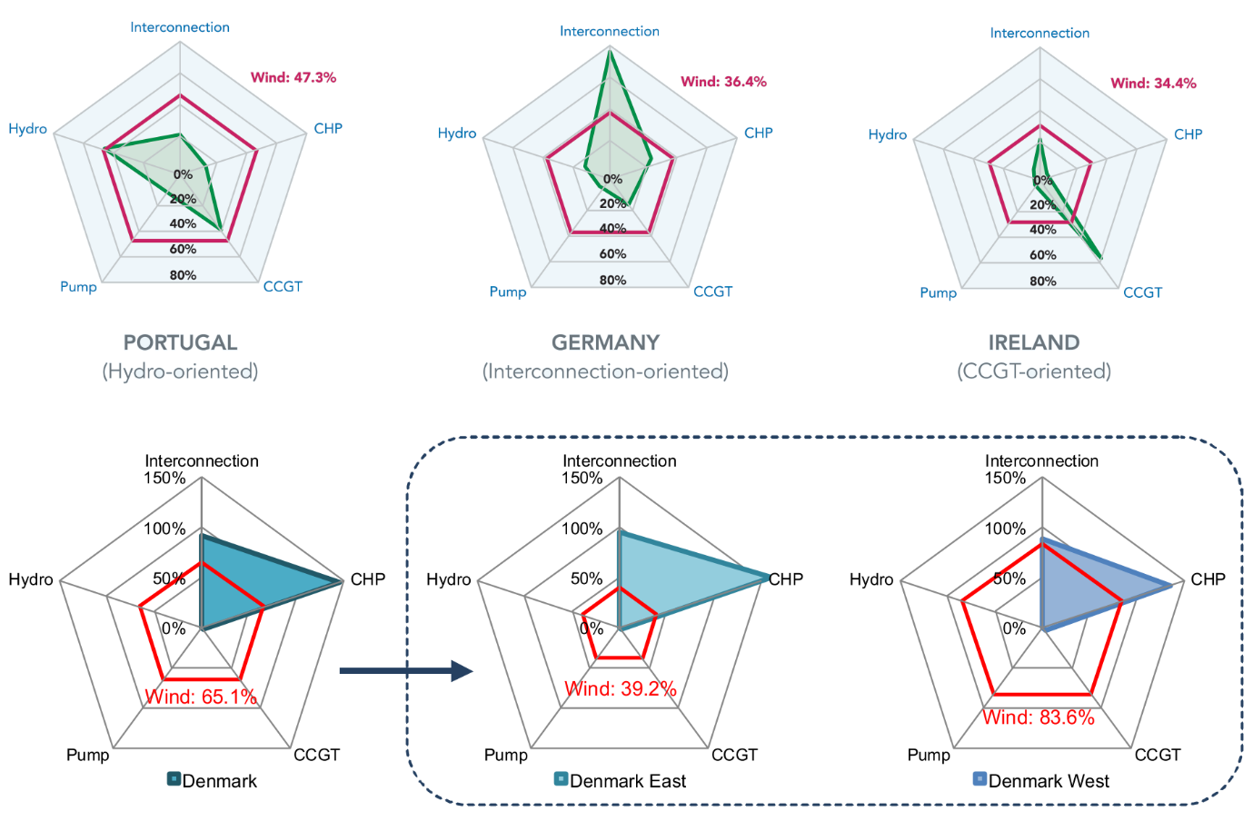
Figure 4. Flexibility charts with wind penetration ratio.
[26, 28]
b) Flexibility measures: flexibility measures can be categorised as probabilistic and deterministic. Insufficient Ramping Resource Expectation (IRRE) [30] is a probabilistic metric for long-term assessment. It considers the ramp-up rate for each generator as well as the flexibility probability distribution function during time intervals. The IRRE of the grid is finally achieved by adding the flexibility calculated for each generation unit. Another flexibility metric, called Normalised Flexibility Index (NFI) [31], belongs to non-probabilistic category. It again uses the flexibility level of each generation unit to evaluate flexibility of the entire power grid. However, despite IREE, NFI focuses on ramp-up/ramp-down rates and spare capacity of each generation unit.
In addition, flexibility measures based on time-series data can provide a practical and precise time-specific quality of flexibility. For example, the flexibility assessment tool proposed in [29] measures the maximum upward or downward change in the supply/demand balance that a power system is capable of meeting over a given time horizon and a given initial operating state (i.e., operation level of different power plants). These methods require several data resources such as hourly time-scales of wind and solar over a year, ramp rate capability and minimum load of conventional power plants, and interconnection information.
In general, the NEM flexibility study using these measures considering operational information of generation units, such as their ramp up/down and spare capacity, is a matter of research.
c) Mathematical flexibility models: This approach can well accommodate variability and uncertainty. Using these models, network structure and operation can be optimised to achieve maximum flexibility. However, models are usually very complicated and take huge effort to be developed and validated. These mathematical models should be still developed by academia before they become ready for applications in industry.
Table 2 summarises available frameworks to measure grid flexibility.
Table 2: Frameworks to measure grid flexibility [27]
Visualisation method | - Flexibility Chart.  - Flexibility Assessment Tool (FAST2), which uses time-series data.  - Grid Integration Variable Renewables, which provides a visually oriented snapshot of flexibility.  - Dynamic upward and downward ramping capability curve | Strength: Easy to create; allows for comparison across different systems; easy to understand.  Weakness: Contains limited information; should be used prudently.
Flexibility metrics | - Percentage of GW installed capacity of generation type relative to peak demand; maximum upward/downward change over given time horizon; expected percentage of incidents in a time period.  - Power provision capacity; power ramp rate capacity; energy provision capacity, and ramp duration.  - System generation mix; dynamic ramp-up/-down ranges; and minimum generation levels.  - IRRE; periods of flexibility deficit.  - Expected unserved demand; operational flexibility index.  - Lack of ramp probability. | Strength: Quantifies the flexibility with available indices; provides suggestions on how to improve the flexibility.  Weakness: Only evaluates one or a few aspects of the system flexibility; lack of comprehensive analytic framework.
Comprehensive models | - Heterogeneous unit clustering method.  - A unified framework for assessing flexibility with robust optimization techniques.  - Measuring the thermal generation flexibility under a stochastic optimization framework. | Strength: Able to calculate the overall margins to accommodate variability and uncertainty. Weakness: Model is usually quite complicated and may be difficult to implement for real systems.

Research Activity Recommendation
The Australian strategy for managing the baseload of power grid during the transition should be finalised. Flexibility of the grid should be regularly assessed using a properly developed tool and appropriate measures. Results of this assessment should be used in mid- and long-term grid administration activities such as generation planning and network topology improvement. This research study would result in determining appropriate rules for settings of the system, for example for FFR, virtual inertia, SVC, STATCOM and batteries, considering flexibility of the grid.

Frequency support services
The inertia in conventional power systems, caused mainly by the kinetic energy stored in synchronous generators, resists frequency fluctuations after an unexpected sudden change in generations or loads. The penetration of renewable energy resources and our commitment to use them as much as possible results in networks with less synchronous generators, thus less inertia. All studies show that we need more efficient inertial and fast frequency response services than what conventional governors normally provide.
The existing frequency control structure in Australia includes ‘Regulation’ and ‘Contingency’ services [32]. Regulation services are centrally controlled by AEMO and are performed by generators and deals with minor changes in the demand/supply balance. Two markets related to these services in the FCAS are ‘Regulation raise/lower’. Contingency services are local responses to directly measured frequency deviations caused by major events such as generator trip or large transmission events. These services are implemented using,
- Generator governor control,
- Load shedding mechanisms in under-frequency events, and
- Rapid generation/unloading.
There are eight (8) markets for contingency services in FCAS, including i) Very fast frequency response (<2 seconds) ii) Fast raise/lower (6 seconds), iii) Slow raise/lower (60 seconds) and iv) Delayed raise/lower (5 minutes).
The “very fast frequency response” rule change was recently determined by the AEMC to react the emerging battery technology in the generation and transmission side. However, there is still a question on “how should these services be re-tuned for a VRE-dominant grid?”. This is the question that a research on future frequency support services in the Australian grid needs to address. There are results from other countries that may help us better understanding the context. For example, the Electric Reliability Council of Texas (ERCOT), US, has proposed a new ancillary service market shown in figure 5. In this framework, Regulation services remains unchanged. It calculates load frequency control (LFC) commands based on a cumulative frequency error and 5-minute net-load changes and sends it to generator governors every four seconds.
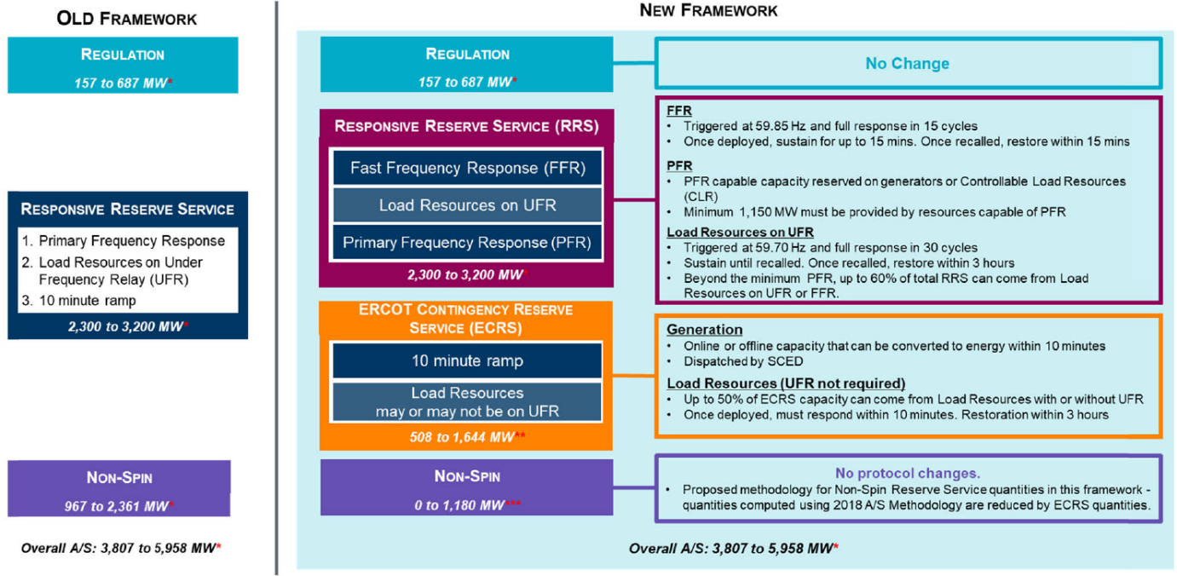
Figure 5. ERCOT ancillary services framework [33].

Fast Frequency Response (FFR) includes resources which can provide their full capacity as fast as 15 cycles from the request deployment. It should work very fast to prevent them from being triggered at an earlier frequency than load shedding under-frequency relays. Once FFR is deployed, it should sustain for a specific time, 15 minutes for the ERCOT, and contribute in the system recovery. In other words, an FFR resource should answer three how’s: How much, how fast and how long [7]. NREL also suggests modern wind turbines as a candidate for the provision of an FFR product. They can perform a pre-curtailment, i.e. reducing the output of the wind turbine below what it could provide, whenever energy price is less than the reserve price. In this case, they are in stand-by mode for any increase in the demand.
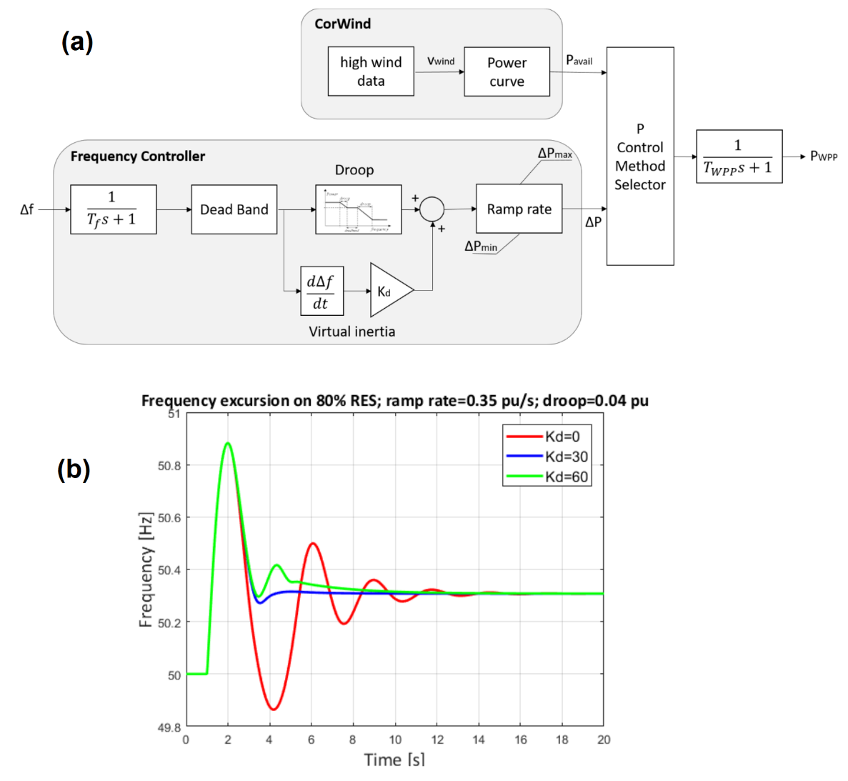
Figure 6. a) Implementation of virtual inertia in wind power plants, and b) Impact of virtual inertia on frequency oscillations [34].

Performance of an FFR resource can be evaluated using the following metric [33],
- How much time does it take for the FFR resource to be deployed once the frequency reaches the threshold?
- For how much time shall the FFR resource sustain after deployment?
- How much does the reset process of the FFR resource take? That means, after a deployment ended, how long does it take for it to get ready for the next deployment?

Fast Frequency Response (FFR), including batteries and appropriate electronic interfaces, can rapidly compensate for the imbalance between generation and consumption. Therefore, it can provide very good flexibility of power for a short time scale [13]. Virtual inertia control (i.e. df/dt based controllers) can also damp oscillations in networks with VRE [35]. It could be implemented as a complementary component to the traditional droop controller of wind power plants or as a separate controller (see figure 6a) [34, 35]. Figure 6b shows how the virtual inertia suppresses frequency oscillations caused by possible sudden variation in supply or demand.
Figure 7. Ancillary services provided by BESS [36].
Battery Energy Storage Systems (BESSs) can also compensate for the effect of prediction errors and optimise the operation of the distribution grid using smart charge/discharge algorithms. Generally, BESSs can provide services in different time-scales (see figure 7) [36]. They can support voltage stability and harmonic mitigations thanks to their very fast response times. They can also provide slow services for secondary frequency control or load smoothing. This shows that augmenting BESS into the power grid services needs a comprehensive framework which considers them as a service provide, not only a generation unit like conventional power plants.
Table 3. Recommendations for the frequency support services.

Voltage support services
Synchronous generators have been the main device used for dynamic voltage control in conventional power grids, in addition to SVCs, STATCOMS and synchronous condensers, by injecting/absorbing reactive power as well as contributing in the fault level by injecting high short-circuit currents. Although VRE are weak in voltage support via Volt/Var compensation regime, it has been shown that solar-PV systems can compensate for volt-var control scheme, although an appropriate protection scheme is required [10]. However, IBR-based generation units, and even DERs, are unable to contribute much in the fault level. This results in a low system short-circuit strength which indicates the stiffness of the system voltage to changes in local demand. Dynamic reactive power compensation devices, such as static-var compensators (SVCs) and static-synchronous compensators (STATCOMs), are employed in power grids to improve voltage stability in network regions with low short-circuit strength [37].
System strength is another important parameter in revisiting voltage support services. Based on the Australian Energy Market Operator (AEMO)’s definition, the system strength is a “measure of the power system stability under all reasonably possible operating conditions” [11]. This definition categorises power systems to strong and weak or non-stiff grid. In a strong grid, voltage is not sensitive to the active or reactive power variation (i.e. dV/dP and dV/dQ are too small) while in a weak grid, it is. A low short-circuit current increases the voltage sensitivity following a fault, therefore it can be said that a part of the system with less short-circuit level can be considered as a weak area. System strength is normally measured by the Short-Circuit Ratio (SCR) which is locally defined based on the point of connection of a generation unit to the grid. There are a lot of studies showing that SCR needs to be improved when a lot of VREs are sited at remote regions in the network [10]. Furthermore, new indices are also defined to measure the system strength (e.g. Composite SCR (CSCR), weighted short-circuit ratio (WSCR)) considering the characteristics of IBRs.
There are several approaches in dealing with voltage control in power grids such as On-Load Tap Changers (OLTC) and Flexible AC Transmission System (FACTS) controllers. Static Var Compensators (SVC) are FACTS voltage controllers using reactive power compensation. Voltage source converter, such as Static Synchronous Compensator (STATCOM), is another type of FACTS controller working based on injecting current to the system. Both SVC and STATCOM are designed for generation and transmission levels. However, voltage flexibility in the distribution level still depends on OLTC and possible household and community batteries.
Demand-side management, using different techniques such as demand-response, is a source of voltage support which has not been available in conventional power grids [38]. The main approach is to match high demand periods with local storage and renewable generation such that demand does not significantly change from generation/transmission point of view. This is an important tool to increase flexibility and needs to be well integrated into the global grid flexibility framework. Demand-side management technique can reduce voltage variability in VPPs, putting less uncertainty on the demand. To this end, smart algorithms for control and scheduling of DERs and loads in the distribution grid is required. In addition, customer-engagement services should be provided to facilitate the smooth operation of VPPs and smart grids.
The above discussions show that VRE and DER are both impacting the voltage stability which, indeed, means that voltage support services need to be revised both on the generation and demand sided. The following open question can be unpacked to investigate the technical service requirements for Australia.
Table 4. Recommendations for voltage support services.

Measures
There are considerable opportunities to define the necessary metrics to facilitate service markets and operational frameworks for a broad range of performance indicators. For example, ESS can provide different services in different sections of power grids. It includes frequency regulation and black-start in generation, voltage support and oscillation damping in the transmission and distribution sections as well as service reliability and peak limiting in the distribution grid (see Figure 8 for a list of possible ESS services) [39]. In order to assess the ESS benefits for frequency and voltage control, and system restoration as well as its economic value and market features, appropriate metrics are necessary.
There are also several metrics to quantify flexibility of power grids, some of them are reviewed in section 3.2.1. For example, system operators consider the “reserve margin” as a common metric to show the percentage of capacity above the anticipated peak demand in each region of a power grid. This metric needs to be improved considering the change in the concept of base load in the presence of VRE sources. AEMO can also consider precise and customised metrics for FFR service providers in the new revision of the recently issued fast frequency response rule change. The metric proposed by ERCOT can give us a clue [33], but need to be customised for the Australian grid:
- An FFR resource must be deployed in 15 cycles (or 10 minutes for verbal deployment) after the frequency reaches the trip threshold;
- A resource must sustain the response for at least 15 minutes or till ERCOT recalls deployment, whichever occurs first;
- A resource must be reset and made available for next event within 15 minutes after the deployment is ended.
If it is concluded to run an inertia trading scheme in Australia, which is indeed a matter of research itself [40], an appropriate metric for inertia-as-a-service is also required. There are also several observations on SCR that needs improvements to a precise metric once there is a high penetration of VRE in a specific region. These discussions support a general question of what metrics should be used to define their associated services (of some value to a system operator) in IBR dominated grids, specifically in Australia, considering voltage support (or flexibility)? This question is further broken to details in Table 6.
Figure 8. Possible services from ESS [39].
Table 5. Recommendations for review or define new metrics.

Financial domain

A recent History of Political Economy article by Daniel Breslau of Virginia Polytechnic Institute [41] describes the control roots of spot pricing of electricity and how it was intended to achieve an economically efficient outcome (i.e. at least cost). Put simply,
- Establish an energy marketplace (with efficient and economical services),
- The existence of the marketplace ensures an at least cost electricity supply,
- When there is a shortage of electricity supply, the price in the marketplace goes up during the periods of shortage,
- A pain-point creates a demand to build a power plant that fills the shortage,
- The most economically efficient power plant gets built (achieving at least cost),
- Return to having a least cost electricity supply.
Recognising and responding to the challenge, the AEMO has in place several activities and proposed rule changes among them, “Integrated System Plan (ISP)” [42]. This plan identifies investment choices and recommends essential actions to maximise consumer benefits at the time Australia is experiencing the so-called world’s fastest energy transition. The aim is to minimise costs and the risk of events that can adversely impact future power costs and consumer prices, while maintaining the reliability and security of the power system [42]. From the power system services perspective, ISP proposes an investment pathway at least cost for the NEM based on the transmission framework, which is helpful if economic aspects of services are considered.
In addition, given the forthcoming declining minimum demand due to increasing adoption of renewable energy sources [43], current planning assumptions may no longer be fit, and need to change to maintain reliability and security while managing operational risks [44]. Since electricity trading leads to a schedule-based system operation, its impact on service quality cannot be underestimated due to the dependency between schedule-based operations and energy market activities as well as on local active power reserves and frequency control processes [45]. From an economic perspective, further consideration of additional investment options is required for providing quality services in increasingly distributed supply-demand environments. This demands additional technological supports as enablers.
Table 6. Recommendations for research activities in the financial domain.

Industry Activities
There is a suite of activities occurring in market institutions including the AEMC, the ESB and AEMO prompted by rule change requests, periodic reviews, or in response to the recommendations of the Finkel Review. These activities broadly cover the open research questions formed above through discovery and review. However, they use a piecemeal approach to solve issues identified by market participants, and rarely consider holistic approach and adaptable but robust approach that includes services supplied by aggregated peer-to-peer trading or services provided by flexible industrial loads that may nicely complement VRE supplies.
In summary, this suite of activities includes AEMC ‘systems services rule changes’ that cover the following,
- Fast frequency response market ancillary service (proposed by Infigen Energy) – issued 15 July 2021
- Primary frequency response incentive arrangements (proposed by AEMO)
- Operating reserve market (proposed by Infigen Energy)
- Capacity commitment mechanism for system security and reliability services (proposed by Delta Electricity)
- Introduction of ramping services (proposed by Delta Electricity)
- Efficient management of system strength on the power system (proposed by TransGrid)
- Synchronous services markets (proposed by Hydro Tasmania)
The AEMC has also recently completed an investigation into system strength frameworks in the NEM. The commission has proposed a framework that has three main components, reflecting how effective coordination between the supply and demand sides is. Through conversations, there was clearly some confusion on defining grid forming capability and the abilities that could be programmed or designed into inverters to provide inertial-type responses for existing protection schema. This is of course not unexpected, as the AEMC seeks technical advice from AEMO and other independent sources owing to technical advice being outside of the AEMC’s capacity.
AEMO’s Engineering Framework aims to provide a secure and efficient energy transition [46]. The attributes being examined in this roadmap include amongst others,
- Resource adequacy,
- Frequency management,
- System strength,
- Voltage Control, and
- System Restoration.
Although aforementioned attributes include flexibility requirements implicitly, new observations about importance of flexibility in IBR-rich grids show that it needs to be considered as a standalone attribute.
Lastly, the ESB is examining Access Reform to create incentives for generators to locate in sensible places, to counteract limitations that may be caused through undesirable constraints. This is a spatial (topological) services approach [47]. This further unlocks new ways of best placing VPPs with more localised structure that may provide least cost services through intra-area pricing signalling while providing capacity protection. This access reform may be an outcome of ESB’s post-2025 market design.

Key Research Questions
With the research questions of the contact initially provided (Appendix A), the research plan’s discovery and review phase’s outcome to-date has uncovered open research questions. These questions can be unpacked further with more specific investigation of the technical requirements to establish these services through either algorithmic, technology, or governance changes, and are reviewed in Table 7. Priority should be given to unlocking any immediate value that is constraining utilisation of VRE assets as well as establishing services described in Open Questions 1 and 2.
To re-focus the future operation of Australia’s power systems through new services and pair the nature of VRE with VPPs, flexible DER and flexible industrial consumers, the next priority should work to achieve an understanding of the physics and controls required (i.e. the technical requirements) that maintain the supply-demand balance from a demand-side perspective while keeping the grid under control.
Table 7. Review of key research questions.

The Research Plan
We identified five classes of open questions (each composed of several research questions) that should be carried out to guarantee appropriate service level in the NEM. Here we prioritise the research questions and suggest a timeline for their implementation.

Short-term plan (< 2 years)
Open questions 2 and 5 are deemed to be urgent actions and our recommendation is to prioritise them for action in a short-term. In particular, we suggest prioritising the frequency support services through FFR as AEMC is planning to revise its rule change by the end of 2022.
The Australian energy grid is transforming from an old paradigm to a new system with increased emerging dynamic entities, such as DERs and electric vehicles. To maintain the required reliability and securing and affordability of the power grid, the Services need to be redefined to plan for (and achieve) the transition at minimum cost (and disruption). This call for an urgent action from AEMC and AEMO some of which have already started happening. We recommend putting some important items regarding financial and a technical framework of services at the highest priority. This includes i) revising tariff policies and make it unified over transmission and distribution in the presence of disruptive technologies, and ii) finalising the Australian strategy in improving flexibility of the grid (will it be through inertia market, services in distribution grid, hydrogen-electrolyser, Tasmanian hydro power plants, etc.).

Mid-term (3-5 years) and long-term (> 5 years) plans
Parts of the open questions 1, 2 and 3, which are related to new and disruptive technologies, might be considered for the next 3-5 years (mid-term). This includes new technologies such as electric vehicles and residential and community batteries, as well as VPP and HVDC. While an urgent action might not be necessary for these questions, thinking should be done in the mid-term. With the uptake of new technologies, flexibility of the grid should be accurately assessed and adopted. That’s why we put the flexibility framework in the short-term requirements. Electric vehicles are possibly the major disruption that the grid will experience in the next 3-10 years. Their uptake will further push IBR to high levels.
Finally, the long-term research plan could be defining metrics to quantify flexibility (and service quality) of IBR-rich grids and assess whether flexibility services are properly configured. Parts of open questions 3 and 4 show mid- and long-term goals about services. Table 8 gives an overview of our research plan for the Australian grid services.
Our review shows that jurisdictions often use different strategies in re-defining services in IBR-dominate power grids, based on the topology and specifications of their grids. One needs to develop a local version for services in Australia. The main skillset required for the Services part is expertise in system-level aspects of power grids. Australian universities and research centres have enough research capabilities with may world-class researchers active in system-level studies. However, this transformation has other technical requirements, from system, hardware and software perspective, to develop the future workforce. For example, further work is required to train digital-ready workforce, which is required for data-driven actions (required to optimise services). Significant targeted investment is required in research and training to make graduates, engineers and PhDs ready to contribute in the services. Our recommendation is to create a CSIRO-led partnership between government (e.g. AEMC, Department of Energy and State departments), AEMO, industry and universities similar to CRC settings.

Table 8. Research plan.

Appendices

Appendix A – Thought-starter Services Research Topic Questions
a. How should the definitions of services for IBR dominated grids be structured? Can standard services and standard characteristics be defined that are reasonable for large and small IBR and across VRE, storage and demand response interfaces?

b. What methodologies can be employed to determine if strong/stiff voltage control services can be reliably provided through reactive power droop or active regulation?

c. What models and methods are necessary to quantify the ability of VRE to provide essential reliability services to the grid, and how do system operators quantify the value of these reliability
services (for example, as an input to system-specific market/incentive design questions)?

d. What roles can offshore wind and HVDC connections play in providing energy system flexibility?

e. What roles can synchronous condensers play in providing energy system flexibility?

f. How can system performance requirements be translated into reliable new technology solutions?

g. What metrics should be used to define services in IBR dominated grids?

h. How can system operators quantify the transmission level service opportunities from DER? What are the practical and technical limitations to the reliable provision of various DER services?

i. How can transmission-level services provided by DER be valued? What DER transmission level service valuation methodologies are best suited as a compromise between simplicity and full cost-reflectiveness?

j. To what level of detail can power market clearing approaches and algorithms take into account the physics?

Note: research questions e, g and j are not part of the GPST consortium research plan.

Appendix B – Services in HVDC systems in a European context
There are two classes of HVDC converter technology, namely Line commutated converters (LCCs) which use thyristors in current source converter (CSC) topologies, and voltage source converters (VSC) that use gate turn-off thyristors (GTOs) or insulated gate bipolar transistors (IGBTs) [48]. HVDC transmission system can be ‘Asynchronous’ to connect two AC systems with different frequencies or phases, ‘Synchronous’ connecting two synchronised AC systems, or ‘Offshore’ which is mainly used to connect offshore wind farms to the grid. If sufficient resources are available in the system, services mentioned in the following table can be provided over HVDC transmission systems [49]. The terms FCR, FRR and RR refer to primary frequency support, Frequency restoration reserves or secondary control, and Replacement Reserve or Tertiary Control, respectively.
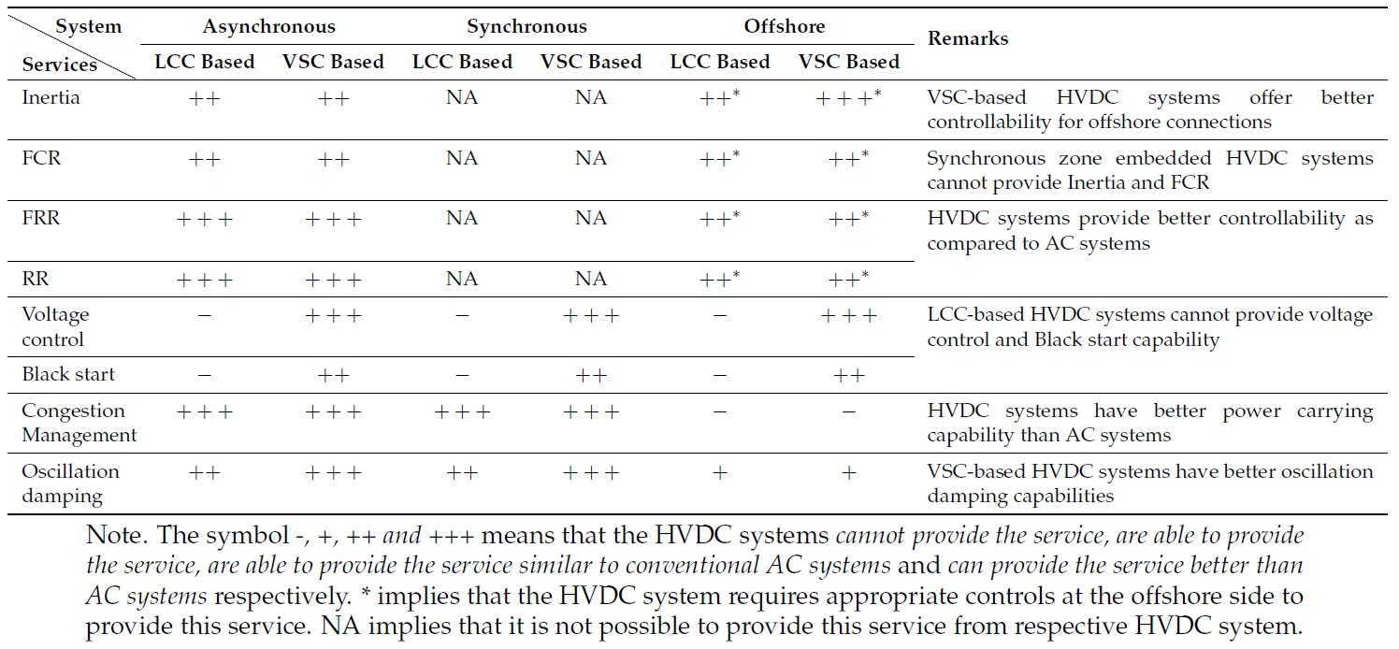

Acknowledgements
The Services research plan development team thanks and express our gratitude to all those who have contributed to providing their insights from across the industry and other research topics of the GPST, enabling us to glean the activities currently in train.
The team thanks the following individuals for their significant contributions,
- Christian Schaefer, GHD,
- Mark O’Malley, GPST Consortium,
- Behrooz Bahrani, Monash University,
- Ben Hiron, AEMC,
- Jess Hunt, ESB,
- Frank Montiel, AEMO,
- Chris Davies, AEMO,
- Christiaan Zuur, AEMC,
- Victoria Mollard, AEMC,
- Julian Eggleston, AEMC,
- Sebastien Henry, AEMC,
- Craig Phasey, EnergyFlex,
- Luke Robinson, AEMO, and
- Scott Chapman, AEMO.

References

1. Nations, U., The Sustainable Development Goals Report. 2019: United Nations.
2. Retirement of coal fired power stations. 2016, Commonwealth of Australia
3. J. Bryant, et al., Frequency control challenges in power systems with high renewable power generation: an Australian Perspective, R. University, Editor. 2019.
4. Market ancilliary service specification. July 2020, Australian Energy Market Operator.
5. Guide to Ancillary Services in the National Electricity Market. April 2015, Australian Energy Market Operator.
6. Bryant, J.S., et al., Synchronous generator governor response: Performance implications under high share of inverter-based renewable energy sources. IEEE Transactions on Power Systems, 2021. 36(3): p. 2721-2724.
7. Denholm, P., Yinong Sun, and Trieu Ma, An Introduction to Grid Services: Concepts, Technical Requirements, and Provision from Wind. 2019, National Renewable Energy Laboratory. NREL/TP-6A20-72578.
8. Commision regulation (EU) 2016/631 of 14 April 2016. 2016.
9. Oureilidis, K., et al., Ancillary Services Market Design in Distribution Networks: Review and Identification of Barriers. Energies, 2020. 13(4).
10. Meegahapola, L., et al., Power system stability in the transition to a low carbon grid: A techno‐economic perspective on challenges and opportunities. WIREs Energy and Environment, 2021.
11. System Strength. March 2020, Australian Energy Market Operator.
12. Chandler, H., Empowering Variable Renewables-Options for Flexible Electricity Systems. 2008.
13. Nguyen, S., et al., Optimizing rooftop photovoltaic distributed generation with battery storage for peer-to-peer energy trading. 2018. 228: p. 2567-2580.
14. Yu, X. and Y. Xue, Smart grids: A cyber physical systems perspective. Proceedings of the IEEE, 2016. 104(5): p. 1058-1070.
15. Agency, I.E., Harnessing Variable Renewables. 2011.
16. Impram, S., S. Varbak Nese, and B. Oral, Challenges of renewable energy penetration on power system flexibility: A survey. Energy Strategy Reviews, 2020. 31.
17. Holttinen, H., Impact of hourly wind power variations on the system operation in the Nordic countries. Wind Energy: An International Journal for Progress Applications in Wind Power Conversion Technology, 2005. 8(2): p. 197-218.
18. G. Papaefthymiou and K. Grave. Can we achieve 100% renewables? Flexibility options in the electricity system. 2014.
19. Henderson, C., Increasing the flexibility of coal-fired power plants. IEA Clean Coal Centre, 2014. 15.
20. Fairley, P., Quicker coal power. IEEE Spectrum, 2013. 50(2): p. 11-11.
21. Non-baseload operation in nuclear power plants: load following and frequency control modes of flexible operation, in IAEA nuclear energy series. 2018.
22. Keppler, J.H. and M.J.N.E.A. Cometto, OECD, Paris, France, Nuclear energy and renewables: system effects in low-carbon electricity systems. 2012.
23. Large-scale electricity interconnection, P. IEA, Editor. 2016.
24. Lal, N., et al., Essential System Services Reform: Australian Market Design for Renewable-Dominated Grids. IEEE Power Energy Magazine, 2021. 19(5): p. 29-45.
25. Ancillary Service Benefits for Marinus Link. 2019, GHD Report for TasNetworks.
26. Cochran, J., et al., Flexibility in 21st century power systems. 2014, National Renewable Energy Lab.(NREL), Golden, CO (United States).
27. Wang, Q. and B.-M. Hodge, Enhancing Power System Operational Flexibility With Flexible Ramping Products: A Review. IEEE Transactions on Industrial Informatics, 2017. 13(4): p. 1652-1664.
28. Yasuda, Y., et al. Flexibility chart: Evaluation on diversity of flexibility in various areas. in 12th International Workshop on Large-Scale Integration of Wind Power into Power Systems as well as on Transmission Networks for Offshore Wind Farms, WIW13. 2013. Energynautics GmbH.
29. The power of transformation. 2014, International Energy Agency.
30. Lannoye, E., D. Flynn, and M. O'Malley, Evaluation of Power System Flexibility. IEEE Transactions on Power Systems, 2012. 27(2): p. 922-931.
31. Ma, J., Evaluating and planning flexibility in a sustainable power system with large wind penetration. 2012, The University of Manchester (United Kingdom).
32. Guide to Ancillary Services in the National Electricity Market. 2015, Australian Energy Market Operator.
33. Du, P., et al., New Ancillary Service Market for ERCOT. IEEE Access, 2020. 8: p. 178391-178401.
34. Dominguez López, G., Frequency control in power systems without must-run units. 2017, Universitat Politècnica de Catalunya.
35. Tan, Y., L. Meegahapola, and K.M. Muttaqi, A suboptimal power-point-tracking-based primary frequency response strategy for DFIGs in hybrid remote area power supply systems. IEEE Transactions on Energy Conversion, 2015. 31(1): p. 93-105.
36. Izadkhast, S., Aggregation of plug-in electric vehicles in power systems for primary frequency control. 2017.
37. Dozein, M.G., et al. System strength and weak grids: Fundamentals, challenges, and mitigation strategies. in 2018 Australasian Universities Power Engineering Conference (AUPEC). 2018. IEEE.
38. Sokolowski, P., et al. Roles of policy settings in distributed generation with battery storage. in IECON 2017-43rd Annual Conference of the IEEE Industrial Electronics Society. 2017. IEEE.
39. Günter, N. and A. Marinopoulos, Energy storage for grid services and applications: Classification, market review, metrics, and methodology for evaluation of deployment cases. Journal of Energy Storage, 2016. 8: p. 226-234.
40. Agranat, O., I. MacGill, and A. Bruce. Fast frequency markets under high penetrations of renewable energy in the Australian national electricity market. in Proceedings of the Asia-Pacific Solar Research Conference, Queensland, Australia. 2015.
41. Breslau, D., Redistributing Agency: The Control Roots of Spot Pricing of Electricity. History of Political Economy, 2020. 52(S1): p. 221-244.
42. Integrated System Plan. July 2020, Australian Energy Market Operator.
43. AEMO's reliability outlook. 2021, Australian Energy Market Operator.
44. Network Support and Control Ancillary Services (NSCAS) Dec 2020, Australian Energy Market Operator.
45. Scherer, M., Frequency control in the European power system considering the organisational structure and division of responsibilities. 2016, ETH Zurich.
46. NEM power system design and engineering framework. 2020, Australian Energy Market Operator (AEMO).
47. Innovation landscape for a renewable-powered future: Solutions to integrate variable renewables. 2019, International Renewable Energy Agency: Abu Dhabi.
48. Flourentzou, N., V.G. Agelidis, and G.D. Demetriades, VSC-based HVDC power transmission systems: An overview. IEEE Transactions on power electronics, 2009. 24(3): p. 592-602.
49. Kaushal, A. and D. Van Hertem, An overview of ancillary services and HVDC systems in European context. Energies, 2019. 12(18): p. 3481.

https://www.cleanenergycouncil.org.au/
https://www.minister.industry.gov.au/ministers/taylor/media-releases/2021-australian-energy-statistics-electricity
Measured by the ratio between the short-circuit level at the point of common coupling of the generator and the generator rated capacity.
This article was recently studied and workshopped by the Institute for Integrated Economic Research – Australia (IIER-A) collaboration, 2020-2021.
https://www.aemc.gov.au/rule-changes/fast-frequency-response-market-ancillary-service
https://www.aemc.gov.au/rule-changes/removal-disincentives-primary-frequency-response
https://www.aemc.gov.au/rule-changes/operating-reserve-market
https://www.aemc.gov.au/rule-changes/capacity-commitment-mechanism-system-security-and-reliability-services
https://www.aemc.gov.au/rule-changes/introduction-ramping-services
https://www.aemc.gov.au/rule-changes/efficient-management-system-strength-power-system
https://www.aemc.gov.au/rule-changes/synchronous-services-markets
https://www.aemc.gov.au/market-reviews-advice/investigation-system-strength-frameworks-nem

