CSIRO Australian Research for the GPST

Task #9 – ENSURING SYSTEM SECURITY AND MODELLING FAST LOAD-DER RESPONSES WITH HIGH PENETRATIONS OF IBR – Report

School of Electrical Engineering and Telecommunications,

School of Photovoltaic and Renewable Energy Engineering

UNSW

28/10/2021

Authors:

* John Fletcher
* Naomi Stringer
* Georgios Konstantinou
* Iain MacGill

# Executive Summary

The growth of inverter based resources (IBR) will continue unabated if we are serious about removing emissions from our growing electrical energy system.

* AEMO and other stakeholders need the tools to model all the different timescales and response times associated with IBR and understand performance ‘on aggregate’
* Load-DER Composite Models will need to adapt and change continuously during the transition
* The impact of large signal responses of inverter based-resources will remain a security issue now and into the future
* EV charging loads will become a significant opportunity for and threat to market and network operators
* Home PV-battery systems are more modest in scale but may have important impacts on disturbution networks including regular instantaneous changes in real and reactive power flows during self-consumption control.
* Significant residential and commercial loads may become inverter-based with the potential for unusual interactions, disconnections and behaviours that when multiplied to scale represent new threats to network operation
* Standards will have to continue to evolve to address new behaviours of individual inverters are identified which may lead to unusual network responses, and that interactions between inverter-based resources become more frequent and severe.
* Compliance with standards, regulations and other related performance standards needs serious consideration given the potential for on the fly updates that could change wither knowingly or unknowingly the response of individual inverters, potentially no longer conforming with standards and regulations.
* Technical performance of inverters including frequency performance, reactive power and operation during black start are important areas that must be investigated.

The objective of the proposed research program is to ensure that those organisations tasked with operating the networks and associated markets are able to access precise and efficient toolsets that model the response of inverter-based resources. These resources being generation, load and storage. The proposed research program includes elements of theory, analysis and application and is predominantly applied and empirically-based using comprehensive laboratory testing, in-field data analysis and simulation to build a comprehensive understanding of DER and load behaviours in our electrical network during normal and abnormal operation of the network.

We propose a multi-faceted approach that focuses on early deployment of improved models that network operators and market operators can use that capture IBR responses to:

* Develop an improved load-DER model tool set that supports AEMO’s development of TNSP models
* Expand UNSW’s inverter benchmarking: market share is fluid, changing, ‘stranded’
* Start benchmarking portfolios of three-phase inverters, hybrid- and storage-only inverters
* Assess the impact of AS4777.2020 on inverter performance
* Further develop our excellent CHIL and PHIL capabilities to assess inverter controller response to grid disturbances.

And have the following impacts:

* Continued development of AEMO’s toolset
* Research/develop/deploy new technologies to solve emerging interconnection problems
* Support Standards revisions and Emergency Measures by identifying security issues related to IBR behaviours
* Continue to educate, train, disseminate findings nationally and internationally

Australia is uniquely placed to deliver valuable insights to ISOs and TSOs internationally, due to its distant and poorly-interconnected power system and substantial, if not world-leading, deployment of distributed solar PV systems, as well as a growing fleet of distributed battery energy storage systems. This five year proposal will continue to support a range of stakeholders including inverter vendors and manufacturers, consumers and consumer groups, network operators and network service providers, and the market operators, regulators and commissions.

Table of Contents

Executive Summary 2

1 Introduction 5

1.1 Background 5

1.1.1 World leading DER uptake 5

1.1.2 Power system security: Threat and opportunity 6

1.1.3 Fast-tracked review of AS/NZS 4777.2 9

1.1.4 UNSW Addressing Barriers to Efficient Renewable Integration 11

1.1.5 UNSW Project MATCH 13

1.2 Energy Transition Goals 14

2 Methodology and Beneficiaries 15

3 Plan Development 16

3.1 Current Solutions and Industry Activities 16

3.2 Key Research Questions 21

4 The Research Plan 23

4.1 What is the problem? 23

4.2 Objective 24

4.3 Targeting Deployment through Research and Development 24

4.4 Practical Deployment Outcomes 26

4.5 Research Elements 27

4.5.1 Inverter responses and sensitivities 27

4.5.2 New Innovations and Techniques 30

4.5.3 Security issue identification 30

4.5.4 Dynamics of power quality modes 30

4.5.5 Data Driven Aggregation Techniques 31

4.5.6 Fault and Disturbance Propagation 32

4.5.7 DER and network dataset mapping 33

4.6 Development Elements 34

4.6.1 Extending AEMO’s tool set 34

4.6.2 New Innovations and Techniques 34

4.6.3 Guidance and guidelines 34

4.6.4 Standards developments and compliance testing 35

4.6.5 Load-DER composite model 35

4.6.6 DER disturbance modelling for NSPs 38

4.7 Research Program Priorities and Gaps 39

4.7.1 Power sector focus (y-axis) 39

4.7.2 Relevance and regional prioritisation (x-axis) 39

4.7.3 Additional research and development activities 39

4.8 Resources and Budget 41

*4.9* Links with the other Australian GPST research programs 43

4.10 Risks Associated with Key Tasks 44

4.11 Key sources of complexity 45

Appendices I

Appendix A – List of current International Standards and Test Procedure Comparisons I

Appendix B – Hardware in-the-loop publications in the PV/DER area

# Introduction

The objective of the proposed research program is to ensure that ISOs and TSOs are able to maintain power system security under very high penetrations of IBR such as distributed PV, energy storage, and other resources including inverter-based demand. Australia is uniquely placed to deliver valuable insights to ISOs and TSOs internationally, due to its distant and poorly-interconnected power system and substantial, if not world-leading, deployment of distributed solar PV systems, as well as a growing fleet of distributed battery energy storage systems.

The proposed research program is highly applied – and recommends that laboratory testing, in-field data analysis and simulation are used in combination to build a comprehensive understanding of DER behaviours during disturbances.

This section of the report outlines relevant background in 1.1 and identifies relevant energy transition goals in 1.2.

## Background

Without adequate DER compliance testing and improved DER behaviour during major power system events, the security risks that already exist due to DPV and other inverter-based DER are likely to worsen with growing penetrations. However DER also offer capabilities to aid in maintaining power system security, if the industry can rely on DER to provide these services.

The proposed research program will develop industry capabilities for managing power system security risks and leveraging these DER opportunities, in order to reduce barriers to growing DER deployment. This section outlines why the research program is needed and provides background on key research underway in Australia.

### World leading DER uptake

Australia is experiencing world leading uptake of DER, particularly DPV, and increasingly battery energy storage systems (BESS). Figure 1 indicates that Australia is currently leading the world in terms of DPV uptake.

Australia is experiencing ongoing world-leading DPV deployment

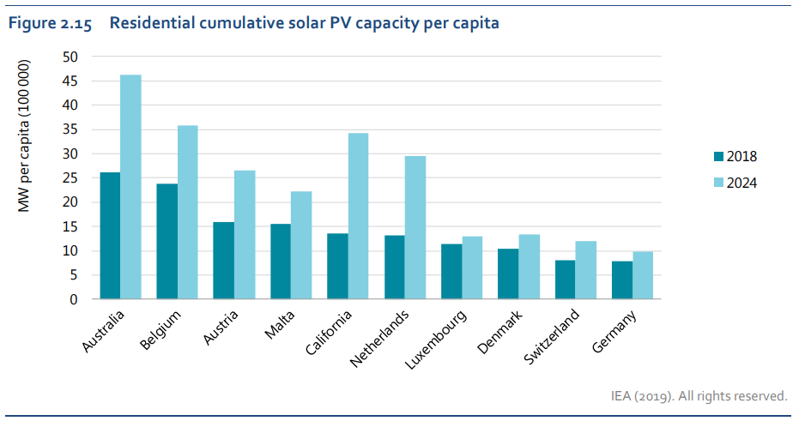

Figure 1 – International deployment of DPV

“Residential cumulative solar PV capacity per capita” (International Energy Agency, 2019)

Almost one in three dwellings have already installed DPV in Australia (around 29% at the time of writing). The total Australian National Electricity Market (NEM) DPV capacity is forecast to almost double by 2030, and BESS capacity is forecast to increase more than five-fold[1]. Taken collectively DPV is already the largest NEM generator at 13.9GW total capacity[2], which significantly outstrips the NEM’s next largest generator, the 2.8GW Eraring black coal plant.

In 2019 the South Australian minimum demand record was broken three times during Spring, then again in Spring of 2020. Including on Sunday 11 October 2020, when DPV generation accounted for more than 50% of South Australia demand for six hours (Figure 2). Australia is leading the world in high penetration DER, and forecasts suggest penetrations will continue to climb over the coming decade.

Despite the current and future significance of DER, there remains very limited visibility and control. Instead DER behaviours are largely dictated by inverter connection standards that define the operational envelope of these DER according to system frequency and local voltage.

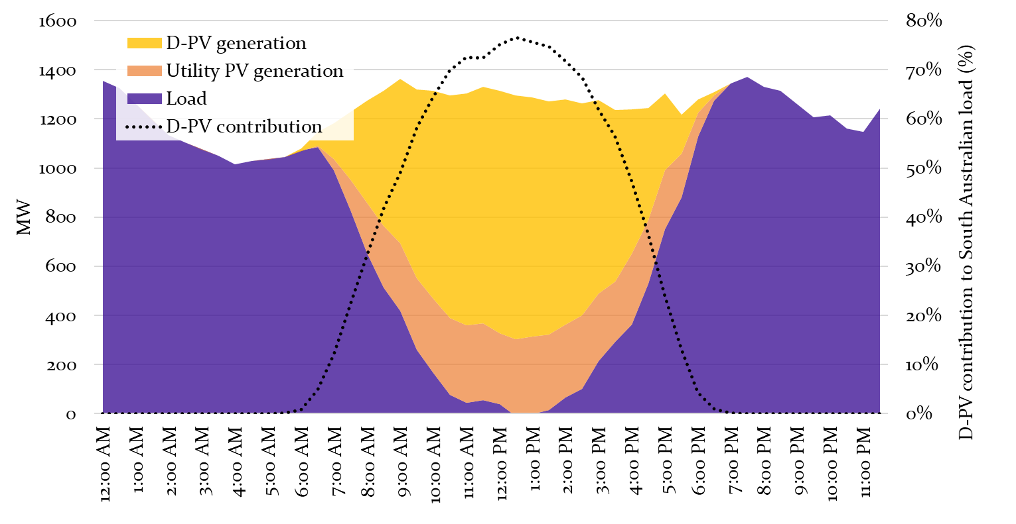

Figure 2 – DPV contribution in South Australia on Sunday 11 October 2020 (minimum demand record)

*Data sourced from: (McConnell et al., 2020)*

### Power system security: Threat and opportunity

The NEM is designed and operated to first and foremost maintain power system security. Credible contingency events, such as the sudden trip of a large generator or transmission line can be expected to occur on occasion, and the system should be operated in order to quickly and securely return to its secure operating envelope. However the current and projected uptake of DER, and its uncertain behaviour in response to credible contingencies means that we are leaving the safe boundaries of operation, and that DER is becoming a material source of risk.

Prior work by AEMO, UNSW and Solar Analytics has shown that DPV inverters can respond *en masse* during major power system disturbances. Synchronised generation reduction across large swathes of the PV fleet following disturbances presents a material risk to power system security[3]. AEMO notes in its 2020 Renewable Integration Study (RIS) that without appropriate actions it may become necessary to impose *‘hard regional hosting capacity limits for passive DPV, which may necessitate moratoriums on new DPV installation or costly retrofit of existing DPV’*[4].

Major events commonly involve voltage disturbance, frequency disturbance, or a combination of both. Some of the risks posed by each of these disturbance types are as follows:

* **Voltage disturbances** DPV has been observed to reduce power output by 30-40% following major voltage disturbances, largely due to inverter tripping. Impacts are particularly acute close to the disturbance origin. As result, voltage disturbance in close proximity to high densities of DPV, such as Brisbane and Adelaide, could potentially cause PV losses that exceed the current largest credible contingency in some time periods. This reduces system predictability during disturbances and may necessitate increased contingency FCAS enablement. The criticality of this issue is illustrated in the Box 1 case study.
* **Frequency disturbances** DPV systems installed under the 2015 Australian inverter connection standard (in effect since October 2016) are expected to deliver an over-frequency droop response. Analysis of Solar Analytics data has shown DPV performing this response, providing the first documented evidence of DPV in the field acting rapidly, autonomously and in concert to assist in managing power system security. However, at least 15-30% of post-2016 PV systems did not perform over-frequency droop response, despite that they should have done so[5]. Highlighting a new major issue with regards to compliancethat is emphasised in the RIS. See Box 2 for details.

Non-compliant inverters may also fail to perform under-frequency or under-voltage ride through. This poses critical power system security concerns as the loss of PV during events where there is already a supply deficit, would exacerbate conditions. It is unclear what is causing non-compliance, and may be in part due to installation errors, for instance not updating the inverter firmware to AS/NZS 4777.2:2015. Efforts to improve standards, whilst vital, will not achieve the desired power system security outcomes under high penetration DER unless they are accompanied by improved compliance rates.

Box 1 – **Voltage disturbance case study:** Loss of Torrens Island

During this non-credible contingency event on 3 March 2017, Torrens Island gas generator in South Australia tripped, causing a deep voltage depression. Analysis of Solar Analytics data from in field systems shows a 40% reduction in aggregate PV generation (Figure 3). Close to the disturbance origin the response was even more extreme with 50% of DPV systems reducing output to zero (Figure 4).

PV response exacerbated the loss of Torrens Island and AEMO noted in its incident reporting that this event shared similarities with the 2016 South Australia system black. Analysis of further events has shown consistent PV tripping, however this case study remains one of the most extreme instances observed to date.

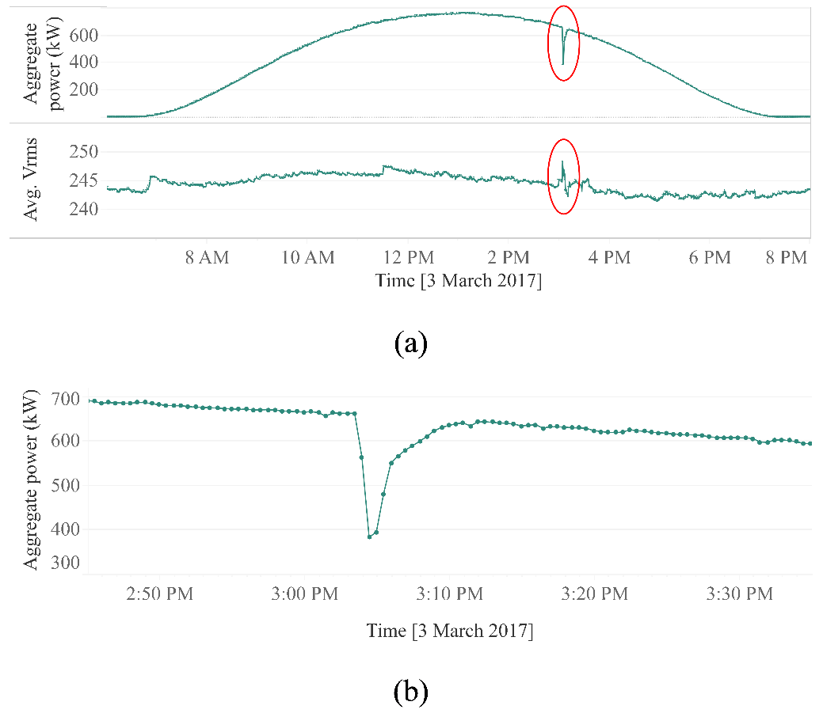

Figure 3 – Aggregate DPV response to voltage disturbance on 3 March 2017, South Australia[6]

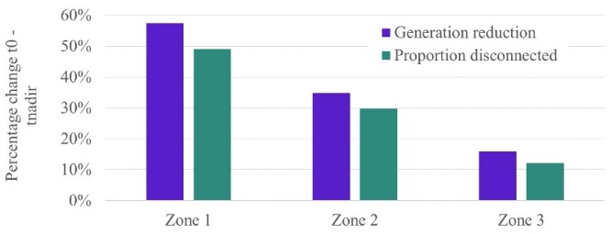 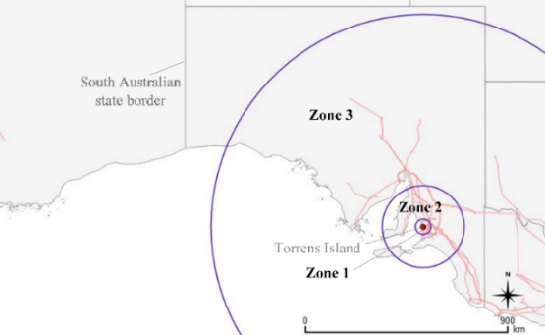

(a) (b)

Figure 4 – Spatial profile of PV response to voltage disturbance (a) magnitude of response, (b) response zones15

Box 2 – **Frequency disturbance case study:** Separation of Queensland and South Australia

On 25 August 2018 a lightning strike caused QNI to trip, and Queensland was islanded from the rest of the NEM, shortly followed by South Australia[7]. Both South Australia and Queensland were exporting power prior to the separation and so over-frequency occurred in each of these islanded regions.

The current inverter connection requirements include over-frequency droop response. That is, a controlled and proportional reduction in generator output when frequency exceeds 50.25Hz. This response was introduced in 2015 and required from October 2016 onwards. At the time it was world leading.

Analysis of Solar Analytics data showed inverters performing this over-frequency droop response during the 25 August 2018 separation event. It has provided the first known evidence that DPV can act rapidly, autonomously and in concert to aid in maintaining power system security. Figure 5 shows the aggregate response of actual PV systems in Queensland (blue) compared with the expected response (orange).

Although in aggregate the PV systems appeared to perform as expected, some systems did not respond at all, and some ‘over’ responded. At least 15-30% of systems did not comply with the standard, highlighting a previously unknown security threat.

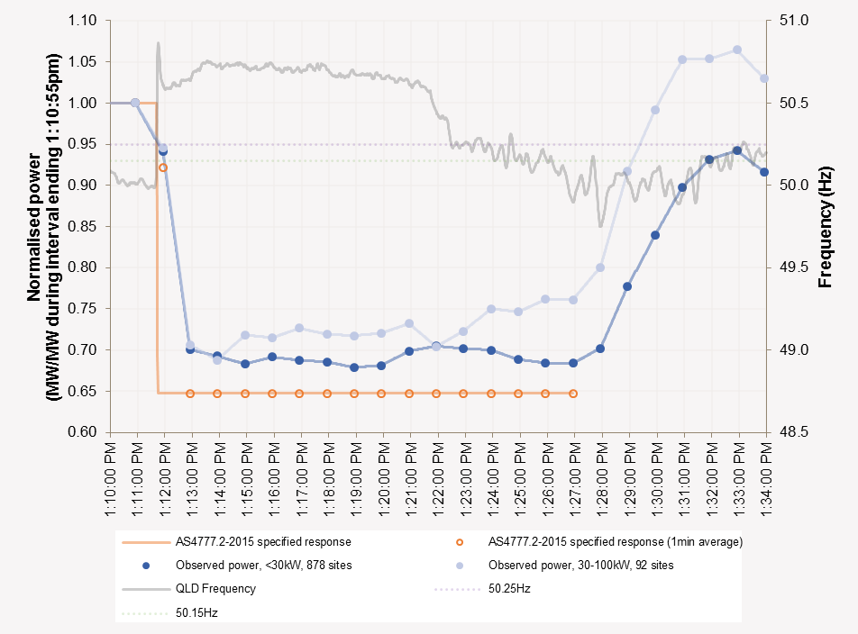

Figure 5 – Over-frequency droop response, Queensland DPV systems installed post-2016

As penetrations grow, DPV response to disturbances will have increased implications for the broader industry. AEMO identified these key risks to power system security in its recent RIS, stating:

*“Once penetrations have become significant at the regional level, the inability to see and actively manage DPV impacts almost all core duties of the power system operator, including managing the supply-demand balance in real time, system stability, and recovery and restoration following major system events.”[8]*

Further, AEMO notes that conservative measures may be required:

*“In the absence of such reforms, AEMO will increasingly need to recommend hard regional hosting capacity limits for passive DPV, which may necessitate moratoriums on new DPV installations or costly retrofit of existing DPV.”[9]*

In April 2020 AEMO adapted a constraint on Heywood interconnector (between Victoria and South Australia) by up to 180MW to manage identified system security issues related to the potential tripping of DPV following the possible trip of a large generator[10]. This is the first constraint update due to DPV behaviour however others are likely to follow as DER penetrations increase. These type of actions may have market implications and emphasise the value of better understanding DER behaviour, to avoid conservative measures.

### Fast-tracked review of AS/NZS 4777.2

The industry has initiated several programs of work in response to the growing threat to power system security posed by high penetration DER. Notably the recent fast-tracked review of inverter connection requirements: Australian and New Zealand Standard 4777.2, completed in 2020.

AS/NZS 4777 is comprised of two parts:

* AS/NZS 4777.1:2016 – Part 1: Installation requirements
* AS/NZS 4777.2:2020 – Part 2: Inverter requirements

The previous version of Part 2 (AS/NZS 4777.2:2015) dictated the required performance of distributed grid connected inverters under a range of local operating frequency and voltage conditions. It is important to note that this previous version of the standard was developed when DPV penetrations were relatively low and was therefore primarily concerned with distribution network impacts of DPV, rather than bulk system impacts such as power system security. As result, important ride-through functionalities were not clearly articulated.

The 2015 standard includes frequency and voltage points at which inverters must disconnect (‘anti-islanding set points’) in order to avoid PV systems exporting during network maintenance. This is vital for ensuring distribution network worker safety. It also specifies settings that relate to over voltage in the distribution network (including limits for sustained operation, Volt-Var and Volt-Watt mode).

The 2020 standard was published in December 2020 and incorporates a number of critical disturbance ride-through functionalities. A 12 month ‘transition period’ has commenced and the standard will come into effect on 18 December 2021. The review has been fast-tracked due to the concerns raised by AEMO in its Technical Integration of DER report:

*“The aggregate performance of the DPV fleet is becoming increasingly critical as penetrations increase. Without action, the largest regional and NEM contingency sizes will increase due to DPV disconnection in response to major system disturbances.”[11]*

The previous very of the standard was published in October 2015 and also allowed a twelve month ‘transition period’ in which the prior 2005 version could still be applied (Figure 6). A ce,prehensive review of inverter standards is provided in Appendix A and highlights the increasing complexity and precision of the control required.

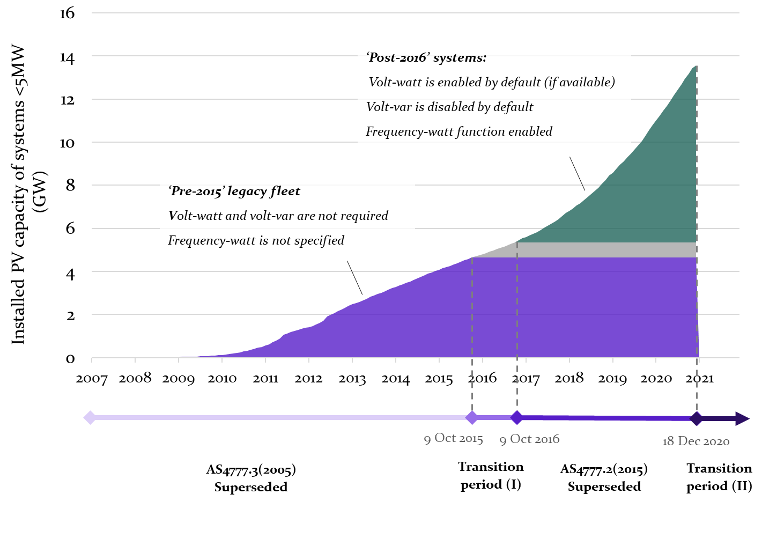

Figure 6 – Cumulative PV installations under the previous (2005) and current (2015) inverter connection standard

However standards alone will not address security risks. AEMO has identified the need to improve compliance rates in its Technical Integration of DER report, stating:

*“This level of apparent non-compliance is a significant concern, and requires further investigation to understand and address the root causes.”[12]*

Work is underway via UNSW bench testing and Project MATCH to develop new compliance testing capabilities. These efforts offer important and timely opportunity to develop compliance assessment processes that can be implemented alongside the revised standard.

### UNSW Addressing Barriers to Efficient Renewable Integration

ARENA’s grant to UNSW to investigate rooftop solar inverters has already created enormous impact. The research at UNSW has discovered that even the world's most successful rooftop inverter manufacturers were not aware of the limitations of their devices to ride through benign grid situations.

* Every inverter model responds differently to regular types of grid events
* This behaviour leads to the sudden reduction or cessation of power generated by the inverter, which when added up represents 30-40% (3-4 GW) of generation loss from 10 GW of residential PV inverters.
* This loss of generation can lead to grid instability, loss of revenue for the home owner, uncertainty in planning and credible contingency events
* Importantly, it leads to a need to radically increase the frequency that the grid is modelled as inverters are able to respond orders of magnitude faster than conventional plant
* The impact of inverter connected generation is already being felt by AEMO and our work is demonstrating wider transmission network operation impacts even before DNSPs need to be concerned by voltage management issues.

The main findings and conclusions from the work completed are as follows:

**1. The project is revealing a wide variety of unexpected inverter behaviours.**

The inverter bench testing is a core theme identifying the various reactions of the inverter portfolio to a wide range of voltage waveform disturbances. This understanding is now being embedded in the load-PV composite model which is a specific and valuable TSO modelling tool that enables the industry partners to understand and more precisely model the response of IBR to grid disturbances, Bench testing results confirmed the undesired behaviour of PV inverters to:

* Grid voltage phase-angle jumps
* Short duration grid voltage sags (80-220 ms sags from 1 to 0.2 pu)
* Rate of change of frequency (RoCoF)
* Power ramp-up rate during inverter start-up

**2. The responses of the inverter portfolio have been used to design and tune the model for distributed energy resource (DER) for the integration in Siemens/PTI (PSSE) software tool.**

Based on the data collected from the inverter test benchmarking, the accuracy of the DER model has been improved. The comparison of the recorded data from recent grid events with the model shows that the updated model based on the inverter test results closely matches the actual recorded data from the network. This fact shows the importance of inverter testing under various transients in the grid.

By identifying and raising awareness of the magnitude and urgency of this issue since 2019, UNSW’s research has already contributed to important outcomes, such as new regulations, new standards, new market participant, and a new invention:

**Rapid pathway from research to impact**

Impact that UNSW research has had on the DPV sector. Project funded by ARENA with AEMO, Electranet and TasNetworks as partners.

### UNSW Project MATCH

Project MATCH (‘Monitoring and Analysis Toolbox for Compliance in a High DER future’) is a three-year ARENA funded project led by UNSW in collaboration with AEMO and Solar Analytics[13]. The project commenced in January 2021 and will run until 2024. Its core objective is to establish robust characterisation of DER risks to power system security in the NEM, thereby reducing barriers to high penetration DER.

It builds on prior work undertaken at AEMO, UNSW and Solar Analytics to understand DER behaviour during disturbances, including:

* Addressing Barriers to Efficient Renewable Integration (section 1.1.4) and
* Enhanced Reliability through Short Time Resolution Data project led by Solar Analytics in collaboration with AEMO and monitoring device company WattWatchers[14].

The project consists of three main workstreams, each focused on increasing understanding of DER operation in the field using real-world data. Together, the workstream outputs are expected to inform AEMO’s PSSE and PSCAD model development, that underpin operational decision making such as the development of constraint equations and FCAS procurement (Figure 7). Findings on DER behaviour in the field may also inform future developments to inverter performance standards and installer training.

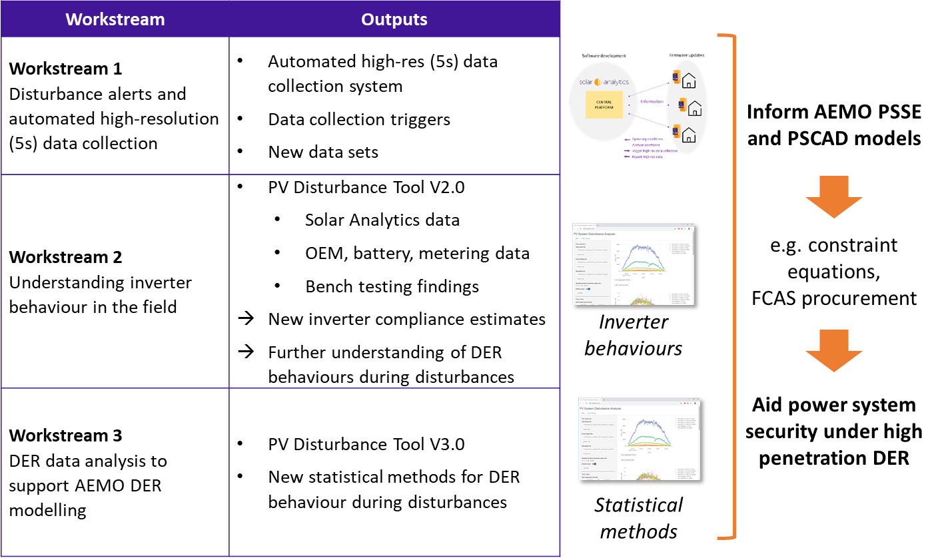

Figure 7 – Overview of Project MATCH scope and intended outcomes

Whilst it is valuable to analyse DER behaviour in the field using actual DER operational data (the focus of Project MATCH), this will necessarily only provide part of the picture as to how DER is behaving and the resulting risks and opportunities. Currently, Project MATCH is using data from DER in the field at 1sec-60sec resolution and therefore our understanding of DER behaviour during disturbances that occur over ~200ms is necessarily limited.

It is expected that understanding of DER behaviours will be improved through a suite of work as set out in the work program proposed in this document. For example, improved understanding of how voltage waveform distortions manifest across the power system could provide a valuable tool for understanding why certain DER operational behaviours are occurring in the field. Similarly, bench testing of inverters provides very high speed understanding of inverter performance.

The process of comparing findings across different projects and developing this deeper understanding of DER behaviour is non-trivial, and could constitute a substantial body of work in its own right.

## Energy Transition Goals

*Establish the relevance and importance of this research to the Australian Energy Sector and how it will enable the affordability and reliability of the electricity sector’s transition.*

* Enable ongoing DER deployment without requiring highly conservative power system operation.
* Avoidance of over-investment in equipment installed to address perceived security or stability issues in the network, or the corollary, to optimise, using the established accurate models of DER, necessary measures to avoid system stability or security problems.
* Increase the network’s capacity to accept DER by improved modelling and understanding of the fundamental responses of inverter-based resources.
* Provide modelling tools that can develop at the same pace of standard revisions, inverter performance improvement, grid operations including model adaptations that have to occur due to changes in grid architectures, network protections and market operations.

# Methodology and Beneficiaries

The methodology used in the development of the research plan involved the extensive consultation with stakeholders, the Steering Committee and Industry Advisory Board of the ARENA-funded grant “G00865: Addressing barriers to efficient renewable integration”, a number of individuals and groups of industry stakeholders whom we have presented and shared the results of our work.

|  |  |
| --- | --- |
| **Name** | **Organisation** |
| Jenny Riesz | AEMO |
| Jahan Pieris | Transgrid |
| Nigel Wilmot | Western Power |
| Hugo Klingenberg | Electranet |
| Andrew Halley | TasNetworks |
| Wai-kin Wong | AGL |
| Alex Watters | Ausgrid |
| Dave Edwards | Horizon Power |
| Simon Heslop | Solar Analytics |
| Caleb Ball | Reposit Power |
| Rizah Memisevic | Powerlink |
| Sebastian Henry | AEMC |
| Darren Gladman | CEC |
| Peter Kilby | Energex |
| Martin Hemphill | RES |
| Boris Celic | SAPN |
| Rod Dewar | Fronius |

|  |  |
| --- | --- |
| **Group** | **Organisation** |
| Inverter Working Group | CEC |
| Ausgrid NIAC | Ausgrid |
| ENA membership | ENA |
| Board and Executive | ARENA |
| Engineers Australia | Engineers Australia |
| Executive team | CEFC |

The methodology was predominantly based on the UNSW research team’s experience of developing the original ARENA-funded proposal and the resultant direction the project took once it was started. There were influences from discussions around the knowledge gaps in the current research program, our discussions at international meetings, conferences and symposia with academics also investigating these areas. The proposal is based on the rationale used to establish funding for the MATCH project and the existing ARENA research project whose outcomes have been creating significant impact and are detailed in their knowledge sharing links[15].

Some key points to address on this proposal related to beneficiaries and partnerships:

* The work plan can be executed at one site and that is reflected in this proposal. However, there are significant elements of the plan that can be divided between CSIRO and UNSW, which may also serve to accelerate, for example, the inverter testing aspects.
* AEMO’s continued involvement in the project is necessary to ensure domestic impacts and AEMO have clearly stated their wish for this work to continue. This should not be interpreted as a singular beneficiary of the outcomes. As evidenced by the current UNSW project, there are many of the necessary stakeholders on its advisory board from inverter manufacturers, VPPs, service providers, and distribution and transmission network operators. The project benefits all of these participants and maintains the privacy of the manufacturers of inverters. This project also has CSIRO representation on its advisory board.
* All of the expected outcomes from the project are important and significant for the expansion of renewable energy integration in Australia. Hence ARENA’s rationale and motivation to fund, alongside UNSW’s cash investment, the original project. Noting that UNSW has contributed 20% of the current project in cash.
* UNSW is well-placed to deliver particularly given the team has the capacity to deliver. Quick wins include regular model updates – the ability to keep pace with market is essential and we highlight the ARENA project’s rapid impact as an example of our capability.

# Plan Development

## Current Solutions and Industry Activities

The current ARENA-funded research project has AEMO’s DER group heavily engaged which both demonstrates AEMO’s commitment to UNSW’s capability and to the importance AEMO place on understanding the impacts on large portfolio’s of small-scale IBR. Much of AEMO’s work in this area is publicly available. The links below provide information on power system operations at high DER penetration. There are also further links from this page to more detailed documentation (consulting reports) on DER and load modelling and various AEMO reports related to power system operations, event reports, and management strategies.

A Capstone Report[16] summarises recent **AEMO activity** in DER that UNSW has contributed to via their inverter benchmarking. Critical to the importance of our proposal are the identified next steps from that Capstone Report:

*“There remain areas where evidence is sparse, particularly around DPV behaviour during frequency disturbances. AEMO has ongoing work programs and continues to work with stakeholders to improve the understanding of DPV behaviours. This includes continuing analysis of any severe disturbances that occur, continuing improvement in tools and methods for analysis of field datasets from Solar Analytics, and ongoing updates to power system models to reflect the latest findings. The behaviour of the DER installed fleet will also continuously change as time progresses and newer models are installed, and AEMO’s ongoing work program will aim to monitor these changes and reflect them in model development over time. Increasing the robustness of the available evidence of DER behaviours will give AEMO increasing confidence in the inputs to operational decisions around management of power system security, and facilitate more targeted modification to power system operating processes to maintain security where necessary, reducing market impacts where better evidence allows less conservative assumptions to be applied. The improved evidence will also assist network operators and other relevant stakeholders in meeting their obligations to ensure modelling data used for planning, design and operational purposes is sufficiently complete and accurate.”*

The critical comments in the above exposition of the next steps are evidence of the need to continue and expand the portfolio of inverters benchmarked as well as the underpinning research tasks (later represented in Figure 9) that enable an enhanced understanding of inverter-based resources. The comments above also map onto related GPST questions (Section 3.2),

* The behaviour of the DER installed fleet will continue to change (GPST Q6, Q10, Q12)
* Evidence of DER behaviours are inputs to operational decisions around management of system security (GPST Q12, Q44, Q45, Q46)
* Targeted modification to power system operating processes are necessary to maintain security (GPST Q45, Q46)
* Better evidence for less conservative assumptions is critical (GPST Q21, Q45, Q46)
* Meeting obligations to ensure modelling data used for planning, design and operational purposes. (GPST Q46)

The Capstone Report makes a compelling case for our proposed methodology and work plan. Essential to our proposal is the lack of existing research and development programs addressing this challenging area. We have surveyed and reviewed both national and international programs.

**Australian Research Council (ARC) Projects**

Relevant **ARC-funded** projects are listed below with a brief summary of their anticipated outcomes:

**Medium voltage DC: Enabling active, flexible and efficient power networks**. The University of New South Wales

Medium voltage DC (MVDC) systems promise to offer the required flexibility in next generation active electricity networks to enable higher renewable energy integration, take advantage of more readily available energy storage, and manifest simpler control and operation. The intended outcome of the Project is to address the challenge of developing MVDC networks via an integrated and cohesive approach, from the initial design of the individual power electronics converters, right up to network design and "system of systems" implementation. The outcomes of the Project will provide clear pathways and solutions for new topologies, facilitating Australia’s and the world’s transition to next generation electricity infrastructure.

**Breaking Performance Limits of Solar Inverters for a Sustainable Future**. The University of Sydney

Micro-inverters offer a unique ability to maximise solar energy yield and streamline the installation, operation and maintenance process of solar power generation, thus having huge potentials to drastically reduce the cost of solar electricity. However, performance limits have hampered their wider applications in the energy sector. This project aims to tackle the performance challenges of micro-inverters by developing a novel power-conversion architecture, a unified design framework, and a new control theory. The intended research outcome will be a new range of ultra-high-performance micro-inverters.

***There is no mention of what aspect of performance that will be broken in this project nor any emphasis of the interaction with the grid which our previous research has demonstrated is critical.***

**A Next Generation Smart Solid-State Transformer for Power Grid Applications**. University of Wollongong

This project aims to design, develop and implement a next generation, compact and light-weight, smart solid-state transformer with a newly developed high-frequency magnetic link and power converters that will provide a better and faster voltage transformation and regulation and support the power grids. The proposed research will revolutionize the power grids by replacing the traditional transformer with a new device made of solid-state power modules that will have multi-feature and multi-function ability and control facilities. The technology developed in this research will help make energy networks more efficient, smart, reliable and flexible, having direct benefits to renewable energy growth, with long-term impact on national economy. The nature of the solid-state transformer necessitates synchronisation to the grid so is effectively an inverter-based resource controlled by a high-frequency control element.

***There is no mention nor any emphasis on the importance of the interaction with the grid which our previous research has demonstrated is critical.***

**Transforming Microgrid to Virtual Power Plant –ICT Frameworks, Tools, Control**. The University of New South Wales

The project aims to enhance large scale renewable penetrations to national power grid by advancing control, optimization, and ancillary services of Virtual Power Plants (VPPs), considering different disruptive events including recent South Australian blackout. This project expects to create new control, frame communication architecture, develop plug and play type IoT enabled grid interfacing inverter, and optimize resource management for distributed VPPs. The anticipated benefits from this institutional level collaborations are that VPPs help in enhancing national power grid operations during normal and disruptive conditions when more renewables are connected and also secure benefits of consumers, prosumers, and grid operators.

***The technology developed in the project is completely dependent on the inverter remaining connected to the grid in all circumstances. Our bench testing of inverters has shown that this is not a reliable assumption to make.***

**Advanced Microgrids for Residential, Commercial and Industry Buildings*.*** Griffith University

The project aims to develop and commercialise an Advanced Microgrid Energy-Management System (AM-EMS) to enhance the energy efficiency of residential, commercial and industry buildings. It will allow the industry partner to integrate their existing products in AM-EMS with maximum returns. The intended outcome of the project is an AM-EMS with optimised energy scheduling and distribution, incorporating renewable energy sources and battery storage systems. End-users will benefit from reduced energy costs, improved energy efficiency and reliability, with the added benefit of new and innovative clean energy technology. The research community will benefit from new knowledge that will underpin international improvements in energy efficiency.

***The technology developed in the project is completely dependent on the microgrid inverters remaining connected to the grid in all circumstances. Our bench testing of inverters has shown that this is not a reliable assumption to make- even more so with microgrid systems that are more fragile than the large-scale grid that represents the NEM.***

**Stability Assessment of Australia’s Future Electrical Grids**. The University of New South Wales

This project promises a unique insight into the dynamics of asynchronous power generators in weak power grid condition, to facilitate their comprehension and mathematical description and to develop well-suited simulation techniques that can capture the potential instabilities. The breakthrough derived from this project will provide the least costly system strength remediation scheme, ensuring generators survive more severe, lower probability non-credible contingency events. It will also provide additional guidance for regulators on introducing new generator performance standards, promote energy independence and sustainability, and eventually lead to a low-carbon economy in Australia.

***This project is seeking to model the stabilities of inverter connection to weak grids. This work begins to suggest that there may be challenges but it is not clear how this addressed the practical issues of remaining synchronised to the grid under the wide range of possible fault types.***

The ARC projects highlighted above are not considering the current state of the electrical network and the practical challenges of implementing a rapid transition of electrical energy systems and concurrently absorbing, through the electrification agenda, the demand of existing fossil fuelled energy in transportation, heating, power to fuels and energy efficiency.

**ARENA-funded Projects**

In addition, there are many **ARENA-funded projects** investigating elements of IBR control, typically at longer time constants and at higher power capacities than the proposed work. Examples include:

**Victorian Distributed Energy Resources Marketplace Trial**: a project that implements a prototype marketplace for trading of DER resources in the so-called Energy Demand and Generation Exchange. Registered market puarticipants, using customers’ DER, will submit bids to the marketplace that are visible to distribution networks to increase the reliability and resilience of the whole system.

**Stability Enhancing Measures for Weak Grids Study**: A study that will characterise system strength and assess options through design, control and configurations including new control systems for renewable energy generators, synchronous condensers, and grid-forming inverters. The study uses the West Murray region of the NEM as a case study due to the region’s current system stability challenges.

**Central West NSW Energy Zone Detailed Scoping Study**: The Central-West Orana region has been chosen for the pilot due to the existing investment, investor interest, relatively low build costs and a strong mix of solar and wind resources. The REZ is expected to deliver new electricity to help fill the anticipated gap from the retirement of ageing power stations in NSW and will unlock at least 3000 MW of new electricity capacity by the mid-2020’s.

**Gridded Renewables Nowcasting Demonstration over South Australia**: Forecasting electricity generation from renewable energy resources on a day ahead or short-term basis is essential for the management of networks with high shares of renewable energy. Existing technologies used to predict the ‘nowcasting’ (i.e. 5 minutes to 6 hours ahead) forecast horizon are based on numerical weather programs, which update two to four times per day. These models leave gaps in the nowcast predictions, which can affect the security and reliability of electricity supply.

**Impact and Management of Harmonic Distortion for Large Renewable Generators**: Electricity network operators are obliged under the National Electricity Rules to manage harmonic distortion levels on electricity networks. This is achieved by allocating ‘emission limits’ to those seeking to connect to networks including renewable energy Independent Power Producers (IPPs). Methodologies for emission allocation are complex, require large amounts of data, and may not be fit-for-purpose or technically robust. The difficulties in applying, and the uncertainties associated with, the use of present methodologies are creating significant and meaningful barriers to the uptake of renewable energy resources.

Other notable international research efforts (though by no means exclusive) include [UKRI’s Networks program](https://epsrc.ukri.org/research/ourportfolio/themes/energy/programme/what-the-energy-programme-funds/networks/)[17], NREL’s [Grid Modernisation](https://www.nrel.gov/grid/index.html)[18], and EPRI’s [Energy Storage and Distributed Generation](https://www.epri.com/portfolio/programs/053125)[19] portfolio.

Whilst there is substantial activity in various specialised research areas related to inverter control and controller design it is clear that many of these do not focus on the practical implementation and associated limitations that are imposed by standards and regulations, nor does the work make serious attempts at considering the economics of inverter design and control.

Other areas that we must explore include the “reach” of transmission level faults across the distribution network, particularly the impact of substation transformer configurations that often have national, state and regional differences much of which is ignored in the research community as it limits the generality of published works. This is an area that requires theoretical analysis, modelling and practical investigation, for example, looking at high frequency sampled data at various points in the network across a range of voltage levels and locations to try and tie together the impacts of faults outside the distribution network.

## Key Research Questions

1. What pilot studies must be performed on the network to better understand the behaviour of DER to grid disturbances?
2. What international activity is underway and the extent of this activity, and what opportunities are there for our research in DER in Australia to be of practical use in other regions? What are those regions and how do we engage and with whom?
3. How do we future-proof the technical interventions being made in the LV network to solve other technical or regulatory challenges given the likely impacts of increased penetrations of DER within the areas of influence of those interventions? (examples include, community batteries, charging infrastructure, phase balancing equipment, STATCOMs, microgrids, voltage restorers, REZs, HVDC etc.)
4. How have standards for inverters evolved internationally around disturbance ride-through, response time definitions and power quality modes? Where do we see the technical requirements evolving to?
5. What are the possible interactions between inverter responses to network dynamic operating envelopes and major power system disturbances. What have we seen happen? What can we predict will happen in the future following the various scenarios in AEMO plans?

In relation to the GPST questions, the proposed research contributes to answering the research questions listed below. Where appropriate, the relevant Practical Deployment, Research and Development activity in this proposed program of work is included along with a link to the next section of this report for further details.

|  |  |
| --- | --- |
| **GPST research questions[20] & UNSW’s proposed program of work:** | **Research Program:** |
| 6. Are the black-box models (impedance-spectrum and binary code) favoured by manufacturers for disclosure sufficient for stability assurance and system design across all problem types?  **Inverter** **benchmarks**  Section 4.5.1 | Inverter Design |
| 10. What is the future of frequency control as the synchronous generation fraction reduces? Might tightened or loosened frequency limits lead to a more reliable, secure, lower cost IBR-based power system?  **Inverter** **benchmarks**  Section 4.5.1 | Inverter Design |
| 12. What approaches can be taken to near real-time system modelling with large quantities of IBR that make design for system stability sufficiently accurate and still tractable?  **Inverter** **benchmarks**  Section 4.5.1 | Tools and methods |
| 19. What tools and methods are needed to identify the best mitigation strategies for voltage-collapse problems under high IBR conditions? And how effective is IBR in recovering from deep voltage dips (bearing in mind lack of short-term overload current)?    emergency measures  Section 4.4 | Tools and methods |
| 21. How can system operators get relevant real-time visibility and situational awareness of the state of the power system with increasing penetrations of IBR and DER?    roll out revised AEMO tool set  extend AEMO’s tool set  Load-DER composite model  DATA DRIVEN aggregation techniques    Section 4.4  Section 4.6.1  Section 4.6.5  Section 4.5.5 | Control Room |
| 44. What studies and metrics are required to evaluate resource adequacy with hybrid plants (e.g. PVplus-storage) and virtual power plants?    dynamics of power quality modes  Section 4.5.4 | Planning |
| 45. How do system operators adequately account for extreme events in planning studies, particularly those that impact the resources used in a high renewable energy future (wind, solar, demand side flexibility)?    security issue identification  Section 4.5.3 | Planning |
| 46. What mechanisms are necessary to accurately model and account for DER in planning exercises to ensure a reliable power system is being planned? What data is necessary to accurately model various levels/paradigms of DER control, including influence on under frequency load shedding schemes?    DER DISTURBANCE MODELLING FOR NSPs  der and network Dataset mapping  fault and disturbance propagation  **Inverter** **benchmarks**    Section 4.6.6  Section 4.5.7  Section 4.5.6  Section 4.5.1 | Planning |

# The Research Plan

The proposed program of work has been designed to deliver five practical deployment outcomes that support the stated objective. Each deployment outcome requires supporting research and development work as shown in Figure 8.

**Research**

**development**

**Practical deployment** **Pathways**

**OBJECTIVE**

Ensure that ISOs and TSOs are able to maintain power system security under very high penetrations of IBR such as distributed PV, energy storage, and other resources including inverter-based demand.

*Section 4.2*

*Section 4.3*

*Section 4.4*

*Section 4.5*

Figure 8 – Research Program high-level overview

The plan is structured as following: in section 4.1 the problem is described, and in section 4.2 the objective of the proposed program of work is stated. In section 4.3 an overview of the program of work is presented, with the practical deployment outcomes detailed in section 4.4. Sections 4.5 and 4.6 then provide further detail on the research and development work necessary in order to achieve these deployment outcomes, and ultimately, the stated objective. Section 4.7 then offers a means of prioritising the program of work and identifying gaps.

## What is the problem?

Australia has over 10GW of installed PV Generation using inverters rated under 10kW. UNSW’s current inverter benchmarking suggest that over 50% of this inverter-based resource will behave undesirably (disconnection or power curtailment) if exposed to a voltage sag of 0.5 pu for 220ms. This represents a clear threat to system security. Similar inverter technologies will drive energy storage systems, hybrid storage inverters, commercial and industrial systems and vehicle charging. It is vital to continuously assess the performance of the inverters to the types of faults and grid disturbances that they are exposed to in the current grid.

Importantly, the grid disturbances and faults of the future, whose characteristics will be very different to disturbances today, must begin to be considered. We are only just starting to understand the threats of mass inverter disconnections in today’s relatively slow-responding but high fault level system. As fault levels all but vanish, and fast-acting inverter controllers operating at significantly higher switching frequencies can make decisions and deliver response times orders of magnitudes faster than today, the risk of mass disconnections will be ever present. So we need this project to highlight issues early on, use the results to ensure standards keep up with technology developments, use inverter benchmarking to continue to adapt our load models that now must account for rapidly-responding distributed energy resources, and research solutions to these problems. In parallel, for the nation we must generate IP, and create jobs and wealth.

**Standards** will have to evolve rapidly. **Emergency measures** may become commonplace. All **stakeholders** will need to be continually educated on the changing landscape and **knowledge shared**. These are all huge, ongoing efforts and core to this proposal.

## Objective

The objective of the proposed research program is to ensure that ISOs and TSOs are able to maintain power system security under very high penetrations of IBR such as distributed PV, energy storage, and other resources including inverter-based demand. Australia is uniquely placed to deliver valuable insights to ISOs and TSOs internationally, due to its distant and poorly-interconnected power system and substantial, if not world-leading, deployment of distributed solar PV systems, as well as a growing fleet of distributed battery energy storage systems.

## Targeting Deployment through Research and Development

In order to achieve the proposed five practical deployment outcomes, research and development work is necessary. Figure 9 provides an overview of the research and development activities that have been identified in this proposal.

The proposed practical deployment outcomes are detailed in section 4.4, with supporting research activities detailed in section 4.5 and development activities detailed in section 4.6.



Figure 9 – Research Program overview: Research and Development supporting Practical Deployment

**project: ensuring system security and modelling fast load-der responses with high penetrations of IBR**

**(for Transmission network operators, planners and market operators)**

***\*Project MATCH contributions***

roll out revised AEMO tool set

**development**

extend AEMO’s tool set

NEW INNOVATIONS AND TECHNIQUES

guidance and guidelines

standards developments on compliance testings

Load-DER composite model

DER DISTURBANCE MODELLING FOR NSPs

**Research Engineers**

**Technology Translators**

**Research Assistants**

Stakeholder Engagement

emergency measures

standards revisions

NEW INNOVATIONS AND TECHNIQUES

**deployment** **Pathways**

**Inverter** **benchmarks**

Laboratory behaviour

field responses

Rooftop PV

Hardware in the loop

Laboratory behaviour

field responses

Hardware in the loop

Storage

Laboratory behaviour

field responses

Hardware in the loop

C & I

Laboratory behaviour

field responses

Hardware in the loop

DPV three phase

Laboratory behaviour

field responses

hybrid pv/store

Hardware in the loop

**Research**

NEW innovations and Techniques “HAM ESTIMATION” "identification

security issue identification

dynamics of power quality modes

fault and disturbance propagation

DATA DRIVEN aggregation techniques

der and network Dataset mapping

**Research Fellows**

inverter responses and sensitivities

***\*Project MATCH contributions***

## Practical Deployment Outcomes

**Practical deployment** **Pathways**

In order to achieve the stated objective, the proposed program of work supports **practical deployment (on the grid)** outcomes. There are five main outcomes envisaged, these are:

1. ***Roll out revised AEMO tool set*** for Load-DER modelling including revisions required to include higher penetrations of IBR throughout DNSPs networks. This objective is met through the examination of responses from the Inverter Benchmarks task that will provide the necessary laboratory evidence of individual inverter performance, in combination with outputs from Project MATCH using real-world operating data from DER in the field[21]. The unusual behaviours of inverters during grid disturbances demonstrates the necessity of adapting and augmenting existing load-DER models to account for their performance. The necessary extensions of the inverter benchmarking activity include new application sectors (commercial and industrial applications of IBR), sectors adopting new technologies (hybrid PV/storage rooftop systems, energy storage inverters, three-phase inverters) and revised standards and regulations as they evolve during the transition.
2. ***Innovation Roll Out*** is a place-holder for technology development and deployment through the work program. The “HAM estimator” technique is a prime example of where high quality research in two different engineering disciplines have solved a significant issue. In this case, one example is illustrated but there are more IP Disclosures at UNSW and of course the proposed work here will include research elements that will generate new IP and commercial opportunities. “HAM estimation” currently offers the unique feature of being able to re-establish and converge on the phase and frequency in a guaranteed single cycle of the mains supply. This convergence rate solves many of the recent inverter misbehaviours that AS4777:2020 attempts to solve. Underpinning the roll-out of this novel estimation technique is the need to finish completely the laboratory assessment of the technique, the analytical framework to prove the performance, and finally deployment of this IP. The IP includes calculation methods, identification methods and hardware/software algorithms.
3. ***Standards Revisions*** may be necessary to maintain currency in the relevant standard and the need of the network and market operators to guide or prescribe IBR responses to avoid contracting for massive contingencies at risk and with cost. The most recent version of AS4777 is 2020. This revised standard was significantly overhauled and many of the **substantive changes to the standard and associated compliance tests are entirely-based on UNSW’s current ARENA project** “addressing Barriers to …”. These changes have led to the requirement for ride-through of both fast voltage sags to 50V for between 80 and 220 ms, and to ride through voltage phase angles jumps of 60o. There are already areas that UNSW has noted in the AS4777:2020 revision that will need tightening up **including response time-scales.**In addition to the updating standards and testing procedures, there is substantial work required to understand how standards are being applied in the field. A core focus of Project MATCH is on developing methods for assessing in-field DER data to understand whether inverters are performing as expected under the standards. Findings may indicate the need for industry action beyond revising the standards, such as installer training, or requirements on how inverter are configured when imported.
4. ***Emergency Measures*** A core theme and impact of the proposed work is **to support AEMO’s need for technical expertise** and **testing capability** and **capacity**, the ability to interrogate the responses of different inverters, **understand these responses** and assist in the process of incorporating the varied responses into the Load-DER Composite model and from the model outputs determine modifications to standards and emergency methods (such as SA’s VDRT requirements).
5. ***Stakeholder Engagement*** the increasing impact of DER on the bulk power system is requiring a growing number of stakeholders from across the electricity supply chain to interact in new ways. For example, PV installers have not historically needed to consider bulk power system implications of residential PV installations, however individual PV commissioning decisions are aggregating to severe power system outcomes. Likewise, DNSPs have not historically been responsible for power system security, however improved understanding of the distribution system – including disturbance propagation – is becoming key. A critical piece of work is therefore to build effective relationships across the many stakeholders, as well as appropriate knowledge sharing forums and cultures.

## Research Elements

**Research**

The key elements of research highlighted in Figure 9 are required early on in the life of the project to prime the delivery of the key areas of deployment described earlier.

As outlined in section 1.1, the benchmarking work undertaken to date has proven to be extremely valuable to AEMO and considerable work remains. Section 4.5.2 provides a detailed outline of how this work can be progressed. Each of the other proposed research elements from Figure 9 are then detailed in the remainder of this section.

### Inverter responses and sensitivities

Rationale: Distributed generation inverters demonstrate diverse responses to the same fault or grid disturbance. Standards only test for a narrow set of disturbances

UNSW’s ongoing inverter bench-testing (see ARENA project that reaches completion in late 2021) has identified a broad variety of inverter responses to common types of grid disturbances. New tests based on special network conditions such as fast voltage sags (see SA VDRT), phase angle jumps, rate of change of frequency (RoCoF) have further exposed a broad range of inverter responses and in many cases, inverters show undesirable responses including power curtailment or even disconnection.

Research: The definition of the inverter testing regime is paramount as it is the type of tests conducted that will tease out the requirements of the next revision of the relevant standards (e.g. AS4777:2020 in Australia, please refer to Appendix A for a list of other international standards). Other critical elements of this research work specifically related to inverter performance tests and their contribution to modelling are the development of advanced bench-testing facilities including the following capabilities:

* High power setup to test inverters up to 250kVA,
* Linear amplifiers for more accurate replication of grid disturbances
* HiL integration
* Multiple paralleled inverter systems

These are necessary to perform the type of advanced tests required as inverter standards evolve around issues related to unusual inverter responses.

As part of the project, UNSW will develop a multi-purpose HIL platform for testing of OEM inverter control products that will be available for use by inverter manufacturers alongside researchers, enabling high-quality knowledge exchange and understanding. Furthermore the platform provides a nationally-important capability for testing more advanced experimental firmware upgrades and pre-production performance assessment prior to deployment in Australia.

**Inverter** **benchmarks**

#### Inverter Benchmarking

We have identified five application areas to address in Figure 9, each area (Rooftop PV, Storage, Commercial and Industrial, Three-phase Systems and Hybrid PV/Storage) requiring inverter testing in the laboratory on a test facility that can generate operating envelopes from nominal to those during extreme events. The purpose is to test inverter technologies when exposed to grid disturbances that are experienced in the field. Noting that the characteristics of faults and disturbances will change in time as IBR become more prevalent. In order to reduce the scale of power hardware-in-the-loop testing required, the proposal includes benchmarking control hardware-in-the-loop against power hardware-in-the-loop and from there make greater use of the more rapid evaluation offered by control HIL.

In parallel we need to develop the capability to observe at high sample rates the transmission of grid disturbances through the network, and capture the response of inverters to these events. This provides the essential capability of tying together the laboratory testing results, the HIL models and the in-field responses.

In the residential PV sector those 25 most popular inverters captured around 20% of the installed capacity which we believe is a reasonable compromise between the practical numbers of inverter makes and models that can be tested, and the aggregated total generation these popular inverters represent. Once you go down to around the 30th most popular inverter model, the net increase in the installed capacity from each additional inverter tested is less than Access to the detailed information of all ~1.8 million systems installed in Australia (up to end of March 2018). CEC involvement may support timely updates to these statistics.

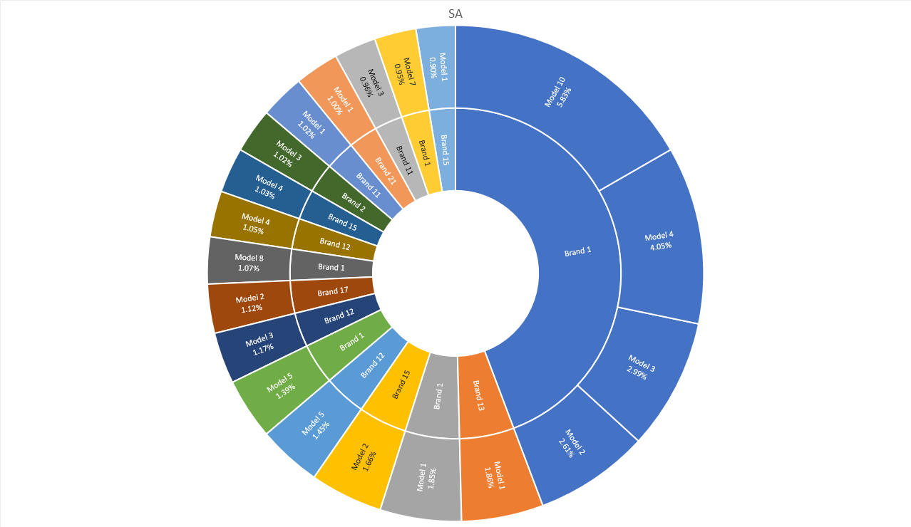

Figure 10 – Example chart showing Brand (manufacturer) and inverter model of most popular inverter makes and models, in this example, installed in South Australia (2019 data)

Figure 9 is an example showing the spread and popularity of rooftop PV inverters in South Australia. The percentage represents the overall contribution of the make and model to the total rooftop PV inverter capacity in South Australia. Using this type of data allows the team to focus on capturing the responses of the popular inverters thereby maximising the coverage of our testing. Please note that the inverter manufacturer and model is anonymised and that must be publicly maintained through the project. We have these breakdowns, Figure 10, for all states: SA is shown as an example.

Key areas for inverter benchmarking include the following:

* Benchmark the inverters for each of the identified sectors and types. When necessary due to available testing infrastructure limitations (Voltage, current, kVA) recourse to Control Hardware-in-the-loop coupled to a real-time simulation capability is made. Sectors/applications: rooftop PV, storage-only, commercial and industrial systems, three-phase systems and hybrid PV/storage inverter systems. There is scope to include EV interfaces as and when their population (MW and MWh) grows to a significant value. **UNSW has a mature testing facility to deliver rapidly test results for <8kVA inverter systems along with a test procedure that has been used for 2 years and which has evolved through experience of testing 30+ inverters for 2005, 2015 and developing the test regime for 2020 revisions to AS4777.**
* The understanding gained through in-lab testing of inverters is complemented by in-lab testing of responses to specific grid events via PHIL (Power hardware in the loop) with DER. This is further verified by interrogating in-field inverter behaviours. Appendix B is specifically focused on HIL for PV inverters and from which it is clear there is very little published work other than testing single inverters and on occasion two in parallel. Our proposal will investigate more realistic conditions and systems including the ability to ‘play back’ field measured voltage conditions during disturbance events.
* In-field disturbance propagation from the HV to MV and LV networks requires assessment to help understand how, for example, voltage phase angle jumps and associated voltage sags are transmitted through the system. This requires existing datasets to be gathered and analysed, and will likely require the installation of additional monitoring.
* There is significant effort in then interrogating observed voltage disturbance propagation across the range of different applications/inverters that have been tested in the lab to help understand learnings and impacts in aggregate. It is necessary to log historical responses to address the issue of embedded IBR responses no longer satisfying the standard of the day.

### New Innovations and Techniques

Modest but important resources are allocated to research and develop techniques that solve any emerging challenges related to the performance of inverter-connected resources, new performance requirements imposed by standard making authorities or measures from network operators. These could include improved methods of frequency, phase and magnitude estimation at the point of common coupling, communication techniques that can be used in local areas to assist in aggregating sub-cycle responses, robust synchronising techniques, and control systems that can adapt and blend inverter responses.

In addition to these, the improvements in power semiconductor technologies will lead to increasing switching frequencies, improved current control bandwidth, and the potential to provide more useful services to the local network. Some of these opportunities could be explored as part of this research package.

### Security issue identification

The power system security risks posed by DER response to disturbances are evolving as the DER fleet continues to grow. ISO and NSP operational decision making therefore require ongoing assessment of security issues related to DER. For example, early work has been undertaken by NREL to assess the volume of DER generation impacted by the trip of various transmission lines [ref]. This constituted a significant modelling exercise and similar work is required in Australia.

This body of work required the development of methods to assess likely DER impacts on security, potentially in real time as well as identification of potential future ‘high risk’ conditions. It will require modelling of DER behaviour such as via composite load models, in combination with ISO and NSP risk assessments such as contingency analysis.

Substantial efforts are required to establish operational practises around DER risk assessment, and then to update these methods as new information becomes available.

### Dynamics of power quality modes

Rationale: Both large-scale inverter-based resources (IBRs) and DGs are expected to respond to disturbances and abnormal conditions in the network they are connected to. For large-scale IBRs, such as windfarms, solar farms and large-scale battery energy storage systems, a process that confirms that the system meets certain grid performance standards is undertaken before the plant can be fully energised. However, such rules do not directly apply to systems below 5MW and in many cases, the response of DG inverters is based on factory settings and predefined firmware. The responses of DG inverters are typically defined by grid standards on a static axis as a range of power quality (PQ) responses that link two static variables (e.g., Voltage with reactive power, frequency with active power etc). Faults in a power system are dynamic and develop as a function of time, in many cases within a few fundamental periods. DG inverters need to respond to grid conditions that also considers the temporal evolution of a disturbance.

Research: It is critical to evaluate and understand the dynamic response of inverters for the different power quality modes that the DG inverters need to provide. As a first step, this can be done based on standards testing as well as bench-testing for specific grid conditions (see. SA VDRT). The inverter overall responses should inform the extension of current standards / inverter technical specifications to include time, i.e., a “Volt-Var” response should include the temporal aspect of a “Volt-Var-time” response to ensure that DG inverters can provide the necessary grid support and in an appropriate time interval. Such considerations should also include the definition of dynamic envelopes for inverters and the impact they have on inverter design e.g., whether oversizing the inverters is a practical solution.

A critical question that also needs to be answered is whether requiring a homogenous response from all DG inverters actually supports or endangers the system at high DG penetrations and whether a degree of variance should be also included.

### Data Driven Aggregation Techniques

Data driven analysis and aggregation techniques are essential for understanding actual in-field behaviour of DER. Whilst there are limitations, data driven techniques offer complementary tools, along side in-lab benchmarking and power system modelling, to understand DER behaviours. Data driven aggregation and analysis techniques are particularly valuable as a means to:

* Verify the accuracy of power system models,
* Capture diverse DER behaviours in response to complex conditions, and
* Identify ‘unknown unknowns’.

Data driven upscaling of DPV response is already being applied by AEMO to verify its Composite Load Models with DER**.** Through this technique, operational data from a sample of DER sites during a disturbance is scaled based on key characteristics of the DPV fleet to estimate the overall change in DPV generation over the course of the event. Key characteristics of the DPV fleet include the installed capacity, proportion of DPV systems above 30kVA (these are subject to different requirements than small systems), the inverter connection standard in place at the time of installation, and in some cases, the proportion of particular manufacturers represented in the dataset. Currently, this method relies on a high-quality dataset provided by solar monitoring company, Solar Analytics [ref], that typically contains hundreds to thousands of DPV sites. Further work is required to estimate the error in this upscaling process, building on initial work already undertaken by AEMO. In addition, further work is required to identify and analyse a broader array of datasets, and to encourage growth in the prevalence of relatively high-resolution in-field DER data.

Analysis of actual in-field DER behaviours is also important for assessing the diverse array of DER behaviours that may occur, particularly given the complexity of how disturbances manifest across the distribution system. For example, under-voltage disturbance events are known to cause load ‘shake off’ and this can result in localised over-voltage conditions. DER may therefore respond to the original under-voltage disturbance, or the resulting over-voltage conditions in the local network. In addition, previous analysis has shown that the depth and duration of DER response during disturbances can vary significantly, and that spatial analysis offers a useful tool to understand the potential DER fleet behaviour.

Finally, given the diversity of the DER fleet and complexity of disturbance events, operational data analysis is critical to identifying ‘unknown unknowns’. For example, data driven analysis of DPV has identified that significant proportions of inverters do not appear to behave as expected under the inverter connection standard, AS4777.2-2015. This suggests non-compliance with the standard in the field, which was a previously unidentified issue.

Whilst data driven techniques are valuable, they also have limitations including sample size, the suitability of specific measurement approaches, as well as sampling frequency and interval. Data driven techniques are therefore likely to be most valuable in combination with other means of interrogating DER behaviour, such as benchmarking and analysis of disturbance manifestation across the power system. Figure 10 provides an illustrative example of how the proposed program of research could build a more complete picture of DER risks to power system security through combining a number of research techniques.

There is a range of timescales and spatial areas that must be considered when assessing inverter behaviours and their impact on the grid.

Figure 11 – Complementary analysis techniques to assess DER behaviour during disturbance events (illustrative only) [22]

### Fault and Disturbance Propagation

Rationale: Conventional analysis of power system protection is highly centralised and typically considers downstream faults propagating upstream of the distribution system. The design of such protection systems also assumes high fault currents, or at least fault currents that are sufficient to trigger overcurrent protections and distinguish between faults and conditions of high loading. Protection coordination that determines protection relay settings and characteristics is also based on downstream faults. Under major network disturbances, as a last resort, underfrequency load shedding (UFLS) with disconnection of large sections of the distribution network is considered.

However, in systems with high penetrations of distributed generation, load shedding can result to a substantial loss of generation, causing additional responses to redress power balance and the potential for power deficit if the system recovers quickly. As the power system transitions, the most likely scenarios include more generation connected in the distribution network. Faults at the transmission level can lead to disconnection of substantial percentages of distributed generation particularly during peak generation.

Research: There is a critical gap in understanding fault transmission and propagation from the transmission network to the distribution network and the impact of transmission network faults on DGs, an area of power system protection that has not been fully explored and understood, since the potential impact with low DG penetration is likely small. Beyond that, there is a need to understand the impact of network topologies and configurations in fault propagation. This extends to voltage sag and voltage phase angle jump characterisation as well as developing real-time models of low-voltage distribution feeders for detailed modelling and bench-testing. This work can then inform the development of fault propagation “heat maps”, highlighting critical areas of the transmission network where faults are likely to cause broad DG disconnections as well as areas of the distribution network that are specifically vulnerable to large-scale inverter curtailments or disconnections. Vital research that underpins all of these research elements is the development and verification of appropriate models for distribution feeders to enable HiL testing of inverter-based resources. Appendix B highlights the scarcity of research in this area which does not extend beyond single inverter tests for a limited set of local network events.

### DER and network dataset mapping

In addition to data driven analysis of DER operational behaviour using known datasets, a useful piece of work is required to ‘map’ the existing and emerging DER and network datasets. That is, to identify all datasets that exist already or are becoming available in the near term (next 2-5 years) that report on operational conditions across the power system during disturbances at a useful time resolution.

The purpose of this work would be to ensure that AEMO, NSPs and researchers have the greatest degree of visibility possible during disturbance events, to improve the quality of analysis and operational decision making. As outlined above, no two disturbances are alike and how they manifest across the power system can be complex, making analysis of DER risks challenging.

This project would be anticipated to involve the following steps:

* Identify existing and emergent sources of relatively high resolution (60 seconds or less) DER operational data. For instance, VPP data and ‘smart meter’ capture of extreme voltages.
* Identify existing and emergent sources of high resolution (voltage wave form) network data from across all voltage levels, and ideally including some measures at DER installation sites. For instance, power quality monitoring.
* ‘Map’ the complementarity of these data sets through detailed review of data collection methods, time scales, locations and accessibility. This would likely draw on static data sources such as the DER register.
* Coordinate resourcing to support data access for ISOs, NSPs, researchers.
* Develop data access platform, documentation, maintenance and process for extension as new datasets become available.
* The identification of valuable areas to extend monitoring, and installation of appropriate equipment.

It is noted that there are substantial barriers to successfully delivering this project, including data privacy requirements, adequate resourcing and the high degree of complexity. However even small, incremental steps could significantly aid in the understanding of how disturbance events manifest and how DER response across difference elements of the power system.

## Development Elements

**development**

These development elements support the translation of the inverter benchmarking outcomes and research elements into deployable solutions. Each development element is detailed below.

### Extending AEMO’s tool set

The description of the Load-DER Composite Model above clearly demonstrates the need to assess in practice real inverter responses to a range of grid disturbances. The tools that this proposal seeks to improve will support AEMO’s needs to understand and model the current portfolio of inverters which will now include 3 revisions of the AS4777 standard. This is the **first extension** of AEMO’s Tool Set: the incorporation of the responses of inverters compliant with the 2020 version of the standard, as well as the impact of the South Australian VDRT measures.

The **second extension** will develop a sub-cycle time-scale model for EMT/time-based simulations that capture the rapid transient responses of inverters. This is necessary to model the true responses, in time, of inverters.

The **third extension** will adapt the developed model to include the behaviours of inverters tested in the 5 benchmarking areas (Table I) which includes inverters with higher power ratings, energy storage and hybrid inverters, and three-phase variants.

All of these extensions will require the **necessary inverter benchmarking effort**, coupled with verification from measurements made from systems connected to the grid with support from that provides a third method of confirmation.

### New Innovations and Techniques

Following on from Section 4.5.2, any new techniques that resolve emerging challenges and have potential commercial outcomes have the opportunity to be further developed with appropriate resources.

### Guidance and guidelines

The ongoing testing and modelling work will generate outcomes that will provide the industry with early insights into potential system security issues. Our excellent working relationships with AEMO provides a rapid pathway for disseminating the findings of our inverter testing. This guidance role can be extended to include where possible, the international GPST partners. The guideline aspects of the project relate to when it becomes clear that other measures are necessary including, for example, emergency measures in specific network areas to avoid or address an emerging challenge related to unusual inverter behaviours, or indeed, to fix an issue that the current standards do not address.

Guidance also relates to information or requests that AEMO or the wider industry have made in the past where UNSW can rapidly assess functionality and behaviour of specific inverters. With playback of network gathered data (specifically high-resolution voltage data) using UNSW’s state-of-the-art facilities, we can confirm, or otherwise, a compliance issue or an emerging performance/behaviour challenge.

### Standards developments and compliance testing

Appendix A reviews various international standards related to PV inverter performance when connected to the distribution network. The colour coding highlights in green the most stringent test definition and in amber the least restrictive definition. From this set of tables, the Australian standard, revised in 2020, is one of a number of standards revised in the period 2019-20 and indicates how more regularly standards are changing internationally. The tables also demonstrate a tightening of operational ranges (uncertainties), measurement precision and time periods. The tables clearly show that the revision to AS4777 from 2015 to 2020 supports the view that AS4777 is taking a lead on the standards and compliance testing.

Rationale: Similar technical issues are experienced around the world and standards are developed accordingly. Typically, this leads to standards leap-frogging each other, integrating newer requirements and adapting to the changing environment in their own relevant context. Not all technical requirements are covered to the same extent by different standards. Identifying and tracking all standards globally is a complex task and no aggregated information currently exists. Australia is at the forefront of standard development in the area but importantly is also at the forefront of the challenges faced given the current DG penetration

Research topics that are necessary include the following points:

* Reviewing and aggregating international experience and standards.
* Identifying the next areas of concern for inverter technical standards as DG continues to increase and accelerating standard-making processes.
* Requirements and updates for Australia based on other emerging international experience.

Technical directions and technical specifications to allow for faster adaptation and assist network operators.

### Load-DER composite model

Recent international work has initiated the development of more precise composite load models for power system dynamic simulations. The Western Electricity Coordinating Council (WECC) proposed a generic composite load model that includes a representation of the distribution feeder, and the aggregate behaviour of various loads and DERs connected to distribution systems. A diagram of the WECC composite load model (WECC-CMLD) is depicted in Figure 11.

Figure 12 – Diagram of the WECC Composite Load Model (WECC-CMLD).

The details of implemented models for “Motor A”, “Motor B”, “Motor C”, “Motor D”, “Electronic Load” and “Static Load” are described on UNSW’s ARENA project pages <http://pvinverters.ee.unsw.edu.au/> in previous milestone reports. One of the main focus areas of this project is to aggregate the results of **inverter benchmarking tests** in improving the model of the distributed generation (DG) part of the Load-DER model. To achieve this goal, the distributed energy resource model version A (DER-A), has been developed in our previous research. An overview of this model is illustrated in Figure 12. It is seen that the model consists of several variables, which should be tuned based on the characteristics and features of the existing DGs in the system. It should be noted that this model is not meant to model a single DG in the power system but model an aggregate of responses. One of the greatest challenges is developing methods of identifying the critical parameters of each block in the DER-A response model.

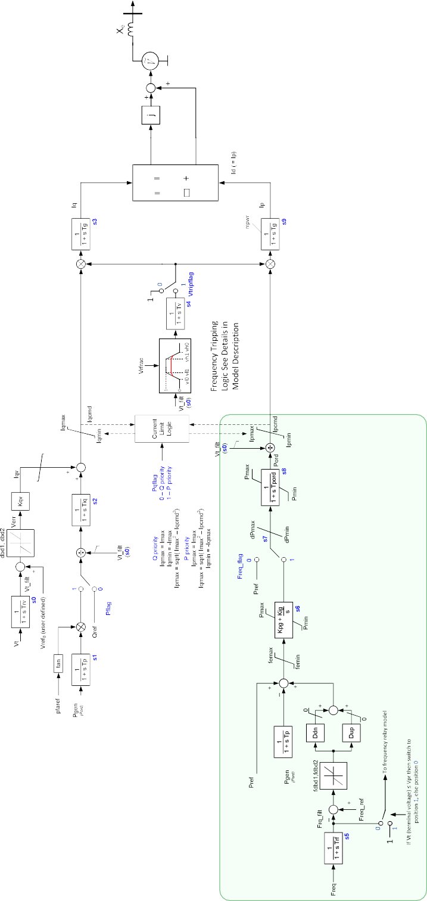

Eq Vtqo id Xe

Ed Vtdo iq Xe

Iqh1

Iql1

Figure 13 – The distributed energy resource model version A (DER A).

The development of the model of the DER A comprises two tasks, one is creating the underlying structure and functionality, the other is deriving the model’s parameters. To create the underlying structure of the DER model, several shortcomings have had to be overcome including inability to represent multiple under frequency trip limits and rate of change of frequency protection, which are all DER behaviours that occur in the Australian power grid. The second task is to tune the parameters of the model based on the applied power grid. Accordingly, the inverter test benchmarking is necessary for the tuning of the DER A model parameters. The following procedure has been implemented in the tuning of the DER-A model parameters:

1. The parameters that are directly prescribed by AS 4777:2005 and AS 4777:2015 (and subsequently AS4777:2020) can be used in the model.
2. The remaining parameters are based on calculations using the inverter test results where possible.
3. Parameters which cannot be calculated using these two preceding steps are estimated using available technical references, relevant information, or engineering judgment.

According to the above-mentioned procedure, the inverter benchmark test results from this project are used to tune various parameters of the model.

One example of the inverter bench tests being utilised is the inverter overvoltage protection disconnection time (*tvh1*). In the AS/NZS 4777.2 2015, the inverters are required to disconnect in less than 2 s for overvoltage between 260 V and 265 V, and AS/NZS 4777.3 2005 requires inverters to disconnect in less than 2 s for these over voltages. However, exact disconnection times are not specified. Based on the inverter benchmarking tests, it was found that the AS/NZS 4777.2 2015 inverters had an average disconnection time of 1.8 s and the AS/NZS 4777.3 2005 inverters had an average disconnection time of 1.9 s. These test results allow that the parameter *tvh1* to be set with higher confidence in the modelling, because it is a reflect of the actual behaviour of rooftop PV inverters. Other parameters which are tuned using the inverter benchmarking test results are listed here along with the UNSW test name:

* Undervoltage trip delay 0 (*tvl0*), based on “Voltage ramp 230V to 160V” test results
* Undervoltage trip delay 0 (*tvl1*), based on “Voltage notch 230V to 50V, 0.1 s” test results
* Overvoltage trip delay 0 (*tvh0*), based on “Voltage notch 230V to 50V, 0.1 s” test results
* Fraction that remain connected (*vrfrac0.1s*), based on “Voltage Notch 230V to 50V 0.1s” test results
* Underfrequency trip delay (*tfl*), based on “Frequency Step 50Hz to 45Hz” test results
* Overfrequency trip delay (*tfh*), based on “Frequency Step 50Hz to 55Hz” test results
* Maximum converter current (*Imax*), based on “Voltage Notch 230V to 50V 0.1s” test results

These parameters are averaged across different standards and inverter test results. One of the challenges in this development activity is to find a solution to tune the ‘dynamic’ parameters, i.e., time constants, based on the outcomes of the inverter test benchmarking. Another challenge is to tune parameters *RoCoF1*, *tRoCoF1* and *frac tRoCoF 1* based on the results of inverter benchmarking tests.

### DER disturbance modelling for NSPs

The Composite Load Model with DER developed by AEMO may usefully be adapted to support NSP analysis of DER within their networks. Coordinated DER behaviours during disturbances may increasingly impact the local distribution and/or transmission network, for example through impacts of protection or sudden large changes in line flows. Being able to model potential DER behaviours could therefore provide valuable for NSPs.

Adaptation of the models would likely necessitate new datasets for tuning and verification. The proposed body of work mapping DER and network datasets could provide useful groundwork.

An open question remains regarding the degree of granularity required when modelling DER disturbance response. It is not practical to model every single inverter across the power system, however the appropriate level of aggregation may prove to be at a ‘lower level’ within the power system than the bulk power system models currently used by AEMO. It is most likely that the appropriate level of modelling is dependent on the task at hand, and this body of work could usefully summarise the possible applications and necessary level of model granularity.

## Research Program Priorities and Gaps

The proposed program of work includes a substantial suite of research and development activities that are necessary to achieve the stated outcome. However, it is important to note that the proposed program of work is unlikely to be comprehensive, and that additional research and development will likely become necessary as the sector develops its understanding of DER impacts on power system security.

In order to (1) develop high level prioritisation of the proposed activities and (2) identify potential gaps, the activities have been ‘mapped’ in terms of physical cover (y-axis) and regional priority (x-axis) in Figure 14.

### Power sector focus (y-axis)

DER response to power system disturbance phenomenon is highly complex, requiring detailed understanding of individual settings as well as fleet performance. As power system security impacts of DER are felt at the transmission level, it is increasingly necessary to build a complete picture from the device level all the way up to the transmission scale.

The y-axis on Figure 14 aims to give an indication of how the different research and development activities fit together, and how they build a more complete understanding, necessary for maintaining power system security with high penetration DER.

### Relevance and regional prioritisation (x-axis)

The research and development activities are then grouped *roughly* along the x-axis in terms of their immediate relevance to Australia, and longer term relevance to international stakeholders, using the following guiding questions:

* **Immediate Australian-focused priorities**
  + What DER / load behaviours are occurring now?
  + What DER / load behaviours are likely in the future?
  + What actions are required?
* **Future-focused and international priorities**
  + What are ‘ideal’ outcomes?
  + How can knowledge be translated globally?

All five of the practical deployment outcomes are located in the ‘what actions are required?’ column.

### Additional research and development activities

Finally, several additional proposed research and development activities have been added to Figure 14 to indicate how it can be used to identify gaps. For example, ‘what are the impacts of momentary cessation?’ and ‘what are inverters capable of?’. Both fall into lower-priority, future focussed category, however represent important avenues for inquiry.



**Legend**

Research project

Development project

Deployment activity

**Immediate Australian-focused priorities**



|  |  |  |  |  |  |  |  |  |
| --- | --- | --- | --- | --- | --- | --- | --- | --- |
| **Sector stakeholders**  **Power sector research focus** | + DER Installer surveys  Stakeholder  Engagement |  | | standards revisions  standards developments on compliance testings | | standards GOVERNANCE ARRANGEMENTS | |  |
| **ISO** | security issue identification | Load-DER composite model  emergency measures | | extend AEMO’s tool set | |  | | guidance and guidelines |
| **Transmission  system** |  | DER DISTURBANCE MODELLING FOR NSPs | | + What are the impacts of momentary cessation?  roll out revised AEMO tool set | | + Data platforms | | + Open-source models and tools |
| **Sub-transmission  system** | fault and disturbance  propagation |  | |  | | der and network Dataset mapping | |  |
| **Distribution system** | inverter responses and sensitivities | dynamics of power quality modes | |  | |  | |  |
| **Household** | DATA DRIVEN aggregation techniques |  | |  | | + What are DER inverters capable of? | |  |
| **Device** | Inverter benchmarks | NEW INNOVATIONS AND TECHNIQUES | | NEW INNOVATIONS AND TECHNIQUES  NEW INNOVATIONS AND TECHNIQUES | |  | |  |
|  | What DER / load behaviours are occurring **now**? | What DER / load behaviours are likely in the **future**? | What actions are required? | | What are ‘ideal’ outcomes? | | How can knowledge be translated globally? | | |

Figure 14 – Overview of research space

**Future-focused and international   
priorities**

**Relevance and regional prioritisation**

## Resources and Budget

The issues this project addresses are by their nature an ongoing effort that will have a life beyond the G-PST.

**Hardware**: Initial investments are required in inverter testing facilities from 5kVA to 250kVA for Power Hardware-in-the-Loop (PHIL) testing, assessment, and verification of inverter performance. This requires appropriately scaled PV emulation (linear PV emulator characteristics), four-quadrant grid emulation (linear grid emulation) and appropriately-rated power analyser equipment, oscilloscopes and other related test and measurement equipment.

**Research assistants:** The main tasks would be inverter testing including establishing new necessary facilities: laboratory test set-ups for the specific areas noting the need for higher-power operations and inverters coupled to storage elements. On the basis of our previous inverter testing, a researcher-year is required to test fully and perform necessary investigations on 25 inverters.

**Research fellows, research engineers and technology translators**: An important distinction is made between the roles required to deliver the outcomes and objectives. This includes the stage of the project, the theme addressed by the role, and the proximity to deployment. These considerations lead to the conclusion that a vital part of any of these proposals is the training and development of human capital that can take the research outcomes, develop solutions and then deploy them in the network. By doing so, they will create their own career pathway translating their research into useful outcomes that benefit society and leverages the tax payers investment beyond usual academic goals. The process of turning research ideas into deployable technologies must also be reflected in the development of our researchers, into engineers and then technology translators.

**PhD scholarships and PhD top-ups:** Research students are an essential resource in delivering the innovations necessary to deliver the outcomes of the project. Furthermore, on graduation they will become an important source of intellectual capital capable of leading the technological solutions to make the transition a reality or motivated proponents of their own research outcomes who can drive a technology transfer agenda delivering the products and services necessary. Integrated into the project plan and budget are 4 PhD scholarships that will assist with the delivery of the research and development elements of the project.

**Technical support**: In-kind contribution with the exception of IT support where a budget request is made as the project will require secure data storage (0.2 FTE).

**Administration support** is requested to manage the operations of the project including university reporting, finance reporting, contractual agreements with staff and partners (0.5 FTE).

**Consumables and equipment** are a necessary investment given the practical nature of the benchmarking and its verification in the field. This includes purchase of inverters to test, ongoing maintenance of the laboratory hardware, upgrading our portfolio of testing systems for operation at 100kVA. In addition, our development of a Control Hardware-in-the-Loop platform for RTDS and OPAL-RT to assess inverter controller hardware/software is a necessary investment.

**Travel** is requested to enable site visits and test facility set-up as well as national collaborative meetings.

**BUDGET TABLE: RESOURCING EXCLUDING UNSW AND OTHER COLLABORATORS IN-KIND AND CASH CONTRIBUTIONS**

|  |  |  |  |  |  |  |  |
| --- | --- | --- | --- | --- | --- | --- | --- |
| **Activity and Budget Year ($k)** | **2022** | **2023** | **2024** | **2025** | **2026** |  | **Total** |
|  |  |  |  |  |  |  |  |
|  |  |  |  |  |  |  |  |
| Benchmarking  (3 RFs for 5 areas) | 348 | 369 | 391 |  |  |  | 1108 |
| Research elements  (2 RFs + 2 PhD) | 420 | 445 | 472 | 500 |  |  | 1837 |
| Development  (1 research engineer + 1 PhD) |  | 232 | 246 | 261 | 277 |  | 1016 |
| Deployment  (1 staff + PhD) |  |  | 214 | 227 | 241 |  | 683 |
|  |  |  |  |  |  |  |  |
| Consumables and equipment | 300 | 300 | 300 | 100 | 100 |  | 1100 |
| Travel | 50 | 50 | 50 | 50 | 50 |  | 250 |
|  |  |  |  |  |  |  |  |
| Admin | 60 | 60 | 60 | 60 | 60 |  | 300 |
| IT | 40 | 40 | 40 | 40 | 40 |  | 200 |
|  |  |  |  |  |  |  |  |
| **Infrastructure** |  |  |  |  |  |  |  |
| RTDS | 0 | 500 |  |  |  |  | 500 |
|  |  |  |  |  |  |  |  |
|  |  |  |  |  |  |  |  |
| Total ($k) | **1218** | **1996** | **1773** | **1238** | **767** |  | **6994** |

## Links with the other Australian GPST research programs

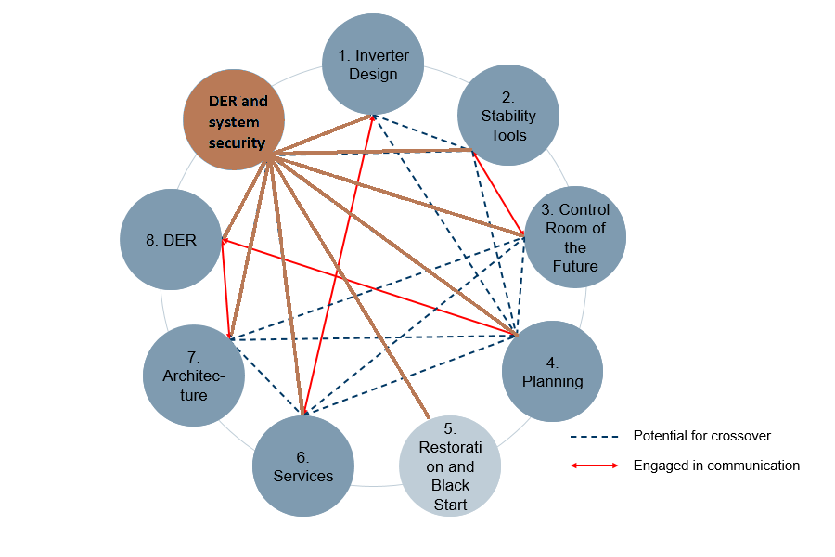

|  |  |  |
| --- | --- | --- |
| **Australian GPST Topic**  **(“Identified Topic”)** | **Relevant inputs to this proposal from Identified Topic** | **Relevant outputs from this proposal that inform Identified Topic** |
| **1 Inverter Design** | Performance metrics: A/us, large- and small-signal current bandwidth | Response requirements |
| **2 Stability Tools** | Performance requirements of models including physical range, time granularity, small-signal response | Large-signal response of DER/IBR |
| **3 Control Room of the Future** | Definition of HMI and underpinning modelling toolset requirements | Load-IBR composite models |
| **4 Planning** | Planning tools and developments | Load-IBR composite models, security issues related to large-signal responses |
| **5 Black start** | Blackstart procedures based on Topics 4 and 7 affect the frequency and severity of disturbances seen by IBRs | Large-signal response of DER/IBR, start-up behaviour, standards |
| **6 Services** | Service requirements and specifications | Verification of IBR performance |
| **7 Architecture** | Proposed suite of architectures and their reliance on DER/IBR response | Load-IBR composite models, security issues related to large-signal responses of DER/IBR, start-up behaviour, standards |
| **8 DER** | Desired DER responses | Load-IBR composite models, security issues related to large-signal responses of DER/IBR, start-up behaviour, standards |
|  |  |  |

## Risks Associated with Key Tasks

Table 2 outlines several high-level risks for the proposed research program. This initial assessment is not exhaustive, and a thorough review would be required for each of the proposed areas of work.

Table 2 – High-level risk assessment for proposed research program

|  |  |  |  |
| --- | --- | --- | --- |
| Risk | Rating  Probability/Impact | Mitigation | Rating after mitigation |
| Insufficient data: locations and data rate/quality | Med/High | Stakeholder engagement specified as a condition of funding | Low/High |
| Modelling complexity | Med/Med | Multiple modelling architectures | Med/Low |
| Researcher resourcing and retention | Med/High | Long term planning > 5years | Low/Med |
| Data privacy concerns resulting in key stakeholders being unwilling to share data | Med/High | Clear, early communication of expectations and responsibilities. | Low/Med |
| Compliance ramifications of findings may deter participation by key stakeholders | Med/Low | Clear, early communication of the intended program outcomes and how information will be shared (e.g. whether OEM names will be revealed) | Low/Low |
| Insecure data sharing leading to data leaks | Low/Low | Development of data management plans in accordance with UNSW policies or similar. | Low/Low |
| Findings not suitably anonymised leading to negative outcomes for key stakeholders | Low/High | Development of data management plans in accordance with UNSW policies or similar. | Low/Med |
| Ineffective/under-resourced knowledge sharing leading to reduced program impact. | Low/Med | Develop resource allocation based on previous knowledge sharing efforts. | Low/Low |
| Poor integration across the different areas of research, leading to reduced program impact | Med/Med | Resource a dedicated position (1xFTE) for the duration who is responsible for collating and integrating findings. Communicate expectations clearly and early regarding engagement with this person. | Low/Low |

## Key sources of complexity

This section sets out why the proposed program of work is non-trivial and identifies several material sources of complexity. In particular: the fact that the work is breaking new ground internationally, Australia has a highly diverse DPV fleet, disturbance events are diverse and rare, large datasets present unique challenges and the stakeholders engaged in this space are highly diverse.

**Breaking new ground**

Australia is experiencing world-leading DER uptake and encountering challenges with high penetration DPV before any other regions in the world. Therefore techniques and tools developed are breaking new ground, and ‘off the shelf’ techniques are not available. The proposed program of work offers an opportunity to build these required capabilities, however it is important to appreciate that the work is novel, and challenging.

**Diverse DPV fleet**

The NEM DPV fleet of over 2 million systems is highly diverse. There are systems from over 20 manufacturers installed, and over 1,000 different inverter models. Some inverter models are more prevalent in the fleet than others, however even the most prevalent inverter represents only ~4% of the overall fleet. In addition, the market share of different manufacturers has changed substantially over time[23]. Whilst each inverter should perform in accordance with the inverter connection standard AS/NZS 4777, there are a number of factors which can still result in a wide range of behaviours, including:

***Local DNSP requirements:*** systems above 30kVA are typically subject to additional requirements specified by the local DNSP. For instance, additional devices that are a ‘backstop’ in case a DPV fails to disconnect in response to frequency or voltage conditions. These requirements have changed over time, and have varied across the 13 DNSPs in the NEM. In addition, further requirements can be in place for systems >100kVA (or in some regions >200kVA), which have also evolved over time.

***Inverter connection standard version:*** as described in section 1.1.3 systems can be divided into three categories: Pre-2015, transition and Post-2016. In addition, the recently completed review of the connection requirements will result in a further two tranches of PV systems: ‘transition II’ and ‘Post-2021’.

***Inverter connection standard ‘gaps’:*** the 2005 and 2015 versions of AS/NZS 4777.2 were developed when DPV penetrations were low and are primarily concerned with distribution level impacts. As result, requirements that relate to system security (such as ride through requirements) are not explicitly stated, are incomplete or ambiguous. For example the current standard does not state how an inverter should measure frequency, and so it is feasible that an inverter would not ‘pick up’ on a very brief frequency disturbance. As result, a wide range of behaviours are possible and each inverter model may perform in a unique way under some disturbance conditions.

**Disturbance events are diverse, and rare**

Section 1.1.2 sets out the key types of disturbance events, however it is important to note that no two disturbances are the same. The conditions that occur, and the system response, are both impacted by the unique operating conditions at the time. Factors can include the following:

* ***Disturbance source:*** such as the loss of a large generator, load, transmission line or combination thereof.
* ***Disturbance source location:*** which can be electrically close to a large load centre with high penetration DPV.
* ***Operating conditions at the time of the disturbance:*** the load level, time of day, generators online, network configuration will all vary. The system response will also vary depending on these initial operating conditions at the time of a disturbance.

Each disturbance can therefore result in a wide range of initial and prolonged conditions. Understanding event characteristics, and how this may influence the diverse DPV fleet is therefore complex. Establishing tools and techniques to analyse disturbances is non-trivial, however as DER penetrations grow, is becoming essential.

In addition, major power system disturbances are rare. Of the order of around five to ten relevant disturbances may occur per year with increased likelihood of disturbances occurring during summer (corresponding to lightning storms, bushfires and high temperature conditions). As result, whilst analysis is complex, there are also relatively few case studies each year. Capturing as many events as possible with the highest resolution possible is therefore critical to building a robust evidence base and it is necessary to engage with the complexity of each disturbance that occurs.

**Large data sets**

The analysis proposed in this program of work requires advanced and bespoke toolsets. A single day of data at 60s resolution for 37,000 sites each reporting from three channels can result in around 160 million rows of data. At 5s resolution this increases to nearly 2 billion rows of data. Whilst large data sets are becoming relatively common, developing tools and techniques to manage large data sets, that can be repeated and broadly applied is a non-trivial exercise.

In addition it is important to understand the underlying data collection methods (such as how voltage is measured) in order to appropriately analyse data. Developing appropriate analysis techniques can be complex, particularly if analysing a broad range of data sets. However this detail matters, and must be considered in order to provide accurate understanding.

**Diverse stakeholders**

The wide array of stakeholders that are impacted by DER response and involved in DER deployment mean that identifying the most appropriate course of action to address concerns is challenging. Stakeholders range from individual ‘mum and dad’ energy users to Standards Australia, the Clean Energy Council, DNSPs and DPV installers.

**Key Stakeholders Engaged with Current ARENA or IBR Projects**

* **AEMO** for the domestic context: Jenny Riesz
  + Also DER team & Australian Energy Simulation Centre (AESC) team
* **Transgrid** – Jahan Pieris
* **Western Power** – Nigel Wilmot
* **Electranet** – Hugo Klingenberg
* **TasNetworks** – Andrew Halley
* **AGL** – Wai-kin Wong
* **Ausgrid** – Alex Watters
* **Horizon Power** – Dave Edwards
* **Solar Analytics** - Simon Heslop
* **Reposit Power** - Caleb Ball
* **Powerlink** - Rizah Memisevic
* **AEMC** - Sebastian Henry
* **CEC** - Darren Gladman
* **Energex** - Peter Kilby
* **RES** - Martin Hemphill
* **SAPN** - Boris Celic
* **Fronius** - Rod Dewar

Further inverter Representatives – SMA, Solax, Sungrow, Solis, Tesla, SMA, Siemens, GE etc

# Appendices

## Appendix A – List of current International Standards and Test Procedure Comparisons

The color coding: GREEN = strictest definition to meet ORANGE = easiest definition to meet

|  |  |  |  |  |  |  |
| --- | --- | --- | --- | --- | --- | --- |
|  | **Reference number** | **Title** | **Country** | **Version** | **Included in AEMO Report** | **Remarks** |
| **1** | IEEE Std 1547 | IEEE Standard for Interconnection and Interoperability of Distributed Energy Resources with Associated Electric Power Systems Interfaces | USA | 2020 | Yes, and updated |  |
| **2** | UL1741 | Standard for Inverters, Converters, Controllers and Interconnection System Equipment for Use With Distributed Energy Resources | USA | 2018 |  | Repeat IEEE Std 1547 |
| **3** | AS/NZS 4777.2 | Australian/New Zealand Standard - Grid connection of energy systems via inverters - Part 2: Inverter requirements | Australia / New Zealand | 2020 | Yes, and updated |  |
| **4** | EN50549-1 | Requirements for generating plants to be connected in parallel with distribution networks - Part 1: Connection to a LV distribution network - Generating plants up to and including Type B | UK | 2019 |  |  |
| **5** | EN50549-2 | Requirements for generating plants to be connected in parallel with distribution networks - Part 2: Connection to a MV distribution network - Generating plants up to and including Type B | UK | 2019 |  |  |
| **6** | TR 3.2.1 | Technical regulation 3.2.1 for power plants up to and including 11 kW | Denmark | 2016 | Yes |  |
| **7** | TR 3.2.2 | Technical regulation 3.2.2 for PV power plants above 11 kW | Denmark | 2016 |  |  |
| **8** | TR 3.2.5 | Technical regulation 3.2.5 for wind power plants above 11 kW | Denmark | 2016 |  |  |
| **9** | GB/T 37408-2019 | Technical requirements for photovoltaic grid-connected inverter | China | 2019 |  | Chinese version, not available in English |
| **10** | GB/T 19963-2011 | Technical rule for connecting wind farm to power system | China | 2011 |  | Chinese version, not available in English |
| **11** | NERC | Reliability Guideline BPS-Connected Inverter-Based Resource Performance | Canada / North America | 2019 |  |  |
| **12** | VDE-AR-N 4105 | Generators connected to the low-voltage distribution network - Technical requirements for the connection to and parallel operation with low-voltage distribution networks | Germany | 2019 | Yes, and updated | Not available |
| **13** | TOR D4 | Technical and organizational rules for operators and users of networks  Part D: Special technical rules  Main section D4: Parallel operation of generating plants with distribution networks | Austria | 2019 |  | German version, not available in English |
| **14** | C10/11 | Specific technical prescriptions regarding power-generating plants operating in parallel to the distribution network | Belgium | 2019 |  |  |
| **15** | NA/EEA-NE7-CH | Network connection for energy generation systems to the low-voltage network - Technical requirements for connection and parallel operation | Switzerland | 2020 |  | German version, not available in English |

**Standards Comparison - Disturbance withstand: Voltage and frequency trip requirements**

|  |  |  |  |  |  |  |  |  |  |
| --- | --- | --- | --- | --- | --- | --- | --- | --- | --- |
| **ITEM** | **AS/NZS 4777.2: 2020 (AU/NZ)**  **(rated:220V)** | **EN50549-1/2:2019 (UK)** | **TR 3.2.1(DK)** | **TR 3.2.2(DK)** | **TR 3.2.5** | **GB/T 19963-2011(China)** | **GB/T 37408-2019(China)** | **NERC Reliability Guidelines** | **IEEE Std 1547: 2020**  **(USA)** |
| Over voltage stage 2 (V>>) | 1.25 p.u.  0.2 s | 1.0 - 1.2 p.u.  (step: 0.01 p.u.)  0.1 - 5 s  (step: 0.05 s) | 1.15 p.u.  0.2 s | 1.15 p.u.  0.2 s | 1.15 p.u.  0.2 s (A2,B,C,D) | N/A | 1.3 p.u.  0.5 s | 1.175 p.u.  0.2 s | 1.2 p.u.  0.16 s |
| Over voltage stage 1 (V>) | 1.2 p.u.  2 s | 1.0 - 1.2 p.u.  (step: 0.01 p.u.)   * 1. - 100 s   (step: 0.1 s) | 1.10 p.u.  60 s | 1.10 p.u.  60 s | 1.10 p.u.  60 s (A2,B,C,D) | 1.1 p.u. | 1.2 p.u.  10 s | 1.1 p.u.  1 s | 1.1 p.u.  2 s |
| Under voltage stage 2 (V<<) | 0.32 p.u.  2 s | 0.2 - 1.0 p.u.  (step: 0.01 p.u.)   * 1. - 5 s   (step: 0.05 s) | 0.80 p.u.  0.1 s | 0.80 p.u.  0.1 s | 0.80 p.u.  0.1 s (A2) | 0.2 p.u.  0.625 s | 0 p.u.  0.15 s  0.2 p.u.  0.625 s | 0.45 p.u.  0.15 s | 0.45 p.u.  0.16 s |
| Under voltage stage 1 (V<) | 0.82 p.u.  11 s | 0.2 - 1.0 p.u.  (step: 0.01 p.u.)   * 1. - 100 s   (step: 0.1 s) | 0.8-5 p.u.  0.50 s | 0.85 p.u.  50 s | 0.85 p.u.  50 s (A2)  0.9 p.u.  10 s (B,C,D) | 0.9 p.u.  2 s | 0.9 p.u.  2 s | 0.9 p.u.  3 s | 0.7 p.u.  2 s |
| Over frequency stage 2 (f>>) | N/A | 50 - 52 Hz  (step: 0.1 Hz)   * 1. - 5 s   (step: 0.05 s) | N/A | N/A | 52 Hz  0.2 s | N/A | 51 - 51.5 Hz  30s | 61.6 Hz  30 s | 62 Hz  0.16 s |
| Over frequency stage 1 (f>) | 52 Hz  0.2 s | 50 - 52 Hz  (step: 0.1 Hz)   * 1. - 5 s   (step: 0.05 s) | 52 Hz  0.2 s | 52 Hz  0.2 s | 51 -51.5 Hz  30 min  51.5 -52 Hz  30 s | 50.2 Hz  5 min | 50.5 -51 Hz  3min | 60.6 Hz  180 s | 61.2 Hz  300 s |
| Under frequency stage 2 (f<<) | N/A | 47 - 50 Hz  (step: 0.1 Hz)   * 1. - 5 s   (step: 0.05 s) | N/A | N/A | 47 Hz  0.2 s | 48 Hz | 46.5 - 47 Hz 5 s  47 - 47.5 Hz 20 s  47.5 - 48 Hz 1 min | 57 - 57.3 Hz 0.75s  57.3 - 57.8 Hz 7.5s  57.8 - 58.4 Hz 30s | 56.5 Hz  0.16 s |
| Under frequency stage 1 (f<) | 47 Hz  2 s | 47 - 50 Hz  (step: 0.1 Hz)   * 1. - 5 s   (step: 0.05 s) | 47 Hz  0.2 s | 47 Hz  0.2 s | 47 - 47.5 Hz  30 s  47.5 - 49 Hz  30 min | 49.5 Hz  30 min | 48 -48.5 Hz  5 min | 58.4 - 59.4 Hz 180s | 58.5 Hz  300 s |

**Standards Comparison - Protection and control function coordination Measurement systems specifications**

|  |  |  |  |  |  |  |  |  |  |
| --- | --- | --- | --- | --- | --- | --- | --- | --- | --- |
| **ITEM** | **AS/NZS 4777.2: 2020 (AU/NZ)**  **(rated:220V)** | **EN50549-1/2:2019 (UK)** | **TR 3.2.1** | **TR 3.2.2** | **TR 3.2.5** | **GB/T 19963-2011(China)** | **GB/T 37408-2019(China)** | **NERC Reliability Guidelines** | **IEEE Std 1547: 2020**  **(USA)** |
| **Measurement accuracy** | **-** | **-** | **-** | **-** | **-** | **-** | **-** | **-** | **-** |
| Frequency – protection | ±10 mHz | ±0.05 Hz | ±0.05 Hz | ±0.05 Hz | ±0.05 Hz | N/A | N/A | N/A | ± 100 mHz |
| Frequency - Regulation | ±10 mHz | ±10 mHz | ±10 mHz | ±10 mHz or  (1 σ) of ±5 mHz | ±10 mHz or  (1 σ) of ±5 mHz | N/A | N/A | N/A | ±10 mHz |
| Voltage – Protection | ±1% Vn | ±0.01 p.u. | ±1% Vn | ±1% Vn | ±1% Vn | N/A | N/A | N/A | ±2% Vn |
| Voltage - Regulation | ±1% Vn | N/A | N/A | N/A | N/A | N/A | N/A | N/A | ±1% Vn |
| Time –  Protection | N/A | N/A | N/A | N/A | N/A | N/A | N/A | N/A | 2 cycles |
| Time –  Regulation | N/A | N/A | N/A | N/A | N/A | N/A | N/A | N/A | 1% measured duration |
| Active power | ±4% Sn | N/A | N/A | N/A | N/A | N/A | N/A | N/A | ±5% Srated |
| Reactive power | ±4% Sn | N/A | N/A | N/A | N/A | N/A | N/A | N/A | ±5% Srated |
| Protection general 1 | N/A | N/A | RMS values | RMS values | RMS values | N/A | N/A | N/A | N/A |
| Protection general 2 | N/A | N/A | Vector shift not  allowed | Vector shift not allowed | Vector shift not allowed | N/A | N/A | N/A | N/A |
| Protection general 3 | N/A | N/A | Measurements across all connected phases | Measurements across all connected phases | Frequency of used phases recorded simultaneously | N/A | N/A | N/A | N/A |
| **Measurement period** | **-** | **-** | **-** | **-** | **-** | **-** | **-** | **-** | **-** |
| Frequency – protection | 100 ms | N/A | 200 ms | 200 ms | 200 ms | N/A | N/A | N/A | 5 cycles |
| Frequency - regulation | 100 ms | N/A | N/A | N/A | N/A | N/A | N/A | N/A | 60 cycles |
| Voltage – protection (V>>) | 100 ms | N/A | 200 ms | 200 ms | 200 ms | N/A | N/A | N/A | 5 cycles |
| Voltage – protection (V<<) | 100 ms | N/A | 100 ms | 100 ms | 100 ms | N/A | N/A | N/A | 5 cycles |
| Voltage - regulation | 100 ms | N/A | N/A | N/A | N/A | N/A | N/A | N/A | 10 cycles |
| df/dt (ROCOF) | N/A | N/A | 80 ms | 80 ms | 80 ms | N/A | N/A | N/A | Average over 0.1 s |
| Active/Reactive power | 200ms | N/A | N/A | N/A | N/A | N/A | N/A | N/A | 10 cycles |

**Grid Support modes – frequency response**

|  |  |  |  |  |  |  |  |  |  |
| --- | --- | --- | --- | --- | --- | --- | --- | --- | --- |
| **ITEM** | **AS/NZS 4777.2: 2020**  **(AU/NZ)**  **(rated:220V)** | **EN50549-1/2:2019**  **(UK)** | **TR 3.2.1**  **(DK)** | **TR 3.2.2**  **(DK)** | **TR 3.2.5** | **GB/T 19963-2011**  **(China)** | **GB/T 37408-2019**  **(China)** | **NERC Reliability Guidelines** | **IEEE Std 1547: 2020**  **(USA)** |
| Start range (High) | 50.1 - 50.5 Hz | 50.2 - 52 Hz | 50 - 52 Hz | 50 – 52 Hz | 50 – 52 Hz | N/A | 50 - 51.5 Hz | N/A | 60.017 – 61 Hz |
| Start default (High) | 50.25 Hz | 50.2 Hz | 50.2 Hz | 50.2 Hz | 50.2 Hz | N/A | 50.03 Hz | 60.036 Hz | 60.036 Hz |
| Stop  (High) | 52 Hz | N/A | 52 Hz | 52 Hz | 52 Hz | N/A | N/A | N/A | N/A |
| Start range (Low) | 49.5 - 49.9 Hz | 46 - 49.8 Hz | 50 - 52 Hz | 47 - 50 Hz | 47 - 50 Hz | N/A | 46.5 - 50 Hz | N/A | 59 - 59.983 Hz |
| Start default (Low) | 49.75 Hz | 49.8 Hz | N/A | N/A | N/A | N/A | 49.97 Hz | 59.964 Hz | 59.964 Hz |
| Stop  (Low) | 48 Hz | N/A | N/A | 47 Hz | 47 Hz | N/A | N/A | N/A | N/A |
| Droop | N/A | 2 - 12% | 2 - 12 % | 2 - 12 % | 2 - 12 % | N/A | N/A | N/A | 3-5% |
| Droop  default | 3.5% (effective OF response)  2% (effective UF response) | 5% | 4% | 4% | 4% | N/A | N/A | 5% | 5% |
| Setting resolution | N/A | ±10 mHz | 10 mHz | 10 mHz | 10 mHz | N/A | N/A | N/A | N/A |

**Grid Support modes – power quality modes – Q(V) regulation specifications**

|  |  |  |  |  |  |  |  |  |  |  |
| --- | --- | --- | --- | --- | --- | --- | --- | --- | --- | --- |
| **ITEM** | **AS/NZS 4777.2: 2020**  **(AU/NZ)**  **(rated:220V)** | **EN50549-1:2019**  **(UK)** | **EN50549-2:2019**  **(UK)** | **TR 3.2.1**  **(DK)** | **TR 3.2.2**  **(DK)** | **TR 3.2.5** | **GB/T 19963-2011**  **(China)** | **GB/T 37408-2019**  **(China)** | **NERC Reliability Guidelines** | **IEEE Std 1547: 2020**  **(USA)** |
| Dead band range | -18% / 20% | N/A | N/A | N/A | N/A | N/A | N/A | N/A | N/A | ± 0 - 3% |
| Deadband default | 0 - 9 | N/A | N/A | N/A | N/A | N/A | N/A | N/A | 10% | ± 2% |
| Droop (default) | 13% | N/A | N/A | N/A | N/A | N/A | N/A | N/A | 5% | ± 6% |
| Droop control – default activation | Enabled | One of 4 options | One of 5 options | N/A | Enabled | Enabled | N/A | N/A | N/A | Disabled |
| Setting ranges | V1 = 0.82 - 1.05 p.u.  V2 = 0.82 - 1.05 p.u.  V3 = 1.05 - 1.2 p.u.  V4 = 1.05 - 1.2 p.u. | N/A | N/A | N/A | N/A | N/A | N/A | N/A | N/A | V1 = 0.88 - 1.0 p.u.  V2 = 0.97 - 1.0 p.u.  V3 = 1.0 - 1.03 p.u.  V4 = 1.0 - 1.18 p.u |
| Reactive power default range | ±0.6 | ±0.9 | ±0.9 | N/A | ±0.95 | N/A | N/A | N/A | N/A | ± 0.915 |
| Reactive power setting range | ±0.6 | 0-1.0 | 0-1.0 | N/A | ±0.95 | N/A | N/A | N/A | ±0.95 | ± 0.915 |

**Grid Support modes – power quality modes – Active power control and P(V) control specification**

|  |  |  |  |  |  |  |  |  |  |
| --- | --- | --- | --- | --- | --- | --- | --- | --- | --- |
| **ITEM** | **AS/NZS 4777.2: 2020**  **(AU/NZ)**  **(rated:220V)** | **EN50549-1/2:2019**  **(UK)** | **TR 3.2.1**  **(DK)** | **TR 3.2.2**  **(DK)** | **TR 3.2.5** | **GB/T 19963-2011**  **(China)** | **GB/T 37408-2019**  **(China)** | **NERC Reliability Guidelines** | **IEEE Std 1547: 2020**  **(USA)** |
| Ramp rate Setting default | 16.67%/min | N/A | N/A | N/A | N/A | N/A | N/A | N/A | 20% / min |
| Active power set points resolution | N/A | N/A | 0.1 kW | 0.1 kW | 1 kW | N/A | N/A | N/A | N/A |
| P(V) control –setting range | V1 = 1.07 - 1.16 p.u.  V2 = 1.09 - 1.2 p.u.  P2 = 0 - 20% | N/A | N/A | N/A | N/A | N/A | N/A | N/A | V1 = 1.05 – 1.09 p.u.  V2 = 1.06 – 1.10 p.u.  P2 = 20 - 100% |
| P(V) control – default setting | V1 = 1.15 p.u.  V2 = 1.18 p.u.  P1 = 20% | N/A | N/A | N/A | N/A | N/A | N/A | N/A | V1 = 1.06 p.u.  V2 = 1.10 p.u.  P2 = 20% rated |
| P(V) control – default activation | Enabled  (if available) | N/A | N/A | N/A | N/A | N/A | N/A | N/A | Disabled |

**Grid Support modes – power quality modes – Reactive and power factor control specifications**

|  |  |  |  |  |  |  |  |  |  |  |
| --- | --- | --- | --- | --- | --- | --- | --- | --- | --- | --- |
| **ITEM** | **AS/NZS 4777.2: 2020 (AU/NZ)**  **(rated:220V)** | **EN50549-1:2019**  **(UK)** | **EN50549-2:2019**  **(UK)** | **TR 3.2.1**  **(DK)** | **TR 3.2.2**  **(DK)** | **TR 3.2.5** | **GB/T**  **19963-2011**  **(China)** | **GB/T 37408-2019**  **(China)** | **NERC Reliability Guidelines** | **IEEE Std 1547: 2020**  **(USA)** |
| Q control – default activation | Disabled | One of 4 options | One of 5 options | Disabled | Disabled | Disabled | N/A | N/A | N/A | Disabled |
| Q control – setting resolution | N/A | 2% Smax | 2% Smax | 0.1 kVar | 0.1 kVar | 1 kVar | N/A | N/A | N/A | N/A |
| PF control – default activation | Disabled | One of 4 options | One of 5 options | Disabled | Disabled | Disabled | N/A | N/A | N/A | Enabled |
| PF control –setting range | ±0.8 | 0.9 - 1.0 | 0.9 - 1.0 | ± 0.9 | ± 0.9 | N/A | N/A | ±0.95 | N/A |  0.915 |
| PF control – setting resolution | N/A | N/A | N/A | 0.01 | 0.01 | 0.01 | N/A | N/A | N/A | N/A |
| PF control – default setting | 1.0 | 1.0 | 1.0 | N/A | 1 | N/A | N/A | N/A | N/A | 1.0 |
| PF(P) control – default activation | N/A | One of 4 options | One of 5 options | Activated at  V = 105% | Activated at  V = 105% | N/A | N/A | N/A | N/A | Disabled |
| PF(P) control –setting range | N/A | N/A | N/A | N/A | N/A | N/A | N/A | N/A | N/A | PF =  0.915 |
| PF(P) control – setting resolution | N/A | N/A | N/A | N/A | N/A | N/A | N/A | N/A | N/A | N/A |
| PF(P) control – default setting | N/A | N/A | N/A | P = 0.5 Pn,  PF = 1  P = 1.0 Pn,  PF = -0.9 | P = 0.5 Pn,  PF = 1  P = 1.0 Pn,  PF = -0.9 | N/A | N/A | N/A | N/A | P = 0.5 Pn,  PF = 1  P = 1.0 Pn,  PF = 0.915 |
| Reactive power capability (PF absorb/generate) General | ±0.8 | ±0.9  ±0.95 for CHP generating units with a capacity ≤ 150 kVA | ±0.52 | ± 0.9 | ± 0.9 | ±0.95 (A2,D)  ±0.995 (B)  ±0.975 (C) | N/A | ±0.95 | ±0.95 |  0.915 |

## Appendix B – Hardware in-the-loop publications in the PV/DER area

**Literature Review for HIL Techniques applied to PV Inverter Testing**

This review brings together recent published research work that reports hardware-in-the-loop systems utilized to test and assess one or more aspects of inverter control. It is a useful review as it demonstrates the potential for real-time simulation techniques married to control HIL and/or power HIL in testing inverter performance. It also demonstrates how far ahead UNSW’s research in this area is internationally. [1] presents a closed loop test process with the Real-Time Digital System (RTDS) running the grid/D-STATCOM model to test fault ride through capability and the ability of the D-STATCOM to compensate voltage dips. In [2], power hardware-in-the-loop (PHIL) testing was verified as a suitable method of testing of the PV inverter and both open loop and closed loop testing are explored. [3] describes and demonstrates a grid interconnection system evaluator that provides a method to vastly increase the efficiency of conducting IEEE Std 1547 and other grid interconnection conformance tests through the use of HIL simulation techniques, advanced analysis scripts, and a single user interface.  In [4], a PHIL approach is validated for a simple distributed resource grid integration scenario and many additional and more complex scenarios can now be assessed. In [5], experimental test results demonstrated some preliminary adverse volt-var control (VVC) interactions with very aggressive VVC parameters. It was evident from simulation and testing that increasing the VVC response time (which slows down the VVC response), reducing time delay and reducing VVC slope mitigated these undesired interactions.

The European White Book on real-time PHIL testing [6] provides an outlook on the utilization of PHIL. The hardware used for testing includes two PV generators, a small wind turbine, battery energy storage, controllable loads, and a controlled interconnection to the local LV grid. The PHIL technique configured by a RTDS, grid simulator, load bank, photovoltaic inverter, DC power supply and bus system is used to characterize and model inverters for grid integration studies under abnormal grid conditions in [7, 8]. [9] presents a unique effort that characterizes multiple inverter, multiple PCC interactions in simulation and hardware utilizing NREL's PHIL capabilities. The modeling and simulation task completed indicates that improper parameter choice in volt-VAR control can cause inverter control instability, unwanted interactions with the utility grid and poor inverter reliability due to excessive reactive power cycling. With limited case studies conducted using actual inverter hardware and simulated impedances, no such harmful interactions could be found in actual hardware testing thus far. Future work identified will expand the hardware testing to various combinations of inverter makes, inverter types, volt-V AR parameters and grid configurations. [10] discusses the stability and accuracy of a PHIL interface with a photovoltaic microinverter. Low pass filter in the control loop would reduce the accuracy of the results observed in the RTS and the phase compensation can be used to mitigate the effect of the low pass filter. In [11], a comparison between simulated and experimental results of the 7-bus power distribution feeder circuit demonstrates that although there is an adverse effect on the accuracy, due to the hardware integration of the PHIL, the errors presented for the bus voltage, as well as the active and reactive power in lines fall under an acceptable range with little to no deviations. These errors are due to the inaccuracy of the PV inverter performance. The report in [12] validates the effectiveness of the PHIL by comparing the simulated results of a 7 bus power distribution feeder circuit obtained from OpenDSS, MATLAB/Simulink with the experimental results obtained from the Opal-RT 5600 platform. [13] presents a multi-megawatt scale testing using PHIL on a real-time simulator, which is a breakthrough in utility-scale grid integration testing. [14] compares three different types of voltage type power amplification units used for PHIL applications and concludes a guidance of what type of PHIL experiment can be achieved with which type of power amplifier. A comprehensive PHIL platform with a DG connected to a weak grid is presented in [15]. The impedance model of the PHIL platform is established and an interface algorithm is proposed to improve the stability and accuracy of the PHIL simulations. [16] proposes a systematic testing procedure for a novel control algorithm from pure software simulation, software-in-the-loop simulation, control hardware-in-the-loop and finally combined power and control hardware-in-the-loop. [17] proposes a control method to improve the stability of the PHIL simulation by introducing an additional current filter in the feedback path. However, the accuracy of the PHIL setup would decrease with the increase of the stability margin of the PHIL simulation.

[1] V. Kleftakis, A. Rigas, A. Vassilakis, P. Kotsampopoulos, and N. Hatziargyriou, "Power-Hardware-in-the-loop simulation of a D-STATCOM equipped MV network interfaced to an actual PV inverter," in *IEEE PES ISGT Europe 2013*, 2013: IEEE, pp. 1-5.

[2] J. Langston *et al.*, "Power hardware-in-the-loop testing of a 500 kW photovoltaic array inverter," in *IECON 2012-38th Annual Conference on IEEE Industrial Electronics Society*, 2012: IEEE, pp. 4797-4802.

[3] B. Lundstrom, M. Shirazi, M. Coddington, and B. Kroposki, "An Advanced Platform for Development and Evaluation of Grid Interconnection Systems Using Hardware-in-the-Loop: Part III--Grid Interconnection System Evaluator," in *2013 IEEE Green Technologies Conference (GreenTech)*, 2013: IEEE, pp. 392-399.

[4] B. Lundstrom, B. Mather, M. Shirazi, and M. Coddington, "Implementation and validation of advanced unintentional islanding testing using power hardware-in-the-loop (PHIL) simulation," in *2013 IEEE 39th Photovoltaic Specialists Conference (PVSC)*, 2013: IEEE, pp. 3141-3146.

[5] S. Chakraborty, A. Nelson, and A. Hoke, "Power hardware-in-the-loop testing of multiple photovoltaic inverters' volt-var control with real-time grid model," in *2016 IEEE Power & Energy Society Innovative Smart Grid Technologies Conference (ISGT)*, 2016: IEEE, pp. 1-5.

[6] E. de Jong *et al.*, "European white book on real-time power hardware in the loop testing: Derlab report no. r-005.0," 2012.

[7] D. V. Terlip, B. Kroposki, and D. Maksimovic, "A methodology for characterizing and modeling inverters for grid integration studies using Power Hardware-in-the-Loop," in *2012 IEEE Power and Energy Society General Meeting*, 2012: IEEE, pp. 1-5.

[8] D. V. Terlip, "A Methodology for Characterizing and Modeling Inverters for Grid Integration Studies using Power Hardware-in-the-Loop," University of Colorado at Boulder, 2011.

[9] S. Chakraborty, A. Hoke, and B. Lundstrom, "Evaluation of multiple inverter volt-VAR control interactions with realistic grid impedances," in *2015 IEEE Power & Energy Society General Meeting*, 2015: IEEE, pp. 1-5.

[10] O. Nzimako and R. Wierckx, "Stability and accuracy evaluation of a power hardware in the loop (PHIL) interface with a photovoltaic micro-inverter," in *IECON 2015-41st Annual Conference of the IEEE Industrial Electronics Society*, 2015: IEEE, pp. 005285-005291.

[11] A. Nelson *et al.*, "Power hardware-in-the-loop evaluation of PV inverter grid support on Hawaiian electric feeders," in *2017 IEEE Power & Energy Society Innovative Smart Grid Technologies Conference (ISGT)*, 2017: IEEE, pp. 1-5.

[12] R. Darbali-Zamora, J. E. Quiroz, J. Hernández-Alvidrez, J. Johnson, and E. I. Ortiz-Rivera, "Validation of a Real-Time Power Hardware-in-the-Loop Distribution Circuit Simulation with Renewable Energy Sources," in *2018 IEEE 7th World Conference on Photovoltaic Energy Conversion (WCPEC)(A Joint Conference of 45th IEEE PVSC, 28th PVSEC & 34th EU PVSEC)*, 2018: IEEE, pp. 1380-1385.

[13] P. Koralewicz, V. Gevorgian, and R. Wallen, "Multi-megawatt-scale fower-hardware-in-the-loop interface for testing ancillary grid services by converter-coupled generation," in *2017 IEEE 18th Workshop on Control and Modeling for Power Electronics (COMPEL)*, 2017: IEEE, pp. 1-8.

[14] F. Lehfuss, G. Lauss, P. Kotsampopoulos, N. Hatziargyriou, P. Crolla, and A. Roscoe, "Comparison of multiple power amplification types for power hardware-in-the-loop applications," in *2012 Complexity in Engineering (COMPENG). Proceedings*, 2012: IEEE, pp. 1-6.

[15] C. Yin, B. Ye, X. Wang, and L. Dai, "Power hardware-in-the-loop simulation of a distributed generation system connected to a weak grid," in *2017 IEEE Conference on Energy Internet and Energy System Integration (EI2)*, 2017: IEEE, pp. 1-6.

[16] M. Maniatopoulos, D. Lagos, P. Kotsampopoulos, and N. Hatziargyriou, "Combined control and power hardware in-the-loop simulation for testing smart grid control algorithms," *IET Generation, Transmission & Distribution,* vol. 11, no. 12, pp. 3009-3018, 2017.

[17] G. Lauss, F. Lehfuß, A. Viehweider, and T. Strasser, "Power hardware in the loop simulation with feedback current filtering for electric systems," in *IECON 2011-37th Annual Conference of the IEEE Industrial Electronics Society*, 2011: IEEE, pp. 3725-3730.

1. AEMO 2020 Integrated System Plan, available [here](https://aemo.com.au/en/energy-systems/major-publications/integrated-system-plan-isp/2020-integrated-system-plan-isp).
2. APVI, available [here](https://pv-map.apvi.org.au/analyses).
3. AEMO Technical Integration of DER 2019, available [here](https://www.aemo.com.au/-/media/Files/Electricity/NEM/DER/2019/Technical-Integration/Technical-Integration-of-DER-Report.pdf).   
   N. Stringer, N. Haghdadi, A. Bruce, J. Riesz, and I. MacGill, *"Observed behavior of distributed photovoltaic systems during major voltage disturbances and implications for power system security"* Applied Energy, available [here](https://www.researchgate.net/publication/338789909_Observed_behavior_of_distributed_photovoltaic_systems_during_major_voltage_disturbances_and_implications_for_power_system_security).
4. Page 42, AEMO Renewable Integration Study (April 2020), available [here](https://aemo.com.au/energy-systems/major-publications/renewable-integration-study-ris).
5. AEMO Final Report: Queensland and South Australia system separation on 25 August 2018 (January 2019) available [here](https://www.aemo.com.au/-/media/Files/Electricity/NEM/Market_Notices_and_Events/Power_System_Incident_Reports/2018/Qld---SA-Separation-25-August-2018-Incident-Report.pdf).

   “Potential Security Implications of distributed photovoltaics: observed response during major power system frequency and voltage disturbance” (2020) N. Stringer, N. Haghdadi, A. Bruce, I. MacGill (undergoing peer review)
6. N. Stringer, N. Haghdadi, A. Bruce, J. Riesz, and I. MacGill, *"Observed behavior of distributed photovoltaic systems during major voltage disturbances and implications for power system security"* Applied Energy, available [here](https://www.researchgate.net/publication/338789909_Observed_behavior_of_distributed_photovoltaic_systems_during_major_voltage_disturbances_and_implications_for_power_system_security).
7. AEMO Final Report – Queensland and South Australia system separation on 25 August 2018, available [here](https://www.aemo.com.au/-/media/Files/Electricity/NEM/Market_Notices_and_Events/Power_System_Incident_Reports/2018/Qld---SA-Separation-25-August-2018-Incident-Report.pdf).

   N. Stringer, N. Haghdadi, A. Bruce, and I. MacGill*, "Potential Security Implications of distributed photovoltaics: observed response during major power system frequency and voltage disturbance"*, submitted for publication.
8. AEMO Renewable Integration Study (April 2020), available [here](https://aemo.com.au/energy-systems/major-publications/renewable-integration-study-ris).
9. AEMO Renewable Integration Study, page 42 (April 2020), available [here](https://aemo.com.au/energy-systems/major-publications/renewable-integration-study-ris).
10. AEMO Market Notice (24 April 2020) SA system normal constraint update – Metro generation and PV contingency, available [here](https://www.aemo.com.au/market-notices?marketNoticeQuery=SA+system+normal+constraint+update+-+Metro+generation+and+PV+contingency&marketNoticeFacets=RECALL+GEN+CAPACITY%2CGENERAL+NOTICE%2CPROCESS+REVIEW%2CPRICES+UNCHANGED).
11. AEMO Renewable Integration Study , Table 8: Challenges and actions – distributed solar PV (April 2020), available [here](https://aemo.com.au/energy-systems/major-publications/renewable-integration-study-ris).
12. AEMO Technical Integration of DER 2019, page 36, available [here](https://www.aemo.com.au/-/media/Files/Electricity/NEM/DER/2019/Technical-Integration/Technical-Integration-of-DER-Report.pdf).
13. Project MATCH, ARENA webpage: <https://arena.gov.au/projects/project-match/>

    Project MATCH, CEEM webpage: <http://www.ceem.unsw.edu.au/project-match>
14. Enhanced Reliability Through Short Time Resolution Data, ARENA webpage: <https://arena.gov.au/projects/enhanced-reliability-through-short-time-resolution-data-around-voltage-disturbances/>
15. ARENA website <https://arena.gov.au/projects/addressing-barriers-efficient-renewable-integration/>
16. UNSW website <http://pvinverters.ee.unsw.edu.au/>

    AEMO Capstone Report ‘Behaviour of distributed resources during power system disturbances’ , May 2021 <https://aemo.com.au/-/media/files/initiatives/der/2021/capstone-report.pdf?la=en&hash=BF184AC51804652E268B3117EC12327A>
17. Available here [UKRI’s Networks program](https://epsrc.ukri.org/research/ourportfolio/themes/energy/programme/what-the-energy-programme-funds/networks/)
18. Available here [Grid Modernisation](https://www.nrel.gov/grid/index.html)
19. Available here [Energy Storage and Distributed Generation](https://www.epri.com/portfolio/programs/053125)
20. GPST Consortium Inaugural Research Agenda March 2021, accessed at: <https://globalpst.org/wp-content/uploads/042921G-PST-Research-Agenda-Master-Document-FINAL_updated.pdf>
21. Specific outputs of project MATCH that are expected to feed into AEMO’s PSSE and PSCAD models include the percentage of distributed PV sites tripping during voltage disturbances, and the percentage of distributed PV sites that appear to deliver over-frequency droop response. In addition, ‘upscaled’ distributed PV behaviour during disturbances based on real world operating data may be may be used to verify the modelled distributed PV behaviour.
22. N. Stringer, "Navigating decentralisation: data driven analysis of distributed energy resources and a framework for their integration into the electricity industry," Doctor of Philosophy, Engineering, UNSW Sydney, 2020. <https://www.unsworks.unsw.edu.au/primo-explore/fulldisplay/unsworks_76884/UNSWORKS>
23. Phoebe Heywood, Navid Haghdadi, Anna Bruce, Iain MacGill, Naomi Stringer *‘Historical Market Trends of Distributed Photovoltaic Inverters in Australia’* (2019) Asia Pacific Solar Research Conference, available [here](http://apvi.org.au/solar-research-conference/wp-content/uploads/2020/02/Heywood-P-Historical-Market-Trends-of-Distributed-Photovoltaic-Inverters-in-Australia.pdf).