An Indigenous-led Digital Climate Stories Platform

Aboriginal and Torres Strait Islander Peoples bring knowledge sustained over millennia and through the platform will connect and build knowledge of Country combining 21st century technologies to be first responders to the climate emergency today and into the future.
The Climate Stories Platform will establish and grow the Indigenous data lake, which enables communities to be on-ground researchers on their Country, to extend nature-based solutions that matter in everyday lives.

A collective of Indigenous co-design members are collaborating to establish an Indigenous-led Digital Climate Story Platform. The concept and collaborations for the Climate Stories Platform emerged through the First Peoples Gathering on Climate Change on Yorta Yorta Country, Barmah Forest and on Gimuy-walubarra yidi Country, Gimuy (Cairns). This work connects with the Steering Committee of the First Peoples’ Gathering on Climate Change.

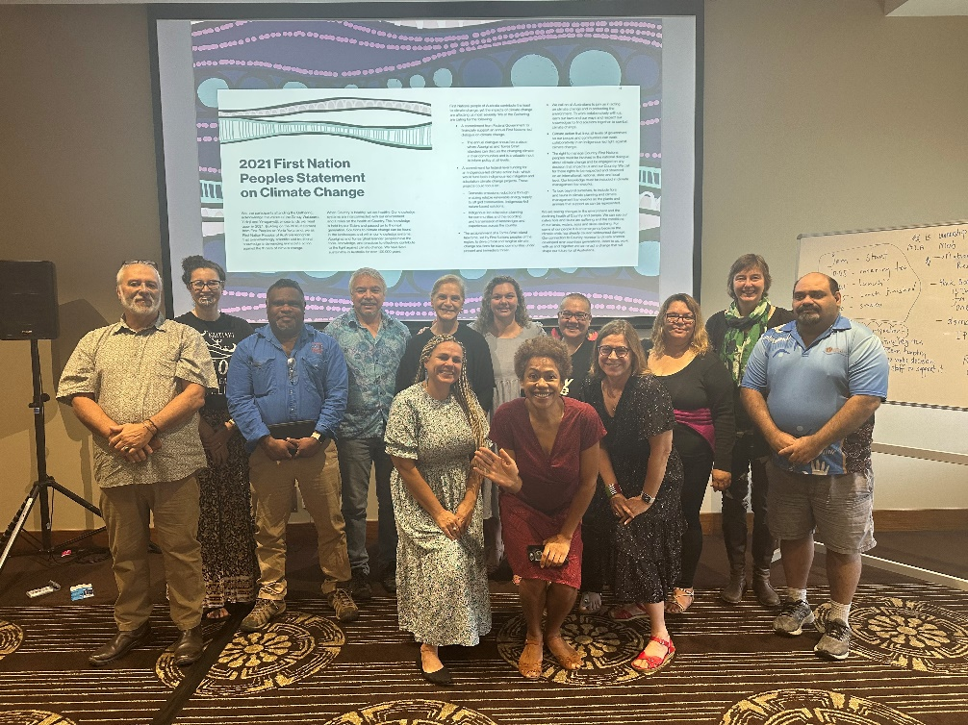
Members of the co-design group, core and project teams, and Maori colleagues in Gimuy/Cairns, 2023
Timeline
2018: National First Peoples Gathering on Climate Change, Yorta Yorta Country
2021: National First Peoples Gathering on Climate Change, Gimuy/Cairns
2023: First meeting of the Co-design group, Core and Project teams for the Indigenous-led Digital Climate Stories Platform
Who we are
Co-design group members are a mix of Indigenous land and sea management experts, Indigenous business owners and experts in media and renewal energy projects, and artists.
The core team members include an Indigenous environmental policy expert and two CSIRO researchers. Additional project team members include CSIRO Indigenous and non-Indigenous research staff.
This initial stage has been designed with key roles for each group:
- A co-design group, to develop the prospectus for the Climate Stories Platform.
- A core team, to support and resource the co-design group.
- A project team, to work with the core group to support the co-design group.

What we want to achieve
The group met on the 27th and 28th of June, 2023 in Gimuy (Cairns) and involved Maori colleagues in two-way learning and sharing. The co-design group discussed the questions:
- What is the Indigenous-led Digital Climate Stories Platform?
- Who are the users and who would benefit from it?
- What are the key principles and values for the platform if it is to succeed?
- What are our next steps?
Together, the group will deliver a prospectus on a Climate Stories Platform that aims to:
- Build on capabilities as first responders across multiple scales
- Strengthen storytelling between groups and facilitate a culturally safe peer-to-peer learning network
- Further Indigenous methodologies in nature-based solutions
- Expand the Indigenous Nations’ data lake
- Work collaboratively between Indigenous and Western data to enhance Indigenous climate responses and adaptation priorities
- Build trusted and reliable data sources and networks.
The next step in the collaboration is to establish an Indigenous-led and centred governance framework for the Climate Stories Platform.

For more information on the Indigenous-led Digital Climate Stories Platform, and opportunities for sponsorship, please contact Damian Morgan-Bulled (0429 022 003) and Pethie Lyons (0477 755 076).

