19 February 2016
Botanical resources australia

 | BOTANICAL RESOURCES AUSTRALIA | 1
 |  | BOTANICAL RESOURCES AUSTRALIA
Case study summary
Key findings
- CSIRO research has helped BRA to maintain its position as the world’s leading supplier of pyrethrum oil for use as a natural insecticide.
- CSIRO has played a key role in increasing the recovered yield of pyrethrins after storage and processing operations and in addressing quality issues
- As a result, BRA has been able to provide significant employment in regional Tasmania and Victoria, and contribute to Australian GDP and exports
- The net present value (NPV) of CSIRO’s work for BRA is approximately $7.53 million under a 7 per cent real discount rate. The benefit-cost ratio (BCR) for the project is just over 6.
Innovation impact
This project provides an excellent example of how CSIRO has become an important and trusted adviser to an Australian firm and enabled it to address a range of scientific and technical challenges and help it to grow its business over time.
The CSIRO’s ability to draw on and adapt its research into grain storage to assist BRA is a good demonstration of how the benefits of research in one area can flow through to other areas.

This case study uses the evaluation framework outlined in the CSIRO Impact Evaluation Guide. The results of applying that framework to the Botanical Resources Australia case study are summarised in Figure 1.

Figure 1.1 CSIRO Case Study Botanical Resources Australia – Impact Framework Diagram
INPUTS |  | ACTIVITIES |  | OUTPUTS |  | OUTCOMES |  | IMPACTS
- BRA contracts with CSIRO  - Cash and in-kind contribution by BRA  - Government grants  - Support from growers |  | - Project planning by CSIRO and BRA  - CSIRO research  - CSIRO-development of software  - CSIRO scientific services (chemical separation, analytical chemistry, product stability studies, process chemistry, entomology) |  | - Reports to BRA  - Small samples of individual active ingredients provided to BRA |  | - Take-up of new processes by BRA  - BRA technical problems better managed  - Expansion of BRA’s pyrethrin production  - Employment at BRA and in the associated supply chain  - Exports of pyrethrin products |  | - BRA sustainability improved  - Significant interaction and development of strong working relationship between CSIRO and private industry  - Increased international trade  - Employment  - Contribution to Tasmanian GSP and to Australian GDP
Source; acil allen

Background

Purpose and audience for case study
This case study describes the economic, environmental and social benefits arising from CSIRO’s provision of research services to Botanical Resources Australia Pty Ltd (BRA). BRA is a majority Tasmanian owned company that produces more than 60 per cent of the world’s pyrethrin technical, a natural botanical insecticide. The majority of the production is sourced from Tasmania, with a smaller quantity grown near Ballarat in Victoria. BRA uses company owned and leased land as well as contracting growers to cultivate in excess of 3,000 ha of pyrethrum crops a year. The product is extracted and refined in BRA’s manufacturing facilities and is formulated for use in pyrethrin-based insecticide products for the world market.
This information is provided for accountability, communication and continual improvement purposes. Audiences for this report may include Members of Parliament, Government Departments, CSIRO and the general public.

Project origins and inputs
In 1981, Commonwealth Industrial Gases (CIG), a subsidiary of the British Oxygen Company (BOC), began to develop the pyrethrins industry in Tasmania, in collaboration with the Tasmanian Government and the University of Tasmania. CIG’s interest in pyrethrin came about through its use in a versatile carbon dioxide propelled aerosol called Pestigas.
Box 1.1 History of the use of pyrethrum as a source of insecticide
Pyrethrum is the common name for certain members of the daisy (or aster) family, Asteraceae. They are all perennial plants with a daisy-like appearance and white petals. One of these species, Tanacetum cinerariifolium is economically important as a natural source of a broad spectrum insecticide (pyrethrin) which attacks the nervous systems of insects. Pyrethrin has been used as an insecticide for many centuries, with the first record of the pyrethrum daisy being 2000 years ago at the time of China’s Chou Dynasty.
Although pyrethrin use constitutes less than 0.1% of the global insecticide market, it is one of the most versatile insecticides, with many hundreds of separate registered product labels in the United States. Specific uses include:
  - in public health (e.g. mosquito abatement)
  - consumer products (head lice, consumer aerosol sprays, home gardening)
  - commercial pest control (houses, restaurants, food warehouses)
  - veterinary applications (domestic pets and indoor animal production (e.g. dairies, poultry))
  - agriculture (potential growing demand in organic agriculture).
Pyrethrin decomposes rapidly on exposure to sunlight, thus having minimal residual presence after use. It is also considered to be amongst the more effective and benign insecticides for use in domestic dwellings and is often used to protect foodstuffs in storage as well as in food processing facilities.
Source: CSIRO

BRA was formed in 1996 through a staff buy-out when BOC decided to sell up its ownership of CIG Pyrethrum, the precursor to Botanical Resources Australia. Through its on-going research programmes, BRA has developed a sustainable industry using focussed research and rapid adoption of appropriate research outcomes such as mechanised planting and harvesting and novel processing techniques. BRA’s breeding programme provides cultivars that are suitable to Tasmanian and Victorian conditions (where the crops are grown). Rapid infrastructure expansion in the last five years has ensured that BRA can respond to changing world supply-demand market forces. It continues to look for ways to improve all aspects of the production chain, including product quality and process efficiency.
Pyrethrum is grown for BRA on a contract basis by farmers on their own land, and on properties owned or leased by BRA. The growers who contract with BRA to grow pyrethrum receive ongoing support and advice from BRA’s team of field officers.
BRA started out as an R&D-based, innovation-active company and has maintained that emphasis since its inception. The company has used research to underpin the many improvements it has made to how it grows, harvests, and ultimately stores the harvested material, as well as to how it manufactures its final products. Being an innovation-active company, BRA has been very successful in sourcing competitive government R&D funding support using in-house staff as well as research partners. CSIRO’s engagement with BRA has been successful in terms of both useful R&D outcomes as well as success with competitive R&D funding support.

Project activities
CSIRO has worked with BRA since 2003, and extensively since 2010, within five series of projects, as follows:

Series 1: Storage of pyrethrum pellets (2003-06)
BRA wished to investigate the causes of heating of pyrethrum pellets in its large crop storage warehouse at Ulverstone, Tasmania. A review of related activities in Australia by BRA together with a recommendation by an experienced grain industry consultant indicated that BRA should approach CSIRO about this issue because of CSIRO’s expertise in post-harvest grain storage. In partnership with CSIRO, BRA was successful in winning a Commonwealth Government R&D Start Grant to support investigation into this problem.
As a result of these studies, CSIRO’s Stored Grains Research Laboratory in Canberra assisted BRA with the development and installation of a prototype crop aeration system at Ulverstone. The prototype infrastructure was supported by the sophisticated Adaptive Discounting Control software developed by CSIRO in conjunction with the Australian grain handling industry and used in the storage of various grain types. This was the first time that this system has been adapted for use on pyrethrum crop material.

Series 2: Separation and supply of pyrethrin esters (2010-12)
Through this series of two projects, CSIRO assisted BRA to supply certain of its customers with samples of the individual active ingredients (esters) of pyrethrum, thereby allowing the customers to better understand the efficacy and knock-down characteristics of each of the esters. BRA engaged CSIRO’s separations and synthesis group to produce gram-scale quantities of the individual pyrethrin esters.

Series 3: Reducing post-harvest losses (2010-15)
This series of five projects commenced in January 2010 and was partially funded by Horticulture Australia Ltd (now Horticulture Innovation Australia). These projects arose from an observation by BRA that pyrethrin losses were occurring during postharvest processing operations. BRA suspected that the losses occurred largely during the storage of crop and prior to extraction of the pyrethrum oleoresin. BRA sought CSIRO’s assistance to:
- Determine what factors caused degradation of the pyrethrins
- Quantify the losses that were occurring at the various stages of processing chain
- Establish which pyrethrin esters were most subject to degradation
- Discover which degradation processes led to the greatest loss of pyrethrins
- Establish how to determine the effectiveness of efforts to reduce degradation.

Series 4: Characterisation of insoluble material (2011-15)
A small number of BRA’s customers had concerns that some shipments contained an oily deposit which had separated from solution (suspected to be an unknown polymer). The immediate impact of these isolated incidents were expensive in their own right, but they also were potentially damaging to the company’s reputation. Through three projects, CSIRO has been providing BRA with assistance in investigating this issue and developing solutions. This work is continuing.

Series 5: Removing pyrethrosin (2011-15)
Pyrethrosin is a natural compound, produced in very small quantities within the pyrethrum flower and captured within BRA’s product. Pyrethrosin has the potential to precipitate and cause product quality issues.
Through a series of four projects, CSIRO developed an analytical method that can be used to quantify pyrethrosin in the pyrethrins product (now a critical quality-control test used routinely in the BRA factory) and provided BRA with assistance in developing options for the removal from, or reductions in the levels of, pyrethrosin in its product.
CSIRO’s expenditure to assist BRA is summarised in Table 1.1.
Table 1.1 CSIRO expenditure on projects for BRA
Activity | Year(s) | Expenditure  $s
Factors affecting heat damage to stored pyrethrum crop material | 2003-04 | 116,021
Factors affecting heat damage to stored pyrethrum crop material  Aeration Parameters | 2004-05 | 43,479  80,300
Post-harvest storage losses  Separation of pyrethrum components | 2009-10 | 15,000  22,159
Post-harvest storage losses  Separation of pyrethrum components | 2010-11 | 25,500  44,108
Separation of pyrethrum components  Microbial pyrethrum degradation  Resupply pyrethrum esters  Post-harvest storage losses | 2011-12 | 55,408  18,064  67,554  15,000
Post-harvest storage losses  Microbial pyrethrum degradation | 2012-13 | 35,000  33,082
Removal of pyrethrosin | 2013-14 | 23,440
Removal of pyrethrosin | 2014-15 | 58,006
CSIRO researcher placement  Polymer studies | 2015-16 | 19,870  10,000
Total |  | 681,991
Source: CSIRO

Project outputs
As noted above, BRA is an SME with a strong focus on R&D, and like most innovation-active SMEs it does not possess all of the R&D resources that it needs. Through working with CSIRO, BRA has gained access to expertise in a range of areas including software development, analytical chemistry, organic chemistry, microbiology, product stability studies and process chemistry. BRA has also gained access to research infrastructure such as Nuclear Magnetic Resonance, Mass Spectroscopy, Ultra Performance Liquid Chromatography and microbial fermentation equipment that were not available to the company. In assisting BRA, CSIRO has been able to draw on its experience in other areas such as grains storage.

Publications and Awards
O. E. Hutt, J. A. Freemont, S. Littler, P. J. Duggan, J. Tsanaktsidis, H. Cole, M. Kerr, J. H. Ryan,* “Staudinger and Ruzicka’s Altered Pyrethrolone: The Cyclopentadienone Dimers Derived from Pyrethrin I”, 2015, Acta Hort. (ISHS),1073:181-190.
J. A. Freemont, S. Littler, O. E. Hutt, P. J. Duggan, M. Kerr, J. H. Ryan,* “Determination of Pyrethrosin Levels in Refined Natural Pyrethrin Extracts”, 2015, Acta Hort. (ISHS), 1073: 171-179.
The BRA Automated Pellet Handling Facility won a 2010 Tasmanian Workcover Safety Award (Best Solution to an Identified Workplace Health and Safety Issue) and a 2011 Engineers Australia (Tasmanian Division) Engineering Excellence Award.

Commercialisation and Innovation
CSIRO was also able to share with BRA knowledge that it had developed while working with other industrial clients, and through working on problems in related areas. The broad experience of CSIRO researchers in developing solutions for industrial clients also allowed them to quickly understand BRA’s needs, to offer a solutions that were implementable within time and budget constraints, and to understand the importance of working with BRA on-site when developing solutions.

Status of Outcomes and Impacts

Economic outcomes and impacts
In part as a consequence of working with CSIRO, BRA has developed a more sustainable business, its sales have more than quadrupled in 15 years, and it has been able to scale up production to support the supply of pyrethrin technical in existing North American and European markets as well as supplying to developing markets in various Asian and South American countries.

Social outcomes and impacts
Pyrethrins have multiple registrations including “sensitive”, for use in environments that are in close proximity to animals and humans as well as in organic farming. BRA provides significant employment in regional Tasmania and Victoria. This includes permanent and seasonal staff, growers, harvesting and other contractors and various service providers such as CSIRO. In addition, the presence of significant hectares of a high return crop such as pyrethrum has provided growers in Tasmania and Ballarat with a profitable rotational crop that is very compatible with vegetable and poppy crops.

Figure 1.2 Pyrethrum Fields ready for harvesting
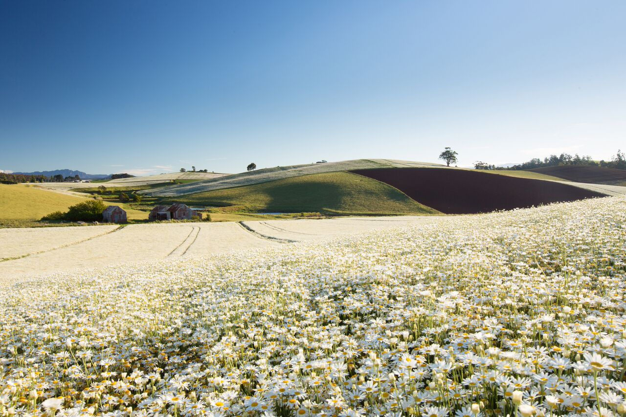
Source: BRA

Environmental outcomes and impacts
BRA’s pyrethrin technical is a natural product and provides users with an environment-friendly product for insect control. Pyrethrin is the only natural insecticide that is registered for a wide range of uses in the USA and the EU. The rapid degradation of pyrethrin esters in sunlight ensures that there is no residual of the insecticide product in the environment after application. The production of pyrethrum crops has provided growers in Tasmania and Ballarat with a viable rotational crop that has advantages of being a semi perennial in nature, has deep roots and require much less irrigation water required compared with potato crops and is harvested in summer, thus having limited impact on soil structure. As a suitable rotational crop, the production of pyrethrum crops do not require the clearing of any new land and operations such as sowing and irrigation can be conducted using existing grower owned equipment.

Counterfactual
While there are other research service providers in Australia that are able to undertake research relevant to BRA’s needs in particular areas, CSIRO:
- has staff working across a very broad range of areas relevant to BRA – including in entomology, industrial chemistry and grains storage – and is thus an efficient partner for interaction
- has also been able to provide access to a range of scientific equipment — some other potential partners would not have been able to provide access across this range
- researchers are experienced in providing research services to industry and in designing solutions that are implementable by industry.

Attribution
While part of the outcomes are due to BRA’s own efforts, CSIRO’s work has been critical in addressing the issues described in Section 1.2. Hence, the attribution of benefits from this work should be as follows:
- BRA —25 per cent
- CSIRO — 75 per cent.

Adoption
Adoption of the results of CSIRO’s work has been very successful. The problems arising from the storage of pyrethrum pellets have been significantly addressed. Post-harvest losses have been reduced. The problem of insoluble material separating out of the product has been partly solved. The levels of pyrethrosin in the BRA product can now be quantified and successfully managed.

Assessment of impacts

Impacts to date
CSIRO’s work has been important in facilitating the growth of BRA’s business. BRA has faced other challenges for which it has sought help from other providers including the University of Tasmania and private consultants. However the benefits from CSIRO research have been significant in helping BRA to maintain its competitive position and product quality.

Potential future impacts
BRA competes against producers of synthetic insecticides and other pyrethrum producers in Africa and China. However because the BRA product is from a reliable supplier that is innovative and responsive to customer needs and concerns, the pyrethrum industry in Australia is likely to maintain a strong global position into the future.

Cost Benefit Analysis
CSIRO was paid a total of $678,991 by BRA in the period 2003-16. In the cost-benefit analysis, the annual costs (shown previously in Table 1.1) have been converted to 2015-16 dollars using CPI inflation data from the Australian Bureau of Statistics (ABS).
CSIRO’s research on post-harvest losses has allowed BRA to save approximately $400,000 a year (from 2010-11 onwards), through better information on storage conditions for pyrethrum crop. According to BRA, CSIRO’s work on advancing product quality (characterisation of insoluble material and removing pyrethrosin) will allow BRA to defend estimated sales of greater than $500,000 a year. This benefit is assumed to accrue from 2015-16 onwards. In addition, BRA has estimated that the benefits from a reduction in returned products are worth $155,000 a year, also from 2015-16 onwards. As noted previously in Section Error! Reference source not found., it is assumed that 75 per cent of the above benefits are attributable to CSIRO.
Using 2015-16 as the base year, the present value of CSIRO project costs is $1,399,051 in 2015-16 dollars under a 7 per cent real discount rate. The present value of benefits to 2029-30 attributable to CSIRO is approximately $8.93 million in 2015-16 dollars under the same real discount rate.
The net present value (NPV) of CSIRO’s work for BRA is therefore approximately $7.53 million under a 7 per cent real discount rate. The benefit-cost ratio (BCR) is approximately 6:1.

CSIRO’s role as an Innovation Catalyst
CSIRO was able to draw on and adapt its research into grain storage for this project.
The Stored Grain Research Laboratory (SGRL) was a long-term joint venture of CSIRO with the (then) Australian Wheat Board and the Australian Bulk Handling Companies, in partnership with the Grains R&D Corporation. The joint venture developed an Adaptive Discounting Control process for grain aeration.
While aeration can be applied to all grain types and in most cases is very cost effective in both capital and operating terms, use of an adaptive control system improves energy efficiency, reduces the need for operator skill and oversight, and provides automatic responsiveness to variations in environmental conditions and the state of the stored grain.
With the help of CSIRO experts from the SGRL, BRA was able to install a prototype crop aeration and drying system in its Ulverstone warehouse that made use of the Adaptive Discounting Control technology.

