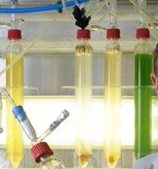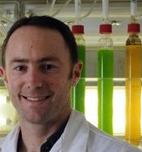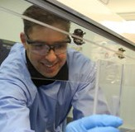

Australia’s innovation catalyst
Strategy 2020

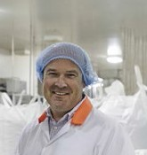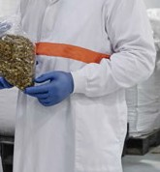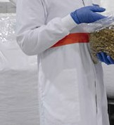

TABLE OF CONTENTS

MESSAGE FROM THE MINISTER 2
MESSAGE FROM THE CHIEF EXECUTIVE 3
OUR FUTURE WORLD
Global megatrends shaping Australia’s future 4
CSIRO STRATEGY AT A GLANCE
Australia’s innovation catalyst 6
OUR BUSINESS UNITS
and focus areas 8
STRATEGIC ACTIONS 10

MESSAGE

from the Minister

CSIRO is Australia’s preeminent scientific organisation.
It has an outstanding reputation not only within the research and scientific sectors, but it is also a household name.

It is recognised and respected across our community.

This professional regard and community goodwill is one of CSIRO’s most potent strengths – not only because of the reach it provides into all sectors of our economy, but also because of the opportunity
this reputation creates for CSIRO to take a leadership role in transforming our economy to capitalise on the industries of the future.

The Australian economy is in transition. Our nation has been built on the traditional foundations of agriculture and heavy manufacturing. These sectors will continue to be an important part of our economy, but increasingly the economic growth and jobs of the future will be in advanced and niche manufacturing, higher value-add sectors and service industries.

We share the transition experience with most other developed countries but we have the opportunity to make the response our own. Australia must
seize the opportunities that are presented in ways that will set us apart and enhance our international competitiveness.

To do so, we must ensure that we make full use of our areas of competitive strength and the areas in which we can excel.

With this objective in mind, the Australian Government is redesigning industry policy to put science, research and technology at the centre of Australian industry.

We are working to lift the rate of collaboration between businesses and researchers, with a focus on innovation that can transform the way our industries operate and the way they compete in international markets.
Through the establishment of Industry Growth Centres in our nation’s areas of comparative advantage, the Australian Government is providing the catalyst for collaboration and transformation of our industries while capitalising on the depth of our innovative and highly skilled workforce.
CSIRO has a central role to play in the translation of science and technology into products and services that benefit our nation and enhance our productivity and our prosperity.
CSIRO has the expertise, the imagination and the capacity to look at the challenges facing Australian industry and think of better, smarter and more effective solutions.
Ultimately, how well Australian industry and researchers rise to the challenge of lifting collaboration rates and boosting commercialisation of Australian ideas and products will determine the role we play in the constantly evolving global economy.
There’s no doubting our capacity to bring
world-leading technologies to the market. Now is Australia’s opportunity to realise that potential. CSIRO will be integral to reaching our goals.
Through the CSIRO Strategy 2020, Australian industry has a blueprint to develop, innovate and compete.
Australian industry and science are both dynamic, so I am certain that this strategy will be essential in addressing the challenges we currently face as well as recognising and reorienting towards future
opportunities in ways that we have yet to encounter or perhaps imagine.
Congratulations on the development of the CSIRO Strategy 2020. The Australian Government looks forward to CSIRO continuing to play a leadership role in industry and across our society.

The Hon Ian Macfarlane MP Minister for Industry and Science
July 2015

MESSAGE

from the Chief Executive

Science always starts with a question. For CSIRO,
our question must be, what does Australia need? In a decade, CSIRO will be 100 – what will we deliver to the nation to celebrate at that centenary?

In 2015, we crowd sourced ideas from more than 7000 of our creative people, customers, thought leaders and the public to help answer this question. These inputs have identified the challenges and opportunities we must respond to, and shaped our Strategy 2020: Australia’s Innovation Catalyst.

Australia must be a high performing innovation economy. In an interconnected world of accelerating, technology-driven change, our future prosperity, health and sustainability is closely bound to our capacity
for innovation. However, in 2014, global rankings of innovation such as those by Cornell, INSEAD and WIPO ranked Australia 10th in the world for innovation inputs, but 81st for innovation efficiency. We rank last in the OECD for research-business collaboration, and our relative rankings for STEM education are in decline.
We can, we must, do better.

Innovation is a team sport, and Australians don’t want to be 81st in any sport! CSIRO will not succeed unless we are helping to lift Australia’s innovation performance – and this won’t happen through
our efforts alone. A catalyst enables reactions in a system, helps new bonds to form, and creates new combinations. Profound innovation happens at the intersection of disciplines, sectors, science and business. For CSIRO to succeed, first and foremost, we must help create these connections and help others succeed.

Our science, technology and innovation must help Australia meet the challenges and opportunities driven by the megatrends shaping Australia’s future. As the nation’s mission-directed research agency, we must help Australia understand and respond to accelerating global change, and the increasing integration and interdependence of human and environmental systems.
We must help respond to digital disruption of every value chain and build Australia’s digital capabilities. We will learn to generate, organise and analyse massive data, and deliver valuable, trusted insight across human and biophysical systems, from planetary to atomic scales. We must respond to a faster, more networked world, where innovation requires collaboration, agility and an ability to partner seamlessly across disciplines and organisational boundaries which are themselves being disrupted and blurred. We must help reinvent existing industries and strive to create a new industry for a changing Australian economy.

To do all these things, we must work at scale to deliver innovation across a broad range of national challenges and opportunities. We must put the current and future needs of our customers first, and always ask ourselves
- who is the customer, what value do they need, and are we delivering? We must work as a seamless team across our business units and support functions. We must be a collaboration hub, we must have a global outlook and global vision. We must be getting the system to move through faster, with virtuous cycles of collaboration, innovation, value creation and learning. We will not always succeed, but we will never give up.

We must continually evolve our portfolio, we must have the courage to take technical and commercial risk – knowing that we may sometimes fail but that there is no better teacher, and we will never stop learning and investing in creating the platforms of the future. We must tackle our own business challenges to ensure that we are delivering value to our customers, moving at the speed of business and maximising our return on the nation’s investment in us.

There is no more potent fuel for creating enduring value than technology-enabled innovation. This is what we do. This is an exciting time. This is our Strategy, our CSIRO, and our commitment to our nation’s future. A future we will help create.

Larry Marshall
July 2015

OUR FUTURE WORLD

Global megatrends shaping Australia’s future

In 2015, we asked more than 7000 of our creative people, customers, thought leaders and the public to help identify
the megatrends which guide the science, technology and innovation we do.

More from less
Innovation in meeting human needs by more efficient
use of mineral, water, energy and food resources in light of escalating demand and constrained supply.

Planetary pushback
Changes in earth systems from the global to microbial are creating challenges for humanity including climate change and antibiotic resistance.

The silk highway
Rapid growth of emerging economies, urbanisation, geopolitical change and the transition from industrialisation into technologically advanced service sectors.

Forever young
The rise of the ageing population, retirement savings gap, lifespans, healthcare expenditure, diet and lifestyle-related illness and mental health awareness.

Digital immersion
The exponential growth in computing power, device connectivity, data volumes, internet users, artificial intelligence and technological capabilities.

Porous boundaries
Changes in organisational models, governance systems and employer-employee relations in a more agile, networked and flexible economy which breaks through traditional boundaries.

Great expectations
The rise of the all important experience factor as society and consumers have rising expectations for personalised and positive experiences involving social interaction, morals and ethics, and the physical world.

THE INNOVATION IMPERATIVE:
Critical importance and accelerating pace of innovation and disruptive change driven by science and technology.

Innovation fuels the future

Strategy 2020 5

AUSTRALIA’S INNOVATION

Strategy 2020

OUR VISION: Australia’s innovation catalyst, boosting Australia’s innovation performance

National challenges and opportunities we focus on

Agriculture Land and Water
Energy

Oceans and Atmosphere

Global
Services Data and Digital

Astronomy and Space Science

Australian Animal Health Laboratory

One-CSIRO support services

What we do

Projects and teams
Creative, entrepreneurial, collaborative teams tackling big challenges through science, technology and innovation
Enterprise Infrastructure

Customer value
Delivering value through innovative solutions for customers in industry, government and community

Impact delivery
Creating new economic, environmental and social impact for Australia

CATALYST

OUR MISSION: Create value for customers through innovation that delivers positive impact for Australia

Manufacturing
Mineral Resources
Health and Biosecurity
Food and Nutrition

Australian National Research Collections
Marine National Facility
National Computing Infrastructure

Strategic actions
Measuring performance

Success is helping to significantly lift Australia’s innovation performance

Team CSIRO
Excellent science Inclusion, trust & respect
Health, safety & environment Deliver above commitments
  - Impact return on investment
  - Customer satisfaction
  - Active licences
  - External revenue
a
  - Collaboration – internal and external
  - People – diversity and inclusion
  - People – engagement and innovation culture
  - People – health and safety
  - Investment in future science and technology

o l

OUR
BUSINESS UNITS

and focus areas

CSIRO invests in an evolving portfolio of businesses to deliver on our mission
Agriculture
Boost the productivity, profitability and agro-ecosystem health for Australia’s agri-food and agri-fibre industries and to partner globally towards food security in a resource and climate challenged world.
Energy
Deliver solutions that will enhance Australia’s economic competitiveness and regional energy security while enabling the transition to a lower emissions energy future.
Land and Water
Deliver solutions for sustainable development and stewardship of land, water, ecosystems and communities, valued at over $12 billion per annum in triple bottom line benefits.
Oceans and Atmosphere
To boost Australia’s prosperity and wellbeing through solutions that enable the sustainable economic, social, and environmental use of Australia’s marine estate, and management of the atmospheric environment.

Data Australia

National Facilities and Collections

Global

CSIRO Services
A digital innovation powerhouse focused on the identification, enablement and commercialisation of valuable datasets for Australia enabling industry, government and research transformation across domains and sectors.

To manage Australia’s state-of-the-art infrastructure and biological collections to enable the delivery of benefits and impacts to the Australian people, environment, research and industry.

Delivering connectivity to the global science, technology and innovation frontier and new customers and markets for Australian innovation and national benefit.

Delivering effective and efficient innovation-enabling businesses including Education, SME Engagement, Infrastructure Technologies, Publishing and Futures.
One-CSIRO
support services
Professional, relevant advice and assistance supporting
CSIRO's business units and operations to deliver on our mission.

Enterprise Infrastructure

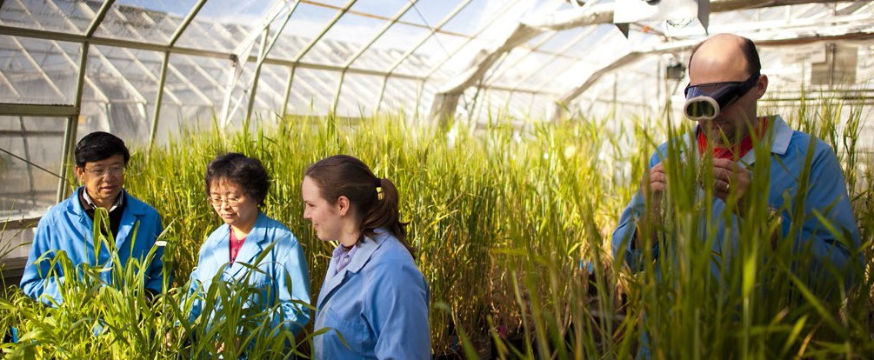

Manufacturing
Deliver the scientific and engineering innovations to transition Australian manufacturing, creating the jobs of the future, export growth, and increasing the value of the sector.
Mineral Resources
Deliver science and technology options for the discovery and efficient development of Australia’s $1 trillion mineral resource endowment and enable flow-on benefits to the wider national economy.
Health and Biosecurity
Increase the productivity and effectiveness of Australia's health and biosecurity systems through technology and services.
Food and Nutrition
Maximise Australia’s food, agribusiness and health-related value chain opportunities by creating innovative products, processes and services for domestic and premium export markets.

Astronomy and Space Science
Understanding the Universe

Australian Animal Health Laboratory Protecting Australia

Australian National Research Collections
Securing our biodiversity future

Marine National Facility Supporting, enabling and inspiring marine science

National Computing Infrastructure
High performance innovation

STRATEGIC
ACTIONS

Customer first Global outlook, national benefit

To create deeper innovation relationships with our customers and prioritise the highest value investments, we will:

- Continually develop and improve the end to end customer experience and our capacity to deliver innovative solutions to customers.
- Embed a rigorous impact and investment planning, monitoring and evaluation framework into our business and employ it to continually optimise
our portfolio.
- Deliver and act upon market and technology roadmaps to support national challenges and industry innovation.

To deliver connectivity to the global science, technology and innovation frontier as well as access new markets for Australian innovation, we will:

- Accelerate our overall rates of international engagement, operations and collaboration where there is a higher potential impact value return to Australia than available domestically.
- Prioritise three key regions for sustained presence and development where there is clear intersection with our impact objectives and sustainable business opportunity.

Collaboration hub Breakthrough innovation

To integrate the best solutions for our customers, increase our flexibility and enhance Australia’s innovation performance, we will:

  - Increase our contribution to the mobility and exchange of people and know-how between research, industry and government.
  - Deepen our partner relationships with universities and other research organisations to access a broader pool of external capability.
  - Develop a more compact, vibrant and efficient property footprint through capital city consolidation and increased co-location.
  - Increase our engagement in education and training from school age to PhD level and the workplace
to help build and equip Australia’s future science, technology, engineering and mathematics (STEM) and innovation capable workforce.

To increase our capacity to help reinvent existing industries and create new industries for Australia and deliver public good, we will:

- Implement a transformative innovation program, new investment models and funding to accelerate our entrepreneurial capacity and provide new models for our customers to adopt technology, knowledge and services.
- Deepen our direct support for Australian technology start-ups and SMEs in areas of national growth priority.
- Create a world class digital innovation capability for Australia.
- Support, develop and incentivise our people to take commercial and scientific risk, tolerate positive failure and promote a learning culture.

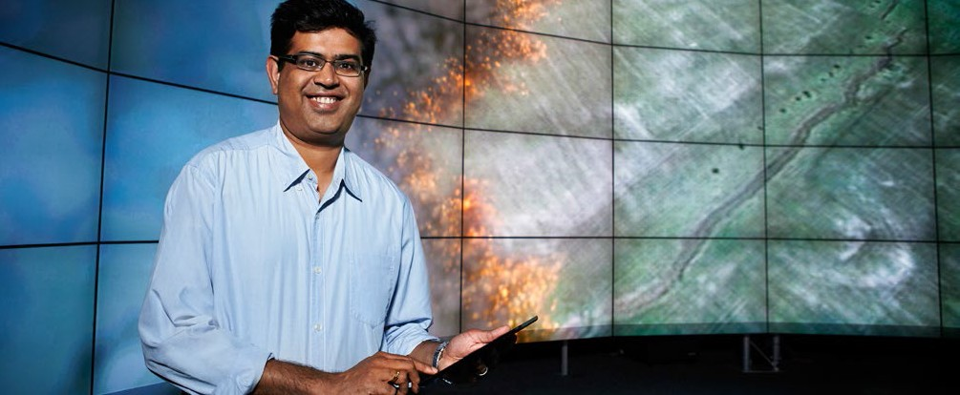To create breakthrough technology and knowledge and be a trusted advisor for Australia, we will:
Excellent science
Health, safety
and environment

  - Invest only in the science and engineering that is aligned to impact objectives and that CSIRO is best placed to do.
  - Increase the value from, and investment in, a portfolio of Future Science Platforms with higher technical risk and the potential to help reinvent and create new industries for Australia.
  - Continue to ensure our brand is a guarantee of the highest quality scientific standards and trusted advice.

To enhance staff safety and wellbeing and to further our aspiration towards zero harm, we will:

- Continue to strengthen our innovation culture and operations in key areas that enhance the wellbeing of our people and improve in areas that detract from wellbeing.
- Equip our people with the knowledge and skills to support the physical and psychological health of their teams across a diverse range of operating
environments, proactively learn from staff and customer experience and provide efficient safety systems.
- Deepen integration of environmental sustainability principles throughout our business areas to reduce consumption of resources and carbon emissions.

Inclusion, trust and respect

Deliver on commitments

To fully enable and support the innovation capacity of our creative people and teams to take risk and deliver to customers, we will:

  - Promote inclusion and diversity as a key driver of innovation, specifically increasing gender and cultural diversity in middle and senior
leadership positions, and the number of Aboriginal Australians and Torres Strait Islanders in CSIRO over the strategy period.
  - Empower frontline teams with autonomy, performance and accountability – maximising frontline capacity for action and providing clear performance goals.
  - Promote seamless collaboration across boundaries, internally and externally.
  - Promote a culture of open sourcing, information sharing and transparency of decision making.

To enhance our agility, financial sustainability and capacity to respond at the speed of business, we will:

- Grow our overall external revenue ratio, focus on growing our industry, international and IP business, and reduce our overhead costs.
- Continually streamline and improve our processes and systems to support efficient and effective commercial engagement and project delivery.
- Continually increase the transparency, availability and utility of relevant information through whole of CSIRO knowledge management systems.

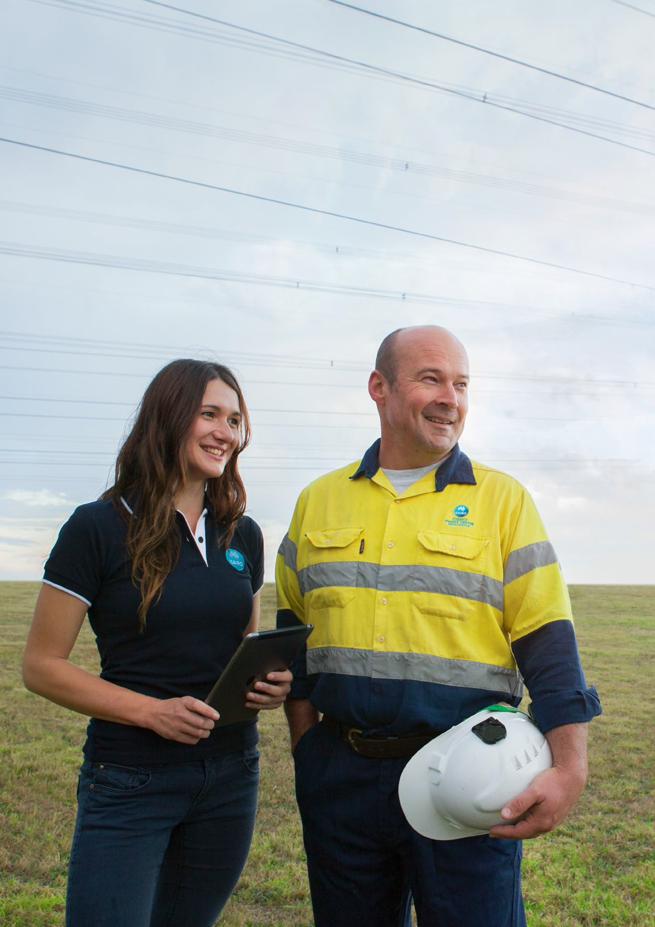More than 7000 people helped shape: Our strategy.

12
Our CSIRO.
Our future.

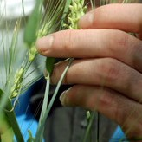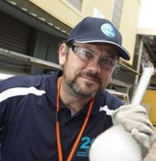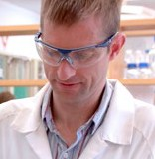

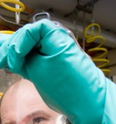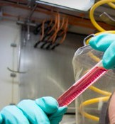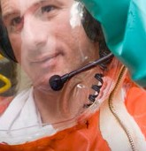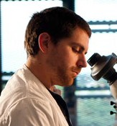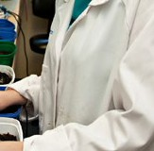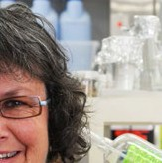

CONTACT US
t 1300 363 400
+61 3 9545 2176
e csiroenquiries@csiro.au
w www.csiro.au

AT CSIRO WE INVENT THE FUTURE
We do this by using science and technology to solve real issues.
Our solutions makes a difference to industry, people and the planet.
As Australia’s national science agency we’ve been pushing the edge of what’s possible for almost 90 years. Today we have thousands of talented people working across Australia and internationally.
Our people work closely with industry and communities to leave a lasting legacy. Collectively, our innovation and excellence places us in the top ten applied research agencies in the world.
WE COLLABORATE TO INNOVATE

FOLLOW US

B&M | 15-00195

