Years 9-10 Activity – My own cat litter investigation

Here Kitty Kitty. . .
Achievement Standards (Years 9&10)
By the end of Year 9, students explain chemical processes and natural radioactivity in terms of atoms and energy transfers and describe examples of important chemical reactions. They describe models of energy transfer and apply these to explain phenomena. They explain global features and events in terms of geological processes and timescales. They analyse how biological systems function and respond to external changes with reference to interdependencies, energy transfers and flows of matter. They describe social and technological factors that have influenced scientific developments and predict how future applications of science and technology may affect people’s lives.
Students design questions that can be investigated using a range of inquiry skills. They design methods that include the control and accurate measurement of variables and systematic collection of data and describe how they considered ethics and safety. They analyse trends in data, identify relationships between variables and reveal inconsistencies in results. They analyse their methods and the quality of their data, and explain specific actions to improve the quality of their evidence. They evaluate others’ methods and explanations from a scientific perspective and use appropriate language and representations when communicating their findings and ideas to specific audiences.
By the end of Year 10, students analyse how the periodic table organises elements and use it to make predictions about the properties of elements. They explain how chemical reactions are used to produce particular products and how different factors influence the rate of reactions. They explain the concept of energy conservation and represent energy transfer and transformation within systems. They apply relationships between force, mass and acceleration to predict changes in the motion of objects. Students describe and analyse interactions and cycles within and between Earth’s spheres. They evaluate the evidence for scientific theories that explain the origin of the universe and the diversity of life on Earth. They explain the processes that underpin heredity and evolution. Students analyse how the models and theories they use have developed over time and discuss the factors that prompted their review.
Students develop questions and hypotheses and independently design and improve appropriate methods of investigation, including field work and laboratory experimentation. They explain how they have considered reliability, safety, fairness and ethical actions in their methods and identify where digital technologies can be used to enhance the quality of data. When analysing data, selecting evidence and developing and justifying conclusions, they identify alternative explanations for findings and explain any sources of uncertainty. Students evaluate the validity and reliability of claims made in secondary sources with reference to currently held scientific views, the quality of the methodology and the evidence cited. They construct evidence-based arguments and select appropriate representations and text types to communicate science ideas for specific purposes.
Introduction
The focus of this activity is for students to design and carry out an investigation of their choice relating to cat litter.
Students will choose appropriate equipment and collect relevant data for carrying out their investigation.
Students will analyse data and reflect on their findings.
Some students may already have experience with cat litter as at home it may be used for their pet cats, rabbits, guinea pigs or other pets.

Material needed for this activity (limited list)

For the class
- 3 different brands of cat litter
- access to water

For each group (ideally 3 to a group)
- 3 identical clear containers with lids (each should contain a different cat litter – make sure each container has the same amount of cat litter)
- 3 smaller clear containers or plastic plates
- plastic teaspoon
- food dye
- strainers
- stopwatch
- measuring cylinders or medicine cups
- other materials as requested by students

Part 1 - Introductory Questions (Engage)
You could start off this activity by asking who uses cat litter at home and for what purposes.
Some useful introductory questions include:
- What is cat litter used for?
- How is it usually used?
- What is it made of?
- Why is it needed?
- What is its main purpose?
Give each group set of three clear containers that contain the different cat litters and let them have a closer look at each of the samples.

Give students access to three different packaging of cat litter and let them know how much each brand costs. This may assist them in coming up with ideas for investigations.

Part 2 – The cat litter investigation (Explore, Explain)

For this activity students can work in small groups (maximum of 3) or individually.
Students should be familiar with how to design simple investigations.
Students are to design and carry out an investigation related to the topic of cat litter.
This investigation is of their choice and design, but should be complex enough for them to spend at least 30 hours on it.

Ideas could include:
The effectiveness of cat litter at reducing odour.
Testing environmentally friendly ways of disposing of cat litter.
Testing if the physical attributes of the cat litter affects its absorbency.

Students should submit a project proposal to you outlining their planned investigation in detail
before the majority of the investigation has been completed.
Items in their proposal that should be included include:
- the question/hypothesis that will be tested
- the equipment that will be used - including descriptive diagrams
- any initial exploratory activities or trial runs that may be required see if the proposed techniques will work
- the specific technique or step-by-step procedure that will be undertaken
- a list of the experimental variables in their experiment indicating which will be changed, which will be controlled and how.
- a description of any vague terms used eg words like ‘best’, ‘faster’, ‘easier’ or ‘most efficient’
- the measurements that will be taken to get results and how these measurements will be taken reliably and accurately.
- how they will organise and present their data.
- a risk assessment describing any possible problems or difficulties that may arise and how they will minimise these
- any ethical issues that may be involved and how they will deal with these issues
- a list of the sources of information they referred to in the planning of their investigation
Ask students to provide you with a detailed list of equipment they require for their investigation. If their requests are beyond what you are able to supply ask them to think about what they could use as an alternative or if they could adapt some existing equipment to do the task. If they are still unable to come up with a suitable alternative then they may have to revise their method for their investigation.
Students may need some assistance while working through their open-ended investigation.
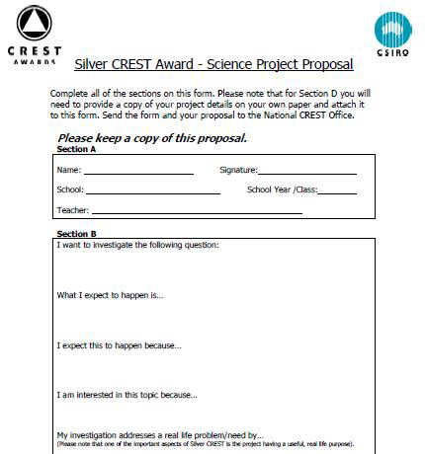
If you are registered for CREST the Silver CREST Proposal form is a good template for students to use in planning their investigations.

If you are registered for CREST, the CREST Student Handbook – Science contains detailed descriptions of the open investigation process an outline of the way to write scientific reports. The Silver CREST Profile Card also provides a checklist of the open investigation key steps.

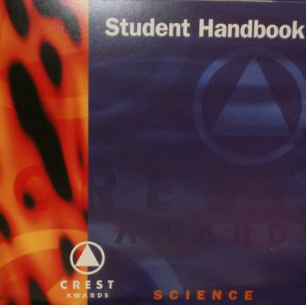
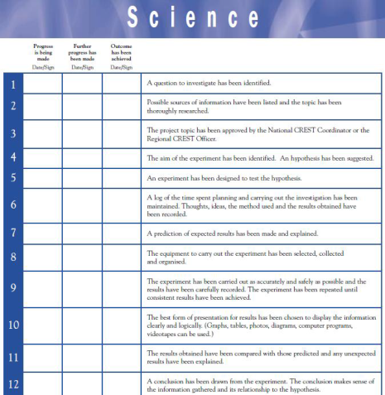

Part 3 – Final Presentation (Elaborate & Evaluate)
Ask the students to prepare a scientific report in written or electronic form.
Their report should contain the information from their project proposal along with their results displayed clearly and logically. A detailed analysis of their data along with an explanation of the reliability of their results and any sources of error identified and an evidence based conclusion should be included. Any modifications and further experimentation identified should be included along with a bibliography and acknowledgments of all assistance received.
Encourage student to present their investigation to the rest of the class in any communication mechanism they wish – booklet, poster, movie, web based etc.
Teacher Notes
Cat litters are made from different materials and are vey different in density, texture and appearance.
Although many of the cat litter products are made from recycled paper products care should still be exercised.
As this activity may require several lessons for students to complete their investigations you will need to consider the storage of their equipment whilst it is being completed.
Students are asked to provide you with a detailed list of equipment they require for their investigation. If you have a lab technician available you could ask students to complete the same forms you provide your lab technician when requesting material. If you also include a risk assessment form work with the students to complete one for their investigation.

Assessment Rubric
This assessment rubric links is based on the content descriptors of the Science Inquiry Skills
strand of the Australian Curriculum: Science
It is provided as guide for you to use with the above activity.
Please feel free to adapt or develop your own rubric to use with your students.

Science Inquiry Skills | Developing | Consolidating | Achieving
Questioning and Predicting | Struggles to formulate questions or hypotheses that can be investigated scientifically. | Requires assistance to formulate questions or hypotheses that can be investigated scientifically | Independently formulate questions or hypotheses that can be investigated scientifically.
Planning and Conducting | Struggles to independently plan, select and use appropriate investigation methods and laboratory experimentation to collect reliable data. Requires vast assistance to assess risk and address ethical issues associated with | With guidance plans, selects and uses appropriate investigation methods and laboratory experimentation, to collect reliable data; assess risk and address ethical issues associated with these methods.  Select and uses | Plans, selects and uses appropriate investigation methods and laboratory experimentation, to collect reliable data; assesses risk and address ethical issues associated with these methods.  Selects and uses appropriate equipment,

 | these methods.  With guidance selects and uses appropriate equipment to collect and record data. | appropriate equipment to collect and record data. Requires assistance to this systematically and accurately. | including digital technologies, to systematically and accurately collect and record data
Processing and Analysing Data and Information | Unable to analyse patterns and trends in data or to describing relationships between variables and identify inconsistencies in the cat litter investigation.  Cannot use knowledge of scientific concepts to draw conclusions that are consistent with evidence. | With guidance is able to analyse patterns and trends in data with limited descriptions of relationships between variables and very few inconsistencies identified.  Requires help to use scientific concepts to draw conclusions that are consistent with evidence. | Analyses patterns and trends in data, including describing relationships between variables and identifying inconsistencies in the cat litter investigation.  Uses knowledge of scientific concepts to draw conclusions that are consistent with evidence.
Evaluating | Struggles to evaluate conclusions or identify sources of uncertainty and possible alternative explanations and cannot describe specific ways to improve the quality of the data. | Require help to evaluate conclusions, including identifying sources of uncertainty and possible alternative explanations as well as describing specific ways to improve the quality of the data. | Evaluates conclusions, including identifying sources of uncertainty and possible alternative explanations and describes specific ways to improve the quality of the data.  Critically analyses the validity of information in secondary sources and evaluates the approaches used to solve problems.
Communicating | Has difficulty in communicating scientific ideas and information for a particular purpose, including constructing evidence-based arguments and using appropriate scientific language, conventions and representations. | With assistance can communicate scientific ideas and information for a particular purpose, including constructing evidence-based arguments and using appropriate scientific language, conventions and representations. | Confidently communicates scientific ideas and information for a particular purpose, including constructing evidence-based arguments and using appropriate scientific language, conventions and representations.

This activity also links to the following in the Australian Curriculum: Science

 | Science as a Human Endeavour
Use and influence of science | People can use scientific knowledge to evaluate whether they should accept claims, explanations or predictions.  The values and needs of contemporary society can influence the focus of scientific research.
CREST Link
By completing this activity, students may be eligible to receive a Silver CREST Award. If schools are registered for CREST, student proposals can submitted to CREST to receive individualised feedback and whether their project is of a suitable standard for the Silver CREST Award level criteria to be met.
CREST Science Investigation Planners- Basic, Intermediate & Advanced.
These planners assist students throughout the open investigation process.
Downloads of both planners can be found at www.csiro.au/crestonline

The CREST Student Handbook – Science containing detailed descriptions of each step in the open investigation process as well as the Silver CREST Profile Card are provided to assist students working at the Silver CREST Award level.
More information about CREST is available at www.csiro.au/crest

