  - Sustainable Futures: World Food Day 2016
Where is our food grown?
Australia has many different environments. Some are warm all year round, while others have cold winters.
In parts of the country it rains so much it floods, while other are lucky to get enough rain each year to fill the creeks, rivers and dams. The best part about this is that we can grow many different types of foods!
PART 1
Read the descriptions below of some of Australia’s different environments. Then read the descriptions of some of the food grown in different parts of Australia. Next, draw a line to MATCH the food with the environment where it grows best.

Tropical  Typically warm and rainy throughout the entire year. Tropical weather is found in areas which are close to the equator such as northern Queensland. |  | Potatoes  Over half of the potatoes grown in Australia are sold fresh, while the rest are made into chips and fries or sent to other countries. Potatoes like growing in areas which are cool in winter and warm in summer. | 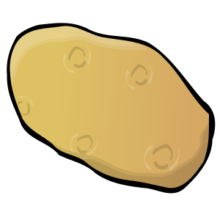
Mediterranean  Summers are warm and not humid and winters are cool and rainy. Mediterranean weather is characteristic of Melbourne through to Adelaide and onto Perth. |  | Peas  Grown to feed both humans and livestock. They are important for keeping the soil healthy and love growing in places that have cool winters and warm, humid summers. | 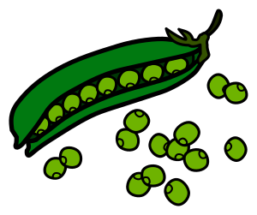
Subtropical  Summers are warm and humid, while winters are mild with little rainfall. This type of weather is typical to Northern NSW coastline and south Queensland. |  | Avocados  Can be spread on your toast, made into a dip or simply enjoyed with a spoon! They thrive in mild to warm temperatures with some rainfall. | 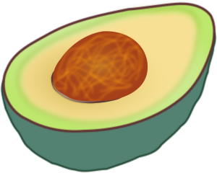
Temperate  Summers are warm and humid and winters are cool and dry. It is a moderate environment and characteristic of inland Queensland, parts of NSW and north of Perth. |  | Bananas  One of the most popular foods eaten in Australia! Bananas love growing in areas which have higher temperatures for most of the year, lots of sunshine and a good amount of rain all year round.

PART 2
Below is a map of Australia. Most maps have a ‘legend’ (also known as a ‘key’) to help us understand what we’re seeing on the map.

Write down the names of the four types of environment in the empty spaces in the table below (the first one has been done for you).

Choose a colour for each type of environment and colour in the small square. Then, use that colour to shade that region on the map of Australia.

If you wish, you can also draw a picture of the food that is grown in that region on your map, or decorate your map in any other way you like!

Legend or Key

Tropical environment

