www.csiro.au

Chief Information Security Officer

Information for applicants

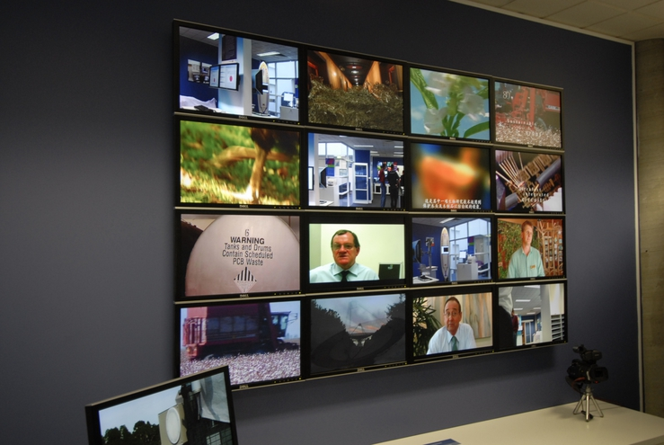
December 2016

CSIRO is Australia’s national science agency and one of the largest and most diverse research organisations in the world. We focus on mission-directed research to answer the big questions for industry and society.

What we do

CSIRO was formed as an independent statutory authority in 1949 and has a proud history of achievement through the excellence and adoption of its science and research.

Our research covers practically all aspects of human activity and the interaction with natural and built environments. This scientific embrace includes our air and water, our diverse landscapes, oceans and climate, agriculture, information and communication technologies, energy, health, space technologies and exploration, manufacturing, materials science, minerals exploration and processing, and more.

We are committed to complementing our science capabilities with outcome focused research that will generate economic, environmental and social benefits for Australia in a global context.

Our vision is to continue to be a world-class research organisation vital to Australia’s future.
Our people

CSIRO employs approximately 5,500 full-time equivalent staff. There is a real passion among our staff to make a difference, to explore new ideas and to play a part in something that is bigger than them alone.

Our goals and values go beyond our science. We know we will be successful when our people always go home safely; our collaborators and partners realise lasting value from our science and involvement; our people share a sense of discovery; and we remain a trusted advisor to government, industry and society.

People are the heart of our organisation and we pride ourselves on recruiting the best talent.

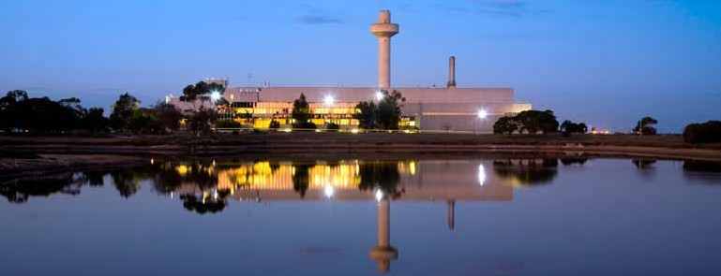

How CSIRO works
CSIRO's operating model has three lines of business, Impact Science, National Facilities and Infrastructure, and Commercial Services. Information Management & Technology (IMT) reports through the Digital, National Facilities and Collections business line and provides all computing and information services for the organisation.

Information Management & Technology
Capability

IMT is currently structured with three distinct business functions; IT Services (Client Services Delivery, Infrastructure, Applications, SAP Services), Scientific Computing (platforms, services, strategy & design, Pawsey Centre for Supercomputing), and Information Services (Libraries, Records and Data Management) and with an Executive Manager heading each of those services. A fourth business function is being developed to oversee CSIRO’s Cyber Security requirement, this position will be accountable to the CIO for the new function. A team of eight managers lead the function areas across IMT.

There are over 300 staff spread across twenty-seven CSIRO sites nationally.

IMT Strategy

Our strategy has been designed to support CSIRO 2020 with a strong focus on ensuring staff and collaborators have seamless, secure access to tools, systems and processes that further enhance the delivery of world class science.

In today’s rapidly changing world, security is a growing challenge and our services will be designed to ensure that CSIRO operates within the appropriate government policies and processes while maintaining business agility.

IMT will continue to partner with our internal customers - CSIRO Business Units and Support Functions, as well as national and international research partners, and government agencies to deliver on CSIRO’s information & technology requirements today and into the future.

Our services will be supported by industry partners and will be established upon leading edge technology and emerging trends.

In delivering our services, IMT will utilise its four functional areas to provide effective end to end and holistic services and will have a solid focus on the client requirements and experience.

IMT Vision
IMT is the trusted advisor and partner in delivering CSIRO’s information and technology needs

IMT Mission
Provide a digital eco-system that supports CSIRO’s scientific and organisational objectives and culture by enabling information and technology capability.

CSIRO Security Structure
CSIRO is required to meet Australian Government policy on Information security as part of the Government’s overall Protective Security Policy Framework. There are two areas responsible for the overall CSIRO Security program – CSIRO Security and Fraud Control and CSIRO Cyber Security.

CSIRO Security and Fraud Control develops security and fraud related governance and provides advice to protect and mitigate the effects of security risks relating to our assets (including staff), information and activities, and for the deterrence, prevention and detection of fraudulent activity with the Organisation.

CSIRO’s Cyber Security function develops and implements appropriate information security measures to ensure that its information is adequately protected from unauthorised use or accidental modification, loss or release. CSIRO has a relatively open information management and technology environment designed to support an open and collaborative science and engineering culture.
Cyber Security Governance
- The Chief Information Security Officer role provides strategic direction for information security and oversees the management of information security personnel. The CISO reports through the CIO to the Security Executive on information security issues.
- Security Executive (Chief Financial Officer) - senior member of the CSIRO Security Executive, which advises and represents the Chief Executive regarding security matters within the organisation.

- Security Committee - responsible to the Security Executive, Executive Team and the Board to ensure CSIRO has implemented effective security measures, programs and strategies in accordance with the PSPF.

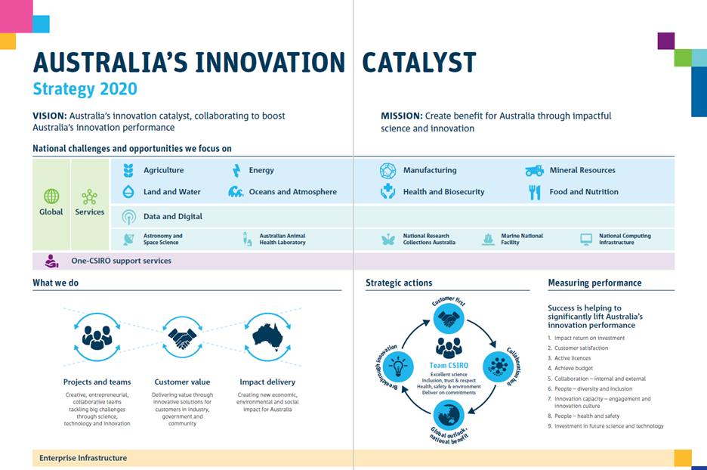

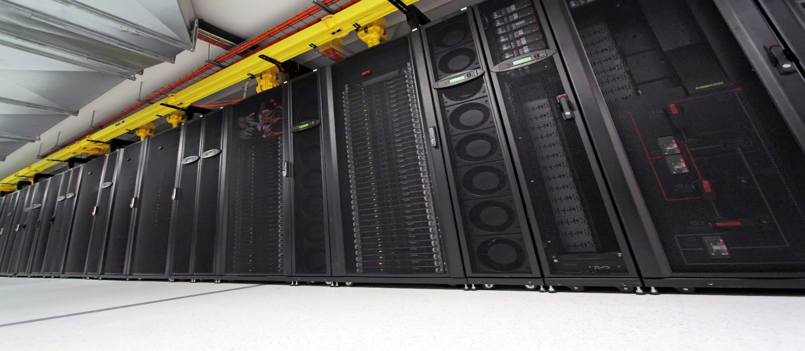

CSIRO Chief Information Officer

Brendan Dalton has been the Chief Information Officer for CSIRO since 6 July 2015.

Over the last 15 years Brendan has held roles as CIO, programme manager and technology executive in a number of Federal Government agencies.

Between 2008 and 2013 Brendan worked as a senior executive and as CIO at the Department of Climate Change and Energy Efficiency where he was ultimately responsible for the delivery of the underpinning technology solutions for Australia’s fixed price scheme.

His varied career has seen Brendan work outside technology as a ministerial advisor, in the design of industry and employment programmes. In the early 2000’s he was successful in enabling the early adoption of online tools enabling the delivery of government services to citizens and business. He also led the establishment of protocols for secure data sharing of social services data and the development of geospatial tools to support policy development and better targeting of service delivery.

Brendan has qualifications in technology management and the humanities.

The Position

The Chief Information Security Officer in CSIRO is a business/technology executive reporting to the Chief Information Officer. The role is responsible for providing enterprise-wide leadership to maintain a comprehensive Cyber and Information Security program for Australia’s premier research agency. CSIRO is a values driven organization and this is a position of trust requiring an individual with strong stakeholder management skills and exceptional levels of integrity.
The role will involve pragmatic thought leadership regarding cyber security and the assurance of CSIRO’s significant science data assets and platforms; setting the agencies cyber agenda, ensuring compliance and managing risks. The CISO leads a small team responsible for policy, education, training, cyber security incident response, risk assessment, contract review, incident prevention, detection and forensics. The role also works

through partnerships across business units and functional groups and with CSIRO partners on security and related initiatives.
As the key executive leading CSIRO information security planning, implementation and overall operations, the CISO is critical to enabling CSIRO to deliver its strategy while protecting the security and integrity of science data delivering competitive advantage for CSIRO’s brand. The CISO will partner very closely with CSIRO’s leadership and is a member of the executive of CSIRO Information Management and Technology.

NOTE: This role requires a NV2 Security Clearance and will require domestic travel.

Duties and Key Result Areas

- Security Strategy
- Develop and execute an enterprise wide security strategy and roadmap that mitigates risk through the right balance of security measures and operational flexibility.
- Standards and Guidelines - Establish policies, procedures, standards and guidelines that enable CSIRO’s security strategy.
- Threat Assessment and Scenario Planning - Identify security vulnerabilities and risks associated with CSIRO’s operations, including partnering with business units to build threat assessment into the product design and development processes.
- Advanced Detection and Containment - Build an industry leading detection and containment capability that will identify and mitigate sophisticated cyber-attacks against CSIRO.
- Day-to-Day Security Operations - Ensure operational procedures enforcing security are effective and optimal, including assessing and testing for vulnerabilities.
- Incident Response - Respond to and resolve security exposures and incidents.
- Security Engineering - Work directly with the business units and IMT to ensure that the right security capabilities are built into offerings, enterprise processes and tools through reusable technology (services oriented architecture).
- Oversee the evaluation, selection and implementation of information security tools.
- Security Compliance and Audits -Manage internal and external assessments of security, and compliance (certification and accreditation).
- Education and Training –develop and conduct security awareness training, information and education to employees, partners and customers.
- Third Party Management - Participate in the development, implementation and ongoing compliance monitoring of information privacy requirements and responsibilities in vendor contracts and agreements.
- Security Metrics and Reporting - Develop and maintain a program that informs business unit and functional group leadership of the top security risks and overall security health of their organizations.
- Commercialization and Customer interaction (Cyber relevant) – supporting wider CSIRO commercialization and pre-contract negotiations, customer contract review, RFP response, and customer audit facilitation.
- Communicate effectively and respectfully with all staff, clients and suppliers in the interests of good business practice, collaboration and enhancement of CSIRO’s reputation.
- Work collaboratively with colleagues within your team, the business unit and across CSIRO, to reach objectives.
- Adhere to the spirit and practice of CSIRO’s Values, Health, Safety and Environment plans and policies, Diversity initiatives and Zero Harm goals.
- Other duties as directed.

Selection Criteria

Please note: Under CSIRO policy only applicants who meet all the essential criteria can be appointed.
Pre-Requisite
- Tertiary qualifications in Information Systems or closely related subject or equivalent experience within an information security context and industry recognised certifications.
- At least 5 years’ experience in a senior enterprise-wide IT security role
- Australian Citizenship and Federal Government NV2 (TOP SECRET) clearance (or able to obtain this clearance).

Essential Criteria:
- Experience implementing and managing technical security controls in a geographically dispersed virtual and physical environment.
- Proven ability to manage stakeholder expectations and relationships at a senior level.
- Demonstrable experience with information security issues at an enterprise level – including technology, compliance and policy as well as a proficient understanding of risk management.
- Strong leadership skills with a focus on superior customer service and client engagement and the ability build and maintain effective working relationships.
- Superior and proactive problem solving and analytical skills.
- Strong written and verbal communication skills with the ability to influence and drive change.

CSIRO is a values based organisation. In your application and at interview you will need to demonstrate behaviours aligned to our values of:
- Integrity of Excellent Science
- Trust & Respect
- Creative Spirit
- Delivering on Commitments
- Health, Safety & Sustainability

How to apply

Please apply online at www.csiro.au/careers by uploading your resume/CV and a short letter (in MS Word) outlining how your qualifications and experience meet the selection criteria. Applicants who do not provide this information may not be considered.
If you experience difficulties applying online call 1300 301 509 and someone will be able to assist you. Outside business hours please email: csiro-careers@csiro.au
Referees
If you do not already have the names and contact details of two previous supervisors or academic/ professional referees included in your resume/CV please add these before uploading your CV.
Contact
If you require further information please contact:
Mr Brendan Dalton via email at brendan.dalton@csiro.au or phone 02 6214 2934.

keep up to date with news from c siro:

csiro

@csironews www.youtube.com/user/csiro
csironewsblog.com

contac t us
t 1300 363 400
e enquiries@csiro.au
w www.csiro.au

your c siro
At CSIRO we shape the future. We do this by using science to solve real issues. Our research makes a difference to industry, people and the planet. That’s why we’re more than Australia’s national science agency – we’re an agent of positive impact.

