Job Title: | Research Director  Cyber Physical Systems
Reference Number: | TBC
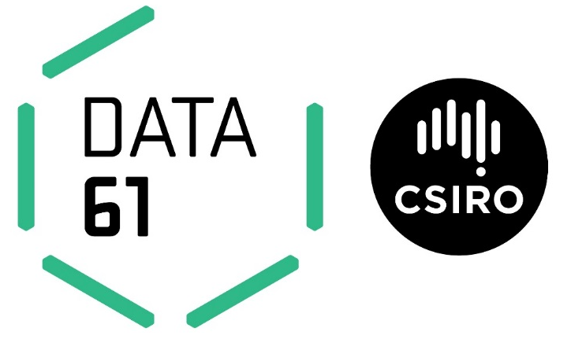
Location: | Sydney or Brisbane preferred, other locations will be considered
Tenure: | Specified Term of 3 years
Relocation assistance: | Will be provided to the successful candidate if required.
Applications are open to: | Australian Citizens Only  Australian Citizens and Permanent Residents Only  - All Candidates  - For Specified Term positions, we will accept applications from Temporary Residents with working rights for the length of the term, who do not require sponsorship.
Functional Area: | Research Management
% Client Focus - Internal: | 70%
% Client Focus - External: | 30%
Reports to the: | Chief Executive Officer, Data61
Number of Direct Reports: | Approx.
Role Overview:
- Part of Data61 Leadership Team
- High profile, high impact newly created role
- Attractive salary package, high level of autonomy
- Make a difference to Australia
Data61 is the largest data innovation group in Australia. We are unrivalled in our intellectual capital and our network within the global technology marketplace with approximately 600 research staff working in digital technologies to create benefit for Australia. Data61 will continue to develop Australia’s future leaders with its strong 300+ PhD student program in collaboration with the best universities across Australia.
The Research Director will develop the scientific vision and direction of the research laboratory. The role requires an experienced leader who will manage and develop world-class science capability that is aligned to Data61 goals and meets future workforce needs. You will partner with the Deputy Director Science and other Research Directors to ensure that our science is globally competitive and addresses meaningful problems in the market. You will be responsible for ensuring we attract and retain world class capability that meets the future needs of the business. Leveraging multiple disciplines and ensuring cross group and cross organisational collaboration, you will have a deep understanding of the market globally and how to create impact from science that brings benefit to Australia first, in a global context.
The vision for this group is to bring together the digital and physical worlds. The successful applicant will have a strong research record in at least one of the following domains:
- micro-sensing
- signal processing
- communication systems
- distributed sensor systems
- robotics
- networks
- smart vision.

Duties and Key Result Areas:
Impact Science Leadership
- Provide high level strategic science leadership to ensure Data61 remains globally competitive in its science.
- Develop and promote a strong scientific culture of excellence consistent with our Values.
- Ensure cross group collaboration and leverage other disciplines across Data 61.
- Identify and develop new science initiatives.
- Be accountable for scientific performance, including citations, patents, students and research that has been commercialised.

Capability Leadership
- Shape science capability internally and through external collaboration to meet future science opportunities.
- Support the attraction, development and retention of world class talent.
- Build the science leadership pipeline.
- Ensure a strong pipeline of students through partnerships with the GO8, partnered Universities and Global University interactions.
- Monitor long term science trends to forecast capability demand.
Engagement & Partnerships
- Manage external scientific relationships with partners to advance Data61’s interests, science delivery and impact.
- Provide high level scientific representation nationally and internationally of Data61’s capability.
- Build strategic alliances with industry, universities and across CSIRO to execute Data61’s strategy.
Resource Leadership
- Develop plans to Data61’s long term future science infrastructure.
- Work with the leadership team to ensure that the capability and resources are effectively prioritised and deployed to meet strategic requirements.

Selection Criteria:
Pre-Requisites: A PhD in a relevant discipline
Essential Criteria:
- An established international eminence in the relevant science domain with evidence of effective world‐class science leadership.
- Evidence of successful leadership of platform, discovery and impact science at scale.
- Evidence of strong engagement skills and strategic relationship management that grows new science opportunities and supports commercial outcomes.
- Demonstrated ability to attract, retain, empower and develop world class talent and to promote wellbeing and foster cross organisational capability.
- A track record in supporting senior leaders to optimise positioning, organisational alignment and science delivery in the national interest.
- Demonstrated track record in planning for science infrastructure to meet short and long term needs.
- Values and behaviours are exemplary, and actively promotes collaboration and benefit to Australia.

About the Cyber Physical Systems research program.
The Cyber Physical Systems research program is focused on bringing together the digital and physical worlds, our researchers and engineers work in the following areas:
- micro-sensing
- signal processing
- communication systems
- distributed sensor systems
- robotics
- networks
- smart vision.
For more information please visit: http://data61.csiro.au/en/Our-expertise/Expertise-Cyber-physical-systems

