Chief Scientist

The role
- Are you passionate about using science and engineering to ensure Australia’s bright future?
- Do you embrace disruptive thinking in order to remodel legacy approaches to large scale problems?
- Do you have the focus and humility necessary to represent Australia’s national science agency as its Chief Scientist?

CSIRO seeks to appoint the Chief Scientist as a full time executive leadership role to be the voice of CSIRO science in the Executive Team, to champion science and impact nationally and globally, and to act as an integrating role across sector and disciplinary boundaries.
CSIRO’s purpose is to solve Australia’s greatest challenges using science. Science excellence has been paramount for CSIRO since our establishment in 1916. The Chief Scientist’s role is to hold the overriding lens of science and solutions on behalf of the entire organisation at the executive decision making table and in the community.

The Chief Scientist is CSIRO’s chief ambassador, thought leader, and champion communicator of solutions from science to key stakeholders in Australia and internationally, with connection to Australia’s government network of chief scientists, national and global academicians and thought leaders, industry chief technology officers, and other partners in science.
CSIRO’s Chief Scientist is a trusted advisor to the Chief Executive, Board, and Australia’s government on matters relating to CSIRO’s science, technology, and innovation. The Chief Scientist will participate in government, academic, and industry groups, to support our strategy “Australia’s Innovation Catalyst”, particularly collaboration, innovation, future science platforms, market vision, and national challenges. The Chief Scientist will guide CSIRO’s research direction to ensure alignment with CSIRO’s market vision, broader national research objectives, and the broader innovation sector including universities and industry.
The successful applicant will be able to examine the capabilities and disciplines within CSIRO and externally and determine potential synergies that can be used to tackle global challenges. The successful applicant will understand the national and global research market and its translation to the experience of science staff and science support staff at CSIRO. This executive level role means taking on responsibility as an attractor of world leading talent to CSIRO and focus on continuous improvement of the quality of experience for all CSIRO staff.

The role requires an individual who is a respected thought leader and well networked across the innovation system. Equally important, the individual must be an innovative, collaborative, inclusive and inspiring leader able to mentor Australia’s emerging science talent for our future.

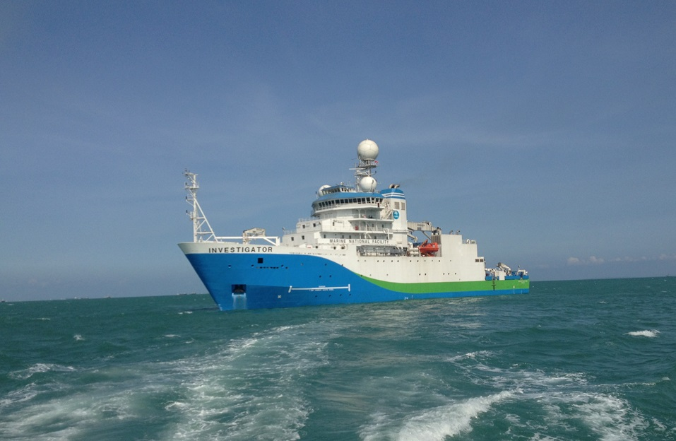

Key result areas
Champion of Science Excellence
Work with the Chief Executive as an Executive Team member to refine and implement CSIRO’s strategy “Australia’s Innovation Catalyst” in the context of science excellence. Be a champion at all levels of the organisation providing strategic science leadership across the breadth of science and promoting a scientific culture of excellence.
The Chief Scientist facilitates dialogue across CSIRO and across institutions to articulate complex problems facing Australia that require a multi-disciplinary and transdisciplinary approach to problem solving. The Chief Scientist helps marshal resources in support of that approach.

Impact Science Leadership
Draw on the CSIRO community and our partners to refine and implement CSIRO strategy. Support, encourage, and mentor emerging science leaders. Drive strategic capability development across CSIRO through active engagement with CSIRO’s Science Directors to deliver on research and investment priorities.
Champion diversity in its broadest sense and develop initiatives to grow and support diversity across CSIRO as a driver for science excellence and innovation.
Convene CSIRO’s Science Council and lead the engagements with the Board Science Excellence Committee. Work in collaboration with the Director of Science Impact and Policy to develop the agenda for CSIRO’s Science Council and the agenda for the Board Science Excellence Committee. Work closely with CSIRO’s Research Office, Market Vision and Innovation Office, and Strategy and Impact Office.
Capability Leadership
Lead cross organisation initiatives to high value outcomes. Demonstrate highly collaborative behaviours and strong communications skills. Strive for “Zero Harm” (physical and psychological) through a commitment to a healthy, safe and environmentally sustainable workplace. Shape science capability through external collaboration with companies, industry bodies, government agencies, universities and other research institutions where common goals can be identified to exploit future science opportunities that deliver our strategy.
Work with the CSIRO Leadership Team to monitor short and long term science trends to identify emerging capability gaps, develop new capabilities, and reshape untenable capability.

Engagement & Partnership
Build positive strategic scientific relationships with current and potential partners to advance CSIRO’s interests, science delivery and impact. Provide high level scientific representation nationally and internationally of CSIRO’s science excellence. Build strategic alliances with industry and the university community to execute CSIRO’s strategy collaboratively. Be a genuine ‘boundary spanner’ and ‘pollinator’ across various domains.
Work collaboratively with the CSIRO Science Council to ensure our science is relevant and competitive and to improve science outcomes across the organisation.

Trusted Advisor, Coach and Mentor
Function as a trusted advisor and coach to senior CSIRO leadership. The Chief Scientist will be a talent magnet for CSIRO, a mentor across CSIRO’s scientific community, and a champion of STEM education and STEM literacy nationally. The Chief Scientist will be responsible for regular updates to the Executive Team and Board Science Excellence Committee raising information that requires executive and board level awareness and action.

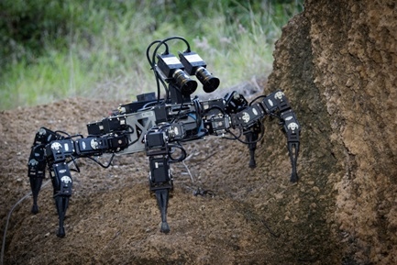

Key personal attributes
The Chief Scientist will demonstrate science eminence whilst holding the role with humility.
- Business leader: business acumen, commercial approach/understanding, ability to assess and provide advice on science excellence.
- Driving for Science Excellence: Setting high goals and driving change for personal and group accomplishment; using measurement methods to monitor progress toward goals; tenaciously working to meet or exceed goals while deriving satisfaction from that achievement and continuous improvement.
- Engaging/Personable: Respectfully attends to the needs and feelings of others to develop effective partnerships and relationships; relates to people easily and with humility.
- Ability to operate effectively at multiple levels: Sit at executive table, work with the Chief Executive and other Executive Directors, and build relationships with all levels of staff and relevant external stakeholders.
- Driving Execution: Translating strategic priorities into operational reality; aligning communication, accountabilities, resource capabilities, internal processes, and ongoing measurement systems to ensure that strategic priorities yield measurable and sustainable impact and outcomes.

Selection criteria

Pre-requisite
- Education/qualifications: Science eminence with significant relevant experience at senior leadership level in a complex or innovation organisation.
- Leadership: Demonstrated experience as a thought leader and an effective, consultative, constructive contributor to a senior executive team.
- Travel: The willingness and ability to travel interstate and internationally as required noting we work hard to accommodate personal arrangements.

As Australia’s Innovation Catalyst, CSIRO has strategic actions underpinned by behaviours aligned to excellent science, inclusion, trust and respect, health, safety and environment, and delivery on commitments. In your application and at interview, you will need to demonstrate alignment with these behaviours.

Key selection criteria
- Demonstrated ability to provide strategic and visionary leadership with established international eminence and evidence of effective science leadership in complex environments.
- Demonstrated experience in forging strategic partnerships internally as well as externally to an organisation.
- Leadership attributes such as collaborative, influential and inclusive in order to create and lead positive transformational change.
- A successful track record of dealing effectively with diverse stakeholder groups; including board of directors, government, industry, other research bodies and agencies, and the general public.
- A track record in supporting senior/executive leaders in optimal positioning, organisational alignment and science delivery in the national interest.
- Behaviours that are exemplary and that actively promote collaboration and consultation.

Location: Negotiable
Salary: An attractive salary package negotiable
Reference: 56507
Term: 3 years, with the potential to renew
Closing date: Thursday 19th April, 2018 (11.30 pm AEST)

We work flexibly at CSIRO, offering a range of options for how, when and where you work. Talk to us about how this role could be flexible for you. Find out more Balance

How to Apply:
Please load one PDF document containing your CV and cover letter and apply online via Jobs Central (if you are an internal applicant) or via CSIRO Careers Current Vacancies (Reference 56507).
If you have difficulty applying please contact CareersOnline@csiro.au or phone 1300 984 220 during Australian business working hours (Eastern Standard Time).
If you would like additional information about this position please contact Mr Ricky Pena, Executive HR Manager at ricky.pena@csiro.au (+61 8 6436 8722) or Dr Anita Hill at anita.hill@csiro.au. Applications sent directly to Mr Pena and Dr Hill may not be considered.

About CSIRO
At CSIRO, we do the extraordinary every day. We innovate for tomorrow and help improve today – for our customers, all Australians and the world.
Our innovations contribute billions of dollars to the Australian economy every year. As the largest patent holder in the nation, our vast wealth of intellectual property has led to more than 150 spin-off companies.
With more than 5,000 experts and a burning desire to get things done, we are Australia’s catalyst for innovation.
CSIRO. We imagine. We collaborate. We innovate.
At the Commonwealth Scientific and Industrial Research Organisation (CSIRO), we shape the future. We do this by using science to solve real issues. Our research makes a difference to people, industry and the planet.

Our research includes the following business units:

- Agriculture and Food
- Australian Animal Health Laboratories
- Data 61
- Energy
- Land and Water
- Manufacturing
- Mineral Resources
- Oceans and Atmosphere

We are responsible for the following national facilities and collections
- Atlas of the Living Australia
- Biocontainment facility
- National Collections
- Scientific computing
- RV Investigator
- ASKAP (Australian Square Kilometre Array Pathfinder)
- The Dish

