Counsellor (CSIRO), Hanoi
Role summary for potential applicants
Advertised Job Title: | Counsellor (CSIRO)
Reference Number: | 58430
Classification: | CSOF7
Salary Range: | AU $134k to AU $148k plus super and international assignment allowances
Location: | Hanoi, Vietnam
Tenure: | Specified Term of 3 years
Relocation assistance: | Will be provided to the successful candidate if required.
Applications are open to: | Australian Citizens Only  Australian/NZ Citizens and Australian Permanent Residents Only  - All Candidates
Functional Area: | General Management
% Client Focus - Internal: | 20%
% Client Focus - External: | 80%
Reports to the: | CSIRO ASEAN Director (Singapore)
Number of Direct Reports: | 3

Role Overview:
The Counsellor position holds primary responsibility for providing program management and technical expertise for the Aus4Innovation initiative – a $10 million, four year collaboration between CSIRO and DFAT to assist Vietnam in developing its innovation system. Innovation is one of the three key pillars of Australia’s bilateral aid relationship with Vietnam. Aus4Innovation supports Vietnam’s continued economic growth and achievement of the Sustainable Development Goals (SDGs). In addition to delivering on Australian foreign policy objectives, the role will advance CSIRO’s interests in Vietnam and deliver benefits for Australia connecting Australian partners and SMEs into Vietnam, advancing CSIRO science capability and exporting Australian innovation.
As part of CSIRO’s offshore network in ASEAN (which includes Singapore and Jakarta), this role is based in the Australian Embassy located in Hanoi, Vietnam. The position is responsible for representing and advancing the goals of the Australian Government with the Vietnamese Government, largely through the management of the Department of Foreign Affairs and Trade (DFAT) Aus4Innovation program. Working closely with other agencies at the Embassy, this program will take a Team Australia approach to:
- Co-develop and pilot models with the Vietnamese Ministry of Science and Technology to strengthen Vietnam’s innovation system. This aims to advance Vietnam’s economic growth and support Vietnam’s achievement of the SDGs.
- Build and strengthen science, technology and innovation capability that aligns with the emerging needs of the public and private sector in Vietnam.
- Extend and deepen institutional relationships between Vietnam and Australia to support the achievement of Aus4Innovation objectives.

Duties and Key Result Areas:
- Program Management of Aus4Innovation (a summary of the program is included as an attachment to this Position Description). It is envisaged program management will constitute approximately 80% of this role with tasks including but not limited to:
      - Establishing and leading a Program Management Office located in the Australian Embassy in Hanoi including management of three locally engaged Aus4Innovation program staff.
      - Overseeing and coordinating the program, its constituent components and a rigorous monitoring and evaluation system.
      - Promoting and representing the Aus4Innovation program and associated output with relevant Vietnamese and multilateral agencies.
      - Managing complex stakeholders including but not limited to the program advisory group and the Vietnamese Ministry of Science and Technology.
- Work with Embassy agencies, particularly Department of Industry Innovation and Science, Austrade, ACIAR and the Department of Agriculture and Water, to develop a collaborative approach which will support an engagement program to showcase CSIRO research and innovation and generate new opportunities for collaboration and development impacts.
- Work with and report in to the lead government agency DFAT and specifically the Australian Ambassador at Hanoi Post.
- On behalf of CSIRO, build relationships with the Vietnamese Government, multilateral agencies, and development banks to enhance the credibility of CSIRO and fulfil objectives that further CSIRO’s interests in Vietnam.
- Work with CSIRO Business Development teams, and within the remit of Embassy requirements and expectations, support commercialisation and growth opportunities for CSIRO research.
- Adhere to the spirit and practice of CSIRO’s Values, Health, Safety and Environment plans and policies, Diversity initiatives and Zero Harm goals.
- Undertake other duties as directed.

Selection Criteria:
Under CSIRO policy only those who meet all essential criteria can be appointed
Pre-Requisites:
- Education/Qualifications: A tertiary qualification (or equivalent experience) in either Science and/or Business, plus extensive experience in a relevant field.
- Security: Australian citizenship and an Australian Government security clearance, NV2 (or the ability to obtain this level clearance).
- Communication: Exceptional written and oral communication and interpersonal skills, evidenced by superior representation and negotiation abilities.
- Behaviours: A history of professional and respectful behaviours and attitudes in a collaborative environment.
Essential Criteria:
- Deep knowledge of, and extensive experience in Australian Government (which may include CSIRO), with demonstrated achievement in building and sensitively developing and managing relationships on behalf of the Australian Government.
- Experience in program management or management of multiple large and complex projects in the Government sector.
- Experience building and leading teams to achieve quality outcomes.
- Experience navigating through and with large, complex organisations and bureaucracies, and overcoming barriers and roadblocks to build awareness and strategic engagement, and leveraging these relationships to identify potential opportunities for CSIRO.
- Demonstrated ability to establish and develop strong stakeholder relationships, utilising influencing skills to gain support for new initiatives both within and outside an organisation.
- Proven ability to represent and articulate science, technology and commercial concepts credibly.
Desirable Criteria:
- Innovation management experience - comprehension and experience in different innovation practice and models.
As Australia’s Innovation Catalyst, CSIRO has strategic actions underpinned by behaviours aligned to:
- Excellent science
- Inclusion, trust & respect
- Health, safety & environment
- Delivery on commitments.
In your application and at interview you will need to demonstrate alignment with these behaviours.

Other Information:
How to Apply
Please apply for this position online at https://jobs.csiro.au/ and enter requisition number 58430. Internal applicants please apply via ‘Jobs Central’ in SAP (click ‘Recruitment’).
Please load one document containing your CV and a brief cover letter which outlines your interest in the role and your motivations for applying (Maximum 2MB). At the end of the online application process, you will also be required to respond to some screening questions. Where text responses are required, to avoid being timed out of the system we recommend that you prepare your responses offline and paste them into the appropriate spot prior to submitting your application.
If you experience difficulties applying online call 1300 984 220 for assistance. Outside Australian business hours please email: csiro-careers@csiro.au.
Referees: Please provide contact details of two previous supervisor or academic/professional referees in your resume/CV.
Contact: If after reading the position details above you require more information please contact:
Dr James Dods via email: James.Dods@csiro.au or telephone: +61 2 9490 8512
Please do not email your application directly to Dr Dods. Applications received via this method may not be considered by the selection panel.
About CSIRO
Australia is founding its future on science and innovation. Its national science agency, the Commonwealth Scientific and Industrial Research Organisation (CSIRO) is a powerhouse of ideas, technologies and skills for building prosperity, growth, health and sustainability. It serves governments, industries, business and communities across the nation.
Find out more! www.csiro.au.
We work flexibly at CSIRO, offering a range of options for how, when and where you work. Talk to us about how this role could be flexible for you.
Find out more! CSIRO Balance
CSIRO ‘s ASEAN network plays a central role in the development and implementation of CSIRO’s Global engagement objectives that deliver benefit to Australia. With colleagues in the Global team, across ASEAN and within the Embassy, you will support the full range of CSIRO’s activities in Hanoi, with a strong focus on the Aus4Innovation activity. Over your posting, you will work in the interest of internal stakeholders in Australia to contribute to the delivery of a sustainable global revenue model, science excellence and capability growth as well as creating pathways for the Australian innovation ecosystem and contributing to the government trade, investment and foreign policy agenda.

Global

Aus4Innovation summary

Background and intent
Over the past 30 years, Vietnam has transformed itself: it has reduced poverty, increased employment, income and GDP and in 2010, transitioned to middle-income country status. This rapid transition highlights new challenges, including ensuring Vietnam continues to be an attractive investment destination for manufacturing as new technology emerges and Vietnam’s wages rise relative to competing countries. The landmark Vietnam 2035 report highlighted the need to improve the country’s innovation capacity to ensure continued economic growth, prosperity and competitiveness.
Vietnam aspires to be an innovation nation: it is well placed to seize the opportunities of an increasingly digital future, leveraging core strengths in science and technology. In the 2017 Global Innovation Index, Vietnam gained 12 positions and now ranks 47th. Vietnam maintains a top ranking among lower-middle-income economies. It shows the best score of the ASEAN group in expenditure on education (amounting to approximately 6.5% of GDP in 2014, or US$7.7 billion).
At the same time, challenges remain: it has some of the lowest scores in tertiary enrolment, state of cluster development, university/ industry research collaboration, and knowledge intensive employment. Vietnam’s political leadership is concerned about the risks of Industry 4.0, particularly for employment in the manufacturing sector.
In November 2016, the Communist Party leadership set out the following objectives for Vietnam’s innovation agenda, with the Ministry of Science and Technology tasked to coordinate Vietnam’s activities:
- Prioritise science and technology transfer, where this is essential to improving the productivity, quality and competitiveness of the economy;
- Increase the technological absorption and innovation of businesses, encourage and enable businesses to participate actively in research, development, tech transfer and commercialisation, including the mobilization of PPP approaches so that private sector can best make use of R&D, technology development, and innovation;
- Continue the development of hi-tech parks, and accelerate start-ups, including the development of hi-tech import policies; and
- Establish a high quality database for high quality forecasting, fore sighting and data analysis for macro-economic decisions
Australia’s economic partnership with Vietnam is supporting reform through stimulating the private sector, upskilling the workforce and supporting inclusive growth. Although innovation is not explicit in the current Aid Investment Plan, there is a clear rationale for a closer innovation partnership with Vietnam that leverages Australian complementary strengths and advances Australia’s interests.
Innovation is already a core enabler in our development cooperation with Vietnam, particularly in private sector development, human resources development and women’s economic empowerment. DFAT are already working with Vietnam in innovation through the National Innovation and Science Agenda (NISA) and the Australian Government’s Mekong Business Initiative (through the Asian Development Bank). Aus4Innovation is an opportunity to build and extend relationships and to help shape Vietnam’s innovation agenda.

Objectives and principles
Aus4Innovation is a four year AUD10m partnership program between Vietnam and Australia that strengthens the innovation system and prepares for Vietnam 2035.
Aus4Innovation is a key initiative that supports the Vietnam-Australia Innovation Partnership, forms part of Australia’s five-year development cooperation program outlined in its Aid Investment Plan 2015-2020, contributes to the Australia in Vietnam Agriculture Strategy and aligns with the Agreement on Scientific and Technological Cooperation. In addition, it supports the recently established MOUs between MOST and the Department of Industry, Innovation and Science, MOST and ACIAR, and MOST and CSIRO.
The three key objectives for Aus4Innovation are:
- To co-develop and pilot models with MOST to advance Vietnam’s innovation system
- To build and strengthen science and technology capability that aligns with the emerging needs of the public and private sector
- To extend and deepen institutional relationships between Vietnam and Australia.
A key principle for the initiative is to jointly develop and test new ways to address policy, capacity and partnering challenges, and to explicitly review and refine outcomes to suit and enhance the Vietnamese innovation system.
Acknowledging the fast pace of innovation and the dynamism of Vietnam’s economy, a second principle is to have flexibility to engage with emerging issues, partners and opportunities as they arise over the duration of the investment.

Delivery approach
Aus4Innovation incorporates a mix of modalities and approaches to deliver innovation through four inter-related activities.
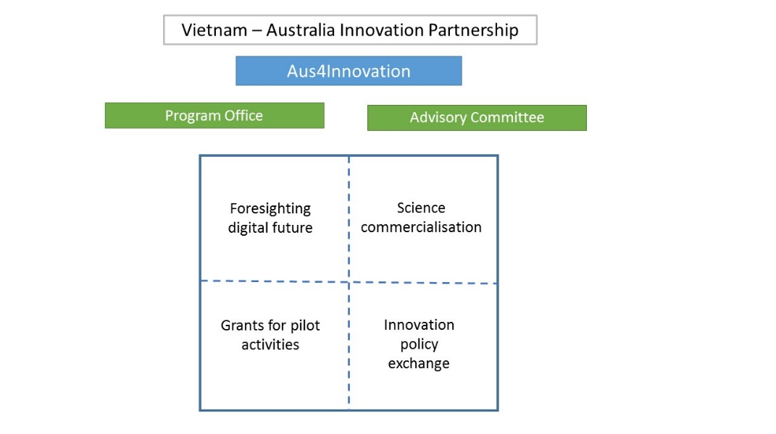
Research – Business Alliances
Foresighting the digital future explores the trends, probable impacts and implications of digital technology on the Vietnamese economy. Two case studies will be developed on Industry 4.0 readiness for Vietnam’s manufacturing and agriculture sectors. A key output for the MOST-Data61/CSIRO partnership will be a set of reports (due March 2018 and March 2019) and an analysis of issues, policy implications and suggested future interventions, including dissemination of findings. Foresighting and scenario capabilities will developed in MOST and other agencies that can be applied across the Vietnamese economy.
A Research - Business Alliances component will explore models for brokering and building partnerships between research institutes and the private sector for research commercialisation. This CSIRO-MOST pilot is intended as an alternative approach to traditional tech transfer, with partnerships built around an innovative idea and a shared R&D process. Based on feedback from the design mission, the focus for the pilot will be on the agriculture sector.
In the second half of 2018, CSIRO and MOST will commission analyses of the private sector landscape and the research capabilities in three regions. Partnerships will be brokered between research and industry, in alignment with provincial and national priorities and in collaboration with relevant regulators, enablers and investors.
From early 2019, a small selection of promising partnerships will be guided through a tailored commercialisation process to explore the science and market aspects of these ideas, with customised training and connection to advisors and mentors in Australia and Vietnam, from industry and academia. CSIRO’s sci-tech innovation accelerator (ON) will be at the heart of the commercialisation process.
Ultimately, a set of collaborative research-business partnerships with sound technical and commercial foundations for investment will be exposed to domestic and international investment pathway options. In addition, a set of collaborative alliances will be established between public and private sector partners and valuable insights will emerge of what is required by research institutes (individually and collectively) to engage effectively with the private sector. A critical activity will be explicit evaluation and refining of the model for adoption into Vietnam’s S&T sector.
A Competitive grants mechanism will provide targeted funds for pilot activities to address emerging challenges or opportunities in any sector of the innovation system. This flexibility will support engagement with new ideas, additional partners and evolving priorities. Examples might include: specific high tech collaboration, enhancing entrepreneurism skills, managing open data.
There will be two themed rounds, with a maximum of three grants awarded in each round, and grants ranging from AUD250K to AUD1m. Pilots will run for 12 months, will be a collaboration between at least a Vietnamese and Australian entity and must have an articulated pathway for scale or sustainability in Vietnam. The grants will be managed by the Aus4Innovation Program Office and the themes and funding will be agreed by the Aus4Innovation Advisory Group (refer Structure and Governance section).
The Innovation policy exchange will address emerging challenges in the implementation of Vietnam’s innovation agenda. This component will also be managed by the Program Office, with oversight by the Advisory Group. This is a flexible fund to explore policy issues and introduce new models of relevance to Vietnam and MOST.
Examples of activities may include: strategic sector roadmapping; commissioning expert advice or technical analysis; agency twinning; joint workshops. An initial stocktake of Vietnam’s innovation initiatives, actors, policies and funding will be commissioned in the second half of 2018, providing the Advisory Group with a foundational analysis.
For each component, links will be explored with existing initiatives and partners in Australia and Vietnam. Examples include: Aus4Skills; Aus4Reform; Aus4Equality; research brokered by the Australian Centre for International Agricultural Research; existing iXc activities and networks in Vietnam; ADB’s Mekong Business Initiative; Australian Education in Vietnam Advisory Group; MARD, MOET initiatives.

