OCEANs AND ATMOSPHERE
Research Director,
Marine Resources
and Industries

Information for applicants
March 2018

CSIRO’s Oceans and Atmosphere
Key challenges we address
Understanding our oceans, coasts, climate and atmosphere is critical to Australia’s future.
Our ocean-based industries contribute over $70 billion a year to the Australian economy. The ocean drives the climate system, provides food and transport, minerals, oil and gas resources, sustains biodiversity and regional economies, and offers recreational and lifestyle opportunities.
Australia’s marine and coastal resources often come under pressure from the competing demands of different sectors. Sharing our ocean’s wealth for the benefit of all Australians requires a careful balancing act of planning, management and co-operation. Oceans and Atmosphere provides the large-scale multidisciplinary science to inform environmentally, socially and economically sustainable outcomes across the broad range of users and uses of Australia’s marine environment.
Marine Resources and Industries is one of four Research Programs in Oceans and Atmosphere. It undertakes research to inform and support the management of marine resources, including fisheries, biodiversity conservation, and offshore oil and gas, both in Australia and internationally. The program has nationally and internationally recognised scientists in quantitative benthic and pelagic ecology, genomics, fisheries and risk assessment, ecosystem modelling and resource economics.
Our vision
Oceans and Atmosphere provides the knowledge to manage Australia’s marine estate and atmospheric environment, plan for and respond to weather and climate related natural hazards and ensure sustainable coastal development and growth of marine industries.
About CSIRO
The Commonwealth Scientific and Industrial Research Organisation (CSIRO) is one of the world’s largest and most successful publicly-funded research and development organisations with locations across Australia and internationally. CSIRO is committed to complementing its world-class science capabilities with outcome-focused research that will generate economic, environmental and social benefits for Australia in a global context.
About the role
The Research Director sets the vision and strategy for the Marine Resources and Industries Research Program and is responsible for leading a portfolio of multi-disciplinary, collaborative research projects that deliver on the goals of the Oceans and Atmosphere Business Unit.
CSIRO’s mandate is to deliver world-class research that provides innovative solutions for industry, government and the community. The research effort is, therefore, mission-directed and impact-focussed and it is essential that the Research Director has, or can readily develop, strong links with industry partners and relevant government agencies. Experience building cohesive, dynamic and creative research teams that integrate across disciplinary and organisational boundaries is essential. It should be expected that the portfolio of research will evolve over time on the basis of need, strategy and performance.
The Research Director must be an entrepreneurial and collaborative leader. He or she will form part of the Oceans and Atmosphere Leadership Team and be accountable for the delivery of specific elements of Oceans and Atmosphere’s overall impact, science and financial objectives.

Key result areas and duties
Science leadership

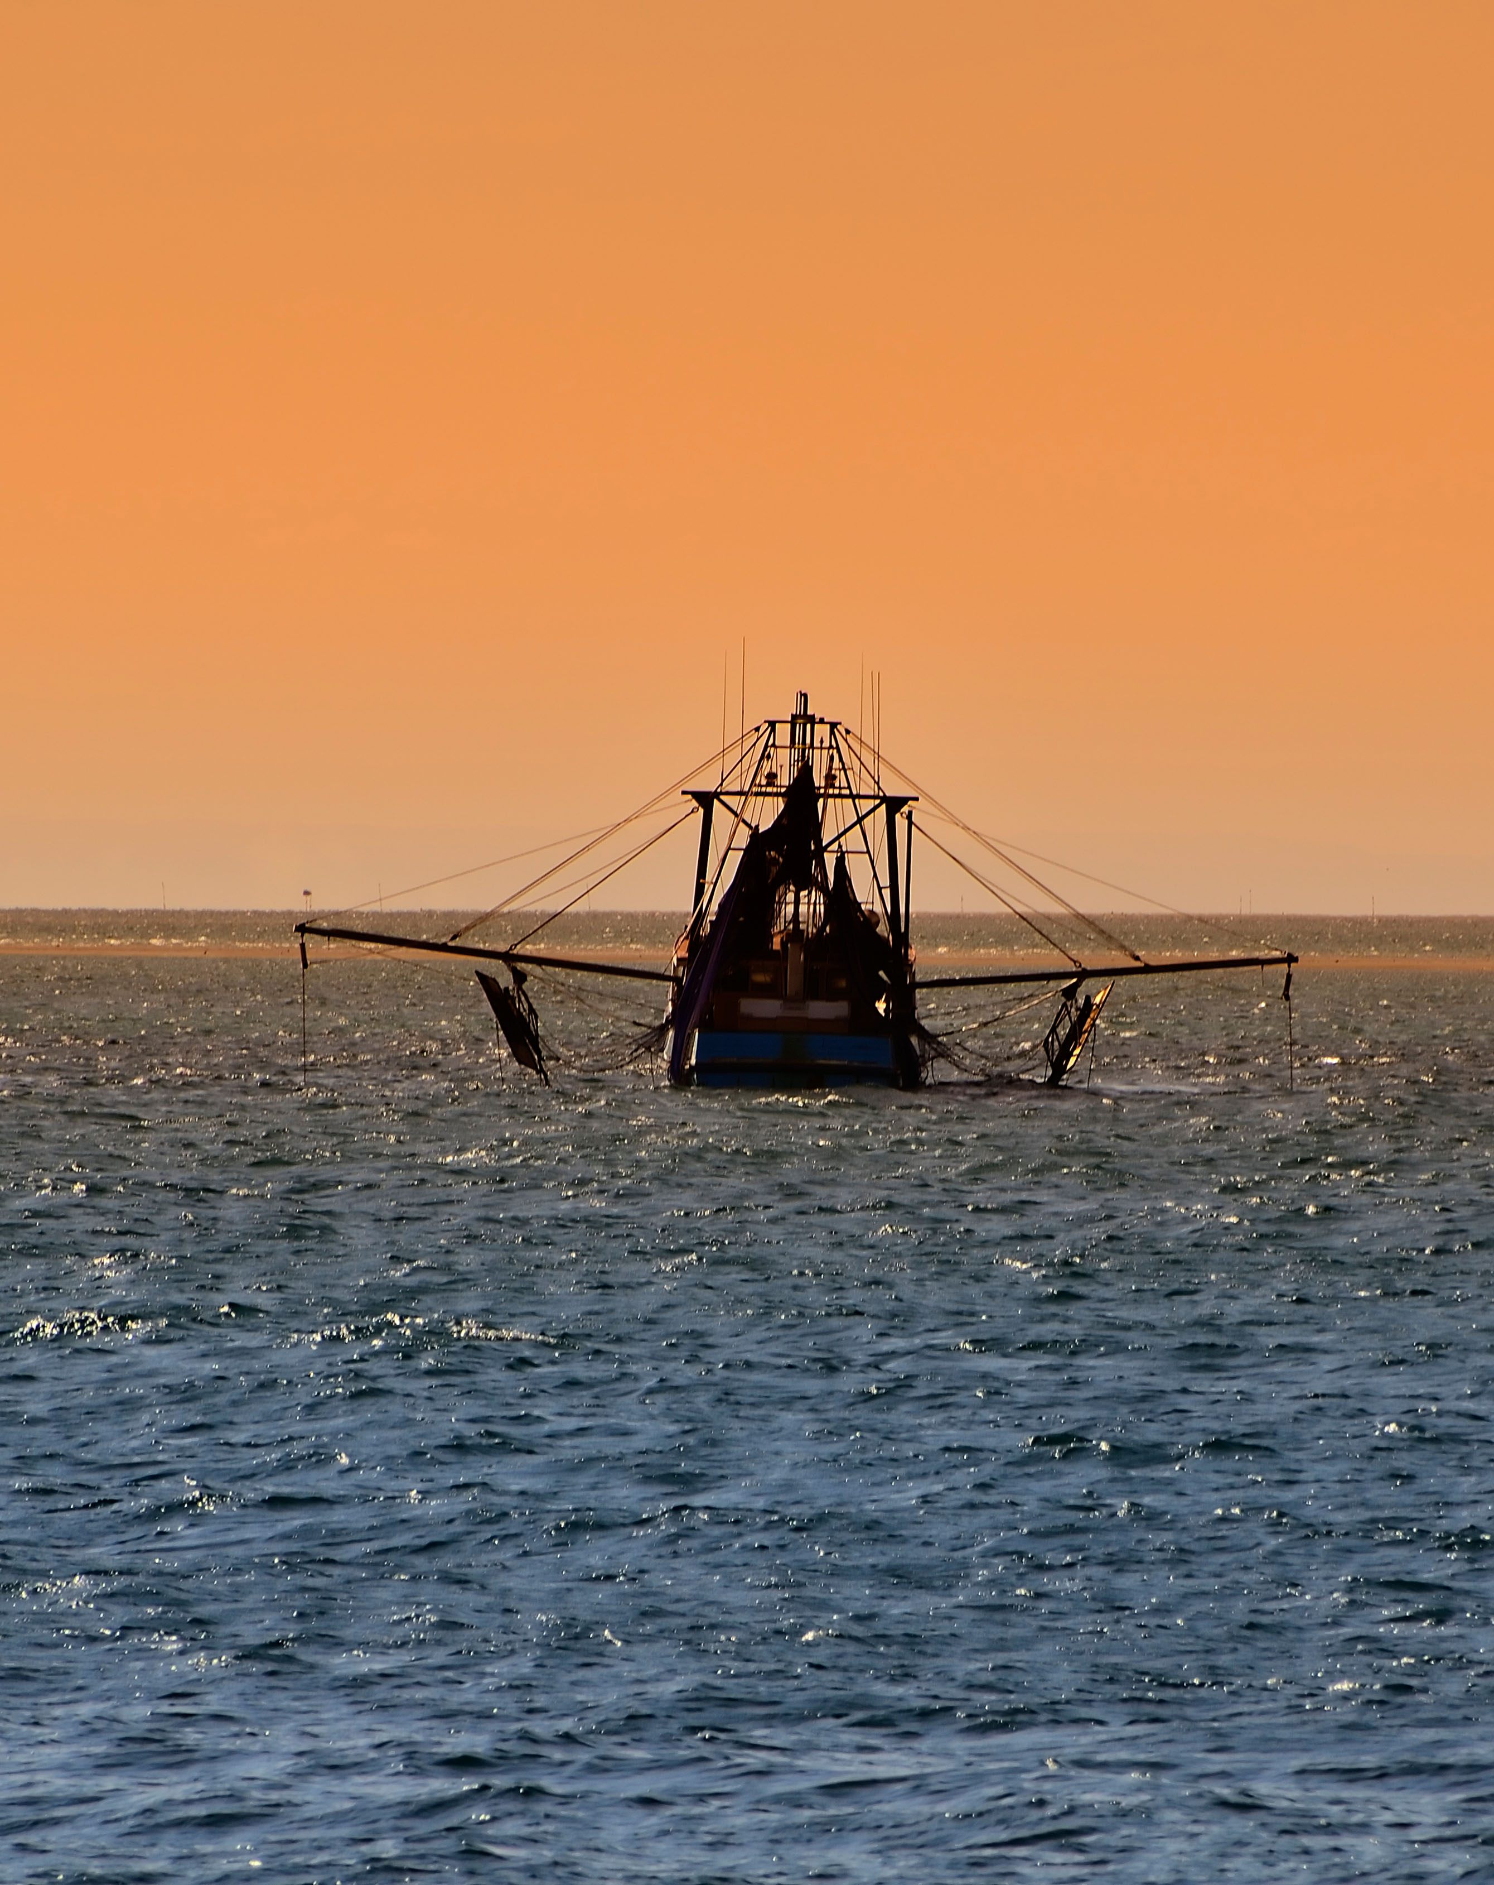
Create a long-term impact plan for the Program that addresses national challenges and builds the necessary capacity to deliver on Program objectives;

Develop a culture of science excellence, creativity, innovation and flexibility;

Stimulate science thinking – develop and encourage science networks, sponsor new initiatives and explore innovative solutions to problems;

Oversee the Program’s pipeline of projects - facilitate prioritisation and allocation decisions;

Build and deliver on a pipeline of contracts (3-5 year focus) including identification of CSIRO-wide opportunities;

Manage the Program’s portfolio of Intellectual Property;

Drive the pursuit of external revenue to support the goals of the business unit;

Engage key stakeholders and clients to build support for investment;

Lead project review processes;

Support the Director and Deputy Director in Oceans and Atmosphere Science and Impact Reviews.

Capability leadership  - Drive “Zero Harm” and actively promote a healthy, safe and environmentally sustainable workplace;  - Attract, develop and retain world class talent which meet current and future needs of the Program;  - Demonstrates exemplary behaviour in the workplace and manages people matters proactively in accordance with CSIRO values;  - Forecast and develop capability which is aligned to the goals of the business unit and supports the delivery of Program research;  - Build effective and diverse teams, facilitate career development for staff and actively plan for succession within the Program;  - Contribute to the development of the Oceans and Atmosphere strategy and communicate to Program staff;  - Proactively lead and support change initiatives across the Research Program and the Business Unit.  Engagement and partnership  - Build strategic alliances within the organisation to collaboratively execute CSIRO Strategy and Oceans and Atmosphere Strategy across lines of business;  - Develop and cultivate national and international research collaborations and networks to keep abreast of emerging advances in relevant science fields and industry challenges;  - Communicate Oceans and Atmosphere strategy and Program goals to internal and external stakeholders;  - Identify and pursue high level contact with customers/partners to identify and capitalise on opportunities for future collaboration – externally and within other Programs and Business Units; | Resource leadership  - Lead and manage the Program’s finances, people, infrastructure and other assets to ensure their effective and efficient use;  - Ensure management of infrastructure and resources in an environmentally sustainable way;  - Ensure best practice governance and management of commercial activities and intellectual property.  - Manage financial performance of the Program and deliver annual budgets;  - Ensure Program delivers against milestones and quality standards;  - Contribute to the development of science plans for future infrastructure.  Key capabilities  - Behaviours  - Leading change through vision and values  - Selling the vision  - Influencing/cultivating networks  - Decision making/judgment  - Establishing strategic direction  - Entrepreneurship  - Expanding and advancing opportunities.

Experience
- Demonstrated high-level research leadership and management (at least 7 years) in a relevant field
- A reputation of exemplary values and behaviours and active promotion of cross business collaboration
- Established reputation for developing and leading strategic direction in a manner that inspires a large multi-disciplined team and supports the achievement of strategic goals
- Excellent written and oral communication skills, evidenced by superior reporting, presentation and negotiation abilities, and the capacity to identify and influence critical stakeholders to gain support for contentious proposals/ideas
- Proven ability to resolve major scientific, technical, commercial or management problems which have significant research impact, through the development of original concepts and approaches
- Demonstrated ability for flexibility to respond to external change and deal with external constraints, including identifying and promoting opportunities arising as a result of change
- Financial and risk management within a group or area.
Selection Criteria
- Evidence of an ability to strategically identify national and global research challenges and opportunities to transform the economic, environmental and social sustainability of marine resources and industries.
- Evidence of successful development and leadership of a pipeline and portfolio of science, research and innovation on a national and international scale.
- Evidence of strong industry engagement and strategic relationship management that grows new impact opportunities and supports positive and sustainable commercial outcomes.
- The ability to work effectively as an integral member and leader of a multi-disciplinary, regionally dispersed research team, and foster an environment in which there is a high level of co-operation within and between teams.
- Demonstrated ability to establish productive teams, manage performance, undertake strategic planning, operationalise the vision for staff, and gain commitment to the direction chosen.

Organisational knowledge  - Broad knowledge of CSIRO Oceans & Atmosphere’s science domains and portfolios, in particular marine resources and biodiversity  - Deep working knowledge of the global and national challenges and opportunities in the research portfolio of Marine Resources and Industries  - Broad knowledge of CSIRO’s Strategy, Structure and Operating Model  - In depth knowledge and understanding of national and international innovation systems (universities, publically funded research agencies and CSIRO’s role)  - Relevant stakeholder networks  Personal attributes  - Ability to navigate complexity  - Credibility  - Resilience  - Emotional intelligence  - Collegiate approach  - Tolerance of ambiguity  - Ability to problem solve  - Ability to optimize diversity | Conditions of employment  - An attractive senior salary package will be offered to the successful candidate. Four weeks annual recreation leave and 15 days Sick Leave and Carers’ Leave apply.  - Relocation and immigration assistance will be provided to the successful candidate where required.  - This is an indefinite position.  - CSIRO’s preferred location for this role is Hobart, Tasmania or Brisbane, Queensland  CSIRO is a values based organisation  You’ll need to demonstrate behaviours aligned to our values of:  - Integrity of excellent science  - Building trust and respect each day  - Initiative to explore new horizons  - Delivering on commitments  - Safety and sustainability
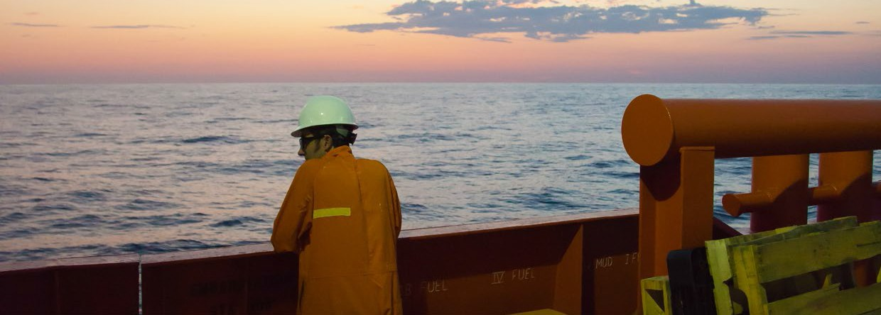
1

CONTACT US  t 1300 363 400  +61 3 9545 2176  e csiroenquiries@csiro.au  w www.csiro.au  At CSIRO, we do the  extraordinary every day  We innovate for tomorrow and help improve today – for our customers, all Australians and the world.  Our innovations contribute billions of dollars to the Australian economy  every year. As the largest patent holder  in the nation, our vast wealth of intellectual property has led to more  than 150 spin-off companies.  With more than 5,000 experts and a burning desire to get things done, we are Australia’s catalyst for innovation.  CSIRO. WE IMAGINE. WE COLLABORATE.  WE INNOVATE. |  | For further information  Oceans and Atmosphere  Dympna Austin  t +61 2 9325 3130  e dympna.austin@csiro.au  w www.csiro.au/en/Research/OandA
