Position Details

Technical Services- CSOF3
The following information is for applicants
Advertised Job Title | Technical Services Officer - IMT, Client Services Delivery
Job Reference | 64233
Tenure | Indefinite  Full-time
Salary Range | AU$63,594 to AU$80,937 pa + up to 15.4% superannuation
Location(s) | Geelong, VIC
Relocation Assistance | Will be provided to the successful candidate if required
Applications are open to | Australian Citizens Only
Position reports to the | Client Services Delivery - Team Lead
Client Focus – Internal | 100%
Client Focus – External | 0%
Number of Direct Reports | 0
Enquire about this job | Contact Davor Topalovic via email: davor.topalovic@csiro.au or phone: (03) 9545 2927.
How to apply | Apply online at https://jobs.csiro.au/  Internal applicants please apply via Jobs Central  If you experience difficulties when applying, please email careers.online@csiro.au or call 1300 984 220.

Role Overview

The role of the Technical Services Officer - IMT, Client Services Delivery is to work with the Client Services Delivery (CSD) team to aid in the delivery of effective and timely IT support within CSIRO. IMT’s CSD group is responsible for providing effective and timely IT support to all of CSIRO and has staff at most CSIRO sites across Australia. Services are delivered through a mixture of physical and remote channels, depending on the location of the site and the type of support required.

CSD is the primary point of contact for all IMT services in CSIRO. Its main functions are: 1) On Site Support: Hands-on support for tasks requiring physical assistance to solve a problem or fulfil a request; 2) Service Desk: The first point of call for IMT’s clients, responsible for logging and management of all calls, telephone support, call resolution using remote desktop technology, and escalation to second- and third-level support for resolution where necessary; 3) Incident Management: managing the response to major incidents and collaborating with IMT’s technical teams to diagnose and resolve them.

The Technical Services Officer will actively contribute to IMT’s service direction, participating in applying adaptive and innovative solutions to complex and/or ambiguous issues across one or more service and/or technical streams. Your demonstrated client focus will gain the support of key stakeholders and contribute to integrating IMT technical solutions with business requirements to achieve CSIRO’s strategic and organisational objectives.
You must abide by and promote AAHL’s microbiological security regulations and conduct work consistent with CSIRO’s Equal Employment Opportunity and Occupational Health, Safety & Environment principles.

Security Clearance:
This is a security assessed position. Applicants must be an Australian citizen, with successful candidate either holding or having the ability to obtain a Negative Vetting 1 Australian Government security clearance or undergo other employment suitability checks.
Note:
- CSIRO utilises the Australian Government Security Vetting Agency to conduct its security clearances. Further information regarding security clearances may be found at http://defence.gov.au/AGSVA/resources.asp
- To obtain an Australian Government security clearance, 10 years’ worth of background information verifiable by independent and reliable sources is required.

Duties and Key Result Areas:
- Provide resolutions in a timely manner to problems or requests that require ‘On Site’ attendance. Examples include:
- Deployment of PC desktops, laptops, LCD monitors, printers and other IT related equipment.
- Network Port patching
- Software fault assistance
- Deliver first contact remote IT support to provide responses and resolutions in a timely manner to incidents or requests
- Conduct analysis of service contacts, classify contacts into service areas and assign to the relevant support groups via the service management toolset
- Develop and maintain relationships contributing to virtual teams across the CSIRO IMT model to ensure the delivery of best practice service
- Contribute positively to stimulate and promote a team approach, and develop sound working relationships with clients on a day to day basis as a representative of CSIRO IMT
- Keep management and other team members informed of progress and issues
- Identify tasks/issues that cannot be resolved and refer them to senior CSD staff and/or Technical Specialist Teams
- Develop, maintain and expand individual skills which are of benefit to the services delivered by CSIRO IMT and that contribute to the skill set of the Client Services Delivery Team
- Adhere to the spirit and practice of CSIRO’s Values, Health, Safety and Environment plans and policies, Diversity initiatives and Zero Harm goals.
- Other duties as directed.

Required Competencies:
- Teamwork and Collaboration: Proactively seeks and considers the ideas and opinions of others from within and outside the team to help form decisions, plans or actions.
- Influence and Communication: Puts forward ideas by presenting factual information supported by data, definitions, examples, illustrations or other aids, which will assist in conveying meaning.
- Resource Management/Leadership: Provides instruction and assists other staff to complete allocated tasks and activities.
- Judgement and Problem Solving: Identifies and considers the implications of a range of available alternatives in order to select the most appropriate response to problems of a familiar or recurring nature.
- Independence: Recognise and makes immediate changes to improve performance (faster, better, lower cost, more efficiently, better quality, improved client satisfaction).
- Adaptability: Willingness to change ideas or perceptions based on new information, contrary evidence or other people's points of view. Prepared to try out different approaches.

Selection Criteria

Essential
Under CSIRO policy only those who meet all essential criteria can be appointed.
- Previous experience in a customer service environment supporting a broad range of IT services, including:
  - Network services, both local and wide area;
  - Videoconferencing/IP telephony services;
  - Microsoft Windows-based workstation environments in an Active Directory framework;
  - PC hardware and software installation, configuration and troubleshooting.
- A strong service delivery background, with the ability to communicate effectively (both written and verbally) with clients regardless of their levels of IT skill and experience.
- Experience collaborating with various stakeholders to achieve operational objectives including assisting with project work focusing on new installations, upgrades, configuration and troubleshooting
- Strong organisational skills including the ability to multi-task.

Desirable:
- Experience in supporting operating environments other than Microsoft Windows, especially Apple Macintosh OS X and Linux/Unix operating systems.
- Experience in supporting mobile devices such as Apple iPhones / iPads and/or Android-based smartphones and tablets

Special Requirements
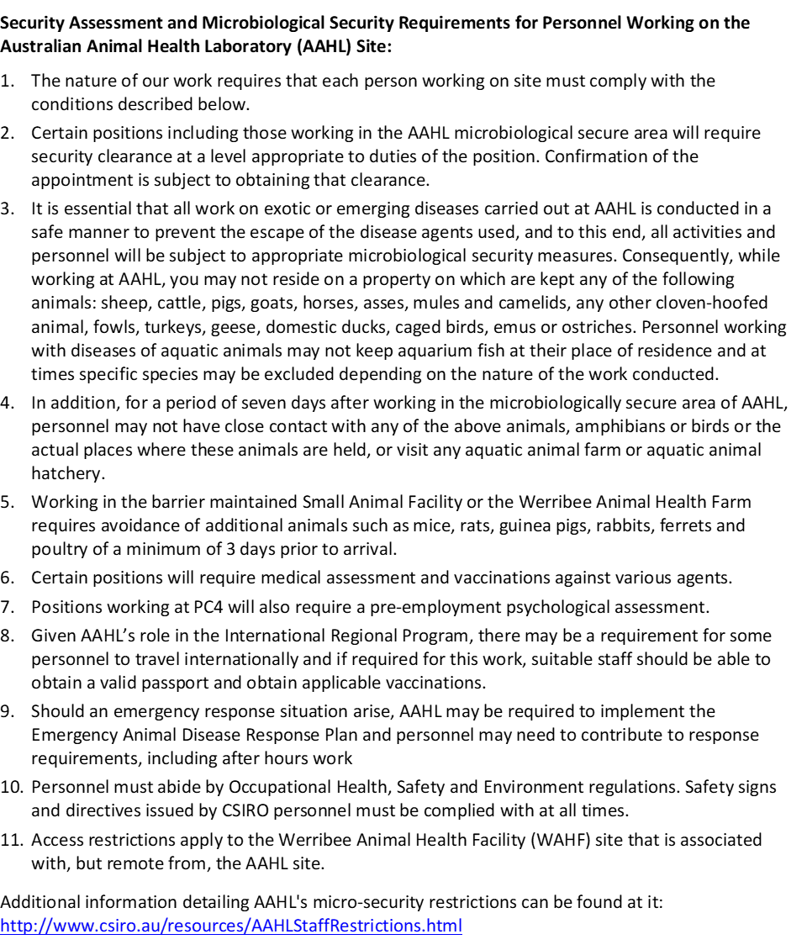

About CSIRO:
We solve the greatest challenges through innovative science and technology. To find out more visit us online!

Find out more about the CSIRO Australian Animal Health Laboratory

