Coviu
An ON program CASE STUDY
OverType Here as Required

Box 1 Coviu Case Study - Executive summary
Key findings
The Coviu project has produced the following outputs:
- A spinout agreement with CSIRO
- A microservices based scalable server architecture and software for video health consultations, including:
  - a Web application system for client signup, login and holding of video consultations
  - an API to provide video consultations as a Platform as a Service
  - an online booking integration system for practice management software
  - a plugin system for the activation of custom in-call features, incl. payments, waiting rooms, and medical imaging
  - a marketing Website and marketing material such as brochures
- Online customer support and payment systems
- Desktop, iOS and Android mobile applications
- Investor pitch decks
- Coviu was spun out in May 2019 with an investment of $1 million by Main Sequence Ventures and is now a stand-alone company called Coviu Global Pty Ltd with Data61, Main Sequence Ventures, Silvia Pfeiffer and Nathan Oehlman (co-founders) as the main shareholders.
- Coviu Global has had significant growth since spinout. It is now one Australia’s biggest telehealth companies having secured Healthdirect as their largest customer.
Coviu currently has over 7,300 trial users, 1,550 paying customers and is experiencing 10% month-on-month growth. ACIL Allen has estimated the net present value (NPV) of the ON program to Coviu to be $150.3 million in 2019 dollars. The benefit-cost ratio (BCR) is estimated to be 442.8.
Role played by ON program
The ON program enabled Coviu to negotiate an IP agreement with CSIRO. It gave them the confidence that they had selected the right market segment to target with their product and gave them the ability to pitch their idea and product to that market and the healthcare sector. In short, the ON program was a major contributor to the commercialisation of Coviu’s services.
This case study uses the evaluation framework outlined in the CSIRO Impact Evaluation Guide. The results of applying that framework to the Coviu case study are summarised in Figure 1.

Figure 1.1 Coviu Case Study – Impact Framework Diagram

INPUTS |  | ACTIVITIES |  | OUTPUTS |  | OUTCOMES |  | IMPACTS
- Venture capital investment of $1m  - Over $2m in in-kind support from DATA61/CSIRO and NICTA  - $323,441 in support from the ON program  - Revenue from customers reinvested in business |  | - Negotiating a spin out agreement with CSIRO  - Developing a browser-based app for delivering video health capability for use by private medical practices and their patients.  - Developing customised add-ons tailored to meet the needs of a variety of end users  - Engaging with customers and developing custom solutions for them  - Preparing marketing material |  | - A spin out agreement with CSIRO  - A microservices based scalable server architecture and software for video health consultations  - Online customer support and payment systems  - Desktop, iOS and Android mobile applications  - Customised products for clients  - Investor pitch decks  - Publications and conference papers  - Awards |  | - An app for video health consultations adopted by private medical practices and their patients  - Customised solutions used by clients  - Coviu spun out in May 2019  - Venture capital funding obtained |  | - Improved patient care and health outcomes, particularly for remote patients  - Earlier diagnosis and treatment of work injuries  - Improved worker productivity  - New services and products that generate revenue for Coviu  - Avoided costs due to hospitalisations  - Modernisation and scalability of the Australian healthcare system through telehealth  - Export revenue

Source: ACIL ALLEN

Purpose and audience for case study
This case study describes the economic, environmental and social benefits arising from the Coviu project.
This evaluation is being undertaken to assess the positive impacts arising from the Coviu project’s participation in the CSIRO’s ON program. This case study can be read as a standalone document or aggregated with other case studies to substantiate the impact and value of the ON program activities as a whole, relative to the funds invested in these activities.
The information in this case study is provided for accountability, communication and continual improvement purposes. Audiences for this report may include Members of Parliament, Government Departments, the ON program, CSIRO and the general public.

The ON Program
CSIRO ON was established in 2015 as a four-year program by CSIRO to help accelerate the impact of science research on the market (the program ends in June 2020). The initiative was expanded through funding from NISA to service more broadly Australia’s publicly funded researchers and their industry partners. The aim of the initiative is to more quickly translate great science and technology research into positive impact to help address some of the economic, environmental and social challenges facing the Australian and global community.
There are two main elements to the program, ON Prime and ON Accelerate. These two elements are designed to complement each other.
ON Prime is an open and collaborative program for existing science projects as well as new technologies and projects that are still in development. ON Prime helps research teams to ensure that they are working on the right problem, it provides frameworks to create and test assumptions about their idea and provide recommendations towards next steps. ON Prime can be considered as an entry level program, in effect it can be seen as a precursor to participation in the ON Accelerate program.
ON Accelerate is designed for teams that have made significant progress with their idea and their target market(s). This may be in the form of contracts for paid or unpaid trials, or at the most advanced stage, recurring sales with both new and existing customers. This implies that teams will have a working prototype of their product or service and have secured any appropriate intellectual property rights. It is expected that teams applying for ON Accelerate would have conducted significant engagement with their potential customers and be able to demonstrate what they learned throughout, including what the total addressable market is and what competition exists.
For ON Accelerate, shortlisted applicants are invited to participate in a two-day Selection Bootcamp event where teams will be provided with training and coaching simulating the accelerator experience. At the conclusion of the selection bootcamp, the teams will pitch to a panel of external judges for a spot in the Accelerator. Projects that are at Investment Readiness Level (IRL) Stage 3 can apply directly for ON Accelerate without going through Prime or Bootcamp.
Following a team’s passage through the ON Prime or ON Accelerate program they are eligible to apply for ON Runway (or Incubation) support. That funding is designed to help teams to further progress their project. The support provided can be spent on a range of services, for example, regulatory certification, marketing, bookkeeping or investor agreements.
The program is expected to exceed its targets for participation. It is predicted that it will have reached 515 teams with over 1,850 people by the time it concludes on 30 June 2020.

Background
In the past using video or teleconferencing to deliver medical services was very expensive. In addition, there was often insufficient bandwidth available to support quality video health applications. Its use was therefore largely confined to hospitals and it was very rarely used in private practice. The Coviu research team has built a video conferencing platform that provides a turn-key telehealth solution for private health practices and an Enterprise solution for hospitals and other private and public health institutions. The Coviu platform goes beyond face to face. It includes the ability to share and discuss medical imaging (MRIs, x-rays, etc.). It is also possible to use the platform to book and pay for appointments. People can also use it to fill in forms and share data. Coviu is a software solution that helps clinics with their digital transformation using video consultations by supporting digital workflows that are efficient and interoperate with the physical workflows of the clinics.
As part of its innovation work, Coviu also is introducing artificial intelligence (AI) based diagnostic and therapeutic tools into the video consultation to help augment the capabilities of clinicians while in virtual consultations (e.g. to identify regions on an image that need attention). Coviu is developing these clinical tools in collaboration with research institutions and with other private and public organisations
Coviu also links into practice management software used by the clinics and can be used to make appointment bookings and to manage the paperwork associated with a visit.

Impact Pathway

Project Inputs
The total cost for the Coviu project was $3,669,807 in cash and in-kind contributions (see Table 1.1). The bulk of the support was in-kind assistance from with NICTA/DATA61 (largely salaries of staff working on the Coviu project) and $1 million in venture capital funding. Coviu also received $323,441 in support from ON Accelerate and Runway programs. That funding was used for:
- Marketing and customer engagement
- Discretionary IP costs that CSIRO outsource
- Legal costs in preparation for spin out
Table 1.1 Support for the Coviu project
Contributor / type of support |  | 2015 ($) | 2016 ($) | 2017 ($) | 2018 ($) | Total
 | Cash
 | ON Accelerate/Runway | $0 | $290,161 | $15,000 | $18,280 | $323,441
 | Customer payments | $31,200 | $45,145 | $83,998 | $102,452 | $262,795
 | Venture Capital Investment | $0 | $0 | $0 | $1,000,000 | $1,000,000
 | In-kind
 | NICTA | $785,358 | $233,542 | $0 | $0 | $1,018,900
 | DATA61/CSIRO | $0 | $467,084 | $597,587 | $65,315 | $1,064,671
 | Total | $816,558 | $1,035,932 | $696,585 | $1,120,732 | $3,669,807

Project activities
The Coviu researchers developed a browser-based application with a simple, user-friendly interface for delivering video health capability for use by private medical practices and their patients. Coviu is able to provide high resolution, high frame rate visual support for interactive, real-time consultations. The team also develops customised add-ons that are tailored to meet the needs of a variety of end users.
The plans to extend the software to introduce AI to help diagnose illnesses are being executed in the Coviu spinout (e.g. to identify regions on an image that need attention) and identify health problems and help with therapy. A CRC-P grant has been awarded worth over $3.9 million over 3.5 years in conjunction with CSIRO-Data61, University of Western Australia and HFRC (a physiotherapy and OT provider). The grant started in January 2019. The partners in the CRC-P are developing an AI tool for range-of-motion calculation.
Coviu is also partnering with other companies to develop digital clinical tools. For example, in December 2019 Coviu announced that it was partnering with ResApp to develop a respiratory analysis algorithm.
In 2019, Coviu achieved significant market uptake after gaining Healthdirect as a customer. Healthdirect is a government-owned organisation that offers Healthdirect Video Call to state and federal telehealth operations. For example, hospitals and public health services across Victoria and West Australia are using Healthdirect Video Call. Also, Healthdirect’s own Pregnancy, Birth & Baby hotline as well as the After Hours GP clinic are being run by Healthdirect Video Call.

Role of the ON program
Coviu was part of the second ON cohort. Three Coviu members participated in the program over the period from March to July/August 2015. Coviu identified the following benefits from their participation in the ON program:
- Learning how to differentiate themselves from other firms in the field
- Learning how to move towards commercialisation within CSIRO. This was probably the most significant benefit for Coviu. Prior to the ON program there was nobody in Data61 who knew how spinouts worked in CSIRO.
- It helped them to identify and consider pathways to market. Coviu had proposed a health application for their software but ON made them consider other potential markets (e.g. law, coaching)
- Helping Coviu set up a ‘practice board’
- Helping them to prepare for an eventual capital raising, in particular by developing their skills in pitching their business ideas. This included giving them an understanding that different benchmarks are required for different levels of investment, and how much equity might be involved.
- Providing Coviu with a lot of useful contacts. For example, one of the ON mentors has offered to help them access grants.
- Coviu already had strong customer engagement, however the ON program helped to confirm this and reinforced that Coviu already had a good understanding of its customers.
Coviu believes that without their participation in the ON Accelerator they would not be where they are now. In particular, Coviu used the ON program to kick-start the contract negotiations with CSIRO. The contract between Coviu and CSIRO was signed in March 2017. Dr Pfeiffer believes it is likely that, in the absence of the ON program, they would not have been able to successfully complete their negotiations with CSIRO.
Since then, Coviu has gone on to close an investment round with Main Sequence Ventures (MSV) in May 2019. Again, this investment would not have happened without Coviu’s participation in the ON Accelerator, since some of the directors of MSV actually met Coviu during the ON Accelerator and built a relationship that ultimately led to the investment. Phil Morle from MSV is now on Coviu’s board.

Project outputs
Coviu is a high quality real-time video conferencing solution custom built to service private health practices. Coviu enables high quality opportunities for patient engagement via online sessions to augment existing face-to-face contact. Coviu launched its first paid product in 2015 during their participation in the ON program.
The business is based on a subscription model (software-as-a-service) that costs $17/month/user. Since then, Coviu has introduced higher value products:
- More diverse plans at $20/user/month and $110/user/month
- Various add-ons that cost between $2 and $100 per team /month
- An API plan that cost $200/month for a base subscription and $2 per additional call.
- Coviu also receives payment for developing custom solutions for its clients. Coviu shares the cost of development with that customer (this way they can retain the IP) and the customer gets what they want as a priority. Coviu currently generates about $200,000 a year from this element of their business.
- Coviu also markets a branded patient entry page and branded mobile app. The custom branded mobile app costs $4,500 to establish, then $100/team/month in support costs. Coviu currently has one customer for this service.

Publications
Coviu research produced a number of journal and conference papers. A full list can be found here: https://www.coviu.com/publications/ . some examples include:
- Hodge M., Sutherland R., Jeng K., Bale G., Batta P., Cambridge A., Detheridge J., Drevensek S., Edwards L., Everett M., Ganesalingam C., Geier P., Kass C., Mathieson S., McCabe M., Micallef K., Molomby K., Pfeiffer S., Pope S., Tait F., Williamsz M., Young-Dwarte L., Silove N. (2018). Literacy Assessment Via Telepractice Is Comparable to Face-to-Face Assessment in Children with Reading Difficulties Living in Rural Australia. Telemedicine and e-Health, 2 (25) 10th April 2019.
- Rebecca Sutherland, David Trembath, Marie Antoinette Hodge, Veronica Rose, Jacqueline Roberts (2019). Telehealth and autism: Are telehealth language assessments reliable and feasible for children with autism? International Journal of Language & Communication Disorders. Special Issue: The use of technology in speech and language therapy, 2(54), March/April 2019.
- Hodge M., Sutherland R., Jeng K., Bale G., Batta P., Cambridge A., Detheridge J., Drevensek S., Edwards L., Everett M., Ganesalingam K., Geier P., Kass C., Mathieson S., McCabe M., Micallef K., Molomby K., Ong N., Pfeiffer S., Pope s., Tait F., Williamsz M., Young-Dwarte L., Silove N. (2018). Agreement between telehealth and face-to-face assessment of intellectual ability in children with specific learning disorder. Journal of telemedicine and telecare., 2018/1/1.
- Sutherland, R., Trembath, D., Hodge, A., Drevensek, S., Lee, S., Silove, N., & Roberts, J. (2017), Telehealth language assessments using consumer grade equipment in rural and urban settings: Feasible, reliable and well tolerated, Journal of Telemedicine and Telecare, 23 (1), 106-115.
- Sutherland, R., Hodge, A., Trembath, D., Drevensek, S., & Roberts, J. (2016), Overcoming barriers to using telehealth for standardized language assessments, Perspectives of the ASHA Special Interest Groups, 1(18), 41-50.
- Sutherland, R. (2017), Telehealth and autism: are telehealth language assessments feasible and well tolerated by students on the spectrum? Paper accepted to the Success and Failure in Telehealth conference, Brisbane, October 2017.
- Sutherland, R, Trembath, D. & Roberts, J.M.A. (2017), Telehealth and autism: State of the art and the science. Paper presented at Speech Pathology Australia National Conference, Sydney, May, 2017.
- Pfeiffer, S. (2017), Speech pathology and telehealth: from assessment and intervention to community capacity building. Paper accepted to the Success and Failure in Telehealth conference, Brisbane, October 2017.
- Sutherland, R., Trembath, D., Hodge, M.A. & Roberts, J.M.A. (2017). Telehealth and autism - growing access to services through technology. Paper presented at the Asia Pacific Autism Conference, Sydney, September 2017.

Patents
Coviu was granted an innovation patent covering aspects of its technology (Application Number: N15 003-PROVAU, Priority Date: 17 Jul 2015)

Awards
Coviu’s technology has been recognised by the following awards:
- Winner of the 2015 NSW iAwards
- Winner of the 2015 National iAwards
- Runner-up of the 2015 CeBIT Business Award
- Winner of the 2017 HealthHack Sydney.
- Winner of the 2018 HealthHack Brisbane.
- Winner of the HIMSS AsiaPac18 innovation challenge
- Runner-up for Healthcare Start Up of the Year at Australian Healthcare Week 2019

Innovation / commercialisation
The advantages of Coviu include that it:
- Enables a gradual transformative process for clinics who want to gradually move to a hybrid model that includes some video consulting as well as face to face consultations. The software can also be progressively implemented across a practice with multiple doctors.
- Provides a mechanism to better manage appointments and reduce the number of no shows.
- Puts a device in the hands of patients to help them get better access to healthcare services.
- Links to existing patient records / management systems
- Is built to digitally support the introduction of artificial intelligence algorithms. Such algorithms could for example identify whether a person is exhibiting signs of mental illness and alert the service.
- Can provide a service that is tailored to meet the needs of patients and specialist service providers.
The Coviu team continues to develop health-specific features that differentiate the solutions further in the marketplace, such as integrating the Coviu applications with electronic medical records (EMR) and practice management software (PMS). This will enable the health practice to be more efficient by reducing the time that has to be spent on paper work.
One of the challenges facing the Coviu technology is that while Medicare reimburses some kinds of consultations, for example, consultations where a patient sits with a GP in rural Australia to meet a specialist remotely (a dual care model) and 70 per cent of Medicare-paid mental health consultations via video, it is still not clear how Medicare will treat reimbursements for other kinds of video consultations. In November 2019, the first GP Medicare reimbursements for direct-to-patient services for remote patients were introduced. Further progress is expected in the coming years. Health Minister Greg Hunt has announced the development of a long-term national health plan which will include on-line health.
Most of the Medicare funded work remains a patchwork, since none of the approaches apply to the whole patient population. This uncertainty is a barrier to both practitioners adopting the system and patients’ willingness to use it. Therefore Coviu’s initial focus is on health businesses that are better able to cover the costs of using Coviu, such as practices dealing with work injuries or ones that provide health management services to the staff of companies. For example Coviu has contracted with a physiotherapy provider that works to reduce work injuries on site for third party firms. This ongoing relationship has been a long and successful one. (see Box 1.1).
ACIL Allen understands that the average cost to a firm from a worker’s compensation claim is between $15,000 and $18,000 per claim.
Box 1.1 Use of Coviu to reduce workplace injuries
Coviu has contracted with a large provider of physiotherapy services (Biosymm), which is a Western Australian medical and physiotherapy consultancy, specialising in the field of occupational health and safety. Biosymm’s services include delivery of physiotherapy treatment to injured workers. There is a strong focus on early intervention using telehealth.
Biosymm’s physiotherapists speak with or video link with the workplace to deliver:
- Assessment and advice to the worker on their musculoskeletal condition.
- Feedback to the workplace regarding suitable duties and a treatment plan.
- Referrals if further management is agreed to.
For example, they have several contracts to supply workplace physiotherapy services to mining corporations and a chain of hardware stores. They delivered over 1,000 consultations online via Coviu during 2017, over 6,000 in 2018, and over 8,000 in 2019. This is reported to have reduced injuries, changed the culture around workplace related muscular strain, increased workforce productivity and created significant savings by reducing the number of workplace compensation claims the corporations had to pay for. Savings for the corporations are estimated to be in the high hundreds of thousands every year.
Source: Coviu presentation and Biosymm website
The next stage will be to market Coviu overseas. Coviu has already developed versions of the software in other languages. Coviu is planning to start to sell its services in the US in 2020 after achieving HIPAA compliance and to open a US office around 2021. Their intention is to market their product through partnerships in the US, Europe, and eventually China and India.

Role of ON program
The ON program enabled Coviu to negotiate an IP agreement with CSIRO. It gave then the confidence that they had selected the right market segment to target with their product and gave them the ability to pitch their idea and product to that market and the healthcare sector.

Project Outcomes
The objective of Coviu is to deliver a paid service to private health practices that helps them to efficiently run their businesses, progressively integrate more video consultations into their services and ultimately deliver better patient care and improved health outcomes.

Role of the ON program
It is unlikely that Coviu would even exist today without the support provided by the ON program. Instead, the software would have likely remained on a shelf in a researcher’s office and not been commercialised.

Adoption
Around two thirds of healthcare professionals (physicians + others) in the US were either using some form of telemedicine in 2015, or were planning to do so in the next few years. In Australia the figure is less than 4%. The availability of Internet connectivity is starting to meet the bandwidth requirements of online video consultations in Australia. Consequently, national, state and insurance policies are changing, and Australia is likely to follow the US model.
The Australian Digital Health Agency recently published a National Digital Health Strategy with a 5 year plan on how to embrace digital technologies in healthcare and help it become a more effective and efficient healthcare system with telehealth / online consultations being one of the key ingredients. The vision for Australia’s National Digital Health Strategy is:
Better health for all Australians enabled by seamless, safe, secure digital health services and technologies that provide a range of innovative, easy to use tools for both patients and providers.
The uptake of Coviu’s product offering has increased rapidly, albeit from a small base. The number of video consultations per month increased fourfold from around 300 to 1,240 in the year from August 2016 to August 2017, then 2.5-fold by August 2018 to 2,907, and then again 2.4-fold by August 2019 to 6,545 (see Figure 1.2). The onboarding of Healthdirect further pushed Coviu and it is now doing over 10,000 consultations a month, more than 3 times the previous year. Coviu expects that a high rate of growth will be maintained for several years.
Figure 1.2 Number of video consultations
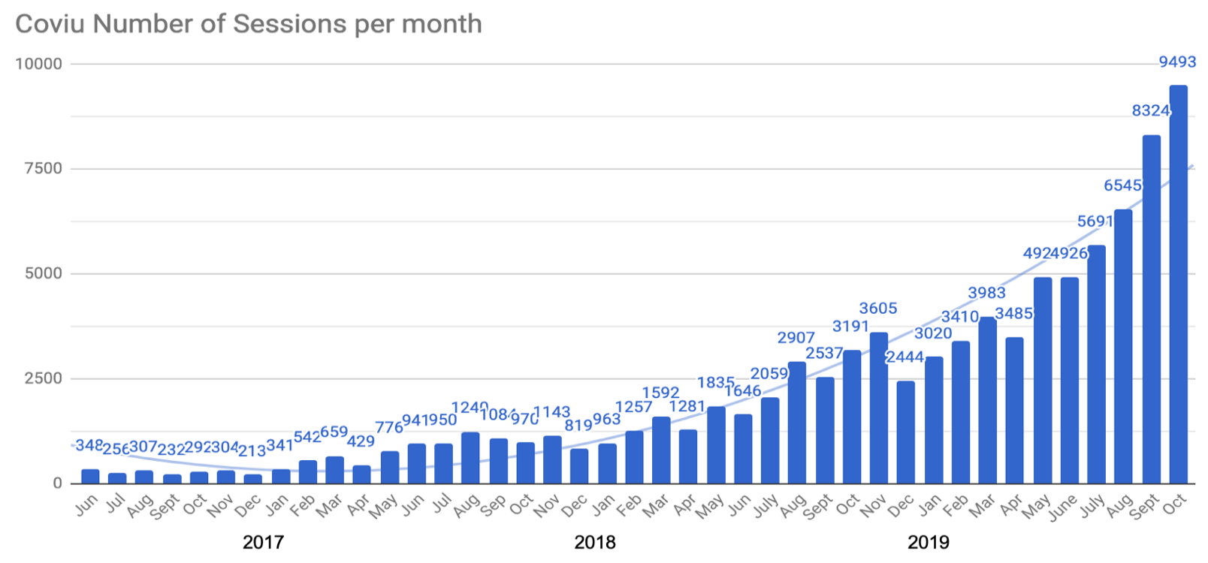

Source: Coviu
The number of video consultation has fluctuated from month to month. However, the growth in monthly recurring revenue (MRR) has been steadier (see Figure 1.3). In addition to the monthly revenue from fees paid by subscribers Coviu also has earnings from the payments by its clients for customised solutions (see Figure 1.4).
Figure 1.3 Monthly Recurring Revenue ($)
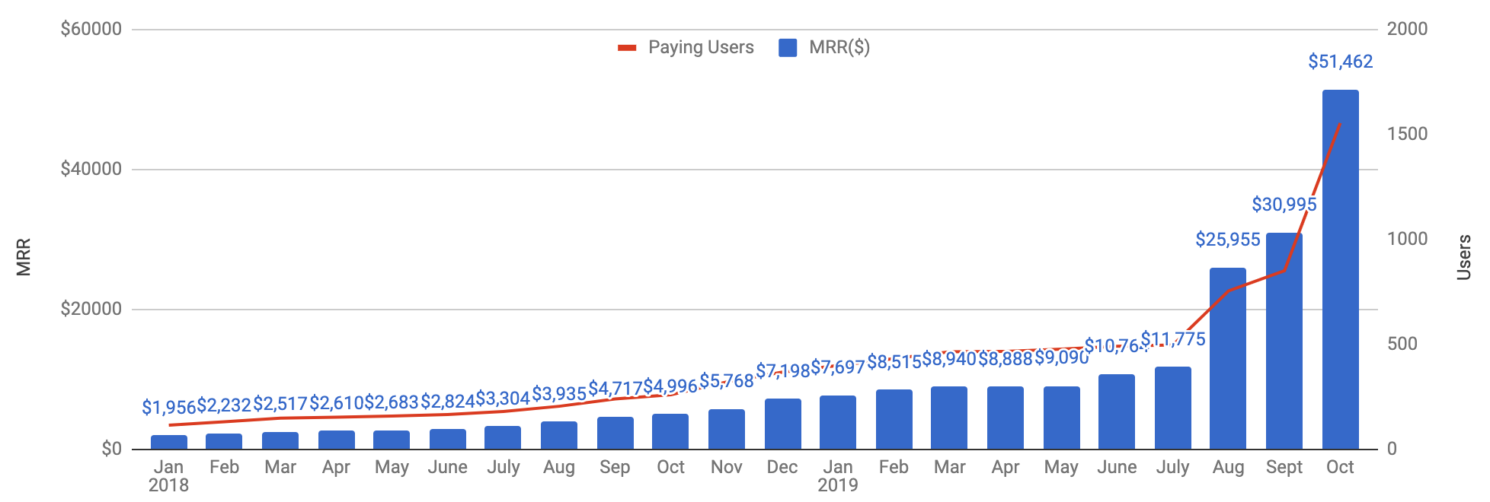

Source: Coviu

Figure 1.4 Users and revenue streams ($)
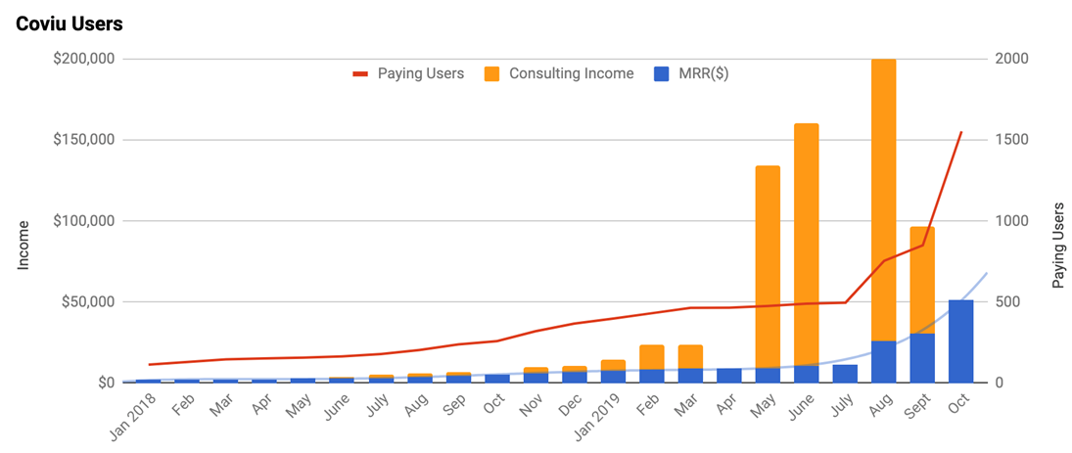
Source: Coviu
Figure 1.5 shows Coviu’s forecast growth for the business. The figures for 2017 and 2018 are actual, the figures for other years are estimates. However, for the purposes of the CBA, ACIL Allen has made some more conservative assumptions about future growth rates. We have assumed 300 per cent growth in 2019, 250 per cent growth in 2020, 100 per cent growth from 2021 to 2022, 50 per cent growth from 2023 to 2024, then 10 per cent a year from 2024 to 2030, then 5 per cent a year until 2035 and then zero growth from then on. While these assumptions are more conservative, they still project considerable growth for the firm.

Figure 1.5 Coviu’s business forecast ($’000)
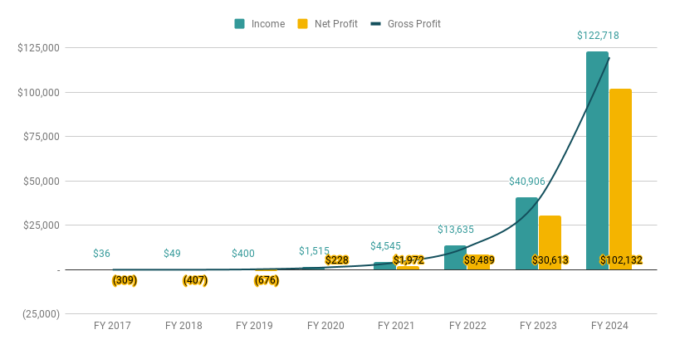

Source: Coviu

Role of the ON program
Coviu’s participation in the ON program gave them the ability and confidence to pitch their services to their target market. The relatively rapid uptake of Coviu’s services is a testament to their capability to market those services. In addition, Coviu also received $234,805 in support from ON Incubation (Runway). That funding was in part used for marketing and customer engagement.

Impacts
The most immediate impact is the revenue that Coviu gets from selling its services. Sales of Coviu’s services overseas also has the potential to generate export income. According to a report by Mordor Intelligence on Global Telemedicine Market - Growth, Trends & Forecasts (2015-2020) the global telehealth market will be worth more than $34 billion by the end of 2020. Coviu’s current estimate of around $1.5 million in revenue by then is still only a very small percentage of the potential global market. Even Coviu’s revenue estimate for 2024 (see Figure 1.5) is still less than 0. 4 per cent of the global market.
The opportunity for early intervention through telehealth has a potential to save Australia billions of dollars of healthcare cost by avoiding hospitalisations through early treatment. In 2011 the Department of Broadband, Communications and the Digital Economy (DBCDE) commissioned a report on the financial and externality impacts of ubiquitous high-speed broadband in relation to health and aged care costs. The resulting report estimated that steady state benefits to Australia from wide scale implementation of tele-health may be in the vicinity of $2 billion to $4 billion dollars per annum.
Early treatment of workplace injuries has also been shown to generate workforce productivity benefits and savings for firms. As mentioned above, ACIL Allen understands that the average cost of a worker’s compensation claim is between $15,000 and $18,000. If we take the lower figure, then a company that avoids say 20 claims a year stands to save $300,000 in workers compensation costs.
While adoption of Coviu’s services will undoubtedly generate some benefits of this nature we have not sought to quantify these impacts.

Clarifying the Impacts

Counterfactual
In the absence of the ON program Coviu would have taken longer to negotiate an IP agreement with CSIRO. Participation in the program also strengthened their ability to pitch their idea and product to their chosen market and the healthcare sector more broadly. Some of the Coviu team believe that the firm might not even exist today were it not for the ON program. However, for the purposes of our analysis, ACIL Allen have assumed that in the absence of the ON program Coviu’s growth path would have been delayed by two years.

Attribution
ACIL Allen has attributed the difference between the NPV of the assumed growth in Coviu’s business with and without the support provided by the ON program to that program.

Evaluating the Impacts

Cost-Benefit Analysis
      - Costs
The costs incurred in relation to Coviu’s participation in the ON program was $323,441 between 2016 and 2019. It is assumed that R&D and in-kind support costs would have been unchanged if Coviu had not participated in the ON program.
      - Benefits
The projected revenues and operational costs for 2017 to 2020 were provided by Coviu. As discussed in Section 1.3.5, ACIL Allen has assumed a growth of 300 per cent growth in 2019, 250 per cent growth in 2020, 100 per cent growth from 2021 to 2022, 50 per cent growth from 2023 to 2024, growth 10 per cent a year from 2025 to 2030, then 5 per cent a year until 2035 and then zero growth from then on.
It is assumed that the benefits would cease in 2035 due to the introduction in the marketplace of a very similar product and service to Coviu. In addition, it is assumed that 10 per cent of Coviu’s revenues “leaks” out of the Australian economy as a result of payment of inputs sourced internationally.
As discussed in Section 1.4.1, it is assumed that in the absence of the ON program Coviu’s growth path would have been delayed by two years. This means that Coviu’s projected revenues and operational costs in the counterfactual lag those in the with-ON case by two years.
The projected revenues with and without participation in the ON program are shown in Figure 1.6.
Figure 1.6 Projected Coviu revenues with and without ON program participation (2019 dollars)
Source: Coviu and ACIL Allen assumptions
The projected operational costs of Coviu with and without participation in the ON program are shown in Figure 1.7.
Figure 1.7 Projected Coviu operational costs with and without ON program participation (2019 dollars)
Source: Coviu and ACIL Allen assumptions
The value added by Coviu to the Australian economy is equal to its revenues minus the “leakage” due to the cost of foreign-sourced inputs. Coviu’s value added with and without participation in the ON program is shown in Figure 1.8.
Figure 1.8 Value added by Coviu to the Australian economy with and without ON program participation (2019 dollars)
Source: Coviu and ACIL Allen assumptions
The quantified benefit of the ON program is the difference in value added with and without ON program participation. This is shown in Figure 1.9. It is a highly conservative estimate of the benefit generated by the ON program in relation to Coviu, as ACIL Allen has not quantified (due to data limitations) the following benefits of Coviu:
- avoided future healthcare costs due to early intervention enabled by Coviu
- the health benefits (including reduction in pain and suffering) enjoyed patients who otherwise would not have sought medical attention without Coviu.
Figure 1.9 Benefit of the ON program in relation to Coviu (2019 dollars)
Source: Coviu and ACIL Allen assumptions
      - Assessment of benefits against costs
The present value of Coviu’s ON-related costs is $340,267 in 2019 dollars under a 7 per cent real discount rate. The present value of Coviu’s benefits arising from its participation in the ON program is estimated at $150.6 million in 2019 dollars under the same discount rate.
The net present value (NPV) of the ON program in relation to Coviu, calculated by subtracting the present value of costs from the present value of benefits, is therefore estimated at $150.3 million in 2019 dollars. The benefit-cost ratio (BCR), estimated by dividing the present value of benefits by the present value of costs, is 442.8.
      - Sensitivity analysis
If the projected revenues of (with participation in the ON program) are 20 per cent higher than those in the central case of the cost-benefit analysis, the BCR will increase from 442.8 to 533.2. Conversely, if the projected revenues are 20 per cent lower than those in the central case, the BCR will decrease to 352.3.
If the projected operational costs and cost of goods sold (with participation in the ON program) are 20 per cent higher than those in the central case of the cost-benefit analysis, the BCR will decrease from 442.8 to 440.8. Conversely, if the projected operational costs and cost of goods sold are 20 per cent lower than those in the central case, the BCR will increase to 444.7.

Potential future impacts
Coviu’s business could grow more quickly than currently estimated. This may include Coviu not only increasing its share of the workplace health and safety market, but also extending its services into other areas of the health sector.

Role of the ON program
Coviu’s participation in the ON program helped them to identify their target market and promote and sell their services to that market. The revenue from sales to the workplace health and safety market helped Coviu to fund the expansion of its service offering. Their participation in the ON program was also instrumental in establishing the contacts that ultimately helped them to obtain the venture capital needed to grow the business.

Ultimately Coviu decided to maintain its focus on the health sector.
Dr Pfeiffer thought that this aspect was too lightly covered in ON Accelerate.
https://www.health.gov.au/ministers/the-hon-greg-hunt-mp/media/national-press-club-address-long-term-national-health-plan accessed January 2020
In the US, 32 states have passed laws requiring private insurers to reimburse doctors for services delivered remotely if the same service would be covered if delivered in person.
https://www.americanwell.com/top-10-stats-you-need-to-know-about-telehealth/ accessed December 2017.
Analysis of 2016 Medicare Statistics (as reported in Coviu’s November 2017 Business Plan).
https://www.digitalhealth.gov.au/australias-national-digital-health-strategy accessed December 2017.
http://inform.regionalaustralia.org.au/industry/innovation-science-and-technology/item/financial-and-externality-impacts-of-high-speed-broadband-for-telehealth

