Executive Summary Report
for Australia’s Global Power System Transformation Research Roadmap
March 2022

Citation
CSIRO (2021) Executive Summary Report for Australia’s Global Power System Transformation (G-PST) Research Roadmap. CSIRO, Australia.
Copyright
© Commonwealth Scientific and Industrial Research Organisation 2021. To the extent permitted by law, all rights are reserved and no part of this publication covered by copyright may be reproduced or copied in any form or by any means except with the written permission of CSIRO.
Important disclaimer
CSIRO advises that the information contained in this publication comprises general statements based on scientific research. The reader is advised and needs to be aware that such information may be incomplete or unable to be used in any specific situation. No reliance or actions must therefore be made on that information without seeking prior expert professional, scientific and technical advice. To the extent permitted by law, CSIRO (including its employees and consultants) excludes all liability to any person for any consequences, including but not limited to all losses, damages, costs, expenses and any other compensation, arising directly or indirectly from using this publication (in part or in whole) and any information or material contained in it.
CSIRO is committed to providing web accessible content wherever possible. If you are having difficulties with accessing this document please contact csiro.au/contact.

Contents
Acknowledgments iii
Acronyms in the Report iv
1 Introduction 5
1.1 Background 5
1.2 Purpose of this Report 6
1.3 Scope and limitations 6
1.4 Assumptions 6
2 Australia’s Power System Transition 7
2.1 Drivers for Change 7
2.2 The Need for Innovation 8
3 Overview of G-PST Research Roadmap 9
3.1 Research Roadmap Outcomes 10
3.2 Developing a Holistic Research Roadmap 11
3.3 Delivering Results 12
3.4 Interaction with AEMO 13
4 Research Plans 16
4.1 Inverter Design 16
4.2 Stability Tools and Methods 18
4.3 Control Room of the Future 19
4.4 Planning 21
4.5 Restoration and Black Start 23
4.6 Services 24
4.7 Architecture 26
4.8 Distributed Energy Resources (DERs) 28
4.9 DERs and Stability 31
5 Stakeholder Engagement 33
6 Resourcing Requirements 34
7 Research Roadmap Risks 36
8 Research Priorities and Next Steps 38
9 References 41

Figures
Figure 1 Australian Research Focus Areas 9
Figure 2 Contributors to the CSIRO G-PST Research Plan 10
Figure 3 Interaction of the nine research topics that make up Australia’s G-PST research roadmap 11
Figure 4 Layered interaction of the proposed G-PST research topics 12
Figure 5 Benefits of the G-PST research roadmap 13
Figure 6 CSIRO and AEMO initiated programs of work relating to power system operability and development 15
Figure 7 EPRI model of the aspects of the control room of the future, applied to the Australian context and including the CROF vision, purpose, pillars and foundations. 20
Figure 8 Five-phase Action Research Plan timeline 27
Figure 9 Average of AEMO Scenarios for DER installed Capacity Forecast 29
Figure 10 Stakeholder engagement for CSIRO’s proposed G-PST research roadmap 33
Figure 11 Aligning the CSIRO Roadmap with AEMO’s programs of work 39
Figure 12 CSIRO G-PST research roadmap timeframes 40

Tables
Table 1 IBR Design (Topic 1) major tasks and highest priority (<3 years) research activities 16
Table 2 Stability Tools and Methods (Topic 2) highest priority (<3 years) research activities 19
Table 3 Control Room of the Future (Topic 3) highest priority (<3 years) research activities 20
Table 4 Power System Planning (Topic 4) highest priority (<3 years) research activities 22
Table 5 System restoration (Topic 5) highest priority (<3 years) research activities 24
Table 6 [Essential System] Services (Topic 6) highest priority (<3 years) research activities 26
Table 7 [Power System] Architecture (Topic 7) highest priority (<3 years) research activities 27
Table 8 Distributed Energy Resources [Orchestration] (Topic 8) highest priority (<3 years) research activities 30
Table 9 DERs and Stability (Topic 9) highest priority (<3 years) research activities 32
Table 10 Risk matrix of perceived risks associated with the research plans 37

Acknowledgments
Acknowledgement of project partners
CSIRO would like to acknowledge the following partners in developing Australia’s Global Power System Transformation (G-PST) roadmap: Australian Energy Market Operator (AEMO), GHD Pty Ltd, Monash University, Electric Power Research Institute (EPRI), The University of Melbourne, Aurecon, RMIT University, Strategen and The University of New South Wales (UNSW).

Acknowledgement of technical assistance
This report summarises and provides insights into Australia’s G-PST research roadmap. We would like to thank all the partners for their efforts in developing the nine research plans in the research roadmaps: Monash University for Topic 1 - Inverter Design, EPRI for Topic 2 - Stability Tools and Methods and Topic 3 - Control Room of Future, The University of Melbourne for Topic 4 - Planning and Topic 8 - Distributed Energy Resources (DERs), Aurecon for Topic 5 - Restoration and Black Start, RMIT University for Topic 6 - Services, Strategen for Topic 7 - Architecture, and UNSW for Topic 9 - DERs and Stability.
We would also like to thank AEMO for their partnership and support under the G-PST consortium, especially Luke Robinson for his efforts in the project coordination, GHD Pty Ltd, especially Christian Schaefer and Matt Nichol, for their support in project coordination and preparing the summary report, and John Ward and Brian Liu from CSIRO for the effors in project coordination.

Acronyms in the Report
AEMC Australian Energy Market Commission
AEMO Australian Energy Market Operator
ARENA Australian Renewable Energy Agency
AVR Automatic Voltage Regulator
CROF Control Room of the Future
CSIRO Commonwealth Scientific and Industrial Research Organisation
DER Distributed Energy Resource
DNSP Distribution Network Service Provider
EF (AEMO) Engineering Framework
EMS Energy Management System
EPRI Electrical Power Research Institute
EV Electric Vehicle
FSO Founding System Operator
GFLI Grid-following Inverters
GFMI Grid-forming Inverters
G-PST Global Power System Transformation
IBR Inverter Based Resource
MMS Market management System
MO Market Operator
NEM National Electricity Market
PMU Phasor Measurement Unit
PV Photovoltaic
RMIT Royal Melbourne Institute of Technology
TNSP Transmission Network Service Provider
TSO Transmission System Operator
UNSW University of New South Wales
VRE Variable Renewable Energy
WEM Wholesale Electricity Market (of Western Australia)

Introduction

Background
The Commonwealth Scientific and Industrial Research Organisation (CSIRO) has engaged seven separate research organisations to develop plans for a research program or “roadmap” that will help facilitate Australia’s energy sector transition. The research topics from which six of the nine plans have been developed were initially produced in the Global Power System Transformation (G-PST) Consortium research agenda. Three additional matters of special interest to Australia were added to complement the program. CSIRO, as well as the Australian Energy Market Operator (AEMO), are Australian representatives of the G-PST Consortium, a consortium of some of the world’s foremost research institutes and system operators who are collaborating to create sustainable, reliable, affordable and decarbonised energy systems for the future.
During 2020 and 2021, the G-PST Consortium established a program of works that captured the research needs of a group of the world’s leading system operators in a series of research questions. While other groups have attempted to map research roadmaps for groups of utilities or system operators, it is evident that the collective needs of the G-PST Consortium’s founding system operators (FSOs) represent the cutting edge of the accelerated transition to increasingly variable, renewable-powered, decentralised, and inverter-based power systems. The FSOs have firsthand experience with the advances required to reliably and cost-effectively plan and operate these future power systems.
CSIRO, supported by AEMO (one of the FSOs), has engaged some of Australia’s and the world’s leading researchers and engineering experts to adapt the G-PST Consortium’s foundational research questions to the Australian context, with the goal of supporting Australia’s energy transition in the long-term interests of consumers, and to seize opportunities for Australia to become a leader in this field of research and technology.
This report summarises at a high level the outcomes of the nine individual research plans that CSIRO has sponsored, focusing on why these are critical to Australia, as well as outlining how these nine separate plans come together to form a cohesive research program. This report also provides, at a high level, the highest priority research items that were proposed in the individual plans.
Notably, this research program does not exist in isolation. Indeed, there are several similar or related activities being progressed by other research institutes in Australia and overseas, as well as by the AEMO. Examples include the AEMO Engineering Framework (EF) and the Operations Technology Roadmap. Both of these will be considered and engaged with in this CSIRO research program.
CSIRO has engaged GHD to provide project coordination services throughout the development of the plans and further support in preparing the summary report.

Purpose of this Report
This summary report highlights the:
- Overall program deliverables, how these outcomes are applicable to Australia, and how Australian research can contribute to the delivery of the program.
- Purpose and objectives of each of the nine research plans, including high priority deliverables proposed to be delivered in the short term.
- Need for orchestration of the nine research plans into a single research program showing the linkages and interactions between the individual plans.
- Key drivers for why this research is critical to Australia.
- Interaction between this research program and other strategic work underway or planned by AEMO.
- Highest priorities and most urgent matters to progress in the first instance as part of the next phase of the Australia’s G-PST research roadmap.
- Resourcing requirements and timeline necessary to deliver the research program, by the details provided in the research plans.
- Risks associated with the research program, as described in the individual research plans.

Scope and limitations
The opinions, conclusions and any recommendations in this report are based on conditions encountered and information reviewed at the date of preparation of the report.
The opinions, conclusions and any recommendations in this report are based on assumptions described in this report (refer to section 1.4 of this report). CSIRO disclaims liability arising from any of the assumptions being incorrect.

Assumptions
The sources of the information presented in this report are the nine separate research plans developed for CSIRO by the researchers [1-9], CSIRO’s original request for proposal and supporting information, publicly available information (as referenced in footnotes of this report), as well as the resourcing requirements and recommendations on research priorities made by GHD in Section 6 and Section 8, respectively.
CSIRO does not claim any original work relating to this report and has presented the summary assuming the veracity of the sourced and referenced material.

Australia’s Power System Transition

Drivers for Change
The global energy transition underway is well recognised in literature, developer strategies, government policy and consumer sentiments. There are many advocates who support the transition, numerous innovators to help us to tackle these challenges through technology, and visionary strategists to plot a pathway to a decarbonised energy sector. Yet the practical design of solutions for the emerging challenges are not as well coordinated as they need to be. This was recognised by some of the leading electricity system operators and energy researchers, who formed the G-PST Consortium with the aim of developing solutions and sharing these with others to accelerate the transition to advanced low emission power systems in collaboration with power system operators in all regions.
The critical need for action here in Australia is reinforced by the rapid change that the two largest Australian electricity systems, the National Electricity Market (NEM) and the Wholesale Electricity Market (WEM), are undergoing. These changes are driven by factors, such as:
- changes in energy production technology, with solar and wind generation becoming the lowest cost forms of energy,
- state based electricity objectives to achieve in many instances as much as 50% renewable energy production by the end of the decade that is accelerating the uptake of renewable generation, and
- en masse consumer uptake of rooftop solar photovoltaic (PV) installations.
Australia is at the cutting edge of the energy transition. Our relationship with other leading system operators through the G-PST Consortium will be an important enabler for how we navigate the transition. The challenges created by this rapid transition are significant:
- Increasing complexity of connecting and integrating new energy sources to the electricity system,
- Ageing tools and processes that are not fit for purpose to plan and manage the electricity network of the future, and
- The need for investment in transmission and distribution network infrastructure.
These are just some of the problem-opportunities that the system and market operator, transmission and distribution asset owners, and generators are working through together.
CSIRO and AEMO are the Australian representatives, and amongst the founding members of the G-PST Consortium. Recognising a need for action they have applied the knowledge and learnings created by the G-PST Consortium since its inception in 2020 to the Australian energy landscape with the aim of creating a roadmap that will deliver a broad range of benefits to Australia from energy security for Australian consumers to the advancement of Australian science and technology.

The Need for Innovation
AEMO CEO Daniel Westerman recently highlighted the urgency of the need for action when noting the rapid growth of renewable generation in Australia’s energy mix, and the formidable challenge of engineering grids capable of operating with ultra-high levels of renewable energy to deliver safe, reliable and affordable energy to consumers who are at the centre of this transition.
“By 2025, there will be periods of time when all customer demand could be met by renewable generation. This underscores AEMO’s priority to develop grids that are capable of running at up to 100 per cent instantaneous renewable penetration by 2025 to deliver reliable and affordable energy to consumers. We aim to do this in close collaboration with industry, market bodies and governments.”

- Daniel Westerman, AEMO CEO
Yet these many challenges also bring opportunities. Australia has always been a network energy exporter, an early adopter of new technologies and an innovator of existing ones. We have a unique opening to not only ensure Australia’s future energy security and consumer reliability, but also to create a stable energy sector to attract investment in our markets, and to build a powerhouse of knowledge that is exportable to the world, while also meeting our emission reductions commitments.
The proposed roadmap targets those areas that will be most critical to ensure ongoing energy security and reliability for Australian consumers, and an efficient and effective investment in infrastructure. Strategically, the roadmap aims to deliver successes and outcomes throughout the deployment period, creating stepping technological stones for further innovation and remaining adaptable to inevitable and further change.

Overview of G-PST Research Roadmap
The pace of the energy transition is accelerating, globally. Nowhere else is this more apparent than in Australia where instantaneous penetration of renewable generation on both the east and west coast power systems have exceeded 50%, and in some parts of the network even 100%, exporting excess production to other regions of the interconnected system. At the same time, we are seeing rooftop solar uptake amongst consumers continue unabated. Across the country, there are now more than 3 million rooftop solar installations. More than one in four homes in Australia host a rooftop solar system.
However, similar transitions are underway in other parts of the world, particularly some industrialised nations that are setting ambitious renewable energy targets in an effort to decarbonise their electricity sectors, such as Ireland, the United Kingdom, and the USA. To jointly meet these challenges, the G-PST Consortium was formed with the visionary goal to “Dramatically accelerate the transition to low emission and low cost, secure, and reliable power systems, contributing to >50% emission reductions over the next 10 years…”.
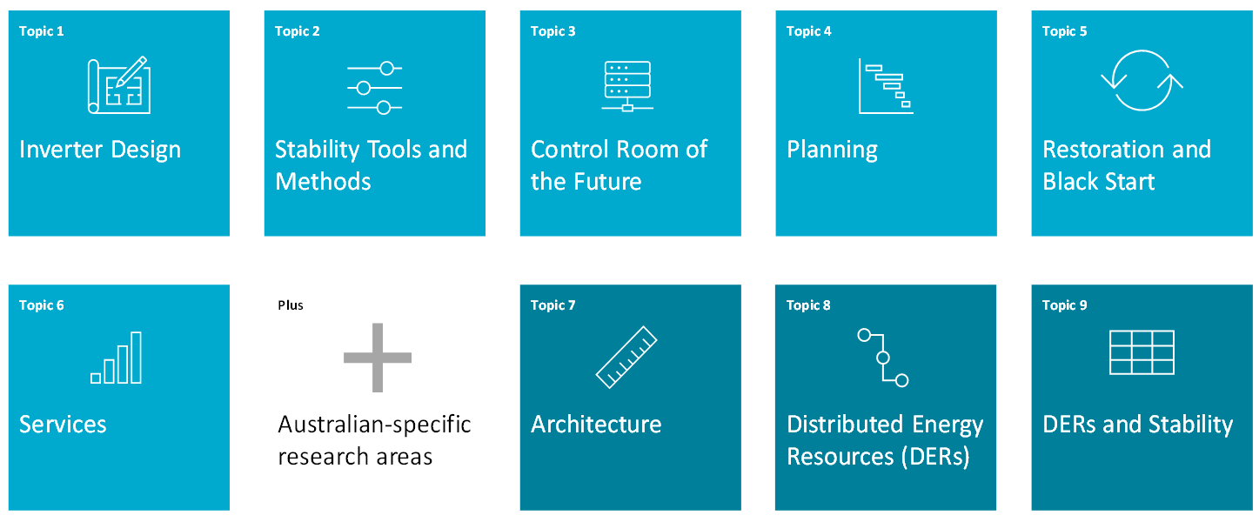
Figure 1 Australian Research Focus Areas
Since its formation in 2020, the G-PST, of which both CSIRO and AEMO are the Australian representatives and key members, has established six key areas of critical research that will be needed to support its goal. These six topics are identified as Topic 1 through to Topic 6 as shown in Figure 1. To these fundamental research topics, CSIRO has added three that are of additional importance to Australia, based on the challenges we are facing in the NEM and the WEM. These additional topics are listed as Topics 7 through Topic 9. The objective of each of the topics that make up the CSIRO proposed research program is described in the following subsections.
To progress research in these areas, CSIRO sought the support of experts and specialists from across Australia. A mix of academic research centres, engineering consultants and overseas-based research organisations were selected. AEMO contributed their expertise and support throughout the development of the research plans and helped to align this work with their EF and other initiatives. The participants of the research plan development are shown in Figure 2.
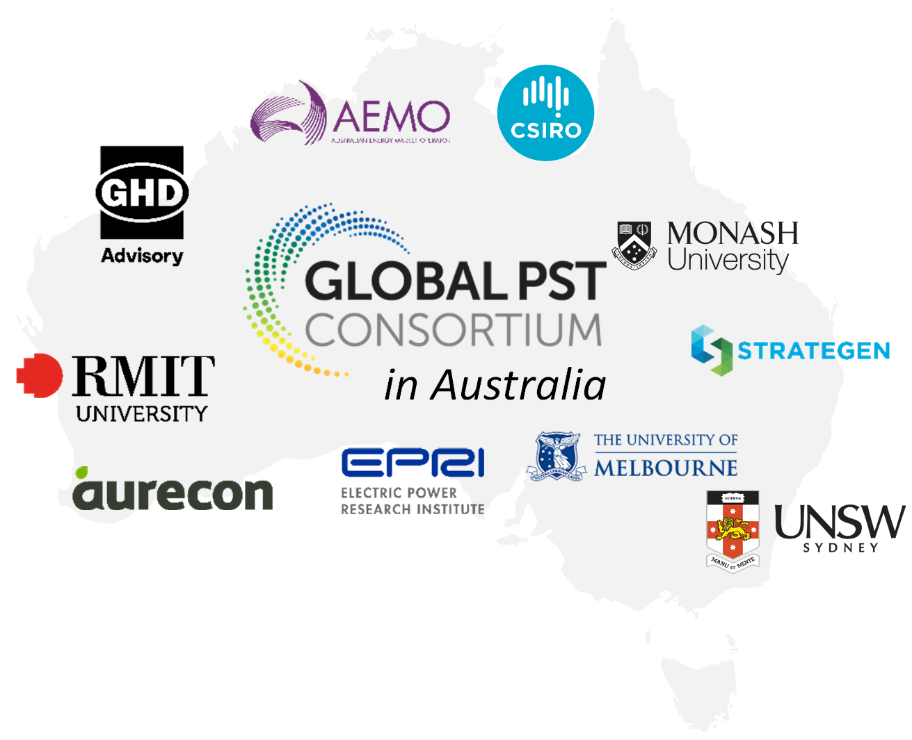
Figure 2 Contributors to the CSIRO G-PST Research Plan

Research Roadmap Outcomes
Each of the nine topics of the research roadmap aims to deliver a functional plan that outlines opportunities for Australian research to support and accelerate the electricity system transformation.
The final research plan for each topic includes:
- A comprehensive review of relevant industry literature and activities. This includes publicly listed projects currently underway by AEMO, transmission and distribution operators, governments, and research bodies.
- The identification of research areas where Australia has a driving need or natural advantage.
- Further exposition and refinement of the proposed research questions.
- Prioritisation of research questions and concerns for the Australian context.
- The development of a research plan for the Australian energy system transformation.
- The identification of resources, including prerequisite information and data, as required to progress these research plans in the G-PST research roadmap.
- Project delivery risk identification.
- The identification of any key stakeholders required to advance Australian research in the topic area.
The research plans for each topic are available separately from CSIRO’s website.

Developing a Holistic Research Roadmap
We live within an energy ecosystem. Considering this, the various research topics must be coordinated, as they are interdependent and interactive. As each group was tasked with the comprehensive identification of research needs for their topic areas, some overlap between groups is expected. To minimise this, as well as identify synergies, research groups were encouraged to interact and identify opportunities for collaboration. Based on the information provided by each of the researchers, the complexity of the interactions is illustrated by the Sankey diagram shown in Figure 3.
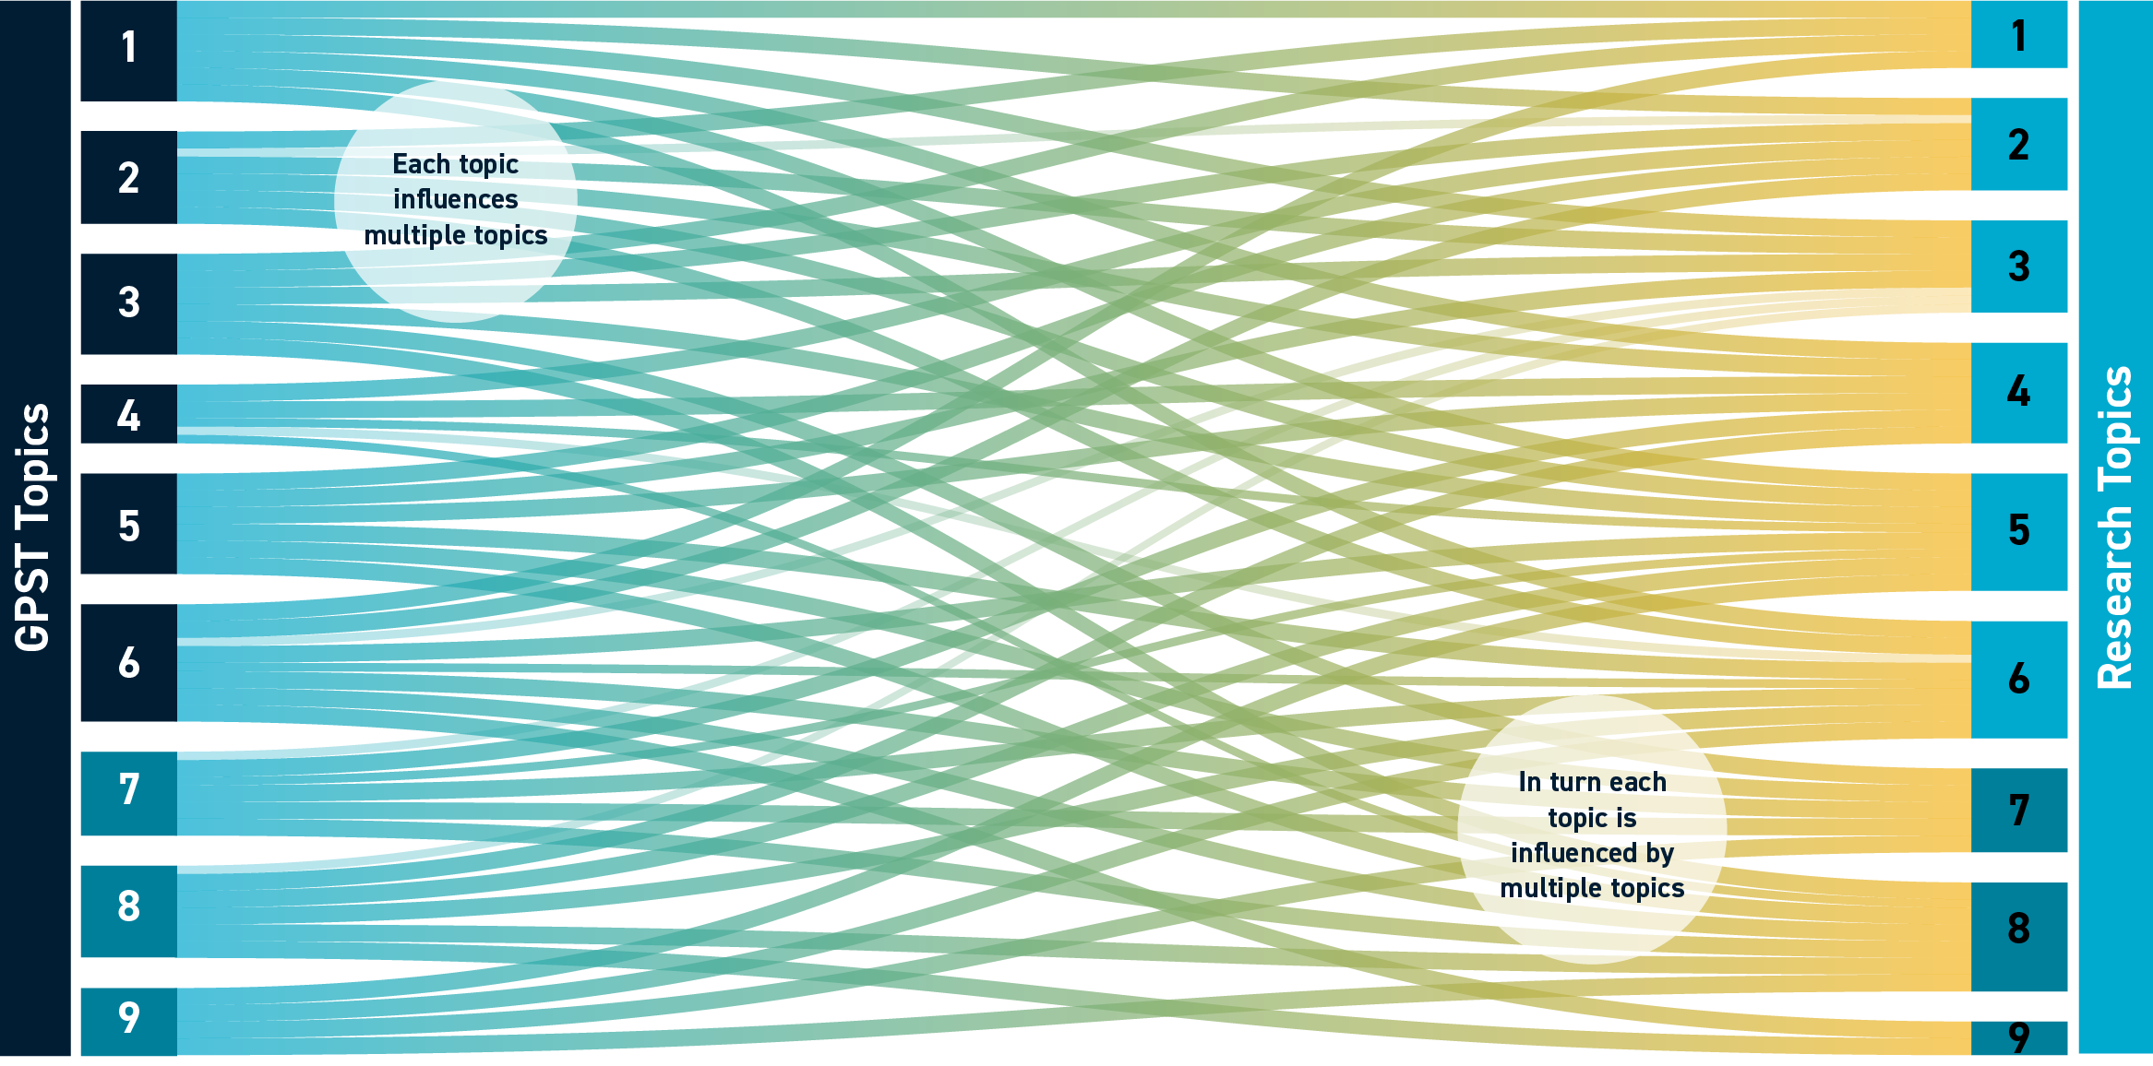
Figure 3 Interaction of the nine research topics that make up Australia’s G-PST research roadmap
The need to coordinate the work across the roadmap is immediately evident; each topic is influenced by the work of at least four other topics. Illustrating this point is the influence that the software tools and analysis processes (Topic 2) has on every research area ranging from inverter design (Topic 1) to the identification of essential system services (Topic 6). This interaction is both a boon, as well as a challenge. If coordinated well, the interaction and interdependence can create synergies and confirmation, but if mismanaged can lead to duplication and, in worst cases, contradictions.
To assist coordinating the overall roadmap, it was recognised that the research topics, which are the focus of the G-PST research roadmap, were selected to achieve:
- optimised planning and design of our future energy networks,
- effective integration of new technology, and
- secure and efficient operability of our changing energy system.
Hence, together the nine research topics are envisaged to develop the tools, processes, and roadmap to assist the Australian energy sector to transition the decarbonisation of our electricity system. Based on the very extensive work detailed by the individual research plans of how and at what levels the various research topics interact, four layers are defined of how the research topics interact to deliver the objectives (Figure 4):
- Foundational layer – creates a platform on which to build the research. It defines multiple dimensions of the energy structure, including data, technology, and economics, and identifies the key stakeholders that are most effective to manage them.
- Tools and methods – critical to all aspects of the delivery and operability of the future grid, such as new software to analyse emerging electrical phenomena, real-time monitoring of all levels of the electricity system, and more effective acquisition and use of system data. It is dependent on the foundational layer, particularly the way that data and information will be managed.
- System design– not only do we need to operate the future grid, but we also have to build it. We have to design the infrastructure and define the services that will support the future needs for electricity from existing consumers, and with increasing sector coupling, future users of the grid.
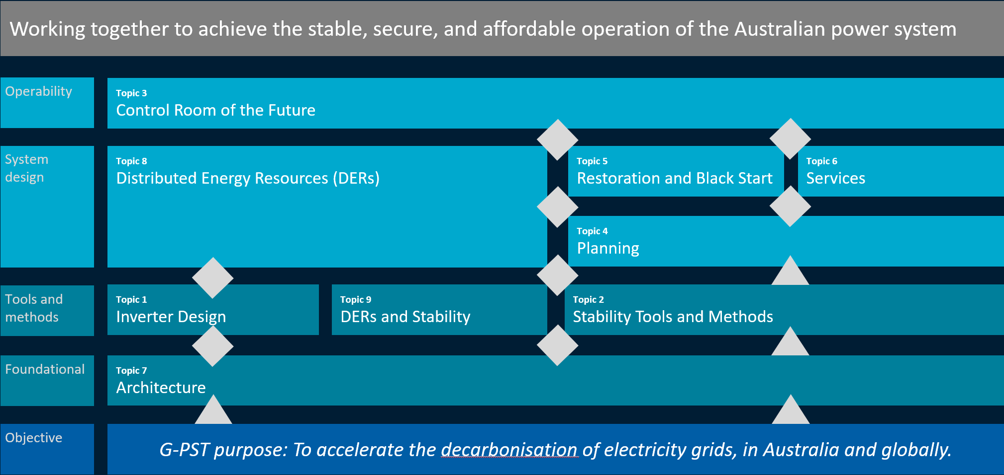
Figure 4 Layered interaction of the proposed G-PST research topics
- System operability – the ever-increasing complexity of our electricity network due to decentralisation, increasing weather dependence, digitalisation, and consumer behaviour challenges our paradigm of system operability. We must adapt and expand if we are to maintain and expand the level of efficiency and security of the past to future consumers of electricity.

Delivering Results
Australia is at the forefront of the energy transition and has the most to gain or lose, depending on whether we act or do not:
- The rate of renewable uptake at the consumer and utility level will continue.
- Electrification of other energy sectors has already commenced and will accelerate.
- Traditional sources of generation will retire.
- Climate change will challenge our energy system resilience.
These are some of the certainties that Australia must prepare for, and the proposed research program is a key aspect of the preparation. Section 4 of this summary report outlines high priority deliverables that each research topic proposes. However, stepping back and looking at what the whole roadmap can deliver for Australia, the benefits are broad and techno-socio-economic, including:
- Security – the roadmap when implemented will help to facilitate a safe and cost-effective energy transition for Australian consumers by developing the tools, processes and designs needed to develop and operate the electricity system of the future.
- Research – implementation of the roadmap will stimulate and advance critically needed research and provide a platform for Australia’s universities and research centres to continue to lead our technology driven transition.
- Innovation – Australia is at the leading edge of the energy transition, and one of the countries that is experiencing the challenges many others will in the future. We are an energy exporter and have the opportunity to continue to be based on our technology and innovation driven leadership
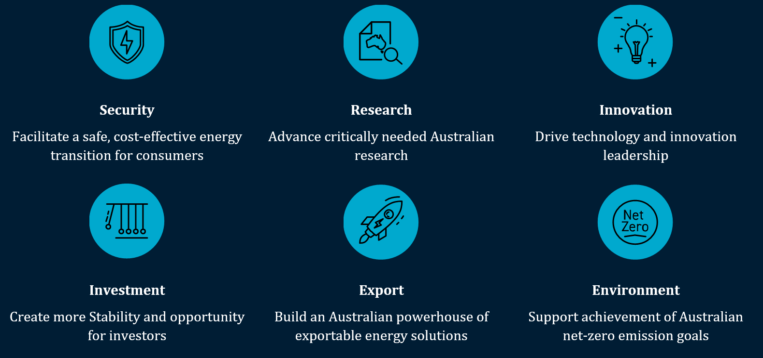
Figure 5 Benefits of the G-PST research roadmap
- Investment – the roadmap provides further stability in the midst of the disruption that the energy sector transition is causing. By creating a stable and sound framework for transition we can help to create Stability and opportunity for local and international investment in our energy sector, driving capital investment and employment across the country.
- Export – Australian innovation and expertise in the energy transition is already recognised globally. By continuing to grow our knowledge and innovative energy system solutions we create global export opportunities for Australian business.
- Environment – decarbonising our electricity sector in an efficient and effective manner, while ensuring energy affordability for Australian consumers, will help support Australian net-zero emission goals.

Interaction with AEMO
CSIRO and AEMO are key stakeholders in the development of Australia’s energy landscape with many mutual interests. They have previously collaborated on several important works, including the conceptualisation of the Australian Energy Simulator, the G-PST Consortium research agenda, and the treatment of electric vehicle uptake in transmission planning scenarios. They also share a number of common interests in the development of an Australia’s G-PST based research roadmap.
The work proposed as part of this Australian contextualised energy sector research is closely aligned with a number of AEMO initiatives, including:
- Engineering Framework – a roadmap to deliver a secure and efficient energy transition with an immediate focus on system operability.
- Advanced Inverter White Paper – an initial publication of the system operator’s view of advanced grid-scale inverter applications and recommendations about enabling this technology to support the future NEM.
- Operations Technology Roadmap – a proposal at the concept stage for an extension and expansion of previous work by the system operator to upgrade their control room and operational technologies needed to operate the power system of the future. This work would build on the work undertaken through the G-PST research plan topics 2 and 3.
- National Energy Simulator – development and implementation of an advanced high-performance (near-real time) energy system simulator for the NEM.
The work proposed under the research plans developed at CSIRO’s request has many parallels to these and other AEMO initiatives, creating a natural fit for collaboration between these two organisations. This is shown in Figure 6, which maps the CSIRO proposed G-PST research roadmap components against the equivalent activities found in the various AEMO programs; the EF’s ten focus areas have been separated and represented individually in the purple coloured boxes, while individual initiatives are shaded grey. The diagram illustrates that there are synergies between the work to be carried out by each organisation and which can be exploited to accelerate both organisation’s successes.
The commonly shared knowledge between these two organisations has already been applied in the development of this research roadmap, with AEMO subject matter experts providing strategic input and guidance to all of the nine topics of the CSIRO proposed G-PST research roadmap presented in this summary report.
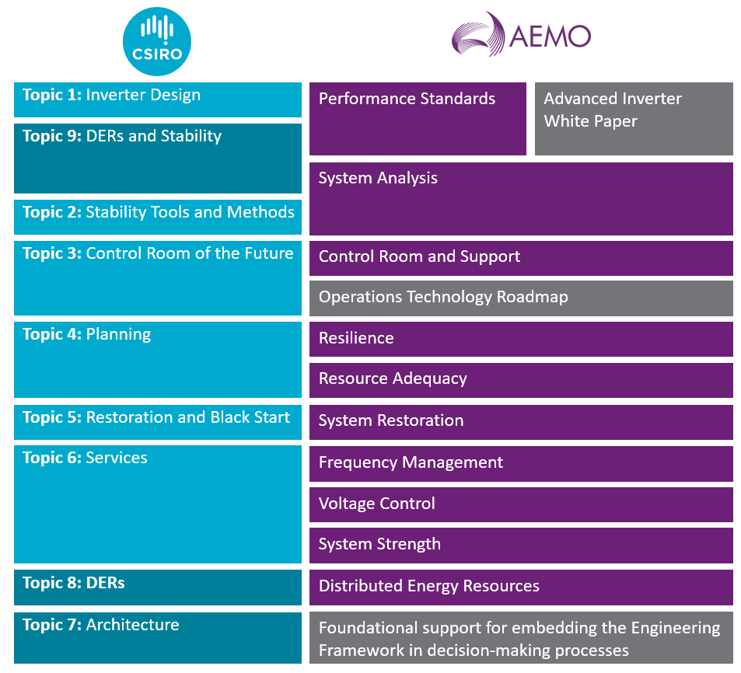
Figure 6 CSIRO and AEMO initiated programs of work relating to power system operability and development

Research Plans

Inverter Design
Power electronic connected generation, also known as inverter-based resources (IBRs), are increasingly the dominant means to connect solar and wind energy to the Australian electricity grid. To date, almost all applications of IBR have been based on Grid-following Inverter technology (GFLI). Essentially, this means that these energy sources rely on other resources, mainly thermal and hydro generation, to set grid voltages and frequency. However, as those other resources are displaced, withdrawn, and retired there will be an increasing gap in the availability of essential grid services to manage voltage and frequency. Such shortfalls can result in a need for operator intervention to maintain system security and increase the need to constrain generation, as well as increasing costs to consumers.
To address these emerging issues, alternative inverter control methods such as those offered in Grid-Forming Inverters (GFMI) are necessary to help achieve a secure, stable, reliable, IBR-dominated grid. Development of these methods requires exploration of control strategies, protection schemes and modelling approaches for IBR-dominated grids. To this end, research to be carried out for Topic 1 will: “contribute to the secure operation of the future IBR-dominant electricity grid, by solving unknowns regarding IBR design, development and operation”, as noted by the G-PST.
The appointed developer of the plan for Topic 1, Monash University, has prepared a research plan that outlines key milestones in the development of new IBR solutions. This is broken down into five major and five shared tasks. The major tasks and the highest priority activities within these, which the proposed research focuses on for the first two years, are listed in Table 1. Subsequent tasks and activities build on these high priority items and are delivered in the medium and long term over 5 to 10 years.
Table 1 IBR Design (Topic 1) major tasks and highest priority (<3 years) research activities
Task | Topic | Activity
1 | Frequency stability | Define advanced IBRs and storage system frequency response requirements and capabilities for future grids, particularly in defining the response of GFLIs and GFMIs for a credible contingency.
2 | Voltage stability | Investigate reactive capability and voltage control requirements of IBR, particularly on the Interactions between synchronous machine Automatic Voltage Regulator (AVR), GFMI AVR and GFLI in providing reactive power support.
3 | Interaction mitigation and oscillation damping | Identify and resolve the source of adverse interaction among aggregated IBRs, particularly in identifying the nature of oscillations in IBR-dominated grids, standardising the models of IBRs and modelling, analysis, control and coordination of IBRs for oscillation damping.
4 | Protection and reliability | Determine and propose mitigation methods for the adverse impact of IBRs on power system control and protection systems, particularly in enhancing IBR response during and subsequent to faults.
5 | Trending topics | Develop advanced IBR control methods (grid-forming inverters) for future grid applications.
These highest priority activities proposed by Monash look to identify risks posed by the continued integration of IBR and the rate at which these risks will likely appear. They were developed to answer the research questions that have been posted by the G-PST Consortium, as well as to further concerns that are related to the Australian context of the research topic, particularly questions raised over the integration of DER into the Australian electricity grid at scale.
Furthermore, in addition to a literature review and identification of underway research in advanced inverter technology, and the insertion of Monash’s own reflections, the research plan developed by Monash also included extensive industry consultation with thirteen stakeholders, including grid operators/owners, Original Equipment Manufacturers (OEM)s, and consultants who were interviewed for their input. This way, the researchers ensured that any underway or completed work related to IBR integration, as well as the views of industry and technology developers, were reflected in the plan.
To deliver the necessary high priority research Monash have estimated that up to 45 university-based researchers and academics may be needed, assuming that some of the supporting activities would be supplied through postgraduate and PhD research studies. Monash has also identified that some overseas and commercial resources will be needed to provide industry expertise to supplement and expand academic and researcher capabilities.
The research plan also considers the need to involve key stakeholders in the execution of the research plan, including AEMO, Transmission Network Service Providers (TNSP)s, and inverter OEMs. Monash also proposes collaboration with other overseas research institutes that are working on similar research topics.
Outcomes of Topic 1 research can help mitigate security constraints such as those that required some solar farms in northwest Victoria and wind farms in South Australia to be output limited for extended periods in the past,, and can help to support:
- Secure operation of future Australian electricity networks, both during normal outage planning as well as contingency events.
- Improving investor and developer confidence that projects can connect to the grid and stably operate.
- Maintaining reliability for consumers by ensuring new energy sources can connect as old power sources shut down.
This work is built for Australian needs using Australian developer, operator and investor experience and expertise.

Stability Tools and Methods
Power system operators have a large variety of existing tools and methods to underpin their power system planning and operating decisions. However, with increased penetrations of Variable Renewable Energy (VRE), IBRs, and DERs and coupling with other sectors, the underlying nature of the power system is changing. These changes will both limit the applicability of some existing tools and methods as well as dictate the development of new tools and methods to ensure the reliability, security, and Stability of the power system.
As observed in the previous section, with increasing IBR penetrations the underlying nature of the power system is changing from one based largely on a synchronous paradigm to one based on a non-synchronous one. Furthermore, an increasingly variable, distributed and IBR based power system will also compound existing challenges to analysing and interpreting results from existing power system models, and lead to a greater range of operational conditions to assess. Therefore, analytical tools that help evaluate the operation of a power system with a large number of IBRs must be developed. Specifically, tools to capture the interactions and impact of IBR control algorithms that can be detrimental, or beneficial, to the power system’s stability and performance, as well as assessment of stability margins, which is particularly challenging with time-domain analysis tools.
Similarly, the operator will require tools and methods to aid real-time decision making and management of power system security. Existing tools are based upon power system phenomena relevant to synchronous machines and these require re-evaluation. This will require faster processes and new methods to identify the emerging issues brought on by the transitioning power system. Additional to managing these emerging issues, AEMO has noted that increased effort is needed to resolve existing legacy data and model issues.
CSIRO appointed the Electrical Power Research Institute (EPRI) to form a plan to develop tools and methods suitable for planning and operating the Australian power grid as it transforms and transitions. Correspondingly, the plan developed by the researchers proposes forming new processes and tools from now until 2030, with the most critical tools required to be available within 3 years. The focus of the research was developed from the researchers own experience and expertise, coupled with extensive engagement with AEMO and Australian TNSPs. The system operator and utilities are the main users of such tools and methods. The most critical processes identified by EPRI to be developed in the first three years of the plan are shown in Table 2.
EPRI has estimated that the cost of delivering the highest priority (critical) outcomes will require up to $3.7 million investment, including in Australian research and academia, as well as allowing for overseas expertise that cannot be obtained locally. However, with the rate of IBR integration in Australia, new tools and methods are urgently needed to ensure we continue to enjoy the benefits of a secure and stable electricity network. However, as well as providing us with the means and processes to achieve this, the proposed research will also connect and advance related but solitary research already happening in this field in Australia, including:
- AEMO’s Real-time Simulator
- New and innovative ways to tune generator control systems for weak grid operation
- Real-time measurement of power system inertia
Table 2 Stability Tools and Methods (Topic 2) highest priority (<3 years) research activities
Task | Topic | Activity
1 | Stability margin evaluation | Develop tools to assess non-linear stability margins using black-box models and evaluation of stability at multiple operating points
2 | Small-signal stability screening methods | Establish procedures to use impedance-based methods for stability screening and linear analysis techniques with black box IBR models.
3 | Voltage stability boundary | Produce tools to identify new boundaries between source and sink regions and recognise voltage stability boundaries as new constraints/criteria for system operation.
4 | Voltage control and collapse recovery | Develop improvement in the way loads and IBRs are considered in voltage and reactive power control tools and tools to assist operators with over-voltage mitigation due to an increase in IBR output.
Overall, the research will raise our academic and research knowledge base, create tools that will allow us to plan and operate the future grid. But not only is this know-how essential for our future, but it’s also exportable thereby creating opportunities for Australian industry and research.

Control Room of the Future
The heart of the modern interconnected electricity grid is a central control room. From here operators and utilities coordinate the dispatch of generation, monitor demand, and ensure sufficient essential services are available to support the efficient transfer of electrical energy across the grid. This is a 24-hours a day, 365-days a year real-time activity. However, things do not always run smoothly. Equipment outages and maintenance must be coordinated, and increasingly climate-driven events, as well as ageing equipment, are creating incidents that the Control Centre must manage all the while ensuring reliable supply to consumers. And if this was not challenging enough, the increasing decentralisation, variability, and overall trend towards an IBR dominated grid are creating gaps in the toolsets and processes of the control centre.
Many control rooms were designed early in the era of large-scale electricity grid interconnection, beginning in the 1970’s and they haven’t significantly changed since. AEMO’s NEM control room design and ergonomics is of current day standard; however, market systems have not materially changed since market start in 1998, and security assessment tools are rapidly becoming obsolete in a power system increasingly dominated by inverter based resources. The control room of 2021 cannot effectively manage our future power system, and operations, and the way power system operators interact with the system, will have to change rapidly.
Topic 3 aims to plan for the Control Room of the Future (CROF), highlighting the functions, processes, tools and data that must be replaced, expanded and developed. To create the plan, CSIRO engaged EPRI, who have also contributed to the G-PST pillar on the same topic.
EPRI has approached the development of the plan using its established methodology and frameworks. In this instance, they have stated the objective of this research roadmap to develop a model for considering the CROF foundations and 11 key pillars and charting the course for advances in these pillars towards 2030. The structure of the pillars and the foundational strategy is shown in Figure 7. Colour coding is provided to show the grouping of related pillars into blocks.
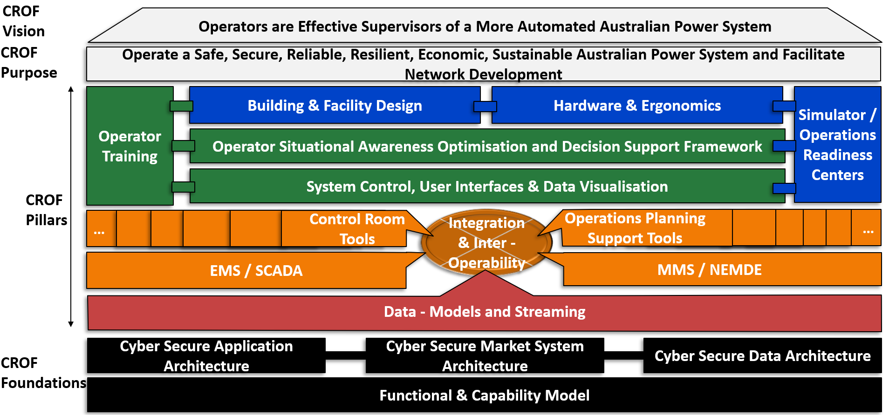
Figure 7 EPRI model of the aspects of the control room of the future, applied to the Australian context and including the CROF vision, purpose, pillars and foundations.
EPRI notes in their research plan provided to CSIRO that the projected advances are both realistic and are aligned with current developments in Australian control rooms, but also are ambitious in the scope of the research and development roadmap towards 2030. The plan has identified several high priority tasks within the overall program, relating particularly to the foundational strategy and the CROF pillars, as shown in Table 3, using the same colour coding as applied in the functional map previously. The tasks relate particularly to the short-term requirements identified by EPRI as being needed during Stage 2, this being the work from now to 2025.
Table 3 Control Room of the Future (Topic 3) highest priority (<3 years) research activities
Task | Topic | Activity
1 | Functional & capability model and architecture (black) | - Develop a full capability model for system operators in Australia.  - Engage with EMS/MMS vendors to discover gaps and design a reference control room architecture for electrical utilities.
2 | Data modelling and streaming (red) | - Alignment of operations model standards & requirements across the industry, with ICE CIM as the cornerstone, especially DER requirements.  - Establish standard approaches to alarm management, asset health monitoring, generation and market participant monitoring. Ensure quality control and validation checks. Investigate wide use of PM, IEC61850 data, where it aids decision support.
3 | Energy and Market Management Systems (orange) | - Promote increased speed & capability for system studies in real-time through the integration of these activities with the real-time energy simulator.  - Automation design for all MMS tasks and processes with a goal of no manual data inputs. Design of common MO/TNSP/DNSP dispatch platform.
4 | Operators and human factors (green) | - Standardised certification for Australian operators and engineer capability. Certification for all CR tools.  - Digitisation of all procedures, work orders and work instructions. Mental workload monitoring.  - Full observability of DER, WAMS. Market and physical system constraints in relevant control room tools. Modelling SPS/RAS in all CR tools.
5 | Buildings, facilities and hardware (blue) | - Building and facilities completely pandemic resilient. Agile flexible spaces for lodging, meetings etc. Cyber-physical standards development.  - Detailed physical architecture design for OR, as seamless integration with existing facilities and ICT.  - Single desk user interface (keyboard/mouse) into dual IT environments.
The work will require significant resourcing and contributions from AEMO, TNSPs and Distribution Network Service Provider (DNSPs). Additional MMS/EMS and software vendor input will be needed to develop solutions. As such the budget allocation for this work will necessitate further work.
Having the right controls is the pathway to achieving the ambitious net-zero goals set by states and territories. This work will:
- Build on existing projects in TNSP and DNSP operations departments across Australia
- Create national alignment and identify industry needs
- Become more important than ever to maintain energy supply through large weather events, that are occurring more frequently

Planning
Planning practices have traditionally adopted deterministic approaches to represent the long-term drivers of system expansion, historically mainly associated with annual load growth, using simplified representations of system operation. However, the increasing operational and technological complexity of power systems, as well as the uncertainty in the future system, market, and policy developments, are diminishing the effectiveness of traditional approaches.
In the broader context of the G-PST research activities such as those on resource adequacy, the University of Melbourne has been commissioned by CSIRO to develop an Australian focused research plan on the topic of “power system planning”. In their proposed plan, the University of Melbourne has identified key issues and challenges that need to be addressed to plan for and build the power system of the future:
- The operation of low-carbon systems dominated by renewables and distributed energy resources (DERs) and with increasing coupling with other energy sectors calls for new modelling requirements and tools.
- Long-term uncertainty is increasingly influenced by factors, including emerging technologies and business models, policy environments, and climate change, which all represent daunting challenges to system reliability and resilience.
- More sophisticated and flexible representations of the possible futures are needed, along with new decision-making frameworks and tools to deliver plans that optimise outcomes across multiple scenarios.
- New metrics and methodologies are needed that account for the technical and economic risks faced by multiple stakeholders during the energy transition.
- The interface between power systems and other energy systems and sectors (i.e., gas, hydrogen, transport) also needs to be properly designed to capture the impact of and flexibility created by multi-energy systems and sector coupling in planning studies.
To meet these challenges, the proposed plan and program of work aims to create tools, methods and frameworks to plan the future of the electric power system. The highest priority activities proposed by the researchers are shown in Table 4. While there are activities scheduled for task 4, these are not proposed to commence until 2026, and hence are not considered high priority activities.
The University of Melbourne estimates that between now and 2030 the investment is predominantly needed to fund around 15-20 research and academic positions as well as industry-based engineering expertise to develop and deliver the necessary tools and processes. Most of the expenditure is largely front-loaded.
The proposed research plan will create real solutions for the Australian power system industry and unlock significant new value for its stakeholders, including:
- Leveraging the best talents of Australian industry and its research partners.
- Focusing on addressing “burning” challenges – climate change, modernised and dynamic planning frameworks, aging infrastructure.
- Making our increasingly decentralised, intermittent power system work.
For Australia to continue to enjoy the energy security and stability of the past, this work is vital.
Table 4 Power System Planning (Topic 4) highest priority (<3 years) research activities
Task | Topic | Activity
1 | Quantify long term uncertainty | Produce future energy scenarios, investigate climate change impact and uncertainty in policy & market developments.
2 | Model power system operation | Develop both steady-state and dynamic power system models for planning purposes and formulating enhanced security constraints.
3 | Assess reliability and resilience | Establish reliability & resilience metrics, study system-level impact of climate change, identify credible & non-credible contingencies and characterise DER/IBR response to different events.
5 | Investigate DERs | Study the impacts from multi-energy systems, distributed energy markets & demand-side flexibility and DERs.

Restoration and Black Start
While operators hope to never call upon black-start services, they are essential for ensuring system resilience. Rapid and efficient black starting, or restoring, a power system is necessary after some partial and all total shutdowns. The last time Australia experienced a major blackout event was the complete supply interruption of South Australia in 2016. This event and others around the world, in conjunction with the underway energy transition, makes it of vital importance to ensure that the are effective processes and capability in place at all times, to restart our electrical grid after a natural disaster or man-made event. However, new systems and procedures must be implemented to achieve this in a high or 100% inverter-based grid, addressing issues arising from:
- Reduction in the number of online synchronous generators.
- Increased uptake of utility scale IBR.
- Increased uptake of DER.
- Changing demand response.
- Insufficient understanding of emerging technologies and the necessary specifications.
- Existing tools and techniques may not necessarily address increasing complexities.
To develop a research plan to investigate opportunities and options for future system restoration in light of the many changes and emerging challenges, CSIRO appointed Aurecon to develop an activities roadmap.
In their project plan, Aurecon noted that Australia’s traditional black-starting plant, predominantly coal and gas-fired turbines, are aging, and face retirement in the coming decades. Investors are unlikely to replace these units. Therefore, Australia must consider black-starting alternatives. Work in this area broadly falls into two categories:
- Specifications for grid-forming IBRs to enable them to directly black-start or to significantly assist with the restoration process.
- Methods, procedures, and analysis techniques to black start and restore a power system with various penetrations of IBRs, up to 100%
The researchers have established five tasks within the Topic 5 research plan and the highest priority activities needed to address these, as listed in Table 5. The time frame for progressing many of these tasks is aligned with the procurement process for system restoration services that AEMO runs every 3-5 years in the NEM, with the most recent having been completed in 2021. The restoration requirements of the WEM are contracted for by AEMO annually. Hence, the time frame for completion of the high priority activities is recommended to occur within the next 2 years to allow outcomes to be included in the next procurement process, commencing around 2024.
Much of the work proposed requires specialist knowledge and expertise, which are mainly found within AEMO, and some select engineering service providers, or overseas. As such research and development in this space has not been costed extensively and will necessitate further discussions with AEMO and Australian TNSPs.
However, while not costed, the work outlined Topic 5 is seen as critical as it would help solve some of the significant barriers to a stable power supply in Australia such as:
- Reliance on ageing generation assets – coal-fired power stations – and the increasing forced outages that come along with them
- Increasing risk of IT related failures, cyber-attacks or sabotage on wide-area power system infrastructures that can result in blackouts.
Reliable and effective system restoration of the future power system would also factor in reducing the risk of the increasing impact of global warming on our energy supply through extreme weather events.
Table 5 System restoration (Topic 5) highest priority (<3 years) research activities
Task | Topic | Activity
1 | IBR as restoration support | Establishing opportunities for using IBRs, including both GFLI and GFMI, as restoration support devices in AEMO’s System Restart Services.
2 | Impact on Network controls and protection systems | Assess the network impact of various system restoration methodologies due to changes in control and protection.
3 | Tools and techniques | Establish new and/or expand existing tools and techniques to develop wide area simulation models to test and evaluate the existing restart processes.
4 | Technical and regulatory requirements | Develop technical and regulatory requirements that include specific restoration requirements into long-term planning requirements.
5 | End-to-end restoration | Consider the end-to-end power system restoration that optimises the use of IBRs and manages the increasing amount of Distributed Energy Resources (DERs).

Services
The System Operator uses essential [power] system services, such as frequency and voltage control, to keep our electricity grid stable. This means keeping the system frequency close to 50Hz, network voltages within acceptable levels and maintaining overall power security, by managing overall energy reserves, having sufficient fast responding plant to act quickly during contingencies, and maintaining system strength and reactive power reserves to ensure stable voltages throughout the grid.
In modern power systems, system services determine:
- the operation and planning of the electricity grid across all time scales
- the required characteristics of the technologies connected to the power system; and
- through commercial mechanisms, the incentives to innovate and invest and to do so equitably.
In Australia, these critical services are predominantly provided by a generating fleet that is changing operational patterns and retiring in the coming decade, this being our coal-fired thermal power stations and gas turbines. It is possible that in a few short decades the dominant remaining synchronous generation in Australia will be made up of hydro generators. Meanwhile, we are transitioning to decentralised, variable and asynchronous generating technology, and consumer uptake of DERs is continuing to grow. It’s been recognised through the work of the Energy Security Board, the Australian Energy Market Commission (AEMC) and AEMO that current state-of-the-art services (e.g., capacity adequacy, ancillary services, etc.) are not fit for enabling the services that will be required for future service requirements; there is a danger of developing electricity grids that are costly, unreliable, inequitable, and not resilient and will therefore not deliver the step-change needed for the energy transition.
To tackle the research questions of the G-PST relating to “Services” and how this applies to the Australian energy landscape, CSIRO appointed the Royal Melbourne Institute of Technology (RMIT) to develop a plan that would help ensure essential system services that keep the electricity grid stable are recognised, and any perceived challenges in sourcing sufficient quantities of these resolved as more renewables are integrated into the grid.
In developing the plan RMIT has proposed five critical areas of essential system services and have proposed immediate priority, mid-term, and long-term outcomes. RMIT’s focus has been on the establishing of services, measuring their performance and consideration of the economics of providing these services, as shown in Table 6.
This work would light a path forward for system security and more efficient essential services to integrate new technology. Key outcomes are pathways to:
- Optimise essential service provision from new technologies
- Integrate system services provided by DERs
- Facilitate provision of system services necessary to support further major network changes such as electric vehicle uptake in Australia
The work would complement AEMO’s EF, the post-2025 market development from Energy Security Board (ESB), and many other crucial activities.
RMIT concludes that by implementing this program, Australia will be positioned to adapt or introduce market services that can encourage efficient investment in the systems and services that are essential for keeping the lights on.
A resourcing and cost structure must still be developed, but it is envisaged that a mixture of industry-based engineering experts, researchers and academics, as well as representatives of AEMO and the AEMC may need to be included in the implementation of the plan.
AEMO observed on review of the research plan that the overall objective of research in this field should be to unbundle the inherent needs of the system for stability purposes. Such an approach could explore the potential for service provision through new means such as frequency response from DER.
Table 6 [Essential System] Services (Topic 6) highest priority (<3 years) research activities
Task | Topic | Activity
1 | Technical Domain | - Defining system requirements to maximise the hosting capacity of DER while maintaining balance in supply-demand.  - More efficient demand response policy and their participation in the demand response market
2 | Frequency support services arrangements | - Specification of performance parameters for the recently issued very fast frequency response should be specified.  - Siting and capacity requirements of FFR resources in the network.
3 | Voltage support services arrangements | - Identify the capabilities of conventional Volt/Var/OLTC equipment operating in a system with high IBR penetration.  - Establish the orchestration requirements for [energy] storage systems in the distribution system.
4 | Performance Assessment Metrics | - Evaluate the performance of existing metrics that can be used to assess the quality of essential services.  - Identify effective metrics specific for services in IBR dominated grids.
5 | Financial Domain | - Integrating new services into the market in such a way that an economically sustainable market is achieved.  - Revising economic aspects of available frequency and voltage support services.  - Introducing services related to DER in the distribution grid in coordination with generation and transmission services,

Architecture
Modern electricity systems are more complex than ever, and they will continue to experience unprecedented change as they transition towards decentralised and renewable sources of generation. Critical to managing this increasing complexity is an understanding of the organised underlying structure or ‘architecture’ of the power system.
The established Systems Architecture engineering discipline is a key for transforming highly complex systems of any type. ‘Power Systems Architecture’ (PSA) is a generic term for an integrated set of disciplines applied to the strategic transformation of legacy power systems to better meet changing policy and customer expectations. It is based on the combined application of Systems Architecture, Network Theory, Control Theory and Software Engineering disciplines.
Strategen has been appointed by CSIRO to develop an architecture roadmap for Australia’s electricity system. Given the scale and pace of Australia’s power system transformation, the Action Research Plan developed by Strategen is designed for full execution over an 18-month period. The proposed 18-month plan promises to deliver a Future Options and Transition Pathways Report that will:
- Enhance and accelerate Australia’s capacity to navigate the complex structural and operational shifts that are inherent in the large-scale transformation of Australia’s Gigawatt-scale power systems.
- Provide a robust methodological basis for establishing a diverse and informed multi-stakeholder ‘community of practice’ that is better equipped to collaborate on the wide range of trade-off decisions essential to enhanced system and customer outcomes and an orderly transition.
- Significantly strengthen multi-stakeholder engagement, process coherence and transparency as a basis for greater trust and enhanced social license for change.
To achieve these outcomes, Strategen have proposed a five-phase action plan as shown in Figure 8. Within each of highlighted phases, Strategen proposes key activities as outlined in Table 7.
The work is highly aligned with AEMO’s EF and mapping of operations requirements for the future grid. Similarly, the architectural structure being proposed also fits strongly across at least two other topics of the research program: CROF and DER. The earlier completion of this architecture work (e.g. within 12 months) is expected to positively contribute to these other topics.

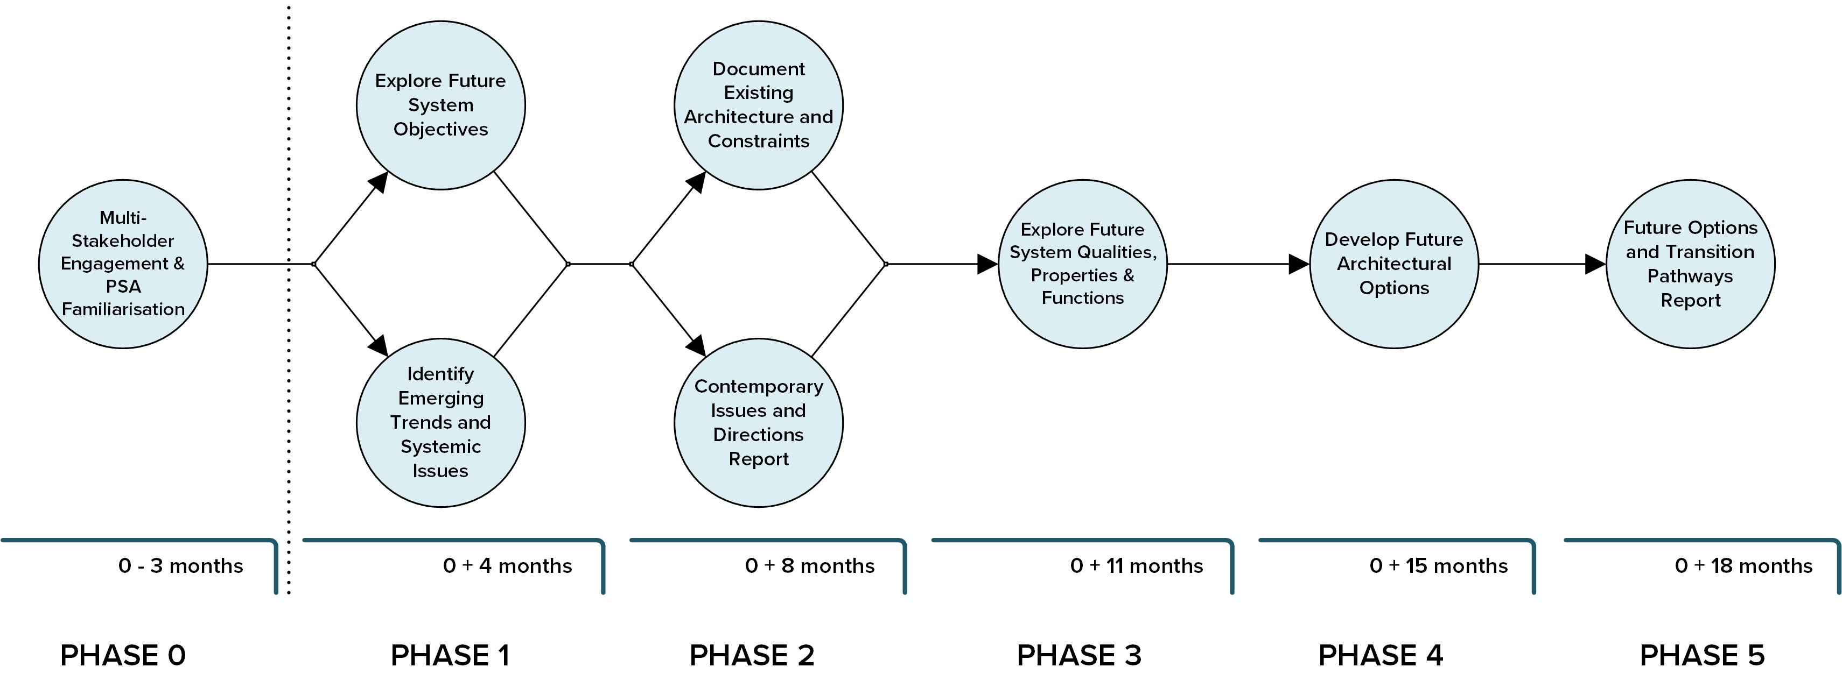
Figure 8 Five-phase Action Research Plan timeline
The investment costs of the architectural research topic require further deliberation, but will likely call for up to ten researchers and analysts over the 18-month period, as well as timely access to subject matter experts from within AEMO, NSPs, AEMC and other regulatory bodies. However, while the costs are somewhat opaque at this early stage, the value of the work is clearly apparent: It provides a platform and structure for many of the functions being developed across the other topics, as well as a connection to critical work that AEMO is carrying out in their EF to ensure future system operability.
Table 7 [Power System] Architecture (Topic 7) highest priority (<3 years) research activities
Phase | Topic | Activity
1 | Explore future system objectives  Identify emerging trends and systemic issues | - Identify the technical/economic/societal objectives that may plausibly play a key role in shaping power system priorities to 2035 and beyond  - Establish the least regret objectives which would provide optionality for different policy settings.  - Examine a diverse range of credible Australian and international studies and scenario planning focused on the 2030-2050 electricity systems futures.  - Establish the emerging systemic issues that Australia’s GW-scale system must be resilient to, and what the range of impacts arising from these are.
2 | Document existing architecture and constraints  Contemporary issues and directions report | - Map out the entity relationships across the NEM and WEM that manage control and dispatch of generation and load, system services, regulatory functions, markets and transactions, and retail.  - Establish the structure of the four foundational architecture layers across the NEM and WEM: Operational control; Market transaction, Information/Data exchange, and power flow. The identity structural constraints that exist when these layers are overlaid with the entity-relationship map.  - Identify which architectural models may have advantages for the Australian context, including transmission-distribution interface design, and DER.
3 | Explore future system qualities, properties and functions | - Confirm the key system qualities desired by policymakers and end-users, then establish the system properties and hence system functionalities required to deliver these.
4 | Develop future architectural options | - From the outcomes of the previous phases, establish plausible alternatives to the entity relationships and interfaces and the functional layers.
5 | Future options and transitions pathways report | - Evaluate the combined outcomes of the preceding phases and establish the issues and risks associated with each option, then consider additional issues that must be considered (e.g., resilience, cyber-security).

Distributed Energy Resources (DERs)
With increasing levels of DER penetration comes increasing uncertainty for the system operator and network planners. DER embedded within the distribution network is generally not operationally visible to the system operator or TNSPs. Instead, it is observed as an aggregated fluctuation in demand at the transmission bulk supply points. This means that net demand seen by the transmission system operator varies drastically with the weather, affecting local settings such as frequency response or Volt-Watt functions. Together, this makes the task of operating and planning the power system economically, securely, and reliably, much more complex. This difficulty will be exacerbated as DER uptake continues to increase.
In Australia, DER predominantly consists of small-scale rooftop PV installations. DER prevalence has rapidly grown to the point where, at the time of writing, it now amounts to over 15 GW of installed capacity. This growth is expected to continue for the next 20 years. Across this period, household batteries are expected to also become increasingly common. From 2030 onwards, Electric Vehicle (EV) growth is likely to eclipse all other DER. This overall projection of DER expansion is illustrated in Figure 9.
Operationally the coordination of so many distributed energy sources and sinks will be a significant task, which can have undesirable outcomes for power system operations should we fail to implement necessary changes effectively.

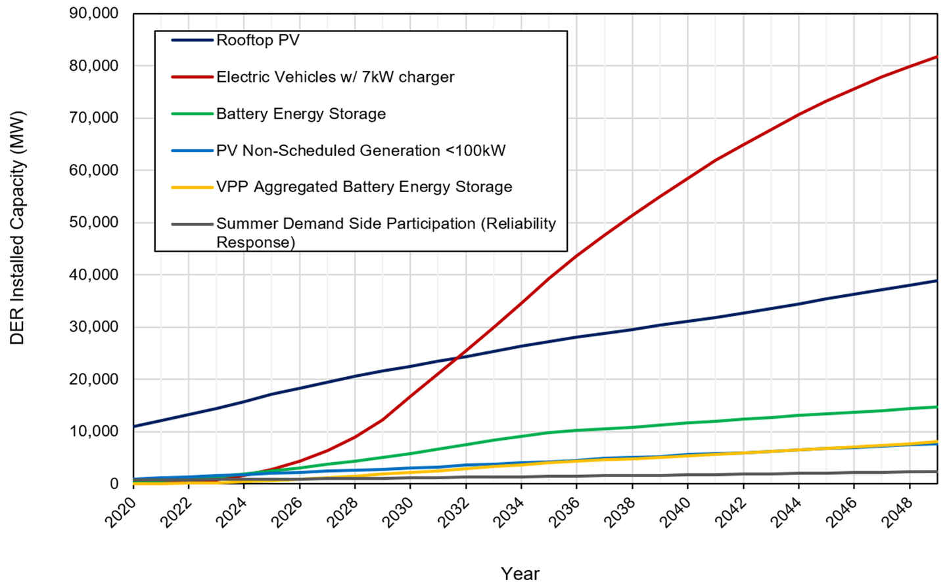
Figure 9 Average of AEMO Scenarios for DER installed Capacity Forecast
CSIRO has appointed The University of Melbourne to develop a research roadmap that explores the critical aspect of DER on the future Australian power system; DER, in the context of this work, is defined by CSIRO as encompassing domestic/residential and small industrial generation and flexible resources such as solar PV, batteries, flexible loads, and electric vehicles. In their final research proposal, the researchers have proposed a ten-year plan with an Australian focus, considering ten research questions across six aspects of DER that need to be addressed.
A total of ten research questions across six areas covering DER challenges have been refined and translated into research activities using the expertise of the team at The University of Melbourne, extensive reviews, and feedback from Australian and international stakeholders. The highest priority activities that the researchers propose must be resolved are listed in Table 8.
Many of the high priority activities outlined are short term research ones that can be conducted by research organisations or engineering consultancies over the next 2-3 years. Some may also require trials and field testing that would often be most suitably led by key stakeholders such as AEMO and/or DNSPs and would run over 2-3 years. Additionally, there may be some long-term research activities of 4-5 years that are well suited to a PhD project or equivalent and able to be carried out by research institutions. However, all of these high priority activities are recommended by Melbourne University to be commenced as soon as practicable with completion by 2026.

Table 8 Distributed Energy Resources [Orchestration] (Topic 8) highest priority (<3 years) research activities
Task | Topic | Activity
0 | DER Visibility | - Define the data flows (DER specs, measurements, forecasts, etc.) needed to ensure AEMO has enough DER/net demand visibility to adequately operate a DER-rich system in different time scales (mins to hours).
1 | Control architecture of DER | - Establish the role of DER standards in concert with the future orchestration of DER  - Define the most adequate decision-making algorithm for each DER control approach to achieve DER aggregation and orchestration.
2 | Communication requirements for monitoring and control | - Determine the most cost-effective communication and control infrastructure for each of the potential technical frameworks for orchestrating DER and the corresponding decision-making algorithms.
3 | Ancillary services provided by DER | - Establish the most cost-effective system services that can be delivered by DER considering the expected technological diversity and ubiquity of DER.
4 | DER influence on system planning | - Define the minimum requirements for a DER-rich distribution network equivalent model to be adequate for its use in system planning studies.  - Estimate the minimum availability of system services from DERs at strategic points in the system throughout the year and across multiple years.
5 | Institutional challenges | - Establish the necessary organisational and regulatory changes to enable the provisioning of system services from DER.  - Define the necessary considerations of establishing a distribution-level market (for energy and services).
Based on the prevalence and ongoing expansion of DER in Australia’s power system progressing the high priority tasks should be considered a critical component of the overall roadmap. Indeed, the outcomes of this work will also contribute to a number of other research plans and activities such as the CROF and Planning topics. However, this research also presents a significant knowledge export opportunity given that Australia is leading the field in per capita rooftop solar PV uptake and is experiencing challenges that many other systems will see in the future should they also experience increased DER penetration. Key drivers for this work are that:
- Australia is leading the way due to high DER uptake – there is no one else to solve these issues for us.
- Australia faces increasing challenges to system security through the growth of electric vehicles and home batteries. It is crucial for us to effectively manage current DER resources so that we can effectively manage the ‘next wave’ of technologies such as batteries and EVs.
- Finding solutions will ensure our own system security and create global export opportunities as other countries meet this challenge.
By implementing these research programs, Australia will be better equipped to face the challenges caused by DER uptake. Additionally, Australia will be equipped as a powerhouse of knowledge in this area and can export this knowledge to the rest of the world.

DERs and Stability
As described in previous sections, IBRs like wind and solar are increasing within both the transmission and distribution system. By far the fastest growth to date has been in the volumes of DERs and this is a trend that in the previous section the University of Melbourne predicted will continue to accelerate.
Concerning is also that the UNSW’s current inverter benchmarking suggest that over 50% of this inverter-based resource will behave undesirably (disconnection or power curtailment) if exposed to distribution voltage depressions such as those that occur during transmission level faults. This represents a clear threat to system security and such concerns are also expressed by AEMO. Observations by AEMO following large system disturbances have shown that small inverters can behave unpredictably in response to electrical disturbances.
Similar inverter technologies will drive energy storage systems, hybrid storage inverters, commercial and industrial systems, and vehicle charging. It is vital to continuously assess the performance of the inverters to the types of faults and grid disturbances that they are exposed to in the current grid.
For now, without an accurate understanding of how inverters operate, it is difficult for system operators to adequately prepare for and respond to disturbance events. Hence, Topic 9 research aims to build a real-world understanding of DER behaviour and develop tools to help system operators to manage the effective integration of DER into the power system. This includes laboratory testing, in-field data analysis, and simulation to build a comprehensive understanding of DER behaviours during disturbances and apply this knowledge to broader system planning and operations.
The objective of the proposed research program is to ensure that Transmission System Operators (TSO) can maintain power system security under very high penetrations of DER. The proposed research program is highly applied – and recommends that laboratory testing, in-field data analysis and simulation are used in combination to build a comprehensive understanding of DER behaviours during disturbances.
UNSW propose a 5-year multi-faceted approach that focuses on the early deployment of improved models that the transmission network operators and market operators can use, as well as expansion of their hardware and facilities to accommodate expanded benchmarking. Activities proposed for this approach are shown in Table 9, with more details contained in the full report.
UNSW estimates the cost of delivering the entire research plan to be up to $7 million over 5 years, involving a number of researchers and PhD candidates, as well as close collaboration with AEMO, inverter manufacturers, and TNSPs and DNSPs.
Australia is uniquely placed to deliver valuable insights to TSOs internationally, due to its distant and weakly-interconnected power system and substantial, if not world-leading, deployment of distributed solar PV systems, as well as a growing fleet of distributed battery energy storage systems. This five-year proposal will continue to support a range of stakeholders including inverter vendors and manufacturers, consumers and consumer groups, network operators and network service providers, and the market operators, regulators, and commissions.
Table 9 DERs and Stability (Topic 9) highest priority (<3 years) research activities
Task | Topic | Activity
1 | Inverter benchmarking | Expand UNSW’s inverter benchmarking: The small inverter market share is fluid, changing, and creating ‘stranded’ technologies as more innovative devices enter the market.  Start benchmarking portfolios of small-scale three-phase inverters, hybrid- and storage-only inverters.
2 | New Innovations and techniques | Research and develop techniques that solve any emerging challenges related to the performance of inverter-connected resources, new performance requirements imposed by standard making authorities or measures from network operators.
3 | Security issue identification | Development of methods to assess likely DER impacts on security, requiring modelling of DER behaviour such as via composite load models, in combination with TSO and NSP risk assessments such as contingency analysis.
4 | Dynamics of power quality modes | Evaluate and understand the dynamic response of inverters for the different power quality modes that the DG inverters need to provide.
5 | Data driven aggregation techniques | Build a more complete picture of DER risks to power system security through combining a number of research techniques such as lab testing, fault data analysis, and expanded distribution system modelling.
6 | Fault and disturbance propagation | Analyse the impact of network topologies and configurations in fault propagation to inform the development of fault propagation “heat maps”, highlighting critical areas of the transmission network where faults are likely to cause broad DG disconnections as well as areas of the distribution network that are specifically vulnerable to large-scale inverter curtailments or disconnections.

Stakeholder Engagement
The research roadmap and its nine distinct topics are a heavily interactive, not only within the roadmap and each other, but also with industry, the broader energy and research sector, as well as statutory bodies. Indeed, the success of the roadmap will only benefit from extensive interaction with the industry to receive feedback on research, obtain data and information for input, and encourage active participation.
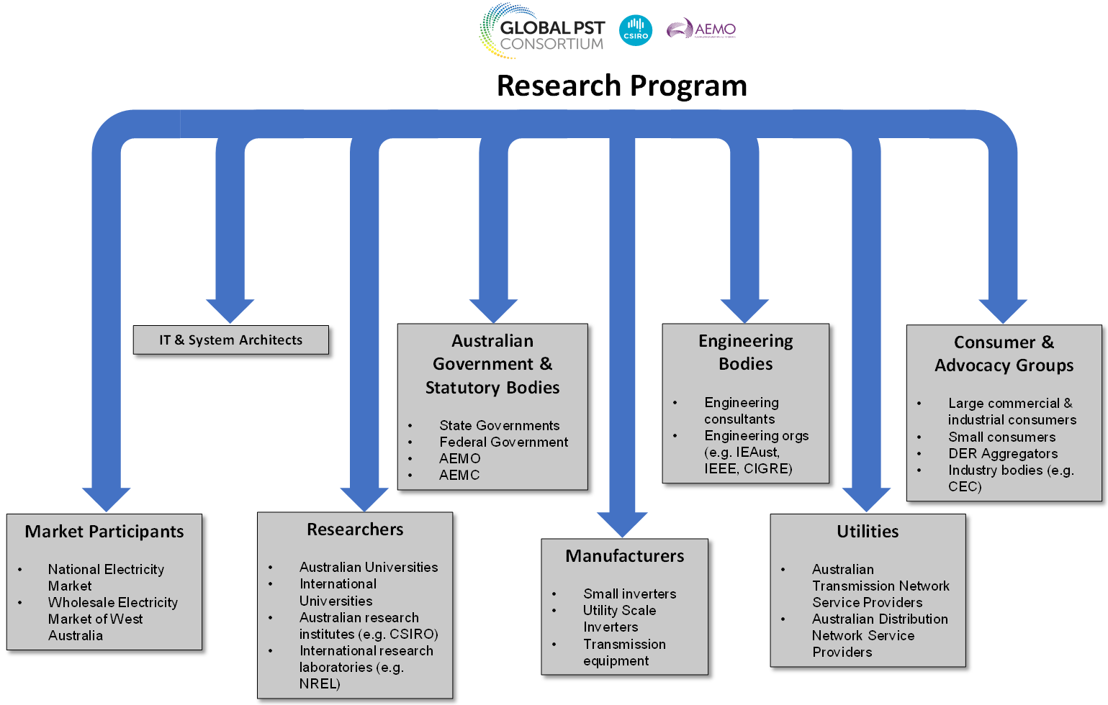
Figure 10 Stakeholder engagement for CSIRO’s proposed G-PST research roadmap
Although many of the of the research topics have identified similar key stakeholders such as transmission and distribution businesses, and the system operator, across all of the topics there were still more than 30 individual stakeholders and stakeholder categories identified that would be important to the success of the overall research. While individually these are too numerous to repeat here, Figure 10 illustrates a broad reflection of the types of organisations and industry bodies the researchers will be looking to engage with during the course of the research program. More detail is found within each research plan, but common to all are AEMO and CSIRO.

Resourcing Requirements
Resourcing a research program that could span a decade requires significant consideration. This is to not only ensure overall success for the proposed plan, but also to allow for the flexibility to adapt the research plans to changes in technology, energy policy and direction, consumer sentiment and behaviour, and regulatory processes.
While providing details of critical research projects and timelines for completing these at this early stage of conceptualisation the plans for each of the nine topics have provided only a high-level projection for likely resource requirements. Key points in resourcing requirements for all nine topics are summarised as follows.
- Topic 1 has provided detailed resource requirements as junior/senior researchers and duration of tasks for urgent, medium- and long-term research tasks.
- Topic 2 has provided approximate total budget and duration of tasks for identified critical, high priority, medium priority and low priority tasks.
- Topic 3 has provided timelines, priorities, and duration of tasks. The researchers have also referred to the majority of the work needing to be progressed by AEMO and the TNSPs. Other tasks within the plan are extensive in their own right, e.g., the Real-time simulator of AEMO is being delivered through an external vendor. Hence, resource requirements of Topic 3 will likely require quotations from vendors, AEMO and TNSPs to establish reasonable resources of delivery.
- The delivery of Topic 4 has been broken down into a series of projects under different programmes/streams. The timelines, priorities, duration of each task and resources requirements as full-time equivalent for all projects have been provided.
- Topic 5 is recommended to commence and be completed prior to commencement of the next NEM SRAS procurement cycle, as such as we have assumed a 2-year working time for the high priority items. Topic 5 also proposes that a large number of industry-based engineering resources would be required, drawn from equipment manufacturers, AEMO, and TNSPs. These resources, which make up around 25% of the total required for each task, could be provided through in-kind contributions from the main beneficiaries of the research, or they could be cash funded.
- Topic 6 has proposed a core team of at least 2 research fellows and 3 PhD researchers or similar for each of the 5 tasks. Additionally, expertise from TNSPs/AEMO/AEMC would be required.
- Topic 7 has issued a detailed 18-month timeline, but no resourcing estimation has been provided.
- Delivery of Topic 8 work includes a mix of short-term research, trials, and long-term research, with short-term applying in the first 2 years, followed/overlapped by trials, all along parallel to longer-term research. On completion of the work comes an implementation phase that is generally beyond 2026 or 2027 for all tasks.
- For Topic 9 UNSW has broken costs into resourcing across all 5 areas for benchmarking works, and similarly, the resources for research, development, and deployment have been spread across the five areas. Project support and hardware has also been costed and included in the final sum.
Resourcing requirements for the research plans vary substantially, which appears to be driven by the need for the researchers to cover uncertainty and risk before developing a detailed project scope.
Furthermore, the research projects within each topic have been presented as individually resourced projects. Assuming that not all positions are full-time roles, many academic positions, and others are PhD funded rather than pay-rolled, there is an opportunity to explore the assignment of resources to multiple projects and similarly optimise labour requirements.
Lastly, many of the researchers flagged that resources would have to be drawn from network service providers, system operators and government agencies. Labour resource requirements may be reduced in these instances, replaced with in-kind contributions. It should be noted, however, that many industry organisations are resource-constrained and research funding should also allow for funding of dedicated resources within industry to alleviate resource constraints, ensure timely support, and avoid bottlenecks.

Research Roadmap Risks
Risks to research roadmap and the associated investments stem from a number of sources, including resource shortages, inability to access the necessary data and information, technology changes, changes to energy policy and legislation, and uncertainty of goals and methods. Understanding these risks and planning for their mitigation are critical to the success of the research and safe-guarding of the investment. As part of the research plan, each researcher was asked to provide a risk review, identifying major concerns, and proposing means to manage these.
Many of the risks are common to most or all of the research plans, others are more specific due to the nature of a particular research task. Those that have been flagged consistently across the research topics, as well as some that are unique to specific plans include:
- Resource adequacy – insufficient resources or access to specialist resources will likely impact delivery time frames for key tasks.
- Access to data – without access to network data, manufacturer information, power system models etc. it will be challenging to develop effective tools and to acceptance test the tools and processes being developed.
- Development of tools and processes in silos can create suboptimal interfaces or incompatible applications.
- Access to specialist tools and hardware such as real-time digital simulators may be limited and establishment of further hardware costly, resulting in delayed delivery of key tasks.
- Lack of key stakeholder engagement – without support and participation from equipment and technology manufacturers, system operators, and other key research bodies the necessary knowledge and skills needed to deliver the plans will be severely restricted in some instances, likely creating significant delays to completion of research. Timely inputs from industry will also be critical to ensure research remains as relevant as possible to our latest understanding of needs and delivers timely value back to industry.
- Emergence of new challenges and consequently new research questions that require adaptability and flexibility to be managed.
- Cybersecurity concerns from increased interconnectivity of our energy system controls and the application of artificial intelligence to real-time operational processes must be carefully managed to avoid creating unnecessary and unforeseen risks.
- Increased pace of technology adaptation in the consumer sector e.g., rooftop solar PV, household batteries, electric vehicles can accelerate the development of issues and network security issues.
The risks have been transferred into a simplified risk matrix as shown in Table 100. The matrix takes the risks identified across the nine research plans and tentatively assigns likelihood and consequences. Consequences could be defined in terms of risk of the investment or more broadly to the risk to the security of our energy supply. For now, the consequences are relative in terms of expected severity.
Some of the research plans propose controls and mitigation to manage their specific risks. However, it is beyond the scope of this summary to provide possible controls in detail and instead, it is expected that further refinements of the research plans will develop a more specific risk and controls structure as part of appropriate project management.
The interdependency of topics creates the potential to exacerbate risks such as resource adequacy and siloed developments. Consequently, the coordination of all topics is not only to exploit synergies and seize opportunities of common interests, but also to manage risks more effectively in the delivery of the research plans.
Table 10 Risk matrix of perceived risks associated with the research plans
 | Consequence
Likelihood | Insignificant | Minor | Moderate | Major | Severe
Very Likely |  |  |  | Resource adequacy
Likely |  | New challenges
Possible |  |  | Siloed projects  Tools and hardware | Data access  Stakeholder engagements  Consumer behaviour  Cybersecurity
Unlikely |  |  |  | Artificial intelligence
Very Unlikely

Research Priorities and Next Steps
The preceding sections of this summary report discussed at a high level the prioritisation of specific research activities within each of the nine topics and more broadly the overall program. Notably, each of the topics has at least five, some as many as ten or more high priority outcomes. This volume of priorities can create a challenge in picking those that are seen as most urgent and for which CSIRO would look to procure the needed expertise and funding for in the first instance.
Furthermore, the risks identified by the researchers almost exclusively identified resourcing as one of the most critical, and it is very unlikely that the hundreds of engineers and scientists can be recruited in time to commence and progress in parallel all of the research at short notice. This risk could be mitigated by CSIRO taking a more proactive approach to managing the research, influencing research streams to be organised with clearly defined interim targets and deliverables which are well documented and thereby allowing to the research to be somewhat resilient to the inevitable changes to personnel that will occur across the life of the research projects. Effective knowledge management and project management will be key to a successful result.
To be clear, all of the proposed work is important and necessary. However, some can be considered urgent and some foundational with broader benefits to all. Priority should be given to research tasks that connect to and overlap with priorities identified by AEMO in its Engineering Framework Initial Roadmap. AEMO suggests that outcomes from the research plan in the first 1-2 years will be particularly valuable in this regard. To create needed forward momentum and as an initial basis for discussion with stakeholders/investors the following should be considered as a first step:
- Prioritise research tasks that connect to and overlap with AEMO activities, including:
  - Topic 1 Inverter Design (AEMO: Advanced Inverter White Paper)
  - Topic 2 Stability Tools & Methods and Topic 3 CROF (AEMO: Operations Technology Roadmap)
  - Topic 7 Architecture (AEMO: EF)
  - Topic 8 DER Orchestration and Topic 9 DERs and Stability (Project Symphony, Project EDGE, Operations Technology Roadmap)
- From within the above identified research topics initially select activities planned for short term delivery (<3 years) as highest priority / lowest hanging fruit, as described in Section 4.
- Select activities that provide broad benefits to Australia and share funding amongst as many diverse stakeholder groups as possible e.g., University research that will create PhD studies and grant opportunities, international education and outreach as proposed by the G-PST teaching agenda, Australian Engineering Firm participation, collaboration with industry partners that will promote local engineering applications and knowledge etc. For the topics above this could mean:
  - Topic 1: Define IBR standards and response requirements to shape the future design of IBR technology.
  - Topic 2 and 3: funding contribution to the AEMO Operations Technology Roadmap – prioritising operability of the electricity grid through software tools such as the National Energy Simulator, new innovative real time technology tools such as real-time inertia and system strength measurement, and efficient and effective means of managing large volumes of PMU and SCADA data from collection, application to storage.
  - Topic 7: This is foundational research and the full proposed Strategen program runs for 18 months focusing on identifying trends and objectives, documenting these, and defining future requirements. This is a parallel piece work to both the AEMO OT Roadmap and the EF and can potentially be coordinated with these.
  - Topic 8: Selective funding of research tasks considered as very high priority in the plan, with a focus to link this work to the existing and underway AEMO research and Australian Renewable Energy Agency (ARENA) funded collaboration.
  - Topic 9: the project has to date been funded by ARENA and heavily supported with in-kind contributions by AEMO. It makes sense to continue in a similar fashion, with additional in-kind support and possibly partial financial support from CSIRO.
Potential implementation time frames based on available information from AEMO on the EF, and the earliest starting dates for CSIRO research is shown in Figure 11.
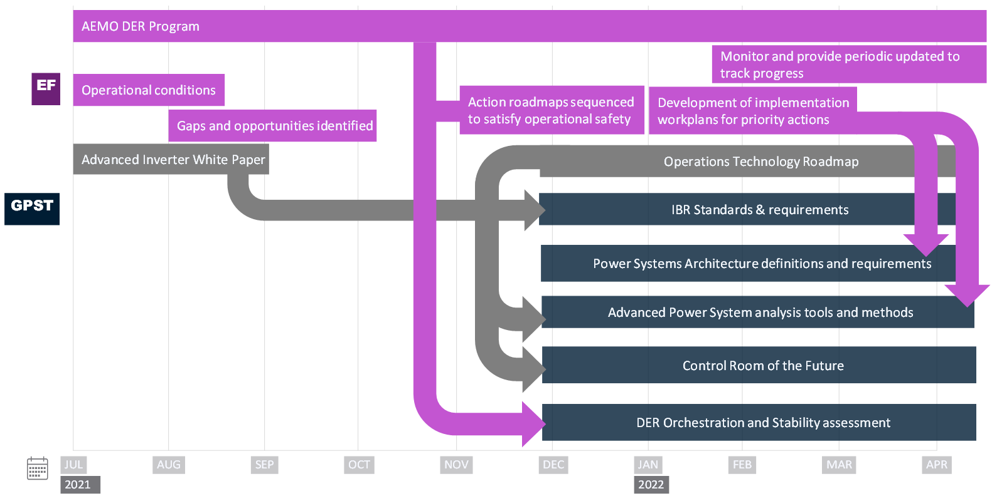
Figure 11 Aligning the CSIRO Roadmap with AEMO’s programs of work
The ability to demonstrate tangible interim results will help maintain ongoing industry support for the research. However, while the initial work is foundational and addresses urgent matters, there are a number of strategic and very important long-term research items that will also have the be progressed. The nine research organisations have established ten-year research plans for each of the topics and these will need to be deployed to create a meaningful and holistic solution to the energy transition challenge that Australia is facing. There is therefore a need to review the implementation strategy of the CSIRO roadmap regularly, and consider breaking down the topic activities and objectives into manageable time frames such as shown in Figure 12. Hence, in addition to kicking off the high priority research, a regular two-year review of progress, future activities, resourcing needs, and funding requirements should also be conducted as part of the research program implementation.
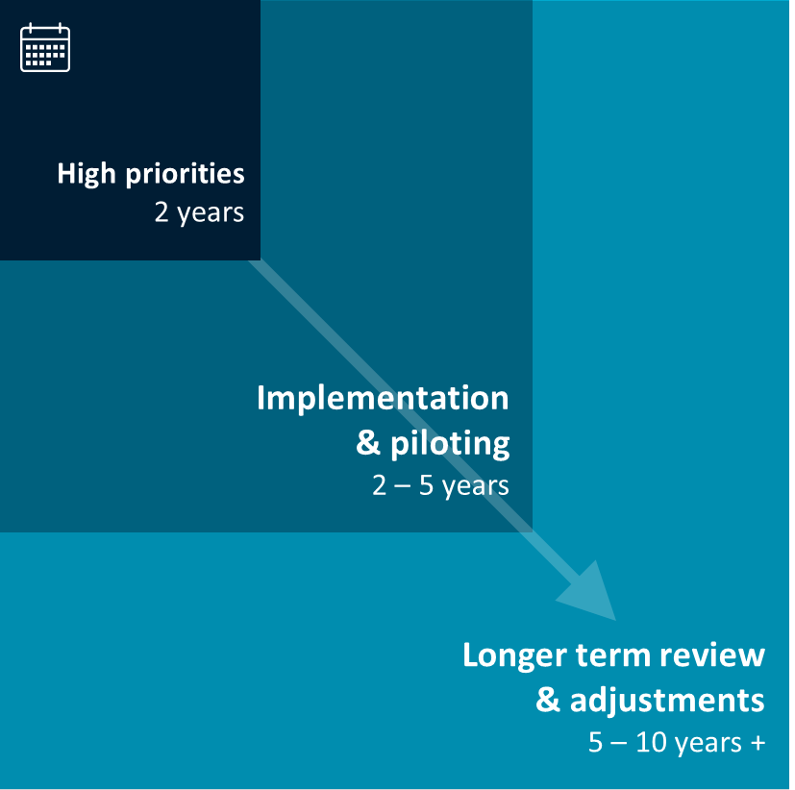
Figure 12 CSIRO G-PST research roadmap timeframes

References
The following documents, prepared by the researchers, outline in detail, tasks, timelines, resourcing, and risks. All are available from CSIRO’s website.
[1] Behrooz Bahrani, Mohammad Hasan Ravanji, Dayan Bandara Rathnayake and Tony Marxsen (2021) CSIRO Australian Research Plan for G-PST on Topic 1: Inverter Design (Development of Capabilities, Services, Design Methodologies and Standards for Inverter-Based Resources). Monash University, Australia.
[2] Deepak Ramasubramanian,Robert Arritt, Papiya Dattaray, Robert Entriken, Evangelos Farantatos, Xavier Francia, Anish Gaikwad, Hossein Hooshyar, Robin Hytowitz, Bruno Leonardi, Georgios Misyris, Parag Mitra, Matthew Pellow, Alberto Del Rosso, Vikas Singhvi, Eknath Vittal and Adam Wigington (2021) CSIRO Australian Research Plan for G-PST on Topic 2: Stability Tools and Methods. Electric Power Research Institute, US.
[3] Adrian Kelly, Sean McGuinness, Matt Pellow and Barry O’Connell (2021) CSIRO Australian Research Plan for G-PST on Topic 3: Control Room of the Future. Electric Power Research Institute (Europe), Ireland.
[4] Lingxi Zhang, Sebastian Püschel-Løvengreen, Guanchi Liu, Roderick Laird, and Pierluigi Mancarella (2021) CSIRO Australian Research Plan for G-PST on Topic 4: Planning (Power System Planning). The University of Melbourne, Australia.
[5] Babak Badrzadeh (2021) CSIRO Australian Research Plan for G-PST on Topic 5: Restoration and Black Start (G-PST Blackouts and System Restoration Research). Aurecon, Australia.
[6] Ali Moradi Amani, Xinghuo Yu, Lasantha Meegahapola, Mahdi Jalili, Brendan McGrath and Peter Sokolowski (2021) CSIRO Australian Research Plan for G-PST on Topic 6: Services (Quantifying the Technical Service Requirements of Future Power Systems to Maintain the Supply-demand Balance Reliably and at Least Cost). RMIT University, Australia.
[7] Mark Paterson, John Phillpotts, Matthew Brid and Peter Howe (2021) CSIRO Australian Research Plan for G-PST on Topic 7: Architecture (Power Systems Architecture). Strategen, Australia.
[8] Luis (Nando) Ochoa, Arthur Gonçalves Givisiez, Dillon Jaglal, Michael Z. Liu and William Nacmanson (2021) CSIRO Australian Research Plan for G-PST on Topic 8: Distributed Energy Resources. The University of Melbourne, Australia.
[9] John Fletcher, Naomi Stringer, Georgios Konstantinou and Iain MacGill (2021) CSIRO Australian Research Plan for G-PST on Topic 9: DERs and Stability (Ensuring System Security and Modelling Fast Load-DER Responses with High Penetration of IBR). The University of New South Wales, Australia.

As Australia’s national science agency and innovation catalyst, CSIRO is solving the greatest challenges through innovative science and technology.
CSIRO. Unlocking a better future for everyone.
Contact us
1300 363 400
+61 3 9545 2176
csiro.au/contact
csiro.au
For further information
CSIRO Energy
Dr John K Ward
Research Director | Energy Systems
+61 2 4960 6072
John.K.Ward@csiro.au
csiro.au/energy

https://globalpst.org/
https://www.carbonbrief.org/solar-is-now-cheapest-electricity-in-history-confirms-iea
http://www.cleanenergyregulator.gov.au/RET/Forms-and-resources/Postcode-data-for-small-scale-installations
AEMO: Media release: 2021 Electricity Statement of Opportunity: Reliability outlook positive as energy transition accelerates
http://www.cleanenergyregulator.gov.au/ERF/Pages/News%20and%20updates/News-item.aspx?ListId=19b4efbb-6f5d-4637-94c4-121c1f96fcfe&ItemId=1016
See The Global Power System Transformation Consortium (G-PST) website (globalpst.org)
https://aemo.com.au/en/initiatives/major-programs/engineering-framework
https://aemo.com.au/-/media/files/initiatives/engineering-framework/2021/application-of-advanced-grid-scale-inverters-in-the-nem.pdf
https://aemo.com.au/en/newsroom/news-updates/aemo-real-time-simulator-project-update
Detailed description of projects, resources, and timelines within each major task of Topic 1 is found in [1] pg. 18-32.
https://globalpst.org/inaugural-research-agenda-released/
https://reneweconomy.com.au/victoria-solar-farms-face-tighter-constraints-new-projects-may-be-blocked-from-grid-82973/
https://reneweconomy.com.au/aemo-to-allow-more-wind-and-solar-in-south-australia-grid-needs-less-gas/
https://aemo.com.au/en/initiatives/trials-and-initiatives/real-time-simulator
https://aemo.com.au/initiatives/trials-and-initiatives/connections-simulation-tool-project
https://www.greentechmedia.com/articles/read/reactive-technologies-pinpointing-the-inertia-of-renewable-powered-grids
Detailed description of specific projects, resources, and timelines within each major high priority task of Topic 2 is found in [2] pg. 26-75.
Detailed description of specific projects, resources, and timelines within each major high priority task of Topic 3 is found in [3] pg.51-70.
https://www.esig.energy/wp-content/uploads/2021/08/ESIG-Redefining-Resource-Adequacy-2021.pdf
Detailed description of specific projects, resources, and timelines within each major high priority task of Topic 4 is found in [4] pg.35-52
In Australia AEMO is responsible for procuring sufficient system restart ancillary services (SRAS) to restart the power system
https://www.aemo.com.au/-/media/Files/Electricity/NEM/Market_Notices_and_Events/Power_System_Incident_Reports/2017/Integrated-Final-Report-SA-Black-System-28-September-2016.pdf
Detailed description of specific projects, resources, and timelines within each major high priority task of Topic 5 is found in [5] pg.12-22.
Detailed description of specific projects, resources, and timelines within each major high priority task of Topic 6 is found in [6] pg. 4-23.
https://aemo.com.au/en/initiatives/major-programs/engineering-framework
Detailed description of specific projects, resources, and timelines within each major high priority task of Topic 7 is found in [7] pg.36-42.
Figure supplied by the University of Melbourne in Topic 8 DER report [8].
Detailed description of specific projects, resources, and timelines within each major high priority task of Topic 8 is found in [8] pg.45-62.
https://aemo.com.au/en/initiatives/major-programs/nem-distributed-energy-resources-der-program/operations/der-behaviour-during-disturbances
Detailed description of specific projects, resources, and timelines within each major high priority task of Topic 9 is found in [9] pg.27-40.
https://globalpst.org/wp-content/uploads/G-PST_Inaugural_Teaching_Agenda_updated.pdf

