
Australia’s National
Science Agency
Australian power systems renewables transition research Topic 1 – Inverter Design - Development of capabilities, services, design methodologies and standards for Inverter-Based Resources (IBRs)

  - AR-PST Topic 1a) Grid Forming Standard Development
Alex Baitch, Principal BES (Aust) Pty Ltd
BES 24917 /3
29 June 2025

Commonwealth Scientific and Industrial Research Organisation
Australian Energy Market Operator



Citation
A. Baitch (2025) AR-PST Topic 1 – Inverter Design – Development of capabilities, services, design methodologies and standards for Inverter-Based Resources (IBRs) Topic 1a Grid Forming Standard Development.
Copyright
© Commonwealth Scientific and Industrial Research Organisation 2025. To the extent permitted by law, all rights are reserved and no part of this publication covered by copyright may be reproduced or copied in any form or by any means except with the written permission of CSIRO.
Important disclaimer
CSIRO advises that the information contained in this publication comprises general statements based on scientific research. The reader is advised and needs to be aware that such information may be incomplete or unable to be used in any specific situation. No reliance or actions must therefore be made on that information without seeking prior expert professional, scientific and technical advice. To the extent permitted by law, CSIRO (including its employees and consultants) excludes all liability to any person for any consequences, including but not limited to all losses, damages, costs, expenses and any other compensation, arising directly or indirectly from using this publication (in part or in whole) and any information or material contained in it.
CSIRO is committed to providing web accessible content wherever possible. If you are having difficulties with accessing this document please contact csiro.au/contact.

Contents
TABLE OF CONTENTS
Acknowledgments iii
Executive summary iv
1 Introduction 1
1.1 Background 1
1.2 Need for a Common International Standard on GFM Converters 2
1.3 Relevance to Australia 3
2 Progress against the Roadmap 4
2.1 General 5
2.2 Dual logo IEC-IEEE Standard on Grid Forming Inverter Standard 5
2.3 Scoping of the Joint IEC /IEEE GFM Standard 5
2.4 Joint Project Structure IEC / IEEE 7
3 Background Documents to the Development of GFM Standards 9
3.1 CIGRE CSE Report 9
3.2 AEMO 10
3.3 UNIFI 11
3.4 ENTSO-E 13
3.5 National Energy System Operator 14
3.6 Summary 15
4 Initial Structure of Proposed IEC IEEE GFM Standard 16
4.1 Progress to date 16
4.2 Development of Working Draft on GFM Converter standards 17
5 Future Work 19
5.1 Short term 19
5.2 Medium term 19
5.3 Long term 19
6 Conclusion 20
References 21

Figures
Figure 1 Topics covered by the 2021 AR-PST Research Road Map 4
Figure 2 Illustration of possible scope covered by IEEE 2800. 6
Figure 3 Possible sequencing of the development of documents related to IEEE 2800 7
Figure 4 IEC IEEE Dual logo development - Joint Project approach 8
Figure 5 IEC / IEEE Joint project structure 8

Tables
Table 1 AR-PST Research Topics relevant to GFM Converter Standard 4
Table 2 Functional Specifications of GFL and GFM Battery Energy Systems 10

List of Acronyms
AEMO Australian Energy Market Commission
AR-PST Australian Research – Power Systems Transition
CIGRE global community committed to the collaborative development and sharing of end to end power system expertise
CSIRO Commonwealth Scientific and Industrial Research Organisation
EPRI Electric Power Research Institute (USA)
ENSTO-E European Network of Transmission System Operators for Electricity
ESIG Energy System Integration Group (USA)
ESO Electricity System Operator
GFM Grid Forming
IBR Inverter Based Resources
IEC International Electrotechnical Commission
IEC SC IEC Subcommittee
IEC TC IEC Technical Committee
IEC TS IEC Technical Specification
IEEE Institute of Electronic and Electrical Engineers
NERC North American Electric Reliability Corporation
NESO National Energy System Operator
OEM Other Equipment Manufacturers
OSD Online Standards Development (IEC)

Acknowledgments
The activities presented in this report have been supported by CSIRO as a part of CSIRO’s contribution to the initiatives of the Australian power systems renewables transition research and is carried out with the support of subject matter experts from both AEMO and CSIRO. This research supports Australia’s transition to a stable, secure and affordable power system. Together with the activities of Standards Australia, the objective is to use the output of the various research activities to accelerate the development of international standards by the IEC and IEEE.

Executive summary
This report provides a review of the progress of A-PSRT Stage 4 Topic 1a Grid Forming Standard Development project that was initiated in July 2024. The objective of this project is to complement the technical research that is being undertaken in this field by leading research groups and coordinating at an international level to assist in creating a path to the development of consistent international standards associated with Grid Forming Converters.
Estimated Timeline for the Standards Development (including progress 2024-25)
Activity | Year 1 2024-25 | Year 2 2025-26 | Year 3 2026-27 | Year 4 2027-28
Development of Strategy for Joint Project IEC IEEE | 100%
Conversion of Proposed Work Item to a New Work Item Proposal IEC | 10% | 90%
Define cooperation arrangement IEC IEEE | 30% | 70%
Development of Working Draft for IEC and IEEE | 20% | 50% | 30%
Process Committee Draft through approval stages within IEC |  | 10% | 60% | 30%
Review and process with IEC and IEEE through Committee draft stages |  | 10% | 60% | 30%

The intention is to provide leadership and coordination on the joint standards development effort with the major players in this space. This leadership and coordination is being provided by participation in the development and management of the joint process between the IEC and IEEE Typically, development of international standards in newly developing fields or with new technology can take many years to complete.
Both the IEC and IEEE were looking to develop a Grid Forming Converter standard. However while the IEEE had a document that was focussed on gird following IBR for grid connection, the IEC documents had a document that was more focused on microgrids and connections at the distribution level. These are described as follows:
In 2022, IEEE published its document “IEEE 28000:2022 IEEE Standard for Interconnection and Interoperability of Inverter-Based resources (IBRS) Interconnection with Associated Transmission Electric Power Systems”. This document deals with connection requirements of grid-following inverters connected to electricity transmission systems, which are characterised as being meshed networks.
Within the IEC, although there are a range of documents that deal with various aspects of IBR devices, the only standards that have been produced that relate to connection issues to the grid are in the IEC 62786 series of standards related to connections to the low and medium voltage systems which are characterised as being typically radial systems. IEC TS 62786-“Distributed energy resources connection with the grid - Part 1: General requirements”.
Rather than developing documents independently and without consistency between the two standards bodies, it was considered desirable to have a common standard. with the Australian representative acting as an accepted liaison person. It is also of benefit to the Australian industry.
In considering a pathway to the development of the Joint IEC/ IEEE GFM standard it is recognised that performance requirements. in terms of interface with the grid or electricity network, need to be defined at the plant level. This is the case for the development of the IEEE 2800-2022 standards. However, to achieve the overall plant performance, it is essential that the required performance is achieved for the various items within the plant at equipment level.
In the Joint Project approach, existing structures and systems of IEC and IEEE are utilised to formalise the adoptions of the various stages of development of a standards and can be implemented within existing Working Groups. Technical content would be developed in a cooperative way.
In the first year of this Research Project, an outline of a framework for the progression of the development of a dual logo iEC /IEEE standard on Grid Forming Converters has been established.

Introduction
This is the Final Report of the Stage 1a Project undertaken in 2024-25 related to Grid Forming Standard Development within the general topic Research Topic 1 – Inverter Design: Development of capabilities, services, design methodologies and standards for Inverter-Based Resources (IBRs). The CSIRO is working together with the Australian Energy Market Operator (AEMO) on a comprehensive “Research Roadmap” referred to as the Australian Power Systems Renewables Transition research that identifies and explores the research required to continue Australia’s transition to a more secure, affordable, and decarbonized electricity system. The Research Roadmap is a collaborative effort and based on input from leading Australian and international electricity utilities and researchers.
Section 1 provides an overview to the research effort being undertaken with respect to GFM Converter requirements. Section 2 deals with the work being undertaken in development of GFM Converters and the possible approach to the development of a joint IEC /IEEE standard. The work being undertaken by various standards bodies is described in Section 3. The approach being taken for the development of a joint IEC /IEEE standard is dealt with in Section 4 while future work is set out in Section 5. Conclusions are set out in Section 6.

Background
The AR-PST Stage 4 Topic 1a Grid Forming Standard Development is a project that was initiated in July 2024. The objective of this project is to complement the technical research that is being undertaken in this field by leading research groups and coordinating at an international level to assist in creating a path to the development of consistent international standards associated with Grid Forming Converters. The intention is to provide leadership and coordination on the joint standards development effort with the major players in this space.
As previously identified Australia is in a rapid transition towards an inverter-dominated structure as most synchronous generators are being displaced by inverter-based resources (IBRs) over the next two decades. Renewable energy plants, such as wind and solar farms, are typically located in regions where wind and solar resources are abundant, yet usually distant to synchronous generators (SGs) and loads. These resources, interfaced by power electronics inverters, may face stability challenges in weak areas of the grid. To address this, grid-forming inverters are deployed in these regions to enhance the stability of the local network. Consequently, the transmission of generated power from these remote energy plants to centralised urban areas necessitates the use of various network topologies, including radial and meshed configurations in transmission networks.
Currently a great deal of research and development is being undertaken in multiple areas internationally to both properly understand the technical issues that are being faced to ensure stable and proper operation of such systems, and with a view to development of a consistent international standard that can be developed to define the requirements of such Grid Forming Inverters.
AEMO, ENTSOE (European Network of Transmission System Operators); UNIFI Consortium (a consortium co-let by the National Renewable Energy Laboratory, the University of Texas- Austin and EPRI); NERC (North American Electric Reliability Council), for instance are all undertaking research activity to try to facilitate the development of specifications addressing grid forming functionality.
Within the IEC a number of committees are actively involved including IEC TC8 “System aspects of electrical energy supply” and its subcommittees, in particular IEC SC8A “Grid Integration of Renewable Energy Generation”, IEC TC 82 “Solar photovoltaic energy systems”, IEC TC88 “Wind energy generation systems” and IEC TC 120 “Electrical Energy Storage (EES) systems”. A range of documents have been produced dealing with aspects of operation of inverter based resources.
Within the IEEE, IEEE 2800-2022 IEEE Standard for Interconnection and Interoperability of Inverter-Based Resources (IBRs) Interconnecting with Associated Transmission Electric Power Systems has been published.

Existing Work and Gaps on Standards for GFM technology.
This part of the project is to drive the coordination and development of a dual logo IEC/IEEE standard (or series of standards) over a period defining the requirements of a Grid Forming Converter. The term Converter is used rather than Inverter as Converter is the general IEC covering all power electronic equipment covering inverters, battery chargers and other conversion modes. The intention is to draw on the resources of the various organisations referred to above to develop a road map to progress to an international standard. This will provide a solid foundation for the adoption of an appropriate Australian Standard which is consistent with international practice.
The project is structured to provide leadership and coordination in the development of Dual Logo Standards with the IEC and IEEE defining the requirements and capabilities of GFM Technology.
Very high shares of Cnverter Based Resources without grid-forming technology pose critical threats to power system reliability. This is evident in the form of grid and equipment instabilities, unwanted grid oscillations, poor power quality and even local and region-wide blackouts. A deliberate framework of demonstrations, requirements and incentives to be deployed quickly is required so the energy transition can continue to accelerate and power system operators can manage the increasingly aggressive global commitments required to address climate change
There is a critical gap in grid forming standards, codes and requirements that address the complex grid and equipment stability problems. Only one or two advanced system operators (one of which is AEMO with the AEMO Voluntary Specification for Grid-forming Inverters May 2023 [1] and the AEMO Voluntary Specification for Grid-forming Inverters: Core Requirements Test Framework Jan 2024 [6] have taken measures to define grid forming requirements today with a couple more in the process of developing them. These early efforts of development and replication from one country to another have been supported by the learnings shared between researchers and grid operators globally. There is an urgent need to more universally define a baseline of grid forming requirements that may be used in all systems around the world when they are needed.
Institutional standards drafted by industry through IEEE and IEC are trusted sources of equipment and system design and industry practice. IEEE generally covers 60Hz systems (mostly North American focus) and IEC covers 50Hz systems (rest of the world).
The AR-PST research for Pillar 4, covering standardization and technology adoption and effort, is being undertaken to develop a joint standard across IEEE and IEC, based on a recently developed IBR standard specifying minimum capabilities in IEEE.

Relevance to Australia
As set out in AEMO’s “Voluntary Specification for Grid-forming Inverters” May 2023 [1], with increasing penetration of inverter-based resources (IBR) and retirement of synchronous generators (SG) in power grids worldwide, new operational challenges with respect to system strength, voltage and frequency control, synchronous inertia, power system protection, and other phenomena will need to be considered by power system operators. Grid-forming (GFM) inverters have the potential capability to address some of the operational challenges associated with high levels of IBR penetration.
Within Australia, Standards Australia is liaising closely with AEMO with a view to develop relevant Australian Standards through its Australian mirror committee to the IEC in this field, being Standards Australia committee EL-064. It is participating at the IEC level to support the activities of the relevant committees in this field in the IEC. Preference is given to the adoption of IEC International Standards such that the requirements can be broad based and common to multiple vendors.
As set out in Section 1, very high shares of Inverter Based Resources (IBRs) without grid-forming technology pose critical threats to power system reliability. This is evident in the form of grid and IBR equipment instabilities, unwanted grid oscillations, poor power quality and even local and region-wide blackouts. A deliberate framework of demonstrations, requirements and incentives to be deployed quickly is required so the energy transition can continue to accelerate and power system operators can manage the increasingly aggressive global commitments required to address climate change.
Given the high percentage of renewable energy growth at the distribution level, it is projected that GFM converters will form an important function in the future grid. As set out in AEMO ‘s Public Consultation Report on “Technical Requirements for 200 kW to 5 MW connections”, Sep 2024 [2], it states in the section on System Strength, that in future, a portion of DER connections are likely to include GFM capabilities. In the short term, this is most likely to be BESS in larger size projects. Some developers have expressed interest in GFM inverters in the sub-5 MW range of equipment. Some DNSPs are also exploring the possibilities for GFM technologies to support the local grid in abnormal power system conditions, including islanding of part of a distribution system.”
Accordingly, the development of a Dual Logo IEC /IEEE GFM Converter standard will be invaluable for Australia and assist in ensuring international alignment of various OEM products and facilitate interoperability of multiple converters supplied by various OEMs.

Progress against the Roadmap
The development of standards related to GFM converters is a practical outcome that can evolve from all of the research effort that is being undertaken
Topic 1a is a new addition to the Roadmap for AR-PST Stage 4 and is thus at the start of the anticipated development, optimistically over the next 3 years but perhaps some time longer.
The development of a Grid Forming Standard will rely on the input from a number of Topics of the Roadmap activity as illustrated in Figure 1.
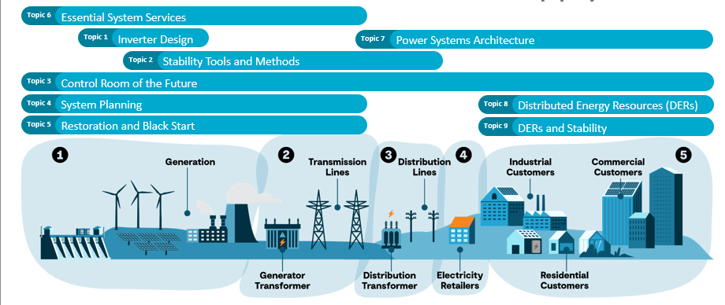

Figure 1 Topics covered by the 2021 AR-PST Research Road Map
In particular, the outputs of the following topics are likely to influence the development of the GFM Converter Standard: are shown in Table 1.
Table 1 AR-PST Research Topics relevant to GFM Converter Standard
Topic Number | Topic Title | Relevant to GFM
Topic 1 | Inverter Design | X
Topic 2 | Stability Tools and Methods | X
Topic 3 | Control Room of the Future
Topic 4 | System Planning | X
Topic 5 | Restoration and Black Start | X
Topic 6 | Services
Topic 7 | Power System Architecture | X
Topic 8 | Distributed Energy Resources
Topic 9 | DERs and Stability Methodology | X

General
This section is a description of the methodology adopted associated with the organisational structures examined and being pursued in the development of a dual logo standard between the IEC and IEEE.

Dual logo IEC-IEEE Standard on Grid Forming Inverter Standard
During the course of meetings of IEC SC8A JWG5 “System issues regarding integration of wind and PV generation into bulk electrical grid”, it was recognised that there would be mutual advantage to the IEC and IEEE for a dual logo standard to be developed to cover the newly developing area of Grid Forming (GFM) inverters. Standards Australia representatives have been participating in the activities of IEC SC8A JWG5 since the formation of the committee.
In 2022, IEEE published its document “IEEE Standard for Interconnection and Interoperability of Inverter-Based resources (IBRS) Interconnection with Associated Transmission Electric Power Systems”. This document deals with connection requirements of grid-following inverters connected to electricity transmission systems, which are characterised as being meshed networks.
Within the IEC, although there are a range of documents that deal with various aspects of IBR devices, the only standards that have been produced that relates to connection issues to the grid are in the IEC 62786 series of standards. These standards relate to connections to the low and medium voltage systems which are characterised as being typically radial systems. The IEC TS 62786 series is titled “Distributed energy resources connection with the grid - Part 1: General requirements”.
Accordingly, it was considered that IEEE 2800 provides a valuable basis for the development of a dual logo IEC / IEEE GFM Inverter Standard.
In July 2024, to progress the matter of a joint IEC IEEE dual logo development, it was proposed that the project progress as a Joint Project utilizing the existing structures and Working Group of IEC and IEEE respectively. This was supported by the SC 8A members and accepted in principle by the IEC TC8 Plenary held in September 2024. At this meeting the following decisions were made;
  - It was agreed in principle to continue to cooperate with a proposal to establish a series of grid connection standards also considering the grid forming converter functions. It agreed in principle to receive a proposal from IEEE for Category C liaison if such an application is received from IEEE.
  - Agreed to seek agreement from IEC National Committees to establish appropriate liaison members from IEC and IEEE to promote the joint development of IEC and IEEE dual logo standard within IEC SC8A JWG5.

Scoping of the Joint IEC /IEEE GFM Standard
In reviewing IEEE 2800 it was noted that the standard deals with legacy IBRs that inject active power at unity power factor and do not provide grid support services. As well, IEEE 2800 deals with conventional IBRs that have capability to provide both frequency and voltage response as well as typically full delivery response over multiple seconds.
However, it does not provide what are referred to as enhanced IBR by delivering full frequency and voltage response within 1 second of an event, nor could it survive the loss of the last synchronous machine. Such IBRs would not be capable of providing blackstart facility and could not sustain a single IBR ride through extreme load-generation mismatch.
The joint IEC /IEEE project is seen as fulfilling the gap of providing the grid services provided by enhanced IBR or future IBR.
This is illustrated in Figure 2.
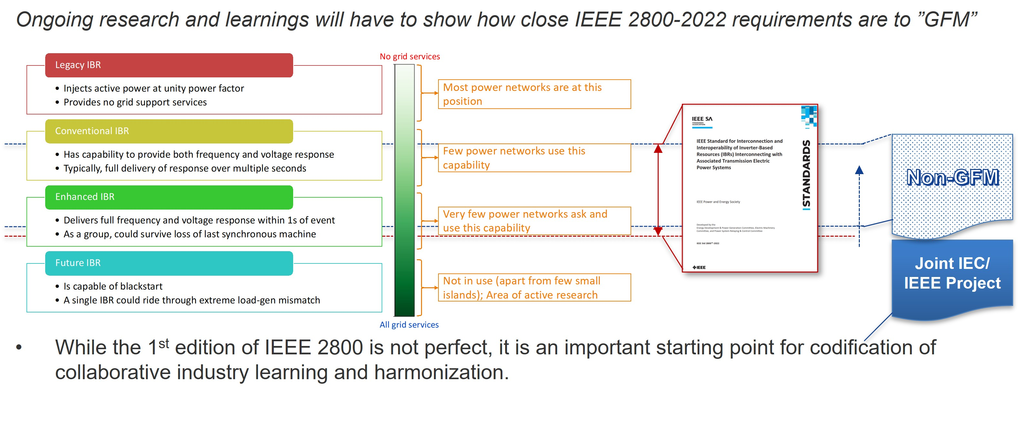

Figure 2 Illustration of possible scope covered by IEEE 2800.
In considering a pathway to the development of the Joint IEC/ IEEE GFM standard, it is recognised that performance requirements in terms of interface with the grid or electricity network needs to be defined at the plant level. This is the case for the development of the IEEE 2800-2022 standards. However, to achieve the overall plant performance, it is essential that the required performance is achieved for the various items within the plant at equipment level.
At the equipment level, it then is dependent on the type of plant as to the particular characteristics of the equipment as to how performance needs to be defined to achieve the plant level performance.
Accordingly, consideration is presently being given to the development of an overall framework document at the plant level to define the performance at the interface between plant and grid or electricity network.
The possible sequencing of the development with respect to IEC and IEEE documents is illustrated in Figure 3.
This illustrates the development of what is referenced in the diagram as a “framework for equipment level”. Working through IEC TC8/SC8A “Grid Integration of Renewable Energy Generation” it would be an overarching document defining equipment level performance for the various types of equipment as defined by the various Technical Committees of the IEC such as:
  - IEC TC82 Solar photovoltaic energy systems
  - IEC TC88 Wind energy generation systems
  - IEC TC114 Marine energy - Wave, tidal and other water current converters
  - IEC TC115 High Voltage Direct Current (HVDC) transmission for DC voltages above 100 kV
  - IEC TC120 Electrical Energy Storage (EES) systems
  - IEC TC22/SC22F Power electronics for electrical transmission and distribution systems

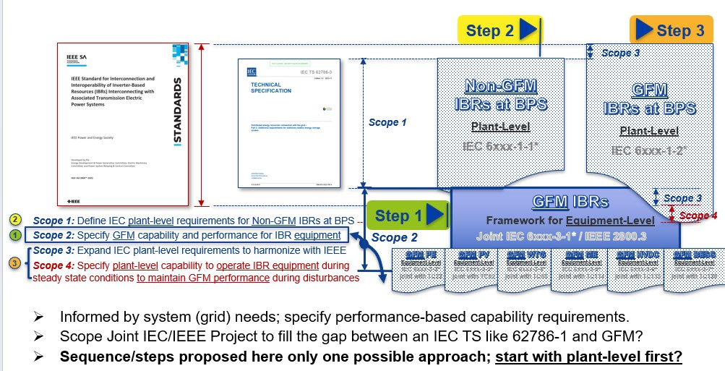

Figure 3 Possible sequencing of the development of documents related to IEEE 2800

Joint Project Structure IEC / IEEE
The formally adopted structure for working by the IEC and IEEE in the development of Dual Logo standards, is to use what is referred to as a Joint Working Group structure. However, based on expert advice provided by a Convenor of another Technical Committee convenor (Ludwig Winkel of IEC TC65), the preferred structure it to utilise what is referred to as a Joint Project structure.
In the Joint Project approach, existing structures and systems of IEC and IEEE are utilised to formalise the adoptions of the various stages of development of standards and can be implemented within existing Working Groups. Technical content would be developed in a cooperative way.
The overall structure in principle is illustrated in Figure 4.
To facilitate the level of close cooperation between the IEC and IEEE, at the 2024 Plenary meeting of IEC TC8 held in September 2024 in Paris-Saclay, based on the recommendation of IEC SC8A, it was agreed that IEC would await the formal request from the IEEE to firstly establish what is referred to as Category C liaison between IEC SC8A and the IEEE to develop a dual logo standard on GFM inverters

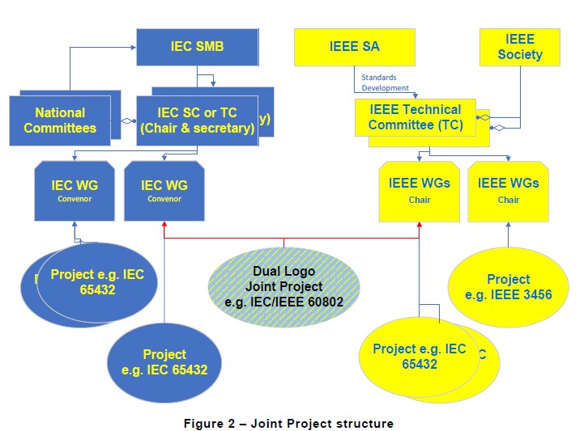

Figure 4 IEC IEEE Dual logo development - Joint Project approach
When specifically related to the IEC / IEEE Joint Project structure and Working Groups the structure will be as illustrated in Figure 5.
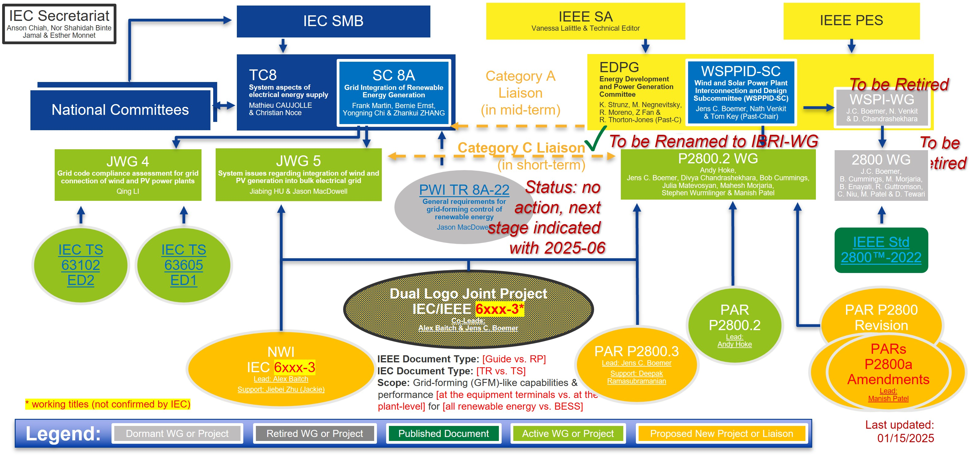

Figure 5 IEC / IEEE Joint project structure

Background Documents to the Development of GFM Standards
In recent years a number of relevant documents have been produced that are helpful in establishing a basis for the development of an international standard in this area. As would be expected in a developing area, each entity that develops a proposal, has its own perspective of the requirements based on its experience and understanding of the issues. Additionally, the complexity of use of differing terminology on a regional / continental basis needs to be addressed.
Ultimately, the aim is to create a uniform framework, that specifies acceptable performance with sufficient technical minimum criteria, that can be used to confirm GFM capabilities and evaluate the design of GFM inverters and plants to show conformance with specified performance criteria.
The aim is to support both grid reliability and the comparison of performance data from GFM systems deployed in diverse environments, thus enabling better understanding of GFM behaviour across different grid conditions and specifying a uniform technical floor for GFM performance.
In the absence of a common international document, there are a range of perspectives and views of what should be covered and what issues needs to be covered in the development of GFM requirements.
Accordingly, the various publications as listed here are part of the overall process of gaining a common understanding and perhaps vocabulary with respect to GFM performance and requirements.

CIGRE CSE Report
Amongst various other CIGRE Publications published, a recent paper titled “Grid forming functional specifications and verification tests for North American bulk power system connected battery energy storage systems” by Thant, Isaacs, Unruh, Quint, Ramasubramanian, Matevosyan and Hoke, CIGRE Science and Engineering publication CSE No 34 October 2024 [5] was presented at the CIGRE 2024 Session in Paris and subsequently published as a CIGRE CSE report.
The authors of this report are from NERC, USA, Electranix, Canada Elevate Energy Consulting, USA, EPRI, USA; ESIG, USA and NREL USA and some, if not all have been involved in the development of IEEE 2800 – 2022.
The paper summary notes that grids dominated by IBRs in the absence of synchronous resources need a portion of the IBR resource mix to be grid forming to maintain stable operation.
A major obstacle of deploying GFM on the bulk power system is establishing clear specifications and interconnection requirements regarding the performance, test procedures and validation of GFM technology. The paper aims to provide contributions to this area.
The report includes a useful summary table of functionality required of a GFM Battery Energy System compared to Grid Following Inverter as shown in Table 1.

Table 2 Functional Specifications of GFL and GFM Battery Energy Systems

AEMO

AEMO Voluntary Specification for Grid-Forming Inverters May 2023
The “voluntary specification” is a preliminary document to provide guidance to stakeholders while the regulatory environment around grid-forming technology develops.

Core requirements are defined as being:
  - Voltage source behaviour – response to voltage magnitude and phase changes
  - Frequency domain response
  - Inertial response
  - Survive the last synchronous connection
  - Weak grid operation and system strength support
  - Oscillation damping

Additional Capabilities
  - Head room and energy buffer
  - Current capacity above continuous rating
  - Black start capability
  - Power Quality Improvement

AEMO Voluntary Specification for GFM Inverters: Core requirements test framework Jan 2024
AEMO has published a set of simulation test methods to guide the assessment of grid-forming inverter’s compliance to the core capabilities in AEMO’s May 2023 ‘Voluntary Specification for Grid-Forming Inverters.
The test framework outlined in this document provides a minimal set of simulation tests which may be used to determine whether a GFMI resource meets the criteria set out as core capabilities in the Voluntary Specification. Each test is presented with a reference to:
  - The Voluntary Specification
  - A described simulation testbench
  - Testbench configuration
  - Criteria for assessment.
The AEMO document notes that the intended audience for the document is original equipment manufacturers (OEMs) and project developers of GFM plant, and any other stakeholders involved with planning, running, or reporting on GFM Inverter performance in the project planning phase. It notes that although voluntary in nature, this document may also be of relevance to parties seeking to procure services from GFM Inverter supplies, who may wish to incorporate elements of this framework into agreements with GFM plant developers and operators.

UNIFI

UNIFI Consortium
As set out in the UNIFI website , the Universal Interoperability for Grid-Forming Inverters (UNIFI) Consortium brings together leading researchers, industry stakeholders, utilities, and system operators to advance grid-forming inverter technologies. Led by the National Renewable Energy Laboratory, the University of Texas at Austin, and the Electric Power Research Institute, the UNIFI Consortium focuses on integrating these uniform and standardized grid-forming technologies into electric grids at any scale to accelerate solar and wind deployment. The consortium, with its industry partners, will ultimately develop a universal set of guidelines that enable seamless integration of inverter-based resources.
The goal of the UNIFI Consortium is to lead the industry to achieve the full potential of grid-forming technologies and to build a self-sustained collaborative community for long-term engagement and innovation. UNIFI will advance the maturity of grid-forming technologies and promote their uniform adoption by identifying and addressing the issues in inverter devices, system considerations, commercialization, standards, guidelines, education, and training. As inverter-based resources like solar, wind, and battery energy storage become the dominant generators in the energy mix, grid-forming inverter technologies are essential to ensure the grid can function with predictable reliability, security, resilience, and stability.
It is understood that funding for this activity has now been finalised, following the publication of the UNIFI Specification as referred to in Section 3.3.2.

UNIFI Specification for Grid-Forming Inverter Based Resources V2 Mar 2024
The UNIFI Specification [7] defines a set of specifications for GFM IBRs that provides requirements at the inverter level that are intended to provide means for vendor-agnostic operation of IBRs at any scale in electric power systems.
The document notes that IBRs can potentially have a large spectrum of control objectives and the terms GFL and GFM may be too general. The GFL/GFM distinction may fail to reflect the relevant variation in spectrum in IBRs’ capabilities and cause the importance of existing IBRs’ capabilities to be underestimated.
This document classifies IBRs in four categories:
  - Category 1 - IBRs that inject active power at unity power factor and provide no grid services.
  - Category 2 - IBRs that provide frequency and voltage response over multiple seconds.
  - Category 3 - IBRs that provide fast voltage/frequency response within 1s of an event in addition to providing a slower response similar to that of conventional IBRs. As a group, these IBRs can help a network with high IBR percentage ride through grid disturbances.
  - Category 4 – IBRs that provide the above services and individually are capable of surviving/riding through grid disturbances. This category is also able to provide blackstart services.
Three categories of operation are defined, as well as performance requirements, within each category:
  - Normal grid operating conditions
  - Operation outside normal grid operation conditions.
  - Additional consideration that may be implemented in coordination with the system operator

Normal grid operation conditions
  - Autonomously support the grid
  - Dispatchability of power output
  - Provide positive damping of voltage and frequency oscillations
  - Active and reactive power sharing across generation sources
  - Operation in grids with low strength
  - Operation under system unbalance.

Operation outside normal grid operation conditions.
  - Ride-through behaviour
  - Response to symmetrical faults
  - Response to asymmetrical faults
  - Response to abnormal frequency
  - Response to phase jumps and voltage steps

Additional considerations
  - Intentional islanding
  - Black start and system restoration
  - Regulating voltage harmonics
  - Communications between System Operator and IBR plant.

ENTSO-E

ENTSO-E Mission
ENTSO-E, the European Network of Transmission System Operators for Electricity, is the association for the cooperation of the European transmission system operators (TSOs). The 40 member TSOs representing 36 countries are responsible for the secure and coordinated operation of Europe’s electricity system, the largest interconnected electrical grid in the world. In addition to its core historical role in technical cooperation, ENTSO-E is also the common voice of TSOs of Europe.
ENTSO-E brings together the unique expertise of TSOs for the benefit of European citizens by keeping the lights on, enabling the energy transition, and promoting the completion and optimal functioning of the internal electricity market, including via the fulfilment of the mandates given to ENTSO-E based on EU legislation.
ENTSO-E’s website defines its mission as being to ensure the security of the interconnected power system in all time frames at pan-European level and the optimal functioning and development of the European interconnected electricity markets, while enabling the integration of electricity generated from renewable energy sources and of emerging technologies.

ENTSOE Grid Forming Capability of Power Park Modules, First Interim Report on Technical Requirements, Final version | 3 May 2024
In the context of grid forming capability for power park modules, this report proposes a first interim non-binding approach of detailing grid forming technical requirements for power park modules.
The ENSTO-E document [8] states that to facilitate its application and address stakeholder concerns about harmonisation, an Implementation Guidance Document is planned to be issued proposing exhaustive GFM requirements after publication of updated regulation, expected in 2025.
Although unclear, presumably the harmonisation relates to the European Grid Operators and not internationally.
The ENSTO-E document states that a “Power park module shall be capable of providing grid forming capability at the connection points, considering the sub-cycle character of the physical quantities where appropriate.” It further states that technical requirements for the voltage source behaviour shall be defined at the terminal of the individual unit(s), while the compliance shall be proven at the connection point.
In terms of describing the compliance tests that a GFM power park must satisfy the capability required of connections to the grid at the connection point includes the functions as summarised in Section 4 below.

4 Verifying compliance with the proposed exhaustive requirements
  - 4.1 Voltage phase angle step test
  - 4.2 Small symmetrical voltage magnitude step
  - 4.3 Short circuit ratio step
  - 4.4 Loss of last synchronous generator
  - 4.5 RoCoF with increasing frequency (typically due to due to loss of load)
  - 4.6 Large symmetrical voltage amplitude step test
  - 4.7 Large asymmetrical (unbalanced) voltage amplitude step test
  - 4.8 RoCof including voltage angle step changes

National Energy System Operator

NESO
As set out in the web site, the National Energy System Operator (NESO) is the system operator for Great Britain. Its role is to make sure that Great Britain has the essential energy it needs by ensuring supply meets demand at all times.
The UK’s 2023 Energy Act established an independent system planner and operator to help accelerate Great Britain’s energy transition, creating the National Energy System Operator (NESO).
NESO is built on the previous experience as the Electricity System Operator (ESO), where ESO had extensive expertise in balancing electricity supply and demand 24/7, whilst making sure the networks were operated and the markets were prepared for the future.
NESO has taken over the electricity system operation from National Grid Electricity System Operator Limited (NGESO) and responsibility for gas system planning from National Gas Transmission plc (NGT).

Grid Code (GC) GC0137 Minimum specification required for provision of GB Grid Forming Capability
In January 2022 Ofgem (as it was known then) directed that a proposed modification to the Grid Code be made in accordance with GC0137.
As set out in the National Grid ESO Final Modification Report, the modification adds a non-mandatory technical specification to the Grid Code, relating to GB Grid Forming Capability (which was formerly referred to as a Virtual Synchronous Machine (“VSM”) capability.
This Report asserts that the modification is fundamental to ensuring future Grid Stability, facilitating the target of zero carbon System operation by 2025 and providing the opportunity to take part in a commercial market or become part of other market arrangements such as the stability pathfinder work and/or dynamic containment.
The Report specification itself comprises three main sections: -
  - The technical performance requirements which define the plant capability.
  - The plant data and modelling information. This is necessary to assess the capability of the plant and enable the model to be integrated into the ESO’s software suite so its impact on the System can be established. It also includes the necessary data to ensure the plant does not cause any undue interactions on other User’s plant or the wider Transmission System.
  - Compliance which is to demonstrate that the plant, as built, is fully capable of meeting the requirements of the Grid Code specification.
The Technical Performance requirements identified include the following requirements.
  - Active Control Based Power
  - Active Phase Jump Power
  - Active Damping Power
  - Active Inertia Power
  - Active ROCOF Response Power
  - Control Based Reactive Power
  - GBGF Fast Fault Current Injection
  - Grid Forming Active Power
  - Grid Forming Capability
  - Voltage Jump Reactive Power

Summary
As evident from the above review, the matter of GFM Inverters is in an active stage of development with many entities defining requirement, largely with similar objectives.

Initial Structure of Proposed IEC IEEE GFM Standard

Progress to date

IEC Technical Reports
In addressing the issues that need to be addressed in connection of grid integration of renewable energy generation, the following documents have been produced by SC8A’s Working Groups: .
  - IEC TR 63043:2020 Renewable energy power forecasting technology
  - EC TS 63102:2021 Grid code compliance assessment methods for grid connection of wind and PV power plants
  - IEC TR 63401-1:2022 Dynamic characteristics of inverter-based resources in bulk power systems - Part 1: Interconnecting inverter-based resources to low short circuit ratio AC networks
  - IEC TR 63401-2:2022 Dynamic characteristics of inverter-based resources in bulk power systems - Part 2: Sub- and Super-synchronous control Interactions
  - IEC TR 63401-3:2023 Dynamic characteristics of inverter-based resources in bulk power systems - Part 3: Fast frequency response and frequency ride-through from inverter-based resources during severe frequency disturbances
  - IEC TR 63401-4:2022 Dynamic characteristics of inverter-based resources in bulk power systems - Part 4: Behaviour of inverter-based resources in response to bulk grid faults
  - IEC TR 63411:2025 Grid connection of offshore wind via VSC-HVDC systems
Within the IEC the matter of development of documents related to general requirements for grid-forming control of renewable energy was registered as Proposed Work Item PWI TR 8A-22 within SC8A JWG5. The work will include input from solar and wind as well as any associated areas such as energy storage system etc. Work will also involve discussions with associated committees including SC 8A, SC 8B, SC 8C, TC 8, TC82, TC 88, TC 115, TC 120.
During consideration of the PWI, SC8A agreed to launch a questionnaire for collection of information and call for participation. As well, a PWI was registered described as “General requirements for grid-forming control of renewable energy”. It was also agreed to closely align with global GFM activities and reports with inputs from all National Committees.
It was recognised that there would be mutual advantage to IEC and IEEE to work closely together with a view to develop a dual logo IEC IEEE standard.
Accordingly the process as described in Section 1.1 was initiated in order to define the working arrangements.
The initial activities associated with this development have been focused on establishing and developing the appropriate structure between the IEC and IEEE to progress the project at an organisational level in the first instance.
While the project has not at this stage been formally initiated as a Joint IEC / IEEE project, initial background work has been undertaken to develop an outline of the technical content of the proposed standard at a Working Draft level.

IEEE Standard
IEEE has the following standards related to grid following inverters at the distribution level and at the transmission voltage level.
  - IEEE Std 1547-2018 IEEE Standard for Interconnection and Interoperability of Distributed Energy Resources with Associated Electric Power Systems Interfaces
  - IEEE 2800-2022 IEEE Standard for Interconnection and Interoperability of Inverter-Based Resources (IBRs) Interconnecting with Associated Transmission Electric Power Systems
IEEE anticipated development of IEEE 2800.2 Recommended Practice for Test and Verification Procedures for Inverter-based Resources (IBRs) Interconnecting with Bulk Power Systems
Nominally, IEEE is looking forward to development of IEEE 2800.3 as the dual logo IEC/IEEE standards for grid forming inverters, although the development would be under an IEC number.

Development of Working Draft on GFM Converter standards
The process of considering the technical content of the GFM converter standards was considered at a SC8A JWG5 meeting held in Kassel, Germany 4-6 March 2025. The basic structure was proposed by Alex Baitch as coordinator between IEC and IEEE. To define the proposed structure and content of the draft consideration has been given to the various documents referred to in Section 3.
The UNIFI Specification for Grid-Forming Inverter Based Resources V2 Mar 2024 and the AEMO Voluntary Specification for Grid-Forming Inverters May 2023 provide valuable input for the development.

Proposed outline of IEC / IEEE Dual Logo GFM standard
The starting point for the development of the IEC IEEE GFM standard is as follows:
  - FOREWORD
  - INTRODUCTION
  - 1 Scope
  - 2 Normative references
  - 3 Terms and definitions
  - 3.1 General definitions
  - 4 Background to requirements re IBRs
  - 4.1 Overview
  - 4.2 Grid Forming (GFM) Controls
  - 4.3 Classification of IBRs
  - 5 Universal requirements of Grid Forming Converters
  - 5.1 General
  - 5.2. Operation at limits
  - 5.3 Sub-cycle voltage and frequency support
  - 5.4 Response to phase angle step
  - 5.5 Response to frequency variations
  - 5.6 Phase-jump resistance
  - 5.7 System strength support
  - 5.8 Stable operation with loss of synchronous machines
  - 6 Additional GFM capabilities and considerations
  - 6.1 Intentional islanding
  - 6.2 Black start and system restoration
  - 6.3 Regulating voltage harmonics
  - 6.4 Communication between system operator and IBR plant
  - 6.5 Secondary voltage and frequency signal response
  - 7 Modelling and documentation
  - Annex A (informative/normative)
  - Bibliography

Detailed content of IEC IEEE GFM standard
The significant challenge that is faced by the Working Group is to examine in detail the technical content of each of the sections.
As referred to in Section 2.3, it is anticipated that an overarching document defining equipment level performance for the various types of equipment as defined by the various Technical Committees of the IEC will be developed at an initial stage.

Transfer to use IEC Online Standards Development (OSD)
The IEC is currently transitioning to the use of the IEC OSD tool for cooperative development. This tool facilitates improved efficiency and collaboration in the development of standards. However, it is, at this stage, unclear how this tool will be applied as a Joint Project with the IEEE.

Future Work

Short term
In the short term, the following issues need to be addressed:
- Complete development of arrangements between IEC and IEEE and confirm whether to proceed with Joint Projects
- Implement transition of the proposed development to the OSD development.
- Continue with development of a working draft of GFM standard
- Commence examination of required grid connection performance data across regions/ countries
- Get feedback from AR-PST of relevant streams of research and other interested parties re relevance / application of findings of research to the standard development

Medium term
In addition to completing the short term issues, in the medium term (1-2 years) , the following issues need to be addressed
- Define performance requirements for grid connection
- Develop anticipated framework document
- Initiate process with relevant Transmission Operators re grid connection

Long term
The long term objective (3-5 years) is to complete the production of a GFM standard.

Conclusion
The AR-PST Stage 4 Topic 1a Grid Forming Standard Development project that was initiated in July 2024, in the first year of its activities has established in principle the framework and proposed structure of the development of a dual logo IEC / IEEE standard.
It is recognised that the process of standards particularly when aiming to align activities of the two large organisations is challenging.
The introduction of new tools within the IEC referred to as Online Standards Development (OSD) is both a challenge and an opportunity to facilitate open processes for the development of standards.
Key development will take place during the year ahead in drafting an initial working document (referred to as pre-work) and being key to defining requirements.

References
[] AEMO Voluntary Specification for Grid-forming Inverters May 2023
[] AEMO Public Consultation Report on “Technical Requirements for 200 kW to 5 MW connections”, Sep 2024
[] IEEE 2800, IEEE Standard for Interconnection and Interoperability of Inverter-Based resources (IBRS) Interconnection with Associated Transmission Electric Power Systems (2022)
[] IEC TS 62786 series is titled “Distributed energy resources connection with the grid - Part 1: General requirements”
[] Thant, Isaacs, Unruh, Quint, Ramasubramanian, Matevosyan and Hoke (2024) “Grid forming functional specifications and verification tests for North American bulk power system connected battery energy storage systems” CIGRE Science and Engineering publication CSE No 34 October 2024
[] AEMO Voluntary Specification for GFM Inverters: Core requirements test framework Jan (2024)
[] UNIFI Consortium UNIFI Specifications for Grid-Forming Inverter-Based Resources Version 2 (2024) Technical Report NREL/TP-5D00-89269 March 21 2024 www.nrel.gov/publicaitons
[] ENTSOE Grid Forming Capability of Power Park Modules, First Interim Report on Technical Requirements, Final version 3 May 2024
[] Grid Code (GC) GC0137Minimum specification required for provision of GB Grid Forming Capability (2022)

BES Projects/24917/CSIRO AR-PST/20250629 ABaitch Final CSIRO report V3
.

As Australia’s national science agency and innovation catalyst, CSIRO is solving the greatest challenges through innovative science and technology.
CSIRO. Unlocking a better future for everyone.
Contact us
1300 363 400
+61 3 9545 2176
csiro.au/contact
csiro.au

https://www.energy.gov/eere/solar/unifi-consortium
https://www.entsoe.eu/about/inside-entsoe/objectives/
https://www.neso.energy/
nationalgirdESO Final Modification report GC0137 published 11 Nov 2021

