Australia’s National
Science Agency
Four-Wire-OPF-Based DOE Quantification Incorporating Volt-var/Watt Response
  - GPST Topic 8 Stage 4
Frederik Geth, Kurt Lucas, Jordan Clark, Nanduni Nimalsiri, Rahmat Heidari
June 30 2025

Citation
Frederik Geth, Kurt Lucas, Jordan Clark, Nanduni Nimalsiri, Rahmat Heidari (2025) Four-Wire-OPF-Based DOE Quantification Incorporating Volt-var/Watt Response. GridQube and CSIRO, Australia.
Copyright
© Commonwealth Scientific and Industrial Research Organisation 2025. To the extent permitted by law, all rights are reserved and no part of this publication covered by copyright may be reproduced or copied in any form or by any means except with the written permission of CSIRO.
Important disclaimer
CSIRO advises that the information contained in this publication comprises general statements based on scientific research. The reader is advised and needs to be aware that such information may be incomplete or unable to be used in any specific situation. No reliance or actions must therefore be made on that information without seeking prior expert professional, scientific and technical advice. To the extent permitted by law, CSIRO (including its employees and consultants) excludes all liability to any person for any consequences, including but not limited to all losses, damages, costs, expenses and any other compensation, arising directly or indirectly from using this publication (in part or in whole) and any information or material contained in it.
CSIRO is committed to providing web accessible content wherever possible. If you are having difficulties with accessing this document, please contact csiro.au/contact.

Contents

Acknowledgments v
Executive summary vi
1 Introduction 9
1.1 Australia and the need for active management of DER in LV networks 9
1.2 DOE goals and vision 10
1.3 DOE quantification in operational technology software stacks 10
2 Literature review and research goal 12
2.1 DOE literature review 12
2.2 Gaps and issues 15
2.3 Simulation and optimisation-based quantification methods 16
2.4 Background on smart inverter controls: Volt-var/Watt 19
2.5 Approximation and model complexity 21
2.6 Research goals 21
3 DOE quantification through four-wire OPF 22
3.1 Four-wire Optimal Power Flow as the foundation 22
3.2 Smooth approximation applied to Volt-var/Watt characteristics 24
3.3 Mathematical model for single-phase PV system with Volt-var/Watt control modes 27
3.4 Implementation and validation 28
3.5 Objectives for DOEs 29
4 Network modelling dataset and results 33
4.1 Network model building methodology 33
4.2 Realistic suburban distribution network model 35
4.3 Network operation at expected simultaneous peak demand 36
4.4 Network operation with varying levels of PV 39
4.5 DOE results without Volt-var/Watt consideration 44
4.6 DOE results with Volt-var/Watt consideration 48
4.7 Comparison with versus without Volt-var/Watt response 49
5 Insights 51
6 Future work 53
Appendix Comparison with work previous topic 8 stages 55
Glossary 57
References 59

List of Figures
Figure 1: Illustration representing optimisation models as the foundation for DOE quantification vi
Figure 2: The evolution of static limits (top, dotted line) to dynamic limits (bottom, dotted line) for customers 9
Figure 3: An example of DOE quantification in an operational technology software stack 11
Figure 4: Volt-var parameterisation. 20
Figure 5: Volt-Watt parameterisation. 20
Figure 6: Illustration of four-wire OPF scope 23
Figure 7 Depiction of ReLU (top) and shifted/scaled ReLU (bottom) functions. 25
Figure 8: Smooth approximation of Volt-Watt characteristics for different smoothness settings. 26
Figure 9: Smooth approximation of Volt-var characteristics for different smoothness settings 27
Figure 10: Illustration of trade-offs between competitive, equal, and variance-penalised solutions. 31
Figure 11: Scope of the developed "as operated" network model 34
Figure 12: The relative and absolute loading of the transformers at the simultaneous peak. 37
Figure 13: Phase-to-neutral voltage distribution per LV feeder at the maximum simultaneous demand peak. Note that most transformers have a no-load voltage of about 250 V. Slight voltage rise occurs due to unbalanced load and untransposed lines with unbalanced impedances. 38
Figure 14: Neutral-to-ground voltage magnitude across the different feeders operating at their maximum demand point. 39
Figure 15: Screenshot of the Pluto.jl notebook allowing for exploration of Volt-var/Watt controls 40
Figure 16: Interactive dials allowing for real-time experimentation with scenarios 41
Figure 17: Volt-Var outcomes for different customers throughout a day. In this illustration, all customers have active Volt-var control (i.e. none are in the dead band zone). 42
Figure 18: Volt-watt outcomes for different customers throughout a day. In this illustration, most of the time Volt-Watt is activated only for certain customers, and only at peak times. 42
Figure 19: Volt-var response of various PV systems throughout a day 43
Figure 20: Resulting curtailment of various PV systems fed with the same bell-curve irradiance 43
Figure 21: Schematic diagram of result visualisation approach. 45
Figure 22: Illustration of an extreme scenario, with a focus on the legend. Forward flows are indicated as P positive, reverse flows occur when P is negative. Note that individual customers are on different phases. 46
Figure 23: Comparison between 0.95 (left) and unity (right) power factor control. 47
Figure 24: Comparison of export limits depending on load levels. 47
Figure 25: Comparison of export limits across different reference voltages at the substation. 47
Figure 26: Comparison of export limits depending on the amount of PV penetration in this network. Note that the x axis scale changes between figures. 48
Figure 27: Comparison of export limits for different load levels. Lower load leads to reduced export limits in voltage-constrained networks. 48
Figure 28: Comparison of export limits for different voltage levels. Higher voltages lead to reduced exports across all cases 49
Figure 29: Comparison of export limits for different levels of PV penetration. 49
Figure 30: Extreme scenario with massively reduced export limits due to high voltage, low load and high PV penetration. Results with Volt-var/Watt on the left, without on the right. 50
Figure 31: More typical scenario comparing DOE limits with and without Volt-var/Watt response. 50
Figure 32: Summary of observations based on the modelling of Volt-var/Watt in the DOE quantification 51

List of Tables
Table 1: Comparison of recent literature on DOEs 12
Table 2: Focus areas of different articles on DOEs 14
Table 3: Simulation vs Optimisation Modelling 19
Table 4: Volt-var/Watt settings since 2021 as per AS/NZS 4777.2:2020, for Ausgrid, AusNet Services, Endeavour Energy, Essential Energy, Ergon Energy and Energex, EvoEnergy, Jemena, CitiPower, Powercor, United Energy and SA Power Networks (‘Australia A’). 21
Table 5: Key features of the 11kV MV feeder 35
Table 6: Key features of the LV networks 35

Acknowledgments
We thank the following people that enabled and/or contributed to the data release effort, the project planning and supervision, the code development, generation of novel insights, the publications and the final report:
CSIRO team
- Nanduni Nimalsiri
- Thomas Brinsmead
- Rahmat Heidari
- Biswajit Bala
Energy Queensland
- Peter Kilby [external advisor in the monthly progress meetings]
GHD
- Christian Schaefer
- Jessica Guth
The University of Melbourne, specifically on the topic of Volt-var modelling.
- Sleiman Mhanna
- Lucas Quiertant
- Pierluigi Mancarella
GridQube team
- Jordan Clark
- Frederik Geth
- Kurt Lucas
- Scarlett Tokunaga

Executive summary
The rapid growth of distributed energy resources (DERs) connected to distribution networks via power electronic converters demands detailed network modelling to address operational and planning challenges. Various inverter designs, e.g. single-phase and three-phase options, along with Volt-var/Watt and grid-forming/following modes, limit operational flexibility and introduce nonlinearities in response to voltage and current changes. This report examines how nonlinear network optimisation can improve upon existing quantification methods to support power quality in distribution networks, through the deployment of Dynamic Operating Envelopes (DOEs) as part of network congestion management.
The existing DOE quantification approaches for customers in low-voltage (LV) networks generally don’t consider inverter response, a.k.a. Volt-var/Watt control modes. The goal of this research was to develop a quantification approach that accurately models the physics of the network and its voltage/current/power limits, while considering customer energy resources and their expected response to changes in voltage levels. Therefore, we cast the DOE quantification approach on top of the foundations of Unbalanced Optimal Power Flow (illustrated in Figure 1), i.e. a generic framework for mathematical optimisation problems subject to the physics of circuits in the presence of envelopes for voltage, current and power.

Figure 1: Illustration representing optimisation models as the foundation for DOE quantification
A DOE case study employing a nonlinear, circuit-physics-based model demonstrates how network-constrained optimisation and advanced inverter modelling enhance DER integration while delivering significant benefits to network utilities and end-users. We observe that fairer outcomes can be achieved across the board, and more curtailment avoided, by considering the expected Volt-var/Watt response in the DOE quantification approach. We demonstrate that using the fairness inducing objective called alpha-fairness presents a great way to balance competitiveness and fairness.

As part of this work, a new dataset representing a real-world suburban distribution network was developed, and made publicly available with a Creative Commons Attribution Noncommercial-Share Alike 4.0 Licence, in the OpenDSS file format.
The report goes into depth on the following topics:
- It provides an overview of the state of the art in DOE research, and a gap analysis to serve as a justification for the proposed DOE quantification approach;
- It develops a mathematical specification of the quantification model, as an extension of (nonconvex) four-wire optimal power flow;
- It summarises the results of numerical studies based on an implementation of the proposed model using the newly-released Australian suburban distribution network dataset;
- It provides conclusions and recommendations for further research.

Introduction

Australia and the need for active management of DER in LV networks
To foster the uptake of distributed energy resources (DER) in the network, active management of the network and the connected DER is becoming a necessity. Historically, customers have been given access to the network with static limits for consumption, and since the roll-out of PV also for injection. As these static limits inherently must be determined conservatively, there is at times a lot of spare capacity in the network that customers cannot access. From this observation, the concept of dynamic operating envelopes (DOE) was developed, as illustrated in Figure 2.

Figure 2: The evolution of static limits (top, dotted line) to dynamic limits (bottom, dotted line) for customers
Today, distribution utilities use various simulation tools to better understand their networks dealing with DER. As active distribution networks evolve, automatic calibration and validation of network data remain key challenges in delivering explainable tools for network operations and planning. The success of orchestration technologies for PV, batteries, and Electric Vehicles (EVs) depends on accurately characterising feasible operating states, such as voltages, currents, and power flows that meet the network’s technical limits.
To deal with these challenges, researchers have studied the different methods to enable automation of network management in the presence of congestion. A key differentiator between possible approaches is whether they build on (existing) power network models or whether they identify model proxies in a data-driven fashion. In this context, both physics-based and AI-based (electrical-model-free) approaches to define feasible network operations, have been explored (review of specific approaches coming up in Section 2.1). Electrical-model-free approaches may have a simplified setup process, bypassing the need for the building, cleaning and validation of power flow models. Conversely, model-based approaches rely on validated network models to deliver verifiable, unbiased, auditable decisions when it comes to network management.

DOE goals and vision

Through DOE deployments, distribution utilities and policy makers try to balance the following outcomes:
- (economic) efficiency, i.e. maximising welfare (with or without economic transfers);
- equity, which refers to the quality of being fair and impartial;
- fairness, which refers to impartial and just treatment or behaviour without favouritism or discrimination;
- equality, which represents the state of being equal.
Furthermore, for customer acceptance reasons, distribution utilities may choose to guarantee customers minimum non-zero import or export limits. Import/export limits should never be negative though, that would imply that customers are forced to consume of produce. This would require remuneration and is considered out-of-scope in this report.
DOE quantification approaches assign export limits to customers, in a way that the simultaneous realisation of these exports would still result in the network not being congested. To do this, we can design ways to rank the quality of different export limit assignments, which may include the following features:
- the choice of measure, e.g. minimizing inequality versus maximizing aggregate exports;
- the subject of the measure (the input), e.g. relative or absolute export power. The measures themselves can be applied to different quantities.
  - For instance, in the context of DOEs, one can choose absolute (kW) or relative (e.g. normalized by the inverter rating) active power export.
  - Granularity is a choice as well, for instance absolute export in terms active power, either aggregate of the phases, or a metric across the phases the customer is connected to.

DOE quantification in operational technology software stacks
Advanced Distribution Management Systems (ADMS) establish the connectivity of the network in real time. ADMS interact through SCADA with remote sensors and actuators. The ADMS performs a crucial role in maintaining system reliability, through the outage management system (OMS). For more details, we refer the reader to the following references:
- Ethan Boardman, “Advanced Applications in an Advanced Distribution Management System: Essentials for Implementation and Integration”[1].
- Dubey et al. “Paving the Way for Advanced Distribution Management Systems Applications: Making the Most of Models and Data”[2].
- Vanin and Van Hertem, “The Role of State Estimation in the Improvement of Low Voltage Distribution Network Models”[3].
Figure 3 illustrates how DOE quantification approaches can be integrated into existing software stacks for operating power networks. Note that this approach to integration is by no means the only one. The DOE engine takes essentially two inputs: 1) a network model, as-currently-operated and 2) real-time demand estimates as provided by the distribution system state estimator (DSSE). Typically, the real-time network configuration (i.e. switch/breaker states) and connectivity is maintained by the ADMS. Together with a model store for network models, the as-currently-operated network model is obtained.
After the DOEs are quantified for the customers in (a part of) the network, these results are shared with the DERMS, which can in turn communicate them to the DER, as well as share it with market systems and participants.
Figure 3: An example of DOE quantification in an operational technology software stack

Literature review and research goal

DOE literature review
In this section we review the state of the art on quantification approaches for DOEs. Table 1 provides an overview of recent literature on DOEs. We focus on a comparison of physics-based and model-free approaches, and therefore prioritise the following features in our analysis:
- The size of the impedance matrices considered. We indicate the maximum size of the impedances used/considered, post Kron’s reduction. The value 1x1 indicates a scalar impedance as used in balanced power flow. 4x4 is needed for explicit neutral simulations of LV grids, whereas 3x3 implies Kron’s reduction has taken place to model the network. We note a variety of approaches used.
- The envelope can be quantified in minima/maxima of active power only (P) or also considering reactive power (Q). We note more works are considering both P and Q.
- We list whether import and export are in scope. Note that on this front there is a disconnect between the implementation (which generally mirrors that of export calculation) and the scope / product definition. When it comes to exports, it is assumed that all exports are flexible, which is reasonable given it is sourced from batteries and PV. However, imports are composed of both flexible (battery energy storage systems BESS, PV, EVs, demand response) and inflexible (normal household consumption) parts.
- We also disentangle the quantification approaches by separating optimisation-based approaches from model-free and simulation-based approaches. We note optimisation-based quantification is gaining popularity, whereas historically there has been a lot of work done using parametric studies based on simulation models too.

Table 1: Comparison of recent literature on DOEs
Reference | Z | envelope | im/export | phys. assets | opt.-based | discussion
Antic et al. [4] | 3x3 | P+Q | export |  | ✓ | Exact, nonlinear, nonconvex formulation
Alahmed et al’ 2023 [5] |  | P+Q | both |  | ✓ | DSSE Assumed
Alam et al. [6] | 3x3 | P+Q | both |  | ✓ | DSSE Assumed, TS Mixed Problem
Attarha et al. [7] |  |  | both |  | ✓ | DOE reallocation
Azim et al. [8] | 3x3 |  | both | BESS | ✓ | P2P Trading
Bassi et al., 2022 [9] | 3x3 | P | both |  | ✗ | Model-free
Blackhall, 2020 [10] | 1x1 |  |  |  | (agnostic) | Design discussion
Gerdroodbari et al., 2022[11] | 4x4 | P+Q | both | BESS,PV | ✗ | Iterative using PF solver
Goncalves et al. [12] |  |  |  |  | (agnostic) | Design Discussion
Guerrero et al. [13] Hoque et al. 2024 [14] | 3x3 | P+Q | both | EV, PV | ✓ | P2P
Fani et al. [15] |  |  |  | SI, EV | ✗ | Extends decentralised DOE
Kaushal et al. 2024 [16] | 3x3 | P+Q | both |  | ✓ | Linearized
Lankeshwara et al. [17] | 3x3 | P+Q | both | AC | ✗ | Monte Carlo
Liu B. & Braslavsky, 2020 [18] | 3x3 | P | both |  | ✓ | Linearisation, robust uncertainty
Liu B. et al. 2023 [19] | 3x3 | P+Q | both |  | ✓ | Linearisation, robust uncertainty
Liu B. et al. [20] | 3x3 |  |  | OLTC |  | Linearisation, MV-LV integration
Liu M. et al., 2022 [21] | 3x3 | P+Q | both |  | ✓ | Linearisation
Liu M. et al., 2021 [22] | 3x3 | P | export |  | ✓ | Linearisation
Mahmoodi et al. 2024 [23] | 3x3 | P+Q | both |  | ✓ | Mixed linearised and exact
Milford & Krause, 2021 [24] | 4x4 | P | both |  | ✓ | Linearised in state estimation solution
Moring et al. [25] |  |  | both |  | ✓ | Comparison and review
Moring et al. [26] | 3x3 |  | both |  | ✓ | DOE using convex relaxation OPF
Nazir et al. [27] | 3x3 |  | both |  | ✓ | Convex inner approx. for OPF limits
Ochoa et al., 2022 [28] | 3x3 | P+Q | both |  | ✓ | Conceptual
Petrou et al., 2020 [29] | 3x3 | P | both | BESS | ✓ | Linearisation
Russell et al. [30] | 3x3 | P | both |  | ✓ | aggregator focused
Russell et al. [31] | 3x3 |  |  |  |  | robust DOE
Tushar et al. [32] |  |  | both |  |  | review/conceptual
Yang et al. [33]  Yi & Verbiˇc, 2022 [34] | 1x1 |  | export | BESS | ✓ | Explicit uncertainty
Attarha et al. [35] |  |  | both | BESS | ✓
Petrou et al. [36] | 3x3 | P+Q | both | BESS | ✓ | MV-LV OPF, with local decisions
Hashmi et al. [37] |  | P+Q | both | SI | ✗ | Volt-Var discharging regions
Riaz et al. [38] |  | P+Q | both | BESS, Diesel gen | ✓ | Aggregator Envelopes
Liu B. et al. [39] |  | P+Q | both |  | ✗ | Conceptual
Rubasinghe et al. [40] |  | P+Q | both |  | ✓ | Comparison & DOE Metrics
Liu B. et al. [41] | 3x3 | P+Q | both |  | ✓ | Linearisation

Table 2 provides an overview of recent literature on DOEs, indicating the topics of the different works, based on the following categories
Uncertainty modelling includes:
- explicit considerations for measurement uncertainty, e.g. chance-constrained approaches to export limits;
- restriction of allocated capacity due to the effect of uncertainty, i.e. safety margins;
- robust optimisation approaches.
Scalability aspects include:
- study of distributed computation approaches, instead of centralized computation;
- decomposition and aggregation approaches, versus solving one big model;
- network-wide decentralised decision making.
Privacy includes:
- alignment of visibility and control between parties;
- specific privacy considerations.
Network accuracy includes:
- detail in the modelling of (relevant) underlying physics;
- better representation of network components, for instance transformers can be modelled with different levels of detail and data collection effort;
- establishing an accurate network state, e.g. through the use of state estimation.

Table 2: Focus areas of different articles on DOEs
Reference | Network Acc. | Pricing Integ. | Scalability | Uncertainty | Fairness | Privacy | Notes
Antic et al. [4] | ✓ | - | - | - | - | - | VUF Constraint
Alahmed et al’ 2023 [5] | - | ✓ | - | - | - | - | Welfare
Alam et al. [6] | - | - | ✓ | - | ✓ | - | MV-LV, DSSE
Attarha et al. [7] | - | ✓ | - | - | - | - | Co-optimisation
Azim et al. [8] | - | ✓ | - | - | - | ✓ | P2P
Bassi et al., 2022 [9] | - | - | ✓ | - | - | - | Model-Free
Blackhall, 2020 [10] | - | - | - | - | - | - | Conceptual
Gerdroodbari et al., 2022[11] | - | - | ✓ | - | - | -
Goncalves et al. [12] | - | - | - | - | - | - | Slide deck
Guerrero et al. [13] | - | ✓ | ✓ | - | - | ✓ | P2P
Hoque et al. 2024 [14] | - | ✓ | - | - | - | ✓ | P2P, EV
Fani et al. [15] | - | - | ✓ | - | - | - | Decentral, EV
Kaushal et al. 2024 [16] | - | ✓ | - | - | - | -
Lankeshwara et al. [17] | - | - | ✓ | - | - | ✓ | Monte-Carlo
Liu B. & Braslavsky, 2020 [18] | - | - | - | ✓ | ✓ | - | Robust DOE
Liu B. et al. 2023 [19] | - | - | - | ✓ | - | -
Liu B. et al. [20] | - | - | - | ✓ | - | -
Liu M. et al., 2022 [21] | - | - | - | - | - | - | Real Network analysis
Liu M. et al., 2021 [22] | - | - | - | - | - | - | Real Network
Mahmoodi et al. 2024 [23] | - | ✓ | ✓ | ✓ | - | -
Milford & Krause, 2021 [24] | - | - | ✓ | ✓ | - | - | DSSE
Moring et al. [25] | - | - | - | - | ✓ | ✓ | Node/Network
Moring et al. [26] | ✓ | - | - | - | - | -
Nazir et al. [27] | - | - | - | - | - | - | Exploration of Convex Approx.
Ochoa et al., 2022 [28] | - | - | - | - | - | - | Slide Deck
Petrou et al., 2020 [29] | - | - | - | - | ✓ | -
Russell et al. [30] | - | - | ✓ | ✓ | - | - | Robust Aggreg.
Russell et al. [31] | - | - | ✓ | - | - | - | Robust in terms of Voltage Unbalance
Tushar et al. [32] | - | - | - | - | - | - | Conceptual
Yang et al. [33] | * | - | ✓ | ✓ | - | - | TS Boundary
Yi & Verbic, 2022 [34] | - | - | - | ✓ | ✓ | - | Convex Relax.
Attarha et al. [35] | - | - | ✓ | ✓ | - | ✓ | ADMM, Recourse
Petrou et al. [36] | - | - | ✓ | - | ✓ | - | Convex OE
Hashmi et al. [37] | - | - | ✓ | - | - | ✓ | Decentralised
Riaz et al. [38] | - | - | ✓ | - | - | - | Aggregated OE
Liu B. et al. [39] | - | - | - | - | - | - | Conceptual
Rubasinghe et al. [40] | - | - | - | - | - | - | Comparison
Liu B. et al. [41] | - | - | - | ✓ | - | - | Z Uncertainty

Table 3 lists fairness objectives discussed in the literature. We note that equal exports, and competitive exports (maximum aggregate exports, “economically efficient”), have been the most commonly-used approaches. We note that Liu and Braslavsky [20] also studied proportional fairness and alpha-fairness concepts (as discussed in Chapter 5), and Alam et al. [8] studied penalised variance.
Table 3: DOE objectives in the literature.
Publication | Objective
Project EDGE [42] | Maximal export, policy outcome, fixed percentage, equal kW reduction, network-level sharing, flat access
Alam et al. [6] | Equal, Competitive, variation-penalised
Liu M. et al. [21] | Competitive
Lankeshwara et al. [17] | Competitive
Liu and Braslavsky [18] | Proportional fairness (logarithmic), Alpha-fairness, Competitive
Yi and Verbic [34] | Competitive

Gaps and issues
From the previous sections, we observe the following gaps in the literature:
- representing Volt-var/Watt response in DOEs, which is important when state estimation is not available (e.g. day-ahead) or slow to update;
- sensitivity to network model and DER model quality, and implications for fairness;
- uncertainty representation and impact on fairness;
- automating the fine tuning of network models to enable physics-based approaches to scale up.
Furthermore, we note an overlooked issue when it comes to fairness of DOE deployments. No amount of PV curtailment is fair unless the customer impact, e.g. the PV curtailment, is justified.
If the curtailment is done for the pursuit of the equal assignment solution, that solution still is only fair if the value for that equal assignment is justified by the presence of real-world network congestion. If the determined equal export value for example is 2 kW, but in practice 3 kW could have been exported without issues, that means some of the curtailment was (potentially) unjustified. Even if the curtailment is done for the pursuit of the competitive solution, the curtailment can still be justified.
Note that there can be a variety or root causes for this: unnecessarily large safety margins, input data inaccuracies that filter through (i.e. garbage in, garbage out), missing data (e.g. PV systems not registered), model simplifications/approximations, and more.

Simulation and optimisation-based quantification methods
Before we discuss how to use optimisation and simulation engines to answer problems related to DOEs, we define some terminology.

Background on the technical terms
We use the following (non-rigorous) definitions for models, algorithms, parameters and variables throughout the work.
- Model: a specification of (mathematical) relationships between inputs and expected outputs, typically a set of mathematical equations that link knowns and unknowns. E.g., the circuit laws, augmented with equations for voltage sources and constant-power loads, together define the canonical power flow problem.
- Algorithms: a step-by-step process to calculate something. E.g. the backward-forward sweep algorithm to calculate a solution to the power flow problem, though many more algorithms exist, e.g. the current-injection method and the holomorphic embedding method.
- Parameters/knowns/data/inputs: E.g., known values for impedances, topology and set points for the loads are all inputs necessary to solve power flow problem.
- Variables/unknowns/outputs: E.g., voltages-to-ground are the typical values obtained from solving a power flow, i.e. they are unknown before, get calculated, and are provided as outputs. All other (state) variables, e.g. current through the wires, complex power supplied at the infeeder, voltage unbalance at the customer sites, can be derived from those voltage-to-ground values.
We furthermore note the following:
- Separating models, algorithms and data is a strategy to develop general-purpose, re-usable software implementations. These separation strategies are now also getting applied in the development of power system models and tools.
- Throughout this document we will refer to the “calculation of DOEs”, i.e. the establishment of export limit values for customers, as the DOE quantification process. We approach this by setting up a (nonlinear) mathematical model that includes the network physics, limits and DER assets, and then using publicly available mathematical optimisation solvers to obtain feasible and maximal values for the export limits depending on choice of objective (competitive, fair, equal).
- Both simulation and optimisation problems are based on models. In the context of simulation problems, typically you have as many unknowns as you have equations, therefore you expect a unique solution.
  - In optimisation problems, usually there are fewer equations than variables, i.e. there are degrees of freedom. These degrees of freedom are the ones being used to minimise (or maximise) the value of the objective.
  - Optimisation problems will generally also involve (additional) inequality constraints, e.g. bounds on the values of the possible decisions, and objective functions that relate costs to the decisions.
  - E.g. in the context of optimal power flow, the degrees of freedom are the generator dispatch values, which are subject to the power ratings of the generators (as inequality constraints). The objective is then to minimize the cost of a fleet of generators, and cost coefficients get defined, e.g. the cost per kWh of generator output.

Four-wire OPF as a Nonlinear Optimisation Model
Unbalanced Optimal Power Flow (UBOPF) provides the optimisation framework constrained by the "distribution network physics". It represents the steady-state AC multiconductor form of Kirchhoff’s circuit laws, capturing phase unbalance and neutral voltage shift. Addressing phase unbalance requires matrix representations for line impedances and phase connectivity of power delivery elements, loads, and generators.
Analysis of network services, such as voltage regulation, benefit from detailed models of network physics. This includes the consideration of mutual inductance between conductors carrying unbalanced currents and the ability of inverters to control current independently across phases.

Inverter Models for OPF
Inverters have various topologies, featuring single, three, or four legs, each with a pair of power electronic switches. The optional fourth leg connects to the neutral. These variations influence phase-independent current control, limiting feasible active and reactive power set points.
The intricacies of inverter designs also influence the capability to provide power quality services, such as phase unbalance compensation and voltage regulation. Consequently, these details should be considered in decision-making scenarios where unbalance is a factor. For example, the quantification of hosting capacity or dynamic operating envelopes will vary depending on the control capabilities of the inverter.
Inverter control laws or modes limit control freedom in inverter operation. For instance, smart inverters with optimised Volt-var and Volt-Watt settings, as required by IEEE 1547-2018 (US) and AS 4777.2:2020 (Australia), actively regulate voltage by adjusting reactive and active power. These modes are now mandatory for new PV installations in regions like Australia. Modelling these laws in steady state improves power system studies by defining feasible regions and enabling dispatchable, regulated outputs.
Several key optimisation problems related to voltage regulation through inverters that have been studied in the last decade.
- Which states depend on grid voltage magnitude? Q=f(V), Q=f(P), ...
- What is the optimal function shape? Linear, piecewise linear, polynomial?
- What are the optimal coefficients for networks (e.g., breakpoints for piecewise linear forms)?
- How to represent these functions in optimisation under network constraints?
In this work, we focus on how to conceptually and mathematically represent Volt-var/Watt response in network-constrained optimisation problems.
Smart inverters and active filters can have specialised control loops to support inter-phase power exchange, unbalanced reactive power set points, and harmonic compensation. These kinds of models can be integrated into physics-based network optimisation frameworks, to study DER integration strategies, and to serve as a foundational technology.

Discussion
Optimisation models are an intuitive way to formulate the following questions:
- What is the maximum amount of load I can put at this place in the network before the customer ends up with undervoltage?
- What is the maximum demand the network can supply before hitting overcurrent?
- What is the maximum aggregate (i.e. sum of) PV injection the network can support before anyone has over-voltage?
Simulation-only models can be used (partially) to give answers to these questions but require iteration. E.g., establish a base case scenario for the loads, simulate the network, validate compliance with respect to the network limits, and - if still within limits - increase the load. This iteration itself is an algorithm, as an outer loop around an existing implementation of a simulation engine.
Optimisation models, when used in conjunction with advanced numerical algorithms, don’t necessarily have to go through the same series of steps of increasing the load until the network limits are hit. In many cases, using proper optimisation methodologies is faster than developing iterative approaches around existing engines.
Table 3: Simulation vs Optimisation Modelling
Simulation | Optimisation
Exploration | Automation
Limits assessed in post | Solution subject to limits
What if? | What to do?
Assess congestion level | Solve congestion through optimal dispatch decisions
Unique solution | Often multiple optimal solutions
# variables = # equalities | #variables > # equalities

Background on smart inverter controls: Volt-var/Watt
ENA (Energy Networks Australia) published an overview of inverter power quality response mode settings [49]. Accordingly, Figure 4 indicates the voltage break points of the Volt-var characteristic and Figure 5 indicates the voltage break points of the Volt-Watt characteristic.
Table 4 summarises relevant break points for Volt-var/Watt curves commonly used in some of the Australian jurisdictions.
Figure 4: Volt-var parameterisation.
Figure 5: Volt-Watt parameterisation.

Discussion on representations
Both Volt-var and Volt-Watt curves as defined in the standard are nonsmooth nonlinear functions, as the derivatives are not defined in the breakpoints. There exist different strategies to encode the Volt-var/Watt curves as mathematical functions:
- mixed-integer representation (including through “special-ordered-sets”), similar to [48,49];
- nonsmooth nonlinear representation, as proposed by [50];
- smooth nonlinear representation, e.g. using logistic (sigmoid) functions or using spline-based approximation. Examples of spline-based encodings in power system optimisation include [51, 52] and softplus encoding.
Note that there are two different perspectives when it comes to the accuracies of the different encodings:
- the piecewise non-smooth function as defined in the standard is the baseline; or
- real-world behaviour of standard-compliant inverters is the baseline.
From the first perspective, smooth encodings invariably entail approximation error, however not from the second perspective. It is well-documented that inverters don’t follow the standards to infinite mathematical precision. For example, the references [53] and [54] suggest that some smoothing takes place in the field anyway.

Table 4: Volt-var/Watt settings since 2021 as per AS/NZS 4777.2:2020, for Ausgrid, AusNet Services, Endeavour Energy, Essential Energy, Ergon Energy and Energex, EvoEnergy, Jemena, CitiPower, Powercor, United Energy and SA Power Networks (‘Australia A’).
Symbol | Value | Percentage of inverter rating
P V₁ | 207 V | 100%
V₂ | 220 V | 100%
V₃ | 253 V | 100%
V₄ | 260 V | 20%
Q V₁ | 207 V | 44% (injection)
V₂ | 220 V | 0
V₃ | 240 V | 0
V₄ | 258 V | 60% (absorption)

Approximation and model complexity
The fundamental representation of four-wire OPF based on the multiconductor frequency-domain variant of Kirchhoff’s circuit laws. This naturally leads to a formulation of the circuit physics in current and voltage variables, and linear relationships between those variables when choosing rectangular coordinates.

In addition, in most optimisation use cases, the definition of complex power is required, e.g. for power-based observations in state estimation or minimum generation cost in economic dispatch. The definition of complex power introduces a nonconvex nonlinear relationship with respect to current and/or voltage, independent of choice of coordinates, leading to a nonconvex feasible set (i.e. the set of all equality and inequality constraints) overall.

Research goals
The existing DOE quantification approaches for customers in low-voltage (LV) networks generally don't consider inverter response, a.k.a. Volt-var/Watt control modes, which leaves opportunities on the table to improve fair outcomes. This research aims to:
- Develop a quantification approach that accurately models the physics of the network and its voltage/current/power limits, while considering customer energy resources and their expected response.
- Inform on approximations and assumptions in modelling, on consequences of inaccuracies in data.
- Determine export limits at the LV customer connection point.
- Contribute network models (datasets) based on real-world LV networks.
- Understand what is ultimately achievable.
- Develop a computationally feasible approach, that could also be the underlying technology in the field.

DOE quantification through four-wire OPF

Four-wire Optimal Power Flow as the foundation

Background
The fundamental representation of four-wire OPF is based on the multiconductor frequency-domain variant of Kirchhoff’s circuit laws. This naturally leads to a formulation of the circuit physics in current and voltage variables, and linear relationships between those variables when choosing rectangular coordinates. Complex power variables are however still needed, for instance for determining maximum power exports, which therefore means using (nonconvex) nonlinear constraints is necessary too.
These optimisation models are used across a range of problem specifications in distribution networks, including but not limited to DER orchestration, EV charging coordination, and data-driven learning of network parameters such as impedances and connectivity [55].
Real-world distribution networks exhibit a lot of diversity in topology, low-level connectivity (single-phase, three-phase, split-phase), grounding philosophies, component designs (e.g. transformer variants across delta-wye-zigzag and voltage ratios). As noted by Kersting [56] some of these components fundamentally cannot be properly described using sequence coordinates.

Representing flexible resources
Prime mover models for DERs such as PV systems, batteries and EVs enable simulations of dynamic and steady-state behaviours. PV models incorporate environmental factors such as irradiance and temperature, while battery models account for electrochemical dynamics, aging, and state-of-charge. Accurate EV models integrate mobility behaviour—such as trip duration and driving patterns—with detailed battery efficiency characterisation, including thermal effects and degradation. Stochastic approaches simulate fleet behaviours, enabling assessments of EV charging demand and grid impacts.
The impact of accurate DER models and EV mobility behaviours is highlighted when incorporated in the network modelling on local voltage variations and thermal loadings. Coordinated control strategies, such as vehicle-to-grid systems, battery storage arbitrage, and inverter controls, have proven effective for mitigating grid stresses. However, standardisation of data exchange and control protocols remains a critical challenge for ensuring grid reliability.
Behind-the-meter (BTM) resources are tied to the network operation, so their response must be considered. In many cases, registers for BTM resources are inaccurate, making their presence and ratings uncertain. EVs can also be charged from normal household circuits, which may necessitate data-driven detection.

Network limits and envelopes
Network operations are also subject to various limits stemming from thermal envelopes and standardisations in grid codes (to avoid damage to the network infrastructure itself, network-connected devices, and to avoid harming other structures and humans in the vicinity). These include limits on voltage magnitude, current magnitude, voltage unbalance, neutral voltage rise etc. In orchestration contexts, the goal is to determine setpoints for the DERs to ensure that all these limits are satisfied. We present an illustration on this concept in Figure 6.
To end up with realistic OPF and DOE quantification problems, we need to find feasible network operation points, i.e. they satisfy the operating envelopes of the network. Network envelopes that apply to steady-state, fundamental-frequency-only power flow models include,
- Voltage limits phase-to-phase, phase-to-neutral, and neutral-to-ground.
- Limits on voltage unbalance, e.g. negative and zero sequence voltage magnitude upper bounds, upper bounds on voltage unbalance factor, phase voltage unbalance ratio, line voltage unbalance ratio.
- Current limits of lines and cables (aka thermal limits).
- Power and/or current ratings for transformers (aka thermal limits).
Figure 6: Illustration of four-wire OPF scope

Methods
Simulation of power distribution networks, at least in steady state (frequency domain), resorts to finding roots of systems of algebraic (nonlinear) equations. Fixed-point iteration methods are often very fast and reliable to find power flow simulation solutions but may struggle to converge at higher loading of the network. For those cases, exploiting the derivative information, e.g. through Newton-Raphson, may be more reliable.
In the context of nonlinear optimisation methods, there is a choice between methods that give local or global optimality guarantees. Only the local methods scale to networks of thousands of buses. Even though they only certify local optimality, the solutions are generally still very highly performing. As the physics isn’t simplified, the results are (physically) feasible, so no post-processing is required to implement the setpoints obtained. The derivative-based interior-point algorithms in solvers such as Ipopt, KNITRO and MadNLP are good examples of reliable algorithms for nonlinear power distribution network optimisation.
There are a set of open-source scientific toolboxes with (proper) distribution network optimisation capabilities, including but not limited to PP_opf (pandapower OPF), PowerModelsDistribution, Open-DSOPF, oedisi_dopf.

Smooth approximation applied to Volt-var/Watt characteristics

Smooth approximation of piece-wise linear functions
Note that we only explore one option here for the smooth approximation of piece-wise linear functions, i.e. based on a symbolic encoding using ReLU functions. Note that smooth approximation of ReLU functions is commonly used in machine learning research. However, we quickly summarize the technique in this section.
Other techniques for developing smooth approximations of piecewise linear and nonlinear functions exist, which are generally out of scope in this work. We show in the later chapters that the proposed ReLU encoding technique is numerically scalable, accurate and reliable.
That being said, we call out splines as a potential way to improve the applicability here, similar to [57]. Namely, when modelling the observed behaviour of real-world inverters, the obtained Volt-var/Watt characteristics may be distinct from the idealized ones [53,54,58]. Furthermore, they may only be known in a sample-based fashion, as obtained from measurements by lab-testing. This may be an obstacle for the strategy based on the ReLU encoding, due to a lack of explicit continuous function encoding, but this poses no issues for encoding strategies using (smoothed) splines.

Encoding piece-wise linear functions using ReLU
The Rectified Linear Unit i.e. ‘ReLU’ function, maps negative numbers to 0 and leaves positive numbers as-is. It can be defined as,
$$\text{ReLU}\left(x\right)=\max\left(0,x\right), x∈R.$$
We can shift this function to a break point in $\left(\overline{x},\overline{y}\right)$ and scale to slope to $a$,
$$y_{a,\overline{x},\overline{y}}\left(x\right)=\overline{y}+a⋅\text{ReLU}\left(x-\overline{x}\right).$$
Figure 7 illustrates the ReLU and shifted/scaled ReLU function as a building block for piecewise linear functions.
Figure 7 Depiction of ReLU (top) and shifted/scaled ReLU (bottom) functions.
Note that we can now compose arbitrary piecewise functions with multiple breakpoints by summing different ReLU functions with different shifts and slopes. Each nontrivial break point (i.e. there must be a change in slope) in the original function requires one ReLU function in the new ReLU-based encoding.

Smooth approximation of ReLU functions
A smooth approximation of the ReLU function with smoothness setting $ϵ$ is,
$${\text{ReLU}}^{ϵ}\left(x\right)=ϵ\ln\left(1+\exp\left(\frac{x}{ϵ}\right)\right),$$
for which the derivatives with respect to $x$ are,
$$\frac{d\left({\text{ReLU}}^{ϵ}\left(x\right)\right)}{dx}=\frac{\exp\left(x/ϵ\right)}{\exp\left(x/ϵ\right)+1}.$$
Note that this function is smooth as exp is a smooth function, and the denominator cannot be 0 for $x, ϵ∈R$.
With $ϵ$ tending to zero, we obtain the original nonsmooth ReLU function again.
Therefore, in any function composed of ReLU functions that does not otherwise involve nonsmooth functions, we can do substitutions of the $\text{ReLU}$ with ${\text{ReLU}}^{ϵ}$ and then fine tune the value of $ϵ$ to end up with a smooth approximation that suits are needs.
A variety of simulation-based approaches have been explored in the literature, but here we focus on using mathematical optimisation to find extreme points for aggregate exports based on cost functions incorporating the individual export ratings for LV customers. To be able to use nonlinear optimisation solvers that rely on functions being smooth, we now represent the Volt-var/Watt response of the inverters through the use of smooth approximation techniques.

Having established in the previous section that we can approach the smooth approximation of piece-wise linear functions symbolically, we can now apply this to Volt-var/Watt characteristics.
We can encode piece-wise linear functions of voltage magnitude as sums of these shifted ReLU functions,
$$f\left(U^{\text{mag}}\right)=\sum_{\left(a,\overline{x},\overline{y}\right)∈C}{y_{a,\overline{x},\overline{y}}\left(U^{\text{mag}}\right)}.$$
For instance, a sum-based encoding of the Volt-Watt characteristic with a drop of 100% to 80% between 253 V and 260 V is,
$$f^{\text{VW}}\left(U^{\text{mag}}\right)=y_{\left(\frac{-80\%}{260 \text{V}-253 \text{V}},253 \text{V},100\%\right)}\left(U^{\text{mag}}\right)+y_{\left(\frac{+80\%}{260 \text{V}-253 \text{V}},260 \text{V},0\right)}\left(U^{\text{mag}}\right).$$
This can be summarized through a set of triples,
$$\left(a,\overline{x},\overline{y}\right)∈C=\left\{\left(\frac{-80\%}{260 \text{V}-253 \text{V}},253 \text{V},100\%\right),\left(\frac{+80\%}{260 \text{V}-253 \text{V}},260 \text{V},0\right)\right\}.$$
The first triple indicates that starting at 253 V, there is a slope decreasing 80% from 253 V to 260 V. At 260 V, we want to return the slope to 0 again, therefore we now apply the negative of the slope of the first triple in the second triple. The smoothened Volt-Watt characteristic for different values of $ϵ$ is shown in Figure 8.
Figure 8: Smooth approximation of Volt-Watt characteristics for different smoothness settings.

Similarly, we now encode the Volt-var characteristic $f^{\text{VV}}\left(U^{\text{mag}}\right)$ (parameters from Table 4), with sensitivity in terms of $ϵ$ shown in Figure 9. Note that at this scale, it is essentially impossible to visually distinguish the $ϵ=0.01$ characteristic from its original nonsmooth version.
Nevertheless, the smoothened functions now have well-defined slopes in the neighbourhood of the original breakpoints. Higher values of $ϵ$ indicate a stronger approximation of the original function. Note that the functions are fundamentally different from the original functions except for in a potential finite number of points (e.g. (230 V, 0) is a fixed point in Figure 9). Nevertheless, the approximation error is numerically close to zero for all curves indicated below 195 V and above 265 V. We make a choice of a specific value for $ϵ$ that will be lower than the lowest indicated in the figure, leading to a negligible approximation error across all values.

Figure 9: Smooth approximation of Volt-var characteristics for different smoothness settings

Mathematical model for single-phase PV system with Volt-var/Watt control modes
The complex power flow $S_{c}^{PV}$from a single-phase PV system $c$connected phase- $p$-to-neutral-$n$ to the network at bus $i$ is defined,
$$S_{c}^{PV}=P_{c}^{PV}+{jQ}_{c}^{PV}=\left(U_{i,p}-U_{i,n}\right)I_{c}^{*},$$
where $U_{i,p}$ is the phase-to-ground complex voltage, $U_{i,n}$ is the neutral-to-ground complex voltage, and $I_{c}^{}$is the PV system current, $P_{c}^{PV}$ is the active power, $Q_{c}^{PV}$ is the reactive power and superscript $*$ indicates the conjugate transpose.
Different bounds apply to current,
$$\left|I_{c}^{}\right|≤I_{c}^{max},$$
the complex/apparent power
$$\left|S_{c}^{PV}\right|≤S_{c}^{max},$$
and the available DC power from the PV panels,
$$P_{c}^{PV}≤P_{c}^{DC, max}.$$
This inequality constraint allows for curtailment if necessary.
We define an auxiliary variable for the phase-to-neutral voltage magnitude of phase $p$ at bus $i,$i.e. $U_{i,p}^{mag, pn}$, and link it to the complex voltage variables to ground, $U_{i,p}-U_{i,n}$,
$${\left(U_{i,p}^{mag, pn}\right)}^{2}=\left(U_{i,p}-U_{i,n}\right){\left(U_{i,p}-U_{i,n}\right)}^{*}.$$
Now, we can enforce the volt-var constraint,
$$Q_{c}^{PV}=f^{\text{VV}}\left(U_{i,p}^{mag, pn}\right),$$
and volt-Watt,
$$P_{c}^{PV}≤f^{\text{VW}}\left(U_{i,p}^{mag, pn}\right).$$
Note that this last constraint is also an inequality, as there may not be sufficient DC power available from the PV panels to lay on the VW characteristic at all times, most commonly due to lack of sun.
Alternative to Volt-var/Watt, we can also model constant power factor response, which used to be common historically. A constant power factor constraint looks like,
$$Q_{c}^{PV}=P_{c}^{PV}\tan\left(\operatorname{acos}{(PF)}\right).$$
Note that this constraint is linear for a known power factor PF.

Implementation and validation
We use PowerModelsDistribution’s (four-wire) current-voltage formulation in rectangular coordinates as the foundational model for the physics [59]. It supports a wide variety of bounds on complex power, current and voltage magnitudes and angle differences [55,59,60].

Note on numerical stability
We implement the equations for the smooth Volt-var/Watt using the JuMP toolbox in Julia.
Originally, we chose the naïve implementation as defined before, i.e. ${\text{ReLU}}^{ϵ}\left(x\right)=ϵ\ln\left(1+\exp\left(\frac{x}{ϵ}\right)\right)$. However, this leads to avoidable floating point over/underflow in the function or derivative evaluation when $ϵ$ is close to zero. The StatsFuns.jl package however contains implementations nested exponential and logarithmic functions that avoid these numerical issues. Specifically, we choose to use to use $log1pexp$ as the foundation for our implementation of the smooth approximation,
$${\text{ReLU}}^{ϵ}\left(x\right)→ϵ⋅log1pexp\left(\frac{x}{ϵ}\right).$$
Tests suggested that $ϵ=0.0001$ (i.e. ${10}^{-4}$) is a value that leads to robust computation as well as negligible approximation error, so we chose that value for the remainder of the work.

Four-wire OPF With volt-var/Watt
Overall, together with the four-wire OPF equations we end up with a nonconvex, transcendental system of equations. We use JuMP’s built-in automatic differentiation propagating through StatsFuns.jl in combination with the NLP solver Ipopt, through PowerModelsDistrbution.jl in the Julia programming language. We set up an example using the network data discussed before.

Objectives for DOEs
We define the set of customers as $c∈C$. We are trying to determine an export limit $P_{c}^{exports}$ for each customer in the network. To accomplish this, we set up optimisation objectives to incentivize competitive solutions, equal assignments and fair outcomes.

Customer model
We define the customer $c$ active power exports $P_{c}^{exports}$ as the difference between the PV generation and the demand, with a minimum of 0,
$$P_{c}^{exports}=\min\left(P_{c}^{PV}- P_{c}^{demand}, 0\right).$$
E.g. at some moments in time, despite PV systems operating, the demand may be higher than the generation. In this case the export $P_{c}^{exports}$is 0, not negative. $P_{c}^{demand}$ represents the active power customer demand, typically obtained from state estimation, and assumed to be insensitive to changes in voltage magnitude in the short term (i.e. constant power load model).
This definition can be extended to include V2G, batteries etc, but that is out-of-scope here.

Competitive outcome
The competitive solution maximizes the aggregate injection of PV into the network,
$$O^{comp}=\max_{}{\sum_{c∈C}{P_{c}^{exports}}}.$$
I.e., we maximise the sum of the exports $P_{c}^{exports}$ of all individual customers $c∈C$. This generally means higher exports for customers close to the substation, as they generally have a lower change in voltage for the same power output than customers further down the feeder. This strategy leads to the lowest levels of curtailment, i.e. the highest effective uptake of renewables.
For notational convenience later on, we can equivalently state the maximisation of the total export as the maximisation of the average export.
First we define the average export limit, $P_{}^{avg.export}$,
$$\frac{1}{|C|}\sum_{c∈C}{P_{c}^{exports}},$$
where $\left|C\right|$ is the amount of customers in the set $C$.
The competitive export objective now is redefined,
$$O^{comp}=\max_{}{P_{}^{avg.export}}.$$
Note that this objective is linear.

Equal outcome
First, we define constraints that force the active power values of customers to have the same value, i.e.,
$$P_{}^{export}=P_{c}^{exports}∀c∈C.$$
Now we maximize this value,
$$O^{equal}=\max_{}{P_{}^{export}}.$$
This effectively means that within the pool of customers, everyone gets the same export limit as the most-constrained customer. This naturally leads to high amounts of curtailment.
This objective is also linear, and introduces additional linear constraints, which are inexpensive computationally.

Variance-penalised outcome
An obvious strategy is to penalise the deviation from the average export limit within a pool of customers. We add a penalty term $s^{penalty}$ with a weight $a$ to the competitive objective,

$$O^{penalty}\left(a\right)=\max_{}\left(P_{}^{avg.export}-a⋅s^{penalty}\right)$$
The penalty can represent for instance the mean absolute deviation,
$$s^{penalty}≥\frac{1}{|C|}\sum_{c}{{|P}_{c}^{exports}- P_{}^{avg.export}}|,$$
or mean deviation squared,
$$s^{penalty}≥\frac{1}{|C|}\sum_{c}{{|P}_{c}^{exports}- P_{}^{avg.export}}{\left.​\right|}^{2}.$$
Note that using a penalisation strategy can be very challenging. First of all the penalty a needs to be fine tuned to achieve the desired trade-off, and typically this fine tuning needs to be done for each network independently, and its value may change over time. Secondly, generally variance between customers can be minimised by curtailing all customers to zero, therefore it must be used in conjunction with the competitive solution. Figure 10 illustrates two trade-offs for different values of the penalty weight a, a higher penalty resulting in customer exports getting reduced.
In the implementation of these penalties, variables need to be introduced to represent the absolute value of the exports of each customer, using an epigraph transform for the absolute value function. For a>0 this is transformation is exact. The additional constraints are linear or quadratic convex, and the objective is linear. E.g. for the least absolute value this becomes,
$$s_{c}^{penalty}≥P_{c}^{exports}-P_{}^{avg.export}$$
$$s_{c}^{penalty}≥P_{}^{avg.export}-P_{c}^{exports}$$
$$s^{penalty}= \frac{1}{|C|}\sum_{c}{s_{c}^{penalty}}$$
Figure 10: Illustration of trade-offs between competitive, equal, and variance-penalised solutions.

Alpha-fair outcome
Finally, we consider a nonlinear objective that incentivises fairness without needing penalties, though it will be nonlinear and transcendental. The alpha fairness utility function [61,62] exists for different values of $α$. The maximum competitive solution is obtained for $α=0$, the equal solution is obtained for $α→∞$. As a typical trade-off $α=1$ is chosen, in turn defined as,
$$O^{fair}\left(α=1\right)=\max_{}{\sum_{c}{\log\left(P_{c}^{exports}\right)}}.$$
This is also called proportional fairness.
For other values, i.e. $α≠1$, the definition is,
$$O^{fair}\left(α\right)=\max_{}{\frac{1}{1-α}\sum_{c}{{\left(P_{c}^{exports}\right)}^{1-α}}}$$
Due to this objective being transcendental, optimisation modelers may struggle to use quadratic programming solvers. Modelling languages with (automatic) differentiation capabilities, and derivative-based solvers can however be used. In our case this is the combination of JuMP’s automatic differentiation and the derivative-based interface of Ipopt, enabling the use of transcendental functions in the constraints and objective.

Network modelling dataset and results
To improve understanding of real-world Australian networks, as part of this initiative, we developed a new dataset based on a real-world Australian network. This dataset, in the OpenDSS format, is made publicly available under the “Creative Commons Attribution Noncommercial-Share Alike 4.0 Licence” on the CSIRO data portal:
- https://data.csiro.au/collection/csiro:65408
When using this dataset, or using data derived from it, please cite the data contribution as,
- Geth, Frederik; Heidari, Rahmat; Clark, Jordan; Lucas, Kurt & Nimalsiri, Nanduni (2025): Realistic Australian Medium Voltage Feeder with Associated Low Voltage Feeders. v1. CSIRO. Data Collection. https://doi.org/10.25919/ghnz-bk28
The data has been released with the permission of the original rights holders and has been anonymised. The source of the original GIS data is not made available, and neither is the location of this network, or anything related to customer identities or their demand.
The network datasets can be run as a single integrated network with more than 3000 buses, but each of the LV feeders can also be run stand-alone. Practitioners are advised though that using this network dataset for power flow simulation purposes requires linking it up with time series data for customers – this is not part of the data release.

Network model building methodology
This network data is sourced from a real-world Australian network, with the network derived from GIS and impedances obtained by solving the modified Carson’s equations for the overhead construction code or cable type. An article discussing approaches to this is [63].
The source of the original GIS data is not made available, and neither is the location of this network, or anything related to customer demand. Figure 11 summarises the scope of the “as-operated” network model with respect to the data sources, and how it is used by state estimation, DOE quantification and other network management applications.
Figure 11: Scope of the developed "as operated" network model

As is typical, these Australian LV feeders are four-wire, with the neutral being grounded at the substation and at/near the customer sites and are operated at 400/230 V +/-10%. Residential customers typically are single-phase connected.
We note the following information has been obtained by tracing the source data from the GIS:
- Operational topology, which is radial.
- Construction codes or cable properties.
- Line lengths.
- Customer service points.
- Switch locations.
- Transformers and their electrical properties and rating.
An OpenDSS model containing this data has been constructed. To make the data realistic for the Australian context, we have also made several additions to the data set based on engineering standards, rules of thumb and best practice:
- Added neutral grounding points at the Wye side of the MV/LV transformers.
- Added neutral grounding points at the customer sides.
- Mapped line/cable information to approximate impedances through the modified Carson’s equations.
- Customers in all of the networks have been assigned a single-phase connection phase-to-neutral, with connections assigned mod 3 to the phase wires, i.e. a b c a b c …
- Open and closed switches have been kept in the OpenDSS model, allowing for research into alternative configurations.

Realistic suburban distribution network model
This section describes the main features of the data set based on a real-world power distribution network. Though the data set is constructed carefully, and sanity tests have been performed for both the topology and the impedance values in the data set, there was no further validation performed as part of this work based on real-world measurements, e.g. as one could do through distribution state estimation and residual analysis.
The distribution network model represents an 11 kV feeder with a variety of residential LV feeders underneath, with an operational voltage of 400/230 V +/-10%. Table 5 lists the key features of the MV feeder parts.
Table 5: Key features of the 11kV MV feeder
Name | #Bus | #Lines | #Transformer Buses to LV | Nominal Voltage | Total Line Length
MV_328bus | 328 | 327 | 32 | 11 kV | 8.29 km

Table 6 Lists the key features of the LV feeders. The number of buses ranges between 14 and 316, the number of residential customers between 0 and 151. Total line lengths are up to 7.8 km. All networks except LV28_25bus have a 433/250V nominal transformer. Some of the small LV networks don’t have customers and represent end points for network reconfiguration.
Table 6: Key features of the LV networks
subnet | #Bus  (-) | #Lines  (-) | #Load Buses  (-) | Transformer Voltage (kV) | Total Line Length (km)
LV1_14bus | 15 | 14 | 2 | 0.433 | 0.01504706
LV2_43bus | 44 | 43 | 7 | 0.433 | 0.92111777
LV3_55bus | 56 | 55 | 12 | 0.433 | 0.99678669
LV4_36bus | 37 | 36 | 1 | 0.433 | 0.62909549
LV5_14bus | 15 | 14 | 2 | 0.433 | 0.0985123
LV6_17bus | 18 | 17 | 1 | 0.433 | 0.11522638
LV7_29bus | 30 | 29 | 5 | 0.433 | 0.37979515
LV8_14bus | 15 | 14 | 2 | 0.433 | 0.27721467
LV9_258bus | 259 | 258 | 123 | 0.433 | 5.12812476
LV10_223bus | 224 | 223 | 94 | 0.433 | 4.71365538
LV11_216bus | 217 | 216 | 110 | 0.433 | 3.79686623
LV12_248bus | 249 | 248 | 121 | 0.433 | 7.82423767
LV13_58bus | 59 | 58 | 11 | 0.433 | 0.85353655
LV14_13bus | 14 | 13 | 0 | 0.433 | 0.00224929
LV15_137bus | 138 | 137 | 46 | 0.433 | 3.63879142
LV16_12bus | 13 | 12 | 1 | 0.433 | 0.0817141
LV17_279bus | 280 | 279 | 141 | 0.433 | 5.83836082
LV18_12bus | 13 | 12 | 1 | 0.433 | 0.09681684
LV19_13bus | 14 | 13 | 0 | 0.433 | 0.00227818
LV20_26bus | 27 | 26 | 4 | 0.433 | 0.34496264
LV22_80bus | 81 | 80 | 21 | 0.433 | 1.81652654
LV23_13bus | 14 | 13 | 1 | 0.433 | 0.0673844
LV24_246bus | 246 | 245 | 121 | 0.433 | 4.63476582
LV25_232bus | 233 | 232 | 112 | 0.433 | 4.7016843
LV26_205bus | 206 | 205 | 94 | 0.433 | 3.82175361
LV27_23bus | 24 | 23 | 1 | 0.433 | 0.32349489
LV28_25bus | 26 | 25 | 3 | 0.415 | 0.59114053
LV29_90bus | 91 | 90 | 41 | 0.433 | 1.22530087
LV30_315bus | 316 | 315 | 151 | 0.433 | 5.46833111
LV31_15bus | 16 | 15 | 3 | 0.433 | 0.28930523
LV32_100bus | 101 | 100 | 22 | 0.433 | 3.21363744
LV34_20bus | 21 | 20 | 1 | 0.433 | 0.76004483
Total | 3112 | 3111 | 1255 | 13.838 | 62.667759

Network operation at expected simultaneous peak demand
We construct an integrated power flow model in OpenDSS, that can solve the power flow at both MV and LV levels simultaneously, here adding up to more than 3000 buses.
Next we solve a power flow for the expected peak demand and inspect the voltages and transformer loading.
Per LV network, we apply the following expected peak demand contributions per customer:
- For 0-4 customers: 6.2 kW.
- For 5-9 customers: 4.4 kW.
- For 10 customers or more: 4 kW.
Figure 12 illustrates the relative and absolute loading of the transformers in the network. Exceedances of the transformer rating are acceptable at times of peak demand.
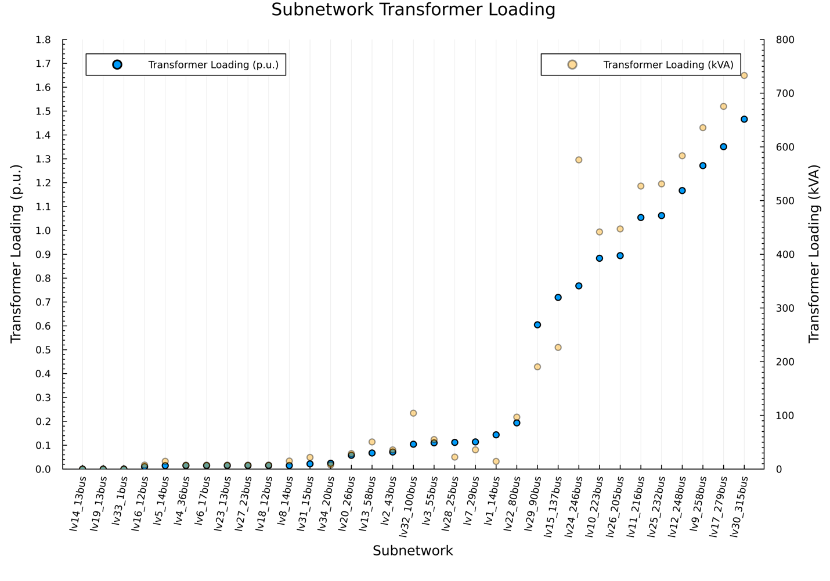
Figure 12: The relative and absolute loading of the transformers at the simultaneous peak.
Figure 13 shows the voltage range for all customers grouped by LV feeder, at the time of peak demand. Slight overvoltages occur due to unbalanced loading and untransposed lines with unbalanced impedances. Some undervoltages occur in LV30_315bus and LV9_258bus.
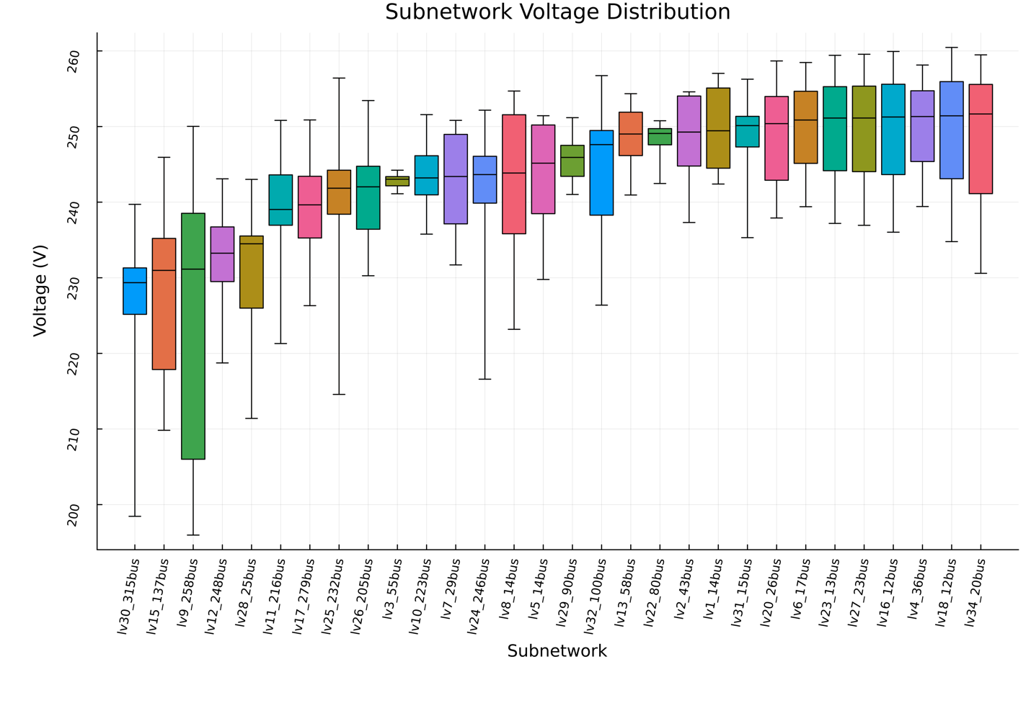
Figure 13: Phase-to-neutral voltage distribution per LV feeder at the maximum simultaneous demand peak. Note that most transformers have a no-load voltage of about 250 V. Slight voltage rise occurs due to unbalanced load and untransposed lines with unbalanced impedances.
Figure 14 shows the phase-to-neutral voltage rises for all the networks operating at their expected after diversity maximum demand point.
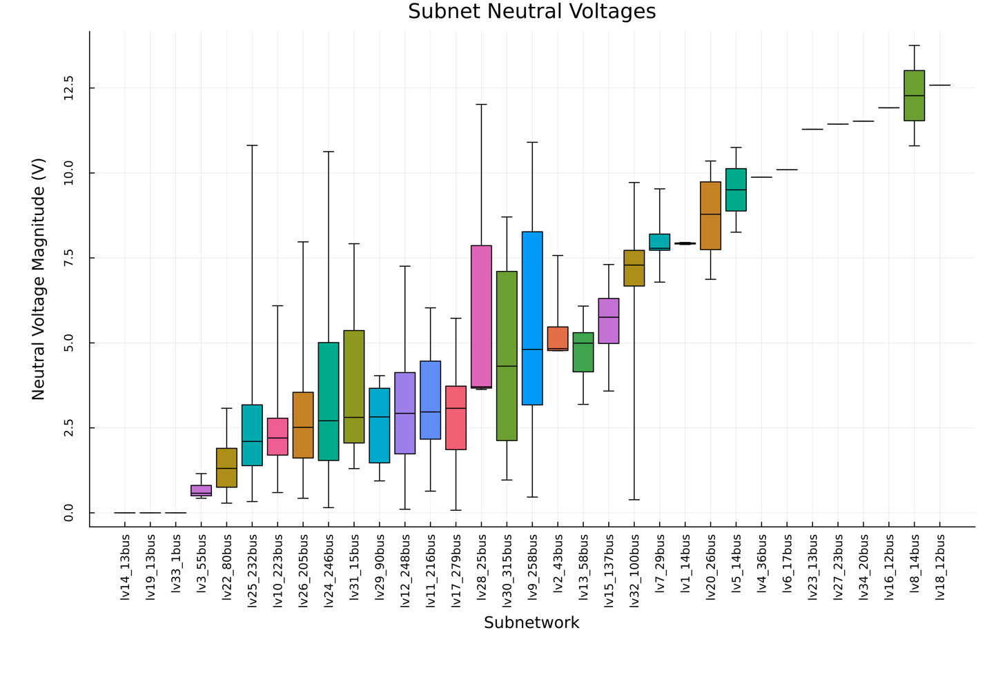
Figure 14: Neutral-to-ground voltage magnitude across the different feeders operating at their maximum demand point.

Network operation with varying levels of PV
We now perform time series simulation with Volt-var/Watt according to Table 4. Furthermore, we develop Pluto.jl notebooks, seen in Figure 15, allowing for interactive exploration. The controllable parameters are illustrated in Figure 16.

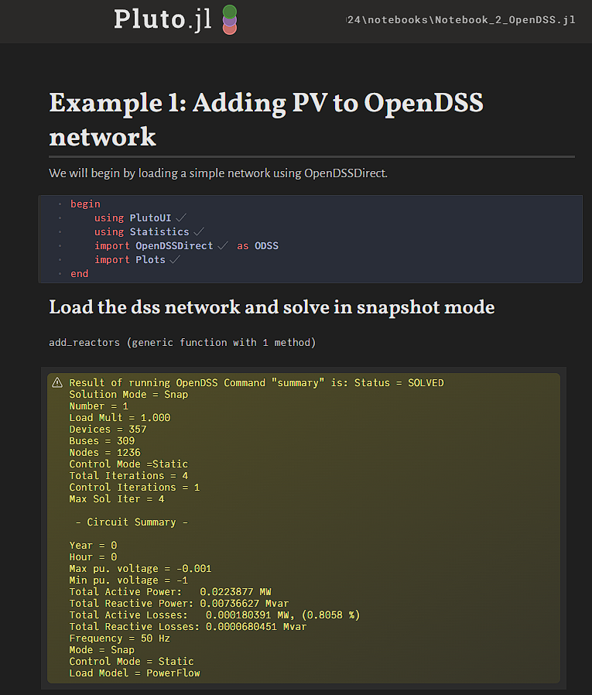
Figure 15: Screenshot of the Pluto.jl notebook allowing for exploration of Volt-var/Watt controls
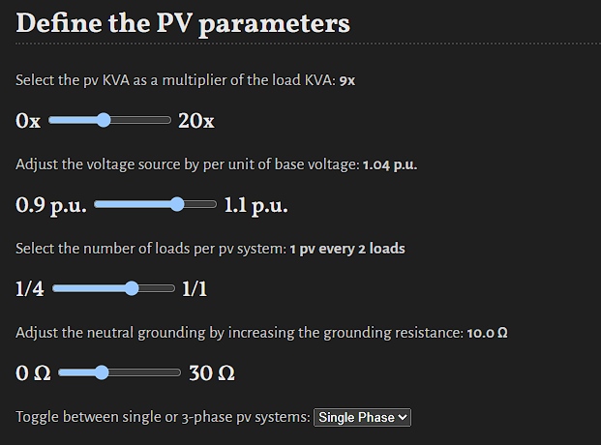
Figure 16: Interactive dials allowing for real-time experimentation with scenarios
Finally, we also present some time series results for network LV9_258bus, illustrating the differences in Volt-var/Watt response throughout the feeder. Customers closer to the substation see less voltage rise overall, leading to lower vars; shown in Figure 17 and Figure 19. Customers at higher voltages will respond with higher vars (Figure 17). The combination of the hard inverter rating in kVA, leads to some (indirect) curtailment happening when volt-var is activated at peak solar (i.e. when the active power is close to the inverter rating, e.g. 4.9 kW w.r.t a 5 kVA inverter). If the voltage increases above 253 V, Volt-Watt based curtailment further reduces solar output (Figure 18). The combination of both effects is shown in Figure 20.
Figure 17: Volt-Var outcomes for different customers throughout a day. In this illustration, all customers have active Volt-var control (i.e. none are in the dead band zone).
Figure 18: Volt-watt outcomes for different customers throughout a day. In this illustration, most of the time Volt-Watt is activated only for certain customers, and only at peak times.

Figure 19: Volt-var response of various PV systems throughout a day
Figure 20: Resulting curtailment of various PV systems fed with the same bell-curve irradiance
After the derivation of the detailed mathematical model in the previous chapter, we are now exploring numerical studies. We choose the network LV9_258bus with 123 customers as the focus of the analysis, as this is the most voltage-constrained network in the set, which allows us to maximally showcase the benefits of considering Volt-var/Watt response. All customers are single-phase connected, and a subset of 30 of them are assigned PV systems with an inverter rating of 5 kVA.
Each DOE quantification problem (which determines the export limits for all 123 customers simultaneously) takes less than 5 seconds to solve. We note that by modelling the Volt-var/Watt response, we fundamentally encapsulate the degrees of freedom for reactive power too – therefore it is a joint PQ export limit.

DOE results without Volt-var/Watt consideration

Result approach and visualisation
We perform the DOE quantification across the following dimensions:
- PV systems operating at a) unity power factor b) 0.95 lagging power factor c) Volt-var/Watt enabled
- PV penetration (indicated ‘pen’ in the upcoming figures), ranging from 10% to 90% of customers.
- Load levels ranging from 0.1 to 1 (1 being the ADMD point, indicated ‘load’ in the figures)
- Voltage at the transformer secondary being in a range of 1.00 pu or 230 V up to 1.09 pu in steps of 0.01 pu (indicated ‘voltage’ in the figures),.
- Three criteria for assignment of export limits, 1) equal, 2) competitive, 3) alpha-fairness with alpha=1
- The net flow through the distribution transformer, i.e. how much power is supplied fromthe MV to the LV, or how much reverse power flows from the LV to the MV.
Figure 21 presents a guide to the reader for interpretation of the upcoming baseline numerical results, which ignore the response from smart inverters. The x axis indicates the PV systems in the network, all of them being subject to DOE export limits. The equal line is the same for every customer, and as long as it is nonzero, it means that all customers have a chance to export power. The fair solution indicated gives some customers a limit that is lower than the equal limit, and may even constrain certain customers to have 0 export. The fair solution is also used for sorting the competitive outcome, i.e. this means that for any vertical slice, we can look which customers are better or worse off between the fair and competitive solutions. In general we observe that with the competitive outcome, more customers get zero exports, and more customers get unconstrained exports. Obviously, the aggregate exports are the highest for the competitive outcome, however, the aggregate output of the alpha-fair solution is typically close to the competitive solution, whereas the fairness is improved significantly.

Figure 21: Schematic diagram of result visualisation approach.
Figure 22 shows a practical realisation of such a scenario. We are looking at the results of a low load, high voltage, high PV penetration case with PV operating at unity power factor.
The legend also summarises the net flows at the distribution transformer. In this case, the competitive outcome results in an aggregate 274 kW of PV injection, which in turn leads to reverse flows at the distribution transformer of 220kW and 1.6kvar. One customer has zero export limits, and quite a few are worse off than with an equal export limit. With an equal export limit, each PV system gets an export limit of 1.07 kW, which results in reverse flows of only 46.6kW and 0.1kvar. With the alpha fairness trade-off, we obtain reverse flows of 215.6 kW and 1.5kvar. Not that this result is very close to the competitive result in terms of reverse flows, and only four customers end up with an export limit slightly below the equal one. This result is an illustration of how equal export limits can lead to a massive loss of renewable uptake.
Figure 22: Illustration of an extreme scenario, with a focus on the legend. Forward flows are indicated as P positive, reverse flows occur when P is negative. Note that individual customers are on different phases.

Results

Sensitivity to power factor
Figure 23 show a comparison in terms of export limits for PV systems with unity power factor (i.e. no reactive power) and constant power factor of 0.95 lagging in a network with typical operating voltage (i.e. 1.04 pu is approximately 240 V). It is seen that the constant power factor operating mode leads to higher export limits across all cases. The additional reactive power flows are quite significant. At unity power factor, there is 0.9kvar of flows needed due to reactive power consumption by the network inductances in the competitive solution. At 0.95 power factor. The reactive power consumption by the PV and the network adds up to 63 kvar. Similar trends hold for the fair and equal solutions.

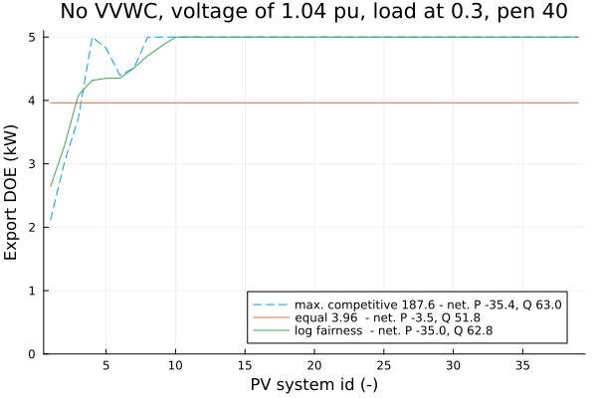
Figure 23: Comparison between 0.95 (left) and unity (right) power factor control.

Sensitivity to load level
Figure 24 illustrates how the export limits drop as a function of the load level. As the export limit here is constrained by the occurrence of over voltage, dropping the load level leads to higher voltages, which in turn leads to reduced export limits.
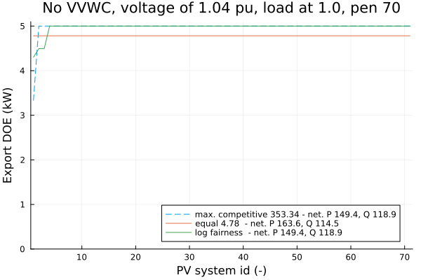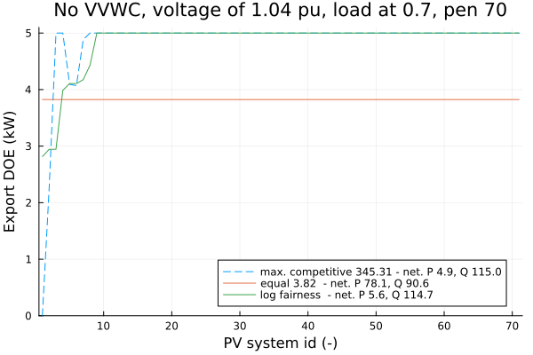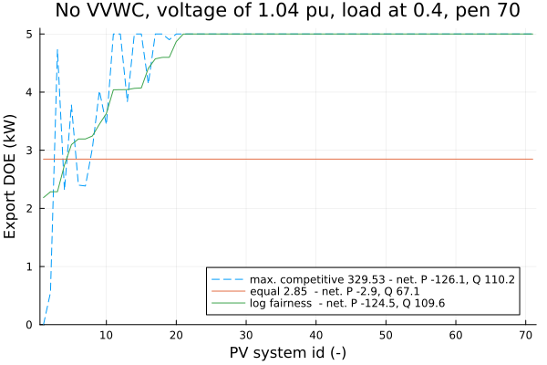
Figure 24: Comparison of export limits depending on load levels.

Sensitivity to voltage level
Figure 25 shows how the export limits drop with increasing voltage at the substation. Higher voltages, as expected, lead to lower export limits for more customers.
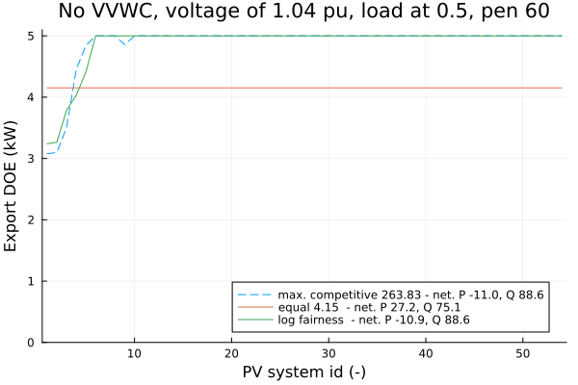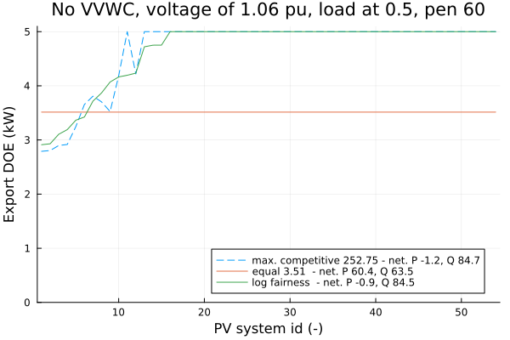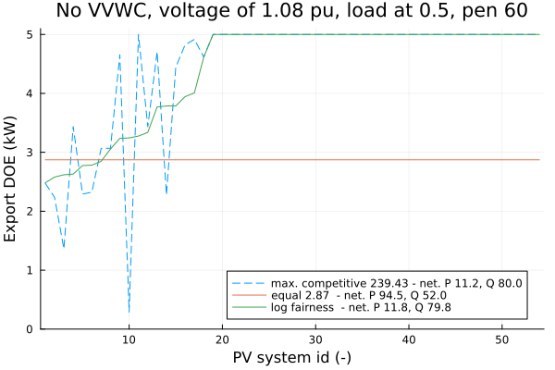
Figure 25: Comparison of export limits across different reference voltages at the substation.

Sensitivity to PV penetration
Figure 26 shows how export limits reduce with increasing PV penetration. In general export limits will drop for all customers, as they all end up seeing higher voltages. Note that this will interact with phase balance though. In the cases with very high PV penetration, the loading of the phases may eventually become more balanced again, which may lead to export limits not dropping slower than expected.
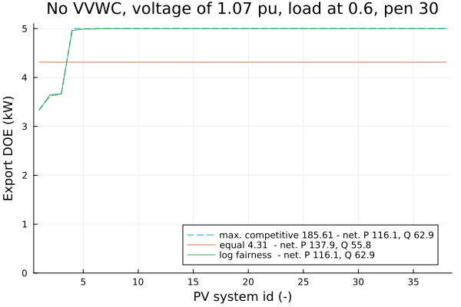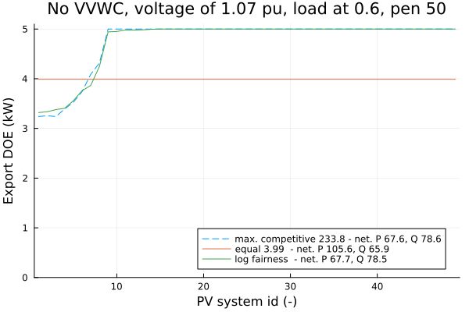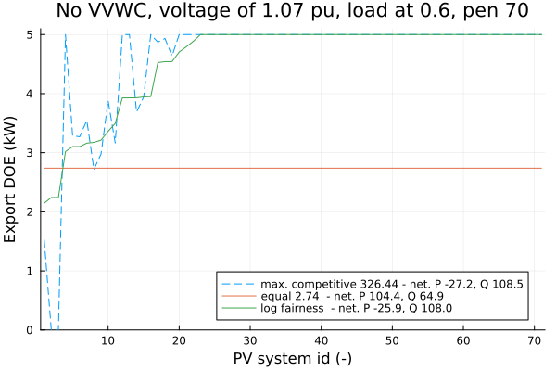
Figure 26: Comparison of export limits depending on the amount of PV penetration in this network. Note that the x axis scale changes between figures.

DOE results with Volt-var/Watt consideration

Sensitivity to load level
Figure 27 shows how at lower load levels, the export limits decrease, assuming all other factors such as voltage and PV penetration being equal. The same observations hold as with constant power factor control of PV systems, namely, the export limits drop with decreasing load.

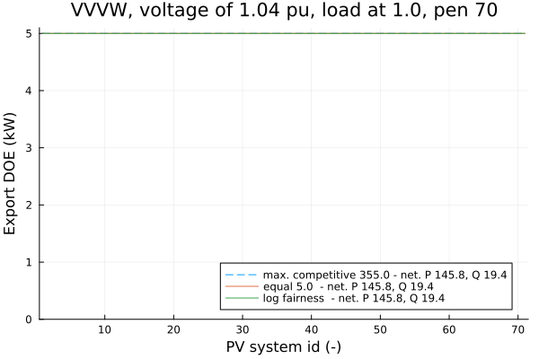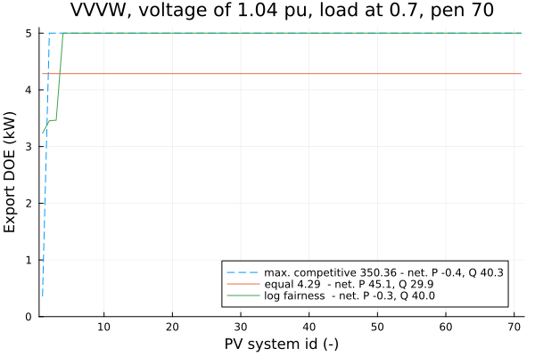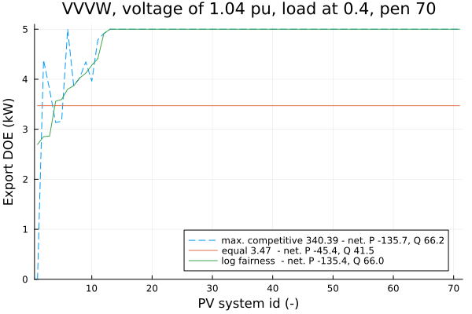
Figure 27: Comparison of export limits for different load levels. Lower load leads to reduced export limits in voltage-constrained networks.

Sensitivity to voltage level
As shown in Figure 28, and consistent with the constant power factor case, higher voltage levels result in reduced exports.
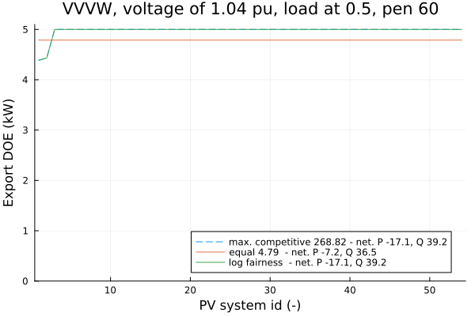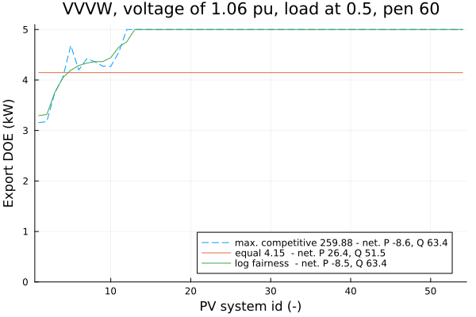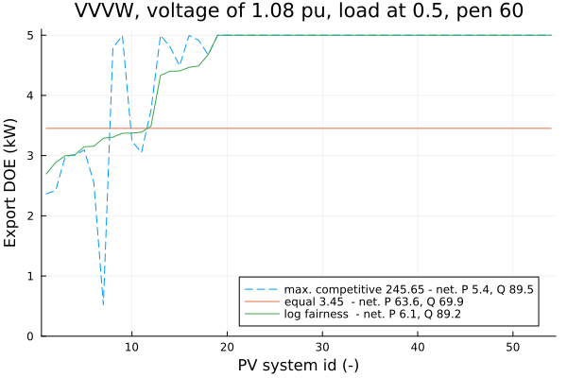
Figure 28: Comparison of export limits for different voltage levels. Higher voltages lead to reduced exports across all cases

Sensitivity to PV penetration
Figure 29 illustrates how the PV exports on average get reduced with higher penetrations of PV. Aggregate exports still increase meaningfully though.
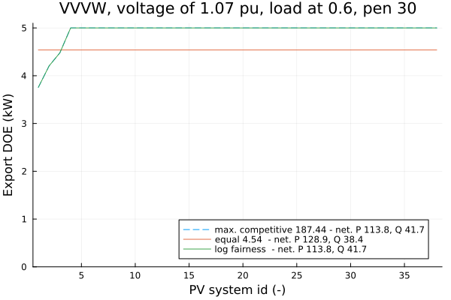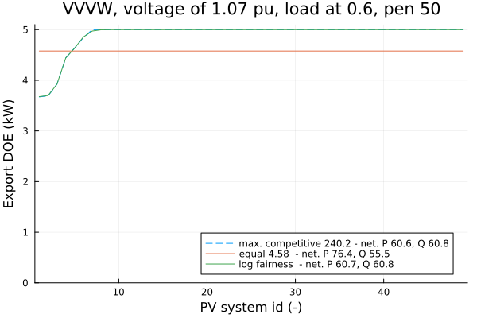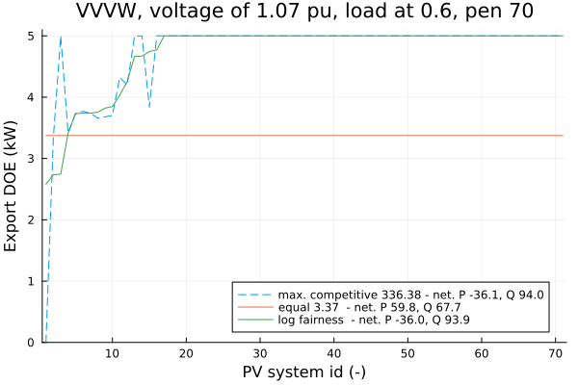
Figure 29: Comparison of export limits for different levels of PV penetration.

Comparison with versus without Volt-var/Watt response
In this section we draw out comparisons between cases with and without the modelling of Volt-var/Watt response. Note that in both of those cases, reactive power is linked to another state (Q depends on P for constant power factor, Q depends on voltage magnitude for Volt-var/Watt), so we have the same overall degrees of freedom.
We focus on some of the scenarios that showcase the advantages of detailed modelling but note that all the results in sections 5.1 and 5.2 are for matching scenarios, so the reader can further study those comparisons to confirm the generality of the conclusions presented here.

Comparison for high voltage, high PV, low load
Figure 30 illustrates the differences for an extreme scenario, where most of the customers in the network are impacted by overvoltage issues, resulting in export limits getting reduced very significantly. Representing the VVWC always results in better outcomes, across the competitive, equal and fair outcomes. This illustrates that simplifying the DOE computation without including VVWC exacerbates unfair outcomes, as avoidable curtailment would have taken place. An additional 250-224=26 kW of renewable energy can be absorbed for the competitive solution, 101-71=30kW for the equal outcome and 245-218=27kW for the fair outcome.
Interestingly, the competitive outcome with Volt-var/Watt has more customers getting their exports reduced to zero.
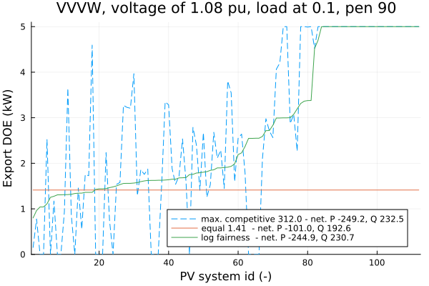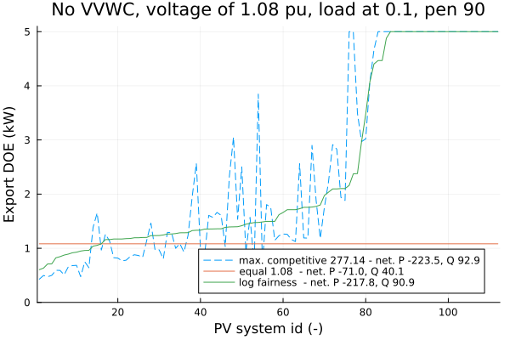
Figure 30: Extreme scenario with massively reduced export limits due to high voltage, low load and high PV penetration. Results with Volt-var/Watt on the left, without on the right.

Comparison for a typical voltage PV and load
Figure 31 Illustrates how the difference in export limits for a more common scenario. Again, the outcomes always improve by incorporating the expected Volt-var/Watt response. An additional 6 kW of exports is enabled for the competitive outcome, 34 kW for the equal outcome, and 6 kW for the fair outcome. Note that the equal outcome ends up curtailing the most – essentially by definition – but it also benefits the most from incorporating the additional detail into the quantification method.
Figure 31: More typical scenario comparing DOE limits with and without Volt-var/Watt response.

Insights
Our results demonstrate that across the board, unnecessary curtailment of solar power can be avoided through modelling the expected Volt-var/Watt response as part of the DOE quantification. Fair outcomes, when modelling Volt-var/Watt response, can be achieved through the application of alpha-fairness, which establishes trade-offs between equal and competitive outcomes. Alpha fairness for alpha=1, also commonly referred to as proportional fairness, delivers high uptake of renewable energy, a.k.a. very little curtailment, while also achieving export limits that are rarely reduced to zero.
We observe that all the curves shift to the top left across all scenarios, which means there are in general more export opportunities, by explicitly modelling Volt-var/Watt response. This means simplifying the DOE quantification model by dropping the Volt-var/Watt response leads to suboptimal outcomes across the board, i.e. unjustified curtailment due to mismatch between the model and reality. Figure 32 summarizes the observations from the inclusion of Volt-var/Watt response into the DOE quantification.
Figure 32: Summary of observations based on the modelling of Volt-var/Watt in the DOE quantification
Through the work, we additionally demonstrated that it is possible to build detailed physics-based approaches that achieve fair outcomes on top of nonlinear mathematical optimisation models. These days, scalable nonlinear programming algorithms support power systems optimisation engines with fewer shortcuts in physical models, enabling better orchestration of DERs. For example, they consider feasible set point restrictions (e.g., three-leg inverters not accepting three independent P/Q set points) and inverter response characteristics (e.g., Volt-var/Watt).
These foundations enable the development of advanced quantification methods for DOEs, exploring trade-offs between fairness and competitiveness using detailed network representations. As demonstrated, export limits are massively reduced when the network is operating at high voltages, though these voltages can be influenced though active network management. Future improvements include integrating flexible voltage management technologies like on load tap changers, voltage regulators and capacitor banks into the DOE quantification model.
Obstacles to the large-scale deployment of distribution network optimisation technology still remain, with the availability and accuracy of network models being the primary challenge. However, nonlinear optimisation can also be used to calibrate network models in a data-driven, physics-based fashion. This includes the identification of control modes and settings of inverters based on measurements or network state estimates. Specifically, we call out opportunities in the automatic calibration of line impedances based on smart meter measurements, correction of unreported switch states/changes, data-driven detection of behind-the-meter DER and their control systems. We refer the reader to [64] for an in-depth discussion.

Future work
We now discuss four directions for future research and development.

Integrating DOEs and active distribution network (congestion) management
DOEs are only a partial solution to help distribution utilities with congestion in their network. If the DOE quantification is done in isolation, a lot of additional network capacity is left inaccessible. To access the broader capacity of the network, the DOE quantification needs to be done in conjunction with the broader network voltage management. Voltage regulators, on-load tap changers, distribution STATCOMS, active filters and capacitor banks can all be used to regulate voltage up and/or down. This may free up additional export capabilities. Furthermore, approaches like the ones proposed here rely in state estimation deployment to establish load patterns in the network.

Integrating DOEs into general power network processes and markets
The impact of DOEs isn’t just observed in distribution network operations. It is expected that predicted DOEs will need to be made available to market participants day-ahead, so they can hedge their risk correspondingly. Furthermore, system-level issues such as minimum demand, can be pursued and enabled through DOE deployments too. Eventually, the presence of DOE deployments will also need to be considered in network development plans.
Flexibility markets, including in distribution networks, are envisioned to help network operators deal with congestion more directly than DOEs. Flexibility markets offer direct control over flexible resources, whereas DOEs stop customers from importing/exporting in a way that would cause congestion. In general, DOEs and flexibility markets are compatible ideas though, as markets can operate within the established import/export limits. The complementarity of these two concepts, and how they can both contribute to active network management across transmission and distribution, is underexplored.
Further research into power system architectures is needed to enable the right outcomes in the long term. New interaction paradigms between TNSPs and DNSPs are likely needed. Novel data exchanges and data models will need to be established to make it practical. The work also needs to be framed in the context of the ongoing DNSP to DSO transition.

Data-driven methods to establish, clean, calibrate and validate network models
Commonly, state estimation, power flow, and DOE quantification methods rely on accurate network models, though model-free approaches have been proposed to bypass this requirement. Physics-based methods offer unique benefits such as auditability, validatability, being unbiased and being based on more than a century of electrical engineering knowledge. Access to network models remains a key challenge remains though, as distribution network utilities generally have not yet pervasively developed such models, and/or had the time to validate them. Network data cleaning and “debugging” is a crucial task, for which new methods and tool chains can be developed.
We note that state estimation itself is a viable methodology to validate network models, even in off-line / desktop study mode [65]. Furthermore, measurements from SCADA RTUs, smart meters, transformer monitors and more, can also be leveraged to learn network features, and properties of behind the meter resources. The last generations of smart meters have features for automatic phase detection and meter-to-transformer mapping built-in. Furthermore, smart meters can provide a lot of technically interesting measurements and metrics of current, voltage and power quality, not just billing data.

DOE policy and consumer acceptance
Establishing different trade-offs in terms of fairness, and implementing a specific choice of a trade-off are two different things. There is no need to lock in specific choices yet, as a lot still needs to be learnt in terms of customer acceptance and real-world technical and economic performance. Currently, it is hard to judge the real-world performance of different design choices for DOEs, especially in the field. More research is needed to design performance metrics for DOE deployments based on realistically collectible data, e.g. from smart meters. Questions also arise in the context of import limits on what is acceptable. Import limits will invariably need to discriminate between flexible and inflexible demand, but how that is done and enforced, with customer acceptance, is an open challenge.

Appendix Comparison with work previous topic 8 stages
In the G-PST Stage 2 and 3, the following Operating Envelope (OE) methods were proposed. Specifically, Stage 2 implemented and assessed OE methods for a low voltage (LV) network, and Stage 3 extended the respective OE methods for multiple neighbourhoods connected to a high voltage (HV) feeder.
- Ideal OE
The Ideal OE method requires a precise electrical model of the network (topology, phase connection of assets and customers, and impedances of conductors and transformers), forecasts (or real-time data) of the voltage at the head of the LV feeder, and forecasts of active and reactive power of passive customers (non-flexible customers).
The algorithm consists of a series of power flow calculations exploring export/import limits until an operational limit (voltages or thermal) in any part of the LV network is not breached. That is, the algorithm first sets the net active power of all active customers to the maximum possible value for the corresponding connection point (e.g., 10 kW). Then it runs the power flow calculation to check if any network limit is breached, in which case, it reduces the net active power of all active customers by a predefined value (e.g., 1 kW), and iterates the process until no network limit is breached. When the algorithm terminates, the OE for each customer is obtained, which is identical for all customers. The Ideal OE is the most accurate method out of all the proposed methods.
- Asset Capacity OE (AC-OE)
The AC-OE only requires monitoring at the distribution transformer to address any thermal issues. This method considers the rated capacity of the distribution transformer and the forecasted (or real-time) aggregated net power of customers at the distribution transformer to calculate the distribution transformer spare capacity (per phase) and divide it among all active customers equally — which is the OE for each customer.
- Asset Capacity & Critical Voltage OE (AC-CV-OE)
The AC-CV-OE requires additional monitoring of the critical customer of the network to address both voltage and thermal issues. By considering the historical voltage magnitude of the critical customer and the historical net active power demand of the same customer, a PV sensitivity curve is created that gives an estimation of the voltage at that critical customer. After allocating the spare capacity across the customers as in the previous method, if the critical customer voltage breaches the network limit, then it reduces the net active power of all active customers by a predefined value (e.g., 1kW), re-estimates the new voltage at the critical customer and iterates the process until no network limit is breached. When the algorithm terminates, the OE for each customer is obtained, which is identical for all customers.
- Asset Capacity & Delta voltage (AC-∆V-OE)
AC-∆V-OE is similar to AC-CV-OE in monitoring requirements and the spare capacity allocation methodology. However, in AC-∆V-OE, a P_{DTx}-V_{DTx} sensitivity curve is used to estimate the voltage magnitude at the distribution transformer DTx for a given aggregated active power passing through the DTx, and a second P_{DTx}-∆V sensitivity curve is used to estimate the delta voltage between the DTx and the critical customer for a given aggregated active power passing through the DTx – both are created with historical data. After the required sensitivity curves are obtained, the AC-∆V-OE algorithm has two main steps. These sensitivity curves are used to estimate the voltage at the critical customer for a given aggregated active power passing through the DTx. Then the spare capacity calculated as with the AC-CV-OE method and the estimated voltage at the critical customer are used in combination to calculate the OEs.
Limitations of the proposed OE methods in Stage 2:
- Although Ideal OE guarantees maximum possible export and/or import limits within the voltage and thermal limits, it requires full observability of the network.
- For the AC-OE, AC-CV-OE and, it is expected that DNSPs will have access to historical/operational net demand data from active customers to estimate the aggregated demand at the distribution transformer.
- The accuracy of AC-CV-OE depends on the selection of the correct critical customer. Incorrect identification of the critical customer will result in OEs violating network limits.
- The method of calculating OEs for exports and imports is similar, but they must be done separately and not simultaneously.
- The pre-defined value to reduce the OE should be determined on a case-by-case basis, as it will affect both the accuracy of the OE and the time required for the OE calculation process.
- Network losses are not considered, which will inevitably introduce some inaccuracies into the OE calculations.
- The accuracy of voltage forecasts at the head of the LV feeder, as well as the forecasts for active and reactive power of passive customers, significantly impacts the calculation of OEs.

Glossary

ADMS | Advanced distribution management system
ADMD | After diversity maximum demand
BESS | Battery energy storage system
BTM | Behind the meter
DER | Distributed energy resources
DERMS | Distributed energy resource management system
DNSP | Distribution network service provider
DSO | Distribution system operator
DOE | Dynamic operating envelopes
DSSE | Distribution state estimation
GIS | Geographic information system
OPF | Optimal power flow
P2P | Peer-to-peer
PV | Photovoltaic (system)
ReLU | Rectified linear unit
RTU | Remote terminal unit
SCADA | Supervisory control and data acquisition
TNSP | Transmission network service provider
UBOPF | Unbalanced optimal power flow

References
[1] E. Boardman, “Advanced applications in an advanced distribution management system: Essentials for implementation and integration,” IEEE Power and Energy Magazine, vol. 18, no. 1, pp. 43–54, 2020.
[2] A. Dubey et al., “Paving the way for advanced distribution management systems applications: Making the most of models and data,” IEEE Power Energy Mag., vol. 18, no. 1, pp. 63–75, 2020.
[3] M. Vanin and D. Van Hertem, “The role of state estimation in the improvement of low voltage distribution network models,” 2022-10-01.
[4] T. Antic, F. Geth, and T. Capuder, “The importance of technical distribution network limits in dynamic operating envelopes,” in IEEE PowerTech, Belgrade, Serbia, 2023, pp. 1–6.
[5] A. S. Alahmed, G. Cavraro, A. Bernstein, and L. Tong, “Operating-envelopes-aware decentralized welfare maximization for energy communities,” in 2023 59th Annual Allerton Conference on Communication, Control, and Computing (Allerton), 2023, pp. 1–8.
[6] M. R. Alam, P. T. H. Nguyen, L. Naranpanawe, T. K. Saha, and G. Lankeshwara, “Allocation of dynamic operating envelopes in distribution networks: Technical and equitable perspectives,” IEEE Transactions on Sustainable Energy, vol. 15, no. 1, pp. 173–186, 2024.
[7] A. Attarha, S. M. Noori R.A., M. Mahmoodi, J. Iria, and P. Scott, “Shaped operating envelopes: Distribution network capacity allocation for market services,” Electric Power Systems Research, vol. 234, p. 110639, 2024. [Online]. Available: https://www.sciencedirect.com/science/article/pii/S037877962400525X
[8] M. I. Azim, G. Lankeshwara, W. Tushar, R. Sharma, M. R. Alam, T. K. Saha, M. Khorasany, and R. Razzaghi, “Dynamic operating envelope-enabled p2p trading to maximize financial returns of prosumers,” IEEE Transactions on Smart Grid, vol. 15, no. 2, pp. 1978–1990, 2024.
[9] V. Bassi, D. Jaglal, L. Ochoa, T. Alpcan, and C. Leckie, “Deliverables 1-2-3a Model-Free Voltage Calculations and Operating Envelopes,” University of Melbourne, Technical Report, 7 2022.
[10] L. Blackhall, “On the calculation and use of dynamic operating envelopes,” Project EVOLVE, Technical Report, 2020. [Online]. Available: https://arena.gov.au/assets/2020/09/ on-the-calculation-and-use-of-dynamic-operating-envelopes.pdf
[11] Y. Zabihinia Gerdroodbari, M. Khorasany, and R. Razzaghi, “Dynamic PQ operating envelopes for prosumers in distribution networks,” Applied Energy, vol. 325, p. 119757, 2022.
[12] A. Goncalves Givisiez, L. F. Ochoa, M. Z. Liu, and V. Bassi, “Assessing the pros and cons of different operating envlopes implementations across australia,” in Int. Conf. Exhib. Elect. Distrib., Rome, Italy, 2023, p. 5.
[13] J. Guerrero, A. C. Chapman, and G. Verbiˇc, “Decentralized p2p energy trading under network constraints in a low-voltage network,” IEEE Transactions on Smart Grid, vol. 10, no. 5, pp. 5163–5173, 2019.
[14] M. M. Hoque, M. Khorasany, M. I. Azim, R. Razzaghi, and M. Jalili, “Dynamic operating envelope-based local energy market for prosumers with electric vehicles,” IEEE Trans. Smart Grid, vol. 15, no. 2, pp. 1712–1724, 2024.
[15] H. Fani, M. U. Hashmi, E. J. Palacios-Garcia, and G. Deconinck, “Impact of dynamic operating envelopes on distribution network hosting capacity for electric vehicles,” 2024. [Online]. Available: https://arxiv.org/abs/2404.18013
[16] A. Kaushal, W. Ananduta, L. Marques, T. Cuypers, and A. Sanjab, “Operating envelopes for the grid-constrained use of distributed flexibility in balancing markets,” arXiv preprint arXiv:2406.17398, 2024.
[17] G. Lankeshwara, R. Sharma, R. Yan, T. K. Saha, and J. V. Milanovic, “Time-varying operating regions of end-users and feeders in low-voltage distribution networks,” IEEE Trans. Power Syst., pp. 1–12, 2023.
[18] B. Liu and J. H. Braslavsky, “Robust dynamic operating envelopes for der integration in unbalanced distribution networks,” IEEE Trans. Power Syst., vol. 39, no. 2, pp. 3921–3936, 2024.
[19] B. Liu, J. H. Braslavsky, and N. Mahdavi, “Linear opf-based robust dynamic operating envelopes with uncertainties in unbalanced distribution networks,” Journal of Modern Power Systems and Clean Energy, pp. 1–6, 2023.
[20] B. Liu and J. H. Braslavsky, “Sensitivity and robustness issues of operating envelopes in unbalanced distribution networks,” IEEE Access, vol. 10, pp. 92789–92798, 2022.
[21] M. Z. Liu, L. F. Ochoa, P. K. C. Wong, and J. Theunissen, “Using OPF-Based Operating Envelopes to Facilitate Residential DER Services,” IEEE Trans. Smart Grid, vol. 13, no. 6, pp. 4494–4504, 2022.
[22] M. Z. Liu, L. F. Ochoa, T. Ting, and J. Theunissen, “Bottom-up services & network integrity: The need for operating envelopes,” in 26th Int. Conf. Exhib. Elect. Distrib., vol. 2021, 2021, pp. 1944–1948.
[23] M. Mahmoodi, L. Blackhall, S. M. Noori R. A., A. Attarha, B. Weise, and A. Bhardwaj, “Der capacity assessment of active distribution systems using dynamic operating envelopes,” IEEE Trans. Smart Grid, vol. 15, no. 2, pp. 1778–1791, 2024.
[24] T. Milford and O. Krause, “Managing DER in distribution networks using state estimation & dynamic operating envelopes,” in IEEE PES Innovative Smart Grid Tech. Conf. Asia, 2021, pp. 1–5.
[25] H. Moring, S. Jang, N. Ozay, and J. L. Mathieu, “Nodal operating envelopes vs. network-wide constraints: What is better for network-safe coordination of ders?” Electric Power Systems Research, vol. 234, p. 110702, 2024. [Online]. Available: https://www.sciencedirect.com/science/article/pii/S0378779624005881
[26] H. Moring and J. L. Mathieu, “Inexactness of second order cone relaxations for calculating operating envelopes,” in 2023 IEEE International Conference on Communications, Control, and Computing Technologies for Smart Grids (SmartGridComm), 2023, pp. 1–6.
[27] N. Nazir and M. Almassalkhi, “Convex inner approximation of the feeder hosting capacity limits on dispatchable demand,” in 2019 IEEE 58th Conference on Decision and Control (CDC), 2019, pp. 4858–4864.
[28] L. Ochoa, M. Liu, J. Theunissen, and N. Regan, “Reactive power and voltage regulation devices to enhance operating envelopes,” Technical Report, 06 2022. [Online].Available: https://www.researchgate.net/publication/361405704 Reactive Power and Voltag Regulation Devices to Enhance Operating Envelopes
[29] K. Petrou, M. Z. Liu, A. T. Procopiou, L. F. Ochoa, J. Theunissen, and J. Harding, “Operating envelopes for prosumers in LV networks: A weighted proportional fairness approach,” in IEEE PES Innovative Smart Grid Techn. Conf. Europe, 2020, pp. 579–583.
[30] J. S. Russell, P. Scott, and J. Iria, “Network-secure aggregator operating regions with flexible dispatch envelopes in unbalanced systems,” Electric Power Systems Research, vol. 235, p. 110728, 2024. [Online]. Available: https://www.sciencedirect.com/science/article/pii/ S037877962400614X
[31] ——, “Robust operating envelopes with phase unbalance constraints in unbalanced three-phase networks,” in IEEE PES Innov. Smart Grid Techn. Asia, 2023, pp. 1–5.
[32] W. Tushar, M. I. Azim, M. R. Alam, C. Yuen, R. Sharma, T. Saha, and H. V. Poor, “Achieving the un’s sustainable energy targets through dynamic operating limits,” Iscience, vol. 26, no. 7, 2023.
[33] S. Yang, Z. Li, and Y. Tian, “Assessment of continuous-time transmission-distributioninterface active and reactive flexibility for flexible distribution networks,” 2024. [Online]. Available: https://arxiv.org/abs/2407.10400
[34] Y. Yi and G. Verbiˇc, “Fair operating envelopes under uncertainty using chance constrained optimal power flow,” Elect. Power Syst. Res., vol. 213, p. 108465, 2022.
[35] A. Attarha, S. Mahdi Noori R. A., P. Scott, and S. Thi´ebaux, “Network-secure envelopes enabling reliable der bidding in energy and reserve markets,” IEEE Transactions on Smart Grid, vol. 13, no. 3, pp. 2050–2062, 2022.
[36] K. Petrou, A. T. Procopiou, L. Gutierrez-Lagos, M. Z. Liu, L. F. Ochoa, T. Langstaff, and J. M. Theunissen, “Ensuring distribution network integrity using dynamic operating limits for prosumers,” IEEE Transactions on Smart Grid, vol. 12, no. 5, pp. 3877–3888, 2021.
[37] M. U. Hashmi and D. V. Hertem, “Robust dynamic operating envelopes for flexibility operation using only local voltage measurement,” 2023. [Online]. Available: https: //arxiv.org/abs/2305.13079
[38] S. Riaz and P. Mancarella, “Modelling and characterisation of flexibility from distributed energy resources,” IEEE Transactions on Power Systems, vol. 37, no. 1, pp. 38–50, 2022.
[39] M. Z. Liu, L. N. Ochoa, S. Riaz, P. Mancarella, T. Ting, J. San, and J. Theunissen, “Grid and market services from the edge: Using operating envelopes to unlock network-aware bottom-up flexibility,” IEEE Power and Energy Magazine, vol. 19, no. 4, pp. 52–62, 2021.
[40] O. Rubasinghe, T. Zhang, T. Fernando, P. Howe, X. Zhang, and H. H.-C. Iu, “Network distribution constraints optimisation algorithm - an australian case study,” in 2023 IEEE PES Innovative Smart Grid Technologies Europe (ISGT EUROPE), 2023, pp. 1–6.
[41] B. Liu and J. Ma, “Feasible region for ders in unbalanced distribution networks with uncertain line impedances,” 2023. [Online]. Available: https://arxiv.org/abs/2212.03985
[42] “Lessons Learnt 2,” Project EDGE, Technical Report, 2022. [Online]. Available: https://arena.gov.au/assets/2022/11/project-edge-lessons-learnt-2.pdf
[43] The Australian National University, “Trial of shaped operating envelopes: Final technical knowledge sharing report,” Technical Report, 2024.
[44] “Review of Dynamic Operating Envelopes Adoption by DNSPs,” CutlerMerz, Technical Report, 2022. [Online]. Available: https://arena.gov.au/assets/2022/07/review-of-dynamic-operating-envelopes-from-dnsps.pdf
[45] “Flexible export limits issues paper,” Australian Energy Regulator, Technical Report, 010 2022. [Online]. Available: https://www.aer.gov.au/networks-pipelines/guidelines-schemes-models-reviews/ review-of-regulatory-framework-for-flexible-export-limit-implementation
[46] V. Bassi, D. Jaglal, L. Ochoa, T. Alpcan, and C. Leckie, “Deliverables 1-2-3a ”model-free voltage calculations and operating envelopes”,” University of Melbourne, Tech. Rep., 07 2022.
[47] “Power quality response mode settings,” Energy Networks Australia, Tech. Rep., 2021. [Online]. Available: https://www.energynetworks.com.au/miscellaneous/ power-quality-response-mode-settings/
[48] A. Inaolaji, A. Savasci, and S. Paudyal, “Distribution grid optimal power flow in unbalanced multiphase networks with volt-var and volt-watt droop settings of smart inverters,” IEEE Trans. Indust. Appl., vol. 58, no. 5, pp. 5832–5843, 2022.
[49] ——, “Distribution grid optimal power flow with volt-var and volt-watt settings of smart inverters,” in 2021 IEEE Industry Applications Society Annual Meeting (IAS), 2021, pp. 1–7.
[50] L. Quiertant, J. Naughton, S. Mhanna, and P. Mancarella, “An optimisation-based study of volt-var control from pv inverters and statcoms in lv unbalanced networks,” in 2023 IEEE International Conference on Energy Technologies for Future Grids (ETFG), 2023, pp. 1–6.
[51] F. Geth and T. Van Acker, “Harmonic optimal power flow with transformer excitation,” Electric Power Systems Research, vol. 213, p. 108604, 2022. [Online]. Available: https://www.sciencedirect.com/science/article/pii/S0378779622006861
[52] P. Aaslid, F. Geth, M. Korp˚as, M. M. Belsnes, and O. B. Fosso, “Non-linear charge-based battery storage optimization model with bi-variate cubic spline constraints,” Journal of Energy Storage, vol. 32, p. 101979, 2020. [Online]. Available: https://www.sciencedirect.com/science/article/pii/S2352152X20318144
[53] “Dynamic response of inverter volt-var power quality mode v3,” UNSW, Tech. Rep., 2021. [Online]. Available: http://pvinverters.ee.unsw.edu.au/pubs
[54] N. Ninad, E. Apablaza-Arancibia, M. Bui, J. Johnson, S. Gonzalez, R. Darbali-Zamora, C. Cho, W. Son, J. Hashimoto, K. Otani, R. Bru¨ndlinger, R. Ablinger, C. Messner, C. Seitl, Z. Miletic, I. V. Temez, J. Montoya, F. Baumgartner, C. Fabian, S. Kumar, J. Kumar, B. Fox, R. Brandl, and R. Conklin, “Pv inverter grid support function assessment using open-source ieee p1547.1 test package,” in 2020 47th IEEE Photovoltaic Specialists Conference (PVSC), 2020, pp. 1138– 1144.
[55] S. Claeys, F. Geth, and G. Deconinck, “Optimal power flow in four-wire distribution networks: Formulation and benchmarking,” Elect. Power Syst. Res., vol. 213, p. 108522, 2022.
[56] W. H. Kersting, "The Whys of Distribution System Analysis," in IEEE Industry Applications Magazine, vol. 17, no. 5, pp. 59-65, Sept.-Oct. 2011, doi: 10.1109/MIAS.2010.939655.
[57] N. Turner-Bandele, A. Pandey and L. Pileggi, "Analytical Inverter-Based Distributed Generator Model for Power Flow Analysis," 2021 IEEE Power & Energy Society General Meeting (PESGM), Washington, DC, USA, 2021, pp. 1-5, doi: 10.1109/PESGM46819.2021.9637823.
[58] D. C. Jayasuriya, M. Rankin, T. Jones, J. de Hoog, D. Thomas, and I. Mareels, “Modeling and validation of an unbalanced lv network using smart meter and scada inputs,” in IEEE 2013 Tencon - Spring, 2013, pp. 386–390.
[59] D. M. Fobes, S. Claeys, F. Geth, and C. Coffrin, “PowerModelsDistribution.jl: An open-source framework for exploring distribution power flow formulations,” Elect. Power Syst. Res., vol. 189, p. 106664, 2020.
[60] F. Geth, A. C. Chapman, R. Heidari, and J. Clark, “Considerations and design goals for unbalanced optimal power flow benchmarks,” Electric Power Systems Research, vol. 235, p. 110646, 2024. [Online]. Available: https://www.sciencedirect.com/science/article/pii/ S0378779624005327
[61] J. Mo and J. Walrand, “Fair end-to-end window-based congestion control,” IEEE/ACM Trans. Networking, vol. 8, no. 5, pp. 556–567, 2000.
[62] V. Xinying Chen and J. Hooker, “A guide to formulating fairness in an optimization model,” Annals Oper. Res., pp. 1–39, 2023.
[63] Banze, T., Kneiske, T.M. Open data for energy networks: introducing DAVE—a data fusion tool for automated network generation. Sci Rep 14, 1938 (2024). https://doi.org/10.1038/s41598-024-52199-w
[64] F. Geth, M. Vanin, W. Van Westering and T. Milford, Making Distribution State Estimation Practical: Challenges and Opportunities, 2023, https://arxiv.org/abs/2311.07021
[65] M. Vanin, R. D’hulst, D. Van Hertem, Distribution system state estimation for system identification and network model validation: An experience on a real low voltage network, Sustainable Energy, Grids and Networks, Volume 42, 2025, 101710, ISSN 2352-4677, https://doi.org/10.1016/j.segan.2025.101710.
As Australia’s national science agency and innovation catalyst, CSIRO is solving the greatest challenges through innovative science and technology.
CSIRO. Unlocking a better future for everyone.
Contact us
1300 363 400
+61 3 9545 2176
csiro.au/contact
csiro.au

V. Xinying Chen and J. Hooker, “A guide to formulating fairness in an optimization model,” Annals Oper. Res., pp. 1–39, 2023. https://johnhooker.tepper.cmu.edu/equityGuideAOR3post.pdf
https://doi.org/10.25919/ghnz-bk28
Technically, values for voltages and currents may be just at their limits, but not exceed them.
See https://en.wikipedia.org/wiki/Softplus . Softplus is a mathematical function commonly used in machine learning, and is a smooth approximation of the ReLU function (https://en.wikipedia.org/wiki/Rectifier_(neural_networks) )
Coordinate space derived from the symmetrical component transformation
https://github.com/tomislavantic/ppOPF
https://github.com/lanl-ansi/PowerModelsDistribution.jl
https://github.com/pnnl/oedisi_dopf
https://en.wikipedia.org/wiki/Spline_(mathematics)
https://github.com/lanl-ansi/PowerModelsDistribution.jl
https://github.com/JuliaStats/StatsFuns.jl
i.e. not polynomial / quadratic, but instead involving functions such as sine, cosine and logarithm
I.e. we provide a “master.dss” file also for the component networks.
This number adds in the MV-LV distribution transformers.
Available here: https://github.com/frederikgeth/GPSTTopic82024
Note that these labels are approximate +/-5%. The assignments are generated from a single random seed. All PV systems part of the 10% scenario remain part of the 20%, those of the 20% scenario remain part of the 30% scenario, and so on.
Due to the DOE quantification having hard bounds of 1.1pu voltage, as well as phase unbalance and mutual coupling between phases, the problems are generally infeasible with a voltage at the transformer secondary at 1.1pu or above.

