Transmission-Distribution Coordination (TDC)

Report 5 of 5: Power Systems Architecture

AR-PST Stage 4, Topic 7

**AUGUST 2025**

*Informing the future of Australia’s power systems*

© Commonwealth Scientific and Industrial Research Organisation 2025. To the extent permitted by law, all rights are reserved and no part of this publication covered by copyright may be reproduced or copied in any form or by any means except with the written permission of CSIRO.

*Important disclaimer*

CSIRO advises that the information contained in this publication comprises general statements based on scientific research. The reader is advised and needs to be aware that such information may be incomplete or unable to be used in any specific situation. No reliance or actions must therefore be made on that information without seeking prior expert professional, scientific and technical advice. To the extent permitted by law, CSIRO (including its employees and consultants) excludes all liability to any person for any consequences, including but not limited to all losses, damages, costs, expenses and any other compensation, arising directly or indirectly from using this publication (in part or in whole) and any information or material contained in it.

CSIRO is committed to providing web accessible content wherever possible. If you are having difficulties with accessing this document, please contact csiro.au/contact.

**Prepared for:**

What is CSIRO?

The Commonwealth Scientific and Industrial Research Organisation is Australia's national science agency, conducting applied research across key sectors to drive national impact.

Citation:

Energy Catalyst, Report 5 of 5: Transmission-Distribution Coordination (TDC) v1.2, AR-PST (Australian Research in Power Systems Transition) Stage 4 Topic 7, prepared for CSIRO, August 2025.

](https://energycatalyst.au/)

Energy Catalyst Disclaimer: The information contained in this publication comprises general statements. No claim to represent the official policy of CSIRO, AEMO or any other third party is made. The reader is advised and acknowledges that the information contained may be incomplete and/or unsuitable for use in specific situations. Therefore, no reliance or actions must be made on the information contained without seeking independent expert professional, scientific and technical advice. To the extent permitted by law, CSIRO and Energy Catalyst (including their employees and consultants) exclude all liability to any person or entity for any consequences, including but not limited to all losses, damages, costs, expenses and any other compensation, arising directly or indirectly from using this publication (in part or in whole) and any information, material, errors and/or omissions contained therein.

|  |
| --- |
| *Navigating to 2035 en route to 2050* |
|  |
| As Australia’s power systems move from a unidirectional past to an increasingly bidirectional future, this report provides a detailed study of the Transmission-Distribution Coordination (TDC) models that become essential where large volumes of resources are connected either side of the transmission-distribution interface. It examines how TDC interface design, data exchange and evolving functional roles will be critical to whole-system operations, enabling the system operator to collaborate more effectively with dozens of individual DSOs in a standardised manner. |

|  |  |
| --- | --- |
| Report Development Team | |
| Lead Author | Matthew Bird |
| Key Technical Advisor | Dr Jeffrey Taft |
| Contributing Authors | Mark Paterson |
| Thomas Prisk |
| Support Staff | Eduardo Ariztia |
| Jenny Mistry |

# Executive Summary

Australia’s large scale power systems are transforming from a past involving hundreds of large generation plant to a future involving tens of millions of diverse energy resources connected across all vertical tiers/layers of the grid.

With the convergence of multiple drivers of change, Australia’s power sector now finds itself on the global frontier of large-scale grid transformation. This involves navigating physics-based phenomena never previously experienced in a continental-scale grid as the nation’s power systems become increasingly volatile and bidirectional.

This scale of transformation provides the specific context in which both Transmission-Distribution Coordination (TDC) and Distribution System Operator (DSO) models become critical to future system operations. Both are properly understood, most fundamentally, as structural interventions which are required to avoid ‘fighting’ the Laws of Physics in a decarbonising power system.

*TDC models become essential where large volumes of resources are connected either side of the transmission-distribution interface, enabling the system operator to collaborate more effectively with dozens of individual DSOs in a standardised manner.*

This report focuses on TDC as first and foremost a systems architecture and engineering challenge grounded in power system physics. While governance, markets and policy frameworks are critical enablers, the ultimate viability of TDC depends on careful architectural design of the technical interfaces, coordination mechanisms, and cyber-physical data exchange frameworks that sit at the core of power system operations. The allocation of roles and responsibilities between system actors is deeply entwined with these structural decisions; architectural choices inherently shape who can see, decide, control, and execute system functions.

The technical underpinnings presented in Chapters 5 and 6 demonstrate the complex interplay of data exchange models, communication protocols, functional timeframes, and latency requirements that define how TDC must operate in practice. The subsequent identification of Core Functions in Chapter 7 shows that while the general functional needs of TDC are well understood internationally, the manner in which these functions are implemented—across structural coordination, scheduling coordination, and real-time operations—varies significantly depending on architectural decisions. Importantly, many of these functions will shift progressively between transmission and distribution actors over time as new DSO capabilities mature.

This reflects one of the reports central conclusions: TDC and DSO models must be developed as tightly inter-dependent, co-evolving structures. TDC provides the upstream coordination layer that allows DSOs to operate within an integrated whole-system context, while DSOs provide the operational and informational basis for TDC’s execution. As DSOs mature and assume greater responsibility for managing their operating zones—including real-time dispatch, forecasting, network management, and resource orchestration—the Transmission-Distribution Interface (TDI) will require a commensurate architectural evolution, transitioning from today's hybridised, interpenetrated cross-layer coordination models towards increasingly layered structures.

The report further emphasises that a clear, shared architectural direction of travel is essential to avoid fragmented development pathways that risk stranded investment, functional duplication, and system incoherence. A “least regrets” approach is recommended to ensure that interim TDC and DSO functions are modular, scalable, and forward-compatible with long-term architectural objectives, without prematurely locking in transitional designs.

To enable this complex structural evolution, the report advocates the application of formal Systems Engineering practices and Model-Based Systems Engineering (MBSE) toolsets, which allow structural configurations, role allocations, and evolutionary pathways to be visualised, tested, and iteratively refined with input from all stakeholders.

In summary, TDC is not a conceptual abstraction or optional overlay. Together with DSO models, both are core structural enablers of Australia’s rapidly decarbonising, participative and cost-efficient future power systems.

Table of Contents

Executive Summary 4

Table of Figures 10

List of Acronyms 12

1 Report Purpose, Context & Rationale 16

1.1 Purpose 16

1.2 National Context 16

1.3 Practical Rationale 18

2 Report Development Approach 20

2.1 Philosophy 20

2.2 Working Definition 21

2.3 Development Methodology 21

2.4 Inherent Limitations & Constraints 22

2.5 Accessing the Reference Set & Providing Feedback 23

3 Changing Grid Dynamics: The growing importance of TDC for whole-system planning and operations 25

4 Future Grid Enabler: TDC is a key structural enabler of low carbon power systems 26

4.1 How TDC is characterised globally 26

4.2 Problem definition underpinning the need for TDC 30

4.3 Strategic objectives for T-D Coordination 34

4.4 Working definitions of TDC and TDI relevant to Australia 38

5 Design Considerations: Key considerations for effective T-D Coordination model design 40

5.1 Formalised structures for whole-system alignment 42

5.2 Formalised information requirements of relevant upstream and downstream entities 43

5.3 Formalised functions and timeframes relevant to upstream and downstream entities 49

5.4 DSO data transformations to provide upstream entities with actionable information at reduced data volumes 55

5.5 Support multi-layered operational visibility and predictability 59

5.6 Support multi-layered, scalable operational coordination 60

5.7 Support the resolution of operational and planning conflicts 62

6 Data Exchange: Considerations for enabling secure and scalable data and information flows 63

6.1 Data Requirements 63

6.2 Data Models 67

6.3 Data Communications 69

6.4 Data and Cyber Security 76

7 Core Functions: Examining key T-D Coordination functions and timeframes 84

7.1 Structural Coordination and Data Exchange 90

7.2 Scheduled Coordination and Data Exchange 92

7.3 Real-time Coordination and Data Exchange 94

8 TDC Benefits: The societal and whole-system benefits TDC is expected to deliver 96

8.1 Societal Benefits 96

8.2 Strategic Transformation Risks 97

8.3 Core Structural and Operability Issues 98

8.4 Digitalisation and Scalability Risks 99

8.5 Sectoral Alignment and Participation Risks 100

9 Recommended Priority Actions 101

9.1 PRIORITY 1: Recognise that 21st century distribution systems are becoming renewable energy zones that will self-supply >50 – 150% of local demand. 102

9.2 PRIORITY 2: Reconceptualise the 21st century transmission-distribution relationship as intrinsically bidirectional, collaborative and mutual-beneficial. 102

9.3 PRIORITY 3: Recognise that DSO & TDC models are transformational enablers, not simply enhancements to the legacy grid structures. 103

9.4 PRIORITY 4: Recognise that activities focused on ‘keeping the lights on’ and ‘creating the future power system’ are equally necessary and require parallel paths of focus and effort. 104

9.5 PRIORITY 5: Accept that in times of profound transformation, there is no textbook, no perfect knowledge and no single entity with all the answers. 104

9.6 PRIORITY 6: Build sector-wide capacity for identifying and addressing structural constraints in addition to upgrading components and targeted enhancements. 105

9.7 PRIORITY 7: Establish a strategic and collaborative program of Systems Architecture development to underpin DSO, TDC and related NCERR initiatives 105

9.8 PRIORITY 8: Advance DSO & TDC designs as interdependent structural enablers 105

9.9 PRIORITY 9: Formalise DSO & TDC roles using a structurally informed approach 106

9.10 PRIORITY 10: Distinguish between transitional and enduring DSO & TDC structures and functions 106

10 Conclusion 107

11 References 109

Appendix A: Principles, Methodologies & Acknowledgements 118

Appendix B: Glossary of Terms 125

Appendix C: Network of Structures 150

Appendix D: Power Systems Architecture vs Enterprise IT Architecture - Important Distinctions 154

# Table of Figures

Figure 1 - The five reports are designed to support an integrative approach to grid transformation 17

Figure 2 - The reference set of five reports applies a Design Thinking approach to whole-system transformation underpinned by Systems Engineering and related disciplines 20

Figure 3 -Typical present-day scenario (top) and future scenario (bottom) in which increased coordination is required to manage a decentralised system [11] 37

Figure 4 - Hierarchical Structure of Power Systems 42

Figure 5 - EPRI's Timeframes of Applicability by Identified Functions [16] 50

Figure 6 - EU-SysFlex Prequalification Phase (see footnote for acronyms) 51

Figure 7 - Procurement organisations and optimisation principles 52

Figure 8 - Procurement Phase - Centralised Optimisation 52

Figure 9 - Procurement Phase - Decentralised Optimisation 53

Figure 10 - Activation Phase - Automatic 53

Figure 11 - Activation Phase - Manual 54

Figure 12 - Settlement Phase 54

Figure 13 – ENTSO-E Congestion Management Process Overview 55

Figure 14 - Data Rates and Information Extraction Relationships 56

Figure 15 - Data/Information Funnel Effect for Power Systems with DSOs 57

Figure 16 - Example Upstream Dataflows and Data Transformations 57

Figure 17 - Dataflows viewed from a whole-system perspective, highlighting the value of established data transformation approaches 58

Figure 18 - Example Solar Variability Over One Day [18] 59

Figure 19 - Energy products that are location-specific [17] 61

Figure 20 - Important areas of coordination between TSO and DSO [24] 63

Figure 21 - Example CIM UML class: Voltage [27] 68

Figure 22 - Example Partial Protocol Stack for Electric Utilities 69

Figure 23 - Example contents of a Substation Configuration Language file with embedded data model [30] 70

Figure 24 - Example IEEE2030.5 JSON formatted data model 71

Figure 25 - OpenADR XML formatted data model 71

Figure 26 - Relative Operational Process Latency Tolerance [35] 75

Figure 27 - Applicable interfaces for DER Group Functions [38] 85

Figure 28 - Customer and Societal Objectives outlined in Report 1 96

Figure 29 - Systemic Issues identified in Report 3 and grouped by category 98

Figure 30 : The field of transition design highlights the need to reconceptualise key paradigms and address system structures that are no longer fit-for-purpose 101

Figure 31: DSO and TDC models are key enablers for ‘crossing the chasm’ between two distinct parallel paths of capability 103

# List of Acronyms

|  |  |
| --- | --- |
| AR-PST | Australian Research in Power System Transition |
| AEMO | Australian Energy Market Operator |
| ADR | Automated Demand Response |
| API | Application Programming Interface |
| AS2 | Applicability Statement 2 |
| BES | Bulk Electric System |
| BPS | Bulk Power System |
| BSP | Bulk Supply Point |
| CAN | Canada |
| CAPEX | Capital Expenditure |
| CER | Consumer Energy Resources |
| CGMES | Grid Model Exchange Specification |
| CIE | Cyber-Informed Engineering |
| CIM | Common Information Model |
| CIP | Critical Infrastructure Protection |
| CIS | Customer Information System |
| CROW | Control Room Operations Window |
| CSIRO | Commonwealth Scientific and Industrial Research Organisation |
| DACP | Day Ahead Commitment Process |
| DER | Distributed Energy Resources |
| DERMS | Distributed Energy Resources Management System |
| DLP | Data Loss Prevention |
| DMS | Distribution Management System |
| DNSP | Distribution Network Service Provider |
| DNP3 | Distributed Network Protocol 3 |
| DOE | Dynamic Operating Envelopes |
| DPV | Distributed Photovoltaics |
| DR | Demand Response |
| DSO | Distribution System Operator |
| EC | Energy Catalyst |
| EDGE (project) | Energy Demand and Generation Exchange |
| EDR | Endpoint Detection and Response |
| ELP | Elapsed Time to Dispatch |
| EMI | Energy Management Interface |
| EMS | Energy Management System |
| ENA | Energy Network Association (UK) |
| ENTSO-E | European Network of Transmission System Operators for Electricity |
| EPRI | Electric Power Research Institute (US) |
| ESO | Electricity System Operator |
| ESS | Essential System Services |
| EST | Eastern Standard Time |
| EV | Electric Vehicle |
| EVSE | Electric Vehicle Supply Equipment |
| FCAS | Frequency Control Ancillary Services |
| FDD | Facility Description Document (CAN) |
| FEL | Forecast Energy Limits |
| FERC | Federal Energy Regulatory Commission (US) |
| FSO | Future System Operator |
| FTM | Front of the Meter |
| GIS | Geographic Information System |
| GMLC | Grid Modernisation Lab Consortium (US) |
| HDR | Hourly Demand Response |
| HOEP | Hourly Ontario Energy Price |
| HTTP | HyperText Transfer Protocol |
| HTTPS | HyperText Transfer Protocol Secure |
| HV | High Voltage |
| IAM | IESO-Administered Markets |
| ICCP | Inter Control Centre Communication Protocol |
| ICG | IESO-Controlled Grid (CAN) |
| IdP | Identity Provider |
| IEC | International Electrotechnical Commission |
| IED | Intelligent Electronic Devices |
| IEEE | Institute of Electrical and Electronics Engineers |
| IESO | Independent Electricity System Operator (CAN) |
| IP | Internet Protocol |
| IPS | Information Publishing System |
| ISO | Independent System Operator (US) |
| JSON | JavaScript Object Notation |
| LV | Low Voltage |
| MBSE | Model System Based Engineering |
| MDAS | Meter Data Acquisition System |
| MDMS | Meter Data Management System |
| MDM/R | Meter Data Management and Repository |
| MGBRT | Minimum Generation Block Run-time |
| MLP | Minimum Loading Point |
| MP | Market Participant |
| MQTT | Message Queuing Telemetry Transport |
| MVAr | Megavolt-ampere Reactive |
| NAESB | North American Energy Standards Board |
| NEM | National Electricity Market |
| NERC | North American Electric Reliability Corporation |
| NESO | National Energy System Operator |
| NIST | National Institute of Standards and Technology |
| NYISO | New York Independent System Operator |
| OASIS | Open Access Same-Time Information System |
| OEM | Original Equipment Manufacturer |
| OMS | Outage Management System |
| OPEX | Operational Expenditure |
| OR | Operating Reserve |
| PV | Photovoltaic |
| REST | Representational State Transfer |
| RSS | Real Simple Syndication |
| RT | Real-Time |
| RTO | Regional Transmission Organisation (US) |
| RTU | Remote Terminal Unit |
| SCADA | Supervisory Control and Data Acquisition |
| SLD | Single Line Diagram |
| SMS | Short Message Service |
| SO | System Operator |
| TASE.2 | Telecontrol Application Service Element 2 |
| TCP | Transmission Control Protocol |
| TDC | Transmission – Distribution Coordination |
| TDI | Transmission - Distribution Interface |
| TDWG | Transmission-Distribution-Coordination Working Group (CAN) |
| TNSP | Transmission Network Service Provider |
| UML | Unified Modelling Language |
| UUID | Universally Unique Identifier |
| VA | Volt-ampere |
| VPP | Virtual Power Plant |
| VRE | Variable Renewable Energy |
| XML | eXtensible Markup Language |

# Report Purpose, Context & Rationale

## Purpose

Australia’s large scale power systems are transforming from a past involving hundreds of large generation plant to a future involving tens of millions of diverse energy resources connected across all vertical tiers/layers of the grid.

With the convergence of multiple drivers of change, Australia’s power sector now finds itself on the global frontier of large-scale grid transformation. This involves navigating physics-based phenomena never previously experienced in a continental-scale grid as the nation’s power systems become increasingly volatile and bidirectional.

Historically, Bulk Supply Points (BSP) have represented the points in a system of one-way flow, where electricity from the bulk power system is delivered via the transmission network to regional and metropolitan distribution networks. As power systems decarbonise and conventional sources of system flexibility are progressively withdrawn, however, significant new volumes of supply, flexibility, buffering and other system services must be sourced and coordinated with system needs. Unlike conventional grids where these system services were largely provided fortuitously by upstream merchant resources, the transforming landscape will require them to be sourced both from hundreds of upstream utility-scale and millions of downstream distributed resources.

In this context, the stable and efficient operation of GW-scale power systems, including the critical function of instantaneous supply-demand balancing, will require more formal models to coordinate the increasingly interdependent relationship between the bulk power/transmission and distribution systems. Informed by Australia’s unique needs, therefore, the purpose of this report is to examine:

|  |
| --- |
| *What is Transmission-Distribution Coordination (TDC)?*  *Why is TDC becoming more critical and how does it relate to the emergence of Distribution System Operator (DSO) models?*  *How is it being considered globally and what are key architectural and design considerations for success?”* |

Finally, given the breadth of matters relevant to the consideration of TDC models, this report should be read in light of the development approach and limitations which are outlined in Chapter 2 below.

## National Context

Electricity systems are some of the largest and most complex systems ever created by humans. Following decades of comparatively slow change, these critical societal systems are now experiencing a scale of structural transformation not seen since the dawn of electrification.

On numerous metrics Australia’s NEM is leading the way in navigating this complex and multi-faceted transformation. In this context, several formal initiatives are currently reviewing key elements of the ‘as built’ NEM and each of these processes are expected to add value within their respective remits in the near to medium-term. It is likely that the recommendations of each of these initiatives will also have near, medium and long-term structural or ‘architectural’ implications that may benefit from a common set of reference materials.

To help support such a foundation, this document is part of an integrated set of five reports developed under the Australian Research – Power System Transformation (AR-PST) initiative sponsored by Australia’s national science agency CSIRO and in collaboration with the Australian Energy Market Operator (AEMO). This reference set consists of the following reports:

* Report 1: Future Customer & Societal Objectives
* Report 2: Emerging Trends Driving Transformation
* Report 3: Systemic Issues & Transformation Risks
* Report 4: Distribution System Operator (DSO) Models
* Report 5: Transmission-Distribution Coordination (TDC)

Figure : The five reports are designed to support an integrative approach to grid transformation

Informed by Design Thinking, the first of the five reports explored customer and societal objectives for our future power systems. This directly informed the development of the entire reference set and encouraged an overarching perspective that placed human and societal interests at the centre of the development process. While more can always be done, and it must, this constructively challenged the application of technical, structural and other analyses employed to constantly recalibrate against supporting the achievement of diverse human and societal interests.

## Practical Rationale

In providing structural insight for navigating Australia’s grid transformation to 2035 and beyond, a key aim of these reports is to support the emergence of robust and future-scalable DSO models together with the related Transmission-Distribution Coordination (TDC) capability.

As indicated previously, these capabilities are not an end in themselves. Rather, they are a necessary response to the profound forces of change now transforming how power systems like the NEM operate. While DSO and TDC models are themselves deeply transformative, it is the wide range of forces transforming our century old power systems that are driving their emergence as priorities. This report focuses on TDC as first and foremost a systems architecture and engineering challenge grounded in power system physics.

The global TDC literature is extensive often highly complex and jurisdiction specific. With that in view, this report has sought to extract the most useful summary insights from the global literature in a relatively succinct and navigable format. Informed by the diverse global literature, the report seeks to distil the most relevant content in a structure that informs Australia’s power system transformation in general, and future architectural structures and transformation pathways in particular.

Importantly, DSO and TDC are distinct but highly complementary topics. Both are foundational structural interventions needed to underpin a secure, cost-efficient, decarbonised power system. Neither topic can be adequately considered in isolation from the other and, therefore, this TDC report (Report 5) should be read with its companion DSO report (Report 4).

Table : An illustrative comparison of the scale of change impacting many GW-scale power systems globally

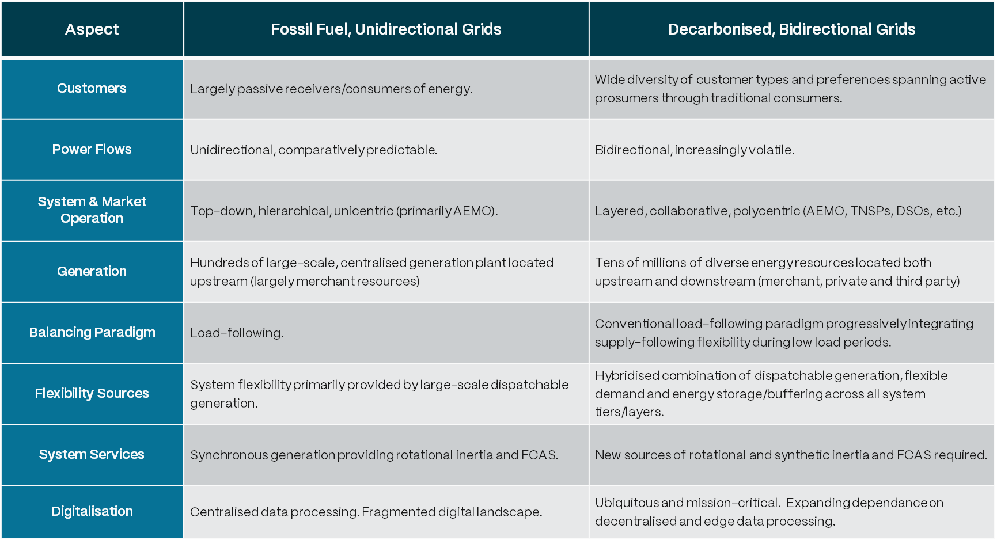

# Report Development Approach

As illustrated in Figure 1 (above), this report focuses on TDC as primarily as a physics-based engineering challenge which, in a complex transforming system, is best approached from the wider context provided by Systems Architecture disciplines. Key aspects of the report development are outlined below.

## Philosophy

The set of reports has been developed through the lens of Design Thinking and underpinned by Systems Engineering, Systems Architecture and related disciplines. In doing so, it attempts to take a longer view of whole-system transformation relevant to the NEM and the increasingly critical role of DSO models for achieving the key objective of the federal National CER Roadmap initiative [1].

*Figure 2: The reference set of five reports applies a Design Thinking approach to whole-system transformation underpinned by Systems Engineering and related disciplines*

As noted previously, the reference set is designed to underpin a subsequent Detailed Architecture process that provides an integrated approach for navigating Australia’s timely and efficient deployment of DSO and TDC models (i.e. ‘solution space’). As illustrated in Figure 2, the five reports developed in AR-PST Stage 4 evaluate the divergent global and Australian content relevant to each of the topics covered (i.e. ‘problem space’). This enables a rigorous, objective and traceable means for reporting and converging on the most critical issues that must be addressed to develop future-ready solutions enabled by constructive multi-stakeholder collaboration.

## Working Definition

In developing the report, the following definition of Transmission-Distribution Coordination (TDC) was distilled:

*A formalised and increasingly automated approach for aligning system planning, operational and market interactions and related data exchanges across the System Operator (AEMO), Transmission Networks and emerging Distribution System Operators (DSO) to enable secure, scalable and cost-efficient operation of a decarbonising power system.*

*TDC becomes necessary as power systems decarbonise, conventional sources of generation and flexibility are progressively withdrawn, and significant new volumes of supply, flexibility, buffering and system services must be sourced both upstream and downstream. Unlike conventional grids where services were largely provided by upstream merchant resources, the transforming landscape will require generation capacity and system services to be sourced from thousands of utility-scale and millions of distributed resources.*

*In this increasingly dynamic environment, active operational interdependence between upstream and downstream entities, resources and systems becomes essential to efficiently source, coordinate and co-optimise these services with the spatial and temporal needs of the end-to-end system.*

*Priority areas of TDC design are expected to include enhanced, low latency data transformations and exchange relevant to the joint management of frequency, voltage, congestion, energy flows, essential system services (ESS) and supply-demand balancing underpinned by end-to-end visibility and operational coordination models.*

For clarity, advanced forms of coordination between the transmission and distribution systems must be considered simultaneously from a top-down strategic policy perspective focused on outcomes and a bottom-up cyber-physical engineering perspective focused on practical implementation. The former typically falls under the topic of Transmission-Distribution Coordination (TDC) models, and the later under Transmission-Distribution Interface (TDI) design, although these labels are often used interchangeably in the literature.

For clarity, when referring to the concept of TDC, this report assumes the combined aspects of both TDC and TDI unless stated otherwise.

## Development Methodology

The global literature relevant to TDC models is extensive, often highly complex and jurisdiction specific. By nature, it is difficult for decision makers to penetrate and apply, particularly in another context such as Australia.

Guided by the principles and methodologies outlined in Appendix A, the report development required several iterative loops, in consultation with several Australian industry stakeholders and policy representatives, through the following steps:

* Clarify the scope and purpose relevant to Australia and synthesise into a working draft table of contents for stakeholder review and feedback.
* Update the report structure informed by feedback provided by CSIRO, AEMO and DNSP staff.
* Identify the most relevant sources from the expansive global literature with a particular focus on the United Kingdom, the United States, the European Union and Australia.
* Interrogate literature, capture insights targeted to TDC and harmonise and converge findings where consensus emerges.
* Further iterate the report structure reflecting insights from the literature review.
* Synthesise key findings into the corresponding report sections and identify gaps requiring further analysis and treatment.
* Undertake stakeholder review of the draft report, integrate feedback and finalise report.

## Inherent Limitations & Constraints

Given the wide-ranging nature of the reference set, the following points highlight limitations that are inherent to any such analysis. They should therefore be noted in the interpretation and application of this report subject to the formal disclaimers provided above.

* The five reports have been developed as an integrated reference set which, by definition, covers an extremely wide range of complex topics. This necessarily means that none of these topics have been treated exhaustively.
* As a reference set, it is anticipated that most readers will refer to particular content on an ‘as needs’ basis. Therefore, each of the five reports is designed to stand alone which has required some repetition of key unifying themes and concepts.
* While a modern GW-scale power system involves a complex overlay of technological, market, regulatory, economic and policy dimensions, the key principles and disciplinary perspectives applied in developing this series are outlined in Appendix A.
* Many of the topics covered by the reference set are inherently complex and some are hotly contested. This is necessary and appropriate in an evolving sector but can often be less productive than it may otherwise be due to a lack of shared concepts and language. Therefore, the development team has firstly attempted to maintain an objective and evidence-based approach. Further, to support the most informed debate, a glossary of key terms is provided in Appendix B and many report sections contain Key Concept breakouts designed to support clarity of communication.
* The reference set focuses on several emerging areas of consideration and is designed to assist navigation of the ‘emerging future’ over the next decade and beyond. It is therefore a consolidation of the development team’s understanding at the time of publishing and will likely benefit from a comprehensive update on at least a bi-annual basis.
* While a range of tools and models are employed as a basis for reasoning about how the power system and its wider societal context may evolve, it is recognised that reality is far more complex than any model or archetype can ultimately represent.
* Recognising the inherent complexity of the topics explored, the diversity of perspectives and terminology, and the many thousands of pages of global content that is more or less relevant, the following points should be noted:
  + The reference set is inherently explorative and spans numerous overlapping topics and developments, many of which are yet to mature to a point of industry consensus, either in Australia or globally.
  + Therefore, it is inevitable, expected and healthy that different readers will draw different conclusions on some or several of the topics addressed.
  + Particular content will mean more to some system actors and/or those with particular discipline expertise than others. The standpoint of the reader and the time horizon they are primarily focused on will likely influence how the desirability or otherwise of particular content is evaluated.
  + Accurately predicting the future and/or foreseeing all eventualities is impossible. Therefore, it is anticipated that some of the content contained in this reference set will prove to be incorrect. For that reason, stakeholder feedback is strongly encouraged and a formal mechanism to do so is provided below.
  + In summary, the information contained in the reference set comprises general statements based on research. No claim to represent the official policy of CSIRO, AEMO or any other third party is made.
* Finally, while each of the five reports are designed to stand alone, they are best employed as an integrated set of reference material. Reports 3, 4 & 5 in particular should be read with reference to each other.

## Accessing the Reference Set & Providing Feedback

The Energy Catalyst team deeply values excellence and humility. We believe that true leaders in times of transformational change do not overestimate their own knowledge. On the contrary, they foster and contribute to an ecosystem of diverse perspectives which enables shared understanding and mutual progress – even where differences remain.

This reference set is developed from a perspective that values exploration, discovery and convergence based on shared learning. Others will have important insights that the development team has not considered, and we would like to hear them. As noted earlier, as realists we also anticipate that some of the content contained will ultimately prove to be incorrect.

The full reference set of reports is available free for download at [energycatalyst.au/futuregrid](http://www.energycatalyst.au/futuregrid) or by scanning the following QR code.

Constructive stakeholder feedback is also strongly encouraged, and a formal mechanism is also provided for each report at the same location. Thank you in advance for your collaboration.

# Changing Grid Dynamics: The growing importance of TDC for whole-system planning and operations

A basic form of transmission-distribution coordination has been a feature of power systems since the emergence of large, interconnected grids. Information and coordination signals have always been exchanged between transmission and distribution operators although, historically, these primarily concerned one-way power flows and used telemetry and industrial protocols to share a limited set of relevant information. In many cases, anomalies were able to be resolved with a simple phone call between control rooms.

By contrast, the scope, frequency, fidelity, volume and variety of coordination signals and information sharing required to securely operate modern power systems is proliferating and will continue to do so. This is due to:

1. Increasingly volatile, atypical power flows at Transmission-Distribution Interfaces (TDI) due to the mass deployment of large and small-scale Variable Renewable Energy (VRE). This is exposing the need for more advanced cooperation on both sides of the TDI to enhance real-time congestion management, align planning and modernisation strategies, and introduce flexibility/buffering to manage system dynamics.
2. An increasingly hybridised power system requiring new mechanisms to enable the secure and efficient participation of both utility-scale VRE and millions CER/DER, manage supply/demand balancing and operate within relevant network constraints. For example, enhanced shared T-D forecasting capabilities provide aggregated visibility and predictability of CER/DER to the bulk power system.
3. World-leading levels of distribution-connected CER/DER driving material operational impacts on the end-to-end power system. In Australia, this has required DNSPs to rapidly build capability to become more active system operators rather than passive network managers as in the historical paradigm. Currently, this requirement is most pronounced cases of Minimum System Load, where mostly unmanaged DPV generation in the middle of the day displaces synchronous generators that would otherwise provide system inertia, a situation leading to insecure operation of the power system.
4. Network and system operations are becoming more digitalised. Specifically, DNSPs are increasingly relying on cloud-based digital platforms and APIs to interact with CER/DER. This is opening up new avenues for enhanced coordination across the TDI – but also introduces communication, cyber-security, and interoperability challenges.
5. Regulatory and policy-led initiatives that impact operational and market frameworks, roles and responsibilities, and strategic objectives for networks and system operators, driven by a focus on consumers and decarbonisation goals.

In this environment, legacy approaches to T-D Coordination across the T-D Interface are no longer fit for purpose. In response, system operators and networks globally are acknowledging the growing importance of enhanced TDC for whole-system planning and operations.

# Future Grid Enabler: TDC is a key structural enabler of low carbon power systems

## How TDC is characterised globally

In recognition of fast-approaching operational challenges, T-D Coordination is receiving significant and urgent attention across the globe. Many jurisdictions have stood up whole-system initiatives to collaboratively advance needed reforms to enable effective T-D Coordination. This section provides a brief snapshot of current developments and a guide to the key programs of work for the United Kingdom, European Union, United States, and Canada.

### United Kingdom

The United Kingdom has been advancing the development of a whole-system approach to the planning and operation of the grid coordinated by the recently established National Energy System Operator (NESO). In this context, Ofgem (the government regulator for UK electricity and gas markets) has been actively shaping regulatory policies to enhance NESO-DSO coordination. Their initiatives aim to:

* Encourage standardised data-sharing platforms between the NESO and DSOs to improve real-time grid operations
* Require DSOs to actively manage distributed energy resources (DERs), and
* Require DSOs to share data with NESO for better system operation.

Much of this work has had its genesis in the ‘Future System Operator (FSO) Proposal’ body of work.

|  |
| --- |
| Excerpt from Ofgem’s Future Systems and Network Regulation: Framework |
| ***Effective ESO-DSO coordination is central to unlocking the value of distributed flexibility, supporting decarbonisation, and enhancing the resilience of Great Britain’s electricity system*** [1]***.*** |

Other notable current or recent initiatives include:

* National Grid ESO - "Future of ESO-DSO Coordination", including the "DSO Implementation Plan" focused on market-based approaches to flexibility services, data sharing, and operational coordination
* The UK’s Energy Networks Association (ENA) – “Open Networks Project”, which includes work on developing common standards for data sharing between ESO and DSOs.
* UK Government – “Smart Systems and Flexibility Plan” (published with Ofgem): outlines how ESO-DSO coordination can support smart, flexible, decarbonised energy system.
* Carbon Trust – “Flexibility in Energy Systems”: a collaboration with NESO and DSOs, has been leading research on flexibility and ESO-DSO coordination. Their work includes studies on how digitalisation and smart grid technologies can enhance transmission-distribution interactions.
* Regional DSO Pilot Projects
  + UK Power Networks’ "Flexibility First" project: Testing local energy markets for ESO-DSO coordination.
  + Scottish Power Energy Networks’ "Smart System Flexibility" trials: Investigating how DSOs can manage grid constraints.

### United States

In the United States, the Federal Energy Regulatory Commission (FERC), regional Independent System Operators (ISOs) and Regional Transmission Organisations (RTOs), and industry bodies like EPRI (Electric Power Research Institute) are working on frameworks to support the level of T-D coordination possible within the legacy ‘as-built’ grid structures.

|  |
| --- |
| Excerpt from EPRI’s TSO-DSO Coordination Frameworks for DER Services |
| ***“As distributed energy resources grow, the need for enhanced coordination between transmission and distribution operators becomes essential for ensuring real-time visibility, system reliability, and efficient market participation.”*** [2] |
| Excerpt from Grid Modernisation Initiative’s Grid Modernisation Strategy 2024: |
| ***“Wide area control and operation for seamless Transmission and Distribution Integration are an important research area.”*** [3] |

Notable current or recent initiatives include:

* EPRI’s "TSO-DSO Coordination for Grid Modernisation" Initiative focuses on examining how TSOs and DSOs can better share data, improve real-time operations, and integrate DERs.
* FERC - Implementation of FERC’s Order 2222 includes requirements for TSOs and DSOs to establish new coordination protocols to manage DER aggregation.
* Grid Modernisation Lab Consortium’s (GMLC) work on improving grid resilience through better T-D coordination, including cyber-security concerns
* Grid Modernisation Lab Consortium’s (GMLC) work on layered decomposition and Laminar Coordination frameworks for distributed grid asset coordination at all levels

### European Union (EU)

In the European Union, the primary focus of TSO-DSO coordination initiatives includes congestion management; allocation of responsibility for balancing; reactive power and voltage control; enabling market-based procurement of flexibility services; and real-time information exchange to ensure overall grid stability.

|  |
| --- |
| Excerpt from ENTSO-E’s TSO-DSO Data Management Report |
| **“Strengthening cooperation between transmission and distribution system operators is fundamental for achieving an efficient and integrated electricity market while ensuring security of supply.”** [4] |
| Key Recommendation from joint TSO, DSO report on an Integrated Approach to Active System Management |
| ***“TSOs and DSOs should pursue an integrated system approach when developing new solutions and should avoid any isolated solution.”*** [5] |

Notable current or recent initiatives include:

* The European Network of Transmission System Operators for Electricity (ENTSO-E) and the DSO Entity (an industry association for European DSO’s) published a collaborative report titled "TSO-DSO Challenges & Opportunities for the Digital EU Electricity System". This report emphasises the critical role of digitalisation in improving grid operations, planning, and customer integration. It recommends implementing Digital Twins of the energy system to help solve major challenges and exploit opportunities.
* BRIDGE Initiative's TSO-DSO Coordination Report (2020): The BRIDGE initiative, under the European Commission, explored interactions between TSOs and DSOs and how best to map them. The focus lies on market design and data exchange between TSO and DSO entities, providing insights into the challenges and recommendations for effective coordination. ​
* CoordiNet Project (2019-2022): Funded under the Horizon 2020 program for research and innovation (by the European Union), the CoordiNet project conducted large-scale demonstrations to showcase how TSOs and DSOs can coordinate to procure grid services efficiently. The project concluded in June 2022, providing valuable insights into coordinated grid management. ​
* SmartNet Project (2018): This project developed a simulation platform to compare alternative TSO-DSO coordination schemes, enabling the participation of distribution network resources in ancillary services markets. It also conducted technological pilots to experiment with solutions that facilitate ancillary services provision from distribution networks.

### Canada

​In recent years, Canada has prioritised enhancing the coordination between TSOs and DSOs, headlined by Ontario’s Independent Electricity System Operator (IESO) establishment of a Transmission-Distribution Coordination Working Group (TDWG). The TDWG aims to develop conceptual coordination protocols that delineate communication processes among the IESO, Local Distribution Companies (LDCs), and DER participants, ensuring reliable and efficient system operations.

|  |
| --- |
| Excerpt from ‘Development of a Transmission-Distribution Interoperability Framework’ compiled for IESO |
| ***“Enhanced operational coordination between the distribution and transmission systems will be required to preserve safe and reliable operation, while enabling DER value and cost-effective electricity services.”*** [6] |

Other notable current or recent initiatives include:​

* Ontario Energy Association’s (OEA) DSO Study (December 2023): This study examines the impact of TSO-DSO coordination on integrating Distributed Energy Resources (DERs) and leveraging their flexibility for a more efficient system. It highlights the potential for cost reductions and improved efficiency through enhanced coordination [7]. ​
* Independent Electricity System Operator (IESO)’s Development of a Transmission- Distribution Interoperability Framework (2020): The IESO released a framework to guide the province of Ontario in designing a transmission-distribution interoperability model. This framework aims to facilitate effective coordination between TSOs and DSOs, ensuring reliable and efficient grid operations amidst increasing DER integration [6].
* EPRI authored ‘Technical Brief on Procuring Services from DERs (2020)’: This technical brief discusses the coordination between Independent System Operators (ISOs), DSOs, and DERs. It adopts a hierarchical structure to describe coordination needs and emphasises the importance of aligning operations across different system levels to effectively integrate aggregations of flexible distribution-connect resources [8]. ​

## Problem definition underpinning the need for TDC

Australia’s electricity system is undergoing a rapid transition driven by the rise of CER/DER, including rooftop solar, batteries, and electric vehicles (EVs), combined with decarbonisation goals and correlated deployment of utility-scale VRE. This shift is fundamentally changing the way that energy flows through the power system, which is creating operational, market, and reliability challenges that require enhanced coordination between the Bulk Power System (BPS) and downstream distribution networks.

This is largely due to the variability in the instantaneous temporal and locational make-up of the fleet of resources impacting and able to be effectively managed in the supply-demand balancing process. The need for formalised Transmission-Distribution Coordination (TDC) arises directly from the resulting mismatch between the system’s legacy design and the realities of Australia’s transforming power sector.

From a strategic perspective, the absence of effective TDC constrains the systemic ability to meet customer and societal objectives (Report 1), increases whole-system vulnerability to many of the emerging trends impacting power systems (Report 2), and exacerbates multiple systemic issues (Report 3).

Collectively, this emphasises the importance and criticality of effective and robust TDC for:

* Addressing near-term system security and reliability challenges associated with the increasing aggregate impact of rooftop solar in Australia’s energy systems, and the resulting implications for system operability
* Establishing the foundations for the operational coordination required to enable a truly ‘two-sided’ energy system, enabling DER aggregation, and capitalising on the flexibility available within the distribution system.

TDC and System Objectives (Report 1)

Insufficient or ineffective TDC directly undermines the system’s ability to deliver against the future Customer & Societal Objectives set out in Report 1. Secure TDC structures are critical to ensuring that customer and societal expectations—dependability, affordability, sustainability, equity, empowerment, expandability, adaptability, and public benefit—can be practically delivered in a grid increasingly shaped by active consumer participation. In the absence of well-implemented TDC, customer investments in the distribution system are likely to be under-utilised, optionality for systemic resilience will decline, and the system’s adaptability to new business models and technologies may be impaired.

TDC and Emerging Trends (Report 2)

Emerging trends catalogued in Report 2 further amplify the risks associated with poor or insufficient TDC. As the report intimates, Australia’s grid transformation is characterised by rapid growth in inverter-based renewables, CER/DER participation, bi-directional power flows, sector-coupling, and real-time operational complexity. The increasing diversity of actors—including aggregators, CER/DER service providers, and multi-sector players (i.e. EV manufacturers) —will exert growing influence across both operational and market layers, without any obligation or accountability for system security unless orchestrated with the support of TDC. Without deliberate coordination frameworks, these trends create unpredictable interactions, fragmented resource optimisation, and new systemic vulnerabilities across both transmission and distribution domains.

TDC and Systemic Issues (Report 3)

Many of the Systemic Issues and Transformation Risks identified in Report 3 stem from the growing operational interdependence between the Bulk Power System (BPS) and distribution systems. Without TDC, critical problems emerge across structural operability (such as balancing risks, system visibility gaps, and coordination failures), digital scalability (including data sharing, solution scalability, and cyber-security vulnerabilities), and sectoral alignment (including unclear roles, responsibility gaps, and conflicting aggregator behaviours). Where inadequate TDC leaves these issues unresolved, these structural weaknesses limit the system’s ability to operate securely, efficiently, and predictably as participation scales.

In summary, without proactive and scalable TDC frameworks, the power system will face growing fragility precisely at the time when its operational complexity and societal importance are both rapidly intensifying. Formalising TDC is thus not simply an incremental policy adjustment—it is a structural necessity for safely integrating the emerging generation mix, preserving system coherence, and securing equitable customer and societal outcomes as the system evolves.

From a functional perspective, in contrast to historical operational philosophies, expanding system volatility and bidirectionality requires that the power system is coordinated from both a SO-down and DSO-up orientation simultaneously. In the absence of such an approach, several whole-system vulnerabilities will arise. This can result in uncoordinated or insufficiently coordinated actions across the end-to-end system. **Error! Reference source not found.**

Table : Impacts of uncoordinated actions of the Bulk Power System and the Distribution System

|  |  |  |
| --- | --- | --- |
| Action | Uncoordinated Market/BPS Actions that Impact Distribution System or Require DSO intervention | Uncoordinated DSO Actions that Impact BPS or Require SO intervention |
| Uncoordinated DER Output, Dispatch or Curtailment | Market dispatch of aggregations or curtailment of DER without considering limits in the distribution operating zone, causing, e.g. voltage fluctuations, tripping of protection devices, or damage to network assets. | DSO permits aggregate DER injections within their operating zone, exceeding secure levels at the BPS level, leading to e.g. insufficient loading for synchronous generating units required for stability, ramping/volatility unable to be managed in the supply-demand imbalance. |
| Inaccurate Load and Generation Forecasting | BPS forecasting does not appropriately account for CER/DER variability, leading to forecasting errors impacting scheduling and dispatch, requiring additional active power reserves to manage. | DSO activities impacting net load at the T-D interface which the Market/BPS is unaware of or unable to take into account, including active management of DER and load control. |
| Conflicting Grid Support and Stability Management Actions | CER providing frequency support for the BPS results in local active power injection/withdrawal resulting in adverse impacts in the distribution network, e.g. customer voltage violations or interference with distribution feeder overcurrent relays, resulting in increased vulnerability to arcing high impedance faults. | DSOs implement voltage regulation actions conflict with BPS-level reactive power management, causing instability. DSOs deactivate sets of CERs due to local real time circuit conditions on short time scales, thus removing them from anticipated (BPS forecasted) availability. |
| Inefficient Congestion Management | Insufficient VRE curtailment at the Market/BPS level causes excessive CER curtailment at the distribution level. Over planning timeframes, overinvestment in network capacity, de-valuing contributions from CER/DER. | DSO unprepared and unable to offset oversupply of DPV with FTM storage headroom when BPS is under minimum load conditions. Over planning timeframes, DSO underinvests in capability leading to unnecessary investment in HV transmission infrastructure. |

|  |  |  |
| --- | --- | --- |
| Uncoordinated Network Switching and Topology Changes | BPS/TNSP changes electrical settings at T-D interconnection points at short notice (for load balancing/congestion management or fault management), changing the relationships of CER/DER to the grid, and changing conditions that the DSO has used or is using. | DSO/DNSP switches circuit sections on short notice (for load balancing/congestion management or fault management), changing the relationships of CER/DER to the grid, and changing conditions that the BPS has used or is using. |
| Uncoordinated Emergency Actions or Constraints | BPS dispatches aggregator CER/DER on recently degraded, islanded, or faulty network segment. | DSO switches or applies constraints on DER to connections providing FCAS services to the BPS. |
| Conflicting or Mismatched Price Signals | Dynamic BPS market prices consistently exceed compensation for local network services, prompting customer agents to only participate in the wholesale market. | DSOs flexibly contract CER/DER participation in local network services markets without temporal alignment to wholesale market, leading customer agents to switch markets on an intra-day basis, which causes instability. |
| Fairness not Observed | BPS augments/upgrades capacity such that a single DSO has an unfair competitive advantage over other DSOs. DSO administered distribution-connected assets are excluded from providing certain services by BPS. | DSO administered distribution-connected assets displace BPS plant that is contracted at a minimum level of service provision. |
| Cybersecurity | BPS suspects cyber-compromised systems and deactivates large population of distribution-connected resources, causing instability on distribution networks. | DSO disconnects large population of cyber-compromised OEM systems at short notice causing supply/demand imbalances at BPS. Similarly, the DSO’s IT environment may also be cyber-compromised. |

In contrast to historical norms, these challenges cannot be addressed by individual actors applying solutions within the boundaries of their existing operational responsibilities. They must be addressed together and therefore new mechanisms for operational coordination across the transmission-distribution divide are critical.

## Strategic objectives for T-D Coordination

Under AEMO’s 2024 Integrated System Plan Step Change scenario, rooftop solar capacity is forecast to quadruple to 72GW of installed capacity, and CER storage is forecast to account for 66% of the NEM’s storage capacity by the year 2050 [9]. CER already provides more than 100% of instantaneous generation in South Australia at times [10]. Beyond kilowatt hours, CER is also expected to provide a range of other services both locally, and into the wholesale market via customer agents. Distribution-connected FTM DER, such as community batteries and generation assets, are anticipated to provide ‘downward’ services to consumers and local network services, and ‘upward’ services to wholesale markets. This emerging operational environment presents several new challenges to joint T-D system operation, as well as significant opportunities for T-D Coordination to support a future-ready power system. In this context, Table 3 offers seven strategic objectives for enhanced Transmission-Distribution Coordination, grouped by two high-order objectives of Whole-system Visibility, Coordination & Balancing and Whole-system Cost Efficiencies (CAPEX & OPEX).

Table : High-level Strategic Objectives for TDC

| **High-Level Objectives** | **Description** | **Objective** | **Description** |
| --- | --- | --- | --- |
| **Whole-system Visibility, Coordination & Balancing** | In a decarbonising power system, an expanding responsibility of a DSO is active participation in the two-way coordination of power flows and data exchange between the upstream bulk power and downstream distribution systems. Unlike the conventional unidirectional operation of the grid, Transmission-Distribution Coordination (TDC) plays an increasingly critical role in whole-system operability as power systems become increasingly volatile and bidirectional. For example, architecturally informed DSO and TDC data structures enable end-to-end visibility which also underpins predictability and observability. They also enable the transition to multi-layer operational coordination and the co-optimisation of layered markets should they exist. In practice, by actively managing load flexibility and CER/DER across an entire distribution system, the DSO becomes an active participant in ensuring whole-system security and economic optimisation by providing dynamic, location-sensitive services that complement bulk power and transmission operations. | 1. Facilitate system reliability and stability | Effective T-D Coordination will help ensure real-time supply/demand balancing, resource adequacy, voltage control, frequency regulation, and system restart capabilities as well as avoid operational conflicts. |
| 1. Support more effective CER/DER integration | In the NEM, the increasing frequency of minimum system load events is being driven by uncoordinated CER/DER together with inadequate shared T-D forecasting capabilities resulting in limited security margins. In some cases, this results in blunt curtailment of DPV. Enhanced coordination mechanisms would allow for higher volumes of DPV, moderate required security margins, and increase confidence in the efficacy of emergency controls where needed. |
| 1. Increase Cybersecurity and Resilience | Coordinated cyber-planning, operations and threat-response measures helps address new vulnerabilities introduced by the CER and their enabling communication systems at the distribution level. |
| 1. Support Distribution-level Market Development | TDC enables distribution-level markets by providing the visibility, coordination, and operational integration needed to safely and efficiently dispatch DER services across both local and system-wide needs, ensuring that market participation aligns with real-time system security, congestion management, and whole-of-system optimisation. |
| **Whole-system Cost Efficiencies (CAPEX & OPEX)** | In an increasingly volatile power system, the participation of DSOs in actively coordinating two-way flows of power, services and data between the transmission and distribution systems has strong potential to enhance whole-system efficiencies over various timescales. From a system planning perspective, the scale of new upstream generation, storage and transmission investments may be moderated as the utilisation of existing assets is enhanced and an expanding set of system services are enabled through the DSOs. From a system operations perspective, enhanced real-time visibility and predictive analytics, underpinned by architecturally informed data structures, enable much more fine-grained operational coordination across the end-to-end system. As the proportion of overall system generation, storage and flexibility resources which are connected at the distribution level continues to expand, this will become even more critical as the need for multi-layer balancing also grows over time. | 1. Enable Co-optimisation of Network Utilisation | Joint T-D planning enables better transmission and distribution network capacity management, avoiding congestion, minimising the need for augmentation and targeting investment for system-wide benefit. Effective T-D Coordination can enable this over the planning time-horizon through whole-system integrated planning procedures and the operational timeline. Figure 3 shows the expanding number of relationships between distribution planning functions and transmission planning functions. |
| 1. Promote Economic Efficiency and Reduce Operational Costs | T-D Coordination schemes that align with and support complimentary DSO Models can promote more cost-reflective procurement of energy services. For example, local DSO-administered distribution-level energy markets that enable more localised trading of energy could reduce reliance on transmission assets, reducing associated costs (noting that distribution-level costs may increase). |
| 1. Streamline Operational Coordination through Standardisation | Proactively providing guardrails on T-D Interface design will simplify implementation, especially where it enables upstream entities to coordinate in a consistent way with several downstream actors. |

Figure 3 -Typical present-day scenario (top) and future scenario (bottom) in which increased coordination is required to manage a decentralised system [11]

## Working definitions of TDC and TDI relevant to Australia

Transmission-Distribution Coordination (TDC) is an expansive topic that touches on many aspects of the power system. The following is provided as a draft definition and description of relevance and key aspects that would benefit from further collaborative enhancement with Australian consumers, industry and regulators.

**Transmission-Distribution Coordination (TDC)**

*A formalised and increasingly automated approach for aligning system planning, operational and market interactions and related data exchanges across the System Operator (AEMO), Transmission Networks and emerging Distribution System Operators (DSO) to enable secure, scalable and cost-efficient operation of a decarbonising power system.*

*TDC becomes necessary as power systems decarbonise, conventional sources of generation and flexibility are progressively withdrawn, and significant new volumes of supply, flexibility, buffering and system services must be sourced both upstream and downstream. Unlike conventional grids where services were largely provided by upstream merchant resources, the transforming landscape will require generation capacity and system services to be sourced from thousands of utility-scale and millions of distributed resources.*

*In this increasingly dynamic environment, active operational interdependence between upstream and downstream entities, resources and systems becomes essential to efficiently source, coordinate and co-optimise these services with the spatial and temporal needs of the end-to-end system.*

*Priority areas of TDC design are expected to include enhanced, low latency data transformations and exchange relevant to the joint management of frequency, voltage, congestion, energy flows, essential system services (ESS) and supply-demand balancing underpinned by end-to-end visibility and operational coordination models.*

It is important to note that the terms Transmission-Distribution Coordination (TDC) and Transmission-Distribution Interface (TDI) are often used interchangeably, but an important distinction between them can be made. TDC refers to the concurrent and collaborative management of the electricity system by the system operator, distribution system operator, and their respective market operators, to ensure secure and reliable operation, supply/demand balance, and economically efficient markets. In other words, it considers the broader structural arrangement of actors and division of roles and responsibilities from both a technical and policy perspective.

TDI has historically described the electrical boundary between the transmission system and the distribution system. This is generally the secondary side of a step-down supply transformer supplying the distribution network, seen as a load from the transmission side. With more and more embedded generation and DER within the distribution, this interchange is becoming increasingly bidirectional.

In this context, TDI now commonly implies a broader concept: the set of discrete systems, processes, digital integrations and cross-entity interactions that provide the counterparty with the necessary control, visibility and predictability needed for whole-system stability. Typically, the operating infrastructure that constitutes the T-D Interface will reside in the respective OT, IT, SCADA, telemetry, control systems and third-party cloud-based environments of both transmission system (i.e. bulk power system) operations and distribution system operations. These systems support the coordination of transmission and distribution systems at their physical and electrical boundary, and a working definition is provided below.

**Transmission-Distribution Interface (TDI)**

*The physical points at which the bulk power/transmission system and a particular distribution system interconnect, typically at one or several major substations.*

*In a conventional, unidirectional power system this has been commonly known as the Bulk Supply Point (BSP), where electricity from the bulk power system is delivered via the transmission network to regional and metropolitan distribution networks.*

*While conventional aspects of the B remain unchanged, the TDI concept represents the need to transition to a more active, two-way interface model capable of enabling the required Transmission-Distribution Coordination (TDC) functions in support of effective whole-system operation.*

In summary, TDC and TDI are inter-dependent. The organisational responsibilities and processes established under a TDC scheme must be enacted by the digital, control and electrical systems of the TDI. Alternate TDC schemes will introduce varying levels of complexity into the implementation of the TDI. Therefore, the capabilities and legacy structural arrangements of the TDI must be considered when establishing TDC schemes. Conversely, the strategic objectives of TDC schemes should not be unduly constrained by the current capabilities of the TDI.

# Design Considerations: Key considerations for effective T-D Coordination model design

Both Distribution System Operator (DSO) and Transmission-Distribution Coordination (TDC) models are best understood as critical structural interventions that are required to enable a decarbonising, high-CER/DER power system to operate securely and efficiently. Although performing distinct functions, DSO and TDC models together with their enabling structures directly impact the pressing issues of whole-system visibility, operational coordination and system balancing.

As the consideration of these models has evolved over the last 10–15 years, the discussion has often been shaped around a set of high-level structural options for how these formalised capabilities may function with the rest of the power system. While a range of different names have been used internationally, three structural archetypes have commonly been advanced for discussion.

Each of these structural models are briefly described in Table 4. As theoretical concepts, the three models have typically been advanced as a basis for comparative economic analyses, often in a manner that suggests they are all similarly credible technological options. This limitation appears to have remained unaddressed and been compounded by the absence of applications of Systems Engineering in the electric power sector coupled with an inadequate awareness of the specific structural constraints embedded in today’s legacy grid arrangements.

However, these non-trivial constraints, inherited from the architectural arrangements of a unidirectional system, directly impact whole-system visibility, operational coordination and system balancing. They are a fundamental reason that structural analysis cannot be sidestepped if the NEM is to be made able to cost-effectively support the very different futures represented by AEMO’s ISP scenarios, not least the high-CER/DER Step Change scenario.

It should also be noted that while there are three basic structural archetypes that have been advanced over the last decade, several different names have been employed in different jurisdictions. To assist with clarity, these three categories have been assigned a simple, accurate title that reflects the predominant, distinguishing features of each structural archetype, namely: Top-down, Multi-entity and Layered Coordination.

Table : Three structural archetypes that are commonly advanced in the context of exploring DSO and TDC models

|  |  |  |  |
| --- | --- | --- | --- |
| Category | Conceptual Schema | High-level Description | Sources & Different Terms Used |
| Top-down |  | The System Operator (SO) of the bulk power system has responsibility to manage all participating resources that are connected across the transmission system and each related distribution system, including all CER/DER. The DSO role in this case is limited and is closer to that of a conventional DNSP than in any other category. | * Total ISO [66] * Total TSO [65]; [66], [67], [68] * ESO Coordinates [70] * Single Integrated Platform [71], [72] |
| Multi-entity |  | The upstream SO and the relevant downstream DSO both have operational responsibilities for managing and/or influencing the operation of distribution-connected resources as do CER/DER aggregators. Enabling scalable operational coordination and market co-optimisation under this model requires significant additional cyber-physical and computational platform investments. | * Hybrid Model [65], [67], [68]’ [69], [71], [72] * Coordinated DSO and ESO Procurement [70] |
| Layered Coordination |  | The DSO has overall responsibility to manage the reliable and cost-optimised performance of the distribution system as an interdependent system layer, including network and non-network assets such as CER/DER. The DSO communicates aggregated data to the SO, and both entities actively manage the two-way interdependencies between the bulk power and distribution systems. | * Total DSO [65], [66], [67], [68], [69] * Two-Step Tiered Platform [71], [72] * DSO Coordinates [70] |

## Formalised structures for whole-system alignment

GW-scale power systems are typically hierarchical – the bulk power system is made up of several transmission networks, which each interface with several distribution networks.

Figure : Hierarchical Structure of Power Systems

Without countermeasures, this can lead to bespoke and disparate bilateral arrangements between the System Operator and TNSPs and between the System Operator and individual DSOs. Further, a single VPP or aggregator entity may need to interact concurrently with many different DSOs and the wholesale market. Without standardised interfaces, complexity escalates, and implementation and operational costs increase.

Each TDI should therefore preferably provide for a distinct, private (closed), and secure informational environment for each SO, TNSP and DSO/DNSP while enabling common interfaces and features for all DSOs. This reduces the complexity and risk of an unmanageable proliferation of interfaces, datasets and control signals. Such a common platform simplifies implementation and operation and reduces related costs for all parties [13].

Cross-jurisdictional standardisation should also be pursued where appropriate. Vendor offerings for utility and VPP DERMS commonly operate across multiple international markets and in the future should be required to adapt their systems to integrate with both DSOs and the System Operator. Given Australia’s smaller market size and influence over vendor offerings, TDI designs that reduce the overhead of adapting systems designed for other international markets will reduce implementation costs and reduce technical barriers to market entry and service provision by aggregators [14].

Regulatory provisions that encourage, and where appropriate, enforce standardisation across the TDI are also essential. In the EU, a key finding of project SmartNet was that without common EU regulations, diverse and non-harmonised agreements between TSOs and adjoining DSOs will be typically implemented [15].

## Formalised information requirements of relevant upstream and downstream entities

In many jurisdictions, initiatives are underway to map the flow of required information through the T-D Interface, either generally or under a specific T-D Coordination model. The formalised outputs of two such initiatives are provided in what follows.

### FERC Order No. 2222 Derived Information Requirements

A recent assessment of functional requirements embedded in FERC Order No. 2222 for TSO-DSO-Aggregator coordination, an assessment commissioned by the US Department of Energy, derived the following set of required information across three core functional areas: DER Registration, Market Coordination, and Operational Coordination [13]. It should be noted that FERC Order No. 2222 is focused on enabling a hybrid model for the coordination of CER/DER participation in wholesale markets and the information requirements identified in the assessment reflect that model of operation. The information origin, source, owner, and responsible maintainer are not specified, as these would likely differ depending on the specific RTO/ISO, DSO and Aggregator roles and responsibilities.

**DER Registration**

|  |  |  |
| --- | --- | --- |
| ID | Functionality | Description |
| R1 | Asset Registration | DER Aggregator register DER assets (“once”), including detailed technical specifications (asset type, location, size and connection point) and ownership details common to all services and markets. |
| R2 | Operating Parameters & Characteristics | Details about the operational aspects of DER assets including performance characteristics, metering, telemetry, and control capabilities. |
| R3 | Interconnection and Operational Constraints | DER interconnection and deliverability parameters, including interconnection requirements and any specific market access limitations (e.g., export limits and temporal constraints). |
| R4 | DER Aggregation Information | Detailed data about DER aggregations including DER composition (e.g., flexible load, distributed generation, and battery storage) and aggregate operational characteristics. |
| R5 | DER Aggregator & DER Owner Registration | Registration of DER Aggregators and participating DER owners including relevant company information (e.g., ownership, contacts and any required regulatory certifications). |
| R6 | Bulk System Operator, Distribution Utility, and Retail Regulatory Jurisdiction Information | Identification of relevant distribution utilities, retail regulatory jurisdiction/s, wholesale market operators, including market and operational contact information and relevant market operational rules, tariffs and other information associated with the provision of DER services. |
| R7 | Aggregation Rules & Market Participation Rules Pre-qualification | Enable initial qualification based on wholesale retail rules for aggregating DERS provision of DERS services for wholesale markets distribution. |

**Market Coordination**

|  |  |  |
| --- | --- | --- |
| ID | Functionality | Description |
| M1 | DER Services Registration | Register specific services offered by DER aggregations. |
| M2 | DER Services Opportunities | A list (or a map) with details on opportunities to provide wholesale and distribution services. |
| M3 | Market Participation Rules Validation | Validation to ensure DERAs adhere to specific market participation rules, such as bidding procedures, pricing structures, and pre-determined operational constraints. |
| M4 | Dual Participation Validation | Validation of DER participation in both local and wholesale markets, ensuring there are no conflicts or issues arising from their dual involvement. |
| M5 | Day-ahead Distribution Operator Validation of Wholesale Commitments | Distribution operator confirmation that DERs are capable of delivering on their wholesale market commitments. |
| M6 | Automated Services Bidding | Automated system for multiple wholesale market and distribution services bidding. |
| M7 | DER State Information & Readiness | Captures real-time information on the state and readiness of each DER, including its availability, current operating capacity, and potential issues affecting performance. |
| M8 | DER Asset Outage & Curtailment Management | Manages DER asset outages and curtailment including derations, notification procedures, and coordination of response strategies. |
| M9 | Coordination of Dispatch Instructions | Coordination of bulk system and distribution dispatch instructions to ensure optimal use of DERAs including real-time adjustments based on system conditions. |
| M10 | Market Conflict Identification | If one asset is participating in two markets (and is operating within the defined market rules), and there is a conflict, users are alerted to it. |
| M11 | Reporting on DER Bidding Dispatch Changes Performance | Provide transparency on dispatch instructions changes to dispatch performance. |
| M12 | Market Monitoring | Enable continuous observation of wholesale distribution market activities, enabling identification of regulatory issues, market faults, and security issues via analytics processes. |

**Operational Coordination**

|  |  |  |
| --- | --- | --- |
| **ID** | **Functionality** | **Description** |
| O1 | Real-Time T-D Node Visibility | Visibility into the Transmission-Distribution (T-D) interface with real-time data on node performance, energy flows, and potential constraints. |
| O2 | DER Reliability Monitoring | DER Compliance with technical standards for interconnection and performance to ensure reliability and safety of the grid. |
| O3 | Distribution Grid State Information | Real-time operational information on specific distribution grid outages, curtailments, and other changes to deliverability including affected locations and expected duration. |
| O4 | T&D Deliverability Optimisation | Capability to enable optimising demand and supply (e.g., constraints) across transmission and distribution. |
| O5 | Operational Instructions Record | Real-time operational log of actions involving changes in deliverability of DER services due to changes in grid conditions (e.g., outages, line derates, circuit switching, etc.). |

In addition, the analysis identified the following cross-cutting requirements relevant for both market and operational coordination mechanisms:

|  |  |  |
| --- | --- | --- |
| ID | Functionality | Description |
| N1 | Standard Data Model | Standard data model that underpins asset, product, and market participant definitions that are used to categorise, describe, and harmonise them across multiple markets, thereby helping participants to find each other and compare products and assets. |
| N2 | User Registration | Registration of users onto the exchange facilitating access to multiple markets through a unified experience. |
| N3 | Role-Based Access Control System | Enable management of user read/write privileges (e.g., Aggregators, DSOs, TSOs, Regulators) with secure access protocols. |
| N4 | Transaction Logging and Historical Data Archiving | Maintain record of all data on prices, volumes, dispatch, trades, metering and settlement as well as interactions and changes within the registry for audit and analysis. |
| N5 | Data Management | Provide efficient, standardised management of data related to DER performance, market transactions, operational activity, and compliance. |
| N6 | Reporting | Provide user defined reports on DER participation and performance, market and operational activity, and related compliance information. |
| N7 | Transparency & Accessibility | Ensure that market participation is transparent and accessible to all qualified DERs and aggregators without undue barriers. |
| N8 | Systems Interoperability | Interoperability with DER Aggregator, TSO, and DSO systems through the implementation of secure Application Programming Interfaces (APIs) using open standard protocols to facilitate seamless communication and operational coordination. |
| N9 | Telemetry Interfaces | Enable interfaces with required telemetry, which can be either individual DER or DER Aggregation level. The level of telemetry required may depend upon the nature of the DER’s participation and wholesale market rules. |
| N10 | Secure & Reliable Communication Channels | Enable robust communication channels for exchange of operational data, market signals, and dispatch instructions. |
| N11 | Business Process Approval Functions | System enables process mechanisms to ensure implementation of markets and operational processes related to approval processes. |
| N12 | Security & Privacy Protections | System enables compliance with security and privacy standards for market and operational data and registry information. |
| N13 | Flexibility & Scalability | System can accommodate millions of DERs involving a wide range of technologies and aggregation compositions, adapting to evolving market conditions and technological advancements. |

### Independent Electricity System Operator (Ontario, Canada) Information Requirements

In Canada, the Independent Electricity System Operator (IESO) has established the **Transmission-Distribution Coordination Working Group (TDWG) to develop conceptual coordination protocol(s) that detail the communications among the IESO, Local Distribution Companies (LDCs), and DER participants for participation in the IESO-Administered Markets. The TDWG has identified the following key datasets grouped by recipient:**

**Upstream Data Submitted to IESO:**

|  |  |
| --- | --- |
| Registration, Facility & Other Miscellaneous Data | |
| Data Exchanged | * Registration, facility, and other miscellaneous data: Participation, registration, and facility data including connection assessment, system impact assessment, technical studies, agreements, installation, authorisation, Single Line Diagram (SLD) & Facility Description Document (FDD), technical facility data (e.g., forbidden regions), Minimum Loading Point (MLP), Minimum Generation Block Run-time (MGBRT), Elapsed Time to Dispatch (ETD), start-up time, min shutdown time), emergency preparedness plans, system restoration plans, reliability data, settlement & invoice concerns, errors & requests, testing & audit data submissions, reports, contributor info, etc. |
| Frequency / Timing | * Some data is provided once upon registration; other data may be updated as changes occur or provided as required. |
| Data Coordination Interfaces | * IESO Gateway: Secure identity Provider (IdP) provides access to market-facing applications. * Online IESO: Web-based registration system allowing all organisations involved in the IESO-Controlled Grid (ICG) & IESO-Administered Markets (IAM) to complete a variety of interactive business tasks and submit information to the IESO in a safe, secure, and efficient manner. The Online IESO system securely hosts a number of market applications. |
| Comm. Mediums | * Internet (user account/identity credentials required for authentication & access to secure IESO web servers & systems). * Email used for some communications & data submissions. |
| Parties Involved | * Data submitted by registered Market Participants (MPs) and Distributors connected to the IESO-Controlled Grid. * This data is received by the IESO and used by multiple internal applications within the IESO. |

|  |  |
| --- | --- |
| Dispatch Data | |
| Data Exchanged | * Dispatch Data: Real-Time Energy bids/offers (2-20 Price/Quantity pairs), Ramp rates (up to 5 sets of ramp up/down values), Operating Reserve (OR) Bids/Offers (2-5 Price/Quantity pairs), energy schedules, energy forecasts, dispatch data and technical data for use in the Day Ahead Commitment Process (DACP) including daily energy limit, 3-part offers for non-quick starts (start-up costs, speed no load costs, incremental energy costs), daily generation data (MLP, MGBRT, Max # of starts per day), etc. |
| Freq./Timing | * Dispatch data may be submitted (without restriction) from 06:00 EST day-ahead until 2 hours prior to the dispatch hour for which the submitted data applies. Standing dispatch data can be submitted at any time in advance of the 06:00 EST day-ahead. To be considered for optimisation in the DACP, dispatch data must be submitted before 10:00 EST day-ahead (or between 10:00-14:00 if a valid reason code is provided). |
| Data Coordination Interfaces | * IESO Gateway: secure identity provider (IdP) provides access to market-facing applications. * Energy Management Interface (EMI): web-based application used for participating in the RT Energy and OR Markets to submit and manage dispatch data. Some MPs also submit data via an EMI Application Programming Interface (API). |
| Comm. Mediums | * Internet (user account/identity credentials required for authentication & access to secure IESO web servers & systems). * Certain information (e.g., change requests in mandatory window) must be communicated via telephone to the IESO Control Room |
| Parties Involved | * MPs participating in IAM, including generators (dispatchable, self-scheduling, intermittent, variable), electricity storage participants, dispatchable loads, hourly demand response resources, etc. * This data is received by the IESO and used by multiple internal applications within the IESO. |

|  |  |
| --- | --- |
| Outage Data | |
| Data Exchanged | * Outage Data: Planned and actual start/end dates & times, equipment description, equipment criticality, priority code (forced, urgent, planned, etc.), purpose code (maintenance, repair, replace, testing, etc.), constraint code (out of service, derate, protection out of service, etc.), max recall time, recurrence, MW & MVAR impact. Distributor-specific: >20MW deviations from average weekday demand/supply, demand control actions, etc. |
| Freq./Timing | * As required. Equipment criticality dictates the timeframes within which a planned outage request must be submitted. |
| Data Coordination Interfaces | * IESO Gateway: secure identity provider (IdP) provides access to market-facing applications. * Outage Management Control Room Operations Window (CROW) Application: Web-based outage management system used for coordinating, scheduling and tracking outages. Some MPs also submit data via an outage management system API. |
| Comm. Mediums | * Internet (user account/identity credentials required for authentication & access to secure IESO web servers & systems). * Certain types of outages and information must be communicated via telephone to the IESO Control Room. |
| Parties Involved | * Data submitted by registered MPs and Distributors connected to the ICG1. * This data is received by the IESO and used by multiple internal applications within the IESO |

|  |  |
| --- | --- |
| Telemetry | |
| Data Exchanged | * Telemetry: Real Time Telemetry from Field including active power (MW), reactive power (MVar), apparent power (VA), voltage (kV), frequency (Hz), unit status, breaker status, equipment status, direction of power flow, transformer low and high side measurements, phase-to-phase voltage, state of charge, dynamic max/min power, base point, meteorological data, etc. |
| Freq./Timing | * Telemetry monitoring and performance requirements vary by resource type and size. |
| Data Coordination Interfaces | * Supervisory Control and Data Acquisition (SCADA) / Energy Management System (EMS): system of remote control and telemetry used to monitor and control the electric system. |
| Communication Mediums | * IESO receives telemetry via one of three methods: * Remote Terminal Unit (RTU) via DNP3 (Distributed Network Protocol 3) * Intermediate communication gateway (HUB) * Inter Control Centre Communication Protocol (ICCP) link. |
| Parties Involved | * Telemetry submitted by registered MPs and Distributors connected to the ICG1. * Telemetry data is received by the IESO and used by multiple internal applications within the IESO. |

|  |  |
| --- | --- |
| Revenue Meter Data | |
| Data Exchanged | * Metering Registration Documentation: Meter registration data including identification, name and contact of metered MP and service provider, Single line diagram of meter installation, site-specific loss adjustment, measurement error correction, conceptual drawing review, defined meter point (or embedded connection point) associated with the metering installation, etc. * Revenue Metering Data: Electrical quantities measured and recorded from each metering installation registered with the IESO (original energy readings, substitutions, estimations, losses, calculated values, delivery points). |
| Freq./Timing | * Meter setup details submitted upon registration & updated as required. * Metering data is made available for each metering interval (5 or 15 minutes), or in some cases, for each dispatch hour. |
| Data Coordination Interfaces | * Online IESO. * Meter Data Acquisition System (MDAS): application used for registering metering installations and collecting metering data. |
| Comm. Mediums | * TCP/IP (Transmission Control Protocol/Internet Protocol), complying with the IESO’s TCP/IP model for site-to-site VPN (Virtual Private Network). |
| Parties Involved | * Revenue meter data is submitted by all metered market participants. * Data is received by the IESO and used for settlement purposes. |

|  |  |
| --- | --- |
| Smart Meter Data | |
| Data Exchanged | * Smart Meter Data: Hourly energy usage gathered from smart meters at homes and businesses across Ontario. * SmartMeter Service & Misc. Data: Incident tickets, requests for change, problem logs, record management, profile information, surveys, etc. |
| Freq./Timing | * Smart metering data is collected from the meter hourly. * Service& misc. data submitted as required. |
| Data Coordination Interfaces | * Meter Data Management and Repository (MDM/R): Central platform for storing, processing, validating and managing smart meter data. One of the largest shared services/transactional systems in the world, supporting all of Ontario’s distributors. * MDM/R Service Desk: Online services management interface. |
| Comm. Mediums | * Applicability Statement 2 (AS2), Business-to-Business (B2B) via internet, mTLS1.3 |
| Parties Involved | * Smart meter data is submitted by all local distribution companies in Ontario. * ▪The IESO, as the designated Smart Metering Entity (SME) develops, manages and protects Ontario’s MDM/R1 |

**Downstream Information Requirements from IESO to DSOs**

|  |  |
| --- | --- |
| Advisory Notices, Alerts & Mass Notifications | |
| Data Exchanged | * Advisory Notices, Alerts & Mass Notifications: ICG operating state notifications (emergency, high risk, conservative), security/adequacy concern advisories, emergency control action advisories, voltage control and demand control notifications, over-and under-generation advisories, notifications of IAM suspension/resumption, notification of planned outages for maintenance/upgrades to IAM software, hardware and communications systems, etc. |
| Freq./Timing | * As required, in accordance with the conditions & triggers for issuing advisory notices, alerts and mass notifications as detailed in the applicable MRs & MMs1. |
| Data Coordination Interfaces | * Online IESO. * Obsolesced Word Now: Critical communications tool used by the IESO to send alerts and mass notifications. * Advisories and notifications are available on the IESO website via the RSS feeds. |
| Comm. Mediums | * Internet (Slowest & RSS feeds). * In certain cases, notifications or alerts may be provided over email, telephone and/or SMS. |
| Parties Involved | * The IESO issues advisories, notifications and alerts for various reasons to various audiences including MPs and Distributors. |

|  |  |
| --- | --- |
| Reports | |
| Data Exchanged | * Reports: Public & private reports including Ontario demand, generation & transmission system capability, adequacy reports, Ontario emergency preparedness plan & system restoration plan, total system load & losses, transmission facility outage limits reports, market clearing prices, hourly Ontario energy price (HOEP), Shadow price report, OR shortfall report, pre-dispatch schedules, day-ahead commitment report, Real-time Energy & OR schedules, HDR Standby/activation reports, etc. |
| Freq./Timing | * Frequency & timing varies by type of report, as detailed in the applicable MRs & MMs1. |
| Data Coordination Interfaces | * Information Publishing System (IPS): Reports are generated using an IPS. Public reports are available via the IESO Reports Site. Login credentials are required to access confidential reports, which are published to the MP private report portals. |
| Comm. Mediums | * Internet (IESO Report Site & MP private report portals). |
| Parties Involved | * The IESO publishes public and private reports for various audiences including MPs and Distributors. |

|  |  |
| --- | --- |
| Dispatch Instructions | |
| Data Exchanged | * Dispatch Instructions: Real time energy dispatch instructions (MW targets) for dispatch intervals, operating reserve activation targets, pre-dispatch schedules, release notifications for variable generators, reactive support and regulation requirements during dispatch intervals, standby/activation notices for HDRs, etc. |
| Freq./Timing | * Every 5minutes, hourly, or as required (e.g., OR activation, one-time dispatch) |
| Data Coordination Interfaces | * Dispatch Service: Application used by the IESO to send dispatch instructions. Dispatch Service also has a web user interface which allows MPs to retrieve and accept/reject dispatch instructions as well as search current and historical dispatch instructions. Some MPs also utilise a dispatch service API. |
| Comm. Mediums | * Internet (user account/identity credentials required for authentication & access to secure IESO web servers & systems) * Communication via telephone in certain situations (e.g., verbal dispatch if MPs are disconnected from Dispatch Service) |
| Parties Involved | * IESO issues dispatch instructions to MPs (ICG connected facilities and some embedded facilities) * MPs interact with Dispatch Service via the IESO Gateway or API and have the ability to accept or reject dispatch instructions. |

|  |  |
| --- | --- |
| Processed Revenue Meter Data | |
| Data Exchanged | * Processed Metering Data: Metering data for settlement purposes. * Metering Data Reports: Metering data reports (e.g., successive versions as they are processed). |
| Freq./Timing | * Processed metering data align with settlement schedules. * Metering data reports are published as required to the private report portals based on the MP’s meter data profiles. |
| Data Coordination Interfaces | * Meter Data Management System (MDMS): metering database application used to storage and manage metering data. MDMS receive data from MDAS and generates totalisation tables. Processed data is then exported to Replacement Settlement System (RSS) (formerly the Commercial Reconciliation System) for the settlement of the IAM. * MDM-Meter Data Reports Tool: tool used to generate metering data reports based on meter data profiles. |
| Comm. Mediums | * Internet (user account/identity credentials required for authentication & access to private report portals). |
| Parties Involved | * Processed revenue meter data is used by the IESO for the settlement of all metered market participants. * Metered market participants can access metering reports published by MDM-Meter Data Reports tool via their private report portals. |

|  |  |
| --- | --- |
| Processed Smart Meter Data | |
| Data Exchanged | * Smart Meter Datasets: Public datasets (aggregated hourly consumption data) and non-public datasets (de-identified, but more detailed data). * Processed Consumption Data: Reports, metrics & processed meter data to facilitate distributor billing (time of use, tiered pricing, ultra-low overnight rate) of residential and small general service customers in Ontario. |
| Freq./Timing | * Hourly Electricity Consumption Data reports published monthly. Processed consumption data aligns with distributor billing schedules. |
| Data Coordination Interfaces | * Meter Data Management and Repository (MDM/R): Central platform for storing, processing, validating and managing smart meter data. One of the largest shared services/transactional systems in the world, supporting all of Ontario’s distributors. * MDM/R Service Desk: Online services management interface. |
| Comm. Mediums | * Applicability Statement 2 (AS2), Business-to-Business (B2B) via internet, mTLS1.3. |
| Parties Involved | * Aggregated anonymised Smart Meter datasets are available to the public, and lower levels of aggregated data is available to other eligible parties (e.g., Canadian governmental entities, municipalities, academic institutions, etc.). * Processed smart meter data is received by distributors for billing purposes. |

## Formalised functions and timeframes relevant to upstream and downstream entities

Mapping functions across timeframes is tightly coupled with the assignment of roles and responsibilities and associated structural arrangements - which are jurisdiction and power system specific. Attempts have been made to provide guidance on potential mapping in a generalised sense in the literature. EPRI convened a diverse industry-wide working group to provide comprehensive guidance on a generalised set of TSO-DSO functions to support FERC Order 2222 implementation efforts [16]. The mapping assumes a generic industry structure and sets of reference actors across the different time horizons associated with these functions (leading up to and post real-time dispatch). This is shown in Figure 5.

Figure 5: [16]

Figure 5: EPRI's Timeframes of Applicability by Identified Functions[16]

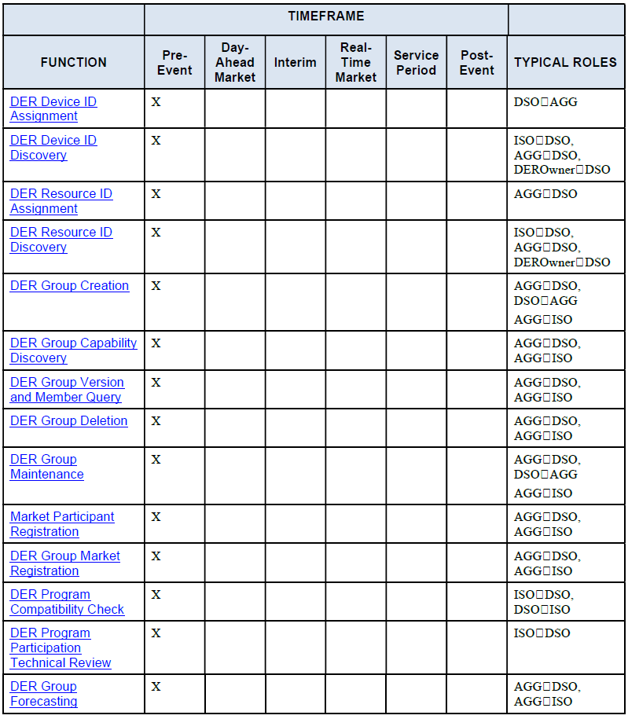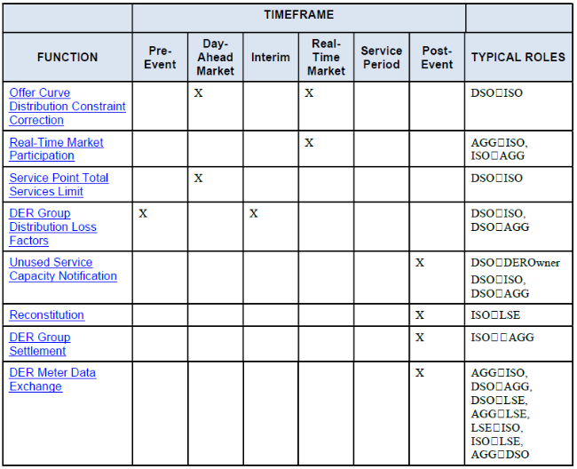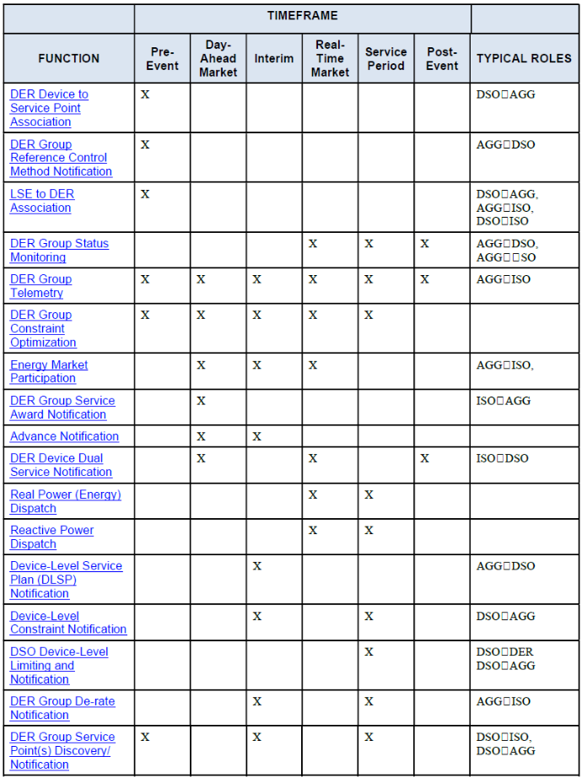

These functions assume established ‘downstream’ interfaces to CER/DER aggregations capable of providing ‘upstream’ data and services to relevant entities. This is consistent with the US’s FERC Order 2222 operational framework and its emphasis on mobilising CER/DER for bulk system markets.

In contrast, the EU-SysFlex Consortium has proposed a generic time-sequenced set of actor-specific functions across prequalification (Figure 6), procurement (Figure 8 & Figure 9) activation (Figure 10 & Figure 11) and settlement (Figure 12) of available flexibility for both DSO and TSO needs [17].

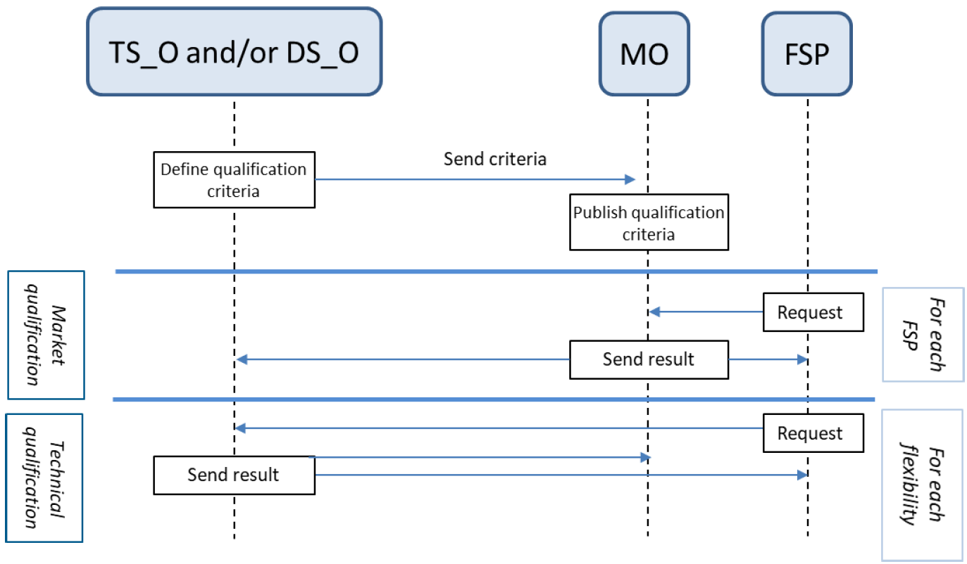

Figure - EU-SysFlex Prequalification Phase (see footnote for acronyms)[1]

Prequalification mainly concerns compliance with the technical, financial and communication requirements necessary to participate in the market/s. Under this schema, TSO and DSO coordination supports the prequalification process, even where neither is the buyer of the service.

The procurement phase includes bidding and clearing of the market resulting in selection of resources. Novel to this model of T-D Coordination is the role of an Optimisation Operator.

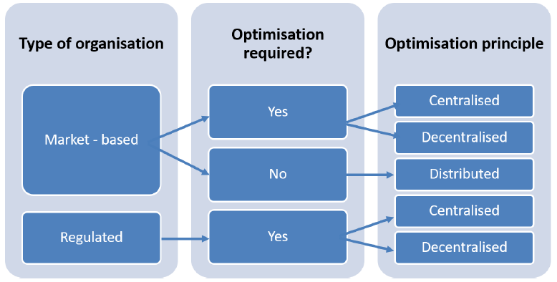

Figure - Procurement organisations and optimisation principles

Figure 7 highlights the independence of market/regulatory organisation from optimisation principles. A key feature of this sequencing of functions is that aggregated CER/DER (FSP) may submit offers to multiple markets via a single Market Operator (MO) platform, while the Optimisation Operator determines the most cost-efficient and secure combination of offers corresponding to SO and DSO needs. This T-D Coordination feature applies regardless of whether optimisation is centralised, as in Figure 8 or decentralised, Figure 9.

Figure - Procurement Phase - Centralised Optimisation

Figure - Procurement Phase - Decentralised Optimisation[2]

The activation phase, resources are dispatched in alignment with accepted offers. Several activation mechanisms are proposed in the EU-SysFlex model, depending on the service being provided and type of control.

Figure - Activation Phase - Automatic

Figure - Activation Phase - Manual

The settlement phase covers financial settlement between the buyer and seller of the service. In this arrangement, meter data is provided from the FSP to the Market Operator who validates it against data from the SO/TSO and DSO and calculates payments and penalties. The specifics of data exchange mechanisms and protocols are not provided; however, it can be assumed that this would be implemented by the T-D Interface.

Figure - Settlement Phase[3]

An ENTSO-E sponsored consortium published a similar European approach (Figure 13) to TDC that is specific to congestion management [5]. A detailed treatment of which particular functions should be specific to either SO/TSO or DSO is not included, but the report recommends flexibility resources (CER/DER aggregations) should be shared and available to SO/TSOs and DSOs through a common register and mutually acceptable pre-qualification process. The report also notes that T-D Coordination and information exchange are essential when invoking balancing and/or congestion management actions on a system scale to avoid any mutual harmful interference.

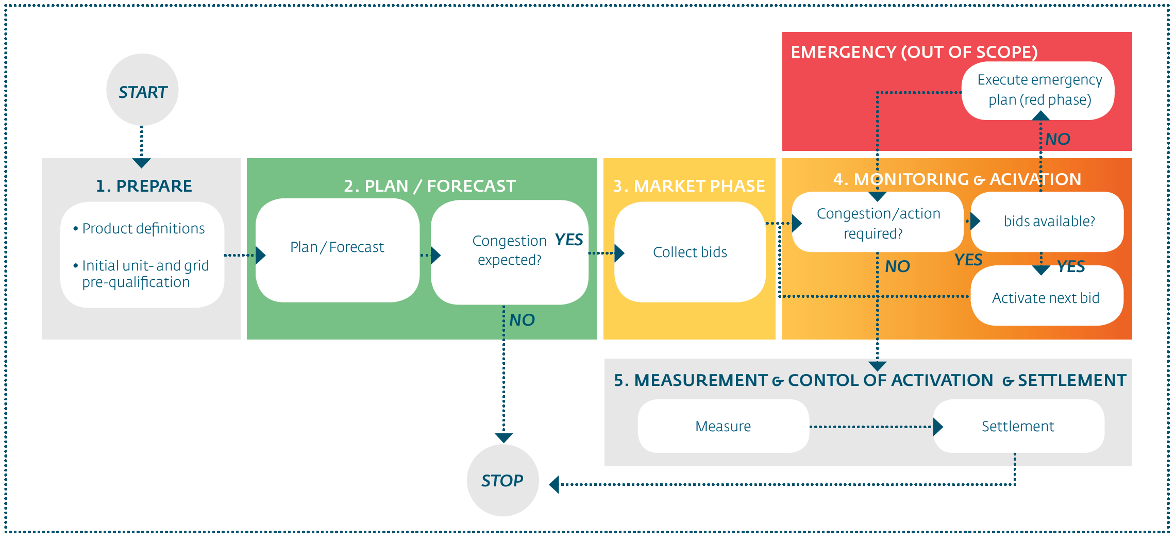

Figure – ENTSO-E Congestion Management Process Overview

## DSO data transformations to provide upstream entities with actionable information at reduced data volumes

Data transformation refers to the synthesis and further processing of data to obtain information. Data consists of measurements, observations, sensor readings, and other basic observable, measurable facts. Grid data may be produced in large volumes and at a variety of rates, depending on the source and purpose. Raw data is typically in the form of numerical values, grid state information or text without context except for the source (meter, line sensor, etc.). Information results from the transformation of data to extract meaning, relationships, or to identify trends in a particular context. The purpose of extracting information is to enable decision-making and control.

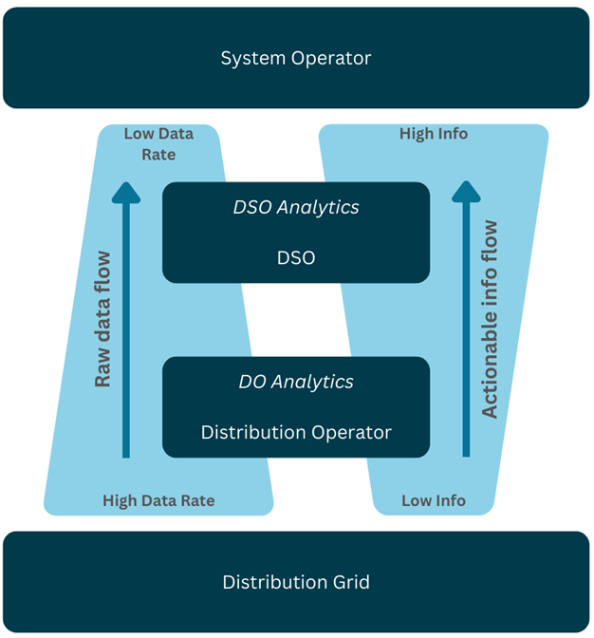

Figure - Data Rates and Information Extraction Relationships

Data transformation reduces data volume while extracting information. This principle can be used to guide the design of multi-stage analytics, distributed data storage, and communications in complex engineered systems. This leads to the concept of a sequence, stack, or hierarchy of data transformations as an information funnel – as we move through a processing chain, extracted information should increase at each stage, while data volume decreases. An implication of this is that information-extracting data transformations (analytics) can also serve as data quantity reduction tools (and not only by data compression), and so analytics can serve to facilitate the scalability of data flows in the information management structure. Figure 14 illustrates the data rate/information relationships on either side of an analytic data transformation.

The foregoing has significant implications for data architecture and specific functionality at the DNSP/DSO, and System Operator scales. Consider a version of the diagram in Figure 15 as a modular component of the system data architecture. By choosing a set of analytics at each level, moving from the distribution grid up through Distribution Operator to DSO to System Operator, it should be possible to design the data/information funnel to avoid the need to aggregate data flows into larger and larger streams as they reach the System Operator. Figure 15 illustrates the data reduction/information extraction concept for a power system with DSO roles.

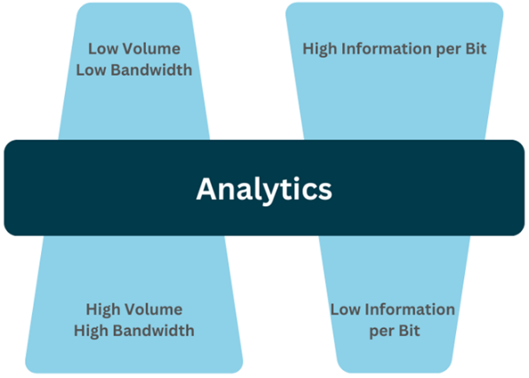

Figure - Data/Information Funnel Effect for Power Systems with DSOs

Each entity along the data/information flow path is going to perform analyses of incoming data for its own purposes of decision and control. Each entity below the System Operator level should be able to use carefully chosen analytics to extract and flow upward the information needed at the next higher level, with an attendant reduction in raw data or volume. The role of the DSO in this process is especially critical as it is best positioned to provide the information the System Operator needs for market and system operations at the relevant T-D Interface (TDI) points. As the System Operator will have multiple DSOs supplying data, the use of multi-stage data rate reduction/information extraction funnel structure at each DSO keeps input data total rates to the System Operator manageable. A second consequence of this data architecture is that data storage can and should also be staged, thus eliminating the need for a massive central data repository with all its attendant disadvantages and vulnerabilities.

As an example of how this would work for operational data, consider the following diagram:

Figure - Example Upstream Dataflows and Data Transformations

Working from upstream from the bottom of the diagram:

1. The distribution grid generates data from line sensors, meters, and related devices and systems. This occurs at different levels, from the low voltage network up to the high voltage and sub-transmission levels.
2. The distribution network business analyses the data streams for its own purposes of protection and control. It summarises the grid state and provides that to the DSO.
3. The DSO analyses the data from the distribution network business and other sources (such as DER aggregators) and uses it for its own purposes in managing the DSO’s resource set. The DSO also summarises the information at the relevant TDI points in its service area and passes that to the System Operator.
4. The System Operator uses the information for its market and system operations purposes.

Note that data persistence requirements at each level are determined by the system functions and applications at that level, and also, some data may have uses at multiple levels and on differing time scales. Also note that longer-term planning processes usually have a slightly different industry structure from operational ones, but the same concept of data rate/information rate concentration also applies to planning.

Figure - Dataflows viewed from a whole-system perspective, highlighting the value of established data transformation approaches

Figure 17 emphasise the value of formalised and consistent data transformations. Viewed from a whole-system perspective, providing low-level data with insufficient analytics is not effective or useful for the System Operator. At the level of the bulk power system, the System Operator only requires an aggregated understanding of activity within the distribution operating zone.

Application of the data/information funnel concept along with the other structural principles is highly relevant in for this purpose in a high-CER/DER context. This can provide guidance for how to design the required TDC roles and required capabilities, where to place functionalities, how to specify interfaces and protocols, and how to align data and communications structure with entity functions.

## Support multi-layered operational visibility and predictability

A much more bi-directional, dynamic and complex power system requires a step-change in operational coordination between both “ends” of the electrical power system. A key enabler of whole-system coordination is visibility and predictability.

In the US, the North American Electric Reliability Corporation (NERC) highlights that the rapid growth of DPV, and the increasing adoption of EVs, each contribute to increased variability in net load, which impacts the bulk power system's reliability. DPV generation can fluctuate significantly within short periods (e.g., cloud cover moving across a region). This intermittent nature creates challenges in maintaining a steady power balance across the grid, as the bulk system needs to respond to sudden drops in distributed generation by ramping up other generation sources. The Midcontinent Independent System Operator (MISO) and other ISO/RTOs have reported that DPV variability makes it difficult to accurately forecast net load, exacerbating the challenges of managing supply and demand in real-time. Consumer EV charging on the demand side creates another emergent source of variability in the bulk power system. EV charging demand can be highly unpredictable, depending on consumer behaviour, such as when and where consumers charge their vehicles. This variability could lead to significant fluctuations in demand, particularly during peak demand periods when many EV chargers may be plugged in simultaneously.

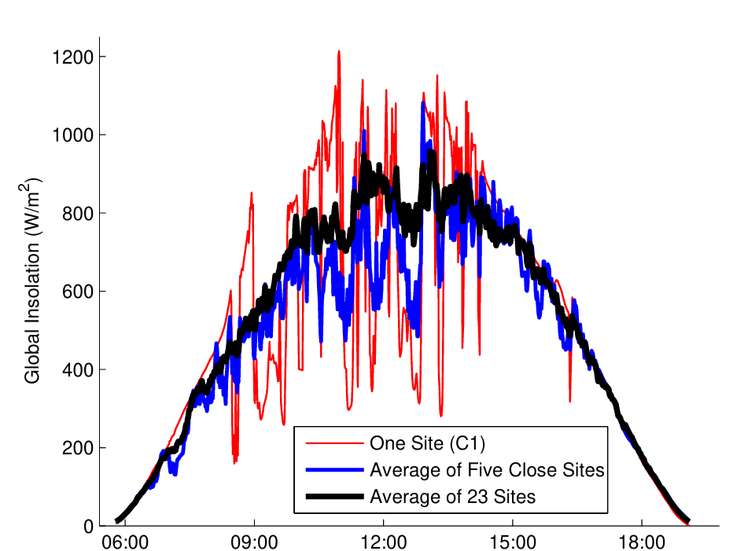

Figure - Example Solar Variability Over One Day [18]

The combined effects of DPV and EV charging on net demand variability are increasingly significant. The New York Independent System Operator (NYISO) reported that day-ahead net load forecast errors have become “significant in magnitude and duration.” NYISO found that based on a historical analysis of 2021-2022, there were several hourly instances where the day-ahead net load forecast errors exceeded the size of the largest generator contingency, thereby becoming the in-principle determinant of required emergency reserve capacity. The distribution system, including connected distributed resources and EV charging, effectively creates demand variability in the bulk power system.

T-D Coordination will need to evolve in parallel with the still-maturing ability to forecast much more dynamic supply and demand. This will require new tools, data sharing and coordination mechanisms to ensure the electrical power system remains stable, reliable, and capable of integrating more DER without jeopardising system security. Currently, DNSPs prepare and act-on their own forecasting capabilities, such as for solar irradiance and cloud movement, for the purposes of network management and calculating operating envelopes.

These DSO forecasting regimes may, in many instances, be superior to that of the ISO/RTO, given organisational knowledge of the service territory and complementary data feeds available to them. In some cases, the ISO/RTO will separately to DSOs, forecast variability in unscheduled distribution-connected generation for supply/demand balancing and calculating security constraints. Harmonising these disparate forecasting capabilities is a key and pressing need that enhanced T-D Coordination could resolve. Importantly, this may require provisioning the T-D Interface to be adaptable to a distribution to bulk power system-oriented “bottom-up” paradigm when developing strategies to value and to manage DER integration and utilisation, particularly in high DER and electrification scenarios [19].

## Support multi-layered, scalable operational coordination

Systemic alignment of the BPS and distribution systems will become increasingly important as the materiality of distribution-connected resources expands. Under AEMO’s 2024 Integrated System Plan ‘Step Change’ scenario, rooftop solar capacity is forecast to quadruple to 72GW of installed capacity, and CER storage is forecast to account for 66% of the NEM’s storage capacity by the year 2050 [9]. Managing this volume of CER/DER becomes challenging, particularly given the expanding range of location-specific products coordinated CER/DERs could potentially provide [17]. In the literature, the concept of layered decomposition is often advocated as a decision and control architecture strategy, for its modular scalability, manageable complexity, and clear separation of concerns [20].

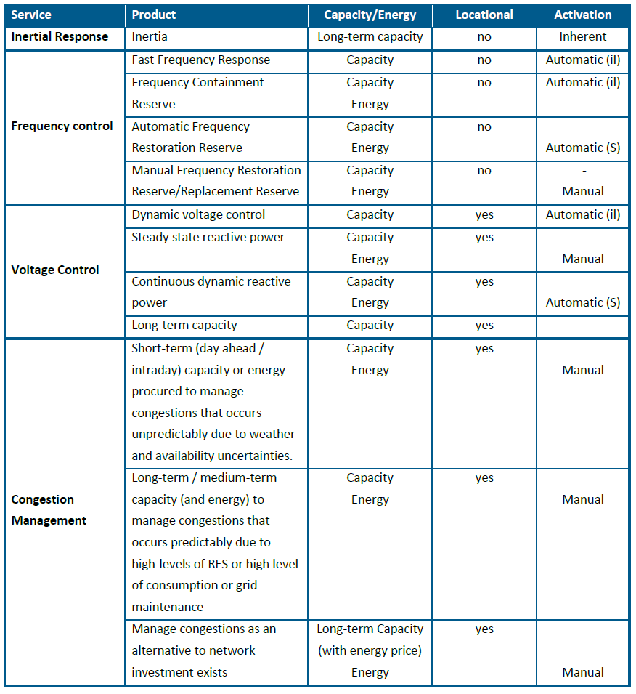

Figure - Energy products that are location-specific [17]

With a longer time-horizon in view, and contingent on the evolution of customer engagement with the grid, it is credible that sufficient distribution-connected resources will offer services such that DSO-administered energy balancing at T-D interconnection points is advantageous. Nearer term implementations of T-D Coordination must be extensible and scalable to this expanded range of capabilities.

## Support the resolution of operational and planning conflicts

Facilitating the resolution of operational conflicts is a critical function that T-D Coordination models must enable and support. In the UK, insufficient Electricity System Operator (ESO) - Distribution Network Operators (DNO) Coordination has led to conflicts over the access to DERs on operational timescales, as well as planning and procurement challenges [21]. These technical conflicts have been examined as part of the Open Networks Programme. Initial interrogation of Use Cases led to the identification of more than two thousand service conflicts [22]. For example, a service conflict may occur in which the DNO/DNSP may procure services to increase generation within an area, whilst the ESO procures services for the opposite from a nearby generator.

In response, the UK is progressing the development of Primacy Rules to pre-determine a hierarchy of operational needs. This is referred to in different ways across jurisdictions and depending on the context, including: control hierarchy, control federation, or functional prioritisation. The ESO and DNOs manage the respective transmission and distribution networks in accordance with their regulated roles, applicable standards and licence conditions. Each organisation may require one or more services, including those available from CER/DER aggregations for this purpose. Resource demand conflicts within one, or among two or more of these services when called upon by different layers may lead to inefficiencies within the whole electricity system. This will likely increase given increase in services procurement and the limited coordination to date. Hence, in order to manage this potential conflict and to enable networks to be optimised efficiently and transparently, a set of clear principles and “primacy” rules is in development. T-D Coordination schemes have an important role in facilitating such mechanisms by operationalising agreed primacy rules. This requires sourcing and sharing supporting data to quantify or validate prioritisation [23].

In the US, the primary focus of TDC is on using CER/DER to solve bulk system needs and to concurrently solve distribution challenges through traditional top-down planning processes. However, the timing needs for distribution and bulk power system decisions are not always aligned. If the bulk system and distribution grid needs are divergent, “DER services for the respective uses may cancel each other out or exacerbate the need in the other domain” [19].

It should be noted that underlying structural arrangements are the greatest determinant and mitigant of the types and frequency of operational conflicts across the T-D Interface.

# Data Exchange: Considerations for enabling secure and scalable data and information flows

In highly digitalised grids, one of the most critical TDC considerations the bi-directional data exchange, between the bulk power system and subsidiary distribution networks or DSOs, to support coordination across timeframes from planning through operational. The data requirements for different DSO and TDC models varies substantially, and impacts implementation complexity, cost and scalability. Therefore, ascertaining the requirements for information exchange and supporting data flows across discrete systems and actors is critical. This includes data requirements, models, transformations, communications and security. The following section provides a summary of each, surfaced from a broad cross section of global TDC research.

## Data Requirements

Data requirements refer to the needed data for a system, application, or process to function effectively. This includes the types, sources, and constraints of data necessary to discharge a system actor’s responsibilities and associated system functions. At a high-level, IRENA provides a summary the key activities that require a coordinated approach to the exchange of information between SO/TSOs and DSOs as shown in Figure 20.

Figure - Important areas of coordination between the SO/TSO and DSO [24]

At a more highly resolved scale, several initiatives have advanced efforts to expansively identify data exchange requirements between the System Operator and DSOs. Commonly, these involve the development of a data taxonomy to organise required data exchange, often by system function. Section 5.2 includes two such examples from the US Department of Energy and Canada’s IESO. A synthesis of the broad data requirement categories into three broad categories is set out in Table 5 and expanded on in Section 7, referencing the work of [25]. These are additional to existing data exchange that have already been implemented and are primarily driven by the presence of large volumes of CER/DER on the distribution network and resultant bi-directional power.

Table - Broad System Operator-DSO data requirement categories

|  |  |  |  |
| --- | --- | --- | --- |
|  | Data Requirements by Category | | |
| Type | Category | Data | Requirement |
| Structural Data | Standing Data & Asset Registrations | CER/DER identification, location, characteristics, and technical specifications, and VPP registrations. | SOs require this data at the distribution level to avoid forecasting errors in aggregate and at specific nodes. [1]. DNSPs/DSOs and VPPs/aggregators collect and retain this data through registration data, connection applications and other sources. |
| Physical Assets, Configuration and Network Topology | CER/DER and distribution network models or representation – appropriately ‘lumped’ or aggregated to the physical TDI | SOs require this data for assessment of active and reactive power flows, static and dynamic security analysis, and contingency studies. DNSPs/DSOs are well placed to maintain and provide this data to SO. |
| Scheduled Data | Forecasts & Schedules | Short-term and long-term forecasts of DER output and flexible capacity. | Both SOs and DSOs benefit from forecasts of distribution-connected CER/DER for operations and planning. This includes aggregated flexibility/curtailable resource forecasts for emergency responses. Day-ahead, intraday and pre-dispatch intentions for wholesale market participation schedules from CER/DER aggregators are also important for supply/demand balancing. |
| Market & Dispatch Data | Bids/offers for flexibility services, clearing prices, and dispatch set-points. | To integrate CER/DERs into wholesale markets, aggregators must exchange market data with the SO/Market Operator. Likewise, DSOs managing local network services markets need to receive CER/DER bids for congestion management or voltage support and communicate dispatched set-points. Exchange of market and dispatch data between SOs and DSOs supports conflict resolution, congestion management and supply/demand balancing. |
| **Limits and Constraints** | Data on distribution network limits and operational envelopes for CER/DERs. | DSOs often determine dynamic operating envelopes (DOEs) – limits on DER export or import at a given time – to prevent distribution overloads. These DOEs must be communicated to aggregators and the market operator/s. Depending on the DSO Model, DSOs may also need the ability to override or adjust SO dispatch signals under emergency conditions [26]. This three-way data on network constraints (from DSO) and DER availability (from aggregator) over the TDI is essential for secure operation of the distribution network. |
| Real Time Data | Real Time: Telemetry & Operability Status | Near real-time measurements of CER/DER generation/consumption, state of charge (for storage), and availability. | DNSPs/DSOs collect this data to monitor local network congestion, while SOs require an aggregated view at T-D interface points. Depending on DSO Models, the SO may also require this data for to verify compliance with dispatch instructions. Increasingly, SOs will also need to integrate distribution-level storage (including EVs) into forecasting and dispatch engines along with status of CER/DER portfolios participating in markets. |

## 

## Data Models

In contrast to data requirements, a data model is a structured representation of how data will be acquired, transmitted, organised, stored, processed and managed. It describes how data elements relate to each other and the rules that govern these relationships. Data model specifications have a direct relationship with data exchange requirements, as the exchange of data within messages will in, most cases, result in updates to data stored in persistent data models, data which informs or triggers control actions. Messages exchanged under T-D Coordination schemes must respect the semantic framework of their corresponding data models to ensure correct interpretation. Harmonising, standardising, and where possible, minimising the number of data models involved within the structural arrangement of the TDC functional specification simplifies downstream implementation and reduces potential model translation errors.

Disparate data models need to ‘understand each other’ to support more dynamic and automated operational coordination – to varying degrees, depending on TDC structural arrangements. It should be noted that data models are often embedded within communications standards that use them. Some common data models are listed in Table 6 followed by a brief treatment of the Common Information Model.

Table - Common Data Model standards

| **Name** | **Domain** | **Description** |
| --- | --- | --- |
| **CIM (IEC 61970/61968/62325) – expanded on below** | Transmission, Distribution, Market | Semantic model for grid assets, markets, and system operations |
| **IEC 61850 Logical Nodes** | Substations, Protection | Object-oriented model for substation automation; defines logical nodes |
| **MultiSpeak** | Distribution | Focuses on enterprise integration: CIS, OMS, GIS, etc. |
| **IEEE 1547.3** | DER telemetry and controls | Defines a data model for DER communications and controls |
| **OpenADR (Model Layer)** | Demand Response | Event and price signalling model for DR automation |
| **OASIS (NAESB Standards)** | Market Scheduling | Defines data structures for transfer capacity and scheduling |

Common Information Model (CIM)

Dating back to the 1980s, the CIM was developed by EPRI in the US to address the need for better interoperability across the utility industry. System Operators commonly use CIM in power system models used for transmission network topology, Energy Management Systems (EMS), state estimation and grid stability, market operations and grid congestion management. It consists of several standardised classes and subclasses defined using UML to capture and share data about the power system see [27].

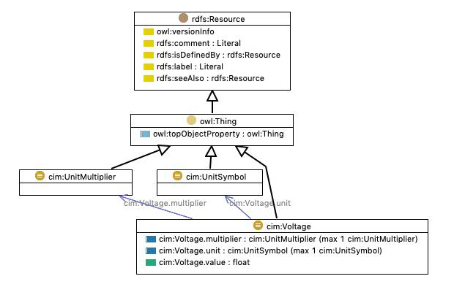

Figure - Example CIM UML class: Voltage [27]

More recently, derivatives of the CIM such as the ENTSO-E’s Common Grid Model Exchange Specification (CGMES) have been investigated for their suitability for data exchange between different grid operators. The TDX-ASSIST project, funded by the European Union's Horizon 2020 program, explored the potential for adapting ENTSO-E’s CGMES) to be used as a scalable and secure information systems and data exchange between TSOs, DSOs and market participants. This included a standardised data model, which specifies relations, hierarchy and a storage format [28].

## Data Communications

Power systems are transitioning from exclusively centralised, operator or network-owned communications systems to public and consumer-administered communications, while also experiencing much faster system dynamics, accommodating expanding number of active participants, and becoming increasingly digitalised. All this both elevates the centrality of the communication networks that support power system operation, and the risks associated with the sub-optimal performance or failure of them.

### Application-layer Protocols

Effective Transmission-Distribution Coordination relies on interoperable data exchange between SOs, DSOs, and CER/DER and their agents. This requires careful alignment between application-layer protocols, their embedded data models, and utility-level models like the Common Information Model (CIM). Protocols such as IEC 61850, OpenADR, and IEEE 2030.5 define both how data is exchanged and what it means, embedding specific semantic models. If these are not harmonised with broader utility models, semantic mismatches can cause data loss, control errors, or integration failures. Ensuring compatibility across these layers allows consistent interpretation of information from field devices to system operators, supporting accurate forecasting, dispatch, and fault response. A protocol-model approach that considers both transport and semantics is essential for automation, reliability, and real-time decision-making. Figure 22 provides an example of the number and diversity of protocols deployed across the power system which require increasing levels of integration. An expanded treatment of IEC 61850, IEEE2030.5 and OpenADR the follows.

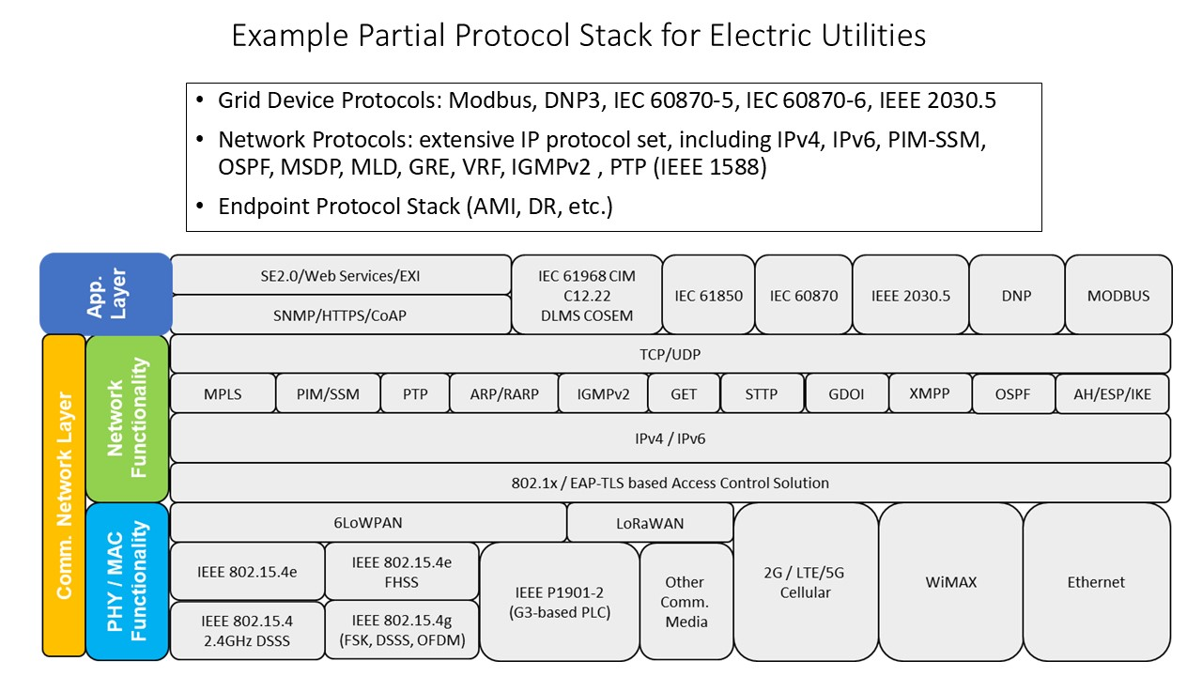

Figure - Example Partial Protocol Stack for Electric Utilities

Automation Systems: IEC 61850

International Electrotechnical Commission (IEC) 61850 (communication networks and systems for power utility automation) is an expansive open international standard for MV and LV utility automation and communication between substations, protection relays, SCADA systems, and CER/DER. It includes a hierarchical, object-oriented data model to represent electrical power system components (known as Intelligent Electronic Devices, or IED) and their behaviours. A key concept within the data model is Logical Nodes, which correspond to a specific protection, control or monitoring functions of an IED.

Each Logical Node is further defined by a set of Data Objects that describe device status and behaviour, the values of which are known as Data Attributes. IEC 61850 is being adopted by utilities in many countries as part of grid modernisation programs. This has led to several initiatives to understand its practical value to TDC, including by the EU as part of the Horizon 2020 program and subsequent OneNet initiative [29].

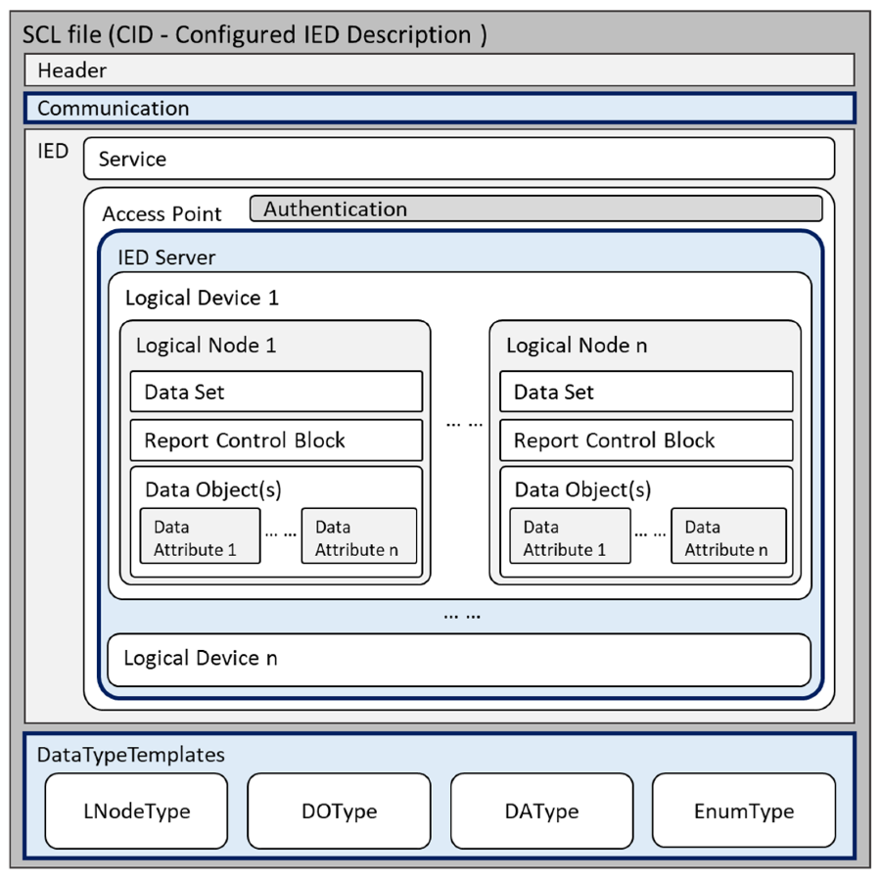

Figure - Example contents of a Substation Configuration Language   
file with embedded data model [30]

IEEE2030.5 and OpenADR

IEEE2030.5 and OpenADR are both communication standards for DNSP/DSO interaction with customer-sited CER/DER. Both specify XML and JSON-based data models as a core part of their specifications. DNSPs/DSOs must integrate these data models with other systems to provide aggregated information to the bulk power system.

Figure - Example IEEE2030.5 JSON formatted data model

**<oadrPayload xmlns="http://openadr.org/oadr-2.0b/2012/07">**

**<oadrSignedObject>**

**<oadrEvent>**

**<eiEvent>**

**<eventDescriptor>**

**<eventID>DR-Event-56789</eventID>**

**<modificationNumber>0</modificationNumber>**

**<priority>1</priority>**

**<eventStatus>far</eventStatus>**

**<createdDateTime>2025-03-11T13:00:00Z</createdDateTime>**

**</eventDescriptor>**

**<eiActivePeriod>**

**<properties>**

**<dtstart>**

**<date-time>2025-03-11T14:00:00Z</date-time>**

**</dtstart>**

**<duration>**

**<duration>PT30M</duration>**

**</duration>**

**</properties>**

**</eiActivePeriod>**

**<eiEventSignals>**

**<eiEventSignal>**

**<signalName>simple</signalName>**

**<signalType>level</signalType>**

**<currentValue>2</currentValue>**

**</eiEventSignal>**

**</eiEventSignals>**

**</eiEvent>**

**</oadrEvent>**

**</oadrSignedObject>**

**</oadrPayload>**

Figure - OpenADR XML formatted data model

**{**

**"DERControl": {**

**"href": "/der/12345/control",**

**"creationTime": "2025-03-11T14:00:00Z",**

**"duration": "PT30M",**

**"modesSupported": ["Charge", "Discharge"],**

**"currentPowerLimit": {**

**"value": 1000,**

**"multiplier": 0,**

**"unit": "W"**

**},**

**"override": {**

**"reason": "Demand Response Event",**

**"requestedBy": "Utility"**

**}**

**}**

**}**

### Data Transfer

Key performance requirements for data transfer relevant to the determining TDC structural approach and supporting TDI mechanisms include bandwidth, throughput, packet loss, availability, security, latency, and jitter. Alternative TDC structural arrangements will either exacerbate or mitigate data transmission constraints depending on the required data volumes and cadence required to facilitate them.

|  |  |  |
| --- | --- | --- |
| Key Data Communications Considerations [31][4] | | |
| Concept | Definition | Relevance |
| Bandwidth | The maximum amount of data that can be transmitted over a link over time between the sender and receiver. | Adequate bandwidth is essential for efficiently transmitting large volumes of data from multiple sources, such as smart meters and sensors. Insufficient bandwidth can lead to delays in data transmission, affecting real-time decision-making in grid operations. |
| Throughput | The actual rate of the message delivery over a communication channel. | In IP-based networks, which are dynamically routed, the throughput and bandwidth may not be equal causing unpredictability. Nonlinear characteristics are a function of the number of endpoints using the network, such that throughput can suddenly drop off drastically (or alternately packet delivery times can suddenly drastically increase) with addition of endpoints that move the network past a breakpoint. |
| Packet loss | The loss or non-delivery of entire data packets during transmission over a network. | Packet loss can result from various issues in network operation, including network congestion, hardware failures, buffer overflows, or errors in routing decisions. Packet loss can also be due to physical factors including noise, interference, signal attenuation, and distortion in the communication channel. Loss of data packets during transmission can result in incomplete or delayed information, affecting the accuracy of grid management decisions. |
| Availability | The accessibility and usability of services when needed by users. | High availability of communication networks ensures continuous monitoring and control of power system assets. Unavailability can lead to gaps in data, potentially causing operators to miss critical changes in grid conditions or be unable to send control commands when needed. The redundancy of communications networks is an important consideration. It could conceivably arise that OEM, vendor or other functions of the power system are dependent on digital connectivity that is in-turn dependent on the power system. During a power-outage those systems become inoperable potentially causing instability, for example, during black-start. |
| Security | The protection of data, information, and communication channels from unauthorised access, disclosure, alteration, and disruption. | Well-designed communication networks can provide many specific security protocols and layers of cyber protection. In addition, the very structure of a network can either enhance or degrade the inherent resilience of a network with regard to cyber security vulnerabilities. Breaches can compromise the control of grid assets and lead to operational disruptions. |
| Latency | The delay in the transmission of data from the sender (source) to the receiver (destination) over a network or communication channel | Low latency is critical for real-time protection, control and coordination of power system assets, especially for quick response needs like load balancing and frequency regulation. High latency can delay responses to grid fluctuations, risking instability. The usefulness of asynchronous networks like the internet for electric grid data communications depends on their ability to achieve sufficiently bounded latency. |

|  |  |  |
| --- | --- | --- |
| Jitter | The variability in latency over time | In power system operations, consistent latency is crucial for synchronising actions across the network. If there is significant jitter, the variability in communication delays can lead to problems in coordinating actions, such as the timing of control signals for grid stability as data packets can arrive out of order. High jitter in a network can undermine the benefits of low latency by making the system less predictable and reliable. Jitter buffers temporarily store incoming packets to allow for out-of-order or delayed packets to arrive. |

### Data Conversion

As intimated above, identifying and specifying data conversions between various protocols, standards and semantic models across the T-D Interface is an important design decision. Historically, data exchange has occurred over a limited number of interfaces between distribution and transmission systems using well established utility-grade protocols[5] and standard data models[6]. These protocols provide standardised means for control rooms and field devices to interoperate across organisational and voltage boundaries. More recently, the need to integrate CER/DER at the distribution-level has led to the introduction of newer protocols, such as IEEE2030.5 and alternate proprietary IP-based communication protocols. These protocols depart from traditional utility communications paradigms, and instead use client-server, RESTful web services architecture (over HTTP/HTTPS) with an XML/JSON payload for the purposes of interacting with customer-sited CER/DER systems via the internet. This heterogeneity of systems either side of the T-D interface requires bridging mechanisms and data manipulations that maintain semantic consistency [32]. Robust translation gateways are needed to avoid protocol translation errors and so that messages maintain their meaning across protocols [33].

In practice, middleware is often used as a translator and integrator between the various protocols and market platforms used by TNSPs, DNSPs, DSOs and aggregators. In the context of TSO-DSO, the EU’s OneNet Project defines middleware as *“a software layer that enables interoperability between different grid control systems, protocols, and market platforms, ensuring real-time data exchange and coordinated decision-making across transmission and distribution networks”* [34]. However, the use of either gateways or middleware must be carefully considered at the architecturally, as each introduces potentially significant disadvantages. Preferably, an expansive architectural process defines and controls interfaces.

Present day utility interoperability using translation layers is a consequence of incremental adaption, and not intentional architectural design. As legacy power systems undergo significant transformation, propagating is likely to introduce structural vulnerabilities. The use of REST in particular has been criticised for being ambiguous and inefficient compared to message-passing protocols, as it is not intended to be a protocol, but a software programming approach. The ambiguity leads to severe mismatch problems with APIs where programmers interpret REST differently. As a result, interfaces to DER/CER have experienced API obsolescence/update issues. Generally, in modern network design, it is considered better to avoid such mechanisms by using unified deep IP protocol stacks (IEC 61850, IEEE 2030.5, SunSpec, etc).

### Data Latency Tolerance

Coordinating operations across the TDI in high-DER power systems introduces stringent latency requirements that are difficult to meet with conventional communications and control systems. Many control and protection actions at the T-D interface must adhere to application- specific timing requirements to be effective. For example, detecting a distribution feeder reverse power flows and sending a remedial signal to the SO might need to happen within seconds or faster to avoid protection trips. Aggregators responding to frequency regulation or dispatch signals from the SO may have only seconds to start modulating dozens of DERs. However, existing communication links may have variable latency (known as jitter). The challenge is ensuring timely and reliable data exchange across a multi-layer network commensurate with the requirements of specific functions, processes and applications (Figure 26). As TDIs will facilitate a broad range of system functions, processes and applications, the specific requirements of each will need to be assessed.

Figure - Relative Operational Process Latency Tolerance [35]

Research by the U.S. Department of Energy emphasises that “latency is a key performance parameter for coordinating DER assets to ensure resilient and reliable” grid operations [35]​. If latency is too high or unpredictable, control actions can become ineffective or even destabilising (e.g. oscillations from delayed responses). T-D communication often involves multiple hops – DER to aggregator, aggregator to DSO SCADA, DSO to TSO – each adding delay. Protocols like IEEE 2030.5 over the internet might have seconds of latency, whereas SO and/or DSO control schemes often expect data refresh rates of 2–4 seconds or faster. Another facet of communications system design is bandwidth and data volume: high DER systems generate large volumes of data (e.g. thousands of PV system readings), which if sent too frequently could congest communications networks and introduce delays. The design of TDC schemes must therefore balance the volume and frequency of data (e.g. using reporting by exception rather than fixed intervals where feasible) and ensure that the overall control loop (for example, from SO to devices and back) meets the necessary latency thresholds and has safe performance behaviour in circumstances where ideal latency thresholds are not satisfied.

## Data and Cyber Security

The increasing use of digital technology expands connectivity to additional devices and systems, introduces additional dataflows, and integrates previously isolated components of the power system into larger communication networks. The resultant coupling of communication networks and power systems - considered critical infrastructure, presents significant power system security concerns. For example, legacy protocols and systems developed in a less digitalised operational environment were not designed with communications security as a priority. These legacy systems continue to be used alongside modern technology and are increasingly exposed to external networks, such as the Internet. Similarly, the increased use of digital and decentralised technology provides a broader attack surface. Various cyber-attacks have successfully targeted global power systems [2], with extended outages having substantial social and economic impacts

### T-D Interface Attack Vectors

While the TDI itself is partially isolated from cybersecurity vulnerabilities due to its reliance on TNSP and DNSP/DSO systems (that operate in their respective OT environments, segregated from the wider internet for their own security requirements), there remains several attack vectors that must be considered for T-D interface design, and to a less degree, for T-D Coordination models.

Based on the work of Krause et al [36], an assessment of possible attack vectors relevant to TNSP/TSO and DNSP/DSO cyber-based systems is provided in Table 7. It should be noted that the TDI provides an aggregated view of subsidiary distribution networks that are increasingly vulnerable to cyber compromise due to its reliance of internet-connected CER/DER, orchestrated by proprietary aggregator or OEM software, and containing OEM device firmware.

The TDI must therefore ensure that protections are in place to avoid the propagation of cyber-compromised data aggregations at the grid edge that might result in SO actions that cause system instability. The example impacts in the last column of Table 7 primarily focuses on those grid-edge vulnerabilities that at scale would impact on the T-D Interface for which mitigations or overrides at the T-D Interface may be required. It is not intended to be an exhaustive or even comprehensive list as that is outside the scope of this report.

Table - Attack vectors for Transmission and Distribution Operators

|  |  |  |  |
| --- | --- | --- | --- |
| ****Attack Vector**** | ****Definition**** | ****T-D Interface Threat Assessment without appropriate Mitigations**** | ****Example Scenario & Potential Impact at T-D Interface**** |
| **Lateral Movement** | The process of an attacker **moving deeper** into a network after gaining initial access to escalate privileges and compromise additional systems. | T-D Coordination requires shared data and communication channels, which create multiple entry points for an attacker. Once an attacker gains access to DSO control systems, they could move laterally to SO-operated SCADA systems or vice versa through the TDI. | * A hacker gains access to a **substation RTU (Remote Terminal Unit)** and moves laterally to take control of **SCADA systems managing network operations across the T-D Interface**. * An attacker starting in the DSO’s network (e.g., via a compromised DER management system) could escalate privileges to transmission-level control systems, leading to grid-wide disruptions. |
| **Physical Access Remote** | Exploiting **remote** physical access points such as **substations, control centres, or field equipment** to compromise cybersecurity. | Moderate – physical access to critical cyber infrastructure has additional prevention measures as compared with digital attack surfaces, and isolated systems at substations are unlikely to be mission critical to the T-D interface. | * Attackers physically access a **remote transmission-distribution interconnection substation**, inserting a rogue device that **intercepts and changes control signals, causing disruption to the T-D Interface.** * **An attacker** physically damages critical cyber systems taking it offline and disrupting the operation of the T-D Interface. |
| **Maintenance Access** | Targeting vulnerabilities in **remote maintenance tools, technician laptops, or firmware updates** to infiltrate the grid. | Moderate – vendors may not have the same cyber-defence capabilities of processes and procedures, and enforcing cyber-standards across organisations can be difficult. | * A malicious software update is injected into a **DMS (Distribution Management System)** during scheduled maintenance, enabling an attacker to issue **unauthorised control commands that alter forecasts for supply/demand balance across the T-D Interface**. |
| **Third-Party Exploit** | Using **vendors, contractors, or external software dependencies** as an entry point into the grid infrastructure. | High - TNSPs and DNSPs/DSOs rely on third-party vendors for network and DER management and automation systems, market platforms, and maintenance. If a vendor’s software is compromised, both TNSP and DSO/DNSP operations could be affected. | * A compromised smart meter manufacturer delivers infected firmware updates, allowing attackers to manipulate energy metering data. * A compromised EV or EVSE OEM issues infected firmware that forces entire fleet to charge or discharge at a set point in time, causing instability across the T-D interface. * A compromised aggregator could inject false market signals, leading to incorrect supply/demand balancing actions. * An exploited third-party cloud provider (e.g., handling DER telemetry or forecasting) could feed manipulated data to SO/TNSP, leading to improper load management. |
| **Overcoming Air Gap** | Bypassing an **air-gapped system** (a network isolated from the internet) using **USB drives, wireless bridges, or insider threats**. | High - Many TNSP and DSO critical control systems (e.g., SCADA and EMS) are air-gapped from the internet for security. Attackers may attempt to bridge the air gap using infected removable media, wireless bridges, or compromised personnel. | * An insider plants a **compromised USB device** in an air-gapped **Energy Management System (EMS)**, allowing remote control of **transmission dispatch functions**. * A cyberattack on an air-gapped EMS at a SO/TNSP disrupts real-time coordination with DSOs, leading to load imbalance, frequency deviations, or blackouts. |
| **Insider Attack** | A **trusted employee or contractor** with system access intentionally or unintentionally compromises grid cybersecurity. | High – TDC requires extensive collaboration and shared system access, increasing the attack surface for insider threats. A disgruntled employee or compromised contractors could abuse their access to sabotage operations on the far side of the T-D Interface. | * A disgruntled engineer with **access to SCADA systems** disables protective relays, causing **load shedding/instability**. * A malicious insider at a SO/TNSP control centres could manipulate real-time grid balancing data, triggering unnecessary load shedding at DSOs. * A rogue employee at a DSO could feed false grid status information to the SO, disrupting transmission scheduling. |
| **Cascading Effects** | A cyberattack on one component **propagates across interconnected systems**, leading to widespread failures. | High - The TDI is highly interdependent, meaning an attack on one component (e.g., DSO operations) can propagate to SO/TNSPs and vice versa. Cyberattacks that manipulate demand response systems, DER controls, or load forecasting can have widespread impacts on power system stability. | * A malware attack on a **regional control centre** manipulates load balancing data, causing **widespread outages across multiple states**. * A compromised DERMS (Distributed Energy Resource Management System) at a DSO could inject false demand and generation data, leading to incorrect dispatch decisions at the SO level. * A DDoS attack on a single DSO within the service territory of a TNSP with multiple DSOs could overload the TNSP causing disruption to other DSOs. |

### Mitigations

A common mitigation concept in cybersecurity is defence-in-depth. This concept describes a layered approach to defence understanding that no single security measure is sufficient.

|  |  |
| --- | --- |
| **Layer** | **Description** |
| 1. Human Layer (User Awareness) | Involves educating and training users to recognise phishing, social engineering, and unsafe behaviours. Humans are the weakest link, so awareness is essential. |
| 2. Perimeter Security | First line of defence using firewalls, intrusion prevention systems (IPS), and network segmentation to prevent unauthorised access. |
| 3. Network Security | Secures internal network traffic through secure protocols, traffic monitoring, access controls, and network-based firewalls. |
| 4. Endpoint Security | Protects individual devices (servers, laptops, mobile phones) using antivirus, EDR (Endpoint Detection and Response), patch management, etc. |
| 5. Application Security | Ensures apps are built securely (input validation, access control) and protected post-deployment using WAFs (Web Application Firewalls) and code scanning tools. |
| 6. Data Security | Protects data at rest and in transit via encryption, DLP (Data Loss Prevention), access controls, and data masking. |
| 7. Mission-Critical Asset Layer | Protects core systems and infrastructure like SCADA, databases, and identity services, ensuring operational continuity and resiliency. |

These concepts are broadly transferable to implementation of the T-D Interface, providing a helpful baseline. More targeted industry-specific cybersecurity frameworks, such as North American Electric Reliability Corporation’s (NERC) Critical Infrastructure Protection (CIP) standards are also instructive in considering mitigations specific to the T-D Interface. In the US, application of the CIP has been limited to the bulk electric system, however, as distribution-connected resources become increasingly material in whole-system operations, a broader application of such frameworks will likely be required.

|  |  |
| --- | --- |
| **Measure** | **Description** |
| Asset Identification | Categorises BES Cyber Systems based on their impact to grid reliability. |
| Security Management Controls | Establishes policies and procedures for cybersecurity governance. |
| Personnel & Training | Ensures individuals with access to BES cyber assets are properly trained and vetted. |
| Electronic Security Perimeters | Defines and protects the boundaries of networks where BES cyber systems operate. |
| Physical Security | Safeguards physical access to critical cyber assets. |
| System Security Management | Covers patch management, malware protection, and system access controls. |
| Incident Response | Requires plans for identifying, responding to, and reporting cybersecurity incidents. |
| Recovery Plans | Ensures BES cyber systems can be restored after a compromise. |
| Configuration Change Management and Vulnerability Assessments | Tracks changes to systems and performs periodic vulnerability assessments. |
| Information Protection | Protects sensitive cyber system data from unauthorised access. |
| Protection of Communications | Secures real-time communication between control centres. |

These above measures assume ownership and accountability of the systems under threat. However, as mentioned above, cyber vulnerabilities are fast emerging at the grid edge due to the reliance on unsecured public networks to interact digitally with inverters and other on-premises devices that interact electrically with the grid. They are also emerging due to the potential to exploit third party and OEM systems that provide customer-facing products and services that are also electrically coupled to the power system. Elevated standards and regulations for electrically coupled devices and control entities, such as OEM clouds, applying defence-in-depth principles will be important. In addition, most proposed mitigation strategies are themselves cyber-based. Achieving a more layered approach to Power System cyber-security also requires the inclusion of non-cyber structural analysis and treatments.

For reference, the US Department of Energy, following a 5-year effort under a legislated mandate, adopted and further developed a conceptual framework known as Cyber-Informed Engineering (CIE) [3]. This framework aims to embed cybersecurity considerations into the conception, design, development, and operation of any physical systems (including power system and industrial control systems) to mitigate or even eliminate avenues for cyber-enabled attacks. Working closely with the National Institute of Standards and Technology (NIST) and the national laboratories, a set of design principles were developed as follows:

1. Assume compromise and expect that any digital component or system may be compromised at some point during its lifecycle
2. Plan for continued operation during and after a cyber-attack that degrades digital controls
3. Implement a zero-trust architecture to the greatest degree possible, and
4. Isolate and defend - isolate or remove the threat without compromising critical operations.

Finally, aside from hardening mechanisms for its own constituent systems, TDI implementations should consider firewalls or redundancies to isolate cyber-compromised actors or systems from the power system. Network and system operator segregation of OT and IT environments should similarly be applied to the T-D Interface [23]. Where TDIs interact with aggregator/VPP IT environments, proactive defence mechanism improvements and regular vulnerability monitoring is essential to increase trust and secure connections [14].

# Core Functions: Examining key T-D Coordination functions and timeframes

An important parallel consideration to T-D Coordination model design (Section 5) and data exchange (Section 6), Section 7 now addresses the implications of both to a representative set of core functions that must be enabled at the T-D Interface. Importantly, these functions are inextricably linked to the maturing role of Distribution System Operators (DSOs) and how the relationship between transmission and distribution system operation evolves.

DSOs, at their core, act as the operational and informational voice of the distribution system. However, the way this role is implemented will vary substantively depending on the structural archetype implemented (refer Section 5, Table 4)[7].

* In a transitional Multi-entity DSO model, the DSO shares observability and decision-making within their operating zone with the System Operator, requiring bilateral engagement to reconcile partial views of distribution-level variables.
* By contrast, in the Layered Coordination DSO model, the DSO assumes primary responsibility for managing CER/DER resources, local reliability, and interfacing with markets up to the TDI. As the name suggests, the DSO functions as the system operator of that particular distribution system and interacts with the System Operator via well-specified service boundaries and fulfils formally defined responsibilities.

Under the Layered Coordination DSO, this substantively reconfigures T-D Coordination. The System Operator (SO) no longer needs to engage in continuous distribution-level oversight, instead interacting with DSOs as if through a “contractual port” defined by agreed service levels and exchange protocols. For example, the DSO offers aggregated services, such as flexibility, or signals shortfalls in local adequacy to the System Operator, while the SO requests distribution-level actions to manage transmission constraints. Importantly, given the potential for volatility within the distribution system, sufficient levels of buffering (storage) will likely be required to support these arrangements. A further discussion on the role of DSOs and their upstream interactions and T-D coordination impacts can be found in Section 10 of Report 4.

In this context, the set of core functions across the T-D interface will evolve as DSOs mature. Given the system security-driven urgency to expand T-D coordination in the near-term, and the gradually emerging consensus that power systems will necessarily transition to more layered approaches via hybridised approaches, much of the attention in the literature has focused on functions needed for Multi-entity approaches. This section also considers nearer-term TDI functions, while noting how each function might evolve or become redundant as DSOs mature and manage a greater share of whole-system resources.

Two formative papers that provide an expansive treatment of immediate functional priorities are [4] and [5]. The former provides a helpful simplified three-fold categorisation of the span of TDC functions and required data exchange: Structural Coordination; Schedule Coordination; and, Real-Time Coordination. An important enabling and cross-cutting concept across each of these functional categories is DER Group Management. A brief treatment of this concept is provided below, followed by an explanation of the column headers used in assessing the set of core functions across structural, schedule and real-time coordination.

DER group management

DER group management standards have emerged in recent years through the design and implementation of DER Management Systems (DERMS). DERMS refers to the management of DER devices at several locations, often through site-level management systems. Examples include: DNSP management, third party aggregation and microgrid applications. DERMS applications all involve some form management or control action across groups of DER.

Grouping of DER results in two primary types of interfaces illustrated in Figure 27 from [38] below:

* **DER Device-level interfaces:** relating to commands for individual DERs. These must be specific, instructing the device to act in a particular way. Commands tend to be device-type specific. For example, battery systems can be instructed to charge/discharge, but PV cannot. Thermostats can offset their temperature setpoint, but electric vehicles cannot. Examples include IEEE2030.5 and Open ADR, described further below.
* **DER Group-level interfaces:** at the DER group-level, services are defined in terms of the aggregate outcome and do not (typically) dictate how individual DER within the group are managed to achieve the overall effect. This allows DER managing entities to compete and innovate in finding more effective and efficient ways to deliver an aggregate response.

Figure - Applicable interfaces for DER Group Functions [38]

Examples of DER Group-level functions include:

* **Defining and maintaining of DER Groups**
  + DER Group Creation – assigning DER devices to relevant topological (different levels in the network topology) and non-topological groups (e.g. aggregator fleets)
  + DER Group Maintenance – addition, removal, or modification of members and/or aggregated capabilities of a given group of DERs
  + DER Group Deletion – removal of an entire group
* **Monitoring and coordination of DER Groups**
  + DER Group Status Monitoring – quantifying or ascertaining the current capabilities and/or status of a group of DERs
  + DER Group Forecast – predicting capabilities and/or status of a group of DER for a given period in future
  + DER Group Dispatch – requesting that specified capabilities of a group of DERs dispatched
  + DER Group – Requesting that DERs either to isolate themselves or reconnect to the grid, as needed

Existing DER group management standards are listed below:

* IEC 61968-5:2020 *Application integration at electric utilities - System interfaces for distribution management - Part 5: Distributed energy optimization* [39]*-* Describes a set of methods needed for enterprise integration of DERMS functions, mapping DER group-level to device-level interactions. Communication to individual DERs is out of scope of this standard. Includes use cases relating to how ‘DER groups’ are managed – how groups are created, maintained, monitored, forecast, dispatched.
* *IEEE 2030.11:2021 IEEE Guide for Distributed Energy Resources Management Systems (DERMS) Functional Specification* [40] *-* more focussed on DERMS interactions with individual devices to achieve group-level functions, including functions relating to device information, control functions, monitoring, and grid services.

Importance of CER/DER group management for TDC

TDC functions in the context of high-CER/DER future will rely heavily on consistent mapping of CER/DER groups, in particular classification of devices across TDI locations, as well as by aggregator and service provider groupings. This requires an information model so that the mapping can be easily exchanged and understood by different software applications across different parties, in a standardised format.

Standardisation of different TDC tasks, in terms of the underlying DER group management functions is a key enabler for scalable coordination between transmission and distribution system operation in a high DER future. This is especially the case in the NEM – which involves one System Operator (AEMO), 5 x regional TNSPs and 13 x regional DNSPs and requires: agreed CER/DER grouping and classification at TDI points, TDC tasks to defined to be agreed (described further in Section 7, including e.g. modelling, forecasting, telemetry and state estimation, etc) and mapped to existing DERMS standards, with associated implementation profiles.

In doing so, this sets expectations for DNSPs and their systems on the operational coordination required with wider system operations, standardises TDC allowing it to take place programmatically and automation, and reduces the distance to integration with different DERMS vendors aligned with existing DERMS standards.

Sections 7.1 to 7.3 provide a summary of the core coordination functions under each of these categories. Each section assesses each of these functions across six dimensions as follows:

1. Timeframes: Identifies the operational phases that each coordination function is required. The phases are provided in Table 8.

Table - Operational Phases

|  |  |
| --- | --- |
| Timeframe | Description |
| Pre-event | Covers long-term planning activities including CER/DER registration, capability modelling, and network configuration to enable participation in future operations. |
| Day-ahead | Market participants submit offers and bids for the next day based on forecasts. Operators assess capacity, constraints, and issue indicative schedules. |
| Pre-Dispatch | Intra-day updates refine forecasts and dispatch schedules, incorporating new data such as demand, generation, and outages, ensuring grid balance readiness. |
| Real-time / Dispatch Interval | Binding 5-minute dispatch instructions are issued by AEMO based on system needs. DERs and market participants must respond accordingly. |
| Post-Event | Settlements and performance verification occur. Metered data is reviewed to assess delivery compliance and inform financial transactions and planning insights. |

1. Latency Threshold: Refers to the time-window in which the function must complete, or outputs be derived. Implicitly, this also indicates its tolerance to delays in data, signals, or actions from constituent sub-systems on either side of the T-D interface. Where possible, a latency-tolerant design allows these functions to maintain performance by using buffering, estimation, or fallback logic, ensuring that short-term gaps or delays in sub-system responses do not propagate into broader operational issues or system instability.

|  |  |  |  |
| --- | --- | --- | --- |
| Latency Category | Range | Use Cases | Requirements |
| Ultra-Low Latency | < 1 second | Protection schemes, inertia response, fast fault detection | Deterministic, hardware-embedded or local controls |
| Very Low Latency | 1 – 5 seconds | Primary frequency response, real-time DER dispatch, voltage regulation | Near-instantaneous control with minimal network delay |
| Low Latency | 5 sec – 1 minute | Secondary frequency response, ramping services, microgrid control | Time-sensitive supervisory control with some delay tolerance |
| Moderate Latency | 1–15 minutes | Economic dispatch, load shifting, reserve activation | Coordinated short-horizon actions, suitable for aggregator/DSO interfaces |
| High Latency | 15 min – 1 hour | Demand response, pre-dispatch forecasting, network reconfiguration | Planned adjustments, tolerates asynchronous control execution |
| Very High Latency | 1 hour – 1 day | Day-ahead market ops, DER scheduling, maintenance planning | Operational preparation with allowance for delayed execution |
| Long-Term Coordination | 1 day –weeks | Network planning, long-term settlement, infrastructure coordination | Strategic alignment: non-operational planning functions that support future readiness and design |

1. **Possible Data Exchange:** Indicates potential data exchange options between transmission and distribution systems, including how it might be facilitated through standardised protocols to ensure interoperability and coordination. This includes:

* Common Information Model (CIM, IEC 61970/61968)-based sharing of physical network data and models, enabling integration of planning, operations, and market systems.
* IEC 61850 supports substation automation and real-time communication for protection and control.
* IEC 61968-5:2020 and other DER group management standards for DER Group-level interactions at the TDIO, including DER group classification and aggregated DER monitoring and control outcomes
* Device and plant-level interactions through various communication standards and protocols including IEC 60870-5-104 and DNP3 for SCADA monitoring and control of larger DER installations, and IEEE 2030.5, Modbus, DNP3 for the DER interface. These standards support key functions like monitoring, control and various grid support functions.

1. **Evolution as DSOs mature:** As noted above, many functions that span the TDI will need to evolve over time as DSOs mature and assume more responsibility for system operations within their localised service area. Due to the scalability issues inherent to Multi-entity DSO architectures, it is anticipated that these structural archetypes will need to evolve in the direction of Layered Coordination DSO models over time (Refer Report 4 Section 10.4). For example, CER/DER dispatch, constraints management, and voltage control often begin under a Multi-entity DSO model with System Operator-led coordination and DSO support. As systems mature, responsibility may progressively shift to DSOs in a layered architecture. Consequently, a commensurate evolution of T-D Coordination will be required.
2. **Directionality**: Indicates which actors have dependencies on other actors to perform the function, most often referring to the provision of required data. Arrows indicated the directionality of the dependency.
3. **Implementation Maturity:** Refers to the current maturity of the function including whether the function is an entirely new function set. Conversely, this indicates the capability gap that must be addressed to support T-D Coordination.

## Structural Coordination and Data Exchange

Structural coordination and data exchange supports grid modelling for planning and operations. It includes persistent attributes like physical asset capacities, network topology, and operational limits. This data forms the foundation for the observability required across the Transmission-Distribution Interfaces (TDI), enabling power flow and voltage analysis, essential for dynamic security assessments, constraint monitoring, and congestion mitigation

| **Structural Coordination and Data Exchange** | | | | | | | |
| --- | --- | --- | --- | --- | --- | --- | --- |
| Core Functions | Purpose | Timeframes | Latency Tolerance | Possible Data Exchange | Evolution as DSOs mature | Directionality | Implementation Maturity |
| Default grid equivalents at T-D interconnection points for models | Enables both system operators to develop models of upstream/downstream systems as a baseline to be updated with schedule data (below). | Pre-event | Long-Term Coordination | CIM (IEC 61970/61968), CGMES | Persists as DSO matures. In nearer-term hybridised approach, shared registers of CER/DER required to build out D-side modelling inputs at the T-D boundary. Where DSO/DMO manages resources, this becomes internalised to DSO and more precise through operational experience. | Bidirectional (SO ↔ DSO) | Australia: Legacy approaches in place. Global: More developed in EU interoperability pilots. |
| Default network switching, connectivity and topology updates | Provides standing data to develop models as a baseline to be updated with schedule data (below). Visibility at the interface is required by both sides to avoid uncoordinated switching that may impact upstream or downstream flows. | Pre-event, | Low to Moderate Latency | IEC 61850, ICCP/TASE.2, DNP3 | Persists in some form as DSO matures. In more layered approaches, where distribution system state inputs are consolidated with DSO, these D-level data points may be integrated into other analyses relevant to system-level operating variables. | DSO → SO (for local topology), SO → DSO (for HV topology) | Australia: Legacy approaches in place. Global: Increasing maturity in North America/EU. |
| Voltage and thermal operating limits at DSO boundary | Constraints imposed by SO or DSO which limit aggregate CER/DER injection or absorption. Separate to dynamic operating envelopes. | Pre-dispatch, | Moderate Latency | CIM, ICCP/TASE.2 | Persists as DSO matures. Even with DSO-centric CER/DER coordination, limits at T-D boundary must be respected for both upstream and downstream power flows. | DSO → SO | Australia: Emerging in some jurisdictions. Global: More mature among advanced DSOs. |
| T-D interface-relevant protection settings, plant boiler-plate ratings | Ensures parameters are not exceeded or conflicted by counterparty actions | Pre-event, | High Latency | IEC 61850, ICCP, DNP3 | Persists at the T-D boundary, though standing data and coordination deeper down in the distribution operating zone may no longer be required as DSO matures. Protection settings for equipment at the interface remain jointly relevant. | DSO → SO, with SO feedback | Australia: Legacy approaches in place to be reviewed. Global: CER/DER protection impacts under review. |
| CER/DER group categories | A prerequisite to monitor and manage CER/DER by topology (substation, bus, feeder, circuit, electrical node), attributes (PV, storage, EV), contractual arrangement (VPP, DNSP program), location (postcode, lat/lon), user class (industrial residential), etc. | Pre-event | Very High Latency | IEC 61968-5, IEEE 2030.11, UUID-based registries | As DSOs assume more operational responsibility for CER/DER in their services territories, they will likely be well-placed to collect and maintain group categories and, in some cases, expose only aggregated views to the SO. | AGG/DSO → SO | Australia: Early maturity for VPP/aggregator groups. Global: Evolving with DSO frameworks. |
| CER/DER Resource IDs (NMIs) by groupings | Exchange of CER/DER resource identifiers, groupings, and nested control logic relevant to orchestrated flexibility. | Pre-event, Day-ahead | High Latency | IEC 61968-5, IEEE 2030.11, IEC 61968-13 | In more layered approaches, it may only be necessary to expose aggregated or service-level capabilities to the SO. In this scenario, Individual resource-level data would be synthesised by the DSO for their operating zone and ‘passed up’ on an as needed basis. | AGG ↔ DSO ↔ SO | Australia: Emerging in VPP pilots. Global: Mature in localised flexibility markets. |
| CER/DER group standing data | Data on CER/DER group market participation, pre-qualification status, controllability, real/reactive limits, ramp rates, frequency response, telemetry, etc. | Pre-event | Moderate Latency | IEC 61968-5, IEEE 2030.11, ICCP | Data acquisition and validation Increasingly shared across mature DSOs with distribution-level market mechanisms and wholesale market operators. | DSO ↔ SO, AGG → DSO | Australia: Used in some trials. Global: Implemented in some DSOs with DERMS integration. |

## Scheduled Coordination and Data Exchange

Scheduled coordination and data exchange captures interactions required at regular intervals for a specific purpose, such as forecasting generation and load, planned outages, network switching and demand response. Combined with structural data, it allows operators to simulate near-future states of the grid for operational planning. It supports proactive transmission and distribution network optimisation and enables coordinated off-market flexibility activation across network layers.

| **Scheduled Coordination and Data Exchange** | | | | | | | |
| --- | --- | --- | --- | --- | --- | --- | --- |
| Core Functions | Purpose | Timeframes | Latency Tolerance | Possible Data Exchange | Evolution as DSOs mature | Directionality | Implementation Maturity |
| Schedule of grid equivalents at T-D interconnection points for models | Upstream and downstream schedule data to update state estimation models and assess security requirements before dispatch intervals/real-time. | Pre-event, Day-ahead | High Latency | CIM (IEC 61970/61968), CGMES | DSOs to assume increased ownership of forecasted equivalents derived from enhanced CER/DER integration capabilities for pre-dispatch planning. Increasingly critical as operational variables push security thresholds under increased system bifurcation. | DSO → SO | Australia: Conceptual/pilot. Global: Advanced in Nordic and EU markets |
| Scheduled substantive network switching, deratings and topology updates | Schedule data to update state estimation models and assess security requirements before dispatch intervals/real-time. | Day-ahead, Pre-dispatch | High Latency | IEC 61850, ICCP/TASE.2 | Will remain relevant though likely integrated into bi-directional forecasting. Both sides of the TDI require advanced awareness of switching actions and deratings affecting stability or dispatchability in their own operating zone. | DSO → SO | Australia: Partially embedded. Global: Moderate in countries with centralised outage planners |
| CER/DER group forecasts of supply/load profiles, voltage, etc. | Forecasts that can be synthesised with other datasets to forecast supply/demand balance and other operational variables (real power, reactive power). | Day-ahead, Pre-dispatch | Moderate Latency | IEC 61968-5, IEEE 2030.11, OpenADR, CIM | Anticipated to become central to mature DSOs operations as they progressively assume localised balancing and dispatch responsibility in their operating zone - driven by complexity and volume of needed coordination. | Aggregator/DSO → SO | Australia: Emerging through trials. Global: More common in US & EU flexibility platforms |
| Planned outages across networks, network assets, and significant CER/DER groups | For integration with other datasets and to cross-check resource availability against planned dispatch. | Pre-event, Day-ahead | Very High Latency | ICCP, CIM | Remains largely unchanged. Responsibility for digitally activated electrical isolation of CER/DER resources will likely migrate to DSOs. Both the SO and DSOs must avoid conflicting planned works or availability assumptions. | Bidirectional (SO ↔ DSO) | Australia: Well-established at T-level, improving at DSO interface. Global: Widespread standard |
| Forecasted fault-current capacity and protection settings | Support safe and coordinated operation of protection devices, including where there are bi-directional power flows. | Pre-event | Long-Term Coordination | CIM, IEC 61850 | Procedures to mature and adapt with DSO role changes. Accurate protection planning depends on upstream-downstream coordination, which is complicated by bi-directional CER/DER impacts. | DSO → SO | Australia: Limited. Global: Growing role in DER integration studies |
| Planned CER/DER service provision schedules | Aggregated CER/DER group commitments for SO/DSO services (e.g., day-ahead, intraday) including off-market services. | Day-ahead, Pre-dispatch | Moderate Latency | IEC 61968-5, IEEE 2030.11, OpenADR, CIM | Mature DSOs assume greater responsibility for managing localised service provision schedules under more layered role. | Aggregator/DSO → SO | Australia: Early trials through VPPs. Global: More advanced in EU coordination pilots (e.g., Coordinet) |
| SO and DSO market co-optimisation | Following analysis of the above, assesses economic opportunities across upcoming dispatch intervals, for example, distribution-level flexibility for alleviation of transmission network constraints | Day-ahead, Pre-dispatch | Moderate Latency | Market APIs, XML/CIM, Clearinghouse platforms | Likely to evolve significantly as DSO matures and DMO emerges. While hybridised, SO leads coordination of bids and flexibility offers. Mature DSOs/DMOs with high transaction volumes and buffering create new co-optimisation opportunities – including across multiple DSOs and upstream SO. | Bidirectional (SO ↔ DSO), mediated via market operator or clearing platform | Australia: Emerging in DER integration design. Global: Demonstrated in EU flexibility market pilots |
| SO and DSO asset and network constraints (FELs/DOEs) and conflict resolution. | Following analysis of the above, assesses cumulative impacts of CER/DER group actions on network assets, and counter-productive signals from SO and DSOs from a whole-system technical perspective | Day-ahead, Pre-dispatch | High Latency | IEC 61968-5, IEEE 2030.11, CGMES, coordination dashboards | Coordination persists. Maturing DSO improves precision of constraint forecasting to create more economic opportunity. Deconfliction procedures established as DSO assumes more holistic responsibility for operating zone. | Bidirectional (SO ↔ DSO) | Australia: DNSP DOEs well-advanced. Global: Proprietary implementation in DERMS coordination platforms |

## Real-time Coordination and Data Exchange

Real-time coordination and data exchange enables live monitoring and control of distributed and bulk power system states. It includes telemetry, setpoints, and activation statuses for CER/DERs, which are vital for situational awareness, frequency stability, and emergency response coordination.

| **Real-time Coordination and Data Exchange** | | | | | | | |
| --- | --- | --- | --- | --- | --- | --- | --- |
| Core Functions | Purpose | Timeframes | Latency Tolerance | Possible Data Exchange | Evolution as DSOs mature | Directionality | Implementation Maturity |
| CER/DER group telemetry | Real-time active/reactive power, state-of-charge, voltage, etc, at CER/DER aggregation points requiring coordination. | Real-time / Dispatch Interval | Low to Very Low Latency | SCADA integration, IEC 61968-5, IEEE 2030.11, ICCP/TASE.2, MQTT, | DSO assumes greater responsibility for surfacing aggregate contribution of CER/DER to system-level operation to SO. In layered control architecture, SO abstracted from CER/DER telemetry, only receiving needed aggregate operational variables at T-D interface. | Aggregator/DSO → SO | Australia: Early VPP versions, i.e. Project EDGE. Global: Maturing in DERMS and VPP systems |
| CER/DER group dispatch commands | Real-time (or near-real-time) setpoints or adjustments for CER/DER services (e.g., MW, MVAr). | Real-time / Dispatch Interval | Very Low Latency | IEC 61968-5, IEEE 2030.11 | Shared/SO-centric under hybridised, evolving to DSO-exclusive under layered control architecture. SO eventually abstracted from CER/DER dispatch, only receiving needed aggregate operational variables at T-D interface. | SO → DSO → Aggregator | Australia: Early stage. Global: Moderately mature in DERMS and aggregator-enabled platforms |
| SO-initiated curtailment / override | When required for bulk system stability, coordinated curtailment of CERs/DERs via DSOs. | Real-time / Dispatch Interval | Ultra-low to Very Low Latency | ICCP/TASE.2, custom SCADA APIs | Retained by SO as DSO matures. Needed during contingencies. Will persist for bulk system stability coordination, even in DSO-centric environments. | SO → DSO | Australia: MVP operationalised for DPV Curtailment. Global: Tested by Coordinet projects |
| DSO group-level unavailability notification due to contingency event | SO informed of CER/DER unavailability due to distribution-level contingency event. | Real-time / Dispatch Interval | Low Latency | SCADA integration, IEC 61850, MQTT, OpenADR | Persists as DSOs mature where unavailability affects system-level operational variables. Potential for mature DSO to respond to shortfall with buffering resources within effected time-interval to circumvent coordination requirement. | DSO → SO | Australia: Conceptual. Global: Piloted in EU congestion coordination tools |
| CER/DER de-rate notifications due to contingency event | DSO and aggregators notify SO of reduced CER/DER service levels due to unforeseen local or asset conditions. | Real-time / Dispatch Interval | Moderate to Low Latency | SCADA integration, CIM, IEEE 2030.5 | Persists as DSOs mature where de-rating affects system-level operational variables. Potential for mature DSO to respond to de-rating with buffering resources within effected time-interval to circumvent coordination requirement. | Aggregator/DSO → SO | Australia: Conceptual. Global: Implemented in advanced DERMS |
| Service delivery confirmation | Acknowledgment of CER/DER actions, e.g., real power adjustments completed. | Real-time / Dispatch Interval | Low Latency | OpenADR, CIM, SCADA integration | Potentially internalised by mature DSO. SO abstracted from granular reporting, only receiving needed aggregate CER/DER that affect system-level operational variables. | Aggregator/DSO → SO | Australia: In development. Global: Embedded in real-time flexibility markets |
| Operational conflicts or exceptions/alerts | Notification of conflicting service activity (SO/DSO) or other alerts requiring resolution. | Real-time / Dispatch Interval | Very Low Latency | ICCP, SCADA messaging, DERMS APIs | Persists for real-time operations time window where conflicts are material enough to affect system-level operational variables and SO and DSO cannot resolve independently without coordination or buffering resources. | Bidirectional (SO ↔ DSO) | Australia: Emerging in research. Global: Being built into DERMS coordination logic |

# TDC Benefits: The societal and whole-system benefits TDC is expected to deliver

This section assesses the benefits of well implemented TDC in the context of Report 1 – System Objectives, and Report 3 – Systemic Issues. For ease of reference, a diagrammatic summary of both reports is provided in Figure 28 and Figure 29 respectively. It should be noted that while this treatment focuses on the benefits of TDC, it assumes an accompanying advanced and mature DSO leveraging the TDI in concert with the System Operator (AEMO).

## Societal Benefits

Transmission-Distribution Coordination (TDC) is a foundational enabler of a customer-centric, bi-directional power system. It indirectly supports several of societal objectives as articulated in Report 1, contributing to a system that is affordable, sustainable, dependable, equitable, empowering, adaptable, beneficial, and expandable.

Figure - Customer and Societal Objectives outlined in Report 1

TDC directly facilitates these goals by enabling more precise orchestration of CER/DER and enhancing the operational and investment efficiency of the power system. Notably, it more strongly correlates with:

* Affordability and Efficiency: TDC enables shared visibility and access to flexibility services across system layers, allowing for co-optimised network operation and investment. It contributes to equalising economic opportunity between the BPS and distribution-level resources, providing more direct channels to market for customer infrastructure. This minimises unnecessary infrastructure duplication and reduces total system costs.
* Sustainability: Effective TDC has the potential to integrate higher levels of variable renewable energy (VRE) and CER/DER through transmission and distribution network co-optimisation, supporting decarbonisation efforts.
* Dependability: Coordinated control and forecasting of CER/DER at the TDI enhances resilience, mitigating risks from system disturbances and increasing dependability during both normal and contingency operations.
* Equity and Empowerment: TDC promotes fairness and participation by ensuring CER/DER owners can contribute to and benefit from both local and wholesale services, fostering a more inclusive energy transition.

These benefits also reinforce public confidence and trust in the energy transition, delivering outcomes that are beneficial and supportive of broader social license.

## Strategic Transformation Risks

TDC plays a central role in mitigating strategic transformation risks outlined in Report 3. These risks emerge from legacy system structures being misaligned with the operational realities and demands of a high-DER future.

* Limited Shared Future Vision: Understanding TDC as an enabler of more layered structural arrangements can help address status-quo bias and reshape legacy paradigms for future power system operation.
* Inadequate Complexity Management: Through modular interface definitions and collaborative protocols, TDC can minimise system complexity and decentralisation.
* Systemic Inertia and Change Fatigue: By structuring coordination roles around clear, shared objectives and leveraging existing capabilities, TDC helps reduce change fatigue and build momentum around the most impactful transformation pathways.

By enabling staged, scalable coordination mechanisms, TDC ensures the strategic transformation proceeds cohesively, avoiding structural fragmentation or duplicated efforts.

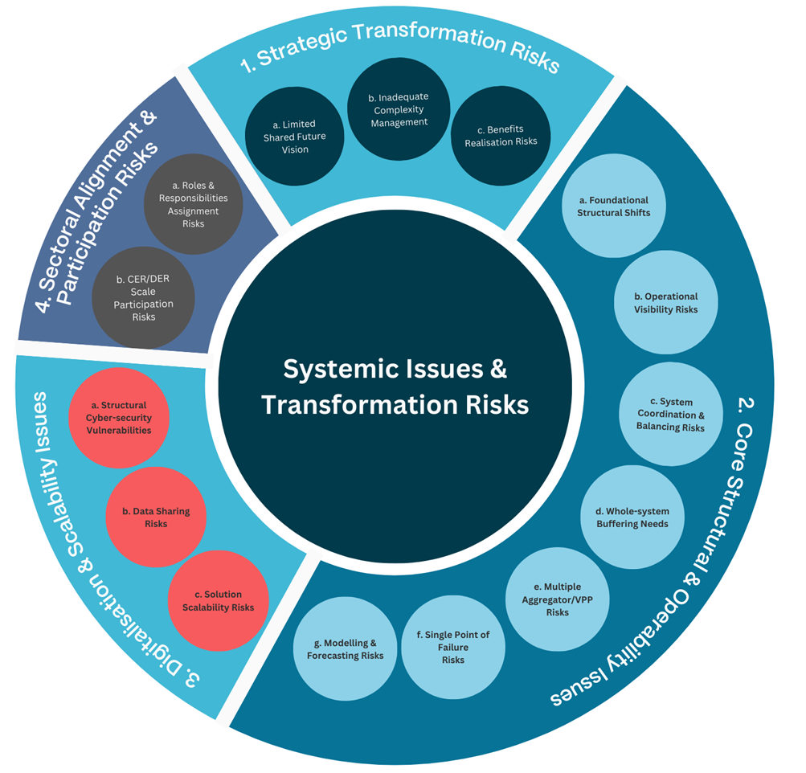

Figure - Systemic Issues identified in Report 3 and grouped by category

## Core Structural and Operability Issues

TDC is central to addressing foundational structural and operability challenges that arise as power systems transition from centralised, one-way architectures to highly distributed, bidirectional and dynamic systems. These challenges include maintaining coherence, stability, and predictability across a grid increasingly shaped by active customer participation and inverter-based resources.

* System Coordination and Balancing Risks: TDC provides the mechanisms and protocols necessary to coordinate the increasing diversity and spatial dispersion of CER/DER and VRE. By enabling near real-time data exchange and flexible dispatchability across system layers, it enhances the system's ability to maintain balance under a wider range of operating conditions.
* Single Point of Failure Risks: TDC promotes a more layered and distributed architecture that reduces dependence on centralised control or visibility hubs. It provides a pathway toward resilient islanding and fallback modes over time through enabling distributed intelligence and shared system operator responsibilities. It can also reduce the likelihood and consequence of local failures escalating into system-wide disruptions.
* Whole-System Buffering Needs: The shift from synchronous to weather-dependent inverter-based generation increases system dynamics and reduces inherent inertia and fault ride-through capability. TDC supports advanced integration and orchestration of storage across transmission and distribution to smooth supply/demand volatility and coordinated synthetic inertia and related system services procurement from CER/DER, enhancing the system’s capability to buffer against disturbances.
* System Model Drift and Unintended Feedback Loops: TDC supports tighter alignment between operational data, planning models, and system states across distribution and transmission systems. This is achieved through shared interface definitions, feedback mechanisms, and collaborative forecasting—minimising the risks of unobserved dynamics or misaligned interventions.
* Emergency Interventions and Override Risks: In high-DER contexts, uncoordinated emergency actions (e.g. mass disconnection) can lead to cascading impacts. TDC enables structured prioritisation, pre-agreed response frameworks, and co-visibility of actions, enhancing operability under stress scenarios.

Collectively, these capabilities ensure that the power system retains stability, controllability, and adaptability as its structural underpinnings evolve. TDC acts not only as a bridge between legacy and future system states, but as a foundational mechanism for sustaining operability in increasingly complex and distributed grid environments.

## Digitalisation and Scalability Risks

Effective TDC addresses key digitalisation and scalability risks, particularly around data access, system visibility, and flexible orchestration capabilities.

* Operational Visibility: TDC facilitates consistent and actionable observability at both the transmission and distribution levels, a prerequisite for much more dynamic control and coordination of CER/DER.
* Modelling and Forecasting: Shared data models and co-developed forecasting frameworks enable accurate, timely insights across system layers, enhancing both planning and operational decision-making.
* Digital Infrastructure Scalability: By driving interface consistency between the System Operator (AEMO) and DSOs, interoperability standards and interface modularity, TDC supports scalable digitalisation and avoids vendor or platform lock-in that could constrain long-term flexibility.

These digital enablers underpin a power system architecture capable of supporting evolving CER/DER volumes and behaviours, enabling efficient scaling without reengineering foundational coordination frameworks.

## Sectoral Alignment and Participation Risks

TDC helps mitigate risks related to fragmented sectoral roles, lack of coordinated decision-making, and misaligned market incentives—all of which constrain effective CER/DER integration.

* Role Clarity and Responsibility Allocation: TDC provides a basis for clarifying who does what at the SO-DSO interface and within evolving DSO functions, reducing duplication and conflict.
* Value Stack Misalignment: Coordination frameworks help resolve conflicting signals for CER/DER between distribution and transmission system-level services, improving investment signals and service efficiency.
* Participation Equity: Structured coordination supports consistent access to markets and services across customer segments and jurisdictions, ensuring that CER/DER participation is not limited by technical or regulatory silos.

By aligning operational, planning, and regulatory functions across sectors, TDC enhances the legitimacy, consistency, and effectiveness of the transition pathway.

# Recommended Priority Actions

Australia’s large scale power systems are transforming from a unidirectional past involving hundreds of large generation plant to a more dynamic and bidirectional future involving tens of millions of diverse energy resources participating across all vertical tiers/layers of the grid.

Many of the challenges faced in preparing existing legacy power systems for a deeply decarbonised and increasingly distributed future are not unique to the NEM. However, the world-leading pace and scale of Australia’s grid transformation will require new ways of conceptualising the nature of the challenges we face and how to best address them.

For example, informed by the field of transition design, it is noteworthy that a primary model of change in the power sector has traditionally focused on addressing elements, often in an issue-in-isolation manner. As Figure 30 below highlights, while focusing on structural elements in relative isolation may be entirely appropriate in a steady-state system, this is less effective where a system is experiencing profound change. In such a case, it becomes essential to reconceptualise dominant paradigms and address critical issues with the system structure which are no longer fit-for-purpose.

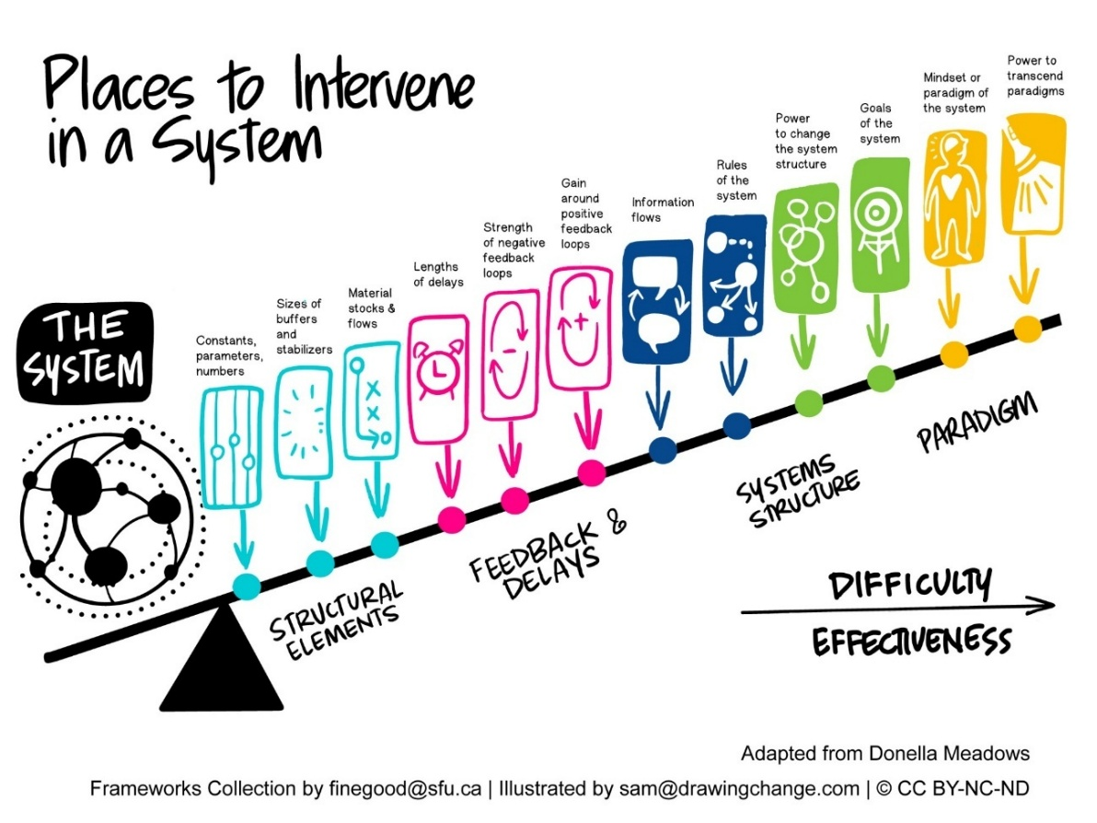

Figure : The field of transition design highlights the need to reconceptualise key paradigms and address system structures that are no longer fit-for-purpose

## PRIORITY 1: Recognise that 21st century distribution systems are becoming renewable energy zones that will self-supply >50 – 150% of local demand.

Given Australia’s world-leading levels of DPV, the NEM already has whole regions that experience close to 100% of instantaneous demand being served by distribution-connected CER/DER on sunny, low load days. Later the same evening, these same regions are almost 100% supplied by the centralised system. This is now resulting in a 24-hour operational profile that is essentially ‘tidal’ – and the transformation still has a very long way yet to go! For example, by 2035 AEMO’s Step Change scenario[9] anticipates DPV capacity reaching approximately ~55GW/70TWh, meaning that the NEM will regularly experience time windows where most supply is flowing ‘upstream’ from the distribution system.

In a legacy context where the dominant models of change primarily focus on enhancements to individual elements, honestly confronting the emerging scale of change and its practical implications is key to ensuring a fit-for-purpose approach. For example, attempting to develop DSO models and supporting TDC in a manner that is, perhaps implicitly, largely based on extrapolations from the legacy models of the past significantly elevates the risk of sub-optimal outcomes, operational disruption and expensive rework. By contrast, where a more realistic and future-facing approach is applied, the DSO models and supporting TDC that is developed can still be implemented in a stepwise manner as CER/DER volumes increase but will be significantly more adaptive, scalable and future-ready by design.

## PRIORITY 2: Reconceptualise the 21st century transmission-distribution relationship as intrinsically bidirectional, collaborative and mutual-beneficial.

This scale of transformation described above is anticipated to only increase as time passes. For example, AEMO’s Step Change scenario[9] anticipates that by 2050 NEM operations will be predominantly bidirectional with ~115GW/100TWh capacity provided by DPV, representing a further fourfold increase on Australia’s already world-leading levels in 2025. In this case, enabling transmission-distribution relationships to function in an intrinsically bidirectional, collaborative and mutual-beneficial manner will be key to future-proofing the NEM.

Once again, allowing the practical implications of the scenarios we regularly discuss to inform our DSO and TDC design considerations will enable significant efficiencies, mitigate the need for subsequent rework and potentially unlock significant economic value much earlier. Addressing these matters holistically will enable a more flexible and interdependent power system end-to-end that can anticipate, adapt to and manage variability and volatility of supply and demand across all relevant time scales. As GW-scale power systems like the NEM become increasingly volatile and bidirectional, this will be essential to operational visibility, coordination and the instantaneous balancing of supply and demand.

## PRIORITY 3: Recognise that DSO & TDC models are transformational enablers, not simply enhancements to the legacy grid structures.

Providing end-to-end visibility, predictability and operational coordination of millions of energy resources located across the system is extremely difficult because of the structural constraints embedded in the legacy systems architecture of the NEM. Therefore, comprehending the intrinsic relationship between the design of DSO and TDC models, and the criticality of their wider structural relationships, illustrates why considering them, even implicitly, as an enhancement to or ‘patch’ on the 20th century power system is vastly inadequate. By contrast, both DSO and TDC models are properly understood as key enablers required to ‘cross the chasm’ illustrated by Figure 31 below.

Similar to the above, addressing these matters holistically will enable a more flexible and interdependent power system that can anticipate, adapt to and manage variability and volatility of supply and demand across all relevant time scales. Unlocking the whole-system value of millions of resources will maximise societal benefits, customer savings and equitable outcomes. Regardless of the DSO or TDC model designs adopted, this cannot ultimately be achieved without the necessary targeted structural interventions critical to their operation.

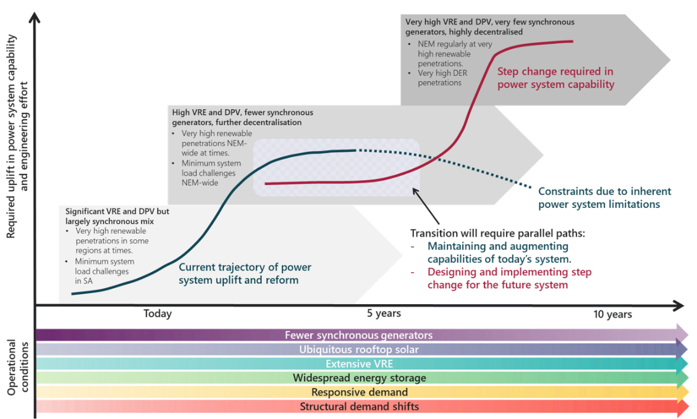

Figure : DSO and TDC models are key enablers for ‘crossing the chasm’ between two distinct parallel paths of capability

## PRIORITY 4: Recognise that activities focused on ‘keeping the lights on’ and ‘creating the future power system’ are equally necessary and require parallel paths of focus and effort.

While the previous considerations may sound reasonable in theory, they are often quickly dismissed as impractical. Most commonly, this is due to there being only one path of transformational activity. Given that the immediate issues of ‘keeping the lights on’ will always take precedence, a practical outcome is that most change initiatives remain disproportionately focused on the nearer term. Most also largely assume a model of extrapolating from the established legacy arrangements into the future. While this may be entirely appropriate in a comparatively steady-state environment, it is largely incapable of effectively responding to large structural transformations.

Consistent with transition design theory and practice, navigating large structural transformations requires at least two simultaneous paths of focus and effort. Path 1 is the most familiar; it is where the necessary enhancements to the existing system continue to be made to enable it to keep operating in the near to medium term. While not always well understood, a further purpose of Path 1 is to ‘buy time’ to address the more complex structural issues that impede longer-term solutions. Given the scale of system change to which DSO and TDC models respond, Path 2 provides the context, processes and time in which all of the relevant matters may be collaboratively interrogated and scalable solutions developed. Further high-value benefits of establishing parallel paths of activity include enabling several time horizons to be kept in focus and relevant learnings can be actively shared between the respective participants to the advantage of both paths.

## PRIORITY 5: Accept that in times of profound transformation, there is no textbook, no perfect knowledge and no single entity with all the answers.

A further challenge a times of profound transformation is that few if any established sources of knowledge exist to seamlessly guide the way to enduring solutions. This is particularly unsettling in a century old sector providing an essential service, where many recurring activities are performed with algorithmic certainty and near perfect knowledge.

An additional benefit of the parallel path approach outlined above is that is provides the environment for intensive shared learning, trial and error, and accelerated convergence on the most credible DSO and TDC design options. In addition, System Architecture tools provide a valuable means for ‘taming’ the structural complexity of transforming power systems by providing multiple points of view on key systemic issues. This enables enhanced multi-stakeholder collaboration to identify critical issues and shortlist the most credible solutions, underpinned by a shared, trusted and evidence-based analytic framework.

## PRIORITY 6: Build sector-wide capacity for identifying and addressing structural constraints in addition to upgrading components and targeted enhancements.

Although GW-scale power systems are some of humanity’s most complex systems, Systems Engineering and related disciplines developed over recent decades have not been widely applied in what was a comparatively steady state environment.

As these capabilities are now increasingly required, multi-stakeholder processes for mapping and documenting the ‘as built’ and plausible future structural arrangements of the NEM delivers tangible benefits and also enable the upskilling of industry participants. A further benefit is that it enables the diverse entities working in different segments of the NEM to acquire a better comprehension of how their segment interfaces with the rest of the system.

## PRIORITY 7: Establish a strategic and collaborative program of Systems Architecture development to underpin DSO, TDC and related NCERR initiatives

Given the structural context that underpins the development of DSO and TDC models, a prerequisite to forward progress is a shared architectural vision. Fragmentation and conflicting assumptions about the future end-state, and especially between the alternate structural archetypes, risks stalling operationalisation of scalable solutions. Stakeholders must collectively agree on the long-term architectural trajectory, recognising this as a dynamic but directional path.

The application of Model-Based Systems Engineering (MBSE) tools also provides a powerful complement that enables:

* Visual and functional mapping of system configurations
* Simulation of different roles, functions and system interface relationships
* Clearly defined structural configurations that may evolve over different time-horizons
* Evaluate performance and scalability dimensions of alternate structural configurations.

Such approaches can bring rigour, traceability and collaborative insight to what would otherwise be fragmented and ad hoc reform.

## PRIORITY 8: Advance DSO & TDC designs as interdependent structural enablers

DSO and TDC model development and implementation should be treated as co-evolving constructs, not parallel or independent streams. TDC is the operational and structural ‘connective tissue’ that enable multiple DSOs to effectively interface with the SO and related markets. Conversely, emerging DSO capabilities form the observability and execution layer utilising the TDC for joint system operation. Recognising this interdependence is essential for coherent policy design, regulatory reform, and technical architecture development.

## PRIORITY 9: Formalise DSO & TDC roles using a structurally informed approach

To operationalise the core functions of both DSO and TDC models, a structurally informed process is needed to assign specific roles and responsibilities in a manner that is cognisant of operational interdependencies over various time-horizons. A rigorous, evidence-based methodology for functional role assignment should be employed together the appropriate tools for shared understanding and codesign.

## PRIORITY 10: Distinguish between transitional and enduring DSO & TDC structures and functions

A critical design challenge lies in distinguishing which DSO and TDC structures and functions are transitional – required to temporarily bridge current constraints - and which are enduring. A ‘lease regrets’ approach should be applied that focuses on scalable, modular investments that enable future evolution and adaptation.

An advantage of this approach is that it avoids forcing premature convergence on role assignments and/or embedding of systems or particular technologies in a manner that is difficult or impossible to reverse. Identifying and avoiding over-investment in technology and/or structural options that will not efficiently scale is key preserving future optionality and avoiding stranded investments.

# Conclusion

This report has examined the foundational role of TDC in supporting Australia’s evolving power system, particularly as increasing volumes of CER/DER, VRE, and inverter-based technologies drive new demands for whole-system coordination. In doing so, it has identified both the technical underpinnings and strategic imperatives required to operationalise effective TDC coupled with maturing DSO functions.

Sections 5 and 6 established the technical scaffolding necessary for TDC design and implementation. Section 5 examined key architectural design considerations for enabling scalable, secure, and interoperable coordination across system layers, highlighting the critical role of standardised structures, information models, and multi-layered operational coordination frameworks. Section 6 then addressed the data and communications foundations, identifying the data requirements, data models, protocols, and cyber-physical communication infrastructure essential for reliable and scalable information exchange between transmission and distribution actors. Together, these sections present the critical cyber-physical enablers upon which practical TDC models must be built.

Building from these foundations, Section 7 articulated a representative set of Core Functions necessary to enable effective TDC across three primary domains: structural coordination, schedule coordination, and real-time operational coordination. Importantly, the report recognises that the implementation of these functions will evolve as DSO capabilities mature and as the system architecture progressively transitions from nearer-term Multi-entity models toward Layered Coordination DSO frameworks. This functional framework provides a pathway to stage the implementation of TDC in ways that remain flexible to future system needs while addressing present operational imperatives.

Sections 8 and 9 then placed these functions into the broader context of system-level benefits, transformation risks, and actionable reform priorities. Section 8 demonstrated how well-implemented TDC delivers whole-of-system benefits that extend across societal objectives—supporting affordability, sustainability, dependability, equity, and adaptability—while simultaneously mitigating core systemic risks including structural operability challenges, strategic transformation risks, digitalisation and scalability risks, and sectoral coordination gaps. In doing so, it makes clear that TDC is not an isolated technical intervention, but rather a foundational enabler for system stability, investment efficiency, and long-term social license.

Finally, Section 9 outlined a set of recommended priority actions to guide the operationalisation of more advanced TDC. These recommendations call for the joint development of DSO and TDC functions as mutually dependent structural enablers, supported by formalised processes to assign roles and responsibilities using evidence-based methodologies. The report underscores the importance of achieving broad architectural consensus on system direction, and of adopting a least-regrets approach that differentiates between transitional coordination functions and those that must endure as the system matures. A critical paradigm shift is also recommended: to reconceive distribution networks as active operational generation zones from the perspective of the transmission system. To enable deliberate, transparent navigation of these transitions, the report advocates for the application of formal Systems Engineering practices and Model-Based Systems Engineering (MBSE) toolsets, providing a means to map structural configurations, simulate evolutionary pathways, and evaluate key decision points collaboratively across stakeholders.

In sum, this report positions Transmission-Distribution Coordination not as a discrete policy choice, but as a structural imperative that sits at the centre of Australia's power system transformation. Its careful implementation will be essential to realising a decarbonised, resilient, and customer-centric electricity system capable of supporting the country’s net zero ambitions.

# 11 References

|  |  |
| --- | --- |
| [1] | IRENA, “Innovation Landscape Brief: Co-operation Between Transmission and Distribution System Operators,” 2020. [Online]. Available: https://www.irena.org/-/media/Files/IRENA/Agency/Publication/2020/Jul/IRENA_TSO-DSO_co-operation_2020.pdf?la=en&hash=5D78444F4339DC130204A0F9A99A30753368AABC. |
| [2] | T. Krause, R. Ernst, B. Klaer, I. Hacker and M. Henze, “Cybersecurity in Power Grids: Challenges and Opportunities,” 16 September 2021. [Online]. Available: https://doi.org/10.3390/s21186225. |
| [3] | US Department of Energy, “Cyber-Informed Engineering,” [Online]. Available: https://www.energy.gov/ceser/cyber-informed-engineering. |
| [4] | CIGRE Working Group C2.40, “TSO-DSO Co-Operation Control Centre Tools Requirements,” *CIGRE Technical Brochure,* vol. Technical Brochure, no. 845, 2021. |
| [5] | Electric Power Research Institute, “Technical Update: TSO-DSO Coordination Functions for DER,” EPRI, 2022. |
| [6] | Energy Networks Association, Primacy Rules for ESO/DNO Coordination – Increment 2, Open Networks Programme, Version 1.0, Oct. 2024. |
| [7] | L. Thompson, Transmission-Distribution Coordination Working Group: IESO-Administered Markets Communication Interfaces, Independent Electricity System Operator, Ontario, Canda, April 2024. |
| [8] | P. De Martini, S. Patel and D. Kathan, TSO-DSO-Aggregator Market and Operational Coordination Requirements, U.S. Department of Energy, Office of Electricity, April 2024. |
| [9] | A. Morch, G. Migliavacca, I. Kockar, H. Xu, J. M. Fernnandez Tecnalia and H. Gerard, Architectures for Optimised Interaction Between TSOs and DSOs: Compliance With The Present Practice, Regulation And Roadmaps, 25th International Conference on Electricity Distribution, June, 2019. |
| [10] | G. A. Council, A Practical Introduction to Common Grid Architecture Techniques, GridWise Architecture Council, April 2024. |
| [11] | Nederlandse Organisatie voor Toegepast Natuurwetenschappelijk Onderzoek (TNO), “Common Information Model Ontology Class Library,” [Online]. Available: https://ontology.tno.nl/IEC_CIM/. |
| [12] | F. Marten, I. Hammermeister, J. Ringelstein, B. Requardt, and M. Braun, CIM CGMES-extensions for the TSO-DSO data exchange in the EU-project ‘TDX-ASSIST’, Kassel, Germany: Horizon 2020, 2019. |
| [13] | A. Stokes, R. Das, T. Joseph, A. Aithal, C. Addison, D. Healey, C. Balrey and E. Horn, Flexibility Markets: Development and Implementation - TSO-DSO Coordination: The UK Case, ISGAN Annex 9, Energy Systems Catapult, Mar. 2022. |
| [14] | J. Kamsamrong and S. Lehnhoff, Aggregators in Digitalised Power Systems: How can Aggregators Improve the TSO-DSO-Customer Coordination in Digitalised Power Systems?, ISGAN Working Group 6, July 2024. |
| [15] | B. Herndler, C. Evrenosoglu, G. Migliavacca, H. Gerard, I. Vilgan, J. C. Ávila, K. Kessels, M. Rossi, P. Lo and S. Wong, Power Transmission & Distribution Systems: Flexibility Harvesting and Its Impact on Stakeholder Interaction, ISGAN Working Group 6, Dec. 2022. |
| [16] | IRENA, Innovation landscape brief: Future role of distribution system operators, Abu Dhabi: International Renewable Energy Agency, 2019. |
| [17] | P. D. Martini, S. Succar and P. Cook, Sourcing Distributed Energy Resources for Distribution Grid Services, U.S. Department of Energy, Office of Electricity, Dec. 2024. |
| [18] | A. Golriz and N. Omran, T-D Coordination to Support Reliable Performance of BPS with DER Integration, Ontario, Canada: Independent Electricity System Operator, Dec. 2023. |
| [19] | CEER, Paper on DSO Data Exchange Relating to Flexibility and NRAs’ Role, Brussels, Belgium, 2024. |
| [20] | IRENA, Innovation Landscape Brief: Co-Operation Between Transmission and Distribution System Operators, Abu Dhabi: International Renewable Energy Agency, 2020. |
| [21] | MISO, “Distribution System Operators (DSOs) & MISO Market Interactions,” 18 November 2024. [Online]. Available: https://cdn.misoenergy.org/20241118%20DERTF%20Item%2004%20Distribution%20System%20Operators_Camus661034.pdf#:~:text=DSO%20Role%201,for%20DERs%20between%20utility%20and. |
| [22] | smartEn, “Data Exchanges for the System Integration of COnsumers: Assessment of Available Standars and Protocols,” May 2023. [Online]. Available: https://smarten.eu/wp-content/uploads/2023/06/smartEn-Standards-mapping-position-paper_final.pdf. |
| [23] | ESB Networks, “Signals & Data Exchange Guidance for DER,” 23 September 2021. [Online]. Available: https://www.esbnetworks.ie/docs/default-source/publications/esb-networks-national-network-local-connections-programme-signal-data-exchange-roadmap.pdf?sfvrsn=8774badc_12. |
| [24] | QualityLogic, “Is IEEE 2030.5 THE DER Protocol? - GridEdge Intelligence Mini Forum,” 25 May 2021. [Online]. Available: https://www.qualitylogic.com/wp-content/uploads/2021/05/GEI-Mini-Forum-2030.5.pdf. |
| [25] | AEMO, “Project EDGE - Public Interim Report,” June 2022. [Online]. Available: https://aemo.com.au/-/media/files/initiatives/der/2022/public-interim-report.pdf?la=en&hash=45036CAC8BE6B43C186426B0B5B8005C. |
| [26] | C. P. G. Donodossola, “Cybersecurity of DER-DSO data exchanges. From Europead Regulations to Italian Norms,” 13 July 2023. [Online]. Available: https://cetpartnership.eu/sites/default/files/documentation/CETP%2060%20minutes%20on%20Cybersecurity%20by%20design_Dondossola_Cybersecurity%20of%20DER-DSO%20exchanges%2013072023_0.pdf#:~:text=%E2%96%A0%20Cybersecurity%20of%20firmware%2Fsoftware%20upgrades. |
| [27] | J. W. L. Schmitt, Future Control Room Architectures for Grid and Market Integrated Operation, Axual and Digital4Grids, Jan. 2025. |
| [28] | J. C.W. Draffin, “Cybersecurity White Paper,” MIT Energy Initiative, 2017. |
| [29] | ENTSO-E, CEDEC, GEODE, EURELECTRIC, EDSO for Smart Grids, “TSO-DSO Data Management Report,” 27 July 2016. [Online]. Available: https://eepublicdownloads.entsoe.eu/clean-documents/Publications/Position%20papers%20and%20reports/entsoe_TSO-DSO_DMR_web.pdf#:~:text=The%20architecture%20of%20IT%20and,. |
| [30] | WSP, Imperial College London Consultants, National Grid, Dissemination of project findings: Final Dissemination Webinar, Energy System Operator (ESO), July 2024. |
| [31] | AEMO, “Integrated System Plan For the National Electricity Market,” 2024. |
| [32] | AEMO, “Engineering Roadmap - FY2025 Priority Actions Report,” 2024. |
| [33] | Ofgem, “Future Systems and Network Regulation: Framework,” 26 October 2023. [Online]. Available: www.ofgem.gov.uk. |
| [34] | PJM Inside Lines, “Order 2222 Filing Furthers DER Market Participation,” 2 February 2022. [Online]. Available: https://insidelines.pjm.com/order-2222-filing-furthers-der-market-participation/. |
| [35] | Electric Power Research Institute (EPRI), “TSO-DSO Coordination Frameworks for DER Services,” Palo Alto, CA, 2023. |
| [36] | CEDEC; EDSO; ENTSOE; EURELECTRIC; GEODE, “TSO-DSO Data Management Report,” 2016. [Online]. Available: https://eepublicdownloads.entsoe.eu/clean-documents/Publications/Position%20papers%20and%20reports/entsoe_TSO-DSO_DMR_web.pdf. [Accessed 20 March 2025]. |
| [37] | IESO, “Distributed Energy Resources (DER) - Market Vision and Design Project,” 25 January 2023. [Online]. Available: https://www.ieso.ca/en/Sector-Participants/Engagement-Initiatives/Engagements/Distributed-Energy-Resources-Market-Vision-and-Design-Project. [Accessed 20 March 20]. |
| [38] | ICF, “Development of a Transmission - Distribution Interoperability Framework,” May 2020. [Online]. Available: https://www.ieso.ca/-/media/Files/IESO/Document-Library/White-papers/IESO-T-D-Coordination-Framework.pdf. |
| [39] | A. Kavgic, “Solving the DER communication problem with HIL Compatible and MBSE,” Typhoon HIL Blog, 1 February 2023. [Online]. Available: https://www.typhoon-hil.com/blog/der-communication-challenge/#:~:text=Some%20modern%20communication%20protocols%2C%20such,or%20full%20support%20for%20multiple%20now%20this,%20please. |
| [40] | N. Suljanović, A. Souvent, G. Taylor, M. Radi, E. Lambert and H. Morais, “Design of Interoperable Communication Architecture for TSO-DSO Data Exchange,” 2019. [Online]. Available: https://bura.brunel.ac.uk/bitstream/2438/18594/1/FullText.pdf.. |
| [41] | C. D'Adamo, F. Cazzato, M. Di Clerico and S. Ferrero, “Coordination and Data Exchange Between DSO and TSO as Key Factors for Optmizing DER Management in the Future Energy System,” in *CIRED 2019*, Madrid, Spain, 2019. |
| [42] | A. G. Givisiez, K. Petrou and L. F. Ochoa, “A Review on TSO-DSO Coordination Models and Solution Techniques,” *Electric Power System Research,* vol. 189, 2020. |
| [43] | S. Chen, F. Ebe, J. Morris, H. Lorenz, C. Kondzialka and G. Heilscher, “Implementation and Test of an IEC 61850-Based Automation Framework for the Automated Data Model Integration of DES (ADMID) into DSO SCADA,” 19 February 2022. [Online]. Available: https://doi.org/10.3390/en15041552. |
| [44] | A. Bytyqi, S. Gandhi, E. Lambert and N. Petrovi, “A Review on TSO-DSO Data Exchange, CIM Extensions and Interoperability Aspects,” *Journal of Modern Power Systems and Clean Energy,* vol. 10, no. March 2022, pp. 309-315, 2022. |
| [45] | N. Suljanovic, M. Radi, G. Taylor, J. Cantenot and E. Lambert, “Developing Enhanced TSO-DSO Information and Data Exchange Based on a Novel Use Case Methodology,” *Frontiers in Energy Research,* vol. 9, 2021. |
| [46] | K. Kukk, F. Bosco, M. Lacerda, V. Sakas, A. Kapetanios and K. Kotsalos, “Cross Stakeholder Data Governance for Energy Data Exchange D6.2,” 31 03 2023. [Online]. Available: https://www.onenet-project.eu/wp-content/uploads/2023/04/D6.2-OneNet-v1.0.pdf. |
| [47] | Electric Power Research Institute, Technical Update Report: Distribution System Operator Interactions with Transmission System Operator, EPRI, 2019. |
| [48] | United States, Department of Energy - Grid Modernization Initiative, Grid Modernization Strategy 2024, US DOE, 2024. |
| [49] | Ontario Energy Association, “Distribution System Operator (DSO) Study,” Ontario Energy Association, 2023. |
| [50] | Electric Power Research Institute, “Technical Brief: Procuring Services from Distribute Energy Resources,” EPRI, 2023. |
| [51] | CEDEC, E.DSO, ENTSOE, Euelectric, GRODE, TSO – DSO REPORT – AN INTEGRATED APPROACH TO ACTIVE SYSTEM MANAGEMENT, ENTSO-E, 2019. |
| [52] | U.S. Department of Energy, Office of Electricity, “Latency Implications for Grid Communications, SPaRC Series White Paper,” 31 January 2024. [Online]. Available: https://www.energy.gov/sites/default/files/2024-02/SPARC%20Series%20-%20Latency%20Whitepaper_01312024_optimized.pdf#:~:text=diverse%20renewable%20energy%20assets%20becomes,resilient%20and%20reliable%20energy%20infrastructure. |
| [53] | BRIDGE Regulation and Data Management WG, BRIDGE TSO-DSO Coordination Report, 2019. |
| [54] | EU-SysFlex, “Conceptual market organisations for the provision of innovative system services: role models,associated market designs and regulatory frameworks,” Horizon 2020, 2020. |
| [55] | U.S. Department of Energy, “Operational Coordination across Bulk Power, Distribution and Customr System,” February 2019. [Online]. Available: https://www.pnnl.gov/sites/default/files/media/file/Operational-Coordination-Across-Bulk-Power-Distribution-Customer-Systems-Feb2019.pdf. |
| [56] | ENA, “Primacy Rules, Rules for ESO/DNO Coordination. Increment 2. V.1.0,” 2024. |
| [57] | Electric Power Research Institute (EPRI), “TSO-DSO Coordination Functions for DER,” *Technical Update Report,* no. 3002021985, 2022. |
| [58] | J. Taft, “Assigning Roles and Responsibilities Rigorously,” Substack, 24 January 2025. [Online]. Available: https://jeffreytaft.substack.com/p/assigning-roles-and-responsibilities. [Accessed June 2025]. |
| [59] | U.S. Department of Energy, Office of Electricity, “Latency Implications for Grid Communications,” 31 January 2024. [Online]. Available: https://www.energy.gov/sites/default/files/2024-02/SPARC%20Series%20-%20Latency%20Whitepaper_01312024_optimized.pdf. |
| [60] | S. Brisley and Camus Energy, “Distribution System Operators (DSOs) & MISO Market Interactions - Presented at the MISO Distributed Energy Resources Task Force (DERTF),” 18 November 2024. [Online]. Available: https://cdn.misoenergy.org/20241118%20DERTF%20Item%2004%20Distribution%20System%20Operators_Camus661034.pdf. |
| [61] | A. Mills and R. Wiser, “Implications of geographic diversity for short-term variability and predictability of solar,” 24 July 2011. [Online]. Available: https://scispace.com/pdf/implications-of-geographic-diversity-for-short-term-412td9fb01.pdf. |
| [62] | Taft, Jeff, “Grid Architecture,” Pacific Northwest National Labs, Oak Ridge, 2015. |
| [63] | Institute of Electrical and Electronics Engineers, “Guide for Distributed Energy Resources Management Systems (DERMS) Functional Specification,” New York, 2021. |
| [64] | International Electrotechnical Commission, “Application Integration at Electric Utilities – System Interfaces for Distribution Management – Part 5: Distributed Energy Optimization,” Geneva, Switzerland, 2020. |
| [65] | Pacific Northwest National Laboratory (PNNL), ‘The Network of Structures Grid Model Paradigm’. 2014. [Online]. Available: https://gridarchitecture.pnnl.gov/media/advanced/The%20Network%20of%20Structures.pdf |
| [66] | UK Power Networks, ‘DSO Performance Panel Report 2023/24’, U.K., 2024 2023. [Online]. Available: https://d1lf1oz5vvdb9r.cloudfront.net/app/uploads/2024/04/UK-Power-Networks-DSO-Performance-Panel-Report-2023-24-FINAL.pdf |
| [67] | Baringa Partners LLP, ‘An Exploration of Potential DSO Models for New Zealand’, Apr. 2025. [Online]. Available: https://www.ena.org.nz/assets/DMSDocuments/Potential-DSO-models-for-New-Zealand.pdf |
| [68] | Energy Systems Integration Group, ‘The Transition to a High-DER Electricity System: Creating a National Initiative on DER Integration for the United States’, Aug. 2022. [Online]. Available: https://www.esig.energy/wp-content/uploads/2022/08/ESIG-DER-integration-US-initiative-report-2022.pdf |
| [69] | New York State Department, ‘Reforming the Energy Vision (REV)’, White Paper, 2016. [Online]. Available: https://www.ny.gov/sites/default/files/atoms/files/WhitePaperREVMarch2016.pdf |
| [70] | Electricity North West, ‘DSO–DNO Governance Framework’, Final Report, Mar. 2025. [Online]. Available: https://www.enwl.co.uk/globalassets/future-energy/dso/reports/dsodno-governance-framework/dso-dno-governance.pdf |
| [71] | Energy Networks Australia and Australian Energy Market Operator, ‘Open Energy Networks: Consultation Paper’, Jun. 2018. [Online]. Available: https://www.energynetworks.com.au/assets/uploads/open_energy_networks_consultation_paper.pdf |
| [72] | Baringa Partners LLP, ‘Assessment of Open Energy Networks Frameworks’, Oct. 2020. [Online]. Available: https://www.energynetworks.com.au/resources/reports/assessment-of-open-energy-networks-frameworks/ |
|  |  |

# Appendix A: Principles, Methodologies & Acknowledgements

This section provides an overview of the guiding principles and integrated disciplines and tools employed in the development of this reference set.

A1 Guiding Principles

Following are a set of principles and characteristics embedded in the Power System Architecture discipline that have guided the development of this reference set.

1. Stakeholder / User-centric: Systems architecture methodologies are grounded in a detailed exploration of the *Future Customer & Societal Objectives (Report 1)* for the power system to ensure the grid can deliver a balanced scorecard of societal outcomes.
2. Contextually Informed: Systems architecture methodologies give priority to examining the full range of *Emerging Trends Driving Transformation (Report 2)* that are driving significant change together with the resulting Systemic Issues that must be addressed if stakeholder expectations of the future system are to be made achievable.
3. Structural Focus: Systems architecture methodologies give particular attention to examining the underpinning legacy structure or ‘architecture’ of a complex system due to the disproportionate influence it has on what the system can safely, reliably and cost-efficiently do (i.e. the ‘performance envelope’ of the system).
4. Principles-based: Systems architecture methodologies are grounded in established principles and formal bases, ensuring conceptual integrity through consistent, traceable and verifiable processes, that enhance multi-stakeholder trust, and minimise the potential for unintended consequences.
5. Whole-system Perspective: Systems architecture methodologies provide a holistic view of the entire system as the primary basis for considering the interdependencies between its many tiers/layers, subsystems and components.
6. Decadal Time Horizon: By identifying structural options that enhance (rather than constrain) multi-year optionality, systems architecture methodologies ensure the system is robust, adaptable, scalable and extensible across a range of alternate future scenarios and maximise the ‘future-proofing’ of investments.
7. Technology & Business Model Agnostic: By focusing on the required outcomes of the current and future system, systems architecture actively identifies alternative implementation pathways, supports technology innovation and avoids dependence on any one proprietary solution or commercial model.
8. Complexity Management: By making the underpinning structures of a legacy system explicitly articulated, systems architecture enables the decomposition of inherent complexity, identification of legacy structural constraints, and proposed changes to be accurately targeted and avoid complexity escalation.
9. Subsystem Analysis: By providing formal analytical tools, systems architecture enables the detailed interrogation of all current Subsystems and Components, their individual form and function, boundaries, interfaces and functional interdependencies to holistically consider potential future enhancements in the context of the whole system.
10. Stakeholder Empowerment: By providing an objective and evidence-based set of tools that can be learned, systems architecture empowers diverse stakeholders – both technical and non-technical – to collectively reason about current and future options and better contribute to key trade-off decisions.

A2 Integrated Disciplines & Tools

Following are a set of disciplines and tools that have informed and enabled the development of this reference set.

|  |  |
| --- | --- |
| Design Thinking | A human-centered, iterative methodology for solving complex problems through empathetic understanding, creative ideation, and rapid experimentation. The purpose of Design Thinking is to foster innovation by prioritising human needs, reframing challenges as opportunities, and developing actionable solutions that balance desirability (user appeal), feasibility (technical viability), and viability (economic sustainability). It functions as a non-linear process that bridges creative exploration with practical implementation, enabling teams across disciplines to navigate ambiguity and deliver user-centric outcomes. |
| Model-Based Systems Engineering (MBSE) | An approach to Systems Engineering that uses software-based models to represent various aspects and behaviours of a complex System. It provides dynamic modelling of System requirements, design, analysis, verification and validation activities in a manner that ensures requirements traceability, reduced errors and enhances multi-stakeholder collaboration in near real-time.  MBSE leverages graphical and textual representations to capture, analyse, simulate, and communicate the requirements, designs, and behaviours of the System. Applied from the conceptual design phase and continuing throughout development and later life cycle phases, it enhances traditional Systems Engineering processes by providing a more structured, integrated, and visual representation of the Architecture and Functions of a System. |

|  |  |
| --- | --- |
| Power Systems Architecture (PSA) | An integrated set of disciplines that support the structural transformation of legacy power systems, enabling them to more effectively serve evolving customer and societal objectives.  At its most fundamental, PSA reflects the application of systems engineering to the transformation of the power system. In recognising each power system as a complex Network of Structures, the PSA methodologies are uniquely designed to provide:   * Whole-system insight over 5, 10 and 20-year time horizons, enabling the interrogation and mapping of current, emerging and future system priorities and objectives including the role and responsibilities, operational coordination and co-optimisation across all vertical tiers/layers. * Evidence-based tools to identify, analyse and shortlist key transformational options through the combination of systems architecture, network theory, control theory, systems science and Model-based Systems Engineering (MBSE). * Future-resilient decision making by surfacing hidden structural constraints early which may otherwise propagate a range of architectural Issues including computational constraints, latency cascading and cyber-security vulnerabilities, providing greater assurance that new investments will be scalable and extensible under all plausible futures.   PSA provides a formalised toolkit for decomposing and ‘taming’ the massive complexity inherent to a transforming power system. The PSA toolkit empowers more informed, multi-stakeholder participation by making critical content explicit and tractable that would otherwise remain opaque and intractable.  It is designed to enhance decision quality, timeliness and traceability to support full benefits-realisation and avoid the propagation of unintended consequences. |

|  |  |
| --- | --- |
| Strategic Foresighting | A systematic, collaborative process for exploring plausible futures, identifying emerging trends, disruptions, and opportunities to inform resilient long-term strategies.  The purpose of Strategic Foresighting is to enable organisations to proactively shape or adapt to future environments by reducing uncertainty, challenging assumptions, and aligning decisions with potential scenarios. It ensures that systems, architectures, and investments remain viable amid evolving technological, societal, economic, and regulatory landscapes.  Strategic Foresighting functions as an upstream enabler of the Systems Architecture process. It facilitates cross-disciplinary dialogue to anticipate future needs, risks, and innovations before architectural decisions are formalised. By analysing weak signals, drivers of change, and systemic interdependencies, it provides context for defining robust requirements in the Reference Architecture phase and ensures Detailed Architecture designs embed adaptability. |
| Structural Analysis | In the context of electricity system transformation, structural analysis refers to the systematic evaluation of the physical, operational, and organisational structures of the power system to determine the changes necessary to transition from a conventional, fossil-fuel-based, unidirectional grid to a decarbonised, distributed, and bidirectional grid.  This process involves assessing how new technologies (such as distributed energy resources, storage, and electric vehicles), market mechanisms, and control strategies will alter the system’s topology, power flows, stability characteristics, and resilience requirements. The goal is to ensure that the restructured grid can accommodate variable renewable energy sources, enable two-way energy and information flows, and maintain security, reliability, and affordability under future scenarios.  Key components of structural analysis include:   * Physical Structure: Reconfiguration of transmission and distribution networks for bidirectional flows. * Operational Structure: Adaptation of protection systems, frequency control, and flexibility measures. * Institutional/Market Structure: Integration of distributed generation, demand-side participation, and new pricing models. * Resilience and Stability: Ensuring robust system performance under uncertainty and high penetration of renewables. |
| Systems Architecture | A formal discipline within Systems Engineering that supports objective and collective reasoning about the foundational structure and organisation of a complex system. This includes its components, interfaces, feedback loops, and other critical behaviours.  The architecture of a system exerts a disproportionate influence on what the system can reliably and efficiently accomplish. Accordingly, a system should not be viewed merely as the sum of its parts, but rather as the product of the interactions among those parts—interactions that are enabled and constrained by the underlying architectural design.  Although architecture plays a pivotal role in shaping system performance, it is often less tangible and more difficult to discern than the system’s individual components. The discipline of Systems Architecture, therefore, provides formal methods and tools to analyse how system components are interconnected, to identify emergent behaviours that arise from these interactions, and to explore robust options for modification and improvement.  By enabling a deeper understanding of how legacy systems function and how their structures can evolve, Systems Architecture empowers stakeholders to visualise relationships, evaluate trade-offs, and make informed decisions that enhance the system’s capacity to meet current and future demands. |
| Systems Engineering | An established engineering discipline applied in numerous sectors focused on the development and operation of ultra-complex Systems including aerospace, military, manufacturing, energy and electronics sectors.  While many engineering disciplines are oriented toward individual Component technologies or sub-systems, Systems Engineering is a transdisciplinary approach that brings a holistic or whole-system approach to the realisation of successful Systems which consistently satisfy the needs of their customers, users and other stakeholders. |
| Systems Science | A multi-domain, integrative discipline that brings together research into all aspects of complex [systems](https://futuregridaccelerator.com/glossary/system-2/) with a focus on identifying, exploring and understanding the universal patterns and behaviours of [complexity](https://futuregridaccelerator.com/glossary/complexity/) and [emergence](https://futuregridaccelerator.com/glossary/emergence/). |

A3 Acknowledgements & Foundational Sources

The Energy Catalyst team has benefited from the expertise of and privilege of collaborating with many global organisations and experts. While it would be impossible to exhaustively recognise all relevant entities, individuals and sources, the following are particularly relevant to the development of this reference set, noting that any errors are those of Energy Catalyst alone.

*Entities*

* Australian Energy Market Operator (AEMO)
* Commonwealth Scientific Industrial Research Organisation (CSIRO)
* Energy Systems Catapult (ESC)
* Massachusetts Institute of Technology (MIT)
* Pacific Northwest National Laboratory (PNNL)
* Rocky Mountains Institute (RMI)
* United States Department of Energy, Office of Electricity (DOE)

*Individuals*

* Dr Thomas Brinsmead
* Pablo Campillos
* Paul De Martini
* Prof. Lynne Kiesling
* Dr Lorenzo Kristov
* Rama Ganguli
* Eamonn McCormick
* Dr Ron Melton
* Peter Senge
* Dr Jeffrey Taft
* Dr John Ward

*Foundational Sources*

The following sources provide key principles and bases for the application of the disciplines and tools employed in developing this reference set.

* International Council on Systems Engineering (INCOSE), INCOSE Systems Engineering Handbook: A Guide for System Life Cycle Processes and Activities, 4th ed. San Diego, CA, USA: INCOSE, 2015.
* R. D. Adcock, S. Friedenthal, D. Dori, R. Walden, and D. Giammarco, “Guide to the Systems Engineering Body of Knowledge (SEBoK),” ver. 2.9, The Systems Engineering Research Center, Hoboken, NJ, USA, May 2023. [Online]. Available: https://sebokwiki.org/wiki/Guide_to_the_Systems_Engineering_Body_of_Knowledge_(SEBoK)
* Bruce Cameron, Edward F. Crawley, and Daniel Selva, Systems Architecture, Global Edition, 1st ed., Pearson Education, 2015.
* J. D. Taft, S. Widergren, A. Shankar, R. Melton, and B. Kelley, Grid Architecture Specification: High DER/DA/STO Reference Architecture (GMLC 1.2.1 v0.3), Pacific Northwest National Laboratory, Richland, WA, USA, Dec. 2019.
* J. D. Taft and A. Becker-Dippmann, Grid Architecture, Pacific Northwest National Laboratory (PNNL), Richland, WA, USA, Jan. 2015, Report No. PNNL‑24044. [Online]. Available: https://gridarchitecture.pnnl.gov/media/white-papers/Grid%20Architecture%20%20-%20DOE%20QER.pdf
* J. D. Taft, Grid Architecture 2, Pacific Northwest National Laboratory (PNNL), Richland, WA, USA, Jan. 2016, Report No. PNNL‑24044 2. [Online]. Available: https://gridarchitecture.pnnl.gov/media/white-papers/GridArchitecture2final.pdf
* J. D. Taft, Comparative Architecture Analysis: Using Laminar Structure to Unify Multiple Grid Architectures, Pacific Northwest National Laboratory (PNNL), Richland, WA, USA, Nov. 2016, Report No. PNNL‑26089. [Online]. Available: <https://gridarchitecture.pnnl.gov/media/advanced/Comparative%20Architecture%20Analysis-Final.pdf>

# Appendix B: Glossary of Terms

|  |  |
| --- | --- |
| Term | Definition |
| Active CER/DER | Consumer Energy Resources (CER/DER) that are capable of automatically altering their operating behaviour in response the needs of the wider power system. This may be in response to changes in the price of energy, the operating conditions of the local distribution network and/or upon receipt of instructions, control inputs or data feeds from authorised external entities.  Active CER/DER are significantly more valuable to the power system than Passive CER/DER as they can provide specific Electric Products in a manner that is highly correlated with the time, location and physics-based needs of the power system. |
| Active Network Management (ANM) | The coordinated, real-time management of network assets, consumer demand, customer-owned CER and large community or third-party DER to optimise the performance of the distribution network.  ANM uses digital technologies, data analytics, and automated control systems to actively manage network issues such as voltage fluctuations, congestion and fault levels. Supported by advanced network models and situational awareness, ANM allows more efficient use of existing network assets and facilitates the integration of high levels of renewable energy, electric vehicles, and flexible loads.  Key capabilities of ANM typically include:   * Dynamic control of generation/export/import; * Voltage regulation through reactive power support; * Real-time monitoring and forecasting of network conditions; and, * Coordination with flexibility markets and CER/DER aggregators.   Observability is foundational to ANM as it relies on accurate, real-time knowledge of the network state to make dynamic decisions about network operation (e.g., voltage control, curtailment, dispatch of flexibility resources).  ANM is distinct from traditional, passive network management, which relies primarily on static planning and reinforcement to manage system limits. |
| Architecture | A holistic conceptual framework that defines how diverse components within a system—spanning physical, informational, operational, and transactional domains—are interconnected through foundational structural relationships. This architecture enables the entire system to operate cohesively in pursuit of specific, often complex, objectives.  At its core, a systems architecture articulates the structural linkages, interdependencies, and interactions among components, capturing the essential logic that binds them into an integrated whole. In simplified terms, while the boxes of a block diagram represent the system’s constituent elements, it is the connecting lines—the architecture—that illustrate how these elements cooperate to achieve functionality.  A primary function of systems architecture is to expose and support collective reasoning about how all components interact to deliver intended capabilities. This includes identifying non-scalable legacy structures that may hinder future performance. While individual components are often more visible, it is the underlying architecture—those hidden yet critical relationships—that exerts disproportionate influence over system-wide capabilities, resilience, and limitations.  In times of rapid change or transformation, ensuring that legacy structural relationships can adapt and scale is vital. This adaptability is crucial to maintaining secure, reliable, and cost-efficient operation in the face of evolving requirements and technological disruption. |
| Architectural Issues | Following are eight important structural issues that the Power Systems Architecture disciplines address that will otherwise negatively impact the operability and resilience of decarbonising power systems:   * Tier/Layer Bypassing: The creation of information flows or coordination signals that ‘leapfrog’ a vertical tier/layer of the power system’s operational hierarchy. * Coordination Gapping: An element of the power system does not receive an explicit flow of coordination signals from any higher tier/layer of the system and therefore operates in isolation. * Hidden Coupling: Two or more control entities with partial views of system state issue simultaneous but conflicting coordination signals to a CER/DER or component of the power system. * Cluster Coupling: Where CER/DER are addressed in groups that do not allow for separation of edge device commands by specific criterion: location, device type, device service provision, etc. * Latency Cascading: Creation of compounding latencies in information flows due to the serial routing of data through various computational systems, processes and organisations. * Computational Time Walls: Where excessive data volumes, latencies and processing ‘bottlenecks’ occur, optimisation engines will hit a computational ‘time wall’ at some point where no amount of computing resource will be adequate to solve the optimisation problems in a reasonable time. * Cybersecurity Structural Vulnerabilities: Ill-informed and often unnecessary structural choices result in communication and routings that create non-cyber vulnerabilities to system penetration. * Back-end Integration Constraints: Multiple vertical silo structures found in many supply-chain organisations drive significant back-end integration costs, anti-resilience and are anti-extensible due to the coupling of applications in which where failure in one can ripple through to degrade others. |
| Bidirectional | In the context of a decarbonising power system served by high levels of both Variable Renewable Energy (VRE) and Consumer Energy Resources (CER/DER), conventional one-way system operations progressively transform to become increasingly two-directional.  As a significant departure from traditional system operations, this drives a profound structural shift toward two-way flows of power, information and market services as follows:   * Bidirectional power flows: Where the output of CER/DER periodically exceeds local demand, with surplus capacity being fed upstream to the wider system. * Bidirectional information flows: Two-way data flows between upstream and downstream actors and resources become essential, spanning System Operator, TNSPs, DSOs, VPPs, CER/DER, etc. * Bidirectional market participation: Millions of customers become both producers and consumers and may provide services to energy markets and the wider system. |
| Capability | The ability to perform certain actions or achieve specific outcomes. |
| Complexity | A system is complex if it has many interrelated, interconnected, or interdependent entities and relationships. A high-level indicator of the complexity of any system is the amount of information required to describe its full range of functions and behaviours (i.e. words, formulae, lines of code, etc.).  It is important to note that additional complexity is driven into a legacy system by ‘asking more’ of it: more functions, more interdependencies, more robustness, more flexibility, etc. This expansion of complexity is always exacerbated by the addition of new components and may ultimately require targeted modifications to the structure through the application of Systems Architecture disciplines. |
| Component | A generic term for the uniquely identifiable elements, building blocks, organisations, devices and applications which are related together by a structure to enable the purposes of the system to be achieved.  The term also includes mechanisms intrinsic to the functioning of the system that are both tangible and intangible, such as policy instruments, regulatory mechanisms, rate or tariff structures, etc. |
| Consumer Energy Resources (CER/DER) | A diverse range of small to medium scale energy resources that are located behind-the-meter at residential, commercial and industrial premises and are owned and operated by the customer. CER/DER are a multi-application resource that include the following types of technologies:   * Distributed Photovoltaics (DPV) and embedded generators * Battery Energy Storage Systems (BESS), including small and medium-scale batteries * Electric Vehicles (EV) * Smart Inverters, and * Flexible Resources (Distributed).   The term Distributed Energy Resources (DER) is appropriately used of these technologies where they connected directly to the distribution system (i.e. front-of-meter). |
| Consumption | The total electricity used over a duration of time, expressed as kilowatt hours (kWh), megawatt hours (MWh), gigawatt hours (GWh) and terawatt hours (TWh). |
| Co-optimisation | A structured approach to ensuring that energy resource services dispatched and/or financially incentivised in one vertical tier/layer of the power system (e.g. bulk power, transmission or distribution system) are not driving unintended negative consequences in other tiers/layers of the system. |
| Customers | The human individuals, families, organisations, institutions and whole societies served by the power system and that are the fundamental reason it exists.  Customers may choose only to receive, consume and pay for services from the power system.  They may also elect to provide services to the power system, in the form of valuable Electric Products consistent with technical requirements, in exchange for some form of value or additional benefit. |
| Cyber-physical | Tightly integrated computational and physical/engineered elements that create a close coupling between the virtual and physical. In cyber-physical systems, computer-based algorithms and capabilities are embedded in, and interact with physical/engineered processes, often in real or near real-time. |
| Decentralisation Ratio | The ratio of CER/DER capacity to total installed capacity. |
| Decentralised System | Multiple separate Components and Energy Resources operating independently and in a manner that is solely focused on local or ‘selfish’ optimisation, with either very limited or no Orchestration or Operational Coordination.  It is important to understand the difference between Decentralised Systems and Distributed Systems. |
| Demand | The electricity needed at a point in time, expressed as kilowatts (kW), megawatts (MW), gigawatts (GW) and terawatts (TW). |

|  |  |
| --- | --- |
| Detailed Architecture | Based on a prior Reference Architecture process, a Detailed Architecture process provides unambiguous technical direction for system realisation, ensuring all structural elements, data flows, protocols, and performance criteria are fully specified to meet stakeholder requirements. It translates the high-level vision of the Reference Architecture into a buildable blueprint.  The development of a Detailed Architecture functions as the second major phase of the Systems Architecture process. It necessitates deep technical rigor and multi-stakeholder collaboration to progressively identify and resolve dependencies and define exact interfaces. It eliminates abstraction by specifying quantifiable attributes (e.g. throughput, latency, scalability targets) and implementation choices (e.g., software frameworks, hardware models, network topologies). This creates a foundation for the development of a Detailed Engineering Design. |
| Distributed Energy Resources (DER) | A diverse range of small to medium scale energy resources that are connected directly to the distribution system (i.e. front-of-meter).  Refer to Consumer Energy Resources (CER/DER). |
| Distributed System | A network of independent Components that are federated or interconnected in a manner which respects their autonomy but also enable them to work together to achieve a common goal.  It is important to understand the difference between Distributed Systems and Decentralised Systems. |
| Distributed Photovoltaics (DPV) | Solar photovoltaic panel installations connected to the distribution network. In many cases, these resources are located behind-the-meter at residential and commercial customer properties. |
| Distribution Market Mechanisms | A general term reflecting a spectrum of approaches and mechanisms to value, incentivise, procure and operationally coordinate energy, flexibility and other system services from CER/DER and flexible loads. In its most basic form, this may include tariff-based incentives and/or bilateral contracts. In more advanced forms, it may include distribution-level markets for the procurement of temporally and spatially dynamic system services, providing clear dispatch signals of the time, location and type of services required and enabling 'value stacking' of services in a manner co-optimised with bulk power markets. |
| Distribution Network Model | A structured digital representation of the physical and operational characteristics of a distribution system. It typically includes:   * Topology: Nodes/buses, transformers, feeders, etc.; * Parameters: Impedance, line capacities, switch status, etc.; * Asset data: Load and generation types, ratings, etc.; and, * Geographic data and schematic layouts.   These models support power flow analysis, fault location, load forecasting, and control applications in distribution system operation and planning. |
| Distribution System Operator (DSO) | The entity responsible for both the active management and optimisation of a high-CER/DER distribution system, and its two-way interoperation with the bulk power system, as the decarbonised grid becomes more volatile and bidirectional. In this more dynamic context, distribution system operation involves real-time coordination of the ‘system’ of network assets, flexible and inflexible demand, customer-owned CER and large-scale DER to deliver enhanced technical and economic outcomes not possible by managing network assets alone.  Somewhat analogous to a conventional bulk power system operator, distribution system operation requires both advanced controls and market mechanisms to ensure firm response and incentivise mutually beneficial participation, underpinned by transparency and neutrality. As distribution systems continue transforming to become an increasingly complex energy ecosystem, the active engagement of customers, CER/DER aggregators and third-party service providers, supported by advanced digital infrastructure and engagement tools, also becomes a critical focus of the DSO. |
| Dynamic Operating Envelope (DOE) | Distinct from Static Operating Envelopes, DOE’s provide Dynamic Export Management from DER/CER to the Power System, based on the operating characteristics of the Distribution Network or wider Bulk Power System, in a manner that varies over time and location. |

|  |  |
| --- | --- |
| Electric Products | The valuable physics-based services that may be provided to the power system by CER/DER in exchange for some form of value or additional benefit.  All beneficial grid services are derivatives of the following ‘3Rs’:   * [Real Power](https://futuregridaccelerator.com/glossary/real-power-active-power/): measured in MW, is the instantaneous rate at which electrical [energy](https://futuregridaccelerator.com/glossary/energy/) is generated, transmitted or consumed; * [Reactive Power](https://futuregridaccelerator.com/glossary/reactive-power/): measured in MVAR, sustains the electrical field in AC systems while maintain voltage within the limits specified for safe operation (source or sink); and, * [Reserves](https://futuregridaccelerator.com/glossary/reserves/): measured in MW, represent contracted commitments to deliver or reduce real power (MW) or energy (MWh) at a point of time in the future. |
| Energy Resources | A universal term for all technologies that provide one or several of the electric products required by the power system. It includes conventional synchronous generation, utility-scale Variable Renewable Energy (VRE), Consumer Energy Resources (CER/DER) and various forms of energy storage and firming resources. |
| Flexible | The capacity of a decarbonising power system to anticipate, adapt to and manage the variability and volatility of supply and demand across all relevant time scales – from seconds to seasons – while maintaining reliability, affordability and system stability.  Flexibility is recognised as foundational to power system decarbonisation, sometimes being equated to being ‘the new baseload’. A key indicator of power system flexibility is the ability to integrate very high levels of both centralised and distributed Variable Renewable Energy (VRE) sources with minimal curtailment. |
| Flexible Resources – Distributed | Certain categories of CER/DER that can, in a reliable and firm manner, modify their operational behaviour in response to [bulk power system](https://futuregridaccelerator.com/glossary/bulk-power-system/), [transmission network](https://futuregridaccelerator.com/glossary/transmission-network/) and/or local distribution network needs in a manner acceptable to the [customer](https://futuregridaccelerator.com/glossary/customers/) or owner/investor.  Enabled by advanced approaches to [Operational Coordination](https://futuregridaccelerator.com/glossary/operational-coordination/), large fleets of these resources can beneficially alter the [demand](https://futuregridaccelerator.com/glossary/demand/) profile of a [feeder](https://futuregridaccelerator.com/glossary/feeder/), [substation](https://futuregridaccelerator.com/glossary/substation/), distribution network, transmission network and/or the bulk power system.  Examples include various types of responsive loads such as water pumping, industrial process loads, battery charging, EV charging, heating loads, cooling loads, etc.  (Note: The terms [demand management](https://futuregridaccelerator.com/glossary/demand-management/), [demand response](https://futuregridaccelerator.com/glossary/demand-response/), [load shifting](https://futuregridaccelerator.com/glossary/load-shifting/), [controllable load](https://futuregridaccelerator.com/glossary/controllable-load/) and [interruptible load](https://futuregridaccelerator.com/glossary/interruptible-load/) are generally synonymous with this concept). |
| Function | Any of a set of related actions contributing to a larger action; a task, operation, or service. Functions combine to implement capabilities. |
| Interdependent Grid | A set of structural and functional arrangements that formalise how the combination of centralised and distributed system management jointly underpins the secure and affordable operation of a decarbonising power system as operational volatility and bidirectional power flows increase.  In a conventional grid, most generation was located upstream, connected to the transmission network and system operations were comparatively hierarchical and ‘top-down’. By contrast, as millions of diverse, participating energy resources emerge across all tiers/layers of the grid, a more interdependent power system enables coordination and dynamic decision-making across all supply chain entities in near real-time.  Supported by an architecturally informed digital infrastructure, the system operator, transmission networks, DSOs, aggregators and market platforms are capable of operating with greater levels of visibility, predictability and alignment. This provides the scalable foundation for both whole-system operational coordination and supply-demand balancing as a decarbonising, high-CER/DER grid becomes more volatile and bidirectional. |
| Interface | A point of interaction or boundary where different subsystems, components, or modules communicate and exchange information or energy. It defines the protocols, standards, and methods through which these interactions occur, ensuring compatibility and coordination among the interconnected parts of the system. Interfaces are crucial for the integration and functionality of complex systems, allowing diverse elements to work together effectively. |

|  |  |
| --- | --- |
| Interoperability | The capability of two or more s[ystems,](https://futuregridaccelerator.com/glossary/system-2/) components or applications to share, transfer, and readily use energy, power, information and services securely and effectively with little or no inconvenience to the user.  Future-ready approaches to Interoperability recognise that is has an intrinsic relationship to the underpinning [Structure](https://futuregridaccelerator.com/glossary/structure/) and Roles & Responsibilities of the wider system, both in their current state form and as they will plausibly need to evolve to enable an increasingly decarbonised future system. |
| Inverter-Based Resource | A diverse range of energy resources that, unlike many conventional resources, do not have moving components that rotate synchronised with the frequency of the power system. In contrast, resources such as wind turbines, solar photovoltaics (solar PV) and battery energy storage systems (BESS) are interfaced with the power system via power electronic converters known as inverters, which electronically replicate the standard operating frequency of the grid. |
| Layered Decomposition | A foundational strategy for managing complexity in large, complex systems by breaking them into semi-independent, logically structured layers, each of which provides services to the layer above and uses services from the layer below.  Based on formally established mathematical techniques, it is employed in many sectors, such as aerospace, internet and communications protocols, cloud computing and autonomous vehicles, to solve Ultra Large Scale (ULS) optimisation problems. It reduces coupling, increases resilience and enables scaling, making it a hallmark of modern complex engineered systems.  As decarbonising power systems face growing levels of volatility and bidirectional power flows while transitioning from hundreds to millions of participating resources, layered decomposition provides an empirical basis for solving the many critical structural issues that impede whole-system visibility and the operational coordination of millions of diverse participating resources.  In contrast with more traditional ‘top-down’ hierarchical control, it enables highly complex problems to be decomposed multiple times into sub-problems, which then work in combination to solve the original problem. |
| Market Mechanism | Any form of exchange mechanism between buyers and sellers of electricity services that enables the monetisation and transaction of their economic value via a range of means, including tariffs, contracts, auctions and digital platforms. |
| Market-Control System | A market-control system in a power system is the integrated set of mechanisms, processes, and technologies that coordinate electricity market operations with real-time grid control. It enables efficient energy trading, ensures the balance of supply and demand, maintains system reliability, enforces regulatory compliance, and supports financial settlement. By aligning economic signals with operational needs, it facilitates transparent pricing, incentivises investment, and enables the integration of diverse energy resources into the grid. |
| Market/System Operator (MSO) | An entity that combines the functions of the Market Operator and System Operator to ensure secure, reliable and efficient provision of electricity services with a primary focus on the bulk power system.  At the highest level, this will include responsibility for:   * System forecasting and planning: to ensure resource adequacy over various time horizons; * Real-time system operation: maintaining the instantaneous balancing of supply and demand; and, * Market operations: to value, incentivise, procure and coordinate the provision of energy, capacity, flexibility and/or ancillary services. |
| Megashift | A term derived from the Strategic Foresight discipline which refers to a large-scale, systemic transformation that reshapes the underlying structures and behaviours of an industry, sector, society and/or the natural environment over an extended time horizon. Key characteristics of a Megashift include:   * Scale and Scope: Global or near-global in impact, typically affecting multiple domains at the same time. * Multiple Drivers: Broader than individual trends or emerging issues, typically reflecting the cumulative effects of many converging drivers. * Temporal Depth: Unlike short-term perturbations, Megashifts unfold over decades and often fundamentally reshape structures and systems for the long-term. |
| Minimum Operational Demand | The lowest amount of electrical Power instantaneously delivered, or forecast to be delivered, in a defined period (day, week, month, season or year), either at a specific Connection Point, network segment or for the entire Power System. Measured in kiloWatts (kW), MegaWatts (MW) or GigaWatts (GW). |
| Model-Based Systems Engineering (MBSE) | An approach to Systems Engineering that uses software-based models to represent various aspects and behaviours of a complex System. It provides dynamic modelling of System requirements, design, analysis, verification and validation activities in a manner that ensures requirements traceability, reduced errors and enhances multi-stakeholder collaboration in near real-time.  MBSE leverages graphical and textual representations to capture, analyse, simulate, and communicate the requirements, designs, and behaviours of the System. Applied from the conceptual design phase and continuing throughout development and later life cycle phases, it enhances traditional Systems Engineering processes by providing a more structured, integrated, and visual representation of the Architecture and Functions of a System. |
| Network of Structures | While it is customary to refer to the power system in the singular, a modern electricity system is in reality a ‘super-system’ of seven structures, four of which are functionally interdependent on a days-to-sub second timescale (coral-coloured nodes)  GW-scale power systems like the NEM and WEM consist of an intricate web of the following seven inter-dependent structures that must ultimately be transformed holistically:   * Electricity Infrastructure (Power Flows) * Digital Infrastructure (Information/Data Exchange, Storage and Processing) * Operational Coordination Structure * Transactional Structure * Industry / Market Structure * Regulatory Structure; and * Sector Coupling Structures (Gas, Water, Transport, etc). |
| Observability | The ability to infer the complete internal state (e.g., voltages, power flows, system frequency, and phase angles at all buses) of the system based on available measurements (e.g., SCADA, PMUs, smart meters) and the network model.  A power system is said to be observable if it is possible to uniquely determine the system's state from available data. |
| Operability | The capability to plan and operate the power system reliably, securely and efficiently under all expected conditions. Core prerequisites for operability include predictability, which is the ability to forecast system behaviour accurately, and dispatchability, which is the ability to control and adjust generation or demand in response to system needs.  Operability is a multidimensional system attribute, not a single metric, and encompasses the ability of system operators and control mechanisms to:   * Maintain supply-demand balance at all times; * Keep voltage and frequency within allowable limits; * Ensure thermal loading of equipment remains within capacity; * Respond to contingencies, such as generator or network outages; * Manage ramping, variability, and uncertainty (especially from renewable sources); * Coordinate resources and orchestrate flexibility (from generation, demand, or storage); and, * Respect operational and market constraints and interfaces (e.g., congestion, availability, ramp rates, dispatchability). |
| Operational Coordination | The management and coordination of decisions, actions, and information flows across multiple actors, assets and system tiers/layers to ensure the secure, efficient, and stable operation of the power system.  It includes the systematic operational alignment, across timescales from day-ahead to real-time operation, of the following:   * System Operator and Distribution System Operators (DSOs); * Generators, Energy Storage, Consumer Energy Resources (CER/DER), etc.; * Transmission and Distribution network assets; * Market participants, CER/DER Aggregators, etc.; and, * Adjacent sector couplings (e.g. gas, transport, water, etc).   Supply-Demand Balancing is a critical outcome of successful Operational Coordination as it enables the right resources to be activated or curtailed in the right locations in the right timescales to maintain this balance. The goals of Operational Coordination also include network constraint management, voltage support, frequency regulation, outage management, and system restoration.  While both Operational Coordination and Supply-Demand Balancing were traditionally the sole or primary responsibility of the MSO, multi-level Operational Coordination will be increasingly required as power systems become more decentralised and volatile as the scale deployment of VRE and CER/DER continues. |
| Orchestration | The coordination of dispatchable Energy Resources, including but not limited to Consumer Energy Resources (CER/DER), in a manner that moderates negative Power System impacts and may include facilitating the provision of Electric Products to various Tiers/Layers of the System under a commercial arrangement. |
| Passive CER/DER | Consumer Energy Resources (CER/DER) that operate only under the direction of their own internal control algorithms and cannot be remotely orchestrated by a third party such as an Aggregator or Distribution System Operator (DSO).  Passive CER/DER are significantly less valuable to the power system than Active CER/DER due to their inability to alter their behaviour in response to significant operational conditions experienced by the wider system. As a result, where deployed at scale they will both impose operational inefficiencies and escalate Minimum Operational Demand risks to the reliability of the power system as a whole. |

|  |  |
| --- | --- |
| Power Systems Architecture (PSA) | An integrated set of disciplines that support the structural transformation of legacy power systems, enabling them to more effectively serve evolving customer and societal objectives.  At its most fundamental, PSA reflects the application of systems engineering to the transformation of the power system. In recognising each power system as a complex Network of Structures, the PSA methodologies are uniquely designed to provide:   * Whole-system insight over 5, 10 and 20-year time horizons, enabling the interrogation and mapping of current, emerging and future system priorities and objectives including the role and responsibilities, operational coordination and co-optimisation across all vertical tiers/layers. * Evidence-based tools to identify, analyse and shortlist key transformational options through the combination of systems architecture, network theory, control theory, systems science and Model-based Systems Engineering (MBSE). * Future-resilient decision making by surfacing hidden structural constraints early which may otherwise propagate a range of architectural Issues including computational constraints, latency cascading and cyber-security vulnerabilities, providing greater assurance that new investments will be scalable and extensible under all plausible futures.   PSA provides a formalised toolkit for decomposing and ‘taming’ the massive complexity inherent to a transforming power system. The PSA toolkit empowers more informed, multi-stakeholder participation by making critical content explicit and tractable that would otherwise remain opaque and intractable.  It is designed to enhance decision quality, timeliness and traceability to support full benefits-realisation and avoid the propagation of unintended consequences. |

|  |  |
| --- | --- |
| Reference Architecture | A Reference Architecture process develops an integrated set of documents and diagrams that capture the essence of the structural relationships, linkages and interdependencies that enable the functioning of a complex system.  The purpose of a Reference Architecture is to provide shared clarity on how the underpinning structures and relationships of a system are currently configured, including how they may need to change to enable future needs and stakeholder requirements.  The development of a Reference Architecture functions as the first major phase of the systems architecture process. The process facilitates a shared understanding across multiple organisations and disciplines of the current and plausible alternative structural arrangements. Necessitating a level of abstraction, it reflects the qualities and intrinsic nature of the system rather than its full detail. This provides a foundational step toward the subsequent Detailed Architecture and Detailed Engineering Design phases. |
| Responsibility | A duty or obligation for which an entity is held accountable. One or more responsibilities attach to a given role. |
| Role | A set of connected behaviours, actions, or processes carried out by an entity (a person or an organisation) to animate, direct, or manage one or more functions. |
| Rough consensus | A collaborative model developed by the Internet Engineering Task Force (IETF), the premier standards development organisation for the Internet, for effective multi-stakeholder problem solving in an ultra-complex systems environment. It provides a collaborative approach to achieving general agreement among multiple participants, rather than strict unanimity or a formal majority. It emphasises general alignment of the direction while allowing for areas of dissent. Points of disagreement are weighed and collectively explored rather than ignored. Decision making largely based on voting outcomes, without understanding and addressing meaningful technical concerns, is avoided. |

|  |  |
| --- | --- |
| Scalability | A central consideration of architectural analysis focusing on the degree to which a complex system can securely and efficiently accommodate scale growth. It is a systemic measure of the underpinning structure’s ability to accommodate significant increases in the number of components and endpoints without degrading system functions and/or requiring major modifications. |
| Smart Inverter | An advanced type of power inverter that converts direct current (DC) into alternating current (AC) while incorporating smart technology features. These features often include grid support functions, remote monitoring, real-time data communication, and the ability to adjust power output to optimize energy usage and efficiency. Smart inverters are commonly used in renewable energy systems, such as solar and wind power installations, to enhance grid stability and integrate seamlessly with smart grids and other modern energy management systems. |
| Structure | Every functioning system created by humans has an underpinning structure. The structure of a system consists of the formal, stable connections, interactions, relationships and interdependencies that exist between the numerous components of the system and enable it to reliably achieve specific purposes. |
| Structural Analysis | In the context of electricity system transformation, structural analysis refers to the systematic evaluation of the physical, operational, and organizational structures of the power system to determine the changes necessary to transition from a conventional, fossil-fuel-based, unidirectional grid to a decarbonised, distributed, and bidirectional grid.  This process involves assessing how new technologies (such as distributed energy resources, storage, and electric vehicles), market mechanisms, and control strategies will alter the system’s topology, power flows, stability characteristics, and resilience requirements. The goal is to ensure that the restructured grid can accommodate variable renewable energy sources, enable two-way energy and information flows, and maintain security, reliability, and affordability under future scenarios.  Key components of structural analysis include:   * Physical Structure: Reconfiguration of transmission and distribution networks for bidirectional flows. * Operational Structure: Adaptation of protection systems, frequency control, and flexibility measures. * Institutional/Market Structure: Integration of distributed generation, demand-side participation, and new pricing models. * Resilience and Stability: Ensuring robust system performance under uncertainty and high penetration of renewables. |
| Structural Intervention | In the context of power system transformation, a structural intervention refers to the deliberate modification or redesign of the physical, operational, and institutional components of the system to enable, for example, the transition from a centralised, fossil-fuel-based, unidirectional grid to a decarbonised, distributed, and bidirectional grid.  Structural interventions go beyond incremental operational adjustments; they involve fundamental changes to the system’s architecture and governance to ensure it can support developments such as:   * High penetration of renewable energy sources * Two-way energy and information flows * Distributed generation, storage, and flexible demand * New market structures and regulatory frameworks   These interventions may include network reinforcement and reconfiguration, deployment of advanced digital infrastructure, implementation of new control and protection schemes, and policy and market redesign to maintain reliability, resilience, and economic efficiency in the evolving energy ecosystem. |
| Supply-Demand Balance | Where volume of electricity delivered by all operating generation (supply) is maintained in equilibrium with all electricity consumed by customers (demand) during each second.  Maintaining this instantaneous balance is crucial for the stable operation of the power system as imbalances lead to frequency and voltage deviations, which can cause cascading outages. |

|  |  |
| --- | --- |
| Supply-Demand Balancing | The continuous process of ensuring that total electricity generation (supply) matches electricity consumption (demand) every second. Maintaining this instantaneous balance is crucial for the stable operation of the power system, with imbalances leading to frequency and voltage deviations, which can cause cascading outages.  Enabled by formal Operational Coordination mechanisms, the maintenance of supply and demand in constant equilibrium involves:   * High levels of operational visibility and observability in real-time; * The real-time dispatch of centralised and decentralised generation and energy storage; * The activation of flexible demand, for example to align with periods of peaks or troughs of Variable Renewable Energy (VRE) generation; and, * Activation of reserves and ancillary services as needed.   Supply-Demand Balancing was traditionally the responsibility of the Market/System Operator and employed a Load-following Operational Paradigm as most generation plant was both dispatchable and connected to the transmission system.  As the scale deployment of VRE and Consumer Energy Resources (CER/DER) continues, and power systems become more volatile and decentralised, multi-level balancing will increasingly be required. This may also require increasing time-windows where a Supply-following Operational Paradigm is employed. |
| Supply-side | The upstream end of a conventional power system where almost all generation plant was traditionally located.  More broadly, the term includes all parts of the power system upstream of the customer connection point, including the bulk power system, transmission networks and distribution networks. |
| Synchronous Generation | Generation plant which is directly connected to the power system and rotates in synchronism with the frequency of the grid. |

|  |  |
| --- | --- |
| System | An interconnected set of components that are formally linked together by a set of structural and functional relationships to achieve specific purpose(s). A system always involves three things:   * Components or elements, which may be many or few, tangible or intangible * Structural and functional relationships, which link or relate all the components together in a manner that enables interdependent operation; and * One or more purpose(s), which provide the ultimate reason for the system’s existence, and toward which the collective functions of all the components are directed, enabled by the architectural structures.   While the components of a system are often the most visible/tangible, the underpinning structure or architecture always has a disproportionate influence on the essential limits of what the system can reliably and efficiently perform. |
| Systemic Issue | In the disciplines of Systems Architecture and Systems Engineering, a Systemic Issue refers to a cross-cutting problem that stems from the fundamental structure, design, or interactions within a system, rather than from isolated component failures or random anomalies. These issues emerge from the way the system is intrinsically organised and how its parts interrelate.  In the context of system transformation, Systemic Issues typically surface when existing, legacy arrangements are placed under stress by the cumulative impact of Emerging Trends -- developments and dynamics that were not anticipated during the original design of the system. For example, in electric power systems, Systemic Issues often appear across one or more of the seven inter-dependent technological, market, and regulatory structures outlined in the Network of Structures framework.  Identifying, analysing, and documenting Systemic Issues is a powerful and holistic approach to problem definition in complex, systems. Compared to traditional methods that examine numerous individual trends or develop extensive use case libraries, focusing on Systemic Issues enables practitioners to distil a limited set of high-leverage problems. Addressing these through targeted structural interventions can deliver transformative, system-wide benefits. |
| Systems Architecture | A formal discipline within Systems Engineering that supports objective and collective reasoning about the foundational structure and organisation of a complex system. This includes its components, interfaces, feedback loops, and other critical behaviours.  The architecture of a system exerts a disproportionate influence on what the system can reliably and efficiently accomplish. Accordingly, a system should not be viewed merely as the sum of its parts, but rather as the product of the interactions among those parts—interactions that are enabled and constrained by the underlying architectural design.  Although architecture plays a pivotal role in shaping system performance, it is often less tangible and more difficult to discern than the system’s individual components. The discipline of Systems Architecture, therefore, provides formal methods and tools to analyse how system components are interconnected, to identify emergent behaviours that arise from these interactions, and to explore robust options for modification and improvement.  By enabling a deeper understanding of how legacy systems function and how their structures can evolve, Systems Architecture empowers stakeholders to visualise relationships, evaluate trade-offs, and make informed decisions that enhance the system’s capacity to meet current and future demands. |
| Systems Engineering | An established engineering discipline applied in numerous sectors focused on the development and operation of ultra-complex Systems including aerospace, military, manufacturing, energy and electronics sectors.  While many engineering disciplines are oriented toward individual Component technologies or sub-systems, Systems Engineering is a transdisciplinary approach that brings a holistic or ‘whole-system’ approach to the realisation of successful Systems which consistently satisfy the needs of their Customers, users and other stakeholders. |
| Systems Science | A multi-domain, integrative discipline that brings together research into all aspects of complex [systems](https://futuregridaccelerator.com/glossary/system-2/) with a focus on identifying, exploring and understanding the universal patterns and behaviours of [complexity](https://futuregridaccelerator.com/glossary/complexity/) and [emergence](https://futuregridaccelerator.com/glossary/emergence/). |
| Theory of Change | A structured framework that outlines the causal pathways through which interventions are expected to lead to desired outcomes.  Collaboratively developing a theory of change helps key stakeholders interrogate how and why an approach to transformation is expected to work, and surface and constructively debate differences early.  In a complex, multi-stakeholder context, this enables more efficient and effective interventions by making the assumptions underlying interventions explicit, identifying the necessary conditions for success, and describing the logical sequence of events that are expected to result in the intended changes. |
| Tier/Layer | The vertical segments of a GW-scale power system which include the bulk power system, transmission networks and distribution networks. In historical context, these tiers have been largely managed as relatively discrete elements of a unidirectional supply chain. As whole-system operations become increasingly volatile and bidirectional, a significant deepening of two-way operational interdependence between the current and emerging entities such as DSOs becomes necessary. |
| Transmission-Distribution Interface (TDI) | The physical points at which the bulk power/transmission system and a particular distribution system interconnect, typically at one or several major substations.  In a conventional, unidirectional power system this has been commonly known as the Bulk Supply Point (BSP), where electricity from the bulk power system is delivered via the transmission network to regional and metropolitan distribution networks.  While conventional aspects of the BSP remain unchanged, the TDI concept represents the need to transition to a more active, two-way interface model capable of enabling the required Transmission-Distribution Coordination (TDC) functions in support of effective whole-system operation. |

|  |  |
| --- | --- |
| Transmission-Distribution Coordination (TDC) | A formalised and increasingly automated approach for aligning system planning, operational and market interactions and related data exchanges across the System Operator (AEMO), Transmission Networks and emerging Distribution System Operators (DSO) to enable secure, scalable and cost-efficient operation of a decarbonising power system.  TDC becomes necessary as power systems decarbonise, conventional sources of generation and flexibility are progressively withdrawn, and significant new volumes of supply, flexibility, buffering and system services must be sourced both upstream and downstream. Unlike conventional grids where services were largely provided by upstream merchant resources, the transforming landscape will require generation capacity and system services to be sourced from thousands of utility-scale and millions of distributed resources.  In this increasingly dynamic environment, active operational interdependence between upstream and downstream entities, resources and systems becomes essential to efficiently source, coordinate and co-optimise these services with the spatial and temporal needs of the end-to-end system.  Priority areas of TDC design are expected to include enhanced, low latency data transformations and exchange relevant to the joint management of frequency, voltage, congestion, energy flows, essential system services (ESS) and supply-demand balancing underpinned by end-to-end visibility and operational coordination models. |

|  |  |
| --- | --- |
| Ultra-large Scale (ULS) | Extremely large, inordinately complex Systems that consist of an unparalleled volume and diversity of hardware and software, data storage and exchange, computational elements and lines of code, participants and stakeholders, together with multiple complicated Structures that are interconnected in complicated ways.  A ULS System also typically exhibits the following characteristics:   * Wide geographic scales (continental to precinct); * Wide-time scales (years to microseconds); * Long-term evolution and near continual deployments; * Centralised and decentralised data, control, and development; * Wide diversity of perspectives on the purpose(s) and priorities of the System; * Inherently conflicting diverse requirements and trade-offs; * Heterogeneous, inconsistent, and changing elements; and, * Locational failures and response occur as a matter of normal operations.   GW-scale Power Systems are prime examples of ULS systems, and arguably some of the world’s largest and most complex. |
| Value Stacking | The process of providing valuable physics-based services to several vertical tiers/layers of the power system (e.g. bulk power system, transmission network, distribution network, etc) for the purpose of maximising the simultaneous value of providing these services in manner that does not create unintended negative impacts.  Value Stacking is closely related to the topic of Co-optimisation. |
| Variable Renewable Energy (VRE) | A generic term for intermittent forms of generation powered by renewable resources that are inherently variable, such as wind and solar energy. While some forms of CER/DER are considered VRE, the term is mostly used to describe large, utility-scale applications of solar and wind generation. In the absence of firming resources, large volumes of VRE can impact the stability of the power system and exacerbate periods of misalignment between demand and supply. |

|  |  |
| --- | --- |
| Visibility | The degree to which information on energy resource characteristics and operational status is available to the System Operator, Distribution System Operator (DSO), and other authorised third parties.  Examples include real-time or near real-time information on electrical demand, generation output, state of charge for energy storage, availability of demand response, system voltages and system frequency, and power flows on major network elements. Statistical data filtering methods also allow establishing trustworthiness of the obtained data enabling the visibility, and reconcile them amongst each other, and with respect to network models, to identify bad and / or malicious data. |
| Volatility | Rapid, significant, and often unpredictable fluctuations in electrical parameters such as voltage, frequency, and power flows, typically caused by fast-changing conditions in generation or demand.  In the context of power systems, volatility is differentiated from general variability or uncertainty by the speed and magnitude of the resulting changes and their impact on the stability and operational control of the grid. At a high level, system volatility affects:   * Voltage stability: Sudden shifts in reactive power demand or generation can cause local voltage spikes or drops. * Frequency control: Large, fast imbalances between supply and demand challenge the system's ability to maintain frequency within acceptable limits. * Power flow dynamics: Bi-directional flows from distribution-connected resources can change direction unpredictably, stressing infrastructure and protection systems. |
| Whole-system | A systems-based approach to power system transformation that recognises the Laws of Physics interact with end-to-end system as one integrated whole, blind to historical structural separations. |

# Appendix C: Network of Structures

While it is customary to refer to the power system in the singular, a modern electricity system is in reality a ‘super-system’ of seven structures, four of which are functionally interdependent on a days-to-sub second timescale (coral-coloured nodes)

GW-scale power systems like the NEM consist of an intricate web of the following seven inter-dependent structures that must ultimately be transformed holistically:

1. Electricity Infrastructure (Power Flows)
2. Digital Infrastructure (Information/Data Exchange, Storage and Processing)
3. Operational Coordination Structure
4. Transactional Structure
5. Industry / Market Structure
6. Regulatory Structure; and
7. Sector Coupling Structures (Gas, Water, Transport, etc).

The seven inter-dependent structures that make up the Network of Structures are now described in more detail below.

**1. Electricity Infrastructure (Power Flows)**

Infrastructures and subsystems that provide for the generation and physical movement of Electricity across the end-to-end Power System, including Generation Plant, Transmission Networks, Distribution Networks, Substations, Embedded Networks, Microgrids and diverse Energy Resources.

While historically designed for unidirectional operational, today Electricity Infrastructure increasingly experiences bi-directional Power Flows, especially in the Distribution Networks. A sample of conventional and emerging examples include:

* Power Flows from the Bulk Power System through the Transmission Networks to Bulk Supply Points (BSP).
* Power flows from BSP through Distribution Networks to Connection Points for each Customer.
* Storage of excess Renewable Energy output for subsequent injection to the Power System at periods of Peak Demand.
* Customer-owned Distributed Photovoltaics (DPV) and Battery Energy Storage Systems (BESS) that provide Power to their own Loads and/or exports to the local Distribution Network.

**2.**  **Digital Infrastructure (Information/Data Exchange, Storage, and Processing)**

Infrastructures and subsystems that provide for all information and data exchange required to maintain the safe and reliable operation of the Power System and underpin its coordinated operation. A sample of conventional and emerging examples include:

* Signals and data used for real-time control of the Power System such as State Estimation, Frequency monitoring, Topology configuration monitoring, etc.
* Energy Resources participating in the Wholesale Market submit real-time asset performance reports to the Market/System Operator (MSO).
* MSO and Distribution System Operators (DSO) exchange system condition information across the relevant Transmission-Distribution Interface (TDI) to support the conjoint Power System management.
* Energy Retailers and Aggregators participating in the Wholesale Market and Distribution-level Markets submit telemetry to the relevant entities to indicate asset performance in real-time.

**3.**  **Transactional Structure**

Infrastructures and Subsystems that provide for the valuation, procurement, sale and measurement of Energy, Capacity and Essential System Services (ESS) at any Tier/Layer of the Power System through market or other financial arrangements. This may include participation in Wholesale Market, Distribution-level Markets, advanced Tariffs/Rates. This also includes market schedules and Dispatch instructions.

A sample of conventional and emerging examples include:

* Energy Resources participating in the Wholesale Market provide bids/offers to the Market/System Operator (MSO) who subsequently schedules the Dispatch of participating resources.
* Relevant to the Operational Coordination of the Power System, both the legacy and emerging market structures are calibrated to ensure Co-optimisation of Energy Resource behaviours across the different Tiers/Layers of the system.
* Energy Retailers and Aggregators procure and contract services from Distributed Energy Resources (DER/CER) and other Flexible Resources (Demand-side) and sell them in various Wholesale Markets and/or Distribution-level Markets.
* Support more granular ‘market-control’ alignment to incentivise and activate targeted provision of valuable services in the form of Electric Products when and where most needed.

**4.**  **Operational Coordination Structure**

Infrastructures and Subsystems that support the systematic operational alignment of both Utility and non-Utility assets as Power Systems move from hundreds to tens of millions of participating Energy Resources. In an operational context characterised by greater Volatility, advanced Operational Coordination is essential for safe, secure and efficient Power System operation in a manner that has a high level of Resilience, Scalability and Extensibility.

A sample of conventional and emerging examples include:

* Market/System Operator (MSO) exerts control over Energy Resources participating in the Wholesale Market by sending Dispatch instructions and basepoints to secure necessary services.
* MSO exerts control over the Transmission Network in response to a constraint or contingency to preserve System Security and Reliability.
* Aggregators provide the MSO and Distribution System Operator (DSO) resource availability forecasts for Energy Resources.
* The MSO and DSO conjointly manage their respective sides of the Transmission-Distribution Interfaces (TDI) due to the growing dependence on Energy Resources located on both sides of the TDI.
* Aggregators orchestrate contracted CER/DER in response to the various market structures for procuring the Electric Products required by different Tiers/Layers of the system.

Advanced Operational Coordination models are ultimately required to enable the transition to a more holistic Transmission-Distribution-Customer (TDC) model of system coordination.

**5.**  **Industry / Market Structure**

The range of Entities involved in operating an end-to-end Power System, across its vertical Tiers/Layers and various markets, and within the boundaries of their formal Roles and Responsibilities, as set out in the legal and regulatory arrangements of a specific jurisdiction. Some examples of these Entities include:

* Market/System Operator (MSO);
* Generators;
* Transmission Network providers;
* Distribution Network providers;
* Distribution System Operators (DSO);
* Energy Retailers; and,
* Aggregators.

**6.**  **Governance / Regulatory Structure**

The range of Entities involved in the governance and regulation of an end-to-end Power System and its related markets, as set out in the legal arrangements of a specific jurisdiction. In Power Systems Architecture, this structure focuses on the mapping of various governance and regulatory relationships, with an emphasis on which Entity regulates which types of organisations as represented in the Industry / Market Structure. These may include:

* Federal governments and agencies;
* Federal regulatory bodies;
* State governments and agencies;
* State regulatory bodies; and,
* Trans-national bodies.

**7.**  **Sector Coupling Structures**

As decarbonisation advances, the proactive management of Interfaces between the Power System and other sectors becomes an increasingly critical part of enabling a more flexible and adaptive Grid. Examples of various sector couplings include:

* Electricity and gas sectors;
* Electricity and industrial processes;
* Electricity and transport;
* Electricity and building services;
* Electricity and water systems;
* Power system and ICT technologies; and,
* Electricity and the emerging Green Hydrogen sector.

# Appendix D: Power Systems Architecture vs Enterprise IT Architecture - Important Distinctions

When considering technological systems, the term ‘architecture’ can be used in several different ways. This can reduce the accuracy of communication between stakeholders, particularly in sectors that less mature in the adoption of Systems Engineering practices. In the global power sector, this has sometimes resulted in an unhelpful confusion of terms, lower quality decisions and unnecessary impediments to timely decision making.

A common mistake is that a focus on ‘digital architecture’ is the primary or singular focus of architectural disciplines when applied to Power System transformation. While digital architecture is indeed vital, it is one of seven overlaid structures that constitute the Architecture of a modern Power System. This is critical to the holistic consideration of transformation options as all seven structures have a significant influence on each other, four of which are dynamically inter-dependent on a hours-to-milliseconds basis (i.e. electricity infrastructure, operational coordination structure and transactional structure).

A closely related error is an assumption that the more generally known concept of Enterprise IT Architecture is broadly the same as Power System Architecture. As such, the following table originally developed by Eamonn McCormick and Stuart McCafferty provides a practical illustration of both the similarities and key differences that must be appreciated to enhance clarity of communication and quality of decision making in an inherently complex area.

|  |  |  |
| --- | --- | --- |
| **Area of Comparison** | **Power Systems Architecture** | **Enterprise IT Architecture** |
| **Target System** | GW-scale Power Systems | Enterprise IT systems |
| **Technological Focus** | Cyber-physical and transactional systems | Digital systems |
| **Focus/Scope** | Employs the Network of Structures model to interrogate the seven structures spanning an end-to-end Power System and across its vertical Tiers/Layers.  This enables holistic, structured consideration of current, transitionary and future states and the targeted structural interventions required to move from one to the other. | Focuses on Digital Infrastructure at enterprise level.  For enterprises operating within the power sector, this will likely include consideration of interfaces between the Enterprise IT Architecture and the wider Power Systems Architecture. |
| **Complexity & Risk** | Industry Level: Ultra-Large-Scale (ULS) Complexity.  Helps manage risk within and across the end-to-end Power System. | Enterprise Level: Large Scale Complexity.  Helps manage risk within the enterprise. |
| **Stakeholders** | Diverse stakeholders including policy makers, regulators, industry, customer groups, environmental groups, etc. | Internal enterprise stakeholders, and generally reporting to CIO.  Primarily reflects focus on corporate IT systems. |
| **Motivation** | Power Systems Architecture is focused on clearly identifying specific Power System challenges and opportunities that require structural interventions to resolve. Defines essential industry limits/constraints. | Focused on the various challenges and opportunities that an enterprise must address internally. |
| **Requirements** | Defines qualities and properties of the future end-to-end Power System based on a broad range of societal and stakeholder perspectives. | Defines business requirements primarily from the perspective of enterprise stakeholders only. |
| **Current State** | Employs the Network of Structures model to interrogate and map the ‘as built’ Power System structures and the relationships across:   * Electricity Infrastructure (Power Flows); * Digital Infrastructure (Information/Data Exchange, Storage & Processing); * Operational Coordination Structure; * Transactional Structure; * Industry / Market Structure; * Governance / Regulatory Structure; and, * Sector Coupling Structures (Gas, Water, Transport, etc). | Defines the current state of the enterprise:   * Strategic enterprise objectives mapped to capabilities; * Enterprise principles; * Business Architecture; * Information System Architecture; and, * Technology Architecture. |
| **Target Future State** | Supports the collaborative development of a future vision for the Power System and employs the Network of Structures model to interrogate and map the most credible enabling structural interventions to achieve the vision across:   * Electricity Infrastructure (Power Flows); * Digital Infrastructure (Information/Data Exchange, Storage & Processing); * Operational Coordination Structure; * Transactional Structure; * Industry / Market Structure; * Governance / Regulatory Structure; and, * Sector Coupling Structures (Gas, Water, Transport, etc). | Defines target state of the enterprise:   * Strategic enterprise objectives mapped to capabilities; * Enterprise principles; * Business Architecture; * Information System Architecture; and, * Technology Architecture. |
| **Transition Planning** | Provides a framework underpinning the progressive transition of a GW-scale Power System from its historical current state to the desired future state. | Develop enterprise roadmap to move from current state to target future state. |

1. TS_O & DS_O refers to Transmission System Operator & Distribution System Operator respectively. MO is Market Operator. FSP is Flexibility Service Provider
2. OO refers to Optimisation Operator
3. BRP refers to balance responsible party and means a market participant or its chosen representative responsible for its Imbalances. FP refers to Flexibility Provider.
4. Adapted from [31]: “Latency Implications for Grid Communications”, 31 January 2024 - U.S. Department of Energy, Office of Electricity.
5. The Inter-Control Center Communications Protocol (ICCP), also known as TASE.2 and defined by IEC 60870-6, is a widely adopted standard for data exchange between utility control rooms
6. Most commonly the Common Information Model (CIM)
7. For a more detailed treatment of DSO models and structural archetypes, refer to Report 4 in this series.