Australia’s National
Science Agency
Evaluation of Small and Large Disturbance Voltage Stabilities for Power Systems with a High Penetration of Inverter-based Resources

  - AR-PST Stage 5 – Topic 2 2025/26
Prof. Nima Amjady
A/Prof. Rakibuzzaman Shah
A/Prof. Rabiul Islam
Dr. Nabil Mohammed
Dr. Mahbubur Rahman Kiran
Dr. Biplob Hossain
Mr. Md Sazal Miah
Mr. Muhammad Usman Aslam
30 June 2026

[Insert client name (delete if not required)]
[Insert client contact (delete if not required)]
[Commercial-in-confidence (delete if not required)]


[Insert partner or collaborator logos here, scale to fit, 3cm maximum height (delete if not required)]

Citation
Amjady N, Shah R, Islam MR, Mohammed N, Rahman Kiran M, Hossain MB, Miah MS and Aslam MU (2026) Topic 2 - Evaluation of Small and Large Disturbance Voltage Stabilities for Power Systems with a High Penetration of Inverter-based Resources. CSIRO, Australia.
Copyright
© Commonwealth Scientific and Industrial Research Organisation 2026. To the extent permitted by law, all rights are reserved and no part of this publication covered by copyright may be reproduced or copied in any form or by any means except with the written permission of CSIRO.
Important disclaimer
CSIRO advises that the information contained in this publication comprises general statements based on scientific research. The reader is advised and needs to be aware that such information may be incomplete or unable to be used in any specific situation. No reliance or actions must therefore be made on that information without seeking prior expert professional, scientific and technical advice. To the extent permitted by law, CSIRO (including its employees and consultants) excludes all liability to any person for any consequences, including but not limited to all losses, damages, costs, expenses and any other compensation, arising directly or indirectly from using this publication (in part or in whole) and any information or material contained in it.
CSIRO is committed to providing web accessible content wherever possible. If you are having difficulties with accessing this document please contact csiro.au/contact.

Contents
Acknowledgments 10
Executive Summary 11
Part I Introduction and Background 15
1 Introduction and Background 16
1.1 Background 16
1.2 Research Relevance to Australia 18
1.3 Relation to the Research Roadmap and Previous Stages 19
1.4 Progress Against the Roadmap 20
1.5 Summary of Stage 5 Research Achievements 22
Part II Small-signal Stability 25
2 Evaluation of Small-signal Stability of Power Systems with Different Controls of Grid-following and Grid-forming Inverters 26
2.1 Introduction 26
2.2 Overview of Small-signal Stability Methods 27
2.3 Impact of Different Voltage Control Strategies on Small-Signal Stability of Grid Forming Inverters 33
2.4 Enhancing Small-Signal Stability of AVR-based Grid-Forming Inverters 38
2.5 Modal/Eigenvalue-Based Small-Signal Stability Analysis 42
2.6 Data-Driven Time-Domain Model-Based Small-Signal Stability Analysis 51
2.7 Chapter Summary 62
Part II Dynamic Signature of the Power System through Stability Indices 63
3 Dynamic Signature of the Power System through Voltage and Small Signal Stability Indices 64
3.1 Introduction 64
3.2 Overview of Power System Stability Indices 64
3.3 System Modelling 68
3.4 Development of Large Disturbance Voltage Stability Index 70
3.5 Development of Small Disturbance Voltage Stability Index 80
3.6 Development of Small Signal Stability Index 87
3.7 Chapter Summary 89
Part II Voltage Stability 91
4 Large-Disturbance Voltage Stability 92
4.1 Introduction 92
4.2 Penetration of PV Generators and Voltage Stability 92
4.3 Penetration of Wind Farms and Voltage Stability 93
4.4 Short-Term Voltage Stability 95
4.5 Motivation for Short-Term Voltage Stability Assessment 96
4.6 Criteria for Assessing Short-Term Voltage Stability 96
4.7 Short-Term Voltage Stability Assessment Methods 97
4.8 Long-Term Voltage Stability 109
4.9 Motivation for Long-Term Voltage Stability Assessment 110
4.10 Long-Term Voltage Stability Assessment Methods 110
4.11 Chapter Summary 113
5 Small-Disturbance Voltage Stability 114
5.1 Introduction 114
5.2 Definition of Small-Disturbance Voltage Stability 114
5.3 Methodology for Small-Disturbance Voltage Stability Assessment 114
5.4 Results and Discussion: Renewable Penetration, Small Load Changes, and AI Data Center Load 117
5.5 Chapter Summary 121
Part II Large Load Model 122
6 Large Load Model 123
6.1 Introduction 123
6.2 Large Load Model for Power System Studies 124
6.3 Methodology 128
6.4 Test System and Numerical Simulations 129
6.5 Chapter Summary 137
Part III Conclusions and Future Work 138
7 Conclusions and Future Work 139
7.1 Conclusions 139
7.2 Future Work 140
Appendix 144
Glossary 154
References 156

Figures
Figure 1: Classification of modern power system stability ‎[1]. 17
Figure 2: Time scale of modern power system stability ‎[2]. 18
Figure 3: Block diagram of the VSG-based GFMI implementing three different voltage control strategies under investigation: Fixed voltage control (FVC), primary voltage control (PVC), and automatic voltage regulation (AVR) ‎[47]. 34
Figure 4: DQ-domain output impedances and Nyquist plots of the VSG-based GFMI under three voltage control methods: (a) and (d) Very weak grid (SCR=1.2), (b) and (e) Weak grid (SCR=2.5), and (c) and (f) Strong grid (SCR=4.0) ‎[47]. 36
Figure 5: Dynamic performance comparison of FVC, PVC, and AVR strategies of GMFI under identical operating conditions. The first, second, and third columns correspond to FVC, PVC, and AVR strategies, respectively. 37
Figure 6: FFT of PCC phase-A current (ipcc,a) of the GMFI under FVC, PVC, and AVR strategies for SCR = 5 and Xg/Rg = 8: (a) FVC; (b) PVC; (c) AVR ‎[47]. 37
Figure 7: Improving the performance of AVR using a virtual impedance loop and adaptive tuning of the K_{i-q} values based on the grid SCR. 38
Figure 8: DQ-domain output impedances & Nyquist plots of the VSG-based GFMI under AVR Control (approach 1) (@ SCR = 4, 𝑋_g / 𝑅_g = 7) : (a) & (d): Virtual resistance only ($0, 0.5Rvir,Rvir)$, (b) & (e): Virtual inductance only ($0, 0.5Lvir,Lvir)$, and (c) & (f): Virtual impedance (resistance + inductance)($0, 0.5Zvir,Zvir$). 39
Figure 9: DQ-domain output impedances & Nyquist plots of the VSG-based GFMI under AVR Control (approach 2) (@ SCR = 4, 𝑋_g / 𝑅_g = 7) and with different 𝐾i-q values: (a) magnitude and phase angle of the impedances and (b) Nyquist plots. 40
Figure 10: Time-domain verification of the performance of AVR strategy using virtual impedance loop (approach 1) control for GMFI under different values of the virtual impedance parameters at: f(R_{vir}) (left column), f(L_{vir}) (middle column), and f(Z_{vir}) (right column). 41
Figure 11: Time-domain verification of the performance of AVR strategy using adaptive tuning of Ki-q based on grid side SCR (approach 2) control for GMFI under different values of the virtual impedance parameters at: 1*Kip (left column), 0.1*Kip (middle column), and 0.01*Kip (right column). 42
Figure 12: Typical block diagram of a grid-connected IBRs. 43
Figure 13: Modified IEEE 39-bus testing system DIgSILENT PowerFactory. 43
Figure 14: Composite Model of the WECC BESS with power-controlled GFLI in DIgSILENT PowerFactory. 45
Figure 15: Composite Model of the virtual synchronous machine DIgSILENT PowerFactory [48]. 46
Figure 16: Eigenvalue plots of the SMIB system with power-controlled GFLI: (a) SCR=1.2, (b) SCR=2.5, and (c) SCR=4.0. 47
Figure 17: Frequency, voltage, and respective eigenvalue plots of the SMIB system with droop-controlled GFMI: (a), (d) SCR=1.2, (b), (e) SCR=2.5, and (c), (f) SCR=4.0. 47
Figure 18: Frequency, voltage, and respective eigenvalue plots of the SMIB system with VSM-controlled GFMI: (a), (d) SCR=1.2, (b), (e) SCR=2.5, and (c), (f) SCR=4.0. 48
Figure 19: Controllability and participation plots: (a) and (b) Power-controlled GFLI, (c) and (d) droop-controlled GFMI, and (e) and (f) VSM-controlled GFMI. 49
Figure 20: Eigenvalue plots: (a) Power-controlled GFLI, (b) VSM-controlled GFMI, Controllability and participation plots: (c) and (d) Power-controlled GFLI, and (e) and (f) VSM-controlled GFMI. 50
Figure 21: (a) Eigenvalue plot of the entire system, (b) Controllability plot (c) Observability plot and (d) Participation plots of Mode 3. 50
Figure 22: Proposed DDTD approach, comprising GRP and ERA. 51
Figure 23: Dynamic behaviour of (a) droop-controlled and (b) VSM-controlled GFMI at different SCR and it is assumed that the converter was assumed to operate as stable at t=30 s. 52
Figure 24: DDTD model validation and SSS evaluation with droop-controlled GFMI at: (a) SCR=9, Pref=0.50 MW, Vset=1.0 p.u., (b) SCR=9, Pref=0.70 MW, Vset=1.0 p.u., and (c) SCR=3, Pref=0.50 MW, Vset=1.0 p.u. 54
Figure 25: DDTD model validation and SSS evaluation with VSM-controlled GFMI at: (a) SCR=9, Pref=0.50 MW, Vset=1.0 p.u., (b) SCR=9, Pref=0.70 MW, Vset=1.0 p.u., and (c) SCR=3, Pref=0.50 MW, Vset=1.0 p.u. 54
Figure 26: Comparative study between ANN, SVM, and the proposed GPR-based DDTD model for SMIB testing system with VSM-controlled GFMI system at SCR=2, Pref=0.25 MW, Vset=1.0. 54
Figure 27: A comparative study between ANN, SVM, and GPR-based DDTD models with: (a) 100 % (b) 50 % (c) 25 % and, (d) 5 % of dataset. 57
Figure 28: Percentage of error in eigenvalue prediction with 100 % data in the training process for: (a) ANN, (b) SVM, and (c) GPR-based DDTD models. 58
Figure 29: Performance analysis the proposed GPR-based DDTD model with noise to the inputs: (a) without any noise (b) 1 % and 0.1 % noise to noise to voltage magnitude and phase angle, respectively, (c) with 10 % reduction in the noise and (d) with 200 % increase in noise to the inputs. 59
Figure 30: EMT results for: (a) V1mag and f (b) P and Q at POCs, (c) id and iq of GFMIs and (d) θpoc in the modified IEEE 39-bus system (it is assumed that the system operates at steady-state at t=40 s). 60
Figure 31: Implementation and validation of the proposed model in modified IEEE 39-bus testing system: (a) Model validation and (b) estimation of eigenvalues. 60
Figure 32: EMT results for: (a) V_{1mag} and f (b) P and Q at POCs, (c) i_{d} and i_{q} of GFMIs and (d) θ_{poc} in the modified and simplified 14-generator Australian power system with VSM-controlled GFMI (it is assumed that the system operates at steady-state at t=60 s). 61
Figure 33: Implementation and validation of the proposed model in the modified and simplified 14-generator Australian power system with VSM-controlled GFMI: (a) Model validation and (b) estimation of eigenvalues. 62
Figure 34: A fictitious post-fault waveform. The black line violates WECC short-term voltage criteria but meets long-term requirements, while the red line shows acceptable short-term response followed by long-term voltage instability. 67
Figure 35: Modified NEM 14-generators area 5 (South Australia) test system. 69
Figure 36: (a) Post-disturbance recovery voltage waveform, and (b) Heatmap of weighting factor showing the impact of a fault at a given location (y-axis) on different buses (x-axis). 73
Figure 37: Flowchart of proposed system-level DVRI (sysDVRI) with an accompanying algorithm to classify oscillatory and non-oscillatory voltage response waveforms for the quantification of LDVS. 74
Figure 38: Post-disturbance voltage waveforms for a fault at bus 507: (a) Gen. Cases and (b) Load Cases. 76
Figure 39: The impact of fault at bus 507 on other buses for (a) Gen. Case 1, (b) Gen. Case 2, (c) Gen. Case 3, and (d) Gen. Case 4. 76
Figure 40: Impact of fault at bus 507 on other buses for (a) Load Case 1, (b) Load Case 2, and (c) Load Case 3. 77
Figure 41: Quantification of bus voltage signatures through the proposed DVRI under different renewable generation percentages (a) STVI, and (b) LTVI. 77
Figure 42: Quantification of bus voltage signatures through the proposed DVRI under different load dynamics percentages (a) STVI, and (b) LTVI. 78
Figure 43: Quantification of system-level voltage signatures through the proposed sysDVRI under different renewable generation percentages (a) Gen. Case 1, (b) Gen. Case 2, (c) Gen. Case 3, and (d) Gen. Case 4. 79
Figure 44: Quantification of system-level voltage signatures through the proposed sysDVRI under different load dynamics percentages: (a) Load Case 1, (b) Load Case 2, and (c) Load Case 3. 80
Figure 45: The value of SDVPI for the selected buses for (a) 0% renewables in IEEE 39 bus system, (b) 83% renewables in IEEE 39 bus system. 85
Figure 46: The value of SDVPI for the weakest buses for different loadability point for (a) 0% renewables in IEEE 39 bus system, (b) 83% renewables in IEEE 39 bus system. 86
Figure 47: Comparison of small signal robustness for different renewable generation levels through the proposed SDVPI. 86
Figure 48: Illustration of small signal security, insecurity and unitability area. 87
Figure 49: Small signal security index versus mode damping. 88
Figure 50: Test systems used for STVS studies involving time-domain simulation. 99
Figure 51: Software tools used for time-domain simulation for STVS assessment. 99
Figure 52: Current through Line 16-19 after fault in the middle of the line. 105
Figure 53: Voltage at Bus 8 due to faults in Line 16-19. 105
The Western Electricity Coordinating Council (WECC) model of composite load is composed of different types of loads as shown in Figure 54. 105
Figure 54: WECC composite load model. 106
Figure 55: Impact on voltage using DIgSILENT composite load vs AEMO composite load model for load at bus 20. 107
Figure 56: Impact of fault location on voltage stability. 108
Figure 57: Impact of fault location analysed. 108
Figure 58: Impact of different fault clearing times on the voltage at Bus 20. 109
Figure 59: Impact of different fault clearing times on the generator (G 03) terminal voltage. 109
Figure 60: The impact of different renewable penetration levels on maximum loadability for contingencies. 112
Figure 61: IEEE 39-bus test system with highlighted critical contingency and critical buses……112
Figure 62: Frequently used small-disturbance voltage stability assessment methods. 115
Figure 63: Modified IEEE 39-bus system for small-disturbance voltage stability studies. 118
Figure 64: A comparison of voltage stability boundary under different renewable penetrations and load levels. 119
Figure 65: Deployment of various power system components[159]. 123
Figure 66: High-level illustrative examples of grid connection for large loads [160]. 125
Figure 67: Generic model of the data centre [160]. 126
Figure 68: Network for dynamic model acceptance test: (a) Network with wind turbine; (b) Network with Synchronous generator ‎[150]. 130
Figure 69: Simplified 14 Generator Australian Power System. 132
Figure 70: Simple model [165]. 134
Figure 71: Data centre model with LV DC distribution [165]. 134
Apx Figure 1: The value of SDVPI for the selected buses for (a) 6% renewables, (b) 13% renewables, (c) 26% renewables, (d) 35% renewables, (e) 44% renewables, (f) 52% renewables, (g) 63% renewables, and (h) 72% renewables in IEEE 39 bus system…………………………….……….147
Apx Figure 2: The value of SDVPI for the weakest buses for different loadability points for (a) 6% renewables, (b) 13% renewables, (c) 26% renewables, (d) 35% renewables, (e) 44% renewables, (f) 52% renewables, (g) 63% renewables, and (h) 72% renewables in IEEE 39 bus system………………………………………………………………………………………………………………………….…….…148
Apx Figure 3: (a) Moving Standard Deviation of ORVW (blue color) and NRVW (red color), and (b) Cumulative distribution function of ORVW (blue color) and NRVW (red color). …………………………………………………………………………………………………………………………………….………..149

Tables
Table 1: Research Progress against the Roadmap of CSIRO-AR-PST. 21
Table 2: Modelling methods of small-signal stability. 31
Table 3: A summary of data-driven methods for small-signal stability analysis. 31
Table 4: System parameters used in the study. 35
Table 5: Parameter of unmodified and modified IEEE 39-bus testing system with three VSM-controlled GFMIs at buses 30, 36, and 37. 44
Table 6: Parameters of the GFMIs. 45
Table 7: Comparison of eigenvalues obtained using ANN+ERA, SVM+ERA, GPR+ERA, and DIgSILENT PowerFactory for "SCR"=2, P_ref=0.25 MW, and V_set=1.0 p.u. 55
Table 8: Bus post-recovery voltage performance identification based on the proposed STVS and LTVS. 70
Table 9: Generation cases for evaluating via comprehensive time-domain simulations implemented in the PSS®E simulation environment. 75
Table 10: Composite load component fractions for Area 5 corresponding to summer and winter evening peak conditions. 75
Table 11: Load cases for evaluating via comprehensive time-domain simulations implemented in the PSS®E simulation environment. 75
Table 12: The local dynamic voltage signature for all buses of the test system. 78
Table 13: Different penetration levels of renewable power by replacing synchronous generators in IEEE 39 bus system. 82
Table 14: The value of SDVPI of different buses for 0% renewables in IEEE 39 bus system. 83
Table 15: The value of SDVPI of different buses for 83% renewables in IEEE 39 bus system. 83
Table 16: The value of SSOASI for different level of renewables in IEEE 39 bus system. 88
Table 17: PV/Wind penetration for voltage stability studies. 94
Short-term voltage stability criteria, used in different parts of the world, are listed in Table 18 [107]: 96
Table 18: Short-term voltage stability criteria. 96
Table 19: A comparison of STVS assessment methods [111][112]. 97
Table 20: Summary of Time-domain Simulation Works for STVS. 100
Table 21: DIgSILENT Default Composite Load Model vs AEMO Composite Load Model 2024 for Victoria. 106
Table 22: Motor D performance parameters. 106
Table 23: A comparison of LTVS assessment methods [111][112]. 111
Table 24: Different penetration levels of wind power by replacing synchronous generators. 111
Table 25: A comparison of voltage stability margin under different renewable penetration and load levels. 118
Table 26: A comparison of voltage stability margins under different renewable, traditional load, and AI data centre penetration levels. 120
Table 27: Impact of large load on power systems ‎[160]. 124
Table 28: Dynamic model acceptance tests for large loads. 131
Table 29: Operation scenarios. 132
Table 30: Stability results. 133
Table 31: Different data centre load models [165]. 133
Table 32: Five data centre load models used for stability studies. 135
Table 33: TVSI values for five different load models. 136
Table 34: TSI values for five different load models. 137

Apx Table 1: Power system dynamic voltage signature of kth bus. 144
Apx Table 2: Pseudocode of the entire calculation process of $syskDVRI$. 144
Apx Table 3: The value of SDVPI of different buses for 6% renewables in IEEE 39 bus system. 145
Apx Table 4: The value of SDVPI of different buses for 13% renewables in IEEE 39 bus system. 146
Apx Table 5: The value of SDVPI of different buses for 26% renewables in IEEE 39 bus system. 146
Apx Table 6: The value of SDVPI of different buses for 35% renewables in IEEE 39 bus system. 147
Apx Table 7: The value of SDVPI of different buses for 44% renewables in IEEE 39 bus system. 147
Apx Table 8: The value of SDVPI of different buses for 52% renewables in IEEE 39 bus system. 148
Apx Table 9: The value of SDVPI of different buses for 63% renewables in IEEE 39 bus system. 148
Apx Table 10: The value of SDVPI of different buses for 72% renewables in IEEE 39 bus system. 149
Apx Table 11: NERC FAC 002 Interconnection Standards for Transmission Planners for Large Load. 149

Acknowledgments
The research presented in this report, Evaluation of Small and Large Disturbance Voltage Stabilities for Power Systems with a High Penetration of Inverter-based Resources (AR-PST Stage 5 – Topic 2 2025/26), was funded by CSIRO, Australia’s national science agency, as part of its contribution to the Australian Power Systems Renewables Transition (AR-PST) initiative. This work supports Australia’s transition to a stable, secure, and affordable power system and contributes to the critical research priorities identified by the AR-PST Consortium to accelerate the decarbonisation of the electricity grid.

The project was carried out with the support and collaboration of subject matter experts from CSIRO and the Australian Energy Market Operator (AEMO), and GHD. The authors gratefully acknowledge their valuable guidance, technical expertise, and feedback, which were instrumental to this work.

In particular, we would like to acknowledge Dr John Ward, Dr Thomas Brinsmead, and Dr Wang Yunqi from CSIRO; Christian Schaefer and Liam Landman from GHD; and Rajesh Nighot and Teresa Smit from AEMO. We sincerely thank them for their contributions, which helped shape the methodologies and outcomes of this work.

Executive Summary
Australian power system is undergoing a rapid transformation due to the increasing penetration of inverter-based resources (IBRs) and the emergence of high-density, converter-dominated loads, such as AI data centers, and green hydrogen plants. These changes introduce fast, control-dominated dynamics, reduced system inertia, and altered voltage and frequency behaviour, which challenge traditional stability assessment methods. Stage 5 of the CSIRO AR-PST Topic 2 project, “Evaluation of Small and Large Disturbance Voltage Stabilities for Power Systems with a High Penetration of Inverter-Based Resources,” addresses these challenges by developing/implementing advanced tools and methodologies to assess both small- and large-disturbance voltage stability in modern power systems, and by proposing enhancement solutions and recommendations.
For small-signal stability (SSS), it has been divided into two distinct tasks. Task 1 focused on the evaluation and enhancement of grid-forming inverter (GFMI) control strategies for improved stability performance. This task investigated the impact of different GFMI voltage control strategies on system stability under varying grid conditions, with particular focus on Fixed Voltage Control (FVC), Primary Voltage Control (PVC), and Automatic Voltage Regulator (AVR)-based control approaches. Based on the stability assessment results, an AVR enhancement method was developed to improve GFMI stability performance and support reliable operation under different grid strength conditions. The key contributions of Task 1 include:
- A comprehensive literature review of methods, test systems, and software tools for small-signal stability analysis of IBR-dominated systems was conducted.
- Three voltage control strategies for grid-forming inverters, namely FVC, PVC, and AVR, were evaluated in both frequency and time domains under very weak, weak, and strong grid conditions, showing that AVR-controlled inverters generally have lower stability margins.
- An AVR-based GFMI stability enhancement method was developed using a virtual impedance loop and adaptive tuning of the AVR integral controller based on grid SCR to improve stability performance.
Task 2 focused on modelling and behaviour assessment of inverter-based systems using both white-box and black-box approaches. The white-box approach investigated system dynamics using eigenvalue-based analysis, while the black-box approach developed data-driven time-domain (DDTD) methods based on Gaussian Process Regression (GPR) and Eigensystem Realization Algorithm (ERA) for stability assessment of inverter-based systems. The studies considered grid-following and grid-forming inverter operation across a range of system conditions, from SMIB to larger network-scale test systems. The key contributions of Task 2 include:
- Eigenvalue and mode analysis was conducted using DIgSILENT PowerFactory models of GFLI, droop-controlled GFMI, and VSM-controlled GFMI under varying SCR conditions to identify dominant modes, key states, and control parameters.
- The IEEE 39-bus system was modified by replacing three synchronous generators with VSM-controlled GFMIs to evaluate SSS under different inverter operating points.
- A GPR and ERA-based DDTD method was developed for SSS assessment, enabling accurate response prediction and eigenvalue estimation without requiring detailed OEM models.
For stability indices, the project presents an integrated framework of stability indices to characterise the dynamic behaviour of modern power systems under both large and small disturbances. It introduces the Dynamic Voltage Resilience Index (DVRI) and its system-level extension (sysDVRI) to assess post-fault voltage performance by capturing both short- and long-term stability while distinguishing oscillatory from non-oscillatory responses, thereby overcoming limitations of conventional scalar metrics in systems with high penetration of inverter-based resources and dynamic loads. Complementing this, the Small-Disturbance Voltage Proximity Index (SDVPI), based on the adaptive continuation load flow method, quantifies proximity to the voltage stability boundary and facilitates identification of weak buses under changing generation, topology, load conditions, and contingencies. In addition, a Small-Signal Stability Index (SSSI), termed Small-Signal Operating Area Security Index (SSOASI), evaluates oscillatory stability by determining the minimum acceptable damping of system modes, providing insight into system security under varying operating conditions. The effectiveness of the proposed framework is demonstrated through comprehensive time-domain and scenario-based simulations on benchmark systems, including the modified 39-bus network and the Australian National Electricity Market (NEM) Area 5 test system, highlighting its value for operational decision-making and planning in low-inertia, high-renewable power systems. The key contributions of this task include:
- Dynamic Voltage Resilience Index (DVRI and sysDVRI)
- A vector-based Dynamic Voltage Resilience Index (DVRI) and its system-level extension (sysDVRI) were developed.
- A statistical waveform classification method was introduced to distinguish oscillatory and non-oscillatory voltage recovery behaviour without waveform-based analysis.
- The impact of renewable integration and dynamic loads was evaluated using DVRI and sysDVRI under changing operating conditions.
- Small-Disturbance Voltage Performance Index (SDVPI)
- A Small-Disturbance Voltage Performance Index (SDVPI) was developed based on the adaptive continuation power flow (ACPF) method.
- A mathematical framework was established to determine proximity to the voltage stability boundary and identify weak operating conditions.
- Scenario-based voltage stability assessment was performed using the modified 39-bus system in DIgSILENT PowerFactory under different generation and load conditions.
- Small-Signal Stability Index (SSSI – SSOASI)
- A Small-Signal Operating Area Security Index (SSOASI) was developed to evaluate oscillatory stability based on minimum acceptable modal damping.
- A small-signal stability assessment framework was established to evaluate the impact of generation mix, network topology, load variation, and contingencies.
- System security assessment was conducted under different generation scenarios using the modified 39-bus system to demonstrate the effectiveness of the proposed index.
For small- and large-disturbance voltage stability, both short-term and long-term system dynamics are critical in high-renewable, inverter-dominated power systems. For short-term stability, time-domain simulations on modified IEEE 39-bus networks incorporating varying renewable penetration and dynamic loads, including region-specific AEMO composite loads, showed that higher renewable shares and network disturbances increase voltage instability risk due to reduced inertia and limited reactive power and fault current support from IBRs.
For large-disturbance long-term voltage stability, the adaptive continuation method in DIgSILENT PowerFactory quantified voltage stability margins under both normal and contingency conditions, showing that increasing renewable penetration from 4% to 95% progressively reduces the voltage stability margin, with the outage of a certain Line emerging as the critical contingency under all renewable generation penetration levels considered in this study. The critical buses shift from a Bus at zero renewable penetration, to a Bus at 4%–54% penetration, a Bus at 64%–83% penetration, and a Bus at 95% renewable penetration. Figure 61 highlights critical contingency and critical buses. The key contributions of this task include:
- Large-disturbance voltage stability (LDVS) was evaluated to assess the system’s ability to maintain acceptable voltages following severe disturbances such as faults, line outages, or generator trips.
- Time-domain simulations using DIgSILENT PowerFactory with AEMO composite load models were performed to capture dynamic load behaviour, particularly induction motors. Adaptive continuation methods were applied to quantify voltage stability margins and identify critical contingencies and weak buses.
- Both short-term voltage stability (STVS) and long-term voltage stability (LTVS) were analysed to provide a comprehensive understanding of immediate and delayed voltage responses in high-IBR systems.
Small-disturbance voltage stability was assessed via Continuation Power Flow (CPF), revealing that incremental load growth, higher renewable integration, and integrating new large AI-driven data center loads (500–1000 MW) significantly reduce stability margins and security envelopes. The main insight from the extended results is that voltage stability degradation is not caused only by higher renewable penetration or higher load level individually, but by the combined effect of reduced synchronous support, increased loading, and concentrated power-electronics-heavy demand. The results show that future planning studies should consider not only the size of emerging large loads, but also their location, dynamic behaviour, reactive power demand, and interaction with high inverter-based renewable generation. The key contributions of this task include:
- Small-disturbance voltage stability (SDVS) was evaluated to assess the system’s ability to maintain voltages under small perturbations, such as incremental load or generation changes.
- The impact of IBR penetration reduced reactive power support from IBRs, and interactions with dynamic loads (e.g., residential induction motors) was analysed to determine system loadability and voltage collapse limits.
- Adaptive continuation power flow (adaptive P–V curve) studies were performed to identify critical loading conditions and maximum permissible loads, providing practical inputs for stability screening and operational planning.
For large loads, such as AI data centres, the project developed a generic dynamic load model based on the Composite Load Model (CMLD) framework, extended to capture power electronic load behaviour, internal redundancy, and ride-through characteristics. These loads, ranging from tens of megawatts to multiple gigawatts and connecting directly to transmission or sub-transmission networks, introduce concentrated operational and planning challenges. The model supports electromechanical stability studies (RMS/phasor domain) below 10–15 Hz. It is complemented by a tailored Dynamic Model Acceptance Test (DMAT) framework in consultation with AEMO. This approach provides a technically defensible and scalable methodology for representing emerging large loads in the absence of Original Equipment Manufacturer (OEM) specific model, enhancing confidence in system stability studies, and laying the foundation for future risk-based modelling standards and regulatory frameworks. The key contributions of this task include:
- Large-load modelling was developed using the Composite Load Model (CMLD) framework, where generic models capturing converter behaviour, ride-through capability, and redundancy were created for RMS studies.
- The developed models were validated against simulation results, and their integration into IBR-dominated networks was assessed to evaluate their impact on voltage and small-signal stability.
- A Dynamic Model Acceptance Test (DMAT) framework was developed with AEMO to provide standardized testing procedures, enabling robust planning and risk assessment for emerging large loads.
Overall, Stage 5 delivers an integrated framework for assessing small-signal stability and small-/large-disturbance voltage stability, combining white-box, black-box, and data-driven methods.
The outcomes achieved through these tasks provide valuable insights into the dynamic behaviour of power systems with high penetration of IBRs and inverter-based loads (IBLs), supporting improved stability assessment, control evaluation, and future power system planning.
In relation to the 2021 Topic 2 Research Roadmap and previous Stages, the Stage 5 work done in this project addresses the topics listed below and advances the work by respective estimated percentage amounts:
- Stability margin evaluation (critical topic) – progressed from 85% to 95%
- Small-signal stability screening methods (critical topic) – progressed from 85% to 95%
- Voltage stability (high priority topic) –progressed from 20% to 60%
- Model and model validation (large load, such as data centre load) – new research priority, progressed from 0% to 30%.

Part I Introduction and Background



Introduction and Background

Background
The modern power system is undergoing a significant transformation due to the rapid growth of inverter-based resources (IBRs), distributed energy resources (DERs), and the reduction of synchronous generation capacity. These changes introduce fast, control-dominated dynamics, reduced system inertia, and altered voltage and reactive power behaviours, which challenge traditional stability assessment methods. Simultaneously, emerging high-density, converter-dominated loads (such as AI data centres, cryptocurrency mining facilities, and green hydrogen plants) introduce new operational challenges, including rapid load ramping, large power draw, and direct connection to transmission or sub-transmission networks. The reasons of considering voltage stability as more dominant in this project are: (1) In this project, voltage stability is adopted as one of the primary analytical goals. This choice is technically motivated by the central role of voltage and reactive power control in IBR-based systems, particularly under weak-grid conditions where voltage–control interactions can give rise to poorly damped or unstable modes. (2) In addition, the focus on voltage stability aligns with key research priorities identified by industry stakeholders, including CSIRO and AEMO, where voltage stability assessment in IBR-dominated systems has been highlighted as a critical challenge, and (3) This was also a defined objective in the underlying project proposal, further motivating the emphasis adopted in this project.
Figure 1 and Figure 2 illustrate the classification of modern power system stability and the time scales of power system transients, respectively, highlighting how these emerging dynamics interact across different stability categories and temporal scales ‎[1],‎ [2]. Specifically, the electromechanical time-scale dynamics are traditionally associated with rotor-angle oscillations and mechanical control influences in synchronous generator-based systems, while IBRs introduce additional control-loop-driven dynamics that can influence system oscillatory behaviour. The slower dynamics are associated with small- and large-disturbance voltage stability, encompassing both short- and long-term behaviour. These perspectives further support the development of stability indices and the modelling of large loads within the proposed research framework.
IBRs are primarily classified into grid-following inverters (GFLIs) and grid-forming inverters (GFMIs), each with distinct dynamic characteristics suited for different grid conditions. GFLIs operate stably in strong grids, synchronizing with the existing voltage and frequency and acting as controlled current sources; however, under weak grid conditions, they may reduce system damping and affect oscillatory stability.In contrast, GFMIs can actively establish and regulate voltage and frequency, mimicking stabilizing functions of synchronous machines, providing grid-supporting characteristics similar to synchronous machines, and contributing to improved damping of system oscillations. As shown in Figure 2, IBRs introduce stability dynamics across multiple time scales. Fast inner control loops operate at sub-millisecond scales, while slower outer loops—particularly in GFMIs—can influence system voltage stability. This enables GFMIs to support multiple stability functions, including virtual inertia, frequency support, voltage regulation, and black-start capability, supporting reliable integration of renewable and storage resources.
With increasing IBR penetration, conventional voltage and frequency regulation approaches must be revisited. IBRs differ from synchronous generators in reactive power capability, fault response, and dynamic interactions, which can reduce voltage stability margins and introduce new oscillatory modes. Figure 2 emphasizes how these effects manifest across fast, medium, and slow time-scale transients. Large, high-density loads amplify these challenges, impacting both small-signal and voltage stability. Accurate modelling of both IBRs and large loads is therefore essential for secure and reliable operation of the National Electricity Market (NEM) and Wholesale Electricity Market (WEM).
Stage 5 of the CSIRO AR-PST Topic 2 project, “Evaluation of Small and Large Disturbance Voltage Stabilities for Power Systems with a High Penetration of Inverter-Based Resources,” builds on previous stages to address these stability challenges, focusing on five key work packages: small-signal stability, small- disturbance voltage stability, large-disturbance voltage stability, dynamic system signatures and stability indices, and large-load modelling.
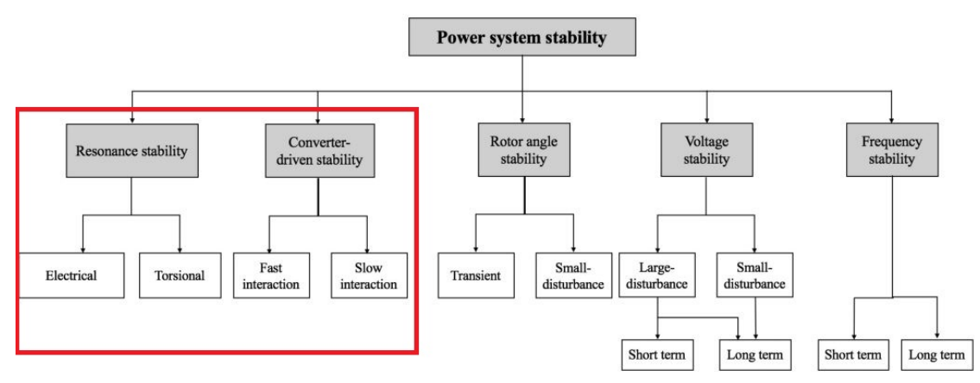
Figure 1: Classification of modern power system stability ‎[1].

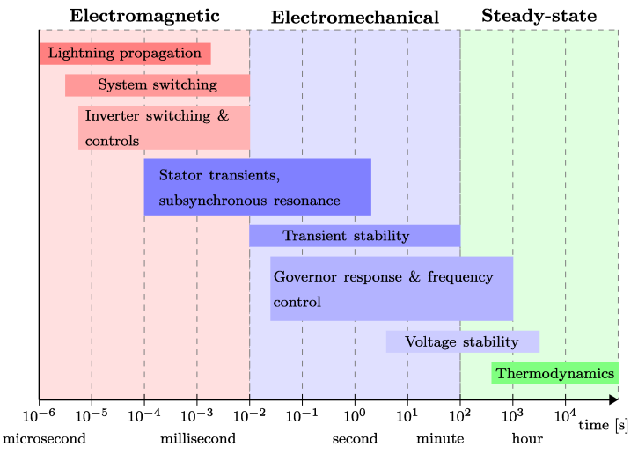
Figure 2: Time scale of modern power system stability ‎[2].

Research Relevance to Australia
Australia's power system will undergo significant changes in the next few years. These changes include increases in inverter-based resources (IBRs) and distributed energy resources (DERs), and a decrease in synchronous generation capacity. Within the next 25 years, significant development of renewable energy zones (REZs) is anticipated, according to AEMO’s Integrated System Plan.
These REZ developments, located across Queensland, New South Wales, Victoria, South Australia, and Western Australia, are being integrated through a combination of existing transmission corridors and network infrastructure, including major transmission backbones. While REZs are identified based on factors such as renewable resource availability and proximity to suitable grid connections, some developments may still involve long transmission paths, lower system strength, and reduced inertia levels, creating new challenges for power system stability. Such operating conditions can significantly influence power system stability, particularly in future inverter-dominated networks where interactions between inverter controls and weak grids may lead to poorly damped oscillations, voltage instability, and transient performance issues. A notable example is the oscillatory issues observed in the West Murray region involving multiple large-scale solar farms, where extensive investigations and remediation studies were undertaken over several years to identify the root causes and implement mitigation measures. These investigations highlighted the complexity of stability assessment in inverter-dominated systems and the importance of detailed RMS and EMT analyses. Therefore, understanding both small-signal and large-signal stability characteristics of systems with high penetration of inverter-based resources has become increasingly important for the reliable operation, operational security, and future planning of the Australian power system. In this context, this project contributes by investigating stability assessment methodologies using both RMS and EMT simulation frameworks to analyse the dynamic behaviour of inverter-dominated power systems under a range of operating conditions and disturbances.
Therefore, understanding both small-signal and large-signal stability characteristics of systems with high penetration of inverter-based resources has become increasingly important for the reliable operation, operational security, and future planning of the Australian power system. In this context, this project contributes by investigating stability assessment methodologies using both RMS and EMT simulation frameworks to analyse the dynamic behaviour of inverter-dominated power systems under a range of operating conditions and disturbances.
In addition, AEMO and several TNSPs (including Powerlink, Transgrid, and AusNet Services) project that large loads—such as data centres and electrolyser facilities—will experience significant growth in Australia over the next two to three years. It is anticipated that the data centre load capacity in NSW and Victoria will exceed that of South Australia by 2030. Large loads such as computational, industrial, and hydrogen production facilities are connecting to the bulk power system (BPS) faster than ever before and at a magnitude beyond the largest currently operating loads. Furthermore, the commissioning time of data centre loads is faster than that of generation. The rapid growth of large data-centre demand could lead to power system security and stability issues. Accurate models are necessary for transmission planners to study the stability and reliability impacts of large loads connecting to the power system.
The CSIRO AR-PST project has already addressed some issues related to frequency regulation and small signal stability. However, there is still a need to fully understand the physical characteristics of IBRs and large loads, and their impact on the small-signal and voltage stability boundaries of the Australian system. Therefore, enhancing modelling, simulation, and analytical capabilities to evaluate these stability phenomena is essential to ensure stable, secure, and reliable system operation. Hence, by investigating the aspects outlined above, this research is expected to make a significant contribution to the stable operation and expansion of REZ regions, and to support future large-load deployment and high renewable energy integration in the Australian power system.

Relation to the Research Roadmap and Previous Stages
Stage 5 of the CSIRO AR-PST Topic 2 project “Evaluation of Small and Large Disturbance Voltage Stabilities for Power Systems with a High Penetration of Inverter-Based Resources,” builds upon previous stages and the 2021 research roadmap, advancing small-signal stability, voltage stability, and large-load modelling in the context of high IBR penetration and emerging large converter-dominated loads.
In the research roadmap submitted to CSIRO, “Australian Research Planning for Global Power Systems Transformation – Stability Tools and Methods”, two critical research topics were identified: stability margin evaluation and small-signal stability screening methods.
Previous stages (Stage 2 and Stage 3) developed data-driven and analytical prediction algorithms to estimate the impedance characteristics of IBRs across a wide range of operating points. These studies highlighted the dependence of frequency-domain admittance characteristics on the operating point and led to the development of an analytical prediction method (APM) to estimate IBR behaviour at operating points not included in the training data.
In Stage 4, research evaluated the potential and limits of using positive-sequence IBR models instead of full EMT models, incorporating IBRs into small-signal stability assessments via impedance scan-based procedures. While these models required less data, their low-frequency impedance profiles were highly sensitive to operating point variations, demonstrating a trade-off between accuracy and data requirements.
Stage 5 of the CSIRO AR-PST Topic 2 project builds upon previous findings and extends the research to comprehensively address high IBR penetration and emerging large, converter-dominated loads. The objectives of this stage are to employ validated models, EMT and RMS simulation tools, and analytical methods to assess both small-signal and voltage stability under realistic Australian network and load conditions. Specifically, Stage 5 aims to:
- Identify the suitable model of large load for voltage and small signal stability assessment.
- EMT and RMS simulation model of the selected network with control testing, benchmarking, and validation for small signal stability and Small and Large Disturbance Voltage Stabilities.
- Parameter bounds, model of the large load/ data centre, IBR-driven load, benchmarking of the controller for the small signal stability and voltage stability. Here, parameter bounds define the operating ranges for key system and control parameters, development of large load/data centre and IBR-driven load models, and benchmarking of controller performance for both small-signal and voltage stability.
- Identify the suitable methods for voltage stability boundary and margin assessment.
- Modelling and control benchmarking of IBRs for stability enhancement.
- Extension of the available stability method for real-time use potential and evaluating the dynamic signature of power system.
Accordingly, the work in this stage is organised into four main technical themes: small-signal stability analysis, dynamic signature analysis of power systems, voltage stability assessment, and large-load modelling. Each of these themes was executed in parallel to ensure effective utilisation of the one-year project duration and to enable coordinated development and validation across all study areas. Together, these parallel workstreams contribute to a unified framework for evaluating stability performance in future inverter-dominated power systems with high penetration of large converter-based loads. In addition, these objectives, which are based on the research proposal, relate to different aspects of power system stability and therefore may differ slightly in structure. However, the research work on all of these objectives was carried out in parallel, and all objectives have now been completed.
These outcomes directly support the critical research objectives of Topic 2 as defined in the 2021 research roadmap:
- Development of tools for the voltage stability boundary recognition as a criterion for system operation.
- Developments of tools that can improve voltage control, recovery, and collapse assessment to assist operators in considering IBR in Volt/Var dispatch tools and mitigate high voltages due to increases in IBR outputs.
By focusing on these objectives, Stage 5 integrates small-signal stability, large- and small-disturbance voltage stability, and large-load modelling into a unified framework, providing a technically robust and scalable approach for planning-stage and operational decision-making in Australia’s evolving low-inertia, high-renewable power system.

Progress Against the Roadmap
Stage 5 directly advances the 2021 AR-PST Topic 2 Roadmap, supporting planning and operational decisions for Australia’s power system. Work on small-signal stability, voltage stability, and large-load modelling underpins future IBR standards and methodologies.
Building on earlier stages, Stage 5 addresses multi-IBR systems, high IBR penetration, and large converter-dominated loads. Table 1 maps roadmap tasks to Stage 5 activities and outcomes.
Key achievements include small-signal stability evaluation, voltage stability assessment, dynamic signature computation, and large-load modelling. Table 1 summarizes Stage 5 progress against the CSIRO Roadmap 2021 for Topic 2: Stability Tools and Methods.
Table 1: Research Progress against the Roadmap of CSIRO-AR-PST.
Task Defined in Roadmap 2021 |  | Related Task in stage 5 | % Progress in Stage 5 vs Roadmap 2021
1 | Small-signal stability
1.1 | Identifying the nature of oscillations and damping in IBR-dominated grids | Evaluating controllability, observability, and eigenvalues of power-controlled GFLI, droop-controlled GFMI, and VSG-controlled GFMI. | 85% → 95%
1.2 | Identifying the nature of oscillations and damping in IBR-dominated grids | SMIB (Single Machine Infinite Bus), modified IEEE 39-Bus System (with power-controlled GFLIs and VSG-controlled GFMIs), and Australian 14-Generator System
1.3 | Online identification of system strength | Development of data-driven time-domain method for evaluation of small-signal stability of grid following and grid forming inverters connected to SMIB testing system.
2 | Small signal stability screening
2.1 | Stability margin evaluation of GFMI in frequency domain | Performance evaluation of GFMI in frequency domain for different voltage controls (FVC, PVC, AVR) under different grid strengths and investigating enhancement strategies for the AVR method. | 85% → 95%
3.1 | Voltage stability boundary | Developed a mathematical model of a new dynamic resilient metric for large disturbance voltage stability evaluation. | 20% → 60%
3.2 | Voltage control, recovery, collapse | Implemented an adaptive continuation algorithm using a Python script and ran it in DIgSILENT PowerFactory on a test case.  Assessing short-term and long-term voltage stability in high-IBR systems and evaluating the impact of varying control parameters.
4 | Model and model validation
4.2 | Modelling and model validation | Identified the required parameters for large load model development, modeling requirements of large load for transmission system studies.  Aggregated large load models are developed for dynamic validation testing. | 0% → 30% (new research priority)
4.3 | Voltage and reactive power management | Investigated the impact of a large disturbance (e.g., a 3-phase symmetrical fault) and fault location on healthy buses (considering their electrical distances from the faulty bus) in terms of voltages for different levels of renewable integration.  Computation of new local and global dynamic resilient index to quantify the system's overall dynamic signature

Summary of Stage 5 Research Achievements
Stage 5 of the AR-PST Topic 2 project has built upon previous research and significantly advanced the assessment of small-signal stability, voltage stability, and large-load modelling in high IBR penetration and emerging large converter-dominated load scenarios. The key contributions of the five work packages are summarized below:
1. Small-Signal Stability (SSS)
- Literature review and modelling approach: A comprehensive study of methods, test systems, and software tools for small-signal stability analysis of IBR-dominated systems was conducted. Based on these studies, state-space (eigenvalue-based) and data-driven models were recommended to evaluate SSS under different IBR control strategies. Three representative test systems were established: (1) SMIB with 1–2 IBRs, and (2) Modified IEEE 39-bus (New England) system with mixed IBRs, and (3) the modified and simplified 14-generator Australian power system with VSM-controlled GFMI.
- Eigenvalue and mode analysis: Built-in DIgSILENT PowerFactory models for power-controlled GFLI, droop-controlled GFMI, and VSM-controlled GFMI were analysed under varying SCRs. Dominant eigenvalues, controllability, observability, and participation factors were used to determine which state variables and control parameters impact specific oscillatory modes.
- Test system extension: The IEEE 39-bus system was modified to replace three synchronous generators with VSM-controlled GFMIs, enabling evaluation of SSS under different inverter operating points (Pref, Qref) at a larger network scale.
- Data-driven evaluation: A Gaussian Process Regression (GPR) and Eigensystem Realization Algorithm (ERA) based data-driven time-domain (DDTD) method was developed to evaluate SSS. Comparative studies against ANN- and ERA-based models demonstrated high prediction accuracy and eigenvalue estimation for both SMIB and IEEE 39-bus systems, allowing black-box stability evaluation where detailed OEM and control information is unavailable.
- Voltage control evaluation: Grid-forming inverter controls, including FVC, PVC, and AVR, were implemented and tested under very weak, weak, and strong grid conditions. The results highlighted that AVR-controlled inverters tend to have the lowest stability margins, providing insights into optimal control selection.
- AVR enhancement: The improvement of AVR-based GFMI stability has been carried out incorporating a virtual impedance loop and adaptive tuning of the K_{i-q} values based on grid SCR. This is crucial for enabling AVR applications in secondary frequency control, enhancing interconnection stability, and enabling faster recovery following disturbances in high-renewable power systems.
2. (a) Dynamic Signature of the Power System (DVRI and sysDVRI stability indices)
- Development of DVRI: A new vector-based Dynamic Voltage Resilience Index (DVRI) was proposed to quantify both short-term (STVS) and long-term voltage stability (LTVS) for post-fault voltage trajectories, overcoming limitations of existing scalar large-disturbance voltage stability indices.
- Waveform classification: A statistical method was introduced to distinguish oscillatory and non-oscillatory voltage recovery without plotting waveforms, addressing shortcomings of existing indices.
- System-level extension (sysDVRI): The System Level Dynamic Voltage Resilience Index (sysDVRI) provides a single vector-based measure of system dynamic performance, enabling planning- and operation-focused assessments of voltage stability across the network.
- Impact assessment of renewable penetration and dynamic load: DVRI and sysDVRI were used to systematically evaluate the effect of higher solar and wind integration and dynamic load models on the system’s overall dynamic signature.
(b) Dynamic Signature of the Power System (SDVPI stability index)
- Development of SDVPI: A general, simple, and comprehensive Small-Disturbance Voltage Performance Index (SDVPI) is proposed, based on the adaptive continuation power flow (ACPF) method, to evaluate voltage stability under small disturbances.
- Mathematical formulation: A quantitative framework is developed to determine the system’s proximity to the voltage collapse margin, clearly identifying the boundary between stable and unstable operating regions.
- Scenario-based assessment: The impact of varying load and generation conditions is systematically analyzed on a modified 39-bus system, where SDVPI is computed using DIgSILENT PowerFactory to identify the weakest bus.

(c ) Dynamic Signature of the Power System (SSSI stability index)
- Development of SSSI (SSOASI): A Small-Signal Stability Index, termed SSOASI, is introduced to evaluate system security by capturing variations in oscillatory behavior through minimum permissible damping of system modes.
- Mathematical formulation: A rigorous formulation is developed to quantify small-signal stability under changes in generation mix, network topology, and load conditions, including contingency events.
- Scenario-based security assessment: The system’s security is evaluated under different generation scenarios using the modified 39-bus system, demonstrating the effectiveness of the proposed index.
3. Large-Disturbance Voltage Stability (LDVS)
- Definition and assessment: LDVS evaluates the system’s ability to maintain acceptable voltages following severe disturbances such as faults, line outages, or generator trips.
- Modeling and simulation: Time-domain simulations using DIgSILENT PowerFactory incorporated AEMO composite load models to capture dynamic load behaviour, particularly induction motors. Adaptive continuation methods were applied to quantify voltage stability margins and identify critical contingencies and weak buses.
- Short-term vs. long-term dynamics: Both short-term voltage stability (STVS) and long-term voltage stability (LTVS) were analysed, providing a comprehensive understanding of immediate and delayed voltage responses in high-IBR systems.
4. Small-Disturbance Voltage Stability (SDVS)
- Assessment under normal operation: SDVS characterizes the system’s ability to maintain voltages under small perturbations, such as incremental load or generation changes.
- Impact of IBR penetration: Reduced reactive power support from IBRs and interactions with dynamic loads (e.g., residential induction motors) were analysed to determine system loadability and voltage collapse limits.
- CPF-based analysis: Adaptive continuation power flow (adaptive P–V curve) studies identified critical loading conditions and maximum permissible loads, providing practical inputs for stability screening and operational planning.
5. Large-Load Modelling
- Dynamic load model development: Using the Composite Load Model (CMLD) framework, generic models capturing converter behaviour, ride-through, and redundancy are created for RMS studies.
- Validation and integration: Models were validated against simulations, and integration with IBR-dominated networks assessed their impact on both voltage and small-signal stability.
- Practical framework: A Dynamic Model Acceptance Test (DMAT) framework was developed with AEMO for standardized testing, enabling robust planning and risk assessment for large emerging loads.
Further details of the completed research tasks are presented in the subsequent chapters of this report.

Part II Small-signal Stability

Evaluation of Small-signal Stability of Power Systems with Different Controls of Grid-following and Grid-forming Inverters

Introduction
The increasing penetration of IBRs has introduced fast, control-dominated dynamics that challenge conventional model-based small-signal stability (SSS) analysis of power systems ‎[3]. IBRs are classified into two primary types: grid-following inverters (GFLIs) and grid-forming inverters (GFMIs), each with distinct dynamics suited for different grid conditions ‎[4]. GFLIs typically operate stably in strong grid connections, where they function as current sources that synchronize with the grid’s voltage and frequency ‎[5]. Unlike conventional grid-following inverters, GFMIs actively establish and regulate voltage and frequency rather than simply injecting current into an existing grid waveform, thereby mimicking key stabilising functions of synchronous machines and enhancing overall grid robustness ‎[6]. This capability allows them to provide virtual inertia and frequency support, stabilise voltage under weak grid conditions, and enable black-start and islanded microgrid operation, thereby making them essential for the reliable integration of high shares of solar, wind and battery energy storage systems in both distributed and utility-scale applications.
In power systems, a SSS analysis is crucial because it helps evaluate and improve the system's capacity to sustain stability, regulate voltage and frequency, and effectively integrate renewable energy sources while guaranteeing a dependable and resilient power supply, particularly in the context of fluctuating resources ‎[7]. Existing SSS analysis methods have mostly considered eigenvalue analysis (white-box modelling) and data-driven frequency-domain (DDFD) impedance-based evaluation (black-box modelling) methodologies. Eigenvalue analysis as predominant in conventional power systems, while the latter approach is being investigated for IBR-based power systems. The former approach may suffer from limited data availability to fully represent the system dynamics, whereas the latter typically needs a careful trade-off between data size and model accuracy. Moreover, in the case of the DDFD impedance-based method, the impedance profile of IBRs in the low-frequency range is highly sensitive to variations in the operating point.
In addition to the eigenvalue-based SSS of power systems with different IBR controls, a Gaussian process regression (GPR) and eigensystem realization algorithm (ERA)-based data-driven time-domain (DDTD) method is proposed and implemented to evaluate the SSS of power systems with grid-forming inverters (GFMIs). DDTD in DigSILENT is being developed within an industry software environment, where many original equipment manufacturer models are implemented and tested for grid-integration studies. The performance of the proposed model is evaluated using a single-machine infinite-bus (SMIB) and a modified IEEE 39-bus testing system with droop-controlled and virtual synchronous machine (VSM)-controlled GFMIs. The remainder of this chapter is organised as follows. Section 2.2 presents an overview of different small-signal stability methods. Section 2.3 discusses the impact of different voltage control strategies on the small-signal stability of grid-forming inverters. Section 2.4 focuses on proposed approaches for enhancing the small-signal stability of AVR-based grid-forming inverters. Section 2.5 presents modal/eigenvalue-based small-signal stability analysis techniques, while Section 2.6 describes the proposed data-driven time-domain model-based small-signal stability analysis methods. Finally, Section 2.7 summarises the key findings and contributions of the chapter.

Overview of Small-signal Stability Methods

A comprehensive literature review in stage-5 reveals that the main methods to evaluate the SSS and voltage boundaries of IBR-based power systems can thereby categorise as: Modal/Eigenvalue-based models (white-box modelling) [8]–[32], and data-driven frequency-domain modelling (black-box modelling) and data-driven time-domain modelling (black-box modelling) ‎[8], ‎[9], ‎[33] – ‎[46].

2.2.1 Modal/Eigenvalue-based Models (White-Box Modelling)
Eigenvalue analysis is used to investigate SSS in the state-space model, which is a time-domain approach based on the explicit knowledge of IBR control architecture. One of the key requirements of eigenvalue-based methods is having full-insight into system dynamics for the accurate evaluation of SSS in IBR-dominated power systems ‎[8]. In addition, eigenvalue-based SSS analysis provides local linear insight around an operating point but fails to capture nonlinear, operating-point-dependent, and fast control-driven dynamics prevalent in modern IBR-dominated power systems. Furthermore, accurate eigenvalue analysis requires detailed and validated models of inverter controls, network parameters, and operating points, which may be unavailable or uncertain in practice ‎[9]. ​A small-signal stability analysis tool for large-scale power systems with high inverter-based resource (IBR) penetration has been presented by the authors in ‎[10].
To describe the whole power system network, a network transfer function matrix (NTFM) was first developed. This matrix contains information about the system structure, transmission lines, loads, locations of IBRs, etc. Second, the sequence impedance/admittance responses of IBRs were obtained using the small-signal perturbation approach while taking frequency cross-coupling effects into account. The suggested stability analysis tool has been validated using various testing scenarios based on an altered IEEE-14 bus system. According to ‎[11], the IBRs may induce oscillations in the system at a variety of frequencies, which ultimately jeopardize the stable operation of the entire system. The development of efficient techniques for analysing the stability of power systems using IBRs has been the subject of numerous efforts in recent years. Most current research reduces the system to a source-load system, or point-to-point connection system, and uses Nyquist criterion-based techniques to analyse the stability of the system ‎[12], ‎[13]. GFM and GFL inverters are designed in PSCAD with programmable parameters and control schemes for ease of deployment.
​The greatest permitted change in the admittance observed at a bus for a mode of interest is indicated by a new metric called Admittance Margin (AM), which was introduced in ‎[14]. For changes smaller than this maximum, the mode will remain stable. AM is designed to be used to evaluate small-signal system strength at buses that do not yet have equipment connected but where a resource improvement is envisaged. It is recommended as a companion to the recently introduced small-signal system strength measure, impedance margin ratio (IMR). It can pinpoint the system's weak busses and direct the installation and positioning of upcoming IBRs appropriately. It is demonstrated that while installing grid-forming (GFM) inverters at buses with low AM could dramatically dampen some oscillatory modes, installing grid-following (GFL) inverters at buses with low AM should be avoided as this greatly destabilizes the system. A modified IEEE 14-Bus test system with several IBRs is used to verify the AM metric's utility. A semi-definite programming (SDP)-based approach has been proposed in ‎[15] to address this problem. The authors employed generalized short-circuit ratio (GSCR), a ratio for measuring small-signal stability from the perspective of grid strength, as the small-signal stability constraint in the suggested technique. The suggested SDP-based approach may be appropriate for a large-scale power system since the GSCR is a static value, avoiding the need to build the system's full model for small-signal stability analysis. The established SDP was solved by the authors using the solver YALMIP. In ‎[16], a small-signal model is created for a multi-converter system that combines VSG and GFL converters linked to an infinite bus. The study looked into how different grid following inverter (GFL)/virtual synchronous generator (VSG) capacity ratios affected system stability. The suggested approach shows efficient stabilization under various grid settings, and PSCAD simulations confirm that adding 20 % VSG converters to GFL systems improves stability across a range of grid strengths.
​The authors of ‎[17] concentrated on small-signal stability and thoroughly examined GFM and GFL controls, paying particular attention to the relationships between synchronous generators (SGs) and IBRs. MATLAB/Simulink time-domain simulations are used to validate the theoretical analyses. Eigenvalue analysis has been performed for both GFL (without droop) and GFM inverters under the SCR of 0.85 to determine the effects of IBR penetration level on small-signal stability. The coupling of multi-timescale control loops and the interactions of multiple inverters and other power devices can cause stability problems for power-electronics-dominated power systems, as was shown in ‎[18]. However, this analysis was restricted to 100% inverter-based microgrids, and the scalability should be further confirmed. In ‎[19], the effect of photovoltaic (PV) power production systems' dynamic behaviour on the short-term transmission system voltage stability was examined; however, the findings were based on stiff and simplified grids. In ‎[20], a method for analysing the effects of increased penetration of doubly fed induction generator wind turbines on the transient and small-signal stability of a large power system was developed; however, some important oscillation modes may be absent and the inner control loops of the inverter-controlled wind turbines are overlooked. Aggregated models are needed to accurately simulate the small-signal behaviour for analytical investigations and the large-signal behaviour in electromagnetic time-domain (EMT) simulations to lessen the burden of simulating huge networks. For small-signal dynamic equivalencing of a renewable power plant, a stepwise general methodology has been proposed in ‎[21], considering true heterogeneity in the hardware, control parameters, control structures, and unique positions of IBRs. EMT simulations of several operating conditions in MATLAB/Simulink are used to validate the aggregated small-signal impedance model.
​In ‎[22], a novel optimization model for coordinating IBR’s active power outputs (i.e., operation adjustment) while meeting small-signal stability constraints was provided. Additionally, to guarantee the presence of workable solutions and further improve the efficiency of the solution, a convex-relaxing approach and a dynamic region-adjustment method were combined. Lastly, an 11-IBR test power system was used to validate the suggested method's performance. The SCR was suggested in ‎[23] to assess small-signal stability of SMIB testing system. SCR from SMIB system was extended to multiple homogeneous (or heterogeneous)-IBR systems in ‎[24], ‎[25] where the grid strength indicator is called GSCR.
Nevertheless, the generalized SCR was not an appropriate indice for non-rated operating circumstances; it was only appropriate for certified operating situations. Ref. ‎[26] suggested a generalized operational SCR (gOSCR) to assess small-signal stability for a multi-IBR system under non-rated operations to address this problem. The system's small-signal stability margin will be represented in the following by gOSCR rather than the damping ratio. A thorough sensitivity analysis of the VSG-based GFM inverter under various system conditions was carried out in ‎[27]. The authors used DIgSILENT PowerFactory simulations to confirm their thorough sensitivity analysis of the VSG-based GFM inverters in an IEEE-39 bus system.
​The authors in ‎[28]–‎[30] created both a detailed model of the complete microgrid and a small-signal model of an IBR with a VSG controller. Important results showed that microgrid performance might be successfully enhanced by carefully adjusting the VSG settings. The small-signal stability of a reduced CIGRE Nordic32 testing system and a two-area four-machine test system was examined in ‎[31], with an emphasis on the inter-area mode damping and frequency behaviour. In ‎[32], the power system electromechanical oscillation has been calculated to assess the effects of inadequate damping torque on the system. These electromechanical oscillation modes were classified as control and torsional modes (>2 Hz), inter-area (0.1–0.7 Hz), and local area (0.7–2 Hz). Additionally, a 4-machine 2-area power system with a wind farm and an IEEE 39-bus power system with three wind farms were used to illustrate and evaluate the performance of different SSS criteria including Routh stability criterion, Nyquist/Bode plot-based methods, passivity-based methods, positive-net-damping methods, impedance-based methods, and bifurcation-based methods.

​2.2.2 Data-driven Frequency-domain and Time-domain Models (Black-box Modelling)
In power systems, considerable attention has been directed towards data-driven modelling approaches over the past two decades to address the limitations of white-box modelling methods ‎[8]. These approaches rely on measured or simulated time-domain data—such as voltages, currents, and power signals—to identify local dynamic characteristics, estimate system modes, or construct equivalent impedance or state-space representations without requiring full analytical models. By directly capturing the true closed-loop behaviour of IBRs and their interaction with the grid, data-driven methods enable practical, scalable, and adaptive stability assessment, particularly under varying grid strength, control settings, and operating conditions.
​In ‎[9], the authors proposed a data-driven frequency-domain approach using support vector machines (SVM) to create a generalized impedance model (IM) for VSM-controlled GFMI in the dq reference frame. However, the method suffers from the limitation of practical applicability as manufacturers often withhold several parameters for commercial confidentiality. By leveraging a small training dataset, the algorithm demonstrated high predictive accuracy across various operating conditions while maintaining computational efficiency. The method required only a small dataset of 18 operating points for SVM training achieved accurate predictions of the dq reference frame IM of IBR. However, the proposed method was subjected to two challenges, as when parameters are inaccessible, specific IM training was necessary for accurate representation, and, if parameters are accessible, incorporating them into the training input vector allows for generalisation without re-training.
​Bode and Nyquist plots were used for the small-signal analysis in ‎[33], that resulted from the impedance model, a frequency-domain technique that could be applied both with (white box) and without (black-box) knowledge of IBR control architecture. The impedance (or admittance) of the IBR at a few operating points was needed for this data-driven method. This was accomplished by measuring impedance in the frequency domain at a certain operating point using pseudorandom binary sequences (PRBS), conducting frequency scans, injecting harmonics, and analysing transient responses ‎[34]. However, the number and distribution of measurement points throughout the whole range of operating points limited the accuracy of the model.
​A method based on artificial neural networks (ANNs) was presented in ‎[35] to determine the impedance model of IBRs over a wide range of operating points. Recurrent neural networks (RNNs) were used in ‎[36] to predict the impedance of IBRs, although this approach was limited to operating locations. Similarly, ‎[37] proposed a deep learning approach based on multilayer feedforward neural networks (FNNs) for modelling and predicting the impedance of IBRs. Additionally, the authors in ‎[38] used transfer learning approaches with an offline data generation phase and an online impedance identifying phase to predict the impedance model of IBRs for modular multilevel converters. To reduce the computational burden of online impedance determination, a data-driven impedance model utilizing physics-informed neural networks (PINNs) was proposed in [39]. Despite its effectiveness in reducing the computational load for real-time impedance identification, the PINN necessitates both offline and online training and some prior knowledge of IBR control structures. Furthermore, its validity is only tested for current-controlled GFLIs. To this end, a common concern in the data-driven methods is their heavy reliance on the amount of training data, limiting their practical utility due to data constraints. In [40] the authors proposed eigensystem realization algorithm (ERA) which are widely used data-driven techniques for identifying the small-signal dynamics of IBRs from time-domain measurements. The proposed ERA method processed transient dq-frame voltage and current responses to extract linear dynamic representations, which was expressed in the s-domain. ERA achieved this by constructing reduced-order state-space models from impulse or step response data, enabling the direct computation of s-domain or frequency-domain admittance without requiring prior knowledge of the system model. In this study, voltage and current measurements collected over a time window from 1 s to 1.98 s, sampled at 2.5 kHz, are used for ERA-based analysis to capture the relevant small-signal dynamics. Gaussian process regression (GPR) has been suggested in [41] as a practical way to overcome the drawbacks of artificial neural networks (ANNs). GPR was suggested as a trained, non-parametric machine learning technique that modelled intricate, nonlinear interactions with exceptional adaptability and resilience. Despite having little training data, it was able to handle noisy data, capture uncertainty, and produce seamless continual predictions. However, the method suffers from the limitations as: (1) low-frequency impedance is highly sensitive to operating point variations, and a considerable trade-off is required between accuracy and data size.
​The authors in [42], explored three system identification techniques: sweep frequency response analysis (SFRA), step excitation method (SEM), and eigensystem realization algorithm (ERA). SFRA employed sinusoidal signals of varying frequencies to measure the system's frequency response, while SEM and ERA utilized step functions to derive time-domain responses and transform them into Laplace-domain transfer functions. Based on a critical comparison, it was found that SEM worked more efficiently in identifying the dq admittance of GFMI over a frequency range of 1–100 Hz compared to frequency scanning.
To ensure stability across different generation mixes, a hybrid convolutional recurrent neural network (CRNN) was proposed in ‎[43], ‎[44]. The CRNN mitigated the computational burden associated with exhaustive simulations by learning the temporal patterns of both stable and unstable trajectories, thereby enabling generalization to previously unseen operating points within the ternary space. This predictive capability reduced the need for repeated simulations of every possible scenario. The training dataset comprised time-series measurements of bus voltages, frequency, and power under diverse stability conditions. Nevertheless, since the data were obtained from RMS simulations, transient dynamics under small disturbances may not have been fully captured.
The assessment of two popular techniques for small-signal stability analysis of IBR-based power systems is summarized in Table 2. Table 3 summarizes the existing data-driven methods for SSS analysis of IBR-based power systems.
Table 2: Modelling methods of small-signal stability.
ASPECT / CRITERIA | STATE-SPACE MODEL (WHITE-BOX / EIGENVALUE-BASED) | IMPEDANCE/ADMITTANCE-BASED MODEL (BLACK-BOX)
DOMAIN OF ANALYSIS | TIME-DOMAIN | FREQUENCY-DOMAIN
Modelling Type | White-box | White-box & Black-box
Model Requirements | Full knowledge of system topology, parameters, and inverter controls | Only input-output measurements; no internal details required
System Representation | Can model MIMO systems | Typically, SISO translates to electrical impedances
Analysis Approach | Eigenvalue analysis, participation factors, linearization | Impedance-based analysis: Bode plots, Nyquist diagrams
Complexity | High (complex) | Moderate to simple
Advantages | High accuracy; identifies root cause of oscillations; detailed mode analysis | Suitable for IBRs devices without access to internal design, scalable; does not require full system models.
Limitations | Computationally intensive; requires a full system model; limited for black-box devices | Limited internal insight; accuracy depends on measurement quality; may miss complex mode interactions
Applications | Detailed system studies, control design, and modal analysis | Field measurements, weak-grid studies, black-box or experimental IBRs

Table 3: A summary of data-driven methods for small-signal stability analysis.
​METHODS | ​KEY FEATURES AND LIMITATIONS | ​DATA REQUIREMENTS
​ PRBS | ​•Applies a step change at the dq voltage source to collect time-domain data, which is then processed to estimate the continuous-time transfer function, representing the admittance of the IBR.  ​•Scalability issues for large datasets due to reliance on the full covariance matrix. | ​•100 injections are required to extract the admittance matrix.  ​•Data (voltage and currents)
​ SVM | ​•Create a generalised IM for IBRs in the dq reference frame.  ​•High predictive accuracy across various operating conditions.  ​• When parameters are inaccessible, specific IM training is necessary for accurate representation.  ​•Practical applicability is limited as vendors often withhold several parameters. | ​•18 operating points for SVM training  ​•Input data (voltage, active power, and reactive power) can be obtained from perturbation measurements
​ ERA | ​•Does not require the state-space model or system equations.  ​•ERA reconstructs a discrete-time state-space model.  ​•Provides modal and small-signal stability information. | ​• Data (voltage and currents) in the time frame from 1s to 1.98s is used for analysis. Sampling frequency is 2.5 kHz
​ GPR | ​•Predict impedance models in the dq reference frame, achieving accurate results with a minimal dataset.  ​•reducing the cost and complexity of data collection.  ​• Uses inverter operating points (P, Q, and V) as inputs to predict output impedances.  ​•A trade-off between the accuracy and data size is required.  ​ | ​•30 uniformly distributed operating points of active and reactive power  ​
​ANN, CNN, RNN, FNN | ​•These machine learning-based models typically utilise bus voltage data with low sampling rates and long sampling windows  ​•Overfitting risk requires a large amount of dataset.  ​ | ​•Voltage magnitude and phase angle, sampled at 100 Hz
​Hybrid CRNN | ​•CRNN plays a complementary role to conventional simulation-based analysis  ​•The CRNN mitigates the challenge of prohibitive computational cost of by learning temporal signatures of stable and unstable trajectories, thereby enabling generalization to unseen operating points in the ternary space  ​•This predictive capability reduces the need for repeated simulation of every candidate scenario  ​• However, the model requires large number of data and may suffer from overfitting risk. | ​  ​•4,851 generation mix scenarios  ​•The total 60000-time samples per feature (voltages magnitude, phase angle, and frequency)  ​
In ‎[45], a physics-informed neural network (PINN)–based data-driven approach was proposed to capture both the steady-state and dynamic behaviour of power systems using time-domain measurements, including voltage phase angle and frequency at the point of common coupling (PCC). However, the model was limited to estimating system outputs and could not directly determine eigenvalues or assess system stability. A data-driven hybrid model was introduced in ‎[46], employing a temporal convolutional neural network to identify high-frequency switching states of power electronic devices and the operational status of renewable energy units in AC/DC power systems under varying weather conditions and other operating conditions. Validation of the model was performed using time-domain responses of DC voltage as well as active and reactive power. Nonetheless, the model did not incorporate stability assessment based on its predicted outputs.
Conventional eigenvalue analysis (white-box model), widely used in traditional power systems, requires full knowledge of the system’s control architecture and parameter values, which are often unavailable in complex inverter-dominated systems due to vendor-specific control structures and proprietary settings. In contrast, data-driven (black-box model) impedance methods have emerged as a promising alternative. To overcome the limitations of white-box modelling, this project proposes a data-driven time-domain methodology (DDTD) combining Gaussian process regression (GPR) with the eigensystem realization algorithm (ERA) for small-signal stability assessment of power systems integrating grid-forming inverters.
The proposed GPR+ERA-based data-driven time-domain (DDTD) framework, which will be presented in details later in this section, is primarily intended for small-signal stability assessment of grid-forming inverter systems in scenarios where detailed dynamic models or controller information are unavailable or cannot be shared. By extracting system dynamics (eigenvalues) directly from time-domain responses, the method enables black-box identification of dominant modes. In addition, the integration of Gaussian Process Regression allows rapid prediction of eigenvalue trajectories across a range of operating conditions, supporting efficient stability screening. While not intended to fully replace conventional model-based modal analysis, the proposed approach complements it by providing a scalable and data-driven alternative when analytical models are difficult to obtain or validate.

Impact of Different Voltage Control Strategies on Small-Signal Stability of Grid Forming Inverters
Grid-forming inverters (GFMIs) have emerged as vital technologies in modern power systems, enhancing stability and resilience through voltage regulation, synthetic inertia emulation, and frequency support. Therefore, understanding how control strategies affect their dynamic performance and stability is essential. The research team has implemented and evaluated different voltage control strategies of FVC, PVC, and AVR for grid-forming inverters. Small-signal stability analyses are conducted across very weak, weak, and strong grids ‎[47]. The results provide clear insights into the relative stability characteristics of these control strategies, with AVR exhibiting the lowest stability margins, as demonstrated by the Nyquist analysis.
This section examines three voltage control methods for maintaining fixed PCC voltage: fixed voltage control (FVC), primary voltage control (PVC), and automatic voltage regulation (AVR). FVC sets a constant direct-axis voltage reference without a primary loop. PVC uses a proportional-integral controller based on the voltage magnitude error. AVR combines voltage regulation with reactive power control, adjusting the voltage reference via an integral controller. A comprehensive study using frequency-domain analysis (Bode and Nyquist plots) and EMT time-domain simulations in MATLAB/Simulink is presented. Results show all methods maintain comparable stability under very weak and weak grids but diverge as grid strength increases. Specifically, AVR shows reduced stability margins and low frequency oscillations under strong grid conditions, indicating robustness challenges. For practical use, FVC offers the highest stability across grid strengths, followed by PVC, with AVR showing reduced robustness at high short-circuit ratios (SCR).
Figure 3 presents the configuration of a VSG-based GFMI used in this study. The power stage comprises a DC energy source, power semiconductor switches forming the inverter bridge, an output LC filter, and the grid represented by its Thevenin equivalent circuit, consisting of the grid voltage source (vg) in series with the equivalent grid impedance. As depicted in Figure 3, the GFMI employs a cascaded control architecture consisted of multiple control loops: an inner current control loop, a voltage control loop, and an outer primary control loop. The current control loop regulates the inductor current to limit over-current stress on the semiconductor switches and filter inductance, whereas the voltage control loop maintains the capacitor voltage with inacceptable limits to prevent over-voltage. The outer VSG-based primary control loop generates the voltage and frequency references required for regulating the GFMI output power in accordance with predefined active and reactive power (or voltage) setpoints.
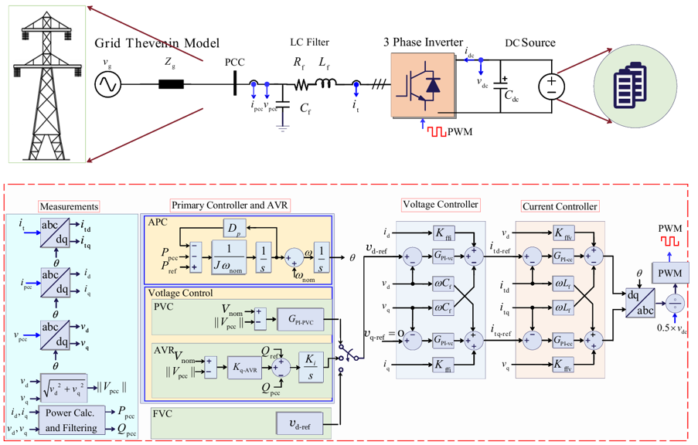
Figure 3: Block diagram of the VSG-based GFMI implementing three different voltage control strategies under investigation: Fixed voltage control (FVC), primary voltage control (PVC), and automatic voltage regulation (AVR) ‎[47].
The GFMI system illustrated in Figure 3 is investigated in both the frequency and time domains to assess the impact of the three voltage control strategies: FVC, PVC, and AVR. The system parameters used in the study are listed in Table 4. In the frequency-domain, a total of nine case studies are conducted under varying grid strengths, corresponding to short-circuit ratios (SCR) of 1.2, 2.5, and 4.0, while maintaining a constant grid impedance ratio at X_{g}/R_{g} = 8. Then, time-domain EMT simulations are employed to verify the stability conclusions drawn from the frequency-domain analysis. Furthermore, additional scenarios are explored for a 10 % grid voltage sag, step changes in the active power reference P_{ref}, and progressive SCR increases to 5. Details of these analyses are presented in the following subsections.

Frequency-Domain Analysis of GFMIs Under Different Voltage Control Strategies
Bode Plots: Figure 4(a)–(c) presents the Bode plots of the output impedances of the GFMI under the three voltage control strategies—FVC, PVC, and AVR—for very weak (SCR=1.2), weak (SCR=2.5), and a relatively strong (SCR=4) grid condition, respectively. The grid impedance ratio is fixed at X_{g}/R_{g}=8, and the GFMI operates at nominal power across all scenarios. The impedance components show include Z_{dd}, Z_{dq}, Z_{qd}, and Z_{qq} in the dq reference frame, providing insights into the inverter’s small-signal frequency response.
Table 4: System parameters used in the study.
Quantity | Value | Unit | Description
Grid parameters
v_{g} | 690 | V | Grid voltage(L-L)
ω_{nom} | 2π×50 | Rad/s | Grid nominal angular frequency
SCR | 1.2, 2.5, 4, and 5 | -
Inverter parameters
S_{rated} | 5.0 | MVA | Inverter rated power
P_{rated} | 4.0 | MW | Inverter rated active power
Q_{rated} | 3.0 | MVar | Inverter rated reactive power
v_{dc} | 1.5 | kV | DC Bus voltage
L_{f} | 95 | µH | Filter inductance
R_{f} | 10 | mΩ | Filter resistance
C_{f} | 1 | mF | Filter capacitance
Control parameters for primary loop
D_{p} | 1.273×10⁶ | W·s/rad | Damping coefficient
J | 2026 | W·s²/rad | Inertia coefficient
V_{d-ref-FVC} | 690× sqrt(2/3) | V | Voltage reference of the FVC strategy
K_{p-FVC} | 1.5×10⁻⁵ | - | Proportional gain of PVC strategy
K_{i-FVC} | 75 | - | Integral gain of PVC
K_{q-AVR} | 6.66×10⁴ | Var/V | Droop gain of AVR strategy
K_{i} | 0.01 | V/Var | Integral gain of AVR strategy
It can be observed that at high frequencies, all control strategies exhibit similar output impedance characteristics, indicating negligible influence from the different voltage control loops. However, notable differences emerge at low frequencies. FVC and PVC display similar behaviours, whereas AVR presents higher impedance magnitudes and sharper phase shifts at comparatively higher frequencies. For instance, the magnitude of Z_{dd} and Z_{qq} under AVR is significantly greater than that of FVC and PVC, intersecting with the grid impedance curve at frequencies below 1Hz across all three SCR levels. In contrast, FVC and PVC impedance curves do not intersect the grid impedance within this low-frequency range, indicating improved impedance separation and reduced system interaction.
Nyquist Plots: Figure 4(d)–(f) depict the corresponding Nyquist plots for SCR values of 1.2, 2.5, and 4, respectively, showing the trajectories of the two eigenvalues of the dq frame 2-by-2 impedance matrix ratio for each control strategy. Both FVC and PVC maintain robust stability margins, with trajectories well separated from the critical point (−1,0j) in the complex plane. In contrast, the AVR control method yields Nyquist plots that approach or nearly encircle the critical point as SCR increases. This effect is most notable in Figure 4(f), where the AVR trajectory at SCR=4 reveals a significant reduction in margins. These results indicate that while AVR improves voltage regulation via dynamic adjustment of v_{d−ref}, it compromises closed-loop stability under strong grid conditions. The subsequent time domain analysis verifies these findings.
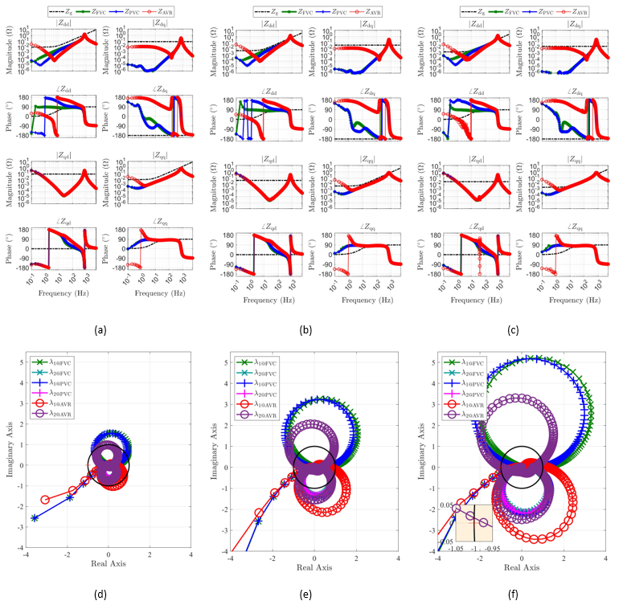
Figure 4: DQ-domain output impedances and Nyquist plots of the VSG-based GFMI under three voltage control methods: (a) and (d) Very weak grid (SCR=1.2), (b) and (e) Weak grid (SCR=2.5), and (c) and (f) Strong grid (SCR=4.0) ‎[47].

Time-Domain Verifications of GFMIs Under Different Voltage Control Strategies
Time-domain EMT simulations implemented in MATLAB/Simulink are conducted to assess the dynamic performance of three GFMI voltage control strategies: FVC, PVC, and AVR. Figure 5 compares their responses under identical conditions, including a step change in Pref at 5 s, a 10 % grid voltage sag during 10–15 s, and sequential SCR increases from 1.2 to 2.5, 4.0, and 5.0, all with X_{g}/R_{g}= fixed at 8. As shown in Figure 5(a), (b) and (c), FVC and PVC regulate V_{pcc} to 1 p.u. (V_{LL−rms} = 690 V) during the sag, whereas AVR yields slightly lower voltage. Figure 5(j)–(l) shows all controllers maintain stable P_{pcc} and Q_{pcc} tracking up to SCR = 4. However, AVR becomes unstable at SCR = 5, unlike FVC and PVC.
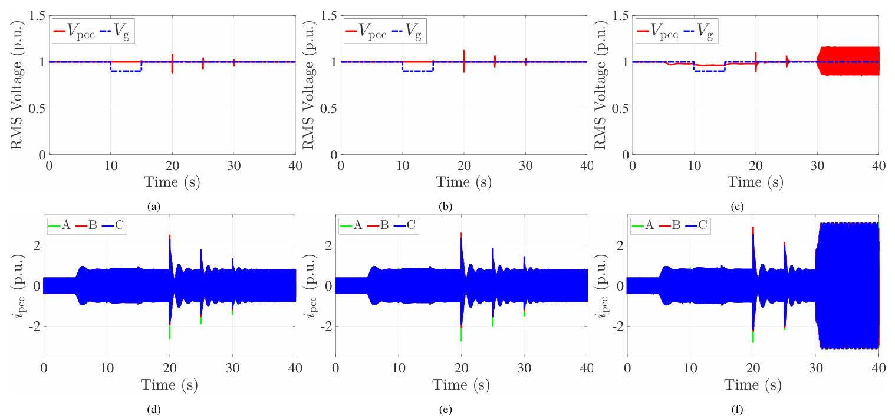
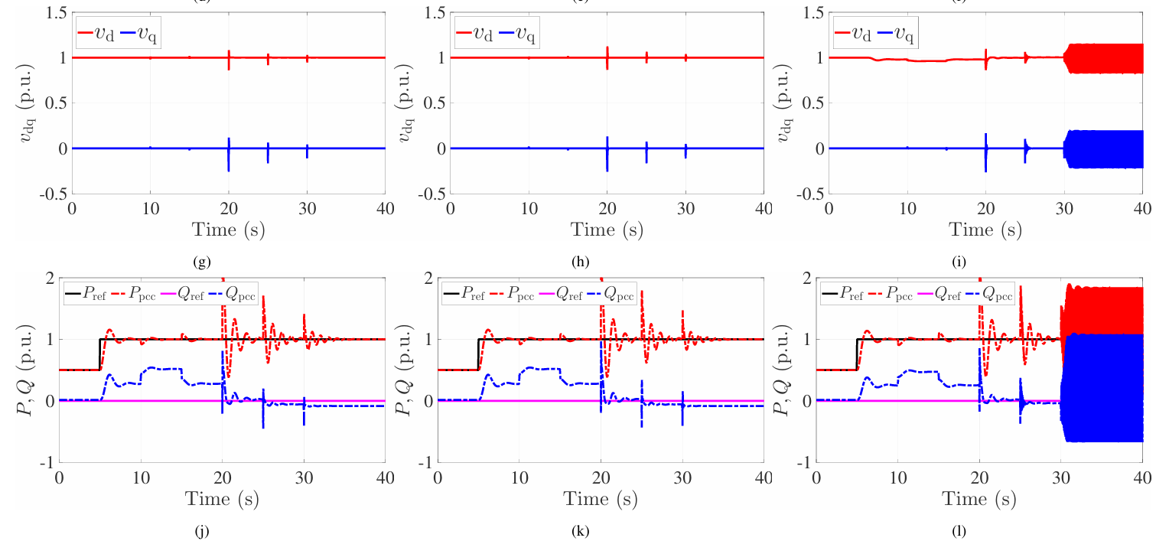
Figure 5: Dynamic performance comparison of FVC, PVC, and AVR strategies of GMFI under identical operating conditions. The first, second, and third columns correspond to FVC, PVC, and AVR strategies, respectively.
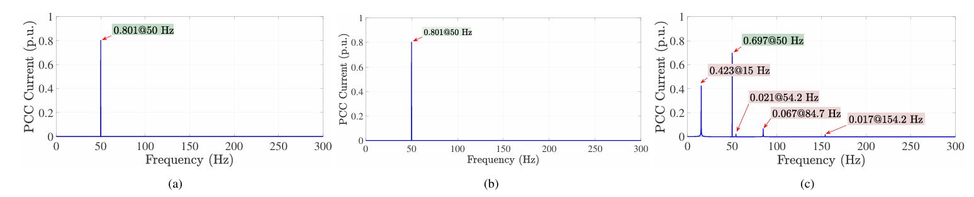
Figure 6: FFT of PCC phase-A current (ipcc,a) of the GMFI under FVC, PVC, and AVR strategies for SCR = 5 and Xg/Rg = 8: (a) FVC; (b) PVC; (c) AVR ‎[47].
This observation aligns with the frequency-domain analysis, where the eigenvalue trajectory of the AVR in Figure 4(f) approaches the critical point (−1,0j) on the Nyquist plot with the increment of SCR. Figure 6 shows the FFT of the PCC current for phase A (i_{pcc,a}) at SCR = 5. FVC and PVC exhibit a dominant 50 Hz com ponent, indicating stable operation. In contrast, AVR produces low-frequency oscillations and harmonic components at 15.3, 54.2, 84.7, and 154.2 Hz, confirming small-signal instability under strong grid conditions.

Enhancing Small-Signal Stability of AVR-based Grid-Forming Inverters
Figure 7 shows the use of a virtual impedance loop and adaptive tuning of the K_{i-q} values based on the grid SCR to improve the performance of the AVR for the GFMI. The virtual impedance loop includes the virtual resistance, virtual inductance, and the overall virtual impedance. The values of the control parameter K_{i-q} are tuned using the adaptive tuning control based the values of the grid side SCR.
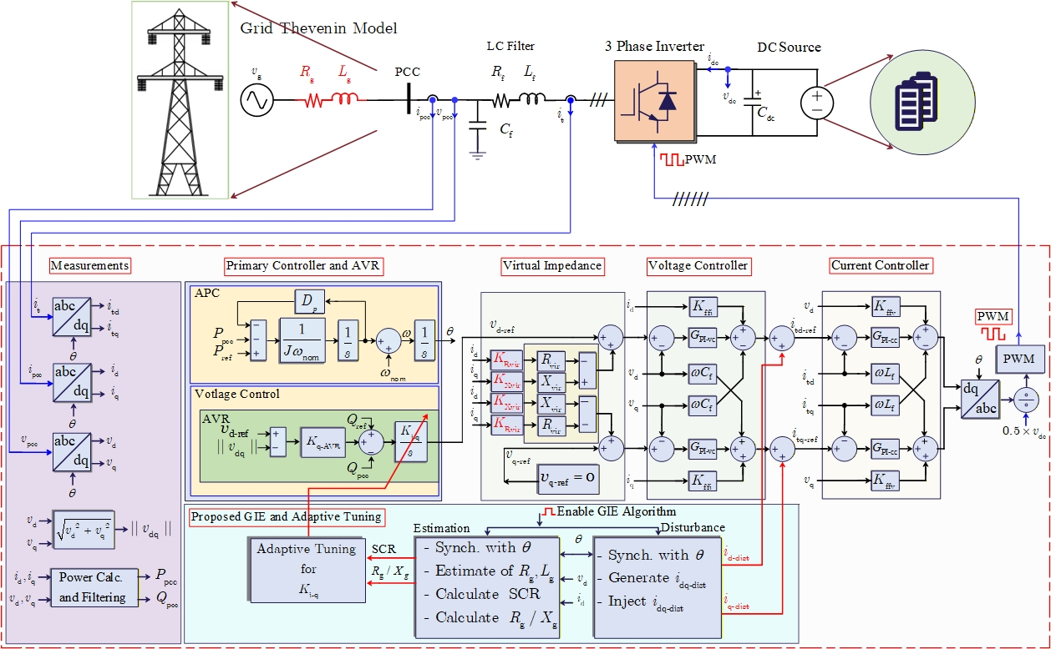
Figure 7: Improving the performance of AVR using a virtual impedance loop and adaptive tuning of the K_{i-q} values based on the grid SCR.

Frequency-Domain Analysis of AVR-Based Grid-Forming Inverters
This part of the report presents the improvement of AVR-based GFMI stability incorporating a virtual impedance loop and adaptive tuning of the K_{i-q} values based on grid SCR. Figure 8 shows the frequency-domain, DQ-domain output impedances & Nyquist plots of the VSG-based GFMI under AVR Control (@ SCR = 4, 𝑋_g / 𝑅_g = 7) : (a) & (d): Virtual resistance only ($0, 0{.5R}_{vir},R_{vir})$, (b) & (e): Virtual inductance only($0, 0{.5L}_{vir},L_{vir})$, and (c) & (f): Virtual impedance (resistance + inductance)($0, 0{.5Z}_{vir},Z_{vir}$). It is observed that varying the values of $R_{vir}$, $L_{vir}$and $Z_{vir}$has significant impact on output impedances at low frequencies and in Nyquist plots. Each approach—$R_{vir}$, $L_{vir}$and $Z_{vir}$—impacts stability differently and $L_{vir}$performs best, pushing the Nyquist trajectory farthest from (-1, 0).

$$f\left(Z_{vir}\right)$$
$$f\left(L_{vir}\right)$$
$$f\left(R_{vir}\right)$$
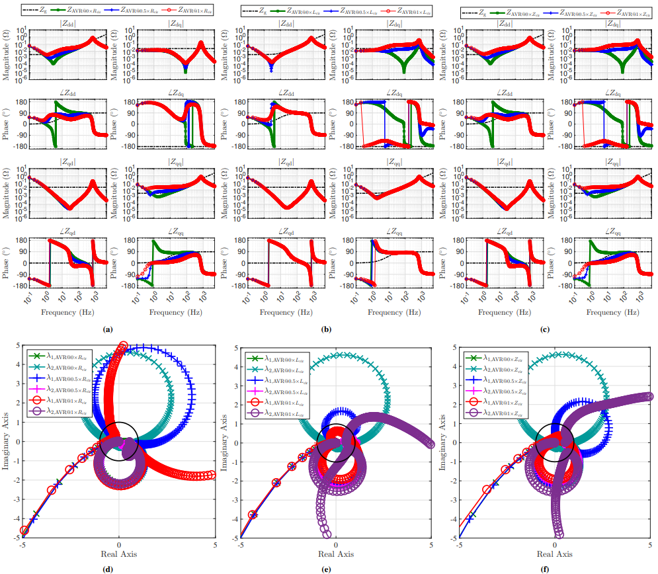
Figure 8: DQ-domain output impedances & Nyquist plots of the VSG-based GFMI under AVR Control (approach 1) (@ SCR = 4, 𝑋_g / 𝑅_g = 7) : (a) & (d): Virtual resistance only ($0, 0{.5R}_{vir},R_{vir})$, (b) & (e): Virtual inductance only ($0, 0{.5L}_{vir},L_{vir})$, and (c) & (f): Virtual impedance (resistance + inductance)($0, 0{.5Z}_{vir},Z_{vir}$).
Figure 9(a) and (b) shows the magnitude and phase angle and the Nyquist plots of the DQ-domain Output Impedances & Nyquist Plots of the VSG-based GFMI under AVR Control (approach 2) (@ SCR = 4, 𝑋_{g} /𝑅_{g} = 7) and with different 𝐾_{i-q} levels such as $K_{i\text{-}q}$, $0.1K_{i\text{-}q} and$ ${0.01K}_{i\text{-}q}$ corresponding to $Z_{\text{AVR@Ki-q1}}$, $Z_{\text{AVR@Ki-q2}}$, and $Z_{\text{AVR@Ki-q3}}$, respectively. It is found that varying $K_{i\text{-}q}$significantly affects output impedances at low frequencies and the Nyquist trajectory. Higher $K_{i\text{-}q}$ improves stability by pushing the Nyquist curve farther from (-1, 0). Adaptive tuning effectively will enhance small-signal stability under strong grid conditions, and lower $K_{i\text{-}q}$ can reduce the steady-state settling time of V_{PCC}.

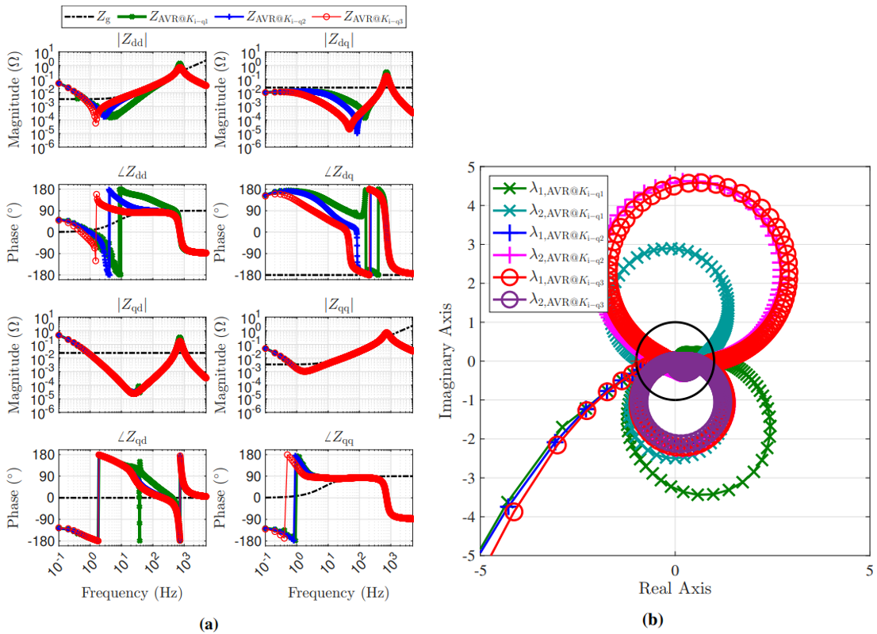
Figure 9: DQ-domain output impedances & Nyquist plots of the VSG-based GFMI under AVR Control (approach 2) (@ SCR = 4, 𝑋_g / 𝑅_g = 7) and with different 𝐾i-q values: (a) magnitude and phase angle of the impedances and (b) Nyquist plots.

Time-Domain Analysis of AVR-Based Grid-Forming Inverters
Figure 10 and Figure 11 illustrate the time-domain verification of the dynamic performances of the AVR control strategy using the virtual impedance loop and adaptive tuning of K_{i-q} based on the grid side SCR, respectively. It is found that, as SCR increases, Approach 1 will not remain stable unless reducing the values of K_{i-q}.

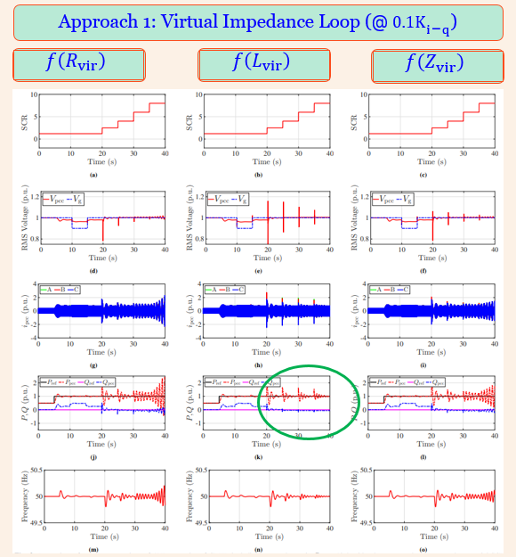
Figure 10: Time-domain verification of the performance of AVR strategy using virtual impedance loop (approach 1) control for GMFI under different values of the virtual impedance parameters at: f(R_{vir}) (left column), f(L_{vir}) (middle column), and f(Z_{vir}) (right column).

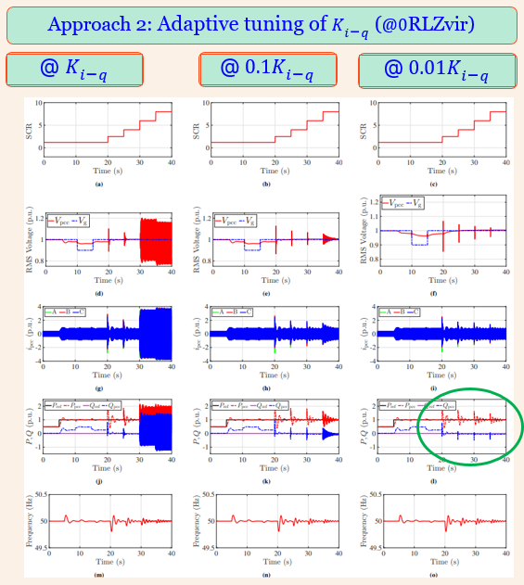
Figure 11: Time-domain verification of the performance of AVR strategy using adaptive tuning of Ki-q based on grid side SCR (approach 2) control for GMFI under different values of the virtual impedance parameters at: 1*Kip (left column), 0.1*Kip (middle column), and 0.01*Kip (right column).

Modal/Eigenvalue-Based Small-Signal Stability Analysis

In accordance with the findings of the literature review, two testing systems which are SMIB testing system and modified IEEE 39-bus testing system have been implemented. In this study, the built-in WECC power-controlled GFLI, WECC droop-controlled GFMI, and VSM-controlled GFMI in DIgSILENT PowerFactory have been considered. The first section presents the results and analysis with SMIB testing system and the three inverter control technologies as mentioned earlier. Figure 12 shows the schematic diagram of the SMIB testing system. The system consists of a DC source, an IBR, and the utility grid. The DC source can be a solar PV, wind, or battery. The IBR comprises both hardware components (e.g., semiconductors, gate drives, output filters, and voltage and current sensors) and a control algorithm that regulates the injected current/power of the IBR at the point of common coupling (PCC) with the grid. The voltage and current at PCC are represented by v_{pcc} and i_{pcc}, respectively. To facilitate its integration with the utility grid, the inverter incorporates an inductor–capacitor (LC) filter comprising an inductance (L_{f}) with an internal resistance (R_{f}), and capacitance (C_{f}). The inverter output current is denoted by it. The grid is represented by an ideal voltage source (vg) with a Thevenin equivalent impedance comprising the grid resistance (R_{g}) and grid inductance (L_{g}).
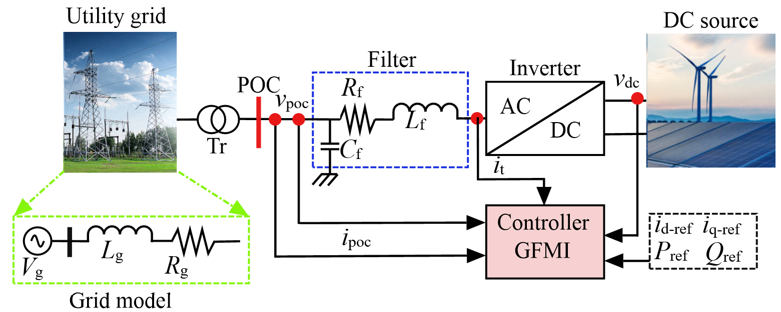
Figure 12: Typical block diagram of a grid-connected IBRs.
In addition to the SMIB test system, a modified IEEE 39-bus test system (Figure 13) was developed to evaluate the small-signal stability (SSS) of the power system with VSM-controlled GFMIs under different operating points (P__{ref} and Q__{ref}) of the inverters. In the modified system, three synchronous generators G10, G07, and G08 on bus 30, 36, and 37, respectively, have been replaced by three VSM-controlled GFMIs. The MVA rating of the synchronous generators are 1000 MVA, 700 MVA, and 700 MVA for G10, G07, and G08, respectively. The GFMIs with the same MVA rating for respective buses have been connected to bus 30, 36, and 37 through step-up transformers and POC1, POC2, and POC3, respectively.
POC2
POC3
POC1
Figure 13: Modified IEEE 39-bus testing system DIgSILENT PowerFactory.
Table 5 summarises the parameters of the unmodified and modified IEEE 39-bus testing system with three VSM-controlled GFMIs at buses 30, 36, and 37.
Table 5: Parameter of unmodified and modified IEEE 39-bus testing system with three VSM-controlled GFMIs at buses 30, 36, and 37.
Parameter | Before load step |  | After load step
Parameter | Unmodified | Modified | Unmodified | Modified
V_{mag} at 30 bus (p.u.) | 1.0475 | 0.9692 | 1.0475 | 0.9732
V_{mag} at 36 bus (p.u.) | 1.064 | 0.9861 | 1.068 | 0.9903
V_{mag} at 37 bus (p.u.) | 1.028 | 0.9547 | 1.028 | 0.9586
V_{mag} at POC1 (p.u.) | - | 1.048 | - | 1.05
V_{mag} at POC2 (p.u.) | - | 1.028 | - | 1.03
V_{mag} at POC3 (p.u.) | - | 1.064 | - | 1.066
f at 30 bus (Hz) | 50 | 50 | 50.63 | 50.65
f at 36 bus (Hz) | 50 | 50 | 50.63 | 50. 65
f at 37 bus (Hz) | 50 | 50 | 50.63 | 50. 65
f at POC1 (Hz) | - | 50 | - | 50. 65
f at POC2 (Hz) | - | 50 | - | 50. 65
f at POC3 (Hz) | - | 50 | - | 50. 65
P_{set} at 30 bus (MW) | 250 | 250 | 250 | 250
P_{mes} at 30 bus (MW) | 250 | 250 | 135.5 | 169.8
P_{set} at 36 bus (MW) | 560 | 560 | 560 | 560
P_{mes} at 36 bus (MW) | 560 | 560 | 510.1 | 449.4
P_{set} at 37 bus (MW) | 540 | 540 | 540 | 540
P_{mes} at 37 bus (MW) | 560 | 540 | 490 | 459.5
Q_{set} at 30 bus (MVar) | 0 | 0 | 0 | 0
Q_{mes} at 30 bus (MVar) | 146.2 | -7.987 | 92.44 | -52.52
Q_{set} at 36 bus (MVar) | 0 | 0 | 0 | 0
Q_{mes} at 36 bus (MVar) | 101.2 | -30.43 | 85.35 | -62.93
Q_{set} at 37 bus (MVar) | 0 | 0 | 0 | 0
Q_{mes} at 37 bus (MVar) | 0.4399 | -56.05 | -34.61 | -69
Table 6 summarises the parameters of the VSM-GFMI C1, C2, and C3 Connected at POC1, POC2, and POC3, respectively, in the modified IEEE 39-bus testing systems. Also, the implementation of modified 14-generator Australian power system (Figure 68) has been carried out. The system has been modified by replacing the SG at bus 501 by a built-in VSM-controlled GFMI in DIgSILENT PowerFactory. The rated MVA of the GFMI is 1.12 MVA and a total of 670 units were connected in parallel to match the power dispatch of the original SG at bus 501.
This section presents the evaluation of small-signal stability of power systems with different controls of GFLIs and GFMIs. Figure 14 shows the composite model frame of Western electricity coordinating council battery energy storage system (WECC BESS) with power-controlled GFLI in DIgSILENT PowerFactory ‎[48]. There are two WECC BESS templates available in PowerFactory which is configured for 50 Hz and 60 Hz systems. Each template has a rated apparent power of 1 MVA. The model incorporates renewable energy electrical control (REEC)-electrical control model, renewable energy generator control (REGC)-generator-converter model, A weak-Grid option model, protection model, plant control, and voltage-current measurements.
Table 6: Parameters of the GFMIs.
Parameter | C1 | C2 | C3
V_{set} (p.u.) | 1.0475 | 1.028 | 1.064
P_{ref} (p.u.) | 0.5 | 0.9 | 0.9
Q_{ref} (p.u.) | 0 | 0 | 0
MVA | 1.12 | 1.12 | 1.12
Power factor | 0.9 | 0.9 | 0.9
Number of parallel units | 500 | 600 | 622
Control | Constant V | Constant V | Constant V
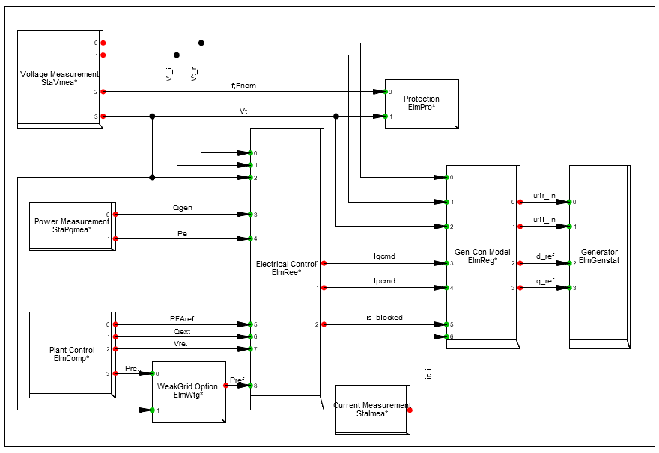
Figure 14: Composite Model of the WECC BESS with power-controlled GFLI in DIgSILENT PowerFactory.
The composite model of the Virtual Synchronous Machine (VSM) DIgSILENT PowerFactory is shown in Figure 15 ‎[49]. It comprises the current and voltage measurement, the power calculation, the grid-forming controller (with the actual VSM), the virtual impedance, the virtual impedance control, the voltage con troller, the output voltage calculation and a slot for a static generator, which is the controlled network element.
The droop control is based on the same frame as the VSM (Figure 15). In the grid-forming droop control, the frequency ∆ω_{droop} and voltage magnitude ∆u_{droop} deviations from the load flow initialization are calculated according to the droop equations ‎[50]:
$∆ω_{droop}=m_{p}∆p_{LPF}$ (1)
$∆v_{droop}=m_{q}∆q_{LPF}$ (2)
where m_{p} and m_{q} are the active and reactive power droop coefficients and ∆p_{LPF} and ∆q_{LPF} are the low-pass filtered active and reactive power deviations from the load flow initialization, respectively. The parameters f_{set}, p_{set}, u_{set} and q_{set} are usually initialized according to the initial load flow. However, they are modelled as input variables to the droop controller and, therefore, can be controlled from outside the block.
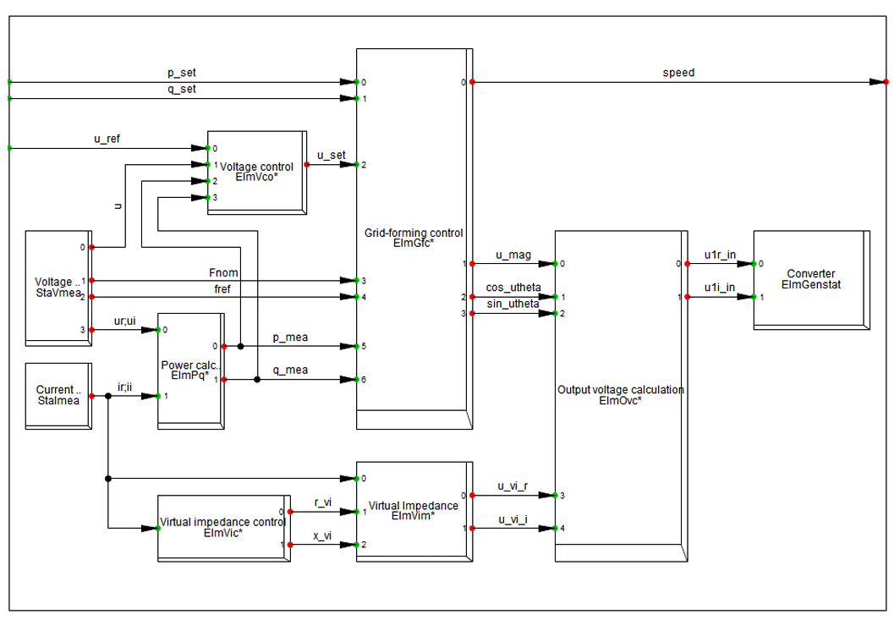
Figure 15: Composite Model of the virtual synchronous machine DIgSILENT PowerFactory [48].
Three case studies have been conducted to evaluate the SSS of the system under three different SCR scenarios, such as SCR=1.2, 2.5, and 4.0. Figure 16 shows the eigenvalue-based SSS evaluation of SMIB testing system with power-controlled GFLI under three SCR scenarios. It is evident from the analysis that, the system experienced with positive (unstable) eigenvalues in the case of very weak and weak grid scenarios and remain stable at strong grid conditions. Figure 17 shows the electromagnetic transient (EMT) results of droop-controlled GFMI for voltage and frequencies at the POC. It is quite evident from the analysis of the results that the performance of the built-in droop-controlled GFMI was slightly affected by the change in SCR values from 1.2 to 2.5, and 4.0.

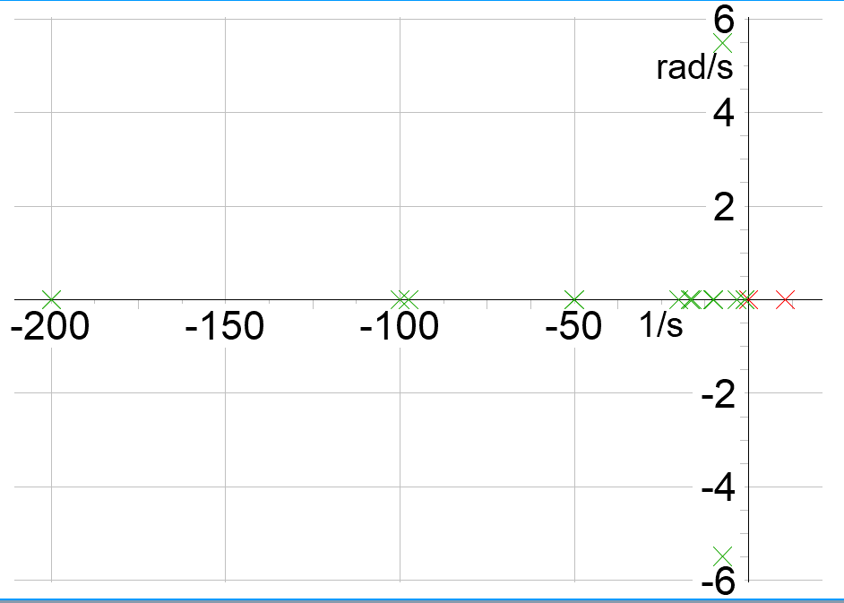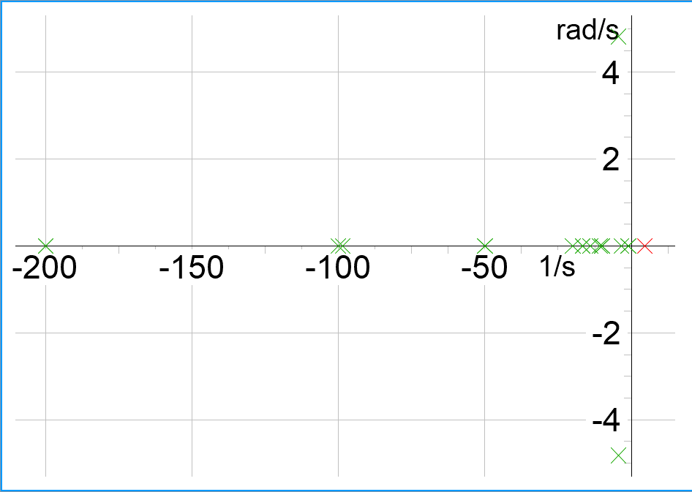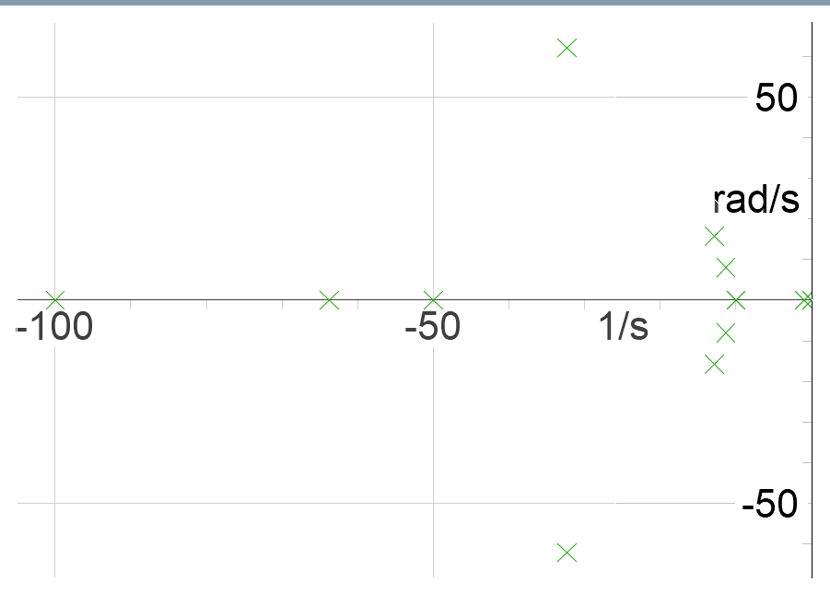
(c)
(b)
(a)

Figure 16: Eigenvalue plots of the SMIB system with power-controlled GFLI: (a) SCR=1.2, (b) SCR=2.5, and (c) SCR=4.0.
Figure 18 depicts the EMT simulation results for voltage and frequencies at POC with VSM-controlled GFMI connected to the infinite bus. The results are obtained using the built-in VSM model in DIgSILENT without any modifications to its control parameters. Compared to the droop-controlled GFMI, VSM-controlled caused more oscillations and higher overshoot in the transients. As the SCR increases to 4.0, the voltage and frequency became smother than those at the SCR of 2.5 and 1.2.
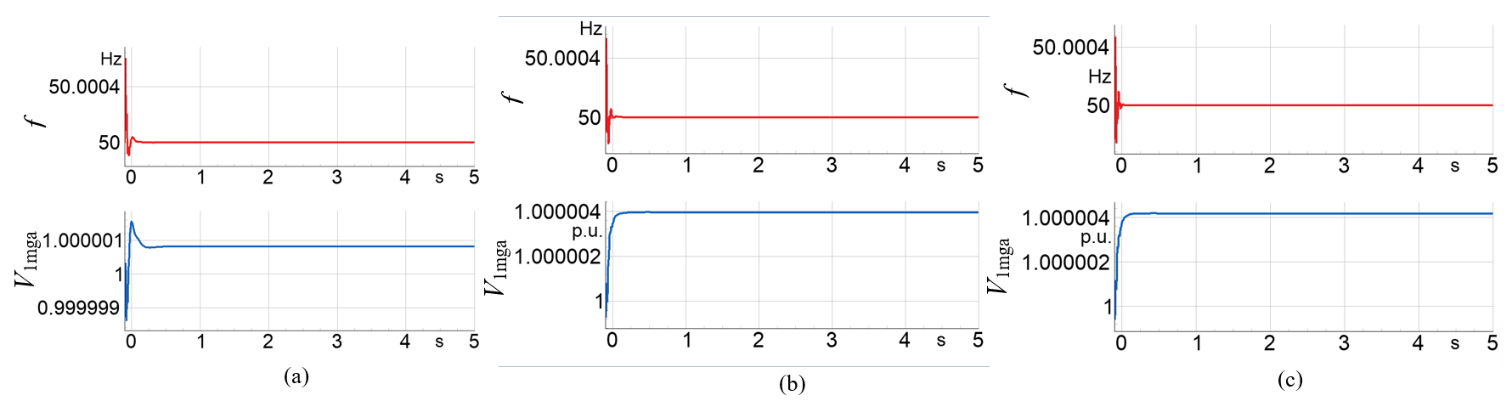
(b)
(a)
(c)

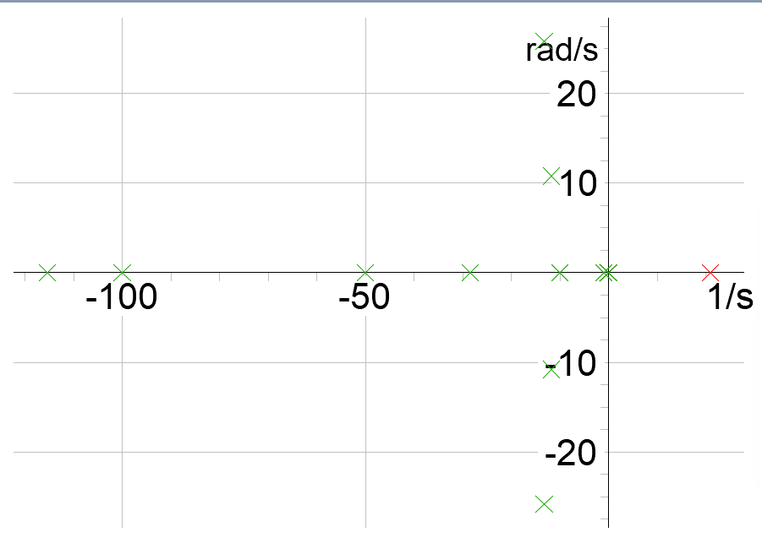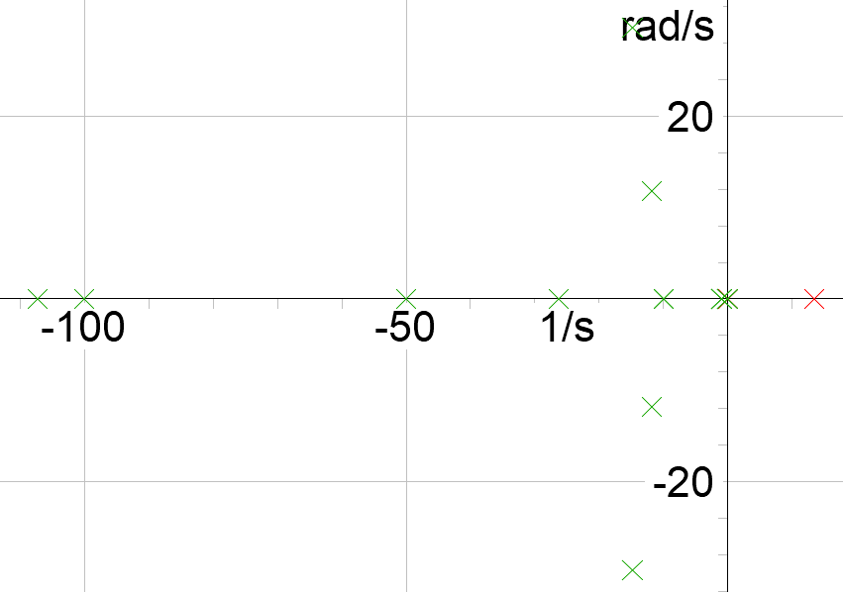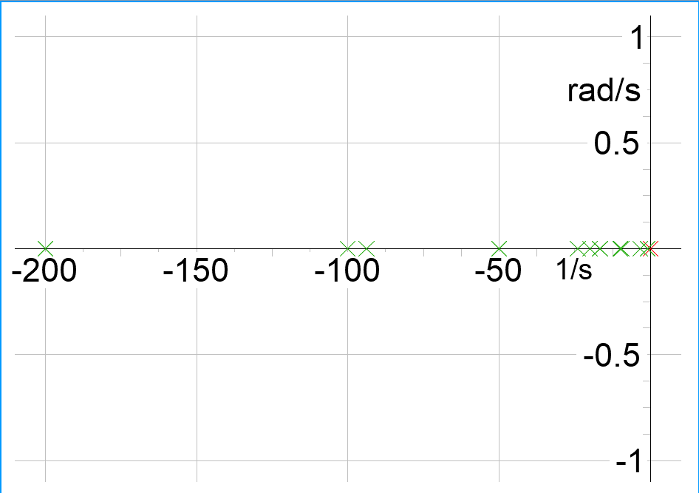
(f)
(e)
(d)
Figure 17: Frequency, voltage, and respective eigenvalue plots of the SMIB system with droop-controlled GFMI: (a), (d) SCR=1.2, (b), (e) SCR=2.5, and (c), (f) SCR=4.0.

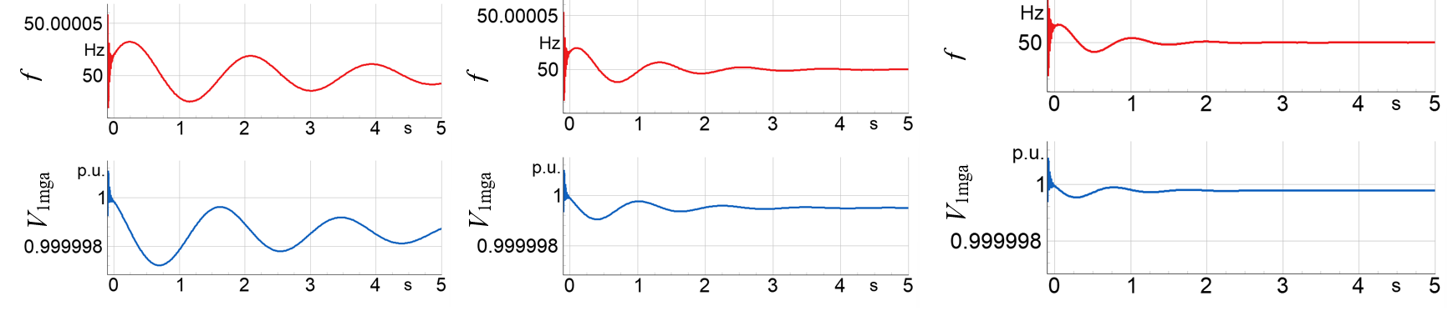
(c)
(b)
(a)
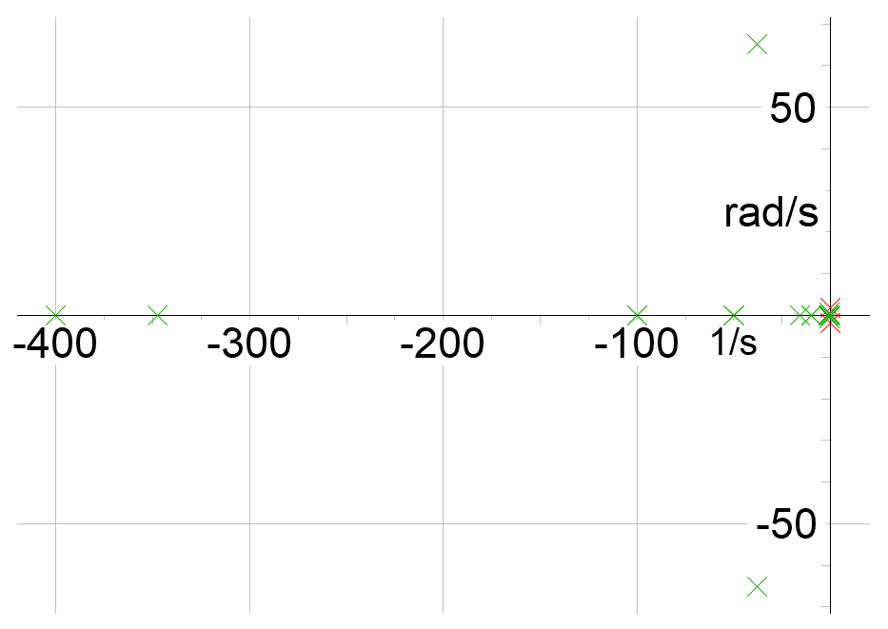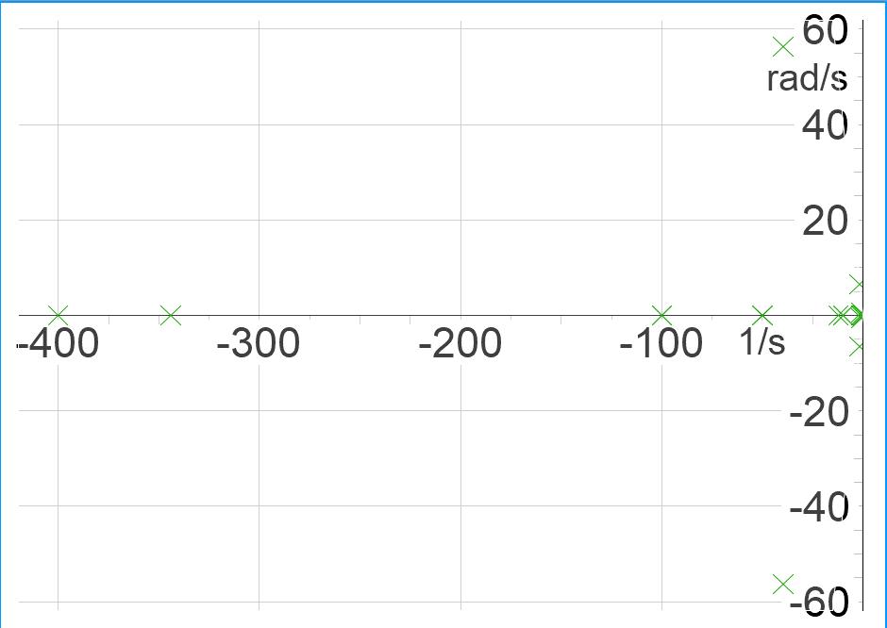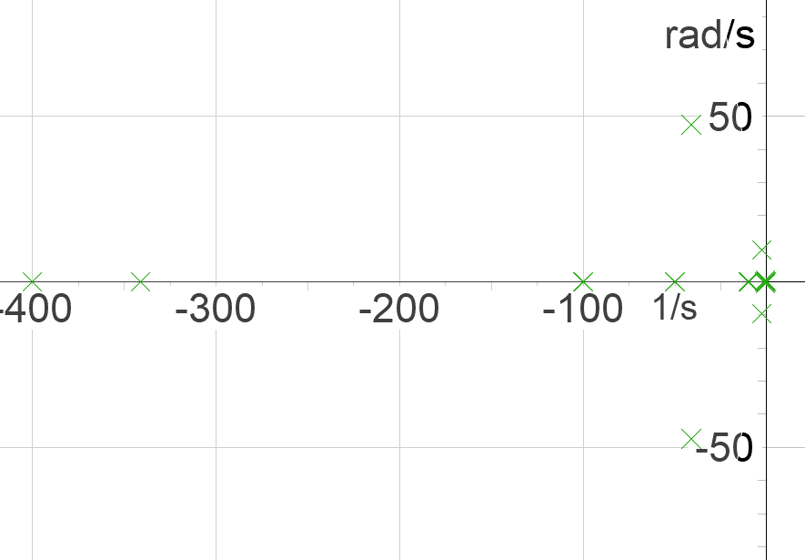
(f)
(e)
(d)

Figure 18: Frequency, voltage, and respective eigenvalue plots of the SMIB system with VSM-controlled GFMI: (a), (d) SCR=1.2, (b), (e) SCR=2.5, and (c), (f) SCR=4.0.
In addition to the eigenvalue analysis with different control strategies of the GFLI and GFMIs, the controllability and participation plots also have been analysed and interpreted. Figure 19 shows the controllability and participation plots for a specific mode of interest (in this case Mode 1) for all operation scenarios.
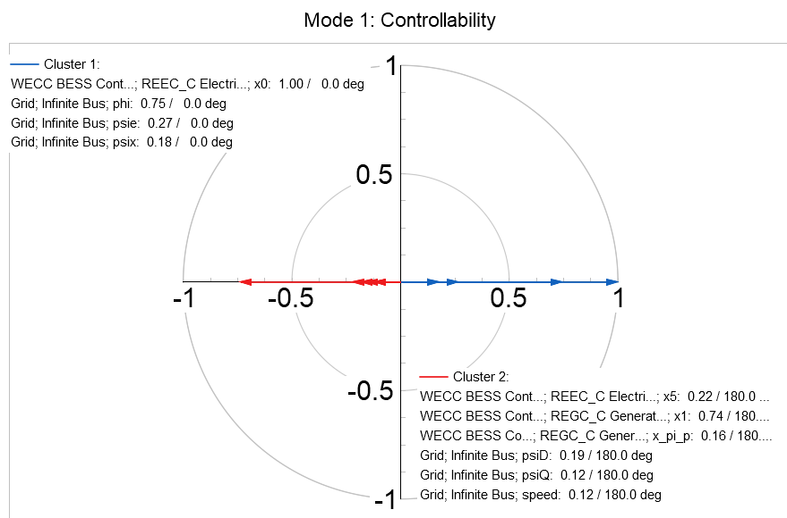 | 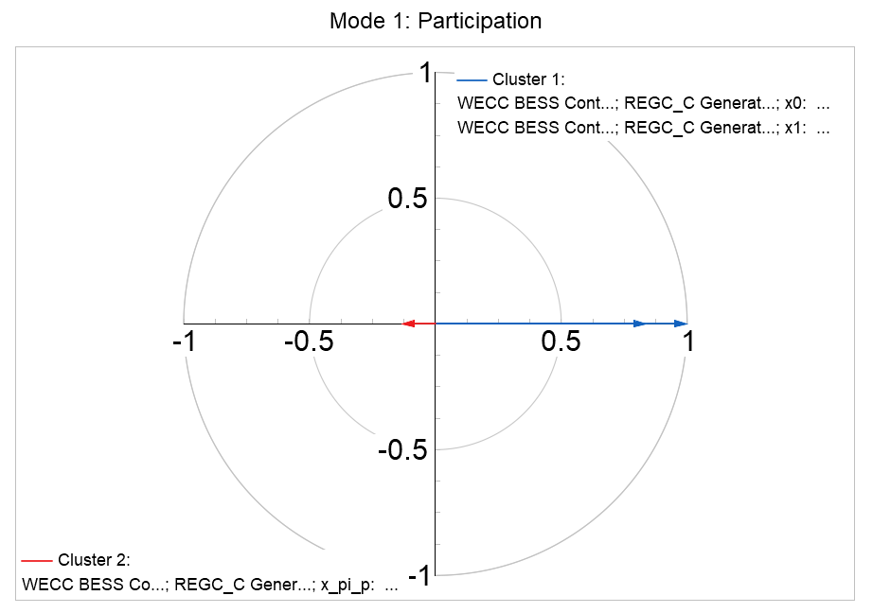
(a) | (b)
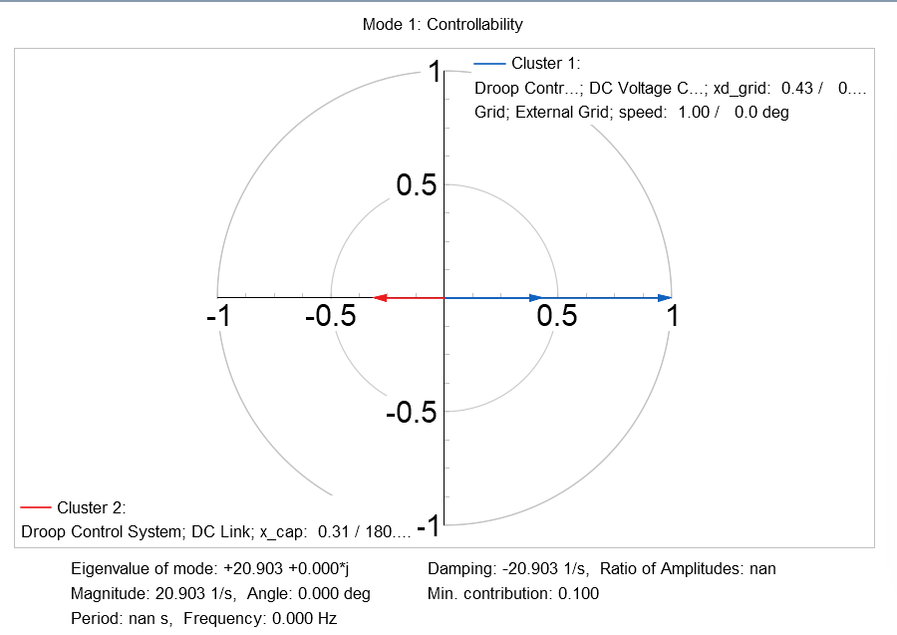 | 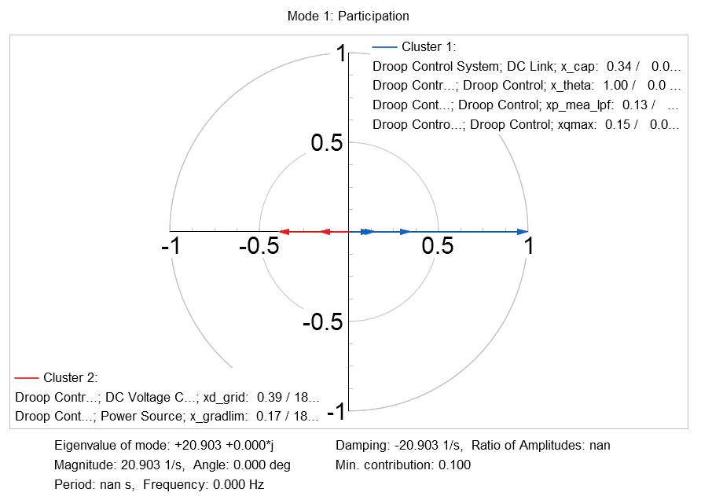
(c) | (d)
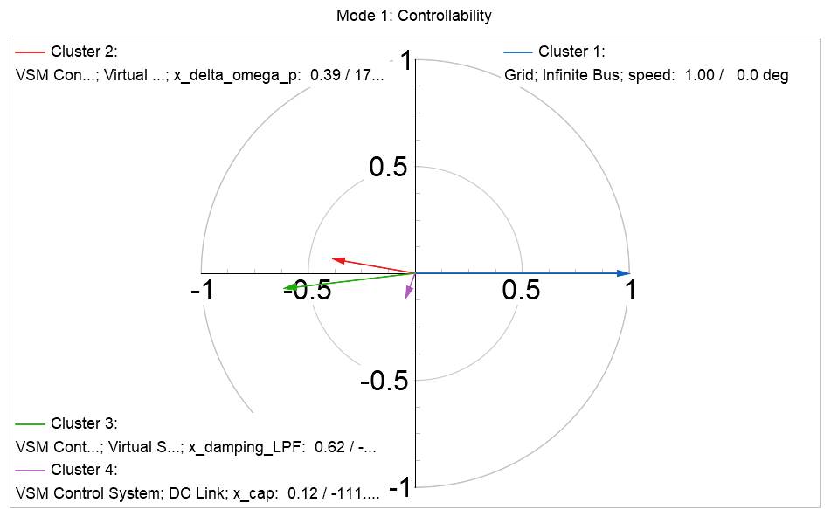 | 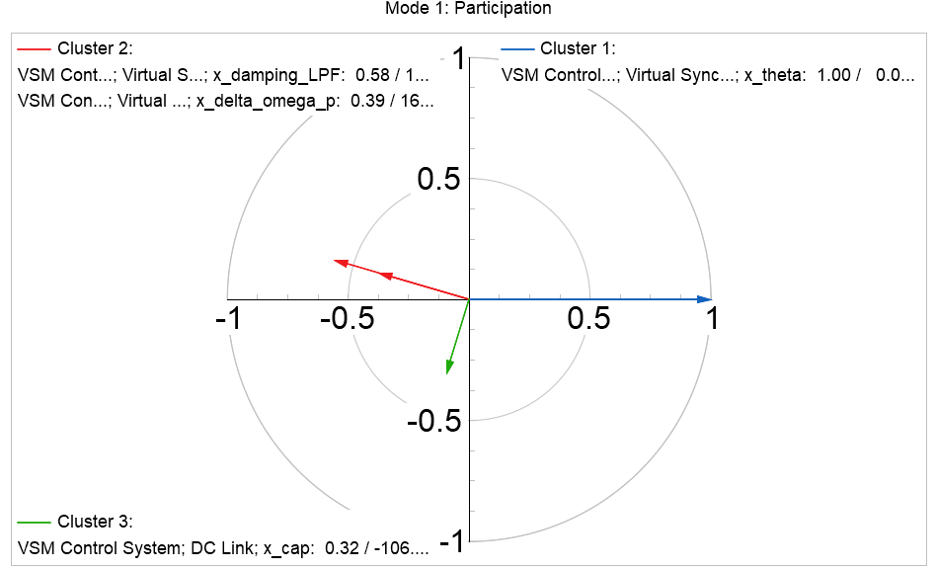
(e) | (f)
Figure 19: Controllability and participation plots: (a) and (b) Power-controlled GFLI, (c) and (d) droop-controlled GFMI, and (e) and (f) VSM-controlled GFMI.
In addition to the SMIB system, the eigenvales, controllability and participation plots of the modified IEEE 39-bus testing system with power controlled-GFLI and VSM-controlled GFMI as shown in Figure 20. GFLI controls caused more dominant positive (unstable) eigenvalues at low SCR and very low SCR conditions and VSM-GFMI caused dominant positive (unstable) eigenvalues at high-SCR scenario. The minimum damping ratio was recorded as 2.022 % and 1.498 % for power-controlled GFLI and VSM-controlled GFMI, respectively.
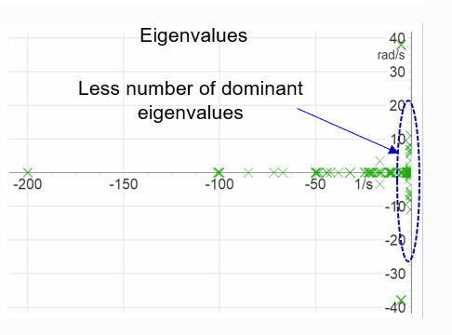 | 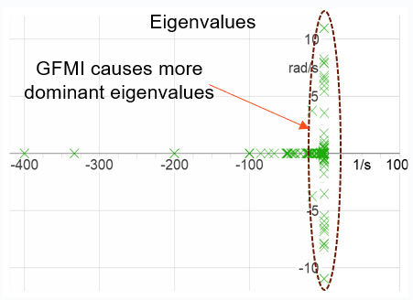
(a) | (b)
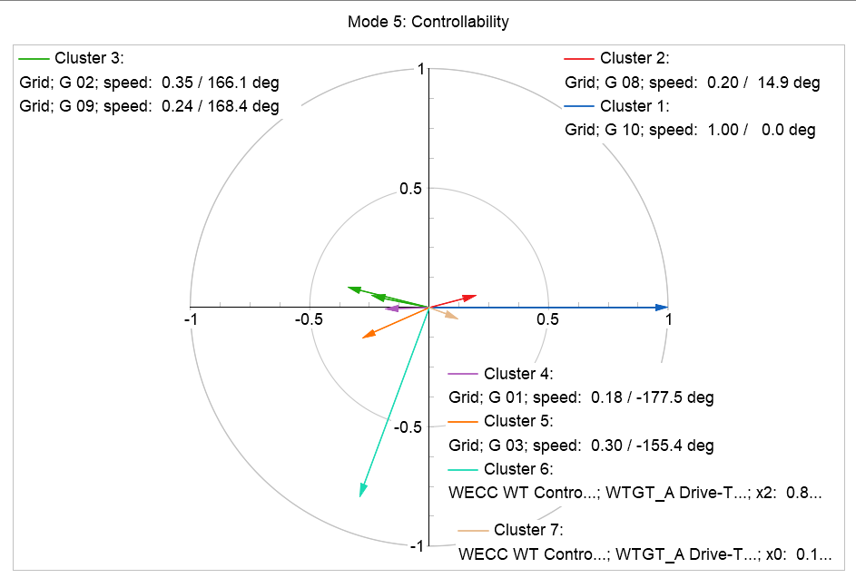 | 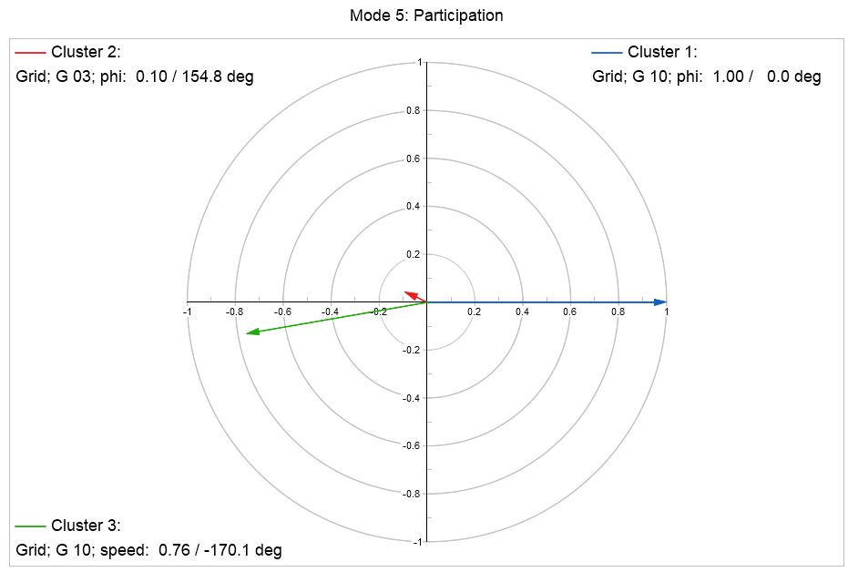
(c) | (d)
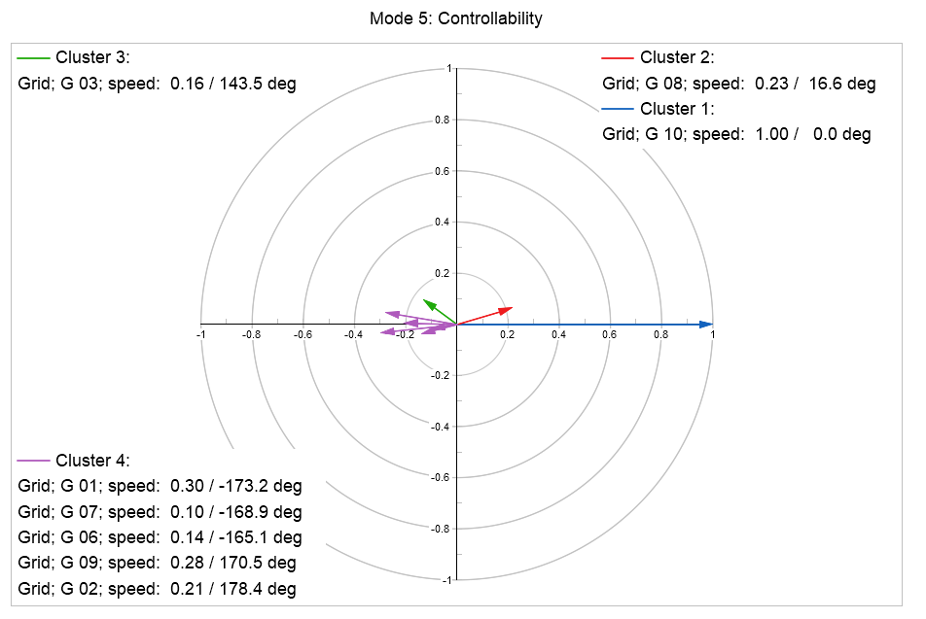 | 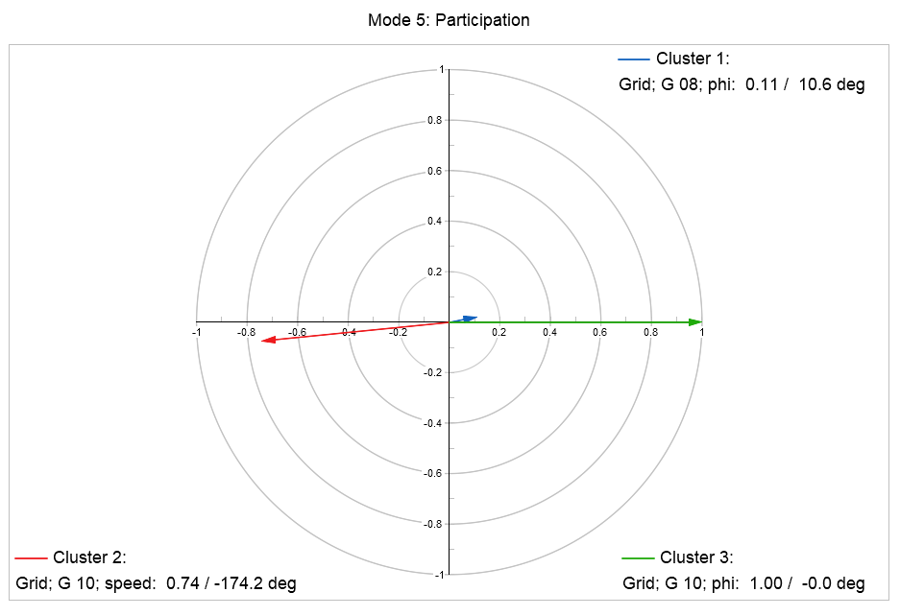
(e) | (f)
Figure 20: Eigenvalue plots: (a) Power-controlled GFLI, (b) VSM-controlled GFMI, Controllability and participation plots: (c) and (d) Power-controlled GFLI, and (e) and (f) VSM-controlled GFMI.
Figure 21 shows the eigenvalue plots and the controllability, participation, and observability plots of a specific mode (Mode 3) with lowest damping ratio. The damping ratio of mode 3 has been recorded as 0.032 (1/s) , which is below the minimum damping standard of 0.05 for frequencies above 0.6 Hz. In this example, the analysis was performed using the built-in DIgSILENT model for testing purposes, without any modifications to the control parameters. Therefore, improving the damping performance would require further tuning of the control parameters or optimisation of the VSM control settings.
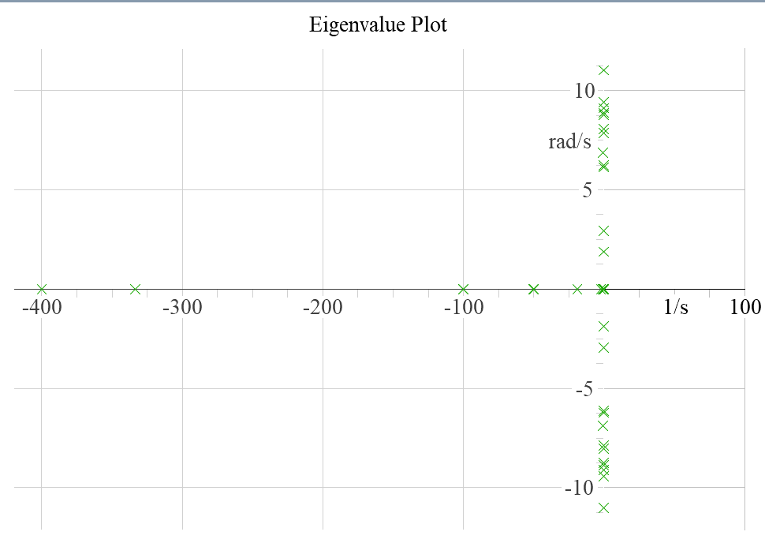 | 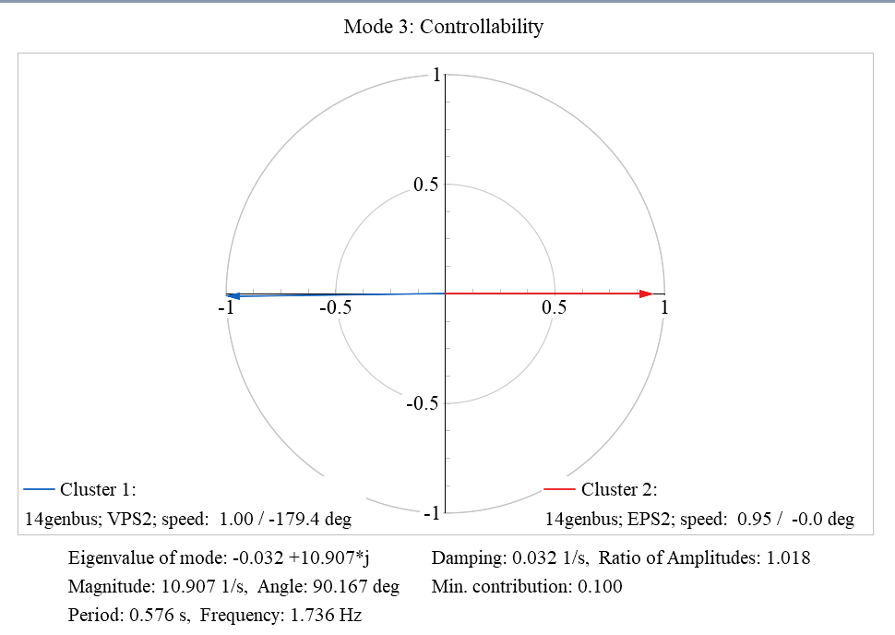
(a) | (b)
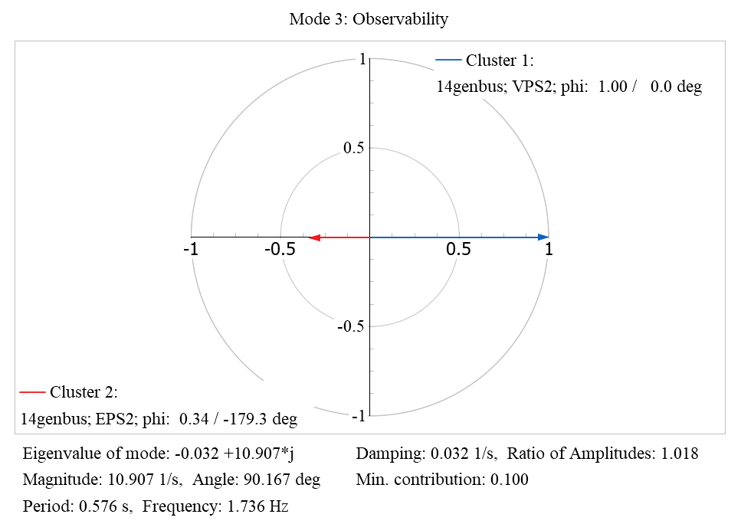 | 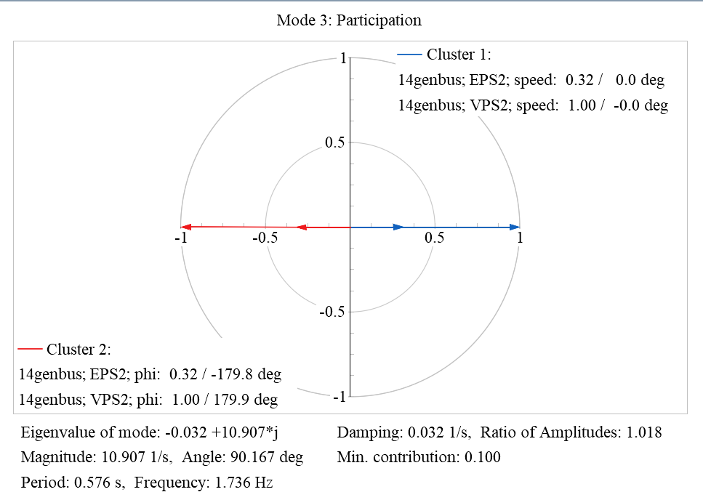
(c) | (d)
Figure 21: (a) Eigenvalue plot of the entire system, (b) Controllability plot (c) Observability plot and (d) Participation plots of Mode 3.

Data-Driven Time-Domain Model-Based Small-Signal Stability Analysis
This section presents the proposed Gaussian process regression (GPR) and eigensystem realisation algorithm (ERA)-based DDTD model to evaluate the SSS of GFMIs under different operation scenarios of the power system. The following sections provide a detailed discussion of the proposed DDTD algorithm. Figure 22 presents the schematic block diagram of the proposed DDTD method for small-signal stability (SSS) analysis of GFMIs.
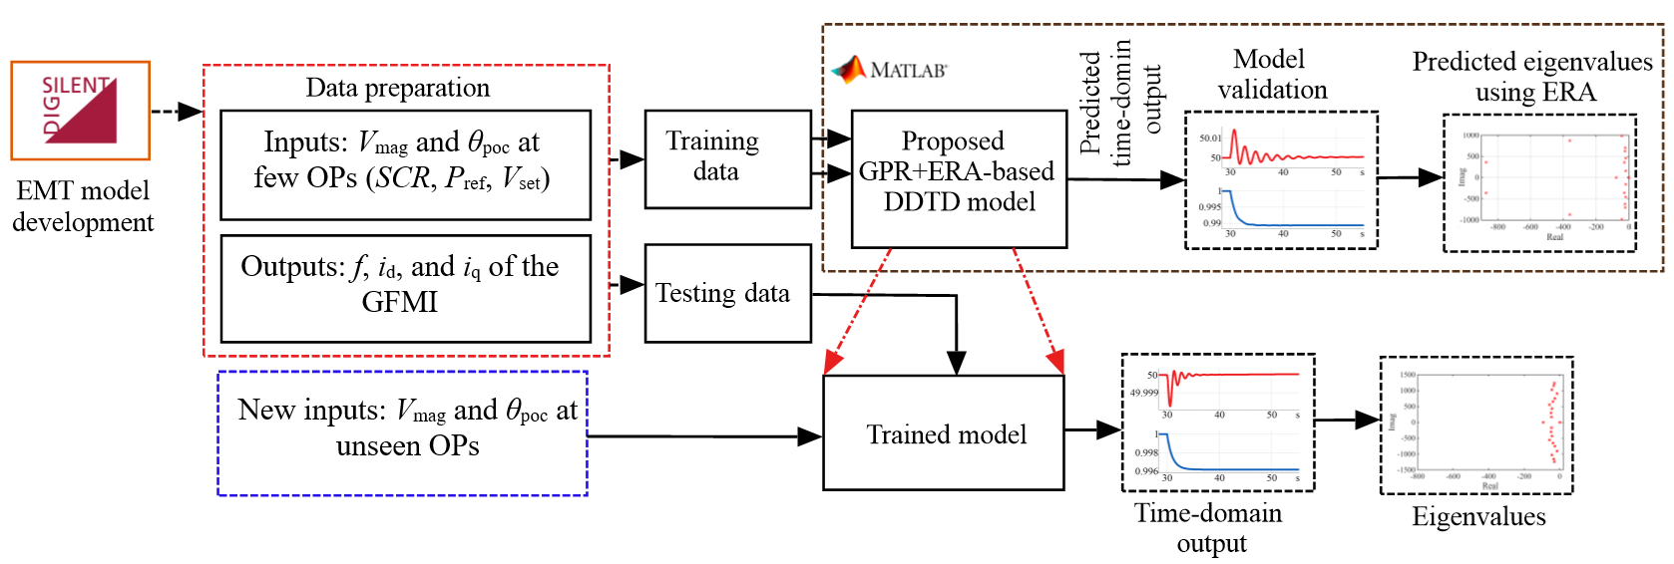
Figure 22: Proposed DDTD approach, comprising GRP and ERA.
The dynamic behaviour of GFMIs is affected by multiple factors, including grid impedance, load variations, operating point fluctuations, control algorithms, and interactions within cascaded control loops. Accounting for these interactions makes accurate modelling of GFMIs a challenging task. The proposed methodology addresses this by generating time-domain training data across various operating points, including different short-circuit ratios (SCRs) and active and reactive power references of the GFMIs. After generating the necessary time-domain data—including positive-sequence voltage magnitude and phase angle, d- and q-axis currents of the GFMI, and frequency at the POC the proposed GPR- and ERA-based model is trained and validated to assess the small-signal stability (SSS) of the system for both droop- and VSM-controlled GFMIs.
In this study, three case studies have been considered: (1) SMIB system with droop and VSM-controlled GFMI, (2) modified IEEE 39-bus testing system with VSM-controlled GFMI, and (3) modified and simplified 14-generator Australian power system with VSM-controlled GFMI. This section also presents the training and validation of the proposed GPR and ERA-based DDTD model for evaluating the SSS of SMIB system and modified IEEE 39-bus testing system with GFMIs. Furthermore, a comparative study between the ANN, SVM, and GPR-based DDTD model has been presented with SMIB system. It is shown that the stability of the system with both droop and VSM-controlled GFMI became affected by the variations of SCR and P_{ref}. Therefore, in this study, the authors defined the operating points by the short-circuit ratio (SCR), active power reference ($P_{ref}$), and voltage set point ($V_{set}$) of the GFMI. The positive-sequence voltage magnitude, V_{1mag} and phase angle, θ_{poc} at POC were used as inputs to the model, while the GFMI frequency, f and d- and q-axis currents ($i_{d},i_{q}$) served as outputs.

Validation of DDTD Models in SMIB System with Droop and VSM-controlled GFMI
Firstly, to illustrate the dynamic behavior of the droop-controlled and VSM-controlled GFMI, the SMIB system as shown in Figure 12, was implemented in DIgSILENT PowerFactory with 1.12 MVA of built-in droop and VSM-controlled GFMIs. Three case studies were conducted to evaluate the small-signal stability (SSS) of the system under different short-circuit ratio (SCR) scenarios: SCR = 1.2, 2.5, and 4.0. Also, the active power reference of the GFMI varied from 0.5, 0.75, and 1.0 MW. Figure 23(a) presents the electromagnetic transient (EMT) results for the droop-controlled GFMI, showing voltage, V and frequency, f at the POC. A small perturbation, consisting of a voltage step from 1.00 p.u. to 1.05 p.u., was applied to the voltage set point of the external grid at 30 s. The system response was monitored to determine the stabilization point, which occurred at approximately 38 s following the perturbation. The results indicate that the performance of the droop-controlled GFMI was only slightly affected as the SCR increased from 1.2 to 4.0. Figure 23(b) shows the EMT results for the VSM-controlled GFMI. Compared to the droop-controlled case, the VSM-controlled GFMI exhibited larger oscillations and higher overshoots during transients. Increasing the SCR to 4.0 improved system response, producing smoother voltage and frequency profiles compared to SCRs of 2.5 and 1.2.
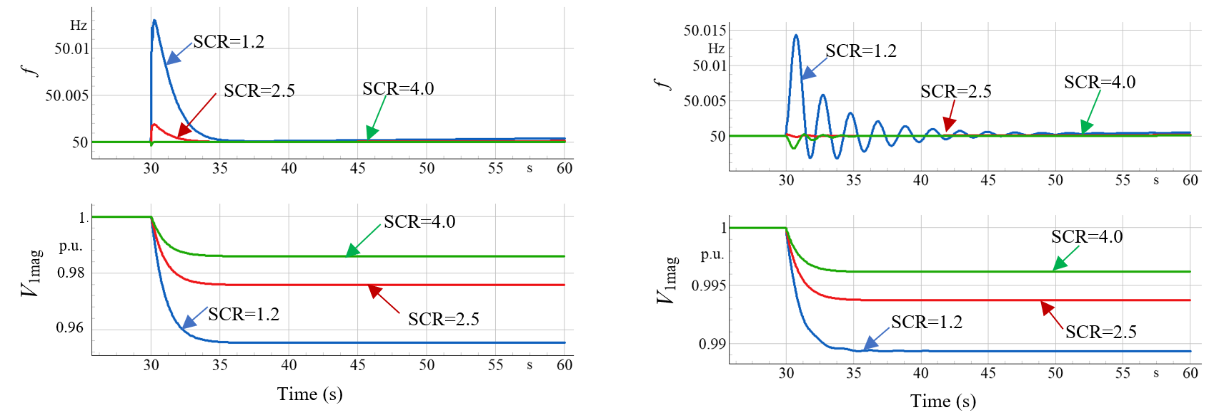
(a) | (b)
Figure 23: Dynamic behaviour of (a) droop-controlled and (b) VSM-controlled GFMI at different SCR and it is assumed that the converter was assumed to operate as stable at t=30 s.
Figure 24 and Figure 25 present the validation of the proposed GPR- and ERA-based DDTD model for evaluating the small-signal stability (SSS) of the SMIB test system with droop- and VSM-controlled GFMIs, respectively.

Comparative Performance Study of ANN, SVM, and GPR-based DDTD Models
In this section, a comparative study has been presented between the ANN and ERA-based DDTD, SVM and ERA-based, and the proposed GPR and ERA-based DDTD models in terms of prediction accuracy of time-domain outputs, estimating the system eigenvalues, and evaluating the SSS of the SMIB testing system with VSM-controlled GFMI. Figure 26 shows the comparison between GPR and ERA-based DDTD model ANN and ERA-based DDTD model to predict the frequency, i_{d}, and i_{q} of the GFMI at new operating point, SCR=2, P_{ref}=0.25 MW, V_{set}=1.0.
The results indicate that the ANN was less accurate in predicting the system outputs compared to the proposed GPR-based model, due to inherent limitations of the ANNs, including their need for large training datasets to achieve accurate predictions. In contrast, the proposed GPR model successfully captured the true system dynamics, which is critical for accurate eigenvalue estimation using the ERA method.

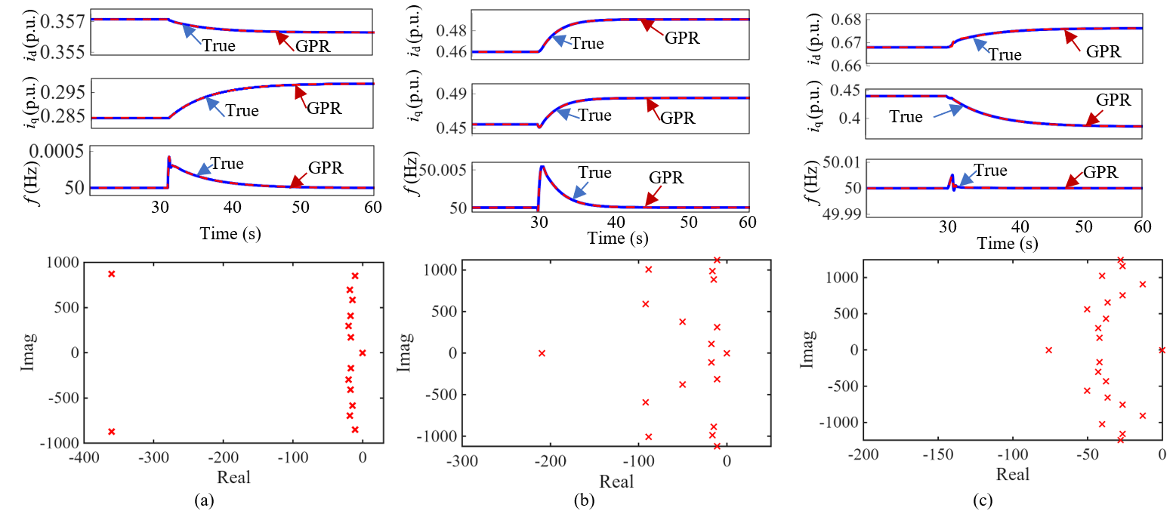
Figure 24: DDTD model validation and SSS evaluation with droop-controlled GFMI at: (a) SCR=9, Pref=0.50 MW, Vset=1.0 p.u., (b) SCR=9, Pref=0.70 MW, Vset=1.0 p.u., and (c) SCR=3, Pref=0.50 MW, Vset=1.0 p.u.
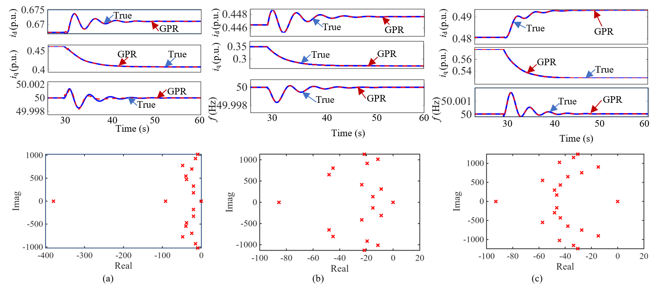
Figure 25: DDTD model validation and SSS evaluation with VSM-controlled GFMI at: (a) SCR=9, Pref=0.50 MW, Vset=1.0 p.u., (b) SCR=9, Pref=0.70 MW, Vset=1.0 p.u., and (c) SCR=3, Pref=0.50 MW, Vset=1.0 p.u.
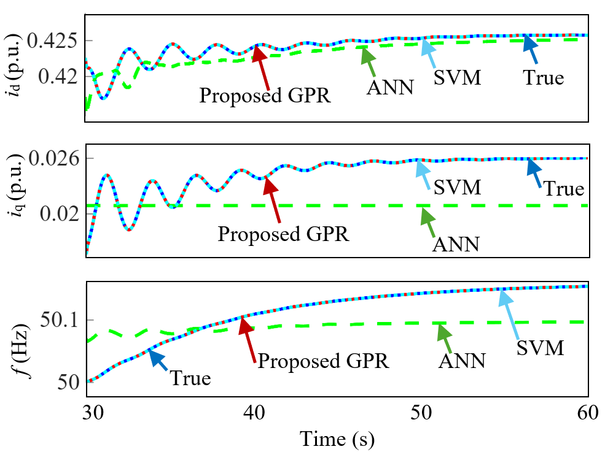
Figure 26: Comparative study between ANN, SVM, and the proposed GPR-based DDTD model for SMIB testing system with VSM-controlled GFMI system at SCR=2, Pref=0.25 MW, Vset=1.0.
A further comparative study was conducted to assess the accuracy of the eigenvalues by comparing them with values obtained from DIgSILENT PowerFactory. Table 7 summarizes the real and imaginary components of the system eigenvalues obtained using the ANN+ERA model, SVM+ERA model, the proposed GPR+ERA model, and the DIgSILENT PowerFactory simulations.

Table 7: Comparison of eigenvalues obtained using ANN+ERA, SVM+ERA, GPR+ERA, and DIgSILENT PowerFactory for "SCR"=2, P_ref=0.25 MW, and V_set=1.0 p.u.
Modes | ANN+ERA |  | SVM+ERA |  | GPR+ERA |  | DIgSILENT PowerFactory
Modes | Real part | Imaginary part | Real part | Imaginary part | Real part | Imaginary part | Real part | Imaginary part
Mode 1 | 0.00000 | j0.00000 | -0.01541 | j0.00000 | -0.01249 | j0.00000 | -0.01376 | j0.00000
Mode 2 | -0.20104 | j0.78454 | -0.11992 | j0.00000 | -0.11095 | j0.00000 | -0.10762 | j0.00000
Mode 3 | -3.90418 | -j0.58454 | -0.5319 | j1.18013 | -0.44073 | j1.17099 | -0.38535 | j0.71260
Mode 4 | -3.90418 | j0.38545 | -0.5319 | - j1.18013 | -0.44073 | - j1.17099 | -0.38535 | -j0.71260
Mode 5 | -5.03409 | j1.01997 | -1.16035 | j1.26003 | -1.13037 | j1.23005 | -1.00000 | j0.00000
Mode 6 | -5.03409 | -j1.01997 | -1.16035 | - j1.26003 | -1.13037 | - j1.23005 | -1.00000 | j0.00000
Mode 7 | -10.0535 | j0.57119 | -2.19157 | j8.86093 | -2.18100 | j8.46091 | -3.00071 | j10.3390
Mode 8 | -10.0535 | -j0.57119 | -2.19157 | -j8.86093 | -2.18100 | -j8.46091 | -3.00071 | -j10.3390
Mode 9 | -12.0959 | j0.32159 | -8.10087 | j0.00764 | -8.00021 | j0.00965 | -9.37830 | j0.00000
Mode 10 | -12.0959 | -j0.32159 | -8.10087 | - j0.0524 | -8.00021 | - j0.0023 | -9.99999 | j0.00000
Mode 11 | -12.0959 | j76.8098 | -8.12053 | j0.00524 | -8.17056 | j0.00567 | -9.99999 | j0.00000
Mode 12 | -32.0994 | -j76.8098 | -27.8371 | J83.3781 | -27.1076 | j86.1100 | -28.2762 | j102.734
Mode 13 | -32.0994 | j0.00000 | -27.8371 | - j83.3781 | -2710760 | - j86.1100 | -28.2762 | -j102.734
Mode 14 | -43.4721 | j0.00000 | -44.0452 | j0.000338 | -46.02862 | j0.000252 | -50.0000 | j0.00000
Mode 15 | -43.4721 | j0.00000 | -44.0452 | j0.000338 | -46.0035 | j0.000252 | -50.0000 | j0.00000
Mode 16 | - | - | -103.086 | j0.000283 | -101.0845 | j0.000046 | -100.000 | j0.00000
Mode 17 | - | - | -103.086 | j0.000283 | -101.0845 | j0.000452 | -100.048 | j0.00000
Mode 18 | - | - | -362.556 | j0.000669 | -361.2330 | j0.000561 | -366.857 | j0.00000
Mode 19 | - | - | -413.005 | j0.000669 | -412.0000 | j0.000561 | -400.000 | j0.00000
MAE | 3.80 | 25.63 | 2.29 | 2.24 | 1.96 | 2.06
The developed approach in this study estimates only the system eigenvalues, from which the modal frequencies and damping ratios are calculated. It does not estimate mode shapes or participation factors.
The proposed GPR- and ERA-based model was able to predict the same number of modes as obtained from DIgSILENT PowerFactory, whereas the ANN+ERA model captured only 15 modes due to insufficient representation of the system dynamics. All modes were analyzed and compared. For instance, Mode 2 exhibited an approximate 46.46 % difference in the real part of the eigenvalue between the ANN-based model and DIgSILENT PowerFactory, whereas the proposed GPR-based model showed only a 3.09 % difference. Similar comparisons across all other modes confirmed that the proposed GPR- and ERA-based DDTD model provides significantly higher accuracy in eigenvalue estimation.

Effect of Data Size on the Performance of ANN, SVM, and GPR-based DDTD Models
In this section, the performance of ANN, SVM, and GPR-based DDTD models has been analysed in terms of data size reduction and time-domain prediction results of the models. Figure 27 shows the time-domain prediction of the outputs for different percentages of data size used in the training of ANN, SVM, and GPR-based DDTD models. Different data sizes of the datasets have been considered 100 %, 50 %, 25 %, and 5 % for all these models. In this study, data size refers to the number of operating points used for training each data-driven dynamic equivalent model. The complete dataset consists of 460 operating points. Therefore, 100% data size corresponds to the complete dataset of 460 operating points, while 50%, 25%, and 5% correspond to 230, 115, and 23 operating points, respectively.
Figure 28 shows the percentage of error in eigenvalue prediction with 100 % data in the training process for ANN, SVM, and GPR-based DDTD models. It has been found that, as the data size is reduced in the training the time-domain prediction of ANN degrades significantly as this model requires large dataset for accurate prediction of the outputs. However, the time-domain prediction of SVM and GPR-based DDTD models was very similar but higher percentage of error in eigenvalue prediction has been observed with the proposed GPR-based DDTD model.
 | 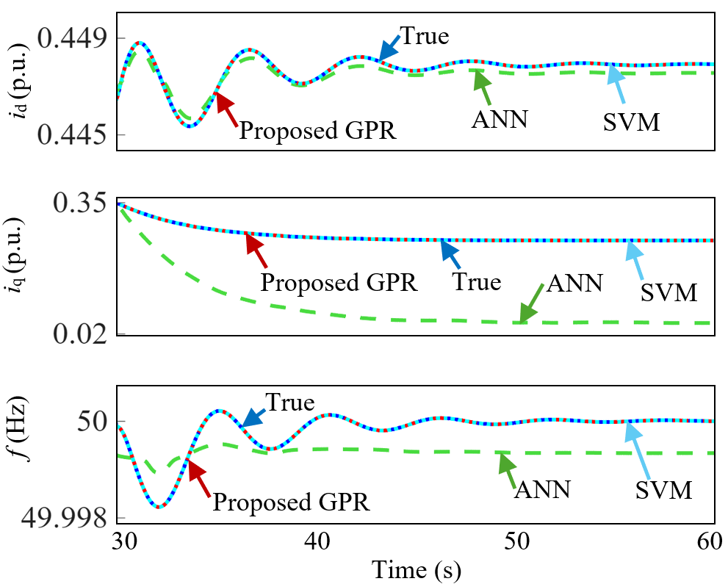
(a) | (b)
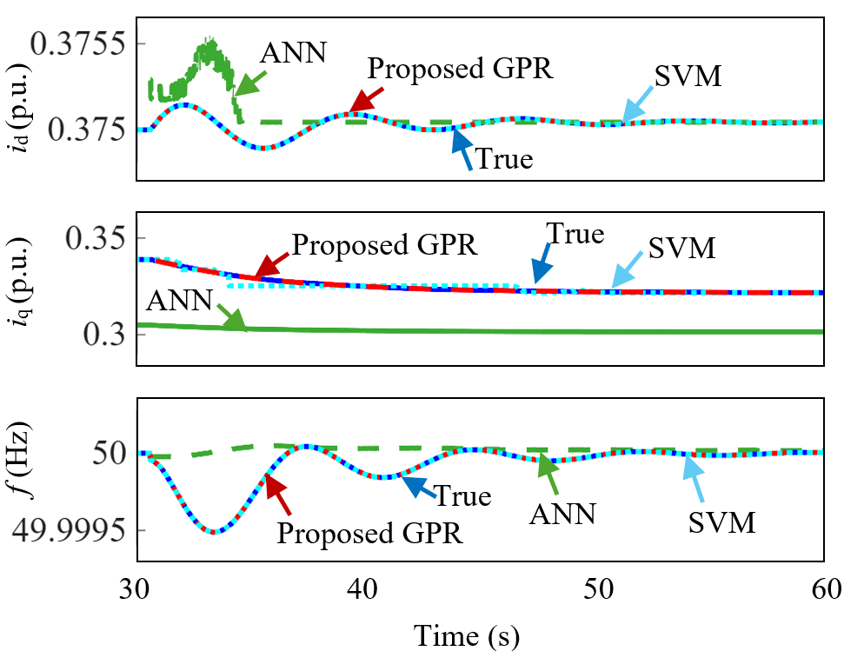 | 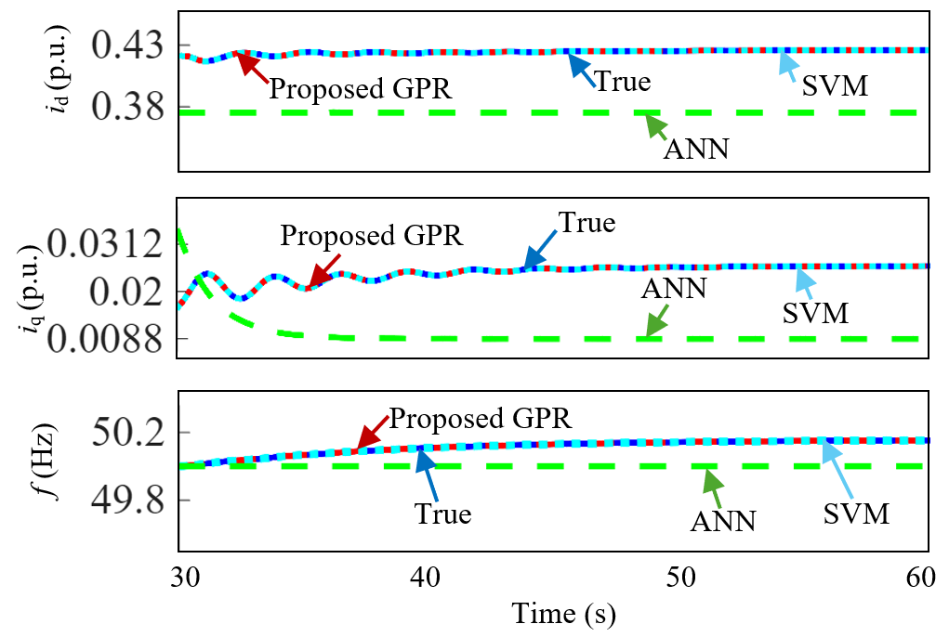
(c) | (d)
Figure 27: A comparative study between ANN, SVM, and GPR-based DDTD models with: (a) 100 % (b) 50 % (c) 25 % and, (d) 5 % of dataset.
(a)
(b)
(c)
Figure 28: Percentage of error in eigenvalue prediction with 100 % data in the training process for: (a) ANN, (b) SVM, and (c) GPR-based DDTD models.

Effect of Noise Measurement on the Performance of GPR
In this section, the performance of GPR-based DDTD model has been analysed considering different noise levels to the inputs of the models such as voltage magnitude and phase angle at POC. Figure 29 shows the effects of measurement noise in the input signals on the time-domain prediction of the GPR-based DDTD model. It is found that, as the level of noise increases, the prediction accuracy slightly decreases. However, proper modelling and optimization of the hyperparameters of the GPR-based model can be considered to reduce the effect of noise on the prediction accuracy of the model.
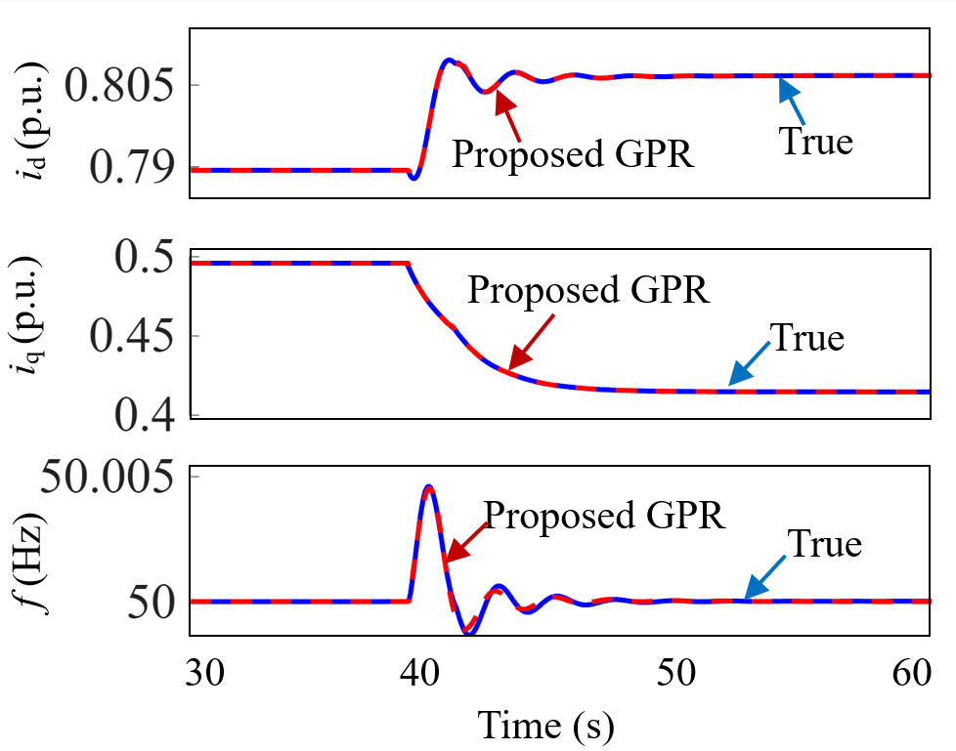 | 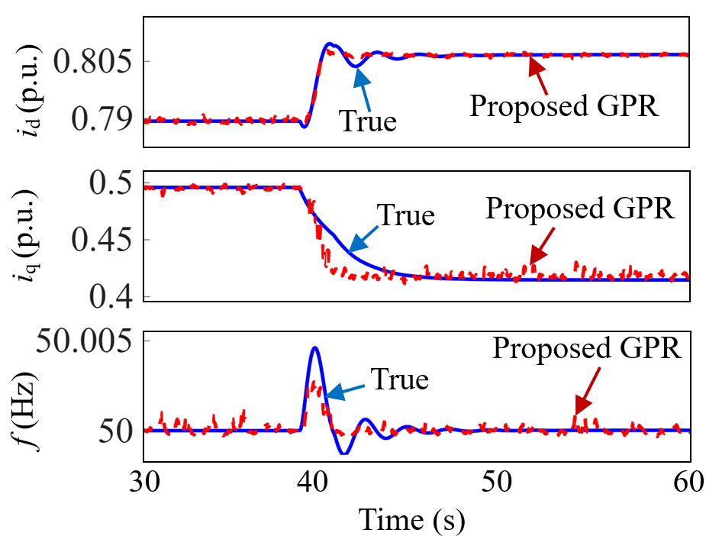
(a) | (b)
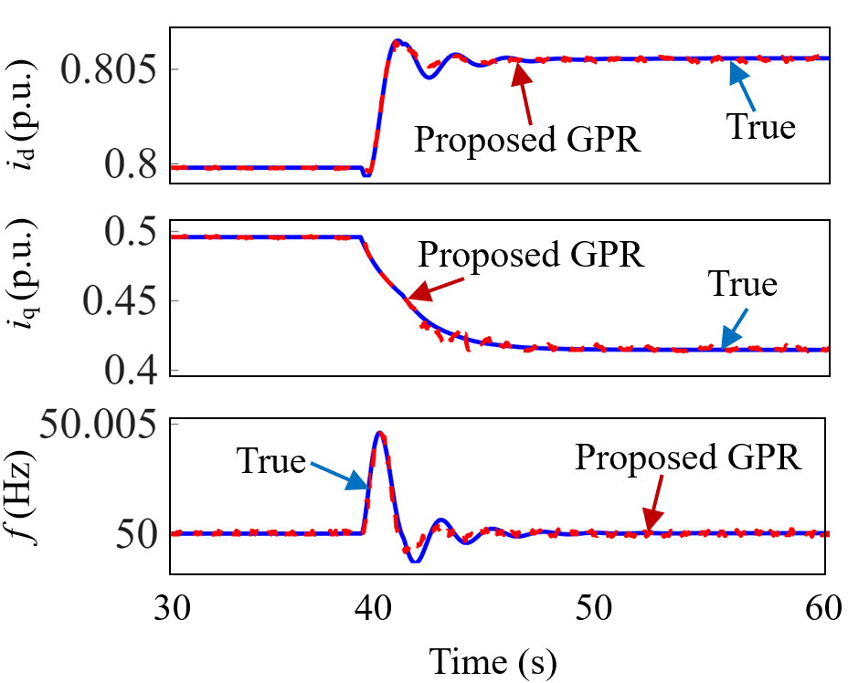 | 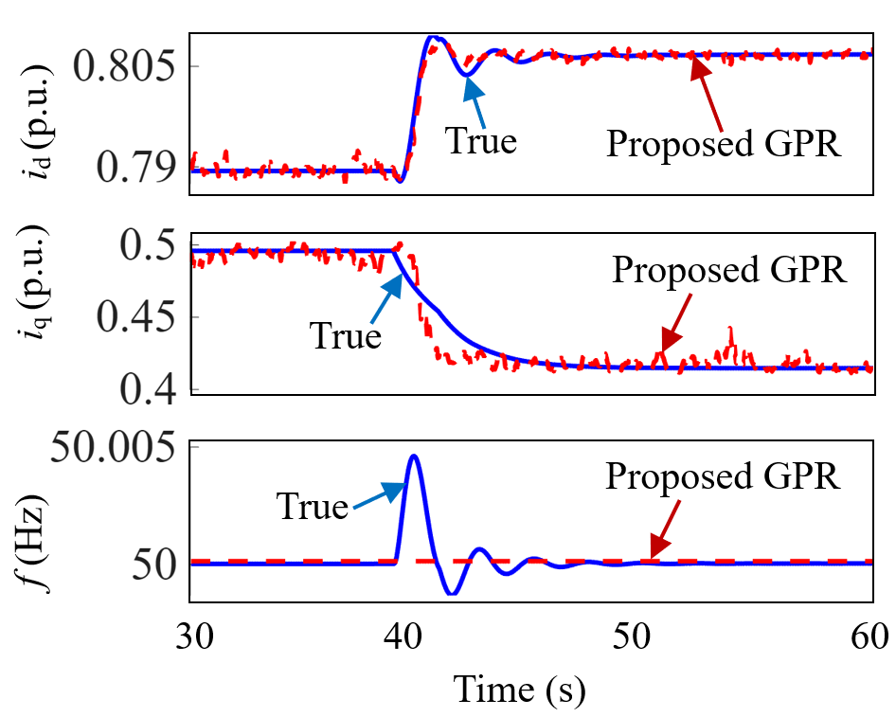
(c) | (d)
Figure 29: Performance analysis the proposed GPR-based DDTD model with noise to the inputs: (a) without any noise (b) 1 % and 0.1 % noise to noise to voltage magnitude and phase angle, respectively, (c) with 10 % reduction in the noise and (d) with 200 % increase in noise to the inputs.

Validation of DDTD Model in Modified IEEE 39-bus System with VSM-Controlled GFMI
A load step of -10 % in active and reactive power was considered for all the 19 loads in the system to illustrate the dynamic behaviour of the system following a disturbance. All the local controller mode of the GFMIs were set to constant V. Therefore, the GFMIs adjusted the reactive power to keep the terminal voltage steady-state as the pre-disturbance condition. The voltage set point were chosen as the same value of the synchronous generators which have been replaced by the corresponding VSM-GFMIs. The number of parallel units were selected to match the actual loading of the synchronous generators at bus 30, 36, and 37 (unmodified IEEE 39-bus testing system). Figure 30 shows the response plots for V-f, PQ, i_{d}, i_{q}, and θ_{poc} for the modified IEEE 39-bus testing system following a total load drop of 10 % at t=40 s.
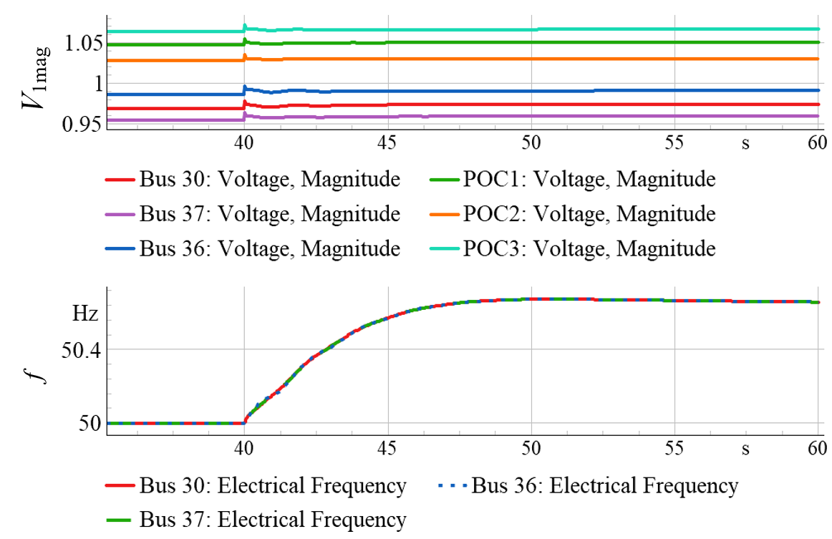 | 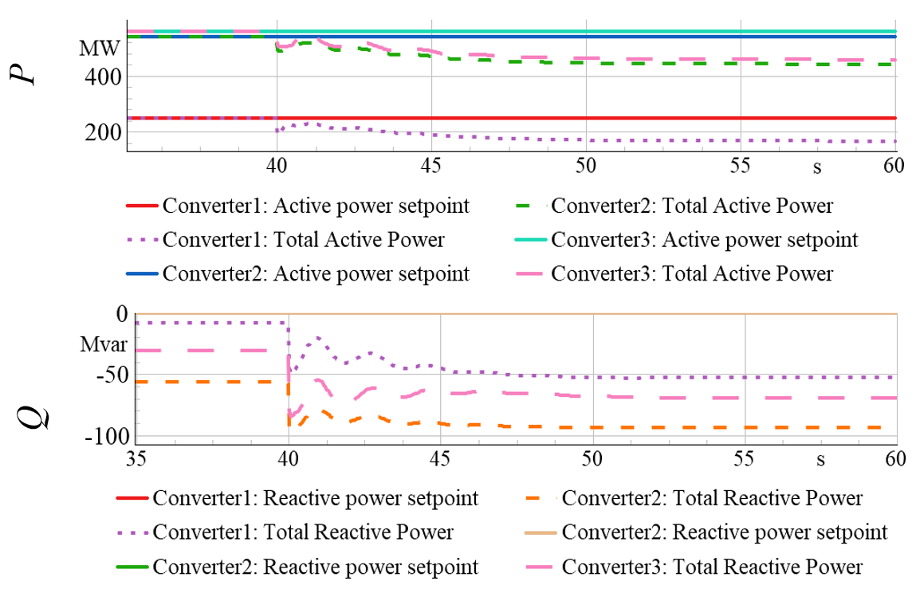
(a) | (b)
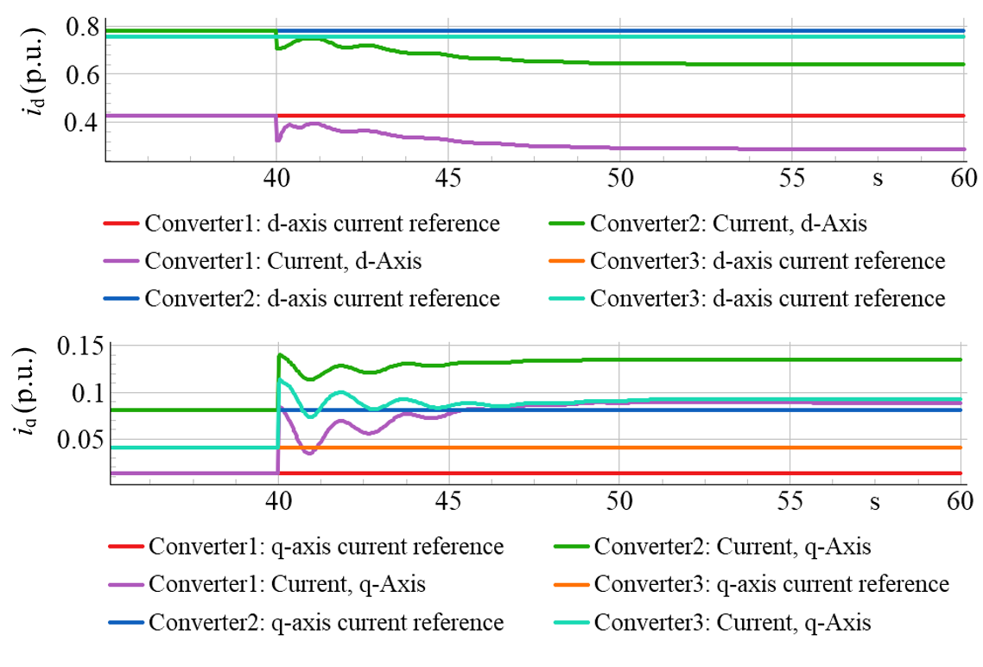 | 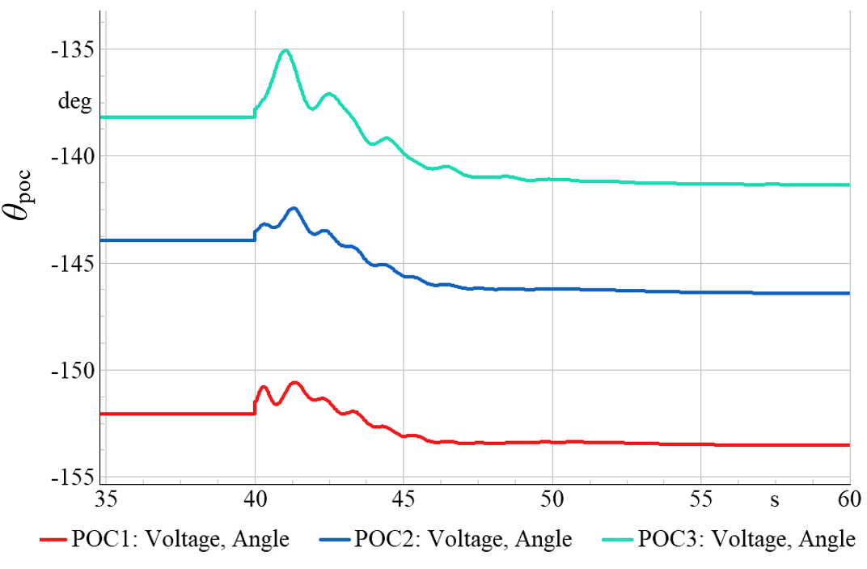
(c) | (d)
Figure 30: EMT results for: (a) V1mag and f (b) P and Q at POCs, (c) id and iq of GFMIs and (d) θpoc in the modified IEEE 39-bus system (it is assumed that the system operates at steady-state at t=40 s).
Figure 31 shows the validation of the proposed DDTD model for modified IEEE 39-bus testing system. In this case, data from operating point such as P_{ref}=0.80 MW, V_{set}=1.0475 p.u., and total load drop of 10 % have been used. It was found that the proposed model was able to capture the full dynamics and the eigenvalues of the system perfectly.
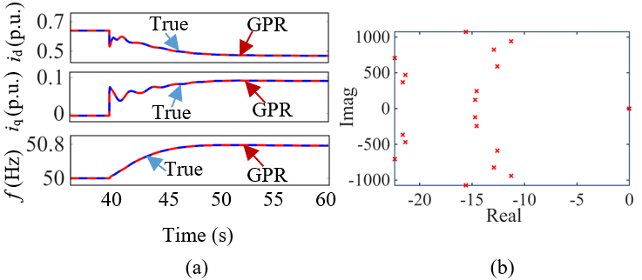
Figure 31: Implementation and validation of the proposed model in modified IEEE 39-bus testing system: (a) Model validation and (b) estimation of eigenvalues.

Validation of DDTD Model in Modified 14-Generator Australian Power System with VSM-controlled GFMI
A load step of 10 % in active and reactive power was considered for all of the 29 loads in the system to illustrate the dynamic behaviour of the system following a disturbance. All the local controller modes of the GFMIs were set to constant V. The number of parallel units were selected to match the actual loading of the synchronous generators at bus 501 (unmodified and simplified 14-generator Australian power system). Figure 32 shows the response plots for V-f, PQ, i_{d}, i_{q}, and θ_{poc} for the modified and simplified 14-generator Australian power system with VSM-controlled GFMI load drop of 10 % at t=60 s.
Figure 33 shows the validation of the proposed DDTD model for modified and simplified 14-generator Australian power system with VSM-controlled GFMI. In this case, data from operating point such as P_{ref}=0.90 MW, V_{set}=1.0 p.u., and total load drop of 10 % have been used. It was found that the proposed model was able to capture the full dynamics and the eigenvalues of the system perfectly. This case study demonstrates the effectiveness of the proposed small-signal DDTD model for evaluating system stability under the considered disturbance condition, where the applied disturbance remains within the linear operating region of the system. However, it should be noted that small-signal analysis is inherently limited in capturing instability phenomena associated with nonlinear mechanisms or large disturbances that drive the system beyond the linear region. Therefore, the proposed approach may not provide accurate stability predictions for all disturbance sizes or network conditions where nonlinear dynamics become dominant.
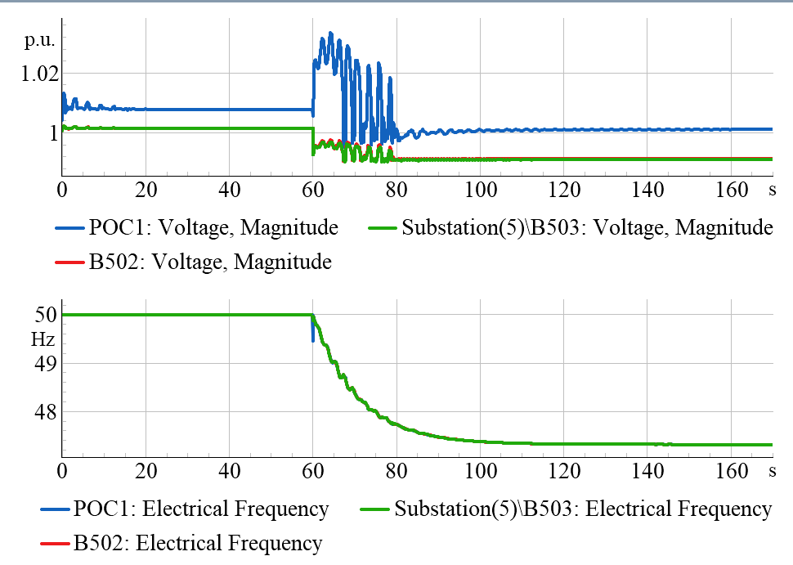 | 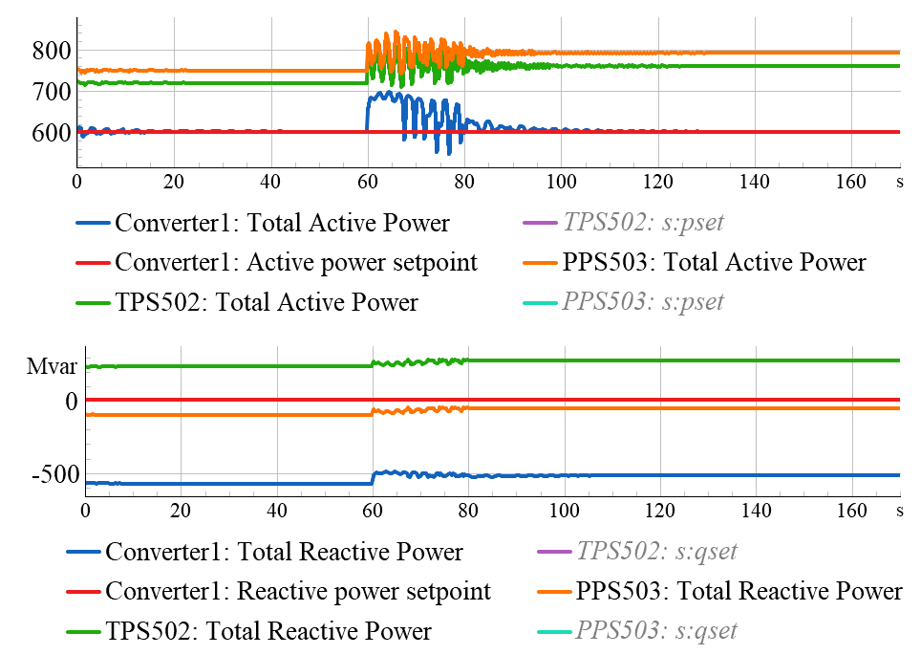
(a) | (b)
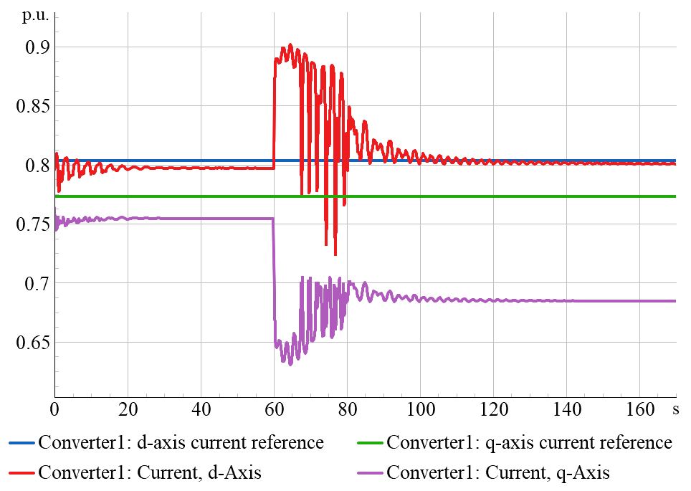 | 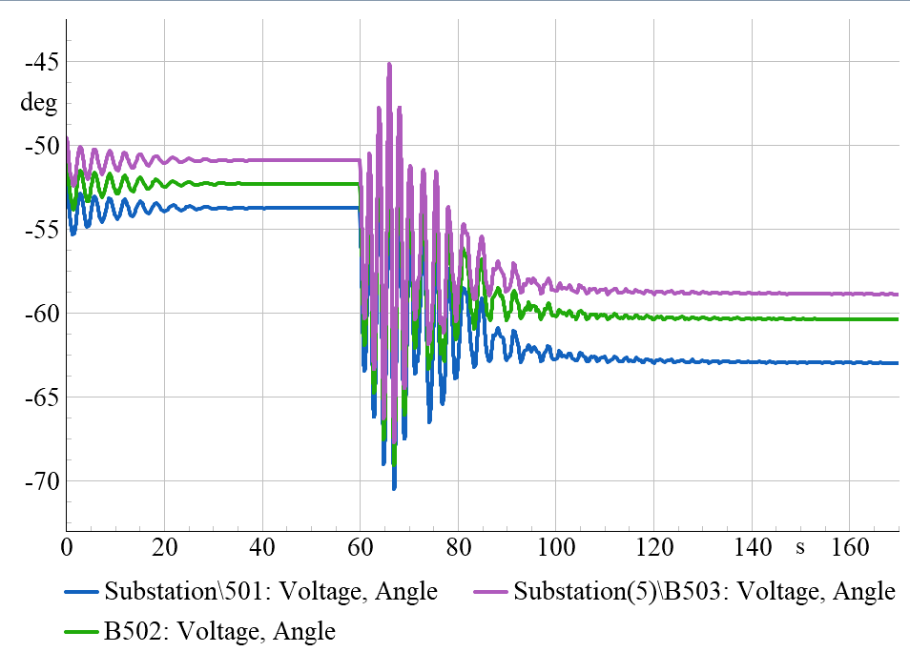
(c) | (d)
Figure 32: EMT results for: (a) V_{1mag} and f (b) P and Q at POCs, (c) i_{d} and i_{q} of GFMIs and (d) θ_{poc} in the modified and simplified 14-generator Australian power system with VSM-controlled GFMI (it is assumed that the system operates at steady-state at t=60 s).

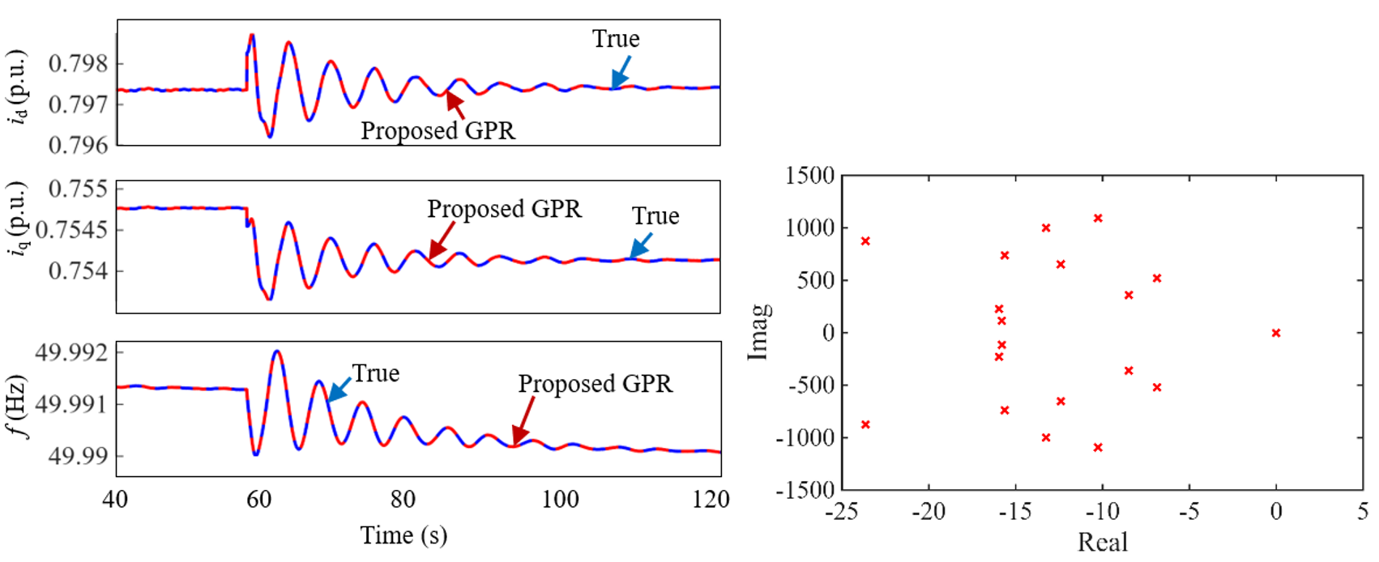
(a) (b)
Figure 33: Implementation and validation of the proposed model in the modified and simplified 14-generator Australian power system with VSM-controlled GFMI: (a) Model validation and (b) estimation of eigenvalues.

Chapter Summary
The small-signal stability analysis work package of AR-PST project in Stage-5 has two distinct contributions:
- The research team has implemented and evaluated different voltage control strategies of FVC, PVC, and AVR for grid-forming inverters. Small-signal stability analyses are conducted across very weak, weak, and strong grids. This contribution also includes the improvement of AVR-based GFMI stability incorporating a virtual impedance loop and adaptive tuning of the K_{i-q} values based on grid SCR.
- The development of a data-driven time-domain identification framework that combines the Eigensystem Realization Algorithm (ERA) and Gaussian Process Regression (GPR) for accurate eigenvalue prediction in IBR-based power system networks. Built-in models in DIgSILENT Powerfactory for power-controlled GFLI, VSM-controlled GFMI, and droop-controlled GFMI were investigated under various SCR circumstances in the three recommended testing systems.
Three test systems were selected for validation of the proposed DDTD model: (1) SMIB with 1–2 IBRs, (2) a modified IEEE 39-bus system with mix IBRs, and (3) the modified 14-generator Australian power system with VSM-controlled GFMI. The control and stability observations of GFMI strategies, along with modal analysis on benchmark systems, were used to motivate, benchmark, and validate the proposed framework. The performance of the proposed model is evaluated using a SMIB system with droop- and VSM-controlled GFMIs. Additionally, a modified IEEE 39-bus test system is implemented, and the SSS is assessed using time-domain data obtained from EMT simulations. A comparative study is conducted between the proposed GPR- and ERA-based DDTD model and an ANN- and ERA-based DDTD model in terms of prediction accuracy, eigenvalue estimation, and SSS evaluation for the SMIB system with VSM-controlled GFMI.

Part II Dynamic Signature of the Power System through Stability Indices

Dynamic Signature of the Power System through Voltage and Small Signal Stability Indices

Introduction
The large-scale integration of renewable generation, predominantly inverter-based resources (IBRs), has introduced significant challenges to power system stability, such as voltage and small signal instability, due to their fundamentally different dynamic and control characteristics. Consequently, voltage and small signal stability have emerged as a critical concern for transmission system operators (TSOs). Although numerous indices have been developed for voltage and small-signal stability assessment, relatively little attention has been paid to systems dominated by IBRs and DLs. For example, in the context of Large-disturbance voltage stability (LDVS), limited work has addressed the simultaneous evaluation of short-term voltage stability (STVS) and long-term voltage stability (LTVS), which is crucial for practical and real-time applications. To address this research gap, this chapter introduces three distinct indices for assessing voltage stability and small-signal stability in modern renewable-rich power systems. These include the Dynamic Voltage Resilience Index (DVRI) and its system-level extension (sysDVRI), which enable simultaneous assessment of short-term voltage stability (STVS) and long-term voltage stability (LTVS) following large disturbances; the Small-Disturbance Voltage Proximity Index (SDVPI), developed using the adaptive continuation power flow (ACPF) method to quantify the system’s proximity to voltage collapse; and the Small-Signal Operating Area Security Index (SSOASI), proposed to quantify the small-signal security of power systems under varying operating conditions.
The rest of this chapter is organised as follows. The overview of power system stability indices is discussed in Section 3.2, and the theoretical background and modelling of the system with components are presented in Section 3.3. The DVRI and sysDVRI mathematical formulations, including the deployment of an oscillatory and non-oscillatory voltage waveform identification algorithm using a statistical approach, and performance analysis, are given in Section 3.4. Section 3.5 presents the methodology, results, and discussion of the proposed SDVPI. The methodology of mathematical formulation of SSOASI, followed by the performance analysis obtained from the results are discussed in Section 3.6. Finally, the work is concluded in Section 3.7.

Overview of Power System Stability Indices
The global transition toward low-carbon energy systems has accelerated the integration of renewable generation technologies, particularly wind and photovoltaic (PV) systems, into modern power grids [51]. This transformation has been driven by the increasing availability of renewable energy resources, advancements in power electronic converter technologies, and the declining cost of renewable generation compared with conventional fossil-fuel-based generation [52]. As a result, inverter-based resources (IBRs) have become a dominant component of contemporary power systems, ranging from distributed rooftop PV installations to utility-scale renewable energy plants [53], [54].
Several studies have reported that the operational characteristics of IBRs differ fundamentally from those of conventional SGs because their dynamic behaviour is predominantly governed by converter control systems rather than inherent electromechanical dynamics [55]. Fast inner current control loops and slower outer voltage or power control loops enable rapid dynamic responses; however, inadequate coordination among these control layers may adversely interact with network dynamics and contribute to stability issues. In addition, the widespread use of phase-locked loops (PLLs) for grid synchronization has been identified as a major source of low-frequency oscillations, particularly in weak-grid conditions where the short-circuit ratio (SCR) is low [56]. Researchers have shown that interactions among multiple converter controllers operating in close electrical proximity may lead to oscillatory behaviour, reactive power hunting, and reduced small-signal stability margins. These challenges become increasingly significant as renewable penetration levels rise and system inertia decreases.
Small-signal stability (SSS) has therefore emerged as a major research focus in renewable-dominated power systems. SSS refers to the ability of a power system to maintain synchronism and return to a stable operating condition following small perturbations, such as minor load changes or generation fluctuations [56], [57]. Conventional small-signal stability analysis is typically conducted by linearising the nonlinear differential-algebraic equations of the system around an operating point to obtain a state-space representation. The eigenvalues of the resulting system matrix are then analysed to determine the damping and oscillatory characteristics of the system [56]. In SG-dominated systems, voltage regulation and dynamic support are naturally maintained through excitation systems that continuously adjust reactive power output [57]. However, in IBR-dominated networks, voltage regulation relies entirely on converter control strategies. Consequently, poor tuning of control parameters, PLL instability, and interactions among multiple inverter controllers can significantly reduce stability margins and introduce sustained oscillatory behaviour, especially under weak-grid operating conditions. Previous studies have further indicated that these phenomena may not always be visible through conventional steady-state load-flow analysis and often require eigenvalue-based small-signal analysis for accurate identification [56].
In parallel with small-signal stability concerns, voltage stability has become another critical issue in renewable-rich power systems. Unlike SGs, which are capable of contributing large fault currents during disturbances, IBRs are inherently current-limited devices and typically supply fault currents of only approximately 1.5 p.u., compared with approximately 6 p.u. for SGs [57]. This reduced fault current capability weakens voltage support during disturbances and increases the likelihood of voltage instability in stressed networks. Voltage stability issues are generally categorised into small-disturbance voltage stability (SDVS) and large-disturbance voltage stability (LDVS) [57]. SDVS problems typically occur under normal operating conditions when the system experiences small variations in load or generation. Under such conditions, inadequate voltage controller tuning, converter interactions, and weak-grid operation may lead to slow voltage oscillations and degraded voltage recovery characteristics. Existing literature has demonstrated that low SCR conditions significantly increase the sensitivity of system voltage to reactive power variations, thereby reducing voltage stability margins in IBR-dominated systems.
LDVS, on the other hand, is associated with severe disturbances such as faults, line outages, or sudden generation loss [58]. Numerous investigations have shown that renewable-rich systems are particularly vulnerable to LDVS because converter-based generation contributes limited fault current and may prioritise active current injection during disturbances, thereby restricting reactive power support when it is most needed. In addition, converter protection mechanisms may trigger blocking or tripping actions during faults, which further weakens system voltage support and delays post-fault voltage recovery [58]. These issues have been observed in several practical power systems, including renewable-rich regions of the Australian National Electricity Market (NEM), where reduced system strength has been linked to voltage recovery concerns and large-scale disturbances such as the 2016 South Australia blackout [55].
Previous studies have commonly divided LDVS into short-term voltage stability (STVS) and long-term voltage stability (LTVS). STVS focuses on the immediate dynamic response of the system following large disturbances and is primarily associated with fast nonlinear dynamics, fault-induced voltage recovery, and short-term control interactions [59]–[61]. In contrast, LTVS addresses slower dynamic processes, including load recovery, transmission–distribution interactions, and long-term reactive power adequacy [62]. Existing research has shown that a system may satisfy short-term voltage recovery criteria while exhibiting long-term voltage collapse, or conversely, may violate short-term voltage recovery limits while remaining stable over longer durations. Therefore, the separate assessment of STVS or LTVS alone may not provide a comprehensive representation of system voltage behaviour under disturbances.
Traditionally, system stability assessment has relied on visual inspection methods: post-disturbance voltage recovery is examined to evaluate voltage stability, while eigenvalue locations in the complex plane before and after small perturbations are compared to assess small-signal stability. However, this manual approach is impractical for large and complex modern power systems [51], [56]. To address this limitation, numerous voltage and small-signal stability indices have been developed. These indices aim to characterise voltage dynamics under both small and large disturbances and to capture system behaviour in terms of small-signal stability following small perturbations. Nevertheless, existing indices vary significantly in their formulation and applicability, particularly in systems dominated by IBRs and DLs. Although numerous indices have been developed for voltage and small-signal stability assessment, relatively little attention has been paid to systems dominated by IBRs and DLs. In the context of LDVS, limited work has addressed the simultaneous evaluation of STVS and LTVS, which is crucial for practical and real-time applications. A disturbance may lead to short-term instability while the system remains stable in the long term, or conversely, exhibit acceptable short-term performance followed by long-term voltage collapse. As illustrated in Figure 34, the black trace represents a voltage response that violates short-term stability criteria but satisfies long-term requirements, according to the Western Electricity Coordinating Council (WECC) criterion. In contrast, the red trace shows stable short-term behaviour followed by long-term voltage instability. These contrasting responses highlight that relying solely on either STVS or LTVS is insufficient. Therefore, comprehensive voltage signature quantification requires the concurrent assessment of both short- and long-term voltage stability.
To address these limitations, recent research efforts have focused on developing advanced stability indices capable of capturing the dynamic signatures of renewable-rich power systems under varying operating conditions. In this context, this chapter introduces three complementary indices for assessing voltage stability and small-signal stability in modern power systems. The first contribution is the development of the Dynamic Voltage Resilience Index (DVRI) and its system-level extension, the system Dynamic Voltage Resilience Index (sysDVRI), which simultaneously evaluates short-term and long-term voltage stability following large disturbances. Unlike conventional scalar-based indices that consider only STVS or LTVS characteristics independently [58], [63]–[68], the proposed DVRI employs a vector-based representation capable of quantifying both short-term and long-term voltage stability characteristics simultaneously. To further improve practical applicability, a statistical waveform identification algorithm is incorporated to distinguish oscillatory voltage responses from undervoltage recovery waveforms without requiring explicit waveform inspection. The proposed sysDVRI further extends the methodology to provide system-level quantification of LDVS performance. The effectiveness of the proposed indices is validated

Figure 34: A fictitious post-fault waveform. The black line violates WECC short-term voltage criteria but meets long-term requirements, while the red line shows acceptable short-term response followed by long-term voltage instability.
through comprehensive time-domain simulations on the Australian NEM Area 5 test system under varying renewable penetration levels and composite load scenarios.
The second contribution of this chapter focuses on small-disturbance voltage stability through the development of the Small-Disturbance Voltage Proximity Index (SDVPI). The proposed SDVPI is formulated using the adaptive continuation power flow (ACPF) method and provides a simple yet comprehensive measure of the system’s proximity to the voltage collapse boundary. A mathematical formulation is developed to quantify the distance between stable and unstable operating regions under changing operating conditions. The proposed approach is further evaluated using a modified IEEE 39-bus system to investigate the impact of different generation and loading scenarios on voltage stability margins and to identify the weakest buses within the network using DIgSILENT PowerFactory simulations.
The final contribution of this chapter addresses small-signal stability assessment through the development of the Small-Signal Operating Area Security Index (SSOASI). The proposed index quantifies variations in system small-signal security by evaluating the minimum permissible damping of oscillatory modes under different operating conditions. A mathematical framework is developed to assess system security under varying generation patterns, network topologies, and loading conditions following contingencies. The proposed methodology is validated through detailed case studies conducted on a modified IEEE 39-bus system under multiple generation scenarios, demonstrating its effectiveness in assessing the dynamic security of renewable-rich power systems.

System Modelling
The study uses an integrated PSS®E/ DIgSILENT PowerFactory /Python/MATLAB® environment: fixed–time-step dynamic simulations (0.05 cycles at 50 Hz) are performed in PSS®E and DIgSILENT PowerFactory; voltage responses are classified as oscillatory or non-oscillatory in MATLAB®; and all simulation workflows are fully automated using Python®.

System Under Consideration
This study utilises two test systems: a modified IEEE 39-bus system for SDVS and small signal stability index (SSSI) analyses, and a modified NEM 14-generator Area 5 test system (representing the South Australian network) for LDVS analysis. As the modified IEEE 39 bus model is the same as that presented in Figure 13 in Chapter 2, its detailed modelling is not repeated in this section.
For the LDVS study, the modified NEM 14-generator Area 5 system comprises 10 buses, three synchronous generators (SGs) with a combined capacity of 2325 MW, two static VAR compensators, four loads, and three transformers. Aggregated models are adopted for both generation and loads to represent the underlying distribution networks, while distribution-level dynamics are not explicitly modelled. The single-line diagram of the system is shown in Figure 35. Bus 315 acts as the interconnection point to the remainder of the 14-generator NEM system.

Synchronous Generators Modelling
In the base case, generators at Buses 501–503 are modelled as conventional SGs using GENROE, ESAC4A, and TGOV1 models [69], [70] with transmission lines represented by π-equivalents. The dominant 1000 MVA unit at Bus 503 has a transient reactance nearly twice that of the other generators, indicating weaker dynamic strength and is therefore treated as a weak grid. Subsequent studies examine the impact of replacing this unit with IBRs.
Figure 35: Modified NEM 14-generators area 5 (South Australia) test system.

Renewable Generators (PVs and Wind) Modelling
This study uses WECC generic renewable models for PV and wind plants, including a WECC-type generic Renewable Energy Generator model named REGCA1, a WECC-type generic Renewable Energy Electrical Control Model named REECA1, and a WECC-type generic Renewable Energy plant control model named REPC [71], consistent with PJM Model Development Guidelines [70], PV and wind units operate at a 0.95 lagging power factor under plant-level control, using parameters from [71]. Inverter AC sides are aggregated at low voltage and stepped up to the grid through collector systems and main step-up transformers (T1–T3), as shown in Figure 35 (Zoom section 1).

Load Modelling
The dynamic load model, CMLDBLDGU2 (which integrates distributed energy resources (DERs) into the WECC Composite Load Model), developed by the Modelling and Validation Working Group, is used in this study [72]. At present, most of this DER connected to the NEM consists of distributed PV generation [73]. It is worth noting that the Australian Energy Market Operator (AEMO) also employs this model for power system stability assessments. Its structure, shown in Figure 35 (Zoom section 2), includes the following components:
1. Distribution transformers with on-load tap changers (OLTCs).
2. Explicit substation shunt capacitors (Bss).
3. An aggregated equivalent of distribution feeders supplying end-use loads (Rfdr + jXfdr), with internal feeder compensation (Bf1 and Bf2) calculated to match transmission-level MW/MVAr.
4. Aggregated load components at the feeder end, including three-phase induction motors (Motors A, B, C), a performance-based residential air-conditioning model (Motor D), and power electronic and static (ZIP) loads. Motor D, developed from laboratory tests, represents single-phase residential induction loads such as air conditioners and refrigeration compressors.
5. The North American DER_A model [73] is used and integrated into the WECC Composite Load Model to create a single aggregated representation of the distribution feeder, including both composite load and feeder-level DER. The model specification is publicly available on the WECC website [73].

Development of Large Disturbance Voltage Stability Index
This section presents the mathematical formulations of the DVRI and sysDVRI indices, along with a detailed description of the statistical algorithm developed for identifying oscillatory and non-oscillatory voltage waveforms, followed by the corresponding results and discussion.

Mathematical Formulation of the Proposed DVRI
To capture simultaneously short- and long-term voltage recovery for varying IBR mixes, the local DVRI is developed based on the percentage voltage deviation $\%VD_{k,n}$ of bus k at nth instant, subject to a disturbance, as given in (3):
$\%VD_{k,n}=\left|\frac{v_{k,n}-v_{k,n=0}}{v_{k,n=0}}\right|×100\%; ∀n∈\left[T_{CL}, T_{ST}, T_{SIM}\right]$ (3)
where $v_{k,n=0}$ is the pre-disturbance initial voltage of bus k; $v_{k,n}$ is the voltage of bus k at the n^{th} time instant based on the post-fault voltage recovery performance; and T_{CL}, T_{ST,} T_{ISM} are the fault clearing time, short-term time horizon, and entire time horizon of interest, respectively. The WECC/NERC planning standards establish criteria for assessing voltage stability under disturbances [74],[75]. These criteria are used to quantitatively assess both STVS and LTVS for post-fault voltage trajectories. Upon checking the WECC condition, the STVS and LTVS of a bus can easily be quantified at the n^{th} instant. In terms of STVS and LTVS, a bus may have four voltage signatures for a specific time instant, as given in Table 8.
Table 8: Bus post-recovery voltage performance identification based on the proposed STVS and LTVS.
$$\%VD_{k,n}≤WECC_{ST}$$ | $$\%VD_{k,n}≤WECC_{LT}$$ | Comments
0 | 0 | Short-term voltage unstable (STVU) and long-term voltage unstable (LTVU)
0 | 1 | STVU and long-term voltage stable (LTVS)
1 | 0 | STVS and LTVU
1 | 1 | STVS and LTVS

From Table 8, it is seen that the STVS and LTVS only provide a binary answer to the voltage stability (i.e., stable or unstable) at the n^{th} time instant. However, it is unable to define the voltage dip magnitude violation and the time of voltage violation. To quantitatively assess the degree of STVS and LTVS, a stability margin vector rather than a single scalar value is proposed. This vector, defined as the DVRI of the bus $k$, is expressed in equation (4):
$DVRI_{k}=\{{STVI}_{k} {LTVI}_{k}\}$ (4)
where
$\left\{\begin{aligned}{STVI}_{k}=\frac{1}{N_{ST}}\sum_{n=T_{cl}}^{T_{ST}}{\left\{μ_{k,n}^{ST} {PDF}_{k,n}^{ST}\right\}} ∀n, T_{CL}≤n{≤T}_{ss} \\ \\ {LTVI}_{k}=\frac{1}{N_{LT}}\sum_{n=T_{ST}}^{T_{sim}}{\left\{μ_{k,n}^{LT} {PDF}_{k,n}^{LT}\right\} ∀n, T_{ST}≤n{≤T}_{SIM}}\end{aligned}\right.$ (5)
In (5), the proposed framework defines separate short-term and long-term PDFs to capture the different dynamic characteristics of voltage recovery. The short-term and long-term PDFs (${PDF}_{k,n}^{ST}$ and ${PDF}_{k,n}^{LT}$) are activated during the interval between fault clearing ($T_{CL}$) and the short-term assessment time ($T_{ss}$); and during the $T_{ST}$ and the end of the simulation period ($T_{SIM}$). The PDF values are assigned as binary indicators (1 within the corresponding assessment interval and 0 otherwise), following the methodology adopted in [51] and [56]. The selection of the probability density functions (PDFs) used in this chapter is based on established short-term voltage stability assessment methodologies reported in the literature, particularly the approaches presented in [51] and [56]. These studies distinguish voltage recovery performance according to specific post-disturbance time horizons and evaluate compliance with recognised voltage recovery criteria, such as the WECC voltage performance standards.
At each sampling instant, the measured voltage is compared against the WECC voltage recovery criterion. A weighting factor ($μ_{k,n}^{ST}$and $μ_{k,n}^{LT}$) defined in (6) is then applied to reward or penalise the voltage response depending on whether the voltage remains within or violates the WECC boundary. Therefore, the selection and formulation of the PDFs are not arbitrary but are informed by established voltage stability assessment literature and the recognised separation of short-term and long-term post-disturbance voltage recovery behaviour.
$\left\{\begin{aligned}μ_{k,n}^{ST}=\left(\begin{aligned}1; if \%VD_{k,n}=0 \\ 1-\left|\%VD_{k,n}\right| ; if \left|\%VD_{k,n}\right|≤\left|WECC_{ST}\right| \\ -1; if \left|\%VD_{k,n}\right|>\left|WECC_{ST}\right|\end{aligned} \right. \\ μ_{k,n}^{LT}=\left(\begin{aligned}1; if \%VD_{k,n}=0 \\ 1-\left|\%VD_{k,n}\right| ; if \left|\%VD_{k,n}\right|≤\left|WECC_{LT}\right| \\ -1; if \left|\%VD_{k,n}\right|>\left|WECC_{LT}\right|\end{aligned}\right. \end{aligned}\right.$ (6)
As indicated in (6), the post-event voltage response is sampled over a fixed interval, and the corresponding percentage voltage deviation, denoted as $\%VD_{k,n}$, is calculated for each sample. These values are then individually evaluated against the WECC performance criteria.
When neither short-term nor long-term voltage deviations are observed following a disturbance, the corresponding $DVRI_{k}$ is assigned a full positive weighting of +1, indicating recovery to pre-fault voltage. In cases where short-term voltage deviation (STVD) and/or long-term voltage deviation (LTVD) occurs but remains within the acceptable limits defined by the WECC criteria, $DVRI_{k}$ is still awarded a positive weighting. The magnitude of these weighting functions approaches +1 as $\%VD_{k,n}$ tends toward zero and gradually decreases as the deviation increases, reflecting the degree of voltage deviation. Conversely, if either STVD or LTVD exceeds the WECC stability thresholds, $DVRI_{k}$ is assigned a negative weighting of −1, indicating a violation of the voltage performance criteria. Accordingly, both the short-term and long-term voltage indices, represented as $\{{STVI}_{k} {LTVI}_{k}\}$, are bounded within the interval of −1 to +1. The combination of these indicator values provides a comprehensive quantification of the dynamic voltage signature at the $k$th bus, as summarized in the Apx Table 1 (Refer to Appendix A.1).

Deployment of an Oscillatory and Non-oscillatory Voltage Waveform Identification Algorithm in the Proposed DVRI
Though the proposed DVRI in (4) is an effective and powerful indicator to quantify the recovery of the voltage waveform, it may give the same DVRI for the post-disturbance oscillatory recovery voltage waveform ($ORVW$) and the non-oscillatory recovery voltage waveform ($NRVW$) because it is based on the aggregation of discretised sample values of the waveform. Computed using (4), since DVRI evaluates each sample of the waveform discretely and then aggregates the results according to (5), it may not distinguish between $ORVW$ and $NRVW$. For example, in Figure 36(a), the proposed STVI in (5) calculates similar values (≈ -0.16) for both $ORVW$ (blue color) and $NRVW$ (red color). It is worth noting that the proposed STVI in (5) quantifies both cases as unstable; however, it is unable to distinguish between $ORVW$ and $NRVW$. However, accurate discrimination between ORVW and NRVW is a critical capability of contemporary voltage stability assessment tools. To address this requirement, a statistical algorithm for distinguishing ORVW from NRVW is developed based on [76] and integrated into the DVRI formulation presented in (4) based on the cumulative distribution function (CDF) defined in (7). Refer to section A.2 in Appendix for step-by-step explanation of deriving (7).
$\left\{\begin{aligned}NRVW: \sum{CDF}=\sum_{n=1}^{T}{CDF\left\{K\left[y\right]\right\}}=0.2894 \\ ORVW : \sum{CDF}=\sum_{n=1}^{T}{CDF\left\{K\left[y\right]\right\}}=158.4894 \end{aligned}\right.$ (7)
It can be concluded that for a given set of waveforms, as shown in Figure 36(a), a higher $\sum{CDF}$value (typically >1) indicates $ORVW$ (for example, in this case, it is $158.4894)$, whereas a lower value (typically <1) indicates $NRVW$ (for example, in this case, it is $0.2894$).

(a) | (b)
Figure 36: (a) Post-disturbance recovery voltage waveform, and (b) Heatmap of weighting factor showing the impact of a fault at a given location (y-axis) on different buses (x-axis).

Mathematical Formulation of the System DVRI
Although the proposed DVRI effectively quantifies post-disturbance voltage recovery at an individual bus, it does not capture the overall voltage signature at the system level. In practical power systems, a voltage dip originates at the faulted bus and propagates throughout the network, with its spatial impact governed by the electrical distances between buses. To account for both the faulted bus and its propagation effects across the network, a system-level DVRI (sysDVRI) is introduced to represent the aggregated influence of a disturbance on system-wide voltage performance.
The voltage variation at bus $l$, denoted by $ΔV_{D,l}$, due to a fault current injected at the bus $k$, can be evaluated using symmetrical fault analysis, as expressed in (8) [74]:
$∆VD_{l}=v_{k,n=0}\left(\frac{Z_{k,l}}{Z_{k,k}}\right)$ (8)
where $Z_{k,k}$ represents the self-impedance at the faulted bus $k$, while $Z_{k,l}$denotes the mutual impedance between buses $k$and $l$. By normalizing (8) with respect to the pre-fault voltage at bus $l$, the formulation can be extended to a system-wide context to quantify the impact of a fault at the bus $k$ on other buses. This influence is expressed through the weighting factor $γ_{k,l}$, as derived below:
$γ_{k,l}\left(\frac{∆VD_{l}}{v_{l,n=0}}\right)=\frac{v_{k,n=0}}{v_{l,n=0}}\left(\frac{Z_{k,l}}{Z_{k,k}}\right)$ (9)
Figure 36(b), derived from (9), presents the weighting factors in a heatmap format to illustrate the influence of a fault at a given location (y-axis) on different buses (x-axis). For example, when a fault occurs at Bus 507, the buses most affected are Buses 505, 506, and 508, while the remaining buses experience relatively minor effects. By incorporating the weighting factor (9) into DVRI (4), the proposed sysDVRI in vector form, corresponding to a fault at k^{th} bus, can be written as:
${}_{sys}^{k}{DVRI}=\{{}_{sys}^{k}{STVI} {}_{sys}^{k}{LTVI}\}$ (10)
where
$\left\{\begin{aligned}{}_{sys}^{k}{STVI}=\left\{\begin{aligned}\left.\begin{aligned}{STVI}_{k}+\frac{\frac{1}{N}\sum_{n=l,≠k}^{N}{{\left(1-γ_{k,l}\right)STVI}_{k,l}}}{\sum_{n=l,≠k}^{N}{\left[1-γ_{k,l}\right]}} \\ if {STVI}_{k}≥0 &and ∑CDF_{k}<1\end{aligned}\right\} \\ \left.\begin{aligned}-1 \\ if {STVI}_{k}<0 &and ∑CDF_{k} ≥1\end{aligned}\right\}\end{aligned}\right. \\ {}_{sys}^{k}{LTVI}=\left\{\begin{aligned}\left.\begin{aligned}{LTVI}_{k}+\frac{\frac{1}{N}\sum_{n=l,≠k}^{N}{{\left(1-γ_{k,l}\right)LTVI}_{k,l}}}{\sum_{n=l,≠k}^{N}{\left[1-γ_{k,l}\right]}} \\ if {LTVI}_{k}≥0 and ∑CDF_{k}<1\end{aligned}\right\} \\ \left.\begin{aligned}-1 \\ if {LTVI}_{k} <0 and ∑CDF_{k} ≥1\end{aligned}\right\}\end{aligned}\right. \\ \end{aligned}\right.$ (11)
The range of ${}_{sys}^{k}{STVI} and {}_{sys}^{k}{LTVI}$ is also from (+1) to (-1), and a higher positive ${}_{sys}^{k}{DVRI}$ reflects better system-level voltage performance. Apx Table 1 in Appendix A.1 is also applicable to ${}_{sys}^{k}{DVRI}$. Figure 37 illustrates the entire process. The pseudocode in Apx Table 2 in Appendix A.1 outlines the steps of ${}_{sys}^{k}{DVRI}$ calculation process.
Figure 37: Flowchart of proposed system-level DVRI (sysDVRI) with an accompanying algorithm to classify oscillatory and non-oscillatory voltage response waveforms for the quantification of LDVS.

Performance Analysis of the Proposed DVRI and sysDVRI Indices
The South Australian power network (area-5), shown in Figure 35, is used as the test case in this study. During each simulation case listed below, a fault is applied to the target bus at 1 s and cleared after 60 ms, while the short-term voltage response is recorded over the following 3 s [58]. The simulation continues for an additional 3 s to capture LTVS [58]. Voltage boundaries are defined according to the WECC criterion, with ±20% for STVS and ±10% for LTVS [58].
Area 5 test system has experienced increasing renewable penetration, including rooftop PV and utility-scale wind and PV plants. To reflect a realistic high-renewable scenario, the test system is modified as reported in [71], with renewable generators progressively integrated at Buses 501–503, as summarized in Table 9. System loading is kept at original levels to avoid the requirement for additional generation and transmission reinforcement.
Table 9: Generation cases for evaluating via comprehensive time-domain simulations implemented in the PSS®E simulation environment.
Gen. Case | Generator at B#501 | Generator at B#502 | Generator at B#503 | % of Renewable
Gen. Case-1 | SG | SG | SG | 0%
Gen. Case-2 | RG | SG | SG | 25%
Gen. Case-3 | RG | RG | SG | 60%
Gen. Case-4 | RG | RG | RG | 100%
To capture realistic load characteristics, composite load component fractions based on AEMO’s summer and winter evening peak data [73] for Area 5 were adopted. The corresponding load fractions are presented in Table 10.
Table 10: Composite load component fractions for Area 5 corresponding to summer and winter evening peak conditions.
SESSION | MOTOR A | MOTOR B | MOTOR C | MOTOR D | ELECTRONIC LOAD | CONST. CURRENT | CONSTANT IMPEDANCE
Summer | 9% | 13% | 11% | 5% | 35% | 7% | 20%
Winter | 5% | 12% | 11% | 6% | 26% | 8% | 32%
To study the influence of load characteristics on renewable generation, Gen. Case-2 from Table 9 is selected, and the different load compositions are specified in Table 11.
Table 11: Load cases for evaluating via comprehensive time-domain simulations implemented in the PSS®E simulation environment.
LOAD CASES | LOADCASE 1 | LOAD CASE 2 | LOAD CASE 3
Load Types | 100% Static | Summer | Winter
Post-Recovery Voltage Performance Analysis through local DVRI: To evaluate the local voltage dynamic signature in Area 5 under various generation and load scenarios (as listed in Table 9 and Table 11), a three-phase fault is applied to a representative load bus, such as Bus 507. The post-disturbance voltage recovery at all buses is analysed using the proposed local DVRI.
Figure 38 illustrates the voltage responses at Bus 507 after the fault for different combinations of generation and load configurations. This analysis provides insight into the dynamic voltage stability signature of bus 507 when subjected to the fault.
(a) | (b)
Figure 38: Post-disturbance voltage waveforms for a fault at bus 507: (a) Gen. Cases and (b) Load Cases.
Figure 38(a) shows that as renewable generation penetration increases, the voltage at bus 507 exhibits greater variability and slower post-fault recovery, indicating a deterioration in system voltage performance. Figure 38(b) illustrates the influence of increased load dynamics on voltage stability at Bus 507. It is observed that the system is highly sensitive to the dynamic composition of the load at the faulted bus. Higher proportions of dynamic loads negatively impact both short-term and long-term voltage stability during post-fault recovery. This impact can cause induction motors (Motors A, B, C, and D) to stall. This stalling may trigger subsequent local disturbances, potentially escalating into system-wide voltage instability.
(a) | (b)
(c) | (d)
Figure 39: The impact of fault at bus 507 on other buses for (a) Gen. Case 1, (b) Gen. Case 2, (c) Gen. Case 3, and (d) Gen. Case 4.
Figure 39(a)–(d) and Figure 40(a)–(c) show the impact of a fault at bus 507 on the other buses for the Gen. Case 1 to Gen. Case 4 and load case-1 to load case 3, respectively.
(a) | (b)
(c)
Figure 40: Impact of fault at bus 507 on other buses for (a) Load Case 1, (b) Load Case 2, and (c) Load Case 3.
Figure 39 and Figure 40 indicate that certain load and generator buses, such as Buses 505, 506, and 508, exhibit high sensitivity to a fault at Bus 507, while other buses experience comparatively minor effects. This sensitivity is largely governed by the electrical distance between the faulted bus and each healthy bus, which will be examined in detail in a later section. Overall, the system voltages display increased variability and slower recovery as the penetration levels of renewable generation and dynamic loads rise.
Figure 41 presents the bus voltage signature quantified using the proposed DVRI for varying levels of renewable generation (Gen. Case 1 to Gen. Case 4). Figure 41(a) shows STVI and Figure 41(b) illustrates LTVI. Overall, the results exhibit a declining trend, indicating that higher renewable penetration leads to greater voltage fluctuations and reduced voltage recovery performance.
(a) | (b)
Figure 41: Quantification of bus voltage signatures through the proposed DVRI under different renewable generation percentages (a) STVI, and (b) LTVI.
Similarly, Figure 42 shows the bus voltage recovery performance evaluated using the proposed DVRI for varying proportions of dynamic loads (Load Case 1 to Load Case 3). Figure 42(a) corresponds to STVI, while Figure 42(b) represents LTVI.
(a) | (b)
Figure 42: Quantification of bus voltage signatures through the proposed DVRI under different load dynamics percentages (a) STVI, and (b) LTVI.
Figure 41 and Figure 42 show the deterioration of dynamic voltage performance at higher renewable generation and dynamic load penetration levels, and this deterioration was successfully quantified using the developed DVRI.
To capture the detailed voltage signature for the study cases, such as varying load dynamics, the local dynamic voltage signature for all buses has been determined using the values of $\left\{{STVI}_{k} {LTVI}_{k}\right\}$. These results are summarized in Table 12. Table 12 emphasizes the necessity of evaluating STVS and LTVS together. It shows that a fault at bus 507 can result in certain buses remaining STVS while exhibiting long-term voltage unstable (LTVU) or vice-versa, particularly under summer and winter load conditions.
Table 12: The local dynamic voltage signature for all buses of the test system.
Buses | STVI |  |  | LTVI |  |  | Comments
Buses | Load Case 1 | Load Case 2 | Load Case 3 | Load Case 1 | Load Case 2 | Load Case 3 | Load Case 1 | Load Case 2 | Load Case 3
B#315 | 0.884 | -.055 | 0.160 | 0.974 | -.666 | -.855 | STVS, and LTVS | STVU, and LTVU | STVS, and LTVU
B#501 | 0.884 | -.550 | 0.160 | 0.974 | -.665 | -.855 | STVS, and LTVS | STVU, and LTVU | STVS, and LTVU
B#502 | 0.939 | 0.510 | 0.517 | 0.930 | -.357 | -.786 | STVS, and LTVS | STVS, and LTVU | STVS, and LTVU
B#503 | 0.883 | -.112 | -.002 | 0.975 | -.645 | -.316 | STVS, and LTVS | STVU, and LTVU | STVU, and LTVU
B#504 | 0.921 | 0.510 | 0.374 | 0.958 | -.188 | -1.0 | STVS, and LTVS | STVS, and LTVU | STVS, and LTVU
B#505 | 0.901 | 0.360 | 0.372 | 0.980 | -.550 | -.778 | STVS, and LTVS | STVS, and LTVU | STVS, and LTVU
B#506 | 0.895 | -.035 | 0.330 | 0.977 | -.658 | -.580 | STVS, and LTVS | STVU, and LTVU | STVS, and LTVU
B#507 | 0.903 | 0.280 | 0.244 | 0.977 | -.568 | -.974 | STVS, and LTVS | STVS, and LTVU | STVS, and LTVU
B#508 | 0.810 | 0.109 | 0.244 | 0.977 | -.632 | -.816 | STVS, and LTVS | STVS, and LTVU | STVS, and LTVU
B#509 | 0.911 | 0.121 | 0.275 | 0.977 | -.632 | -.797 | STVS, and LTVS | STVS, and LTVU | STVS, and LTVU
Post-Recovery Voltage Performance Analysis through System DVRI: Figure 43 presents the system-level DVRI (sysDVRI) under faults at various locations, illustrating the decline in dynamic voltage performance as renewable generation penetration increase. This deterioration is effectively captured by the proposed sysDVRI, as indicated by the decreasing trend of the index. Figure 43(a)–(d) show progressively poorer voltage recovery with increasing renewable penetration. For example, when a fault occurs at Bus 507, sysDVRI values for the base case and the 60% renewable penetration scenario are {0.97, 0.96} and {0.76, 0.89}, respectively, highlighting the reduction in system voltage stability at higher renewable penetration levels.
Interestingly in Figure 43(a), the substitution of the SG at Bus 503 with renewable generation improves the sysDVRI, indicating the comparatively weaker dynamic performance of the original SG relative to the renewable plants. This occurs because the SG at Bus 503 is the largest generating unit with a weak dynamic characteristic in the system. Consequently, a fault at this bus significantly reduces the reactive power support previously provided by the SG, leading to a substantial voltage drop and resulting in voltage instability as indicated by -1 in Figure 43(a).
(a) | (b)
(c) | (d)
Figure 43: Quantification of system-level voltage signatures through the proposed sysDVRI under different renewable generation percentages (a) Gen. Case 1, (b) Gen. Case 2, (c) Gen. Case 3, and (d) Gen. Case 4.
The influence of load composition on sysDVRI is evident in Figure 44(a)–(c). The results indicate that higher penetration of dynamic loads leads to voltage oscillations and unstable voltage recovery. For example, under the fault condition with a static load model, both short-term and long-term voltage stability are maintained, as shown in Figure 44(a). In contrast, Figure 44(b) and Figure 44(c) show poorer performance of the sysDVRI for the summer and winter load cases. In particular, the sysDVRI values are {−1, −1} when a fault occurs at Bus 503, indicating both short-term and long-term voltage instability. These findings suggest that increasing the proportion of dynamic loads in the system can adversely affect overall voltage performance.
(a) | (b)
(c)
Figure 44: Quantification of system-level voltage signatures through the proposed sysDVRI under different load dynamics percentages: (a) Load Case 1, (b) Load Case 2, and (c) Load Case 3.

Development of Small Disturbance Voltage Stability Index
This section describes the proposed SDVPI methodology and its associated workflow, followed by the presentation and discussion of the obtained results.

Methodology of the Proposed SDVPI
The effect of SDVS during and following a small disturbance occurring in a particular bus can be translated into a change of voltage and current at that bus. This translation is universally applicable for SGs, IBRs with DLs dominated power system. However, the behaviour of the change of voltage and current depends on the power system dynamics. For example, the dynamics of IBRs is quite different from the SGs. Therefore, the behaviour of the change of voltage and current during and following a small disturbance for a power system dominated by IBRs is different from the power system dominated by SGs. However, distinct characteristics can result in the change of voltage and current at that bus. Therefore, the calculation of SDVPI is said to be generic and based on the distance of a particular operating point from voltage collapse points as described below.
Consider a local load bus k of a general power system, as shown in Figure 13 in Chapter 2. The complex voltage, current, and power available at this bus can be written as:
$\left.\begin{aligned}v_{k}=V_{k}∠δ_{k} \\ i_{k}=I_{k}∠θ_{k} \\ s_{k}=S_{k}∠{(δ}_{k}-θ_{k}) \\ =V_{k}I_{k}∠{(δ}_{k}-θ_{k}) \\ =P_{k}+jQ_{k} \end{aligned}\right\}$ (12)
When the amount of apparent power is changed, both$V_{k}$ and $I_{k}$ also change to satisfy (1). Note that for a given level of load, $V_{k}$ and $I_{k}$ may also change when the network configuration and component changes. Using Taylor’s theorem, the relationship between changes in $V_{k}$; and due to incremental change in $S_{k}$ can be written as:
$∆S_{k}=\left(\frac{δS_{k}}{δI_{k}} ∆I_{k}+\frac{δS_{k}}{δV_{k}} ∆V_{k}\right)+\frac{1}{2!}\left(\frac{δ{S_{k}}^{2}}{δ{I_{k}}^{2}} ∆{I_{k}}^{2}+2\frac{δ{S_{k}}^{2}}{δI_{k}δV_{k}}∆I_{k}∆V_{k}+\frac{δ{S_{k}}^{2}}{δ{V_{k}}^{2}} ∆{V_{k}}^{2}\right)+higher order$
(13)
In (13), as S = VI is a quadratic expression, the third order and all higher-order derivatives are close to zero for small perturbations, higher-order terms can be neglected.
In (13), First-order and Second-order derivatives can be derived as:
$First order derivatives: \left\{\begin{aligned}\frac{∂S_{k}}{∂V_{k}}=I_{k} \\ \frac{∂S_{k}}{∂I_{k}}=V_{k}\end{aligned}\right.$ (14)
$Second order derivatives: \left\{\begin{aligned}\frac{δ{S_{k}}^{2}}{δ{I_{k}}^{2}}=0 \\ \frac{δ{S_{k}}^{2}}{δ{V_{k}}^{2}}=0 \\ \frac{δ{S_{k}}^{2}}{δI_{k}δV_{k}}=1\end{aligned}\right.$ (15)
Substitute (14) and (15) into the Taylor expansion (13), when the higher-order terms are neglected, $∆S_{k}$ in (13) can be written as:

$∆S_{k}=V_{k}∆I_{k}+I_{k}∆V_{k}+∆I_{k}∆V_{k}$ (16)

In (15), term $V_{k}∆I_{k}+I_{k}∆V_{k}$ is the first-order sensitivity term, which indicates the linear relationship between the small perturbations in apparent power ($ΔS$) and change in voltage ($ΔV$) and current ($ΔI$) around the operating point $(V,I)$; whereas, term $∆I_{k}∆V_{k}$ is the second-order interaction term, which indicates nonlinear relationship between simultaneous changes in voltage and current and their combined effect on the small perturbations in apparent power $\left(ΔS\right)$ at bus k.
In general, when the load of a bus is increased, the current load increases and the load voltage decreases. In other words, for a positive value of $∆S_{k}$, $∆I_{k}$ is positive, and $V_{k}$ is negative. However, when the load of a bus approaches the voltage collapse point, the addition of more loads to the bus may not increase the load's apparent power because of a rapid reduction in voltage compared to the increase in current. Under this case, $∆S_{k}$ of (14) approaches zero. However, within the voltage stability limit or when the actual load is less than the critical value, the addition of more loads would always provide a positive value of $∆S_{k}$. Thus, within the voltage stability limit, (16) can be defined as SDVPI and rewritten as:
SDVPI =$1+\left(\frac{I_{k}}{V_{k}}×\frac{∆V_{k}}{∆I_{k}}\right)+\frac{∆V_{k}}{V_{k}}≤0$ (17)
The value of SDVPI is considered as a measure of the distance to voltage collapse. At no load, $I_{k}=0$ and $∆V_{k}=0$, and thus SDVPI becomes unity. As the load is increased, the value of $RHS$ decreases and eventually reduces to zero value at the voltage collapse point.

Workflow of SDVPI
(i) Define the set of parameters, including power system configuration, load pattern consisting of load level and distribution, and generation pattern, which determine the base case conditions.
(ii) Conduct an adaptive load flow solution and calculate $SDVPI for base load$. In obtaining this solution, controller limits (such as reactive power limits of the generators) are considered.
(iii) Change the load and generation patterns of the power system by one step (apply the small perturbation) according to the scheduled system operating strategy or the predefined security assessment scenario. For instance, changing the load and generation patterns may be simply in the form of linearly increasing consumption of a load bus and accordingly increasing the generation of the slack bus, respectively.
(iv) Identification of voltage collapse point: Determine the distance between current operating point and voltage collapse point after applying the step change. If no solution (singularity in the solution) has been detected, voltage collapse occurs. Otherwise, calculate $SDVPI$ for the post-disturbance operating point (with changed load and generation patterns).
(v) The procedure described from step II to step IV is repeated until voltage collapse point (voltage stability boundary) is found.

Performance Analysis of the Proposed SDVPI
IEEE 39 bus test system is modified as reported in Figure 13 in chapter 2, with renewable generators progressively integrated at Buses 30–38, as summarized in Table 13. System loading is determined based on the calculated value of SDVPI until getting voltage collapse points by applying ACPF.
Table 13: Different penetration levels of renewable power by replacing synchronous generators in IEEE 39 bus system.
Renewable Penetration Level | G 10 at Bus 30 | G 08 at Bus 37 | G 09 at Bus 38 | G 07 at Bus 36 | G 05 at Bus 34 | G04 at  Bus 33 | G03 at  Bus 32 | G02 at  Bus 31 | G06 at  Bus 35
Renewable Penetration Level | 250 MW | 540 MW | 830 MW | 560 MW | 508 MW | 632 MW | 650 MW | 520 MW | 650 MW
4 % | ✓
13% | ✓ | ✓
26% | ✓ | ✓ | ✓
35% | ✓ | ✓ | ✓ | ✓
44% | ✓ | ✓ | ✓ | ✓ | ✓
52% | ✓ | ✓ | ✓ | ✓ | ✓ | ✓
63% | ✓ | ✓ | ✓ | ✓ | ✓ | ✓ | ✓
72% | ✓ | ✓ | ✓ | ✓ | ✓ | ✓ | ✓ | ✓
83% | ✓ | ✓ | ✓ | ✓ | ✓ | ✓ | ✓ | ✓ | ✓
Table 14 and Table 15 show the value of SDVPI of different buses for 0% and 83% renewables, respectively. For the rest of the renewable cases tabulated in Table 13, the values of SDVPI of different buses are shown in Apx Table 3 to Apx Table 10 in Appendix A.1, respectively.
Table 14: The value of SDVPI of different buses for 0% renewables in IEEE 39 bus system.
Bus \ Scaling | 0 | 0.05 | 0.11 | 0.18 | 0.26 | 0.36 | 0.46 | 0.56 | 0.57
Bus 03 | 1 | 0.921756 | 0.928134 | 0.916218 | 0.887107 | 0.837364 | 0.765053 | 0.49288 | 0
Bus 04 | 1 | 0.894142 | 0.897209 | 0.882495 | 0.84914 | 0.793376 | 0.713156 | 0.322502 | 0
Bus 07 | 1 | 0.894253 | 0.89576 | 0.878955 | 0.840615 | 0.775682 | 0.680444 | 0.185416 | 0
Bus 08 | 1 | 0.893776 | 0.894737 | 0.876247 | 0.835002 | 0.76521 | 0.66241 | 0.149858 | 0
Bus 12 | 1 | 0.890489 | 0.891969 | 0.877725 | 0.846878 | 0.7963 | 0.724676 | 0.301757 | 0
Bus 15 | 1 | 0.898721 | 0.908368 | 0.898648 | 0.8739 | 0.832365 | 0.773823 | 0.545371 | 0
Bus 16 | 1 | 0.916457 | 0.929284 | 0.923728 | 0.905529 | 0.873865 | 0.828842 | 0.674393 | 0
Bus 18 | 1 | 0.916084 | 0.924542 | 0.913674 | 0.88672 | 0.840936 | 0.775157 | 0.546329 | 0
Bus 20 | 1 | 0.96133 | 0.964451 | 0.961718 | 0.955033 | 0.944474 | 0.930674 | 0.893284 | 0
Bus 21 | 1 | 0.917304 | 0.93143 | 0.928088 | 0.91434 | 0.8902 | 0.856246 | 0.758724 | 0
Bus 23 | 1 | 0.941073 | 0.953906 | 0.953496 | 0.946378 | 0.933129 | 0.91436 | 0.870828 | 0
Bus 24 | 1 | 0.921339 | 0.936393 | 0.932827 | 0.917345 | 0.889546 | 0.849614 | 0.713596 | 0
Bus 25 | 1 | 0.960937 | 0.947801 | 0.926895 | 0.897608 | 0.854816 | 0.797066 | 0.632953 | 0
Bus 26 | 1 | 0.934582 | 0.932553 | 0.917122 | 0.89065 | 0.849719 | 0.793595 | 0.634255 | 0
Bus 27 | 1 | 0.9176 | 0.91915 | 0.904637 | 0.877069 | 0.83335 | 0.772811 | 0.590156 | 0
Bus 28 | 1 | 0.949787 | 0.952203 | 0.944299 | 0.929475 | 0.90638 | 0.875134 | 0.790465 | 0
Bus 29 | 1 | 0.962451 | 0.965361 | 0.960277 | 0.950203 | 0.934363 | 0.912936 | 0.854944 | 0
Bus 31 | 1 | 1 | 1 | 1 | 1 | 1 | 1 | 0.637087 | 0
Table 15: The value of SDVPI of different buses for 83% renewables in IEEE 39 bus system.
Bus \ Scaling | 0 | 0.05 | 0.11 | 0.18 | 0.26 | 0.29 | 0.30
Bus 03 | 1 | 0.904062 | 0.869642 | 0.817594 | 0.634936 | 0.56235 | 0
Bus 04 | 1 | 0.873448 | 0.833569 | 0.773422 | 0.508194 | 0.382172 | 0
Bus 07 | 1 | 0.866834 | 0.821189 | 0.751364 | 0.439376 | 0.284613 | 0
Bus 08 | 1 | 0.862454 | 0.814338 | 0.740505 | 0.426818 | 0.270699 | 0
Bus 12 | 1 | 0.870709 | 0.832969 | 0.77637 | 0.475723 | 0.325399 | 0
Bus 15 | 1 | 0.887999 | 0.855578 | 0.808046 | 0.620023 | 0.527753 | 0
Bus 16 | 1 | 0.91044 | 0.883744 | 0.84501 | 0.700465 | 0.628653 | 0
Bus 18 | 1 | 0.901167 | 0.868675 | 0.820239 | 0.653194 | 0.582252 | 0
Bus 20 | 1 | 0.910433 | 0.884736 | 0.852542 | 0.756153 | 0.671422 | 0
Bus 21 | 1 | 0.920921 | 0.89927 | 0.868142 | 0.745509 | 0.688159 | 0
Bus 23 | 1 | 0.946979 | 0.932888 | 0.912749 | 0.826067 | 0.802926 | 0
Bus 24 | 1 | 0.920357 | 0.896016 | 0.860677 | 0.725494 | 0.661083 | 0
Bus 25 | 1 | 0.90467 | 0.875749 | 0.8325 | 0.716721 | 0.700263 | 0
Bus 26 | 1 | 0.905757 | 0.878352 | 0.837883 | 0.719822 | 0.681973 | 0
Bus 27 | 1 | 0.894941 | 0.864874 | 0.820631 | 0.682265 | 0.62879 | 0
Bus 28 | 1 | 0.935801 | 0.918195 | 0.892472 | 0.819231 | 0.795997 | 0
Bus 29 | 1 | 0.950706 | 0.937236 | 0.917588 | 0.861482 | 0.843754 | 0
Bus 31 | 1 | 0.974157 | 0.965324 | 0.951973 | 0.631246 | 0.486798 | 0
Table 14 and Table 15 demonstrate that increasing renewable penetration levels lead to a reduction in the maximum loadability points of the system. For instance, in the 0% renewable scenario, the calculated SDVPI attains its highest and lowest values at the base load condition and at 156% loadability, respectively. In this scenario, the proposed SDVPI successfully identifies the maximum operating limit at 156% loadability, as well as the voltage collapse point at 157% loadability.
Another notable observation is the behaviour of SDVPI on individual buses. For a given bus (e.g., Bus 12), SDVPI values decrease as the loadability level increases, which is likely associated with voltage degradation due to increased loadability points. Similarly, with increasing renewable penetration, the SDVPI declines for the same bus and operating condition. For example, at Bus 12 and 126% loadability, the SDVPI decreases significantly from 0.846878 in the 0% renewable case to 0.475723 at 83% renewable penetration levels. This trend indicates that increased integration of IBRs reduces reactive power support, leading to weaker SDVS which is an effect effectively captured by the proposed SDVPI.
Figure 45(a) and Figure 45(b) show the value of SDVPI for some selected buses for 0% and 83% renewables, respectively. For the rest of the renewable cases tabulated in Apx Table 3 to Apx Table 10 in Appendix A1, the values of SDVPI of the selected buses are shown in Apx Figure 1 in Appendix A1, respectively.

(a) (b)
Figure 45: The value of SDVPI for the selected buses for (a) 0% renewables in IEEE 39 bus system, (b) 83% renewables in IEEE 39 bus system.
Figure 45(a) and Figure 45(b) illustrate the impact of varying loadability levels on the post-step response as captured by the proposed SDVPI for the 0% and 83% renewable scenarios, respectively. These results provide insight into the relative robustness of individual buses against small disturbances under different levels of renewable penetration. The observed trends are consistent with established findings in the literature, where increased integration of IBRs reduces system strength, and weakens voltage resilience, thereby increasing the sensitivity of voltage profiles to load and network variations.
The proposed SDVPI also quantifies the degradation in bus-level voltage stability when transitioning between operating scenarios, such as from 0% to 83% renewable penetration. This comparison highlights the impact of higher IBR penetration in reducing locally available reactive power support and weakening the system’s Q–V characteristics, resulting in reduced voltage stability margins. From a dynamic standpoint, interactions between power electronic converters, control systems, and network impedance further increase sensitivity to small disturbances under high renewable penetration. The results from Figure 45(a) and Figure 45(b) demonstrate that the proposed SDVPI captures the progressive deterioration of voltage stability with increasing loadability while also distinguishing the impact of high renewable penetration on individual bus robustness, enabling clear identification of buses that exhibit the greatest reduction in voltage stability margins under high IBR integration.
Furthermore, the feature of the proposed SDVPI is capable of identify the weakest bus at individual loadability is illustrated through Figure 46(a) and Figure 46(b), respectively. For rest of the renewable cases tabulated in Apx Table 3 to Apx Table 10 in Appendix A1, the capablity of identify the weakest bus at individual loadability is shown in Apx Figure 2 in Appendix A1, respectively.
(a) (b)
Figure 46: The value of SDVPI for the weakest buses for different loadability point for (a) 0% renewables in IEEE 39 bus system, (b) 83% renewables in IEEE 39 bus system.
Figure 46(a) and Figure 46(b) are derived from the minimum SDVPI values, representing the weakest bus with respect to small-disturbance robustness for each loadability point under the 0% and 83% renewable penetration scenarios. These figures effectively highlight the most vulnerable operating conditions in the system by identifying the worst-performing bus responses across the studied range of renewable penetration levels.
Figure 47 presents the trajectory of overall small-signal voltage robustness degradation with respect to increasing loadability, based on the proposed SDVPI formulation. It also enables a comparative assessment of system behaviour under different renewable penetration levels, illustrating how voltage stability margins evolve as loading conditions change.
Figure 47: Comparison of small signal robustness for different renewable generation levels through the proposed SDVPI.
From Figure 47, it can be observed that the 83% renewable penetration scenario reaches the voltage instability point more rapidly and sharply compared to other renewable cases. This accelerated deterioration is primarily attributed to reduced reactive power support and the increased influence of IBRs, which collectively weaken system voltage regulation capability and reduce overall SDVS margins.

Development of Small Signal Stability Index
This section describes the methodology and mathematical formulation of the proposed SSOASI, followed by the performance analysis and discussion of the obtained results.

Methodology and Mathematical Formulation of the Proposed SSOASI
The proposed SSOASI can be explained by considering the distribution of system modes in the complex plane as shown in Figure 48 [27]. If the eigenvalue corresponding to the most critical mode lies far to the left in the complex plane (denoted as ϒ₁), the system is considered secure. Following a contingency, system security decreases as modal damping is reduced and the eigenvalue (ϒ₂) shifts closer to the line representing the minimum permissible damping level.
Figure 48: Illustration of small signal security, insecurity and unitability area.
The system becomes small-signal insecure when the modal damping (ϒ₃) falls below this minimum threshold, placing the eigenvalue within the region bounded by the minimum damping limit (ζMᵢₙ) and the absolute damping limit (ζ_{Abs} = 0%). If the modal damping drops below the absolute damping limit (ζ_{Abs} = 0%), the system becomes unstable, with the eigenvalue (ϒ₄) entering the right half of the complex plane.
Let ζ denote the damping ratio of the most critical oscillatory mode at a given operating condition of the power system. The proposed SSOASI is formulated based on damping ratio (say ζᵢ) in relation to the minimum acceptable damping threshold, ζₘᵢₙ. This threshold is system-specific and is typically chosen within the range of 3–5% [77]. Accordingly, the SSOASI is expressed as given in (18):
$SSOASI =\left\{\begin{aligned}\max\left[0, 1-{\left(\frac{ζ_{i}}{ζ_{Min}}\right)}^{-n}\right] if ζ_{i}>ζ_{Min} \\ 0 if ζ_{i}≤ζ_{Min}\end{aligned}\right.$ (18)
Here, n denotes the index norm. The $SSOASI$varies from values close to 0, when the damping ratio approaches its minimum allowable limit (ζₘᵢₙ), to 1, corresponding to a fully damped oscillatory response. Power systems exhibit varying degrees of dynamic behaviour: in some cases, disturbances significantly impact oscillatory modes, whereas in others the effect is minimal. To accommodate this variation, the sensitivity of the index can be tuned by appropriately selecting the norm n. The choice of the norm depends on the specific objectives of the study and may be determined based on engineering judgement or informed by system sensitivity analyses.
In this study, the norm n is set to 1.38. This value is selected to satisfy the criterion whereby the index equals 0.5 at a damping ratio of 5% and reduces to 0 at the minimum permissible damping level of 3%. This criterion reflects typical damping ranges and is considered adequate for the purposes of this work; however, alternative applications may adopt different values of n as required. The variation of $SSOASI$with respect to damping is illustrated in Figure 49, which presents a continuous damping trajectory and demonstrates the smooth behavior of the index. Based on the $SSOASI$, the critical small-signal security condition can be identified: a value of 1 indicates a highly secure system, values within the range (0, 1) indicate acceptable small-signal security, and a value of 0 signifies an insecure system.
Figure 49: Small signal security index versus mode damping.

Performance Analysis of the Proposed SSOASI
The same generation scenario as tabulated in Table 13 is considered for this section. Table 16 show the value of SSOASI different level of renewables from 0% to 83%, respectively.
Table 16 demonstrates that increasing renewable penetration levels lead to a reduction in the damping ratio, which directly translates to a decrease in the proposed SSOASI of the system. This trend is fundamentally driven by the progressive replacement of SGs with IBRs. Unlike SGs, which inherently provide rotational inertia and natural damping through electromechanical dynamics, IBRs are governed by fast control systems with limited or no intrinsic inertia. As a result, the system’s ability to naturally damp oscillations is weakened as renewable penetration increases.
For instance, in the 0% renewable scenario, the system is dominated by SGs, and the calculated SSOASI attains the highest distance (0.55299231) from the minimum allowable limit (ζₘᵢₙ = 3%), indicating a highly secure small-signal stability condition. In this case, strong synchronising and damping torque contributions ensure that oscillatory modes are well-damped.
Table 16: The value of SSOASI for different level of renewables in IEEE 39 bus system.
Scenario/  Renewable | Critical Damping Eigen Values | Unstable Eigen Values (No. of Modes) | Damping Ratio | SSOASI
Base | -0.3817425471±7.0896651176j | 0  (0) | 5.376704718 | 0.55299231
6% | -0.44776703671±10.95513756j | 0  (0) | 4.083869196 | 0.34664651
13% | -0.441710973±10.97700483j | 0  (0) | 4.020712362 | 0.332441724
26% | -0.432167891±10.99358397j | 0  (0) | 3.928057982 | 0.310614978
35% | -0.432049252±10.9967628j | 0  (0) | 3.925847892 | 0.310079349
44% | -0.431536658±10.99496814j | 0  (0) | 3.92183639 | 0.309105301
52% |  | 189.2999444±350.0624359j  (02) | -47.56667727 | 0
63% |  | 1174.14369+0j; 116.7517524+0j  (02) | -100 | 0
72% |  | 2238.7664599+0j; 53.984357575+0j  (02) | -100 | 0
83% |  | 4066.3293171+0j; 10.432335466+0j  (02) | -100 | 0

However, as IBRs increase, several interacting factors contribute to the degradation of damping:
Reduction in system inertia: The displacement of synchronous machines reduces overall system inertia, leading to faster and less damped dynamic responses.
Control-dominated dynamics: IBRs introduce tightly coupled control loops (e.g., PLLs, outer power loops, voltage regulators), which can interact with network dynamics and create poorly damped or even unstable modes.
Weaker grid conditions (low SCR): Higher renewable penetration is often associated with lower SCR, increasing network impedance, which reduces stability margins.
Inter-IBR interactions: As more inverters are connected, their control systems can interact with each other, leading to oscillatory modes that are not present in conventional systems.
With the gradual increase in renewable penetration, the damping ratio moves closer to the insecure region, as depicted in Figure 48. Consequently, the security margin captured by the proposed SSOASI also decreases. For renewable penetration levels between 52% and 83%, the damping ratio falls below the minimum allowable limit (ζₘᵢₙ = 3%). Therefore, according to (18), the SSOASI becomes zero (0), indicating that the system is small-signal unstable under these conditions.
In summary, the proposed SSOASI effectively quantifies the evolving dynamic signature of the system from a small-signal stability perspective. It captures the reduction in damping, providing a meaningful indicator of stability degradation in high-renewable power systems.

Chapter Summary
This chapter develops voltage and small-signal stability indices for characterising the dynamic behaviour of modern power systems, particularly inverter-dominated networks. For large disturbances, the Dynamic Voltage Resilience Index (DVRI) and its system-level extension (sysDVRI) model voltage stability as a vector quantity, enabling simultaneous assessment of short- and long-term responses while systematically distinguishing oscillatory and non-oscillatory recovery patterns; case studies on the NEM Area 5 system confirm their reliability, scalability, and interpretability under high renewable penetration and composite loading. For small disturbances, the Small-Disturbance Voltage Proximity Index (SDVPI), derived from adaptive continuation load flow, quantifies proximity to voltage collapse and identifies weak buses by capturing nonlinear load–voltage relationships. Complementing this, the Small-Signal Operating Area Security Index (SSOASI) translates eigenvalue-based analysis into a single oscillatory security metric using a minimum damping threshold, effectively reflecting the degradation of damping associated with increased renewable penetration, reduced inertia, and intensified control interactions. Collectively, these indices provide an integrated and practical framework for stability assessment in both operational and planning contexts.

Part II Voltage Stability

Large-Disturbance Voltage Stability

Introduction
Voltage stability refers to the ability of a power system to maintain steady voltages close to nominal values at all buses in the system after being subjected to a disturbance[78]. Australian Energy Market Operator (AEMO) defines voltage stability as the ability of a power system to maintain or recover voltage magnitudes to acceptable levels after a contingency event. Moreover, voltage instability refers to a part of the power system experiencing uncontrolled sustained increase or decrease in voltage over time, which is called a run-away condition. Similarly, instability can be in the form of sustained or undamped oscillatory behaviour over time in a part of power system [79]. Voltage stability classification in Figure 1 shows that it can be caused by a large-disturbance or a small-disturbance. Large disturbance can cause instability in short-term or long-term [1].
Large-disturbance voltage stability refers to the system’s ability to maintain steady voltages following large disturbances such as:
  - system faults (e.g. bus faults),
  - loss of generation (even a cloud cover in case of PV generation can cause loss of PV generation due to extreme dip in voltage-based trip of distributed PV [80],
  - or circuit contingencies.
The study period of interest may extend from a few seconds to tens of minutes. If the voltage stability goes undetected, which is a rare occurrence, the timescale can go up to a few hours [81].

Penetration of PV Generators and Voltage Stability
In the literature, PV generation has been included either by replacing the existing synchronous generation, or by adding it while keeping the existing synchronous generation. PV penetration has been formulated as in equation 19 [80] [82]:
$PV penetration (\%) = \frac{Total PV generation (MW)}{Total generation (MW)}$ (19)
The study in [81] also shows that as we increase the PV penetration in a network, the bus voltages typically grow quadratically till 30% penetration level, and after that drop quadratically till 50% penetration level. A consistent trend is shown by the reactive power availability. At 30%, a voltage rise of +10% can be seen and corrective action is to switch off shunt capacitors or adjust synchronous generation. The modelling of residential distributed PV can be done as zero MVAR and negative (-ve) MW load for steady state analysis. For dynamic analysis, distributed PV can be represented by constant current load with -ve power injection. However, utility-scale PV generation is modelled like proper generators (i.e., as a voltage-controlled bus with appropriate Var limits). As the level of the PV generation in the studied case grows, more conventional generators are displaced to account for the generation and load balance within the system. In selection of the displaced generators the existence of adequate reactive power margin has been considered. Therefore, the critical generators in terms of the reactive power generation have not been switched off from the system. In all power flow studies, the amount of active power export to the other areas is kept constant. A penetration level of 20% has been considered as high PV penetration level in [80]. In [83], PV penetration is also defined as the PV generation equal to 30% of the peak load, e.g., for 100 MW peak load, and 30 MW PV generation, the PV penetration is 30% of peak load. Also, both keeping the original synchronous generation and displacing the original generation with PV can be considered.
As per [84], large-scale PV can cause STVS problem during fault ride-through (FRT). Also, it is not feasible or necessary to model the individual PV plants. Therefore, IEEE, WECC and IEC suggest using aggregated single PV plant. Also, three-phase symmetrical faults cause most severe disturbances, that is why they are mostly considered. Moreover,[85] suggests that by optimally selecting the ramp rate of active power recovery (k_{P}) and low-voltage ride-through (LVRT) reactive current coefficient (k_{Q}) values that correspond to the FRT of photovoltaic power plant (PVPP), the STVS can be improved. Moreover, their impact on STVS is nonlinear and interactive. According to the Chines grid code, $k_{P}$and $k_{Q}$ are constrained as shown in (20) and (21).
$0.3≤k_{P}≤10$ (20)
$1.5 ≤k_{Q}≤ max (1.5, \frac{1.05}{0.9 -U_{residual}}) where, 0<U_{residual}<0.9$ (21)
For the 25%, 50%, and 75% three-phase voltage dips, the corresponding residual voltages (voltage during fault) are 75%, 50%, and 25% of the rated voltage, respectively. The work in [85]assesses distributed PV bearing capacity considering static voltage stability and PV-load coupling. A distributed integration strategy can host more PV and more voltage improvements. If PV source-load correlation is positive, higher loads can host higher PV capacity. As per [86], the integration of DERs can improve or worsen STVS depending on the control settings and specifications used.

Penetration of Wind Farms and Voltage Stability
In the literature, two approaches have been used for studying the impact of wind penetrations.
- Replacing existing synchronous generation with the same generation capacity of wind turbines.
- Keeping the existing synchronous generation unchanged and integrating additional wind turbines to increase the total generation capacity.
The study presented in [87] uses the second approach described above. It uses 134 wind turbines of 1.5 MW each to aggregate 200 MW generation. 12 such aggregated wind farms have been added to IEEE 39-bus New England test system as distributed generation (DG). Scenarios have been generated based on 2400 MW (41.3% wind penetration), 1200 MW (20.7% wind penetration), and zero wind penetration (original 39-bus) wind-based generation.
Wind penetration has been formulated as shown in equation 22 [88],
$Wind penetration (\%) = \frac{Total wind generation (MW)}{Total generation (MW)}$ (22)
The low-voltage ride-through (LVRT) of wind turbines requires three-phase fault for testing the LVRT. However, NEM in Australia requires LLG fault for this purpose as it introduces unbalanced conditions and calls it ‘the most onerous contingency’ for wind farms. Notably, the PSS/E being used in NEM cannot perform unbalanced RMS simulation [89] and treats it like balanced fault. DIgSILENT in this regard is more capable as it can simulate unbalanced RMS cases. The requirement set out in clause S5.1a.4 of the NER for withstanding high voltages of up to 1.3 for 50 ms is considered one of the most stringent of all grid codes. Usually, HVRT is up to 1.2 pu.
A concern for Type 4 wind turbines has been LVRT for prolonged 10-20% voltage dip for 10-12 seconds [12]. LVRT is usually 0.8 to 0.9 pu. In terms of reactive current, WTGs are capable of 1 pu current injection, whereas synchronous generators have up to 3 pu value [89].
The automatic access standard set out in clause S5.2.5.1 of the NER requires the plant to provide reactive power of 0.396 pu at any level of active power output for voltages within 0.9 – 1.1 pu. Q_{max} can be 0.58 pu for Type 4 and 0.164 for PV plant [89].
Operating the wind turbine in voltage control mode is the most efficient way of using the available static and dynamic reactive power capability of the turbine and wind farm overall [13]. This can reduce the reactive power requirements of synchronous generators. Reactive power and power factor controls may be the preferred mode of operation when connecting to very strong transmission systems, but for other conditions it can give rise to under-utilisation of the wind turbine reactive power capability.
With type 3 and 4 wind turbines, unlike type 1 and 2, active and reactive power can be controlled independently. For example, a change in active power dispatch set-point will not result in a change in the reactive power. For type 1 and 2 wind turbines the active and reactive power are correlated [89]. Table 17 presents a summary of the PV and wind penetration in different voltage stability studies.
Table 17: PV/Wind penetration for voltage stability studies.
Ref. | PV | Wind | Replacement  /Addition | Test System | Penetration (%) | Type of voltage stability
[80] | ✓ | × | Replacement | WECC | 10% ,20%, 30%, 40%, 50% | STVS/LTVS
[82] | ✓ | × | Replacement | Nordic | 15% (G6, G7, G14, G17)  130 MVA, 240 MVA, 300 MVA etc. | STVS
[90] | × | ✓ | Replacement | Nordic | G6, G7, G14, G15, and G16 | STVS/LTVS
[91] | ✓ | × | Addition | IEEE 14-bus | Bus 5 (non-generator bus) | STVS/LTVS
[88] | × | ✓ | Replacement | IEEE 39-bus  IEEE 30-bus | 20% (G30, G34, G37)  35% (G13, G22, G23) | STVS/LTVS
[92] | ✓ | × | Replacement | Nordic,  4-bus | 2-25% (G6, G7, G14, G15, G16) | LTVS
[93] | × | ✓ | Replacement | IEEE 39-bus | 0, 10%, 20%, 30% (G30, G34, G37) | STVS
[87] | × | ✓ | Addition | IEEE 39-bus | 0, 20.7%, 41.3% (12 wind farms) | STVS
[94] | × | ✓ | Addition | Six-bus | 30%, 45%, 60%, 75%, 90% | STVS
[95] | × | ✓ | Replacement | Nordic | 500 MW (5 x 100 MW wind farms) | STVS
[95] | ✓ | ✓ | Built-in | CSEE-VS | Above 50% (PV + Wind) | STVS
[96] | ✓ | × | Addition | IEEE 39-bus | 30 % of (Load1-Load17 excluding Load 5) | STVS
[97] | ✓ | ✓ | Replacement | Nordic | Wind (G 4041), PV (G 4051) | STVS
[98] | × | ✓ | Replacement | IEEE 39-bus | Wind DFIG (G30, G32, G34) | STVS
[99] | ✓ | ✓ | - | CSEE-VS, actual grid | 30%-70% (PV + Wind) | STVS
[100] | × | ✓ | Replacement | IEEE 39-bus | G10 replaced with 700 MW wind | STVS
[101] | × | ✓ | Replacement | IEEE 39-bus | 36.58% (bus 32, 35, 37) (1.5  × remaining Generators) | STVS
[102] | × | ✓ | Replacement | IEEE 39-bus | G10, G8 | STVS
[103] | ✓ | ✓ | Addition | IEEE 39-bus | Bus 6, 15 ,18 (PV + Wind) 25% penetration | STVS
[104] | ✓ | × | Replacement | Nordic | G6, G7 replaced with 5 PV-BESS plants (130 MVA each), G14 with 3 PV-BESS plants (240 MVA each), G17 with 2 PV-BESS plants (300 MVA each). Out of these 10 PV-BESS plants, 3 use GFM inverters, 7 use GFL inverters. | STVS
[105] | × | ✓ | Addition | Nordic | At distribution feeders, 3 types of DERs (new model) | STVS
[106] | × | ✓ | Replacement | IEEE 39-bus | G8, G10 replaced with PMSG (Wind) | STVS
[86] | ✓ | ✓ | - | IEEE 14-bus, 220 kV Kerala Grid | 16 MW PV, 16 MW Wind (14-bus)  6.82% PV, 1.82% Wind (Kerala) | STVS

Short-Term Voltage Stability
It involves dynamics of fast acting load components such as:
- induction motors (e.g. air conditioners causing fault-induced delayed voltage recovery (FIDVR)),
- electronically controlled loads,
- HVDC links,
- Inverter-based generators.
The study period of interest is in the order of several seconds, typically 1 to 10 seconds. It can be studied up to 20 seconds as suggested in [80] or even up to 30 seconds as suggested in [81], and analysis requires solution of appropriate system differential equations. Dynamic modelling of loads is often essential. In contrast to angle stability, short circuits near loads are important. It is recommended that the term transient voltage stability not be used. The main concern of short-term voltage stability is short-circuit fault near loads, which is not the case in rotor-angle stability [1]. FIDVR is mostly due to stalling of air conditioning units, although it can happen due to any induction motor [107].

Motivation for Short-Term Voltage Stability Assessment
Short-term voltage stability assessment is essential for maintaining secure and reliable power system operation, supporting the following key operational and planning objectives:
- To prevent voltage collapse leading to blackouts with their socio-economic consequences.
- To avoid sustained low voltage conditions.
- To support system operators in taking timely corrective actions, such as load shedding.
- To avoid reactive power deficiency.
- To guide optimal placement of dynamic VAR devices as part of system planning and reinforcement.
- To identify critical grid regions or weak areas in relation to short-term voltage stability.
- To prevent fault-induced delayed voltage recovery (FIDVR) and avoiding undesirable actions, such as tripping of wind turbine due to insufficient low-voltage ride-through capability.

Criteria for Assessing Short-Term Voltage Stability
Short-term voltage stability criteria, used in different parts of the world, are listed in Table 18 [107]:
Table 18: Short-term voltage stability criteria.
Ref. | Authority | Voltage  Threshold | Duration of under voltage
[109] | WECC (N-1) for faults causing FIDVR | 0.8 pu of pre-fault | 20 s
[108] | WECC for faults not causing FIDVR | 0.7 pu of pre-fault | 0.5 s
[108] | WECC for faults not causing FIDVR | 0.8 pu of pre-fault | 2 s
[108] | Electric Reliability Council of Texas (ERCOT), North America, for P1 type faults | 0.9 pu | 5 s
[108] | Electric Reliability Council of Texas (ERCOT), North America, for P2 to P7 faults | 0.9 pu | 10 s
[110] | State Grid Corporation of China (SGCC) | 0.8 pu | 10 s
[109] | China Southern Power Grid | 0.75 pu | 1 s
[108] | Calculation Specification for Power System Security and Stability (China, 2021) | 0.8 pu | Within 10 s
[108] | Power and Water Corporation, Australia, 2020 | 0.75 pu | 0 s
[108] | Power and Water Corporation, Australia, 2020 | 0.8 pu | 0.4s
The AEMO criteria for STVS for planning and operation is based on National Electricity Rules (NER) clause S5.1a.3, which states that halving time of voltage oscillations must be less than or equal to 5 seconds ‎[61].

Short-Term Voltage Stability Assessment Methods
A comparative analysis of different methods for STVS assessment is given below in Table 19. It shows that time-domain simulation is an appropriate method for STVS assessment.
Time-domain simulation (TDS) is the most accurate method that solves differential-algebraic equations[111]. It considers the detailed modelling of the dynamic characteristics of the components involved [113]. It is suitable for offline modelling as well as qualitative analysis of system stability. However, its computation time is longer, and it does not provide the voltage stability margin [113].
The most common fault inception time reported in the studied literature, as summarized in Table 20, is 1 s, which allows the system to reach steady-state conditions before the disturbance is applied. Approximately one-third of the studies use fault inception times between 0 and 0.5 s, while only a few studies consider later fault application at 2 s or above to evaluate system response under delayed disturbance conditions. The fault clearing time in most studies is 0.1 s, with the most frequently adopted range being 0.05 s to 0.15 s, consistent with typical transmission protection clearing times. However, some studies have also examined longer fault clearing durations in the range of 0.2 s to 0.3 s, and in a few cases up to 0.4 s, to assess system stability under more severe or delayed protection scenarios.
Table 19: A comparison of STVS assessment methods [111][112].
Assessment Method | Useful for  IBR-rich Systems | Accuracy | Computational Complexity
Time-domain simulation | Very Useful | Very High | High
Lyapunov Exponent using PMU | Very Useful | High | High
Data-driven approach | Very Useful | High | High
Thevenin impedance matching | Less Useful | Low | Low
Energy function method | Less Useful | Moderate | Moderate
The most adopted total simulation times in the reviewed studies are 5 s and 10 s, which are generally sufficient to capture short-term voltage recovery and electromechanical dynamics following the disturbance. A smaller number of studies employ extended simulation durations of 20 s to 30 s to assess longer-term system recovery and slower dynamic processes. Most studies simulate transmission line faults, reflecting their dominant role in initiating voltage instability and dynamic stress in power systems. However, bus faults and generator-related contingencies have also been considered in several cases.
Among the fault types, the three-phase fault is the most adopted worst-case scenario, as it results in the most severe voltage depression and represents the most critical condition for stability assessment. The fault location is frequently varied along the transmission line, typically at 0%, 25%, 50%, 75%, and 100% of the line length, to comprehensively evaluate system vulnerability at different electrical distances and to identify the most critical fault positions affecting voltage stability.
Half of the reviewed studies use the IEEE 39-bus New England test system, making it the most widely adopted benchmark for voltage stability and dynamic analysis. The Nordic test system is the second most used test system. Other test systems, including the IEEE 14-bus system, IEEE 118-bus system, and real-world power grids, have also been used to validate proposed methodologies under different system conditions as shown in the Figure 50.
Among the simulation platforms, DIgSILENT PowerFactory is the most frequently used software for time-domain simulation, reflecting its widespread adoption. PSD-BPA appears as the second most used tool, particularly in WECC-related studies. Other simulation tools, such as PSS/E, PSASP, DSP, PSLF, TSAT, and PSCAD, have also been employed in the literature as shown in Figure 51.
Finally, the load level variation in most studies ranges from 80% to 120% of the base-load value, enabling the evaluation of system stability under both light and heavy loading conditions. Similarly, for creating diverse scenarios, some studies have varied the generation from 80% to 120%.

Figure 50: Test systems used for STVS studies involving time-domain simulation.

Figure 51: Software tools used for time-domain simulation for STVS assessment.

Table 20: Summary of Time-domain Simulation Works for STVS.
Ref. | Fault Start/  Inception time | Fault clearing time | Total Simulation Time | Fault Location | Test system | Load model/  Load variations | Software
[90] | 1 sec | 110 ms  120 ms | 5 sec | Line fault Near load bus end | 2-bus | Induction motor (IM) | DIgSILENT Power Factory
[80] | 5 sec | 66.67 ms (4 cycles) | 8 sec | Bus fault with line disconnected | Entire WECC system | - | DSATools and PSLF
[91] | 1 sec | 200 ms  300 ms | 30 sec | Bus fault | IEEE 14-bus sub-transmission | Constant power load, induction motor load | PSAT
[88] | 1 sec | 100 ms | 20 sec | - | IEEE 39-bus  IEEE 30-bus | ZIP load and first order IM model | DIgSILENT PowerFactory
[95] | 1 sec | 100 ms  200 ms | 5 sec | Line 4032-4044 (near 4044) | Modified Nordic | IM | DIgSILENT PowerFactory
[95] | 1 sec | 150 ms  300 ms | 5 sec | Line 12-13, near bus 13 | CSEE-VS | IM | DIgSILENT PowerFactory
[82] | 1 sec | 0.1s | 14-20 s | Line 4032-4044, Near bus 1044, line open,  Line 4045-4051 | Modified Nordic | 70% static, 30% dynamic load | DIgSILENT PowerFactory
[90] | 1 s | 110 ms,  120 ms | 5 s | Line fault Near load bus end | 2-bus system | IM | DIgSILENT PowerFactory
[96] | 0 sec | 0.1 sec | 1.2 sec | Multiple lines | Modified IEEE 39-bus | 50% IM load, All dynamic except L18 | -
[98] | 0.1 s | 0.1 s | 1.7 s | Multiple line outages | Modified IEEE 39-bus | CLOD load in PSS/E | PSS/E
[109] | 0.5 s | 0.1 s | 3 s | Three-phase fault at the middle of the line | modified IEEE 39-bus, IEEE 118-bus | ZIP and IM, 40-60% IM | Power System Analysis Software Package (PSASP)
[114] | 0.1 s | 0.18 sec | 1.2 sec | Lines 2-13, 15-19, 24-26 (all 10% distance from starting bus) | IEEE 39-bus | Composite load model | Dynamic Simulation Program (DSP)
[115] | 0.1 s | 0.24 sec | 10 sec | Multiple lines | 2-bus system and IEEE 39-bus | Composite load model | DSP
[116] | - | - | 5 sec | Multiple locations on lines, lines tripped due to fault | IEEE 39-bus | 0.8-1.2 load levels  IM load ratios (70%, 80%, 90%) | PSASP
[97] | - | 5,10,15,  20 cycles | 8 sec | All lines | Modified Nordic | 10 composite loads, Complex load model (CLOD) in PSS/E | PSS/E
[117] | - | 0.1 s | 10 s | 0%, 25%, 50%, 75% of line length | IEEE 39-bus (3rd order exciter model generator) | 0.8-1.2 load levels  IM load ratios (70%, 80%, 90%) | PSD-BPA
[99] | 50 cycles | 0.1 s  0.2 s  0.3 s | 300 cycles | 0% and 50% of line length. | CSEE-VC,  Actual grid | Motor load 50%-70%, Generation 80% to 120% | PSD-BPA
[118] | - | 0.1 s  0.2 s  0.3 s | 5 s | Various random faults | New England 39-bus 10-machine test system and the Nordic system | 0.8 pu to 1.2 pu load | DSA tools
[119] | 0.1 s | 0.05 s, 0.1 s | - | 0%, 20%, 40%, 60%, 80% of line | IEEE 39-bus | 0.8, 1, 1.2 pu, 70%, 80%, 90% IM load ratio | PSD-BPA
[100] | - | 0.1-0.3 s random | 5 s | - | IEEE 39-bus | 0-700 MW wind generation, 0.8-1.2 p.u. load, 180 N-1 faults, with and without outage | Transient Stability Assessment Tool (TSAT)
[103] | - | 0.1 s | 5 s | All lines 0-80%, Fault is cleared without line outage | IEEE 39-bus | 0.8-1.2 pu load, variable PV and Wind generation, 0-80% IM load | DIgSILENT PowerFactory
[120] | 0.1 s | 0.15 s  0.2 s |  | 0%, 20%, 40%, 60%, 80% line faults |  | 0.8 pu 1 pu, 1.2 pu, 60%, 70%, 80%, 90% composite load IM | PSD-BPA
[121] | - | 0.05 s for near end,  0.1 s for far end |  | 0,25,50,75% of line length | IEEE 39-bus | 0.8, 1, 1.2 pu loads, 70,80,90% IM load ratio | PSD-BPA
[122] | 1 s | 0.1 s, 0.106 s,  0.112 s,  0.115 s | 5-7 s | 50% of line 4-14 | IEEE 39-bus | 11 composite loads in heavy load region | DIgSILENT PowerFactory
[123] | 0.1 s | 0.15 s,  0.2 s |  | 25%, 50%, 75% of line length | IEEE 39-bus | 80,90,100,110,  120% load and generation, 70,80,90% IM | PSD-BPA
[124] | 0.12 s (line outage),  0.2 s (gen outage) | 80 ms (line),  180 ms (gen) | 10 s | Different locations | IEEE 39-bus | N-1 line and generation contingencies | DIgSILENT PowerFactory
[101] | 1 s | 0.1 s – 0.3 s | - | Three-phase random fault location | Modified IEEE 39-bus | CLOD, 0.8-1.2, wind power 0-100%, | PSS/E
[125] | 1 s | 0.07 s,  0.08 s,  0.09 s,  0.1 s | 8 s | All lines, 25%, 50%, 75% | IEEE 39-bus | 3-phase, 2-phase, 2-phase to ground, 1-phase to ground | DIgSILENT PowerFactory
[102] | 1 s | 0.05 s | 5 s | Line 23-24 (0-100% of line length) | IEEE 39-bus | 19, 21, 22, and 23 composite loads | -
[126] | 0.1 s | 0.1-0.3 s random | 10 s | Random fault location, with/without loss of line | IEEE 39-bus | Random load between 0.8-1.2 pu | PSS/E
[127] | 0.1 s | 0.1 s | 10 s | 45 different contingencies | IEEE 39-bus | Mix of static and dynamic loads | DIgSILENT PowerFactory
[128] | - | Different | 10 s | Different fault locations | IEEE 39-bus | Different IM ratios | PSD-BPA
[129] | 2 s | 5-8 cycles randomly | 10 s | Different | IEEE 39-bus | Different IM ratios  CLOD model | PSS/E
[130] | 0 s | 0.1 s | 10 s | 0% and 100% of faulted line | IEEE 39-bus | 75%,80%…,120% load, 30%-70% IM ratio | PSD-BPA
[131] | 0.5 s | 0.1-0.2 s | 5 s | Various locations, three-phase short-circuit at each bus | IEEE 39-bus | 0.8-1.2 pu (201 operating points) | PSAT in MATLAB
[66] | 0.5 s | 0.1 s | 5 s | Faults at four buses | IEEE 39-bus | 8 composite loads, IM ratios 25%, 50%, 75%, 3 operating points | PSAT in MATLAB
[104] | 1 s | 0.07-0.1 s | 20 s | Central area buses | Modified Nordic | ±5%, ±10% composite load | PSS/E
[105] | 0.9 s | 0.1 s | 10 s | Generator / line outages, single-phase fault | Modified Nordic | Central area load 6,190 MW to 5,823 MW for making 7% security margin as per Brazilian grid code | -
[132] | 0.1 s | 0.1 s | 5 s | Generation outage, 3-phase faults at random locations on lines | Modified 39-bus | IEEE type-2 dynamic loads for IM | DIgSILENT PowerFactory
[111] | - | 0.05 s (near-end)  0.1 s (far-end) | - | 0%, 25%, 50%, 75% of line length | IEEE 39-bus | Load level: 80%,90%,100%,  110%,120%  IM ratio: 70%, 80%, 90% | PSD-BPA
[115] | 0.5 s | 0.05 s,  0.1 s | 5 s | Various transmission lines | IEEE 118-bus | Multiple load levels and dynamic load ratios | DIgSILENT PowerFactory
[106] | - | - | - | All lines different locations, different faults | Modified 39-bus, real-world 100-node system | Bus 3,7,20,39  50% IM, 50% static load, DC tie-line at Bus 22 is incorporated to inject external grid power | -
[133] | - | 0.125 s | 8 s | Middle of line 3-4 | Modified 39-bus | All WECC loads, unstable at loading above 70%, stable at 10%-70% loading. | DIgSILENT PowerFactory
[134] | 01 s | 0.1 s | 2 s | Line-end fault, faulty line removed | Simplified real power system | Different combinations of GFL and GFM | PSCAD
[135] | 1 s | 0.1-0.4 s | 5 s | N-1 three-phase SC | IEEE 39-bus | 0.8-1.2 pu load, IM and constant-power loads | Power System Toolbox
[86] | 1 s | 0.1 s | 5 s | 0-80% line length random, three-phase faults | IEEE 14-bus and 220 kV Kerala | Some static, some composite loads (EVs, IM, ZIP load) | PSAT
[136] | 1 s | 0.4 s | 40 s | Three-phase fault at Bus 4 | 9-bus  IEEE 39-bus | Composite load model | DIgSILENT PowerFactory
[137] | - | 0.05/0.25 s for near ends; 0.15/0.3 s for remote ends (primary/backup protection) | - | Three-phase short-circuit 0, 20%, 40%, 60%, 80% of the line length | Nordic test system | Composite load: 60%, 75%, 90% ratio of dynamic load | PSASP
[138] | - | 0.1, 0.2, 0.3, 0.4, 0.5 s | 10 s | Different random fault locations | 101-bus real-world Guangdong Power Grid in South China | Composite load, IM ratio: 0.3, 0.5, 0.7, 0.9 | PSD-BPA
[139] | - | 0.1 s,  0.2 s | 10 s | N-1 three-phase short-circuit faults on lines | Real-world Hong Kong power grid | Composite load model, 80%-120% load, IM ratios: 60%, 70%, 80%, 90% | PSD-BPA
[140] | 2 s | Line fault 5, 10, 15, 20 or 24 cycles, bus fault 5 cycles | 8 s | N-1 three-phase line faults, bus faults | IEEE 32-bus Nordic test system | CLOD model of PSS/E | PSS/E

A Comparison of the Impact of Different Types of Faults on Bus Voltage
For IEEE 39-bus test system, a comparison of different types of line faults has been performed. Firstly, in the middle of Line 16-19, faults have been simulated one by one. The fault starts at 2 s and lasts for 0.1 s in each case. The phase currents through the faulty line are compared as shown in Figure 52.
A comparison of fault currents indicates that the three-phase fault produces the largest first-swing current deviation from the pre-fault value. The double-line-to-ground fault exhibits the second-largest deviation, followed by the line-to-line fault, while the single-line-to-ground fault results in the smallest deviation from the pre-fault current. The impact of different line faults on the voltage at a distant bus, Bus 8 is compared as shown in Figure 53.
A comparison of the voltage at Bus 8 for different types of faults at Line 16-19 shows that three-phase fault results in the highest deviation in voltage from the pre-fault voltage. This is followed, in descending order of severity, by the double-line-to-ground fault, the line-to-line fault, and the single-line-to-ground fault.
The results presented above endorse the selection of three-phase fault for assessing the voltage stability as this fault presents the most severe impact on voltage, consistent with other studies, such as [109] and [141].

Figure 52: Current through Line 16-19 after fault in the middle of the line.

Figure 53: Voltage at Bus 8 due to faults in Line 16-19.

Impact of Composite Load on STVS
The Western Electricity Coordinating Council (WECC) model of composite load is composed of different types of loads as shown in Figure 54.
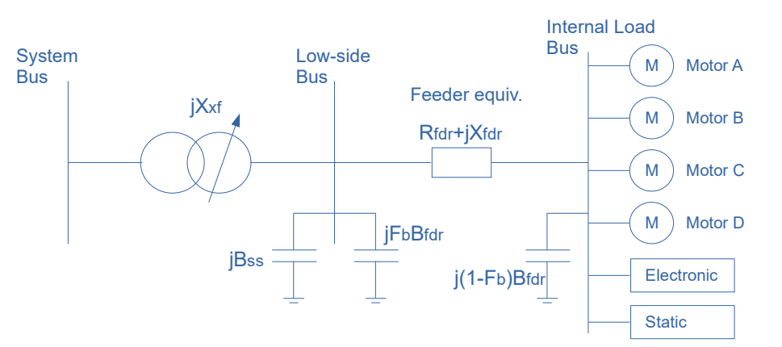
Figure 54: WECC composite load model.
The proportion of each load depends on the physical conditions of the region under study. In DIgSILENT PowerFactory, the WECC composite load model comes with certain default proportions of different types of loads. AEMO, in its 2024 report, has provided composite load proportions to replicate the load of different states in Australia. Moreover, the performance parameters of Motor D have been updated by AEMO [146]. The details of the updated load composition and Motor D performance parameters are shown in the Table 21 and Table 22.
Table 21: DIgSILENT Default Composite Load Model vs AEMO Composite Load Model 2024 for Victoria.
Composite Load | Motor A | Motor B | Motor C | Motor D | Electronic Load
DIgSILENT Default | 19.5 % | 19.5 % | 9.5 % | 24 % | 19.5 %
AEMO 2024 (VIC) | 15.3 % | 18.7 % | 12.4 % | 0.2 % | 35 %
Table 22: Motor D performance parameters.
Parameter | Description | DIgSILENT Default | AEMO 2024
Tstall | Motor D stall delay time (s) | 0.033 | 0.04
CompPF | Motor D power factor at 1.0 pu voltage | 0.98 | 1.00
Vstall | Motor D stall voltage (pu) | 0.50 | 0.60
Rstall | Motor D stall resistance (pu of motor base) | 0.10 | 0.17
Xstall | Motor D stall reactance (pu of motor base) | 0.10 | 0.07
Frst | Motor D fraction capable of restart after stall | 0.20 | 0.55
Vrst | Motor D voltage for restart after stall (pu) | 0.95 | 0.90
Vc1off | Motor D voltage contactors start opening (pu) | 0.60 | 0.50
Vc1on | Motor D voltage all contactors closed (pu) | 0.65 | 0.60
UVtr2 | Motor D 2nd undervoltage pick-up (pu) | 0.10 | 0.00
Tth | Motor D heating time constant (s) | 15 | 16

The impact of the DIgSILENT PowerFactory default composite load model and the AEMO composite load model on voltage stability is compared by applying each load model separately to the 628 MW load connected at Bus 20. A three-phase short-circuit fault is applied at the midpoint of Line 16-19 at 1 s and cleared at 1.1 s. The resulting voltage response at Bus 20 is then observed, as shown in Figure 55.

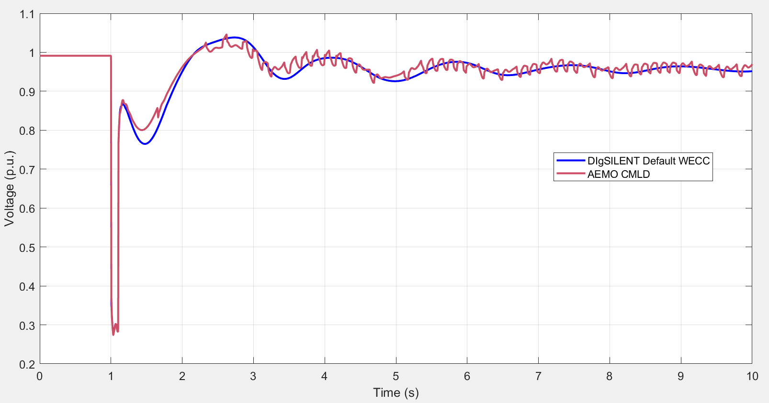
Figure 55: Impact on voltage using DIgSILENT composite load vs AEMO composite load model for load at bus 20.

The figure suggests that the AEMO composite load model exhibits a shallower first-swing voltage dip following fault clearing compared to the default WECC composite load model in DIgSILENT PowerFactory. In addition, the post-fault response under the AEMO model is characterized by higher-frequency oscillations, whereas the WECC model produces a comparatively smoother dynamic response.

Impact of Fault Location on STVS
A three-phase fault was created at locations 0%, 10%, 20%, 30%, 40%, 50%, 60%, 70%, 80%, 90%, and 100% of Line 16-19. The impact on voltage at bus 20 was recorded for all the cases. The results are shown in Figure 56.
To better demonstrate the trend, Figure 57 shows that 100% fault location results in minimum voltage, whereas 0% fault location results in maximum voltage at bus 20. As bus 19 is nearer to bus 20, the fault at 100% of Line 16-19 is at bus 19 and having greater influence on bus 20 voltage. As the fault location moves away from bus 20, the impact on voltage decreases until minimum for a fault at 0% of Line 16-19 or at bus 16.

Impact of Fault Clearing Time on STVS
To assess the impact of different fault clearing times (0.1 s, 0.15 s, and 0.2 s) on STVS, a three-phase short-circuit fault was applied at the midpoint of Line 16-19. The resulting voltage waveforms at bus 20 (load bus) and generator G03 terminals are shown in Figure 58 and Figure 59 respectively.
Figure 58 illustrates that fault clearing times of 0.1 s and 0.15 s can maintain voltage stability at the load bus. However, the 0.2 s fault clearing time results in voltage instability. Similarly, Figure 59 shows that fault clearing times of 0.1 s and 0.15 s maintain voltage stability at the generator terminals, whereas the 0.2 s case leads to voltage instability.
Figure 56: Impact of fault location on voltage stability.
Figure 57: Impact of fault location analysed.
Overall, the results indicate that the system maintains short-term voltage stability for fault clearing times up to 0.15 s, whereas a clearing time of 0.2 s exceeds the transient voltage stability limit and results in voltage instability. This behaviour highlights the strong sensitivity of the system to fault duration under the considered operating condition. As the fault clearing time increases, the system experiences more severe voltage depression and reduced post-fault voltage recovery capability, eventually leading to instability. Therefore, fast fault detection and clearing are essential for maintaining secure operation and preventing voltage collapse under large disturbances.
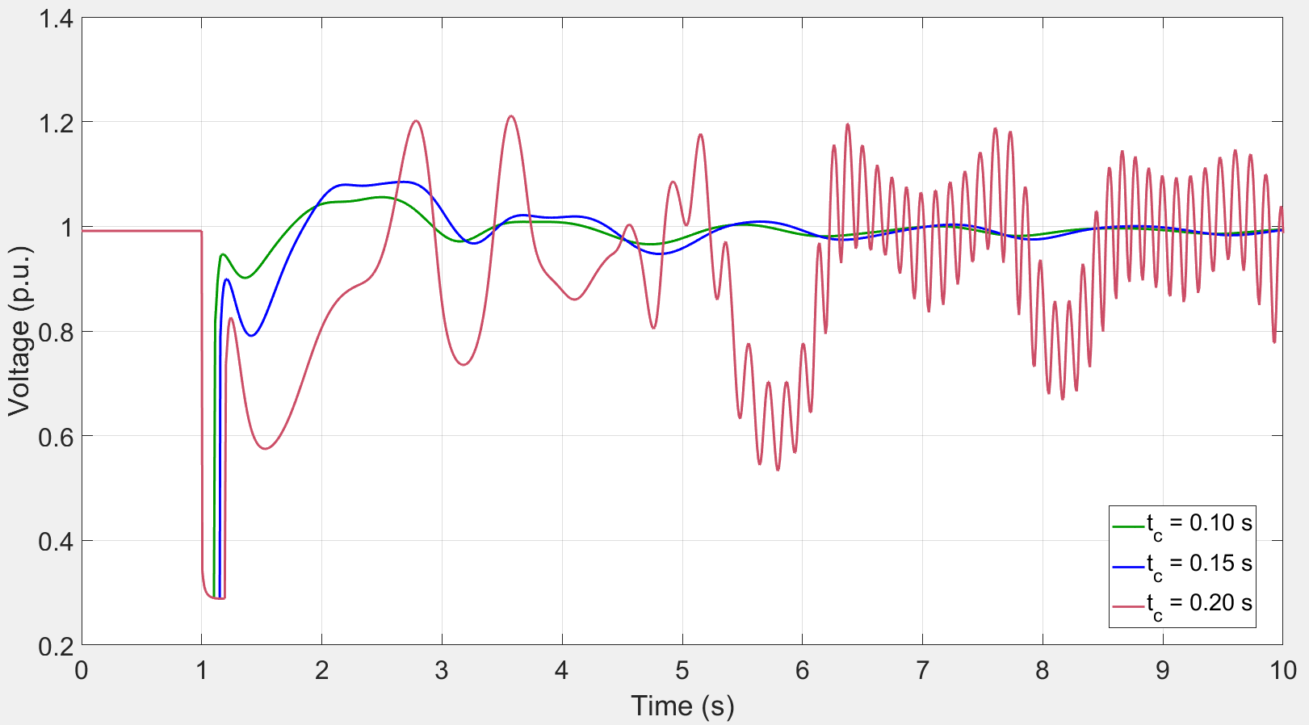
Figure 58: Impact of different fault clearing times on the voltage at Bus 20.
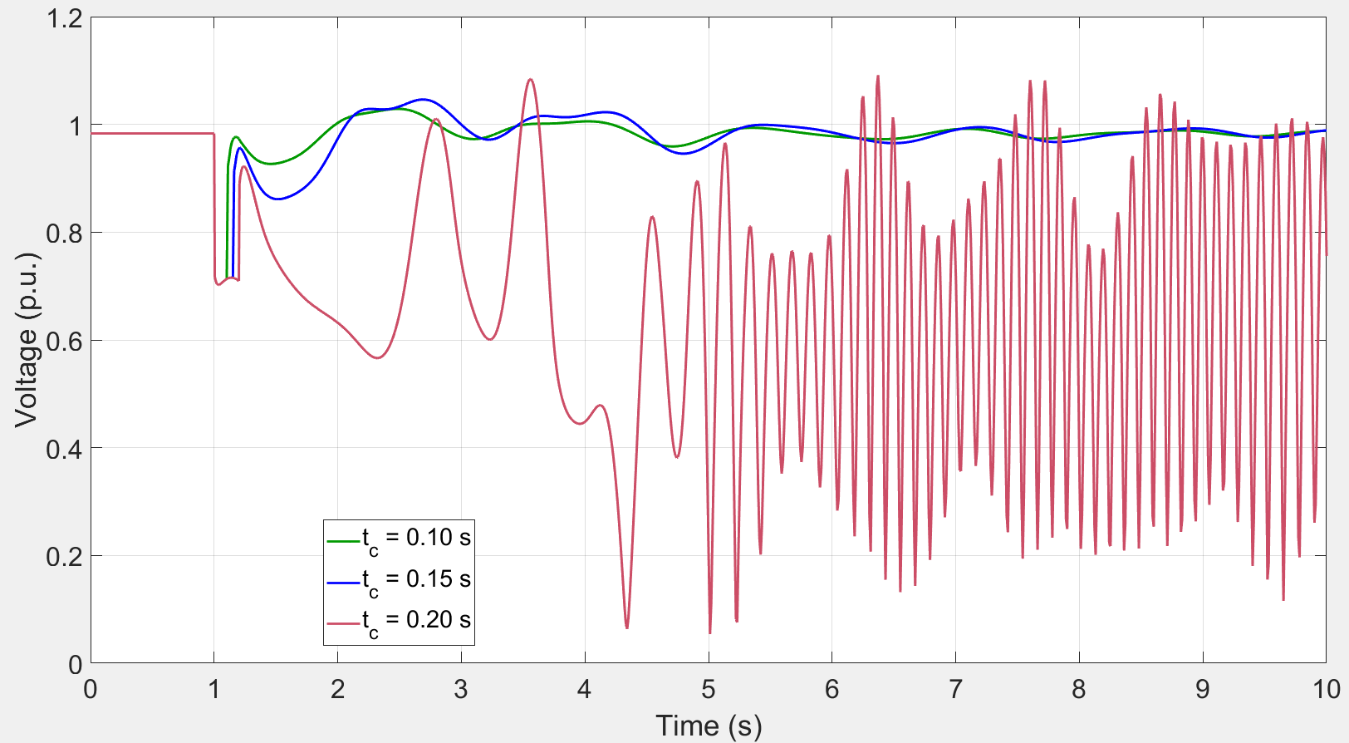
Figure 59: Impact of different fault clearing times on the generator (G 03) terminal voltage.

Long-Term Voltage Stability
Long-term voltage stability involves slower acting equipment such as
- tap-changing transformers,
- thermostatically controlled loads,
- and generator current limiters.
The study period of interest starts from 10 to 20 seconds after the disturbance and lasts up to tens of minutes [112]. In the long-term voltage stability study, it is assumed that the system has survived the transient period after a disturbance [91]. Stability is usually determined by the resulting outage of equipment, rather than the severity of the initial disturbance. Instability is due to the loss of long-term equilibrium (e.g., when loads try to restore their power beyond the capability of the transmission network and connected generation), or a lack of attraction toward the stable post-disturbance equilibrium (e.g., when a remedial action is applied too late).
Although voltage instability is typically associated with a gradual reduction in bus voltages, overvoltage instability may also arise and has been reported in some situations. It typically occurs due to the capacitive behaviour of the network, for example when EHV/HV transmission lines operate below their surge impedance loading, combined with the action of under-excitation limiters that prevent generators or synchronous compensators from absorbing surplus reactive power. In this case, the instability is associated with the inability of the combined generation and transmission system to operate below a minimum load consumption level.
The Western Electricity Coordinating Council (WECC) specifies that the minimum P–V margin should be at least 5% for single (N-1) contingencies, 2.5% for double (N-2) contingencies, and greater than zero for multiple contingencies (N ≥ 3) [143].

Motivation for Long-Term Voltage Stability Assessment
Long-term voltage stability assessment is essential for secure system operation under slow dynamic and control processes, supporting the following objectives:
- To investigate the root causes of blackouts driven by slow-acting controls.
- To prevent large-scale blackouts by enabling effective preventive actions.
- To support system operators in enhancing their emergency response capability.
- To avoid long-term reactive power deficiency.
- To develop and evaluate load shedding strategies for avoiding long-term voltage degradation.
- To evaluate the effectiveness of reactive power support.
- To study the allocation and distribution of spinning reserves to improve long-term system recovery.
- To study the impact of response from boiler control system (including reactor) and auxiliary equipment of power plant after large disturbance on the operation characteristics of power plants and coordinate the control and protection system of power plants.

Long-Term Voltage Stability Assessment Methods
A comparative analysis of different methods for LTVS assessment is given below in Table 23. It shows that time-domain simulation is an appropriate method for LTVS assessment.
Long-term voltage stability is commonly evaluated by estimating the stability margin, which represents the allowable increase in load demand from the initial operating point up to the maximum power transfer point where voltage instability begins. Accurate representation of system behaviour therefore requires nonlinear models capable of incorporating effects such as operational limits, deadbands, discrete tap-changer actions, and constant or variable time delays. Continuation power flow (CPF), commonly used for PV curve analysis, remains applicable for assessing long-term voltage stability. Nevertheless, accurate modelling of voltage-controlling sources and their associated reactive power limits is necessary to ensure realistic stability margins. Both quasi-steady-state long-term dynamic simulations and full time-scale dynamic simulations may be employed for the analysis [112].
Table 23: A comparison of LTVS assessment methods [111][112].
Assessment Method | Useful for  IBR-rich Systems | Accuracy | Computational Complexity
Time-domain simulation | Very Useful | Very High | Very High
Adaptive continuation method | Moderately Useful | High | Moderate
Energy function method | Less Useful | Moderate | Moderate
Coupled single-port Thevenin equivalent method | Less Useful | Low | Low

Impact of Increasing Renewable Penetration for Different Contingencies on LTVS
For assessing the impact of increased penetration of renewable generation, synchronous generators in IEEE 39-bus test system were gradually replaced with wind farms of the same MVA and MW rating as shown in Table 24. The wind turbine generators were assigned a reactive power capability of ±0.436 pu and operated in voltage control mode. Voltage stability limits in terms of maximum loadability are shown in Figure 60.
Table 24: Different penetration levels of wind power by replacing synchronous generators.
Wind Power Penetration  Level | G 10 at  Bus 30 | G 08 at  Bus 37 | G 09 at  Bus 38 | G 07 at  Bus 36 | G 05 at  Bus 34 | G 04 at  Bus 33 | G 03 at  Bus 33 | G 02 at  Bus 31 | G06 at  Bus 35 | G01 at  Bus 39
Wind Power Penetration  Level | 250  MW | 540  MW | 830  MW | 560  MW | 508  MW | 632  MW | 650  MW | 520  MW | 650  MW | 1000  MW
4 % | ✓
13% | ✓ | ✓
26% | ✓ | ✓ | ✓
35% | ✓ | ✓ | ✓ | ✓
44% | ✓ | ✓ | ✓ | ✓ | ✓
54% | ✓ | ✓ | ✓ | ✓ | ✓ | ✓
64% | ✓ | ✓ | ✓ | ✓ | ✓ | ✓ | ✓
73% | ✓ | ✓ | ✓ | ✓ | ✓ | ✓ | ✓ | ✓
83% | ✓ | ✓ | ✓ | ✓ | ✓ | ✓ | ✓ | ✓ | ✓
95% |  | ✓ | ✓ | ✓ | ✓ | ✓ | ✓ | ✓ | ✓ | ✓
The adaptive continuation-based PV-curve analysis of the base-case and contingency cases has revealed the critical contingency and critical buses as highlighted in Figure 61. The outcomes of the analysis are discussed below:
- For the base case with no renewable generation, the outage of Line 16-19 is identified as critical contingency, while bus 12 emerges as the critical bus.

Figure 60: The impact of different renewable penetration levels on maximum loadability for contingencies.
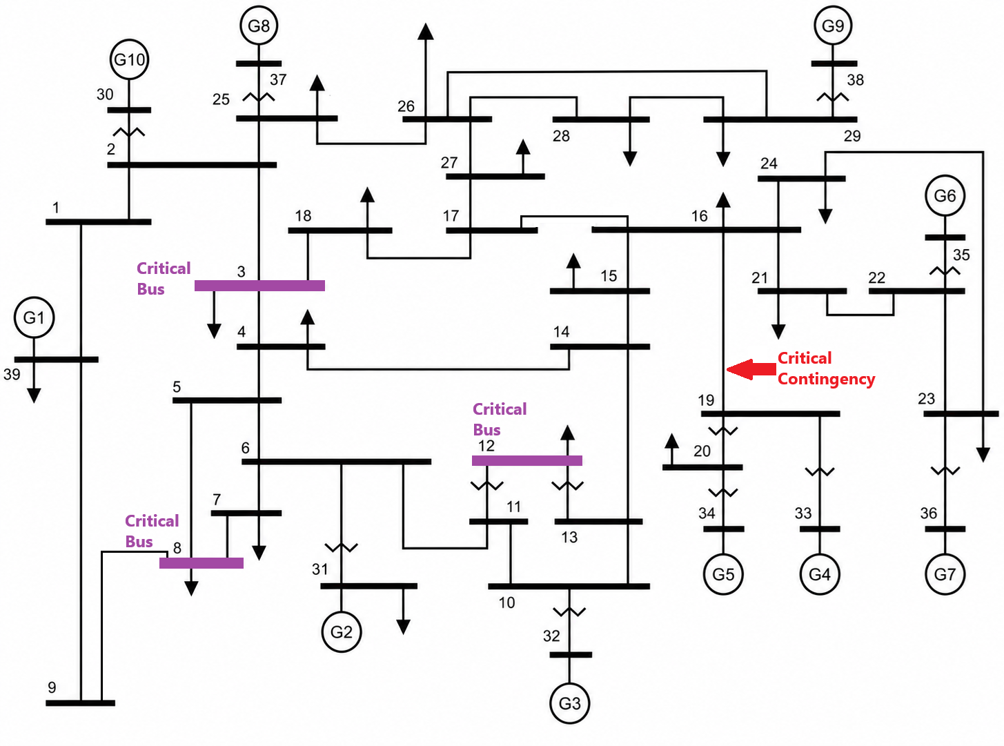
Figure 61: IEEE 39-bus test system with highlighted critical contingency and critical buses.
- At renewable penetration from 4-54%, the outage of Line 16-19 is identified as the critical contingency resulting in the lowest loadability limit, while Bus 08 appears as the critical bus.
- At renewable penetration of 64-83%, the outage of Line 16-19 is identified as the critical contingency, while Bus 12 emerges as the critical bus.
- At renewable generation penetration level of 95%, the outage of Line 16-19 is identified as critical contingency, while bus 3 appears as the critical bus.
- Gradually replacing synchronous generators with wind-based generators to achieve renewable penetration levels of up to 95% shows that the maximum loadability decreases as renewable penetration increases. Moreover, the critical buses vary across different renewable penetration levels, whereas the critical contingency remains consistent.

Chapter Summary
In conclusion, this study demonstrates that the increasing penetration of inverter-based resources and the presence of highly dynamic loads introduce significant challenges for maintaining large-disturbance voltage stability in modern power systems. The adaptive continuation method used for long-term voltage stability assessment, applied to the modified IEEE 39-bus test system, shows that higher renewable penetration reduces voltage stability margins due to reduced system inertia, limited fault current contribution, and constrained reactive power support from inverter-based resources. Adaptive continuation-based PV-curve analysis under both base-case and contingency conditions shows that progressively increasing renewable generation penetration reduces the maximum loadability of the system. The results further indicate that the critical contingency remains unchanged across different levels of renewable generation penetration, whereas the critical buses vary with the penetration level. Among the investigated line contingencies, the outage of Line 16–19 is identified as the critical contingency for all renewable penetration levels ranging from 4% to 95%. The corresponding critical buses shift from Bus 12 at zero renewable penetration to Bus 08 at 4%–54% penetration, Bus 12 at 64%–83% penetration, and Bus 03 at 95% renewable penetration. Furthermore, the reactive power capability of renewable energy-based IBRs is identified as an important factor influencing the location of the critical buses.
Variations in the reactive power capability of the generators result in changes to the corresponding critical buses. Time-domain simulations conducted for short-term voltage stability assessment highlight that the choice of composite load model significantly influences the large-disturbance voltage response. Compared to the default WECC composite load model in DIgSILENT PowerFactory, the AEMO composite load model produces a shallower first-swing voltage dip following fault clearance but exhibits higher-frequency post-fault oscillations, highlighting the importance of using region-specific load models for accurate voltage stability assessment in Australian power systems. The results confirm that three-phase faults represent the most severe disturbance for voltage stability assessment, producing the largest voltage depression and weakest post-fault recovery. The analysis further shows that the system remains short-term voltage stable for fault clearing times up to 0.15 s, whereas a clearing time of 0.2 s leads to voltage instability. These findings highlight the strong sensitivity of the system to fault duration, emphasizing the importance of rapid fault detection and clearing to maintain secure operation and prevent voltage collapse under large disturbances. Overall, the results provide important insights into stability limits and weak network locations in future IBR-dominated systems and support the development of reliable assessment methods to assist system operators in maintaining secure and stable operation of the NEM.

Small-Disturbance Voltage Stability

Introduction
Small-disturbance voltage stability assessment is particularly relevant for emerging developments that lead to concentrated demand in specific network locations. Large computational loads, including AI-oriented data centers, are explicitly highlighted as fast-growing and operationally consequential because they combine high energy demand, substantial cooling requirements, and fast ramps that can stress voltage and frequency regulation [144]. In parallel, higher penetration of inverter-based generation changes how voltage is supported (reactive power control behaviour, current limits, plant-level controls, and reduced synchronous strength), which can shift weak areas and reduce the stability margin under both normal and contingency conditions if not managed carefully [145].
The rest of the chapter is organised as follows. The theoretical background of small-disturbance voltage stability is presented in Section 5.2. Small-disturbance voltage stability assessment methods, simulation tools, and test systems are discussed in Section 5.3. Section 5.4 presents the simulation results for various operating scenarios like different renewable penetration levels, load levels, and AI data center load levels. Finally, the work is concluded, and future research direction is provided in Section 5.5.

Definition of Small-Disturbance Voltage Stability
In the IEEE [146] /CIGRE ‎[112] stability framework, small-disturbance voltage stability is defined as the ability of a power system to maintain steady voltages when subjected to small perturbations such as incremental changes in system load or generation. It is influenced by load characteristics, continuous controls, and discrete controls at a given instant of time; and, under suitable assumptions, it can be studied by linearizing the system equations around the operating point to obtain sensitivity information that helps identify factors driving instability ‎[112].
Mechanistically, voltage instability is tied to the inability of the combined transmission-generation system to supply the reactive power and voltage support needed as loads attempt to restore power consumption, leading to progressively falling voltages and possible collapse [147]. In static (steady state) terms, the practical boundary is frequently associated with a maximum loadability point that appears as the “nose” of a PV curve [146].

Methodology for Small-Disturbance Voltage Stability Assessment

Small-disturbance Voltage Stability Assessment Methods
Small-disturbance voltage stability assessment methods can be grouped by what they compute (such as stability margin, sensitivities, modes, or indices), how much modelling detail they need, and whether they are intended for offline planning studies or near-real-time monitoring [66]. The IEEE/CIGRE framework explicitly notes that linearization enables valuable sensitivity information, but also cautions that purely linearized analysis cannot capture some nonlinearities (for example, discrete tap-changer effects), so complementary nonlinear analyses are often used in practice ‎[112]. In small-disturbance voltage stability approaches (shown in Figure 62), the following families are most relevant:

Figure 62: Frequently used small-disturbance voltage stability assessment methods.
Continuation-based PV/QV tracing (most commonly called continuation power flow (CPF)) directly traces equilibrium solutions as loading is parameterized and increased, producing PV (and sometimes QV) curves, identifying the critical point, and allowing a loadability margin to be quantified. This approach aligns naturally with incremental-load (small-disturbance) questions and with long-term/quasi-steady-state interpretations of voltage stability ‎[112].
Modal (eigenvalue) analysis evaluates voltage stability by computing eigenvalues and eigenvectors of a reduced power-flow Jacobian, helping to identify critical modes and participation factors useful for locating weak buses/areas and understanding which state combinations drive proximity to instability [149]. Singular value decomposition (SVD)-based indices use the smallest singular value of the power-flow Jacobian as a proximity indicator; the singular vectors provide directional sensitivity information for voltages and injections [150].
Thevenin-equivalent and impedance-matching methods estimate a local Thevenin equivalent seen by a bus or corridor and infer proximity to maximum power transfer; these methods can be attractive for online monitoring but can have limitations in multi-load systems and when system conditions and controls change rapidly, motivating improved or wide-area variants [151]. Synchrophasor-based and state-estimation-based monitoring approaches compute voltage stability indices or margins from PMU measurements, aiming for operational visibility with fast refresh rates; these are commonly positioned as monitoring layers rather than replacements for planning-grade margin studies [152].
The decision to use CPF is fundamentally about robustness and interpretability near the critical operating boundary. Conventional repeated Newton-Raphson power flows, run by progressively increasing load, often suffer convergence problems close to collapse and do not reliably locate the actual limit; this becomes especially problematic when the study needs a precise margin and when many control limits (generator reactive limits, regulating transformers, HVDC controls) can change the system equations along the path [146]. Continuation methods were developed precisely to overcome these limitations by reliably computing the solution path and the bifurcation point [146].
A second reason is that CPF produces outputs that map cleanly to operational questions. PV curves provide a direct visual and numerical link between loading levels and bus voltages and identify the critical point of voltage instability [153]. When paired with contingency analysis (N−1 screening), CPF-based margins can be computed for normal operation and for the “limiting contingency,” giving planners and operators a concrete prioritization of risk and a defensible basis for preventive or corrective measures [153].
A third reason is alignment with the meaning of “small disturbance” in the IEEE/CIGRE definition: incremental changes in system load and generation. CPF explicitly parameterizes these incremental changes and can be combined with linearized sensitivities along the path to identify which controls or buses become critical as the system approaches the boundary ‎[112]. Practically, this supports both planning use and operational use.

Frequently used Tools for Small-Disturbance Voltage Stability and Why DIgSILENT PowerFactory was Selected
In open and research-centric workflows, MATLAB-based ecosystems are common: PSAT documents an integrated set of power-flow, CPF, small-signal stability analysis, time-domain simulation, and extensive component models (including load tap changers and thermostatically controlled loads), which explains why it is frequently used in academic voltage stability workflows [154]. MATPOWER is similarly positioned as a widely used research and education package explicitly supporting power flow, CPF, and optimal power flow in a form designed to be easy to modify and automate [155].
At the same time, industry-grade studies, particularly those that must reflect detailed equipment limits, standard dynamic model libraries, and utility-style contingency and reporting workflows frequently rely on commercial platforms, real-time digital simulators, or hybrid pipelines. The RTDS Simulator, for example, is designed for real-time EMT simulation and hardware-in-the-loop testing of protection/control devices, which is a different value proposition than a CPF-based static margin engine [156].
Within that tool spectrum, the selection of DIgSILENT PowerFactory ‎[112] is justified by direct feature support and by workflow fit for this objective. PowerFactory explicitly provides PV curve calculation for voltage stability assessment by determination of the critical point of voltage instability, and QV curves for voltage stability limit assessment and reactive compensation evaluation; it also ties these functions to contingency analysis for limiting-contingency identification [153]. This matches the core deliverable of a small-disturbance voltage stability objective: compute, compare, and explain margins across scenarios. Beyond the static engine, PowerFactory’s RMS simulation environment supports mid-term and long-term transient studies with a large library of standard models (IEEE/IEC/WECC) and user-defined modeling via DIgSILENT Simulation Language (DSL), which matters when the project needs to connect static margins to dynamic behavior [153]. Finally, the platform supports scripting and automation via Python and the DIgSILENT Programming Language (DPL), enabling parametric studies across renewable penetration levels, load levels, and contingency sets without turning the study into a manual exercise [157].

Frequently used Test Systems and Rationale for the Modified IEEE 39-bus System
Small-disturbance voltage stability research frequently uses benchmark IEEE systems (e.g., IEEE 14-, 30-, 57-, 118-bus) because they provide shared reference points that make method comparisons meaningful and reproducible across papers and tools. The New England IEEE 39-bus case is widely recognized as the 10-machine New England power system, with parameters traceable to classic stability study sources, and is commonly used as a benchmark for stability studies [158].
The modified IEEE 39-bus test system used in this study was adapted to incorporate two stressors aligned with the project objectives: renewable generation penetration and emerging large load (AI data centre) integration. Methodologically, the modifications can be described as (i) replacing selected synchronous generators with aggregated inverter-based renewable plants to reach target penetration levels (4% penetration at G10; 13% penetration at G10+G08), (ii) applying small, systematic load scaling (e.g., 90% to 110% of base load) to represent incremental demand drift consistent with the small-disturbance definition, and (iii) adding a large data center load block (500 MW and 1000 MW) at the chosen interconnection bus to test how concentrated demand reshapes the PV/QV margin under normal operation and a selected limiting N−1 contingency. The rationale for these particular modifications is that they target two mechanisms known to be voltage-stability-relevant: reduced synchronous reactive strength and changed voltage control behaviour as inverter-based resources displace synchronous generation, and increased reactive demand/voltage sensitivity as large, power-electronics-dominated loads and their cooling systems concentrate at specific buses ‎[112]. Figure 63 illustrates the modified IEEE 39-bus test system used for small-disturbance voltage stability studies, where selected synchronous generators are replaced with aggregated inverter-based renewable plants to achieve the target penetration levels.

Results and Discussion: Renewable Penetration, Small Load Changes, and AI Data Center Load
The renewable penetration scenarios show a consistent and operationally intuitive pattern: as renewable penetration increases, the voltage stability margin decreases, and the sensitivity to small load increases becomes sharper. This is consistent with the broader observation that voltage instability is driven by the system’s inability to meet the combined real and reactive power requirements as operating conditions become stressed, and with evidence that weak-grid behaviours and control limits become more consequential as inverter-based resources displace synchronous strength [147].

Small-Disturbance Voltage Stability Assessment under Different Renewable Penetration and Load Levels
Table 25 compares the voltage stability margins across different renewable penetration scenarios and load levels. For the targeted renewable cases, the CPF-derived margins decline materially when moving from the base case (no renewables) to 4% renewable penetration at G10, and further to 13% renewable penetration at G10+G08, across the full ±10% load-scaling band. At 100% base load, the margin drops from 56.65% (no renewables) to 48.83% (4%) and to 46.87% (13%). At 110% base load, the same trend intensifies: 43.73% (no renewables) falls to 36.44% (4%) and then to 34.69% (13%). Interpreted through a stability lens, the incremental load increase pushes the operating point toward the PV “nose,” while the renewable replacement reduces the system’s effective voltage-support headroom ‎[112].
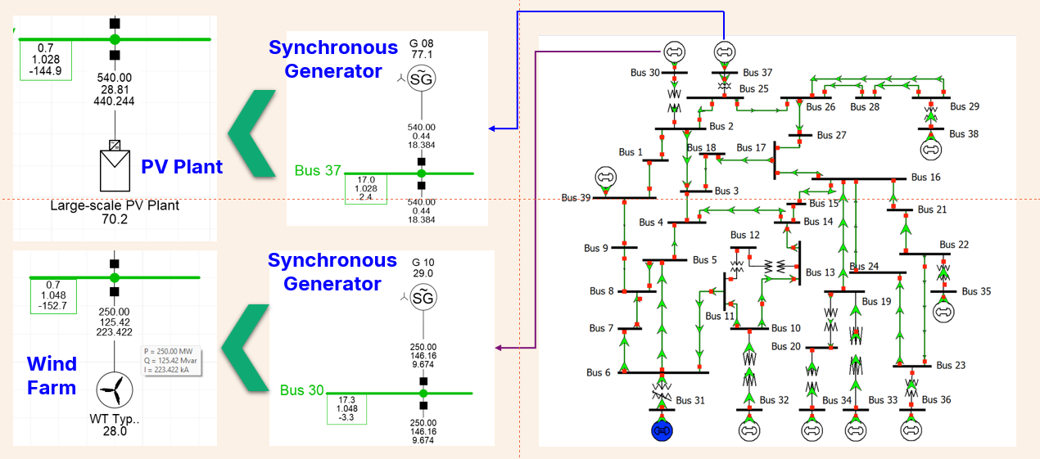
Figure 63: Modified IEEE 39-bus system for small-disturbance voltage stability studies.
Table 25: A comparison of voltage stability margin under different renewable penetration and load levels.
Base Load | Base Case  (No Renewable  Generation) | 4% Renewable Generation  (Wind Farm) | 13% Renewable Generation  (Wind Farm+ PV Plant)
0.9 (90%) | 71.94% | 63.61% | 61.39%
0.95 (95%) | 63.97% | 55.98% | 53.81%
1.0 (100%) | 56.65% | 48.83% | 46.87%
1.05 (105%) | 49.97% | 42.38% | 40.53%
1.1 (110%) | 43.73% | 36.44% | 34.69%
Figure 64 extends the voltage stability boundary assessment up to 95% renewable penetration under different base-load conditions. The extended results confirm the same trend observed earlier: the voltage stability margin decreases consistently as both renewable penetration and load level increase. At the 100% base-load point, the margin falls from 36.16% in the no-renewable base case to 32.81% at 4%, 31.91% at 13%, 28.50% at 44%, 22.47% at 83%, and finally 20.17% at 95% renewable penetration. This represents a total reduction of about 16 percentage points from the base case to the 95% renewable case.
The higher renewable penetration cases show a sharper reduction in stability headroom, particularly under stressed loading conditions. For example, at 110% base load, the voltage stability margin decreases from 30.43% in the no-renewable case to only 12.81% at 95% renewable penetration, indicating that the system is operating much closer to its voltage stability boundary. Even at the lighter 90% load condition, the margin drops from 41.84% to 27.46% as renewable penetration increases to 95%, showing that the impact is not limited to heavily loaded operation.
Overall, the extended results demonstrate that very high renewable penetration significantly reduces voltage stability margins, especially when combined with moderate load growth. The progressive decline from 83% to 95% renewable penetration further highlights that the system becomes increasingly sensitive to small load variations as synchronous generation is displaced by inverter-based resources. Therefore, at high renewable penetration levels, additional voltage support, reactive power capability, grid-forming inverter control, and other stability enhancement measures are required to preserve adequate voltage stability margins under future operating conditions.

Figure 64: A comparison of voltage stability boundary under different renewable penetrations and load levels.

Small-Disturbance Voltage Stability Assessment under Different AI Data Center Load Penetration Levels
The extended results in Table 3 further show that voltage stability degradation is not driven by a single factor, but by the combined influence of renewable displacement, load concentration, and load dynamic characteristics. Compared with the base case, all three stressed scenarios reduce the voltage stability margin across the full loading range from 90% to 110%. However, the severity differs clearly. The 1000 MW traditional load case causes a moderate reduction in stability margin, while the 95% renewable case produces a much larger reduction due to the displacement of synchronous generation and the associated reduction in reactive power strength and voltage support. The 1000 MW AI data centre case produces the most severe impact, indicating that concentrated, power-electronics-heavy data centre demand creates a stronger voltage stability stress than an equivalent traditional load.
At the 100% base-load condition, the voltage stability margin decreases from 36.16% in the base case to 29.16% with the addition of a 1000 MW traditional load, 20.17% under the 95% renewable case, and only 11.96% with the 1000 MW AI data centre load. This means that the traditional 1000 MW load reduces the margin by about 7.0 percentage points, while the 95% renewable case reduces it by about 16.0 percentage points. The AI data centre case gives the largest reduction of about 24.2 percentage points, leaving the system much closer to the voltage stability boundary.
The difference becomes even more critical as the loading level increases. At 110% base load, the base case still maintains a margin of 30.43%, while the 1000 MW traditional load case falls to 23.30% and the 95% renewable case falls to 12.81%. In contrast, the 1000 MW AI data centre case drops sharply to only 4.81%, indicating a very limited remaining stability headroom. Similarly, at 105% loading, the AI data centre case has a margin of only 8.39%, already below a practical security buffer for stressed operating conditions.
Overall, the results show that a 1000 MW AI data centre load is more detrimental to voltage stability than a 1000 MW traditional load at every loading condition. The difference is particularly clear at the 100% base-load point, where the AI data centre margin is 17.20 percentage points lower than the traditional load case. This confirms that the impact of AI data centre load cannot be assessed only by their MW size; their concentrated location, high power density, cooling demand, power-electronics interface, and potential fast variability make them more challenging from a voltage stability perspective.
The comparison with the 95% renewable case is also important. While very high renewable penetration significantly reduces voltage stability margins, the 1000 MW AI data centre case produces an even lower margin. This suggests that future planning studies should treat high renewable penetration and large AI data centre load integration as separate but interacting stress factors. If both conditions occur simultaneously in weak areas of the grid, additional voltage support, dynamic reactive compensation, grid-forming inverter capability, and network reinforcement may be required to maintain sufficient voltage stability margin.
Table 26: A comparison of voltage stability margins under different renewable, traditional load, and AI data centre penetration levels.
Loading | Base Case | 95% Renewable Case VSM (%) | 1000 MW Traditional Load VSM (%) | 1000 MW AI Data Center VSM (%)
0.9 (90%) | 41.83944716 | 27.46 | 33.9382452 | 18.968311
0.95 (95%) | 39.01295078 | 23.84 | 32.0199993 | 15.472779
1.0 (100%) | 36.1615929 | 20.17 | 29.1577954 | 11.95568
1.05 (105%) | 33.31922007 | 16.50 | 26.2571534 | 8.3922606
1.1 (110%) | 30.42728216 | 12.81 | 23.3029108 | 4.8059583

Chapter Summary
The combined results indicate that voltage stability margins can deteriorate through both supply-side transformation and demand-side load evolution, and that these effects become more critical under stressed operating conditions. On the supply side, increasing inverter-based renewable penetration progressively reduces the voltage stability margin as synchronous generation, reactive power strength, and short-circuit support are displaced. At the 100% base-load condition, the margin falls from 36.16% in the no-renewable base case to 20.17% at 95% renewable penetration, representing a reduction of about 16 percentage points. At 110% base loading, the margin further decreases to only 12.81% under 95% renewable penetration, confirming that very high renewable operation leaves the system much closer to the voltage stability boundary.
On the demand side, the results show that large-load integration is not only a question of additional MW capacity, but also of load type, location, concentration, and dynamic characteristics. A 1000 MW traditional load reduces the voltage stability margin at the 100% base-load point to 29.16%, whereas the 1000 MW AI data centre load reduces it more severely to 11.96%. The difference becomes even more pronounced at 110% base loading, where the AI data centre case leaves only 4.81% margin, compared with 23.30% for the traditional load case and 12.81% for the 95% renewable case. These results confirm that high renewable penetration and large AI data centre integration should be treated as separate but interacting voltage stability stress factors. Therefore, future planning studies should explicitly consider renewable displacement, large-load interconnection, reactive power adequacy, and dynamic load behaviour together. Adequate voltage support, dynamic reactive compensation, grid-forming inverter capability, BESS reactive power control, and targeted network reinforcement may be required to preserve sufficient voltage stability margins in future low-inertia, high-IBR power systems [127], [128].

Part II Large Load Model

Large Load Model

Introduction
For roughly the mid-2000s to late-2010s, electricity consumption in many developed economies remained flat (or even declined slightly) despite economic growth. This occurred because improvements in energy efficiency largely offset increases in demand drivers such as population growth, GDP growth, and new electrical appliances. However, aggregate system demand is projected to increase substantially in the coming years, largely driven by the proliferation of large-scale data centres supporting artificial intelligence (AI) workloads. Such facilities typically exhibit power demands ranging from tens of megawatts to multiple gigawatts, representing concentrated, high-density loads connected at single points within the transmission or sub-transmission network.
In addition to data centres and cryptocurrency mining operations, green hydrogen production facilities are also emerging as large-scale electrical loads. A common characteristic of these loads is the extensive use of power electronic converters. For example, in data centres and crypto mining facilities, approximately 90% of the load is associated with server racks, which are supplied through rectifier-based power conversion systems [159].
Loads such as computational, industrial, and hydrogen production facilities are connecting to the bulk power system (BPS) faster than ever before and at a magnitude beyond the largest currently operating loads. Figure 65 shows the timeline for large load deployment compared to the timeline for the installation of transmission system, renewable generations, and battery energy storage systems.

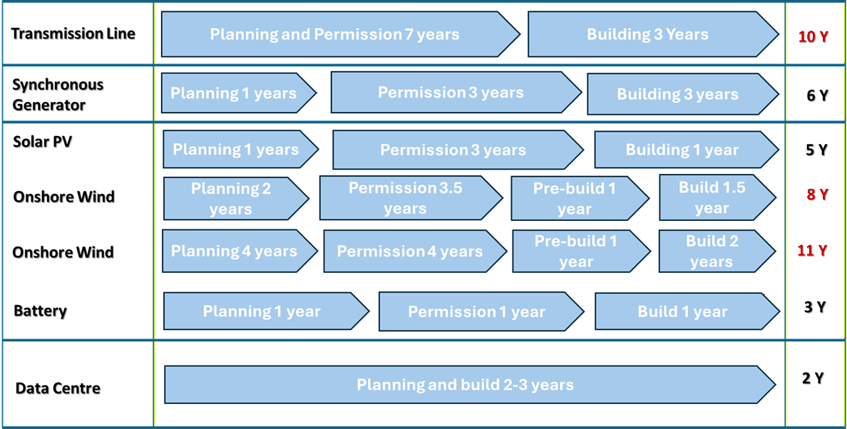
Figure 65: Deployment of various power system components[159].

Large loads present emerging risks across both planning and operational timeframes. Accelerated connection timeframes and high peak demand levels can introduce generation and transmission adequacy risks. In addition, fast ramp rates and operational variability may contribute to voltage and frequency instability, particularly in weaker network areas.
Without accurate and validated dynamic models, system planners and operators may be unable to reliably predict ride-through capability and system response during disturbances. Furthermore, the high penetration of power electronic–based load within facilities such as data centres can introduce harmonics, voltage fluctuations, and other power quality concerns.
Large loads are also exposed to cyber-security risks; malicious or coordinated actions could trigger rapid load ramps, potentially affecting system stability. The scale and speed of integration of these loads may therefore have adverse implications for overall system resilience if not properly assessed and managed. Accordingly, large loads must be appropriately considered in load-shedding obligations, under-frequency load-shedding (UFLS) program design, and black start restoration planning. Recognising these risks, the North American Electric Reliability Corporation (NERC) has prioritised large load–related risks, as summarised in Table 27. This work aims to model the electromechanical dynamics of a large load, with a primary focus on voltage and angle stability, which are considered high-priority risks for secure and reliable system operation (as in Table 27).
Table 27: Impact of large load on power systems ‎[160].
High priority risks | Medium priority risks | Low priority risks
Long-term planning-resource adequacy | Medium-term planning-demand forecasting | Power quality – harmonics and voltage fluctuations
Operations and balancing | Stability-frequency stability | System restoration
Stability – voltage, angle, oscillations, fault-ride through | Security – Cyber security | -

Large Load Model for Power System Studies
Although modelling system loads plays a critical role in power system security and reliability assessments, it differs significantly from generator modelling. In practice, it is common to model all generators individually for the transmission system studies. However, because the number of loads far exceeds the number of generators, it is generally impractical to represent each load in the same level of detail. Furthermore, it should be worth noting that the small-scale DERs are also represented as an aggregated model due to the large number of such generators in the distribution systems.
To develop an accurate large-load model, it is important to understand its operational characteristics, the components involved, and how it is connected to the power system. The size of large loads connecting to the power system often determines the appropriate point of connection, whether at distribution, sub-transmission, or transmission voltage levels. This is typically governed by local utility requirements and technical standards, although economic considerations and overall cost-effectiveness may also influence the final connection arrangement [160].
- Large loads of approximately 5 MW are typically connected at the distribution level. Loads in the range of 5–20 MW may be connected at multiple points within the distribution network, depending on feeder capacity and network constraints.
- Large loads in the range of 20–150 MW are typically connected to the sub-transmission network, subject to local network capacity, fault level constraints, and system strength considerations.
- Loads of approximately 150 MW and above are generally connected to high-voltage transmission substations, typically at 132 kV or higher, to ensure adequate network capacity, voltage stability, and reliability.
As shown in the Figure 66, the data centre model comprises step-up transformers, on-site energy resources (such as energy storage systems and synchronous generators), lighting loads, cooling loads, multiple uninterruptible power supply (UPS) units, reactive power support devices, and a synchronous condenser to enable islanded operation [161]. This representation captures both the internal electrical infrastructure and the operational characteristics of the facility, ensuring that the dynamic behaviour of the data centre—under grid-connected and islanded conditions—is adequately reflected in system studies.
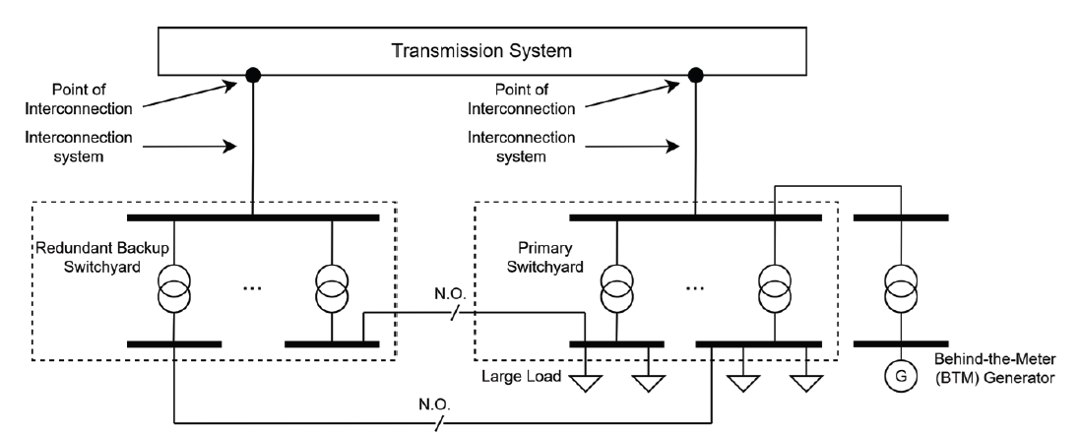
Figure 66: High-level illustrative examples of grid connection for large loads [160].
While utility supply is typically arranged with redundancy to ensure reliable delivery of power, the electrical infrastructure within the customer boundary of a data centre is likewise designed to provide continuous and highly reliable power. This is achieved through built-in redundancy, backup systems, and multiple supply paths to prevent service interruptions. Power generally enters the customer switchyard at high voltage (HV) or medium voltage (MV) levels. The HV/MV busbar may be connected to switchgear, harmonic filters, shunt reactive compensation devices, power factor correction equipment, dynamic reactive power support systems, and other auxiliary loads. These components ensure voltage regulation, power quality, and compliance with grid requirements. MV-to-low voltage (LV) transformers then step the voltage down to suitable levels for internal distribution within the data centre. The LV network typically supplies critical loads such as IT equipment (via UPS systems), as well as large cooling units that are essential for maintaining thermal constraints and ensuring reliable operation of servers and associated infrastructure ‎[148]. Figure 67 shows an illustrative the electrical infrastructure of a data centre (i.e., generic data centre).
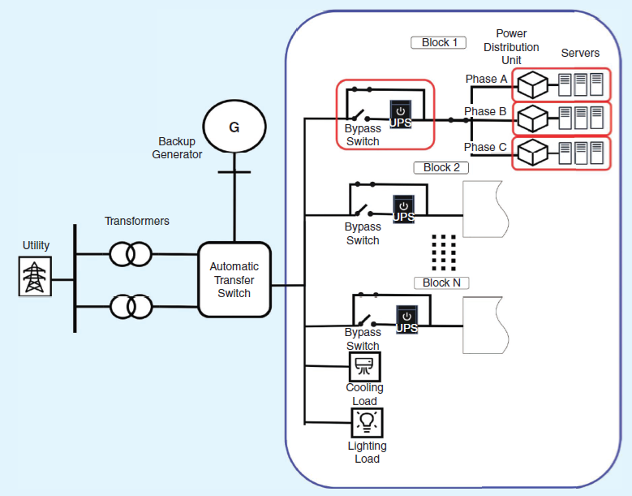
Figure 67: Generic model of the data centre [160].
From Figure 65 and Figure 66, it is evident that many of the key components of the large load are already represented within the CMLD load model. Therefore, the development of the large load model has been done in this work using the CMLD load model as the foundational framework. This approach ensures consistency with established modelling practices while enabling appropriate modifications and extensions to accurately capture the specific operational characteristics and dynamic behaviour of the data centre load under both normal and disturbed operating conditions. Parameters given in “Developing dynamic load models for the Australian Eastern interconnected system,” Power and Energy, Analysis, Consulting and Education (PEACE), 2020, were used for the initial study [162]. The parameters of this model have been retuned to obtain the similar point of common coupling responses as given in Figure 65 and Figure 66. The CMLD includes the following components, as described in Section 3 of this report:
- Distribution transformers equipped with on-load tap changers (OLTCs).
- Explicit substation shunt capacitors.
- An aggregated equivalent representation of the distribution feeders supplying end-use loads, including internal feeder compensation that is calculated to match the transmission-level active and reactive power (MW/MVAr).
- Aggregated end-use load components at the feeder level, comprising three-phase induction motors (Motors A, B, and C), a performance-based residential air-conditioning model (Motor D), and power electronic and static (ZIP) loads. Motor D, developed from laboratory testing, represents single-phase residential induction motor loads such as air conditioners and refrigeration compressors.
- The North American DER_A model [73] is integrated into the WECC Composite Load Model to provide a single aggregated representation of the distribution feeder, including both the composite load and feeder-level distributed energy resources (DERs). The model specification is publicly available on the WECC website [73].
Among these components, only the parameters associated with Motors A–D and the DER_A model, as described in the AEMO report [], were varied during the sensitivity study. The objective was to calibrate the modified CMLD so that its fault ride-through response at POC closely matches that of the detailed large load model, while all other model components and parameters remain unchanged.
The following models have been developed in this stage (stage 5):
- Phasor domain power flow model.
- Phasor domain transient (PDT) dynamic model – standard library model.
The large load model has been assessed in accordance with the Dynamic Model Acceptance Test Guideline, as described in the following section.
The generic model of the large load has been developed for stability studies in the frequency range below 10–15 Hz [161],[162]. The model structure is based on a fundamental understanding of the large load characteristics and its associated control systems. It is worth noting that, unlike generation facilities, there is currently no explicit requirement for large loads to provide grid support services, nor are there stringent obligations for load facilities to submit detailed dynamic models comparable to those required for generators. Therefore, a suitably parameterised generic model is considered sufficient for assessing system stability impacts within the electromechanical frequency range.
Since electromagnetic transient (EMT) models are highly detailed and computationally intensive, it is more appropriate to develop them for specific facilities rather than adopting a fully generic approach. Detailed EMT models should therefore be prepared on a case-by-case basis, guided by a risk-based assessment framework as outlined in the Australian Energy Market Operator Power System Model Guidelines [161].
The risk-based assessment typically considers the following factors:
- The size and electrical strength of the connection point (e.g., fault level and system strength).
- The penetration level of inverter-based resources (IBRs) in the surrounding network.
- The use of grid-forming or advanced converter control strategies.
- Proximity to system constraints or known oscillatory modes.
- The potential for adverse interactions with nearby generation, FACTS devices, or other large loads.
- Historical evidence of control interactions, harmonic issues, or instability in similar network conditions.

Methodology

Overview of Dynamic Model Acceptance Test
The Australian Energy Market Operator (AEMO) has prepared this Guideline to explain how it assesses the accuracy, consistency, and robustness of computer models used for power system analysis. The acceptance test report outlines the process for conducting Dynamic Model Acceptance Tests (DMATs) for both root mean square (RMS) and electromagnetic transient (EMT) models [163]. DMATs are required to provide confidence that a model is usable, numerically stable, and capable of accurately representing the installed plant under reasonably expected operating conditions.
The objectives of the acceptance tests described in this document are to determine whether:
- The model accurately represents the physical plant and its control systems.
- The model behaves correctly under steady-state and dynamic (disturbance) conditions.
- The model is numerically stable and robust across a range of operating scenarios.
- The model produces consistent and repeatable results.
- The model complies with AEMO’s modelling standards and performance requirements.
- The model is suitable for use in power system planning, operational studies, and system security assessments.
The following tests are outlined in the DMAT report for generators and battery energy storage systems.
- Load flow and load ramp.
- Flat run test - test duration of 5 s and 300 s.
- Balanced fault -large disturbance test for the fault duration of 0.43 s and 0.5 s.
- Unbalanced fault - large disturbance test for the fault duration of 0.43 s and 0.5 s.
- Initialisation test.
- Multiple-fault ride-through test.
- Temporary overvoltage test for 0.1 s and 0.9 s.
- Voltage reference step change.
- Active power controller reference step change.
- Grid-frequency controller test.
- Grid voltage change -response test.
- Grid voltage angle change response.
- FRT assessment for site-specific SCR and X/R.
- Input-power source step change.

Dynamic Model Acceptance Test
However, there is currently no formal guideline for testing and validating large load dynamic models. It is important to note that not all tests applicable to generators and battery energy storage systems are suitable for large load models. Therefore, in consultation with an AEMO representative, we have developed the following dynamic model acceptance tests specifically for large loads:
- Load flow and load ramp.
- Flat run test - test duration of 5 s and 300 s.
- Balanced fault -large disturbance test for the fault duration of 0.43 s and 0.5 s.
- Unbalanced fault - large disturbance test for the fault duration of 0.43 s and 0.5 s.
- FRT assessment for site-specific SCR and X/R.
It should be worth noting that the dynamic model acceptance tests used in this work are also aligned with the NERC FAC 002 – Interconnection Standards for Transmission Planner. NERC FAC 002 (Interconnection Standards for Transmission Planner) is provided in Apx Table 11 in the Appendix A1.

Test System and Numerical Simulations
The following two simple test systems (given in Figure 68 (a) and (b)), as recommended in the Dynamic Model Acceptance Test (DMAT) report, are used in this work to perform the dynamic acceptance testing of the large load model. It is worth noting that the wind turbine model shown in Figure 67 (a) is represented using a grid-forming converter with virtual synchronous generator (VSG) control. The model parameters have been adopted from the Australian Energy Market Operator (AEMO) Dynamic Model Acceptance Test guidelines [163]. Furthermore, to capture the interaction between multiple wind turbines and their associated control systems, the wind generators are modelled using collector systems with parallel-connected generator units. This approach enables a more realistic representation of aggregated wind farm behaviour and control interactions under dynamic conditions.
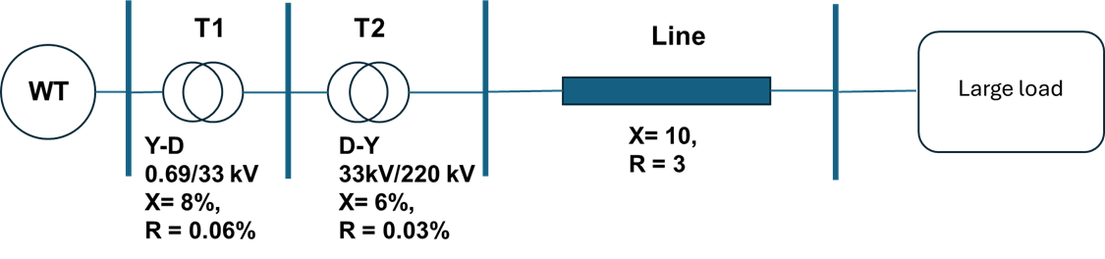
(a)
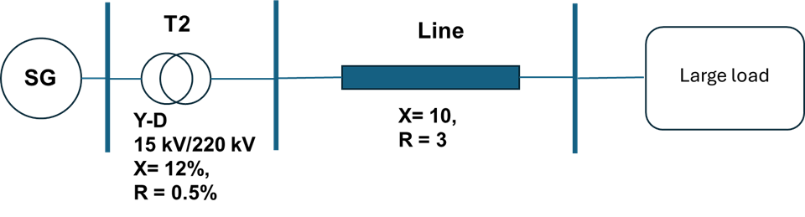
(b)
Figure 68: Network for dynamic model acceptance test: (a) Network with wind turbine; (b) Network with Synchronous generator ‎[150].
The outcomes of the model acceptance tests are presented in Table 28. The load flow and load ramp studies were performed to verify the steady-state operating point and to assess the system response under gradual loading variations. The flat run tests with durations of 5 s and 300 s were conducted to confirm that the dynamic model remains in equilibrium and precisely preserves the initial operating point obtained from the load flow solution. The flat run test with large-load models has confirmed that the system maintains equilibrium and precisely preserves the initial condition of the load-flow solution with the proposed models (e.g., the model is ready for dynamic studies).
Furthermore, large disturbance tests under both balanced and unbalanced fault conditions were carried out to investigate the transient stability and robustness of the system during severe network disturbances. These tests were essentially examining oscillatory behaviour and recovery capability under symmetrical and asymmetrical faults. The large disturbance test results demonstrated that the developed dynamic model accurately captures system transient behaviour under both balanced and unbalanced fault conditions without any convergence issue. During the balanced three-phase fault, the system experienced significant voltage reduction and temporary power oscillations, while maintaining overall stability and recovering successfully after fault clearance. Under unbalanced fault conditions, the model effectively represented phase asymmetry and negative-sequence dynamics, with stable post-fault recovery observed in all key electrical variables. These results confirm the suitability of the developed model for transient stability analysis and grid disturbance assessment studies. In addition, the fault-ride-through (FRT) test confirmed the capability of the system to remain connected and operational during temporary voltage disturbances, which is a critical requirement for modern grid-connected inverter-based resources. Overall, the successful completion of all recommended simulation cases demonstrates that the proposed system satisfies the necessary operational and stability requirements under both normal and disturbed grid conditions.

Table 28: Dynamic model acceptance tests for large loads.
Recommended Simulation Case | Status
Load flow and load ramp | ☑
Flat run test - test duration of 5 s and 300 s | ☑
Large disturbance test (balanced fault) | ☑
Large disturbance test (unbalanced fault) | ☑
Fault-ride through test | ☑

For the voltage and small-signal stability studies, a reduced representation of the South-East Australian Power System has been considered, as shown in Figure 69. The detailed model parameters and network data are available in the reference [78] and therein. To reflect the current renewable energy penetration levels, the system has been modified as illustrated in [163] (please see Table 29). Initially, power flow studies were conducted to assess steady-state security constraints in the presence of large loads. Subsequently, small-signal stability analysis was performed with respect to the base case (as presented in [78]) to examine the potential emergence of new oscillatory modes in the electromechanical time frame. This sequential approach ensures that both steady-state operating limits and dynamic performance characteristics are adequately evaluated under increased renewable integration and large load conditions.
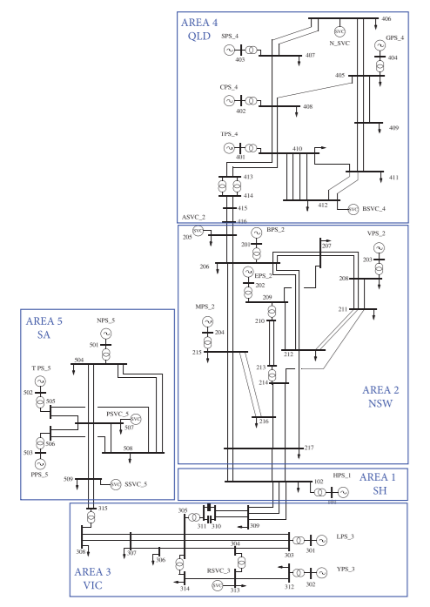
Figure 69: Simplified 14 Generator Australian Power System.
Two different test systems have been deliberately used in this work. A single-generator model has been employed to evaluate the dynamic responses of the load and to identify any convergence issues associated with the large load models. In contrast, a simplified 14-generator Australian power system model has been used to investigate voltage and angle stability performance.
Table 29: Operation scenarios.
Loading scenario | Renewable Generations
Medium loading | Wind in area 5, aggregated solar in Area 4 and Area 3
Medium to heavy | Wind in area 5, aggregated solar in Area 4 and Area 3
Heavy loading | Wind in area 5, aggregated solar in Area 4 and Area 3

A detailed assessment of the high-, medium-, and low-frequency inter-area modes was conducted to evaluate frequency shifts, damping variations, and the potential emergence of new modes within the inter-area frequency range. The analysis confirmed that no new inter-area modes were introduced [164].
The impact of the large load was further evaluated using the Transient Voltage Stability Index (TVSI) and the Transient Stability Index (TSI), as summarised in Table 30. The results indicate no abnormal or abrupt variations in either index beyond the anticipated changes.
Table 30: Stability results.
Loading scenario | TVSI | TSI
Medium loading | 0.145 | 92
Medium to heavy | 0.157 | 89
Heavy loading | 0.162 | 87
Pacific Northwest National Laboratory has recently proposed six different large load models, specifically for data centre applications (see Table 31). Figure 70 and Figure 71 illustrate the simple data centre model and the data centre model with LV DC distribution, respectively. Initially, these two models were integrated into the systems shown in Figure 67(a)–(b) to conduct dynamic model acceptance testing before being applied to the system presented in Figure 68.
Table 31: Different data centre load models [165].
Model | Description
1 | Simple
2 | Centralised UPS
3 | Distributed UPS
4 | LV DC Distribution
5 | MV Solid State Transformer
6 | MV DC Distribution

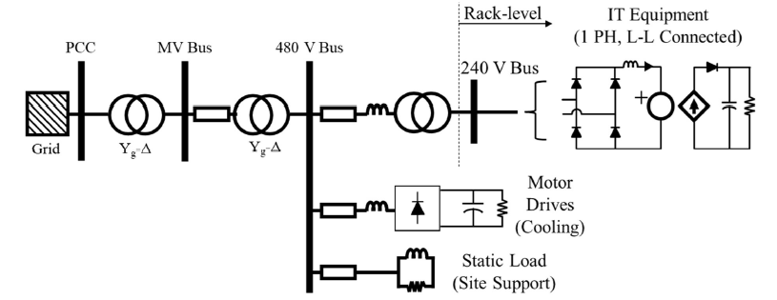
Figure 70: Simple model [165].
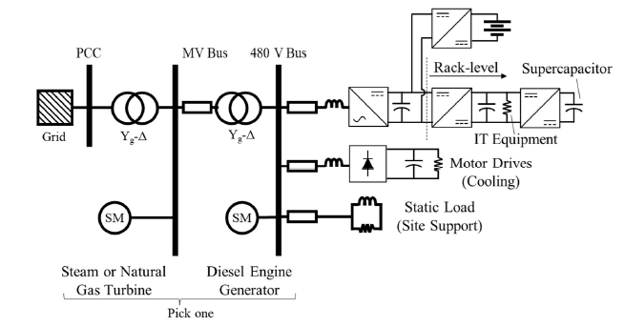
Figure 71: Data centre model with LV DC distribution [165].
Table 32 presents the different large-load models considered in this study, ranging from highly detailed representations to simplified aggregated models. The detailed model (M1) provides a comprehensive representation of the large load, including collector systems, inverter-based generation, battery storage, static loads, and transformers. This model is primarily used as a benchmark to capture the detailed electromechanical dynamics and interactions among different load components.
The aggregated single converter model (M2) simplifies the representation by modelling the large load as a single inverter-based unit, similar to an inverter-based generation system. This approach reduces modelling complexity while preserving the dominant dynamic characteristics associated with converter-based loads.
The modified CMLD (M3) extends the conventional load representation by incorporating an aggregated distribution feeder, transformer, static load, motor load, and distributed photovoltaic (PV) generation. This model enables the analysis of the interaction between distributed energy resources and conventional load dynamics under disturbed operating conditions.
The PNNL Model 2 (M4) further represents the load using static components, rectifier-based motor loads, and aggregated medium-voltage (MV) and low-voltage (LV) transformers. This configuration is suitable for studying the impact of power-electronic-interfaced motor loads on system dynamic performance.
Finally, the PNNL Model 3 (M5) provides the most comprehensive aggregated representation among the simplified models by including static loads, rectifier-based motors, grid-forming inverter-based battery systems, gas generators, diesel generators, and aggregated MV/LV transformers. This model captures the interactions between converter-dominated resources and conventional rotating generation sources, making it suitable for voltage and angle stability assessments in weak grid conditions.
Table 32: Five data centre load models used for stability studies.
Load Type | Description
Detail model (M1) | This model includes the detailed representation of a large load, including collector systems, an inverter-based generator, a battery, a static load, transformer.
Aggregated single converter model (M2) | Single inverter-based loads are similar to inverter-based generation.
Modified CMLD model (M3) | CML load with aggregated distribution feeder, transformer, static model, motor load and distributed PV.
PNNL Model 2 (M4) | Static load, rectifier-based motor, aggregated MV and LV transformer.
PNNL Model 3 (M5) | Static load, rectifier-based motor, grid-forming inverter-based battery, gas generator, diesel generator, aggregated MV and LV transformer.

Table 33 presents the TVSI values obtained under different loading conditions for the five large-load models as outlined in Table 32. The results indicate that the TVSI increases progressively as the loading condition changes from medium to heavy loading for all models, demonstrating a reduction in voltage stability margin with increased system stress.
Among the investigated models, the detailed model (M1) consistently produces the highest TVSI values under all loading conditions, with values increasing from 0.255 under medium loading to 0.279 under heavy loading. This indicates that the detailed representation captures stronger dynamic interactions and higher voltage stability sensitivity compared to the aggregated models.
The aggregated single converter model (M2) and modified CMLD model (M3) exhibit similar trends and produce comparable TVSI values. However, M3 generally results in slightly lower TVSI values than M2, suggesting that the inclusion of aggregated feeder dynamics, motor loads, and distributed PV slightly improves the overall voltage stability performance.
PNNL Model 2 (M4) produces the lowest TVSI values across all loading scenarios, ranging from 0.223 to 0.243. This indicates comparatively improved voltage stability characteristics, potentially due to the simplified aggregated representation of the load and transformer components.
PNNL Model 3 (M5), which includes grid-forming battery systems and conventional generation sources, produces intermediate TVSI values between M3 and M4. The results suggest that the additional support from inverter-based battery systems and conventional generators contributes positively to voltage stability performance under increased loading conditions.
Table 33: TVSI values for five different load models.
Loading conditions | TVSI (M1) | TVSI (M2) | TVSI (M3) | TVSI (M4) | TVSI(M5)
Medium loading | 0.255 | 0.246 | 0.245 | 0.223 | 0.243
Medium to heavy loading | 0.268 | 0.258 | 0.256 | 0.234 | 0.253
Heavy loading | 0.279 | 0.273 | 0.261 | 0.243 | 0.259

Table 34 presents the Transient Stability Index (TSI) values for the five large-load models under different loading conditions. The results show that the TSI decreases as the system loading increases from medium to heavy loading, indicating a reduction in angle stability margin and overall transient stability performance under stressed operating conditions.
The detailed model (M1) consistently exhibits the highest TSI values among all investigated models, with values decreasing from 92 under medium loading to 87 under heavy loading. This indicates that the detailed representation of the large load maintains comparatively stronger transient stability characteristics and better captures the electromechanical support provided by the interconnected components.
The aggregated single converter model (M2) produces lower TSI values than M1 across all loading conditions, suggesting that simplified inverter-based representations may not fully capture the dynamic interactions present in the detailed model. Similarly, the modified CML model (M3) shows a further reduction in TSI values, particularly under heavy loading where the index decreases to 74. This behaviour indicates that the inclusion of aggregated feeder dynamics, motor loads, and distributed PV increases the sensitivity of the system to transient disturbances.
PNNL Model 2 (M4) produces the lowest TSI values under all loading conditions, with the index decreasing from 81 during medium loading to 73 under heavy loading. These results suggest comparatively weaker angle stability performance for this model configuration. In contrast, PNNL Model 3 (M5), which includes grid-forming battery systems and conventional generators, demonstrates improved transient stability performance compared to M3 and M4, particularly under heavy loading conditions where the TSI remains at 77. The additional inverter-based and synchronous generation support contributes positively to maintaining rotor angle stability following disturbances.
Overall, the results demonstrate that the selection of large-load models significantly affects transient stability assessment outcomes, especially under high loading conditions where system stability margins become increasingly critical.
Table 34: TSI values for five different load models.
Loading conditions | TSI (M1) | TSI (M2) | TSI (M3) | TSI (M4) | TSI(M5)
Medium loading | 92 | 86 | 83 | 81 | 82
Medium to heavy loading | 89 | 83 | 81 | 79 | 81
Heavy loading | 87 | 80 | 74 | 73 | 77

Chapter Summary
The rapid growth in high-density electrical demand from AI-driven facilities, cryptocurrency operations, and green hydrogen production represents a structural shift in load composition, with significant implications for system adequacy, stability, and operational resilience. This study has addressed limitations of various large converter-dominated loads, particularly data centers, in the context of power system voltage stability. A generic large-load dynamic model was developed using the CMLD framework as a foundation and extended to capture the internal architecture and control characteristics typical of modern data centres. The model is suitable for electromechanical stability analysis in the frequency range below 10–15 Hz and is compatible with phasor-domain (RMS) simulation environments used for planning and operational studies.

Part III Conclusions and Future Work

Conclusions and Future Work

Conclusions
Stage 5 of the CSIRO AR-PST Topic 2 project has substantially advanced the technical understanding and practical assessment of stability phenomena in power systems with high penetration of inverter-based resources (IBRs) and emerging large converter-dominated loads. The work delivered an integrated, technically defensible framework encompassing small-signal stability, small- and large-disturbance voltage stability, dynamic performance metrics, and scalable large-load modelling. Collectively, these outcomes enhance transmission system operators’ and planners’ ability to manage the transition toward low-inertia, power-electronics-dominated networks.
A central project-level finding is that voltage stability margins are increasingly influenced by both supply-side changes—such as inverter controls, reduced inertia, and system strength—and demand-side evolution, particularly large, concentrated converter loads. These effects can compound under contingencies. Proper selection and tuning of inverter controls, advanced stability indices (DVRI/sysDVRI, SDVPI and SSOASI), and validated large-load models are essential for maintaining system resilience and informing operational and planning decisions.
The main conclusions from the five work packages are summarized below:
- Small-Signal Stability (SSS):
The project established a comprehensive methodological foundation combining state-space (eigenvalue-based) and data-driven approaches. Representative SMIB and IEEE 39-bus test systems enabled scalable evaluation of grid-following and grid-forming inverter behaviours. Eigenvalue and modal analyses identified the control parameters and state variables most influential on oscillatory modes. The study confirmed that while FVC and PVC controls generally maintain robust damping across grid strengths, AVR-controlled GFMIs can experience reduced stability margins due to outer-loop interactions; although performance is comparable in weak grids, AVR configurations showed susceptibility to low-frequency oscillations and reduced robustness under strong-grid (high SCR) conditions, highlighting the need for careful tuning. In parallel, the proposed GPR- and ERA-based data-driven time-domain framework demonstrated high prediction accuracy for black-box stability assessment when detailed vendor models are unavailable.
Dynamic Voltage Signature: Stage 5 introduces advanced stability indices specifically designed for inverter-based resource (IBR) dominated networks. For large-disturbance analysis, the Dynamic Voltage Resilience Index (DVRI) and its system-wide extension (sysDVRI) improve upon conventional scalar metrics by using a vector-based approach to simultaneously quantify short- and long-term voltage stability. This methodology integrates statistical classification utilising moving standard deviation and kernel density estimation to automate the detection of oscillatory recovery patterns, providing scalable real-time monitoring validated on the NEM Area 5 system.
Small-disturbance voltage stability is assessed via the Small-Disturbance Voltage Proximity Index (SDVPI), a computationally efficient tool based on adaptive continuation load flow that quantifies a system’s proximity to voltage collapse. By identifying weak buses and tracking how increased renewable penetration reduces stability margins, SDVPI serves as a vital tool for planning and contingency screening. Finally, the Small-Signal Operating Area Security Index (SSOASI) translates complex modal damping characteristics into a practical scalar metric. This index effectively captures the degradation of damping performance caused by reduced inertia and IBR control interactions, offering a systematic way to assess operational security limits in future low-inertia power systems.
- Large-Disturbance Voltage Stability (LDVS):
The LDVS studies quantified system behaviour following severe contingencies using detailed time-domain simulations with AEMO composite load models. The work highlighted the growing sensitivity of voltage recovery to renewable penetration, reduced system strength, and limited fault current contribution from IBRs. Adaptive continuation analysis further identified critical contingencies and weak buses, enabling more targeted voltage support planning. Importantly, the combined short-term and long-term assessment framework provides operators with improved visibility of delayed voltage risks that may not be evident from traditional screening.
- Small-Disturbance Voltage Stability (SDVS):
Continuation power flow studies demonstrated that incremental load growth, increased renewable penetration, and large concentrated loads can materially reduce voltage stability margins. The analysis quantified loadability limits and P–V characteristics under evolving operating conditions, providing practical inputs for operational planning and security assessment. The results reinforce that reactive power capability, load composition, and network strength must be jointly considered in future planning studies.
- Large-Load Modelling:
To address the rapid emergence of converter-dominated demand, the project developed a generic dynamic large-load model based on the Composite Load Model (CMLD) framework. The model captures key characteristics of power electronic based load behaviour, internal redundancy, and ride-through capability and it is suitable for RMS/phasor-domain electromechanical studies below 10–15 Hz. The accompanying Dynamic Model Acceptance Test (DMAT) framework, developed in consultation with AEMO, establishes a practical pathway for standardized validation and integration of large load models into planning workflows.

Future Work
The future research directions for this topic are motivated by unresolved stability and modelling challenges in inverter-dominated power systems, particularly those arising from weak-grid conditions, high renewable penetration, fast control interactions, and emerging large converter-interfaced loads, where robust assessment and mitigation of stability issues remain critical gaps. The proposed future research directions are based on the research priorities of the 2021 roadmap for Topic 2, with a focus on stability assessment methodologies.
The following outlines the key future research directions, prioritised based on their criticality and urgency. Each item builds on the findings of Stage 5 and aims to further enhance both small- and large-signal stability in IBR-dominated networks, addressing challenges associated with high renewable penetration, fast control dynamics, and emerging large converter-dominated loads.
- Small-Signal Stability (SSS):
  - Using joint time- and frequency-domain analysis for more effective small signal stability assessment. Previous work has placed significant emphasis on developing frequency-domain methods for small-signal stability assessment. Future work can jointly analyse time and frequency domains for small-signal stability evaluation, considering different control strategies of IBRs.
  - One key challenge in this regard is the black-box nature of converter models (due to IP restrictions imposed by converter vendors), which prevents system operators and planners from fully understanding the dynamic behaviour of these new devices. This work will aim to use physics-informed machine learning to identify the parameters of converter model structures using a measurement-based approach.
  - Evaluating small-signal stability of power systems with different IBR controls using the developed data-driven time-domain black-box model in stage-5.
  - Future works also include comparing the developed black-box model in stage-5 with the real-world issues and OEM specific models.
- Dynamic Voltage Signature:
In Stage 5, the proposed adaptive CPF-based SDVPI was limited by quasi-steady-state assumptions, focusing only on the static saddle-node bifurcation (SNB) and overlooking dynamic Hopf bifurcations (HB) critical to IBR-dominated grids. To address this, the future work proposes a Small-Disturbance Voltage Assessment Index (SDAI). This framework integrates both static and dynamic analyses to capture complex HB and SNB interactions, ensuring a comprehensive assessment of IBR and IBL stability. The tasks will include:
  - Development of a Linear–Nonlinear Framework: The proposed SDAI will incorporate the nonlinear dynamics of IBRs and IBLs, including PLL synchronization, fast current limiting, and control mode switching (e.g., PQ to voltage control). These dynamics can introduce voltage oscillations and interactions that are not captured by conventional linear or static models.
  - Development of a Hybrid Static–Dynamic Framework: The proposed SDAI will simultaneously quantify the dynamic stability margin (DSM) and static stability margin (SSM) following a small disturbance. The framework will integrate static and dynamic analyses based on saddle-node bifurcation (SNB) and Hopf bifurcation (HB) by developing differential-algebraic equations (DAE) of the system and solving it. A vector-based representation will be utilised to enable comprehensive and quantitative stability assessment similar to the LDVS in stage 5.
  - Network-Wide Propagation Analysis: The proposed approach will extend stability assessment beyond individual buses by evaluating SDAI across multiple network locations. This enables the characterization of disturbance propagation, spatial interactions, and overall system voltage recovery.
  - Benchmarking with adaptive CPF and Time-Domain Simulation: The SSM and DSM corresponding to post-disturbance operating conditions will be evaluated using adaptive CPF and time-domain simulation methods. The proposed SDAI will be validated against these CPF and Time-Domain Simulation based analysis, to ensure accuracy and consistency.
  - Sensitivity Analysis: The framework will assess the impact of variations in load composition (e.g., dynamics versus ZIP loads), generation mix (e.g., IBR versus SMs), and network contingencies on voltage stability.
- Large-Disturbance Voltage Stability (LDVS):
  - To perform STVS assessment considering network topology changes using an effective data-driven approach with adequate learning capability to capture spatio-temporal characteristics of this problem.
  - To evaluate the effects of voltage-current dual-loop control on the voltage support capability of VSGs (GFMs) and to investigate the dynamic interactions between GFM and GFL converters for improving voltage stability.
  - To identify voltage control areas including optimum location of control devices (e.g., VSGs, SVCs, STATCOMs, BESSs) and critical contingencies in each area. Subsequently, to mitigate fault-induced delayed voltage recovery (FIDVR) using a Deep Reinforcement Learning (DRL)-based control strategy.
  - To develop hybrid machine-learning frameworks that leverage historical system data for robust baseline training while enabling real-time adaptive learning to ensure sustained stability monitoring accuracy and fast operational decision support under evolving grid conditions.
  - To develop voltage stability assessment frameworks that remain reliable under extreme class imbalance (e.g., >200:1), by addressing training instability and poor representation of rare instability events using stabilization techniques such as spectral normalization, curriculum-based sampling, hybrid resampling and deep generative AI techniques.
  - To investigate the impact of renewable energy intermittency and fluctuations on voltage stability assessment while addressing unbalanced sample generation (for instance using active learning techniques). In addition, to incorporate more realistic PMU measurement error models, including non-Gaussian noise characteristics, to improve model robustness under practical operating conditions.
  - To perform multi-timescale dynamic simulation to capture the interaction between fast and slow dynamics for accurately assessing LTVS.
- Small-Disturbance Voltage Stability (SDVS):
  - Integrate physics-informed neural networks (PINNs) to enforce power flow and dynamic stability constraints in data-driven models, enhancing both small- and large-disturbance voltage stability predictions with limited training data.
  - Use machine‑learning surrogates to approximate small‑disturbance voltage stability margins, trained on offline adaptive CPF results.
  - Develop PMU‑based, model‑light indices (using AI techniques) that can track small‑signal voltage security in real time under high IBR penetration.
  - Apply transfer learning so that AI models for voltage stability assessment stay accurate when topology, dispatch, or IBR mix changes.
  - Build distribution‑level AI tools for small‑disturbance voltage stability assessment, then embed them into integrated T–D assessments.
  - Add uncertainty‑aware AI (e.g., deep generative AI) techniques to turn small‑disturbance margins into risk‑based, probabilistic security indicators.
- Large-Load Modelling:
  - A data-driven large load generic framework (RMS/EMT) for stability studies will be developed. This framework will guide the types of large load models that should be used for various power system stability studies.
  - Existing dynamic load models in commercial software packages lack sufficient control and protection components to properly model large loads such as data centres. Future research would focus on this.
  - Reactive power capability and support services from the large load would be explored.
  - An appropriate model of distribution system with distinct dynamics of the IBR for transmission system stability studies, i.e., interaction of TSO/DSO in the stability boundary, will be developed.

Appendix
- Additional Data and Results
Apx Table 1: Power system dynamic voltage signature of kth bus.
$${STVM}_{K}$$ | $${LTVM}_{K}$$ | DYNAMIC SIGNATURE | COMMENTS
+1 | +1 | Voltage recovers to its pre-fault values | Short-term voltage stable (STVS) and long-term voltage stable (LTVS)
+ve | +1 | Short-term voltage within the WECC criterion and  long-term voltage recovers to its pre-fault values | STVS and LTVS
+1 | +ve | Short-term voltage recovers to its pre-fault values, and long-term voltage within the WECC criterion | STVS and LTVS
+ve | +ve | Short-term voltage and long-term voltage within the WECC criterion | STVS and LTVS
+1 | -ve | Short-term voltage recovers to its pre-fault values, but long-term voltage violates the WECC criterion | STVS and long-term voltage unstable (LTVU)
-ve | +1 | Short-term voltage violates the WECC criterion, but long-term voltage recovers to its pre-fault values | Short-term voltage unstable (STVU) and LTVS
-ve | +ve | Short-term voltage violates the WECC criterion, but long-term voltage within the WECC criterion | STVU and LTVS
+ve | -ve | Short-term voltage within the WECC criterion, but long-term voltage violates the WECC criterion | STVS and LTVU
-ve | -ve | Short-term voltage and long-term voltage violate the WECC criterion | STVU and LTVU

Apx Table 2: Pseudocode of the entire calculation process of ${}_{sys}^{k}{DVRI}$.

Step-1: Identification of an oscillatory and non-oscillatory voltage waveform
1: Calculate mSD for ORVW and NRVW
2: Compute PDF, CDF and ∑CDF of mSD profile through KDE
3: If ∑CDF of mSD of any STVS or LTVS ≥ 1:
4: Flag: sysSTVI or sysLTVI= -1
5: Comments: System is either STVU or LTVU
6: end
7: else-GOTO step-2
Step-2: Computation of local STVI and LTVI
8: Define WECC and Calculate %VD
9: Compute $μ_{k,n}^{ST} and μ_{k,n}^{LT}$ as a $f\{\%VD_{k,n}($WECC)}
10: if STVI or LTVI < 0
11: Flag: sysSTVI or sysLTVI= -1
12: Comments: System is either STVU or LTVU
13: end
14: else-GOTO step-3
Step-3: Computation of sysSTVI or sysLTVI
15: Calculate $Z_{k,k}, Z_{k,l}$ and $γ_{k,l}$
16: Compute sysSTVI and sysLTVI
17: if sysSTVI δδ sysLTVI < 0
18: Comments: System is either STVI or LTVI
19: end
20: else
21: Comments: System is both STVS or LTVS
22: end
Apx Table 3: The value of SDVPI of different buses for 6% renewables in IEEE 39 bus system.
Bus \ Scaling | 0 | 0.05 | 0.11 | 0.18 | 0.26 | 0.36 | 0.46 | 0.48 | 0.49 | 0.5
Bus 03 | 1 | 0.91791 | 0.927838 | 0.912753 | 0.87509 | 0.806659 | 0.663482 | 0.596604 | 0.505196 | 0
Bus 04 | 1 | 0.89158 | 0.896492 | 0.876683 | 0.832042 | 0.75272 | 0.56945 | 0.467127 | 0.337385 | 0
Bus 07 | 1 | 0.892532 | 0.895287 | 0.870951 | 0.816728 | 0.718954 | 0.483093 | 0.35374 | 0.192371 | 0
Bus 08 | 1 | 0.892094 | 0.894018 | 0.867163 | 0.808481 | 0.702651 | 0.452105 | 0.319393 | 0.153754 | 0
Bus 12 | 1 | 0.888729 | 0.891464 | 0.872548 | 0.831588 | 0.759996 | 0.584699 | 0.468227 | 0.323141 | 0
Bus 15 | 1 | 0.896387 | 0.908102 | 0.89557 | 0.86429 | 0.808991 | 0.692589 | 0.632099 | 0.556398 | 0
Bus 16 | 1 | 0.91411 | 0.92914 | 0.921766 | 0.899064 | 0.85771 | 0.772933 | 0.73184 | 0.679531 | 0
Bus 18 | 1 | 0.912911 | 0.924344 | 0.91109 | 0.877651 | 0.8175 | 0.6951 | 0.639102 | 0.564474 | 0
Bus 20 | 1 | 0.960324 | 0.964428 | 0.961298 | 0.953632 | 0.940969 | 0.918578 | 0.909166 | 0.897592 | 0
Bus 21 | 1 | 0.915648 | 0.931328 | 0.926697 | 0.909744 | 0.878697 | 0.816445 | 0.786954 | 0.749626 | 0
Bus 23 | 1 | 0.940141 | 0.95386 | 0.952726 | 0.943818 | 0.926731 | 0.892316 | 0.876012 | 0.855373 | 0
Bus 24 | 1 | 0.919202 | 0.936271 | 0.931046 | 0.911457 | 0.874846 | 0.798875 | 0.761753 | 0.714445 | 0
Bus 25 | 1 | 0.959656 | 0.947868 | 0.9248 | 0.888776 | 0.831014 | 0.726616 | 0.687235 | 0.628575 | 0
Bus 26 | 1 | 0.933382 | 0.933276 | 0.91688 | 0.886538 | 0.836249 | 0.743961 | 0.707385 | 0.657613 | 0
Bus 27 | 1 | 0.915818 | 0.919705 | 0.903913 | 0.871935 | 0.817795 | 0.715316 | 0.672194 | 0.61486 | 0
Bus 28 | 1 | 0.949182 | 0.952614 | 0.944198 | 0.927316 | 0.899267 | 0.849023 | 0.829612 | 0.803415 | 0
Bus 29 | 1 | 0.962041 | 0.965659 | 0.960217 | 0.948714 | 0.929442 | 0.894899 | 0.881523 | 0.863444 | 0
Bus 31 | 1 | 1 | 1 | 1 | 1 | 1 | 0.880833 | 0.773838 | 0.647041 | 0

Apx Table 4: The value of SDVPI of different buses for 13% renewables in IEEE 39 bus system.
Bus \ Scaling | 0 | 0.05 | 0.11 | 0.18 | 0.26 | 0.36 | 0.41 | 0.44 | 0.47 | 0.48
Bus 03 | 1 | 0.928421 | 0.933222 | 0.912044 | 0.869078 | 0.793299 | 0.73848 | 0.683635 | 0.572249 | 0
Bus 04 | 1 | 0.895514 | 0.898435 | 0.874362 | 0.825739 | 0.740326 | 0.678534 | 0.608083 | 0.453233 | 0
Bus 07 | 1 | 0.894257 | 0.896 | 0.867473 | 0.809261 | 0.704976 | 0.627757 | 0.535675 | 0.346318 | 0
Bus 08 | 1 | 0.893888 | 0.894469 | 0.863224 | 0.800332 | 0.687527 | 0.603587 | 0.50645 | 0.312647 | 0
Bus 12 | 1 | 0.89045 | 0.892372 | 0.870334 | 0.826376 | 0.750031 | 0.695293 | 0.629821 | 0.45883 | 0
Bus 15 | 1 | 0.898963 | 0.909285 | 0.893886 | 0.859856 | 0.800384 | 0.758432 | 0.715048 | 0.621677 | 0
Bus 16 | 1 | 0.916331 | 0.930214 | 0.920418 | 0.89538 | 0.850541 | 0.818808 | 0.787078 | 0.72166 | 0
Bus 18 | 1 | 0.919146 | 0.9273 | 0.909614 | 0.87209 | 0.806043 | 0.758812 | 0.712431 | 0.619945 | 0
Bus 20 | 1 | 0.960608 | 0.964724 | 0.961045 | 0.952862 | 0.939436 | 0.930576 | 0.922481 | 0.907546 | 0
Bus 21 | 1 | 0.917362 | 0.932163 | 0.925792 | 0.907164 | 0.873623 | 0.850097 | 0.826926 | 0.779977 | 0
Bus 23 | 1 | 0.941233 | 0.954393 | 0.952263 | 0.94241 | 0.923933 | 0.910924 | 0.898111 | 0.872104 | 0
Bus 24 | 1 | 0.921302 | 0.937294 | 0.929844 | 0.90812 | 0.868341 | 0.840005 | 0.811507 | 0.752348 | 0
Bus 25 | 1 | 0.948386 | 0.934762 | 0.908802 | 0.867296 | 0.799448 | 0.751914 | 0.709581 | 0.625947 | 0
Bus 26 | 1 | 0.932381 | 0.930048 | 0.910923 | 0.877014 | 0.820722 | 0.781627 | 0.746175 | 0.679092 | 0
Bus 27 | 1 | 0.917513 | 0.918937 | 0.899985 | 0.864462 | 0.804667 | 0.76296 | 0.724081 | 0.64944 | 0
Bus 28 | 1 | 0.948901 | 0.951034 | 0.941125 | 0.922328 | 0.891102 | 0.869687 | 0.850549 | 0.814976 | 0
Bus 29 | 1 | 0.961917 | 0.964596 | 0.958107 | 0.945271 | 0.923802 | 0.909081 | 0.895919 | 0.871367 | 0
Bus 31 | 1 | 1 | 1 | 1 | 1 | 1 | 1 | 0.926495 | 0.766595 | 0
Apx Table 5: The value of SDVPI of different buses for 26% renewables in IEEE 39 bus system.
Bus \ Scaling | 0 | 0.05 | 0.11 | 0.18 | 0.26 | 0.36 | 0.41 | 0.44 | 0.46 | 0.47
Bus 03 | 1 | 0.93358 | 0.93398 | 0.910358 | 0.865189 | 0.786204 | 0.728502 | 0.662707 | 0.6261 | 0
Bus 04 | 1 | 0.89788 | 0.898592 | 0.872555 | 0.822053 | 0.733687 | 0.66886 | 0.581024 | 0.5263 | 0
Bus 07 | 1 | 0.895524 | 0.895869 | 0.865347 | 0.805184 | 0.69764 | 0.616748 | 0.502937 | 0.434848 | 0
Bus 08 | 1 | 0.895185 | 0.894189 | 0.860859 | 0.795909 | 0.679608 | 0.591739 | 0.472763 | 0.403118 | 0
Bus 12 | 1 | 0.891834 | 0.892448 | 0.868872 | 0.823416 | 0.74467 | 0.687331 | 0.601837 | 0.539809 | 0
Bus 15 | 1 | 0.901946 | 0.909673 | 0.892595 | 0.856984 | 0.795183 | 0.751108 | 0.697475 | 0.664572 | 0
Bus 16 | 1 | 0.919386 | 0.930683 | 0.919354 | 0.892896 | 0.84603 | 0.812557 | 0.773808 | 0.751203 | 0
Bus 18 | 1 | 0.923815 | 0.927857 | 0.907846 | 0.868169 | 0.79902 | 0.749122 | 0.693341 | 0.662475 | 0
Bus 20 | 1 | 0.96154 | 0.964952 | 0.9609 | 0.952388 | 0.938512 | 0.929274 | 0.919655 | 0.914441 | 0
Bus 21 | 1 | 0.919832 | 0.932659 | 0.92515 | 0.905483 | 0.870481 | 0.845713 | 0.817539 | 0.80129 | 0
Bus 23 | 1 | 0.942878 | 0.9548 | 0.951992 | 0.941541 | 0.922246 | 0.90855 | 0.892962 | 0.88396 | 0
Bus 24 | 1 | 0.924239 | 0.937804 | 0.928931 | 0.905902 | 0.864279 | 0.834368 | 0.799501 | 0.779067 | 0
Bus 25 | 1 | 0.946665 | 0.931481 | 0.904272 | 0.861096 | 0.790335 | 0.74023 | 0.691268 | 0.667426 | 0
Bus 26 | 1 | 0.938297 | 0.929257 | 0.90646 | 0.868844 | 0.807287 | 0.764264 | 0.720992 | 0.699111 | 0
Bus 27 | 1 | 0.923167 | 0.91893 | 0.896888 | 0.858331 | 0.794218 | 0.749162 | 0.702051 | 0.677252 | 0
Bus 28 | 1 | 0.95546 | 0.948959 | 0.933927 | 0.909667 | 0.870796 | 0.844127 | 0.817814 | 0.804688 | 0
Bus 29 | 1 | 0.965798 | 0.960844 | 0.949379 | 0.930909 | 0.901399 | 0.881211 | 0.861299 | 0.851353 | 0
Bus 31 | 1 | 1 | 1 | 1 | 1 | 1 | 0.998424 | 0.897932 | 0.839586 | 0

Apx Table 6: The value of SDVPI of different buses for 35% renewables in IEEE 39 bus system.
Bus \ Scaling | 0 | 0.05 | 0.11 | 0.18 | 0.26 | 0.36 | 0.41 | 0.45 | 0.46
Bus 03 | 1 | 0.939751 | 0.934364 | 0.907584 | 0.859619 | 0.776501 | 0.711593 | 0.614899 | 0
Bus 04 | 1 | 0.902134 | 0.898923 | 0.869767 | 0.81642 | 0.723696 | 0.648339 | 0.513192 | 0
Bus 07 | 1 | 0.898125 | 0.89559 | 0.861808 | 0.798565 | 0.685977 | 0.591176 | 0.420873 | 0
Bus 08 | 1 | 0.897802 | 0.893622 | 0.856896 | 0.788695 | 0.666966 | 0.564968 | 0.389048 | 0
Bus 12 | 1 | 0.894936 | 0.892768 | 0.866578 | 0.818714 | 0.736257 | 0.668711 | 0.526126 | 0
Bus 15 | 1 | 0.911751 | 0.912465 | 0.89173 | 0.853139 | 0.787442 | 0.736888 | 0.654184 | 0
Bus 16 | 1 | 0.930518 | 0.934282 | 0.919349 | 0.890076 | 0.839746 | 0.801403 | 0.742649 | 0
Bus 18 | 1 | 0.93215 | 0.929444 | 0.905993 | 0.863421 | 0.790281 | 0.734122 | 0.652214 | 0
Bus 20 | 1 | 0.964235 | 0.965847 | 0.960976 | 0.951837 | 0.937203 | 0.926911 | 0.912946 | 0
Bus 21 | 1 | 0.933586 | 0.937818 | 0.926445 | 0.903891 | 0.865571 | 0.836845 | 0.793803 | 0
Bus 23 | 1 | 0.955167 | 0.958686 | 0.951946 | 0.938265 | 0.9151 | 0.897857 | 0.872125 | 0
Bus 24 | 1 | 0.937546 | 0.942476 | 0.929601 | 0.903523 | 0.858287 | 0.823688 | 0.770327 | 0
Bus 25 | 1 | 0.946236 | 0.928792 | 0.900262 | 0.855487 | 0.781828 | 0.727281 | 0.659372 | 0
Bus 26 | 1 | 0.94066 | 0.928152 | 0.903572 | 0.864169 | 0.79979 | 0.75253 | 0.691727 | 0
Bus 27 | 1 | 0.928291 | 0.919079 | 0.89455 | 0.853732 | 0.786318 | 0.73632 | 0.668818 | 0
Bus 28 | 1 | 0.956887 | 0.948303 | 0.932202 | 0.906874 | 0.866328 | 0.837153 | 0.800451 | 0
Bus 29 | 1 | 0.966895 | 0.960346 | 0.948064 | 0.928779 | 0.898 | 0.875912 | 0.848108 | 0
Bus 31 | 1 | 1 | 1 | 1 | 1 | 1 | 0.97543 | 0.827219 | 0

Apx Table 7: The value of SDVPI of different buses for 44% renewables in IEEE 39 bus system.
Bus \ Scaling | 0 | 0.05 | 0.11 | 0.18 | 0.26 | 0.36 | 0.41 | 0.45
Bus 03 | 0 | 0.05 | 0.11 | 0.18 | 0.26 | 0.36 | 0.39 | 0.4
Bus 04 | 1 | 0.935905 | 0.910083 | 0.870565 | 0.805799 | 0.686423 | 0.609235 | 0
Bus 07 | 1 | 0.908155 | 0.880251 | 0.836456 | 0.764925 | 0.630197 | 0.523596 | 0
Bus 08 | 1 | 0.90763 | 0.876091 | 0.825403 | 0.741584 | 0.577496 | 0.4442 | 0
Bus 12 | 1 | 0.905257 | 0.871331 | 0.817034 | 0.727058 | 0.550613 | 0.413026 | 0
Bus 15 | 1 | 0.905186 | 0.880009 | 0.840578 | 0.776822 | 0.657 | 0.546238 | 0
Bus 16 | 1 | 0.919225 | 0.896823 | 0.862787 | 0.807235 | 0.709265 | 0.641001 | 0
Bus 18 | 1 | 0.939551 | 0.92176 | 0.89479 | 0.850033 | 0.77263 | 0.722556 | 0
Bus 20 | 1 | 0.932057 | 0.908172 | 0.871937 | 0.812658 | 0.706178 | 0.639274 | 0
Bus 21 | 1 | 0.953368 | 0.944061 | 0.928419 | 0.889051 | 0.834487 | 0.805819 | 0
Bus 23 | 1 | 0.945854 | 0.931742 | 0.910696 | 0.876408 | 0.818187 | 0.781375 | 0
Bus 24 | 1 | 0.964912 | 0.956155 | 0.943191 | 0.922253 | 0.887078 | 0.864946 | 0
Bus 25 | 1 | 0.947936 | 0.931975 | 0.90769 | 0.86725 | 0.797222 | 0.751661 | 0
Bus 26 | 1 | 0.926718 | 0.902603 | 0.867342 | 0.811266 | 0.711304 | 0.657672 | 0
Bus 27 | 1 | 0.928107 | 0.906163 | 0.874125 | 0.823212 | 0.734343 | 0.684904 | 0
Bus 28 | 1 | 0.920995 | 0.897825 | 0.863752 | 0.809192 | 0.713903 | 0.658453 | 0
Bus 29 | 1 | 0.949333 | 0.935056 | 0.914441 | 0.882184 | 0.827074 | 0.797095 | 0
Bus 31 | 1 | 0.9611 | 0.950185 | 0.934447 | 0.909874 | 0.868029 | 0.845254 | 0

Apx Table 8: The value of SDVPI of different buses for 52% renewables in IEEE 39 bus system.
Bus \ Scaling | 0 | 0.05 | 0.11 | 0.18 | 0.26 | 0.36 | 0.38 | 0.39
Bus 03 | 1 | 0.928736 | 0.899365 | 0.856145 | 0.786937 | 0.647767 | 0.399635 | 0
Bus 04 | 1 | 0.903502 | 0.871109 | 0.823338 | 0.747016 | 0.585555 | 0.277651 | 0
Bus 07 | 1 | 0.903913 | 0.867621 | 0.813037 | 0.724012 | 0.526426 | 0.182205 | 0
Bus 08 | 1 | 0.900865 | 0.8622 | 0.803911 | 0.708422 | 0.497748 | 0.149981 | 0
Bus 12 | 1 | 0.902045 | 0.872823 | 0.829963 | 0.762085 | 0.617005 | 0.285987 | 0
Bus 15 | 1 | 0.912338 | 0.88452 | 0.845272 | 0.784892 | 0.667348 | 0.446403 | 0
Bus 16 | 1 | 0.932416 | 0.908981 | 0.876567 | 0.82735 | 0.733778 | 0.556689 | 0
Bus 18 | 1 | 0.924539 | 0.896377 | 0.855773 | 0.791936 | 0.667029 | 0.447664 | 0
Bus 20 | 1 | 0.94562 | 0.915067 | 0.881519 | 0.838684 | 0.767374 | 0.571838 | 0
Bus 21 | 1 | 0.9407 | 0.922484 | 0.897464 | 0.859925 | 0.790004 | 0.671045 | 0
Bus 23 | 1 | 0.961797 | 0.950543 | 0.93517 | 0.912292 | 0.870131 | 0.825431 | 0
Bus 24 | 1 | 0.94137 | 0.920205 | 0.890921 | 0.846428 | 0.761682 | 0.604473 | 0
Bus 25 | 1 | 0.920555 | 0.894827 | 0.857326 | 0.798055 | 0.685404 | 0.473338 | 0
Bus 26 | 1 | 0.921923 | 0.897545 | 0.862624 | 0.808377 | 0.706708 | 0.533731 | 0
Bus 27 | 1 | 0.914071 | 0.887474 | 0.849638 | 0.791104 | 0.680629 | 0.49171 | 0
Bus 28 | 1 | 0.945601 | 0.929842 | 0.907478 | 0.873225 | 0.810504 | 0.706459 | 0
Bus 29 | 1 | 0.958236 | 0.946182 | 0.929105 | 0.903012 | 0.855379 | 0.775808 | 0
Bus 31 | 1 | 1 | 1 | 1 | 1 | 0.927349 | 0.624459 | 0

Apx Table 9: The value of SDVPI of different buses for 63% renewables in IEEE 39 bus system.
Bus \ Scaling | 0 | 0.05 | 0.11 | 0.18 | 0.26 | 0.31 | 0.33 | 0.34 | 0.35
Bus 03 | 1 | 0.922987 | 0.891453 | 0.845656 | 0.771346 | 0.678541 | 0.624307 | 0.582256 | 0
Bus 04 | 1 | 0.895542 | 0.859925 | 0.808111 | 0.724235 | 0.597671 | 0.51624 | 0.454594 | 0
Bus 07 | 1 | 0.894501 | 0.85474 | 0.795594 | 0.697993 | 0.551258 | 0.45381 | 0.381985 | 0
Bus 08 | 1 | 0.891139 | 0.849022 | 0.786131 | 0.681871 | 0.531099 | 0.432747 | 0.360393 | 0
Bus 12 | 1 | 0.89146 | 0.858088 | 0.809723 | 0.732009 | 0.588875 | 0.494812 | 0.424134 | 0
Bus 15 | 1 | 0.907278 | 0.876777 | 0.834982 | 0.769621 | 0.680441 | 0.626915 | 0.580981 | 0
Bus 16 | 1 | 0.928774 | 0.903057 | 0.868961 | 0.816249 | 0.74962 | 0.710833 | 0.674008 | 0
Bus 18 | 1 | 0.919699 | 0.889387 | 0.846586 | 0.77831 | 0.695038 | 0.647115 | 0.607542 | 0
Bus 20 | 1 | 0.944288 | 0.907713 | 0.874462 | 0.830147 | 0.783241 | 0.757951 | 0.715434 | 0
Bus 21 | 1 | 0.938066 | 0.918185 | 0.891934 | 0.851853 | 0.802358 | 0.773808 | 0.746806 | 0
Bus 23 | 1 | 0.960208 | 0.947938 | 0.931824 | 0.907419 | 0.877426 | 0.86013 | 0.843738 | 0
Bus 24 | 1 | 0.938024 | 0.914754 | 0.883932 | 0.836248 | 0.775571 | 0.740152 | 0.706462 | 0
Bus 25 | 1 | 0.916839 | 0.889991 | 0.850962 | 0.788507 | 0.723776 | 0.690025 | 0.664922 | 0
Bus 26 | 1 | 0.918492 | 0.892789 | 0.856391 | 0.799076 | 0.736993 | 0.703613 | 0.676825 | 0
Bus 27 | 1 | 0.910206 | 0.881907 | 0.84235 | 0.780257 | 0.709927 | 0.671072 | 0.638649 | 0
Bus 28 | 1 | 0.943531 | 0.926965 | 0.903708 | 0.867612 | 0.829328 | 0.80896 | 0.792678 | 0
Bus 29 | 1 | 0.95665 | 0.943976 | 0.926215 | 0.898717 | 0.869538 | 0.853991 | 0.841545 | 0
Bus 31 | 1 | 1 | 1 | 1 | 1 | 0.931305 | 0.83575 | 0.769146 | 0

Apx Table 10: The value of SDVPI of different buses for 72% renewables in IEEE 39 bus system.
Bus \ Scaling | 0 | 0.05 | 0.11 | 0.18 | 0.26 | 0.29 | 0.31 | 0.32
Bus 03 | 1 | 0.912573 | 0.878813 | 0.82893 | 0.682692 | 0.603432 | 0.535643 | 0
Bus 04 | 1 | 0.88185 | 0.842787 | 0.784983 | 0.574813 | 0.455123 | 0.354277 | 0
Bus 07 | 1 | 0.874946 | 0.830326 | 0.762973 | 0.512474 | 0.368917 | 0.250102 | 0
Bus 08 | 1 | 0.870847 | 0.823822 | 0.752579 | 0.499336 | 0.354715 | 0.235245 | 0
Bus 12 | 1 | 0.878003 | 0.841042 | 0.786559 | 0.551553 | 0.412516 | 0.29575 | 0
Bus 15 | 1 | 0.898917 | 0.866801 | 0.82168 | 0.678791 | 0.60001 | 0.525887 | 0
Bus 16 | 1 | 0.921815 | 0.895105 | 0.858598 | 0.752309 | 0.695058 | 0.635764 | 0
Bus 18 | 1 | 0.910841 | 0.878808 | 0.832617 | 0.701832 | 0.631647 | 0.567995 | 0
Bus 20 | 1 | 0.934176 | 0.899851 | 0.866256 | 0.791126 | 0.75349 | 0.685857 | 0
Bus 21 | 1 | 0.933021 | 0.9124 | 0.884382 | 0.805029 | 0.762662 | 0.718959 | 0
Bus 23 | 1 | 0.957135 | 0.944414 | 0.927228 | 0.878786 | 0.852956 | 0.82622 | 0
Bus 24 | 1 | 0.931599 | 0.907419 | 0.874388 | 0.777342 | 0.724989 | 0.670649 | 0
Bus 25 | 1 | 0.910052 | 0.88175 | 0.840057 | 0.743194 | 0.694106 | 0.654026 | 0
Bus 26 | 1 | 0.912303 | 0.885358 | 0.84655 | 0.751475 | 0.70256 | 0.659539 | 0
Bus 27 | 1 | 0.903207 | 0.873565 | 0.831303 | 0.722309 | 0.665305 | 0.613207 | 0
Bus 28 | 1 | 0.939777 | 0.922449 | 0.897727 | 0.838586 | 0.80851 | 0.782173 | 0
Bus 29 | 1 | 0.953763 | 0.940504 | 0.92162 | 0.876388 | 0.853369 | 0.833167 | 0
Bus 31 | 1 | 0.975923 | 0.967297 | 0.954454 | 0.707019 | 0.569746 | 0.460019 | 0

Apx Table 11: NERC FAC 002 Interconnection Standards for Transmission Planners for Large Load.
NERC FAC 002 Interconnection Standards | Description
Power Flow Analysis | Determine voltage profiles, thermal loading, and system congestion.
Short Circuit Study | Verify equipment interrupting capability and protection coordination.
Frequency Stability | Facilities must disconnect if system frequency exceeds defined thresholds (e.g., above 51.5 Hz or below 47.5 Hz). Reconnection must be staggered to avoid sudden load surges that could destabilize the grid.
Rotor angle Stability Study | Assess the impact of new equipment on the rotor angle stability of the system. Large load facilities must not introduce or amplify oscillations that could destabilize the grid. Loads with power electronics, motor drives, or cyclical operation must be assessed for forced oscillation risks. Also, it requires to study the power electronic interactions and oscillations
Voltage Stability Study | Assess system voltage collapse risks under stressed conditions.  Large load facilities must operate within a defined power factor limit, typically ±0.95, to manage reactive power impacts on system stability. For large loads, tighter limits may be necessary to prevent excessive reactive power consumption.
Ride-through envelopes | Voltage/frequency ride-through expectations should be met by the UPS/protection. Equipment should be designed and operated to meet certain ride-through requirements (e.g., Reliability Standard PRC-024) so that it remains on-line during disturbances and supports the system.

(a) (b)
(c) (d)
(e) (f)
(g) (h)

Apx Figure 1: The value of SDVPI for the selected buses for (a) 6% renewables, (b) 13% renewables, (c) 26% renewables, (d) 35% renewables, (e) 44% renewables, (f) 52% renewables, (g) 63% renewables, and (h) 72% renewables in IEEE 39 bus system.

(a) (b)
(c) (d)
(e) (f)
(g) (h)
Apx Figure 2: The value of SDVPI for the weakest buses for different loadability points for (a) 6% renewables, (b) 13% renewables, (c) 26% renewables, (d) 35% renewables, (e) 44% renewables, (f) 52% renewables, (g) 63% renewables, and (h) 72% renewables in IEEE 39 bus system.
- Step-by-step explanation of deriving the cumulative distribution function (CDF)
Under this appendix section, the differentiation between ORVW and NRVW is achieved using a statistical approach based on the cumulative distribution function (CDF), a method widely employed in the design and sizing of hybrid energy storage systems and related applications. To implement this algorithm, a representative set of time-dependent post-disturbance voltage profiles, such as those illustrated in Figure 24(a), is assumed to be available and used for analysis.
Firstly, ORVW and NRVW are being gone through moving Standard Deviation (mSD):
${mSD}_{k}=\frac{\sum_{i=k-m+1}^{k}{{|y_{i}-\tilde{y}|}^{2}}}{m-1} where ∀ k=1,2, …n$ (A.1)

In (A.1), $y_{i}$ indicates the element at the i^{th} row of vector y ($≈$time-dependent post-recovery voltage value), $\tilde{y}$ is the mean of the vector $y$, $m$ is the window size, and $n$ is the total number of elements in the vector $y.$ The $mSD$ in (A.1) is a computational formula similar to that of the standard deviation over a sliding window. Apx Figure A.1(a) depicts $mSD$ of $ORVW$ and $NRVW$ shown.
(a)
(b)
Apx Figure 3: (a) Moving Standard Deviation of $ORVW$ (blue color) and $NRVW$ (red color), and (b) Cumulative distribution function of $ORVW$ (blue color) and $NRVW$ (red color).
As shown in Apx Figure 3(a), the mSD approaches zero when the voltage response exhibits minimal high-frequency variation. To quantitatively characterize the mSD behavior for ORVW and NRVW, a nonparametric probability density representation is constructed using Kernel Density estimation (KDE), which is employed to model the distribution of y, as outlined below.
Let's assume that {y (k=1), y (k=2)… y (k=n)} are the independent and identically distributed samples within the post-recovery voltage profile whose PDF is computed by applying KDE. The KDE of the vector $y$ is defined as follows:

$K\left[y\right]=\frac{1}{BM}\sum_{k=1}^{n}{K(\frac{y\left(k\right)-y\left(k-1\right)}{B})}; ∀\left(k∈n\right)$ (A.2)

where K(⋅) denotes the kernel function, while K[y] represents the resulting KDE. The kernel is symmetric, though it is not necessarily strictly positive. The parameter B>0 defines the bandwidth and plays a critical role in controlling the smoothness of the estimated density; smaller bandwidth values generally yield finer resolution, and in this study, B is selected as 100 of the data spans [k=1…n]. Although multiple kernel functions are available in practice, a normal kernel function is adopted here to construct the PDFs of the mSD associated with the vector y. The normal kernel function is chosen because of smooth and continuous density estimation of the vector y, which is a prerequisite for calculating CDF. The density estimates are evaluated at 500 uniformly spaced points over a 5-second interval covering the range of y.

Finally, the CDF shown in (A.3) of the PDF calculated from (A.2) as:

$CDF\left\{K\left[y\right]\right\}=\sum_{k=1}^{n}{\int_{k=1}^{n}{K[y]dk} ; }∀\left(k∈n\right)$ (A.3)

The CDFs derived from (A.3) are illustrated in Apx Figure 3(b), where the blue curve corresponds to ORVW and the red curve represents NRVW. Based on these distributions, a numerical distinction between ORVW and NRVW can be achieved by evaluating the aggregated CDF measure, denoted as $\sum{CDF}$, which is defined in Eq. (7).

Glossary
AI – Artificial Intelligence
AI Data Centre – Artificial Intelligence Data Centre
APC – Active Power Control
ACPF– Adaptive Continuation Power Flow
AR-PST – Australian Research in Power Systems Transition
AVR – Automatic Voltage Regulation
BESS – Battery Energy Storage System
CDF – Cumulative distribution function
CNN – Convolutional Neural Network
CPF – Continuation Power Flow
DDTD – Data-Drive Time Domain
DER – Distributed Energy Resource
DRL – Deep Reinforcement Learning
DVRI – Dynamic Voltage Resilience Index
EMT – Electromagnetic Transient
FVC – Fixed Voltage Control
GFL – Grid-Following
GFLI – Grid-Following Inverter
GFM – Grid-Forming
GFMI – Grid-Forming Inverter
GPR – Gaussian Process Regression
IBR – Inverter-Based Resource
LDVS – Large-Disturbance Voltage Stability
LSTM – Long Short-Term Memory (neural network)
LTVS – Long-term voltage stability
NEM – National Electricity Market
NER – National Electricity Rules
NM – Normal Mode
NR – Newton-Raphson
PCC / POC – Point of Common Coupling
PI – Proportional Integral
PVC – Primary Voltage Control
PLL – Phase-Locked Loop
RMS – Root Mean Square
SDVS – Small-Disturbance Voltage Stability
SDVPI– Small-Disturbance Voltage Proximity Index
SG – Synchronous Generator
SMIB – Single Machine Infinite Bus
SSOASI– Small-Signal Operating Area Security Index
SSS– Small-Signal Stability
STVS – Short-term voltage stability
THD – Total Harmonic Distortion
TNSP – Transmission Network Service Provider
TS – Transient Stability
VC – Voltage Control
VSC – Voltage Source Converter
VSG – Virtual Synchronous Generator
WMZ – West Murray Zone

References
- N. Hatziargyriou, et al., “Definition and Classification of Power System Stability – Revisited & Extended,” in IEEE Transactions on Power Systems, vol. 36, no. 4, pp. 3271-3281, July 2021.
- L. Meegahapola, et al., “Power System Stability with Power-Electronic Converter Interfaced Renewable Power Generation: Present Issues and Future Trends,” in Energies, vol. 13, p. 3441, 2021.
- M. Amin and M. Molinas, "Small-Signal Stability Assessment of Power Electronics Based Power Systems: A Discussion of Impedance- and Eigenvalue-Based Methods," in IEEE Transactions on Industry Applications, vol. 53, no. 5, pp. 5014-5030, Sept.-Oct. 2017.
- Y. Li, Y. Gu and T. C. Green, "Revisiting Grid-Forming and Grid-Following Inverters: A Duality Theory," in IEEE Transactions on Power Systems, vol. 37, no. 6, pp. 4541-4554, Nov. 2022
- N. Mohammed, W. Zhou and B. Bahrani, "Comparison of PLL-Based and PLL-Less Control Strategies for Grid-Following Inverters Considering Time and Frequency Domain Analysis," in IEEE Access, vol. 10, pp. 80518-80538, 2022
- K. Rahman, et.al., “Reviewing Control Paradigms and Emerging Trends of Grid-Forming Inverters—A Comparative Study,” in Energies, vol. 17, p. 2400, 2024.
- P. Li, Y. Wei, J. Qi et al., “A closed-form formulation of eigenvalue sensitivity based on matrix calculus for small-signal stability analysis in power system,” in Journal of Modern Power Systems and Clean Energy, vol. 9, no.6, pp. 1436-1445, Nov. 2021.
- M. Khodayar, G. Liu, J. Wang, and M. E. Khodayar, “Deep learning in power systems research: A review,” in CSEE J. Power Energy Syst., vol.7, no. 2, pp. 209–220, Mar. 2021.
- N. Mohammed, W. Zhou, B. Bahrani, D.J. Hill, Support vector machines for predicting the impedance model of inverter-based resources, in IEEE Trans. Power Syst., vol. 39, no. 6, pp. 7359-7375, Nov. 2024.
- D. Sun, H. Liu, M. Gong, Z. Chen and P. Hart, "A Stability Analysis Tool for Bulk Power Systems Using Black-Box Models of Inverter-Based Resources," in IEEE Transactions on Industry Applications, vol. 59, no. 6, pp. 7318-7327, Nov.-Dec. 2023.
- S. Shahil, et al. "Impedance Methods for Analyzing Stability Impacts of Inverter-Based Resources: Stability Analysis Tools for Modern Power Systems." In IEEE Electrification Magazine, vol. 9, no. 1, pp. 53-65, Mar. 2021.
- B. Wen, D. Dong, D. Boroyevich, R. Burgos, P. Mattavelli, and Z. Shen, “Impedance-based analysis of grid-synchronization stability for three phase paralleled converters,” in IEEE Trans. Power Electron., vol. 31, no.1, pp. 26–38, Jan. 2016.
- Y. Liao and X. Wang, "Impedance-Based Stability Analysis for Interconnected Converter Systems with Open-Loop RHP Poles," in IEEE Transactions on Power Electronics, vol. 35, no. 4, pp. 4388-4397, April 2020.
- A. Hadjileonidas, Y. Zhu and T. C. Green, "Admittance Margin: A Guideline for Placement of Grid-Following and Grid-Forming Inverters Regarding Small-Signal Stability," in IECON 2024 - 50th Annual Conference of the IEEE Industrial Electronics Society, Chicago, IL, USA, 2024, pp. 1-6.
- H. Yuan, X. Qin, L. Su, G. Shen and H. Xin, "Assessing Grid-Accommodable Capacity of Grid-Following Inverter-Based Resources with Small Signal Stability Constraint," in IEEE 1st International Power Electronics and Application Symposium (PEAS), Shanghai, China, 2021, pp. 1-5.
- Y. Xu, H. Cui, R. Yan and T. K. Saha, "Capacity Planning for Virtual Synchronous Generator Batteries to Enhance Small-Signal Stability of Grid-Following Converters," in IEEE 34th Australasian Universities Power Engineering Conference (AUPEC), Sydney, Australia, 2024, pp. 1-6.
- L. Ding, X. Lu and J. Tan, "Comparative Small-Signal Stability Analysis of Grid-Forming and Grid-Following Inverters in Low-Inertia Power Systems," in IECON 2021 – 47th Annual Conference of the IEEE Industrial Electronics Society, Toronto, ON, Canada, 2021, pp. 1-6.
- Q. Peng, Q. Jiang, Y. Yang, T. Liu, H. Wang and F. Blaabjerg, "On the Stability of Power Electronics-Dominated Systems: Challenges and Potential Solutions," in IEEE Trans. Industry Appl., vol. 55, no. 6, pp. 7657-7670, 2019.
- K. Kawabe and K. Tanaka, "Impact of Dynamic Behavior of Photovoltaic Power Generation Systems on Short-Term Voltage Stability," in IEEE Trans. Power Syst., vol. 30, no. 6, pp. 3416-3424, 2015.
- D. Gautam, V. Vittal and T. Harbour, "Impact of Increased Penetration of DFIGURE-Based Wind Turbine Generators on Transient and Small Signal Stability of Power Systems," in IEEE Trans. Power Syst., vol. 24, no. 3, pp. 1426-1434, 2009.
- A. Sharma, P. D. Achlerkar, and B. K. Panigrahi, “Dynamically Aggregated Small-Signal Impedance Model of Inverter-Based Resources”, in IEEE Trans. Energy conversion, vol. 40, no. 1, pp. 360-370, Mar. 2025.
- H. Yuan, H. Xin, Z. Li, S. Li, J. Dai and H. Gao, "Enhancing the Small-Signal Stability of Power Grids via Optimally Coordinating Inverter-Based Resources," in IEEE Transactions on Sustainable Energy, vol. 16, no. 1, pp. 17-31, Jan. 2025
- W. Dong, H. Xin, and et. al., “Small-signal stability analysis of multiinfeed power electronic systems based on grid strength assessment,” in IEEE Trans. Power syst., vol. 34, no. 2, pp. 1393–1403, May. 2019.
- J. Zhou, H. Ding, S. Fan, Y. Zhang, and A. Gole, “Impact of short-circuit ratio and phase-locked-loop parameters on the small-signal behavior of a VSC-HVDC converter,” in IEEE Trans. Power Del., vol. 29, no. 5, pp. 2287–2296, Oct. 2014.
- Y. Zhou, H. Xin, D. Wu, and et al., "Small-signal stability assessment of heterogeneous grid-following converter power systems based on grid strength analysis," in IEEE Trans. Power syst., vol. 38, no. 3, pp. 2566–2579, May 2023.
- C. Liu, H. Xin, et al, “Generalized Operational Short-Circuit Ratio for Grid Strength Assessment in Renewable Power Systems under Non-Rated Operating Conditions,” TechRxiv. Preprint. https://doi.org/10.36227/techrxiv.20692483.v1.
- M. Tayyab and S. K. E. Awadallah, " Investigation of virtual synchronous generator control parameters for small signal stability at different levels of renewable resource penetration," in 4th International Conference on Smart Grid and Renewable Energy (SGRE), Doha, Qatar, 2024, pp. 1-6.
- H. Nguyen-Duc, H. Nguyen-Van and Q. Nguyen-Gia, "Modeling and Small-signal Stability of Microgrid with Virtual Synchronous Generators," in 11th International Conference on Power and Energy Systems Engineering (CPESE), Nara City, Japan, 2024, pp. 1-7
- L. Ding et al., "Quantitative Small-signal Stability Analysis of Grid-forming Inverters in Large-scale Power Systems," in IEEE Energy Conversion Congress and Exposition (ECCE), Nashville, TN, USA, 2023, pp. 112-119
- P. Kundur, Power system stability and control. New York, NY, USA: McGraw-Hill, 1994.
- A. Clark et. al., ‘Small Signal Stability Analysis of Power Systems with a Very High Penetration of Converter Based Generation’, in CIGRE Science and Engineering, no, 37, pp. 1-26, June 2025.
- Q. Chen, S. Bu and C. Y. Chung, "Small-Signal Stability Criteria in Power Electronics-Dominated Power Systems: A Comparative Review," in Journal of Modern Power Systems and Clean Energy, vol. 12, no. 4, pp. 1003-1018, July 2024
- J. Sun, Impedance-based stability criterion for grid-connected inverters, in IEEE Trans. Power Electron., vol. 26, no. 11, pp. 3073–3078, 2011.
- T. Roinila, H. Abdollahi, E. Santi, “Frequency-domain identification based on pseudorandom sequences in analysis and control of DC power distribution systems: A review,” in IEEE Trans. Power Electron., vol. 36, no. 4, pp. 3744–3756, 2020.
- J. Shair, Y. Zhan, L. Wang, X. Xie, “Impedance network-based oscillatory stability analyzer (INOSA)–a frequency domain tool for investigating IBR-grid interactions,” in Int. J. Electr. Power Energy Syst., vol. 155, art. no. 109480, 2024.
- P. Xiao, G.K. Venayagamoorthy, K.A. Corzine, J. Huang, Recurrent neural networks-based impedance measurement technique for power electronic systems, in IEEE Trans. Power Electron., vol. 25, no. 2, pp. 382–390, 2009.
- Y. Liao et al., “Neural Network Design for Impedance Modeling of Power Electronic Systems Based on Latent Features,” in IEEE Trans. Neural Networks and Learning Systems, vol. 35, no. 5, pp. 5968–5980, May 2024.
- Y. Li, et. al., “Neural network models and transfer learning for impedance modeling of grid-tied inverters”, in Proc. IEEE 13th International Symposium on Power Electronics for Distributed Generation Systems, PEDG, IEEE, 2022, pp. 1–6.
- M. Zhang, Y. Zhang and Q. Xu, “Transfer Learning Based Online Impedance Identification for Modular Multilevel Converters,” in IEEE Trans. Power Electron., vol. 38, no. 10, pp. 12207–12218, Oct. 2023.
- L. Fan and Z. Miao, "Time-Domain Measurement-Based DQ -Frame Admittance Model Identification for Inverter-Based Resources," in IEEE Transactions on Power Systems, vol. 36, no. 3, pp. 2211-2221, May 2021
- N. Mohammed et al., “Data-driven estimation of impedance of inverter-based resources for efficient stability evaluation,” in Electric Power Systems Research, vol. 244, art. no. 111559, 2025.
- A. Intriago, A. Paspatis, F. Liberati, and C. Konstantinou, “Admittance Identification of Grid-Forming Inverters Using Time and Frequency-Domain Techniques,” in Electrical Engineering and Systems Science, arXiv:2504.17512 [eess.SY], Apr. 2025.
- O. Bertozzi et al., “A data-driven advisory tool for mixed-generation power systems,” in Proc. 2024 IEEE Energy Conversion Congress and Exposition, 2024, pp. 1695–1701.
- O. Bertozzi et al., “Data-driven planning of mixed-generation power systems: Towards 100% RES-based grids,” in Electric Power Energy Syst., vol. 172, art. no. 111207, 2025.
- G. S. Misyris, A. Venzke, and S. Chatzivasileiadis, “Physics-informed neural networks for power systems,” in Proc. 2020 IEEE Power & Energy Soc. Gen. Meeting, 2020, pp. 1–5.
- J. et al., “Hybrid data-driven modeling for an AC/DC power system considering renewable energy uncertainty,” in Proc. 2022 Frontiers in Energy Research, 2022, art. no. 830833.
- N. Mohammed, R. Shah and N. Amjady, "Impact of Different Voltage Control Strategies on Small-Signal Stability of Grid-Forming Inverters," in 2025 IEEE International Conference on Energy Technologies for Future Grids (ETFG), Wollongong, Australia, 2025, pp. 1-6
- WECC Energy Storage System Model- Phase II, April 2015.
- DIgSILENT Grid-forming converter templates (droop-controlled converter, Synchronverter, Virtual Synchronous Machine), DIgSILENT PowerFactory 2024, Technical reference, 2024.
- S. Eberlein and K. Rudion, “Small-signal stability modelling, sensitivity analysis and optimization of droop-controlled inverters in LV microgrids,” in International Journal of Electrical Power & Energy Systems, vol. 125, p. 106404, 2021.
- A. Alshareef, R. Shah, N. Mithulananthan, and S. Alzahrani, “A new global index for short-term voltage stability assessment,” in IEEE Access, vol. 9, pp. 36114–36124, 2021.
- S. Rodríguez-Romero et al., “Analysis of advanced non-isolated topologies for vehicle-integrated photovoltaic (ViPV) systems in urban electric transport buses,” in Proc. IEEE 53rd Photovoltaic Specialists Conf. (PVSC), Jun. 2025, pp. 492–498.
- M. R. Maghami, A. G. O. Mutambara, and C. Gomes, “Assessing cyber-attack vulnerabilities of distributed generation in grid-connected systems,” in Environ. Develop. Sustain., pp. 1–27, 2025.
- M. B. Hossain, M. R. Islam, K. M. Muttaqi, D. Sutanto, and A. P. Agalgaonkar, “A power dispatch allocation strategy to produce green hydrogen in a grid-integrated offshore hybrid energy system,” in Int. J. Hydrogen Energy, vol. 62, pp. 1103–1112, 2024.
- Australian Energy Market Operator (AEMO), Black System South Australia 28 September 2016—Final Report, Melbourne, VIC, Australia, 2017.
- S. Alzahrani, R. Shah, and N. Mithulananthan, “Exploring the dynamic voltage signature of renewable rich weak power system,” in IEEE Access, vol. 8, pp. 216529–216542, 2020.
- N. Amjady and M. R. Ansari, “Small disturbance voltage stability evaluation of power systems,” in Proc. IEEE/PES Transmission and Distribution Conf. Expo., Apr. 2008, pp. 1–9.
- M. Cui, F. Li, H. Cui, S. Bu, and D. Shi, “Data-driven joint voltage stability assessment considering load uncertainty: A variational Bayes inference integrated with multi-CNNs,” in IEEE Trans. Power Syst., vol. 37, no. 3, pp. 1904–1915, 2021.
- M. Hasan, N. A. Zarin, M. R. Ahmed, and O. Farrok, “Global pathways for hybrid renewable energy systems: challenges, solutions, policy, and regulatory frameworks,” in Energy Convers. Manag.: X, p. 101534, 2026.
- J. J. Q. Yu, D. J. Hill, A. Y. Lam, J. Gu, and V. O. K. Li, “Intelligent time-adaptive transient stability assessment system,” in IEEE Trans. Power Syst., vol. 33, no. 1, pp. 1049–1058, 2017.
- Y. Wang, V. Vittal, M. Abdi-Khorsand, and C. Singh, “Probabilistic reliability evaluation including adequacy and dynamic security assessment,” in IEEE Trans. Power Syst., vol. 35, no. 1, pp. 551–559, 2019.
- W. D. Oliveira, J. P. Vieira, U. H. Bezerra, D. A. Martins, and B. D. G. Rodrigues, “Power system security assessment for multiple contingencies using multiway decision tree,” in Elect. Power Syst. Res., vol. 148, pp. 264–272, 2017.
- Y. Xue, T. Xu, B. Liu, and Y. Li, “Quantitative assessments for transient voltage security,” in IEEE Trans. Power Syst., vol. 15, no. 3, pp. 1077–1083, 2000.
- A. Tiwari and V. Ajjarapu, “Optimal allocation of dynamic VAR support using mixed integer dynamic optimization,” in IEEE Trans. Power Syst., vol. 26, no. 1, pp. 305–314, 2010.
- M. Ismail et al., “Stability indices for modern power systems integrated with IBRs and composite load models: A review,” in Proc. IEEE Australasian Universities Power Engineering Conf. (AUPEC), Nov. 2024, pp. 1–6.
- X. Zhang, D. J. Hill, and Y. Song, “A load dynamic stability index for short-term voltage stability assessment and control,” in IEEE Trans. Power Syst., vol. 38, no. 4, pp. 3304–3316, 2022.
- Y. Chi, Y. Xu, and T. Ding, “Coordinated VAR planning for voltage stability enhancement of a wind-energy power system considering multiple resilience indices,” in IEEE Trans. Sustain. Energy, vol. 11, no. 4, pp. 2367–2379, 2019.
- H. N. V. Pico and B. B. Johnson, “Transient stability assessment of multi-machine multi-converter power systems,” in IEEE Trans. Power Syst., vol. 34, no. 5, pp. 3504–3514, 2019.
- Siemens Industry, Inc., Model Library PSS®E 35.6.1, Siemens Power Technologies International, Schenectady, NY, USA.
- PJM Interconnection, PJM Dynamic Model Development Guidelines for Interconnection Analysis, Sep. 2024.
- S. Sakib, M. B. Hossain, M. A. Zamee, M. J. Hossain, and M. A. Habib, “Strengthening renewable-rich weak grids through improved voltage stability and fault-ride through capability,” in IET Renew. Power Gener., vol. 99, pp. 1-12, (accepted), 2026.
- Western Electricity Coordinating Council (WECC), WECC Composite Load Model Specification, 2024.
- Australian Energy Market Operator (AEMO), Developing Dynamic Load Models for the Australian Eastern Interconnected System, 2020.
- H. Saadat, “Balanced fault,” in Power System Analysis. New York, NY, USA: McGraw-Hill, 1999, pp. 363–366.
- Reactive Reserve Working Group (RRWG), Guide to WECC/NERC Planning Standards I.D: Voltage Support and Reactive Power, Mar. 30, 2006.
- M. B. Hossain, M. R. Islam, K. M. Muttaqi, D. Sutanto, and A. P. Agalgaonkar, “Component sizing and energy management for a supercapacitor and hydrogen storage-based hybrid energy storage system to improve power dispatch scheduling of a wind energy system,” in IEEE Trans. Ind. Appl., vol. 61, no. 1, pp. 872-883, 2024.
- U. Kerin, N. T. Trinh, E. Lerch, and G. Bizjak, “Small signal security index for contingency classification in dynamic security assessment,” in Proc. IEEE Trondheim PowerTech, Jun. 2011, pp. 1–6.

- P. Kundur et al., "Definition and classification of power system stability IEEE/CIGRE joint task force on stability terms and definitions," in IEEE Transactions on Power Systems, vol. 19, no. 3, pp. 1387-1401, 2004.
- O. Australian Energy Market, "Power System Stability Guidelines," in "Power System Stability Guidelines," Australian Energy Market Operator (AEMO), Melbourne, VIC, Australia, 2022/12/01 2022, vol. 2.0. Accessed: 2022/09/27. [Online]. Available: https://www.aemo.com.au/
- S. Eftekharnejad, V. Vittal, G. T. Heydt, B. Keel, and J. Loehr, "Impact of increased penetration of photovoltaic generation on power systems," in IEEE Transactions on Power Systems, vol. 28, no. 2, pp. 893-901, 2013.
- Use of Voltage Stability Assessment and Transient Stability Assessment Tools in Grid Operations, S. N. Nuthalapati, ed.: Springer, 2021. [Online]. Available: https://link.springer.com/book/10.1007/978-3-030-67482-3.
- G. Lammert, D. Premm, L. D. P. Ospina, J. C. Boemer, M. Braun, and T. V. Cutsem, "Control of Photovoltaic Systems for Enhanced Short-Term Voltage Stability and Recovery," in IEEE Transactions on Energy Conversion, vol. 34, no. 1, pp. 243-254, 2019.
- S. Achilles, S. Schramm, and J. Bebic, "Transmission System Performance Analysis for High-Penetration Photovoltaics," National Renewable Energy Laboratory (NREL), Golden, CO, 2008, vol. SR-581-42300. [Online]. Available: http://www.nrel.gov/docs/fy08osti/42300.pdf
- B. Li, S. Xu, W. Li, P. Chao, X. Liang, and Z. Li, "Fast analytical calculation-based modeling method and fault ride-through parameters selection to enhance short-term voltage stability of grids with large-scale photovoltaic power plants," in International Journal of Electrical Power & Energy Systems, vol. 164, p. 110414, 2025.
- Y. Sun, Z. Wang, Y. Liu, Y. Jiang, and Y. Li, "Distributed PV Bearing Capacity Assessment Method Based on Source–Load Coupling Scenarios," in Energies, vol. 18, no. 20, p. 5520.
- V. V. Vineeth and V. J. Vijayalakshmi, "A novel deep learning approach for estimating and classifying short-term voltage stability events in modern power systems with composite load and distributed energy resources," in Electrical Engineering, vol. 107, no. 2, pp. 1783-1795, 2025.
- E. Vittal and A. Keane, "Identification of Critical Wind Farm Locations for Improved Stability and System Planning," in IEEE Transactions on Power Systems, vol. 28, no. 3, pp. 2950-2958, 2013.
- M. Alzubaidi, K. N. Hasan, and L. Meegahapola, "Probabilistic steady-state and short-term voltage stability assessment considering correlated system uncertainties," in Electric Power Systems Research, vol. 228, p. 110008, 2024.
- AEMO, "Wind Turbine Plant Capabilities Report 2013 Wind Integration Studies," 2013. [Online]. Available: https://www.aemo.com.au/-/media/files/electricity/nem/security_and_reliability/reports/wind_turbine_plant_capabilities_report.pdf
- L. Meegahapola, E. Munkhchuluun, and K. Amarasekara, "Voltage Stability with Wind Power Generation," in Handbook of Renewable Energy Technology & Systems: WORLD SCIENTIFIC (EUROPE), 2020, pp. 73-90.
- S. Kabir, O. Krause, R. Bansal, and J. Ravishanker, "Dynamic voltage stability analysis of sub-transmission networks with large-scale photovoltaic systems," in IEEE PES General Meeting | Conference & Exposition, 27-31 July 2014 2014, pp. 1-5.
- E. Munkhchuluun and L. Meegahapola, "Impact of the solar photovoltaic (PV) generation on long-term voltage stability of a power network," in wIEEE Innovative Smart Grid Technologies - Asia (ISGT-Asia), 4-7 Dec. 2017 2017, pp. 1-6.
- M. Alzubaidi, K. N. Hasan, and L. Meegahapola, "Identification of the Impact of Wind Speed and Load Uncertainties on Short-term Voltage Stability," inIEEE PES 14th Asia-Pacific Power and Energy Engineering Conference (APPEEC), 20-23 Nov. 2022.
- D. Bowman, R. A. McCann, and N. Bean, "Method of Assessing Voltage Response of Inverter-Based Generation Due to System Faults," in IEEE Green Technologies Conference (GreenTech), 7-9 April 2021 2021, pp. 489-493.
- H. Gao, D. Yang, Y. Lv, and L. Wang, "Short-Term Voltage Stability Prediction for Power Systems Based on a Dominant Koopman Operator-Enhanced MLE," in IEEE Access, vol. 13, pp. 61056-61066, 2025.
- K. Kawabe, Y. Ota, A. Yokoyama, and K. Tanaka, "Novel Dynamic Voltage Support Capability of Photovoltaic Systems for Improvement of Short-Term Voltage Stability in Power Systems," in IEEE Transactions on Power Systems, vol. 32, no. 3, pp. 1796-1804, 2017.
- K. Dharmapala, A. Rajapakse, and Y. Zhang, "Hierarchical-decentralized scheme for short-term voltage stability status prediction and localization," in Electric Power Systems Research, vol. 247, p. 111767, 2025.
- N. Zhou, J. Guo, Y. Chi, X. Zheng, Q. Wang, Y. Luo, and J. Ye, "Candidate bus identification for voltage stability enhancement of wind-penetrated power system based on spectral learning technique," in IET Generation, Transmission & Distribution, vol. 19, no. 1, p. e13351, 2025.
- B. Li, S. Xu, Z. Li, and H. Sun, "A Short-Term Voltage Stability Evaluation Method Combining Data-Driven and Mechanism Criterion," in IEEE Transactions on Power Systems, vol. 40, no. 2, pp. 1891-1902, 2025.
- Y. Zhang, Y. Xu, Z. Y. Dong, and R. Zhang, "A Hierarchical Self-Adaptive Data-Analytics Method for Real-Time Power System Short-Term Voltage Stability Assessment," in IEEE Transactions on Industrial Informatics, vol. 15, no. 1, pp. 74-84, 2019.
- C. Ren, Y. Xu, J. Zhao, R. Zhang, and T. Wan, "A super-resolution perception-based incremental learning approach for power system voltage stability assessment with incomplete PMU measurements," in CSEE Journal of Power and Energy Systems, vol. 8, no. 1, pp. 76-85, 2022.
- G. Cai, Z. Cao, C. Liu, H. Yang, Y. Cheng, and V. Terzija, "Online assessment of short-term voltage stability based on hybrid model and data-driven approach," in International Journal of Electrical Power & Energy Systems, vol. 158, p. 109930, 2024.
- A. Adhikari, S. Naetiladdanon, and A. Sangswang, "Real-Time Short-Term Voltage Stability Assessment Using Combined Temporal Convolutional Neural Network and Long Short-Term Memory Neural Network," in Applied Sciences, vol. 12, no. 13, p. 6333, 2022.
- M. Sarwar, V. Ajjarapu, A. R. R. Matavalam, S. Roy, and H. N. V. Pico, "Short-Term Voltage Stability Improvement in Power System Through Grid-Forming Hybrid PV Plants," in IEEE Transactions on Industry Applications, vol. 61, no. 5, pp. 7892-7902, 2025.
- J. A. d. Santos, J. M. Binotto, A. B. Piardi, A. P. G. Pavani, J. C. M. V. Junior, and R. A. Ramos, "Short-Term Voltage Stability Analysis Considering the Mandatory Disconnection of Distributed Energy Resources," in Journal of Control, Automation and Electrical Systems, vol. 36, no. 6, pp. 1180-1195, 2025.
- Z. Cao, C. Liu, C. Jiang, S. Hao, S. Zhou, and G. Cai, "Mechanism-Guided Data-Driven assessment method for Multi-Scenario Short-Term voltage stability," in International Journal of Electrical Power & Energy Systems, vol. 171, p. 111062, 2025.
- S. Adhikari, J. Schoene, N. Gurung, and A. Mogilevsky, "Fault Induced Delayed Voltage Recovery (FIDVR): Modeling and Guidelines," in 2019 IEEE Power & Energy Society General Meeting (PESGM), 4-8 Aug. 2019 2019.
- Z. Dong, K. Feng, H. Wu, J. Li, C. Jiang, S. Ma, and X. Zhang, "Practical Criteria for Transient Voltage Stability: A Comprehensive Review," in 2025 7th International Conference on Energy Systems and Electrical Power (ICESEP), 20-22 June 2025.
- Z. Lv, B. Wang, Q. Guo, H. Zhao, Z. Wang, and H. Sun, "Short-Term Voltage Stability Assessment Based on Heterogeneous Edge-Integrated Graph Attention Network," in IEEE Transactions on Power Systems, vol. 40, no. 1, pp. 421-434, 2025
- W. Zhao et. al., "A Short-Term Voltage Stability Index and case studies," in IET Generation, Transmission and Distribution, vol. 12, pp. 4292-4300, 2018.
- Y. Li, C. Ma, Y. Li, S. Li, Y. Chen, and Z. Dong, "QSTAformer: A quantum-enhanced Transformer for robust short-term voltage stability assessment against adversarial attacks," Applied Energy, vol. 405, p. 127196, 2026.
- J. L. Rueda-Torres et. al., "Evaluation of Voltage Stability Assessment Methodologies in Modern Power Systems with Increased Penetration of Inverter-Based Resources," CIGRE C4/C2.58/IEEE Joint Working Group on Evaluation of Voltage Stability Assessment Methodologies in Transmission Systems, 2024.
- X. Li, Z. Li, L. Guan, L. Zhu, and F. Liu, "Review on Transient Voltage Stability of Power System," in IEEE Sustainable Power and Energy Conference (iSPEC), 23-25 Nov. 2020.
- C. Bi, D. Liu, L. Zhu, S. Li, X. Wu, and C. Lu, "Short-term voltage stability emergency control strategy pre-formulation for massive operating scenarios via adversarial reinforcement learning," Applied Energy, vol. 389, p. 125751, 2025.
- C. Bi, D. Liu, X. Zhang, S. Zhu, S. Li, C. Fu, and C. Lu, "Power System Short-Term Voltage Stability Assessment and Margin Estimation via Neural Barrier Function," in IEEE Transactions on Automation Science and Engineering, vol. 22, pp. 18416-18430, 2025.
- H. Li, Z. Liang, D. Ma, S. Zhang, and W. Mo, "Power System Short-Term Voltage Stability Assessment Method Based on Spatial-Temporal Graph Attention Network," in IET Generation, Transmission & Distribution, vol. 19, no. 1, p. e70067, 2025.
- C. Ma, H. Wang, and J. Cao, "Federated learning and conditional diffusion model for privacy-preserving short-term voltage stability assessment in multi-region power systems," in Energy Reports, vol. 14, pp. 17-30, 2025.
- Q. Li, C. Ren, R. Zhang, and Y. Xu, "A Multi-Task Learning-Based Approach for Power System Short-Term Voltage Stability Assessment With Missing PMU Data," in IEEE Transactions on Automation Science and Engineering, vol. 22, pp. 13187-13197, 2025.
- M. Zhang, J. Li, Y. Li, and R. Xu, "Deep Learning for Short-Term Voltage Stability Assessment of Power Systems," in IEEE Access, vol. 9, pp. 29711-29718, 2021.
- Y. Li, M. Zhang, and C. Chen, "A Deep-Learning intelligent system incorporating data augmentation for Short-Term voltage stability assessment of power systems," in Applied Energy, vol. 308, p. 118347, 2022.
- Y. Li, J. Cao, Y. Xu, L. Zhu, and Z. Y. Dong, "Deep learning based on Transformer architecture for power system short-term voltage stability assessment with class imbalance," Renewable and Sustainable Energy Reviews, vol. 189, p. 113913, 2024.
- H. Yang, W. Zhang, J. Chen, and L. Wang, "PMU-based voltage stability prediction using least square support vector machine with online learning," in Electric Power Systems Research, vol. 160, pp. 234-242, 2018.
- Y. Li, S. Zhang, Y. Li, J. Cao, and S. Jia, "PMU Measurements-Based Short-Term Voltage Stability Assessment of Power Systems via Deep Transfer Learning," in IEEE Transactions on Instrumentation and Measurement, vol. 72, pp. 1-11, 2023.
- J. C. Cepeda, J. L. Rueda, D. G. Colomé, and I. Erlich, "Data-mining-based approach for predicting the power system post-contingency dynamic vulnerability status," in International Transactions on Electrical Energy Systems, vol. 25, no. 10, pp. 2515-2546, 2015.
- M. Shahriyari, A. Safari, A. Quteishat, and H. Afsharirad, "A short-term voltage stability online assessment based on multi-layer perceptron learning," in Electric Power Systems Research, vol. 223, p. 109562, 2023.
- C. Ren, Y. Xu, Y. Zhang, and R. Zhang, "A Hybrid Randomized Learning System for Temporal-Adaptive Voltage Stability Assessment of Power Systems," in IEEE Transactions on Industrial Informatics, vol. 16, no. 6, pp. 3672-3684, 2020.
- J. D. Pinzón and D. G. Colomé, "Real-time multi-state classification of short-term voltage stability based on multivariate time series machine learning," in International Journal of Electrical Power & Energy Systems, vol. 108, pp. 402-414, 2019.
- Y. Luo, C. Lu, L. Zhu, and J. Song, "Graph Convolutional Network-Based Interpretable Machine Learning Scheme in Smart Grids," in IEEE Transactions on Automation Science and Engineering, vol. 20, no. 1, pp. 47-58, 2023.
- S. M. H. Rizvi, S. K. Sadanandan, and A. K. Srivastava, "Data-Driven Short-Term Voltage Stability Assessment Using Convolutional Neural Networks Considering Data Anomalies and Localization," in IEEE Access, vol. 9, pp. 128345-128358, 2021.
- Z. Zhong, L. Guan, Y. Su, J. Yu, J. Huang, and M. Guo, "A method of multivariate short-term voltage stability assessment based on heterogeneous graph attention deep network," in International Journal of Electrical Power & Energy Systems, vol. 136, p. 107648, 2022.
- H. Cai and D. J. Hill, "A data-driven distributed and easy-to-transfer method for short-term voltage stability assessment," in International Journal of Electrical Power & Energy Systems, vol. 139, p. 107960, 2022.
- E. A. T. Suárez, D. G. Colomé, and J. L. R. Torres, "Real Time Adaptive Corrective Control of Short-Term Voltage Stability," in IEEE Access, vol. 13, pp. 217644-216559, 2025.

- D. Nitsch and H. Vennegeerts, "Evaluation of Simulations for Short-Term Voltage Stability Assessment with Respect to Model Uncertainties," in Eng, vol. 6, no. 3, p. 41, 2025.
- Z. Chen and L. Guan, "Transient voltage stability of power systems with virtual synchronous generators or grid-following converters: analysis and enhanced control," in International Journal of Electrical Power & Energy Systems, vol. 172, p. 111122, 2025.
- X. Chen, L. Huo, and C. Sun, "Deep-Learning-Based Short-Term Voltage Stability Assessment with Topology-Adaptive Voltage Dynamic Feature and Domain Transfer," in Journal of Modern Power Systems and Clean Energy, vol. 13, no. 5, pp. 1545-1555, 2025.
- A. Joseph, M. Cvetković, and P. Palensky, "Predictive Mitigation of Short Term Voltage Instability Using a Faster Than Real-Time Digital Replica," in IEEE PES Innovative Smart Grid Technologies Conference Europe (ISGT-Europe), 21-25 Oct. 2018 2018, pp. 1-6.
- L. Zhu, C. Lu, Z. Y. Dong, and C. Hong, "Imbalance Learning Machine-Based Power System Short-Term Voltage Stability Assessment," in IEEE Transactions on Industrial Informatics, vol. 13, no. 5, pp. 2533-2543, 2017.
- Y. Luo, C. Lu, L. Zhu, and J. Song, "Data-driven short-term voltage stability assessment based on spatial-temporal graph convolutional network," in International Journal of Electrical Power & Energy Systems, vol. 130, p. 106753, 2021.
- L. Zhu, C. Lu, I. Kamwa, and H. Zeng, "Spatial–Temporal Feature Learning in Smart Grids: A Case Study on Short-Term Voltage Stability Assessment," in IEEE Transactions on Industrial Informatics, vol. 16, no. 3, pp. 1470-1482, 2020.
- K. Dharmapala and A. Rajapakse, "Short-term voltage instability prediction using pre-identified voltage templates and machine learning classifiers," in International Journal of Electrical Power & Energy Systems, vol. 156, p. 109758, 2024.
- M. Jiang, Q. Guo, H. Sun, and H. Ge, "Short-Term Voltage Stability-Constrained Unit Commitment for Receiving-End Grid With Multi-Infeed HVDCs," in IEEE Transactions on Power Systems, vol. 36, no. 3, pp. 2603-2613, 2021.
- Australian Energy Market Operator, "PSS®E composite load and distributed PV model updates," in "CMLD and DER model updates: An addendum to the 'PSS®E models for load and distributed PV in the NEM' report released 25/11/2022," Australian Energy Market Operator (AEMO), Australia, 2024/06 2024.
- C.-Y. Lee, S.-H. Tsai, and Y.-K. Wu, "A new approach to the assessment of steady-state voltage stability margins using the P–Q–V curve," in International Journal of Electrical Power & Energy Systems, vol. 32, no. 10, pp. 1091-1098, 2010.
- NERC “Characteristics and Risks of Emerging Large Loads”, July 2025. [Online]. Available: https://www.nerc.com/globalassets/who-we-are/standing-committees/rstc/whitepaper-characteristics-and-risks-of-emerging-large-loads.pdf
- NERC “Reliability Guideline BPS-Connected Inverter-Based Resource Performance”, September 2018. [Online]. Available: https://www.nerc.com/globalassets/who-we-are/standing-committees/rstc/irpwg/inverter-based_resource_performance_guideline.pdf
- C. A. Canizares, and F. L. Alvarado, “Point of collapse and continuation methods for large AC/DC systems” in IEEE transactions on Power Systems, vol. 8, no. 1, pp.1-8, 2002.
- T. Van Cutsem, “Voltage instability: phenomena, countermeasures, and analysis methods,” in Proceedings of the IEEE, vol. 88, no. 2, pp.208-227, 2002.
- Gu, Y. and Green, T.C., 2022. Power system stability with a high penetration of inverter-based resources. Proceedings of the IEEE, 111(7), pp.832-853.
- B. Gao, G. K. Morison, and P. Kundur, “Voltage stability evaluation using modal analysis,” in IEEE transactions on power systems, vol. 7, no. 4, pp.1529-1542, 2002.
- P. A. Lof, T. Smed, G. Andersson, and D.J. Hill, “Fast calculation of a voltage stability index,” in IEEE Transactions on power systems, vol. 7, no. 1, pp. 54-64, 2002.
- B. C. Karatas, M. Sarkar, H, Jóhannsson, A. H. Nielsen, and P.E, Sørensen, “Voltage stability assessment accounting for current-limited converters,” Electric Power Systems Research, 189, p.106772, 2020.
- M. Glavic, and D. Novosel “Voltage Stability Monitoring Detection Control,” 2021. [Online]. Available: https://orbi.uliege.be/bitstream/2268/211078/1/Voltage_Stability_Monitoring_Detection_Control.pdf
- “Transmission Network Tools” Available: https://www.digsilent.de/en/transmission-network-tools.html
- “Power System Analysis Toolbox (PSAT)” Available: https://www.ucg.ac.me/skladiste/blog_616054/objava_129015/fajlovi/PSAT_Power_System_Analysis_Toolbox.pdf
- “MATPOWER” Available: https://zenodo.org/records/3251119
- “Real-Time Simulation with the RTDS Simulator” Available: https://www.rtds.com/
- “Scripting and Automation” Available: https://www.digsilent.de/en/scripting-and-automation.html
- “New England IEEE 39-Bus System” Available: https://electricgrids.engr.tamu.edu/electric-grid-test-cases/new-england-ieee-39-bus-system/
- Practical Guideline and Considerations for Large Load Interconnections, GridLab, May 2025.
- Characteristics and Risks of Emerging Large Loads, Large Load Task Force, White Paper, Jul. 2025.
- P. Mitra, J. Lu, and L. Sundaresh, “Emerging Loads: Modeling for Transmission Reliability Studies,” in IEEE Power and Energy Magazine, vol. 23, no. 5, pp. 33-43, Sept. 2025.
- Developing Dynamic Load Models for the Australian Eastern Interconnection System, Power and Energy Analysis, Consulting and Education, 2019,
- Dynamic Model Acceptance Gudineline, AEMO, Nov. 2021.
- M. Garmroodi, D. J. Hill, G. Vervic, and J. Ma, “Impact of Load Dynamics on Electromechanical Oscillations of Power Systems,” in IEEE Trans. Power Systems, vol. 33, no. 6, pp. 6611-6620, 2018.
- Electromagnetic Transient Modeling of Large Data Centers for Grid Level Studies, Pacific Northwest National Laboratory, Alpha Release, Dec 2025.

As Australia’s national science agency,
CSIRO is solving the greatest challenges through innovative science and technology.
CSIRO. Creating a better future for everyone.
Contact us
1300 363 400
+61 3 9545 2176
csiro.au/contact
csiro.au

