
Grid Intregration Specialists
The intersection of Dynamic Operating Envelopes and Vehicle-to-Grid Technology

  - AR-PST Round Stage 5 - Topic 8 DER

Andrew Fraser, Ben Weise, (Elentar)
Laura Jones, Yeliz Simsek, Philipa Watson, Kim Blackmore (ANU)
Final Report
3 June 2026

Prepared for CSIRO
Nanduni Nimalsiri
Public Release

In partnership with


Citation
Fraser A, Weise B, (Elentar), Jones L, Simsek Y, Watson P, Blackmore KL (ANU)
Copyright
© Elentar Pty Ltd 2026. To the extent permitted by law, all rights are reserved and no part of this publication covered by copyright may be reproduced or copied in any form or by any means except with the written permission of Elentar.
Important disclaimer
Elentar advises that the information contained in this publication comprises general statements based on scientific research. The reader is advised and needs to be aware that such information may be incomplete or unable to be used in any specific situation. No reliance or actions must therefore be made on that information without seeking prior expert professional, scientific and technical advice. To the extent permitted by law, Elentar (including its employees and consultants) excludes all liability to any person for any consequences, including but not limited to all losses, damages, costs, expenses and any other compensation, arising directly or indirectly from using this publication (in part or in whole) and any information or material contained in it.
This report was reviewed by specialists at CSIRO before publishing.
Acknowledgement of Country
Elentar acknowledges the Traditional Owners of the lands, seas and waters that we live and work on across Australia and pays its respects to Elders past and present. Elentar recognises that Aboriginal and Torres Strait Islander peoples have made, and will continue to make, extraordinary contributions to Australian life including in cultural, economic, and scientific domains.

Contents
Contents i
Figures iv
Tables v
Acknowledgments vi
Executive summary vii
Key Findings vii
Barriers to DOE–V2G Integration viii
Future Work Priorities ix
Roadmap Recommendation ix
1 Introduction 1
1.1 Aim 1
1.2 Relevance 2
2 Background 5
2.1 Disconnects and evolving DOEs to factor in V2G 5
2.2 Existing DOE application 7
2.3 Benefits and challenges of Vehicle-to-Grid technology 8
3 Methods 11
3.1 Work package research activities 11
3.2 DOE and V2G evidence collection (Work package 1) 12
3.2.1 Literature review 12
3.2.2 Workshops 13
3.2.3 Interviews 14
3.2.4 Analysis 15
3.3 Technical analysis & modelling (Work package 2) 16
3.3.1 Modelling tool development, purpose and rationale 16
3.3.2 Input data sources 17
3.3.3 Scenario configuration 18
3.3.4 Optimisation approach 20
3.3.5 Outputs 20
3.4 Synthesis (Work package 3) 22
4 Results 23
4.1 DOE and V2G evidence collection, analysis and assessment (WP1) 23
4.1.1 What is the V2G landscape? 23
4.1.2 What is the DOE landscape? 29
4.1.3 How do DOEs and V2G intersect 36
4.1.4 Key themes emerging from evidence collection (WP1) 38
4.2 Technical analysis and modelling built on empirical evidence (WP2) 40
4.2.1 Baseline V2X operations 40
4.2.2 DOES as applied to V2G 54
4.3 Linking energy user functional outcomes to DOEs and modelling (WP3) 63
4.3.1 Advancing user conceptualisations via ‘capability framework’ 64
4.3.2 V2G, DOEs and using an outcomes for people (capability) framework 66
4.3.3 Modelling for the charge now event 67
5 Insights 71
5.1 Barriers to DOE-V2G integration 71
Barrier 1: Export DOEs benefit from a settled methodology; the equivalent import side framework remains undeveloped 71
Barrier 2: Networks are uncertain how to measure the impacts of load-side DOEs 72
Barrier 3: The export DOE value proposition does not transfer to the import side, where the benefit depends on device-level optimisation rather than on a one-time capacity grant 72
Barrier 4: Networks are uncertain on the householder acceptance of more advanced capacity allocation methods 73
Barrier 5: DOE–V2G frameworks are poorly equipped to handle high-impact, low-frequency events. 73
Barrier 6: Limited customer acceptance of import envelopes constrains their use in support of V2G. 73
Barrier 7: Practical information limits constrain the ability of DOEs to reflect customer needs. 74
5.2 Relative salience of V2H and V2G 74
5.3 Technical Dependencies and System Dynamics 75
Insight: Behind-the-meter DER deployment progressively degrades the underlying demand signal on which export DOE allocation depends 75
Insight: V2X makes import DOEs technically more achievable, but does not on its own resolve the methodology, incentive, or acceptance barriers that determine whether they are operationally viable 76
5.4 Allocation Methodology 77
6 Progress against the Roadmap 80
7 Future Work 84
Future work area 1: Application framework for import DOEs 84
Future work area 2: Revisit stakeholder V2X perspectives in the light of more experience 84
Future work area 3: Embedding user preferences in optimisation 85
Future work area 4: Expanded network allocation methods 85
Future work area 5: Richer EV behaviour models 86
Future work area 6: Expand data source options 86
Future work area 7: Further explore use of capability framework embed justice in energy system frameworks 86
References 87
Acronyms and Definitions 94
Appendices 97
A.1 Appendix - Literature Review 97
A.2 Appendix - DOE Allocation Approaches 102
A.3 V2X and V2G features, and user experiences 104
A.4 Appendix – Workshop details during CSIP-AUS event 108
A.4.1 Scenarios shared with participants 108
A.4.2 Workshop Questions 112
A.5 DOES 4 V2G interview guide 113
A.6 Scenario Baseline V2X 121
A.7 Project questions from proposal 124

Figures
Figure 1 Methodological approach of the research. Each box indicates a work package. 12
Figure 2 2G Ecosystem stakeholders 26
Figure 3 Conceptual V2G lifecycle used in interviews 31
Figure 4 Wholesale prices for NSW in 2024 43
Figure 5 Value of EV battery size for V2G 46
Figure 6 Model 1 V2H discharge heatmap 48
Figure 7 Model 2 home battery discharge heatmap 48
Figure 8 Model 3 V2H (always home) discharge heatmap 49
Figure 9 Model 1 V2H discharge event size probability density 49
Figure 10 Model 2 home battery discharge event size probability density 50
Figure 11 Model 3 V2H (always home) discharge probability density 50
Figure 12 Model 4 market-response BESS discharge heatmap 51
Figure 13 Model 5 market-response V2G discharge heatmap 51
Figure 14 Model 4 home battery discharge probability density 52
Figure 15 Model 5 V2G discharge probability density 52
Figure 16 DOEs with market prices >$300MWh 55
Figure 17 Import DOE Heatmap 57
Figure 18 Export DOE violations - base case 59
Figure 19 Import DOE violations - base case 59
Figure 20 Import DOE violations - Variant 2 - EV Charging only 60
Figure 21 Import DOE violations - Variant 3 – V2H 60
Figure 22 Export DOE violations - Variant 4 - V2G 61
Figure 23 Import DOE violations - Variant 4 - V2G 61
Figure 24 Load duration curve of market price passthrough scenario 68
Figure 25 Load duration curve of time of use tariff scenario 69
Figure 26 Impact of DOEs on "Charge Now" performance 69
Figure 27 Vehicle-to-Home Response Baseline 121
Figure 28 V2G response 122
Figure 29 BESS and Solar Response 123
Figure 30 Day time connected v2G 123
Figure 31 V2G + Solar + BESS on market 124

Tables
Table 1 Interview participant areas of work and gender 14
Table 2 Scenario configuration parameters 19
Table 3 Optimisation Problem Class 24
Table 4 Current known V2G products approved in Australia 49
Table 5 Common battery ratings 50
Table 6 Vehicle kWh Capacity for three top-selling EVs (The Driven, 2026) 51
Table 7 Energy modelling scenarios 53
Table 8 Summary of kWh comparison 60
Table 9 Comparison between Flexible connections and static alternatives 64
Table 10 Import DOE Scenario Parameters 65
Table 11 Maximum demand impact 70
Table 12 Charge Now button scenarios 76
Table 13 Progress against AR-PST tasks 91
Table 14 Taxonomy - V2X features and solution landscape 116

Acknowledgments
The authors with to acknowledge and thank CSIRO for funding this project as part of the Australian Research in Power System Transition (AR-PST) Stage 5.
Specifically, we wish to thank the contributions of Nanduni Nimalsiri, Christian Schaefer and Thomas Wearne.
We also thank Essential Energy for their guidance, experience and data contributions to this project.
Finally, we thank all the participants who contributed insights to this work. Your contributions were key to understanding the particulars of emerging DOE and V2G contexts.

Executive summary
This project, funded by CSIRO through the Australian Research in Power System Transition (AR-PST) Stage 5 funding round, investigates how Dynamic Operating Envelope (DOE) frameworks could evolve to support Vehicle-to-Grid (V2G). The work was delivered through a multi-methods project with three integrated work packages: evidence collection via literature review, four stakeholder workshops (~80 participants, CSIP-AUS Connect, October 2025) and 12 industry interviews (work package 1); technical modelling using Cadium, a purpose-built scenario tool delivered to CSIRO as a project output (work package 2); and a synthesis integrating findings from the previous two work packages (work package 3).

Key Findings
V2G is entering early commercialisation in Australia, with the first commercial products now available but with most deployment largely confined to trials and a few early technology adopters. This creates a vacuum of real experience – most industry perspectives are based on expectations of future V2G behaviour.
Industry stakeholders broadly expect V2G to slot into existing DOE frameworks like home batteries: “Maybe a bit simplistically we see V2G as just a different battery energy storage system” (Distribution network service provider interview, 21/11/2025).
DOEs that manage exports are broadly compatible with V2G. Modelling confirms that daytime DOE constraints driven by solar export leave sufficient evening headroom for V2G export, with only minor impact (8.4% overlap of high price intervals and DOE limitations in model example) on V2G discharge behaviour. In interviews, stakeholder concerns around export DOEs were around the relatively low 10 kW fixed maximum inverter capacity limits imposed by some networks, which challenged installation of a V2G charger with an existing solar system or battery.
DOEs that manage import of energy (loads) are far more uncertain. Stakeholders communicated that managing load with import DOEs was different to managing generation with export DOEs, sharing comments such as:
“that other side of the equation, the load-side and how that works seems a lot trickier from a – acceptance kind of perspective” (Consultant interview, 28/11/2025).
implying the need for a different assessment and allocation framework when engaging with import situations.
Modelling shows that import DOEs can remove peak demand impacts from EV charging and V2G activity. This in turn could limit pressure on electricity supply and with it limit related issues. However, without clear evidence of householder acceptance, allocation frameworks, regulatory structures, and impact measurement approaches, it is unclear the level of demand reduction that will be possible in practice. This challenge is exacerbated by a lack of clear value propositions for householders that would convince them to engage with import restrictions. For generation the enticement of a usually larger export limit creates value in export DOEs. From the householder’s perspective, import DOEs do not offer additional network capacity like export DOEs do, instead they offer a potential impost on householder’s daily lives.
A consistent theme emerging from our interviews is that consumer interest appears to lean more strongly toward Vehicle-to-Home (V2H) functionality than full V2G participation. Coupled with the relatively large power capacity of V2G chargers, peak demand events may shift to around the boundaries of lower price energy periods.
To advance how we consider fairness and impacts of DOEs on EV users, this project applied Nussbaum and Sen's Capability Approach (Nussbaum, 2011; Sen, 1999). This approach provided a framework for evaluating DOE impacts on EV and energy users. Standard DOE equity frameworks are focused on allocation of energy and ask how much capacity each connection receives. The capability framework asks whether the allocation provided enables people to do what they have reason to value, including being mobile, caring for dependents, and managing their household.
The idea of a 'charge now' scenario — an EV user with an urgent need to use their car— was explored to better understand capability (end user outcomes). ‘Charge now’ modelling identified that DOE limits set to avoid peak demand increases from EV charging could render user’s ‘charge now’ buttons ineffective at the times they are most likely to need to use them. However, if peak demand limits were raised by even a relatively modest amount, the ‘charge now’ performance recovered to a level close to that expected from unconstrained operation. This provides initial insights toward an import DOE fairness framework.

Barriers to DOE–V2G Integration
This project identified 7 key barriers, described below.
Barrier 1 | No load-side equivalent of the export DOE approach. Key gaps: no allocation methodology, visibility mechanism, or settled definition of what a dynamic import envelope regulates.
Barrier 2 | No assessment framework for load-side (import) DOEs. Existing metrics measure unserved energy; they cannot capture when end users cannot be ‘flexible’ with energy use or when a DOE impost becomes unacceptable.
Barrier 3 | There is an export DOE value proposition that does not transfer to import DOEs. Compliance with import DOEs requires active device optimisation and a customer incentive that does not yet exist.
Barrier 4 | Distribution network service providers lack confidence that customers might accept anything beyond equal allocation, limiting more efficient approaches being tested, despite their recognised technical benefits.
Barrier 5 | DOE–V2G approaches are poorly equipped for high-impact, low-frequency events that reshape mobility needs unpredictably including emergencies, weather events, community and disruptions.
Barrier 6 | Customer acceptance of import (load) envelopes is largely untested and will be conditional; constraints on mobility-critical assets carry higher welfare stakes than export curtailment.
Barrier 7 | Practical information limits related to energy use mean DOEs cannot distinguish discretionary from essential use: DNSPs cannot see device state, urgency, or mobility context.

Future Work Priorities
Future work priorities based on findings and their implications are listed here.
Area | Focus
1. Import DOE application framework | Develop allocation method and assessment metrics, identify regulatory structures, and customer engagement approach for load-side DOEs, drawing on the capability framework as a foundation (i.e. using end use need as a lens).
2. Stakeholder perspectives revisited | Repeat consultations in 1–2 years as commercial V2G deployments scale and expectation-based perspectives give way to experience-grounded ones.
3. User preferences in optimisation | Develop more behaviourally realistic optimisation models that reflect actual user decision-making rather than converging on economic optima that users may not recognise or accept.
4. Expanded allocation methods in Cadium | Extend the modelling tool to support more sophisticated DOE allocation, including time-differentiated methods that distinguish solar-only from battery and V2G-capable connections.
5. Richer EV behaviour models | As real-world charging and V2G data becomes available, incorporate validated behaviour patterns and emerging operating models (VPP participation, leasing) into scenarios.
6. Broader data sources | Develop common data framework to enable more precise geographic profiles, commercial/industrial loads, and forward-looking inputs.
7. Capability framework methodology | Develop a systematic, participatory methodology for capability-based DOE assessment — defining metrics, weighing competing capabilities, and embedding justice in engineering frameworks.

Roadmap Recommendation
The project's central finding for the AR-PST Roadmap is that the binding constraints on DOE–V2G integration are no longer predominantly technical. Customer acceptance, allocation equity, incentive design, and behind-the-meter interoperability all contribute to whether technical capabilities translate into system outcomes. A technically sound import DOE that customers will not accept will not be deployable. Where behind-the-meter devices do not interoperate, DNSPs won’t have confidence in the solutions ability to adhere to limits and limit connections. We recommend gaps and issues raised in this project are be treated as first-order research needs that need to be explored with technical aspects of distributed energy resource topics, rather than being addressed downstream after the engineering is (apparently) settled.

Introduction
Australia’s electricity system is undergoing rapid transformation as consumer energy resources (CER) continue to scale and electric vehicles (EV) emerge as significant ‘flexible’ loads and potential storage assets. Vehicle-to-Grid (V2G) capability represents a particularly important frontier: EV batteries offer storage capacities several times larger than typical household batteries, and their integration has the potential to enhance grid resilience, support renewable uptake, and reduce energy costs for consumers. However, V2G also introduces new technical challenges due to EV mobility, variable use patterns, and interaction with EV user values and market-based value streams.
Dynamic Operating Envelopes (DOEs) are a cornerstone of Australia’s approach to enabling CER integration, yet current frameworks are primarily designed around managing export from static, stationary assets. As V2G adoption grows, understanding how DOEs must evolve to accommodate both the opportunities and constraints of mobile storage becomes critical. Ensuring DOEs work smoothly with V2G is important to stakeholders. One participant in a workshop for this project described it well:
“Customers don’t care about standards or interoperability. They want their product/service to just work” - CSIP-AUS Connect workshop 2 participant (03/10/2025).
This project investigates the intersection of DOEs and V2G. It examines how DOE frameworks can be adapted to ensure technically robust, socially acceptable, and consumer aligned integration of V2G services.
Through a literature review and consultations with industry experts in workshops and interviews (in groups and individually), and detailed modelling of V2G–DOE interactions, the project provides evidence-based insights to inform the AR-PST Roadmap and guide future V2G implementation across Australian distribution networks.

Aim
This project aims to identify areas of change that will be needed in DOE frameworks to enable technically, socially and commercially viable integration of V2G. This project therefore provides exploration related to V2G as a case study to support the future evolution of DOEs so that they can better interact with key technologies. This work focuses on V2G because it is a significant new load, that can discharge energy to the network and respond to dynamic signals such as price and DOEs, and is also mobile, creating a challenge to planning use of the potential discharged energy. The project considers multiple perspectives of DOE and V2G, including DNSPs and their need to reduce grid peaks, market bodies and the need for market viability, and EV owners and their need of the car as a device to keep them mobile in flexible ways.
This project therefore:
- Identifies current DOE and V2G contexts to use to guide work,
- Identifies how DOE frameworks can be evolved for integration of V2G to balance grid needs and EV owner mobility requirements,
- Provides a model, and related data sets that show likely DOE-V2G activity and interactions with Australian electricity grids, services and mobility, and
- Develops proposals for the evolution of DOEs/DOE frameworks, grounded in gathered evidence and the modelled outputs, that can inform practical alterations to CSIP-AUS, the CER roadmap, the V2G roadmap, and the AR-PST roadmap.
To achieve this, the project has:
- Reviewed evidence on current DOE practices, V2G value propositions, and expected evolution pathways through literature and consultations (WP1).
- Modelled key DOE–V2G interaction scenarios using a techno socio economic simulation framework to test the impacts of different DOE configurations and V2G participation modes (WP2).
- Produced insights and recommendations to support DOE evolution, including suggestions for to CSIP-AUS, the CER roadmap, the V2G roadmap, and the AR-PST roadmap (WP3).

Relevance
The rapid evolution of Consumer Energy Resources (CER) of different types has led to networks developing DOEs to manage their network impacts. DOE frameworks were first defined to manage solar generation infeed and are now increasingly being used to manage other kinds of CER such as batteries and (in the future) V2G. Vehicle-to-Grid capability is expected to scale rapidly in Australia over the coming years. Because V2G interacts both with household energy use and the broader energy system, its operational behaviour will differ from other CER technologies and from stationary batteries. Some of these differences are unique to V2G. For example, as EVs are mobile charging and discharging may occur in different locations, and as EVs are primarily for moving people and their goods, users may have different values and expectations around EV energy use (e.g. state of charge) that are not focused on storing and discharging energy. But in many ways, V2G creates the potential for EVs to connect like other kinds of DER like, such as home energy storage.
Despite this, limited work has examined how V2G should be integrated within DOE frameworks, or how DOEs themselves may need to evolve to enable technically robust and socially acceptable V2G participation.
Our project addresses this gap by exploring how DOE frameworks can be adapted and expanded to support V2G integration. This work aligns closely with key research needs identified by AR-PST, particularly in the following areas:

Why is this work needed, and how does it help answer the research needs?
Managing grids with high battery penetration.
V2G presents a storage resource of unprecedented scale. If widely taken up, it could unlock five times that of Snowy Hydro 2.0 pumped hydro project worth of energy storage capacity (Renew Economy, 2020). As V2G technology and business models mature, its diverse operational patterns will significantly affect grid management and planning.
This project explores how V2G is like (or not) a home battery, adds stakeholder perspectives and expectations around its use, and develops these into potential evolutions for DOE frameworks to better manage grids with high EV penetration.

Coordinating consumer energy resource (CER) storage.
V2G adds a large, mobile storage asset class that has potential to be coordinated for system benefit. Unlocking this value depends on customer preferences, participation models, and how coordination schemes operate in practice.
This project adds detail behind what co-ordination may mean for V2G EVs. Quantitatively it explores the level of demand response that could be expected from a V2G EV, although a lack of public EV usage data is challenging for broader applicability of these results. Qualitatively it explores the use of V2G as a grid device: tensions expectations around EV usage and grid participation. It uses the capability framework as way to bring together differing perspectives.

Defining data exchange requirements for DOE implementation.
The project examines stakeholder perspectives on the application of DOEs to V2G, including on the suitability of underlying protocols (e.g. CSIP-AUS) and the interoperability of V2G with other DER assets behind-the-meter.
It explores data requirements in a mainly qualitative way, with an important question being – What do stakeholders see as their main gaps, and what might resolve them?

Establishing performance management frameworks for V2G DOEs.
DOE designs for V2G must consider vehicle amenity and user expectations. Our work identifies the likely expectations from the point of view of stakeholders and proposes guidance to inform a DOE performance management framework that is fit for purpose.
In relation to performance management frameworks, this project explores two key themes:
- What does performance mean in the context of V2G and especially import DOEs?
- How are DNSPs assessing performance today? What are the gaps and opportunities?
The first theme has a focus on imported energy, which is electricity that is imported from the grid to be used by consumers, normally behind an electricity meter. Electric vehicles fundamentally need to consume (import) energy. V2G allows them the possibility of exporting energy as well.

How this work helps overcome current barriers
Our consultations, technical analysis, modelling and overall insights address several persistent gaps that limit DOE–V2G interoperability. Specifically, this work helps:
- identify technical DOE constraints that would otherwise prevent meaningful V2G participation.
- accelerate resolution of integration challenges, enabling earlier realisation of system and customer benefits.
- provide frameworks that reduce duplicated problem‑solving efforts across networks, EV manufacturers, and V2G service providers
- support national DOE and V2G strategy development and contributes to more advanced grid orchestration frameworks
- support distribution network operators, DER integration teams, and companies developing EV and V2G connection solutions.
Further discussion of insights and how they engage with gaps and issues for DOE for V2G are described throughout the report, with results in Section 4, insights coming from results in Section 5, how these insights interact with the roadmap in Section 6 and future work areas in Section 7.

Background
Project information and information on key factors are provided here as background. DOEs are electricity network level constraint management mechanisms that allocate time varying export and import limits to consumer energy resources (CER), maximising CER network access and ensuring the network remains within its safe operating range. Limits are based on real time or forecast thermal, voltage, and phase imbalance conditions on low and medium voltage feeders. Vehicle-to-Grid – where EV batteries are connected to the electricity grid – are approaches and systems that create a bidirectional storage resource in conjunction with EVs. V2G has fast response characteristics, substantial aggregated capacity potential, and spatial coincidence with residential load centres. Further literature is relayed in Appendix A.1 and also is described later in the report wherever it is needed to support discussion.

Disconnects and evolving DOEs to factor in V2G
Previous research on grid management, DOEs, CER, and EVs show how DOEs and V2G interact, with both involved in supporting coordinated, flexible responses to network constraints (Yu et al., 2026). This literature predominantly frames both DOEs and V2G as technical optimisation problems, focusing on EVs as a distributed resource, communication protocols, control algorithms, and network capacity management and limits attention to the socio-technical dimensions that shape how these systems operate in practice (Safdarian et al., 2019; Yu et al., 2026).
DOE and V2G explorations tend to assume that V2G will behave similarly to other behind-the-meter batteries – stationary assets with predictable availability that can be managed through the same dynamic export/import limit (Safdarian et al., 2019; Štogl et al., 2024; Yu et al., 2026). Indeed, EVs and their V2G capacity are keenly anticipated by various groups as a potential key actor in a DER-coupled electricity system. The electricity sector and advocacy groups have notably conceptualised EVs as “batteries on wheels” (BoW, 2026; Bowler, 2024; SolarCitizen, 2026).
The assumption that V2G can simply slot into existing DOE approaches as unproblematic distributed energy resources (DER) overlooks fundamental differences between stationary storage and mobile assets. As assets EVs are not stationary and are primarily for mobility and must serve car-user transportation before anything else and are therefore very different to rooftop solar or fixed batteries as grid connected DER. As such EVs occupy a unique position in DER coupled electricity systems due to their priority as mobility device (Jones et al., 2021).
This abstraction of EVs as straightforward batteries fails to account for users’ expectations of transport, the priorities of the transport sector, and the diverse everyday meanings and uses of vehicles. It also obscures the deeply embedded social role of vehicles in people’s daily lives, particularly the need for time sensitive availability and the essential place of mobility in household and business routines.
Some attempts to model V2G as a moveable resource is included in previous work undertaken in the modelling for the National Roadmap for Bidirectional EV Charging (ARENA, 2025) and the REVS project (Jones et al., 2022). In these investigations the plug in behaviour of EVs was modelled as though EVs were resources that are not always available (i.e. a “sometimes battery”). This approach was pragmatic and appropriate for the work undertaken at the time. However, while this just-not-available-all-the-time approach is a useful start, it does not represent how dynamic EV use car patterns and interactions with energy systems can be. For example, EV: availability can vary with car user priorities, daily driving patterns and seasonal travel; availability at charger may be irregular and could be unpredictable; connection may occur at multiple chargers in multiple locations as the EV moves around; and vehicle owners may resist grid management interventions that compromise their mobility autonomy. While this extra complexity of EV related phenomena could be a challenge to model, it nevertheless needs be further consideration and exploration.
When DOEs are layered into the picture with V2G, there are problematic gaps in research. While DOEs have been extensively explored for integrating distributed photovoltaic systems and stationary battery storage (Blackhall, 2022; Brohi et al., 2025), at the time of writing there are notable gaps in research regarding DOE applicability to, and evolution for, Vehicle-to-Grid resources. Real world DOE–V2G integration therefore requires attention not only in relation to technical and operational coordination, but also in relation to how vehicles are actually used, valued, and made available by their owners.
The disconnects between the conceptual potential of V2G, and the lived realities of EV use has significant implications for DOEs, which will need to evolve to function effectively within real EV (car) use contexts. Understanding the dynamics of how EVs are used for mobility is clearly essential if we are to identify how DOE frameworks need to adapt to incorporate V2G. If DOEs are to evolve towards viable V2G interactions, it is important to understand existing DOE frameworks and what needs to evolve. Existing DOE frameworks generally assume relatively predictable DER behaviour with static configurations (Wickramasinghe et al., 2025). V2G could challenge this: Vehicles aren’t always there, so connection configuration will be variable. Similarly, users have different expectations on vehicle state of charge than they may for a fixed battery. DOE studies to date have not examined how DOE algorithms must adapt to account for stochastic EV availability, charger diversity, mobility patterns, and aggregated fleet behaviour. Due to lack of data this study has also not been able to explore the impact of mobility patterns fully, so this remains a gap. These factors can challenge traditional forecasting, constraint allocation, and compliance mechanisms currently in use for DOE. There is also limited understanding of the state of interoperability, communication latencies, and control strategy requirements needed for synchronising DOE based dynamic export limits with V2G operational schedules
These gaps in research highlight the need for further exploration of how to better integrate real life understanding into models and generate empirically validated frameworks that evolve DOEs beyond static DER assumptions to effectively manage V2G as a dynamic, bidirectional, and flexible grid resource. While we are not likely to over and respond to all the gaps in this one study, in what follows we work towards addressing various aspects of these gaps. We are in essence preparing ground for the gaps to be further understood and for resolutions to be explored.

Existing DOE application
DOEs are at varying stages of implementation across Australian distribution networks. Approaches range from early-stage trials and simple static profile adjustments in many jurisdictions to operational export limits in South Australia.
Different DOE approaches are being applied with multiple DOE calculation philosophies co existing across the NEM (Ochoa et al., 2023). We provide a brief overview of DOE approaches here, describe them in some further detail in Section 4.1.2 and provide supporting information in Appendix A.2. Allocation requires underlying guides or rules to be put in place, and this is key aspect of the calculation philosophies/approaches. A major underlying function of DOEs is that they need to embed a way to allocate energy capacity (allow certain capacities) to consumers. The questions of how to allocate is therefore critical to the design of any given DOE. And there have been different allocation approaches being used, mainly for export capacity allocation.
DOEs are being applied into the existing electricity infrastructure environments. There is consequently an underlying existing allocation of electricity via existing infrastructure that creates a starting condition or context for DOE application. Most DOE allocations are applied into those existing electrical contexts where allocation of capacity was previously decided, perhaps many years ago. Networks in the past were generally built with simple assumptions of householder energy use using metrics such as After Diversity Maximum Demand (ADMD), with protection (through service fuses) from overuse. However, the key assumption behind ADMD was that consumption is diverse, which is an assumption that does not hold for solar PV, and potentially V2G – hence the need for algorithm mediated allocation approaches (McQueen et al., 2004).
With the existing infrastructural decisions already embedded, there are currently a number of DOE approaches being applied, tested or theorised. They approach the concept of fairness and equality in different ways. The key approaches can be described as:
- Equal-proportional approach reduces DER export limit as a proportion of the installed capacity, e.g. from 100% to 15% (min export amount). Fairness is assumed to achieved if participants get an equal proportion of the nameplate capacity of their DER.
- Equal-waterline approaches use the strategy of reducing the output of the largest DER first, analogous to a moving water level impacting all equally. This impacts the largest sized DER more than smaller DER but has an advantage of simple implementation as the calculations do not require knowledge of the installed DER capacity. In this case fairness is assumed when all participants get the same capacity.
- Optimal allocation for overall network performance, while maintaining operation within network voltage and thermal limits, is another approach. Many studies have identified opportunities for optimal allocation methods (Wickramasinghe et al., 2025) . However, none have proceeded beyond trial implementation to the author’s knowledge. These approaches aim to maximise the amount of energy that can be exported to the grid (in sum).
- Enabling user or aggregator input into capacity allocation (Jones et al., 2024). This approach requires technology that can interact and assess load needs.
All connections have some type of capacity allocation set up at time of connection. Sometimes this is the only active allocation, other times DOEs are used to increase the install capacity allocation. DOEs may be applied when new CER is installed, meaning that only new installations are associated with DOEs. For example, South Australia Power Networks apply DOEs to newly built solar installations and have adopted DOEs as the standard connection arrangement for new CER (EDGE, 2023). South Australia’s need came in part from 63A per phase connections, coupling with 10kVA inverters.
Further information on key approaches and examples of where these have been examined or applied can be found in Appendix A.2.
Low voltage and DER are commonly associated with current DOE application. Evidence from ARENA and DEIP indicates that Australian DNSPs are deploying DOEs primarily to manage localised network constraints on low voltage feeders and to enable greater hosting capacity for DER, particularly rooftop PV (DEIP, 2025a; Ochoa et al., 2023). Deployments of DOEs necessarily have to respond to the network contexts, for example, quality and capacity of the network infrastructure, The University of Melbourne’s national assessment further highlights that these deployments remain heterogeneous due to variations in DNSP data quality, LV network modelling capability, and availability of smart meter telemetry, resulting in multiple DOE calculation philosophies co existing across the NEM (Ochoa et al., 2023). The multiple ways of using DOEs can be an opportunity but has also raised concern (DEIP, 2025a). While there are different approaches to DOE calculations, all still currently converge on some version of equal allocation, which is a practical response but also means there is less drive to develop accurate and refined calculations.
Over the next decade, DOEs are expected to evolve toward more sophisticated, scalable models—incorporating probabilistic forecasting, improved LV visibility, high resolution telemetry, and harmonised design principles—to support higher DER penetration and new flexible technologies such as electric vehicles and future V2G services. ARENA’s 2026 Navigating Dynamic Operating Envelopes report emphasises an incremental trajectory: starting with simple DOE models to unlock early value, then progressing to advanced, algorithmically complex envelopes that enable market integration, orchestration, and dynamic customer participation as system needs grow (DEIP, 2025a). This evolution is driven by rising DER saturation, increasing bidirectional flows, and the need for distribution networks to actively manage hosting capacity while enabling broader participation in local and NEM wide flexibility market.
Several projects have assessed fairness and DOEs (Alam et al., 2024; Azim et al., 2025; Jiang and Guo, 2025; Nikdel et al., 2025). Often these reports examine fair through a distributional lens: ensuring users get relatively equal allocations or bear a level of costs through participation proportional to their benefits (Alam et al., 2024; Nikdel et al., 2025). Others use trading or bargaining based approaches to allocate capacity to users who request it (Azim et al., 2025; Jiang and Guo, 2025). However there have been calls to better integrate justice into engineering approaches, including DOEs. For example, Matheiu found “[Low-Middle Income] households are more likely to shoulder a great burden of coordination” (Mathieu, 2023). In this report, particularly in section 4.3, we have used the evidence we have collected in this project to add to this discussion.

Benefits and challenges of Vehicle-to-Grid technology
V2G is one possible bidirectional way that EV batteries can interact with the home, energy systems and energy markets. The bidirectional (Vehicle-to-Everything or V2X) connection options for EVs and how V2G sits within the various V2X options are listed in Appendix A.3. Vehicle-to-Grid technology is of particular interest nationally and internationally because it offers a suite of potentially positive value propositions that extend beyond individual benefits to transformative opportunities for electricity networks and energy systems.
V2G is in a nascent phase, and it is unknown to what degree different EV users will participate in V2G, and under what conditions and timeframes. V2G using DC chargers is beginning to be available in Australia now. Bidirectional AC EVSEs are not yet available in Australia.
There are certainly lots of possible benefits in V2G. By enabling bidirectional energy flow, V2G can potentially enhance grid stability through services such as frequency regulation, voltage support, and peak shaving, reducing reliance on costly peaking plants and improving resilience during contingencies (Haque et al., 2022; Sturmberg et al., 2024). V2G can facilitate renewable energy integration by acting as distributed storage, absorbing excess generation and discharging during peak demand, thereby supporting higher penetration of intermittent sources like solar and wind (CSIRO and Essential Energy, 2025). Economically, V2G creates new revenue streams for EV owners through participation in ancillary service markets and energy arbitrage, while utilities benefit from deferred infrastructure investments and reduced need for stationary storage (Jones et al., 2022). Environmentally, V2G can contribute to decarbonization by reducing fossil-fuel-based generation and aligning with global sustainability targets (Sturmberg et al., 2021). There is also anticipation that V2G can drive energy market innovation through aggregator-led flexibility services, dynamic pricing, and peer-to-peer trading models (Cenex, 2020). Finally, V2G has the potential to enhance resilience by providing emergency backup power during outages, strengthening energy security for households and critical infrastructure (S. Liu et al., 2025). Collectively, these propositions underscore V2G’s role as a socio-technical enabler of sustainable, flexible, and economically viable energy systems.
In the Australian context, V2G technology presents unique value propositions aligned with the country’s energy transition and market structure. V2G can deliver Frequency Control Ancillary Services (FCAS) to the National Electricity Market (NEM), enhancing grid stability and providing significant revenue opportunities for EV owners and fleet operators, as demonstrated in the REVS project where individual vehicles earned up to $12,000 annually through FCAS participation (ENERGEIA, 2024; Haque et al., 2022). However, in today’s FCAS market this value would be far lower as FCAS prices have fallen dramatically since this work. EV battery storage can potentially also support renewable energy integration by mitigating solar curtailment and flattening out/easing peak demand (CSIRO and Essential Energy, 2025; ENERGEIA, 2024). From a resilience perspective, EVs can offer much needed support during emergencies. Events in Australia have demonstrated EV batteries can supply household energy for two to four days during outages, with some EVs providing emergency backup power in recent blackout events in Victoria (Sturmberg et al., 2024).
Economically in Australia, V2G can potentially bring about cost savings and new revenue streams, particularly for commercial fleets, while reducing infrastructure investment needs for utilities (ENERGEIA, 2024; Sturmberg et al., 2024). Furthermore, widespread adoption could provide national-scale storage capacity, with projections indicating that 1.5 million EVs could meet up to 37% of NEM’s storage requirements by 2030, surpassing the capacity of Snowy 2.0 (ARENA, 2023a). Finally, V2G empowers consumers by increasing solar self-consumption and energy independence, supported by emerging standards for bidirectional charging in Australia (ENERGEIA, 2024). Collectively, these propositions underscore V2G’s potential to deliver technical, economic, and social benefits tailored to Australia’s evolving energy landscape. Further information about V2G and other V2X products are described in Appendix A.3.

Methods
This section describes our staged multimethod approach used in this research. In what follows we first list the methods used and then in following subsection we provide detail on these. This work was delivered through three work packages and these underpinned research approaches used. The work packages are:
- Work package 1: DOE and V2G evidence collection, analysis and assessment
- Work Package 2: Modelling built on empirical evidence
- Work Package 3: Deriving recommendations
These packages framed the methods used and the way they were staged and grouped. The methods generated both quantitative and qualitative data.

Work package research activities
Work package one (WP1) allowed the establishment of baseline and contextual understanding, including likely trajectories for DOEs combined with V2G. This work package used mainly qualitative processes and mainly collected descriptive information. Work package two (WP2) focused on developing a V2G-DOE analysis and modelling capability, using it to explore the quantitative intersections between V2G and DOEs. WP2 built on insights from WP1 and utilised mainly quantitative data and analysis to generate modelling outcomes. Work package three (WP3) integrated social research and modelling approaches to integrate and synthesise insights and to understand their use in application. Figure 1 below shows the work packages, key research activities and how they connected. The subsections below relay further detail about methods used for each research activity conducted in each work package.
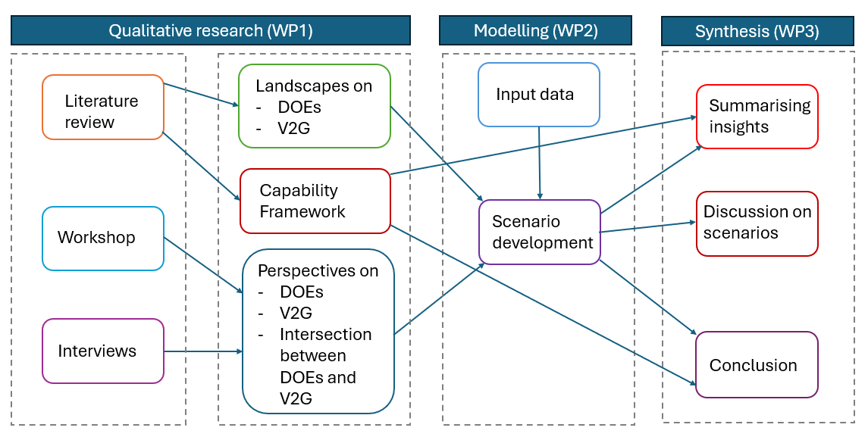
Figure 1 Methodological approach of the research. Each box indicates a work package.

DOE and V2G evidence collection (Work package 1)
To establish baseline and contextual understanding, including likely potential of and trajectories for DOEs combined with V2G, work package 1 applied three main methods:
- Review of current academic and grey literature,
- Workshops with stakeholders to generate group exploration of DOE and V2G, and
- Interviews with stakeholders to better understand non-published expert perspectives on DOE and V2G and their trajectories.
These multiple approaches used mainly qualitative processes to explore various perspectives about the topic and together provided triangulation of perspectives and insights. Stakeholders in this instance were people who had expert insights about DOEs, V2G and related topics. Stakeholder insights provided a range of otherwise unattainable and unrecorded insights, including information on potential evolution of DER interoperability standards, distribution level visibility and telemetry requirements, inverter-based resource (IBR) operational envelopes, and regulatory reforms aimed at enabling dynamic export control and flexible load management. Overall, this created a situational picture of DOEs, V2G, and the intersections between them.
Workshops and interviews focussed on interviewee knowledge of and perspectives on:
- DOEs, including their current state, development pathways, issues, value, and impact, and
- V2G, including current experiences and products, controls, and expectations.
Both workshops and interviews included people from the research team with qualitative research experience and technical knowledge. This mix of background experience allowed multiple perspectives to help guide conversations and allowed technical team members the chance to directly absorb conversations, rather than technical experts only hearing about the conversation via thematic reports, after analysis. Analysis begins the moment a conversation is held, and so this approach of having technical specialists in the interviews meant that the research team could begin processing insights early and build on them through later formal thematic analysis.

Literature review
During the academic and grey literature review, a targeted set of search terms were used to capture work relevant to both Vehicle-to-Grid and Dynamic Operating Envelopes. For the V2G component, terms such as stakeholders, value propositions, owner expectations and preferences, and barriers and challenges were applied to ensure that diverse perspectives on adoption and implementation were identified. For the DOE component, search terms including applications, calculation methods, implementations, and challenges were employed so that a broad understanding of how DOEs are conceptualised, modelled, and deployed in various contexts could be developed. Further details of the full literature review can be found in Appendix A.1, with literature from this review also used in the background section of this report (section 2).

Workshops
In person workshops were conducted as part of the “CSIP-AUS Connect” conference on October 3rd, 2025. This conference was held in Canberra. Approximately 80 participants attended the conference, providing a substantial group familiar with DOEs, DER, V2G and related technology and systems. The workshops served two purposes:
- to generate input data for this project, and
- to inform ongoing development of CSIP-AUS in Australia.
The agenda of the day included four 90-minute sessions. Each session consisted of a 45-minute panel discussion (that was not part of the research) followed by a 45-minute workshop. The workshops were designed to discuss DOE related issues, including V2G; and were direct research activities for this project. We designed workshops into the conference because there was direct alignment between the topic of the conference and this research; and because this was an unprecedented chance to talk to a large group of specialists about DOE and V2G topics.
The overarching topics for the workshop sessions were:
- Lessons to action: what has gone wrong and right in CSIP-AUS to date (session 1).
- Technical interoperability: current state (of), gaps, and promise in both in front of and behind-the-meter interoperability (session 2).
- Users and intermediaries: what are the current experiences of DOE and V2G users? How can it be made better? (session 3)
- ‘Wargaming’: What are we missing? What needs to be the prioritised (session 4).
Conference participants moved from the conference's presentations into four subgroups in nearby spaces for the workshop discussions. Participants were directed to different groups for each workshop with different letters of names and dates being used to assign people to different workshop groups each time. The groupings for workshops were generated using the: first letter of last names (session 1), first letter of first names (session 2), birthdays (session 3) and in session 4, all participants were in a single, combined group. Each workshop, except the fourth, therefore separated out the larger group into smaller groups. Not all of the 80 people attending attended every workshop session, but most did. Therefore, each subgroup included around 15 people. Each group was allocated a different space so they could talk without as much background noise and hold smaller group discussions.
Once in the workshop groups and allocated spaces, participants were asked to sit in small clusters within the space. The intention in workshops was to generate collective discussion and therefore collective insights. If a person was uncomfortable in groups, we also explained they could think and contribute as an individual. A small number of people chose to respond to the workshop questions in this individual way.
Participants were given several questions to consider and there were a series of prompts associated with each question to further help discussions. To further facilitate thinking participants were supplied with 12 scenarios on post cards that described different kinds of events (such as people experiencing issues with DOEs or cyber security attacks). Please see appendix A.4.1 for further details about the scenarios shared. These scenarios were used as prompts for discussion in the workshops.
Workshop questions were shared by a facilitator with an entire workshop group that gathered in a given space. The questions posed are listed in appendix A.4.2. People listened to the questions posed and then together with their cluster, decided on the most important aspects of the questions and ideas and discussed these. This process meant the specific threads of discussion were chosen in the smaller discussion clusters. This approach was used because we had many people with knowledge of DOEs and a sense of the specific gaps in development of DOEs. A larger group discussion was then held before the end of the workshop to share thoughts across groups.
Participants reported back by: adding sticky notes to, or writing on, themed pieces of paper, which were hung on walls (and had the questions written at the top); relaying information to workshop facilitators during their group discussions, which facilitators noted on the themes pieces of paper; through sharing in the larger group discussions held; and/or, via scribes who took further notes in the groups. Workshop questions and scenarios are provided as attachments to this report (See Appendix A.4.2).

Interviews
Semi-structured interviews were conducted with stakeholders who have experience working with, or knowledge about, DOEs and V2G. These interviews allowed exploration of issues that were not yet publicly well published and also to explore key topics in more depth. Interviews were 45m-1h in length. Twelve interviews were undertaken in November and December 2025. Interview participant areas of work and gender are shown in Table 1.
Table 1 Interview participant areas of work and gender
Category | Number
Distribution Network | 6
Technology Provider | 2
V2G User | 2
Consultant/Other | 2
Men | 10
Women | 2
As this interview group is a small group, we aimed to include people with different work roles in the interviews so we could explore our topic via multiple perspectives. DNSPs are represented more heavily as networks are spaces of work where there is a growing number of experts and where solutions to DOE for V2G are most needed. Women were less involved with only 2 of the 12 interviews being held with women. This is a common issue in this area of energy research. There are commonly less women to invite to interviews due to a broader predominance of men in energy industries (IEA, 2025). As these interviews were voluntary, were undertaken in a set timeframe and within a set scope, there was not the capacity to search further for more women. This said, we advocate for future (larger) projects with more capability in recruitment, time and overall scope to seek out a better gender balance as having gender diverse contributions from participants is important for DOE and V2G to evolve in effective ways.
The interview questions asked about:
- Perspectives on Dynamic Operating Envelopes
- Perspectives on Vehicle-to-Grid, and
- Perspectives on the intersection between V2G and DOEs.
The interview guide has been provided as an attachment to this report in Appendix A.5. Interviews were semi-structured, which means while questions were posed, participants were free to take the conversation where they thought it needed to go. This allowed interviews and participants to use the interview times in the way the participant thought most useful and allowed focus on an expert’s main areas of knowledge and insight. Additionally, the semi structured approach acknowledged that interviews were exploring an area where not all knowledge is well understood, and therefore there was space for areas of emergent knowledge to come forward in conversation.
In order to ensure participants had freedom to tell us the most important things on their mind and to talk with definitions of concepts as they saw them, were careful to avoid providing overly detailed definitions. For example, import and export are key concepts in relation to V2G and are commonly known in the participant group we interviewed. There are specifics to these concepts that could be critiqued. We kept the space for this critique by leaving space for participants to discuss these concepts as they saw them.
We ensured each interview had interviewers with both interviewing and technical skills. This meant we had either one or two people interviewing each time. This ensured that technical specialists on the research team heard directly from technically specialised interviewees. Interpretation and sharing of specialist information by interviewers with less technically specialised knowledge would have been problematic in this instance, as information shared would have lost nuance in the interpretation. The topics being discussed were in depth and embedded in a range of technically specific languages. Therefore, this technique of paring skills in interviews, so that interviewers had the interview experience and technical skills covered, proved extremely useful.

Analysis
Notes from the workshops and recordings from the interviews were transcribed and thematically analysed using a mix of qualitative analysis software (NVivo) and large language model assisted approaches. Themes were generated:
- Directly through understanding from conversations,
- Inductively and deductively through formal thematic analysis, and
- Through collective interrogation of insights as a research team.
Workshop notes were transcribed by hand by a team member from notes and ‘sticky-note’ comments generated from discussions during the workshops. Interviews were transcribed by a professional transcription agency to capture details of the discussions.
Transcripts were formally analysed through reading and tagging of themes in the software NVivo 15, and through large language model analysis using M365 CoPilot built on the GPT-5 chat model. In NVivo we read and highlighted any themes that emerged from the transaction (inductively) and also looked for pre identified themes. In the large language model, we used CoPilot to work inductively with a series of instructions about the way we wanted the text to be reviewed using sensitising concepts from sociotechnical energy research. Starting with a codebook consisting of themes from the NVivo analysis, the workflow involved refining the codebook using early transcripts, producing interview‑specific analytic memos, and iteratively revisiting interpretations as new perspectives and tensions emerged across cases.
We used multiple thematic analysis methods because this generated richer outcomes overall and allowed us to apply both the human ability to identify meaning and a large language application’s ability to quickly extract content knowledge from textual information.

Technical analysis and modelling (Work package 2)
This section outlines the approach taken to the technical analysis and modelling in the project by describing the purpose of the modelling, input data sources, scenarios used, the optimisation approach and what outputs looked like. A modelling tool named Cadium was developed for this project and is made publicly available, open-sourced under MIT licence as a project output (Fraser, 2025). The modelling tool is an output of this project and designed to be used with a range of public and private data sets.
WP1 (mostly qualitative) insights were discussed extensively as they emerged throughout the projects and were considered in relation to how they could inform and support WP2 and WP3. The modelling team was involved with WP1 interviews, and a weekly cross-organisation project team meeting provided a forum to discuss insights as they arose.
How to include the diverse qualitative insights in the modelling was discussed at length in team meetings, and methods for interpreting qualitative work into models were also examined. For example see section 4.3 for an early application of one model. Approaches to altering the model to include WP1 insights included considering stochastic events, different views of customer values, and modelling preferences explicitly. However, in this instance the project team decided to use a relatively simple model and use the qualitative insights as a lens to overlay over the modelling results. This was because of a lack of data that could be used to assess how these factors would influence modelling – both what these factors would be implemented like in practice, and evidence on frequency and co-incidence. The risk of modelling at this level was the outcome of the model may be more reflective of input assumptions than real phenomena expected to be observed in the field. In this project qualitative data was collected from intermediaries rather than customers themselves, which means that the project didn’t have access to direct householder perspectives.
At a fundamental level, qualitative insights confirmed contexts, starting positions and technical aspects of V2G and DOE approaches and provided confidence about useful starting positions within the modelling. Additionally, WP1 confirmed that V2G was at a nascent phase, and that it was unknown by stakeholders to what degree different EV users will participate in V2G, and under what conditions and timeframes. This meant that diverse V2G applications could emerge in real life.
It was important to ensure the model retained capability to generate scenarios of adoption reflecting key behavioural patterns, and that technical analysis and modelling needed to allow for accessible interrogation of the underlying assumptions that contribute to various world models. The resolution after processing all possible ways to integrate insights, was that it was best to avoid tuning the model to a particular outcome, and having the model built on too many assumptions. The ‘least assumption’ approach seemed appropriate at this nascent phase and would allow the model to be available to explore a variety of situations, without being too complex to handle.
.
Qualitative insights (themes) were therefore mostly applied as themes to explore alongside outputs, rather than including them in the model itself. WP1 insights also helped firm and apply key scenarios - storms, charge now events, and outages. Further detail of the model is described below. How WP1 insights further informed project results overall and the modelled scenarios are reported in relevant locations in Section 4 results, Section 5 insights and Section 7 future work.

Modelling tool development, purpose and rationale
The purpose of developing a modelling tool for this project is to provide a broadly accessible way of generating realistic, highly configurable DER scenarios that can be compared. The intent is for this tool to be able to be used in multiple ways:
- As an integrated web application. The full web application allows for a range of potential users to construct scenarios, optimise and derive results, and analyse those results within the platform.
- As a scenario-driven optimisation API. For technical users, who can use the API (or elements of the web application) to construct scenarios, manage and access results for custom analysis. We envisage two main scenario-based optimisation use cases:
  - The first is to use the UI to construct various scenarios and generate results. Scenario inputs and results can then be manually downloaded for follow-on analysis in other tools, for example Jupyter Notebook.
  - The second is to allow programmatic construction of scenarios and management of results via the API. For example – by building a custom tool that interacts with the API, for investigating the impact of different DOE allocation methods on the same baseline scenario. (Note: while this would also be possible in the UI, constructing and managing many scenarios may be more convoluted).
- As stand-alone, modular components. The tool is structured to allow for different functions to be composed in alternate ways or extended to support different use cases. For example, investigating the impact of alternative DOE allocation methods could be achieved by extending the existing codebase.
- As a site-level and aggregation of site level operation modelling tool. The tool provides real power aggregation that can reflect aggregate thermal power modelling, aimed at representing small LV networks. Detailed network-level modelling, such as unbalanced LV power flow, is outside the scope of this modelling work.
In the modelling, a scenario is a possible DOE–V2G interaction or event that was deemed important to explore. A site is a node in the model that represents a household location that may have an EV, a solar system, and/or a battery. EVs and batteries may be interacting from behind the meter with the grid. EVs may interact with the grid through bidirectionally (i.e. with V2G) or through smart charging. As with all models, the quantitative representation in the model of a site limits what can be represented of the household site. In the model a site factors in an energy load profile, vehicle usage patterns, and a tariff.

Input data sources
Producing useful scenarios that provide a realistic baseline of input data and flexibility in modelling DER uptake is challenging. While highly granular data exists through smart metering and distribution network monitoring, this data is not in general available publicly. In this project, we incorporate multiple historical datasets to build a tuneable scenario modelling framework. The key input data sets are:
- AEMO Net System Load Profiles (AEMO, 2026a): while normally used for inferring load profile shape from interval meter readings, these have been incorporated into the scenario time series generation to emulate the overall ‘shape’ of a yearly load (including seasonality effects).
- ERGAN Synthetic Residential Load Patterns (Liang, 2025): Emulating the inherent variability of electricity usage across households is important for building a realistic overall energy profile. The tool incorporates the ERGAN Dataset as the basis for generating load patterns that “closely emulate the temporal dependencies and distribution features present in genuine training data”. In order to generate a per-site consumption time series, daily profiles are sampled from a randomly selected cluster, which provides some long-term consistency for load profiles for a given site, while incorporating realistic variability between sites.
post-processing of these distributions involves:
  - Scaling (on a per-timestamp basis) to match the scenario to the overall reference load profile (based on the NSLP), and
  - Scaling each site to a particular average daily energy consumption.
- APVI Solar Generation (APVI, 2025): APVI provides 2-digit postcode-level estimates of historical generation at 15-minute resolution. This provides a basis for developing an independent PV timeseries data stream from an input inverter/panel size.
- Retail Tariff Plans (CDR, 2025): Consumer Data Rights (CDR) mandates the publishing of retail tariffs in a consistent format. The modelling tool processes and caches this data. Choosing a particular network and postcode for a given scenario narrows the set of available tariffs to only those published in the CDR that are available in that particular location.
- Network Tariffs (CDR, 2025): To support the simulation of market-exposed tariffs (which are not defined in the CDR) and system behaviours, representative network tariffs have been synthesised, based on retail tariff data and network-published prices.
- NEM Historical Spot Prices (AEMO, 2026b): downloaded from the publicly available AEMO FTP server via Nemosis. This data is used to simulate market-exposed systems.
- EV Dwell Times and Usage: A key input is the overall usage and user profile for modelling EV behaviour. Different profiles are available for configuration for each cohort – for example, a commuter profile, a hybrid worker, and a commuter with the capability to charge at work. In the latter case, an additional retail tariff must be selected to determine the costs for charging while at work.

Scenario configuration
The modelling used a scenario-based approach. See Section 4.2 for the scenarios modelled in this project. An example of a scenario is of a distribution transformer, loaded to near its nameplate rating and connected to 50 residential connection points. The residential connection points are configured across a range of 4 cohorts, representing four usage types (No solar, Solar, EVs, EV+V2G).
In this instance scenarios are possible DOE–V2G situations (events) that we have identified as being important to explore, through WP1 insights or other reasons. Various model-based features of a scenario are described in Table 2 below.
Scenarios are highly configurable, and consist of a top-level scenario configuration, as well as configuration options for each defined cohort. A cohort defines the properties of a proportion of the sites within a scenario – for example, the DER configuration, site consumption, and applicable retail tariff. Scenario configuration parameters are presented in Table 2.
Table 2 Scenario configuration parameters
Field | Type | Required | Description
Scenario-Level Configuration
name | string | No | Optional scenario name used in outputs and UI.
description | string | No | Optional context for the scenario.
energyNetwork | string | Yes | DNSP/network identifier used to resolve network tariffs and constraints.
postcode | string | Yes | Drives tariff availability and APVI solar mapping.
totalSites | int | Yes | Total number of sites simulated across cohorts (>0).
year | int | Yes | 2020–2050; scenario year for profile selection and labelling.
cohorts | list | Yes | List of cohort definitions (min 1).
networkConstraints | object | No | DOE-style network limits and allocation settings.
random_seed | int | No | Seed for reproducible scenario generation.
Scenario-Level: networkConstraints
totalImportLimitKw | float | No | Feeder-level import cap (kW).
totalExportLimitKw | float | No | Feeder-level export cap (kW).
minImportLimitKw | float | No | Per-site minimum import limit (kW).
maxImportLimitKw | float | No | Per-site maximum import limit (kW).
minExportLimitKw | float | No | Per-site minimum export limit (kW).
maxExportLimitKw | float | No | Per-site maximum export limit (kW).
allocationMethod | string | No | equal or solar_proportional
cohorts | list[string] | No | Cohort names subject to constraints. Remaining cohorts will be used as the baseline for computing available capacity, while the selected cohorts will have limits imposed.
solarCurtailable | bool | No | Allow solar curtailment under limits. Required if modelling export limited behaviour.
Cohort-Level Configuration
name | string | Yes | Cohort identifier used in reporting and constraints.
fraction | float | Yes | Share of totalSites (0–1) for this cohort. The proportions across all cohorts must sum to 1
siteType | string | Yes | Currently only residential is supported.
avgDailyConsumption | float | Yes | Average daily kWh for scaling load.
tariff | string | No | Retail plan ID (CDR plan).
tariffType | string | No | retail or market.
networkTariff | string | No | Network plan ID for market-exposed cohorts.
solar | object | No | Solar configuration (see below).
battery | object | No | Battery configuration (see below).
evCharger | object | No | EV charger configuration (see below).
Cohort-Level: solar
avgSize | float | Yes | Average PV nameplate kW.
stdDev | float | Yes | Variability in PV size (kW). Non-zero values will randomly assign sizes based on a Gaussian distribution
Cohort-Level: battery
avgSize | float | Yes | Average battery capacity (kWh). By default, batteries are assumed to have 2-hour duration.
stdDev | float | Yes | Variability in battery size (kWh).
Cohort-Level: evCharger
avgSize | float | Yes | Average charger size (kW).
stdDev | float | Yes | Variability in charger size (kW).
v2gEnabled | bool | No | Enables V2G export.
maxDischargeKw | float | Cond. | Required if v2gEnabled=true.
capacityKwh | float | No | EV battery capacity (kWh).
profile | object | No | EV behavior profile (see below).
awayTariff | string | No | Retail tariff for away charging.
awayTariffType | string | No | retail or market.
awayNetworkTariff | string | No | Network tariff for market-away charging.
Cohort-Level: evCharger.profile
profileType | string | Yes | commuter, hybrid, or commuter_workplace.
leaveTime | string | Yes | Average leave time HH:MM.
arrivalTime | string | Yes | Average arrival time HH:MM.
leaveStdMinutes | float | No | Leave time variability (minutes).
arrivalStdMinutes | float | No | Arrival time variability (minutes).
energyPerCommuteKwh | float | No | Average trip energy (kWh).
commuteProportion | float | No | Hybrid profile commute share (0–1).
In addition to scenario and cohort level configuration options, when running an optimisation across a scenario, additional optimisation options are available, including:
- Solver to use – defaults to a CVXPY-based solver using HiGHs. Note: each solver has additional configuration options available that are solver-specific.
- Month to solve – a user can choose to only solve for a month of data or solve across the full year (which is slower to process).
- Constraint handling – that can inform he model whether to ignore DOEs, to treat them as soft or hard constraints. Each option has different use cases. For example, in order to determine by how much a system would naturally exceed its operating limits, the model can be set to ignore and look at the magnitude of DOE exceedance.
- Parallelisation – depending on how it is deployed, this option allows the user to use parallelisation to speed up the solver.

Optimisation approach
The optimisation approach is to create a scenario to simulate a variable number of sites acting independently according to their own incentive structures. The tool builds a per-site snapshot of input data and uses CVXPY (and by default HiGHs) to generate a solution, subject to the optimisation configuration options given. The tool employs a solver plugin system, which allows additional solvers to be built and registered with the system.
Each site is optimised independently as a convex programme solved with CVXPY. For a site with load $L_{t}$, solar $S_{t}$, a battery, and an EV charger, the decision variables at each 15-minute timestep $t$ are set out below.
Decision Variables
- Battery charge $c_{t} ≥ 0$ and discharge $d_{t} ≥ 0$, with net power $p_{t}^{b} = d_{t} - c_{t}$.
- EV charger power $p_{t}^{ev}$ (negative = charging, positive = V2G discharge when enabled).
- Solar dispatch $s_{t} ∈ [0, S_{t}^{max}]$ — a variable only when solar is curtailable; otherwise fixed at $S_{t}^{max}$.
- Grid import $g_{t}^{+} ≥ 0$ and grid export $g_{t}^{-} ≥ 0$.

Grid Balance Constraint
The grid balance constraint is:
$$g_{t}^{+} - g_{t}^{-} = L_{t} - s_{t} - p_{t}^{b} - p_{t}^{ev,home}$$
where $p_{t}^{ev,home}$ is EV power only when the vehicle is plugged in at home. EV charging that occurs away from home does not flow through the site meter, but its cost is included in the objective via a separate away tariff.
Objective Function
The objective minimises the sum of four cost components over the optimisation horizon, evaluated at each timestep $t$ (or billing window $k$ for demand charges):
Energy cost / credit
$$\sum_{t}{\left[c_{t}^{+} · g_{t}^{+} - c_{t}^{-} · g_{t}^{-}\right] Δt}$$
Away-charging cost
$$\sum_{t}{c_{t}^{aw} · p_{t}^{ev,away} · Δt}$$
Demand charges
$$\sum_{k}{D_{k} · \max_{t ∈ w_{k}} g_{t}^{+}}$$
Throughput penalties
$$λ^{b} \sum_{t}{\left(c_{t} + d_{t}\right) Δt} + λ^{ev} \sum_{t}{|p_{t}^{ev}| Δt}$$
Here $c_{t}^{+}$ and $c_{t}^{-}$ are retail import and export prices, $D_{k}$ is the $/kW demand charge rate over billing window $w_{k}$, and $λ^{b}$ and $λ^{ev}$ are throughput cost penalties (default 6 c/kWh for batteries and 12 c/kWh for EVs) representing degradation and discouraging unnecessary cycling.
Battery Constraints
Battery constraints enforce capacity limits, charge/discharge rate limits, and an energy balance:
$$E_{t+1} = E_{t} - p_{t}^{b} Δt$$
with $E_{t} ∈ [0, E^{cap}]$. Per-timestep bounds on state of charge, charge rate, and discharge rate can additionally be imposed via time-series constraint profiles.
EV Constraints
EV constraints enforce availability windows (the vehicle must be plugged in at home to charge or discharge), V2G discharge limits (zero for non-V2G chargers), capacity bounds, and an energy balance that accounts for trip energy consumed between timesteps and ensures sufficient energy before each departure.
DOE Network Constraints
DOE network constraints on $g_{t}^{+}$ and $g_{t}^{-}$ are applied at one of three levels:
- Ignore — no constraint applied.
- Soft — a penalty $ρ · \max\left(g_{t}^{±} - {ḡ}_{t}^{±}, 0\right) · Δt$ is added to the objective, allowing violations at a cost (default $1/kWh).
- Hard — a strict constraint $g_{t}^{±} ≤ {ḡ}_{t}^{±}$ is imposed; the problem remains an LP.
It is recommended to only use soft constraints when looking at behaviour of a cohort of systems – which represents the best effort of the systems to meet constraints, rather than failing the entire simulation if a single limit cannot be met.
Dispatch Strategy
Dispatch strategy controls the regularisation term added to the objective:
- Greedy (default) — adds a small linear early-action bias $ε \sum_{t}{\left(t + 1\right) Δt · \left(c_{t} + d_{t}\right)}$ that encourages earlier dispatch decisions. Remains an LP.
- Smooth — replaces the bias with a quadratic penalty on battery power changes $w \sum_{t}{{\left(p_{t+1}^{b} - p_{t}^{b}\right)}^{2}}$, making it a QP.

Import/Export Complementarity
To prevent simultaneous grid import and export within a single timestep (which can arise under pathological price conditions), binary flags $z_{t}^{+}, z_{t}^{-} ∈ \left\{0,1\right\}$ can be added with:
$$g_{t}^{+} ≤ Mz_{t}^{+}$$
$$g_{t}^{-} ≤ Mz_{t}^{-}$$
$$z_{t}^{+} + z_{t}^{-} ≤ 1$$
This converts the problem to a MILP. It is off by default; violations are detected post-solve and trigger a re-run with the MILP enforced if needed.
Resulting Problem Class
The resulting problem class is shown in Table 3 below.
Table 3 Optimisation Problem Class
Configuration | Problem class
Greedy strategy, ignore/soft/hard DOE, no complementarity | LP
Smooth strategy | QP
Complementarity enforced | MILP

It is highly recommended to only use the default configuration, both for realism and for speed of optimisation. The smooth strategy adds quadratic constraints and does not generally correspond to any realistic battery or charger behaviour. If a situation is found where complementarity is violated, it is highly likely due to a pathological tariff that enables energy arbitrage – in this case the financially optimal behaviour leads to unrealistically rapid battery cycling. This would be the case in a scenario where the export tariff exceeds the import tariff, and in these cases any financially optimal strategy is not a realistic behaviour.

Solution Horizon and Solver
Long annual horizons are solved using a rolling 30-day window with 7-day overlap, with battery and EV state of charge carried forward between windows. The solver used is HiGHS, falling back to CLARABEL or ECOS if needed (ECOS-BB for MILP).

Outputs
The outputs from the tool are available as raw data downloads, to enable follow-on analysis. Additionally, there are in-built analysis, and comparison features available within the tool, which support a range of analytic questions. There is one set of outputs per scenario.

Output Data
All data used as both input and output is available for download via the UI or API. Data is available either in JavaScript Object Notation (JSON) or Parquet (an efficient open-source data file format). Available data include:
- Scenario Configuration (JSON): initial scenario and cohort configuration. Note this can also be separately imported to form the starting point for a new scenario.
- Scenario Data (Parquet): the initial time series input data for each site, including baseline load, maximum solar generation, EV availability and usage.
- Scenario Metadata (Parquet): metadata for each site – average daily energy consumption, installed solar, battery and charger size.
- Optimisation Configuration (JSON): solver parameters, date range, methods for handling import and export limits.
- Site Costs summary (JSON): a summary of overall site costs, based on the optimisation results. Used for display purposes.
Additional data is available in debug mode to support debugging and analysis. Under regular use these outputs are not required or displayed.
- Site Timings (Parquet): optimisation solver times for each site – helpful to debug, for example, solver issues or a new solver plugin.
- System optimisation raw output (CSV): Raw time series outputs from the optimisation solution.

Analysis Tools (model outputs)
The outputs section of the model includes information on the categories listed below:
- Overview: Outputs useful for analysis include a summary of the scenario, total energy and peak power statistics, and overview graphs of load profiles.
- Interesting Days: surfaces days of interest – for example high import/export days, or high and low-price events.
- Time Series: Statistics, breakdown by cohort, full time series overview with option to highlight specific days
- Load Duration Curve: Load duration percentile curves, optionally split by cohort
- Time-of-Day Profiles: Average profile for any available metric, overlayed with wholesale price ranges. Optionally segment by cohorts, or filter by type of day.
- Constraints: identifies days and times where one (or more) sites breach their import or export limits. Additionally presents a ‘Net (No Breach)’ profile, which highlights the gap between simulation results and the counter-factual where all limits were adhered to.
- Sites: detailed time series overview of each site behaviour.
- Costs: summary of (per site or per cohort) costs. Also presents counter-factual costs (for example, costs without battery and EV charging).
- Wholesale Responsiveness: presents a scatterplot of a particular metric against the wholesale price, to identify how responsive to price sites are. Optionally segmented by cohort.
- V2G/BESS Distributions: shows distributions of V2G and BESS responses
- Heatmaps: presents a range of different heatmaps views of the annual results. Best used for 24 month analysis.
- Files: This section allows a user to download all available files.

Assumptions and Limitations of modelling tool
- Designed for use without a network model This limits the network outputs to aggregated loss-less thermal results. There is no impedance model allowing losses or voltage calculations.
- Load data input sources are configurable. The tool can be used with either publicly available or private load data inputs. CSIRO required us to use publicly available data sets. This ensured the software could be exercised without limitations on data usage, which would almost certainly arise if confidential meter data sets were used. A limitation arising from the use of public data sets in this study is individual load volatility has been partially removed. Private data sets such as NEM12 meter data can be used to provide greater fidelity in the modelling results.
- Practical barriers to V2G impact connections prior to operations. The modelling tool is limited to modelling V2G operations in the context of multiple residential sites. Several V2G barriers identified during the interviews impact the connection of V2G in the first place, rather than being a factor to explore in the modelling. For example, poor behind the meter interoperability results in the combination of equipment not being installed or being allowed to be installed under the connection agreement.
- Designed with a simple model of householder behaviour. The modelling tool assumed that householders had a simple, consistent vehicle usage pattern and that householders were purely profit seeking. We know that this is not the case for real households. However, due to a limited data for input to the model, simplistic assumptions were felt to be more credible than assumed ones. The primary integration with householder behaviour occurred through engagement with the results (i.e. “given a system behaviour as modelled, what may be the customer response?)

Synthesis (Work package 3)
This work package 3 (WP3) brought together insights from the two earlier work packages (1 and 2) through combination, comparison and synthesis. We note this as a particular stage of the work because often technical and qualitative work are not combined well in projects, despite combination and integration of the technical and qualitative insights being useful to generating practical outcomes of projects. While this is named WP3, in reality this synthesis stage happened incrementally through the entire project, through regular group discussion of what we were finding, through having both qualitative and technical skills sets involved in WP1 and WP2, including in analysis. Activities that supported WP3 included:
- The whole team of researchers devising the project,
- The whole team of researchers being involved in workshop discussions, with both technical and qualitative researchers running different workshop discussions,
- Having people with both qualitative and technical insight involved in all interviews,
- Regular team discussions to explore insights as they emerged, including exploring insights and their possible influences on the modelling process, and
- Both Elentar and ANU team members exploring the model, parameters of scenarios, and the consequential outputs.
Through repeated conversation and cross exposure to qualitative (mainly as thematic insights) and quantitative (technical and model) outputs, we derived findings and recommendations that included:
- key insights about how DOE and V2G are likely to evolve together,
- a set of the most relevant modelling scenarios,
- critique of gaps in approaches, including better defining and framing lived needs and equality outcomes,
- proposed updates to CSIP‑AUS, CER, V2G and AR‑PST roadmaps,
- key messages about likely DOE V2G futures for further dissemination, and
- Suggestions for future research including proposals for future trials.

Results
Results section includes results of each work package, structured to reflect the progression of the research through the work packages, which leads us to report findings under the following sections:
- DOE and V2G evidence collection, analysis and assessment (WP1 findings)
- Technical analysis and modelling (WP2 findings)
- Synthesis (deriving recommendations through WP3 processes)

DOE and V2G evidence collection, analysis and assessment (WP1)
Work package 1 explored the landscape of V2G and DOEs, providing a baseline for the modelling work as well as creating findings. Data used here includes literature and qualitative data collected during the project.
There were three main lines of enquiry:
- What is the V2G landscape? What are the products, initiatives, and experiences of V2G to date?
- What is the DOE landscape? How is it likely to develop? What tensions and diversity is there in expectations around DOEs?
- How are DOEs and V2G expected to interact?
These will be discussed in turn below.

What is the V2G landscape?
Understanding the V2G landscape is important as an underpinning base for the technical work and generating findings in this project. In this section we build on the background shared earlier in section 2, by reporting on the V2G landscape. We include insights about services, products, initiatives and experiences that we were able to capture.
V2G is a nascent technology both in Australia and worldwide. It was first conceived in 1997 by Kempton and Letendre as a way for electric vehicles to provide services to the grid while securing financial returns for themselves (Kempton and Letendre, 1997). Since then, it has scaled slowly in line with the uptake of electric vehicles, with the first commercial-off-the-shelf systems installed and operating in Australia in late 2026 (Peacock, 2024; Thai, 2025).
Both in the literature and in stakeholder discussions, bidirectional charging is narrated as having a similar role to grid involved home batteries. For example:
“So our Vehicle-to-Grid charger will be enabled just like a stationary battery energy storage system would so you can participate in [Vehicle-to-Home]. If you want to participate in the VPP, be our guest, same thing.” –– Technology provider interview (26/11/2025)
“Maybe a bit simplistically we see V2G as just a different battery energy storage system. That might be mistaken, I’m open to being informed on that but we don’t really want to treat them differently. I guess the appeal for us of dynamic connections is that bidirectional element.” – Distribution network service provider interview (21/11/2025)
This conceptualisation was also evident in workshop discussions, where EV charging was frequently described as a flexible load that is comparable to other schedulable household appliances. Participants emphasised the need to “prioritise largest loads and generation to be interoperable,” including loads that were seen to “minimally affect [users]… e.g. EV, hot water, heating.” (Workshop session 2). Together, these perspectives reinforce a dominant industry framing of EVs—and by extension V2G—as inherently amenable to orchestration through demand flexibility, interoperability standards, and emerging distribution-level control mechanisms.
While the focus of this project is on V2G, Vehicle-to-Home (V2H) was often raised in our interviews with stakeholders (interviews 21/11/2026, 26/11/2026, 28/11/2026, 18/12/2026). V2H and V2G represent two distinct pathways for utilising the energy stored in electric vehicles, each shaped by different consumer priorities and system objectives. V2H is typically motivated by a desire for household resilience and self-sufficiency, offering a relatively simple operational model in which the EV functions as a flexible, behind-the-meter storage asset that supports the home during periods of high demand or reduced solar generation (Lucas-Healey et al., 2021) . In contrast, V2G enables energy export beyond the household and is therefore oriented toward maximising economic value by participating in broader market mechanisms or future flexibility services. As with other DER involvement with the grid, V2G can also be conceptualised as important by EV users because it ‘helps’ the grid and contribute energy back to the community (Boyle et al., 2023).

Current offerings and trials
At present, the Australian V2G market remains in an early commercialisation phase, characterised by a limited number of certified and deployable charging products (SolarChoice, 2026). Only a small selection of bidirectional chargers are available and approved for deployment (SolarChoice, 2026). Currently available and in-development V2G options include Sigenergy (Sigenergy, 2026), Starcharge (SolarChoice, 2026), V2Grid Australia (InfyPower, 2025), and Red Earth (RedEarth, 2025). These products are now available as a commercial off the shelf solution, although have varying challenges gaining connection agreements with DNSPs. While commercially available, some solutions are only released under controlled conditions or pilot programs rather than broad retail availability, reflecting the immaturity of certification pathways, interoperability requirements, and grid connection frameworks. As a result, V2G participation is still largely restricted to demonstration sites, research partners, or customers willing to engage in trial programs rather than standard commercial offers (Pagliarella and Kilby, 2026).
A functioning V2G proposition also depends heavily on the availability of suitable retail energy products that create an economic incentive for exporting energy from vehicles (ARENA and RACE 2030, 2025) (interviews 25/11/2025, 18/12/2025, 10/12/2025). This could be discharging the vehicle to supply behind-the-meter load, instead of purchasing grid energy (V2H) or exporting energy for a payment such as a feed-in tariff, wholesale passthrough electricity pricing or participation in virtual power plant (VPP) programs. In these arrangements, value is derived from exporting energy during high-price events rather than continuous arbitrage. Participants expected that some V2G EVs may potentially participate in VPPs to a stationary battery (interview 26/11/2025). VPP dispatch events often reward exported energy at rates approaching $1/kWh, but only for limited periods and volumes (for example up to approximately 250 kWh annually per participant (AGL, 2025).
Current V2G offerings are coming to market as extensions to existing DER products that are closely coupled to an existing/new/replacement solar inverter, with an implicit acknowledgement that V2G forms part of a behind-the-meter eco-system that is (or intended to be in the future) tightly integrated, where all DER assets are coordinated. In our interviews, there was a widespread expectation among network participants that V2G would be integrated through existing DER control regimes, rather than treated as a distinct category. As one DNSP engineer explained:
“We don’t care about V2G… it’s just like any other resource to us. From a DOE generation and power system operation perspective it’s just another resource.” Distribution network service provider interview (17/12/2025).
Significant integration and operational challenges remain unresolved. Local charging optimisers — the systems responsible for determining when and how much a vehicle can export — still require improved characterisation of vehicle capacity and availability (De Caro et al., 2025). Electric vehicles mobility requirements and the consequent constraints on their shareable energy need to be reflected in V2G systems. However, control algorithms that attempt to factor in EV use and energy sharing constraints are still evolving. Network connection frameworks also present barriers. In some distribution network service provider (DNSP) jurisdictions, V2G export capacity is treated cumulatively alongside existing behind-the-meter battery storage by DNSPs. This means that sites with a stationary battery may be unable to add V2G export capability without exceeding connection limits, effectively constraining adoption even where physical network capacity exists (interviews 25/11/2025, 10/12/2025). This position was driven by a lack of mature behind-the-meter interoperability, where the DNSP lacks confidence in the ability for multiple DER assets to adhere to a site level limit (interviews 10/12/2025, 18/12/2025, 12/12/2025).
Several trials across Australia are attempting to address these challenges and inform future regulatory and commercial frameworks. Retailer-led programs such as those undertaken by Amber (ARENA, 2024) and Origin (ARENA, 2023b) are exploring price-responsive charging and export behaviour, while network-led research including the Essential Energy and CSIRO collaboration is investigating operational integration with distribution networks (CSIRO and Essential Energy, 2025). Additional work by Energy Masters in South Australia addresses technology integration between behind-the-meter devices (Energy Masters, 2025) and is trialling DOEs for import control (Energy Masters, 2026).

Stakeholders and their effects
V2G ecosystems involve a diverse set of stakeholders whose roles and motivations shape the viability and scalability of the technology as summarised in Figure 2 (Jones et al., 2021; Vishnu et al., 2023). At the core are EV drivers, including private owners, fleet operators, commercial vehicle owners, public transport operators, leasing companies, and car-sharing services, who provide battery capacity for grid services in exchange for financial incentives, sustainability benefits, and backup power (Santinha and Tavares, 2025). Original Equipment Manufacturers (OEMs) enable V2G through bidirectional charging capabilities, while charging infrastructure providers ensure the deployment and maintenance of compatible EVSE. Interviewees described V2G as a capability that is enabled at the vehicle level but made operational through charging infrastructure. As one participant explained:
“the customers can do V2G if their car can, but they have a charger — they have a charge, discharge button or schedule in the Sig app.” Distribution network service provider interview (25/11/2025)
Aggregators play a critical role in coordinating energy flows between EVs and the grid, optimizing participation in energy markets (Ru et al., 2025). Grid stability and operational efficiency are managed by Distribution System Operators (DSOs) and Transmission System Operators (TSOs), supported by energy retailers and suppliers offering dynamic pricing models (Zhang et al., 2025). Policymakers and regulators establish standards and incentives, whereas utility companies integrate V2G into grid operations through pilot programs. Additionally, technology providers and startups develop platforms for real-time optimization and energy trading (Ru et al., 2025), and research institutions contribute through pilot studies and user experience assessments (Sagaria et al., 2024). Finally, consumers and the public as societal and cultural collectives influence adoption through awareness and trust, underscoring the socio-technical complexity of V2G implementation (Sagaria et al., 2024; Santinha and Tavares, 2025).
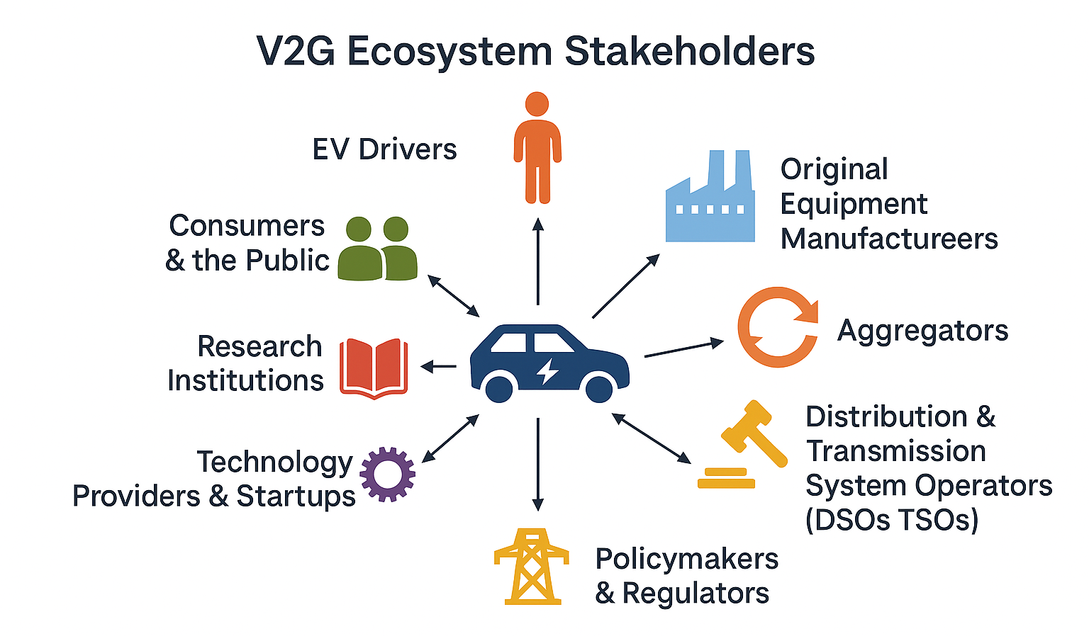
Figure 2 V2G Ecosystem stakeholders

EV owner expectations and preferences
Consumer segmentation reveals meaningful heterogeneity. Broneske et al. (Broneske, 2015) identified three segments: “V2G enthusiasts” willing to participate extensively, “V2G flexibility lovers” preferring conditions that do not restrict their flexibility, and “V2G skeptics” who are disinclined to participate. Similarly, in another studies, participants in a field trial with actual V2G experience were divided across high, conditional, and low acceptance categories, with tangible factors like range anxiety and user interface given more importance than abstract concepts by those with direct V2G experience (Ghotge et al., 2022). V2G is not the only potential consideration for EV users. Other bidirectional options such as Vehicle-to-Load and Vehicle-to-Home may be more of interest and could be prioritised over involvement with V2G. Exploration of different ways that V2G may interact is explored in section 4.2. Please also see Appendix A.3 for examples of the range of possible V2X services.
The primary barriers to acceptance of V2G include battery degradation concerns (J. Liu et al., 2025), range anxiety, and restrictions on vehicle flexibility (Ghotge et al., 2022), while financial incentives (Hu et al., 2024), environmental benefits (Baumgartner et al., 2022), and user-friendly interfaces with real-time battery information (Ghotge et al., 2022) serve as key facilitators. Financial incentives, battery range and state of charge concerns and user flexibility were all focused on in different studies, so details are shared here as key V2G design parameters. Researchers and observers have noted financial compensation is a critical determinant of V2G participation, though expectations vary substantially across populations, ranging quite significantly from $8.83 USD monthly in South Korea (Lee et al., 2020) to $197 USD in Norway. German households required slightly higher compensation than UK households in a discrete choice experiment undertaken by Baumgartner et al. (€67.54 vs. €60.96) (Baumgartner et al., 2024). The authors considered this could be caused by Germany’s higher average income. Mehdizadeh (2023) examined expectations of financial return in Norway and found that they were moderated by
- demographic factors of age, with each additional year of age reducing compensation demands by approximately $0.81 USD,
- psychological factors, with greater perceived usefulness of V2G system, favourable attitudes to V2G, and stronger trust in V2G technology leading to a lower financial demand for compensation overall (Mehdizadeh et al., 2023).
Mehdizadeh et. al. did not find any strong relationship between income and willingness to accept V2G (Mehdizadeh et al., 2023).
Researchers and observers have noted battery state of charge and related driving range available are key. While country to country results differ, and methods used are not consistent across different studies researchers have reported that EV users consistently express concerns about maintaining adequate vehicle range, with minimum guaranteed charge levels emerging as a critical contract parameter. Users consistently require minimum guaranteed battery levels before permitting V2G operations, state of charge thresholds typically ranged from 55% to 73% of capacity. Norwegian participants require a minimum guaranteed charging level of 65% battery capacity before permitting V2G operations (Mehdizadeh et al., 2023). Chinese EV users demonstrate anxiety when average state-of-charge falls below 31% on average and become willing to participate in V2G only when the average state of charge (SOC) exceeds 73% (Li et al., 2021). South Korean drivers prefer plug-in hybrid- and battery EVs to other vehicles. Additionally, findings show that drivers perceived utility of their vehicle becomes positive when more than 56% of their battery capacity reserved after V2G (Maeng et al., 2020). Researchers also found that users perceived the state of charge reservation level that results in the minimum utility (as in where users were least likely to accept V2G) was when 28% of the battery’s capacity is reserved after V2G. These findings indicate that users require substantial battery reserves to be assured before considering V2G participation.
Interview participants in this study articulated comparable concerns, framing minimum state-of-charge as a non-negotiable condition linked to the vehicle’s primary mobility function. One participant explained that while discharging may be acceptable:
“You don’t want to drop below a particular state of charge, because the primary use of your vehicle is for mobility — you don’t want to take that away.” Distribution network service provider interview (10/12/2025).
Several participants also described intervening manually when charge levels approached personal thresholds, prioritising what one retailer described as “peace of mind” over automated optimisation (interview 25/11/2025). A near-zero charge state was widely understood as an unacceptable outcome, with one technology provider remarking that reaching a zero-charge limit “won’t be interesting; it’ll be not good.” Distribution network service provider interview (21/11/2025).
State of charge and range anxiety may change depending on the number and types of chargers available. Dutch EV drivers found the minimum state of charge of the EV batter half as important when there were fast recharging speeds compared to their current slower charging EVs (Meijssen, A, 2019), suggesting that improvements in charging infrastructure may reduce range anxiety concerns and lower minimum charge requirements.
In relation to operational flexibility for EV users, prior research has shown that user interest in participating in V2G relies on maintaining control over charging and discharging decisions. Swedish EV drivers show “high interest in having full control over when and how the electric car is charged/discharged” and want “the option to override the command and start charging if I need to” (Khezri et al., 2024). Norwegian participants similarly value “options in the interface allowing the user to override the standards easily” (Mehdizadeh et al., 2023). Similar expectations were evident in this study, with interviewees repeatedly framing override as essential to user trust and acceptance. As one retailer explained, “our customers are in control of their assets completely … to switch off automation, charge from grid, discharge to grid whenever they choose.” (Interview, 25/11/2025). While automation was broadly supported, it was tolerated only so long as manual intervention remained possible, with another participant noting that “we still have 30 odd per cent of our customers that use manual control … because they know something the algorithm doesn’t.” (Interview, 21/11/2025)
Users are also sensitive to mandatory connection requirements. Dutch EV drivers base contract decisions partly on “required plug-in time” (Meijssen, A, 2019). Dutch consumers strongly prefer “charging at home” followed by “public charging network”, and favour “private ownership of an EV and a bidirectional charger instead of community ownership” (Bohnsack et al., 2015). German focus groups emphasized that “acceptance of bidirectional charging was related to its compatibility with daily life, participants had greater concerns of employing bidirectional charging when wishing to use their EV spontaneously” (Fahrner et al., 2023). Interview participants articulated similar concerns, emphasizing that flexibility expectations are highly situational:
“if you’ve got a road trip coming up you’re going to feel differently about your vehicle being dispatched.” Distribution network service provider interview (17/12/2025).
Rather than abstract system benefits, participants foregrounded practical and experiential factors, echoing findings from Dutch field trials that users prioritized “tangible factors such as range anxiety and the user interface” over abstract concerns, emphasizing the need for “real-time insight on battery state-of-charge (Ghotge et al., 2022). One advanced user reinforced the role of interface design and real-time visibility across actors in enabling trust and participation:
“I can actually see all of the VPP messaging and the DNSP messaging coming through … I can see what’s being asked of the system just neatly in the app” Consultant / other interview (10/12/2025)
In essence, users across studies expressing a range of concerns and wanting the “amenity to do what I want to do when I want to do it.” with their EVs. Workshop session (03/10/2025).
In relation to experiences of applying V2G personally, two interview participants had V2G systems installed and could provide direct experience of V2G coupled with home batteries. They critiqued the apps they were using and the way the VPP made decisions thinking the app poor and the optimising sometimes questionable. We note though that they were still using these products and connected so their critiques were note leading to them disconnecting from the service. Please see more detail about their experiences in in A.3.
Taken together, these findings point to the limits of understanding V2G participation solely in terms of technical flexibility or control settings and instead highlight the need to attend to what energy users are trying to do in their everyday lives. To address this, in section 4.3 introduces a capability-based framework that focuses on user outcomes, and the real freedoms energy systems enable or constrain.

V2G implications for DOEs
Generally, energy industry stakeholders expected that V2G EVs will integrate into existing DOE frameworks in the same way as other energy resources. However, V2G is notably different from other kinds of energy generation and consumption in several ways that will influence how they interact with DOEs. Key differences between V2G enabled EVs and other devices like batteries and solar are:
- Higher energy capacity,
- User expectations around EV battery state of charge for mobility, especially for events like unexpected trips, and
- Likely lower availability due to driving needs and charging practices.
EVs also have a different role in society and in people’s lives to batteries and solar systems, with energy generation as a secondary function. So, even though all of a householder’s needs (when measured through individual factors like state of charge) may be met, they may still be unwilling to use V2G if it is perceived to challenge an EV’s primary purpose (for mobility).
These factors are considered as part of the modelling (4.2) and modelling/social research integration (4.3) sections.

What is the DOE landscape?
As with understanding the V2G landscape, it is important in this project to understand the DOE landscape. In this section, we build on the background section on DOEs (in section 2) and share detail from participants about the DOE landscape, how it is likely to develop, and what diversity we observed in expectations around DOEs.
As discussed in the background section, DOEs are seeing increasing application in Australia. The network stakeholders we spoke to were all involved in implementing DOEs in their respective networks and all the other stakeholder participants we spoke to were also familiar with DOEs. Two main kinds of DOEs were discussed by participants: DOEs for managing export to the grid (called “export DOEs” here) and DOEs for managing import from the grid (called “import DOEs” here).
Stakeholders described DOEs as creating a confluence of benefits: unlocking additional network capacity that could not be offered normally, enabling greater choice for customers, and managing the network risk of overload. For example, participants remarked:
“DOEs are envelopes that are typically wider than traditionally would be permitted because most of the time we have far more network capacity than we need. They describe the flows that can happen to and from a network at a connection point.” – Distribution network service provider interview (21/11/2025)
“The philosophy behind Dynamic Operating Envelopes is to move that decision-making from the DNSP to the customer so that they can actually prioritise what responds and what doesn’t rather than the DNSP deciding and it’s just more about communicating the problem rather than the solution.” – Distribution network service provider interview (05/12/2025)
Export DOEs are rapidly becoming part of business as usual across Australian networks. Export DOEs are used to manage DER such as rooftop PV. Rooftop PV is highly coincident (i.e. it is usually sunny everywhere at the same time) which creates risk of overloading the grid. Export DOEs have a clear benefit for the user as they usually unlock additional network capacity, particularly at times where market prices are high:
“The reason we like those flexible exports is because outside of that period of high supply you get a larger export limit in the evening and I can make more money from my battery or V to G charger” – Technology provider interview (25/11/2026)
Import (load-side) DOEs (or consumption behind the meter) are beginning to be considered but are at a much earlier stage of development than export DOEs. In workshops participants cautioned against assuming that approaches developed for export limits would readily translate to constraints on consumption:
“Limiting imports can be a contentious issue that have social licence questions that need to be looked at before widespread adoption.” Workshop Session 1 (03/10/2025)
Interview participants also felt that controlling consumption was different to generation because of its very different use case:
Participant: I think that that other side of the equation, the load-side and how that works seems a lot trickier from a – acceptance kind of perspective.
Interview: What do you think the issues might be with acceptance?
Participant: That people have a starting point. I mean probably rightly so of like access to electricity is kind of essential and a human right and you can’t take that away
Consultant interview (28/11/2025)
There was also a significantly broader mix of approaches discussed for import DOEs as opposed to export DOEs. While generally export DOEs are seen as a condition of connection to the grid, stakeholders felt participation in import DOEs should be based on a strong value proposition:
“We’re going on the assumption at the moment that we think flexible load and flexible import should be optional but it should be an offer too good to refuse because you’re value-stacking, not just the customer’s benefit of being able to support the grid and keep the lights on for everyone which is very nice and warm and fuzzy but your VPP or your aggregator benefits.” – Distribution network service provider interview (10/12/2025)
Even though DOEs are rapidly becoming part of “business as usual” for networks, they still are at a relatively early stage compared to established, nationally consistent infrastructure. There is still a large gap between the future visions ideated by stakeholders and the practical, on the ground reality. Workshop participants were wary that missteps at this formative stage could have long-term consequences, particularly if early experiences undermine reliability and customer trust. For example:
“Reliability of meeting customer expectation. One ill-timed flat EV battery could completely change community acceptance of the energy transition.” Workshop Session 3 (03/10/2025)
“None of this works terrifically and so if it all worked perfectly like I’ll do it for two bucks a day but if it screws up 10% of the time and it makes my life harder and I’m … I just don’t want it to be an extra thing I have to worry about.” – Consultant/other interview (28/11/2025)

Calculating DOE Envelopes
DOEs were discussed with stakeholders through a conceptual “lifecycle” as shown in Figure 3. In this section we will describe the findings from interviews across this lifecycle.
Figure 3 Conceptual V2G lifecycle used in interviews
DOEs are based on a view of the total capacity (“envelope”) of the network to sustain energy input or consumption at that location and point of time (Blackhall, 2020). Participants and literature describe several potential kinds of limits that may lead to constraints including limitations on the local transformer, voltage limits, limits within the distribution network, or limits imposed by transmission or power system constraints (Alam et al., 2024; Lankeshwara et al., 2023; Wickramasinghe et al., 2025) (Participant interviews 12/12/2025, 18/12/2026, 21/12/2025).
Literature describes many methods of calculating a nuanced view of the capacity of the network. Some rely on good network models such as those that use Optimal Power Flow (OPF) (Liu et al., 2023) or unbalanced three-phase optimal power flow (UTOPF) (Liu and Braslavsky, 2024) approaches. Some use approximations of full network models or “model free” type approaches (Badmus and Pandey, 2024; Trinh and Chung, 2024), which reduce the need for data or computational power to calculate. Different methods have different trade-offs such as the accuracy to which they calculate and manage limits. These methods are described in more detail in Appendix A.2.
Currently, DNSPs develop envelopes primarily based on transformer thermal limits, which also has a follow-on benefit of providing some level of network voltage control. DNSPs were generally using simple approaches to calculate DOEs (interviews 05/12/2025, 10/12/2025, 21/12/2025). Generally, the simplistic approach used today provides relatively low levels of impact on solar generation and managed the main MV/LV transformer level constraints they were most concerned about (interviews 05/12/2025, 12/12/2025, 18/12/2025, 21/12/2025)
Even when considering only transformer capacity limits there are a number of ways, they can be calculated. DNSPs use different methods in different situations:
“How you calculate operating envelopes is going to vary based on - what data you have available might be different in different networks like different parts of the network might have different reasons. So they were sort of like oh you should pick a calculation methodology and then stick to it whereas it’s not that simple because maybe the one that you should use is different in different areas to get the best outcome.” – Distribution network service provider interview (05/12/2025)

“Interviewer: The other thing we’ve heard about is when you have say a commercial customer in the same constraint where you’ve got one larger customer and a number of smaller ones has been particularly challenging areas for allocation.
Participant: Yeah, that is tricky and I think the way that [the DNSP] treats that but you’ll have heard this directly from them so – is treating those two separate cohorts as two separate things, I think, and doing a waterline for each one is my recollection of how that was being addressed” Distribution network service provider interview (18/12/2025)
Common data related to DOEs includes estimates, transformer monitoring, and smart meter data. In many parts of the grid where there are few constraints simplistic estimate-based approaches provide acceptable performance. As the grid becomes more constrained additional monitoring and more advanced controls can unlock additional capacity:
“It’s a graduated approach, we move to those more advanced solutions. Where we see emerging amounts of curtailment that might justify the installation of the transformer monitor as a relatively low cost way of mitigating that curtailment. Where we see curtailment occurring even with a good visibility monitor maybe there’s investments that can be made in better modelling of the LV network or something as well.” – Distribution network service provider interview (21/11/2025)
Networks usually derive DOEs from continuous transformer limits, with cyclic limits used to manage inevitable inaccuracies in measurement and control of generation and demand:
“…there was talk about setting it to the cyclic limit for imports but […] you want it to operate before it trips so yeah, it’s probably going to be set to the nameplate rating and then the cyclic rating sort of gives you that buffer for a distribution transformer.” – Distribution network service provider interview (05/12/2025)
Today, DOEs are usually applied per individual connection point, even though the technical constraint to be managed is usually shared across multiple connection points. This means the shared capacity limit must be allocated between individual connection points. One participant noted this was an opportunity for innovation:
“Then managing DOE gives you – if you do it on transformer level – gives you a tool to actually say what you actually need.” – Technology provider interview (26/11/2025)

Allocating capacity
Literature describes both centralised and decentralised allocation approaches for DOEs. In centralised approaches, capacity is allocated by DNSPs through various algorithms (Gerdroodbari et al., 2022). In decentralised approaches, there is some level of participation from aggregators or consumers in the allocation process (Badmus and Pandey, 2024). There is more discussion of these methods in Appendix A.2.
All DNSPs we spoke to as part of this research used a centralised allocation approach. In many cases, networks equally allocated the available capacity across customers (e.g. if there was 100kVA of capacity and 10 customers, each would get 10kVA). This allocation method is not dependent on the installed CER capacity at each site. Participants noted this was likely to be problematic where installed CER capacity was very uneven, and as networks become more constrained this was likely to utilise capacity inefficiently. Similarly, for load-side DOEs where some usage is likely to be quarantined from DOEs (like cooking and lighting) some estimate of “inflexible” consumption is needed to estimate capacity that can be safely distributed among flexible loads. Some DNSPs used other allocation methods (such as proportional allocation or “waterline” methods), especially in cases where there were very differently sized connections that shared a common limit.
The barriers to using alternative allocation methods were not usually related to a lack of modelling showing the benefits. The primary gaps were around data availability, customer support, and regulatory support:
“As for allocation, we’ve looked at an equal allocation methodology because we don’t foresee that you can get around customer buy-in and fairness concerns by doing any other allocation methodology without some sort of framework to underpin that.” – Distribution network service provider interview (05/12/2025)
“So, I think equal allocation as you’re starting off makes sense because it’s easy to explain to customers” – Distribution network service provider interview (12/12/2026)
“I think we’d like to explore unequal allocations, but it’d be good to have a bit more guidance from policymakers on how to do that and I guess the way I see at least that happening is with some price signals” – Distribution network service provider interview (21/11/2026).
While only relatively simple allocation models are in use, participants did ideate different allocation methods that may be used in the future or different situations including:
- “Shared DOE” models where aggregators may take an active role on capacity allocation (aligning with the decentralised architecture from literature), and
- After major events, where some connections may preferentially receive capacity (e.g. community halls, hospitals).
Stakeholders did not raise computation power constraints, although it was a common theme in literature (Liu and Braslavsky, 2024; Wickramasinghe et al., 2025). This is likely because the relatively simple allocation methods used today did not require significant computational power.
Even with DOEs, many networks still have per-phase CER capacity limits of around 10kVA. Technology providers felt this was highly constraining. Most potential V2G owners already have some kind of CER installed, and V2G chargers commonly exceed 7kVA/phase alone.

Applying DOEs
The application framework for export DOEs was generally well-understood. Because all export is expected to be discretionary, export limits are firm limits applied to all export. Given equal allocation it would be expected that different connections have different levels of constraint because of their different installed capacities of CER.
Load-side DOEs were far less settled in discussions. As is commonly understood, people use energy for a variety of reasons some of which are critical. However, many loads can be flexible and could comply with a DOE. DNSPs expected that load-side DOEs are likely to only apply to flexible load (like V2G chargers) and not to inflexible load (like cooking).
Particularly for EVs, it may be expected that sometimes EV owners may have a more urgent need for charging than other times, for example when an urgent trip has come up. In interviews we explored this concept using a “charge now” button. Charge now buttons enable a driver to bypass charge automation and charge their EV as fast as possible if they have an urgent need for energy. If a site is at or close to its import limit there may be little capacity to enable faster charging if EV owners aren’t also able to bypass their DOE limits. So, the charge now button may not enable faster charging in this circumstance. We used this to explore situations where usually flexible loads may be less flexible.
One DNSP planned to enable participants to opt out of DOEs for a given appliance dynamically if they have urgent needs for energy. In the “charge now” scenario above the driver would be able to opt out of DOEs for their EV charger when they press the charge now button and charge faster. Another DNSP planned a minimum DOE import capacity (e.g. 10A) to enable EV users to always charge when they need to (albeit slowly):
“So an example of one that definitely can is if you think of an EV charger.., we might say that the fast charger you have no choice, you have to [comply with your DOE] but you can always slow charge because you can always unplug the car and plug it into a 10 amp socket in the wall. But we might just say okay but you can’t fast charge at the moment but you can trickle charge.” – Distribution network service provider interview (05/12/2026)
Other interviewees felt that an opt-out option would be undesirable either because people may opt out too often, because it would be less fair on others, or because of potential major grid impacts.
When we discussed the “charge now button” imaginary, there was a more fundamental theme at play: what should the energy system enable? Participants felt ethical dilemmas keenly around the impact of import DOEs on EVs:
“If someone goes to their car and it either hasn’t charged because they’ve had a limitation on it and they can’t drive it and use it as they planned or alternatively if it’s being as a Vehicle-to-Grid it’s discharged for whatever reason. That’s one of the concerns, I think.”- Distribution network service provider interview (12/12/2026)
However, participants also noted that there was never guaranteed electricity available (e.g. due to outages) and in these circumstances drivers would also not be able to charge their vehicle.
“This is the same issue you have if you have a blackout. Again, it’s outside of your control. If you’re on the physical limitations of your infrastructure which is the only reason why you would be enacted on an inbound basis because you’re trying to avoid is the actual blackouts limiting your capability? If you’re at that particular point in time you’ve got two options. Ignore it, blackout, you really have no power. Don’t ignore it and limit people down to a point where you can manage it. So you might not be able to charge your car at – I don’t know, 10, 12, 15kw but you might be able to charge it at 2.” – Technology provider interview (26/11/2025)
Although in a circumstance of a DOE limiting charge power, the causes for low charge speed may be less obvious than when there is a blackout. We discuss “charge now” buttons through the lens of the capability framework more in section 4.3.

Assessing impact
In some cases, the impact of DOEs becomes too great and the network needs to be reinforced. The DNSPs that we interviewed did not use deterministic metrics to trigger augmentation.
Currently export DOEs are assessed and reported on using relatively simple metrics (such as percent of time not at maximum export capacity)
“The AER gets the DNSPs to report on percentage of time not at the maximum export which I don’t particularly like because the whole point of DOEs is that it’s not one or off, it’s a threshold so you could be 99% of the maximum but then that would count to that threshold”– Distribution network service provider interview (05/12/2026)
Constraining export is not expected to impact how people live their lives, and solar is relatively predictable. Customer Export Curtailment Value (CECV) is a metric that was designed to value curtailed solar exports (Australian Energy Regulator, 2025) and thus provide an economic indicator of when the impact of a constraint has reached the level where it is better to invest in its removal. However, with V2G and energy storage CECV, that is based on a generalised view of the value of curtailed exports, may be less representative of the actual impact of curtailment.
Traditionally, metrics such as Service Target Performance Incentive Scheme (STPIS) or Value of Customer Reliability (VCR) provide a way of quantifying the economic cost of grid constraints. However, load-side DOEs are expected to mainly apply to flexible loads. VCR and STPIS are designed to value unserved energy (or energy that was not supplied at all). In most circumstances, a DOE is expected to shift when a flexible load consumes energy rather than this energy being left completely unserved:
“It is important to note that a limit being reduced doesn’t mean that there’s an actual impact to the customer.” - Distribution network service provider interview (05/12/2026)
Therefore, a different framework may be more applicable to DOEs. We discuss application frameworks through the lens of the capability framework in more detail in section 4.3.

How do DOEs and V2G intersect
In our literature review there is relatively little literature explicitly linking DOEs and V2G. However, the connection between DOEs and V2G was one of the main topics discussed during interviews.
From the point of view of technology developers and retailers, DOEs were a mix of opportunity and constraint. This tension was not only technical, but perceptual. Workshop participants noted that customer resistance often stems less from opposition to system outcomes than from concerns about loss of control and a lack of clarity about the benefits. As one participant put it:
“Customers fear loss of autonomy but don't understand the upside. E.g., curtailing generation vs export limit uplift.” Workshop session 3 (03/10/2025)
The opportunity the developers and retailers perceived is driven by the fact that usually customers with V2G will be able to transact far more energy with the grid with a DOE than without. Today, fixed inverter capacity limits are a major barrier to uptake of V2G as most prospective V2G owners already have solar systems, and many also batteries. Many networks limit total inverter capacity at each connection point in lieu of (or as well as) DOEs, and often these limits are around 10kW/phase. This is particularly problematic for V2G where many chargers are 7-22kW by themselves.
“So I’ve always loved flex exports for battery customers ‘cause great, I get 10kw, I can export more power, make more money, support the grid with more power to enable the renewable transition from my house. Whereas my neighbour who’s on a 5kw export limit can only support half of the power and make half of the impact to customer bills, energy transition, network congestion.
So I’ve always liked that. however I put in a V2G charger the other day, I’m still stuck on this 10kw export limit when I have more to give when it’s needed most.” – Technology provider interview (25/11/2025)
However, DOEs are a constraint. Technology developers acknowledged there may be times when drivers are unable to charge their vehicles as they want because of the interaction of DOEs. They expected this to be most likely during abnormal system conditions like around storms. Workshop participants highlighted that these constraints can be particularly problematic when customers have no practical way to respond or adapt in real time. As one participant put it:
“[If] Not visibility for customers to do anything in response to being curtailed → just have to wait for DNSPs to decide to augment network to resolve constraints.” Workshop Session 3 (03/10/2025)
However, interview participants pointed out in this case that there were many other reasons that faster charging may not be able to be facilitated, for example due to outages, or because the extra load of faster charging may cause a blackout (Interviews 26/11/2026, 05/12/2025).
Of the EV users we interviewed, only one had direct experience of DOEs. In some cases, they had observed DOEs were helpful in avoiding the impacts of poor optimisation outcomes from incorrect price forecasts:
“The ones being sent by [the DNSP] are effectively okay well the grid’s looking a little bit overloaded right now, we need everyone to ramp down and for whatever reason I’ll get a message from [the retailer] and there’ll be a negative feed-in tariff effectively with those conditions, generally speaking, [the retailer] will be stuck on some sort of oh we need to clear out energy ‘cause energy’s going to get cheaper in 15 minutes and sell energy out at a rapid rate and it’s like trying to push out energy into the grid because it can see that right now it’s bad. … The problem is [the retailer’s] algorithm is always way too over-optimistic about negative power price events, it always thinks they’re coming up and never materialise. It’s just such like rob Peter to pay Paul-type logic but the paying of Paul never happens on the back end.” – V2G user interview (10/12/2025)
From a DNSP point of view, DOEs were always intended as a technology agnostic way to ration limited network capacity among customers, while giving customers choice in how to meet the limit:
“We see DOEs as a way to express the limits of the network and that then provides customer autonomy in how they use their assets.” – Distribution network service provider interview (12/12/2026)
However, there was a clear expectation that some special considerations may be required, especially as DOEs began to be applied more regularly to the energy consumption of flexible loads. For example, minimum capacity allocation to enable slow charging if required (interview 05/12/2025).
As described in section 4.1.2, DNSPs felt there was a lack of evidence on which they could base decisions on application of DOEs to energy consumption (including V2G). They felt a lack of evidence relating to the social acceptance of load-side DOEs, and a lack of evidence which they could build assessment frameworks on (Interviews 12/12/2025, 17/12/2025, 21/12/2025). Participants saw interoperability, behind-the-meter device control, and customer agents as a key facilitator of acceptance:
“If it’s a 40-degree day you’re going to feel differently about your aircon being dispatched and so ideal strategy is that this customer agent’s doing a lot of heavy lifting with interfaces and technology to help automate a lot of this on the customer’s behalf so that they feel safe and comfortable to engage with offers like DOEs and flexibility knowing that they’re still in control.” – Distribution network service provider interview (17/12/2026)
However, when considering the impact of DOEs and demand flexibility on their own or others’ lives, participants were more measured in their expectations:
" The issue I can see is there are customers with different levels of proficiency for one and there are customers with different levels of demand flexibility. I got some surveys from SAPN about a year ago that were all asking me about what is your appetite for we turn off your air-conditioner at bad times or limit other loads? I took screenshots of a whole bunch of the questions and then just chucked them out to a few people in a few different demographics mentally in my head and just asked them the same questions. A lot of people – my grandparents are one example, they’re on [dynamic pricing]. They’re relatively smart energy consumers. They’ve got an electric vehicle. They still don’t like the idea of changing their air-conditioner usage to suit the pricing” – V2G user interview (10/12/2025)

“Yeah like I used to be on [dynamic pricing] and when the price was high I’d just go to the pub and justify I can spend some money at the pub and it saves me the cash and that’s fun ‘cause back then I had a flexible lifestyle and I didn’t really need to do it if I really wanted to. […] and that’s a fun one but if there’s somebody who is switching off their breaker at that time and just sitting in the dark and it’s probably either too hot or too cold and they do it for financial need, that’s less of a fun scenario even though it’s the same behavioural response. I don’t know how you unpick that like you don’t want to say to some people oh I’m not going to give you access to this opportunity ‘cause that’s not great. So how do you either not create this situation where you’re only allowing the rich people to do the opportunistic things but also you don’t want to force people into certain situations.” – Consultant/other interview (28/11/2025)
This theme is discussed further in section 4.3 through the lens of the capability framework.

Key themes emerging from evidence collection (WP1)
This section explored the V2G landscape, the DOE landscape, and the intersections between them.
V2G is at an early stage. The first few products are becoming available now, but there are as yet few users. This means that to date expert perspectives are mostly based on expectations of how V2G will behave rather than experience of how it does behave. Most experts and users expect V2G (and V2X) to act like a home battery except with:
- A higher energy storage,
- Lower availability due to driving rates, moveability and plug in practices,
- Higher requirements for energy availability and state of charge (due to expected and unexpected driving needs)
This is analysed quantitatively in section 4.2.1.
Stakeholders perceived import and export DOEs differently. Export DOEs are in use across much of Australia. Frameworks for import DOEs are still developing, with stakeholders unsure of the appropriate governance frameworks and the potential for customer impacts. Today, allocation and assessment frameworks are relatively simple with most DNSPs using simple equal or waterline allocation methods. A lack of regulatory frameworks, behind-the-meter interoperability, and customer acceptance are the main barriers facing wider uptake of import DOEs.
Particularly regulatory frameworks were identified as a barrier – specifically around capacity allocation methods and measurement/impact assessment. A lack of regulatory guidance leads to DNSPs using simplistic approaches (such as equal capacity allocation, or simple measures of impact). Stakeholders felt this simplistic approach is only a credible solution for energy export to the grid where the impact on the householder is minimal, but not credible for energy import form the grid where capacity limits impact householder’s use of energy.
Stakeholder perspectives on the connections between DOEs and V2G was challenged by the fact that both import DOEs and V2G were early in their development. Today, fixed maximum export limits are limiting V2G in many cases as most V2G users already have solar and battery systems. In the future, how the energy system’s needs to manage their network capacity and EV user’s needs to drive their vehicles intersect is not clear.

Technical analysis and modelling built on empirical evidence (WP2)
The technical analysis and modelling undertaken in this project, as work package 2, aims to quantify the impacts, trends and, challenges to the operation of V2G within the DOE framework. This package was employed to better understand potential intersections of V2G and DOEs, and to further explore issues that emerged as key technical themes during qualitative research in work package 1.
The modelling in this report uses a scenario-based approach. A range of scenarios are used to explore example situation or events (e.g. what could happen in certain use circumstances). Scenarios were selected to represent particular phenomena rather than be broadly representative of a particular future. They explored the impact of vehicle usage patterns, pricing, and CER mix (e.g. solar, battery, and V2G). Where possible within these varying scenarios, the modelling uses consistent units and baselines to understand different system response for different example scenarios. The modelling in this report is not designed to expose dynamics in a complex system, rather than to reveal system wide impacts, prevalence of specific system impacts, or how the phenomena revealed in the scenarios might scale up to a system wide outcome.
As noted in Section 3.3, V2G technology and its deployments are nascent, with very limited data sets. In addition, there are many practical implementation challenges which are difficult to represent in this modelling approach as these challenges affect availability and installation of V2G in the first place. For example, the challenges of behind-the-meter interoperability delay overall system uptake rather than affect V2G operation.
Key qualitative themes explored in the modelling and technical analysis were:
- How do plug in windows impact the operation DOEs with V2G assets?
- Is the additional capacity of V2G (over a home battery) material?
- How does V2G operation change with DOEs, are their sufficient triggers and incentives?
- What are the implementation and practical challenges that have been identified?
In what follows a scenario baseline scenario is reported in 4.2.1 and then themes are explored as scenarios further in 4.2.2.

Baseline V2X operations
This section provides a view of how V2X acts without DOEs. It explores V2X behaviour and compares it to stationary batteries.

EV user expectations and modelling implications
Interview participants generally felt that V2X was somewhat different to a home battery, even if for most purposes they expected they could be treated the same. The key differences participants raised were around:
- Availability and usage: V2X EVs aren’t always plugged in, and their main purpose is transport
- Capacity: EV batteries are significantly larger than home batteries
- Expectation: EV owners may have a higher expectation of state of charge from their vehicles, or may expect a minimum state of charge on their EVs

Plug in, driving, and charge behaviours
Unlike a stationary battery, an EV is only an energy asset when it is plugged in. This was raised in interviews by participants:
“Yeah, the harder thing is obviously you don’t know whether the car’s going to be there and plugged in and ready to charge or discharge” – Distribution network service provider interview (10/12/2025)
Similarly in the literature review undertaken for this project, state of charge was commonly cited as a concern for potential V2G participants. In literature, with sources citing “reservation values” (or the minimum acceptable state of charge) between around 30% and 70% (see section 4.1.1), which indicates that EV owners with V2G may prefer their vehicle battery operated conservatively. However, it is important to note that these studies were generally surveys whose participants had not directly experienced V2G, so experienced V2G users may be more receptive to lower states of charge.
In effect, the connection point sees a battery whose effective capacity, availability, and willingness to dispatch are all functions of how the vehicle is being used as a vehicle. For modelling purposes, we treat vehicle SOC as seen by the connection point as the relevant quantity — the battery capacity actually presented to the network in a given interval — and recognise that this quantity is shaped by a layered set of factors with no equivalent in stationary storage.
1. Ordinary charging for mobility. The baseline driver of SOC is the energy required to restore the battery to the owner's daily usage target. This depends on daily kilometres travelled, vehicle efficiency, and the rated power of the charger. For most households the requirement is modest relative to total battery capacity. The average Australian vehicle travels about 33km/day (ABS, 2020) which would consume around 6 kWh/day in the average 188wh/km vehicle energy efficiency (Kaggle, 2024). Although it is important to note that from a user perspective, the vehicle simply having (just) enough energy to meet daily driving needs may be insufficient for customer acceptance.
2. Smart (economically optimised) charging. The modelling represents charging as economically optimised: the controller schedules sessions to minimise cost. Under a TOU tariff this typically defers charging until the evening peak window has closed. Under spot-price exposure it concentrates charging in the lowest-priced overnight intervals. This aligns with literature that shows EV users typically charge at lower price periods (Andrenacci and Valentini, 2023; Roozkhosh and Yao, 2026) . A side effect is very peaky overnight demand at common low-price intervals across the fleet. Real-world optimisers smooth charge behaviour through the implementation of round-trip efficiency constraints, as well as measures to smooth small variations that could trigger ongoing charge and discharge behaviour.
3. Vehicle away time. When the vehicle is absent from the connection point, no charging can occur — neither from rooftop solar during the day nor from off-peak energy overnight. Daytime absence eliminates self-consumption pairing with PV; overnight absence eliminates access to the cheapest charging windows. The ability to model away-time accurately is constrained by the absence of granular real-world plug-in data for this study, and that data limitation is itself a finding: the information the energy system would need to forecast V2G availability is not currently available at any meaningful scale (Cabral et al., 2020; Lahariya et al., 2020).
Sometimes a vehicle may charge away from home (e.g. through workplace charging). Whether away from home charging enables additional (financial) value from V2G depends on the charging cost at the public charger. Today, daytime public destination charging costs around $0.50/kWh and DC charging costs around $0.80/kWh. This is significantly higher than home charging costs which indicates that it is unlikely to be optimal from a price perspective to charge at a public charger during the day to enable V2G discharge at night. Workplace charging however may be available at a lower cost.
4. Variable return SOC. The SOC at which a vehicle returns to the connection point varies day to day. It can be lower than expected after an unplanned trip, or considerably higher if the vehicle has been charged at work or at a public DC charger during the day. There is no continuous SOC trajectory across plug-out events, and the energy system cannot assume one.
5. Coincidence of plug-in with wholesale price events. For V2G to deliver export revenue under a price-responsive trigger, the vehicle must be plugged in at the moment the price event occurs. There is some reason to expect a limited coincidence between residential plug-in patterns (typically evening) and elevated wholesale price (Jenn and Highleyman, 2022; Needell et al., 2023; Sobhy et al., 2025; Zhang et al., 2020). However, the price spikes occur sporadically at other times of the day, as well as significant day time negative pricing (Elias, 2024), which cannot be captured if a vehicle is used as a commuter vehicle and not available to charge. Figure 4 shows a heatmap of the wholesale prices in New South Wales in 2024. While most high prices are in the morning and evening peaks, there is a notable period around December where daytime high prices are common.
The combined effect of these factors is that V2G has a significantly more variable capacity to support the grid. The difficulty in forecasting these impacts exacerbates this issue. A lack of public data is a barrier to better understanding this impact. However, the challenge is not just one of better data or better algorithms — many of these factors are genuinely unknowable in advance, including by the vehicle owner. From a DOE-system perspective, the operation of the electricity system should not be designed to depend on accurate forecasts of individual V2G availability. Forecasts of stationary BESS dispatch are, by contrast, a substantially more tractable problem: the asset is always present, its SOC is continuous, and its dispatch is governed by a controller responding to known signals rather than by human mobility decisions. This forecast ability gap is one of the reasons the response to evening export pressure should be built around coordination rather than forecasting — a point taken up in the DOE discussion in section 4.2.2.
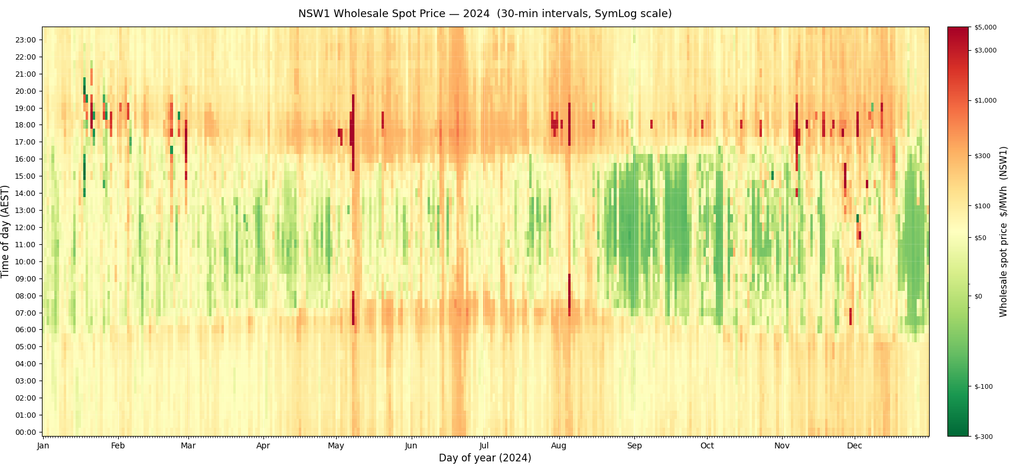
Figure 4 Wholesale prices for NSW in 2024

Capacity and expectations
A key value of V2G is that a standard EV has a much larger battery than a typical home battery. Additional capacity could be either power (kW) or energy (kWh).
Power (kW)
There are two main drivers of the ability of energy storage to deliver power to the grid: the capacity of the inverter, and what the DNSP will allow to be connected to the grid. There are relatively few V2G products on the market today. A summary of known current V2G products approved in Australia is listed in Table 3.
Table 4 Current known V2G products approved in Australia
DEVICE | LIMIT
Sig Energy Sigenstore | 12.5 kW or 25 kW EV charge/discharge capacity (to internal DC bus)  3-12kW grid export capacity (Sigenergy, 2026)
RedEarth Boomerang | 11 KW (RedEarth, 2025)
Starcharge Halo | 7.4 – 19.2 kW (SolarChoice, 2026)
V2G Australia Numbat | 6.2 kVA (InfyPower, 2025)
In the case of the Sigenergy product, currently a commonly adopted solution, the specification outlines two DC V2G capacity options: 12.5kW or 25kW. However, these should be viewed as capacity at the DC bus of the hybrid system, rather than AC capacity supplying load or exporting to the grid. The Sigen Energy Controller is available in various sizes, up to 12kW, with battery modules capable of 3kW to 4.6kW (max), compared to 25kW available from the vehicle on the DC bus. With the hybrid configuration, the V2G charger can be used to charge the battery and vice versa, and the EV can charge from excess solar generation at the full 25kW capacity, however the usable V2G export capacity is limited by the inverter to 12kW. The principal advantage of the 25kW capacity of the Sigenergy charger is for EV charging, especially where large quantities of solar also exist. In this case, the EV can charge from Solar and BESS at up to 25kW, which ensures all solar is used for charging and not spilling to grid due to charger limits. Solar systems are commonly installed with significantly more capacity than the inverter can inject into the grid. Clean Energy Council (CEC) guidelines state “the inverter nominal AC power output cannot be less than 75 per cent of the array peak power” (Clean Energy Council, 2022) which enables solar array DC power to be 33% more than the AC power output capacity (e.g. a 16 kW solar array on the 12 kW AC capacity Sigenergy DC coupled solar/battery/V2G system).
The other approved V2G chargers in Australia do not have inbuilt PV or battery capability. In these cases, the charger capacity is the same as the AC input/output capacity.
Today, all V2G chargers approved in Australia have a DC connection to the vehicle. Some AC V2G capable EVSEs are available internationally (Enovates, 2026). AC V2G EVSE charge/discharge capacity will be related to the EV inbuilt inverter capacity as well as the EVSE capacity.
There are many models of home battery available with varying power capacities. Commonly, battery power capacity is between 5 kW and 10 kW for single battery modules (Peacock, 2026), although in many cases homeowners may install more than one battery to gain additional capacity which may increase the power capacity too (depending on topology). The top home battery OEMs (Williamson, 2026) and their power ratings is shown in Table 4.
Table 5 Common battery ratings
OEM | MODEL | CAPACITY
Sig Energy | Sigen Battery | 4.6 kW per 9 kWh module (Sigenergy, 2026)
Sungrow | SBR series | 3.2 kWh/module (up to 8 modules)  3.2 kW – 17.5 kW discharge power (depending on inverter capacity and number of modules) (SunGrow, 2024)
Alpha ESS | SMILE5 | 5 kW, 2.9-80 kWh storage (AlphaESS, 2023)
Tesla | Powerwall 3 | 5.8-11.5 kW  13.5 kWh (Tesla, 2025)
Many DNSPs limit the inverter capacity connected to the grid, and maximum export to the grid.
Even with export DOEs, many DNSPs place maximum export values that can be limiting for V2G systems. This can limit the value that V2G users can realise:
“I put in a V to G charger the other day, I’m still stuck on this 10kw export limit when I have more to give when it’s needed most. My piddly little 50 amp supply can import 15kw but I can’t support the network with more than that and make more money for doing so” – Technology provider interview (25/11/2025)
In many cases, V2G chargers are added to existing solar or energy storage systems, which means these lower limits can be felt more keenly in the cases of these multi-technology early adopters.
Commonly DNSPs will limit inverter capacity regardless of export limits. Common limits are 10kW or 10kW/phase, although some DNSPs have different limits (AusGrid, 2023; AusNet, 2026; SA Power Networks, 2025). Inverter limits also limit self-consumption potential as they are an installed capacity limit rather than an export limit.
In conclusion, we can show that V2X power capacity is within the range of common home battery power capacity, so may not offer additional power capacity over a home battery.
Energy (kWh)
Typical EV batteries range from 20-100 kWh with an average around 74 kWh (Kaggle, 2024). Home batteries are increasing in capacity on average (potentially due to current subsidies that favour larger batteries). By the end of August 2025, average battery capacity across Australia was 19 kWh (Clean Energy Regulator, 2025). So, in these terms, an EV battery can still store over three times as much energy as a home battery. This storage capacity needs to be tempered with EV user’s willingness to discharge their EV for grid purposes (see section 4.1.1).
Table 5 shows vehicle kWh Capacity for three top-selling EVs. The storage available ranges from within the range of stationary home storage (e.g. an Atto 2 owner with a high minimum state of charge requirement) to significantly more (a Zeekr 7X owner with a low minimum state of charge requirement).
Table 6 Vehicle kWh Capacity for three top-selling EVs (The Driven, 2026)
VEHICLE | ADVERTISED CAPACITY | POTENTIAL CAPACITY FOR V2X
BYD Sealion 7 | 82.56 kWh (Fisk, 2026) | 25 - 58 kWh
BYD Atto 2 | 51.3 kWh (RACV, 2025) | 15 - 36 kWh
Zeekr 7X | 100 kWh (Parkinson, 2025) | 30-70 kWh
Figure 5 shows how EV battery capacity (available for V2X) influences the achievable V2G revenue for one modelled scenario. The scenario settings for this plot are:
- Amber market price passthrough tariff with Ausgrid network tariff
- Commuter EV usage profile
- 10kW EV charge/discharge power capacity, and
- 10 sites, all with the same assumptions.
Figure 5 plots three data points:
- The total V2G energy discharge per site
- The wholesale market value of the V2G system, and
- The retail (incl. network tariff) value of the V2G system.
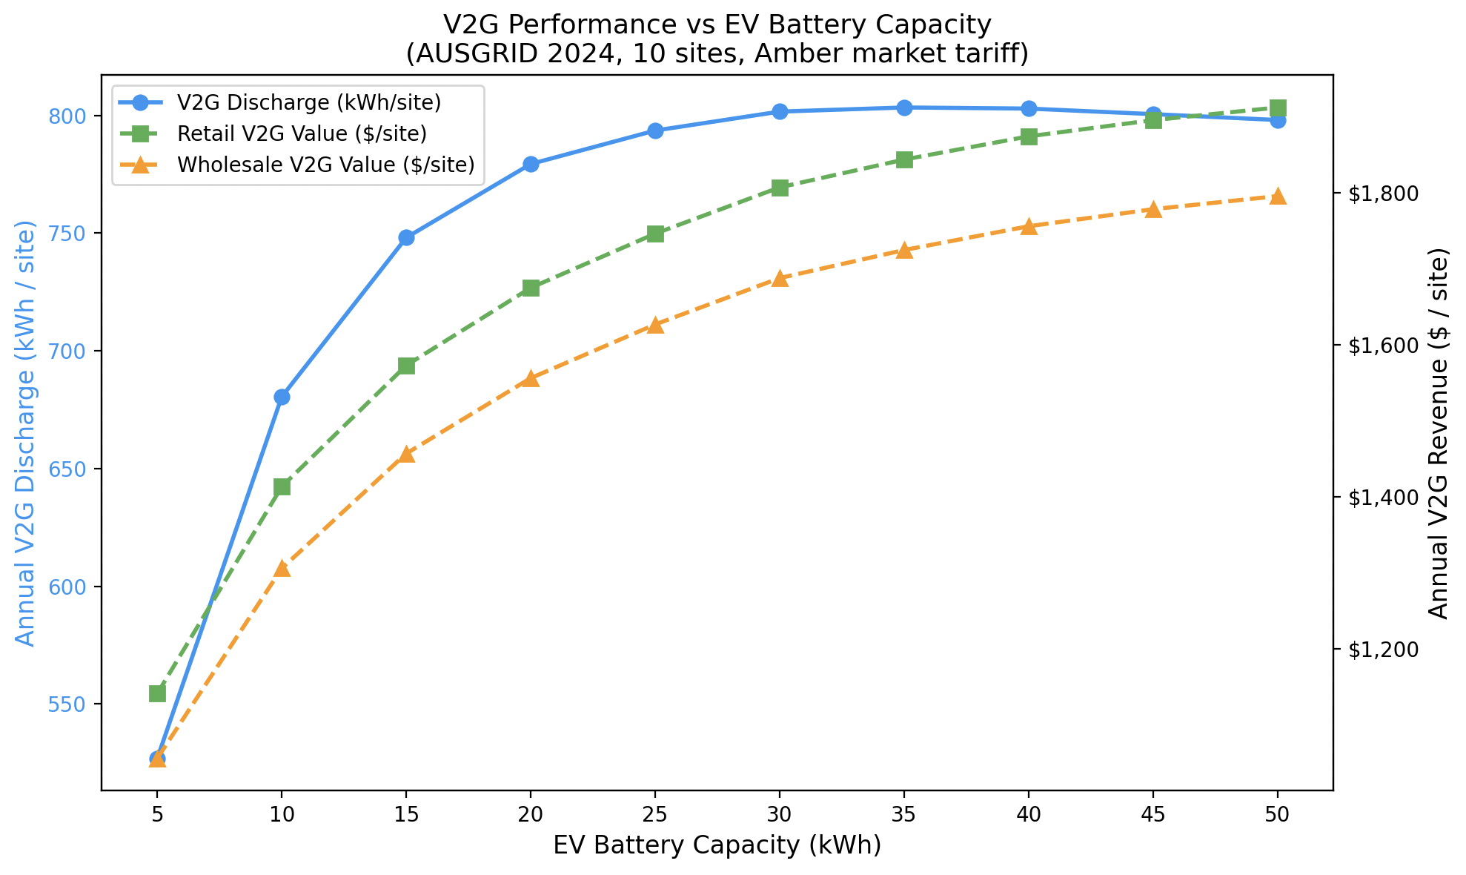
Figure 5 Value of EV battery size for V2G
The value of an incremental kWh of battery capacity reduces as installed capacity increases, as expected. The first 10kWh of capacity delivers around $140/kWh of value per kWh. The second 10kWh delivers around $30/kWh of capacity. This is promising for the scaling potential of V2G: even with modest capacity allocation to V2G, significant value is still on the table. 20kWh represents less than 1/3 of the capacity of the average EV’s battery.

How does V2X operate?
Scenarios Even though quantitatively an EV has a much larger energy capacity than as home battery, real operation may not exercise the additional capacity. A set of scenarios was constructed to help explore the potential realised value of the larger energy storage capacity.
Factors affecting V2X capacity availability are:
How much EV charge is available for V2G use?
- Minimum state of charge
  - assumed 40% - lower than the range found in literature in 4.1.1, however was reduced to ensure this value did not overly constrain the optimiser in the modelling tool.
- Vehicle return SOC
  - An average of 15kWh daily usage was assumed, with the model assigning variable usage around this average.
- Vehicle usage pattern
- Vehicle warranty
  - Not explicitly modelled in this study
- V2G charger capacity
  - Assumed 10kVA
How the EV is to be used
- Vehicle charging strategy
  - Standard EV tariff or market passthrough
  - Very simple options (like timers) aren’t modelled here as they are unlikely to be used in V2X
- The duration of time that the V2X Trigger condition exists, either the elevated high wholesale price for V2G or high retail peak TOU periods for V2H.
Factors 1, 2, and 6 above create a V2G available timeseries value, separate to a SOC time series value. Factors 5, and 7 combine to represent the energy sought per event. For example, a 7kW charger over a 3-hour event could seek 21kWh from the vehicle. Factor 4 related to warranty, is still largely under development, with few vehicle OEMs willing to explicitly warrant V2G usage outside of selective trials. Warranty limits have been excluded from this analysis.
Scenarios help explore the relative value of V2G, V2H, and home energy storage. The scenarios in Table 6 were modelled. V2H is modelled using an economic optimiser to trigger V2X operations, however in the case of V2H, the tariff is set to a standard TOU retail tariff rather than a wholesale exposed tariff. This has the result using vehicle stored energy during the evening peak period to minimise the cost of energy.
Table 7 Energy modelling scenarios
PARAMETER | Scenario 1 | Scenario 2 | Scenario 3 | Scenario 4 | Scenario 5
DER | V2H | BESS | V2H | BESS | V2G + H
Retail Product | Alinta DMO | Alinta DMO | Alinta DMO | Amber | Amber
Storage/Charger Power | 10 | 10 | 10 | 10 | 10
Storage Energy spec sheet (kWh) | 75 | 13.5 | 75 | 13.5 | 75
EV Daily usage (kWh) | 15 | 15 | 0 | 15 | 15
EV usage pattern | Commuter | N/A | Vehicle at home during day | N/A | Commuter
Charging bounds | 10-90% | 10-90% | 10-90% | 10-90% | 10-90%
Min V2G SoC | 40% | NA | 40% | N/A | 40%
Useable capacity (kWh) | 22.5 | 13.5 | 22.5 | 13.5 | 22.5

Scenario 1, 2, and 3 – Behind-the-meter usage
Figures 6, 7 & 8 show the comparison of scenarios1, 2, and 3 battery/EV performance for three scenarios:
- A standard “V2H” use case for a commuting vehicle that isn’t always there during the day (Figure 6)
- A home battery (Figure 7)
- An EV that is always at home (e.g. never drives) (Figure 8)
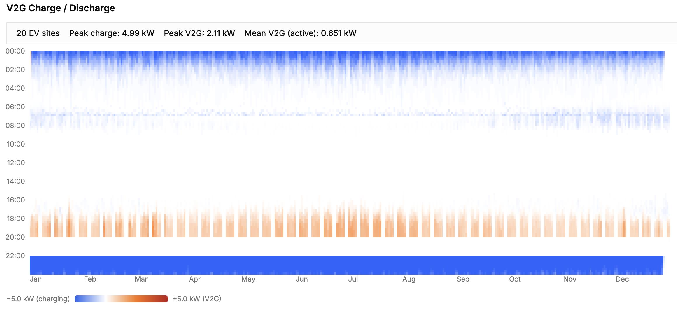
Figure 6 Scenario 1 V2H discharge heatmap
As expected, in scenario 1 EVs charge when the off-peak period starts in the evening until they have charged enough to meet the next day’s energy needs. Sometimes they also charge in the morning in summer when there is excess solar generation before they leave for work around 8AM. EVs discharge almost exclusively in the evening when the vehicle returns back home.
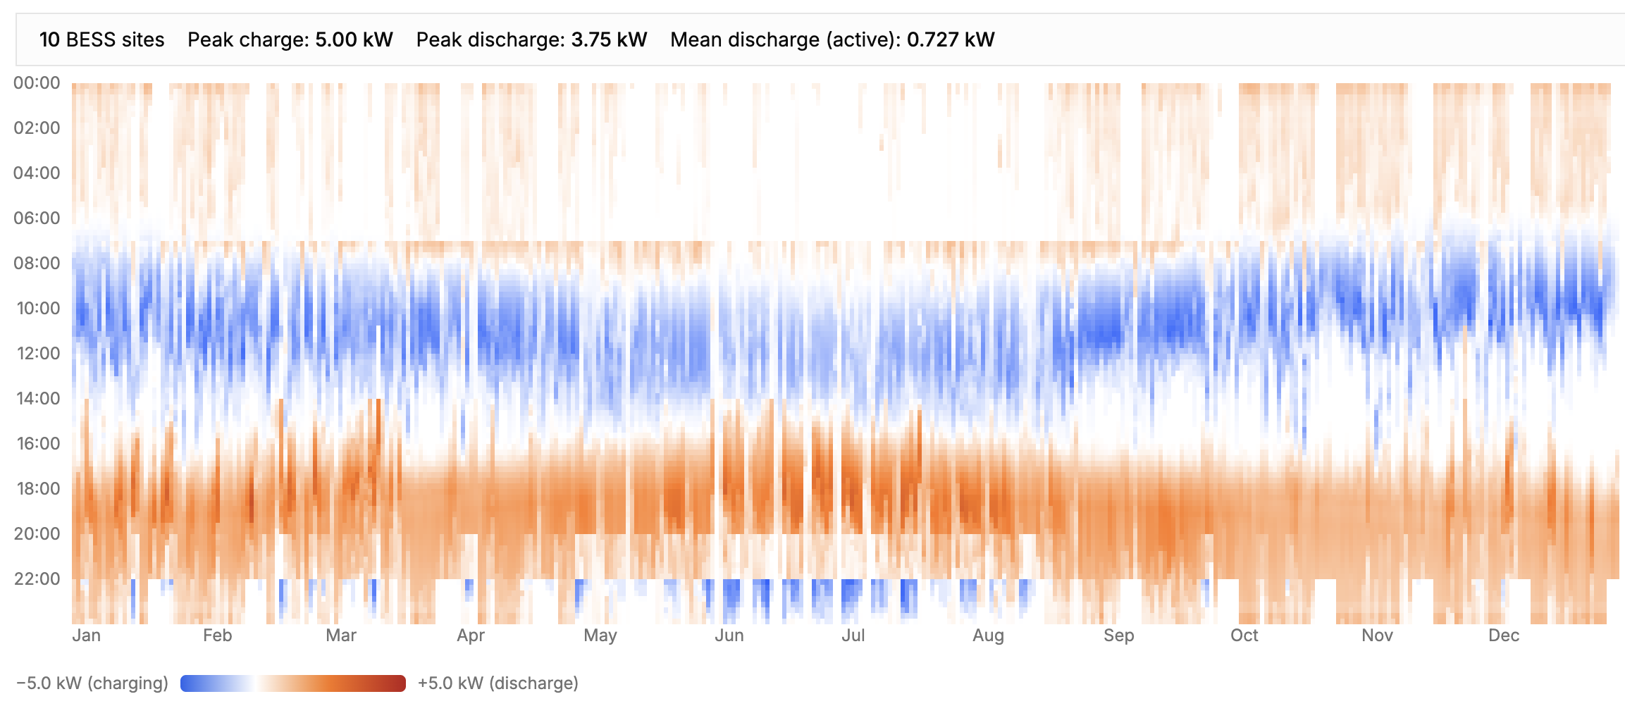
Figure 7 Scenario 2 home battery discharge heatmap
Home batteries contrast with EV discharge by shifting most of their charging to during the day. In winter and on less sunny days the battery charges from the grid sometimes in off-peak periods. There is more discharge for the evening peak as the battery is there to discharge.
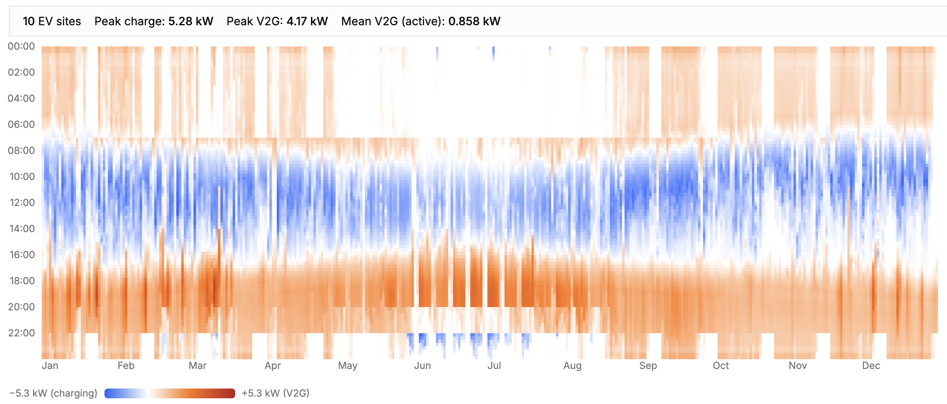
Figure 8 Scenario 3 V2H (always home) discharge heatmap
Scenario 3 removes transport needs from the EV. This makes the EV act much like a home battery. It charges during the day from excess solar and discharges into the morning and evening peak periods. As expected, scenarios 2 and 3 are very similar. The energy storage mostly charges during the day, with occasional evening charges on less sunny days. In scenario 1 charging occurs at night instead of during the day. For the V2H use case EVs always start charging when the off-peak window starts at 10PM. Charge finish time varies depending on how much energy is need for the next day. Discharge mostly occurs during the evening peak (apart from the weekend, which is all off-peak pricing, removing the economic incentive to discharge). There is often a small amount of charge occurring just before the morning peak period starts around 7AM, however the vehicle is not often home to discharge for the morning peak.
Figures 9, 10 & 11 show the distributions of V2H and V2G discharge events. An event is defined as a continuous series of discharging intervals and shows the amount of energy discharged in that event.
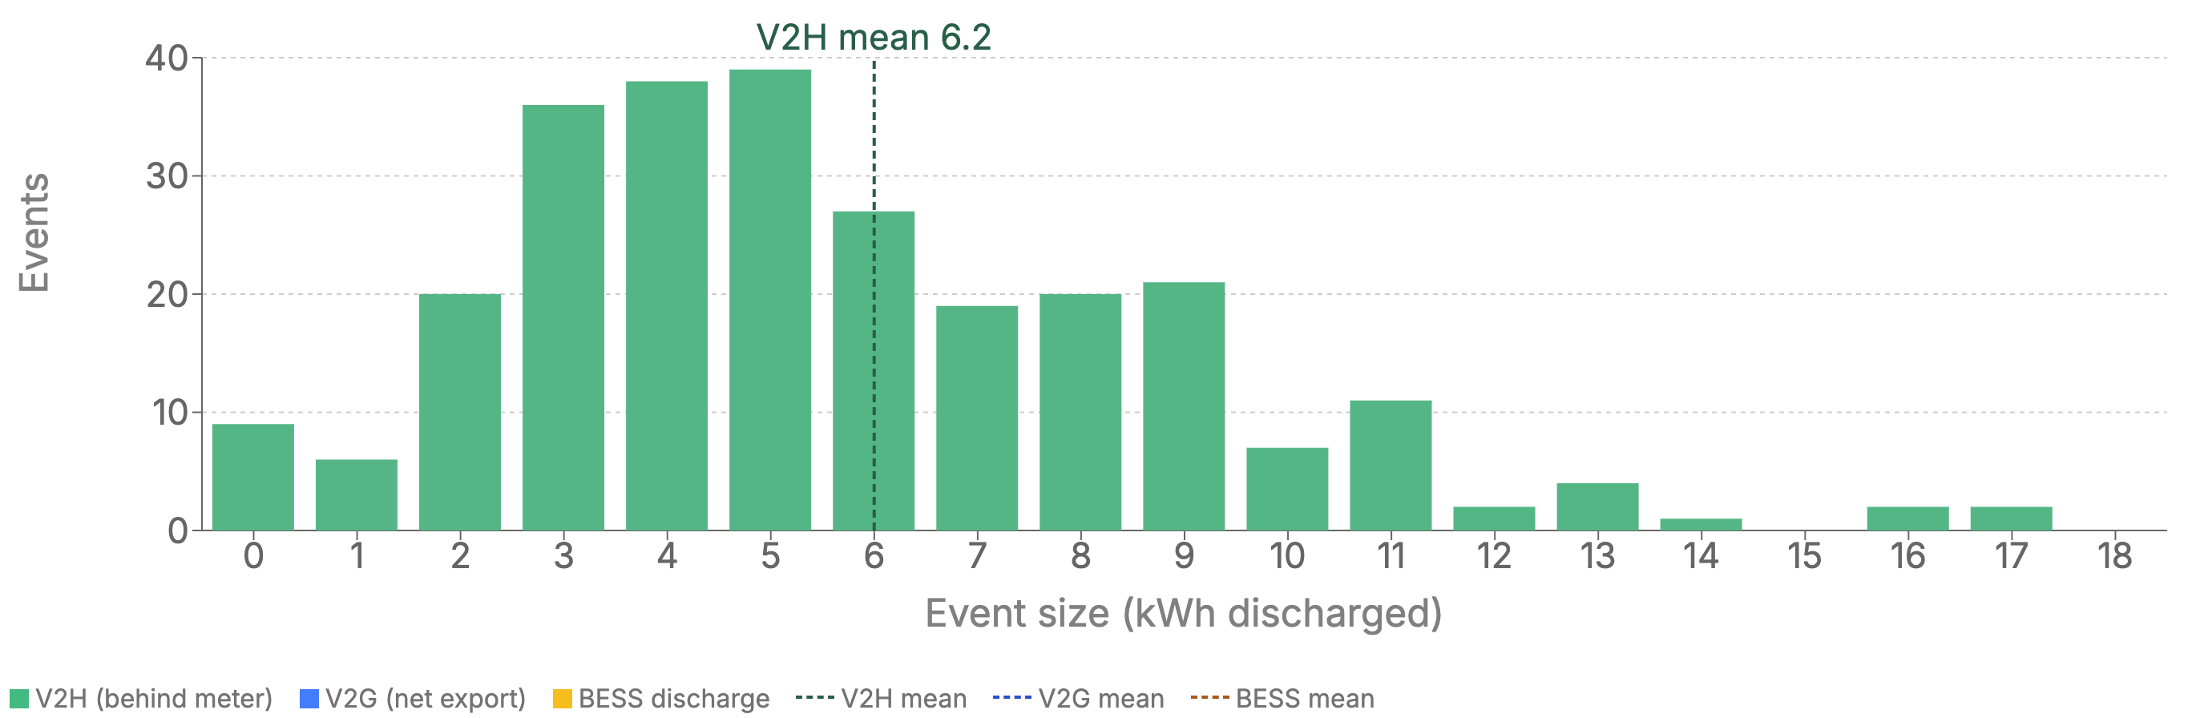
Figure 9 Scenario 1 V2H discharge event size probability density
Scenario 1 discharge events average 6.2kWh, however this is influenced by a few much larger events around 17kWh. The majority of events are between 3 kWh and 7 kWh.

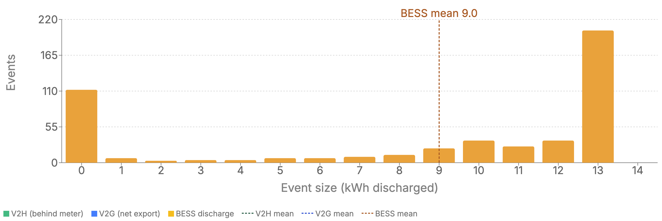
Figure 10 Scenario 2 home battery discharge event size probability density
Scenario 2 shows a distinctly bimodal event pattern. The largest number of events consume the total battery capacity (around 13kWh). There are also many small events – likely caused by the battery matching solar generation and load on days with intermittent clouds.
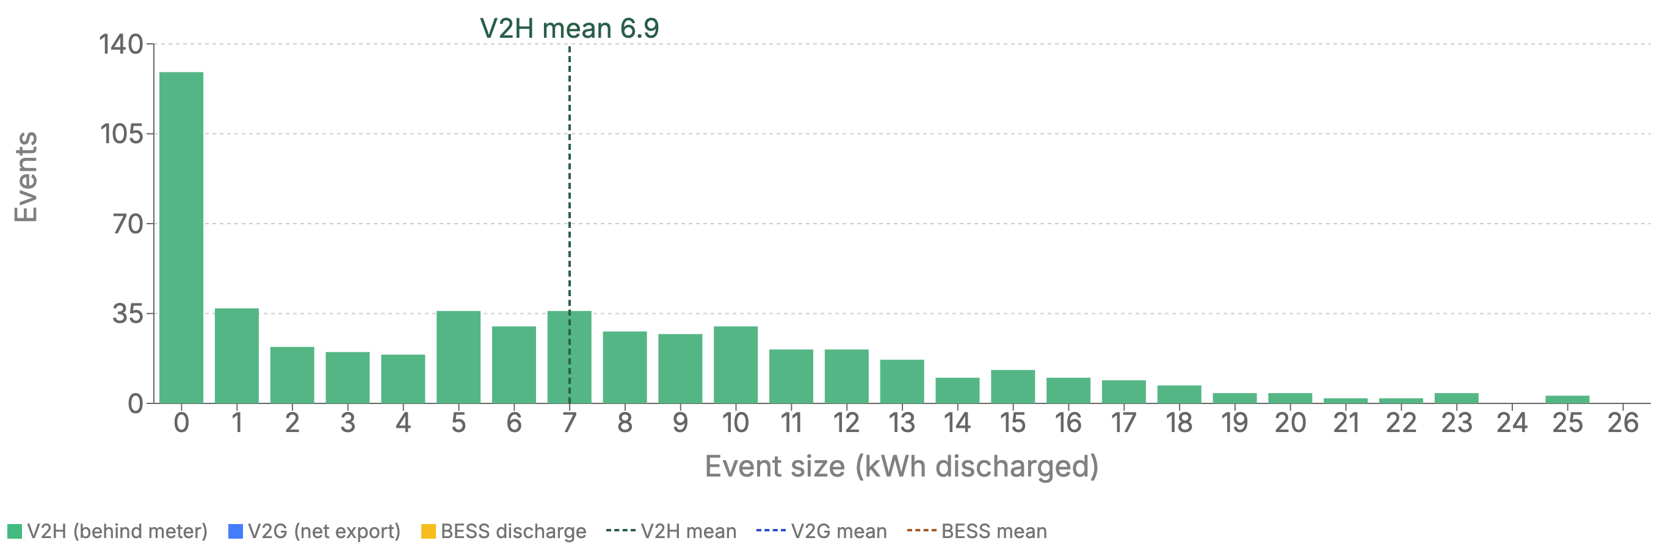
Figure 11 Scenario 3 V2H (always home) discharge probability density
Scenario 3 is different from scenario 2, even though the vehicle never drives in scenario 3. The additional battery capacity of the EV does make a difference, with several events larger than the size of the home battery. The overall shape of the plot is somewhat different though, and not fully explainable by the larger battery. There are more smaller events and less larger events. This is likely due to the slightly different way that the optimiser handles EVs and batteries.
Average event sizes across the EV scenarios is overall relatively similar at 6-7kWh. The battery scenarios (scenario 2) had a higher average event size at 9kWh. The shape of the probability density between models 2 and 3 on one hand and model 1 on the other is different.
The BESS (model 2) probability density is distinctly bimodal. Most events either transact a very small amount of energy (<1kWh) or the full battery capacity. Model 3 also shows a large number of very small events but a smoother distribution of event size at other times. This indicates that potentially the larger energy storage in the vehicle in Model 3 is sufficient to meet the user’s energy needs.
Model 1 probability density does not have the characteristic large numbers of small events. Otherwise, the overall shape is broadly similar to model 3 except skewed towards slightly smaller events. This may be because the EVs are not there during the day, and the smaller discharge events are in the afternoon as the sun sets and load and generation are close to matching.

Model 4 and 5 – Market price passthrough
Figure 12 and 13 show market-response BESS discharge heatmap for Model 4 and 5, accordingly.
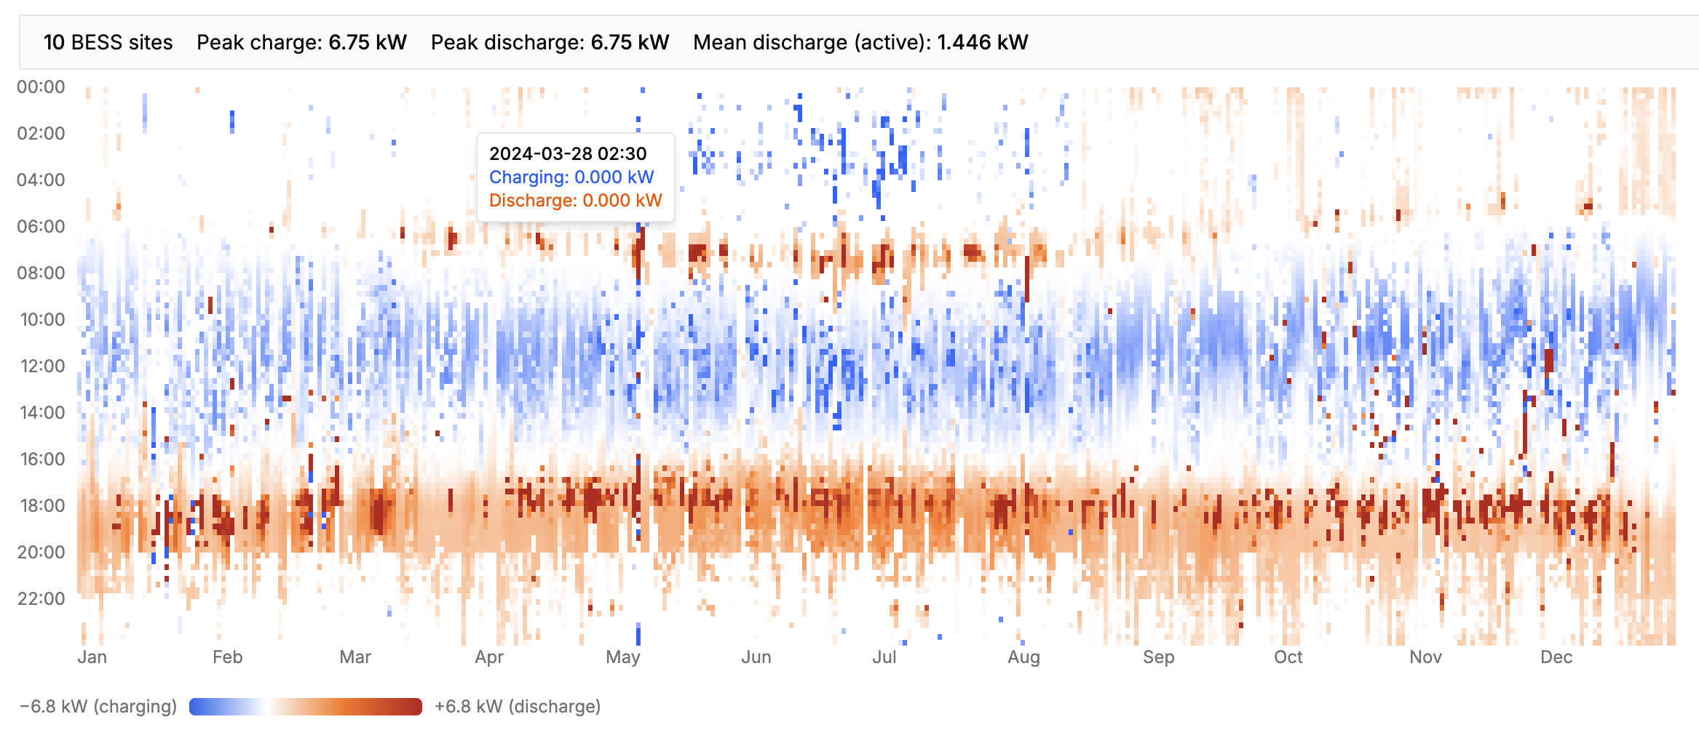
Figure 12 Scenario 4 market-response BESS discharge heatmap
As expected, dynamic pricing results in much more variance in charge and discharge patterns. For example, the impact of market price events can be seen in intermittent high power discharges during the day, especially around October – December. The overlaid network price can still be seen in the relatively similar times discharge ceases in the evening.
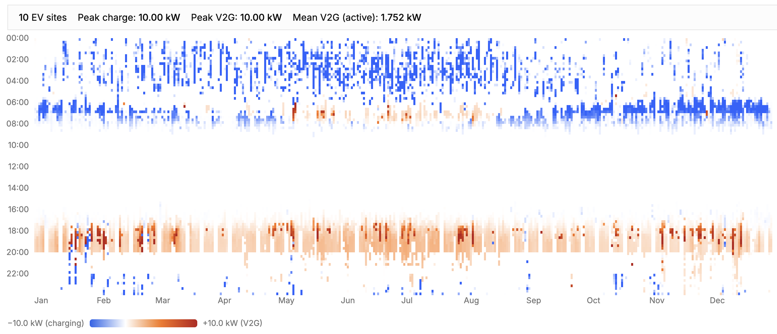
Figure 13 Scenario 5 market-response V2G discharge heatmap
Like Scenario 1, scenario 5 shows the vehicle availability clearly. The vehicle is unable to charge during the day so charges overnight instead – usually in the early morning. In summer, the vehicle can capture some excess solar energy due to early sunrise. Evening discharges are shorter and less intense, likely due to the higher cost of overnight energy compared to daytime energy which reduces the arbitrage value.
Like scenario 1 and 2, EVS not being home during the day has a major impact on charge/discharge profiles in models 5 and 6. The lack of availability during the day forces most charging to happen at night in the early hours of the morning. Unlike the V2H use case, there is no one consistent time when charging happens. However, it is important to note that this simulation had perfect foresight which is not likely to be the case in a real deployment. It is likely a real deployment will not be as efficient at capturing peak periods therefore charging may be more distributed across the overnight lower price period. The intensity of discharges (deep red) is notably less in model 5 too. This is likely because the cost of the energy in the battery is higher for the EV as it is charged with relatively more expensive overnight energy compared to low-cost daytime energy for the home battery. This in effect sets the economic bar higher for EV discharge.
In scenarios 1-3 price was always the same. In scenario 4, there are notable events visible in the heatmap. For example, around 27/11 there was a high price period that is visible in scenario 4 as a strong discharge (red) pattern around 2PM. This period is not visible in scenario 5 as the vehicle was not plugged in. There are several other discharge events during the day throughout the year which the V2G EV was also unable to respond to. High price discharge events are rare overnight, which means the V2G EV is able to respond to volatility much less often. This means that in total, V2G may be significantly less able to respond to extreme events than its availability indicates.
The scenario 4 results also has important implications for the behaviour that drivers might observe from their V2G system. A home battery has a relatively predictable pattern – it charges from excess solar until full then discharges in the evening. The V2H system misses this opportunity so charges at different times, and to different amounts every day. Experience from past customer-facing projects has shown that some element of predictability in DER behaviour is important for people to become comfortable with their DER system.
The probability density results for scenarios 4 (Figure 14) and 5 (Figure 15) show much more similar probability density functions than for the V2H case. Average event size is somewhat lower for the BESS case, likely because market price peaks are often much shorter in duration than the peak windows of a standard time of use tariff.

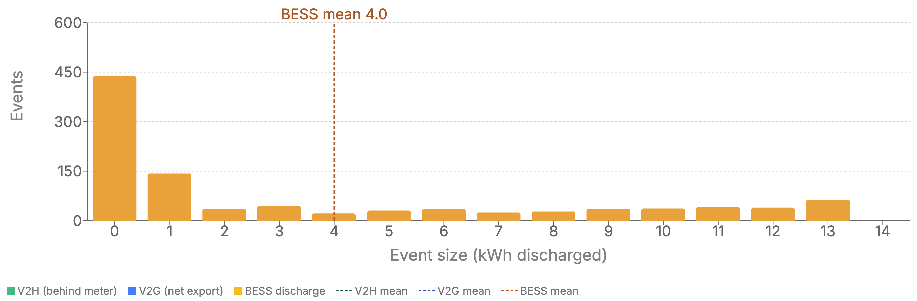
Figure 14 Scenario 4 home battery discharge probability density
Compared to the standard time of use offer, scenario 4 shows more smaller events and less larger events. As pricing is more dynamic in scenario 4 it may be expected that shorter discharges are needed to manage more variable dynamic energy pricing.
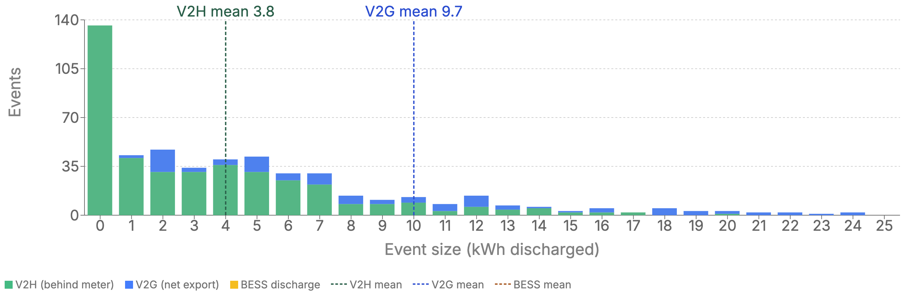
Figure 15 Scenario 5 V2G discharge probability density
The V2G results are split for where discharge is primarily to local load (V2H) and the grid (V2G). V2G events are significantly larger (at 9.7kWh) than V2H events (at 3.8kWh). This is likely because V2G events will more often cause the vehicle to discharge at its maximum rate, while V2H events just net out the local generation.

Energy comparisons
Table 7 summarises kWh comparison of 5 different scenarios and events. From this summary we can see the total energy used by both BESS and V2G/H are within a range of 1.6 to 4.3 MWh/year. The smaller BESS (13.5kWh) produces the greatest energy in absolute terms. This gap is widened when considering that the EV battery has a much higher capacity (22.5kWh available for grid use).
Table 8 Summary of kWh comparison
Scenario | Events | Mean energy (kWh) | Total Energy/year (kWh)
1: V2H Commuter | 264 | 6.2 | 1631
2: Bess (Alinta DMO TOU) | 483 | 9.0 | 4343
3: V2H home during the daytime | 541 | 6.9 | 3713
4: V2H/G (Amber) | 403/100 | 3.8/9.7 | 1549/973
5: BESS (Amber) | 1013 | 4.0 | 4029
The availability is the main influence. The scenarios where the EV is not at home during the day have a much lower energy throughput because of the limited ability to charge from daytime solar behind-the-meter. The V2H daytime scenario shows significantly greater energy throughput than the commuter case, however, is still less than the home battery case.

Summary of baseline behaviour
V2X is often mooted as a high capacity, mobile battery; high capacity and mobile being two factors in tension. The results in this section show the impact of these two factors. V2G EVs are indeed higher capacity than home batteries, but their ability to deploy that capacity can be severely limited by driving needs.
The driving profile used in this study is intentionally worst case – a vehicle that is away all day every day. A real vehicle will likely be home at least sometimes during the day, and if those days overlay with days that have high prices, then there is significant additional value that could be unlocked from V2G.
V2G is likely to result in a much more variable EV charge/discharge pattern. Previous experience has shown that sometimes highly variable DER behaviour can be difficult for householders to build practices around (Boyle et al., 2023). This emphasises that householder engagement will be an important part of V2G uptake.

DOEs as applied to V2G
This section takes the V2X operations explored in the previous section and applies DOEs to explore the impact of DOEs. In the case of export DOEs or flexible export connections, a known and relatively consistent approach across DNSPs can be applied. For import DOEs, the approaches from DNPSs are still emerging, hence prototypical application of import DOEs is applied to understand the range of impacts and opportunities.
From the analysis of stakeholder interviews, the prevailing view is that V2G should fit within the current export DOE/Flexible Exports arrangements (Interviews 15/12/2025, 25/11/2025, 10/12/2025, 12/12/2025, 18/12/2025), with some networks already seeing connections of V2G systems in-line with this (Interviews 10/12/2025, 10/12/2025).
At the same time there was broad acknowledgement that import DOEs require effort to develop for all load types, with V2G under-explored in this regard.
The technical analysis seeks to confirm the boundaries of export DOEs for V2G operation, as well as begin the exploration of how import DOEs may interact with V2G. Import side envelopes concern the charging behaviour of EVs, with some limited interaction with V2G and V2H. Export DOEs are reviewed within the context of the deeper understanding of V2G behaviour modelled in 4.2.1 as well as insights from the qualitative evidence. Import DOEs are examined from a starting point of mirrored export DOE approach, with the aim of identifying points of tension and/or alignment. Finally technical implementation challenges identified are outlined.

Review of export DOEs applied to V2X
We analyse export DOEs from the perspective that DOEs are already available and operating for some customers with V2G. With that context we assess the technical factors that may impact V2G operations both positively and negatively and aim to understand whether any modifications to the framework are required to see V2G reach its full potential while the still meeting the objectives of DOEs and flexible exports.
Several factors influence whether a V2G connection can deliver its nominal export capacity, independent of whether the DOE itself is correctly calculated. The current flexible exports framework is being pushed beyond its original solar-driven design intent, and its performance under that pressure is worth examining.

Coincidence of export DOE and V2G operation
In Figure 16, we can see a simulated export DOE calculation profile based on a simplified thermal capacity calculation in combination with the underlying meter data set within Cadium. DOEs reduce during the sunlight hours, which is a reflection of the uncontrolled solar exports already present in the meter data set, reducing the export capacity available in this network area. Refer to section 4.1.2 for detail on DOE calculations.
For V2G (and other stationary BESS) we know that exports are currently only triggered by an elevated wholesale price. Figure 16 overlays market prices greater than $300/MWh, and we can observe a general correlation of 91.6% of high prices where the DOE allowed a greater than 7.5kW output. Note, this example is of a particularly constrained network section.
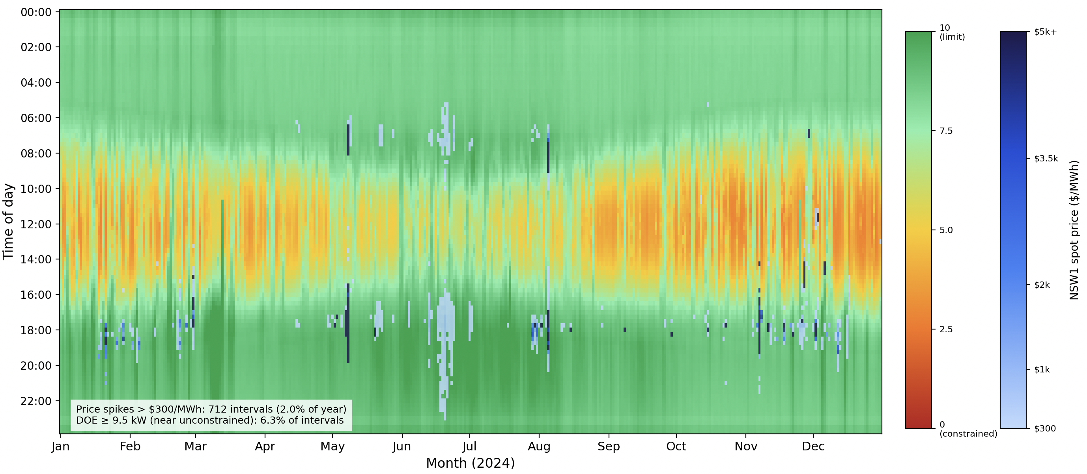
Figure 16 DOEs with market prices >$300MWh
In the current network and DER operating posture, DOEs are limiting exports during the daytime due to uncontrolled solar output, however the evening times have greater capacity available for DOE allocation to V2G (and BESS) connection points. This aligns with export DOEs primary objective, which is to manage solar PV exports into the distribution network.

Misaligned Market and Network drivers
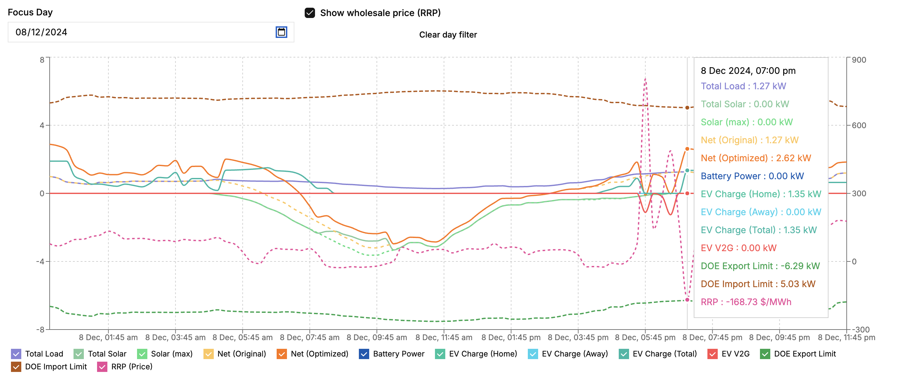
Figure 17 Evening negative price example
An expectation among interview participants was that network and market needs would generally incentivise similar behaviour. I.e. higher prices in the afternoon would incentivise EV owners to discharge in the evening network peak and vice versa at midday. Figure 17 shows and example of evening negative pricing on a V2G enabled cohort. The negative price interval occurs at 7:00pm, eliciting the V2G EV to begin charging despite the potential for network peaks. This could cause increased localised network demand. While this may be considered an outlier event, this demonstrates that network and market signals are not always aligned. Generally, networks need to be sized for peak demand, and price-responsive V2G creates a risk that these peaks are during price excursions.
This position confirms the current ability of the DOE framework to facilitate V2G exports. Further, as we will explore in the import DOE section, there an opportunity for V2G (and stationary BESS) to export at times of peak network demand, to address network limitations, as demonstrated in Ausgrid’s Project Edith (DEIP, 2025b).
While the majority of price elevations occur outside the solar maximum periods, there are some occurrences of high prices during these periods, due to abnormal network conditions, weather patterns or largescale generation outages. The intermittent plug-in rate must also be overlaid here again, as in the case of commuter vehicle usage patterns may make it difficult or unrealistic for vehicles to be plugged in away from home during these periods. The result is diminishing opportunity to export at times when export DOEs will be limiting.

What may erode DOEs?
Table 8 presents the comparison between Flexible connections and static alternatives. DOE export capacity can be eroded by the connection and operation of uncontrolled exporting DER, such as BESS or indeed V2G itself. BESS or V2G can be connected to most DNSPs under the minimum capacity threshold for necessitating a flexible connection, which varies between 0kW and 5kW. Queensland, NSW and Victoria (states with 5kW) will see the greatest impact here.
Table 9 Comparison between Flexible connections and static alternatives
Network | Flexible Connections Roadmap | Fixed Alternative | Flexible Upper Limit
SA Power Networks (SA) | All new exporting solar from 1 Jul 2023 — no size threshold | 1.5 kW/phase (or 0 kW SWER) | up to 10 kW/phase variable
Energex / Ergon (QLD) | Optional — choose Basic vs Dynamic connection | 5 kW/phase | Dynamic: up to 10 kW/phase, 1.5 kW floor during constraints
Ausgrid / Endeavour / Essential (NSW) | Trials underway, standardised from Mid-late 2026 | 5 kW/phase | ~10 kW/phase variable (planned)
CitiPower / Powercor / Jemena / AusNet / United Energy (VIC) | Coming Jul 2026 onwards | 5 kW/phase | up to 10 kW/phase under flex
Western Power (SWIS, WA) | From 1 Feb 2026 — CSIP-AUS required on all new/upgraded systems | 1.5 kW/phase | up to 5 kW/phase with offtake; higher under DOE
TasNetworks / Evoenergy | Not yet announced | 10kW | -
This trend may create a situation where the uncontrolled (not enrolled in flexible exports/DOE programs) V2G reduces the available headroom capacity between the underlying load and the network capacity, reducing the remaining DOE capacity available for allocation to the controlled DER. In some cases, this will either limit the DOE available such that it creates ongoing export limiting, or in severe cases results in network augmentation to alleviate these constraints, ultimately undermining the very purpose of DOEs.

Import DOEs
Import or load-side DOEs have been proposed by some DNSPs with the aim of developing flexible assets during times of peak demand. EVs through V2X are one such flexible asset. Importantly EV charging is potentially impacted by import DOEs, as explored in Section 4.1 and could have a material impact on the interaction of users, charging and their dynamic network connection.
With load-side flexible connection agreements still undefined by DNSPs, we define a scenario here for the purposes of exploring the technical challenges and opportunities for import DOEs. The scenario focusses on the impact of EV charging on peak demand as a representative challenge that import DOEs will aim to solve. For ease of modelling we define an overall site import limit, rather than limit a subset of site loads, although there is an open question as to where import DOEs apply to the whole connection point or a subset of load.
Figure 18 shows an example of DOE import capacity across a network segment, noting the stark difference between the import and export envelope heatmaps. We can approximate import DOE capacity as the delta between the underlying load usage and the transformer capacity (ignoring voltage constraints for now). We can see that the temporal nature of import DOEs as favourable during the day with solar exports increasing the imports available, and compressing at most other times, with some additional constraining times in the evenings. In this example we can already observe evening capacity limited to around half of the 15kW connection agreement limit.
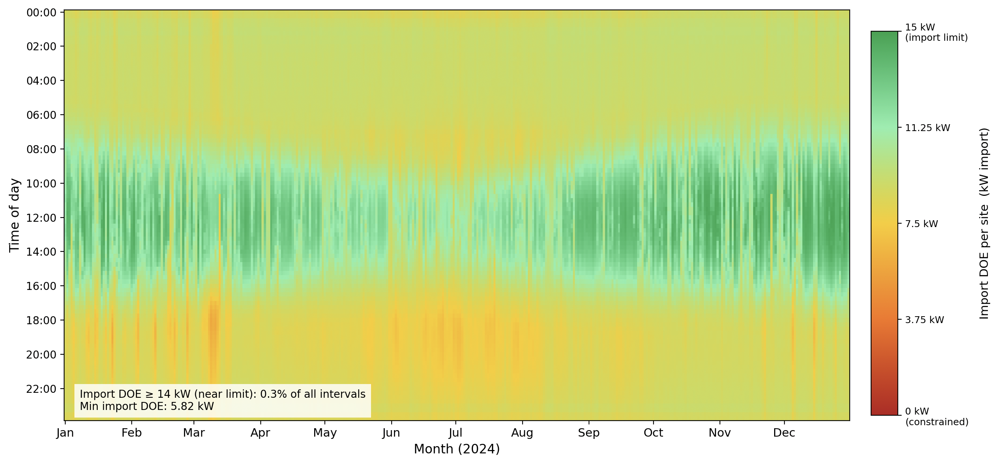
Figure 19 Import DOE Heatmap

Modelling DOEs and V2X
The aim of flexible imports is to see a reduction in aggregate peak demand across a network segment. The modelling shows this, with and without flexible exports to determine a range of benefits and impacts to user. Flexible imports scenario is defined below in Table 9.
Table 10 Import DOE Scenario Parameters
FACTOR | PARAMETERS
Flexible Load | EV charging and V2X
Min import | 5 (2x ADMD)
Max import | 15 (SA example)
Enrolled portion | 5%
Network Size | 50 residential connections, 315kVA Transformer
Uncontrolled additional EV charging | 20% at 3kW charger
Variants | Base case, no EV charging/V2X,  EV charging only, no V2X  V2H  V2G
We compare four variants of this scenario to examine the impact of DOEs on V2G. All cases have solar.
Figure 18 show export DOE violations and Figure 19 show import DOE for base cases. The output heatmaps below (Figure 18 and 19) overlay the resulting demand profiles (in blue) with the corresponding DOE violations (in Red). The plots show aggregated data across the 50 residential sites, with any DOE violations contributing towards the red plot to enhance this visual representation. The % violation figure shown is the percentage of 15 min intervals for all sites across the year, hence a low % violation figure in comparison with the significant amounts of red shown in the heatmaps.
Here we can see when DOEs will impact desired export and import behaviour. Export and Import DOE plots are shown separately so we can see the distinctly differing profiles.
Export profiles show minimal limiting, partly as the scenario was tuned based on expected solar penetrations, size and number of connections and a healthy sized transformer for this number of connections.
Import DOEs are applied to the overall connection, with a minimum 5kW import level set. While this configuration may never be applied in practice it provides a useful comparison point between the variants.

Scenario 1 – Base case
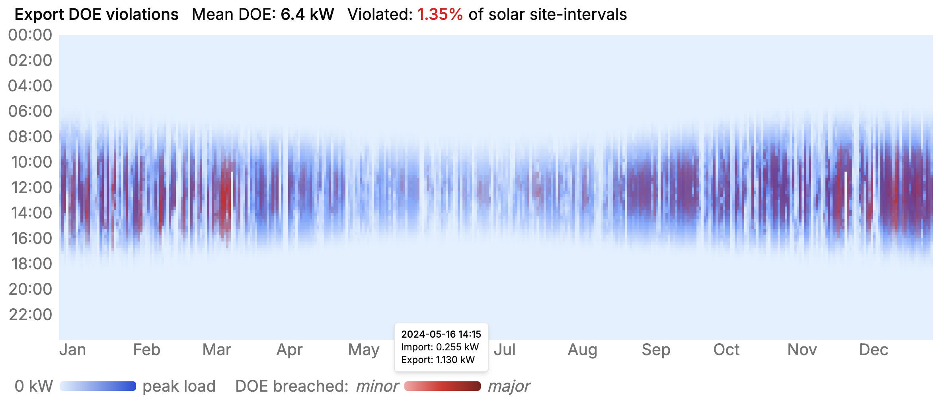

Figure 20 Export DOE violations - base case
The export-side heatmap shows a result as expected, with a clear difference in the V2G variant, where clear non-solar hours exports occur, triggered by wholesale price-based exports. Solar output is sized on this network size for minimal export limitations, in line with high solar penetration on a well loaded transformer.
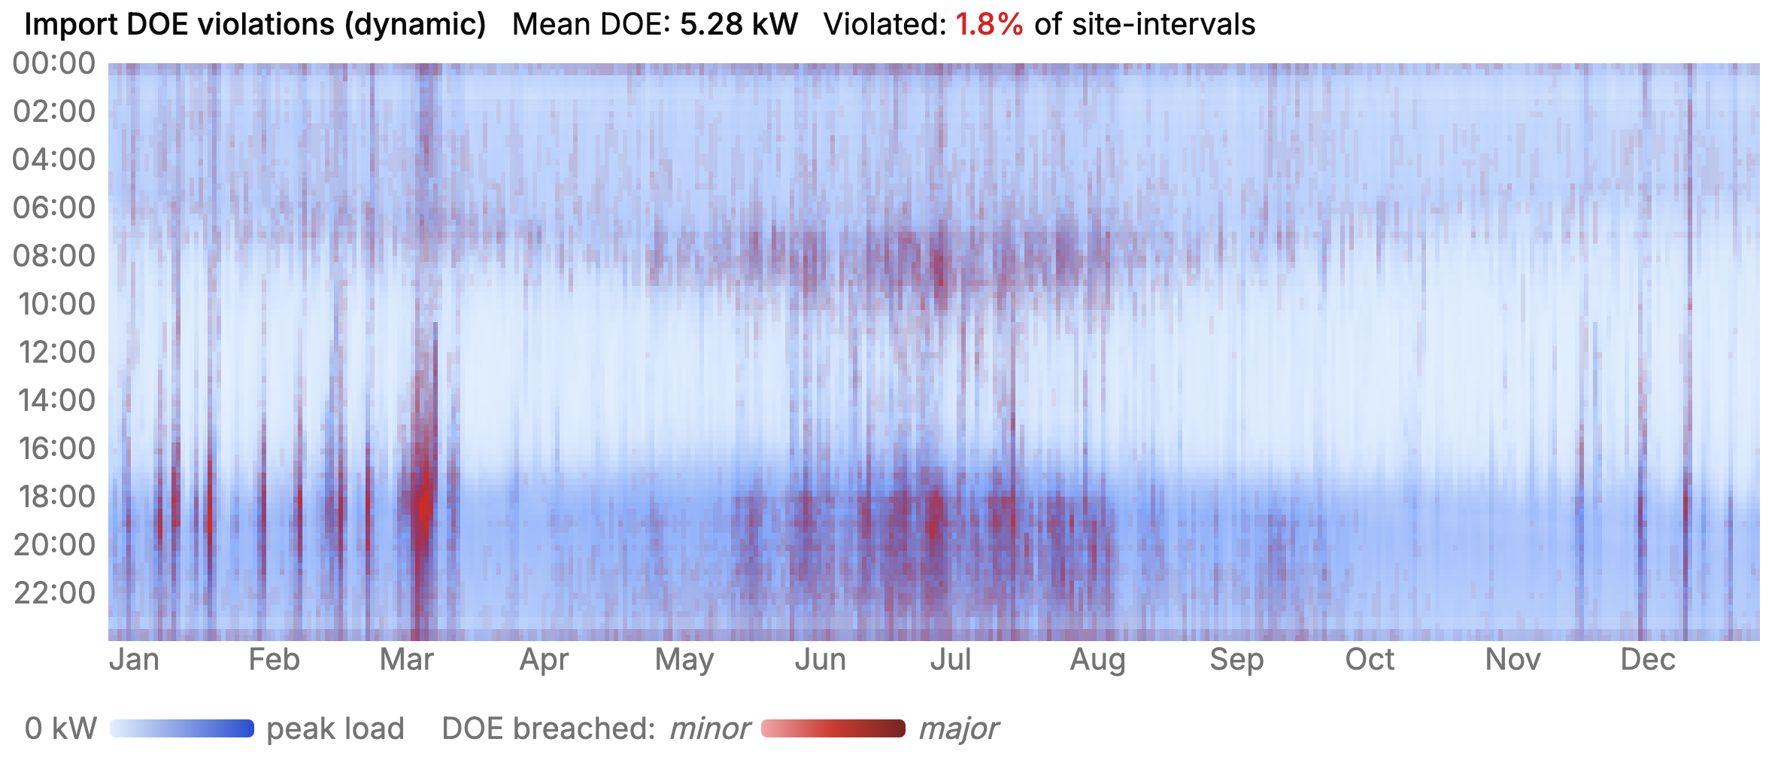
Figure 21 Import DOE violations - base case
The import side heatmap shows several different features. Firstly, in the base-case we can observe many times where there are already intervals where import DOEs would be limiting, even prior to EV charging being added to the scenario. This is reflective of a scenario of a well loaded transformer (not overloaded) resulting in DOE calculations at an individual level in the order of 5kW at peak times. It is not uncommon for a distribution transformer to be loaded above its nameplate rating in practice for short periods (Perez, 2010; Strzalka-Goluszka, 1999).
In this case, where we are considering applying DOEs at the connection point level, the DOE would apply to household load. In practice there are many challenges with this approach and this report is not advocating for it, rather this combination of load demand and transformer sizing has been selected to highlight the incremental effect of EV charging demand on the load profile and hence impact of DOEs.

Scenario 2 - EV Charging
Scenario 2 adds EV smart-charging to the load profile, with a clear increase in violations with import DOEs (as shown in Figure 20), given then increasing point loads of 7kW average EV chargers. The increased violations occur in both the winter peak evening periods, as well as a new bar of charging occurring in line with the evening TOU off-peak tariff change time at 10pm.

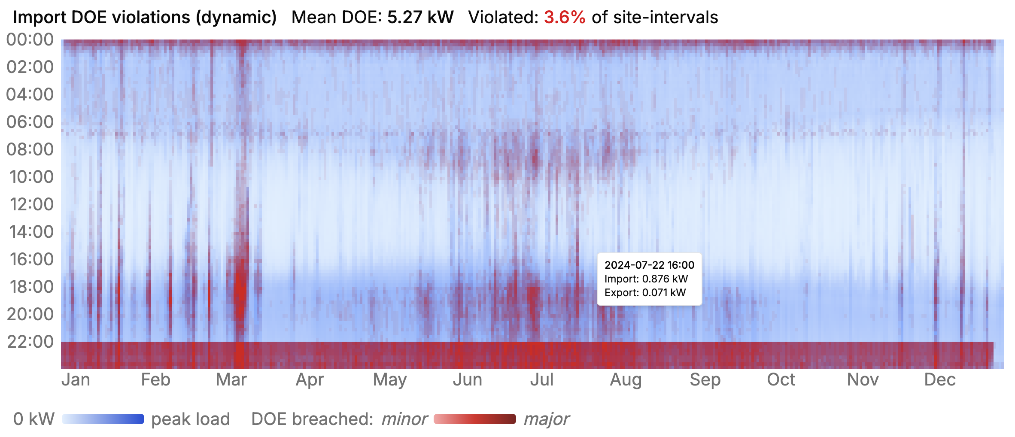
Figure 22 Import DOE violations - Variant 2 - EV Charging only

Scenario 3 - V2H
Scenario 3 introduces V2H operation (as presented in Figure 21), allowing the vehicle to respond to the retail tariffs, resulting in less DOE violations in the evening period, at the expense of greater coincident charging in the post 10pm period. Of note is that in both Scenario 2 and Scenario 3, the peak demand interval of the year shifts from 11 Mar 18:15 in Variant 1 to 9 Mar 22:00 for both scenarios, revealing the EV charging is driving peak demand.
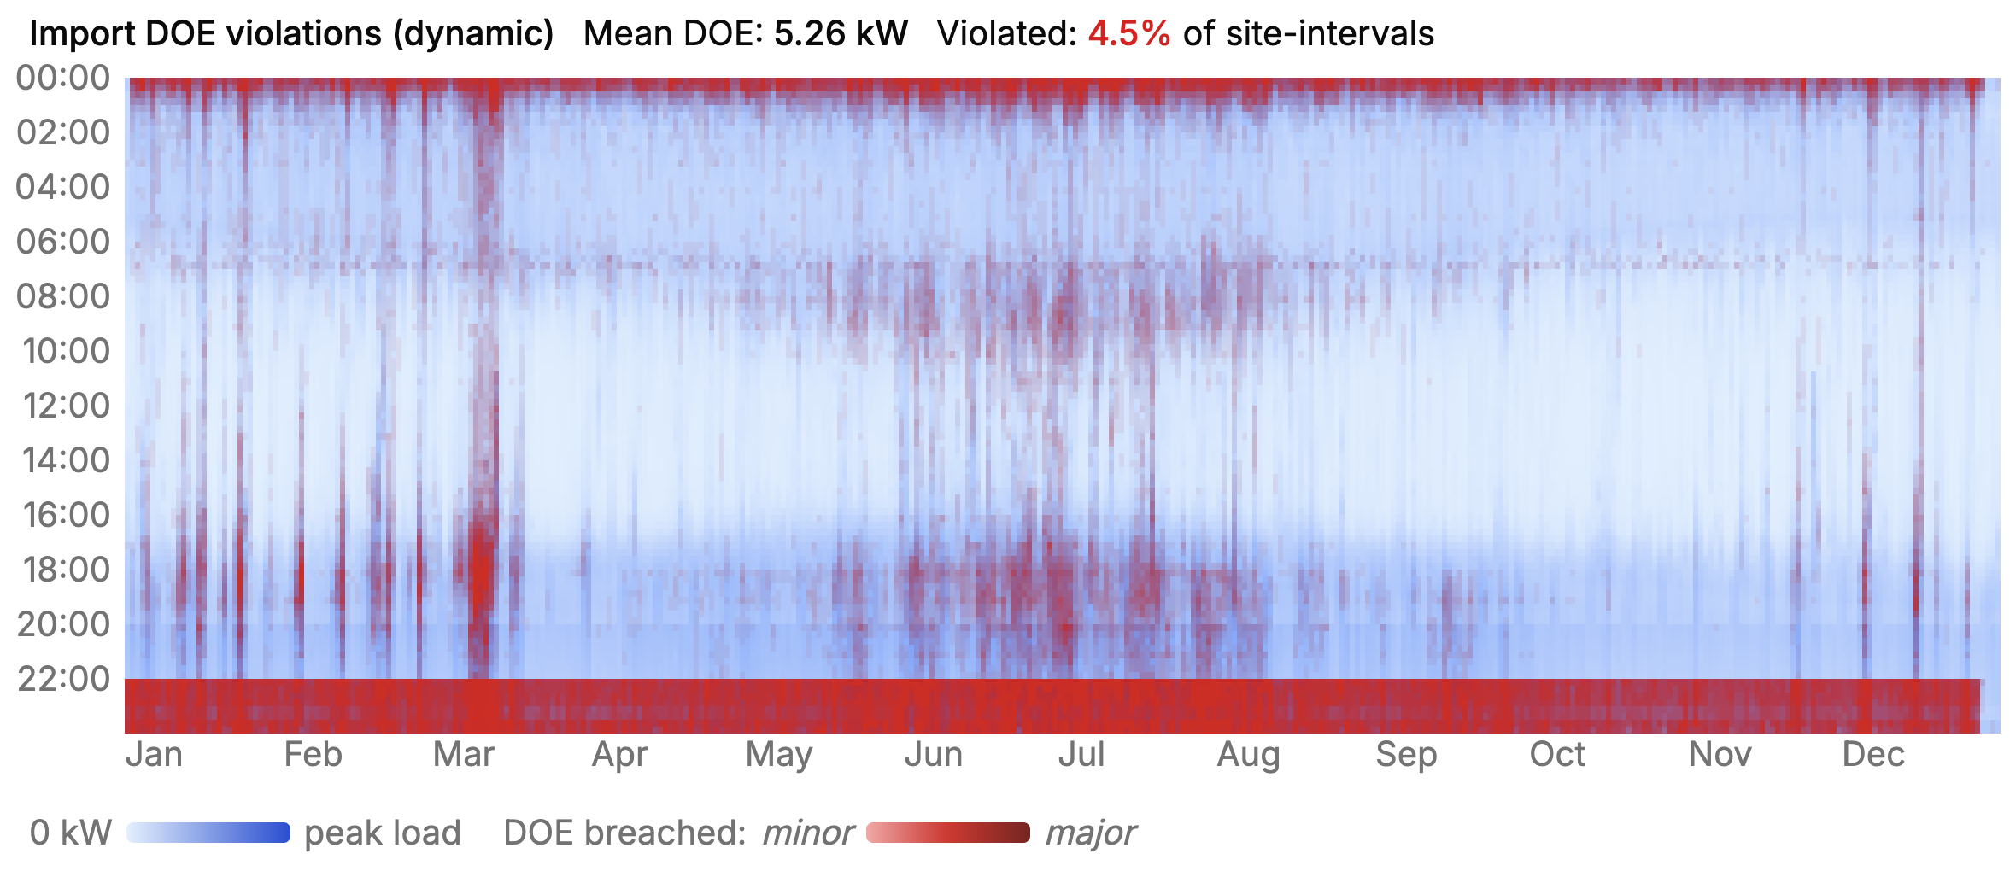
Figure 23 Import DOE violations -Scenario 3 – V2H
The overall number of interval violations does not significantly change between scenarios 2 and 3 and remains around 4.5%. In the context of export DOEs, a 5% violations level is expected and planned for, with explicit conditions on flexible export connection agreements outlined upfront (AER, 2024). While this is likely tolerated by consumers for export, it’s still untested as to whether this amount will be acceptable to consumers on the import side. This is further explored in section 4.3.

Scenario 4 - V2G
The final case in Figure 22 and Figure 23 with V2G enabled shows the export and import DOE impacts. The effect of a retail passthrough tariff creates the conditions for non-solar hours exports, with DOEs still impacting these exports, however these are extremely minimal, with an increase in only 0.21% site-interval violations for the case examined here.

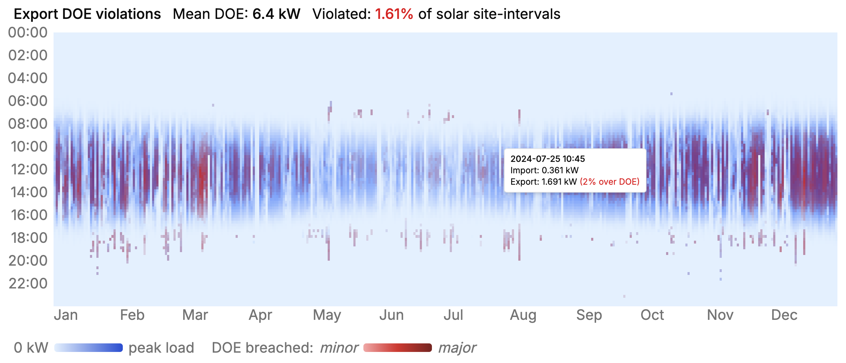

Figure 24 Export DOE violations - Scenario 4 - V2G
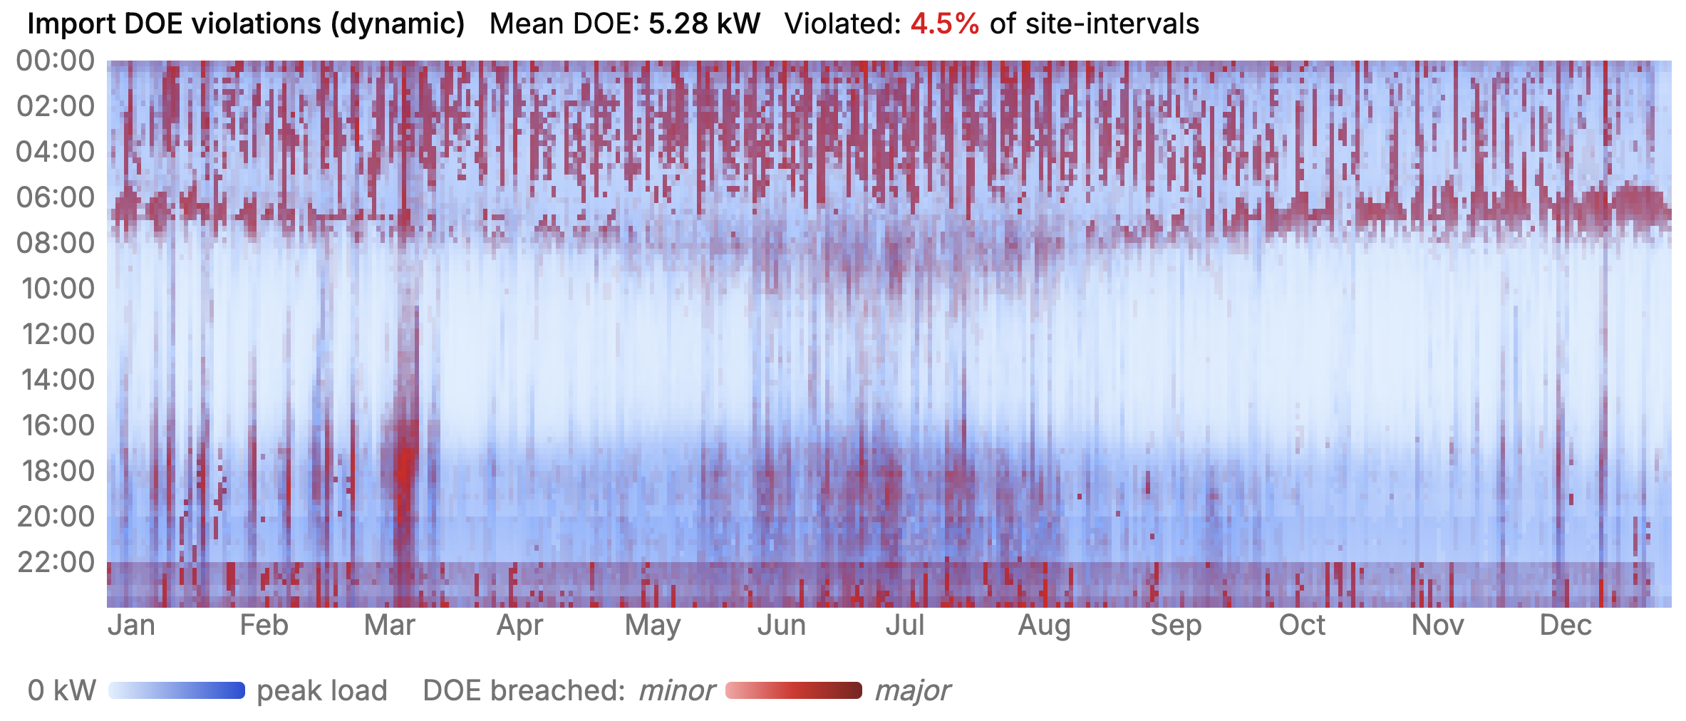
Figure 25 Import DOE violations – Scenario 4 - V2G
The pattern change in import violations is stark, when compared to the V2H scenario, reflecting the response to the higher fidelity wholesale price in place of the retail TOU tariff.
The network TOU tariff is still present; however, the response is less pronounced. There is greater charging in the morning, just prior to the morning shoulder/peak changes. The overall number of violated site-intervals remains at 4.5%, reflecting a similar amount but redistributed differently over the year.

Maximum demand changes
As mentioned, the key objective of import DOEs is as a management tool for peak demand control. Table 10 summarises the maximum demand impact for No EV (base), EV Charging, V2H and V2G scenarios.
Table 11 Maximum demand impact
SCENARIO | MAX DEMAND (BEFORE DOE) | ADMD (BEFORE DOE) | TIMESTAMP | MAX DEMAND (WITH DOE) | ADMD (WITH DOE) | TIMESTAMP
No EV (base) | 199.6 | 4.0 | 11 Mar 18:15 | - | - | -
EV Charging | 278.5 | 5.6 | 9 Mar 22:00 | 206.5 | 4.13 | 11 Mar 18:15
V2H | 302.4 | 6.1 | 9 Mar 22:00 | 195.5 | 3.91 | 9 Mar 18:00
V2G | 283.8 | 5.7 | 11 Mar 18:30 | 199.2 | 3.98 | 11 Mar 18:30
From the scenarios without DOE application, we can see a change in the peak demand magnitude and time to the off-peak start time of 10pm, with a considerable increase in peak demand, in the order of 50%. Note the EV Charging only scenario has slightly smaller charger kW of 3kW average, as opposed to the 7kW chargers in the V2H and V2G scenarios. The V2G scenario sees the peak demand shift back to the 6:30 time, reflecting the stronger wholesale price signal.
We then apply DOEs, with visibility to the optimiser and a soft financial incentive (3.3.4) to achieve these. This gives the optimiser an incentive to minimise peak demand and, in some cases, supply the local load. We can see the effect of the DOEs in the peak demand results, essentially capping the demand at the pre-existing demand level but still maintaining the same energy throughput. Today, optimisers are not always aware of DOEs:
“Things like export limits and CSIP commands at the moment just slap over the top of what we’re doing so we might send a command and then it’ll just be overridden.” – Technology provider interview (25/11/2025)
In conclusion import DOEs, when considered by the optimiser controlling EV and V2X operations can shift the charging/discharging behaviour to stay within the existing demand profile.

Missing incentive
While the optimiser response was achieved through the introduction of an incentive mechanism, which needs to also be reflected in some way, in the more general connection agreement and/or tariff offer to the customer. This is currently absent.
Further, while the modelling confirms the technical ability for V2G and DOEs to operate in unison under the hypothetical combination of technical parameters, this solution has not been tested and accepted as a solution with customers or combination of retailers and solution providers that will ultimately offer and support such as solution. The presentation here represents the techno-only considerations from a network and system perspective. Incentives need to derive from the overall system benefits and distilled into a valuable offering to consumers. The offering must contain either an implicit or explicit incentive that can be reflected in the DOE optimisation response. For exports this incentive is having the option to increase installed DER capacity to 10kVA on the condition that DOE limits are adhered to. This is built into the site optimiser/controller at the time of commissioning.

Notes on implementation
This study implemented an integrated behind-the-meter energy optimisation solution that considers local behind-the-meter load, DOEs, wholesale prices, forecasts of each, as well as knowledge of vehicle SOC and target charging. In practice this require significant data, forecasting and control integration, as well as (likely) local behind-the-meter hardware running the optimisation algorithm. There are very few commercial-off-the-shelf solutions that offer this level of integration and functionality at this point.
Within the stakeholder group interviewed, there were current gaps identified in the V2G solutions either in the integration with the vehicle or integration with the DOEs. In addition, the stakeholders expressed many challenges with technology interoperability, and although this is expected to improve in time, is a critical dependency for achieving the modelled level of response to DOEs.

Linking energy user functional outcomes to DOEs and modelling (WP3)
Because V2G is acting on a device that is used for another important primary purpose for people, it was important to further explore the interactions of V2G and car use needs and activities. One common function observed in V2G products are "charge now" buttons. In interviews and workshop, we used a ‘charge now’ button imaginary to explore energy user needs and outcomes in relation to DOEs and V2G.
When a user presses the charge now button, they are signalling that they would like to charge their vehicle as fast as possible, possibly because they have a sudden, pressing or unexpected need for energy quickly to use their vehicle for transport. Charge now buttons can be used by EV users to direct V2G chargers to charge at the maximum possible rate. From the perspective of workshop participants, this functionality reflects a broader expectation that "customers need an override for certain DER” Workshop session 2, (03/10/2025), particularly EV chargers (ibid).
Charge now buttons and DOEs may be expected to interact when the charger is instructed to disregard how it normally operates and charge as fast as possible, energy consumption will increase, but potentially a customer's import limit will block them from charging any faster. We asked interviewees about charge now buttons to help explore this interaction, with a focus on understanding what a constrained or blocked charge request might mean for the EV users and systems affected.
Participants regularly raised the potential for DOEs to impact people's lives by influencing the electricity use of major devices in their home. As described in section 2.2, most DOE design treats equity of energy allocation as a distributional question: who gets how much capacity. And current DOEs often treat equal allocation as the best distribution of energy. Yet what people need electricity for, and what its curtailment costs them, varies considerably across households. If network capacity shapes how people heat their homes, care for dependents, run medical equipment, or participate in paid work, then an equal allocation is not necessarily an equitable one.
Distributive justice is a helpful lens here: rooted in philosophical traditions of social justice (Rawls, 1971; Sen, 1999) and developed as an analytical framework for energy systems by (Sovacool and Dworkin, 2014), it asks what is fair and just in the provision of energy — including how energy poverty, vulnerability, and disadvantage interact with access to energy services (Walker and Day, 2012). In this context, it supports the argument that energy allocation in DOEs cannot simply be reduced to equal shares. It requires asking whether the consequences of an allocation allow people to go about their daily lives on roughly equal terms, with reasonably fair outcomes.
The interview responses in this project suggest that an unjust distribution of capacity is in part a symptom of a deeper problem: the models producing that distribution represent people in simplified ways and this approach provides too simple a picture and overlooks or ignores the consequences of the model’s own outputs. When an energy user is modelled as little more than a recipient of capacity with no account of what that capacity is for, or what its absence costs, it becomes easy to make false assumptions about that energy user’s needs. This simplified version of an energy user, that has been coined in energy research as the "resource man", provides an abstracted, largely homogenous representation of people that strips away the social and material context of their lives (Strengers, 2014).
Impacts of this simplification is not merely technical. Fraser argues that when institutions including the systems and models that govern resource allocation fail to account for the diverse realities of people's lives, this constitutes a form of status harm: the person is not seen as a full and complex participant in the system affecting them, but as an interchangeable unit (Fraser, 1998; Van Uffelen, 2022).The implication is there can be unjust distribution when people’s end use requirements are not factored in.
While factoring people’s actual needs is important, we recognise the challenges: that translating social complexity into model parameters and DOE decisions is genuinely difficult, and no representation will be complete. Despite this understanding the problem of only using equal allocation for DOEs opens the door to decision makers and designers asking better questions about how allocation methods can be improved and what factors models should consider.

Advancing user conceptualisations via ‘capability framework’
Considering outcomes for users on top of the standard approaches used to allocate electrons, requires supportive heuristics. The Capability Approach, a framework developed primarily by economist and philosopher Amartya Sen and later expanded by Martha Nussbaum, offers further conceptual assistance when thinking about energy user/end user needs. This approach is used in development studies, welfare economics, and social justice research and work.
In this project we use the capability approach to introduce end use and user outcomes conceptualisations as important and needing considerations. Here we introduce the concepts without being able to fully integrate them but do so anyway as we see the need to advance considerations of end user experience outcomes in DOEs and V2G to be considered and evolved alongside modelling for DOE and V2G modelling. Therefore, at this stage in this project, we are introducing this as a useful interpretive lens, rather than a formal style of assessment or measurement.
The Approach, instead of measuring well-being by resources (income, wealth) or utility (happiness, satisfaction), focuses on what people are actually able to do and be by using the energy provided. That is, the energy use supports people’s capabilities. A capability in this Approach is the real freedom or opportunity to achieve valuable states of being (like being healthy, educated, or participating in society) and doing (like working, voting, or caring for others). It distinguishes between functioning - the things a person manages to do or be (e.g., being nourished, having shelter) - and capabilities - the genuine opportunities to achieve valuable life functions (Nussbaum, 2011; Sen, 1999). So, the Approach prioritises outcomes for people, rather than measuring only the function of the resource. Martha Nussbaum built on Sen’s original Capability Approach to but the Approach more universally applicable. She argues that every person should have access to a set of basic capabilities to live a life with dignity. Unlike Sen, who avoids prescribing a fixed list of capabilities, Nussbaum provides a list because she believes further specification was essential in order to apply justice and constitutional principles. While Nussbaum acknowledges these are not the only capabilities, she defines ten core capabilities, summarised as follows (Hillerbrand et al., 2021):
- Life: being able to live a normal length of life, not dying prematurely or before one’s life is worth living.
- Bodily health: having good health, adequate nutrition, and shelter.
- Bodily integrity: freedom of movement, security against assault, and reproductive choice.
- Senses, imagination, and thought: being able to use senses, imagine, think, and reason—supported by education and freedom of expression.
- Emotions: having attachments to people and things, loving, grieving, and experiencing emotions without fear.
- Practical reason: being able to form a conception of the good and critically reflect on one’s life.
- Affiliation: living with and toward others, showing concern, engaging in social interaction, and having self-respect.
- Other species: being able to live with concern for animals, plants, and nature.
- Play: enjoying recreation, laughter, and play.
- Control over one’s environment.
- Political: participating in political choices.
- Material: holding property and seeking employment.
In her research Nussbaum applies the Capability Approach to energy contexts which provides us with examples of direct examples applications for energy systems design. Energy topics she has engaged with include energy system development (Corvino et al., 2021), energy poverty as capability deprivation (Bartiaux et al., 2021; Corvino et al., 2021), energy justice and equity (Frigo et al., 2021; Groves et al., 2021; Hillerbrand et al., 2021; Lee et al., 2021), renewable energy and rural electrification impacts, Indigenous communities' experiences with energy infrastructure (Hunt et al., 2021), gender dimensions of energy access (Fernández-Baldor et al., 2015), and energy policy and technology assessment (Hillerbrand et al., 2021).

Applying an outcomes, end user (capability) framework
Using a capability framework is useful here as a way of reading what DOE outcomes mean for people's lives and for surfacing tensions that a purely technical account of capacity allocation cannot see. The ‘charge now’ scenario, already introduced in this report as a device for discussion in workshops and interviews, assisted to explore these capability intersections and issues.
The capability framework helps understand how the charge now button links back to achieving and important outcome for EV users, which is using their vehicle even in urgent times. An example scenario where a dear relative has become ill and the EV user needs to get to the hospital a long way away to see her quickly, and therefore needs to charge their vehicle immediately, may be most strongly linked to Nussbaum’s “emotions” capability. Nussbaum details this capability as:
Being able to have attachments to things and people outside ourselves; to love those who love and care for us, to grieve at their absence; in general, to love, to grieve, to experience longing, gratitude, and justified anger. Not having one’s emotional development blighted by overwhelming fear and anxiety, or by traumatic events of abuse or neglect. (Supporting this capability means supporting forms of human association that can be shown to be crucial in their development.) (Nussbaum, 2001)
In this situation, the urgent need for transport helps fulfil the core functioning to “have attachments to things and people outside ourselves” (ibid) and to achieve the outcome of getting to see their dear relative. Conceptually, the DOE consumption limitation and the need to charge now may intersect when the user presses the “charge now” button and the DOE is active leading to their being no capacity available to actually charge the vehicle. So maybe the person in the scenario above will be unable to charge their vehicle and may not be able to see their relative, or at least not as quickly.
Some interview participants also felt that a charge now button that doesn’t actually charge the vehicle any faster (sometimes) would be a bad outcome. For example:
“Interviewer: It’ll be interesting to see people’s reactions if the charge limit ends up as zero.
Participant: It won’t be interesting; it’ll be not good. We’ll try and avoid that.” – Technology provider interview (25/11/2025)
However, some participants also thought that people should expect to occasionally not be able to “charge now” because the network cannot be expected to provide additional capacity all the time. For example,
“… if everybody wants to be able to [charge now] we could do that, but power prices would cost more which no one wants.” – Distribution network service provider interview (05/12/2025)
This tension can be related to Nussbaum’s framework “Affiliation” and “Other species” capabilities, which provide a frame to consider this phenomenon. Details of these capabilities are described by Nussbaum:
Affiliation. ‘Being able to live with and toward others, to recognize and show concern for other human beings, to engage in various forms of social interaction; to be able to imagine the situation of another and to have compassion for that situation; to have the capability for both justice and friendship. (Protecting this capability means protecting institutions that constitute and nourish such forms of affiliation, and also protecting the freedom of assembly and political speech.)’ (Nussbaum, 2001, page 79).
Other Species. ‘Being able to live with concern for and in relation to animals, plants, and the world of nature’ (ibid-Page 80).
If people have the capability to manage their consumption to within the limits of the existing network, it can be kept smaller, less, costly, and less ecologically impactful. In many circumstances there may be actions an individual can take to make their vehicle charge faster without having as much of an impact on the network. For example, they could turn off high drain appliances in their house, like clothes dryers, heaters, or ovens. Additionally, DOEs fundamentally are strategies that relate to managing a share resource and shared constraints (e.g. all those connected to a transformer), which means that careful consumption of energy, within envelopes could be considered as a means to “recognize and show concern for other human beings” (ibid.). Although DOE frameworks of today do not make apparent this connection.
What the capability framework makes visible here is not a problem with a clean solution, but a genuine conflict between different aims that both matters. Current DOE modelling has no mechanism to represent this conflict — capacity is allocated without any account of what it is for, or what competing goods are at stake in how limits are set. Acknowledging this gap is a necessary first step toward modelling approaches that can at least ask the right questions, even where the answers remain contested.

Modelling for the charge now event
The modelling component of this project provides a way to explore what the physical impact of DOEs might be on the use of a “charge now” button. This allows us to begin to quantitatively explore the energy user needs and outcomes (Nussbaum’s capabilities). For this analysis we have defined a metric for the effectiveness of a charge now button of:
How much energy would a user be 95% sure they could add to their EV battery if they pressed the “charge now” button during peak demand times (4:00 PM – 9:00 PM)
This metric aims to explore how often a “charge now” button is likely to perform worse when people might need it most – or when the impacts of not satisfying a person’s emotional needs (emotions capability) may be most real.
There are two scenarios considered as summarised in Table 11:
Table 12 Charge Now button scenarios
SCENARIO | SCENARIO 1: MARKET PRICE PASSTHROUGH | SCENARIO 2: TIME OF USE RETAIL TARIFF
Connections | Number of connections: 10  Solar: No  EV charger: 7kW V2G  EV usage patterns: Commuter  EV battery size: 60kWh  Average daily energy usage: 20kWh
Tariff | Market price passthrough on Ausgrid single-rate tariff | Alita Energy “Homedeal On” time-of-use tariff
Unconstrained max demand | 87.5kW | 90.63kW
Studied DOE limits | 99th percentile: 77.87kW  95th percentile: 75.62kW  94th percentile: 72.13kW  90th percentile: 29.69kW  75th percentile: 12.06kW | 99th percentile: 84.02kW  95th percentile: 78.14kW  93rd percentile: 76.09kW  90th percentile: 23.08kW  75th percentile: 11.35kW
The unconstrained load duration curves for these scenarios are presented in Figure 24 and Figure 25 below. The market price passthrough scenario has a larger dynamic range as negative prices incentivise export from V2G vehicles (albeit relatively rarely). The time of use tariff does not incentivise energy export so minimum demand is zero. At lower percentiles the duration curve has a broadly similar shape. Peaks are generally driven by co-incident EV charging due to co-incident (dynamic or time of use) price signals.
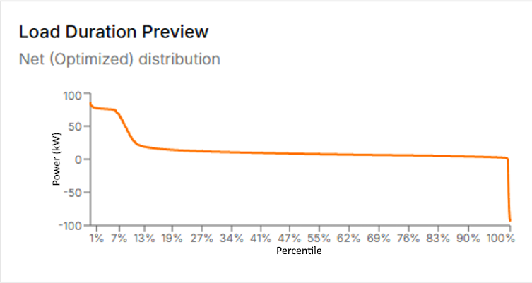
Figure 26 Load duration curve of market price passthrough scenario
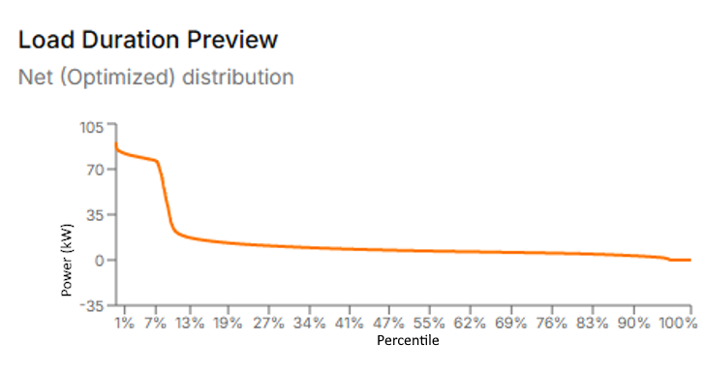
Figure 27 Load duration curve of time of use tariff scenario
Figure 26 shows the modelled charge now metric across all studied DOE limits for both scenarios in Figure 24 and 25. The blue bars are the market price passthrough scenario, the green bars are the time-of-use retail tariff scenario, and the red bar is the no DOE case. The results reveal a pronounced ‘knee point’ (significant change in trajectory) in the data: at DOE limits set at or below the 90th percentile of demand, a user pressing ‘charge now’ during peak hours could be 95% confident of adding only 0.4–2.0 kWh in an hour — equivalent to roughly 2–10 km of range. Above that threshold, performance recovers sharply to 6.2–6.7 kWh, approaching the unconstrained case of 7.0 kWh.

Figure 28 Impact of DOEs on "Charge Now" performance
Figure 29 shows the cumulative probability density function of charge now button performance for the 90th and 94th percentile scenarios (market pricing). It shows the stark difference in charge now button performance – in the 90th percentile scenario the user would never be able to add more than 15 km of driving range to their EV within an hour.
Figure 29 Cumulative probability density function of 90th and 94th percentile market scenario charge now button performance
This knee point corresponds closely to the non-EV load level — the typical household demand when no EV charging is occurring. DOE limits set below this point leave little headroom for EV charging during peak periods, effectively making the charge now button potentially non-functional precisely when it is most likely to be needed.
Figure 28 shows a 95th percentile charge now button performance. This figure was chosen as the amount of energy users could be reasonably certain of adding to their EV battery if they pressed charge now. However, the numbers can’t say whether this is sufficient. The capability framework invites us to ask why the user might be using their charge now button – what are they not able to do without the additional charge now energy? Lower charge now performance may represent a user being less able to use their vehicle in an emergency (to meet the emotions capability) in the scenario described earlier. A person needing to reach a seriously ill relative cannot meaningfully act on that need with 2 km of added range – especially if their EV started the event with a low state of charge. If this scenario plays out in practice the user may lose trust in their charging system. However, quantitatively there is not a large difference in the amount of time consumption is constrained in the two scenarios. The modelling result and the capability argument converge on the same point: DOE limits set below the non-EV load threshold impose costs that current equity frameworks in the literature have no language to describe.
There is a further subtlety in how the costs of DOEs should be understood. Current practice tends to treat a DOE as costless until it binds — that is, until observed consumption actually reaches the allocation limit. But the modelling results in Figure 26 suggest this framing is incomplete. A household operating close to its DOE limit has less freedom to respond to changing circumstances. Or in other words they don’t have as much head room for other uses. The household may be operating close to their limit due to reasonable functional factors, such as having a number of people living in the house or living in a poor-quality house that needs extra energy use to stay thermally comfortable. Or in other words, they don’t have much ‘option value.’ The cost of a DOE therefore begins before it actively binds and continues once it does.
Hard DOE constraints working on diverse user situations has implications for how equity assessments are framed. If head room (option value) is limited for legitimate reasons then households can lose out under tight DOE regimes, then equity cannot be assessed solely by observing whether limits are reached. A household that curtails its behaviour in anticipation of a constraint — turning off appliances, deferring charging, foregoing the charge now button — has experienced a real cost that leaves no trace in consumption data. In certain circumstances, the cost can be significant.
While this is a real gap in current DOE management, the response to this challenge cannot simply be to advocate for more generous allocations. Expanding network capacity to restore household headroom carries its own costs — financial, material, and ecological — that fall on Nussbaums’s ‘others’, e.g. the whole community, including future generations and the natural world. In Nussbaum's terms, the Affiliation and Other Species capabilities place legitimate constraints on how far individual head room challenged can be extended at collective expense. The capability framework does not resolve this tension itself. It does however complement technical approaches by giving both sides of the argument a common language, and it provides a basis for ensuring both are considered in design decisions.
Fully working through this tension — developing criteria for how individual end user needs and benefits and collective costs can be weighed against one another in DOE design is work that remains to be done. What this analysis establishes is that the tension between end user outcomes and DOE and V2G management is important, that this challenge can be thought through logically, and that the tools to begin reasoning through this challenge are available.

Insights
Several insights have been identified through the project, arising from the interview discussions, modelling and subsequent analysis. A recurring concern raised by workshop participants was that poorly designed or poorly communicated DOE interactions risk undermining consumer confidence in V2G altogether. Participants emphasised that technical flexibility alone is insufficient to drive participation if customers cannot clearly see the benefit or purpose of their involvement. As one workshop participant put it:
“Consumers won’t sign up unless they can see why or values.” Workshop Session 4 (03/10/2026).
This concern cuts across the technical and social dimensions explored in this report. While DOEs may enable more efficient use of network capacity, their interaction with customer-owned assets such as EVs must reinforce—rather than erode—trust in V2G value propositions. If customers experience constraints without understanding the rationale, benefits, or limits of those constraints, they may simply opt out of V2G participation altogether, slowing adoption and constraining system-wide benefits. This risk is particularly salient given the earlier framing of EV charging as a flexible load, and the subsequent tensions revealed through “charge now” scenarios and capability-based analysis.
In the following we detail the barriers to effective DOE implementation which will maintain customer confidence and encourage customers to participate in flexible V2G and V2H systems.

Barriers to DOE-V2G integration

Barrier 1: Export DOEs benefit from a settled methodology; the equivalent import side framework remains undeveloped
This barrier is based on insights identified through interviews (see sections 4.1.2 and 4.1.3).
The Flexible Exports approach implemented by SAPN and other DNSPs through connection agreements, and the CSIP-AUS protocol that underpins it, has produced a workable framework for managing export DOEs on distribution feeders. While its limitations under battery and V2G operation are well documented, the export domain at least possesses a defined allocation methodology, a published constraint signal, an established communication protocol, and a settled industry interpretation of what a DOE represents.
No equivalent infrastructure yet exists on the import side. There is no agreed allocation methodology, no DNSP-facing mechanism for visibility into coordinated charging, and no consensus framing of what a dynamic import envelope is intended to regulate. This gap is not closed by transposing the export methodology, because import behaviour exhibits structurally different characteristics: charging events are frequently non-deferrable in ways that export events are not, and equal allocation cannot reconcile cases in which a household has a near-empty EV and an imminent travel requirement. Until the import side design question is treated on its own terms, networks lack a coherent basis on which to size feeders for a V2X-enabled future, and the more granular barriers identified in subsequent sections operate without a stable methodological foundation.

Barrier 2: Distribution Network Service Providers are uncertain how to measure the impacts of load-side DOEs
This barrier is based on insights identified through interviews (see sections 4.1.2 and 4.1.3).
While export-side DOEs are currently evaluated using relatively simple metrics such as the percentage of time export limits are constrained or the estimated value of curtailed generation, equivalent assessment frameworks do not yet exist for load-side DOEs. This gap is particularly significant for V2G, where constraints on energy import directly affect households’ ability to meet mobility needs, manage daily routines, or respond to unexpected events.
Existing reliability metrics, such as the Value of Customer Reliability (VCR) and the Service Target Performance Incentive Scheme (STPIS), are designed to capture the economic cost of unserved energy during outages. They are poorly suited to situations where energy is technically available but dynamically rationed, delayed, or limited. As a result, networks lack clear thresholds for determining when a DOE constraint has moved from benign load shifting into a material degradation of customer outcomes.
In interviews, DNSPs consistently noted that without credible, defensible metrics to describe customer impact, decisions about tightening, relaxing, or augmenting network capacity rely heavily on judgement rather than evidence. This uncertainty creates regulatory risk and makes networks cautious about expanding import-side DOEs, particularly for assets such as EVs where the downstream consequences affect both energy and transport services.

Barrier 3: The export DOE value proposition does not transfer to the import side, where the benefit depends on device-level optimisation rather than on a one-time capacity grant
This barrier is based on insights identified through interview findings (section 4.1.1) and the modelling outcomes (see section 4.2.2).
The export DOE framework rests on a clear bilateral exchange at the point of connection. In SAPN's Flexible Exports arrangement, for example, customers accept dynamic curtailment of their solar export in return for permission to install larger generation capacity than would otherwise be permitted — typically a 10 kVA inverter under flexible connection terms, against a 1.5 kW fixed limit under static connection terms.
The customer-side compliance task is passive: a solar inverter simply reduces its generation output.
This shifts the design question for import DOEs. The framework relies on three conditions that the export framework did not require: the device must be capable of optimising against a DOE signal; the signal must be made available in a form the device can act on; and the optimisation value must flow through to the customer in a way that justifies the cost of installing intelligent equipment. Devices that lack this capability, such as an EV that plugs in and charges at full rated power without responding to any external signal, render the framework moot at the device layer, regardless of what the network operator can technically broadcast.

Barrier 4: Distribution Network Service Providers are uncertain about the householder acceptance of more advanced capacity allocation methods
This barrier is based on insights identified in interviews (see section 4.1.2).
Most DNSPs currently rely on simple and easily explainable DOE allocation approaches, most commonly equal allocation across connection points. While interviewees widely acknowledged the technical inefficiency of these methods, particularly in contexts with uneven DER penetration or heterogeneous load profiles, networks expressed reluctance to adopt more sophisticated allocation schemes without stronger evidence of customer acceptance and regulatory support. Participants emphasised that allocation methods are not merely technical choices but social ones. Unequal or dynamic allocations raise questions of perceived fairness, transparency, and legitimacy, especially when applied to consumption rather than export. Without a shared framework for articulating why one household receives more flexibility than another or why flexibility is reduced at times, networks fear that more efficient allocation schemes could provoke resistance, complaints, or loss of trust. This reluctance has direct implications for V2G. EV charging is often identified as a priority flexible load, yet the absence of accepted principles for allocating limited import capacity means that networks default to conservative settings. In turn, this reduces the operational headroom available for V2G and limits the value propositions that retailers and aggregators can credibly offer to customers.

Barrier 5: DOE–V2G frameworks are poorly equipped to handle high-impact, low-frequency events.
This barrier is based in insights identified in the modelling and capability framework (see sections 4.2.2 and 4.3).
Although much of the discussion around V2G focuses on typical, predictable patterns of vehicle use, it is also important to consider the outlier events that may create unusual or critical interactions between V2G operation and DOEs. Individual EV users may have established daily routines that align well with expected charging windows yet occasionally experience extraordinary needs—such as an unplanned late-night trip, medical emergency, or unexpected travel requirement—at times when their vehicle is usually connected and charging. In addition to these personal deviations, there are also foreseeable but infrequent community-wide events, such as major festivals, sporting events, or planned network outages, that can reshape local driving behaviour and shift the timing and location of EV connection to the grid. Widespread unplanned events, including storms, bushfires, or extreme weather, can introduce even greater variability in mobility needs and availability of DER assets. Understanding how DOEs and V2G interact during these atypical conditions is therefore essential. These scenarios may stress the boundaries of existing assumptions about flexibility, highlight potential vulnerabilities in load or export constraints, and reveal new categories of events that, while rare, carry disproportionate social, operational or regulatory significance.

Barrier 6: Limited customer acceptance of import envelopes constrains their use in support of V2G.
This barrier is based in insights identified in the interviews (see sections 4.1.2 and 4.1.3).
While export-side DOEs have become increasingly familiar to customers through solar integration, import envelopes represent a more fundamental challenge to established expectations of electricity service. Constraints on energy import are experienced directly as limits on consumption, affecting households’ ability to use electricity when and how they choose. For assets such as EVs, this translates into constraints on mobility, elevating import envelopes from a technical mechanism to a lived service limitation. Interviews and workshops indicated that customer acceptance of import envelopes is highly conditional. Participants noted that while customers may tolerate occasional or predictable constraints, acceptance deteriorates rapidly when limits are experienced as unexplained, poorly timed, or misaligned with users’ priorities. Participants expressed concern that during moments of urgency such as EV charging ahead of unplanned travel, customers may interpret import constraints as system unreliability rather than deliberate network management. This creates a practical and reputational risk for V2G deployment. If customers associate import DOEs with loss of control or reduced reliability, they may opt out of V2G participation entirely, regardless of the broader system benefits. As a result, DNSPs face constraints not only in how aggressively import envelopes can be set, but also in how confidently they can be applied to loads that are critical to customers’ daily lives. Without clearer frameworks for communicating purpose, ensuring predictability, and protecting critical use cases, import envelopes risk undermining consumer confidence in both DOE arrangements and V2G more broadly.

Barrier 7: Practical information limits constrain the ability of DOEs to reflect customer needs.
This barrier is based in insights identified in the modelling and capability framework findings (see section 4.2 and 4.3).
The effective application of DOEs relies on assumptions about the availability and relevance of information used to set import and export limits. For many DER assets, particularly EVs and batteries, DNSPs typically have limited visibility of device-level state, including battery state of charge, charging targets, or anticipated usage requirements. As a result, DOEs are applied without direct knowledge of how critical a given constraint may be for a particular household at a particular time. This limitation is especially significant for V2G, where energy import is closely tied to mobility outcomes. While EV charging is often described as flexible in aggregate, individual transport needs such as imminent departure times or urgent travel requirements are socially meaningful but technically invisible to network systems. Without access to this contextual information, DOEs cannot reliably differentiate between discretionary and essential energy use, increasing the risk that constraints are experienced as unreasonable or harmful. Participants also highlighted that broader access to such information is constrained by privacy expectations, consent arrangements, data governance challenges, and concerns about liability if information is inaccurate or outdated. Even where intermediaries such as aggregators or OEMs may hold relevant data, translating this into network-actionable signals remains complex.
These practical information limits mean that DOEs are necessarily conservative and coarse-grained. While this may be sufficient for managing aggregate network risk, it constrains the ability of DOE frameworks to support nuanced, context-aware interactions that align with customer expectations of control, reliability, and fairness particularly for V2G participation. In a practical sense this means that customers may accept automated charging optimisation when it saves money, meets their other needs and values, and preserves override capability but may not accept a binding DOE that prevents urgent charging.

Relative salience of V2H and V2G
A consistent theme emerging from our interviews is that consumer interest appears to lean more strongly toward Vehicle-to-Home (V2H) functionality than full V2G participation. V2H aligns more naturally with everyday household priorities such as resilience, energy independence, and maximising self-consumption of rooftop solar, all delivered through a relatively simple and predictable operating model. In contrast, V2G requires users to engage with more complex energy market interactions, less predictable revenue streams, and a higher level of technical and behavioural commitment. This distinction suggests that, even as V2G remains central to long term flexibility markets, the near-term consumer value, and therefore the more immediate impact on distribution networks, is likely to arise from widespread adoption of V2H rather than V2G. As EV uptake accelerates, the simpler pathway offered by V2H may lead to significantly higher aggregate behind-the-meter activity in the short to medium term. This has material implications for DOEs, particularly in relation to import management, local load patterns, solar self-consumption dynamics, and household-level resilience strategies, even in the absence of large-scale V2G participation.
The shift toward V2H also has a less visible consequence for distribution networks, and one that may ultimately reshape the import side problem more than V2G itself. V2H discharge occurs behind-the-meter and is therefore counted as a reduction in underlying load by the network's measurement systems, which inflates the apparent demand baseline against which DOE allocations and capacity planning decisions are made. The effect is compounded by the larger charger ratings typical of V2H-capable installations — commonly 5–7 kW or higher, against the 2.4 kW assumed in many existing planning frameworks — and by the price-responsive optimisation that customers and retailers will reasonably apply to refilling V2H-depleted batteries. The likely behavioural pattern is high-power, longer-duration charging concentrated at the time-of-use off-peak shoulder, which then becomes the new period of peak demand. Tariff structures intended to flatten the evening peak by shifting load to the off-peak window may therefore, at scale, create a new peak at the off-peak boundary. This dynamic is unlikely to be resolved by tariff settings designed under earlier assumptions about household load and warrants explicit consideration in the design of future network tariffs before V2H reaches material penetration.

Technical Dependencies and System Dynamics

Insight: Behind-the-meter DER deployment progressively degrades the underlying demand signal on which export DOE allocation depends
DNSP visibility of household demand is derived from smart meter data measured at the connection point, which records net rather than gross consumption. A household with a self-consuming battery — and, increasingly, with V2H discharging to service home load — appears in the meter record as a low-demand site even when its underlying load is unchanged. The DNSP cannot distinguish genuine demand reduction from demand masking, and the signal degrades progressively as behind-the-meter battery and EV penetration grows.
The consequence is most acute for evening export DOE allocation, where forecast underlying load determines the true export headroom available on the feeder. If a meaningful share of apparent demand is in fact BEHIND-THE-METER assets servicing internal load, the forecast understates the demand that will reassert when those assets deplete or switch modes. Export allocations sized against the apparent signal will be larger than the feeder can in fact support under load reassertion, leaving conservative correction as the only available response in the absence of better visibility.

Insight: V2X makes import DOEs technically more achievable, but does not on its own resolve the methodology, incentive, or acceptance barriers that determine whether they are operationally viable
V2X capability is, on its face, the closest match to the requirements of an effective import DOE framework. Bidirectional-capable devices are intelligent by construction, have storage available to shift load, and are increasingly delivered with the communications stack required to receive and act on a network signal. In principle, a fleet of V2X-capable connections is precisely the device population that an import DOE depends on: each connection can schedule its charging — and, in the V2G case, its discharging — around the envelope, absorbing the constraint within its own operating flexibility rather than passing it through to the customer as a felt limitation. To this extent, the answer to whether V2X makes import DOEs more achievable is yes.
The technical achievability is, however, narrower than that headline answer suggests. The DOE signal must be made available to V2X devices in a form their controllers can act on, which requires interoperability standards, signal latency budgets, and fallback behaviour that are not yet settled. V2G in particular introduces failure modes that the existing DOE framework has not been designed to accommodate: state-of-charge discontinuity when an EV leaves and returns with an unknown SOC, correlated absence patterns across a feeder during community-wide events, and SOC floors that customers themselves set dynamically and that are not visible to the network. These conditions are not solved by the presence of V2X capability; they are introduced by it.
The achievability question further depends on incentive design and customer acceptance, neither of which V2X resolves on its own. The optimisation value created by a V2X device scheduling around an import DOE must flow through to the customer in a form that justifies the cost and complexity of the installation. In its absence, V2X-capable connections will either default to passive operation — experiencing the DOE only as a hard constraint, as a dumb load would — or rely on aggregators whose commercial proposition depends on the same unresolved question of how the value is distributed. Customer acceptance is similarly conditional: V2X raises the stakes of an import constraint because the constrained asset is also a mobility asset, and the welfare consequences of a binding limit at an inopportune moment are correspondingly higher than for stationary storage. The conclusion is that V2X is a necessary but not sufficient condition for import DOEs to function as intended. It supplies the device-level capability on which the optimisation pathway depends, but does not on its own establish the methodology, the incentive structure, or the customer trust required for that pathway to be relied upon at scale. Each of these remains an open design question, and the rate at which import DOEs become operationally credible will be set by the slowest of them, not the fastest. Barrier N+: Behind-the-meter interoperability is a foundational dependency for coordinated DER operation, but there is no commercial pathway to deliver it and no DNSP fallback if it fails to emerge
The optimisation pathway that gives import DOEs their value depends not only on individual smart devices but on those devices being able to coordinate behind-the-meter. A V2G charger, a stationary battery, a controllable hot water system, and a solar inverter in the same household share a single connection point and a single DOE allocation. Their combined behaviour against that allocation determines whether the constraint is absorbed by device intelligence or felt by the customer. For absorption to occur, the devices must exchange information on available capacity, state of charge, anticipated dispatch, and underlying load — that is, they must be interoperable in a meaningful operational sense, not merely capable of being co-located.
The commercial environment in which behind-the-meter DER devices are manufactured and sold does not produce this interoperability. Manufacturers face no commercial imperative to ensure their devices operate fluidly within mixed-vendor installations, and in many cases the prevailing incentive runs in the opposite direction, with closed ecosystems and proprietary control stacks used to anchor customers within a single vendor's portfolio. The commercial logic of a walled garden — captive aftermarket sales, retention through switching costs, and tighter ownership of the customer relationship — directly opposes the operational requirement that competing-vendor devices coordinate seamlessly within a household. In the absence of regulation or a standards-based mandate with credible enforcement, this incentive structure persists by default.
DNSPs, for their part, appear to assume that behind-the-meter interoperability will resolve itself in time. This assumption is largely implicit rather than reasoned and is rarely accompanied by a contingency plan if it fails to materialise. Interviews and workshops did not surface a clearly articulated fallback mechanism for the case in which households end up with non-interoperable device combinations, nor any active programme of work to influence the standards or commercial settings that would produce interoperability as an outcome. The current arrangement therefore rests on a belief that the commercial actors most directly disincentivised from delivering interoperability will nonetheless do so, at scale and in time to meet the requirements of an expanding V2X-enabled DOE framework.
This is a significant unaddressed dependency. If behind-the-meter interoperability does not emerge, the optimisation pathway on which import DOEs and V2X-mediated flexibility depend will function in single-vendor installations and fail in mixed ones, with the corresponding constraint passed through to the customer as a felt limitation. The risk identified here is not that the technology cannot be built, but that the commercial conditions for its widespread deployment are not in place and are not currently being actively created by either the manufacturing sector or the network sector that ultimately depends on it. This limits the ability to apply DOEs to multi-DER and multi-vendor sites, and limits householder choice of new devices to those which will work with their other devices. In this environment, networks may be unable to apply DOEs or will need to be more conservative in their application recognising that only some of the devices in the home may be able to respond.

Allocation Methodology
Allocation was raised in section 4.1.2, and in Appendix A.2. How remaining headroom is distributed across registered exporting connections has been explored in other work to some extent, but V2G introduces new dimensions worth examining. While haven’t explicitly modelled different allocation methods deliberately – it would replicate existing work - we offer here process-based thinking.
The current standard reported by participants is equal allocation with available feeder headroom divided equally among all registered exporting connections regardless of asset type, nameplate rating, or expected behaviour. Equal allocation assumes worst-case and that all allocated devices export simultaneously at maximum rate.
This equal approach can work but also can cause difficulties for different CER:
- For solar equal allocation is in general appropriate as the worst case (sunny midday) is a common case and somewhat anticipatable, which means a conservative assumption can be regularly applied.
- For batteries, worst case situations where DOE control is needed only occur during wholesale price spikes where there can be correlated export driven by the same market signal. The rest of the time, allocated capacity very likely sits unused due to the optimising activity of the battery. So where there are batteries behind the meter, equal allocation over-protects the rare worst-case scenario at the cost of under-utilizing available feeder capacity during normal operation.
- For V2G-specific equal allocation can be a problem. On a mixed feeder, solar-only connections receive an evening export allocation they have no ability to use. This is an inefficiency for stationary BESS and is potentially exacerbated by V2G. So this all leads to equal allocation of headroom/capacity being distributed to connections that cannot participate in evening export at all.
The V2G (and the BESS) situation suggest that other allocation methodologies need to be explored to manage the unused headroom. What we did do, was explore with stakeholder a more nuanced picture of the requirements of allocation methods. Through these discussions we revealed three key factors:
- Defensibility and decodability as a selection criterion. Beyond technical efficiency, an allocation method must be one that network operators can readily explain and that customers can understand. Participants emphasised that a method whose logic is opaque to the people it affects will struggle to gain acceptance, however efficiently it uses feeder capacity. A 'decodable' method — one whose allocation a customer can interpret and recognise as reasonable — is a precondition for trust. This places a premium on simplicity and transparency that can pull against the more sophisticated, asset-aware schemes that would otherwise make better use of headroom.
- A lack of regulatory frameworks, and the need to demonstrate to regulators that a particular method is appropriate and efficient. There is currently no settled regulatory basis for moving beyond equal allocation. A network wishing to adopt a more nuanced method would need to convince regulators that it is both appropriate — fair and non-discriminatory across customers — and efficient in its use of network capacity. In the absence of agreed criteria, metrics, or precedent for making that case, networks face regulatory risk in departing from the simple equal-allocation default, which discourages innovation even where a better method is technically available.
- A gap in existing work that overlooks the lived experience of customers in the design and assessment of allocation methods. Existing approaches, and the work that evaluates them, are framed almost entirely in technical and distributional terms — how many kilowatts each connection receives — and largely omit how those allocations are actually experienced by households. As explored in Section 4.3, an allocation that appears fair on paper can impose very different real costs depending on a household's circumstances, assets and needs. Recognising these lived experiences — whose needs are visible to the method, and how the resulting constraints are felt — is largely absent from current design and assessment and is a necessary addition if allocation methods are to be both fair and accepted.
Taken together, these factors suggest that the path beyond equal allocation is not primarily a technical one. The methods that would make better use of feeder headroom — distinguishing solar-only connections from battery and V2G-capable ones, or allocating capacity by time of use — are already technically feasible. What is missing is the surrounding framework: defensible and decodable methods that regulators will sanction, and that reflect how customers actually experience the constraints placed upon them. Developing and testing such methods, against criteria that include customer experience alongside technical efficiency, is identified as a priority for future work in Section 7.
This project was an assessment of the application of DOEs to V2G. It aimed to identify how DOEs need to evolve to integrate V2G. Specific evolutions to DOEs to integrate V2G include:
- Usage of frameworks like the capability framework to help build assessment frameworks responsive to both the need for energy in people’s daily lives and the impact of more capacity than absolutely necessary into the design of DOEs.
- Clearer regulatory framework and acceptance of advanced capacity allocation methods for DOEs
- Consumer engagement in the expected user experience of load side DOEs, so that impact of DOEs on their life (e.g. failed ”charge now”) is not a surprise.

Progress against the Roadmap
The 2021 Australian Research in Power System Transformation (AR-PST) roadmap, developed by CSIRO and AEMO, set out nine research topics to guide the transition to a secure, affordable and decarbonised power system. Distributed energy resources are addressed across several of these topics — most directly the distributed energy resource and distributed-energy-resource-and-stability topics, and the architecture and planning topics that depend on them. The roadmap framed these as engineering and system-operation challenges: how to model, coordinate, plan for and maintain the security of a grid with very high levels of inverter-based, distributed resources. This project was scoped against that framing, using V2G as a case study for how DOE frameworks must evolve to integrate a large, mobile, bidirectional resource.
The project's central finding for the roadmap is that, in the distributed energy resource domain, the binding constraints are no longer predominantly technical. Across the literature review, workshops, interviews and modelling, the issues that most strongly determine whether DOE-based V2G integration succeeds are matters of customer acceptance, trust, equity, amenity and behaviour, regulatory frameworks, and of the commercial incentives that govern whether devices interoperate behind-the-meter. The modelling showed that export DOEs have only a small effect on the financial value of V2G; the harder problems sit on the import side and in the human, regulatory, and market context around the technology, not in the network engineering itself.
These are not separate from the roadmap's technical concerns — they sit upstream of them. A technically sound import DOE that customers will not accept does not get deployed, so the network never gains the visibility or controllability that the planning and operability topics assume. An allocation method that is efficient but cannot be explained or defended will not be adopted, so the security benefit it offers is never realised. Where behind-the-meter devices do not interoperate, the coordination pathway on which high-penetration operability depends simply fails, and the constraint is passed to the customer as a felt limitation. In each case a consumer or market-design factor decides whether a technical capability translates into a system outcome.
We therefore recommend that the roadmap be realigned so that these adjacent matters are treated as first-order research needs within the distributed energy resource topics, rather than as downstream considerations addressed only after the engineering is settled. In practice this means the roadmap's research questions on coordination and operability should explicitly carry companion questions on: assessment metrics that capture the customer impact rather than only curtailed energy; allocation methods that are simultaneously just, efficient and explainable; the incentive and interoperability conditions required for behind-the-meter coordination to emerge; and the justice and amenity implications of import side constraints, including for the households least able to absorb them. Treating these as part of the technical critical path — because that is what they are — would make the roadmap a more accurate guide to what actually has to be solved for high-penetration distributed energy resource integration to succeed.
Table 12 records progress against the roadmap research needs most relevant to this project, together with the realignment or extension we recommend for each.

Table 13 Progress against AR-PST tasks
TASK | TOPIC | CONTRIBUTIONS FROM THIS PROJECT
RQ0.1 | What data flows (DER specifications, measurements, forecasts, etc.) are needed to ensure AEMO has enough visibility of DER/net demand to adequately operate a DER-rich system in different time scales (mins to hours)? | This project modelled V2G operation within the DOE framework and assessed its visibility to DNSPs and AEMO, including the similarities to and differences from stationary storage. It identified gaps in the DER registration process that allow V2G to connect without the network's knowledge: while all V2G should be approved and enrolled in the DER register, and AC V2G requires an approved EVSE–vehicle pairing and explicit connection approval, one DNSP is already allowing connections without CEC listing by exception. Reporting is inconsistent — particularly where a V2G charger is coupled with a stationary battery — which can produce inconsistent data via CSIP-AUS. More fundamentally, the project showed that behind-the-meter operation progressively degrades the net-demand signal on which visibility depends: V2H discharge that is neither exporting nor in a flexible-export arrangement masks underlying load at the connection-point meter, reducing what AEMO and DNSPs can see and inflating the apparent demand baseline used for planning. | 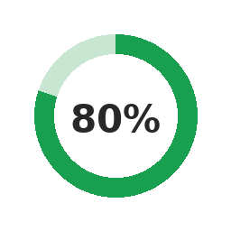
RQ1.1 | For each of the potential technical frameworks for orchestrating DERs in Australia (e.g., based on the OpEN Project), what is the most cost-effective DER control approach to deal with the expected technological diversity and ubiquity of DERs? | On the export side, intermediaries expect the DOE framework — including flexible-export connection agreements — to be the cost-effective control approach, absorbing all exporting DER including V2G, and DNSPs are adapting their rules to allow this. The project found, however, that the binding constraints are less about the control approach than about behind-the-meter interoperability: where devices from different vendors do not coordinate behind a single connection, DNSPs take conservative positions that in some cases limit V2G adoption, and no clear fallback exists if interoperability fails to emerge. The project also showed that equal allocation, while cost-effective and explainable for solar, is inefficient for batteries and V2G because it sizes headroom for a rare correlated worst case. On the import side, networks propose divergent approaches, particularly to household optionality; modelling demonstrated that import DOEs can technically mitigate EV-charging peak demand, but significant technical, commercial and customer gaps remain. Finally, observations of current V2G users showed that some DNSP assumptions — such as the likelihood of grid discharge during negative prices — may not hold. | 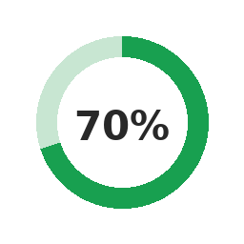
RQ1.2 | For each DER control approach, what is the most adequate decision-making algorithm (solution method)? | V2G control algorithms remain nascent — either extensions of home hybrid-inverter controllers (solar plus stationary BESS) or integrations with third-party site-level optimisers. Both currently constrain V2G output or the ability to connect. The project's modelling formulated site control as an economic optimisation, which lets behaviours emerge from price and cost factors rather than being enumerated in advance; but it also showed this can produce fragile 'magic-number' thresholds, where a small tariff change switches a behaviour on or off, and occasionally counter-intuitive optimal actions (for example shuttling energy from an EV into a stationary battery). A central finding is that human decision-making about purchasing and configuration is critical to future system behaviour and is poorly captured by economic optimisation alone. Current V2G users are very early adopters; the technology is not yet seamless and users still intervene regularly in its operation. | 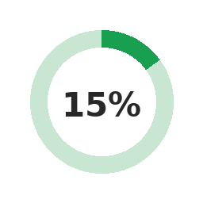  *for V2G
RQ1.3 | What is the role of DER standards in concert with the future orchestration of DERs? | Standards are central to this project, which examines the application of V2G within CSIP-AUS and provides explicit recommendations to ensure V2G alignment and benefit; it also considers AS/NZS 4777.2 and DNSP connection standards. CSIP-AUS version 1.2 is now active, with version 1.3 (adding pricing and storage extensions) in development. The project found that standards alone do not resolve orchestration: a DOE signal must be delivered to V2X devices in a form their controllers can act on — requiring interoperability standards, latency budgets and fallback behaviour that are not yet settled. Behind-the-meter interoperability between mixed-vendor devices is not produced by the current commercial environment, in which closed ecosystems are often used to anchor customers. | 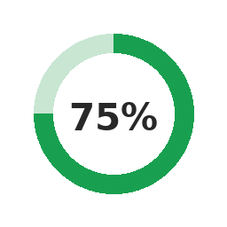
RQ2.1 | For each of the potential technical frameworks for orchestrating DERs and the corresponding decision-making algorithms, what is the most cost-effective communication and control infrastructure? | The project surveyed current V2G offerings from energy retailers and hardware/software providers, characterising their maturity, expected improvements and key adoption challenges. Products are early in their development and the orchestration frameworks are not yet clear. Participants were particularly unsure how driving needs and the ebb and flow of attached storage capacity will be handled by future algorithms — a V2G-specific problem (state-of-charge discontinuity and correlated EV absence) with no equivalent in stationary storage.  The project also found that V2H may gain popularity ahead of V2G, with the potential to increase peak demand, reduce visibility and weaken the case for import DOEs. Import DOEs were explored, but DNSPs are pursuing adjacent solutions to the same peak-demand challenge (for example Ausgrid's Edith); this should be treated as its own challenge rather than an extension of export DOEs. | 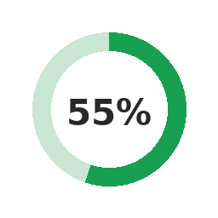
RQ4.1 | What are the minimum requirements for a DER-rich distribution network equivalent model to be adequate for its use in system planning studies? | The project considered how DOEs and hosting capacity feed into network planning, and the particular characteristics V2G introduces relative to stationary BESS due to its primary mobility requirement. Modelling indicated that export DOEs will have minimal impact on V2G operation. In contrast, import DOEs (and adjacent solutions) can materially affect peak demand but require significant development before they can be relied upon as a planning option. A key planning caveat the project surfaced is that behind-the-meter assets progressively degrade the net-demand signal used for planning. Self-consuming batteries and V2H inflate the apparent demand baseline. This raises an open question about whether import DOEs should complement or eventually supersede ADMD as the capacity-planning tool.
RQ5.1 | What are the necessary organisational and regulatory changes to enable the provisioning of ancillary services from DER? | The project found that ancillary services are not a core consideration for current V2G products: low service prices combined with technical complexity make them unattractive to product developers today, though this may change in coming years as products mature. More broadly, consultations highlighted that the organisational and regulatory enablers most often raised by stakeholders were not ancillary-service market rules. Instead, they focused on the settled methodologies, assessment metrics and customer-acceptance evidence needed before networks will rely on advanced DER coordination — including on the import side, where no agreed allocation or regulatory framework yet exists.
RQ5.2 | What are the necessary considerations of establishing a distribution-level market (for energy and services)? | Stakeholder views diverged on the need for and value of distribution-level markets for energy and services: some support full markets for local network capacity, while others see them as unnecessary complexity. Although this project is DOE-focused, DOEs intersect such markets. For example, they can enable mechanisms that let participants access additional capacity at the times they most need it. This is closely tied to the household-optionality and allocation questions raised on the import side. The project found that that correlated, price-driven export is better managed by coordination than by conservative static allocation. This points to a potential role for market-like coordination at the distribution layer, while underlining that customer acceptance and explainability remain preconditions for adopting such approaches. | 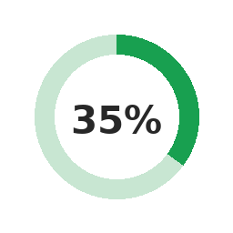

Future Work
This work identified several key gaps that warrant further investigation. They are described below.

Future work area 1: Application framework for import DOEs
Stakeholders were generally comfortable with export DOEs and their application to V2G, corroborated by modelling which showed that export DOEs had a relatively small impact on the financial value of V2G. Import DOEs are a different matter. Stakeholders were considerably less certain about how import DOEs should be designed and applied, and identified a set of interconnected gaps that this project was not scoped to resolve:
- Application frameworks: how are DOEs best applied to load? Should they apply only to flexible load or to all load, and should minimum capacity entitlements be established to protect households from unacceptable constraint?
- Allocation frameworks: how can import capacity be distributed fairly among customers whose energy needs and circumstances differ substantially?
- Assessment: how should the impact of import DOEs be measured, and at what point does the impost on users become unacceptable?
- Regulatory frameworks: what regulatory structures are needed to ensure import DOEs are applied in a just and consistent way? And
- Communication frameworks: how can energy users be meaningfully engaged in import DOE design and deployment in ways that build rather than erode trust?
The capability framework developed in this work offers a promising foundation for several of these questions — in particular for assessment and allocation, where it provides a principled basis for evaluating whether a given DOE configuration imposes unacceptable costs on users' ability to go about their daily lives. It also provides a language for identifying which households face the greatest risks from import constraints, including those with structural barriers to participation such as renters, low-income households, and people with medical or care needs.

Future work area 2: Revisit stakeholder V2X perspectives in the light of more experience
V2G is in a nascent state. This was apparent in our expert interviews, where participant perspectives were largely grounded in expectation rather than experience. While we did speak to two early adopters of V2X products, these were still isolated experiences.
As key initiatives and V2G projects begin to enter delivery phase and more V2X products enter the market, industry experience is likely to increase rapidly.
Revisiting industry stakeholder perspectives in 1-2 years will enable a more nuanced understanding of v2G behaviour grounded in real experience.

Future work area 3: Embedding user preferences in optimisation
The construction of the site optimisation problem as an economic optimisation problem abstracts the link between behaviour and user preferences. For example, the user preference to choose whether a battery should pre-charge in off-peak in order to satisfy shoulder or peak usage, is generally governed by the values of the battery throughput cost and battery efficiency. If the difference in retail prices, accounting for any efficiency losses, is greater than the (artificial) throughput cost, then this will be a valid strategy that emerges from the optimisation. Posing scenarios in this way has some advantages. It is not necessary (or desirable, in this formulation) to define the complete set of possible behaviours, and encode them into the problem statement – rather, they emerge naturally from the construction of the economic factors. However, this is rarely how users think about these assets and can lead to the construction of ‘magic’ numbers as determinants of the range of possible behaviours. Since the result always converges on the globally optimal solution, these magic numbers can be fragile determinants of behaviour – for example, a small change in tariff costs can lead to the enabling/disabling of a particular behaviour.
A more user- or behaviour-centric formulation would limit the ability of the system to respond to more complex objectives but would arguably more closely emulate the expectations of real-world users.
For more complex systems, the number of available actions will increase, and so this approach will necessarily require additional preferences encoded. For example, with a battery and an EV, it is possible to exchange stored energy between the two. In a scenario with away-from-home charging, this could lead to an unintuitive optimal action as follows:
  - EV charges at work at low rate
  - EV returns home and discharges coincident with battery charging (effectively shifting the stored energy into the battery)
  - Battery is then used to supply household power at times when the EV is unavailable
This sequence of events may be unexpected (and potentially undesired) but is a natural outcome of the economic optimisation framework. However, encoding this as user preferences becomes significantly more complicated. It is likely that a ‘user preference’ formulation is more intuitive for eliciting expected behaviour from the majority of EV users; however the economic formulation will still be relevant for a smaller subsection of technical early adopters.

Future work area 4: Expanded network allocation methods
Given the already broad range of optionality that exists for constructing scenarios, we have deliberately kept the options for network allocation relatively simple, in line with currently operating systems. As DNSPs grow more comfortable with operations at scale, and potentially look for improvements in network usage, more allocation methods may be incorporated into the tool. These could incorporate network characteristics more deeply and potentially include learnings from previous pilot projects that have investigated more complex allocation and reallocation strategies.

Future work area 5: Richer EV behaviour models
Validated data on actual user behaviour for EV charging (both standard charging and V2G-enabled) is very scarce. We anticipate that over time, trends will emerge that may be incorporated in richer models of EV usage and charging behaviour. Additionally, new forms of operating models may emerge (for example, more VPP alternatives, EV leasing models) that can be incorporated in the tool.

Future work area 6: Expand data source options
We use Net System Load Profiles as a means for synthesising load models that match appropriately with daily and seasonal trends, including weather effects. Alternative models may be incorporated, either to provide more accurate or more geographically precise household profiles, or to account for other types of users – for example commercial and industrial. Further work may develop a broader pluggable model to enable a diversity of data sources as inputs, potentially expanding into forward-looking data sets as well.

Future work area 7: Further explore use of capability framework embed justice in energy system frameworks
The capability framework is a promising way to integrate justice into energy system reform. In particular it provides a language to incorporate recognition justice — the question of whose needs and circumstances are visible to the systems making decisions that affect them — which is often absent from technical frameworks that focus primarily on distributional outcomes. This report has demonstrated one way the framework can be applied: using Nussbaum's capabilities as a lens for interpreting modelling results, and as a basis for identifying where capacity constraints impose costs that standard metrics do not capture. However, this is a first step rather than a complete methodology.
Further work is needed to develop this into a more systematic assessment approach. This would include establishing how capability-relevant metrics — such as the charge now effectiveness metric explored here — can be defined and calculated for a broader range of household circumstances and energy uses; how the tensions between competing capabilities (for example, between individual option value and collective ecological and financial costs) can be weighed in a principled way; and how such an approach could be embedded in the design and evaluation of DOE frameworks in practice. Participatory methods are likely to be important here, both to ensure that the capabilities considered reflect the actual diversity of household needs, and to give the assessment process the legitimacy that technical modelling alone cannot provide.

Future work area 8: Rework the roadmap to consider new factors
Based on insights generated and the implications for the roadmap discussed, we suggest further work be undertaken to adjust the roadmap and realigned it so that adjacent matters, such as incentives and just approaches are treated as first-order research needs within the distributed energy resource topics, rather than as downstream considerations addressed only after the engineering is settled
In practice this means the roadmap's research questions on coordination and operability should explicitly carry companion questions on: assessment metrics that capture the customer impact rather than only curtailed energy; allocation methods that are simultaneously just, efficient and explainable; the incentive and interoperability conditions required for behind-the-meter coordination to emerge; and the justice and amenity implications of import side constraints, including for the households least able to absorb them. Treating these as part of the technical critical path — because that is what they are — would make the roadmap a more accurate guide to what actually has to be solved for high-penetration distributed energy resource integration to succeed.
To achieve this alteration in the roadmap, we anticipate some further discussion and exploration will need to be undertaken by a group of knowledgeable stakeholders.

References
ABS, 2020. Survey of Motor Vehicle Use, Australia.
AEMO, 2026a. Load Profiles.
AEMO, 2026b. Aggregated price and demand data. URL https://www.aemo.com.au/energy-systems/electricity/national-electricity-market-nem/data-nem/aggregated-data (accessed 9.12.25).
AER, 2024. Export limit guidance note. Australian Energy Regulator, Australia.
AGL, 2025. Save on your energy bills when we use your battery, with VPP event credits. URL https://www.agl.com.au/residential/solar-and-batteries/virtual-power-plant (accessed 3.15.26).
Alam, M.R., Nguyen, P.T.H., Naranpanawe, L., Saha, T.K., Lankeshwara, G., 2024. Allocation of Dynamic Operating Envelopes in Distribution Networks: Technical and Equitable Perspectives 15.
AlphaESS, 2023. SMILE5 Battery: RESIDENTIAL SERIES.
Andrenacci, N., Valentini, M.P., 2023. A Literature Review on the Charging Behaviour of Private Electric Vehicles. Appl. Sci. 13, 12877. https://doi.org/10.3390/app132312877
APVI, 2025. PV Postcode Data.
ARENA, 2025. National Roadmap for Bidirectional EV Charging, ARENA. Race for 2030.
ARENA, 2024. Amber – Automating EV Charging in line with Wholesale Pricing. URL https://arena.gov.au/projects/amber-automating-ev-charging-in-line-with-wholesale-pricing/ (accessed 5.9.26).
ARENA, 2023a. V2X.au Summary Report –Opportunities and Challenges for Bidirectional Charging in Australia30. ARENA.
ARENA, 2023b. Origin Energy Smart Charging Trial – Final report. URL https://arena.gov.au/assets/2023/08/20230829-ORIGIN-Smart-Charging-Trial-Final-report.pdf (accessed 7.9.25).
ARENA, RACE 2030, 2025. National Roadmap for Bidirectional EV Charging.
AusGrid, 2023. Network Standard.
AusNet, 2026. Make and manage a solar application. URL https://www.ausnetservices.com.au/renewables/industry-solar/make-and-manage-a-solar-application/up-to-30kw-connections (accessed 5.25.26).
Australian Energy Regulator, 2025. 2025-26 Customer export curtailment values (CECV) Update.
Azim, M.I., Hoque, M.M., Khorasany, M., Razzaghi, R., Jalili, M., Hill, D.J., 2025. Dynamic Operating Envelope-Integrated Cooperative Energy Trading: A Fair Allocation Approach. IEEE Trans. Power Syst. 40, 2845–2859. https://doi.org/10.1109/TPWRS.2024.3510673
Badmus, E.O., Pandey, A., 2024. ANOCA: AC Network-aware Optimal Curtailment Approach for Dynamic Hosting Capacity, in: 2024 IEEE 63rd Conference on Decision and Control (CDC). Presented at the 2024 IEEE 63rd Conference on Decision and Control (CDC), IEEE, Milan, Italy, pp. 5338–5345. https://doi.org/10.1109/CDC56724.2024.10886763
Bartiaux, F., Day, R., Lahaye, W., 2021. Energy Poverty as a Restriction of Multiple Capabilities: A Systemic Approach for Belgium. J. Hum. Dev. Capab. 22, 270–291. https://doi.org/10.1080/19452829.2021.1887107
Baumgartner, N., Kellerer, F., Ruppert, M., Hirsch, S., Mang, S., Fichtner, W., 2022. Does experience matter? Assessing user motivations to accept a vehicle-to-grid charging tariff. Transp. Res. Part Transp. Environ. 113, 103528. https://doi.org/10.1016/j.trd.2022.103528
Baumgartner, N., Klumpp, N., Signer, T., Wadud, Z., Fichtner, W., 2024. Users’ Willingness to Participate in V2G – A Comparison Between German and UK Households, in: 2024 20th International Conference on the European Energy Market (EEM). Presented at the 2024 20th International Conference on the European Energy Market (EEM), IEEE, Istanbul, Turkiye, pp. 1–8. https://doi.org/10.1109/EEM60825.2024.10609014
Blackhall, L., 2022. The role of dynamic operating envelopes in co-ordinating and optimising DER.
Blackhall, L., 2020. On the calculation and use of dynamic operating envelopes: volve Project M4 Knowledge Sharing Report. ARENA.
Bohnsack, R., Van Den Hoed, R., Oude Reimer, H., 2015. Deriving vehicle-to-grid business models from consumer preferences. World Electr. Veh. J. 7, 621–630. https://doi.org/10.3390/wevj7040621
BoW, 2026. Three Key Benefits of Bidirectional Charging. URL https://batteriesonwheels.com.au/ (accessed 4.12.26).
Bowler, J., 2024. Batteries on wheels. URL https://switchedon.reneweconomy.com.au/content/batteries-on-wheels (accessed 5.30.26).
Boyle, M., Watson, P., Soh, J., Lovell, H., Jones, L., 2023. Project Symphony Social Research Report.
Brohi, N.A., Thirunavukkarasu, G., Seyedmahmoudian, M., Ahmed, K., Stojcevski, A., Mekhilef, S., 2025. Advances in Hosting Capacity Assessment and Enhancement Techniques for Distributed Energy Resources: A Review of Dynamic Operating Envelopes in the Australian Grid. Energies 18, 2922. https://doi.org/10.3390/en18112922
Broneske, G., 2015. A Choice Experiment on Consumer Preferences for Vehicle-to-Grid Products. Econ. Environ. Sci.
Cabral, B., Fonseca, T., Sousa, C., Ferreira, L.L., 2020. FlexiGen: Stochastic Dataset Generator for Electric Vehicle Charging Energy Flexibility.
CDR, 2025. Energy APIs. URL https://consumerdatastandardsaustralia.github.io/standards/#cdr-energy-api_get-generic-plans (accessed 3.5.25).
Cenex, 2020. A Fresh Look at V2G Value Propositions.
Clean Energy Council, 2022. Clean Energy council Guideline for Grid-Connected Solar PV Systems- (No Storage). Clean Energy Council.
Clean Energy Regulator, 2025. Solar battery installations on the rise. URL https://cer.gov.au/news-and-media/news/2025/september/solar-battery-installations-rise (accessed 4.1.26).
Corvino, F., Pellegrini-Masini, G., Pirni, A., Maran, S., 2021. Compensation for Energy Infrastructures: Can a Capability Approach be More Equitable? J. Hum. Dev. Capab. 22, 197–217. https://doi.org/10.1080/19452829.2021.1887106
CSIRO, Essential Energy, 2025. Development of a Vehicle-to-Grid Testing & Demonstration Facility – Phase 1.
De Caro, F., Graber, G., Calderaro, V., Vaccaro, A., Galdi, V., 2025. Exploring economic profit of EV aggregators in supplying flexibility services through V2G. Sustain. Energy Grids Netw. 43, 101851. https://doi.org/10.1016/j.segan.2025.101851
DEIP, 2025a. NAVIGATING DYNAMIC OPERATING ENVELOPES. Distributer Energy Integration Program.
DEIP, 2025b. PROJECT EDITH STAGE 3 INSIGHTS REPORT.
EDGE, 2023. Fairness in DOE Objective Functions.
Elias, F.T., 2024. The Anatomy of Price Spikes. URL https://www.globalpowerenergy.com.au/welcome-to-the-nem-the-anatomy-of-price-spikes (accessed 5.5.26).
ENERGEIA, 2024. Insights from the Realising Electric Vehicle-to-Grid Services Project – Final Report.
Energy Masters, 2026. Energy Masters Lessons Learnt Report 2.
Energy Masters, 2025. 500 energy masters. 500 energy-smart homes. One sustainable future. URL https://www.saenergymasters.com.au/about-energy-masters (accessed 5.25.26).
Enovates, 2026. A brief introduction to V2G. URL https://www.enovates.com/v2g/ (accessed 5.10.26).
Essayeh, C., Morstyn, T., 2024. Dynamic Operating Envelopes in Distribution Networks: A Reliable Computation, in: 2024 IEEE Power & Energy Society General Meeting (PESGM). Presented at the 2024 IEEE Power & Energy Society General Meeting (PESGM), IEEE, Seattle, WA, USA, pp. 1–5. https://doi.org/10.1109/PESGM51994.2024.10688950
Fahrner, V.M., Bergfeld, M., Eisenmann, C., 2023. Electric vehicles and their charging – in or out? User acceptance of bidirectional charging in Germany. Transp. Res. Procedia 70, 196–203. https://doi.org/10.1016/j.trpro.2023.11.019
Fernández-Baldor, Á., Lillo, P., Boni, A., 2015. Gender, Energy, and Inequalities: A Capabilities Approach Analysis of Renewable Electrification Projects in Peru. Springer. https://doi.org/https://doi.org/10.1007/978-3-319-20209-9_17
Fisk, K., 2026. 026 BYD Sealion 7 Premium review.
Fraser, A., 2025. Cadium. Cadium-Elentar Energy. URL https://github.com/elentar-energy/cadium (accessed 3.4.26).
Fraser, N., 1998. Social justice in the age of identity politics: Redistribution, recognition, participation.
Frigo, G., Baumann, M., Hillerbrand, R., 2021. Energy and the Good Life: Capabilities as the Foundation of the Right to Access Energy Services. J. Hum. Dev. Capab. 22, 218–248. https://doi.org/10.1080/19452829.2021.1887109
Gerdroodbari, Y.Z., Khorasany, M., Razzaghi, R., 2022. Dynamic PQ Operating Envelopes for prosumers in distribution networks. Appl. Energy 325, 119757. https://doi.org/10.1016/j.apenergy.2022.119757
Ghotge, R., Nijssen, K.P., Annema, J.A., Lukszo, Z., 2022. Use before You Choose: What Do EV Drivers Think about V2G after Experiencing It? Energies 15, 4907. https://doi.org/10.3390/en15134907
Groves, C., Shirani, F., Pidgeon, N., Cherry, C., Thomas, G., Roberts, E., Henwood, K., 2021. A Missing Link? Capabilities, the Ethics of Care and the Relational Context of Energy Justice. J. Hum. Dev. Capab. 22, 249–269. https://doi.org/10.1080/19452829.2021.1887105
Haque, M., Jones, L., Lucas-Healey, K., Sturmberg, B., 2022. Evaluation of FCAS Capabilities of a V2G Capable EV Charger – A Case Study.
Herding, L., Cossent, R., Rivier, M., 2023. Enhancing RES Grid Connection via Dynamic Hosting Capacity and Hybridization, in: 2023 IEEE Belgrade PowerTech. Presented at the 2023 IEEE Belgrade PowerTech, IEEE, Belgrade, Serbia, pp. 1–6. https://doi.org/10.1109/PowerTech55446.2023.10202726
Hillerbrand, R., Milchram, C., Schippl, J., 2021. Using the Capability Approach as a normative perspective on energy justice: Insights from two case studies on digitalisation in the energy sector. J. Hum. Dev. Capab. 22, 336–359. https://doi.org/10.1080/19452829.2021.1901672
Hu, P., Tarroja, B., Dean, M., Forrest, K., Hittinger, E., Jenn, A., Helveston, J.P., 2024. Measuring Consumer Willingness to Enroll in Battery Electric Vehicle Smart Charging Programs, in: 2024 IEEE Vehicle Power and Propulsion Conference (VPPC). Presented at the 2024 IEEE Vehicle Power and Propulsion Conference (VPPC), IEEE, Washington, DC, USA, pp. 1–17. https://doi.org/10.1109/VPPC63154.2024.10755299
Hunt, J., Riley, B., O’Neill, L., Maynard, G., 2021. Transition to Renewable Energy and Indigenous People in Northern Australia: Enhancing or Inhibiting Capabilities? J. Hum. Dev. Capab. 22, 360–378. https://doi.org/10.1080/19452829.2021.1901670
IEA, 2025. Gender and Energy Data Explorer.
Ilic, M.D., Jaddivada, R., Korpas, M., 2020. Interactive protocols for distributed energy resource management systems (DERMS). IET Gener. Transm. Distrib. 14, 2065–2081. https://doi.org/10.1049/iet-gtd.2019.1022
InfyPower, 2025. EXP07K1E-FSW 6.2kW 750V Single Phase V2G/V2H DC Wallbox Charger.
Jenn, A., Highleyman, J., 2022. Distribution grid impacts of electric vehicles: A California case study. iScience 25, 103686. https://doi.org/10.1016/j.isci.2021.103686
Jiang, Z., Guo, Y., 2025. Bargaining-Based Approach for Dynamic Operating Envelope Allocation in Distribution Networks. IEEE Trans. Smart Grid 16, 3588–3600. https://doi.org/10.1109/TSG.2025.3566419
Jones, L., Lucas-Healey, K., Sturmberg, B., Hendriks, J., 2022. Modelling V2G A study on the economic and technical value proposition for V2G. Australian National University.
Jones, L., Lucas-Healey, K., Sturmberg, B., Temby, H., Islam, M., 2021. A comprehensive analysis of vehicle-to-grid technology worldwide.
Jones, L., Watson, P., Wilson, S., Martin, B., Gordon, D., 2024. KSR 12 Converge Project final knowledge sharing report.
Kaggle, 2024. Electric Vehicle Dataset 2024.
Kempton, W., Letendre, S.E., 1997. Electric vehicles as a new power source for electric utilities. Transp. Res. Part Transp. Environ. 2, 157–175. https://doi.org/10.1016/S1361-9209(97)00001-1
Khezri, R., Steen, D., Anh Tuan, L., 2024. Willingness to Participate in Vehicle-to-Everything (V2X) in Sweden, 2022—Using an Electric Vehicle’s Battery for More Than Transport. Sustainability 16, 1792. https://doi.org/10.3390/su16051792
Lahariya, M., Benoit, D., Develder, C., 2020. Defining a synthetic data generator for realistic electric vehicle charging sessions, in: Proceedings of the Eleventh ACM International Conference on Future Energy Systems. pp. 406–407. https://doi.org/10.1145/3396851.3403509
Lankeshwara, G., Sharma, R., Alam, M.R., Yan, R., Saha, T.K., 2023. Development and Validation of a Dynamic Operating Envelopes-enabled Demand Response Scheme in Low-voltage Distribution Networks. https://doi.org/10.48550/arXiv.2311.15514
Lee, C.-Y., Jang, J.-W., Lee, M.-K., 2020. Willingness to accept values for vehicle-to-grid service in South Korea. Transp. Res. Part Transp. Environ. 87, 102487. https://doi.org/10.1016/j.trd.2020.102487
Lee, J., Kim, H., Byrne, J., 2021. Operationalising Capability Thinking in the Assessment of Energy Poverty Relief Policies: Moving from Compensation-based to Empowerment-focused Policy Strategies. J. Hum. Dev. Capab. 22, 292–315. https://doi.org/10.1080/19452829.2021.1887108
Li, T., Tao, S., He, K., Lu, M., Xie, B., Yang, B., Sun, Y., 2021. V2G Multi-Objective Dispatching Optimization Strategy Based on User Behavior Model. Front. Energy Res. 9, 739527. https://doi.org/10.3389/fenrg.2021.739527
Liang, A., 2025. ERGAN-Dataset. URL https://github.com/AdamLiang42/ERGAN-Dataset
Liu, B., Braslavsky, J.H., 2024. Robust Dynamic Operating Envelopes for DER Integration in Unbalanced Distribution Networks. IEEE Trans. Power Syst. 39, 3921–3936. https://doi.org/10.1109/TPWRS.2023.3308104
Liu, J., Zhuge, C., Tang, J.H.C.G., Meng, M., Zhang, J., 2025. Consumers’ attitudes toward benefits and drawbacks of vehicle-to-grid technology: An agent-based model. Int. J. Sustain. Transp. 19, 1105–1120. https://doi.org/10.1080/15568318.2025.2546033
Liu, M.Z., Ochoa, L.F., Wong, P.K.C., Theunissen, J., 2023. Using OPF-Based Operating Envelopes to Facilitate Residential DER Services, in: 2023 IEEE Power & Energy Society General Meeting (PESGM). Presented at the 2023 IEEE Power & Energy Society General Meeting (PESGM), IEEE, Orlando, FL, USA, pp. 1–1. https://doi.org/10.1109/PESGM52003.2023.10253358
Liu, S., Vlachokostas, A., Kontou, E., 2025. Leveraging electric vehicles as a resiliency solution for residential backup power during outages. Energy 318, 134613. https://doi.org/10.1016/j.energy.2025.134613
Lucas-Healey, K., Jones, L., Sturmberg, B., Ransan-Cooper, H., 2021. Interim Social Report: From the Realising Electric Vehicle-to-grid Services (REVS) trial. ACES, ANU.
Maeng, K., Ko, S., Shin, J., Cho, Y., 2020. How Much Electricity Sharing Will Electric Vehicle Owners Allow from Their Battery? Incorporating Vehicle-to-Grid Technology and Electricity Generation Mix. Energies 13, 4248. https://doi.org/10.3390/en13164248
Mahmoodi, M., Blackhall, L., Noori R. A., S.M., Attarha, A., Weise, B., Bhardwaj, A., 2024. DER Capacity Assessment of Active Distribution Systems Using Dynamic Operating Envelopes. IEEE Trans. Smart Grid 15, 1778–1791. https://doi.org/10.1109/TSG.2023.3313550
Mathieu, J.L., 2023. Algorithms for Energy Justice, in: Women in Power. Springer.
McQueen, D.H.O., Hyland, P.R., Watson, S.J., 2004. Monte Carlo simulation of residential electricity demand for forecasting maximum demand on distribution networks. IEEE Trans. Power Syst. 19.
Mehdizadeh, M., Nordfjaern, T., Klockner, C.A., 2023. Estimating financial compensation and minimum guaranteed charge for vehicle-to-grid technology. Energy Policy 180, 113649. https://doi.org/10.1016/j.enpol.2023.113649
Meijssen, A, 2019. Dutch electric vehicle drivers’ preferences regarding vehicle-to-grid contracts: Examining the willingness to participate in vehicle-to-grid contracts by conducting a context-dependent stated choice experiment taking into account the EV recharging speed. Environ. Sci. Eng. Econ.
Milford, T., Krause, O., 2021. Managing DER in Distribution Networks Using State Estimation & Dynamic Operating Envelopes, in: 2021 IEEE PES Innovative Smart Grid Technologies - Asia (ISGT Asia). Presented at the 2021 IEEE PES Innovative Smart Grid Technologies - Asia (ISGT Asia), IEEE, Brisbane, Australia, pp. 1–5. https://doi.org/10.1109/ISGTAsia49270.2021.9715663
Needell, Z., Wei, W., Trancik, J.E., 2023. Strategies for beneficial electric vehicle charging to reduce peak electricity demand and store solar energy. Cell Rep. Phys. Sci. 4, 101287. https://doi.org/10.1016/j.xcrp.2023.101287
Nikdel, P., Amani, A.M., Barzegar, A., Jalili, M., Yu, X., Mahdavi, N., 2025. Equitable Dynamic Operating Envelopes: A Two Step Approach, in: 2025 IEEE PES 35th Australasian Universities Power Engineering Conference (AUPEC). Presented at the 2025 IEEE PES 35th Australasian Universities Power Engineering Conference (AUPEC), IEEE, Brisbane, Australia, pp. 1–5. https://doi.org/10.1109/AUPEC66173.2025.11219594
Nussbaum, M.C., 2011. Creating Capabilities: The Human Development Approach. Harward University Press.
Nussbaum, M.C., 2001. CENTRAL HUMAN FUNCTIONAL CAPABILITIES, in: Women and Human Development: The Capabilities Approach. Cambridge University Press, pp. 79–80.
Ochoa, L., Givisiez, A.G., Bassi, V., Liu, M.Z., 2023. Assessing the Benefits of Using Operating Envelopes to Orchestrate DERs Across Australia. The University of Melbourne.
Pagliarella, R.M., Kilby, P., 2026. V2G explainer: Safety and the current state of turning electric cars into batteries on wheels. Renew Econ. URL https://reneweconomy.com.au/v2g-explainer-safety-and-the-current-state-of-turning-electric-cars-into-batteries-on-wheels/ (accessed 4.1.26).
Parkinson, S., 2025. The Zeekr 7X review: Very quick, very polished, and hard to ignore. The Driven.
Peacock, F., 2026. Solar Batteries: Comparison Table. URL https://www.solarquotes.com.au/battery-storage/comparison-table/#compare (accessed 5.15.26).
Peacock, F., 2024. Home EV Charging Just Got Serious: Meet Sigenergy’s 25kW Bi-Directional Beast. URL https://www.solarquotes.com.au/blog/sigenstor-install/ (accessed 5.8.26).
Perez, J., 2010. FUNDAMENTAL PRINCIPLES OF TRANSFORMER THERMAL LOADING AND PROTECTION. Presented at the Western Protective Relay Conference.
RACV, 2025. 2026 BYD Atto 2 small SUV: price, specs and release date in Australia.
Rawls, J., 1971. A Theory of Justice, Second. ed. Harward University Press.
RedEarth, 2025. Boomerang: Powering the grid from your driveway- Australia’s first 11kW DC bi-directional charger.
Renew Economy, 2020. Five times size of Snowy 2.0” – V2G trial to tap potential of EVs as mass mobile storage. URL https://reneweconomy.com.au/five-times-size-of-snowy-2-0-v2g-trial-to-tap-potential-of-evs-as-mass-mobile-storage-12456/ (accessed 2.26.26).
Roozkhosh, F., Yao, X.A., 2026. Understanding electric vehicle charging behavior: A multidisciplinary review and conceptual framework. Transp. Res. Part Transp. Environ. 153, 105227. https://doi.org/10.1016/j.trd.2026.105227
Ru, J., Gillott, M., Shipman, R., 2025. Vehicle-to-Grid (V2G) Research: A Decade of Progress, Achievements, and Future Directions. Energies 18, 6148. https://doi.org/10.3390/en18236148
Ryan, C., 2026. Infypower V2G EV Charger Review. SolarChoice. URL https://www.solarchoice.net.au/ev-chargers/reviews/infypower/ (accessed 4.2.26).
SA Power Networks, 2025. Technical Standard - TS129 Small EG Connections Technical Requirements - Capacity not exceeding 30kVA.
Safdarian, F., Lamonte, L., Kargarian, A., Farasat, M., 2019. Distributed Optimization-Based Hourly Coordination for V2G and G2V, in: 2019 IEEE Texas Power and Energy Conference (TPEC). Presented at the 2019 IEEE Texas Power and Energy conference (TPEC), IEEE, College Station, TX, USA, pp. 1–6. https://doi.org/10.1109/TPEC.2019.8662148
Sagaria, S., van der Kam, M., Boström, T., 2024. The influence of socio-technical variables on vehicle-to-grid technology. Energy 305, 132299. https://doi.org/10.1016/j.energy.2024.132299
Santinha, G., Tavares, J., 2025. A systematic review of citizen perceptions and expectations of V2G adoption in the context of sustainable transitions. Discov. Sustain. 6, 957. https://doi.org/10.1007/s43621-025-01683-y
Schmidt, B., 2025. StarCharge Halo V2G Charger | Independent Review. SolarChoice. URL https://www.solarchoice.net.au/products/ev-chargers/starcharge-halo-v2g-charger-review/ (accessed 2.9.26).
Sen, A., 1999. Development as Freedom. Oxford University Press (OUP).
Sigenergy, 2026. Home Energy Solution Disclaimer: Let the world enjoy green energy.
Sobhy, A.S.M., Caesary, D., Kim, H., Eom, J., 2025. When and where it counts: enhancing demand response in electric vehicle charging. Appl. Energy 401, 126739. https://doi.org/10.1016/j.apenergy.2025.126739
SolarChoice, 2026. Available V2G EV Chargers in Australia Compared. URL https://www.solarchoice.net.au/ev/charging/available-v2g-chargers-australia/ (accessed 4.16.26).
SolarCitizen, 2026. “Batteries on wheels” How we can accelerate vehicles to grid in Australia. URL https://www.solarcitizens.org.au/batteries_on_wheels (accessed 3.22.26).
Sovacool, B.K., Dworkin, M.H., 2014. Global Energy Justice: Problems, Principles, and Practices. Cambridge University Press.
Štogl, O., Miltner, M., Zanocco, C., Traverso, M., Starý, O., 2024. Electric vehicles as facilitators of grid stability and flexibility: A multidisciplinary overview. WIREs Energy Environ. 13, e536. https://doi.org/10.1002/wene.536
Strengers, Y., 2014. Smart energy in everyday life: are you designing for resource man? Interactions 21, 24–31. https://doi.org/10.1145/2621931
Strzalka-Goluszka, K., 1999. Overload Capacity of Power Transformers, in: Power Transformer Overload Capacity Guide. Leonardo Energy.
Sturmberg, B.C.P., Hapuarachchi, L., Jones, L., Lucas-Healey, K., Van Biljon, J., 2024. Vehicle-to-grid response to a frequency contingency in a national grid. Npj Sustain. Mobil. Transp. 1, 7. https://doi.org/10.1038/s44333-024-00010-8
Sturmberg, B.C.P., Jones, L., Lucas-Healey, K., Islam, M., Temby, H., 2021. Niche to normality -- an interdisciplinary review of Vehicle-to-Grid. https://doi.org/10.48550/arXiv.2106.05837
SunGrow, 2024. SBR064/096/128/160/ 192/224/256 High Voltage LFP Battery.
Tesla, 2025. Powerwall: fully integrated solar and battery system.
Thai, D., 2025. Amber Electric Kicks Off First Residential V2G Charger Installation. URL https://zecar.com/reviews/amber-electric-kicks-off-first-residential-v2g-charger-installation (accessed 4.4.26).
The Driven, 2026. BYD, Zeekr and Geely take top spots in EV sales, as Tesla slump heralds changing of guard.
Trinh, P.-H., Chung, I.-Y., 2024. Integrated Active and Reactive Power Control Methods for Distributed Energy Resources in Distribution Systems for Enhancing Hosting Capacity. Energies 17, 1642. https://doi.org/10.3390/en17071642
Van Uffelen, N., 2022. Revisiting recognition in energy justice. Energy Res. Soc. Sci. 92, 102764. https://doi.org/10.1016/j.erss.2022.102764
Vishnu, G., Kaliyaperumal, D., Jayaprakash, R., Karthick, A., Kumar Chinnaiyan, V., Ghosh, A., 2023. Review of Challenges and Opportunities in the Integration of Electric Vehicles to the Grid. World Electr. Veh. J. 14, 259. https://doi.org/10.3390/wevj14090259
Walker, G., Day, R., 2012. Fuel poverty as injustice: Integrating distribution, recognition and procedure in the struggle for affordable warmth. Energy Policy 49, 69–75. https://doi.org/10.1016/j.enpol.2012.01.044
Wickramasinghe, A., Vilathgamuwa, M., Nourbakhsh, G., Corry, P., 2025. A Review of Dynamic Operating Envelopes: Computation, Applications and Challenges. Modelling 6, 29. https://doi.org/10.3390/modelling6020029
Williamson, R., 2026. Sigenergy crowned top home battery supplier in Australia, trumping Tesla and Sungrow. URL https://reneweconomy.com.au/sigenergy-crowned-top-home-battery-supplier-in-australia-trumping-tesla-and-sungrow/ (accessed 5.13.26).
Williamson, R., 2025. AC or DC? The charger tech choice that may dictate what your V2G future looks like. The Driven. URL https://thedriven.io/2025/04/23/ac-or-dc-the-charger-tech-choice-that-may-dictate-what-your-v2g-future-looks-like/ (accessed 5.30.26).
Yao, Y., Ding, F., Horowitz, K., Jain, A., 2022. Coordinated Inverter Control to Increase Dynamic PV Hosting Capacity: A Real-Time Optimal Power Flow Approach. IEEE Syst. J. 16, 1933–1944. https://doi.org/10.1109/JSYST.2021.3071998
Yu, H., Wu, C., Liu, Y., 2026. Vehicle-to-Grid Integration in Smart Energy Systems: An Overview of Enabling Technologies, System-Level Impacts, and Open Issues. Machines 14, 418. https://doi.org/10.3390/machines14040418
Zhang, C., Wang, X., Wang, Y., Tang, P., 2025. Economic Viability of Vehicle-to-Grid (V2G) Reassessed: A Degradation Cost Integrated Life-Cycle Analysis. Sustainability 17, 5626. https://doi.org/10.3390/su17125626
Zhang, Q., Raman, G., Peng, J.C.-H., 2020. EV Charging Optimization based on Day-ahead Pricing Incorporating Consumer Behavior, in: 2020 IEEE REGION 10 CONFERENCE (TENCON). Presented at the TENCON 2020 - 2020 IEEE REGION 10 CONFERENCE (TENCON), IEEE, Osaka, Japan, pp. 325–330. https://doi.org/10.1109/TENCON50793.2020.9293897

Acronyms and Definitions
WORD/ACRONYM | DEFINITION
AC | Alternating current
ACT | Australian Capital Territory
ADMD | After Diversity Maximum Demand
AEMO | Australian Energy Market Operator
AER | Australian Energy Regulator
Aggregator | An agent who aggregates energy production and consumption from multiple sources to present to the grid as a single source.
ANU | Australian National University
APVI | Australian PV Institute
ARENA | Australian Renewable Energy Agency
Behind-the-meter | Electrical related activity that sits in a private system that is ‘behind’ an electricity meter, which is supplied by electricity organisations. All electricity customers connected to networks in Australia have a meter. So, behind-the-meter can apply to all consumer types.
BESS | Battery Energy Storage System
Capacity | In this report, capacity refers to electrical capacity of an electrical system, unless otherwise specified as human related capacity.
CDR | Consumer Data Rights
CECV | Customer Export Curtailment Value
CER | Consumer or customer energy resources. Energy assets including solar photovoltaics, batteries, EVs and controllable loads that can potentially respond signals for various network purposes. CER are a subset of the overall category of DER (described below).
CF | Capability Framework
CSIP-AUS | Common Smart Inverter Profile is a communications standard for DER devices. It is based on IEEE 2030.5.
DC | Direct current
DER | Distributed Energy Resources. Assets or systems (including solar photovoltaics, batteries, EVs and controllable loads) that generate or store renewable energy from separate, distributed locations. These can potentially respond to signals for various network and market purposes. They can be located on private, commercial or public property. DER includes solar generation at homes, electric vehicles and batteries.
DNSP | Distribution Network Service Provider. These are entities (organisations) responsible for operating and maintaining electricity distribution networks.
DOEs | Dynamic operating envelopes. These are ‘electricity import and export limits that vary over time and location. DOEs can enable higher levels of energy exports from customers’ solar and battery systems by allowing higher export limits when there is more hosting capacity on the local network.’ (Dynamic Operating Envelopes Workstream Australian Renewable Energy Agency (ARENA))
DSO | Distribution systems operators/operations
Dynamic connection | An electricity connection where energy limits can vary over time.
Dynamic pricing | Time based tariffs for electricity. These are used to influence energy use behaviour and can be used with DOEs.
Emergency backstop | Systems used to rapidly curtail or stop energy exports or imports from behind-the-meter and on an electricity network in emergency circumstances.
EV | Electric Vehicle. And electrically powered vehicle that includes batteries to store energy from electricity.
EVSE | Electric vehicle supply equipment.
Export | In this report is referring to electricity export to the grid that is generate from DER/CER. Electric vehicles fundamentally need to consume (import) energy and V2G allows them the possibility of exporting energy as well.
FCAS | Frequency Control Ancillary Services
Flexibility | the ability for import and export loads from a consumer to be adjusted in response to network and market needs.
FOE | Fixed Operating Envelope
FRMP | Financially Responsible Market Participant
Grid Integration | Grid integration is the process of incorporating electricity generation into an existing system. This includes connecting what are often called consumer energy resources, like household batteries, into the local electricity network. Integration with the grid leads to householders being in a two-way relationship with the grid.
HEMs | Home energy management systems
IBR | Inverter-based resource
IEA | International Energy Agency
Import | In this report is referring to electricity imported from the grid to be used by consumers, normally behind an electricity meter. Electric vehicles fundamentally need to consume (import) energy. V2G allows them the possibility of exporting energy as well.
Intermediary | Intermediaries are human actors who have a function or purpose in any given system
kW | kilowatt
kWh | kilowatt-hour
LV | Low voltage
MV | Medium voltage
MW | Megawatt
MWh | Megawatt-hour
NEM | National Electricity Market
NMI | National Meter Identifier. A number that identifies a specific meter on networks/grids in Australia.
OEMs | Original Equipment Manufacturers
OLTC | On Load Tap Changer
Operating envelopes | Are a term used to note the limits that an electricity customer can import and export to the electricity grid. These limits are most likely set by networks but are likely agreed between networks, customers and the Australian Energy Regulator as part of the customer connection or regulatory process. Currently, in most cases, operating envelopes are fixed at conservative levels regardless of the capacity of the network because they are static and need to account for ‘worst case scenario’ conditions.
OPF | Optimal Power Flow
PV | Photovoltaic
REVS | Realising Electric Vehicle-to-Grid Services
RIT-D | Regulatory Investment Test for Distribution
SA | South Australia
SAPN | SA Power Networks
Scenarios | A possible combination of CER, pricing, events, and householder expectations that was deemed important to explore.
Site | A node in the model that quantitatively represents a household location that has an EV that is interacting from behind the meter with the grid through V2G-related technology.
Smart meter | Record and communicate near–real-time electricity usage and export data.
SoC | State of charge
Socio-technical | Approaches of investigation and theories that incorporate consideration of social and technical factors.
STPIS | Service Target Performance Incentive Scheme
TSOs | Transmission System Operators
UTOPF | Unbalanced three-phase optimal power flow
V2E | Vehicle-to-Equipment
V2G | Vehicle-to-Grid. Technology that enables EVs to discharge electricity back to the grid for various network and market purposes.
V2H | Vehicle-to-Home. Technology that enables EVs to discharge electricity back to the home for use.
V2L | Vehicle-to-Load
V2X | Vehicle-to-Everything (x)
VCR | Value of Customer Reliability
VPP | Virtual power plants – Are aggregation systems utilising technology that coordinate energy from various sources. The energy is from DER and is coordinated using algorithms, software platforms and systems and are used for network and market purposes.
WP | Work package

Appendices
- Appendix - Literature Review
The literature presents diverse mathematical approaches to DOE calculation, ranging from linearized models to full AC optimal power flow formulations. This section synthesizes the key methodological approaches identified across sources and mathematical model types and optimisation techniques are summarised in Table A1.
Linearized models dominate the literature, with studies employing linearized three-phase OPF (Liu et al., 2023), linear UTOPF (Liu and Braslavsky, 2024), and sensitivity-based linearized approaches (Trinh and Chung, 2024). These approximations reduce computational complexity but may sacrifice accuracy in representing actual grid physics (Badmus and Pandey, 2024).
A notable methodological distinction emerges between studies that use convex or linear approximations and those employing full AC models. E. O. Badmus et al. explicitly critique existing OE-based frameworks built on convex or linear models, noting that these can violate technical limits in practice because they approximate grid physics. Their ANOCA framework addresses this gap through a two-stage optimization built on three-phase AC models, ensuring AC feasibility of the network (Badmus and Pandey, 2024). Similarly, M. Ilić et al. employ non-linear non-convex ACOPF to ensure accurate power flow delivery (Ilic et al., 2020).
Table A1: Mathematical Model Types and Optimisation Techniques
SCENARIO | MAX DEMAND (BEFORE DOE) | ADMD (BEFORE DOE) | TIMESTAMP
Convex | Right-hand side decomposition | Novel capacity allocation to mutually independent consumers | (Mahmoodi et al., 2024)
Various | OPF-based methods | Focus on forecast accuracy and network modelling | (Wickramasinghe et al., 2025)
Not specified | Capacity constrained optimization | Novel Distribution System State Estimation engine for network visibility | (Milford and Krause, 2021)
Linear unbalanced three-phase optimal power flow | Geometric construction within feasible region | Three-step process: DFR identification, FR updating, DFR expansion | (Liu and Braslavsky, 2024)
Linearized | Chance-constrained model | Approximate linear model for multi-phase networks | (Essayeh and Morstyn, 2024)
Three-phase AC | Two-stage optimization; receding horizon multi-period | L1, L2, and Linf norm-based dispatch algorithms | (Badmus and Pandey, 2024)
Not specified | Considers voltage and current limits | Dynamic PQ envelope calculation per prosumer | (Gerdroodbari et al., 2022)
Linearized three-phase OPF | OPF | Exploits controllable network assets | (Liu et al., 2023)
Linearized (sensitivity-based) | Iterative search algorithms | Q-V, P-V, Q-I, P-I sensitivity factors | (Trinh and Chung, 2024)
Not specified | Dynamic hosting capacity model | Hybridization of renewable sources | (Herding et al., 2023)
Not specified | Real-time OPF | Measurement feedback correction | (Yao et al., 2022)
Non-linear non-convex | AC Optimal Power Flow (ACOPF) | NETSS Extended ACOPF; distributed MPC | (Ilic et al., 2020)
Studies consistently incorporate voltage, current, and power constraints into DOE calculations, though implementation varies as summarised in Table A2. The robust DOE (RDOE) approach developed by B. Liu et al. provides a geometric construction strictly included within the feasible region of a linear UTOPF problem, explicitly hedging against uncertainty in customer loads and generations. This approach delivers proportional fairness in capacity allocations and can be enlarged by exploiting customer operational statuses and optimizing controllable reactive powers (Liu and Braslavsky, 2024).
Table A2: Voltage, current, and power constraints into DOE calculations
VOLTAGE CONSTRAINTS | CURRENT/THERMAL CONSTRAINTS | OTHER CONSTRAINTS | STUDY
Implied | Implied | Network constraints ensuring acceptable power exchange | (Mahmoodi et al., 2024)
Yes | Yes | Linearized for computational efficiency | (Liu and Braslavsky, 2024)
Yes | Yes (Thermal) | Transformer rating constraints | (Essayeh and Morstyn, 2024)
Node voltage limits | Line current limits | Over-voltage and over-current mitigation | (Gerdroodbari et al., 2022)
Q-V, P-V sensitivity | Q-I, P-I sensitivity | Voltage maintenance range ±5%, targeted ±2% | (Trinh and Chung, 2024)
Yes | Thermal limits | Stability constraints | (Ilic et al., 2020)
Additionally, several studies address the critical challenge of uncertainty in DOE calculation as follows: chance-constrained formulation for handling uncertain network inflexible loading (Essayeh and Morstyn, 2024), robust DOEs hedged against uncertainty and variability in customers’ loads and generations (Liu and Braslavsky, 2024), measurement feedback correction to eliminate dependence on load knowledge (Yao et al., 2022) and hierarchical assessment considering uncertainty of solar power and demand (Mahmoodi et al., 2024).
The implementation of DOE methodologies varies significantly across studies, with both centralized and decentralized architectures represented in Table A3. Centralized architectures predominate, with network operators collecting customer data and calculating DOEs for each connection point (Gerdroodbari et al., 2022). However, decentralized approaches are emerging, particularly where prosumers participate actively in optimization processes. The hybrid architecture proposed by E. O. Badmus et al. represents an innovative approach where prosumers first run receding horizon optimization to identify optimal export power setpoints, followed by utility-level infeasibility-based optimization (Badmus and Pandey, 2024).
Table A3. Implementation Architectures
SYSTEM ARCHITECTURE | TECHNOLOGY PLATFORM | COMMUNICATION REQUIREMENTS | DEPLOYMENT SETTING | STUDY
Both centralized and decentralized explored | Not specified | Challenge identified | Not specified | (Wickramasinghe et al., 2025)
Centralized | Novel DSSE engine | Not specified | Real-world (Queensland) | (Milford and Krause, 2021)
Centralized | Ipopt, Xpress | IEEE 2030.5 protocol | Pilot (Australia) | (Liu and Braslavsky, 2024)
Hybrid: decentralized (prosumers) and centralized (utility) | Not specified | Not specified | Not specified | (Badmus and Pandey, 2024)
Centralized | Not specified | Not specified | Simulation | (Gerdroodbari et al., 2022)
Centralized | Not specified | Not specified | Simulation (realistic network) | (Liu et al., 2023)
Centralized | MATLAB | DMS Integration | Laboratory/pilot | (Trinh and Chung, 2024)
Decentralized | Not specified | Real-time measurements required | Pilot (Southern California) | (Yao et al., 2022)
Decentralized | NETSS Extended ACOPF | Advanced infrastructure needed | Commercial/pilot | (Ilic et al., 2020)
The literature identifies multiple barriers to practical DOE deployment spanning technical, computational, and regulatory dimensions as summarised in Table A4. The computational challenge is particularly pronounced for approaches that seek greater accuracy. While linearized models reduce computational burden, they may sacrifice accuracy (Liu and Braslavsky, 2024). Full AC models, though more accurate, may not be feasible within the whole region of operating envelopes (Badmus and Pandey, 2024). Forecast accuracy emerges as a critical dependency across multiple studies. Uncertainty in customer demand and generation can lead to network constraint violations if not properly addressed. The robust DOE approach addresses this through conservative envelope calculation, though at the cost of reduced capacity utilization (Liu and Braslavsky, 2024). Integration with existing systems presents ongoing challenges, with studies noting the need for new architectures like DyMonDS (Ilic et al., 2020) and integration with DMS systems (Trinh and Chung, 2024). Managing uncertainties and equipment failures represents a practical deployment obstacle (Ilic et al., 2020).
Table A4. Implementation Challenges
CHALLENGE CATEGORY | SPECIFIC CHALLENGES IDENTIFIED
Computational complexity | Centralized formulations overwhelmed by stochastic multitemporal non-linear optimization (Ilic et al., 2020); UTOPF-based approaches computationally demanding for large-scale problems (Liu and Braslavsky, 2024); Increased computational time with larger distribution systems (Trinh and Chung, 2024)
Forecast accuracy | Uncertainty in customer demand and generation can lead to constraint violations (Liu and Braslavsky, 2024); Uncertainty in solar power and demand (Mahmoodi et al., 2024); Need for precise forecasting and real-time adaptability (Trinh and Chung, 2024)
Technical limitations | Linear models sacrifice accuracy for tractability (Liu and Braslavsky, 2024); Convex and linear models can violate technical limits due to grid physics approximations (Badmus and Pandey, 2024); Sensitivity of control methods to operating point changes (Trinh and Chung, 2024); Data availability and integrity sensitivity (Yao et al., 2022)
Communication/data | Communication infrastructure challenges (Wickramasinghe et al., 2025); Interoperability between DER types and communication protocols (Trinh and Chung, 2024); Advanced infrastructure needed for data exchange (Ilic et al., 2020)
Regulatory/market | Lack of DSO control over consumer-owned DER units (Mahmoodi et al., 2024); Distribution companies cannot directly manage DER or aggregators (Liu et al., 2023); Need for new mechanisms and regulations (Essayeh and Morstyn, 2024)
Fairness concern | Balancing efficiency and fairness in resource allocation (Wickramasinghe et al., 2025); Trade-off between robustness and maximum capacity allocation (Liu and Braslavsky, 2024)
Economic barriers | Battery investment costs result in economic infeasibility of storage installation (Herding et al., 2023)

- Appendix - DOE Allocation Approaches
ALLOCATION APPROACH | SYNOPSIS | EXAMPLES/QUOTES
Fixed allocation | This is the baseline “non DOE” case, where a DER system receives a single fixed allocation at connection time. DNSPs can use any approach (e.g. equal, proportional) to assign the fixed allocation.  Sometimes a dynamic operating envelope can function as a fixed allocation (where a network is not constrained) | “So you might have the case, and particularly with flexible exports, where to start off with the network may just be sending the maximum of that agreed range for years and years and years without doing any calculations because that part of the network has been identified that there is no constraint at the moment however we don’t want to lock in a fixed connection with our customer where that fixed capacity now is permanently allocated to that customer. So actually deciding to calculate and send out operating envelopes for a certain area is going to be based on expected constraints. Areas where we expect that constraints might appear and obviously doing the forecasting to calculate those envelopes.” – Distribution network service provider interview (18/12/2025)
Equal allocation / waterline | Each customer is equally entitled to network capacity, regardless of installed capacity.  $$Allocation=\frac{capacity}{\# connections}$$  Equal allocation is a simple allocation method that does not rely on extensive data (or any data) on householder energy usage. The largest DER will be impacted first and most.  Among interviewees this was a widely used allocation method because of its simplicity and decodability.  This approach appears to be the most widely used approach. | “In [  location] we chose to allocate [network capacity] on this waterline model as it’s referred to, to try to ensure that everyone’s paying the same, everyone’s on the same connection agreement therefore everyone should get the same allocation of capacity” – Distribution network service provider interview (17/12/2025)  “as for allocation we’ve looked at an equal allocation methodology because we don’t foresee that you can get around customer buy-in and fairness concerns by doing any other allocation methodology without some sort of framework to underpin that” – Distribution network service provider interview (05/12/2025)  “The other thing that we don’t do at the moment is how we allocate so I haven’t really mentioned at all how we allocate but it’s all fully equal and I think that’s informed by the work that DEIP previously in terms of the principles for DOEs and that’s been published by the AER now. So that means that everyone on the one LV network gets their equal share in kilowatts, not a proportional share up to their maximum capacity. – Distribution network service provider interview (21/12/2025)
Proportional allocation | The impact of DOEs on each customer should be the same in proportion to installed capacity.  $$Allocation=\frac{capacity X site DER capacity}{total DER capacity}$$  Proportional allocation requires knowledge of installed capacity. This is relatively simple for generation devices (like solar and battery) but less simple for load.  The underlying assumption is that each participant should lose an equal proportion of their capacity. | “We’re doing a mix of proportional and water line approaches. It’s evolving because now we have commercial and industrial customers. When it was just residential it was a proportional methodology then with commercial and industrial customers it’s more of a water line approach … now we have areas where there is residential customers and commercial customers so we’re having to mix this water line and proportional approach” – Distribution network service provider interview (10/12/2025)
Optimal allocation for overall system stability or function (eg utilisation). | There are a number of algorithms in literature that allocate capacity using different kinds of optimisation with different objectives such as maximising export capacity. Others have proposed capacity markets or capacity trading. See A.1 | None of the interview participants were using unequal capacity allocation in practice.  “I think we’d like to explore unequal allocations but it’d be good to have a bit more guidance from policymakers on how to do that and I guess the way I see at least that happening is with some price signals” – Distribution network service provider interview (21/12/2025)  “Well it’s a very good question to ask here because it actually requires instrumentation on a per transformer level and on a per feeder level and subfeeder level and on a substation level. Well most if not all of the DNSPs don’t have it at that granularity. The way [DOEs] would be applied is you could then open up a market for basically bringing back to zero zero or managing it to within the capabilities of your grid infrastructure and the requirements of the grid infrastructure at that particular point in time.” – Technology developer interview (26/11/2025)

- V2X and V2G features, and user experiences
Table 13 outlines the full range of V2X solution features that can be combined into the various product offerings. The full range of features and parameters have been collated from the product offers as well as stakeholder interviews and workshops that also outline a several desirable and future state features.
Table 13 helps to taxonomise bidirectional charging features overall and V2G features more specifically within the V2X landscape. Taxonomizing/categorising features is undertaken here to move towards a shared language and understanding. The V2X features presented are broad ranging and we have considered V2X features from the perspective of the overall bidirectional industry, not just a single perspective of a homeowner or a single EV user.
The future features are identified as conceptual features and are included in the taxonomy table as placeholder values and also serve as a record for capturing current expectations of V2G system integration.
The first few V2G chargers available on the market are DC chargers, so are relatively expensive as they include power conversion hardware. Alternating current (AC) V2G represents a significant future development not yet widely available in the market (Williamson, 2025). While it promises lower hardware costs and broader compatibility due to leveraging existing onboard vehicle inverters, it currently lacks fully defined technical standards, certification pathways, and network operating frameworks within Australia (ARENA and RACE 2030, 2025). As a result, AC V2G remains largely absent from commercial offerings despite strong long-term potential to reduce deployment cost and enable mass participation. While AC V2G was described by participants as conceptually attractive, interviewees emphasised that it remains difficult to implement in practice. As one participant explained:
“The only way you can do AC Vehicle-to-Grid at the moment is with a bespoke integration between the AC EVSE that’s bidirectional and the EV.” Distribution network service provider interview (21/11/2025).
The need for bespoke integration positions AC V2G as a custom, site-specific solution rather than a commercially standardised offering, help to explain its limited availability despite its perceived longer-term potential.

Table 14 Taxonomy - V2X features and solution landscape
PARAMETER | VALUES | VEHICLE-TO-LOAD | VEHICLE-TO-HOME | VEHICLE-TO-GRID | SIGENERGY SIGENSTORE (Sigenergy, 2026) | V2G AUSTRALIA NUMBAT (InfyPower, 2025; Ryan, 2026) | STARCHARGE HALO (Schmidt, 2025; SolarChoice, 2026) | REDEARTH BOOMERANG (RedEarth, 2025)
Vehicle output | [AC, DC] | AC or DC | AC of DC | AC or DC | DC | DC | DC | DC
Capacity (kW) | [kW] |  |  |  | 12.5kW | 6.2kW | 7.4 – 19.2kW | 10.7kW
Topology | [Standalone, Hybrid (DC coupled)] |  |  |  | Hybrid DC coupled | Standalone | Standalone | Standalone
EMS Integration (eg HEMS) | [Integrated, standalone, Not required] | Not required | Yes | Yes | Integrated | External EMS required | Integrates with other Starcharge home energy products | External EMS required
Standard integration | [Proprietary,  bespoke int,  standards based] | Single vendor prop, bespoke integration, standards based | Single vendor prop, bespoke integration, standards based | Single vendor prop, bespoke integration, standards based | Proprietary, local modbus control | OCPP | “OCPP2.1 ready” | OCPP1.6J, OCPP2.0.1*, OCPP2.1*, HTTPS MQTT*, SmartHome protocols*, Modbus TCP
Connection point meter | [Yes, No] |  | Yes | Yes | Yes | Optional | Unknown | Unknown
Isolation Device | [Yes, No] | Yes |  |  | Yes | Yes | Unknown | Yes
Local site level controller / optimiser objectives | [Backup mode, Match metered site load, optimise against tariff/solar, smart charging, no export, Network tariff incentive, external price signals] | Backup mode | -Match metered site load  -optimise against tariff/solar  -smart charging  -no export  -Network tariff incentive | -external price signals | -Match metered site load  -optimise against tariff/solar  -Smart charging  -Backup mode | None provided (requires external EMS) | Unknown | None provided (requires external EMS)
Price response | [Flat, TOU, Wholesale pass through, VPP,FiT] | Not Required | Flat  TOU | -Wholesale pass through  -VPP  -FiT | -Optional Amber integration | No | No | No
Site level export DOEs | [Import, Export] | NA | Non exporting | Yes | Yes | Not currently certified | Not currently certified | Not currently certified
Backstop - solar only currently | [No, Yes via solar hybrid] |  |  |  | -Yes via solar hybrid | Not currently certified | Not currently certified | Not currently certified

Two interview participants had installed V2G hardware themselves, both coupled with a home battery storage system. They both used the same company’s market exposed retail product, and one used their company’s software for optimisation. Both users described the OEM supplied app as poor:
“[OEM] have one in their app which is very blunt and quite poor. Non-standards aligned way to do it which is just completely proprietary app. You can say I want to cut off charging at this percentage and I want to cut off discharging at this percentage and you can just set that. Minimum is 20% discharge. They used to have it at true zero” – User 2 interview (10/12/2025)
Each user had a different way to manage their EV. Each platform revealed different capabilities, however generally integration was not smooth and required significant technical expertise. User 2 used the market exposed product. User 1 had built their own optimisation platform on a local HomeAssitant server:
“So the installation was set up with [VPP company] as the retailer so I could get access to some degree of varying price and so I had some signal to respond to and I left the thing on [product name] for a while, three or four months, just to see how [product name] performed and then moved it over to home assistant which essentially replicates the optimisation that [product name] does. It’s in that mode you’re basically mucking around with the various config parameters of the inverter and the battery to control its behaviour and to get things like max export from battery, PV curtailment where there’s negative prices, that sort of fun stuff.” – User 1 interview (24/11/2025)
A common expectation among industry stakeholder interviews was that V2G would charge when energy is low cost and discharge when energy is expensive (Interviews 12/12/2025, 25/11/2025), however User 2 reported cases where their vehicle would discharge when market price was low or negative, especially if the price forecast included strongly negative prices in the future:
“So if it’s a negative feed-in tariff that means for us it’s going to be cheap but it might be predicting in 45 minutes the price is going to go down to negative like 7c and so it’ll be trying to make the grade of pay 2c to feed energy out right now and then buy energy back at -7 and pocket the difference and do that arbitrage. The problem is [VPP company’s] algorithm is always way too over-optimistic about negative power price events, it always thinks they’re coming up and never materialise. It’s just such like rob Peter to pay Paul-type logic but the paying of Paul never happens on the back end.” – User 2 interview (10/12/2025)
Potentially reflecting the early-stage technology in use, the integration between the V2G system, solar system, and battery in the product both users used was imperfect:
“Loosely the Vehicle-to-Grid slots in, it sometimes tricks it into thinking it’s solar power, sometimes it tricks it thinking it’s extra battery power or this weird phantom negative load” – User 2 interview (10/12/2025)
Even given the issues though, users reported receiving significant financial benefits form their V2G systems:
“So that’s average 4 day dollars and then when there’s price spikes it can go up to $30, 20 to $30 but in my time, I’ve been running this probably now for three or four months and I’ve had two price spikes” – User 1 interview (24/11/2025)
- Appendix – Workshop details during CSIP-AUS event
- Scenarios shared with participants
The following scenarios were used in the CSIP-AUS Connect project to prompt consideration of the socio-technical implications of the CSIP-AUS standard and the broader integration of distributed energy resources (DER).

Jim & Joan – The Cautious V2G Couple
The Story: Jim (68) and Joan (65) live in suburban Melbourne and recently bought their first electric vehicle (EV) —a new SUV with Vehicle-to-Grid (V2G) capabilities—after their grandson convinced them it would save money and help the environment. Their installer, Mark, set up the bidirectional charger and showed them the app, but they're still confused about how it all works.
The Challenge: It's Friday afternoon, and they need to drive to Bendigo on Saturday morning for their granddaughter's birthday party—a 300km round trip. Joan notices their vehicle battery is quite low, and Joan knows they’ll need to charge fast to have enough energy to get there. Mark showed her the “charge now” button on the front of their charger that would prioritise charging for their vehicle as much as possible. In fact, this was exactly the capability that finally convinced Joan to try V2G.
Questions: What does the “charge now” button influence? How can we give Joan the confidence her vehicle will be charged? Who needs to know that Joan’s car charging isn’t actually flexible at the moment? What are the standards implications?

George – The High-Tech Power User
The Story: George is an engineer who lives in a smart home in Brisbane with 10kW solar, 20kWh battery, Tesla Model Y, heat pump, and a sophisticated Home Energy Management System (HEMS). Despite having all this technology, he just received a letter from his distribution network system provider (DNSP) explaining that he is non-compliant with his dynamic import limit. Even with all his technical ability, he’s not sure what this notice means. He can see all his devices in the app of his HEMS, and they all look configured correctly. So, he calls up his DNSP.
The Situation: Jane works at the DNSP and receives George’s call. She can see non-compliance with his import dynamic operating envelope (DOE), and that it looks like some of his devices listed as being flexible energy users are still consuming when he breaches his limit. She can see his smart devices aren't communicating properly—the HEMS is receiving real-time grid constraints, but the EV charger is ignoring demand response signals.
Questions: How is non-compliance managed? What information do DNSPs need on how people are using energy to assess why limits are being breached? What role do technology providers have in managing breaches? How do we know if a customer has “run out of flexibility”?

Community Hall: Shared Energy, Shared Confusion
The Story: The Frankston Community Centre installed 30kW of solar panels, a 50kWh battery, and two public EV chargers after receiving a community energy grant. The system works well, but the company that manages their chargers and battery has just gone out of business. They would really rather that these chargers just work, and their battery just self-consumes their excess solar, and they don’t want to find a new operator now they have been burnt once. As a community hall they can’t really afford to replace the previous company’s proprietary control box that managed their solar system, EV charger, battery, and dynamic operating limit.
The Crisis: Their DNSP requires that chargers be able to receive dynamic operating limits, but the previous control box no longer works. Without the hall being able to invest, how can the DNSP help resolve this issue?
Questions: How can standards help in this situation? What protections or mechanisms might be needed?

Gilly – The Frustrated Attempt to Switch
The Story: Gilly is a small business owner from Perth who installed solar, battery, and V2G charging two years ago through her current energy retailer's integrated package. She's been happy with the system but frustrated with customer service and wants to switch to a competitor offering better rates. But she really wants to keep the parts of her existing system she values. For example, she wants to keep the ability to use controls on the V2G charger that indicate charge/discharge preferences and that she can also use it like a non-V2G charger.
The Dilemma: When Gilly calls the new energy retailer, the sales rep says that the controls on her V2G charger are non-standard so they can’t make them work the same way as the old system. To keep the functions, she likes she’d need to replace the charger. The new retailer’s technical team explains that while her hardware should theoretically work with any CSIP-AUS compliant system, her current retailer has implemented proprietary extensions to enable charge/discharge preferences that won’t transfer.
Feeling trapped, Gilly discovers several neighbours have faced similar issues, with some losing thousands in stranded investments when switching providers.
Questions: What functions might we be missing in standardisation? Is it reasonable for people to bring functions and hardware with them when they change providers? How do we make it easier for people to bring value propositions and hardware with them when they change providers?

Sarah – The Stretched Single Parent
The Story: Sarah is a single mother of two in Adelaide, working two part-time jobs to make ends meet. She signed up for a "flexible connection" deal with an energy retailer that gave her cheaper electricity rates in exchange for allowing some control over her hot water system during peak times. The smart hot water controller was provided free as part of the sign on to the program.
The Crisis: It's been a tough winter, and Sarah is three months behind on her electricity bill despite the cheaper rates. Her kids have been sick, she's missed work, and money is extremely tight. Today, she receives a notice that her retailer is "implementing enhanced demand flexibility measures" due to her payment arrears and also because of high system stress due to high peak loads in her area.
The technical language is confusing, but the result is clear: her hot water will be limited to off-peak periods only and import restrictions will apply if she exceeds certain thresholds. Sarah realises this means no hot showers in the morning before school, and she's terrified about what happens if the power gets cut off entirely during the school holidays when the kids are home all day.
Questions: What consumer protections are needed? What mechanisms could pre-empt and avoid a scenario like this occurring?

Jane – The Grid Operator Under Cyber Attack
The Story: Jane is a senior network operations engineer for a major Australian distributor. It's 4:30 AM on a Tuesday when her phone starts buzzing with emergency alerts: their DER communication systems are under cyber-attack, affecting thousands of smart inverters, batteries, and EV chargers across their network.
The Emergency: The attack appears to be exploiting vulnerabilities in older CSIP-AUS implementations, causing devices to ignore network signals and potentially creating safety risks. Some solar inverters are failing to disconnect during maintenance work, batteries are not responding to emergency curtailment signals, and V2G systems are providing false availability data to aggregators.
Jane activates the emergency response team, but they face difficult decisions: Should they issue a mass disconnect command that might stop thousands of devices from working? How do they communicate with customers whose systems might be compromised? Some cybersecurity experts recommend shutting down all DER communications, but this would eliminate critical grid support services just as morning demand is ramping up.
Questions: What mechanisms are needed to manage cyber security breaches?

Alex – The Aggregator's Standardisation Dilemma
The Story: Alex runs a virtual power plant (VPP) company trying to integrate distributed energy resources across multiple Australian states. Each state's distribution networks implement Dynamic Operating Envelopes (DOEs) differently, making it nearly impossible to create standardised products for customers.
The Challenge: In NSW, one DNSP requires specific CSIP-AUS extensions to enable additional functionality. Another network implements DOE capacity allocation in a completely different way, and one state’s aggregator registration process takes months longer than another’s. Alex's technical team spends more time managing integration variations than improving customer value.
Yesterday, Alex pitched a new V2G product to a fleet operator with vehicles across three states. The operator loved the concept but walked away when Alex couldn't guarantee consistent functionality across their locations. Meanwhile, international competitors with simpler regulatory frameworks are entering getting all the investment and talent.
Questions: How can we build consistency as an industry?

Regional Community Equity Challenge
The Story: The rural town of Noama (population 6,000) sits on the NSW-Victoria border with ageing network infrastructure and growing equity concerns. While wealthy riverside properties have installed premium solar and battery systems, many low-income residents in older homes can't afford those types of upgrades.
The challenge: The local Distributed Network Service Provider announces a new Dynamic Operating Envelope-based demand flexibility program offering payments to customers who can reduce consumption during peak periods. Property owners with smart systems stand to earn hundreds annually, while renters and mortgage-stressed families face higher charges for inflexible usage patterns.
Lisa, who works at the local Community Centre, lives in a rental property with old electric heating and no air conditioning. During summer peaks, she faces surcharges for running a portable cooling unit, while her wealthy neighbour earns credits for automatically shifting their pool pump timing. The program inadvertently widens the gap between those who can invest in flexibility of their energy use and those who cannot.
Community leader David is organising opposition to the scheme, arguing the system is fundamentally unfair and should be redesigned to ensure everyone benefits from the transition to smarter energy systems.
Questions: Why would David think the scheme is unfair? How can we build fairness and equity into our DOE, DER and interoperable systems?

Sam – The Installer's Standards Confusion
The Story: Sam is a qualified electrician who started installing smart energy systems three years ago. Business is booming, but they’re increasingly frustrated with the complexity of different standards, constant firmware updates, and confused customers asking questions they can't answer.
The Daily Struggle: This morning, Sam arrives at the Johnson family's house to install their new EV charger. The hardware is CSIP-AUS certified, but configuring it requires navigating multiple apps and understanding the difference between CSIP-AUS implementations. Added to this Sam must explain to customers how their existing solar system will interact with demand response signals.
The Johnsons keep asking: "Will this work with our current setup? What happens if we change electricity companies? Can we override the system when needed?" Sam knows the theoretical answers, but practical experience has taught them that "compliant" doesn't always mean "compatible," and customer expectations often exceed system capabilities.
By afternoon, Sam receives three support calls from previous installations where customers are experiencing issues, they don't know how to resolve. The manufacturer's technical support line has a two-hour wait time.
Questions: How can we help make installers’ lives easier?

Barry – Internet Connection Dramas
The Story: Barry is a qualified electrician who started installing smart energy systems three years ago. Business is booming, but he's increasingly frustrated with keeping the systems working for his clients. Every other day a customer upgrades their modem then calls Barry when the network tells them their system isn’t receiving DOEs anymore. The network blames Barry for not configuring the system properly, so the customers usually refuse to pay.
The Daily Struggle: This morning, it’s crazy for Barry. One of the gateways he uses has botched a firmware update so now he has hundreds of customers with systems that are stuck on zero export until he gets around to fixing all of them. Barry wishes there was some easier way to do all this.
Questions: How do we manage issues like firmware update issues or internet connection issues?

Maria – Health Equity in the Heat
The Story: Maria is a 45-year-old renter living in Darwin with severe asthma and heat sensitivity. Her landlord installed a smart air conditioning system to meet new energy efficiency requirements, but Maria doesn't control the settings—they're managed through the property manager's app and subject to network demand response.
The Health Crisis: It's the peak of the wet season, with temperatures hitting 38°C and 90% humidity. Maria's condition deteriorates rapidly in extreme heat, but her air conditioning keeps cycling off during peak demand periods as part of the building's automated demand response program. She's already used her emergency inhaler twice today.
Maria calls the property manager, but they can't override the system without landlord approval. The landlord is overseas and unreachable. The medical exemption process requires documentation Maria's doctor can't provide until Monday, and the energy retailer's hardship team says they can only help with billing issues, not equipment control.
By evening, Maria's breathing becomes so laboured that her neighbour drives her to the emergency department, where she's treated for heat-induced respiratory distress.
Questions: How do we manage cases like Maria’s?

Lee – The Participant in the Dark
The Story: Lee, a retired teacher from Ballarat, volunteered for her distributor's "Smart Grid initiative" after receiving a $200 participation incentive and promises of future savings. Six months later, she has no idea what the trial actually changed or whether it's working.
The Confusion: Lee's electricity bills look roughly the same, her solar system seems to work normally, and her daily routine hasn't changed. Occasionally, she receives emails with technical language about "demand response events" and "network optimisation," but they don't explain what happened at her house or how she benefited.
When Lee calls the provided hotline, the operator reads from a script about "the importance of her participating in contributing to grid modernisation" but can't answer her specific questions: Did her devices actually respond to any signals? How much money did she save? What data was collected from her home?
Lee starts to worry she's being taken advantage of, especially after reading online complaints from other participants who discovered their hot water systems had been remotely controlled without clear notification.
Questions: How do we ensure we can tell people both why but also how their devices have been used in grid management?
- Workshop Questions
The following questions were used in the CSIP-AUS Connect workshops to prompt discussion of the socio-technical implications of the CSIP-AUS standard and the broader integration of distributed energy resources (DER).

Session 1: Lessons to Action – CER/DER DOE Standards
- What critical lessons have we learned so far from CSIP-AUS, emergency backstop, and DOEs?
- What approaches are currently being used or planned for DOEs and CSIP-AUS? Are there ideas worth exploring that haven’t yet been planned?
- What actions should we take now to build on these lessons? What should be on the future roadmap? What actions are priority?

Session 2: Interoperability – Where and How to Apply It
- What do you think people need to do that requires interoperability?
- What needs to be interoperable with what? Consider how specific technologies or actions might result in specific requirements as proposed to a general case. Write your ideas on a note.
- How do you think interoperability should be achieved and with what?

Session 3: Considering Users, Customers, and Intermediaries
- From what you have heard today in the panel (and from what you have heard more generally), what are your concerns with respect to the customer experiences of DOEs, CSIP-AUS, and interoperability?
- What are your hopes for the future? How do you expect the customer experience to evolve in the future? What are your worries about the future? Please think of some specific use cases as these are critical to the customer experience. How might a future customer experience differ from today?
- What advice can we give people who are building CSIP-AUS and DOE frameworks today to ensure better outcomes in the future?

Session 4: What Could Go Wrong – ‘Wargaming’ Outcomes and Resolutions
- Start by silent writing everything we can think of that might go wrong or right on notes.
- Now we would like to use the same process, but for solutions. Find a problem on the wall you would like to focus on. Please do this task individually.
- Was there anything offered in the panel discussion or the rest of the day that you would like to explore further? Do you agree/disagree with the trajectories the panel have presented as possible, and why/why not?
- DOES 4 V2G interview guide
Interview structure
This interview guide explores DOEs, V2G, and DOE/V2G interactions. There are two targets for interviewees:
- People who have created/offer V2G related products and services
- People who have experience with the development of DOEs
This is a semi-structured interview, but we want to focus on areas interviewees have lived experience. So, our focus is on the more relevant questions.
 | PEOPLE WITH V2G PRODUCT EXPERIENCE | PEOPLE WITH DOE DEVELOPMENT EXPERIENCE
Questions asked | Q1-Q7, Q17- Q20 | Q1, Q8- Q14, Q15 - Q20
Questions skipped | Q8-Q13 | Q2- Q7

Introduction and Consent
Please ensure you have checked that people have read the information sheet before beginning, then ensure you have covered the following points at the beginning of each interview.
Project Overview – check have seen and note verbally
- Have you had a chance to run over the project description or overview?
- [Post project overview in the chat function if needed. This may need sharing/covering but will have been noted in emails and appointment information.]
- This interview is part of the research project titled 'Intersections between Dynamic Operating Envelopes and Vehicle-to-Grid', funded by CSIRO AR-PST and supported by ACES.
- The project is conducted by researchers from the Australian National University: A/Prof Kim Blackmore, Laura Jones, Dr Yeliz Simsek, and Dr Phillipa Watson.
Project aim – please note verbally
- The aim is to explore how Dynamic Operating Envelopes (DOEs) can evolve to support Vehicle-to-Grid (V2G) technologies in technically robust and socially acceptable ways.
Consent related checks – note verbally:
We have a few details we need to run through to confirm you have heard them:
Participation:
- Participation is voluntary.
- You may choose not to answer any question.
- You can stop the interview at any time.
- You may withdraw comments made in interviews up to 2 weeks after the interview.
- We have ethics approval.
Recording and Data Use:
- This interview will be audio recorded.
- All data will be de-identified before analysis and reporting.
- Only the ANU research team will have access to identifiable data.
- De-identified data may be shared with CSIRO and other researchers for future analysis.
- You may be invited to review how your input is represented in draft reports, and you can ask to see sections of the draft report to check how you are quoted.
- Further risks, data storage and confidentiality and other details are in the information sheet.
Contact Information:
- Is listed in the information sheet - our details and ethics contacts.
Consent:
- By continuing with this interview, we take your participation as indication of your consent to be involved.

About the interview:
This is a semi-structured interview so that we can explore with you what you think is important. We have questions but we are very happy to simply follow along where you think it is important to go. Your insights are the most important thing.
Recording
If that is all feeling ok, can I start recording now please?
[start recording now]
Interview semi-structured
Explanation
We are interested in DOEs and V2G together because DOEs and V2G/V2x will interact. Electric Vehicles (or EVs) provide an interesting example because the asset is not used purely for flexibility like a home battery is. With EVs, moving people and things around – or mobility - is the primary reason EVs are purchased, and this may contrast with the purpose of DOEs.
Section 1 - Your background and roles that are relevant
Q1. We are interested in understanding a bit of your background as it relates to DOEs and V2G. Can you please relay a little about how your professional role relates to these processes and their related products?
Section 2 - perspectives on DOEs and V2G
We will step through some questions on V2G and DOE separately first and then ask about them together after that.
V2G
Q2. Are you clear on what V2G is? [If the person is unsure use the description below]
V2G is a technology that enables electric vehicles to both charge and discharge their batteries to support the grid. This can be used in several ways to support the grid like providing network voltage support, energy market price arbitrage, or frequency control services. V2H is a related technology that is similar but related technology that focusses on local/behind-the-meter energy management
Q3. [If the person has mentioned work with V2G] Can you please describe a touch further work you do related to or with V2G products/systems/companies?
Q4. What do you think of V2G in its current state? ie its pros and cons? What are the key benefits or issues we might see from V2G?
Prompts:
- What do you think are the best points of V2G systems?
- What do you think are the biggest issues with V2G?
- If we were to start again on V2G what would you do differently?
- What do you think are appropriate or inappropriate uses for V2G?
Q5. [If have mentioned work with V2G] Do you work with/offer particular V2G related products, V2H or and other Vehicle-to- technology?
Prompt - By products we mean something that enables drivers to access, use, or derive value from V2G. Examples are:
- V2G chargers
- V2G capable vehicles
- V2G operation platforms (like aggregators, optimizers, apps)
If Yes:
Q6. Can you describe the V2G products please?
[If notes specific products] Can you share links to product examples online?
Prompts:
- Who are the users of this product? We can consider some products as platforms too: e.g. provides service to both EV drivers and others (like energy retailers, DNSPs)
- What are the main selling points?
- What questions are you hearing from customers about them?
- What is the customer interface? Can you show us?
- What are the controls? Which ones are most important to people? How do people use them? What do the controls do?
- What was your design philosophy?
- How do these products interface with other devices? E.g. batteries, solar, etc
- How do these product interact with the grid? E.g. energy market, DOEs
Q7. What do you think is missing in V2G products today? How you think V2G will evolve in the near future?
Prompts:
- What do you have planned for V2G?
- What issues should we resolve and how?
- What might be done to make them better?
- What should and shouldn’t V2G be used for?
DOEs
Now we are moving to exploring your perspectives on network capacity and network capacity management through DOEs. First, we will explore your perspectives on network capacity, then on capacity management through DOEs.
Q8. What is your understanding of what defines the capacity of the network to supply load or transmit generation?
Prompts:
- When would you say a network has run out of capacity?
- What are the phenomena that define the network’s capacity?
Q8. What is your understanding of Dynamic Operating Envelopes? Can you describe them to us? How does your role relate to them?
[If the interviewee has not heard of them before, use description below.]
Dynamic Operating Envelopes (also called DOEs) are a way for networks to assign limits on consumption or generation. These limits reflect an allocation of the capacity of the network to absorb generation or support load at the time and place. These limits are being used in conjunction often with certain assets at properties.
[Next DOE questions are for people working at networks and those managing power quality and customer complaints]
Q9. [If mentioned work with DOEs but hasn’t provided much detail yet] Can you please describe a touch further the work you do that relates to DOEs?
Prompts:
- What activities or initiatives are you undertaking related to DOEs?
- What products relating to DOEs do you offer?
- How do customers interact with DOEs?
Q10. What do you think of DOE in its current state? What are the key benefits or issues we might see with DOEs?
Prompts:
- What do you think are the best points of DOEs?
- What do you think are the biggest issues with DOEs?
- If we were to start again on DOEs what would you do differently?
- What do you think are appropriate or inappropriate uses for DOEs?
- What network problems are being solved with them? Which ones aren’t?
Q11.
Specifically we want to explore capacity allocation. Capacity allocation is the step in DOE calculation where capacity is distributed across customers.
This image can be put in chat to help describe
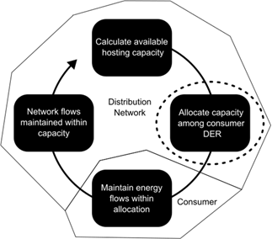
Q12. What is capacity allocation for your organisation/network? And can you describe what method(s) for capacity allocation you use at your network, and what methods you are planning to use in the future, and why?
Prompts:
- How do you determine what the most appropriate method of capacity allocation is?
- What are the trade-offs between different capacity allocation methods?What have you seen go right and what have you seen go wrong so far with capacity allocation
Q13. In relation to DOEs and methods and calculations associated with them. How do you define the capacity to be shared in a DOE?
- Have you experienced events where there was spare unused capacity or more capacity was allocated than the network had to share? What happened?
- How do you manage the risk of overallocation (e.g. allocating more capacity than is actually available)?
- How do you manage the risk of under allocation (e.g. allocating less capacity than is actually available)?
- What is the mark of a good capacity calculation in your mind?

Q14 – Can you comment on the relationship between DOEs and other network management tools? For example AS 4777, or the Demand Response Enabling Device (DRED) standard (part of the AS/NZS 4755 framework in Australia) .

Q15 –We wanted to also ask specifically about emergency backstop. What approach is your organisation network taking to backstop in terms of technical implementation? Is EVSE under the purview of backstop requirements?
- How complex will the models for allocation be? Will there be any consideration of site usage, or site requests, or any principles of re-allocation?

Q16. Thinking about DOEs in the future - What do you think are, or perhaps should be, the next steps for DOEs? How you think DOEs will evolve in the near future?
Prompts:
- What issues should we resolve and how?
- What might be done to make them better?
- What should and shouldn’t DOEs be used for?

Section 3 relating DOEs and V2G to each other
Now we would like to talk with you about V2Gs as they might relate to DOEs and vice versa.
Q17. Have you thought much about the interaction between DOEs and V2G? And if you have we would love to hear about what you have thought through.
Q18. Thinking about the interaction between DOEs and V2Gs:
- How do you see that DOE and V2G need to interact?
- What touchpoints will there need to be for them to interact?
- What are the potential good and bad outcomes of their interactions?
Q19. How do you feel DOEs could or should respond to V2G? We are interested in as much detail as you wish to share.
Prompts
- What might EV drivers with V2G expect of DOEs?
- What might driver’s concerns be about DOEs on V2G? Are these concerns founded? Why/why not?
- How might DOEs interact with using vehicles for driving?
- How might DOEs influence V2G products?
Q20. More generally, do you have any thoughts on how specific technologies could be integrated into DOEs?
Prompts
- Do DOEs need to be different depending on technology they apply to (connect with)?
- What else might influence application of DOEs?
- Has there needed to be any special considerations for specific technology so far? (e.g. batteries or EV chargers)
Q21. What systems, processes, or products do you think need to be in place to support DOE and V2G interactions?
Prompts
- How might standards/approaches like CSIP-AUS need to evolve?
- What new actors might be involved in DOEs?
Q22. Have you got any other comments on how DOE and V2G could or should evolve so they can interact into the near future. Are there potential future changes to DOE frameworks to integrate V2G.
End of interview
Thank you so much, that is the end of the questions.
Please do email us if you have any other thoughts you would like to contribute. You are able to check the draft report sections where we report your insights if you would like. Just email us to let us know if you would like to check how your contributions are reported.
The project report submission is next year. We will send out the report to participants when we have permission to.

- Scenario Baseline V2X
This section provides baseline V2X responses. It provides a quantitative background to complement the qualitative outcomes from WP1 and to add context to the results in the rest of this section.
The modelling tool utilises the same optimisation algorithm for all modes (BESS, V2G, V2H) but alters the input total electricity price. In the case of V2H, the TOU retail tariff is used, and for V2G a wholesale passthrough tariff is modelled.
The results of a single day are compared in the cases below.

Vehicle-to-Home Response
The Figure 27 above shows the EV V2H plot outputting energy to match the home load during the morning and evening peak TOU periods. The vehicle starts charging in the evening as the TOU moves to the off-peak period. Under this scenario, there is no financial incentive for the vehicle to export to the grid and therefore has no impact on export DOEs. Note the likely coincident peak demand created by the off-peak charging.
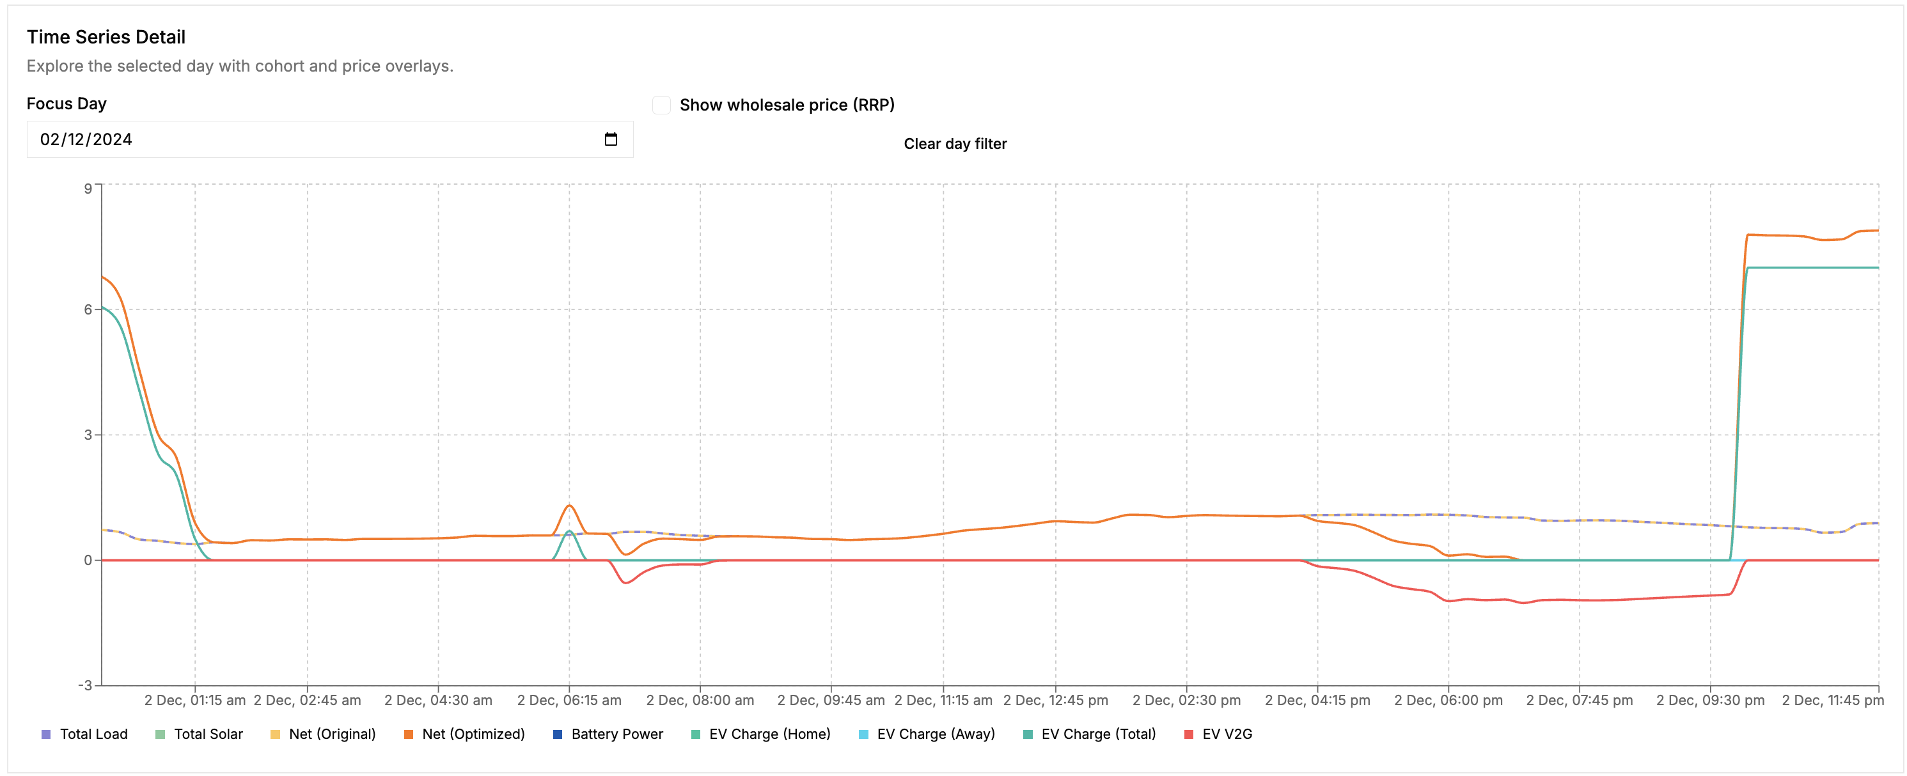
Figure 30 Vehicle-to-Home Response Baseline

Vehicle-to-Grid Response
In contrast, the Figure 28 shows a V2G response, with a strong export response to the high wholesale price in the evening. Note here, that V2G also creates price responsive charging behaviour, where the charging occurs in the lowest price hours of the early morning, rather than directly after a TOU price window change as in V2H. The V2G system’s ability to predict the exact lowest price periods during the evening will be challenging but also likely create diversity of charging during the nighttime period. This diversity will likely be beneficial to the aggregate demand profiles.

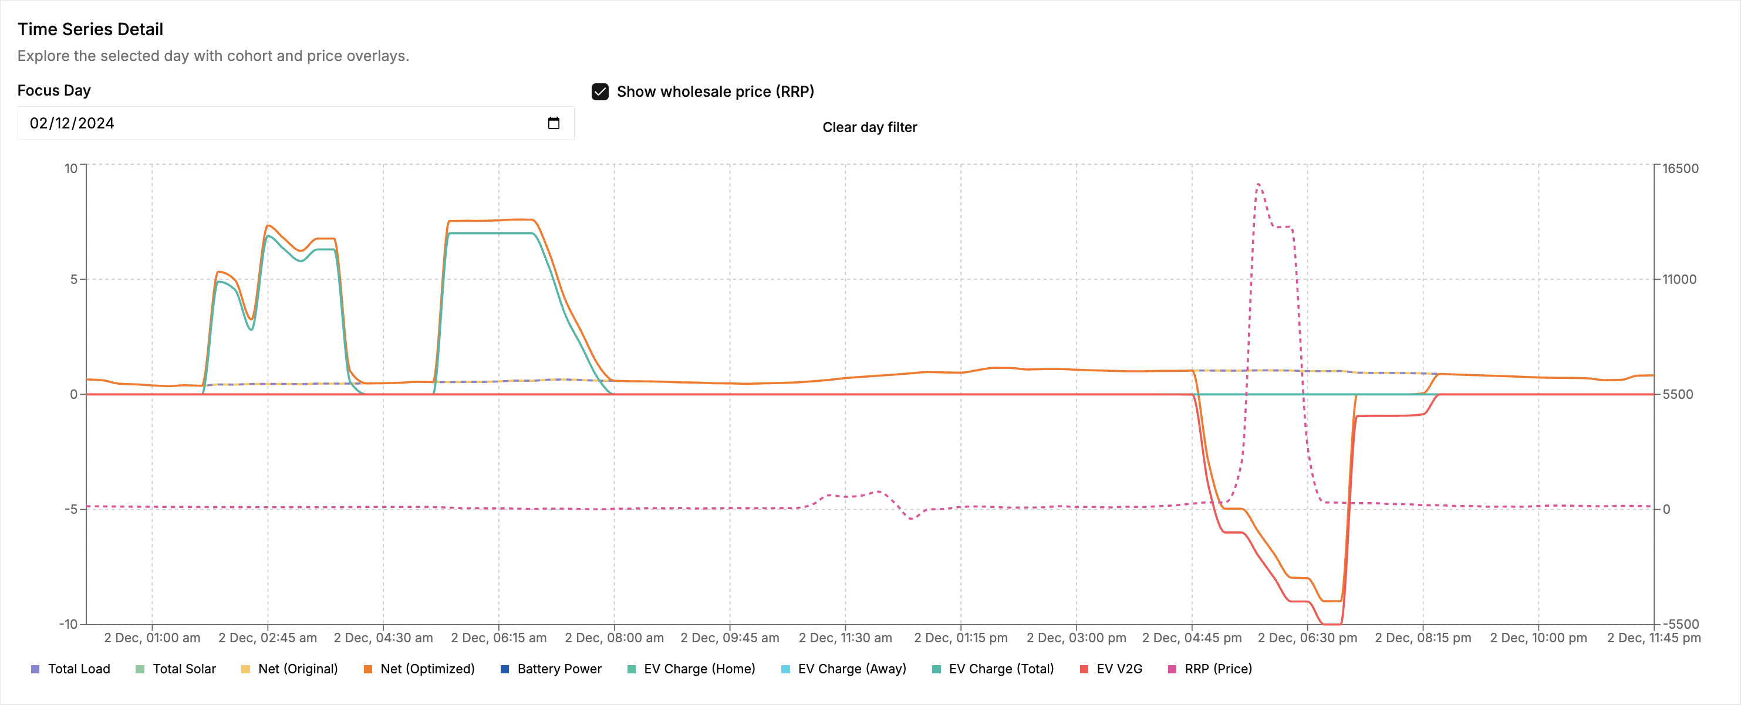
Figure 31 V2G response
This scenario modelled an EV with a commuter usage profile, where the vehicle was parked elsewhere during business hours. On this day, a minor spot price increase occurred in the middle of the day, however as the vehicle was not plugged in at this time, there was no response.

BESS and Solar Response
For further context and comparison, a solar and stationary BESS system is modelled as presented in Figure 29, optimised under a market exposed tariff. The simulation presents an expected BESS discharge in the evening; however this particular day has a minor wholesale price increase in the middle of the day, sufficient to elicit a BESS discharge response during the day. Under export DOEs, this export would be likely limited to 1.5kVA export.
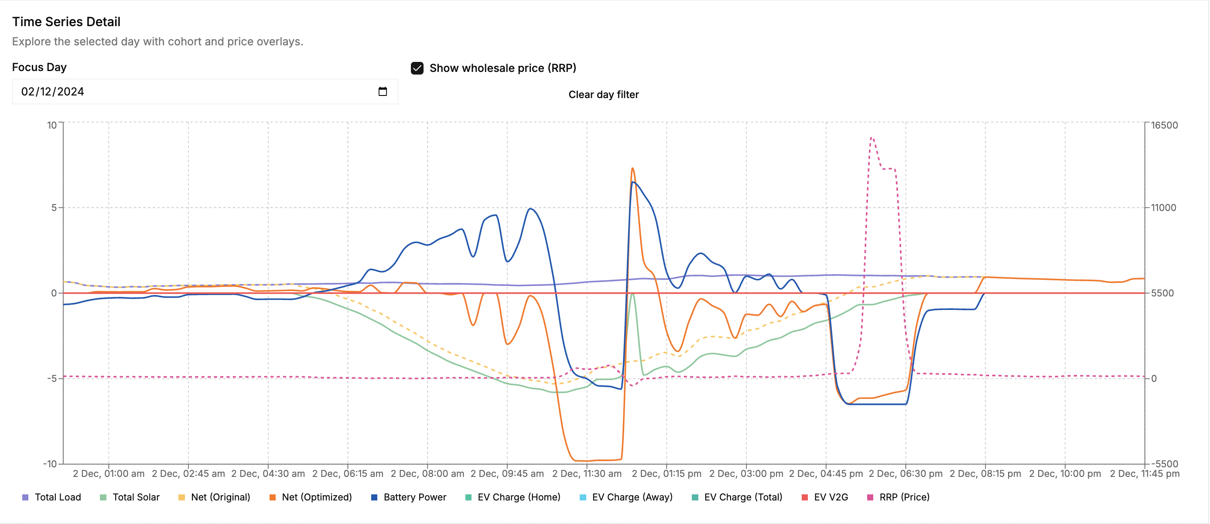
Figure 32 BESS and Solar Response

Day time connected V2G
The Figure 30 alters the vehicle usage profile to be plugged in all day. In this case, the vehicle is available and responds to the midday spot price increase. There is also optimal charging based on the lowest spot prices. In this case there is effectively no vehicle usage requirement, allowing the V2G to operate much like a stationary BESS.

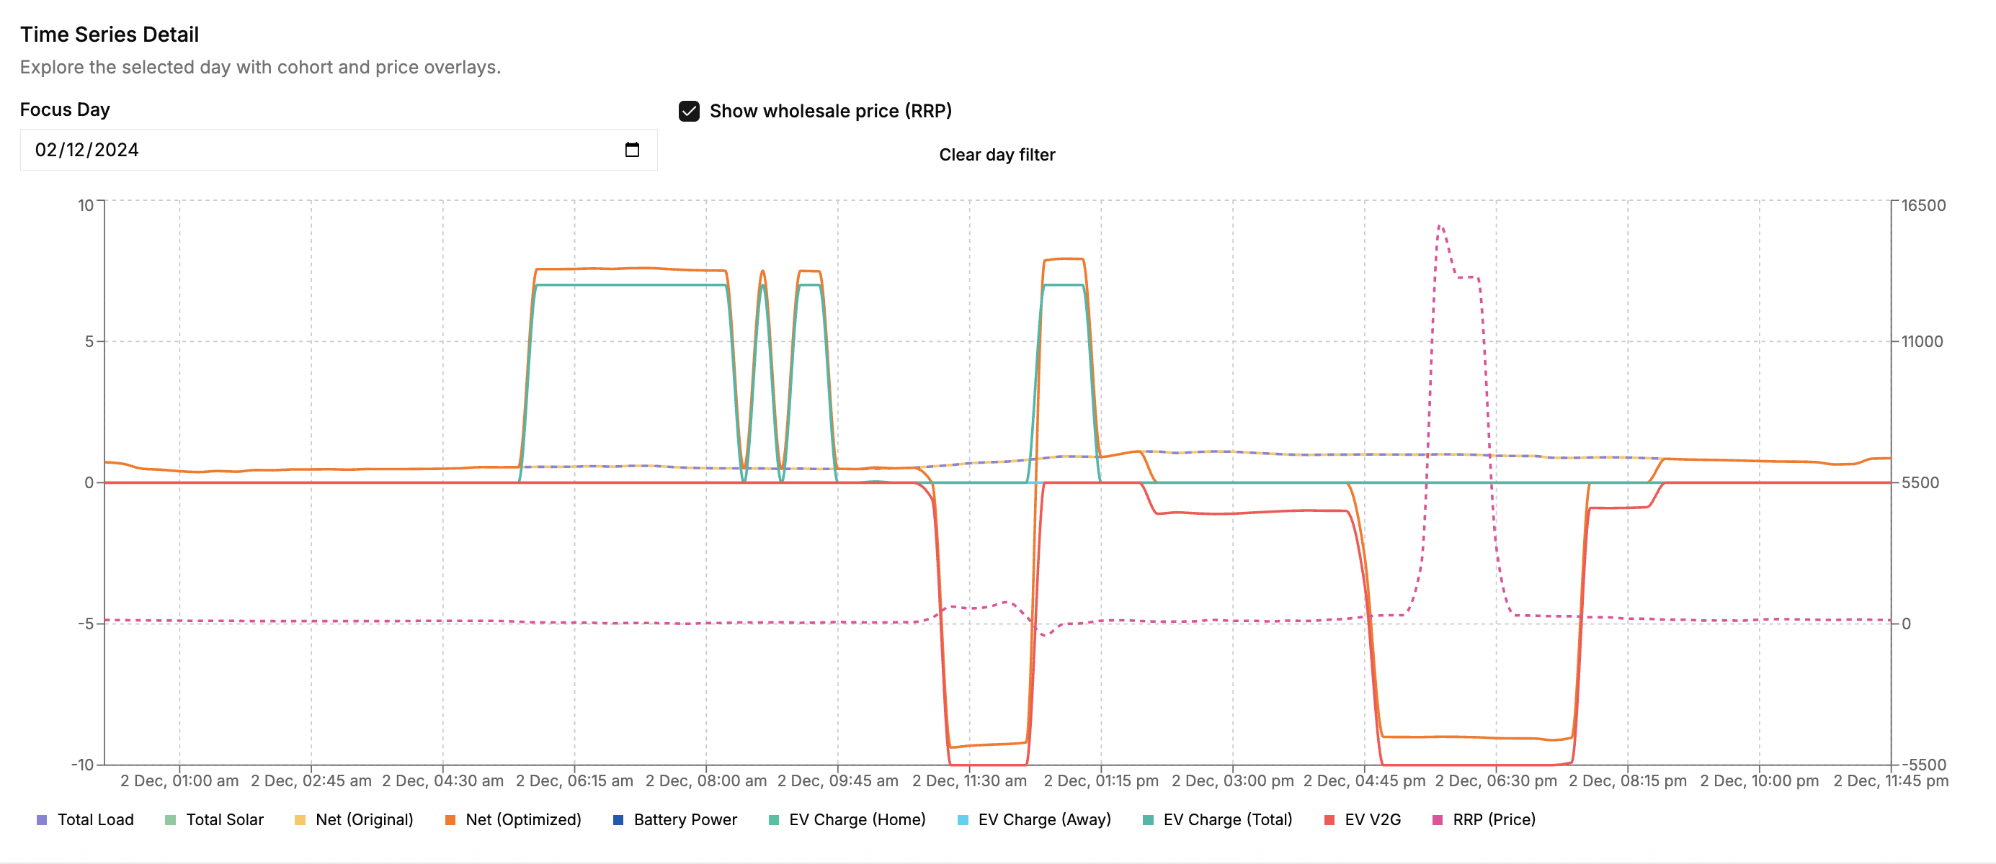
Figure 33 Day time connected v2G

V2G (commuter profile) with Solar + BESS
The Figure 31 shows a scenario containing sites with V2G, a solar system and BESS operating under a market exposed retail tariff. We can see the combination of previous scenarios, including the early morning charging period optimised to the lowest cost overnight spot price, midday BESS export due to higher spot price. The notable difference is the evening peak price where we can observe BESS and V2G both contributing exports here. BESS starts earlier approximately 5pm, and the V2G starts a little later, due to the commuter profile having the vehicle returning around 5:30pm.
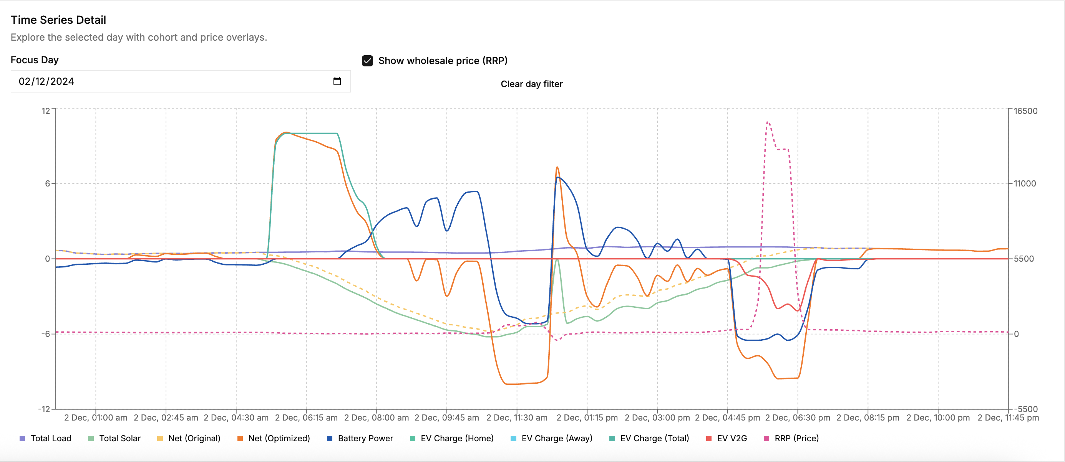
Figure 34 V2G + Solar + BESS on market
- Project questions from proposal
What do DOEs currently look like on Australian electricity grids, how are DOEs likely to evolve, and why?
See sections 2.1, 4.1.2, A.1, A.2

How could V2G be used by customers and Australian electricity grids (through VPPs or otherwise) and what are the key value propositions behind incorporating V2G?
See sections 2.3, 4.1.1, A.3

What are the most likely V2G use scenarios for Australian electricity grids, and why?
See sections 4.1.1, 4.2.1

Considering the data and insights gathered through the above questions, what are the most likely ways DOEs will interact with V2G on Australian electricity grids?
See sections 4.1.3, 4.2.2, 4.3

What modelling parameters can be developed from these insights?
See sections 4.2 and 4.3

A taxonomy (or classification) of V2G products and value propositions, including associated targets and constraints
See sections 2.3, 4.1.1, A.3. Findings challenged by early stage of V2X market.

A descriptive list of DOE evolution pathways for the near future that describe potential future changes to DOE frameworks to integrate V2G
See sections 4.1.4, 4.2.2, 4.3

Case studies, examples, and descriptions of potential DOE-V2G interactions on Australian electricity grids as V2G scales over the coming 5 years.
See sections 4.1.3, 4.2.2, 4.3

A list of DOE evolutions, targets and constraints that could be used in modelling, and a process describing the prioritisation of these parameters.
See sections 3.3, 4.2, 4.3

A detailed connection point level model, including individual asset representation, multiple optimisation points, and specific vehicle representation for mobility and energy.
See modelling tool described in 3.3

A data set available for CSIRO use in future operation of the model
See Github repository

Modelled scenarios of the mostly likely or impacting DOE-V2G interactions for the Australian electricity grids, services and mobility, and explanation of the assumptions used.
See section 4.2 and 4.3
The overall outcome from this work is a series of pragmatic proposals for changes to DOE frameworks to integrate V2G.
See sections 4.1.4, 4.3, 5, 7

Consumer energy resources - CER - are a subset of the broader group of distributed energy resources (DER) that interact with electricity networks and related to energy resources at consumer sites.
X. Liang, Z. Wang and H. Wang, "Synthetic Data Generation for Residential Load Patterns via Recurrent GAN and Ensemble Method," in IEEE Transactions on Instrumentation and Measurement, vol. 73, pp. 1-12, 2024.
https://parquet.apache.org
EVx 54 Gordon Cres, Lane Cove public type 2 22 kW AC charger 8AM-8PM price accessed 23/05/2026.
ChargeFox bp pulse Carlingford fast charger any time price accessed 23/05/2026.
At the time of writing
Based on 30% - 70% range from section 4.1.1
https://wattclarity.com.au/articles/2024/11/chronological-record-of-events-27-november-2024/
This is just one way that the impact of DOEs on “charge now” buttons could be measured.
The 93/94th percentile scenarios were chosen as the point just before the demand drops significantly (as can be seen at the 90th percentile)

