Topic 1 – Inverter Design
2023/24 - Transient Stability Enhancement of IBR-dominated Grids in the Presence of Grid Forming Inverters
Commonwealth Scientific and Industrial Research Organisation
15 December 2023

Team – Harith Udawatte, Hansi Wijayalath, Salah Hajtaleb, Nabil Mohammed, Nazila Rajaei, Behrooz Bahrani

Contents
1. Introduction 1
2. Research relevance 2
3. Research completed 2
4. Outstanding activities 4
5. Progress against the Roadmap 4
6. Recommendations 5

Introduction
Renewable energy plants, such as wind and solar farms, are typically located in regions where wind and solar resources are abundant, yet usually distant to synchronous generators (SGs) and loads. These resources, interfaced by power electronic inverters, may face stability challenges in weak areas of the grid. To address this, grid-forming inverters are deployed in these regions to enhance the stability of the local network. As a consequence, the transmission of generated power from these remote energy plants to centralised urban areas necessitates the use of various network topologies, including radial and meshed configurations in transmission networks. It is essential to investigate the stability of these networks to determine operational limits and propose solutions for improvement. Given the vulnerability of power systems during faults and fault recoveries, a thorough examination of transient stability and its impacts on the networks during such events becomes imperative.
Since Grid Forming Inverters (GFMIs) are power electronic converters, they are sensitive to overcurrent due to the limited thermal capability of the internal switches and their voltage-source-like operation, both during and after large disturbances. Thus, GFMIs are always equipped with a current limiter (CL) in their control system to protect themselves from overcurrent. The engagement of CLs in the GFMI’s control can significantly affect the operation of GFMIs and negatively impact their stability. Therefore, the impacts of CLs on the transient stability of GFMIs need to be investigated.
This project involves undertaking multiple studies aimed at analysing and improving the transient stability of networks dominated by Inverter-Based Resources (IBR) during faults and fault recoveries. In Task 1, ongoing efforts focus on expanding the transient stability analysis developed in Stage 2 to encompass various network topologies. Simultaneously, Task 2 is dedicated to the development of a tool specifically designed for conducting transient stability analysis for multi-IBR systems. The results of these studies can be utilised to compare various networks and different network arrangements within the same system.
The primary objective of Task 3 is to analyse the impact of negative sequence (NS) current injections from IBRs on their transient stability (TS), while complying with the IEEE P2800 NS current requirement. The assessment will explore the influence of various GFMI control features on TS. Additionally, it will evaluate the impact of NS current allocation on protection system operation, potentially through a literature review or, if relay models are available, one or two case studies. The findings will be presented in a report formatted as a white paper.
In Task 4, the transient stability of current-limited grid-forming control implementation in non-BESS IBRs, particularly wind turbine generators, is being investigated. This initiative represents a partial continuation and improvement of Stage 2 studies on the transient stability of GFMIs in the presence of current limiters.

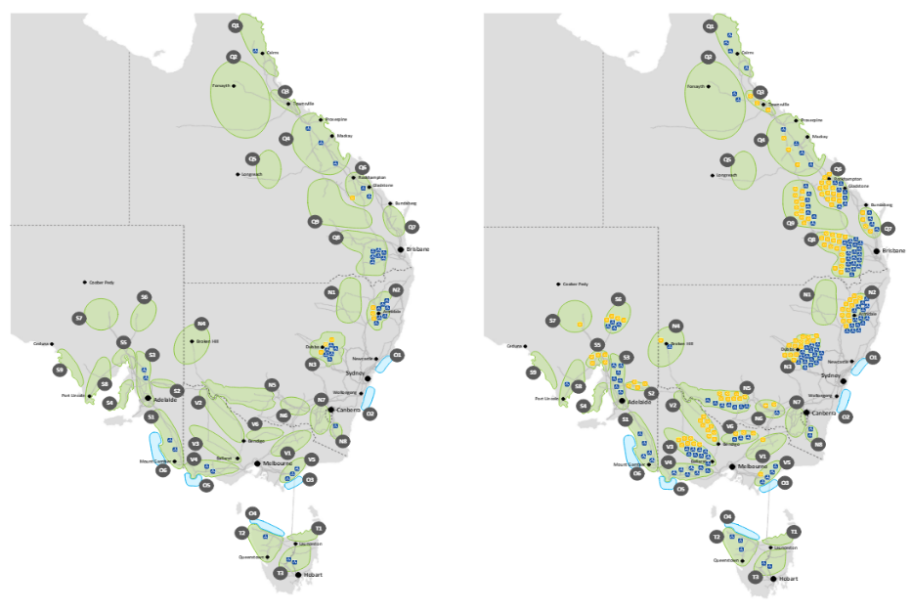
Research relevance
Within the next 25 years, a significant development of renewable energy zones (REZ) is anticipated according to AEMO’s Integrated System Plan. The REZ developments are likely to be in radial network configurations and be located far from the remaining synchronous generators. Therefore, stability issues may inevitably emerge in such regions. This research effort is aimed at establishing a simple framework to allow an accurate analysis and estimation of transient stability margins of large IBR-clusters that constitute REZ regions, thereby supporting the network service providers and the network operator in maintaining a stable and secure grid, which is becoming more and more crucial as the penetration of IBRs in the NEM gradually increases.
Figure 03 - REZ development in the Step Change scenario – 2029-30 (left) and 2049-50 (right) - Ref: AEMO Integrated System Plan (ISP) 2022

In addition, wind power generation capacity is expected to be larger in comparison to other forms of generation both in REZ regions and the wider NEM. Therefore, it is imperative to investigate the impacts of grid-forming wind generation systems on the transient stability of REZ regions and examine their grid-strengthening capabilities in this regard. Therefore, by investigating the aforementioned aspects, this research effort is expected to provide a significant contribution to the stable operation and expansion of REZ regions, and potentially support future off-shore REZ developments.

Research completed
Task 1 - Transient stability analysis of multi-inverter-based-resource (multi-IBR) systems considering a wide-area network - (Monash)
This study is conducted to develop an indicator for quickly measuring the transient stability margin of a system comprising multiple IBRs. The foundation of this study is based on the analysis of transient stability behavior in a paralleled GFMI and GFLI system that was completed in Stage 2 of this project.
The synchronising loop of an IBR, such as the active power control loop for GFMI and the phase-locked loop (PLL) for Grid-Forming Load Inverter (GFLI), possesses two equilibrium points: a stable equilibrium point (SEP) and an unstable equilibrium point (UEP). If the operating point (OP) of an IBR surpasses the UEP, the synchronising loop turns into positive feedback, causing the OP to deviate from the SEP. This results in extremely severe transients in the power and frequency of the IBR. Furthermore, the UEP of a paralleled GFMI-GFLI system can be identified as detailed in the Stage 2 report. The greater the distance between the SEP and the UEP, the further the initial OP is from a positive feedback mode, indicating a more stable system.
For a multi-IBR system, if the post-fault UEP of any IBR is exceeded, the corresponding IBR becomes positive feedback and introduces additional transients to the connected system, leading to an undesirable scenario. Therefore, estimating the distance between the SEP and the closest UEP of a multi-IBR system can provide insights into the system's stability. A system with a longer distance between the SEP and the UEP is expected to be more stable than one with a shorter distance. The derived method enables the derivation of stability boundaries without having to solve differential equations.
A preliminary study was conducted at the end of Stage 2 to prove the feasibility of expanding the idea above into a multi-IBR system. However, the study was limited to a radially connected small-scale IBR system. Since the scalability of this methodology was identified at the beginning of this stage, the proposed transient stability analysis is expanded for a wider area network, considering different network topologies, such as mesh networks, in this stage.
Initially, the effectiveness of the transient stability margin indicator was tested for a radially connected medium-scale multi-IBR network through different case studies. Apart from the IBRs, the dynamics of loads are also considered in this study. The network is divided into several clusters, and the transient stability margin indicator is calculated for each cluster using the power angle difference between the SEP and UEP points. Finally, the minimum indicator value is chosen as the stability margin indicator of the entire IBR network.
Moreover, the proposed methodology of estimating the transient stability margin indicator was extended to mesh network topologies to enable applicability to a wider area network. The preliminary study conducted using a miniature-scale meshed IBR network demonstrated the ability of this idea to be used in different network scenarios.

Task 2 - Development of an analysis tool to conduct transient stability studies for multi-IBR systems - (Monash)
As the study paves the way for a broader network, the complexity of the mathematical equations required to obtain the stability margin indicator is increased. Thus, a more computationally efficient, configurable, and generic tool was required to further extend the studies.
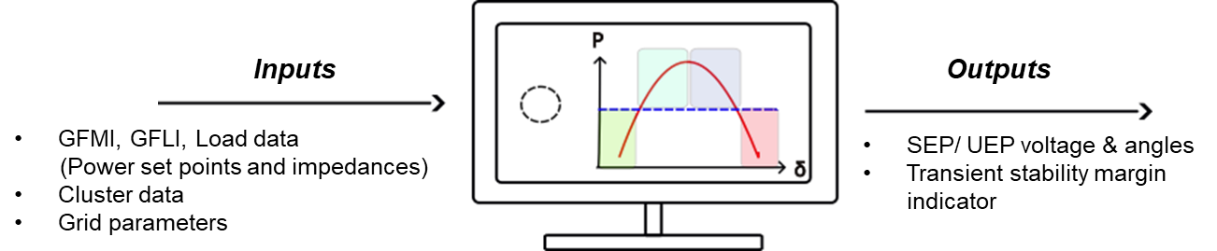
Figure 01: Basic structure of the transient stability margin tool
The initial tool objective is to calculate the transient stability margin indicator for a radially connected system with clusters that include any number of IBRs and loads. This automates the analysis in Task 1 and enables and can be employed as a convenient tool in the planning and designing stage of a renewable energy zone. After investigating the available numerical computing methods, Newton’s method was utilised to solve the equations due to its high accuracy, efficiency, and low complexity. Figure 01 illustrates the basic structure of the tool.  Furthermore, the analysis conducted on mesh networks will be integrated into the tool, making it applicable to any network topology in a wider area network. The collaborative efforts of Task 1 and Task 2 will propel the study toward the utilisation of the proposed transient stability margin indicator in larger networks. This will include a specific case study in the West Murray renewable energy zone (See Figure 02) and the IEEE 9-bus system. | 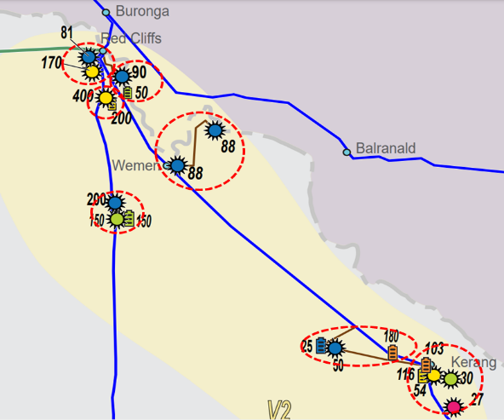  Figure 02: West Murray renewable energy zone with identified clusters (circled in red) for the study [Ref: NEM Generation Maps -2023]

Outstanding activities
3.1 Task 3 - Investigation of negative-sequence current control and its impacts on transient stability of GFMIs - EPRI
The purpose of this task is to evaluate the impact of NS current injections from IBRs on their TS. The IEEE P2800 standard mandates the injection of NS currents from IBRs to activate existing protection systems and adhere to grid codes. While this requirement enables IBRs to emulate behaviour closely resembling that of traditional resources in terms of NS current injection for reliable protection system operation, it can limit the positive-sequence (PS) active current headroom, which is essential for GFMIs to synchronise with the grid. Thus, the NS current requirement may introduce stability risks for GFMIs. In this task, we assess the impact of various control features of GFMIs, such as control methodology (virtual synchronous machine (VSM) vs. droop control), frequency freezing, K2-factor, and different current limiting methods (current saturation vs. virtual impedance), on the TS of inverters complying with the IEEE P2800 NS current requirement. Additionally, the impact of the allocation of negative sequence current on potential protection system operation will be studied. This could be in the form of a literature review study, or if relay models are available, one or two test scenarios are analysed to assess the impact of negative sequence current injection on the operation of relays. Finally, observations are provided either as a new white paper or as amendments to the white paper prepared in the last stage.
3.2 Task 4 - Enhancing transient stability of current-limited grid forming control by implementation in non-BESS IBRs - (Monash)
The primary objective of this task is to explore the feasibility of implementing current-limited grid-forming control in non-Battery Energy Storage System (BESS) IBRs as a viable alternative to BESS-GFMIs. The approach involves conducting an in-depth literature review on the transient stability of non-BESS GFMIs, specifically focusing on Type 3 and Type 4 wind turbine generator systems. Following this, a comprehensive comparison will be made between the transient responses of non-BESS GFMIs and current-limited BESS-GFMIs to lay out their respective shortcomings and advantages. Subsequently, the task aims to establish the specific current limitation requirements for the converter(s) in non-BESS GFMIs based on the identified shortcomings and develop appropriate schemes to address them. Finally, the newly formulated stability-enhancing schemes will be implemented in non-BESS GFMIs, and their transient performance will be rigorously evaluated to gauge their effectiveness in improving the overall system stability.

Progress against the Roadmap
Table 01 outlines the overall research progress in comparison to the full program as defined in the Roadmap.
Table 01: Research Progress against the Roadmap
Task |  | Related Task in stage 3 | Stage 3 progress
Major Task 4: Protection and Reliability
4.3 | Assessment and enhancement of IBRs reliability | Transient stability analysis of multi-IBR systems considering a wide-area network  Development of an analysis tool to conduct transient stability studies for multi-IBR systems | 70%
4.2 | Enhancing IBR response during and subsequent to faults | Investigation into the impact of various controls (e.g., GFM controls, current limiting, frequency freezing and K2-factor) of GFMIs on the TS of inverters conforming to IEEE P2800 NS current requirement.  Study of the impact of NS current allocation on protection system, conducted either through a literature review, or if relay models are available, one or two case studies.  Enhancing transient stability of current-limited grid forming control by implementation in non-BESS IBRs | 50%
5 | Trending Topics
5.2 | Grid-forming capability for HVDC stations and wind and solar farms | Enhancing transient stability of current-limited grid forming control by implementation in non-BESS IBRs | 20%

Recommendations
The following research activities are recommended for the 2024/25 program. The recommendations are made based on CSIRO Australian Research Plan for the G-PST, Task 1 – Inverter Design – Final Report, 2021
- Investigate the transient stability of the GFMIs under various fault profiles (Next round): In the studies conducted thus far, only three-phase faults occurring in the grid have been considered. However, fault profiles like type of fault, fault location, and fault duration can influence transient stability. Therefore, it is crucial to investigate the transient stability of GFMIs by considering different fault profiles. This investigation will be essential for improving the overall reliability and performance of GFMI systems, contributing valuable insights to the design and operation of advanced power systems.
- Extension of transient stability analysis considering various fault profiles across different network topologies (Next round): This investigation aims to explore the dynamic response of power systems to a range of fault scenarios under different network configurations. By incorporating diverse fault profiles, including various types and magnitudes of faults, the study will seek to provide a comprehensive understanding of the transient stability performance of the system. This approach will recognise the intricate interplay between fault characteristics and network structures, offering valuable insights to inform the design and operation of power systems.
- Investigate efficient real-time transient instability detection methods (TID) for enhanced power system analysis, quick decision-making, and improved grid reliability. Prioritize low computational load, high accuracy, and speed for real-time applications.
- Investigate the impact of system conditions, including load level, load type, grid strength, and generation mix, on the TS and operation of GFMIs with NS controls. Conduct a sensitivity analysis to identify the major conditions or parameters that influence the operation of GFMIs on TS.

