GPST Topic 3 – Control Room of the Future
  - CSIRO GPST Research Stage 3
Interim Report
15th December 2023 Version 1.0

Contents
1. Introduction 1
2. Summary Overview of the Project 1
2.1 Task 1. Machine learning applications and use case methodology developments. 1
2.2 Task 2 - Exploration of language and text-based machine learning and knowledge-based systems in system operations 1
2.3 Task 3 - Network and generator model validation processes and systems 2
3. Research Completed to Date 2
4. Outstanding Activities 3
5. Research Relevance to Australia 3
6. Progress Related to Research Roadmap 3
7. Recommendations for Next Steps and Future Research 4

Introduction
https://www.csiro.au/en/research/technology-space/energy/g-pst-research-roadmap).

EPRI are conducting research on the GPST Topic 3 Control Room of the Future (CROF). The original 2021 roadmap outlined pathways for innovation around a of key pillars, with focus on Data and Software Applications, and Human Factors and Operator Interactions.

The CSIRO CROF stage 2 work in 2022-3 began work on the elements of the roadmap with focus on the CROF research pillars for data and control room applications. The aim was to work on aspects of artificial intelligence and machine learning (AI/ML) for real time operations applications, given the long gestational period of development. This work involved close interaction between EPRI, Royal Melbourne Institute of Technology (RMIT) and AEMO to identify a methodology for developing machine learning projects, data and use cases and to build a prototype proof of concept application for use on real AEMO data. The stage 2 project was completed in 2023 and the report on the project is available publicly on the CSIRO website.

The framework and proof of concept development work from stage 2 is being continued in the stage 3 project in 2023-4. EPRI are again partnering with RMIT and AEMO to continue the research. The focus remains on the data pillar of the original 2021 roadmap, with a new focus on operational models and how the process for model validation could be improved in the operational domain.

Summary Overview of the Project
The project comprises three main tasks, detailed below:

Task 1. Machine learning applications and use case methodology developments.
This work involves continuation of the stage 2 work with deployment of a prototype directly on AEMO systems using AEMO data.
The sub tasks for the project are below:
- Prototype deployed at AEMO for at least one use-case on alarm management.
- Completed investigation into machine learning for constraint management use case.
- Experimentation and analysis with actual AEMO datasets
Deliverables
- Prototype code suitable for public release, including non-proprietary sample demonstration data to show that the prototype functions properly, and instructions on how to use the tool(s).
- Brief technical report(s) or presentations for each of above, or inclusion in final report

Task 2 - Exploration of language and text-based machine learning and knowledge-based systems in system operations
This task involves exploration of possible use cases for large language models in the system operations domain. Given this is emerging technology it is unclear what or if it could be potentially useful for system operators. The sub tasks are:
- A prototype developed by the project team based on textual information, or a knowledge-based task that is suitable for public release, instructions on the tool(s) demonstration on either a publicly available data set or a non-proprietary data set that can be released with the prototype.
- Experimentation and analysis against any available public datasets.
Deliverables:
- Brief technical report(s) or presentations for all activities above, or inclusion in final report

Task 3 - Network and generator model validation processes and systems
This task involves engaging with modelling subject matter experts in AEMO to define a methodology for automatically validating the accuracy of a model using high-speed data recorders. The sub tasks are:
- Identified 2-3 models for study inclusion based on priority, complexity, and ease of access as defined by AEMO.
- Initial investigation on standardization framework for model validation. Brief progress report on above exploratory work, or inclusion in final report.

Deliverables
- Final report should include a proposed development pathway for how the validation tools might be developed into a final product to be integrated within a power system operations company.

Research Completed to Date
The project team consisting of EPRI, AEMO, RMIT with input from CSIRO has been assembled and are working actively and have made good progress. The team meets every week with reports to the CSIRO project management team every 2-4 weeks.

For task 1 the following tasks have been completed:
- Alignment of the AEMO datasets for experimentation and ML development. All databases have a time element so can be synchronised and synchronised by assets. There are four key databases.
  - The operational alarm database
  - The SMIRK database for market incident reporting
  - The EPSOC database for network incident reporting
  - The NOS database for planned network outages
- Correlation of “incidents” based on time. This means that the points in time that have common time points are aligned, such as spikes in alarms co-incident with reports in EPSOC.
- Incident labelling framework set up and being populated: Where corelated incidents are detected, they are labelled by experienced operators from AEMO with what happened at the time. These labels will be used in machine learning training.

Task 1 is approximately 30 % complete.

For Task 2 the following tasks have been completed
- Exploration of open, publicly available large language models (LLM), by deployment in a cloud instance offline and separate to the AEMO environment.
- Testing of the open LLM with synthetic alarm data sets to assess its efficacy and viability for future use.
- Initial preparations for deployment of LLM on the AEMO system with data from the four datasets listed above.

Task 2 is approximately 30 % complete.

For Task 3 the following tasks have been completed
- Initial meeting and scoping exercise with the AEMO subject matter experts for dynamic modelling.
- Agreement reached to proceed with methodology development and proof of concept test on an asset model to be defined.

Task 3 is approximately 20 % complete.

Outstanding Activities
The project and research are at an early stage, and so there are many outstanding activities still left to be achieved, including:
- Completion of labelling on a large set of identified incidents, such as for 6-12 months to facilitate ML model training.
- Access to the real AEMO system to develop and deploy the ML models for incident detection.
- Testing of ML model on test datasets from the four main datasets.
- Build a user interface for the prototype for displaying output information to the operator based on the output of the ML model for incident detection.
- Access to the real AEMO system to develop and deploy the LLM model for interaction with the datasets.
- Development of the methodology for model validation for an asset with high-speed recording.
- Development of the framework for automated model validation, based on the manual model validation framework.

Research Relevance to Australia
Currently there is no existing machine learning project methodology for power system use cases. In addition, the despite widespread industry adoption, there are limited machine learning applications in the power system and energy sector more broadly, both in Australia and around the world. The development of the methodology and use cases in this project can be used by researchers and practitioners in Australia. The solutions developed in this project for incident detection can, in theory, generalise to other network operators in Australia and globally with similar sets of databases (reporting, alarms, outages etc).
The model validation task is also highly relevant to other network operators in Australia and beyond. As network become weaker, new phenomena arise on the network that need to be studied, this requires more advanced simulation capability which requires more advanced and accurate models. Having a methodology to validate models automatically and continuously with real time data.

Progress Related to Research Roadmap
Some early-stage progress has been made on two of the original 2021 research roadmaps for data. The AI/ML techniques were envisaged as a later stage of development, but early-stage work – such as the work in the stage 3 project - must be carried out over many years to achieve success in this field. Some work around data model standardisation must still be completed in the coming years.

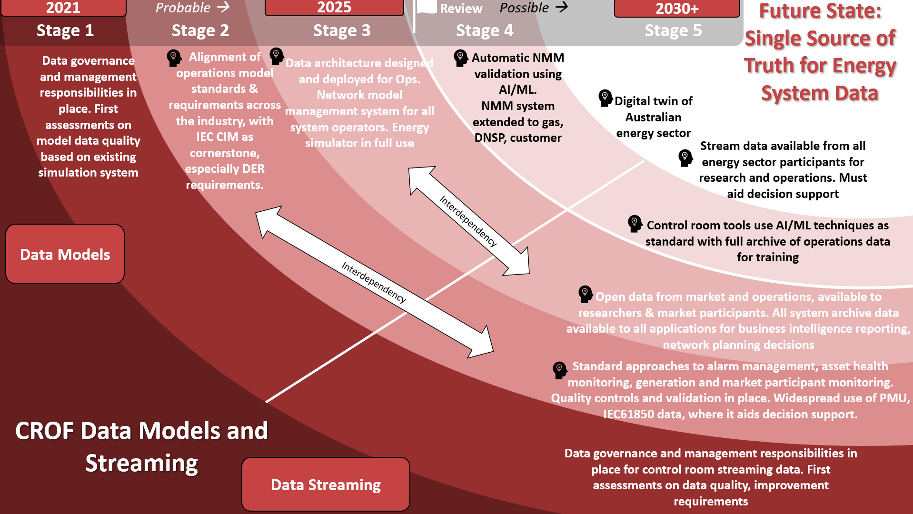
Figure 1 CROF Data Models and Streaming Roadmap

Recommendations for Next Steps and Future Research

The aim of the stage 3 project is to continue development of the incident detection ML model to a fully workable prototype in operations at AEMO and available to other network operators in Australia. Work in this should continue beyond the scope of the stage 3 project but perhaps focussed within the network operators as they transition to business-as-usual operational technology systems.

The 2021 research roadmap was ambitious and vast, covering six core pillars. The focus of stage 2 and stage 3 was on the data pillar, but research activities should also be initiated in the other pillars – Architecture, EMS/SCADA, Operational Technology Tools, Human Factors, Buildings and Facilities.

For future research areas in Topic 3 CROF, it may be appropriate to initiate the human factors research actions, which are focussed on decision making, training standardisation, visualisation. Or the buildings and facilities which focusses on the value of ergonomics and building design to the control room experience and the need for operational readiness centers.

The architecture pillars and the software applications tools roadmaps are less urgent as priorities. They both have active work actions within the CSIRO G-PST framework (Topic 7) and within AEMO through the Operational Technology Roadmap and Programme, co-funded by CSIRO.

Topic 3 Control Room of the Future Stage 2 Report: https://www.csiro.au/-/media/EF/Files/GPST-Roadmap/Final-Reports/Topic-3-GPST-Stage-2.pdf

