Topic 4 – Planning
  - 2023/24 CSIRO GPST Research
Commonwealth Scientific and Industrial Research Organisation
15 December 2023

Contents
1. Introduction 1
2. Research completed 2
3. Outstanding activities 4
4. Progress in the current project in the context of the general “Planning” research plan 5
5. Research relevance 7
6. Recommendations for future developments 8

Acronyms
AEMO Australian Energy Market Operator
DER Distributed Energy Resources
GPST Global Power System Transformation
HILP High Impact Low Probability
IASR Inputs, Assumptions and Scenarios Report
ISP Integrated System Plan
LWWR Least-Worst Weighted Regret
REZ Renewable Energy Zone
UoM The University of Melbourne
VPP Virtual Power Plant
VRE Variable Renewable Energy

Introduction
The transition to a fully decarbonised energy system is spearheaded by the increasing uptake of variable renewable energy (VRE) and distributed energy resources (DER), the electrification of different sectors, and the large-scale adoption of low-carbon fuels such as green hydrogen. Developing the aforementioned technologies is a challenging task exacerbated by the increasing uncertainty around what and how much of each technology will connect to the system, as well as when and where. Energy system planners are thus faced with the task of striking a good compromise between the cost-effectiveness of a deeply decarbonised energy system and the need for ensuring day-to-day operational security, reliability and resilience against high-impact low-probability (HILP) events, which are particularly challenging to model and capture in traditional planning methodologies.
In this project, The University of Melbourne (UoM) elects to address several fundamental issues associated with Topic 4, “Planning” of the CSIRO-GPST roadmap, particularly in the context of energy systems integration. Specifically, we aim to examine and assess, from a techno-economic perspective, the impact and benefits of integrating DER, sector-coupling, and storage technologies in low-carbon energy infrastructure planning, under different sources of uncertainty. Among other studies, the project seeks to determine the option value of operational flexibility provided by DER, hydrogen electrolysers, and the inherent storage capability of hydrogen pipelines (linepack) in supporting system operation and displacing or delaying investments in transmission infrastructure. Moreover, to deal with the inevitable computational challenges that emerge from modelling the complexity of the operation of power systems, clustering and optimisation techniques are explored to identify methodological options for the identification of representative periods to use in the planning process and determine how these techniques could inform on the procedures adopted by the Australian Energy Market Operator (AEMO) in their integrated system plan (ISP).
The project aims to comprehensively represent and analyse the influence of incorporating operational flexibility from DER, hydrogen electrolysers and options for hydrogen transmission and storage infrastructure within the expansion planning problem under multiple uncertainties. These objectives are aligned with Research Program 5 (Distributed energy systems) and have interactions with Research Program 2 (Power system operation), 3 (Reliability and resilience) and 4 (Decision-making). The main goal is to evaluate planning strategies and the impact of flexible technologies in making robust and forward-thinking investments, thereby reducing planning risks and regrets. This provides valuable insights into the current decision-making processes undertaken by different stakeholders and informs the next steps in methodological developments in this topic. The project tasks and their alignment with the planning roadmap are as follows:
- Analyse pertinent representative period selection (e.g., days, weeks, months, or years) techniques in the planning process through big data classification algorithms. (Planning roadmap: Research project R2S1P1).
- Identify and quantify the value of the operational flexibility that different types of storage, demand-side (including DER), and sector-coupling (particularly hydrogen electrolysers) technologies could provide in displacing or delaying transmission investments and enhancing resilience to extreme events. (Planning roadmap²: projects R5S2P1, R5S2P2 and R5S3P2. Interactions with projects R4S2P3 and R5S1P1).
- Model and numerically assess the potential benefits from integrated electricity-hydrogen infrastructure design and relevant long-duration storage options in optimal integrated infrastructure planning under deep, long-term uncertainty. (Planning roadmap²: research project R5S1P1).
- Quantify the resilience benefits that different types of storage, DER, hydrogen technology and transmission infrastructure could provide against different types of extreme events, including dunkelflaute periods and prolonged outages of conventional generators and interconnectors. (Planning roadmap²: research project R3S3P3. Interactions with project R5S3P2).
In this interim report, we summarise the research work that has been done up to date and outline a few ideas for a potential follow-up, in line with the research plan developed in 2021.

Research completed
To shorten the description of the project’s progress, the tasks presented in the previous section are disaggregated and presented in the form of a simplified Gantt chart in Figure 2.1.
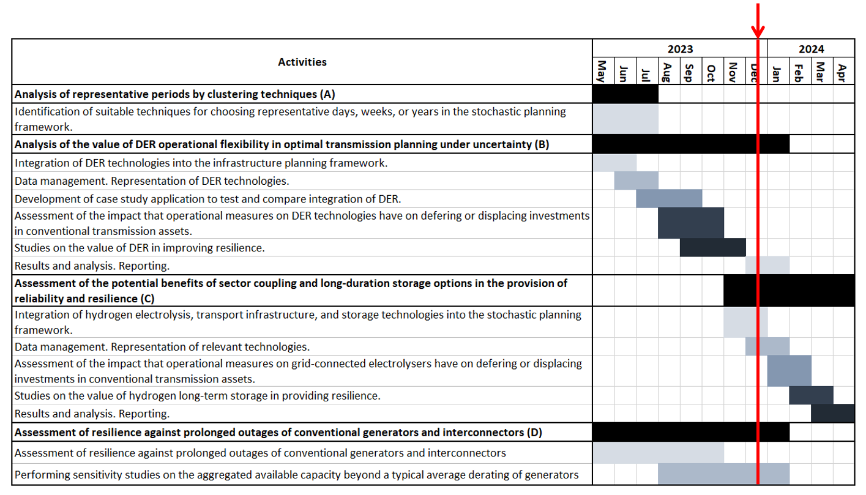
Figure 2.1. Project’s Gantt chart
As presented in Figure 2.1, a methodological analysis has been undertaken to identify appropriate techniques for selecting representative periods (Part A) to simulate power system operation in planning studies. Furthermore, the integration of DER, encompassing data management and modelling within the stochastic infrastructure planning framework, has been completed. Additionally, the analysis and assessment of the impact of DER operational flexibility on utility-scale system investments has been finalised (Part B). Parallel to Part B, a resilience assessment of conventional asset outages and HILP events (Part D) was conducted to evaluate the advantages of DER integration and its benefits under critical system conditions. Significant progress has been made in this domain.
Part A of the project involved a thorough review of the techniques used in the literature to identify appropriate methodologies for optimally selecting representative input datasets (demand, VRE, inflow traces) for the simulation of power system operation in planning studies. The review identified various big data and optimisation techniques and evaluated their advantages and disadvantages. Additionally, metrics were identified to assess the performance of the selected periods, both from a data management perspective and from the impact on the results of the expansion portfolios. The main insights obtained at this stage are:
- The representation of the details in the system operation (e.g., in temporal terms, the number of typical days or weeks supporting the planning) substantially influences the definition of the optimal portfolio of new investments for the system. If the operation is not adequately represented (oversimplified), the resulting investment portfolio will be naturally tailored to those simplified operating conditions, posing the risk of infeasible solutions for other operational conditions. For instance, if models have insufficient temporal granularity (number of timesteps included in each simulation) or employ only a few representative periods, the resulting investment portfolio could lead to a suboptimal operation of the system.
- The selection of representative weeks instead of days, along with an hourly time resolution, allows for better capturing the variability, diversity, and capacity factors of VRE and the value of long-term storage (inter-day) and other flexibility features emerging from different technologies such as DER or hydrogen electrolysers. This approach allows more accurate estimates of the contribution that new investments and existing assets can provide to the power system operation in terms of short- and long-term flexibility. Consequently, this increases investment decisions’ robustness when multiple technologies are co-optimised within an integrated system planning framework.
- By adequately selecting enough representative periods, realistic and accurate approximations of the power system operation can be achieved without significantly increasing the computational complexity of the planning problem. This is crucial for system planners, as applying these techniques can increase the computational efficiency of the algorithms employed for planning without sacrificing the quality of the results, striking a compromise between computational tractability and the robustness of the outcomes.
- The most used approach for selecting representative periods in the literature is applying clustering techniques over large datasets that aggregate time series containing different data traces (e.g., demand, VRE and hydro inflow profiles). These techniques identify a subset of the original data traces, representing a fixed number of selected periods (e.g., hours, days, or weeks) that closely capture the temporal dynamics of the original dataset. Subsequently, user-defined metrics are employed to evaluate the effectiveness of these selected periods. These techniques have demonstrated applicability, computational efficiency, and tractability in selecting appropriate representative periods for power system planning. However, their primary limitation lies in their inability to incorporate the dynamic nature of power system operations and investments. As data-driven algorithms, they focus on evaluating and applying metrics to the input data rather than considering the potential influence these data may have on the outcomes (investment and operation decisions).
- Optimisation-based selection techniques offer the potential for higher confidence in choosing representative periods for power system’s operation. By tailoring these techniques to assess different data traces based on specific power system metrics (e.g., investment portfolios, unserved energy, generator dispatches), they can identify the most suitable periods to represent the system operation. These techniques, formulated with specific metrics and constraints embedded within an optimisation problem, have demonstrated superior accuracy compared to other methods, as documented in the literature. However, their computational cost remains a significant challenge, which can become prohibitive for large datasets.
Part B of the project focused on modelling and assessing the impact of integrating controllable DER technologies into the expansion planning framework. To fulfil the project objectives, DER were incorporated as flexible demand-side technologies, accounting for deployment uncertainties into the stochastic framework and scenario representation developed in Stage 2. Subsequently, a series of studies were conducted to examine the implications of modelling and enabling DER controllability using aggregation frameworks like virtual power plants (VPPs) and demand response. The case studies explored how the stochastic framework values the flexibility provided by DER, its influence on investment portfolios, and how it compares to deterministic approaches. The following conclusions can be drawn:
- Including flexible and controllable assets from the demand side can impact the decision-making process for transmission investments, as higher flexibility can be leveraged to make consumption patterns more efficient, thus reducing transmission requirements. Moreover, a stochastic planning approach places a higher value on the flexibility services emerging from controllable DER than a deterministic approach. As expected, when DER become dispatchable, for example, through VPP, the system increases its operational flexibility, leading to the potential deferral of investments in utility-scale assets such as transmission and storage. Consistent with this, results demonstrate the ability of the stochastic approach to recognise the long-term flexibility potential of DER by deferring higher volumes of investments in later stages. Conversely, a deterministic approach primarily defers investments by leveraging DER flexibility in the initial planning stages, indicating its inability to adequately assess and value the long-term flexibility benefits that emerge with the expected higher deployment levels of DER at the end of the planning horizon.
- When employing a stochastic planning framework, the results show clear robustness in the paths for investment portfolios. Remarkably, the first-stage investments are uniform across all the scenarios, thus giving a unique investment portfolio and a robust investment path for future transmission developments. Subsequently, the risk of over or underestimating installed transmission capacity across scenarios is considerably lower for the further stages than when a deterministic approach is employed. Moreover, if the controllability of DER is enabled, the difference between minimum and maximum installed transmission capacity for the portfolios of different scenarios is narrowed down, increasing the certainty regarding the required investments because the investment paths are more stable across the different scenarios. On the other hand, as the deterministic portfolios are tailored to specific system conditions, the benefits of enhanced flexibility are not leveraged. Therefore, no systematic and insightful changes in the investment portfolios are observed.
The results for Part D of the project, which corresponds to the assessment and modelling of prolonged and scheduled network outages for different conventional assets, suggest that:
- When different events that affect the status of the network are modelled along with normal operational conditions, investment portfolios are modified, primarily through the prioritisation of early reinforcements for critical interconnections. For example, modelling partial scheduled outages that could reduce the transfer capacity of specific interconnectors or HILP events that lead to the separation of network zones prompts the recommendation of early construction of transmission infrastructure to increase power transfers from other areas that are not impacted.

Outstanding activities
Following the information presented in the Gantt chart of Figure 2.1, the following tasks are planned for the next 4 months:
- Task C (sector coupling and new technologies):
  - determine the best options for whole-system expansion when dealing with alternative energy infrastructure, particularly hydrogen, to provide insights into the benefits and risks of adopting a fully electric energy transmission system or a more integrated electricity-hydrogen one.
  - study the potential “option value” of pro-active hydrogen infrastructure investment, including its potential role in providing resilience to various climate-driven events through electrolyser demand flexibility and deep storage options.
- Task D (resilience and network outages):
  - perform sensitivity analysis to better understand the impact of modelling network infrastructure outages on investment recommendations and the influence of diverse methodological approaches for representing scheduled and non-scheduled events within the scenario tree employed in the stochastic planning framework.

Progress in the current project in the context of the general “Planning” research plan
This section describes the general progress of the research plan associated with the “Planning” topic based on the activities being conducted in the currently active project.
Table 1 presents a general prospect of the different activities that were initially projected for the topic “Planning”, specifying the different Research Programmes (R), Streams (S), and projects (P).
The ongoing project was essentially designed to continue the work developed during stage 2, focusing on the option value of different flexible technologies such as DER and hydrogen for the reliable and resilient operation of energy systems. The core of the past and ongoing tasks is centred around a portfolio of activities from Research Programme 5 (R5, Distributed Energy Systems), with interactions with programmes R2, R3 and R4, as illustrated in Table 2.
Table 2 also depicts our estimate of the completion stage of each relevant research activity by the end of the current ongoing project.

Table 1. Summary of proposed research programmes, streams and projects for topic 4 Planning
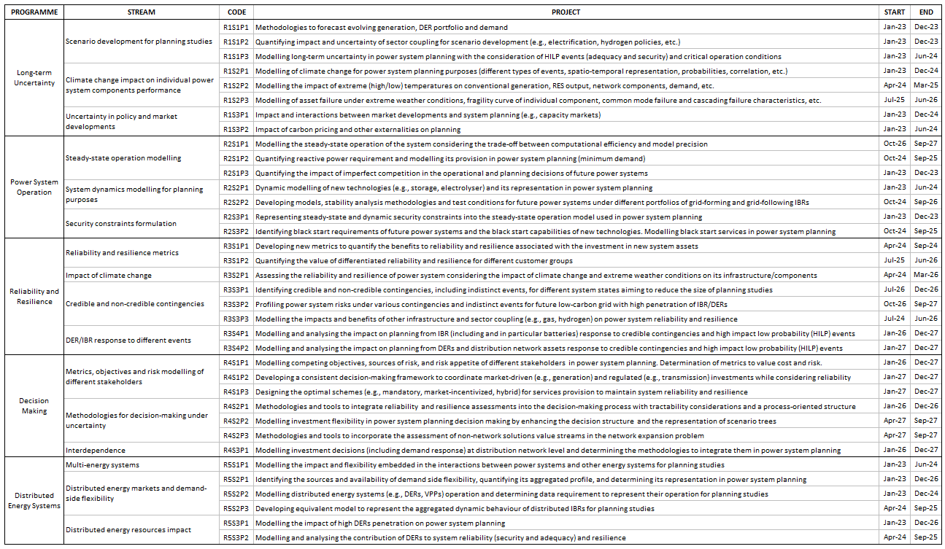

Table 2. Expected progress for the research activities considered in the initial research plan by the end of the current ongoing project.
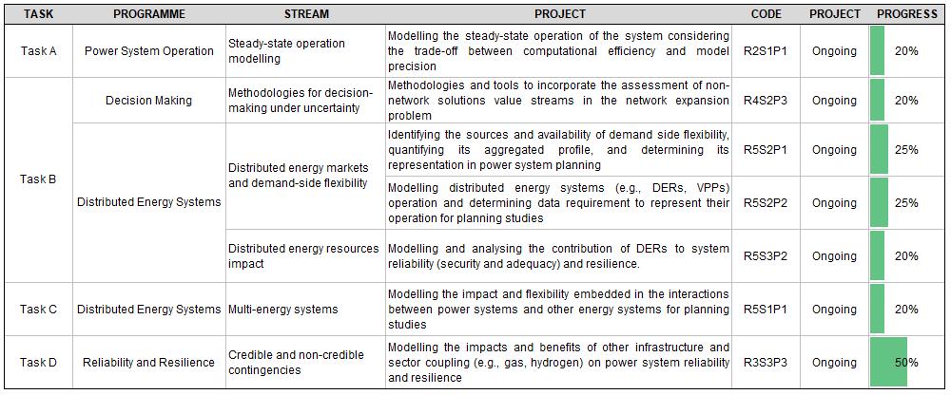

Research relevance
This project studies how employing a multi-stage stochastic approach can yield flexible, adaptive investment portfolios that capture investment optionality instead of other frameworks used worldwide, for example, LWWR. In this regard, this project will support and inform the development of the planning approaches used by AEMO and other system operators (e.g., National Grid ESO). The project’s outcomes will also serve to guide and inform developments in other jurisdictions, particularly within the context of the GPST consortium’s international activities and outreach.
Particularly, Australia’s power system is at a crossroads when making decisions about new infrastructure. Transmission is key to unlocking renewable energy zones (REZs) around the country and transporting the energy produced to load centres. However, the development of the REZs, demand growth, the fast uptake of different distributed energy resources, advancements in storage technologies, the retirement of synchronous units, and the potential to produce alternative energy carriers such as hydrogen, among many other elements, are subject to deep uncertainties that make the decision to build new transmission assets both strategic and challenging. Making the right decisions regarding new transmission investment can yield value for the system through lower costs, enhanced reliability, increased resilience, and reduced renewable energy curtailment, which will largely offset the investment costs. On the other hand, incorrect decisions could lead to stranded or underutilised assets and potentially higher costs.
Employing methodologies that rely on deterministic assessments to make these decisions can fail to identify the transmission options that hold the greatest potential to generate value for the system. Therefore, developing and assessing stochastic transmission planning approaches, accounting for multiple long-term uncertainties, is crucial for building a system capable of achieving net zero emissions at minimum cost.

Recommendations for future developments
Based on the analysis conducted so far and the interim results obtained in the current project, as well as from the discussions with project partners and other stakeholders, and considering the state of the emerging developments and discussions around the Australian energy system, to address immediate challenges faced by the Australian power system and to capture more value from planning methodologies and decisions, we recommend to focus on the following research activities (which we generally call “Tasks”) from the original research plan in Table 1.

- Task 1: Deep dive into the modelling and assessment of integrating distribution and transmission network planning within the expansion planning process.
  - This task would be a follow-up of the current project, where we analysed and assessed the impact of flexibility arising from the distribution networks, mainly from DER, in investment portfolios. In this vein, distribution networks could be key for fostering robust connections between energy supply sources and active demand participation. Therefore, their inclusion in an integrated planning process would enable capturing crucial trade-offs between large-scale and small-scale investments in a more detailed and informed way, potentially leading to more cost-effective development of power systems.
  - From the Research Plan, the activities to be performed in this Task would be associated with:
    - Project R4S2P3: Methodologies and tools to incorporate the assessment of non-network solutions value streams in the network expansion problem.
    - Project R4S3P1: Modelling investment decisions (including demand response) at distribution network level and determining the methodologies to integrate them in power system planning.
    - Project R5S2P1: Identifying the sources and availability of demand-side flexibility, quantifying its aggregated profile, and determining its representation in power system planning.
    - Project R5S3P1: Modelling the impact of high DER penetration on power system planning.
- Task 2: Analyse the potential economic and operational benefits of better integrating gas and electricity infrastructure planning.
  - This task would be another follow-up of the activities being undertaken in the current project by including hydrogen assets in the decision portfolio. This task aims to continue developing models and exploring further potential integrated infrastructure investment strategies and benefits that might be required under renewable energy export scenarios, for example, in the Green Energy Exports scenario from the AEMO’s IASR 2023.
  - In terms of the link to the original research plan, this task would be essentially associated with the following projects:
    - Project R3S3P3: Impacts and benefits of other infrastructure and sector coupling on reliability and resilience.
    - Project R5S1P1: Modelling the impact and flexibility embedded in the interactions between power systems and other energy systems for planning studies.

- Task 3: Leverage advanced mathematical algorithms to optimise the computational efficiency and enhance the performance of long-term planning frameworks.
  - The need to accurately capture the operational flexibility of different technologies within the expansion planning problem raises the requirement for a more detailed and granular modelling of the power system operation. This introduces a manifold of computational and methodological challenges in advanced long-term planning frameworks, resulting in intractable problems for commercial solvers.
  - In this context, employing and enhancing currently available decomposition techniques that exploit the mathematical structure of planning problems can significantly improve computational efficiency. The activities to be performed in this Task would be associated with:
    - Project R2S1P1: Modelling the steady-state operation of the system considering the trade-off between computational efficiency and model precision.
The three research Tasks are in what we believe is an order of priority for the next stage of the project. This order is also subject to changes depending on the discussions regarding the project and with other stakeholders.
We estimate that each Task proposed above would roughly require similar resources as in the current, ongoing research project. Essentially, the three Tasks could be seen as a research plan, assuming a level of resources similar to the ongoing project.
Table 3 summarises how the activities in the proposed Tasks could advance the project activities envisaged in the original research plan.
Table 3. Progress expected at the end of the proposed Tasks for the research activities envisaged in the initial research plan.
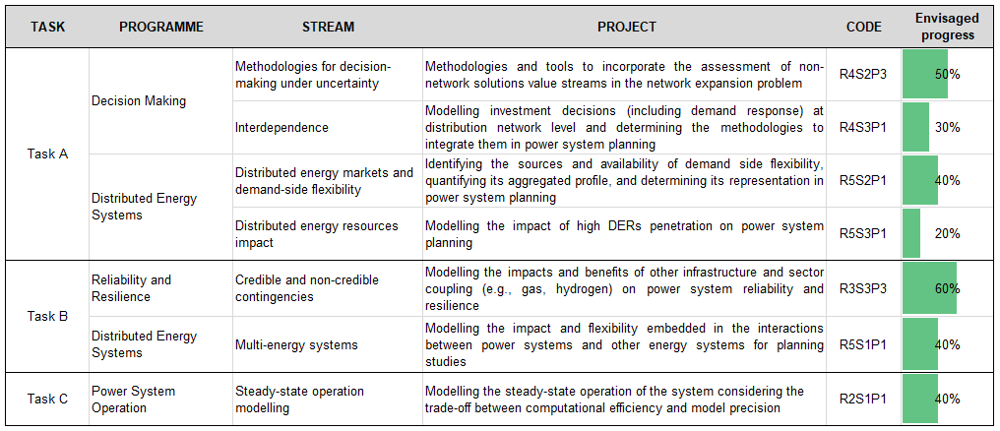

The linepack is the amount of pressured gas stored in a pipeline.
L. Zhang, S. Püschel-Løvengreen, G. Liu, R. Laird, and P. Mancarella. Australia's Global Power System Transformation Research Roadmap. Topic 4: “Planning”. https://www.csiro.au/-/media/EF/Files/GPST-Roadmap/Topic-4-Planning-Final-report_with-AltText-2.pdf
S. Püschel-Løvengreen, S. Mhanna, P. Apablaza, P. Mancarella, J. Bukenberger, M. Ortega-Vazquez. Assessing Flexibility, Risk and Resilience in Low-Carbon Power Systems Planning Under Deep Uncertainty. https://www.csiro.au/-/media/EF/Files/GPST-Roadmap/Final-Reports/Topic-4-GPST-Stage-2.pdf
L. Zhang, S. Püschel-Løvengreen, G. Liu, R. Laird, and P. Mancarella. Australia's Global Power System Transformation Research Roadmap. Topic 4: “Planning”. https://www.csiro.au/-/media/EF/Files/GPST-Roadmap/Topic-4-Planning-Final-report_with-AltText-2.pdf
S. Püschel-Løvengreen, S. Mhanna, P. Apablaza, P. Mancarella, J. Bukenberger, M. Ortega-Vazquez. Assessing Flexibility, Risk and Resilience in Low-Carbon Power Systems Planning Under Deep Uncertainty. https://www.csiro.au/-/media/EF/Files/GPST-Roadmap/Final-Reports/Topic-4-GPST-Stage-2.pdf
AEMO, 2023 Inputs, Assumptions and Scenarios Report. https://aemo.com.au/-/media/files/major-publications/isp/2023/2023-inputs-assumptions-and-scenarios-report.pdf

