Topic 9 - DER and Stability
  - 2023/24 CSIRO GPST Research
Commonwealth Scientific and Industrial Research Organisation
15 December 2023

Contents
1. Introduction 1
2. Research completed. 1
2.1 DER, BESS & HESS Testing 2
2.2 Inverter Reconnection Testing 2
2.2.1 Testing Procedure 2
2.2.1.1 Black Start 3
2.2.1.2 Enhanced Voltage Management 3
2.2.2 Results 3
2.3 Load Testing 4
2.3.1 Testing Procedure 4
2.3.1.1 Stall Tests 4
2.3.1.2 Sag Tests 4
2.3.1.3 Voltage Restart Tests 4
2.3.1.4 List of Appliances Tested 5
3. Outstanding activities 5
4. Progress against the Roadmap 5
5. Research relevance 6
5.1 DER, BESS & HESS Testing 6
5.2 Update on CMPLDW Parameters 6
6. Recommendations 7

Introduction
The integration of distributed energy resources (DERs) such as solar PV systems, battery energy storage systems (BESS), electric vehicle chargers, and flexible loads into distribution networks introduces complexities in network management. This transformation necessitates advanced and accurate toolsets for network operators and market responsible entities like AEMO, TNSPs, and DNSPs in Australia and globally. These tools must not only accurately represent the power system's state at any given time and location but also adapt to the evolving demands of the network. The detailed modelling of these devices is critical, as they exhibit complex behaviours during power system disturbances and in steady states, necessitating informed operational and planning decisions by System Operators to ensure a stable and resilient power system.
Current simulation and modelling approaches, particularly involving DERs and intelligent loads such as air conditioners and heat pumps, fall short in capturing the complexities of real-world conditions. This gap highlights the importance of experimental validation of simulations to ensure model accuracy and reliability. GPST Stage 2's experimental testing revealed significant discrepancies in the responses of DER, BESSs, EVs, and various loads to grid disturbances compared to distributed PV inverters. These findings emphasize the need for public access to testing results for BESS, EVs, and smart loads to confidently integrate them into network models.
Major challenges in the operation of DER in LV networks involves i) inconsistencies with standards' requirements, ii) varied responses to grid disturbances, iii) differences across inverters from different manufacturers and iv) differences between models and actual inverter behaviour. These inconsistencies directly affect the accurate representation of systems, especially ones that are in the early stages of growth within LV networks, such as BESS, hybrid PV/BESS systems, EVs, and smart loads. Comprehensive testing of DER and smart loads is therefore essential as it facilitates ongoing DER deployment without resorting to overly conservative power system operation, prevents unnecessary network investment, enhances the network's capacity to accommodate DER, and ensures that modelling tools evolve in tandem with grid operations and standards.
Historically, research on DER inverters has concentrated on grid disturbances and disconnection events, neglecting their diverse responses to grid restoration, particularly after low-probability, high-impact events; the focus of system restoration practices has been on response of large-scale generators and not DER. Current practices alos often fail to fully utilize DERs in system restoration, thereby limiting their potential. The absence of a direct load model incorporating DER in the EMT domain and the scarcity of experimental data on DER behaviour during reconnections and system restoration present significant challenges. 'Topic 9 - DERs and Stability' aims to address these issues by enhancing the modelling and analysis of DER responses, enabling system operators to maintain security in power systems with high DER penetration.
The following interim report provides the progress of the project in Q3 & Q4 2023, and the activities scheduled for Q1 and Q2, 2024.

Research completed.
Topic 9 is a collaboration between the University of New South Wales (UNSW Sydney) and the University of Wollongong (UoW). The tasks are split so that UNSW conducts tests on DER including solar PV inverters, standalone and hybrid energy storage systems, while UoW is conducting load testing across a large variety of common loads and electric vehicles.

DER, BESS & HESS Testing
The introduction of battery and hybrid energy storage systems (BESS/HESS) necessitates the development of new tools and methods. An experimental bench-testing of inverters compliant with the newest AS4777.2020 standard extends testing to BESS and HESS that have the capacity to respond to grid disturbances. In addition, supporting evidence from real-world DER data offers a complementary understanding in-field diversity of behaviours. It also addresses the dynamic interaction between loads and small-scale generation during network disturbances, providing critical inputs to developing a holistic load model that accurately reflects the dynamic operation of the modern power system.
Hybrid inverters can operate in three modes (Mode 1: PV+Battery, Mode 2: PV Mode and Mode 3: Battery Mode). Each mode underwent the same testing procedure to identify the differences in behaviours under different modes of operation. Testing has been conducted on a total of 9 inverters, encompassing DER, BESS, and HESS. The testing outcomes were communicated to OEMs to analyse and address undesirable behaviours observed during testing. In the ongoing collaboration with OEMs in stage 3, firmware and setting updates have been integrated into the inverters. This strategic intervention ensures that the inverters exhibit desirable behaviour even under grid disturbances. This achievement stands as a significant outcome, contributing to the security and stability of the Australian power system.

Inverter Reconnection Testing
Despite extensive evaluation of the DER fleet of inverters and smart loads under grid disturbances, more information must be available on their reconnection behaviour, particularly considering the growing amount of DER in distribution networks. Such analysis can also define new methods and actions for system restoration following large disturbances and guide new principles and requirements for standards. While most restoration modelling efforts have been carried out in the EMT domain, there is a pressing need for a direct load model that integrates DER within the EMT domain. Additionally, insufficient experimental evidence is needed to understand the behaviour of DER systems during reconnections and system restoration.
These tests aim to verify the behaviour of the PV inverter under system blackout conditions and capture the behaviour of the inverter under reconnection. AS4777.2:2020 defines limits for excursions above and below the nominal reconnection as well as the power ramp rate for the inverter after reconnection.
The standard requires the following conditions to be maintained for the inverter to reconnect with the system after disconnection:
- The system voltage should be kept within the utilization limits of AS 600038 for at least 60s.
- The system frequency should be maintained within the range of 47.5 Hz to 50.15 Hz for at least 60s.
These tests analyse the inverter behaviour during the reconnection when the system frequency or the voltages are slightly above or below the specified limits.

Testing Procedure
The frequency and voltage variations are pre-programmed in the AC Grid Emulator, and the response of the inverter is captured. The following tests are performed:

Black Start
To test the response of the inverter after the system starts for the first time with nominal frequency and voltage. In this test, the inverter is disconnected and restarted with nominal frequency and voltage to observe the reconnection time of the inverter and the time taken by the inverter after reconnection to reach maximum power.

Enhanced Voltage Management
To test the response of the inverter after the system starts with elevated voltages. In this test, the inverter is disconnected and restarted with nominal frequency but with an elevated voltage level of 265V. This voltage is stepped down 5V every two minutes until it reaches 230V, shown in Fig. 2. The purpose of this test is to find the reconnection voltage levels for each inverter.
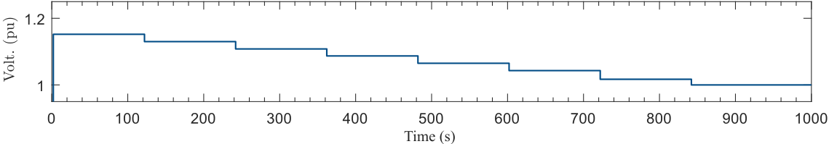
Figure 1. Inverter reconnection with elevated voltages.

Summary of Results
Table 1. Test results
Inverter | Mode | Time To Recon (s) | Time to Reach Max (s) | Voltage of Recon (V)
53 | 3 | 74.5 | 90 | 260
52 | 2 | 157 | 352 | 245
51 | 1 | 60 | 277 | 250
 | 2 | 60 | 430 | 250
 | 3 | 16 | 123 | 250
49 | 2 | 77 | 17 | 250
48 | 2 | 125 | 379 | 230/235
47 | 1 | - | 377 | 250
 | 2 | - | 370 | 245
 | 3 | - | - | 245/250
45 | 3 | 73 | 61 | 265
42 | 2 | 161 | 352 | 245
41 | 2 | 12 | 360 | 260
40 | 2 | 66 | 343 | 250
38 | 2 | 72 | 379 | 250

Up-to-date results can be found at https://pvinverters.ee.unsw.edu.au

Load Testing
The focus in the load testing activities in Q3 and Q4 of 2023 has been towards bench tests conducted on Motor D loads within the CMPLDW model. The work included extensive testing of multiple Motor D loads, assessing responses to voltage sags at various magnitudes and durations, along with voltage restart tests tailored for appliances like non-inverter-based air conditioners and refrigerators. These thorough evaluations aim to provide understanding of the stalling behaviour and restart capabilities of these loads and to provide crucial data for refining CMPLDW model parameters. The dataset obtained will play a pivotal role in the subsequent electromagnetic transient (EMT) modelling of the load.

Testing Procedure

Stall Tests
The first phase of the testing was a device start-up test, aimed at recording the appliances' initial behavior during start-up. This phase was designed to differentiate the stalling behaviors of the load from motor inrush currents. Subsequently, sag tests of varying depths and durations were conducted to assess the tendency of the appliances to stall under different grid disturbances. Once the stalling behavior was documented, the tests were repeated with smaller increments to accurately determine the stalling threshold voltage. The final phase involved a voltage restart test to establish the voltage level required for the device to restart.

Sag Tests
Table 2 illustrates the voltage sag disturbances applied in the experiments, encompassing various durations and magnitudes to assess motor stalling. Voltage magnitudes spanned from 0.8 pu to 0.2 pu, with durations of 80 ms and 120 ms. Following the identification of the motor's stalling point, subsequent stall tests varied the voltage magnitudes in increments of 0.02 pu to precisely pinpoint the initiation of the voltage sag. This process yields critical experimental data for the Vstall parameter. Additionally, as indicated in the table below, an extra sag test was conducted with a 400 ms duration at 0.2 pu to assess whether the device disconnects under extreme sag conditions.
Table 2. Voltage Sag Magnitude and Duration
Voltage Sag Magnitude (up) | Duration of Sag (ms)
0.8 | 80 | 120 | N/A
0.7 | 80 | 120
0.6 | 80 | 120
0.5 | 80 | 120
0.4 | 80 | 120
0.3 | 80 | 120
0.2 | 80 | 120 | 400

Voltage Restart Tests
To determine the voltage restart parameters for Motor D appliances capable of restarting after a stall, this project conducted voltage restart tests on the tested appliances. The test procedure began with a voltage sag reducing the voltage to 0.2 pu for 120 ms. The voltage was then sequentially restored to 0.7, 0.8, and 0.9 pu. Figure 2 illustrates the three voltage waveforms, used to assess whether the restored voltage after the fault clearance was sufficient for a motor restart from stall. Overall, the testing procedure results in 27 tests per appliance.
Figure 2 Tests done for Voltage Restart

List of Appliances Tested
Motor D testing involved a total of 15 appliances tested to investigate the stalling behavior of Motor D. This included six non-inverter-based air conditioners, comprising both portable and window units. Additionally, seven fridges were tested, consisting of five regular top-mount units and two freezers. The list of appliances also included a washing machine and a dryer.

Outstanding activities
The main activities scheduled for the next 6 months of the project are the following:
- Complete BESS testing in different modes.
- Continuation of reconnection testing of remaining 30+ inverters.
- Identifying the point on wave disturbance effect on the PV inverters.
- Continuation of Load Testing with EV load and analysis of the load testing results.
- Update of the project website with the PV and BESS results.
- Expansion of the project website with load testing results.

Progress against the Roadmap
The research progress for Topic 9 aligns with several key objectives of the original GPST Roadmap developed in 2021. The collaboration between UNSW Sydney and UoW, focusing on testing DERs, BESS, HESS, and various loads, addresses the need for advanced understanding and modeling of DERs under different conditions as emphasized in the roadmap.
This progress reflects the roadmap emphasis on improving system stability and reliability in the face of increasing DER integration. The ongoing work and findings, particularly in understanding the diverse behaviors of DERs and loads and their impact on grid stability, are crucial steps towards goals of enhancing power system security and efficiency under high DER scenarios.

Research relevance

DER, BESS & HESS Testing
The current project is highly relevant for Australia, as the country is experiencing world leading uptake of DER, particularly DPV, and increasingly battery energy storage systems (BESS). indicates that Australia is currently leading the world in terms of DPV uptake, an aspect that was highlighted in the original project overview. This reality has become even more relevant following the substantial growth in DPV experienced over 2021 and 2022 and the ongoing global energy crisis.
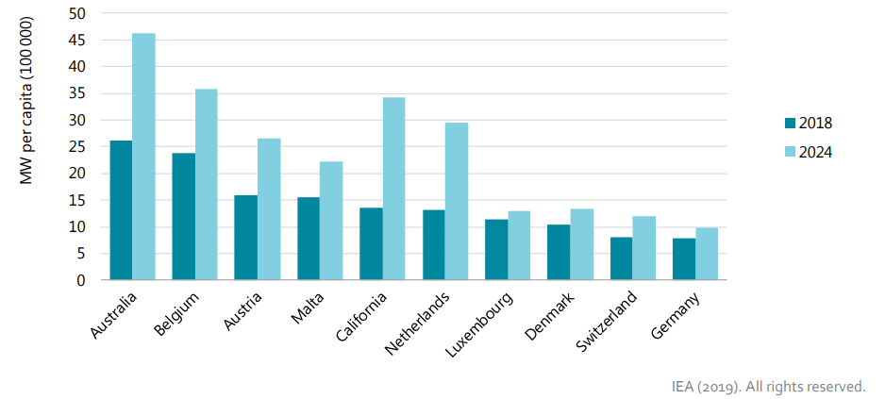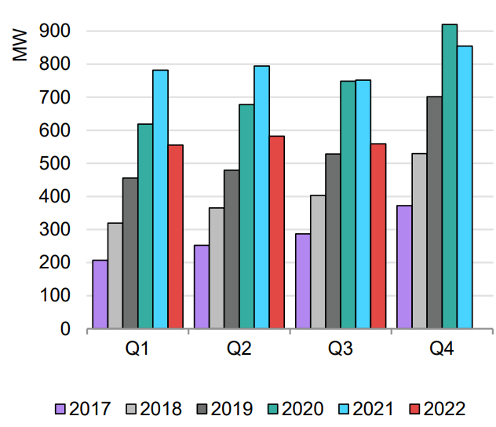
Australia is experiencing ongoing world leading DPV deployment.
Figure 3. International deployment of DPV (Residential cumulative solar PV capacity per capita 2019* Latest Figures by IEA) and quarterly deployment for distributed PV
More than one in three dwellings have already installed DPV in Australia and inline with previous forecasts regarding DPV capacity in the NEM DPV capacity is forecast to almost double by 2030, and BESS capacity is forecast to increase more than five-fold. Taken collectively DPV is already the largest NEM generator and highlight the important of addressing the issue of DER and load response.
The broader research relevance of Topic 9 remains valid, further supported by the current experience following the October 2022 South Australia islanding which resulted in extensive curtailment of PV systems in order to maintain system stability. Extensive DER and load testing will allow for
- Ongoing DER deployment without requiring highly conservative power system operation.
- Avoidance of over-investment in equipment installed to address perceived security or stability issues in the network, or the corollary, to optimise, using the established accurate models of DER, necessary measures to avoid system stability or security problems.
- Increase the network’s capacity to accept DER by improved modelling and understanding of the fundamental responses of inverter-based resources.
- Modelling tools that can develop at the same pace of standard revisions, inverter performance improvement, grid operations including model adaptations that must occur due to changes in grid architectures, network protections and market operations.

Update on CMPLDW Parameters
The project directly contributes to ongoing updates of AEMO’s Composite Load Model beyond the DER component. The latest updates to the Composite Load Model resulting from the test outcomes, focusing on Motor D behaviour, are summarized in Table 3. Key parameters, such as Vstall, were updated based on the test results by analyzing the starting point of the sag of motors. Other significant parameter updates included Rstall and Xstall, determined by analyzing the power consumed during stalling and the restart behavior of the motors. All these modifications were verified through Single Machine Infinite Bus (SMIB) simulations of the CMLD model to ensure alignment between simulation and experimental values.
Table 3. Updates on Motor D parameters
Motor D Parameters | Description | Original | AEMO Updated 2023
Vstall | Stall Voltage | 0.49 | 0.45
Rstall | Stall Resistance | 0.143 | 0.1
Vrst | Voltage for Restart after stall | 0.95 | 0.9
Xstall | Stall Reactance | 0.143 | 0.05
Frst | Fraction Capable of restart | 0.1 | 0.5

Recommendations
The following are highlighted as research priorities for the next steps of Research Topic 9
- PV inverters - Conduct advanced wave disturbance analysis on residential PV inverters, focusing on testing point on wave (POW) disturbance analysis on the fleet of residential PV inverters to grid disturbances, informing future updates to standards, and informing ongoing development of dynamic models representing distributed PV.
- BESS/hybrid inverters - Further testing of the responses of the fleet of BESS and hybrid inverters to grid disturbances, examining compliance with AS/NZS4777.2:2020, informing development of dynamic models representing distributed BESS.
- Weak Grids: Establish the laboratory configuration to illustrate a weak grid scenarios for LV networks, aiming to comprehend the behaviour of residential PV, Hybrid, and BESS inverters in a weak grid conditions.
- Parallel Inverter Connection: Investigate the response of inverters when connected in parallel under various grid disturbances.
- Loads – Surveying and testing of further residential and commercial loads in order to better tune and improve dynamic load models. Load models remain the largest source of uncertainty in NEM dynamic models.
- Industrial loads – Surveying industrial and commercial load sites to understand load composition, any relevant protection on site, and test behaviour of various load types during disturbances
- EVs – Testing of EV charging infrastructure to understand responses during disturbances. This will inform development of suitable performance standards for EVs with regards to impacts on grid stability. It will also inform development of dynamic power system models for EVs.
- Larger capacity inverters - Develop laboratory facilities capable of testing MW size inverters. These are one of the biggest growth areas, and behaviour in disturbances is poorly understood.
- Grid Restoration Strategies: Explore the role of DERs in grid restoration post high-impact events, focusing on optimizing DER contributions to enhance system resilience.
- Aggregation of Distributed Energy Resources: Explore strategies and technologies for effectively aggregating DERs including the development of algorithms and control systems for real-time management and optimization of DER aggregates.

