Australia’s National

Science Agency

Reconstructed Global Mean Sea Level (1880 – 2009)

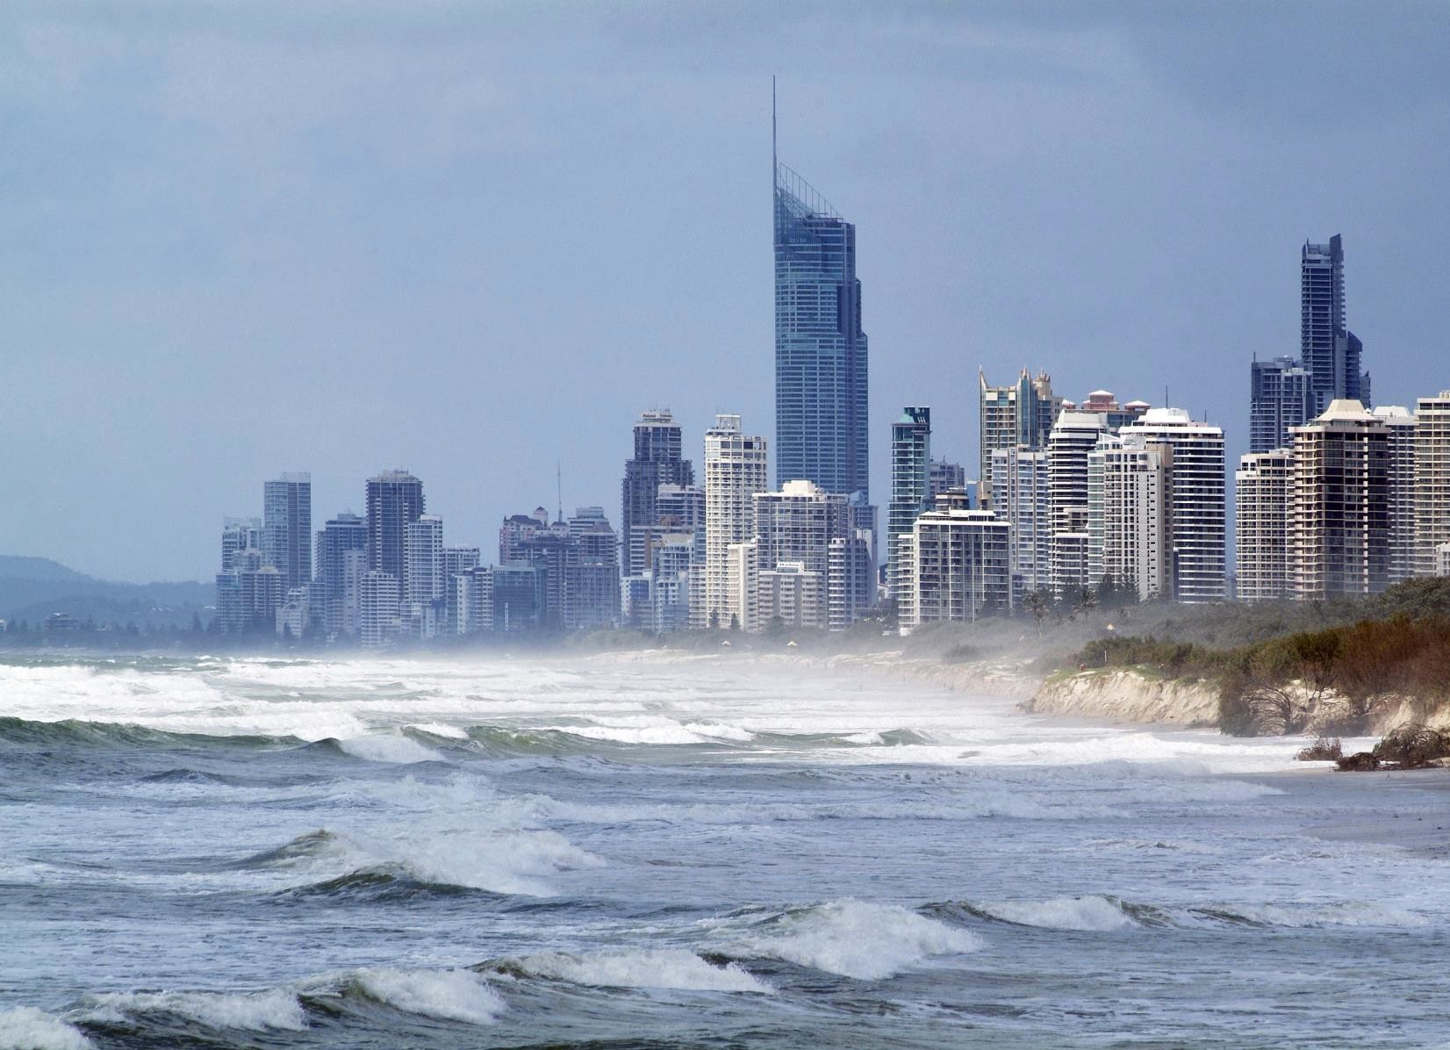Educational Datasets Teachers Guide Year 7-10

# Contents

Contents 1

1 Dataset Overview 2

CSIRO Educational Datasets 2

Dataset Description 2

Understanding this Dataset 3

Research Findings 4

Learning Goals 5

2 Lesson Materials 9

Required Understanding 9

Content Engager 10

Introductory Description 11

Thinking Time 11

Activities 11

Appendix A References 16

# Dataset Overview

## CSIRO Educational Datasets

CSIRO Educational datasets have been derived from CSIRO research data and adapted for classroom use. They are delivered in three different levels; Novice, Expert and Programmer.

Novice level data has been simplified for the classroom. Potentially confusing outliers and partial entries have been removed from the data for the novice level, to make analysis and comprehension easier. Data labels have been modified to make them easier to understand.

Expert level data retains outliers and partial entries and has not always had the labels adjusted. This may mean that students are required to undertake research into subject language to fully understand what they are looking at. Both Novice and Expert level data contains a limited number of rows to ensure that they can be opened in spreadsheet packages.

Programmer level datasets and activities are intended to be used with more advanced tools and programming languages. This level provides the data in an unmodified format, allowing students to organise and analyse it independently.

## Dataset Description

The Reconstructed Global Mean Sea Level (GMSL) dataset records the sea level from 1880 to 2009. It is measured as millimetres, and as the difference from the average in 1990.

Sea level is important to record because rising sea levels is one of the major effects of climate change. There are many factors contributing to sea level rise, chief among which are ocean thermal expansion (that water takes up more space when warmer) and melting land ice.

Correctly estimating historical sea level rises is critical to projecting future climate change and its consequences. There is a great deal of uncertainty as to how the GMSL will change up to 2100.

This data was collected as part of a study to try and improve current estimates of GMSL rise.

The early sea level values given here are calculated from tide gauge records. These records are sometimes unreliable, as the gauges are attached to land which can rise and fall, making the readings inaccurate. For this reason, a small number of gauges (around 24) have been chosen from around the world, and a “reconstructed” global mean sea level has been calculated based on those readings.

For a link to the original data in the CSIRO Data Access Portal, see Appendix A

## Understanding this Dataset

This section relates to understanding this specific dataset. For more general information on understanding and interpreting datasets, see the Educational Datasets Companion document.

The GMSL dataset shows changes in sea level relative to the 1990 average. Negative numbers indicate that the sea level was lower than the 1990 average. Positive numbers indicate that the sea level was higher than the 1990 average.

Sea level at any given location will be influenced by both local and regional meteorological effects, climate variability and long-term trends. Taking a worldwide average of the sea level has been shown to have less short-term variability, as small localised effects are filtered out. Local tide gauges can vary due to the land the gauge is on rising or sinking, as well as local changes in water flow.

Since 1992, satellites have been providing global measurements of sea level that can be used to calculate the global mean. This dataset includes both satellite-based calculations of sea level and tide gauge based (in situ) calculations. This gives an opportunity to compare the two techniques to investigate the ways in which they differ.

The tide gauges that have contributed to this dataset are located all over the world. The use of the term “reconstructed” here indicates that the GMSL value is based on all available reliable information.

The dataset lists the year that recordings were made, the height of the global mean sea level and the uncertainty of that value, both of which are recorded in millimetres. The height of the mean sea level is a comparison to the global mean sea level in the year 1990.

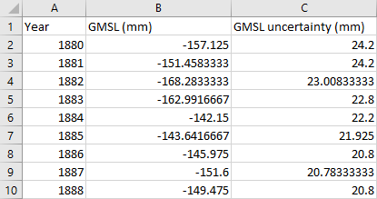

Figure 1 - This sample from the novice dataset indicates that in 1884, the average Global Mean Sea Level for the year was 142.15mm below the mean sea level for the year 1990, with an uncertainty of 22.2mm. This uncertainty indicates that the mean sea level in that year could have been between 119.95 and 164.25mm below the 1990 average.

The Expert Dataset provides both the satellite and terrestrial datasets, with two files for each. One file contains the monthly readings, while the other contains the annual averages. The Novice dataset provides only the terrestrial dataset with yearly readings.

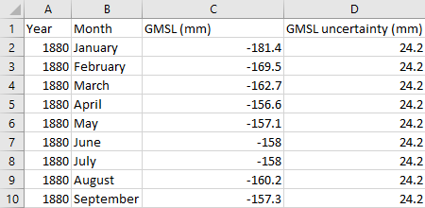

Figure 2 – This sample from the expert dataset indicates that in April of 1880, the global mean sea level was measured to be 156.6mm below the 1990 average. The GMSL uncertainty of 24.2mm indicates that the mean sea level in that month could have been between 132.4 and 180.8mm.

## Research Findings

This data was used to improve modelling of changes in sea level and update existing models. It was found that the estimated rise between 1993 and 2009 was 3.2 ± 0.4 mm per year from satellite data, and 2.8 ± 0.8 mm per year from the in situ data. This was compared to the linear trend from 1900 to 2009, which gives a rise of 1.7 ± 0.2 mm per year, and the linear trend from 1961 to 2009, which gives a rise of 1.9 ± 0.4 mm per year.

This indicated that existing models for predicting sea level rise had dramatically underestimated the rate at which it was taking place.

For more information about this research, see Appendix A.

## Learning Goals

As with any lesson resources, there are any number of ways this dataset could be brought into the classroom, depending on your approach and personal style. Here you’ll find some potential overarching learning goals, most of which address general data literacy, understanding and representation to guide you in introducing this dataset to your students.

### Understanding this dataset

Students examine simple ways of exploring datasets to understand them and discuss the positives and negatives of using a specific dataset. In achieving this learning goal, some activities might include:

* Averaging. Knowing that the data in this dataset is averages of multiple readings, does that limit what we can find out at all? What does the average not tell us? Is it possible for two wildly different sets of readings to have the same average value?
* Mean vs Median. When taking the mean and the median of a dataset, it’s possible to get two different results. What does this mean? Why are they different? Which one is a better indicator of the centre of the dataset? In this case, which value is more useful to us?
* Graphing. What kinds of graphs can we use to represent this data? Are there any subsets of the data that might be useful to compare on a graph?

### Accurately report findings made from data

Students examine how to best represent their findings from the dataset. How can we display this data so that humans can easily read and understand it? Representing the whole dataset in a single table can make it difficult to identify trends and link related concepts. Using statistical tools, such as using the average, range, median, mode or percentages can help give the audience a better idea of what the data tells us, but some of these values are more useful than others, depending on context. If you’re packing for a trip, the range of temperatures for each day is more important than the median temperature for the whole trip. Knowing that the temperature will get as high as 27°C and as low as -2°C is more important than knowing that the median temperature will be 13°C, as it gives you a much better idea of what to pack.

With this dataset, consider if it is useful to display the uncertainty for each year on a pie chart. The change in uncertainty over time gives a good indication in the changes in technology and methodology that have taken place over this period, as well as helping to guide models, but this visualisation makes it difficult to interpret that information. The dataset contains 130 years, which gives the pie chart 130 slices. This limits the amount of information that the viewer can obtain, as they would need to be able to interpret the size difference between 130 different pieces. It is important to consider the purpose of a visualisation, in terms of the story it presents the viewer.

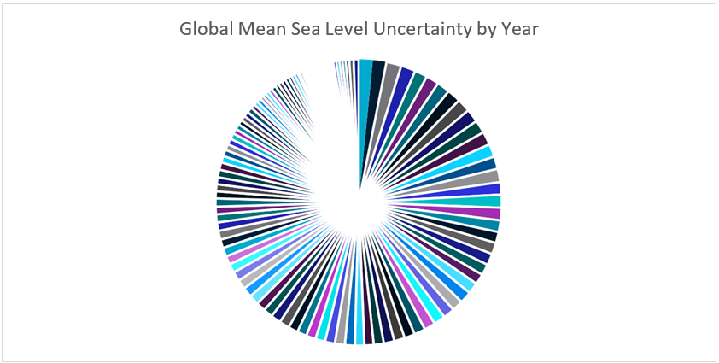

Figure 3 – Pie chart indicating uncertainty in the Global Mean Sea Level recording by year. The amount of data being displayed here makes it difficult to get information. Some slices on this chart are so small that they appear blank.

What else can we do to make sure that the findings we’re reporting don’t skew the data or misrepresent it? Examine ideas such as considering the whole data set, not just favourable sections of it, or ensuring that when using two graphs to compare data, they use the same start and end points, the same scales, and the same display ranges.

Alternately, you could reverse this lesson idea and ask students to find a way to misrepresent the dataset to distort the truth, without lying about the data. How could you display it so that it looks like it’s saying something that it isn’t? This could generate discussion about misuse of data in the media and advertising, or ethics in scientific research, and the importance of representing data accurately.

### Understanding Outliers

Outliers in data refer to things that fall well outside of the other values observed. They can be legitimate variations in the thing you’re measuring, or can be measurement errors, where the reading was not taken correctly for a variety of reasons.

With this lesson goal, students examine the dataset, identifying the average, median and range. Once that is done, students can then identify any outliers, using methods like looking for sharp spikes in readings, or surprisingly high or low values, remove them from the dataset and recalculate their average, median and range, compare the values, and discuss which ones have changed and why, as well as discussing where the outlier values may have come from.

For more information on Outliers, see the Educational Datasets Companion document.

### Identifying the Right Visualisation

As the idiom goes, a picture is worth a thousand words and there are lots of ways we can take data and make it visual. Some of the more common methods of creating visualisations are pie charts, line graphs and bar graphs. Depending on the data set, other visualisations may be appropriate to give the audience a better illustration of the data and the trends and patterns it contains.

For this dataset, since the individual sensor readings have already been condensed into a single global average, maps would not be the most relevant way of displaying this data. Most graphs would be appropriate, especially line graphs and scatter plots, as they can easily indicate the overall trend in global mean sea level over time.

It’s important to remember that while students can generate visualisations for data using digital resources, there’s also the opportunity with smaller datasets to create these visualisations by hand, using printed maps or sketches.

For more examples of data visualisations, see the Educational Datasets Companion document.

### Spreadsheet and Numeric Skills

Spreadsheets and numerical skills are embedded across the curriculum, and this data offers an opportunity for students to put their skills to work on real-world scientific measurements. While a wide range of mathematical skills and spreadsheet skills can be applied, some key examples are:

* Developing spreadsheet formulae. Look for places in the data that an automatically calculated total or average might be useful. In this case, we might try to simplify the data and create averages for each decade to make it easier to display.
* Graphing. Consider the different types of charts that your spreadsheet software can make. How can we modify the settings of a graph to display data appropriately? What is an appropriate title? What labels and value ranges should be used for its axes? Students could construct graphs on paper, to build manual graphing skills.
* Conditional formatting. Create a set of rules so that the cell background indicates the rise and fall in global mean sea level each year.
* What-if calculations. Students can use the real-world data to make predictions. What is the GMSL likely to be in 2050? What if we manage to slow the current trend by 10%? What if it speeds up another 10% from expected? What would that mean for your nearest section of coastline, or nearest capital city?
* Non-digital numerical skills. Students can manually take averages of sets of readings, examine other statistical quantifiers such as median and range or identify the standard deviation. Alternate goals for this dataset could be utilising algebraic skills to estimate potential future scenarios.

### Programming

Many of the files in this dataset can be opened and manipulated in a variety of programming languages. CSV files are very easy for most programming languages to work with, since they are simple text files which use commas to split data points. Python has a specific module (csv) that adds additional functionality when working with these files.

Teaching programming with this dataset gives students an opportunity to practice skills relating to reading and writing data to and from files directly and incorporates string manipulation so they can directly access specific pieces of data. Students can investigate data structures such as lists, dictionaries and objects, assessing their usefulness in storing this data, and utilise control structures to perform calculations on the data, or organise it in a manner appropriate for output.

Depending on the prior understanding students have of programming principles, this can lead to activities ranging from calculating averages automatically and outputting them to the screen, to searching for potential outliers and removing them from the dataset before outputting it as a separate file, to creating interactive visualisation tools for the dataset.

### Subject Links

This dataset can be linked to the Australian curriculum learning areas of Mathematics, Science (Earth Sciences and Environmental Science), Technologies (Digital Technologies), and Humanities and Social Sciences (Geography and History)

# Lesson Materials

## Required Understanding

A list of the existing skills students will require to work effectively with each level of this dataset can be found in the table below. This dataset can also be used as a tool to develop these skills.

The novice dataset lists the GMSL for each year, along with an uncertainty value. In addition to this data, the expert dataset provides the monthly readings and satellite readings for each year and month. The activities listed for the novice package can also be achieved with the expert package.

**Spreadsheet Novice**

* Spreadsheet software and the relevant key terminology, such as cell, row, column, sheet, data, cell reference and cell range
* Developing spreadsheet formulas
* Creating charts in spreadsheet software packages
* Basic mathematical statistical concepts, such as averages, range and median values.

**Spreadsheet Expert**

* Spreadsheet software, including appropriate formatting skills and relevant key terminology, such as cell, row, column, sheet, data, cell reference and cell range.
* Developing spreadsheet formulas
* Creating charts in spreadsheet software packages
* Basic statistical concepts, such as averages, range and median values.

**Programmer**

* Basic understanding of commands for a specific programming language
* Understanding of data structures and file input/output
* Understanding of programming control structures, such as sequence, selection and repetition
* Basic statistical concepts, such as averages, range and median values.

## Content Engager

Use these resources to introduce the importance of measuring the Global Mean Sea Level.

* [CSIRO Oceans and Atmosphere – Climate change information for Australia](https://www.csiro.au/en/research/environmental-impacts/climate-change/climate-change-information)
* [CSIRO Oceans and Atmosphere – Planning for sea-level rise](https://www.csiro.au/en/research/environmental-impacts/climate-change/Sea-level-rise-planning)
* [YouTube – NOAA – Global vs Local Sea Level](https://www.youtube.com/watch?v=gq5DmiRfmG0)
* [YouTube – NASA’s Earth Minute: Sea Level Rise](https://www.youtube.com/watch?v=msnOHuPep9I)
* [ABC news – Fiji leader slams Liberal MP’s useless climate change advice](https://www.abc.net.au/news/2019-05-08/fiji-leader-slams-liberal-mps-useless-climate-change-advice/11091370)

Some questions that you can use to start discussion about this topic and activate students’ prior

knowledge include:

* Why should we care about the sea level and changes in it?
* Why are human settlements often located near oceans, lakes and rivers?
* Have you ever personally noticed a change in the sea level?
* How can we account for the tides when measuring changes to the sea level?
* How do we measure sea level changes?
* How high could the sea level possibly get? What would that mean for life on Earth?
* How would changes in sea level change the way we live?
* What does a rising sea level mean for developing nations?

## Introductory Description

To introduce students to this dataset, consider reading the following paragraph to them, or something similar.

‘Today we’re going to be looking at data taken from multiple sources to track the change in global sea levels since 1880. Before 1992, the data comes largely from tide gauges, which measure sea levels in a specific location, and has been averaged out to give us a worldwide average in sea level change. Since 1992, satellites have also been used to generate additional data. The data given

here was used to refine our models for what the sea levels might do in the future.’

## Thinking Time

Once students have an idea of the dataset’s content, give them 5 minutes to brainstorm questions

they’d like to try and answer using this data. Try not to lead students too much during this time. There is a high chance that students will develop questions which cannot be answered by the data. This creates an opportunity to explore why those questions cannot be answered.

## Activities

### Spreadsheet Novice

1. Global Mean Sea Level is calculated using sea level measurements from around the world. Given that the data begins in 1880, how might the nature of the data measurements have changed over time?

**Since 1880, more measuring stations have been added to cover the globe more effectively. Instruments have been improved and are more sophisticated. Satellite imagery has been included in making sea level estimates.**

1. Consider the measurement techniques being used. Do we use the same measurement techniques that were used in 1880? Research how sea level is measured.

**Methods of measuring sea level have changed a lot since 1880. Historical methods used a float connected to a line, where modern methods include radar and satellite.**

1. If thermal expansion is one of the reasons that sea levels are rising, why does the volume of water not increase when we boil a kettle?

**The change in percentage volume is very small, so it isn’t noticeable at a glance when working with small volumes of water. When specifically looking for the change and attempting to measure it accurately, it will become more apparent. Additionally, when boiling water, the increased volume is offset by losing water as steam.**

1. The visualisations below in Figure 2 show the number & location of tide gauges over time. Consider the number of measurements/available records. Do you think the accuracy will have changed from 1880 until now?

**With more sea level gauges located around the world, the global mean can be taken with greater certainty, reducing the impact of local effects on sea level, such as flooding, seasonal heating and cooling, erosion and weather effects. Adding more gauges in the southern hemisphere means that a more global understanding of the sea level can be achieved and the seasonal impacts in the northern hemisphere can be accounted for.**

This visualisation indicates the distribution of tidal gauges. it consists of 6 sub-images, labelled a, b, c, d, e and f. The first image is an area graph showing the number of tide gauges worldwide, while the others are all maps showing the location of tide gauges around the world.

Image a is an area graph indicating the number of locations where tidal gauges contributed measurements to the dataset, with one colour indicating the number in the Northern Hemisphere, and another indicating the number in the Southern Hemisphere. The total number grows steadily over time from just under 50 in 1900 to 200 in 1960 before levelling off around 230. The number of tidal gauges is always higher in the Northern Hemisphere, with a maximum of around 50 gauges in the Southern Hemisphere.

Image b indicates the locations of all 16 tidal gauges between 1880-1889. No gauges are in the Southern Hemisphere, with one gauge marked on the west coast of North America, another on the west coast of India, one on the east coast of Africa, one in the Mediterranean, one on the Portuguese Atlantic coast, another on the south coast of the UK and the remainders along the European North Sea coastline.

Image c shows the 58 tidal gauges present from 1910-1919. Additional gauges have been added on the North and South American Atlantic coasts, in Central America, in the Mediterranean Sea, and in Pacific Ocean in Hawaii, New Zealand, Australia, Japan, China and South East Asia, and one on the west coast of Australia.

Image d shows the 81 tidal gauges present from 1930-1939. Additional gauges have been added on the North American Atlantic and Pacific coasts, the African Atlantic coast, Japan and Korea.

Image e shows the 204 tidal gauges present from 1960-1969. The highest density of new gauges is along both South American Coasts, through Central America, the Pacific Islands and on the south coast of Africa.

Image f shows the 230 tidal gauges present from 1990-1999. The highest density of new gauges is in on Pacific Islands, and in the Indian Ocean.

Figure 4 - Number and distribution of tidal gauges. (a) indicates the growth over time in the total number of measuring gauges in locations across the world, with green representing the northern hemisphere and purple representing the southern hemisphere. (b) through to (f) indicate the specific locations of tide gauges during those decades.

1. What information can you take from reading the sea level data directly from the spreadsheet? What is your impression of the change in sea level over time? How can you explore the data to get a better sense of the overall trend?

**It can be difficult to get information from reading the data directly like this, there is a clear and largely regular upward trend in the GMSL over time. A better idea for exploring this data is to create a visualisation for it.**

1. Create a conditional formatting rule that indicates when the sea level has risen and when it has fallen. What information does this give us?

**This highlights the regular increase of the GMSL and indicates groupings of years where the sea level consistently rose. Most notably, the cluster from 1986 to 2003 where the sea level rose steadily for every year excepting 1993.**

1. What is the best graph type for this information? Create an appropriate visualisation to represent this data effectively.

**Line graphs are a very good choice for this data, as it compares change from year to year. A filled-area line graph could also be used to show the measurements along with their potential variance.**

1. Create a new column in the spreadsheet which calculates the change from year to year. Use this column to create a formula that calculates the average yearly change. Use conditional formatting to highlight years that are above the average yearly change. What does this indicate?

**The average change is quite high, at about 1.648mm a year. Using conditional formatting highlights the times that the sea level rose more than the average. It also highlights periods where the sea level rise was consistently lower than the average. Early in the 20 century (1915-1928) there is a cluster of very low rise, with very few years above the average (and some periods where the sea level fell).**

1. Create a column that expresses the change from year to year as a percentage of the overall sea level. Consider what this value. What does it indicate about the data? What does it not indicate? How could we make this aspect of the data more useful? It might be helpful to create an appropriate visualisation.

**Percentage rise and fall is tough to categorise this way, since the initial values are negative and become positive. Without accounting for this, rise will be expressed as a negative percentage, and fall will be expressed as a positive until sea level reach positive values, when it will be reversed. This makes it difficult to compare values. Additionally, when sea levels approach 0 in 1990, the percentage change will become very large, because the sea levels are very small. It can be more useful to express the change as a percentage of the total rise. While that graph will also be difficult to interpret, use of a trend line indicates that the percentage of the total change that happens each year has been growing steadily. Using a smaller sample section, such as a single decade, or re- zeroing the data at 1880 might help in making it more understandable, but the large fluctuations in the early years of the data make visualising this aspect of the data difficult.**

### Spreadsheet Expert

1. Examine the difference between the reconstructed GMSL estimates for 1993-2009 and the satellite readings of the sea level for the same period. Add a new column in the spreadsheet that calculates the difference between them. Calculate the average of this column. Because the magnitude of the difference is more important than whether it is positive or negative, take the absolute value of this column and recalculate the average. Are they different? Why?

**The average of overall difference is low because some of the satellite records are lower than reconstructed records and others are higher. This makes the overall average difference 2.8mm, where the average of the absolute value of difference is 3.6mm. The average variance is higher than the average of the values implies.**

1. Examine the monthly average values for the last 10 years of recordings. Are there any consistent patterns that you can identify? What might cause this pattern, if there is one? Can it be seen in other decades? How can we identify if this is an overall trend? It might be helpful to use a visualisation to support your assessment.

**There is a regular pattern of a rise during May/June/July that drops off again until December. This pattern is most evident in the data for 2000, 2004, 2007, and 2008. This is a seasonal fluctuation as large amounts of water are stored on land during the Northern Hemisphere’s winter, reducing the volume of the oceans. The trend cannot be seen every year, but there are notable years in most decades where it appears strongly. 1996 reverses this trend, for example. Graphing the average per month would give a sense of how broad this trend is. The average recording level peaks in June and hits a minimum in January, so it would appear to hold up, but January has a very high average. There are also seasonal fluctuations localised in each hemisphere as water expands with the additional heat over the summer, which cannot be seen in this data.**

1. Calculate the average change per year across the entire dataset. Using this value, predict the sea level values until the year 2100. Compare the height from your prediction for the current year to the current readings (current readings are available from [NASA](https://climate.nasa.gov/vital-signs/sea-level/))

**The current readings are significantly higher than the predictions from the average, using the yearly values. Using the average to predict to 2019 gives 72mm. The actual reading in February 2019 was 91mm with a margin of uncertainty of 4mm. Extending this to 2100 gives a sea level height of 205mm.**

1. Find out the expected rate of sea level rise due to climate change according to the worst-case predictions made by the Intergovernmental Panel on Climate Change (IPCC). Compare this value to your estimates. How close is your estimate to the IPCC’s? Why?

**In 2013, IPCC predicted a worst-case scenario of 980mm, far higher than the estimate of 205mm that can be taken by using the average. This is caused by several factors, notably that the increase has been seen to be exponential in recent years, while the model developed from the average is a linear progression and assumes that change has been the same since 1880. The IPCC model also incorporates additional factors beyond observed sea level changes.**

1. Find out how far above sea level your house is using [National Map](https://www.nationalmap.gov.au/). Examine a coastal city such as Adelaide or Perth and find out the elevation of some of the suburbs near the coast. What impact will sea level rise have on these places? How soon will those suburbs be threatened if sea level rise continues using the linear estimates? How soon will those suburbs be threatened if the IPCC’s worst-case sea-level prediction is accurate?

**To access height data using national map, add the ‘National Datasets/Elevation/SRTM 1 sec DEM Image’ dataset, and click on the map in the appropriate location. Use the appropriate models to work out when the sea level rise will reach that level.**

### Programmer

Write a program using your chosen programming language to perform the following tasks:

1. Store the data in an appropriate data structure.
2. Calculate the high and low values indicated by the uncertainty range for each month.
3. Convert the date format in the original data from decimal notation to a more human readable format.
4. Take a year and month as input and estimate where sea levels might be in that year.
5. Take a year as input and graph the data for a predicted sea level in that year, along with the existing historical data.

### Open Inquiry

In addition to the activities listed above, this dataset can be used for student-centred open inquiry projects. Using open inquiry, students generate research questions and design investigations to answer those questions. Students can use this dataset to support their independent research and investigation in a range of areas. There are additional readings from this project available on the CSIRO Data Access Portal

Examples of inquiry questions that could be explored using this data include:

* What is the relationship between human population growth and sea level rise?
* What impact have major world events had on sea level rise?
* How do historical sea levels in the local area compare to the global mean?
* What factors contribute to sea level rise and in what proportions? If some of those factors can be controlled, what can we expect sea level rise to look like in the future?
* What cities and countries will be most dramatically impacted by rising sea levels?

### Assessment

Assessment items for this dataset could include:

* A spreadsheet that includes calculated fields and detailed graphs of the dataset.
* A poster explaining sea level rise and the factors that contribute to it.
* A visualisation showing areas of Australia that will be lost to sea level rise given a specific model of future sea level rise.
* A program which, given a year and a geographical location will print out whether that location is likely to be under water, based on either IPCC projections or student-calculated projections.

# Appendix A References

**Educational Dataset:**

Reconstructed Global Mean Sea Level

**Original Dataset:**

Church, John; White, Neil (2016): Reconstructed Global Mean Sea Level for 1880 to 2009. v1. CSIRO. Data Collection. <https://doi.org/10.4225/08/57BF85D6023D1>

**Data Copyright:**

CSIRO Data Licence

**Published Papers:**

Church, J.A., White, N.J. Sea-Level Rise from the Late 19th to the Early 21st Century. Surv Geophys 32, 585–602 (2011). <https://doi.org/10.1007/s10712-011-9119-1>

**Supporting Information:**

* [CSIRO – Why does sea level change?](https://research.csiro.au/slrwavescoast/sea-level/sea-level-change/)
* [How Stuff Works – How do they measure sea level?](https://science.howstuffworks.com/environmental/earth/oceanography/question356.htm)
* [GeoSpace – Early climate action has big effect on rising sea levels](https://blogs.agu.org/geospace/2018/04/06/early-climate-action-has-big-effect-on-rising-sea-levels/)

**Australian Curriculum:**

© Australian Curriculum, Assessment and Reporting Authority (ACARA) 2010 to present, unless otherwise indicated. This material was downloaded from the Australian Curriculum website ([www.australiancurriculum.edu.au](../www.australiancurriculum.edu.au)) (Website) (accessed December 2018) and was not modified. The material is licensed under CC BY 4.0 (https://creativecommons.org/licenses/by/4.0). Version updates are tracked in the ‘Curriculum version history’ section on the 'About the Australian Curriculum' page (<http://australiancurriculum.edu.au/about-the-australian-curriculum/>) of the Australian Curriculum website

**As Australia’s national science agency and innovation catalyst,   
CSIRO is solving the greatest challenges through innovative science and technology.  
CSIRO. Unlocking a better future for everyone.**

**Contact us**

1300 363 400

+61 3 9545 2176

csiroenquiries@csiro.au csiro.au

**For further information**

CSIRO Education and Outreach

1300 136 376

+61 2 9490 5588

education@csiro.au csiro.au/education

***Cover Image Credit  
CSIRO Marine Research***