Australia’s National

Science Agency

Income Inequality in Australian Regions

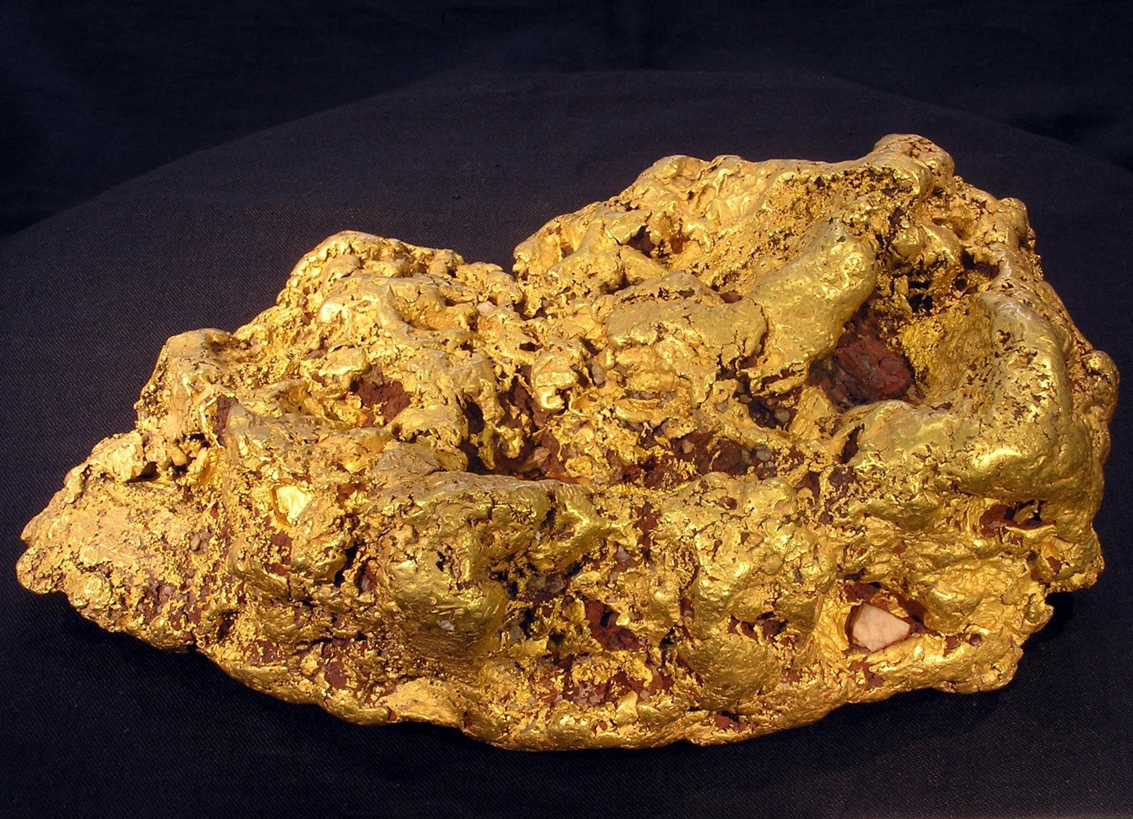Educational Datasets Teachers Guide Year 7-10

# Contents

1 Dataset Overview 2

CSIRO Educational Datasets 2

Dataset Description 3

Understanding this Dataset 4

Research Findings 5

Learning Goals 5

2 Lesson Materials 10

Required Understanding 10

Content Engager 11

Introductory Description 12

Thinking Time 12

Activities 12

Appendix A References 16

# Dataset Overview

## CSIRO Educational Datasets

CSIRO Educational datasets have been derived from CSIRO research data and adapted for classroom use. They are delivered in three different levels; Novice, Expert and Programmer.

Novice level data has been simplified for the classroom. Potentially confusing outliers and partial entries have been removed from the data for the novice level, to make analysis and comprehension easier. Data labels have been modified to make them easier to understand.

Expert level data retains outliers and partial entries and has not always had the labels adjusted. This may mean that students are required to undertake research into subject language to fully understand what they are looking at. Both Novice and Expert level data contains a limited number of rows to ensure that they can be opened in spreadsheet packages.

Programmer level datasets and activities are intended to be used with more advanced tools and programming languages. This level provides the data in an unmodified format, allowing students to organise and analyse it independently.

## Dataset Description

This dataset is a measure of income inequality around Australia. In data science terms it’s a relatively small dataset, with only one value for each local government area (LGA), and a code for the area the number relates to. Despite the small size, it is a very rich set of information with a lot of potential to fit into different subject areas.

The dataset was calculated from Census data by CSIRO scientists. It contains the Gini coefficient (GC) for every LGA in Australia, calculated for 2001 and 2011. The GC is a measure of income inequality which measures how incomes are balanced across a community. A perfectly equal society where everyone has the same income would have a GC of 0, and a completely unequal society where one person earns all the income and everyone else earns nothing would have a GC of 1. So, a GC of 0.8 shows that most of the income is going to a very small proportion of society - meaning some people have very high incomes, and some have very low - whereas a GC of 0.2 shows that income is being fairly equally shared among everyone and that everyone is earning roughly the same amount. In practice, GC values of 0 or 1 do not happen, because the real world is not that neat.

It’s not a perfect measure of equality since it doesn’t give you much detail, much in the same way as taking an average. Very different datasets may lead to the same GC, just as 100 can be the average of both the following sets:

**Set 1**

* 50
* 100
* 150

**Set 2**

* 99
* 100
* 110

It is also important to remember that this measures inequality not poverty levels. So, if everyone in a given area has a very low income, the GC value will indicate that incomes are very equal.

The dataset has state level information and LGA level - meaning you can compare, say, Victoria with Queensland, but you can also look at the distribution around Victoria, or across Melbourne, or any other slice of Australia that is interesting and relevant to students.

For a link to the original data in the CSIRO Data Access Portal, see Appendix A.

## Understanding this Dataset

This section relates to understanding this specific dataset. For more general information on understanding and interpreting datasets, see the Educational Datasets Companion document.

The data is grouped by Local Government Area. There are several areas across the country that are defined as unincorporated areas. These areas are grouped together in this data in some cases, or missing entirely for others (Qld, Tas, WA). Note that in ACT, the role of Local Government is

filled by the Territory Government, so all data for the ACT is grouped as “Unincorporated ACT.” For activities requiring calculations on multiple data points (such as finding the average) it is recommended that ACT students use NSW data.

The Novice files are broken up into State files, so there is a file for each state that has the 2001 and 2011 GC calculated for each LGA, which looks like this:

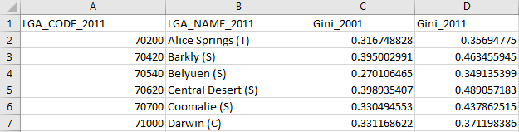  
Figure 1 - This sample from the novice dataset indicates that the Belyuen Local Government Area has a code of 70540 and had a Gini coefficient of 0.270106465 in 2001 and 0.349135399 in 2011.

The LGA code is a 5-digit number. The first digit of the LGA code identifies the state or territory and the last 4 digits identify the area.

The Expert files contain the GC values for all of Australia, with 2001 and 2011 in the same file:

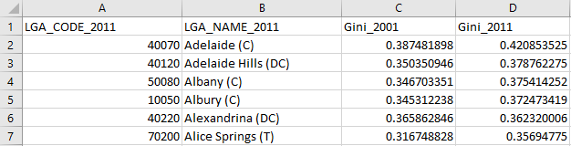  
Figure 2 - This sample from the expert dataset demonstrates the same structure seen in Figure 1. The only difference is that LGAs across multiple states are presented. Note that Adelaide, Albany, and Albury can all be seen.

The Programmer files are the original 2001 and 2011 files. Each file contains the LGA code and GC value for that year for all of Australia. To process this file, the two files will need to be compared and students will need to find a list of the LGA codes, link LGA names to the codes and output this to a new file.

Adding the LGA names to the dataset is not necessary to do the analysis, but it is necessary to make that analysis meaningful. Very few people will know the code for their LGA, but most will know its name.

## Research Findings

The initial research undertaken with this data aimed to determine the impacts of mining activity on income inequality. The focus of the study was on examining the change in GC across the mining boom decade (2001 – 2011) and comparing the changes in mining and non-mining regions of Australia.

The study found that on average, income inequality increased over this period by around 4.8% in mining regions, while in non-mining regions the average increase was found to be 8.7%. There were other aspects of variation found in the changes to GC that indicated that the mining industry is likely to affect the distribution of local incomes in different ways.

The primary goal of this research was to guide future research and assist regional policy makers, specifically those working with the socio-economic impacts of industries such as mining across geographic regions.

For more information about this research and a link to the reported findings, see Appendix A.

## Learning Goals

As with any lesson resources, there are any number of ways this dataset could be brought into the classroom, depending on your approach and personal style. Here you’ll find some potential overarching learning goals, most of which address general data literacy, understanding and representation to guide you in introducing this dataset to your students.

### Understanding this dataset

Students examine simple ways of exploring datasets to understand them and discuss the positives and negatives of using a specific dataset. In achieving this learning goal, some activities might include:

* Sorting the data. Some different trends become far more obvious once the data has been sorted in certain ways. Are there trends that become apparent when grouping the highest Gini coefficients together? Are there any when grouping the lowest Gini coefficients?
* Averaging. Does taking the average Gini coefficient for an entire state tell us anything important about the makeup of that state? Does taking an average for specific regions tell us anything important about those regions?
* Mean vs Median. When taking the mean and the median of a dataset, it’s possible to get two different results. What does this mean? Why are they different? Which one is a better indicator of the centre of the dataset? In this case, which value is more useful to us?
* Visualisation. What kinds of data visualisations can we use to accurately and informatively represent this data? Are there any subsets of the data that might be useful to compare on a visualisation?

### Accurately report findings made from data

Students examine how to best represent their findings from the dataset. How can we display this data so that humans can easily read and understand it? Representing the whole dataset in a single table can make it difficult to identify trends and link related concepts. Using statistical tools, such as using the average, range, median, mode or percentages can help give the audience a better idea of what the data tells us, but some of these values are more useful than others, depending on context. If you’re packing for a trip, the range of temperatures for each day is more important than the median temperature for the whole trip. Knowing that the temperature will get as high as 27°C and as low as -2°C is more important than knowing that the median temperature will be 13°C, as it gives you a much better idea of what to pack.

With this dataset, consider if it is useful to display the state-wide average of Gini coefficient for each state and territory in 2001 on a pie chart. Presenting the data this way doesn’t tell us much about the actual values. There’s no real information about which places have higher or lower Gini coefficients. The state and territory average values are relatively close together and will be difficult to differentiate on such a chart, especially with so many slices.

Overview:
A pie chart is shown, comparing the average Gini coefficient values by state and territory. All of the average values for each state are roughly the same.

Values:
The data for this graph was taken from the linked Dataset and comprises the averages of the Gini coefficient values for each state and territory

Presentation:
The pie chart is divided into 9 slices, with each slice representing each Australian State and Territory, with an additional slice for Other Territories. 

Intent:
This graph is intentionally presented poorly, with limited information able to be gleaned from it. Pie charts are not designed to compare information in this way, particularly when there are so many slices, and when the values are so similar. 

More information could be easily obtained by reviewing the raw numerical data. This element highlights the need to consider the information you are trying to present when visualising data.

Figure 3 – Average Gini coefficient values for each state and territory in 2001. Since the values are so close, there is very little information that can be gathered from this chart at a quick glance, defeating the purpose of a visualisation.

What else can we do to make sure that the findings we’re reporting don’t skew the data or misrepresent it? Examine ideas such as considering the whole data set, not just favourable sections of it, or ensuring that when using two graphs to compare data, they use the same start and end points, the same scales, and the same display ranges.

Alternately, you could reverse this lesson idea and ask students to find a way to misrepresent the dataset to distort the truth, without lying about the data. How could it be displayed so that it looks like it’s saying something that it isn’t? This could generate discussion about the misuse of data in the media and advertising, or ethics in scientific research, and the importance of representing data accurately.

### Understanding Outliers

Outliers in data refer to things that fall well outside of the other values observed. They can be legitimate variations in the thing you’re measuring, or can be measurement errors, where the reading was not taken correctly for a variety of reasons.

With this lesson goal, students examine the dataset, identifying the average, median and range. Once that is done, students can then identify any outliers, using methods like looking for sharp spikes in sightings of specific species, remove them from the dataset and recalculate their average, median and range, compare the values, and discuss which ones have changed and why, as well as discussing where the outlier values may have come from. Are the outliers in this dataset likely to be incorrect, or is there another reason that those LGAs have a particularly high or low level of income inequality?

For more information on Outliers, see the Educational Datasets Companion document.

### Identifying the Right Visualisation

As the idiom goes, a picture is worth a thousand words and there are lots of ways we can take data and make it visual. Some of the more common methods of creating visualisations are pie charts, line graphs and bar graphs. Depending on the data set, other visualisations may be appropriate to give the audience a better illustration of the data and the trends and patterns it contains.

For this dataset, since we are using geographical data, maps would be a useful way of displaying the data. Most line graphs would also be appropriate for displaying the range of values across the nation or state.

It’s important to remember that while students can generate visualisations for data using digital resources, there’s also the opportunity with smaller datasets to create these visualisations by hand.

For more examples of data visualisations, see the Educational Datasets Companion document.

### Spreadsheet and Numeric Skills

Spreadsheets and numerical skills are embedded across the curriculum, and this data offers an opportunity for students to put their skills to work on real-world scientific measurements. While a wide range of mathematical skills and spreadsheet skills can be applied, some key examples are:

* Sorting data. Sorting the data along different values can reveal different trends. What different ways can we sort it? Consider whether each way gives us useful or useless information.
* Developing spreadsheet formulae. Look for places in the data that an automatically calculated total or an average might be useful. In this case, we might need to check the state average to determine and which local government areas are above or below that average. Alternately, there are formulas that can be used to determine the minimum and maximum value of a list of data, to examine the highest and lowest values in each state.
* Graphing. Consider the different types of graphs that your spreadsheet software can make. How can we modify the settings of a graph to display data appropriately? What is an appropriate title? What are labels and value ranges should be used for its axes? Students could construct graphs on paper, to build manual graphing skills.
* Conditional formatting. Create a set of rules so that extremely high or low Gini coefficients are highlighted in the spreadsheet.
* What-if calculations. Students can use the original data, independent research and implement the formula to work out what would happen to the Gini coefficient if 10% of the families in a given area double their income, or create a sample dataset and estimate what would happen if everyone in an area earns $10,000 a year more? What would that demonstrate about what a Gini coefficient indicates?
* Non-digital numerical skills. Students can manually take averages of sets of readings, examine other statistical quantifiers such as median and range or identify the standard deviation.

### Programming

Many of the files in this dataset can be opened and manipulated in a variety of programming languages. CSV files are very easy for most programming languages to work with, since they are simple text files which use commas to split data points. Python has a specific module (csv) that adds additional functionality when working with these files.

Integrating programming with this dataset gives students an opportunity to practice skills relating to reading and writing data to and from files directly and incorporates string manipulation so they can directly access specific pieces of data. Students can use the programmer level of the dataset to add the LGA names to an output file, investigate data structures such as lists, dictionaries and objects, assessing their usefulness in storing this data, or organise it in a manner appropriate for output.

Depending on the prior understanding students have of programming principles, this can lead to activities ranging from calculating averages automatically and outputting them to the screen, to searching for potential outliers and removing them from the dataset before outputting it as a separate file, to creating interactive visualisation tools for the dataset.

### Subject Links

This dataset can be linked to the Australian curriculum learning areas of Mathematics, Technologies (Digital Technologies), and Humanities and Social Sciences (Geography, Economics and Business)

# Lesson Materials

## Required Understanding

A list of the existing skills students will require to work effectively with each level of this dataset can be found in the table below. This dataset can also be used as a tool to develop these skills.

The Novice data provides the same data that is shared in the Expert data, but in a more structured and easier to read manner. In the Novice package, files are separated into states, whereas in the Expert package, all the entries are in a single CSV file and not sorted by state. Both sets of activities are similar, but Expert activities require a stronger understanding of graphing and mapping.

**Spreadsheet Novice:**

* Spreadsheet software and the relevant key terminology, such as cell, row, column, sheet, data, cell reference and cell range
* Developing spreadsheet formulas
* Creating charts in spreadsheet software packages
* Basic mathematical statistical concepts, such as averages, range and median values.

**Spreadsheet Expert:**

* Spreadsheet software, including appropriate formatting skills and relevant key terminology, such as cell, row, column, sheet, data, cell reference and cell range.
* Developing spreadsheet formulas
* Creating charts in spreadsheet software packages
* Basic statistical concepts, such as averages, range and median values.
* Complex graphing and mapping interpretation skills.

**Programmer**

* Basic understanding of commands for a specific programming language
* Understanding of data structures and file input/output
* Understanding of programming control structures, such as sequence, selection and repetition
* Basic statistical concepts, such as averages, range and median values.

## Content Engager

Use these resources to introduce the topic of income inequality.

* [CSIRO Blog – Rich and poor: which areas of Australia are most unequal?](https://blog.csiro.au/rich-and-poor-which-areas-of-australia-are-most-unequal/)
* [YouTube – OECD – Rising inequality threatens social cohesion and growth](https://youtu.be/xyprxOa1H1s)
* [YouTube – Crash Course Economics – Income and Wealth Inequality](https://youtu.be/0xMCWr0O3Hs)
* [Inequality.org – Income Inequality in the United States](https://inequality.org/facts/income-inequality/)

Some questions that you can use to start discussion about this topic and activate students’ prior

knowledge include:

* What does income inequality mean?
* Can you think of any notable examples of income inequality?
* What kind of effects does a high level of income inequality have on a community?
* What do you think causes income inequality?
* How do we measure income inequality?
* Are there any places in your state where you think income inequality is very high?
* Where have you noticed the effects of income inequality?

## Introductory Description

To introduce students to this dataset, consider reading the following paragraph to them, or something similar.

‘Today we’re going to be looking at some data that was calculated as part of a scientific study on income inequality. It was part of a study of the changes in income inequality in mining areas during the 2001 to 2011 mining boom in Australia. The data files we will be looking at use a value called the Gini Coefficient, or GC to represent an area’s income inequality, where a GC of 0 means everyone earns the exact same amount and 1 means that income is not equal at all, where one person earns almost all the money while everyone else earns almost nothing. There are two sets of recorded GC values, one from 2001 and another from 2011.’

## Thinking Time

Once students have an idea of the dataset’s content, give them 5 minutes to brainstorm questions they’d like to try and answer using this data. Try not to lead students too much during this time.

There is a high chance that students will develop questions which cannot be answered by the data. This creates an opportunity to explore why those questions cannot be answered.

## Activities

### Spreadsheet Novice

1. Calculate the average Gini coefficient in your state for both 2001 and 2011. As a class, discuss how income inequality has changed over that 10-year period. Have incomes become more equal (closer to 0) or less equal (closer to 1)? Why does income inequality matter?

**For New South Wales, the average Gini coefficient in 2001 was 0.368951, for 2011 it was 0.386878. We could take this to indicate that the state has become less equal in terms of income, but it could also mean that there is less income clustering in LGAs across the state. For example, if all people with low incomes move to one LGA, while all people with high incomes move to another, then those LGAs will skew the average towards being more equal, even though the overall state income inequality will not have changed at all. Using only the average for this does not give us the full picture of what is happening in the state.**

1. Calculate the average Gini coefficient for each state and territory for 2011. What does this tell us about income inequality in each state?

**The average values indicate a high-level income inequality in NT, WA and NSW. The lowest rates are found in TAS and QLD. Even the highest and lowest rates are generally average in a global sense (most developed nations sit between 0.25 and 0.45.)**

1. Calculate the raw change in average GC for each state between 2001 and 2011. What is the average raw change? What information does this calculation give you about the change between 2001 and 2011?

**Gini coefficient average has risen in every state and territory between 2001 and 2011, which implies that income inequality may have also increased, with ACT and NT having notably high changes. This could be reflective of their low population, where changes in the income of one person has a greater impact on the overall income equality, or in the case of the ACT, only having one area to take the average of. Several LGAs in NT had a very high change in Gini coefficient (0.07-0.1), which impacted the average. With over 100 LGAs in larger states, their average is less susceptible to being skewed by outlier LGAs.**

1. Sort the data and identify the most equal and unequal Local Government Areas in your state or territory using the values for 2011. Do the least equal areas have anything in common? Do the most equal areas have anything in common?

**For Queensland, the four areas with the highest income equality are all located in the west of the state and have a population lower than 400. The four areas with the highest income inequality are all in the north of the state and have populations lower than 1000. The low population of these areas means that the income of a small number of people, and internal migration between LGAs can more easily skew the Gini coefficient.**

1. Sort the LGAs by change between 2001 and 2011. Research the LGA with the largest reduction in Gini coefficient and the LGA with the largest increase in Gini coefficient. What has happened in these areas during that decade which might have caused the changes?

**Again, the biggest shifts will be notable in small areas with small populations, as a small group of people with a high- or low-income, changing incomes or leaving the area can dramatically impact the Gini coefficient. The areas of Victoria that have moved closer to income equality are in the west of the state and have a high level of agricultural industry. Research could include details such as commodity prices and industry specialisations.**

1. Graph the Gini coefficient data for all LGAs in your state or territory. What type of graph will give us the best understanding of the information? What types of graph are unsuitable? How can we make the default graph easier to understand?

**This will depend somewhat on the number of LGAs in the state being used. Using a line graph for Tasmania makes clear a few interesting points, highlighting LGAs that have reversed the trend and have a lowered Gini coefficient, such as Flinders, Tasman and Circular Head. Flinders is highlighted on this graph as having a dramatic shift and could make for an interesting case study. Bar graphs would be very useful here, but for most states, the number of LGAs would make them difficult to read. Limiting the number of LGAs being graphed by population, or a random sample would make a bar graph useful.**

1. Group the LGAs that are in rural areas and metropolitan areas together. It may be helpful to use a map for this activity. Do you notice anything about the different groupings?

**Regional areas often have lower populations and have more noticeable swings in Gini coefficient between the two values. In addition, agricultural towns and mining areas would have had increased income across this decade due to the performance of those industries.**

### Spreadsheet Expert

1. Split the data in the file into different states and territories. The first numeral in the LGA code indicates the state. Identify the different states and territories and add this to the file as an additional column.

**One easy way to do this is to sort the data by LGA code and look for the point at which the first digit changes. Students could use conditional formatting to look for values from 10000-19999, 20000-29999 etc. To match the states up, students could research the LGA names on the Internet, or could take a cue from the Unincorporated area that includes the state name, such as 19399 being Unincorporated NSW.**

1. Work out the average Gini Coefficient for each state and territory for 2001 and 2011. Compare the state averages for 2001 and 2011. What does this indicate about the changes in each state over that decade? Using visualisation techniques to examine the data may be useful.

**Individually graphed, we can easily compare the averages for each state to each other. With the two graphed**

**together, some interesting things become apparent. Most notably, WA’s growth in income inequality has taken it**

**from a more equal position than NSW to a less equal position over the course of the decade.**

1. Consider the data for your state or territory, so that the 2001 and 2011 values for each LGA are graphed together. Research the LGAs with the largest changes. What do many of them have in common? Why would this cause larger fluctuations in Gini coefficient than other regions? It may be helpful to use a data visualisation tool to examine the data.

**Low populations are a huge common factor here, as above. Low populations mean that changes in a single**

**person’s income or a small group’s income can have a greater impact on the LGA’s Gini coefficient than in a large population. Students could also examine major industries in the area to examine how they fared over the period tracked.**

1. Use a scatter chart to compare the 2001 value with the 2011 value for each LGA. Add a trendline to the chart. Are there any notable clusters on the chart? What does the trendline tell you about the overall trend in Gini coefficient?

**There is a large cluster around the centre, though there are a few notable outliers, such as Sandstone in WA which has gone from an extremely equal distribution to an extremely unequal distribution. Largely, the cluster of note sits between 2001 values of 0.34 and 0.38, and 2011 values of 0.35 and 0.42. The cluster tends to rise, indicating that the more unequal income distribution was in 2001, the greater the increase in inequality has been across the decade. The trendline indicates the same trend, but not as pronouncedly as the datapoints that make up the cluster.**

1. Create a box and whisker chart to compare each state and territory’s Gini coefficient for 2001. What does each state’s chart tell you? Compare each state and territory to their 2011 values using a box and whisker chart.

**Compared to the other states and territories, WA and NT have longer boxes, and in the case of WA particularly, far longer whiskers. This indicates that these two states and territories have a far wider range of Gini coefficients in their LGAs. When compared to their 2011 values, most states have indicated a shift towards inequality (notably NT), but SA is an odd one in the general pattern. Not only has the box shifted down, the upper boundary of the range has come down as well, so the extremes of inequality are less than they were in 2001, but the bottom of the box has moved up, as has the median, and the clustering of values inside the box has caused the mean to rise significantly, which is why it looked to be in line with the pattern when only the median was examined.**

1. Use [National Map](http://www.nationalmap.gov.au/) to show the magnitude and direction of change in Gini coefficient from 2001 to 2011. Are there any notable clusters? What happens if you use the national map to split the data, and compare 2001 to 2011? Are there any notable clusters?

**There are clusters in NT, WA and QLD which demonstrate significant changes in income equality. Western Queensland changes quite dramatically between the two values. There is also a large cluster of inequality for 2011 in Western Australia.**

### Programmer

Write a program using your chosen programming language to perform the following tasks:

1. Read the data file into an appropriate file structure.
2. Using the Internet, find a list of the Local Government Area codes and names. Write a program that takes the csv file as input and outputs a csv file that contains LGA code, LGA name and Gini coefficient values for 2001 and 2011.
3. Using the Internet, find the mean income and population for each of the Local Government Areas. Write a program that adds the mean income data for each LGA to the file in a new column. Is there any correlation between the newly added data and the Gini coefficient? Is there a correlation between changes in the newly added data over the time period and the change in the Gini coefficient? Explain why that might be the case.

### Open Inquiry

In addition to the activities listed above, this dataset can be used for student-centred open inquiry projects. Using open inquiry, students generate research questions and design investigations to answer those questions. Students can use this dataset to support their independent research and investigation in a range of areas.

Examples of inquiry questions that could be explored using this data include:

* What impact does population change have on income inequality?
* What impact does age of population have on income inequality?
* What industries are linked to areas of high or low income inequality?
* What correlation is there between house prices and income inequality?

### Assessment

Assessment items for this dataset could include:

* A written discussion of the differences in Gini coefficient between 2001 and 2011 in a given area and the possible reasons behind the changes.
* A spreadsheet with average Gini coefficient, raw change and percentage change calculated accurately using formulae, across the whole dataset or a specific state.
* Visualisations highlighting specific aspects of the data, such as change between 2001 and 2011, differences between states, or differences between rural and urban LGAs.
* Code to link region names to LGA codes, calculate and print summary data.

# Appendix A References

**Educational Dataset:**

Income Inequality in Australian regions

**Original Dataset:**

Fleming, David; Measham, Tom (2015): Income Inequality (Gini Coefficients) for Australian regions. v1. CSIRO. Data Collection. <https://doi.org/10.4225/08/55093772960E4>

**Published Papers:**

David A. Fleming & Thomas G. Measham (2015) Income Inequality across Australian Regions during the Mining Boom: 2001–11, Australian Geographer, 46:2, 203-216, DOI: 10.1080/00049182.2015.1020596

**Supporting Information:**

ABS data on income by LGA

Wikipedia article on Gini Coefficient

**Australian Curriculum**

© Australian Curriculum, Assessment and Reporting Authority (ACARA) 2010 to present, unless otherwise indicated. This material was downloaded from the Australian Curriculum website (www.australiancurriculum.edu.au) (Website) (accessed December 2018) and was not modified. The material is licensed under CC BY 4.0 (https://creativecommons.org/licenses/by/4.0). Version updates are tracked in the ‘Curriculum version history’ section on the 'About the Australian Curriculum' page (http://australiancurriculum.edu.au/about-the-australian-curriculum/) of the Australian Curriculum website

18 | **CSIRO** Australia’s National Science Agency

**As Australia’s national science agency and innovation catalyst,   
CSIRO is solving the greatest challenges through innovative science and technology.  
CSIRO. Unlocking a better future for everyone.**

**Contact us**

1300 363 400

+61 3 9545 2176

csiroenquiries@csiro.au csiro.au

**For further information**

CSIRO Education and Outreach

1300 136 376

+61 2 9490 5588

education@csiro.au csiro.au/education

***Cover Image Credit  
CSIRO Science Image***