Australia’s National

Science Agency

Logan’s Dam Water Quality

Educational Datasets Teachers Guide Year 7-10

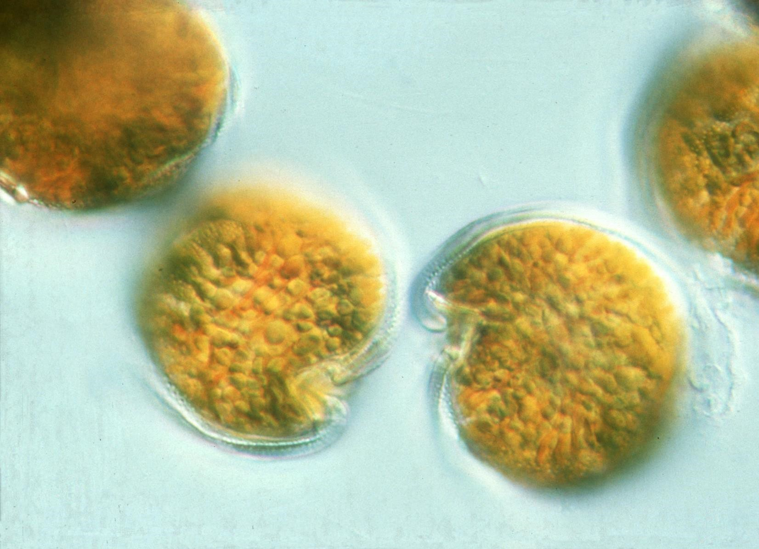

# Contents

1 Dataset Overview 2

CSIRO Educational Datasets 2

Dataset Description 2

Dataset Copyright 2

Understanding this Dataset 3

Research Findings 4

Learning Goals 5

2 Lesson Materials 9

Required Understanding 9

Content Engager 10

Introductory Description 11

Thinking Time 11

Activities 11

Appendix A References 15

# Dataset Overview

## CSIRO Educational Datasets

CSIRO Educational datasets have been derived from CSIRO research data and adapted for classroom use. They are delivered in three different levels; Novice, Expert and Programmer.

Novice level data has been simplified for the classroom. Potentially confusing outliers and partial entries have been removed from the data for the novice level, to make analysis and comprehension easier. Data labels have been modified to make them easier to understand.

Expert level data retains outliers and partial entries and has not always had the labels adjusted. This may mean that students are required to undertake research into subject language to fully understand what they are looking at. Both Novice and Expert level data contains a limited number of rows to ensure that they can be opened in spreadsheet packages.

Programmer level datasets and activities are intended to be used with more advanced tools and programming languages. This level provides the data in an unmodified format, allowing students to organise and analyse it independently.

## Dataset Description

This data compiles fortnightly observations of Logan’s Dam, a small body of water located near Gatton, in South East Queensland. It consists of measurements taken by CSIRO and the Urban Water Security Research Alliance with the intention of measuring the impact of the application of an evaporation-reducing monolayer on the dam’s surface. The timeframe for this data is from July 2009 to June 2011, a window spanning one year before the application of the monolayer and one year after.

The measurements recorded indicate the biomasses present in the dam and their types, chemicals present in the dam, as well as more general measures of water quality such as transparency, pH, temperature and conductivity. Taken together, these recordings can give an overview of the health of the dam, as well as giving an indication of what needs to be done to ensure it can be maintained effectively.

The intended application of the evaporation-reducing monolayer did not take place as intended, but short-term trials of the monolayer were undertaken, and the impact of those trials was assessed in the context of other factors and natural ecosystem processes.

For a link to the original data in the CSIRO Data Access Portal, see Appendix A

## Dataset Copyright

The original research data that this dataset is based on was originally released under a CSIRO data licence. As such, derivative works that are based on this dataset cannot be published digitally without explicit permission. Please be aware of this when using this dataset for educational purposes. For a link to the copyright information, see Appendix A.

## Understanding this Dataset

This section relates to understanding this specific dataset. For more general information on understanding and interpreting datasets, see the Educational Datasets Companion document.

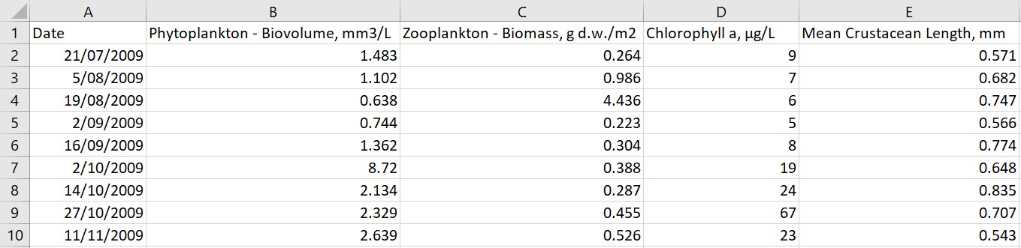The dataset comprises readings taken roughly every two weeks, starting in July 2009 and finishing in June 2011. The timing of the readings is not always exactly two weeks, but in some cases is skewed by a day or two. The dataset records a range of different indicators of water health, along with the date those readings were made.

Figure 1 - This sample from the novice dataset indicates that in the reading taken on 2/09/2009, the Phytoplankton Biovolume was 0.744 mm3/L, Zooplankton Biomass was .223g dry weight/m2, Chlorophyll a was present in the sample, with 19µg/L and the average length of crustaceans in the sample was 0.648mm.

These indicators include Phytoplankton Biovolume, which is measured in millimetres3 per litre, Zooplankton Biomass, which measured in grams of dry weight per meter2 and Chlorophyll a, which is measured in micrograms per litre. As a further indicator of the quality of the water, the length of crustaceans found in the sample were measured, and their average length recorded as Mean Crustacean Length, in millimetres. When examining the mean crustacean length, it is important to note that the majority of crustaceans found in water sources like this are microscopic.

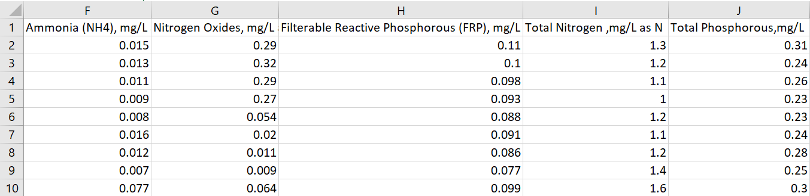Figure 2 - This sample from the novice dataset indicates the overall levels of nitrogen and phosphorus in the sample, as well as breaking them down into amounts present in ammonia, Nitrogen oxides and filterable reactive phosphorus.

The data records the concentration levels of different nutrients, including Ammonia (NH4) and Nitrogen Oxides, which are both measured as the amount of nitrogen they contribute to the water in milligrams per litre. Filterable Reactive Phosphorus is similarly measured as the amount of phosphorus it contributes to the water in milligrams per litre. The final two values are Total Nitrogen and Total Phosphorus, indicating the overall nitrogen and phosphorus content of the water from all sources, both of which are measured in grams per litre.

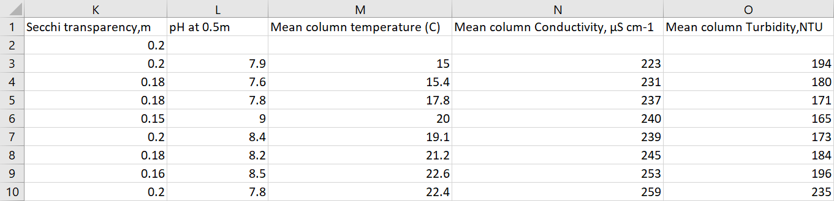Figure 3 - This sample from the novice dataset indicates the physical properties of the water sample, and the pH value. In addition to pH, this section contains two measures of clarity (Secchi depth and Mean column turbidity), a measure of water conductivity and temperature readings.

The final readings largely refer to the physical properties of the water rather than the chemical. An exception to this is pH, and is measured at a depth of 0.5 meters below the surface. The physical properties of the water that were recorded include Secchi transparency, which is measured in meters, the average temperature of the water column, which is measured in Celsius, the average conductivity of the water column, which is measured in microSiemens per centimetre and the turbidity of the water column, which is measured in Nephelometric Turbidity Units (NTU).

It is important to note that the dataset contains two distinct measures of water clarity, Secchi transparency, which records the depth at which a disc of a set size and colour is no longer visible to the observer at the surface, and average column turbidity, which uses a nephelometer to measure clarity. A nephelometer measures the concentration of particulates in a gas or a liquid by measuring how light is scattered in the sample. The more particulates in the liquid, the more light is scattered as it bounces off the suspended particles. These two measurements give us an opportunity to investigate correlation between two values that should, in principle, be linked, but are recording very different values, given that one measures the clarity of the entire column, while the other measures only the surface clarity.

## Research Findings

The initial research undertaken with this data aimed to measure the effectiveness of the application of an evaporation-reducing monolayer in maintaining water quality. Continuous application of the monolayer did not take place as planned after the first year, though short term trials were undertaken, and their effectiveness assessed.

From the observations, it was found that the key factors impacting water quality in Logan’s Dam were phytoplankton abundance and turbidity due to detritus. Additionally, the ratio of nitrogen to phosphorus was found to be at a level that is known to favour blooms of toxic cyanobacteria.

Despite being unable to ascertain the effectiveness of monolayers in reducing water loss to evaporation, the study was able to demonstrate that strong seasonal and inter-annual variation in ecological variables that are associated with water quality can be expected and need to be considered for any future studies of monolayer treatments.

For more information about this research, see Appendix A.

## Learning Goals

As with any lesson resources, there are any number of ways this dataset could be brought into the classroom, depending on your approach and personal style. Here you’ll find some potential overarching learning goals, most of which address general data literacy, understanding and representation to guide you in introducing this dataset to your students.

### Understanding this dataset

Students examine simple ways of exploring datasets to understand them and discuss the positives and negatives of using a specific dataset. In achieving this learning goal, some activities might include:

* Sorting the data. Some different trends become more apparent once the data has been sorted in certain ways. When were the highest mean column temperatures reached? When were the lowest temperatures reached? Is that as expected?
* Averaging. What does the average for specific values tell us? What does it not tell us? Is it possible for two wildly different sets of readings to have the same average value? Is the link between mean column turbidity and Secchi transparency clear? Is there a difference between taking a reading from the top of the water and taking the average of the whole column of water?
* Mean vs Median. When taking the mean and the median of a dataset, it’s possible to get two different results. What does this mean? Why are they different? In the case of this dataset, the mean and median for Phytoplankton Biovolume are wildly different values? Which value would be more useful in analysing this data? Why?
* Graphing. What kinds of graphs can we use to represent this data? Are there any subsets of the data that might be useful to compare on a graph?

### Accurately report findings made from data

Students examine how to best represent their findings from the dataset. How can we display this data so that humans can easily read and understand it? Representing the whole dataset in a single table can make it difficult to identify trends and link related concepts. Using statistical tools, such as using the average, range, median, mode or percentages can help give the audience a better idea of what the data tells us, but some of these values are more useful than others, depending on context. If you’re packing for a trip, the range of temperatures for each day is more important than the median temperature for the whole trip. Knowing that the temperature will get as high as 27°C and as low as -2°C is more important than knowing that the median temperature will be 13°C, as it gives you a much better idea of what to pack.

With this dataset, consider if it is useful to display the values of Phytoplankton and Zooplankton on the same scale on a line graph. Given the different units used to measure both and the sharp spikes in Phytoplankton values, changes in Zooplankton are barely registered on such a graph and can tell the viewer little about how those values have varied over time. It is important to consider the purpose of a visualisation, in terms of the story it presents the viewer.

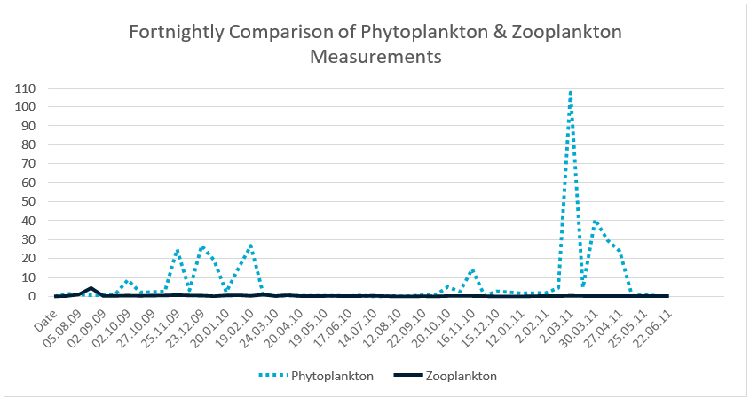

Figure 4 – Line graph comparing Phytoplankton values with Zooplankton values. When graphed using the same scale as Phytoplankton values, the Zooplankton values appear to be almost unchanging. On an appropriate scale, the Zooplankton values show a great deal of variance.

What else can we do to make sure that the findings we’re reporting don’t skew the data or misrepresent it? Examine ideas such as considering the whole data set, not just favourable sections of it, or ensuring that when using two graphs to compare data, they use the same start and end points, the same scales, and the same display ranges.

Alternately, you could reverse this lesson idea and ask students to find a way to misrepresent the dataset to distort the truth, without lying about the data. How could you display it so that it looks like it’s saying something that it isn’t? This could generate discussion about misuse of data in the media and advertising, or ethics in scientific research, and the importance of representing data accurately.

### Understanding Outliers

Outliers in data refer to things that fall well outside of the other values observed. They can be legitimate variations in the thing you’re measuring, or can be measurement errors, where the reading was not taken correctly for a variety of reasons.

With this lesson goal, students examine the dataset, identifying the average, median and range. Once that is done, students can then identify any outliers, using methods like looking for sharp spikes in readings, or surprisingly high or low values, remove them from the dataset and recalculate their average, median and range, compare the values, and discuss which ones have changed and why, as well as discussing where the outlier values may have come from.

For more information on Outliers, see the Educational Datasets Companion document.

### Identifying the Right Visualisation

As the idiom goes, a picture is worth a thousand words and there are lots of ways we can take data and make it visual. Some of the more common methods of creating visualisations are pie charts, line graphs and bar graphs. Depending on the data set, other visualisations may be appropriate to give the audience a better illustration of the data and the trends and patterns it contains.

For this dataset, since we only have one set of readings from a single location, maps would not be the most relevant way of displaying this data. Most graphs would be appropriate, especially line graphs, as they can easily indicate trends over time and seasonal variation.

It’s important to remember that while students can generate visualisations for data using digital resources, there’s also the opportunity with smaller datasets to create these visualisations by hand, using printed maps or sketches.

### Spreadsheet and Numeric Skills

Spreadsheets and numerical skills are embedded across the curriculum, and this data offers an opportunity for students to put their skills to work on real-world scientific measurements. While a wide range of mathematical skills and spreadsheet skills can be applied, some key examples are:

* Sorting data. Sorting the data along different values can reveal different trends. What different ways can we sort it? Consider whether each way gives us useful or useless information.
* Developing spreadsheet formulae. Look for places in the data that an automatically calculated total or average might be useful. In this case, we might want to check water quality standards and see if conditions in the dam are likely to damage agricultural pipes. Alternately, there are formulas that can be used to determine the minimum and maximum value of a list of data, to examine spikes in nutrients, or water clarity.
* Graphing. Consider the different types of charts that your spreadsheet software can make. How can we modify the settings of a graph to display data appropriately? What is an appropriate title? What labels and value ranges should be used for its axes? Students could construct graphs on paper, to build manual graphing skills.
* Conditional formatting. Create a set of rules so that the cell background indicates spikes levels in nutrient values or when conditions in the dam are likely to damage pipes.
* What-if calculations. Students can use the real-world data to make predictions. Examine what happens if the nutrient values increase by 10% across all readings. Do other values have a clear correlation with the nutrient values? What impact is the change likely to have on those values?
* Non-digital numerical skills. Students can manually take averages of sets of readings, examine other statistical quantifiers such as median and range or identify the standard deviation.

### Programming

Many of the files in this dataset can be opened and manipulated in a variety of programming languages. CSV files are very easy for most programming languages to work with, since they are simple text files which use commas to split data points. Python has a specific module (csv) that adds additional functionality when working with these files.

Teaching programming with this dataset gives students an opportunity to practice skills relating to reading and writing data to and from files directly and incorporates string manipulation so they can directly access specific pieces of data. Students can investigate data structures such as lists, dictionaries and objects, assessing their usefulness in storing this data, and utilise control structures to perform calculations on the data, or organise it in a manner appropriate for output.

Depending on the prior understanding students have of programming principles, this can lead to activities ranging from calculating averages automatically and outputting them to the screen, to searching for potential outliers and removing them from the dataset before outputting it as a separate file, to creating interactive visualisation tools for the dataset.

### Subject Links

This dataset can be linked to the Australian curriculum learning areas of Mathematics, Science (Earth Sciences and Environmental Science), Technologies (Design and Technologies and Digital Technologies), and Humanities and Social Sciences (Geography).

# Lesson Materials

## Required Understanding

A list of the existing skills students will require to work effectively with each level of this dataset can be found in the table below. This dataset can also be used as a tool to develop these skills.

The activities listed for the novice package can also be achieved with the expert package. The major difference between the levels of package is the format used for the date.

**Spreadsheet Novice**

* Spreadsheet software and the relevant key terminology, such as cell, row, column, sheet, data, cell reference and cell range
* Developing spreadsheet formulas
* Creating charts in spreadsheet software packages
* Basic mathematical statistical concepts, such as averages, range and median values.

**Spreadsheet Expert**

* Spreadsheet software, including appropriate formatting skills and relevant key terminology, such as cell, row, column, sheet, data, cell reference and cell range.
* Developing spreadsheet formulas
* Creating charts in spreadsheet software packages
* Basic statistical concepts, such as averages, range and median values.

**Programmer**

* Basic understanding of commands for a specific programming language
* Understanding of data structures and file input/output
* Understanding of programming control structures, such as sequence, selection and repetition
* Basic statistical concepts, such as averages, range and median values.

## Content Engager

Use these resources to introduce the topic of water quality.

* [YouTube – UNDP – Cody Simpson on Nutrient Pollution](https://www.youtube.com/watch?v=TqPzdFXEGiE)
* [CSIRO – Blue-green algae management options](https://www.csiro.au/en/research/natural-environment/ecosystems/Blue-green-algae/Management-options)
* [YouTube – UNESCO - Protecting Water Quality for People and the Environment](https://www.youtube.com/watch?v=i5jGxO28Kw8)
* [ABC News – Swan River health hangs in balance as climate change and nutrient run-off take toll](https://www.abc.net.au/news/2019-05-21/swan-river-health-in-balance-as-climate-change-run-off-take-toll/11120938)

Some questions that you can use to start discussion about this topic and activate students’ prior

knowledge include:

* Why do we care about water quality?
* What are some of the uses for water in an agricultural setting?
* Why do the standards for water quality vary depending on the intended use of the water?
* Do you, personally, ever notice differences in water quality?
* What are some of the things that we might want to measure about water quality?

## Introductory Description

To introduce students to this dataset, consider reading the following paragraph to them, or something similar.

‘Today we’re going to be looking at some data that was measured as part of a scientific study of water quality. It was part of a study done in Queensland by the Urban Water Security Research Alliance, with the intention of measuring how a thin layer of chemicals placed on top of the water impacted water health and evaporation. During the study, the monolayer film was not able to be applied regularly, so the initial intention of the research was not achieved, but the study was able to gather valuable data for the base line conditions of the dam, and how it changes across seasons that can be used to provide information for future studies. The data files we will be looking at contain a range of measurements, taken roughly once every two weeks and record several indicators of water health. The measurements take place over a period of two years.’

## Thinking Time

Once students have an idea of the dataset’s content, give them 5 minutes to brainstorm questions

they’d like to try and answer using this data. Try not to lead students too much during this time. There is a high chance that students will develop questions which cannot be answered by the data. This creates an opportunity to explore why those questions cannot be answered.

## Activities

### Spreadsheet Novice

1. Explore the dataset in a spreadsheet and consider the question: What kinds of questions do you need to ask about the dataset and how it was collected in order to make sense of this data?

**Where was it collected, as this impacts the water standards being used. What is the water being used for? Is it for human consumption? Animal consumption? Crop watering? What are the different substances being measured, and what health impact do they have on water, humans, animals and plants? Where do they come from?**

1. How can all of the data in the spreadsheet be represented in a way that is useful and meaningful?

**Presenting all the data at once would be overwhelming. Consider how to split the columns of data up or group them. What are good visualisation types for each of the columns? Can some of them be graphed together, given that they have different scales? They can be graphed together but will need to use multiple scales. What are the strengths and weaknesses of the different visualisations in exploring this dataset? What characteristics of the dataset does each type of visualisation highlight?**

1. Examine the Phytoplankton Biovolume values and take the average of those records. What does this tell you about the expected amount of phytoplankton? What does the average look like if you exclude the highest value? How severe is this change? What does the average look like if you exclude the lowest value? Why are the changes so different? What does the average look like if you take a random set of 10 samples from the recordings?

**The average gives a good baseline but is skewed very high by a small number of readings that greatly exceed the average. Excluding the highest value drops the average by 16%. Excluding the lowest raises the average by 2%. The highest value is a great deal higher than the other readings, while the lowest value is in line with the other readings. Using a random sample should give an average slightly below the overall average but may not if the sample contains some of the extreme values.**

1. Does the extremely high value for the highest reading of Phytoplankton Biovolume value mean that it is incorrect and can be excluded from our results?

**Not necessarily. While an extreme value like this that falls dramatically outside of the expected range like this could be an anomalous reading, in this case, it’s possible that a significant algal bloom took place, especially when compared to the next four readings, as well as the readings from the same time the previous year. It could also be an anomaly caused by the January 2011 Lockyer Valley floods changing the water composition.**

1. For each spike in the Phytoplankton Biovolume, calculate what percentage increase has taken place over the average value.

**For some of the spikes, it’s extremely high. For the spike on the 2nd of March 2011, the percentage increase above average is 1276.8%.**

1. Consider the default graph your spreadsheet gives you if you ask it to graph the Phytoplankton Biovolume against the Zooplankton Biomass. What information can you easily determine from this graph? What can’t be determined from this graph? How can you improve this graph to make it easier to compare these two readings?

**The readings for the two sets of values, when placed on the same scale means that the very high values for Phytoplankton will necessitate a scale that makes the pattern of the Zooplankton graph difficult to examine and interpret. The two will need to be graphed together using a secondary scale to be compared properly.**

1. Compare the temperature data gathered over the summer months with data gathered over the winter months. Does the data trend in the way you’d expect? How can you effectively represent this information visually?

**There is a clear distinction between summer temperatures and winter temperatures, but the temperature changes are not as significant as might be expected. The water temperature range is only 14.1 degrees across the entire dataset.**

1. Using the internet, locate weather and temperature data for the area over the time period that the recordings took place. Add that data to your spreadsheet and compare it to the

temperature data for the dam. Use your spreadsheet’s correlation function to check how closely the dam’s temperature change correlates with the air temperature changes.

**The values do correlate quite well, with rises and falls matching, but the water’s temperature does not fluctuate as much as the air temperature. The water temperature is generally about 5-9 degrees lower than the daily maximum temperature.**

1. Take an overall average for each of the readings taken. Compare this average with the individual values. Discuss why using all the readings taken is more important than just looking at an overall average when assessing the health of the dam. It may be helpful to graph the values when comparing.

**Concentration spikes can take place in the readings, making the dam water unsafe for pipes, irrigation or certain uses. These spikes can make the water unusable without impacting the overall average significantly.**

### Spreadsheet Expert

1. To prevent corrosion to pipes, pH of water intended for domestic, irrigation or chemical use should be between 6.5 and 11. Create a conditional formatting rule to indicate when the pH of the water is outside of this range.

**One of the most visible ways to do this is a rule that colours the cell. Consider using one colour for values below**

**6.5 and a different colour for values above 11 to differentiate the two extremes.**

1. If pH rises above 8.5, scale may form inside pipes and plumbing fittings. Create an additional conditional formatting rule to indicate when the pH of the water is above 8.5. Ensure that this does not override the rule created to indicate when the pH is over 11.

**This rule should introduce a third colour to indicate the condition where the pH level may cause scale to form but is not yet likely to cause corrosion. To ensure it does not override the initial rule, this one either should not take priority over it, or should only cover the range from 8.5 to 11.**

1. Use your spreadsheet’s correlation function to calculate the Pearson product-moment correlation coefficient (r) for Phytoplankton Biovolume and NH4 concentration. Do the two values appear to be correlated, looking at this value?

**The r value for these two groupings is -0.0429 which indicates a very low negative correlation. A negative correlation indicates that when one value falls, the other rises. An r value of -1 would mean that when one value rises, the other falls in an exact proportion to it, where 0 indicates there is no link between the two values at all.**

1. Graph the Phytoplankton Biovolume and NH4 concentration on the same graph, using appropriate scales for each value. Does this graph indicate a correlation between these values? How does that compare to what the r value indicates? Why?

**When graphed, there may be a link between the two values, in that the NH4 values rise around two readings before the phytoplankton biovolume rises by a similar amount. This link would not be indicated by an r value, as the changes do not happen in the same reading, in fact the change in phytoplankton biovolume takes place as the NH4 values are falling.**

1. The values for both Secchi depth and mean column turbidity are both measurements of water clarity. Using your spreadsheet’s correlation function, calculate r for these two sets of values. What does the r value tell us about the two measurements? Why is it negative? Given that they are both measuring the same thing, why do they not correlate exactly? Are both recordings necessary?

**The Secchi depth measures the clarity of the top section of the water, while the mean column turbidity samples a much greater section of the water. The two values have an r value of -.722, indicating that they are strongly correlated, but the negative value indicates that the Secchi values fall when the turbidity rises and vice versa.**

**This is because a high Secchi value indicates the water is clear, whereas clear water is represented by a low value when measuring turbidity. Ensuring that both values are recorded means that we can understand the difference in water quality at different levels of the water.**

### Programmer

Write a program using your chosen programming language to perform the following tasks:

1. Store the data in an appropriate data structure.
2. Calculate summary statistics for each column of data.
3. Detect when pH is outside of the expected range, and provide output indicating how far outside the expected range the pH value is, and in which direction.
4. Calculate the percentage of total N that is stored in NH4 and as Nitrogen Oxides. Calculate the percentage of total P that is stored as Filterable Reactive Phosphorous (FRP).

### Open Inquiry

In addition to the activities listed above, this dataset can be used for student-centred open inquiry projects. Using open inquiry, students generate research questions and design investigations to answer those questions. Students can use this dataset to support their independent research and investigation in a range of areas.

Examples of inquiry questions that could be explored using this data include:

* What impact do Nitrogen and Phosphorus have on water health?
* What water conditions are needed for phytoplankton to thrive?
* How do local bodies of water compare on key indicators of water health?
* How can we limit phytoplankton growth in agricultural settings?

### Assessment

Assessment items for this dataset could include:

* Representing the records using a labelled graph, or series of graphs with the default settings customized to make sure that scales start at zero, labels are accurate and readable, and legends are clear, readable, and understandable
* Graphs comparing Summer and Winter values for key measurements.
* Investigation of a local waterway, recording related data values on similar dates during the year

and comparing them to readings from Logan’s Dam.

* A poster about the water standards for the local area, with visualisations indicating how the

water quality of Logan’s Dam compares to those standards.

* A spreadsheet with formulae to calculate summary statistics
* Code to extract specific measurements from the file, then calculate and report summary statistics

# Appendix A References

**Educational Dataset:**

Logan’s Dam Water Quality

**Original Dataset:**

Matveev, Vlad (2012): Time-series for plankton and physio-chemistry of Logan's Dam. v3. CSIRO. Data Collection. https://doi.org/10.4225/08/50F62E0D359D5

**Data Copyright:**

CSIRO Data Licence

**Published Papers:**

Matveev, Vlad; McJannet, David; Burn, Stewart. Water quality of Logan's Dam as a function of ecosystem variables, climate fluctuations and application of a monolayer. In: Begbie, DL and Wakem, S, editor/s. UWSRA Science Forum; 19-20 June 2012; Brisbane. Brisbane: CSIRO; 2012. 58-63. http://hdl.handle.net/102.100.100/100413?index=1

Matveev, Vlad. Pre-treatment monitoring of Logan Dam ecosystem and its potential responses to monolayer application.. In: Begbie, DK and Wakem, SL, editor/s. UWSRA Science Forum and Stakeholder Engagement: Building Linkages, Collaboration and Science Quality; 28-29 September 2010; Brisbane. Brisbane: Urban Water Security Research Alliance; 2010. 44. http://hdl.handle.net/102.100.100/108368?index=1

Effect of a Monolayer on Water Quality at the Air-Water Interface –

Pittaway, P, Matveev, V. and Stuckey, N. (2011)

Begbie, D.K. and Wakem, S.L. (eds) (2011), Science Forum and Stakeholder Engagement: Building Linkages, Collaboration and Science Quality, Urban Water Security Research Alliance, 14-15 September, Brisbane, Queensland.

**Supporting Information:**

Urban Water Security Research Alliance website

Queensland Department of Environment and Science – Queensland Water Quality Guidelines

Australian Government Water Quality - ANZECC & ARMCANZ (2000) water quality guidelines

**Australian Curriculum:**

© Australian Curriculum, Assessment and Reporting Authority (ACARA) 2010 to present, unless otherwise indicated. This material was downloaded from the Australian Curriculum website ([www.australiancurriculum.edu.au](../www.australiancurriculum.edu.au)) (Website) (accessed December 2018) and was not modified. The material is licensed under CC BY 4.0 (https://creativecommons.org/licenses/by/4.0). Version updates are tracked in the ‘Curriculum version history’ section on the 'About the Australian Curriculum' page (<http://australiancurriculum.edu.au/about-the-australian-curriculum/>) of the Australian Curriculum website.

**As Australia’s national science agency and innovation catalyst,   
CSIRO is solving the greatest challenges through innovative science and technology.  
CSIRO. Unlocking a better future for everyone.**

**Contact us**

1300 363 400

+61 3 9545 2176

csiroenquiries@csiro.au csiro.au

**For further information**

CSIRO Education and Outreach

1300 136 376

+61 2 9490 5588

education@csiro.au csiro.au/education

***Cover Image Credit  
CSIRO Science Image***