Australia’s National

Science Agency

Western Australian Wheatbelt Bird Survey

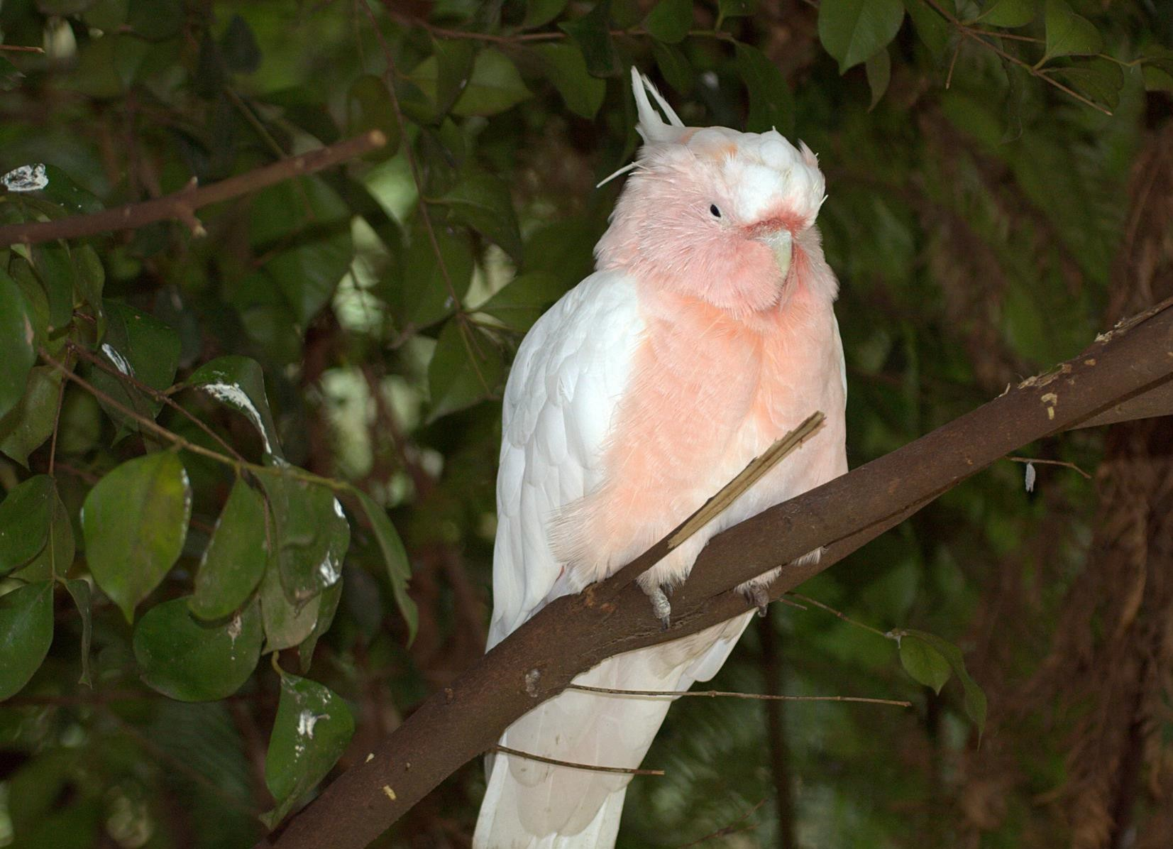Educational Datasets Teachers Guide Year 3-6

# Contents

1 Dataset Overview 2

CSIRO Educational Datasets 2

Dataset Description 2

Understanding this Dataset 3

Research Findings 5

Learning Goals 5

2 Lesson Materials 9

Required Understanding 9

Content Engager 10

Introductory Description 10

Thinking Time 10

Activities 11

Appendix A References 15

# Dataset Overview

## CSIRO Educational Datasets

CSIRO Educational datasets have been derived from CSIRO research data and adapted for classroom use. They are delivered in three different levels; Novice, Expert and Programmer.

Novice level data has been simplified for the classroom. Potentially confusing outliers and partial entries have been removed from the data for the novice level, to make analysis and comprehension easier. Data labels have been modified to make them easier to understand.

Expert level data retains outliers and partial entries and has not always had the labels adjusted. This may mean that students are required to undertake research into subject language to fully understand what they are looking at. Both Novice and Expert level data contains a limited number of rows to ensure that they can be opened in spreadsheet packages.

Programmer level datasets and activities are intended to be used with more advanced tools and programming languages. This level provides the data in an unmodified format, allowing students to organise and analyse it independently.

## Dataset Description

This data was collected by Alison and John Doley on their property ‘Koobabbie’, which is in the northern wheatbelt of Western Australia. The data is a record of every species of bird they saw, grouped by week over a period of 30 years. It was collected in a booklet created by the CSIRO Division of Wildlife and Rangelands Research for its 1987 to 1990 bird atlas. The data does not list the number of each species observed, nor how many different sightings took place across the week. It is a simple binary record indicating that either a species was observed, or it was not.

The booklet listed all species known to have been observed in the central wheatbelt and divided the year into 12 months, with each month divided into four weeks. Each year, therefore, consists of 48 weeks of observations in total. Any species seen on the property that was not listed in the booklet was added to the list. If a species was seen in that week, it was given a tick. Therefore, one Red-capped Robin seen only once would be recorded in the exact same way as a flock of 100 Galahs that were seen daily.

The property the measurements were made from is located approximately 220km north of Perth, with the farmhouse located at 29° 56.452’ S 116° 012.014E. A large proportion of the property retains native vegetation, making it a valuable location for tracking native birdlife sightings.

Notes were returned on a yearly basis, by providing the notebook to the project’s manager, Denis

Saunders.

For a link to the original data in the CSIRO Data Access Portal, see Appendix A.

## Understanding this Dataset

This section relates to understanding this specific dataset. For more general information on understanding and interpreting datasets, see the Educational Datasets Companion document.

The original data in this dataset consisted of a single tick to indicate that a bird of that species had been observed that week. It’s important to note that a tick simply indicates the presence of that species in a given week and is not an indicator of the number of that species observed, or the number of times it was sighted during the week.

In the spreadsheets given, each tick is represented by a 1. For the novice dataset, the spreadsheets given are in summary form. SightingsPerYear.csv provides an overall summary for each year, indicating how many of the weeks that year that species was sighted.

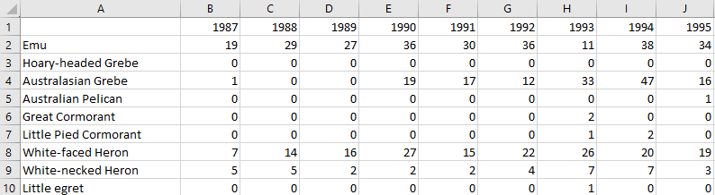

Figure 1 - This sample from the novice dataset indicates that the Emu was sighted on the property for 19 of the 48 weeks recorded in 1987, and 29 of the 48 weeks recorded in 1988. The Australasian Grebe was sighted almost every week during 1994.

The file SightingsByMonth.csv is a summary file indicating how many times a bird was sighted during that month, across all the years of observation.

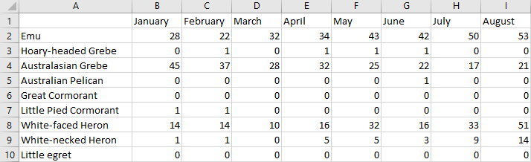

Figure 2 - This sample from the novice dataset indicates that the Emu was sighted 28 times during January. Given that the dataset spans 30 years, with 4 recordings per year, the maximum potential sightings for any given month is 120.

The final grouping in the novice files is a folder that contains one file for each species of bird being tracked. The data is grouped by year and month, indicating how many sightings took place in that year and month. This means that each cell has a maximum value of 4, which is the number of weeks tracked for each month. These files can be used to give students or groups of students individual birds to analyse and discuss.

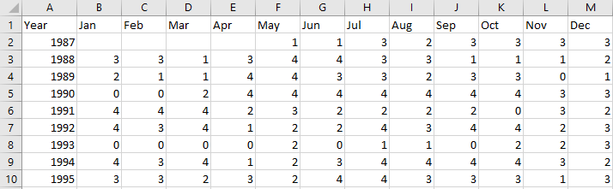

Figure 3 - This sample from Emu – Dromaius novaehollandiae.csv indicates that an Emu sighting was recorded on the property every week of recording from April to October of 1990. It also indicates that no Emu sightings took place during the first 4 months of 1993.

In the expert package, the dataset has not been split into distinct files. All the data is in a single csv file, with each row recording a single week of recordings, and the different bird species making up the different columns. This makes it difficult to read but preserves the original data for more detailed analysis.

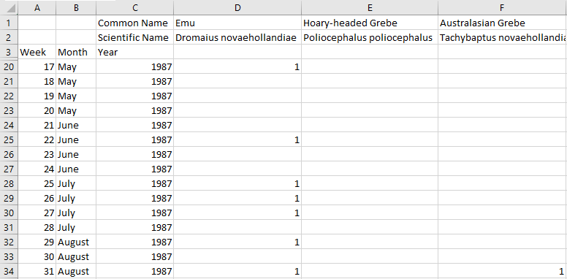

Figure 4 - This sample from the Expert Dataset indicates that the Emu was sighted in the first week of May, the second week of June, the first three weeks of July and the first and third weeks of August. The Australasian Grebe was sighted in the third week of August.

## Research Findings

This data was used in a project to map the distribution of birds throughout the wheatbelt of Western Australia. It involved 187 observers collecting data on the species of birds observed on their property each week from 1987 to 1990. Of these 187 observers, 79 contributed data for each year of the project. The results were published as an atlas of changes in the distribution and abundance of birds in the wheatbelt.

Data from Koobabbie was contributed throughout the life of the project and Alison and John Doley continued collecting data after its conclusion. Their data continues to provide a valuable opportunity to investigate the changes in the avifauna of the region.

For more information about this research and a link to the reported findings, see Appendix A.

## Learning Goals

As with any lesson resources, there are any number of ways this dataset could be brought into the classroom, depending on your approach and personal style. Here you’ll find some potential overarching learning goals, most of which address general data literacy, understanding and representation to guide you in introducing this dataset to your students.

### Understanding this dataset

Students examine simple ways of exploring datasets to understand them and discuss the positives and negatives of using a specific dataset. In achieving this learning goal, some activities might include:

* Sorting the data. Some different trends become far more obvious once the data has been sorted in certain ways. If we look at bird appearances by month, can we see patterns? How about across different years? What different patterns appear depending on the way we sort our data?
* Averaging. How useful is it to take averages of readings for this dataset? What would an average by month tell us as opposed to an average by year? Is it possible that in taking averages we could skew the meaning of our data?
* Mean vs Median. When taking the mean and the median of a dataset, it’s possible to get two different results. What does this mean? Why are they different? Which one is a better indicator of the centre of the dataset? In this case, which value is more useful to us?
* Graphing. What kinds of graphs can we use to represent this data? Are there any subsets of the data that might be useful to compare on a graph?

### Accurately report findings made from data

Students examine how to best represent their findings from the dataset. How can we display this data so that humans can easily read and understand it? Representing the whole dataset in a single table can make it difficult to identify trends and link related concepts. Using statistical tools, such as using the average, range, median, mode or percentages can help give the audience a better idea of what the data tells us, but some of these values are more useful than others, depending on context. If you’re packing for a trip, the range of temperatures for each day is more important than the median temperature for the whole trip. Knowing that the temperature will get as high as 27°C and as low as -2°C is more important than knowing that the median temperature will be 13°C, as it gives you a much better idea of what to pack.

With this dataset, consider if it is useful to represent bird sightings per year as a percentage of total bird sightings on a pie chart. As this data is about frequency of sightings, a pie chart would display the years that a bird species was most sighted. This information could be useful but the fact that the data covers 30 years means that a pie chart will require the viewer to interpret 30 different sizes of slice to try and establish which is biggest, while comparing 30 different colours.

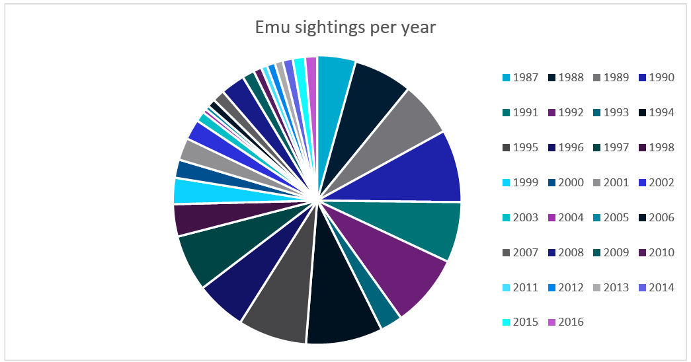

Figure 5 - Emu sightings per year, as a percentage of overall Emu sightings. This could be useful information but there are too many data points for a pie chart. It’s difficult at a glance to see which year had the most sightings (1994, the black sector at the bottom.)

What else can we do to make sure that the findings we’re reporting don’t skew the data or misrepresent it? Examine ideas such as considering the whole data set, not just favourable sections of it, or ensuring that when using two graphs to compare data, they use the same start and end points, the same scales, and the same display ranges.

Alternately, you could reverse this lesson idea and ask students to find a way to misrepresent the dataset to distort the truth, without lying about the data. How could it be displayed so that it looks like it’s saying something that it isn’t? This could generate discussion about the misuse of data in the media and advertising, or ethics in scientific research, and the importance of representing data accurately.

### Understanding Outliers

Outliers in data refer to things that fall well outside of the other values observed. They can be legitimate variations in the thing you’re measuring, or can be measurement errors, where the reading was not taken correctly for a variety of reasons.

With this lesson goal, students examine the dataset, identifying the average, median and range. Once that is done, students can then identify any outliers, using methods like looking for sharp spikes in sightings of specific species, remove them from the dataset and recalculate their average, median and range, compare the values, and discuss which ones have changed and why, as well as discussing where the outlier values may have come from. In this case, it might be wise to insert an anomalous value into the dataset before sharing it with students, and task them with identifying the anomalous value and estimating what the value likely was.

For more information on Outliers, see the Educational Datasets Companion document.

### Identifying the Right Visualisation

As the idiom goes, a picture is worth a thousand words and there are lots of ways we can take data and make it visual. Some of the more common methods of creating visualisations are pie charts, line graphs and bar graphs. Depending on the data set, other visualisations may be appropriate to give the audience a better illustration of the data and the trends and patterns it contains.

For this dataset, since we only have one set of readings from a single location, maps would not be the most relevant way of displaying this data. Most graphs would be appropriate, especially line graphs, as they can easily indicate changes in sightings over time.

It’s important to remember that while students can generate visualisations for data using digital resources, there’s also the opportunity with smaller datasets to create these visualisations by hand.

For more examples of data visualisations, see the Educational Datasets Companion document.

### Spreadsheet and Numeric Skills

Spreadsheets and numerical skills are embedded across the curriculum, and this data offers an opportunity for students to put their skills to work on real-world scientific measurements. While a wide range of mathematical skills and spreadsheet skills can be applied, some key examples are:

* Sorting data. Sorting the data along different values can reveal different trends. What different ways can we sort it? Consider whether each way gives us useful or useless information.
* Developing spreadsheet formulae. Look for places in the data that an automatically calculated total or an average might be useful. In this case, we might need to check the average number of sightings per month and which months are above or below that average. Alternately, there are formulas that can be used to determine the minimum and maximum value of a list of data, to examine where the time periods where sightings are most frequent.
* Graphing. Consider the different types of charts that your spreadsheet software can make. How can we modify the settings of a graph to display data appropriately? What is an appropriate title? What are labels and value ranges should be used for its axes? Students could construct graphs on paper, to build manual graphing skills.
* Conditional formatting. Create a set of rules so that any time that the number of sightings is over the median by a given percentage, it displays the colours the cell in an appropriate colour. Do the same for records that are lower than the median by the same percentage.
* What-if calculations. Students can use the real-world data to make estimates of potential changes. How would the results change if Magpies were sighted 10% more frequently? Where would that place them in comparison to the other birds?
* Non-digital numerical skills. Students can manually take averages of sets of readings, examine other statistical quantifiers such as median and range or identify the standard deviation.

### Programming

Many of the files in this dataset can be opened and manipulated in a variety of programming languages. CSV files are very easy for most programming languages to work with, since they are simple text files which use commas to split data points. Python has a specific module (csv) that adds additional functionality when working with these files.

Teaching programming with this dataset gives students an opportunity to practice skills relating to reading and writing data to and from files directly and incorporates string manipulation so they can directly access specific pieces of data. Students can investigate data structures such as lists, dictionaries and objects, assessing their usefulness in storing this data, and utilise control structures to perform calculations on the data, or organise it in a manner appropriate for output.

Depending on the prior understanding students have of programming principles, this can lead to activities ranging from calculating averages automatically and outputting them to the screen, to searching for potential outliers and removing them from the dataset before outputting it as a separate file, to creating interactive visualisation tools for the dataset.

### Subject Links

This dataset can be linked to the Australian curriculum learning areas of Mathematics, Science (Biological Science), Technologies (Digital Technologies), and Humanities and Social Sciences (Geography.)

# Lesson Materials

## Required Understanding

A list of the existing skills students will require to work effectively with each level of this dataset can be found in the table below. This dataset can also be used as a tool to develop these skills.

The Novice data provides most of the data that is shared in the Expert data, but in a more structured and easier to read manner. The specific weeks of sightings is not recorded in the Novice data. The activities listed below can be undertaken with either package but undertaking some activities with the Expert package will require it to be formatted and reorganised.

**Spreadsheet Novice**

* Spreadsheet software and the relevant key terminology, such as cell, row, column, sheet, data, cell reference and cell range
* Developing spreadsheet formulas
* Creating charts in spreadsheet software packages
* Basic mathematical statistical concepts, such as averages, range and median values.

**Spreadsheet Expert**

* Spreadsheet software, including appropriate formatting skills and relevant key terminology, such as cell, row, column, sheet, data, cell reference and cell range.
* Developing spreadsheet formulas
* Creating charts in spreadsheet software packages
* Basic statistical concepts, such as averages, range and median values.

**Programmer**

* Basic understanding of commands for a specific programming language
* Understanding of data structures and file input/output
* Understanding of programming control structures, such as sequence, selection and repetition
* Basic statistical concepts, such as averages, range and median values.

## Content Engager

Use these resources to introduce the topic of biodiversity.

* [CSIRO – Australia’s biodiversity: status and trends](https://vimeo.com/115944135)
* [CSIRO blog – Explainer: what is biodiversity and why does it matter?](https://blog.csiro.au/explainer-what-is-biodiversity-and-why-does-it-matter/)
* [CSIRO – What is biodiversity and why is it important?](https://www.youtube.com/watch?v=7tgNamjTRkk)
* [TED-Ed – Why is biodiversity so important? – Kim Preshoff](https://www.youtube.com/watch?v=GK_vRtHJZu4)

Some questions that you can use to start discussion about this topic and activate students’ prior

knowledge include:

* Why is biodiversity important?
* Why is biodiversity important to monitor?
* How many different species of bird can you name?
* How many of those bird species can be spotted in the local area?
* What are some of the roles that birds play in the ecosystem?
* Are bird populations in the local area the same all the time? What might be some reasons for changes in the local bird population?

## Introductory Description

To introduce students to this dataset, consider reading the following paragraph to them, or something similar.

‘Today we’re going to be looking at data that was measured as part of a scientific study of bird species in the northern wheatbelt of Western Australia. The initial study covered the years 1987 to 1990, but records made by Alison and John Doley on their property Koobabbie continued for a long time after the end of the initial study, which gives us excellent insight into the diversity of bird life on their property.’

## Thinking Time

Once students have an idea of the dataset’s content, give them 5 minutes to brainstorm questions

they’d like to try and answer using this data. Try not to lead students too much during this time. There is a high chance that students will develop questions which cannot be answered by the data. This creates an opportunity to explore why those questions cannot be answered.

## Activities

### Spreadsheet Novice and Expert

1. What are the limitations on what we can find out from this data, given the nature of how it was collected?

**Given the binary method of data collection where a tick indicates one or more sightings during that week and no tick indicates no sighting, we are unable to find out how many of a species were sighted, how many times they were sighted, if they were sighted in different places around the property or what days they were sighted.**

1. Given how much it limits what we can find out later from the dataset, what are the major advantages to collecting data in this way?

**This is a very easy method for the person collecting the data. Since this is a volunteer project using property owners for data collection, it was important to make it easy for the volunteers. With this collection method, a booklet can be carried and marked if a bird is sighted, without disrupting the management of the property.**

1. How can you spot a species of bird that migrates seasonally in this data?

**Sightings of seasonally migratory birds drop off for several months at a time, then rise again for several months with a regular pattern. Graphing the data by month on a line graph helps, as it makes it easier to spot such a trend. The Australian Shelduck is a good example of a migratory bird pattern in this dataset, appearing strongly during the winter months.**

1. Use all the data in the SightingsPerMonth file to create a line graph. How easy is this graph to read? What information can we get from it? What would make this graph easier to read?

**Graphing everything will create a cluttered line graph that is difficult to get information from. Each species will be graphed on an individual line, creating a graph with 122 lines. There is little that can be learned from this graph, except that the range of sightings is 120 to 0. To make it easier to read, graph 5-10 species at a time.**

**This enables the viewer to make comparisons between species quickly without the graph getting cluttered.**

1. Graph the data for the Australian Shelduck, Striated Pardalote, Banded Lapwing, Major

Mitchell’s Cockatoo, and Grey Fantail. Which birds are migratory, based on this graph? How could you describe a graph belonging to a migratory bird, so that someone who doesn’t understand what migration is could identify them?

**Australian Shelduck, Grey Fantail and Banded Lapwing are the most obviously migratory. Striated Pardalote may be migratory, with a low point in sightings in February and March, but if so has an odd migratory pattern. Major Mitchell’s Cockatoo has consistent sightings across the year (January to April were not recorded in 1987, so these months have 4 less possible sightings than other months.) The graph for a migratory species has a clear high section and a low section. Students may state that the high section must be in the middle of the graph, which is true of the migration pattern in these examples. This leads into the next activity. Animals that hibernate would show up as migratory in this dataset, since where the birds go is not tracked, just that they have not been sighted.**

1. Graph the data for the Carnaby’s Cockatoo on a line graph. Does it look like this species is migratory? Does this graph fit the description you wrote for part 5? If not, how could you adapt your description so that it covers these birds as well? Can you think of any other graph shapes that might indicate migratory behaviour?

**The Carnaby’s Cockatoo is migratory from the line graph but is recorded on the property from July-February. This gives it a line graph pattern that has the low point in the middle, the opposite to the previous examples. This may require that the description of a migratory bird is adjusted to fit the idea that the graph should have a gradual rise and a gradual fall, with clear months of sightings and clear months with few or no sightings.**

1. Why do birds migrate? List some of the reasons you can think of for birds migrating according to the patterns shown in the data. Why do some birds such as Carnaby’s Cockatoo and the Australian Shelduck, migrate at different times of year?

**Birds migrate for several reasons, such as breeding, food supply, weather, the length of the day/night cycle and climate. In terms of timing, one answer could be that birds from colder climates move further north during winter, while birds from warmer climates move south during summer.**

1. Analyse the average number of sightings per year and compare it to yearly sightings for a specific species. Does it tell us anything? It might be helpful to use a visualisation to support your analysis.

**This shows us when sightings were above average and when they were below average at a glance. The White- faced Heron has a high level of sightings from 1988 to 2002. After 2002, sightings became far less frequent until 2015 when they started to rise to pre-2002 levels again. Using the average shows us at a glance when sightings are high or low and can help identify the overall trend and when the population is growing or declining.**

1. Graph sightings per year for the Emu on a line graph. What information can we quickly and easily get from examining this graph?

**The Emu population in the area is in decline, with a sharp drop off in sightings around 1998. Sightings of Emus on the property have been increasing slightly since 2011 but are not approaching the mid-1990’s numbers.**

1. If recordings of a species are shown to be in decline or absent in this data, can we safely use this data alone to declare the species to be endangered or extinct? Why or why not?

**There is not enough data to conclusively declare a species endangered or extinct. This is just one set of sightings for one location. Absence in this data could mean that a species has moved for several reasons, such as habitat change. The species may still be thriving elsewhere, but not appearing on the property. If this property was known to be the only habitat for a species, we might be able to make such a claim, but it would need to collect further data for verification.**

1. Choose three species of bird and compare the sightings per year for those species. What does the data tell us about those species, and their presence on the property? Work out the average yearly sightings for those species. Using a visualisation can support this comparison.

**The graphs will depend on the bird species selected, but could indicate low population, high population, declining population, growing population. Average yearly sightings can be worked out using the average formula.**

1. Using the monthly sightings for one of the species chosen, work out the average sightings per month. How do the monthly sightings compare to the average? Is there a pattern to when the sightings are above or below the average? Why does that pattern exist for this species? Repeat this for all three species.

**Again, it depends on the species selected, but this could reveal a migratory pattern in the species, or it could reveal that no migratory pattern exists.**

1. Use the monthly sighting data for Australian Shelduck, Black-faced Cuckoo-shrike, Carnaby’s Cockatoo, Banded Lapwing and Weebill to generate box and whisker plots. These five birds all have similar total numbers of total sightings (between 688 and 799) but have very different box and whisker plots. How can we interpret these plots? What useful information do they show us? Can we tell from this which of those birds had the highest number of total sightings?

**The box and whisker plot can indicate which of these birds might be migratory, and which are seen in higher numbers on the property with regularity. The ones with the widest range have a large difference between the high sightings and the low sightings, whereas the ones with smaller boxes and ranges are seen in similar numbers almost year-round. Australian Shelduck and Carnaby’s Cockatoo indicate a very strong migratory pattern, Black-faced Cuckoo-shrike and Banded Lapwing indicate a weak migratory pattern and Weebill has regular sightings throughout the year. We cannot tell from this visualisation which bird had the highest number of sightings (unless the box and whisker plot includes a mean marker, in which case, the one with the highest mean is the highest number of sightings.)**

### Programmer

Write a program using your chosen programming language to perform the following tasks:

1. Read the data file into an appropriate file structure.
2. Output a list of birds that are potentially migratory, based on monthly observations. Research some of the bird species in the list and examine the original data to ensure the program’s conclusions are accurate.
3. Output a list of birds with a notable decline in frequency of observations on the property.
4. Graph the data for each species separately.

### Open Inquiry

In addition to the activities listed above, this dataset can be used for student-centred open inquiry projects. Using open inquiry, students generate research questions and design investigations to answer those questions. Students can use this dataset to support their independent research and investigation in a range of areas. There is also further data from this project available on the CSIRO Data Access Portal, along with related datasets gathered from other properties linked below.

Examples of inquiry questions that could be explored using this data include:

* What impact do weather conditions have on bird sightings?
* What impact do major bushfires have on bird life?
* How does the diversity of bird species in your local area compare to bird species in this data?
* When compared to data from other, similar properties, is there a noticeable difference in biodiversity on Koobabbie?
* Which species of birds are most common in the Wheatbelt of Western Australia and what traits do they share?

### Assessment

Assessment items for this dataset could include:

* A labelled graph, or series of graphs for several species of bird, analysing their appearance patterns and explaining the reason for the shape of the graph.
* A comparison of local bird species, using the same data collection protocols over an extended period.
* A poster providing more information about a species listed in the data, with reference to the data to support research.
* A spreadsheet with formulae to calculate summary statistics
* Code to identify migratory birds and indicate which months or seasons they are expected to be in the region.
* Code to examine meteorological data in the area and examine patterns with species sightings, to

see if temperature/weather impacts specific species’ appearances.

# Appendix A References

**Educational Dataset:**

Western Australian Wheatbelt Bird Survey (1987-2017)

**Original Dataset:**

[Saunders, Denis; Doley, Alison (2018): WA Northern Wheatbelt Bird Counts from Koobabbie 1987-2017. v5. CSIRO. Data Collection. https://doi.org/10.4225/08/5ad3f03d31c69](https://doi.org/10.4225/08/5ad3f03d31c69)

**Related Datasets:**

[Saunders, Denis; McAleer, Tony (2016): Bird counts from McAleer property in northern wheatbelt of Western Australia. v2. CSIRO. Data Collection. https://doi.org/10.4225/08/572C51E67CE3A](https://doi.org/10.4225/08/572C51E67CE3A)

[Saunders, Denis (2016): Atlas of the birds of the Western Australian Wheatbelt 1987-1990. v1. CSIRO. Data Collection. https://doi.org/10.4225/08/57A98E5F609D7](Saunders,%20Denis%20(2016):%20Atlas%20of%20the%20birds%20of%20the%20Western%20Australian%20Wheatbelt%201987-1990.%20v1.%20CSIRO.%20Data%20Collection.%20https://doi.org/10.4225/08/57A98E5F609D7)

**Published Papers:**

[Saunders Denis A Doley Alison (2013) The birds of “Koobabbie” in the northern wheatbelt of Western Australia (1987–2011) and the contribution of the farm to conservation of the region’s avifauna. Pacific Conservation Biology 19, 204-232](https://www.publish.csiro.au/PC/PC130204).

**Supporting Information:**

* [Northern Agricultural Catchments Council case study on Alison](https://www.nacc.com.au/wp-content/uploads/2016/03/Alison-Case-study.pdf) Doley
* [CSIRO - Biodiversity](https://www.csiro.au/en/research/natural-environment/biodiversity)

**Australian Curriculum:**

© Australian Curriculum, Assessment and Reporting Authority (ACARA) 2010 to present, unless otherwise indicated. This material was downloaded from the Australian Curriculum website ([www.australiancurriculum.edu.au](../www.australiancurriculum.edu.au)) (Website) (accessed December 2018) and was not modified. The material is licensed under CC BY 4.0 (https://creativecommons.org/licenses/by/4.0). Version updates are tracked in the ‘Curriculum version history’ section on the 'About the Australian Curriculum' page (<http://australiancurriculum.edu.au/about-the-australian-curriculum/>) of the Australian Curriculum website

**As Australia’s national science agency and innovation catalyst,   
CSIRO is solving the greatest challenges through innovative science and technology.  
CSIRO. Unlocking a better future for everyone.**

**Contact us**

1300 363 400

+61 3 9545 2176

csiroenquiries@csiro.au csiro.au

**For further information**

CSIRO Education and Outreach

1300 136 376

+61 2 9490 5588

education@csiro.au csiro.au/education

***Cover Image Credit  
CSIRO Marine Research***