EDUCATION AND OUTREACH

www.csiro.au
www.csiro.au

How to…
Evaluate a learning activity

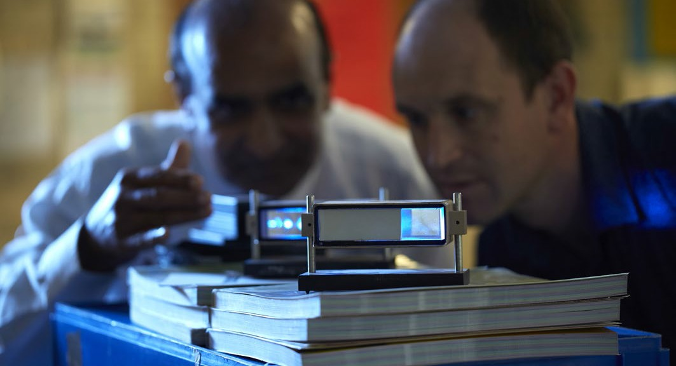

This guide will help you assess how the STEM Professionals in Schools partnership activity went, what worked well and what might work better next time. Reflect on whether it met your objectives to help you develop future activities with your partner.
Use the Activity Evaluation template in this guide to assess how the activity went and ask your partner what they thought.

Supporting activities
Your STEM Professionals in Schools project officer is available to support your partnership. We also love sharing practices that are happening across the country as it helps generate ideas for other partnerships.

The STEM professional conducted a series of lessons closely connected to the curriculum. It was great to see a STEM professional at work and how closely their work is actually related to what we do at school.
TEACHER – STEM PROFESSIONALS IN SCHOOLS PROGRAM

STEM Professionals in Schools is supported by the Australian Government Department of Education and Training

Learning activity evaluation
This Learning activity evaluation template will help you record the details of your learning activity and evaluate what worked well and what could be improved. Share the evaluation with your partner to ensure expectations were met. This will also help with future planning.

Learning activity/session task

What was the learning intention? Did you achieve this?

What worked well? What were the highlights?

Is there anything you would change? If yes, what?
What was the highlight for you?

What was the students’ feedback about the learning activity?

What follow-on opportunities and other learning activities could you and your partner achieve?

CONTACT US
t 1300 363 400
+61 3 9545 2176
e csiroenquiries@csiro.au
w www.csiro.au

WE DO THE EXTRAORDINARY EVERYDAY
We innovate for tomorrow and help improve today – for our customers, all Australians and the world.
WE IMAGINE
WE COLLABORATE WE INNOVATE

FOR FURTHER INFORMATION
STEM Professionals in Schools
e education@csiro.au
t 1300 136 376
w www.csiro.au/STEM-Professionals-in-Schools

B&M | 17-00524

