EDUCATION AND OUTREACH

www.csiro.au
www.csiro.au

How to…
Get started

To get the best out of your STEM Professionals in Schools partnership, it’s important to get to know your partner and explore the different ways you can work together.

Developing your partnership
After receiving your partnership confirmation email, contact your partner via phone or email. Refer to the form on the following page to learn more about your partner.
We suggest meeting in person to develop your relationship (if possible), and to discuss the learning activities you could do that bring your areas of expertise together. This will help build your confidence before running your first activity.
Some types of activities you could do include mentoring, a hands on activity, a presentation or field trip – there is no right or wrong type of partnership. A key benefit of the program is that you and your partner work out together what you would like to do.

Ongoing support
Your STEM Professionals in Schools Project Officer is available for advice and support throughout your
partnership. We run a series of webinars, networking events and professional learning opportunities,
and there’s a range of resources also available on our website.
Refer to the How to plan your activity and How to evaluate an activity guides to ensure you feel confident and equipped to deliver activities together with
your partner.

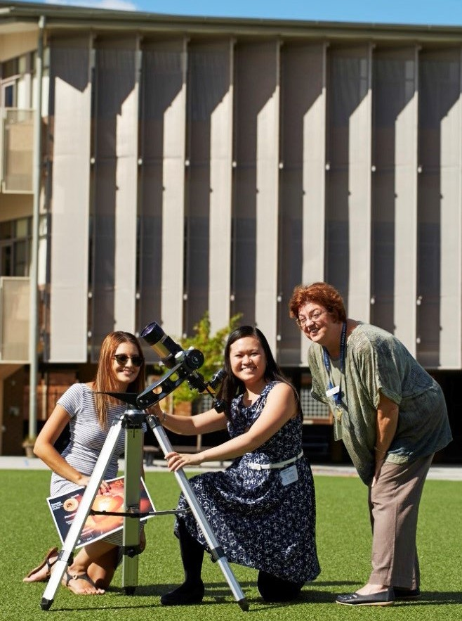
Seek advice from each other – teachers know what works well in the classroom, and STEM professionals know what content they can assist with.

The STEM professional’s expertise and depth of knowledge improved the quality of the subject, not only for myself, but also the students.
TEACHER – STEM PROFESSIONALS IN SCHOOLS

STEM Professionals in Schools is supported by the Australian Government Department of Education and Training

Getting to know your partner
Use this form as a conversation starter to learn things about your partner and to help make your partnership a rewarding experience. Make notes of your discussion so you have it as a handy reference. When talking with your partner, discover how you will work best together, the style of partnership you are both looking for and the sort of learning activities you can plan together.

Partner’s contact details | Name: Tel:  Email:
Partner’s current role and workplace
Preferred style of communication
e.g. phone, email or face-to-face
Availability, including any preferences
What do you do in your workplace?
What interests you about STEM
Professionals in Schools?
What sort of ideas are you wanting to try in the partnership?
What do you want to gain from the partnership?

CONTACT US
t 1300 363 400
+61 3 9545 2176
e csiroenquiries@csiro.au
w www.csiro.au
WE DO THE EXTRAORDINARY EVERYDAY
We innovate for tomorrow and help improve today – for our customers, all Australians and the world.
WE IMAGINE
WE COLLABORATE WE INNOVATE
FOR FURTHER INFORMATION
STEM Professionals in Schools
e education@csiro.au
t 1300 136 376
w www.csiro.au/STEM-Professionals-in-Schools

B&M | 17-00524

