EDUCATION AND OUTREACH

www.csiro.au
www.csiro.au

How to…
Plan a learning activity

We are excited that you are part of STEM Professionals in Schools to increase STEM skills, knowledge and confidence for teachers, students and STEM professionals.
This guide will help you plan, support and execute ideas as part of your partnership.

To ensure that you are both confident in running an activity together, decide on what sort of activity will work best for both of you to meet your mutual goals and what time/s of year would be suitable.
Teachers will be able to assist the STEM professional when running the activity to help students understand the content and align to the general capabilities of the school curriculum, while the STEM professional will be able to equip teachers with the knowledge and skills they need.

Understanding the school environment
For STEM professionals, it’s important to note that:
- Most schools have a school calendar of four terms per year, commencing in late January and concluding in December. Check term times when planning activities to avoid school holidays and assessment periods.
- In most primary schools, teachers are allocated to a year level and are responsible for teaching most subjects. Some primary schools are implementing a specialist
STEM teacher.
- In most high schools, teachers specialise in subject areas and are responsible
for teaching those subjects to students across multiple year levels. Some high schools integrate STEM across a range of subject areas.

STEM Professionals in Schools is supported by the Australian Government Department of Education and Training

Activity checklist
There’s plenty of scope and flexibility around the activities you can do, in and out of the classroom. Discuss what the STEM professional is doing at work, what the needs of the curriculum might be, or if there’s an opportunity to work on an integrated project. Refer to the Term Planner and Activity Plan template to help you and your partner plan your activity and cover everything you need to know to make it a success.
Some important yet simple things to consider are:
- Your school term times
- What particular areas can your partnership add value (short-term and long-term)
- The age and ability of the students, and how many will be participating
- School's visitor policy
- The time available for the activity
- Curriculum learning area
- Health, safety and environment requirements
- Practical information such as where to park and how to find the classroom
- Whether student/parent consent forms are required

The Australian Curriculum

The Australian Curriculum sets the expectations for what school students should be taught, regardless of where they live in Australia. It outlines the quality of learning expected of young people as they progress through school.
Work together with your partner to align activities around the teaching plan. It’s not critical that an activity through STEM Professionals in Schools aligns to the Australian Curriculum but it is beneficial to have an understanding of what the curriculum is and how the activity might support the general capabilities of the curriculum to increase students’ learning outcomes

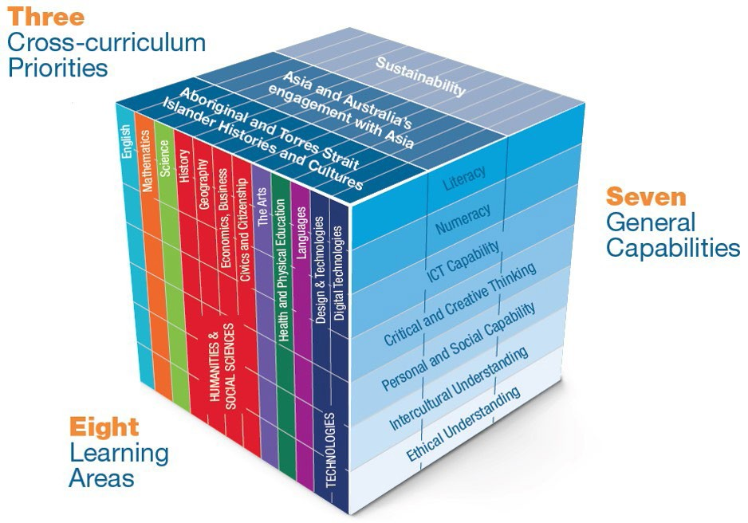

Courtesy of Australian Curriculum, Assessment and Reporting Authority (ACARA)

SUPPORT AND ENGAGEMENT IDEAS
There are a range of ideas to deliver engaging STEM activities– remember it’s all about what works for you and your partner.
Talk to each other about what style will work best for you and the students and what you will feel confident in delivering in the time you have available.
Some ideas include:
- Teacher professional learning
- Teacher and student mentoring
- Presentations about your work
- Hands-on demonstrations
- Online engagement

Student engagement
There’s a range of ways STEM professionals can work with teachers to increase knowledge in STEM and to increase student engagement. Here’s some suggestions to build confidence when running activities:
- Try different formats to see what suits your partnerships best e.g. experiments, presentations or mentoring. You may try one style but then find a different format works better for you and your partner.
- The STEM professional can share with the teacher and students their own journey, their workplace and what they do there.

- STEM professionals should try to avoid jargon – it’s fine to use correct terms but try to break it down and explain what it means to increase learning and understanding for the teacher and students.
- Allocate some time for students to ask questions or digest new information during an activity.
- Using visuals, props and artefacts can help bring an activity to life and help students remember what they have learnt.
- Work together with your partner to lead a hands-on activity so you can use both your strengths.

Term Planner
Use this term planner to work out suitable times to conduct an activity. Determine with your partner what sort of activities you would like to run and how they might align to the teacher’s lessons and what knowledge the STEM professional can share. You may choose to run an activity weekly, monthly or even yearly – it’s up to you!

Sample Planner

Term | Teaching plan | STEM professional ideas | Partnership ideas
Term 1
Term 2
Term 3
Term 4

Learning plan template

This form will help you and your partner plan your activity to make sure you are prepared. You may find that you and your partner would prefer to plan your activity face-to-face or via email. Either way, this form will help you identify what you need to do to in preparation for an activity.

Curriculum learning area and learning focus

How much time is required?

What’s the role of students in this learning activity?
Age/ year level of students
Key learning intention
Health, safety and risk considerations

Facilities required

Materials required
How will learning be assessed

CONTACT US
t 1300 363 400
+61 3 9545 2176
e csiroenquiries@csiro.au
w www.csiro.au
WE DO THE EXTRAORDINARY EVERYDAY
We innovate for tomorrow and help improve today – for our customers, all Australians and the world.
WE IMAGINE
WE COLLABORATE WE INNOVATE
FOR FURTHER INFORMATION
STEM Professionals in Schools
e education@csiro.au
t 1300 136 376
w www.csiro.au/STEM-Professionals-in-Schools

B&M | 17-00524

