Generation STEM

‘The fascinating world of supercomputers’ masterclass –
Teacher instructions for classroom activities

Classroom Activity 1 – Group work
Aim
The aim of this activity is to demonstrate how a supercomputer uses multiple processors at the same time to solve big problems more efficiently and that each problem has an optimal number of processors.
Preparation
- Prepare a dozen or more multiplications (ie 37x29, 19x34). Keep them hidden while giving initial class instructions.
- All students will require a calculator.
Instructions
- Split the class into groups of 1 student, 3 students, 5 students and 10 students. You can adjust these group sizes depending on student numbers, as long as there is a clear small, medium and big group.
- At the word Go, reveal your equations. Groups must solve all of the equations with their calculators. They will sum all the individual answers up to reach a final answer. There should be an even distribution of workload amongst all members of the group.
- Record how long it takes each group to solve the equation, noting which group finishes first.
Outcome:
This activity will demonstrate that working simultaneously as a group on a problem can lead to a faster solve, but that the ideal group size depends on the complexity of the problem. The expected outcome is that the middle-sized group is fastest, as they have a good balance of having lots of processors (brains) but not too many that it slows down the activity with people management. A supercomputer similarly uses multiple processors at the same time to solve big problems more efficiently, but each problem has its optimal number of processors.

Classroom Activity 2 – National Map Exercise
Aim
The aim of this activity is to allow students to explore a real-world application of supercomputers and explore the map by adjusting the dates and input data. National Map is an online map-based tool to allow easy access to spatial data from Australian government agencies. It was an initiative of the Department of Communications and the Arts (DCA), now currently managed by the Digital Transformation Agency (DTA), and the software has been developed by Data61 working closely with the DCA, Geoscience Australia and other government agencies.
Preparation
- Students should have access to a computer and the internet
- Can access the NCI National Map here: NationalMap
- More information about NationalMap
Instructions
- When students click the link above, they should click “yes” on the screen below:
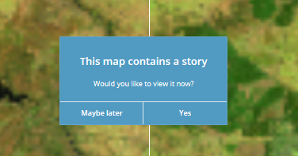
- This guides students through a series of scenes, showing the Canberra region before and after the recent bushfires. Students can move through the story using the arrows at the bottom of the screen:
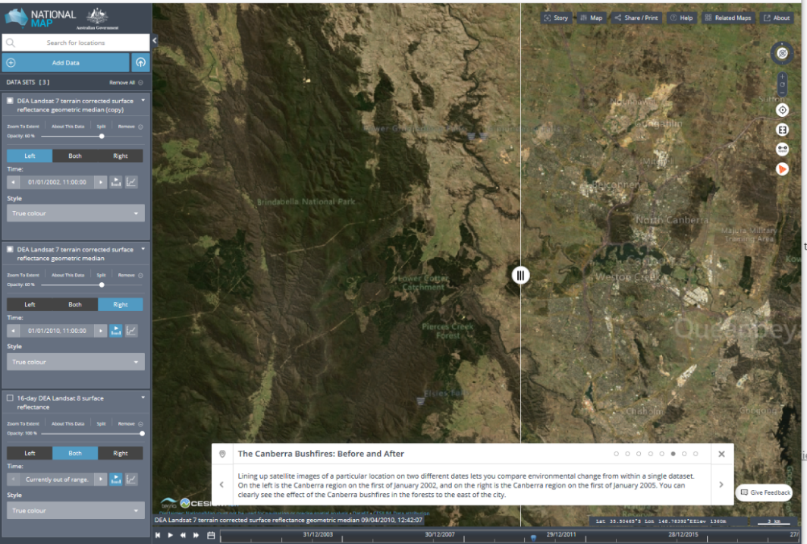
- Students can also explore the site on their own by adjusting the dates and input data on the left-hand side (click on the blue “add data” button), perhaps investigating their hometown.
Further Resources
If you would like to learn more about Supercomputers, you can visit the following sites:
- National Computational Infrastructure (NCI) – www.nci.org.au
- About Gadi Supercomputer – www.nci.org.au/our-systems/hpc-systems
- Pawsey Supercomputing Center - www.pawsey.org.au / www.csiro.au/en/about/facilities-collections/pawsey-supercomputing-centre

