
Australia’s National
Science Agency
AR-PST Stage 5 Topic 1-2
Inverter Design – GFM Converter Standard Development

  - Grid Forming Converter Standard Development
Alex Baitch
BES 25930/3
6 July 2026

Commonwealth Scientific and Industrial Research Organisation
Australian Energy Market Operator
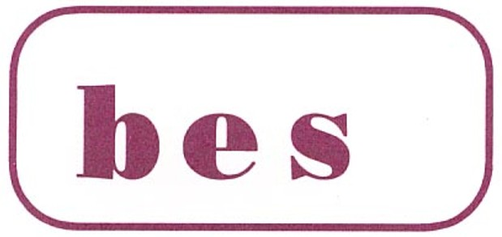

Citation
A. Baitch (2026) AR-PST Topic 1-2 – Inverter Design – Grid-Forming Converter Standard
Development.
Copyright
© Commonwealth Scientific and Industrial Research Organisation 2026. To the extent permitted by law, all rights are reserved and no part of this publication covered by copyright may be reproduced or copied in any form or by any means except with the written permission of CSIRO.
Important disclaimer
CSIRO advises that the information contained in this publication comprises general statements based on scientific research. The reader is advised and needs to be aware that such information may be incomplete or unable to be used in any specific situation. No reliance or actions must therefore be made on that information without seeking prior expert professional, scientific and technical advice. To the extent permitted by law, CSIRO (including its employees and consultants) excludes all liability to any person for any consequences, including but not limited to all losses, damages, costs, expenses and any other compensation, arising directly or indirectly from using this publication (in part or in whole) and any information or material contained in it.
CSIRO is committed to providing web accessible content wherever possible. If you are having difficulties with accessing this document, please contact csiro.au/contact.
Acknowledgement of Country
CSIRO acknowledges the Traditional Owners of the lands, seas and waters of the area that we live and work on across Australia and pays its respects to Elders past and present. CSIRO recognises that Aboriginal and Torres Strait Islander peoples have made, and will continue to make, extraordinary contributions to Australian life including in cultural, economic, and scientific domains.

Contents
Acknowledgments iv
Executive summary v
1 Introduction 8
1.1 Background 8
1.2 Existing Work and Gaps on Standards for GFM technology. 9
1.3 Relevance to Australia 10
2 Progress against the Roadmap 12
2.1 General 13
2.2 Dual logo IEC/IEEE Standard on Grid Forming Inverter Standard 13
2.3 Scoping of the Joint IEC/IEEE GFM Standard 15
2.4 Joint Project Structure IEC/IEEE 16
2.5 Meetings held 18
2.6 Estimated progress compared to original plan (2024) 18
3 Background Documents to the Development of GFM Standards 19
3.1 CIGRE CSE Report 19
3.2 AEMO 20
3.3 UNIFI 21
3.4 ENTSO-E 21
3.5 National Energy System Operator 27
3.6 Summary 27
4 Results to date in development of GFM standards 28
4.1 Challenges faced 28
4.2 Examination of UNIFI V3 clauses 29
4.3 Performance Requirements for Operation Outside Normal Conditions 34
4.4 Additional GFM Capabilities defined in UNIFI V3 35
4.5 Further work 37
4.6 Comparison of IEC/IEEE OSD Working draft with ENSTO-E CENELEC 37
5 Insights re future direction and future work 39
5.1 Short term 39
5.2 Medium term 39
5.3 Long term 39
5.4 Risks being faced 39
6 Conclusion 41
Glossary 42
References 44

Figures
Figure 1 Topics covered by the 2021 AR-PST Research Road Map 12
Figure 2 Illustration of possible scope covered by IEEE 2800. 15
Figure 3 Sequencing of the development of documents related to IEEE 2800 16
Figure 4 IEC/IEEE Dual logo development - Joint Project approach 16
Figure 5 IEC/IEEE Joint project structure 17
Figure 6 IEEE structure of Working Groups 17
Figure 7 Generating plant small signal equivalent representation [5] 23
Figure 8 : Current limitation requirement reducing the unlimited current phasor to a current phasor within the current capability of the generating unit, while maintaining the current phasor angle constant.[5] 23
Figure 9 Example of a test setup for evaluating GFM capabilities based on a passive setup 24
Figure 10 Example of a test setup for evaluating GFM capabilities based on grid emulation 24
Figure 11 Mapping of ENTSO-E and UNIFI tiers 30

No table of figures entries found.

Tables
Table 1 AR-PST Research Topics relevant to GFM Converter Standard 12
Table 2 Functional Specifications of GFL and GFM Battery Energy Systems 19
Table 3 UNIFI V3 GFM Performance Tiers (UNIFI V3 Table 1) 29
Table 4 Overview of Requirements and Tests (UNIFI V3) 32
Table 5 Draft comparison of the structure and content IEC/IEEE OSD working draft with the structure of the ENSTO-E CENENLEC document 37
Table 6 SWOT Items, Description and Measures being taken 39

Acknowledgments
The activities presented in this report have been supported by CSIRO as a part of CSIRO’s contribution to the initiatives of the Australian Research in Power Systems Transition (AR-PST) and is carried out with the support of subject matter experts from both AEMO and CSIRO. This research supports Australia’s transition to a stable, secure and affordable power system. Together with the activities of Standards Australia, the objective is to use the output of the various research activities to accelerate the development of international standards by the IEC and IEEE.

Executive summary
This is the Final Report of the Stage 1-2 Project undertaken in 2025-26 related to Grid Forming Standard Development within the general topic Research Topic 1 – Inverter Design: Development of capabilities, services, design methodologies and standards for Inverter-Based Resources (IBRs).
The objective of this project is to complement the technical research that is being undertaken in this field by leading research groups and coordinating at an international level to assist in creating a path to the development of consistent international standards Iassociated with Grid Forming Converters. The project was initiated as part of CSIRO’s commitment to the Global Power System Transformation Consortium (G-PST) and its commitment to the global cooperation The intention is to provide leadership and coordination on the joint standards development effort with the major players in this space. Australian leadership was seen as valuable to achieving alignment between European / Asian / US interests.
This part of the project is to drive the coordination and development of a dual logo IEC/IEEE standard providing a framework for the interoperability of grid forming converters connected to the power system.
The reduction of generation from synchronous machines has led to an increasing proportion of generation being from Converter-Based Resources (CBRs). Not having grid-forming technology but rather grid following technology (as is presently the case) poses a critical threat to power system reliability. This is evident in the form of grid and CBR equipment instabilities, unwanted grid oscillations, poor power quality and even local and region-wide blackouts. A deliberate framework of demonstrations, requirements and incentives to be deployed quickly is required so the energy transition can continue to accelerate and power system operators can manage the increasingly aggressive global commitments required to address climate change.
As the IEEE 2800 standard deals with grid following CBRs IEEE have three separate activities underway for work in the short/medium-term future to cover this deficiency:
- 2800.1 New Recommended Practice for GFM IBR Equipment (being the internal IEEE nomenclature for the Joint IEC/IEEE project)
- 2800 Base Std Revision
- 2800a Amendment to reduce barriers to GFM
As set out in the AR-PST Stage 4 Topic 1a report, the development of the dual logo standard is being undertaken as a Joint Project between the IEC and IEEE Task Group members. During the initial phase of development of a Working Draft of a dual logo GFM standard, close collaboration is being maintained between the IEC and IEEE Task Group members who are actively participating in the development. Currently, regular (approx. fortnightly) meetings are being held jointly online and are expected to continue to the end of this year.
During the course of the 2025-26 and 2026-27 calendar years the major development work of a Working Draft is being undertaken by the joint members of IEC and IEEE on Working Group of IEC/IEEE within IEC JWG5. This process is now well underway with the objective that by June 2026 progress is to reach 70 % completion although actual progress is estimated to be 60% After review, it will then progress as a Committee Draft for broader review. While it is recognised that the most demanding and challenging activities to achieve completion is the last 40%, there is a level of confidence that this will be achieved.
Multiple challenges are faced when developing a new standard in an area that is still immature and under development.This included but not limited to issues such as:
  - Alignment of terminology used in IEEE’s standard on grid following IBRS
  - The published UNIFI V3 GFM standard does not fully align with the structure of the IEEE 2800-2022 standard
  - Coping with various terminologies across regions of the world
  - There have been procedural challenges in terms of providing committee-in-confidence documents prepared within the IEC and within the IEEE
  - Dealing with divergent views of technical requirements in a developing area
  - Availability of experts to participate in collaborative work
  - Dealing with different time zones across the world for cooperative work
  - Applying the Online Standards Development tool introduced by the IEC.
The objective of producing a standard document at the early phase of the maturity of the technology and definition of requirements is to establish a consistent foundation at an early stage in order to provide guidance to TSOs in setting requirements and provide some some direction to manufacturers, while at the same time seeking not to limit technological development. The publication of this dual logo standard aims to achieve this objective.
Two significant input documents are being used as the input to the specification development. These are:
- UNIFI Specification for Grid-Forming Inverter Based Resources V3 Oct 2025
- ENTSO-E Grid Forming Capability of Power Park Modules, Final Report on Technical Requirements, Final | 3 October 2025
While addressing some specific objectives, these documents are not written in a style that is required by the IEC or IEEE,. They provide guidance on requirements that need to be covered.
The challenge currently being faced is to find alignment between the approaches used in the work of UNIFI (essentially representing USA industry practice), and ENSTO-E which represents European industry organisations.
A working draft is expected to be completed by the end of the 2026 calendar year.

Introduction
This is the Final Report of the Stage 1-2 Project undertaken in 2025-26 related to Grid Forming Standard Development within the general topic Research Topic 1 – Inverter Design: Development of capabilities, services, design methodologies and standards for Inverter-Based Resources (IBRs). The CSIRO is working together with the Australian Energy Market Operator (AEMO) on a comprehensive “Research Roadmap” referred to as the Australian Power Systems Renewables Transition research that identifies and explores the research required to continue Australia’s transition to a more secure, affordable, and decarbonized electricity system. The Research Roadmap is a collaborative effort and based on input from leading Australian and international electricity utilities and researchers.
Section 1 provides an overview to the research effort being undertaken with respect to GFM Converter requirements. Section 2 deals with the work being undertaken in development of GFM Converters and the possible approach to the development of a joint IEC/IEEE standard. The work being undertaken by various standards bodies is described in Section 3. The approach being taken for the development of a joint IEC/IEEE standard is dealt with in Section 4, while future work is set out in Section 5. Conclusions are set out in Section 6.

Background
The AR-PST Stage 5 Topic 1-2 Grid Forming Standard Development is a project that was initiated in July 2024 as Topic 1a in the 2024-25 program. The objective of this project is to complement the technical research that is being undertaken in this field by leading research groups and coordinating at an international level to assist in creating a path to the development of consistent international standards associated with Grid Forming Converters. The project was initiated as part of CSIRO’s commitment to the Global Power System Transformation Consortium (G-PST) and its commitment to the global cooperation The intention is to provide leadership and coordination on the joint standards development effort with the major players in this space. Australian leadership was seen as valuable to achieving alignment between European / Asian / US interests.
As previously identified Australia is in a rapid transition towards a converter-dominated structure as most synchronous generators are being displaced by converter-based resources (CBRs) (commonly referred to as inverter-based resources (IBR)) over the next two decades. Renewable energy plants, such as wind and solar farms, are typically located in regions where wind and solar resources are abundant, yet usually distant to synchronous generators (SGs) and loads. These resources, interfaced by power electronics inverters, may face stability challenges in weak areas of the grid. To address this, grid-forming inverters are deployed in these regions to enhance the stability of the local network. Consequently, the transmission of generated power from these remote energy plants to centralised urban areas necessitates the use of various network topologies, including radial and meshed configurations in transmission networks.
Currently a great deal of research and development is being undertaken in multiple areas internationally to both properly understand the technical issues that are being faced to ensure stable and proper operation of such systems, with a view to development of a consistent international standard that can be developed to define the requirements of such Grid Forming Inverters.
AEMO, ENTSOE, CENELEC UNIFI Consortium, and NERC for instance are all undertaking research activity to try to facilitate the development of specifications addressing grid forming functionality.
ENSTO is an organisation representing European Network of Transmission System Operators.
CENELEC is the European Committee for Electrotechnical Standardization.
UNIFI is a consortium co-led by what is now called the National Laboratories of the Rockies (formerly the National Renewable Energy Laboratory), the University of Texas- Austin and the Electric Power Research Institute.
NERC is the North American Electric Reliability Council
A listing of a number of key recent publications in this is included in the References at [1], [3] to [10] inclusive.
Within the IEC a number of committees are actively involved, including IEC TC8 “System aspects of electrical energy supply” and its subcommittees, in particular IEC SC8A “Grid Integration of Renewable Energy Generation”, IEC TC 82 “Solar photovoltaic energy systems”, IEC TC88 “Wind energy generation systems”, TC 115 “High Voltage Direct Current (HVDC) transmission for DC voltages above 100 kV” and IEC TC 120 “Electrical Energy Storage (EES) systems”. A range of documents have been produced dealing with aspects of operation of converter-based resources.
Within the IEEE, IEEE 2800-2022 IEEE Standard for Interconnection and Interoperability of Inverter-Based Resources (IBRs) Interconnecting with Associated Transmission Electric Power Systems has been published.

Existing Work and Gaps on Standards for GFM technology.
This part of the project is to drive the coordination and development of a dual logo IEC/IEEE standard (or series of standards) over a period defining the requirements of a Grid Forming Converter. The term Converter is used rather than Inverter as Converter is the general IEC term used covering all power electronic equipment covering inverters, battery chargers and other conversion modes. The intention is to draw on the resources of the various organisations referred to above to develop a roadmap to progress to an international standard. This will provide a solid foundation for the adoption of an appropriate Australian Standard which is consistent with international practice. Throughout this document, although the original source may have used the term IBR for Inverter Based Resources, the term CBR for Converter Base Resources is placed in its stead except where it is quoting a title.
The project is structured to provide leadership and coordination in the development of Dual Logo Standards with the IEC and IEEE defining the requirements and capabilities of GFM Technology.
The reduction of generation from synchronous machines has led to an increasing proportion of generation being from Converter-Based Resources (CBRs). Not having grid-forming technology but rather grid following technology (as is presently the case) poses a critical threat to power system reliability. This is evident in the form of grid and equipment instabilities, unwanted grid oscillations, poor power quality and even local and region-wide blackouts. A deliberate framework of demonstrations, requirements and incentives to be deployed quickly is required so the energy transition can continue to accelerate and power system operators can manage the increasingly aggressive global commitments required to address climate change.
There is a critical gap in grid forming standards, codes and requirements that address the complex grid and equipment stability problems. Only one or two advanced system operators (one of which is AEMO with the AEMO Voluntary Specification for Grid-forming Inverters May 2023 and the AEMO Voluntary Specification for Grid-forming Inverters: Core Requirements Test Framework Jan 2024) have taken measures to define grid forming requirements today with a couple more in the process of developing them. These early efforts of development and replication from one country to another have been supported by the learnings shared between researchers and grid operators globally. There is an urgent need to more universally define a baseline of grid forming requirements that may be used in all systems around the world when they are needed.
Institutional standards drafted by industry through IEEE and IEC are trusted sources of equipment and system design and industry practice. IEEE generally covers 60Hz systems (mostly North American focus) and IEC covers 50Hz systems (rest of the world).
The AR-PST research for Pillar 4, covering standardization and technology adoption and effort, is being undertaken to develop a joint standard across IEEE and IEC, based on a recently developed IBR standard specifying minimum capabilities in IEEE.

Relevance to Australia
As set out in AEMO’s “Voluntary Specification for Grid-forming Inverters” May 2023, with increasing penetration of inverter-based resources (IBR) and retirement of synchronous generators (SG) in power grids worldwide, new operational challenges with respect to system strength, voltage and frequency control, synchronous inertia, power system protection, and other phenomena will need to be considered by power system operators. Grid-forming (GFM) inverters have the potential capability to address some of the operational challenges associated with high levels of IBR penetration.
Within Australia, Standards Australia is liaising closely with AEMO with a view to develop relevant Australian Standards through its Australian mirror committee to the IEC in this field, being Standards Australia committee EL-064. It is participating at the IEC level to support the activities of the relevant committees in this field in the IEC. Preference is given to the adoption of IEC International Standards such that the requirements can be broad based and common to multiple vendors.
As set out in Section 1, very high shares of Converter Based Resources (CBRs) without grid-forming technology pose critical threats to power system reliability. This is evident in the form of grid and CBR equipment instabilities, unwanted grid oscillations, poor power quality and even local and region-wide blackouts. A deliberate framework of demonstrations, requirements and incentives to be deployed quickly is required so the energy transition can continue to accelerate and power system operators can manage the increasingly aggressive global commitments required to address climate change.
Given the high percentage of renewable energy growth at the distribution level, it is projected that GFM converters will form an important function in the future grid. As set out in AEMO’s Public Consultation Report on “Technical Requirements for 200 kW to 5 MW connections”, Sep 2024, it states in the section on System Strength, that in future, a portion of DER connections are likely to include GFM capabilities. In the short term, this is most likely to be battery energy storage systems (BESS) in larger size projects. Some developers have expressed interest in GFM converters in the sub-5 MW range of equipment. Some DNSPs are also exploring the possibilities for GFM technologies to support the local grid in abnormal power system conditions, including islanding of part of a distribution system.”
Accordingly, the development of a Dual Logo IEC/IEEE GFM Converter standard will be invaluable for Australia and assist in ensuring international alignment of various OEM products and facilitate interoperability of multiple converters supplied by various OEMs.

Progress against the Roadmap
As set out in the Stage 4 Report [2], the development of standards related to GFM converters is a practical outcome that can evolve from all of the research effort that is being undertaken.
Topic 1-2 was added to the Roadmap for AR-PST Stage 4 (but referred to as Topic 1a) and is thus now in the second year of the anticipated development, optimistically over the next 2 years but perhaps some time longer. The development of a standard on GFM converters was not an activity that was identified as a desirable outcome when the original Roadmap, as shown in Figure 1, was developed.
The development of a Grid Forming Standard relies on the input from a number of Topics of the Roadmap activity as illustrated in Figure 1.
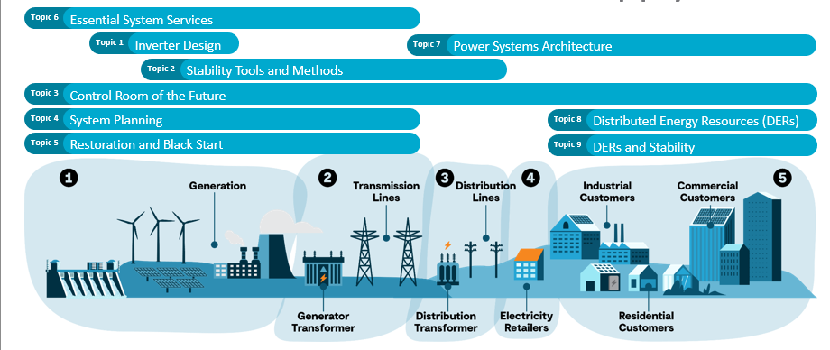

Figure 1 Topics covered by the 2021 AR-PST Research Road Map
In particular, the outputs of the Topics which will influence the development of the GFM Converter Standard are shown in Table 1.
Table 1 AR-PST Research Topics relevant to GFM Converter Standard
Topic number | Topic Title | Relevant to GFM
Topic 1 | Inverter Design | Relevant
Topic 2 | Stability Tools and Methods | Relevant
Topic 3 | Control Room of the Future
Topic 4 | System Planning | Relevant
Topic 5 | Restoration and Black Start | Relevant
Topic 6 | Services
Topic 7 | Power System Architecture | Relevant
Topic 8 | Distributed Energy Resources
Topic 9 | DERs and Stability Methodology | Relevant
The need for GFM capability is becoming a significant issue because of the decrease in synchronous machines associated with electricity generation supplying the system. Most converter-based resources presently connect to the electricity system are ‘grid following’ and thus require the presence of an incoming supply to allow them to stay connected even when generating output to the grid. Traditionally, the synchronous generation is located at the power generation sources. Accordingly, the number of synchronous machines connected is limited. However, if the electricity system generation sources are purely from converter-based sources, which would be the case if all coal fired power stations and only limited oil or gas fired are connected, the presence of GFM converters are seen as being required. As a result, this impacts on many aspects of the operation of power system and a significant issue with respect to system stability. Accordingly, all of the Topic areas referenced in Table 1 above are impacted and research effort is required to fully understand the system wide implications in all these aspects.

General
This section is a description of the methodology adopted associated with the organisational structures examined and being pursued in the development of a dual logo standard between the IEC and IEEE and is an update on the approach that was foreshadowed in the AR-PST Stage 4 Topic 1a report.

Dual logo IEC/IEEE Standard on Grid Forming Inverter Standard
As set out in the AR-PST Stage 4 Topic 1a report, during the course of meetings of IEC SC8A JWG5 “System issues regarding integration of wind and PV generation into bulk electrical grid”, it was recognised that there would be mutual advantage to the IEC and IEEE for a dual logo standard to be developed to cover the newly developing area of Grid Forming (GFM) inverters. Standards Australia representatives have been participating in the activities of IEC SC8A JWG5 since the formation of the committee.
The IEEE 2022 publication of “IEEE 2800 Standard for Interconnection and Interoperability of Inverter-Based resources (IBRS) Interconnection with Associated Transmission Electric Power Systems”, which deals with connection requirements of grid-following inverters connected to electricity transmission systems, was considered to be a valuable basis for the development of a dual logo IEC/IEEE GFM Inverter Standard.
In July 2024, to progress the matter of a joint IEC/IEEE dual logo development, it was proposed that the project progress as a Joint Project utilizing the existing structures and Working Group of IEC and IEEE respectively. This was supported by the SC 8A members and accepted in principle by the IEC TC8 Plenary held in September 2024.
IEEE is now a Category C Liaison member to IEC SC 8A and agreement has been reached to proceed with this joint project and this was confirmed at the 2025 IEC TC8 Plenary Meeting held in Delhi 2025.
The IEEE have identified that there will be a need to make minor amendments to the IEEE 2800 document in order to accommodate the anticipated amendments related to GFM CBR. Additionally, in line with IEEE’s approach to compliance testing, a separate document will be prepared.
As the IEEE 2800 standard deals with grid following CBRs IEEE have three separate activities underway for work in the short/medium term future to cover this deficiency:
- 2800.1 New Recommended Practice for GFM IBR Equipment (being the internal IEEE nomenclature for the Joint IEC/IEEE project
- 2800 Base Std Revision
- 2800a Amendment to reduce barriers to GFM
A further task group P2800-2 Recommended Practice for IBR Conformity Assessment is dormant while the development of the IEC/IEEE project is being completed.
Within the IEC, although there are a range of documents that deal with various aspects of CBR devices, the only standards that have been produced that relate to connection issues to the grid are in the IEC 62786 series of standards. These standards relate to connections to the low and medium voltage systems which are characterised as being typically radial systems. The IEC TS 62786 series is titled “Distributed energy resources connection with the grid - Part 1: General requirements”.
To address this identified shortfall, within the IEC, two parallel projects are underway:
IEC TR 63731 ED1 Grid-forming technology and applications in renewable energy dominated power systems:
This project, which is in the process of creating a technical report, provides a comprehensive analysis of grid-forming (GFM) technology, establishing its critical role in addressing the stability and operational challenges of renewable energy dominated power systems.
PNW TS 8A-219 ED1 Grid Connection Requirements for Converter-Based Resources Interconnecting with Bulk Power Systems:
This project has been initiated to produce a technical specification which will specify minimum performance requirements for the connection of converter-based resources (CBRs) to bulk power systems. It applies to converter-based generation (e.g., photovoltaic and wind power plants), grid-scale energy storage systems, and other converter-interfaced resources operated as grid-connected plants.
The requirements are specified at the interface point(s) of applicability and cover, as a minimum: general connection technical specifications and performance requirements, voltage/reactive-power performance, frequency/active-power performance (including primary and fast frequency response), response to grid abnormal conditions, and power quality.

Scoping of the Joint IEC/IEEE GFM Standard
The joint IEC/IEEE project is seen as fulfilling the gap of providing the grid services provided by enhanced CBR or future CBR.
This is illustrated in Figure 2.
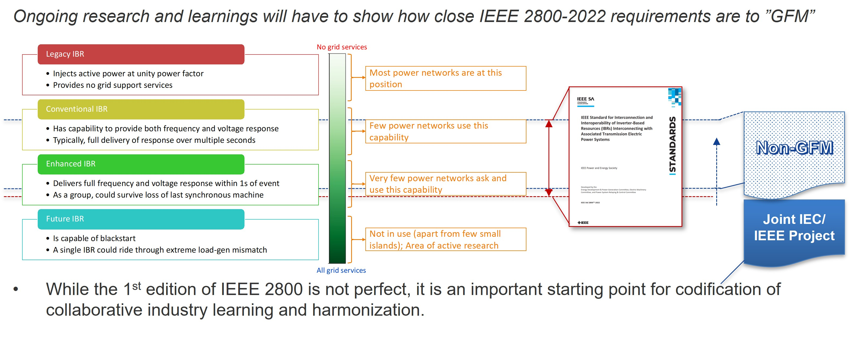

Figure 2 Illustration of possible scope covered by IEEE 2800.
In considering a pathway to the development of the Joint IEC/IEEE GFM standard, it is recognised that performance requirements in terms of interface with the grid or electricity network needs to be defined at the plant level. This is the case for the development of the IEEE 2800-2022 Standard. To achieve the required plant-level performance, it is essential that the required performance is achieved at equipment level.
At the equipment level, it is then dependent on the type of plant as to the particular characteristics of the equipment as to how performance needs to be defined to achieve the plant level performance.
The document being developed for GFM Converters is a framework at plant level to define the performance at the interface between plant and grid or electricity network.
The possible sequencing of the development with respect to IEC and IEEE documents is illustrated in Figure 3.
This illustrates the development of what is referenced in the diagram as a “Framework for Equipment-Level”. Working through IEC TC8/SC8A “Grid Integration of Renewable Energy Generation”, it would be an overarching document defining equipment-level performance for the various types of equipment as defined by the various Technical Committees of the IEC such as:
  - IEC TC82 Solar photovoltaic energy systems
  - IEC TC88 Wind energy generation systems
  - IEC TC114 Marine energy - Wave, tidal and other water current converters
  - IEC TC115 High Voltage Direct Current (HVDC) transmission for DC voltages above 100 kV
  - IEC TC120 Electrical Energy Storage (EES) systems
  - IEC TC22/SC22F Power electronics for electrical transmission and distribution systems
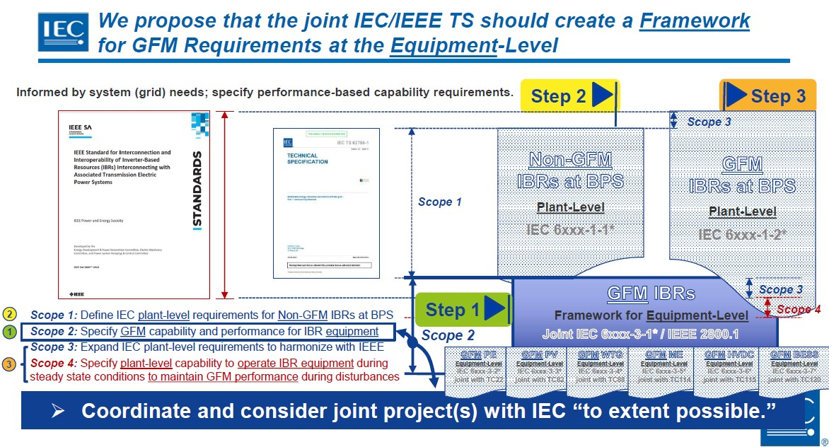

Figure 3 Sequencing of the development of documents related to IEEE 2800

Joint Project Structure IEC/IEEE
As set out in the AR-PST Stage 4 Topic 1a report, the development of the document is being undertaken as a Joint Project. During the initial phase of development of a Working Draft, close collaboration is being maintained between the IEC and IEEE Task Group members who are actively participating in the development. Currently, regular (approximately fortnightly) meetings are being held jointly online.
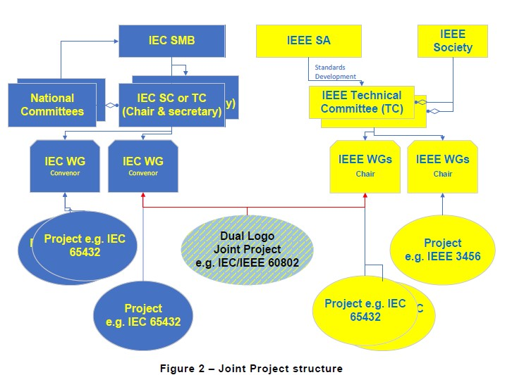

Figure 4 IEC/IEEE Dual logo development - Joint Project approach

When specifically related to the IEC/IEEE Joint Project structure and Working Groups, the structure is as illustrated in general terms in Figure 4 and in more specific terms relevant to this project in Figure 5.
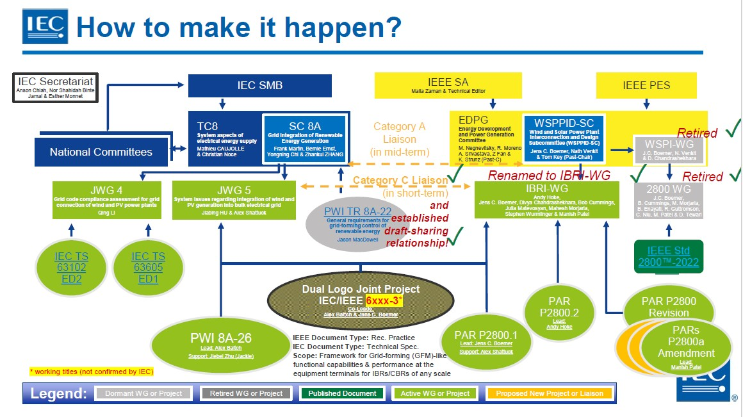

Figure 5 IEC/IEEE Joint project structure
Figure 6 illustrates the IEEE organization structure of the Working Group and identifies the three Project Approval Requests (PARs) that have been processed.
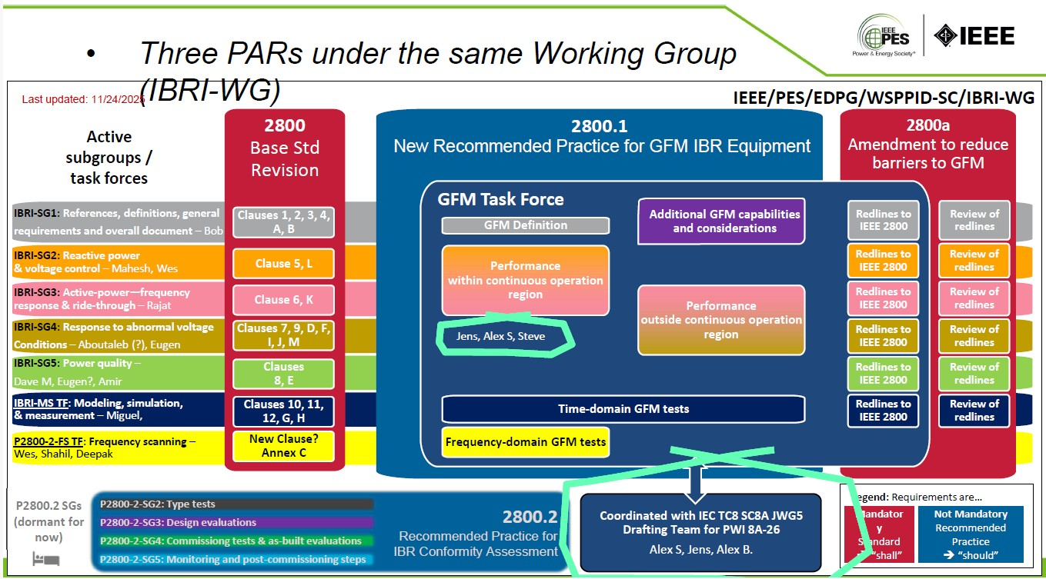

Figure 6 IEEE structure of Working Groups

Meetings held
Since June 2025, the following meetings have been held of SC8A JWG5 in conjunction with participation by representatives of IEEE/IBR-WG as follows:
- IEC SC8A-38 AHG3 JWG5 JWG8 Rome 10-12 June 2025
- IEC SC8A-39 JWG5 Video Meeting August 2025
- IEC SC8A-39A SC8A Plenary 8 September 2025 India
- IEC SC8A-40 JWG5 Video Meeting November 2025
- IEC SC8A-40B JWG5 Vido Meeting 11 December 2025
- IEC SC8A-42 JWG5 Copenhagen 27-29 January 2026
- Throughout this period regular 1.5-hour joint virtual meetings have been held jointly between SC8A JWG5 and of IEEE/IBR-WG members to progress the work. Since February 2026 the meetings have been more frequent on a weekly or fortnightly basis.

Estimated progress compared to original plan (2024)
Activity | Year 1 2024-25  (planned / actual) | Year 2 2025-26  (planned / actual) | Year 3 2026-27  (planned / estimated actual) | Year 4 2027-28  (planned / estimated actual)
Development of Strategy for Joint Project IEC IEEE | 100 % / 80% | 0 % / 100 %
Conversion of Proposed Work Item to a New Work Item Proposal IEC | 10 % / 10 % | 100% / 100 %
Define cooperation arrangement IEC IEEE | 30 % / 30 % | 100% / 100 %
Development of Working Draft for IEC and IEEE | 20% / 20 % | 70% / 60 % | 100% / 100 %
Process Committee Draft through approval stages within IEC |  | 10 % / 10 % | 70 % / 60 % | 100 % / 90%
Review and process with IEC and IEEE through Committee draft stages |  | 10 % / 10% | 70 % / 60% | 100 % / 90 %
This table shows the cumulative annual progress of the project against what was originally anticipated would be completed. Some minor procedural processes works are anticipated in 2028/29. This is on the assumption that consensus is reached on the draft.

Background Documents to the Development of GFM Standards
The AR-PST Stage 4 Topic 1a report sets out the background to the development of GFM Standards and is not being fully repeated in this report. Accordingly, in this report, apart from the functionality described in a CIGRE CSE Report as described in Section 3.1 below, this report focuses on any new documents that have been published since then relevant to GFM standards development.

CIGRE CSE Report
Amongst various other CIGRE Publications published in this area, the paper titled “Grid forming functional specifications and verification tests for North American bulk power system connected battery energy storage systems” by Thant, Isaacs, Unruh, Quint, Ramasubramanian, Matevosyan and Hoke, CIGRE Science and Engineering publication CSE No 34 October 2024 was presented at the CIGRE 2024 Session in Paris and subsequently published as a CIGRE CSE report provides a useful reference for the development of Grid Forming Converters.
The paper summary notes that grids dominated by CBRs in the absence of synchronous resources need a portion of the CBR resource mix to be grid forming to maintain stable operation.
The report includes a useful summary table of functionality required of a GFM Battery Energy System compared to Grid Following Inverter as shown in Table 2.

Table 2 Functional Specifications of GFL and GFM Battery Energy Systems
Capability | Grid Forming | Grid Following
Sub-cycle voltage and frequency support | ü
Phase jump resistance | ü
System strength support | ü
Ability to stably operate with loss of last synchronous machine | ü
Dispatchability | ü | ü
Steady-state voltage control | ü | ü
Dynamic reactive power support | ü | ü
Active-power frequency control | ü | ü
Disturbance ride-through performance | ü | ü
Fault current and negative sequence current contribution | ü | ü
Cyber and physical security | ü | ü
Reference: “Grid forming functional specifications and verification tests for North American bulk power system connected battery energy storage systems” by Thant, Isaacs, Unruh, Quint, Ramasubramanian, Matevosyan and Hoke, CIGRE Science and Engineering publication CSE No 34 October 2024

AEMO

AEMO GFM Technology Access Standards Approach Paper 25 August 2025
In this paper AEMO has observed a rapid increase in the deployment of grid-forming based plants, highlighting the need to revisit and refine the technical requirements in National Electricity Rules (NER) Schedule 5.2.5 to fully leverage GFM plant capabilities. To support the integration of this technology, AEMO initiated a targeted technical review in October 2024, focusing specifically on GFM technology.
AEMO notes that while GFM inverters offer several enhanced capabilities compared to grid-following (GFL) inverters, AEMO recognises that they may also exhibit distinct limitations under certain conditions. AEMO seeks to strike a balanced approach, recognising that reduced performance in certain aspects may be acceptable if the overall capabilities of GFM deliver superior outcomes for the power system and support the Australian National Energy Objectives. (NEO).

Summary of initial recommendations
Firstly, AEMO proposes a clear definition of a GFM plant within the asynchronous category in NER Schedule 5.2. The GFM plants are characterised by an ability to independently establish and regulate an internal voltage phase or behaving as a voltage source behind an impedance and to autonomously oppose rapid changes in voltage magnitude, frequency, and phase angle within a sub-cycle time frames. This enables a practical distinction between GFM and GFL technology and facilitates the development of access standards tailored to each. It also provides clarity for both proponents and network service providers during the connection process.
Secondly, AEMO recommends that Schedule 5.2 plants with GFM inverters are recognised as a subset of asynchronous technology within NER Schedule 5.2.
Thirdly, AEMO proposes a set of changes to NER Schedule 5.2.5, such that these changes clarify how existing standards should be retained or modified to reflect the distinctive characteristics of GFM plant.

UNIFI

UNIFI Consortium
As set out in the AR-PST Stage 4 Topic 1a report Universal Interoperability for Grid-Forming Inverters, the UNIFI Consortium brings together leading researchers, industry stakeholders, utilities, and system operators to advance grid-forming inverter technologies. Led by the National Laboratory of the Rockies, (formerly the National Renewable Energy Laboratory), the University of Texas at Austin, and the Electric Power Research Institute, the UNIFI Consortium focuses on integrating these uniform and standardized grid-forming technologies into electric grids at any scale to accelerate solar and wind deployment.

UNIFI Specification for Grid-Forming Inverter Based Resources V3 October 2025
The UNIFI Version 2 Specification was published in March 2024 and was largely used as the basis of the first draft of the draft dual logo working draft as loaded onto the IEC OSD platform.
In October 2025, the UNIFI V3 document was made available to IEC 8A JWG5 and the IEEE Working Group. This version has now been used as the basis of consideration of the document that was then loaded onto the IEC Online Standards Development platform. Both the UNIFI V3 document wording and the initial documents were visible with a view to reaching alignment of the various participants in the project.
The UNIFI V3 document is intended to be a set of specifications for GFM CBRs that provide requirements at the converter level that are intended to provide means for vendor-agnostic operation of CBRs at any scale in electric power systems.
A more detailed examination of the UNIFI V3 document is provided in Section 4.

ENTSO-E

ENTSO-E Mission
As set out in the AR-PST Stage 4 Topic 1a report ENTSO-E, the European Network of Transmission System Operators for Electricity, is the association for the cooperation of the European transmission system operators (TSOs). The 40 member TSOs representing 36 countries are responsible for the secure and coordinated operation of Europe’s electricity system, the largest interconnected electrical grid in the world. In addition to its core historical role in technical cooperation, ENTSO-E is also the common voice of TSOs of Europe.

ENTSO-E Grid Forming Capability of Power Park Modules, Report on Technical Requirements, Final | 3 October 2025
In the context of grid forming capability for power park modules, this report proposes a first interim non-binding approach of detailing grid forming technical requirements in the national implementation of the amended Network Code on Requirements for Generators (NC RfG).
In addition to outlining detailed requirements, it proposes a range of parameters and compliance tests for GFM-capable power park modules (PPMs).
To the best of ENTSO-E’s knowledge, and without prejudice to existing patents, the report adopts a technology-neutral stance, providing a patent-free and technology-agnostic framework for defining technical requirements for GFM capabilities for PPMs. This approach is intended to ensure independence from specific control implementations or manufacturer patents issued before the report’s publication date, thereby fostering an environment conducive to innovation.
To facilitate the national implementation of NC RfG 2.0 and address stakeholders’ concerns about harmonising requirements while respecting national system needs, in November 2025 ENTSO-E has published the Phase II Report, a consolidated version endorsed by all participating stakeholders. This non-binding document provides technical guidance on GFM requirements under the draft NC RfG 2.0 and will serve as a basis for the future Implementation Guidance Document (IGD) on Grid Forming capability.
The ENSTO-E report states that it is worth noting that GFM technical requirements as auxiliary services have been recently adopted by system operators in Great Britain (GB) and Australia. The National Energy System Operator (NESO) published the GB GFM Best Practice Guide in April 2023 and the Guidance Notes in September 2023 following the inclusion of GFM requirements into the GB Grid Code (GC0137 - Minimum Specification Required for Provision of GB GFM Capability), and the Australian Energy Market Operator (AEMO) released a Core Requirements Test Framework in January 2024 to complement the Voluntary Specification for GFM Inverters. Within the EU, at least one Member State, namely Germany, published in July 2024, a guideline document recommending requirements for an inertia market based on GFM PPMs.
In the regulation, all the connection requirements are evaluated for compliance (either by tests, simulations, or equipment certificates) at the point of connection of the PPM with the grid. In the case of GFM capability and “within the PPM’s current and energy limits, the PPM shall be capable of behaving at the terminals of the individual unit(s) as a voltage source behind an internal impedance…”. Therefore, technical requirements for the voltage source behaviour shall be defined at the terminal of the individual power generating unit(s), while compliance shall be verified as described in Chapter 3.

Approach adopted by ENSTO-E
The technical requirements presented in the ENSTO-E document are based on a simplified equivalent circuit representation of a generating plant and its generating unit(s). Figure 7, that appears in the ENSTO-E document, presents the equivalent circuit representation.
This represents the internal voltage phasor (amplitude, voltage phase angle and frequency) of the Thévenin source of a given generating unit and is illustrated in Figure 7.

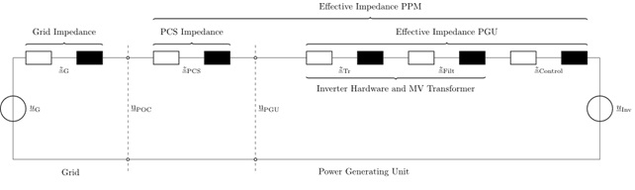

Figure 7 Generating plant small signal equivalent representation [5]

As set out in the ENSTO-E document [5], both the generating units internal voltage phasor (in amplitude, phase, and frequency) and the effective impedance of each generating unit as well as of the generating plant shall be constant upon inception of a network disturbance at the connection point. The output current depends on the severity of the grid disturbance, voltage magnitude change and voltage angle change and the effective impedance.
After inception of a grid disturbance the internal voltage phasor is adapted according to the dynamic behaviour of the internal voltage source.
The dynamic behaviour of the internal voltage source is configured by:
- The minimum damping ratio.
- Steady-state reactive power control requirements of the generating plant according to applicable connection requirements such as EN 50549.
- The synthetic inertia.
Figure 8 shows the principles set out in the ENSTO-E document to limit the unlimited current phasor to the current limits of the generating unit. The generating unit limits the output current only by reducing the current phasor magnitude while maintaining the current phasor angle of the unlimited phasor constant. Active power priority or reactive power priority is not accepted for grid-forming generating units.

Figure 8 : Current limitation requirement reducing the unlimited current phasor to a current phasor within the current capability of the generating unit, while maintaining the current phasor angle constant.[5]

The ENSTO-E approach is different to that adopted by IEEE, UNIFI or other system operators. Accordingly, an effort is currently being made to attempt to reconcile the approaches and accommodate that approach being taken by ENSTO-E within the GFM standard.

Verifying compliance
In Section 2 of the ENSTO-E V3 Report, the Grid Forming Capability at the point of connection of Power Park Modules (PPM) is described as follows:
“Where grid forming capability is specified by the relevant TSO in coordination with the relevant system operator in accordance with NC RfG 2.0 Article Y, or defined in Articles 20, 21 and 22, a power park module shall be capable of providing grid forming capability at the connection point as listed below, considering the sub-cycle character of the physical quantities where appropriate.”
Requirements for power park modules are set out in Chapter 3 of Annex 1 – Amended RfG Regulation of the NC RfD DC Recommendation. Here it states that the compliance evaluation needs to be possible for different power generating units (PGU) technologies in a wide range of nominal power. Two possible test bench setups are presented in Figure 9 and Figure 10.
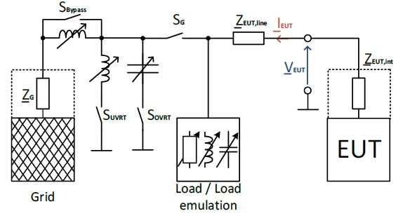

Figure 9 Example of a test setup for evaluating GFM capabilities based on a passive setup
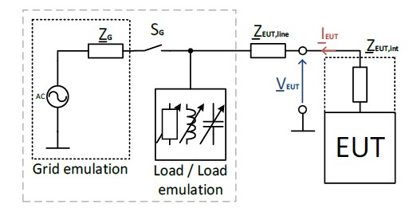

Figure 10 Example of a test setup for evaluating GFM capabilities based on grid emulation

The ENSTO-E report further states that while the compliance is ultimately being evaluated at the PGU level, the Equipment Under Test (EUT) does not necessarily need to be a complete PGU and could contain PPM-level controls if necessary. A further reference to testing is at [8]. Depending on the size of the PGU, technology, and behaviour to be evaluated, relevant standards provide multiple options to conduct tests. Because the voltage source and inertia requirements affect the fundamental control and the mechanical, electromagnetic and electromechanical behaviour of a PGU, the test setup and EUT must be defined with great care.
The following four main tests items for GFM capabilities are proposed:
- Voltage source behaviour of the PGU
- Synthetic inertia behaviour of the PGU
- When reaching current capability limits
- Controller interactions of GFM PGUs
The following additional tests are described as interim but unverified tests:
- Islanding (loss of last synchronous generator)
- Phase jump
- Synthetic inertia evaluation of the PGU
- Damping ratio of active power oscillations
- Under- and over-voltage events
- Severe rate of change of frequency (ROCOF) events
- Phase jump events
- Impedance spectroscopy
- Closed loop stability

ENSTO-E Stakeholder comments
In reviewing ENSTO-E Final 3 October 2025 report, it is valuable to note that at Appendix G an extensive treatment is presented of the Stakeholder’s deviating positions.

CENELEC
In brief, TC8X WG03, the committee that represents CENELEC, agrees with the technical contents of the ENSTO-E report. However, it is emphasized that this does not provide the required degree of technical details to allow an effective harmonization in Europe.
To avoid a further differentiation of national requirements, especially for technically challenging items such as GFM, CENELEC states that the application of international and European standards must become the principle in all Member States and national implementations deviating from or exceeding European standards must become the exception.
Therefore, the reference to standardisation in the Article 7 of the draft NC RfG 2.0 needs to be strengthened, and standards must not only be “considered” but also must be “applied” and deviations from European standards must be reasoned and should only be accepted by National Regulatory Authorities (NRAs) if technically not avoidable.

SolarPower Europe
SolarPower Europe state that ENSTO-E report is an important step toward harmonised implementation and, with further clarification, can support the integration of inverter-based, renewable energy resources to strengthen grid stability across Europe. Despite the value of harmonised EU-wide requirements, SolarPower Europe’s position remains unchanged: mandatory deployment of GFM inverters should not be pursued. Instead, GFM and inertia services should be procured transparently, through competitive markets, in line with the Electricity Directive (EU) 2019/944. Compliance frameworks should define only the required capabilities based on performance criteria without prescribing control architectures and consider technology readiness, while remaining technology-agnostic within the same Technology Readiness Level (TRL), ensuring cost efficiency and fostering innovation.

WindEurope
WindEurope states that GFM capabilities will be essential for contributing to power system inertia and ensuring stability in the future power system. However, changing the technical characteristics of renewables and High Voltage Direct Current (HVDC) systems is not easily achievable within a few years with minor control modifications. The change will be much more profound and will need to be driven by solid industry and regulatory consensus. These upgrades will come with higher capital and operational costs, creating financial risks for developers and consumers. Full GFM capabilities from wind turbines remain several years away. Without the right market incentives to scale up clean technologies that enhance system stability, Europe risks continued reliance on fossil fuel-based systems dependent on imported gas. This would directly hinder progress toward Europe’s goals of energy independence, economic competitiveness and climate neutrality

Energy Storage Europe Association
Generally, the Energy Storage Europe Association considers the ENTSO-E report as an insightful tool not only in identifying which GFM capabilities must be met to comply with future EU grid needs, but also in setting a framework for TSOs to account for European stakeholders, including energy storage providers, in assessing and delivering GFM capabilities.
However, the Energy Storage Europe Association sees this report as a starting point for further analysis of the types of storage units that support the development of PPMs with GFM capabilities.
More specifically, even if the ENTSO-E report acknowledges the importance of including storage module units, it does not differentiate between batteries and other inverter-based technologies. Consequently, the specific strengths of different storage solutions in providing GFM capabilities are only partially reflected.

National Energy System Operator

NESO
As set out in the AR-PST Stage 4 Topic 1a report, the National Energy System Operator (NESO) is the system operator for Great Britain. Its role is to make sure that Great Britain has the essential energy it needs by ensuring supply meets demand at all times.
The UK’s 2023 Energy Act established an independent system planner and operator to help accelerate Great Britain’s energy transition, creating the National Energy System Operator (NESO).
NESO is built on the previous experience as the Electricity System Operator (ESO), where ESO had extensive expertise in balancing electricity supply and demand 24/7, whilst making sure the networks were operated and the markets were prepared for the future.
NESO has taken over the electricity system operation from National Grid Electricity System Operator Limited (NGESO) and responsibility for gas system planning from National Gas Transmission plc (NGT).
In a paper by NESO authors [6] the Great Britain (GB) energy system operator, aims to share its best practice for the introduction and development of emerging grid-forming (GF) capability for voltage-sourced-converter-based technological applications, including but not limited to high-voltage direct current (HVDC), the flexible ac transmission system, and other converter-based applications within GB energy markets, through its strategic development

Grid Forming Guidance Note - Issue 3 (Sep 2025)
In addition to various publications referred to in the AR-PST Stage 4 Topic 1a report, the Grid Forming Guidance Note Issue 3 provides additional description of the technical studies and testing set out within the Grid Code for Grid Forming Technology. The other general technical requirements such as reactive power capability, voltage control, PSS Tuning/Damping control, FSM/LFSM control and FRT are covered by other published Guidance Documents.
An Expert Working Group is currently formulating recommendations in preparation for a formal Grid Code Modification. The objective is to modify and clarify various clauses, tests, and definitions, drawing on insights gained from practical experience. Among the topics under discussion are the clarification and simplification of definitions such as Active ROCOF Response Power, Active Control Based Droop Power and Active Control Based Power; simplifying Schedule 20 of the Data Registration Code; and refining the technical requirements relating to Fast Fault Current Injection and Peak Current Rating.

Summary
As evident from the above review of recent additional material, the matter of GFM Converters is in an active stage of development with many entities defining requirements, largely with similar objectives.

Results to date in development of GFM standards

As described in Section 2.6 during the course of 2025-26 and 2026-27 calendar years the major development work of a Working Draft is undertaken. This process is now well underway with the objective that by June 2026 progress is to reach 70% completion. While it is recognised that the most demanding and challenging activities to achieve completion are the last 10 to 20%, there is a level of confidence that this will be achieved.
Multiple challenges are faced when developing a new standard in an area that is still immature and under development. The objective of producing a standard document at the early phase of the maturity of the technology and definition of requirements, is to establish a consistent foundation at an early stage in order to provide some direction to manufacturers, while at the same time seeking not to limit technological development.

Challenges faced
Identified challenges include:
- Alignment of terminology used in IEEE’s standard on grid following IBRS (2800-2022) with its structure and ultimate desire for some consistency between the structure of the IEEE document, the IEC terminiolgoy and the terminology used in the dual-logo IEC/IEEE standard that is under development
- The published UNIFI V3 GFM standard does not fully align with the structure of the IEEE 2800-2022 standard and the dual log IEC/IEEE document will require realignment with the existing IEEE document. Additionally, the IEC document that is under development for the broad range of converters will need to be aligned with the dual logo IEC /IEEE standard.
- The language of the UNIFI V2 and V3 specifications is written in a descriptive form, The wording needs to be adapted in order for it to be applied to a standard as a normative document.

- The terminology adopted by IEC and IEEE is not fully aligned and consideration is required to establish how multiple language forms can be adapted.
- For comparison purposes, the wording of the UNIFI V3 document has been populated into the draft OSD document together with the initial draft version.
- ENSTO-E, as a representative body, has put forward an approach of a voltage source behind an impedance that has not been considered with the work of IEEE, UNIFI and various system operators. However, there is recognition that the approach has merit. A way of accommodating the ENSTO-E approach needs to be found.
- There have been procedural challenges in terms of providing committee-in-confidence documents prepared within the IEC and within the IEEE to personnel of the other organisation where a member is of only a member of one of the organisations. Workarounds have been developed to address this issue, albeit the workaround addresses he issue, but nevertheless not ideal.
- Dealing with divergent views of technical requirements in a developing area
- Availability of experts to participate in collaborative work
- Dealing with different time zones across the world for cooperative work
- Applying the Online Standards Development tool introduced by the IEC.

Despite all to these challenges, there is strong desire on the part of all participants in this project to overcome the challenges and to produce a framework document that will result in a joint IEC/IEEE publication.

Examination of UNIFI V3 clauses

General
A significant focus of the development has been an examination of the UNIFI V3 document [10] and it has been added to the initial version of the working draft with a view to identify clauses that are the most appropriate.

Grid-Forming Controls
The UNIFI V3 document defines GFM CBR controls as follows:
“GFM CBR controls maintain an internal voltage phasor, i.e., ac voltage magnitude and angle, that is constant or nearly constant in the sub-transient to transient time frame.”
The time frames specified in this section are intended as general descriptions rather than requirements or hard limits as sub-transient and transient times are a function of machine characteristics. This definition means that the GFM CBR will nearly immediately (in the sub-transient time frame) begin to respond to changes in the external system and attempt to maintain CBR control during challenging network conditions to maintain grid stability. In GFM CBRs, the voltage phasor is controlled to maintain synchronism with other devices in the grid at steady-state conditions while regulating the active and reactive power appropriately to support the grid.
Because different types of GFM CBRs have different capabilities and limitations, the UNIFI V3 document proposes four tiers of GFM device capability as illustrated in Table 3.
Table 3 UNIFI V3 GFM Performance Tiers (UNIFI V3 Table 1)
GFM Tier | Key Function(s) | Examples of Resource Types | Notes
1 | Voltage magnitude support | GFM STATCOM
2 | Voltage angle/frequency support & minimum islanding capability | GFM E-STATCOM, GFM wind turbine (Type 3 and Type 4), GFM PV | Active power contribution is subject to complex intermittency, asymmetry, headroom, and resonance (for GFM IBRs with rotating machines) aspects.
3 | Voltage angle/frequency support & extended islanding capability | GFM BESS
4 | Black start | GFM BESS with black start

Comparison with the ENSTO-E and UNIFI Tiers
This is an issue for development as there is some contention with respect to the appropriateness of dividing performance in these tiers. This is illustrated in comparing the ENSTO-E and UNIFI Tiers shown in Figure 11, where the ENSTO-E view is that the functionality described should not be limited to the UNIFI V3 tiers.
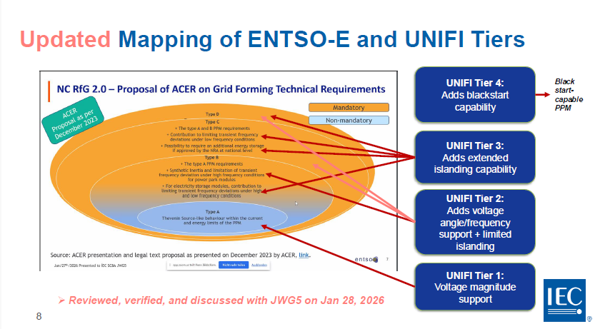

Figure 11 Mapping of ENTSO-E and UNIFI tiers

Performance Requirements for GFM CBRs
The clauses as they appear in the UNIFI V3 document are examined and, as appropriate, the relevant clause number where the clause currently appears in the OSD draft is noted.
The performance requirements for GFM resources connected to an electric power system based on the GFM tiers are to be provided regardless of the type of GFM resource and the strength of the grid to which it is connected.
The first column of UNIFI V3 Table 4 summarizes the GFM requirements and each requirement is described in more detail in the remainder of this section. Table 4 also states which requirements are unique to GFM CBRs and which are not.
Table 4 Overview of Requirements and Tests (UNIFI V3)
Requirement | IEC IEEE OSD Draft WD Clause | GFM Has a Unique Requirement? | Applicable Test
2.1.1: Autonomously Support the Grid | 6.1.1 | No | NA
2.1.2: Dispatchability of Power Output | 6.1.2 | No | NA
2.1.3: Provide Positive Damping of Voltage and Frequency Oscillations | 6.1.3 | Some GFL could comply depending on oscillation frequency | Frequency scan tests in Section 6 and Appendix A. Also spot-checked in various time-domain tests in Section 5.
2.1.4: Active and Reactive Power Sharing across Generation Resources | 6.1.4 | No | 5.9: Loss of Grid Connection Test
2.1.5: Operation in Grids with Low System Strength | 6.1.5 | Yes, for very weak grids | 5.3: System Strength Test
2.1.6: Operation under System Unbalance | 6.1.6 | Some GFL comply | 5.4: Unbalance Step-Up Test
2.2.1: Voltage Ride-Through Capability | 6.2.1 | No | Refer to relevant interconnection standard, e.g. IEEE 2800 or IEEE 1547
2.2.2: Performance During Symmetrical Faults | 6.2.2 | Some GFL comply | 5.5: Fault Test (informative)
2.2.3: Performance During Asymmetrical Faults | 6.2.3 | Some GFL comply | 5.5: Fault Test (informative)
2.2.4: Abnormal Frequency Ride-Through Capability | 6.2.4 | No | Refer to relevant interconnection standard, e.g. IEEE 2800 or IEEE 1547
2.2.5: Performance in Response to Frequency Deviations | 6.2.5 | Yes, in sub-transient timeframe. | 5.6: Response to Frequency Change Test
2.2.6: Performance During Phase Jumps and Voltage Steps | 6.2.6 | Yes | 5.7: Phase Angle Jump Test  5.8: Small Voltage Step Test
3.1: Intentional Islanding | 7.1 | Yes | 5.9: Loss of Grid Connection Test
3.2: Black Start and System Restoration | 7.2 | Yes | Requirements are application-specific; no generic test provided here.
3.3: Regulating Voltage Harmonics | 7.3 | Some GFL comply at least partially | No consensus on quantitative GFM-specific requirement; no test provided here. Relevant interconnection standard applies.
3.4: Communications between System Operator and IBR Plant | 7.4 | No | NA
3.5: Secondary Voltage and Frequency Signal Response | 7.5 | No | NA

Autonomously Support the Grid
Clause 2.1.1 of UNIFI V3 states that “GFM CBRs are expected to autonomously respond to changes (both transient and steady state) in their locally measured signals (e.g., terminals of CBR or point of interconnection (POI) voltage, current, and frequency) to support the local power system per the appropriate GFM performance tier.”

Dispatchability of Power Output
Clause 2.1.2 of UNIFI V3 states that “When operating as part of an interconnected grid, a GFM CBR plant’s steady state power output, within the normal range of voltage magnitude and frequency, should be dispatchable either through system operator control or by a locally determined goal that may be based upon a market clearing solution. GFM resources in Tiers 1 are not required to have dispatchable active power, but shall have dispatchable reactive power. Tier 2 GFM resources may or may not have dispatchable active power, but shall have dispatchable reactive power. Tier 3 and Tier 4 GFM resources shall have dispatchable active and reactive power capability.

Provide Positive Damping of Voltage and Frequency Oscillations
Clause 2.1.3 of UNIFI V3 states that “It is expected that a GFM CBR will present a non-negative resistance or damping to the grid within the frequency range of common grid electrical resonances to prevent the initiation of any adverse interactions or oscillations.

Active and Reactive Power Sharing Across Generation Resources
Clause 2.1.4 of UNIFI V3 states that “A GFM CBR is expected to autonomously share power (e.g., incrementally increase or decrease power burden within its capability) with other generation resources at all times using the principles of droop akin to the operation of conventional synchronous generators or GFL CBRs. CBRs in all GFM Tiers shall share reactive power. For Tier 1 GFM IBRs, only reactive power sharing is required. Tier 2 has limited active power sharing capability, and Tiers 3 and 4 have full active power sharing capability.”

Operation in Grids With Low System Strength
Clause 2.1.5 of UNIFI V3 states that “A GFM CBR is expected to operate stably when connected to a power system with a low system strength, as evaluated in the test described in Section 5.” Section 5 of UNIFI V3 which deals with GFM Conformity Assessment Procedures,

Operation Under System Unbalance
Clause 2.1.6 of UNIFI V3 states that “A GFM CBR should not actively oppose or prevent the flow of negative sequence current for small levels of voltage unbalance.”

Performance Requirements for Operation Outside Normal Conditions

Voltage Ride-Through Capability
Clause 2.2.1 of UNIFI V3 states that “A GFM CBR is expected to ride-through events that result in operations outside normal limits. The ride-through capability should follow applicable standards (e.g. IEEE 1547, IEEE 2800) or grid operator requirements. This includes not just voltage ride-through, but also ride-through of other events specified by the relevant standard or system planner such as voltage phase angle jumps.”

Performance During Symmetrical Faults
Clause 2.2.2 of UNIFI V3 states that “During symmetrical undervoltage events (e.g. due to faults) and symmetrical overvoltage events, a GFM IBR is expected to maintain a balanced internal voltage to the extent possible within its physical limits. The GFM IBR should inject current to oppose the change in voltage.”

Performance During Asymmetrical Faults
Clause 2.2.3 of UNIFI V3 states that “During asymmetrical faults, a GFM CBR is expected to maintain a balanced voltage to the extent possible within its physical limits. This naturally results in the GFM CBR outputting unbalanced currents, including negative sequence currents.”

Abnormal Frequency Ride-Through Capability
Clause 2.2.4 of UNIFI V3 states that “As long as the frequency remains within the must-not-trip region defined by the system planner or by the applicable standard (e.g. IEEE 1547-2018, IEEE 2800-2022, or other applicable requirements or standards), a GFM IBR is expected to ride through frequency events.”

Performance in Response to Frequency Deviations
Clause 2.2.5 of UNIFI V3 states that “A GFM CBR is expected to modulate active power as required during and after frequency changes to aid in frequency recovery and stability. Tier 1 GFM IBRs are excepted from this requirement.”

Performance During Phase Jumps and Voltage Steps
Clause 2.2.6 of UNIFI V3 states that “A GFM CBR is expected to absorb or inject active and/or reactive power to resist changes in positive sequence voltage phase angle and is expected to do so unless it exceeds an equipment limit. Similarly, a GFM CBR is expected to absorb or inject reactive/active power to reduce changes in the positive sequence voltage magnitude. Active power injection is not required for Tier 1 GFM CBRs

Additional GFM Capabilities defined in UNIFI V3

Intentional Islanding
Clause 3.1.1 and 3.1.2 of UNIFI V3 states that “Intentional islands are parts of electrical power systems that operate separately from the main power grid. Examples include islanding of an area in a larger interconnected transmission system or formation of a microgrid in the distribution network. Intentional islanding covers both planned and unplanned events.
A GFM IBR that is designed to maintain an intentional island (i.e. Tier 3 and Tier 4 GFM IBRs) is expected to be capable of maintaining stable voltage and frequency when intentional islanding occurs.”

Black Start and System Restoration
Clause 3.2.1 and 3.2.2 of UNIFI V3 states that “GFM CBRs in GFM Tier 4 are designed and programmed to provide black start services. If implemented, these black start services should be coordinated with system operators to help in system restoration from black-out conditions. Having GFM CBRs with black start capabilities may be essential in high IBR penetration grids since the black start capability may no longer be provided by synchronous machines. Not all GFM CBRs are expected to be able to provide black-start services since it may require additional hardware, design, and functionalities, and therefore implementing black-start capability may incur additional cost and require special coordination with system operators”.
Those GFM IBRs that are designated to provide black start services should be designed to be
able to:
- Start and establish the voltage without an external voltage or frequency reference at the ac terminals.
- Supply transformer, cold-load, and other inrush current needed within the GFM IBR limits. This process is a key step in black start, since it may cause significant inrush current, especially from transformers and motor loads, which is, in general, more challenging when using IBRs than synchronous generators due to lower overcurrent capability. To facilitate restoration, it may be useful to soft start loads (i.e., by ramping up the output voltage at a programmable rate).
- Provide a steady voltage reference for GFM and GFL IBRs and other resources to synchronize to and facilitate a smooth system restoration including synchronization with other restored portions of the grid. Note some GFM IBRs may be configured to synchronize their own voltage and phase angle to a primary GFM that is providing the voltage waveform for the entire system.
- If designed to operate in parallel with other black-start GFM IBRs, it should be able to achieve a collective black start. This is optional and only needed for black starts using multiple GFM IBRs. This technique is used when the baseline load exceeds one single GFM IBR’s capability. This functionality may incur additional complexity, but it would increase flexibility and survivability of the system.

Regulating Voltage Harmonics
Clause 3.3.1 of UNIFI V3 states that “The harmonic distortion of the line-to-neutral voltage waveforms produced by a GFM IBR plant should comply with the requirements of the system planner. As a result, a GFM IBR may inject harmonic currents at its point of interconnection to aid in reducing the amplitude of voltage harmonics induced by other power system components. It is not required that GFM IBRs actively mitigate voltage harmonics emanating from the AC grid side.”

Communications Between System Operator and IBR Plant
Clause 3.4.1 of UNIFI V3 states that “When communications are required between the GFM CBR units or plant and the system operator, a cyber-secure communications method should be used. The power system and the GFM CBR should continue to function as specified by the system operator when communications are delayed or interrupted. It is expected that signals from the power system operator or an aggregator would have an update rate of the order of seconds and represent a secondary control signal (primary control being autonomous controls inside the IBR unit) for providing power flow set points or other commands. Faster communications may be needed to respond to transient conditions. A GFM CBR or CBR plant and associated equipment may also provide signals back to the power system operator. Examples of these signals include status signals such as online devices, switch states, capacity and headroom, and metered values such as frequency, voltage, or power flows. Distribution-connected GFM CBRs will be required to have the capability of communicating as specified by the system operator and respective interconnection standard”.

Secondary Voltage and Frequency Signal Response
Clause 3.5.1 of UNIFI V3 states that “GFM CBR plants that are expected to participate in secondary control, should be able to receive an external signal that enables power flow control from a system operator. This is known as the secondary control signal since the CBR unit or CBR plant receives an external signal to adjust power output. Once it receives new setpoints, the GFM CBR plant is expected to operate (within the GFM CBR's limits) at the new steady state condition within the time specified by the system operator. Tier 1 GFM CBRs are not required to be capable of participating in secondary frequency control. Tier 2 GFM CBRs may also be exempted from this requirement”.

Further work
As set out in Section 4.1 a number of challenges need to be addressed in carrying the further work forward to a successful conclusion.
While the UNIFI V3 document provides a valuable descriptive framework of the objectives that need to be met for the various parameters that have been defined, they have mostly been provided in a descriptive manner and without quantification. It would be valuable to define normative values or ranges. Whether or not that could be achieved in the first round of development is yet to be seen. However, it is important that a framework be put in place that can lead to consistent development.

Comparison of IEC/IEEE OSD Working draft with ENSTO-E CENELEC
As set out in the ENSTOE-E/CENELEC publication, it is desirable that the requirements be defined in such a way that there is uniform adoption and not a range of regional or national variations. If that was to occur, there is concern that appropriate guidance would not be provided to manufacturers and industry. However, the approach presented and developed by ENSTO-E/CENELEC does not currently align with the approach developed by the UNIFI/IEEE experts or that of other researchers. Nevertheless, there is confidence that the approaches will be reconciled.
A comparison of the structure/content of the IEC/IEEE OSD working draft with the structure of the ENSTO-E/CENELEC document (in early draft form) is shown in Table 5.
Table 5 Draft comparison of the structure and content IEC/IEEE OSD working draft with the structure of the ENSTO-E CENENLEC document
Requirement | GFM Has a Unique Requirement? | Applicable Test | Mapping to ENTSO-E Structure
6.1.1: Autonomously Support the Grid | No | NA
6.1.2: Dispatchability of Power Output | No | NA | Not included, considered not a GFM issue
6.1.3: Provide Positive Damping of Voltage and Frequency Oscillations | Some GFL could comply depending on oscillation frequency | Frequency scan tests in Section 10 and Appendix A. Also spot-checked in various time-domain tests in Section 9. | 2.3.1 voltage source requirement
6.1.4: Active and Reactive Power Sharing across Generation Resources | No | 9.9: Loss of Grid Connection Test | Not included, considered not a GFM issue
6.1.5: Operation in Grids with Low System Strength | Yes, for very weak grids | 9.3: System Strength Test | 2.3.1 voltage source requirement
6.1.6: Operation under System Unbalance | Some GFL comply | 9.4: Unbalance Step-Up Test | 2.3.1 voltage source requirement
6.2.1: Voltage Ride-Through Capability | No | Refer to relevant interconnection standard, e.g., IEEE 2800 or IEEE 1547 | Not included, considered not a GFM issue
6.2.2: Performance During Symmetrical Faults | Some GFL comply | 9.5: Fault Test (informative) | 2.3.1 voltage source requirement
2.3.3 when reaching capability limits
6.2.3: Performance During Asymmetrical Faults | Some GFL comply | 9.5: Fault Test (informative) | 2.3.1 voltage source requirement
2.3.3 when reaching capability limits
6.2.4: Abnormal Frequency Ride-Through Capability | No |  | Not included, considered not a GFM issue
6.2.5: Performance in Response to Frequency Deviations | Yes, in sub-transient timeframe. | 9.6: Response to Frequency Change Test | 2.3.2 synthetic inertia
7.1: Intentional Islanding | Yes | 9.9: Loss of Grid Connection Test | Out of scope
7.2: Black Start and System Restoration | Yes | Requirements are application-specific; no generic test provided here. | Out of scope
7.3: Regulating Voltage Harmonics | Some GFL comply at least partially | No consensus on quantitative GFM-specific requirement; no test provided here. Relevant interconnection standard applies. | 2.3.1 voltage source requirement
7.4: Communications between System Operator and IBR Plant | No | NA | Not included, considered not a GFM issue
7.5: Secondary Voltage and Frequency Signal Response | No | NA | Not included, considered not a GFM issue
—GAP— | Yes | —GAP— | ***Some content included in the ENTSO-E documents that is not yet included in UNIFI and IEEE documents (gaps to be filled)***

Insights re future direction and future work

Short term
In the short term, the following issues need to be addressed:
- Continue with development of the Working Draft with the Task Team Experts.

Medium term
Following development of the Working Draft, the procedural processes of review by both IEC and IEEE through each respective organisation
This will involve issuing the documents as Committee Drafts (CD) within the IEC and the corresponding process within the IEEE. The comments received will then need to be reviewed by both the IEC and IEEE Task Teams and synchronised
In the process of review, the objective is to confirm that the draft:
- Defines the performance requirements for grid connection of GFM Converter
- Provides the anticipated framework document
- Is of a form that System Operators can specify and use the standard within their regulatory processes.

Long term
The long-term objective (3-5 years) is to complete the production of a GFM standard.

Risks being faced
As set out in the Project Plan, a description of the SWOT Items is included in Table 6
Table 6 SWOT Items, Description and Measures being taken
SWOT ITEM | Description | Measures
Strength | A broad set of stakeholders, including many original equipment manufacturers (OEMs) | A positive pressure point to achieve a successful outcome
Strength | Leveraging of subject matter experts (SMEs) from regions with substantial practical technical and regulatory experience | Alignment of objectives amongst participants being harnessed to overcome any obstacles
Strength | Given the standing of IEC and IEEE standards as they are produced by industry experts through a consensus process, they are seen be authoritative. It provides more weight for potential adoption by entities such as system operators.
Weakness | Additional administrative burden | This issue not a key issue at Working Draft development stage. However, regular coordination required.
Weakness | More complicated consensus building | Issue to be resolved during formal voting stages
Weakness | Potential delays | Issue to be resolved during formal voting stages
Opportunities | Precedence for successful joint standards like IEC/IEEE 60802 standards, including 802.11 Wi-Fi standard | Advantage being taken on this precedent
Opportunities | One step towards an International Standard (IS) | Important step to eventual IS. That is why an interim TS is required to be developed as a dual logo document.
Opportunities | One set of harmonized specifications | Key objective.
Opportunities | Reduction of technical barriers for products in a global market | Key factor for international compatibility
Threats | IEC Technical Committee (TC 8 and other TCs) have or are moving ahead or IEEE Committees moving ahead of IEC | Managed by ensuring alignment of this project within both IEC and IEEE with any other initiatives
Threats | Lack of coordination could create diverging sets of specifications | Constant and regular meetings to ensure alignment
Threats | If not coordinated properly, sub-par specifications could impact bulk power system reliability | Constant and regular meetings to ensure alignment
Threats | IEC or IEEE policy issues impeding progress | To be managed if they arise. Current issue of dual logo Technical Specifications not complying with dual logo policy under management.

Conclusion
The AR-PST Stage 5 Topic 1-2 Grid Forming Standard Development project that was initiated in July 2024, has established in principle the framework and proposed structure of the development of a dual logo IEC/IEEE standard.
It is recognised that the process of standards development, particularly when aiming to align activities of the two or more large organisations, is challenging.
The introduction of new tools within the IEC referred to as Online Standards Development (OSD) provides an opportunity to facilitate open processes for the development of standards. This has introduced an additional challenge with respect to provision of broader access to documents, although work arounds are being applied.
The development of an initial working draft will take place during the 2026 calendar year.

Glossary
Term | Definition
AEMO | Australian Energy Market Operator
Amprion | Transmission system operator active in Germany and Europe
AR-PST | Australian Research in Power Systems Transition
BESS | Battery Energy Storage System
CBR | Converter Based Resources
CD | Committee Draft (IEC)
CENELEC | European Committee for Electrotechnical Standardisation (Comité Européen de Normalisation Électrotechnique)
CSIRO | Commonwealth Scientific and Industrial Research Organisation
DER | Distributed Energy Resources
DNSP | Distribution Network Service Provider
IEC | International Electrotechnical Commission
IEEE | Institute of Electrical and Electronic Engineers (USA)
ENTSO-E | European Network of Transmission System Operators for Electricity
ERCOT | Electric Reliability Council of Texas
Fingrid | Finland’s transmission system operator
GFM | Grid-forming
G-PST | Global Power System Transformation Consortium
IBR | Inverter Based Resources
IEC | International Electrotechnical Commission
IEC SC 8A | IEC Subcommittee 8A - Grid Integration of Renewable Energy Generation. A subcommittee of the International Electrotechnical Commission.
IEC TC8 | IEC Technical Committee 8 - System aspects of electrical energy supply
IEEE | Institute of Electrical and Electronics Engineers
IEEE 2800 | Standard for Interconnection and Interoperability of Inverter/Converter-Based Resources (IBRs/CBRs) Interconnecting with Transmission Electric Power Systems
IEEE 2800-2022 | IEEE Standard for Interconnection and Interoperability of Inverter-Based Resources (IBRs) Interconnecting with Associated Transmission Electric Power Systems
ISON | International System Operator Network
NC RfG | Network Code on Requirements for Generators (Europe)
NERC | North American Electric Reliability Corporation
NGESO | National Grid Electricity System Operator (UK)
NLR | National Laboratories of the Rockies (formerly the National Renewable Energy Laboratory (NREL)
OEM | Original Equipment Manufacturer
OSD | IEC Online Standards Development Platform
PGU | Power Generation Unit
PPM | Power Plant Module
ROCOF | Rate of Change of Frequency
SG | Synchronous generator
UNIFI | The UNIFI (Universal Interoperability for Grid-Forming Inverters) consortium is a U.S. Department of Energy Solar Energy Technologies Office funded effort to advance grid-forming inverter technology, led by the National Laboratory of the Rockies (NLR).
VDE | Association for Electrical, Electronic & Information Technologies

References

Australian Energy Market Operator (AEMO). GFM Technology Access Standards Approach Paper 25 August 2025
CSIRO - AEMO Australian power systems renewables transition research. Topic 1 – Inverter Design – Development of capabilities, services, design methodologies and stanrdards for Inverter Base Resources (IBRs). Topic 1a) Grid Forming Standards Development by Alex Baitch June 2025.

Ernst P, Denninger R, Singer R, Scholl C, Schaupp T, Rauscher F, Massmann J, Hennig T, Kuchler S, Rogalla S, Grid-Forming-Benchmarking-Project – Part II: Comparative Analysis of the properties of “Support to Power Quality, Operation during Critical Grid Events and Controller interactions”. Wind and Solar Integration Workshop, Berlin Germany Oct 2025.
Ernst P, Denninger R, Singer R, Scholl C, Schaupp T, Rauscher F, Massmann J, Hennig T, Kuchler S, Rogalla S, Grid-Forming-Benchmarking-Project – Part III: Comparative Analysis of the properties of “Voltage Sources Properties” and “Inertial Response”. Wind and Solar Integration Workshop, Berlin Germany Oct 2025.
ENSTO-E, SolarPower Europe, WindEurope, DCO Entity, DSOs for Europe, CENELEC, Energy Storage Europe; Grid forming capability of Power Park Modules, Report on Technical Requirements, Final 3 October 2025
Kong, D, Johnson A, Zhou X Best Practice, IEEE power & energy magazine, March / April 2025, 1540-7977/25©2025 IEEE.
National Energy Operator (NESO) Grid Forming Guidance Note – Issue 3 (2025) https://www.neso.energy/document/301686/download
Rogalla, S., Ernst, P., Lens, H., Schaupp, T., Schöll, C., Singer, R., Ungerland, J.: Grid-forming converters in interconnected power systems: Requirements, testing aspects, and system impact. IET Renew. Power Gener. 1–14 (2024). https://doi.org/10.1049/rpg2.12967
Thant, Isaacs, Unruh, Quint, Ramasubramanian, Matevosyan and Hoke (Oct 2024); Grid forming functional specifications and verification tests for North American bulk power system connected battery energy storage systems, CIGRE CSE Report No 34.
Universal Interoperability for Grid-Forming Inverters (UNIFI) Consortium Specification for Grid-Forming Inverter Based Resources V3 Oct 2025
As Australia’s national science agency,
CSIRO is solving the greatest challenges through innovative science and technology.
CSIRO. Creating a better future for everyone.
Contact us
1300 363 400
+61 3 9545 2176
csiro.au/contact
csiro.au

Inverter Based Resources (IBR) are a subset of the broader category of Converters and only includes conversion from DC to AC. Accordingly, to cover battery charging modes, the more general term of Converter Based Resources is adopted by the IEC. In the IEEE, IBR is more commonly used.
Refer to the Glossary at the end of this report
https://www.entsoe.eu/about/inside-entsoe/objectives/

