Australia’s National
Science Agency
Australian Research in Power Systems Transition (AR-PST) Topic 3 Stage 5 Control Room of the Future

  - Final Report: Human-Centred Information Visualisation for Improved Situational Awareness & Critical Decision Making in Energy Control Rooms
Dr Sarah Goodwin
Dr Mor Vered
Dr Caddie Gao
Dr Lee Lawrence
Dr Benjamin Tag
Dr Michael Wybrow
Dr Markus Wagner
Dr Tim Dwyer
Dr Yidan Zhang

Monash University, Australia

28 May 2026



Australian Research in Power Systems Transformation AR-PST Stage 5
Citation
Goodwin, S. et al. (2026) Australian Research in Power Systems Transformation Topic 3 – Control Room of the Future: Stage 5, CSIRO, Australia.
Copyright
© Commonwealth Scientific and Industrial Research Organisation 2026. To the extent permitted by law, all rights are reserved and no part of this publication covered by copyright may be reproduced or copied in any form or by any means except with the written permission of CSIRO.
Important disclaimer
CSIRO advises that the information contained in this publication comprises general statements based on scientific research. The reader is advised and needs to be aware that such information may be incomplete or unable to be used in any specific situation. No reliance or actions must therefore be made on that information without seeking prior expert professional, scientific and technical advice. To the extent permitted by law, CSIRO (including its employees and consultants) excludes all liability to any person for any consequences, including but not limited to all losses, damages, costs, expenses and any other compensation, arising directly or indirectly from using this publication (in part or in whole) and any information or material contained in it.
CSIRO is committed to providing web accessible content wherever possible. If you are having difficulties with accessing this document please contact csiro.au/contact.
Acknowledgement of Country
CSIRO acknowledges [the Traditional Owner/s name(s) as (delete if not required)] the Traditional Owners of the lands, seas and waters of the are that we live and work on across Australia and pays its respects to Elders past and present. CSIRO recognises that Aboriginal and Torres Strait Islander peoples have made, and will continue to make, extraordinary contributions to Australian life including in cultural, economic, and scientific domains.

Contents
Abbreviation and Glossary of Terms iv
Acknowledgments vi
Executive summary vii
1 Introduction 1
1.1 Project Background and Context 1
1.2 AEMO NEM Control Room(s) 3
1.3 Connection to Research Roadmap 4
1.4 Project Team 6
2 Research Approach and Methodology 8
2.1 Phase 1A: Current Practice 8
2.2 Phase 1B: Future Scenarios 9
2.3 Phase 2: Combined Analysis 10
2.4 Phase 3: Refined Outcomes 11
3 Data Collection and Preparation 12
3.1 Current Operations 12
3.2 Future Control Room Scenarios 18
4 Analysis 20
4.1 Current Control Room Practice 20
4.2 Future Control Room Ideation 28
4.3 Combined Analysis and Visualisation Audit 29
5 Results 31
5.1 Key Pain Points (PP1-7) 31
5.2 Design Vision Principles (VP1-5) 31
5.3 CROF Recommendations 32
5.4 Guidelines for Control Room Visualisation 42
6 Conclusions 46
Appendix……….. 47
Supplementary Material 49
References…….. 50

Figures
Figure 1: One operator’s workstation at AEMO in the training environment. Each workstation has the same seven-screen set up. In addition, each has a keyboard, mouse, a telephone and a smaller screen (see right above laptop). Some operators also have access to a laptop and/or tablet. In the training room there is a second phone as one is the training phone, the other is used if the room is converted to a live control room. 4
Figure 2: Replication of Figure 2-1 from Research Roadmap (Adrian Kelly et al., 2021, p. 13), with relevant sections for Stage 5 CROF highlighted. 5
Figure 3: Replication of Figure 4-5 CROF Roadmap for Operator and Human Factors (Adrian Kelly et al., 2021), with relevant sections from Stage 5 CROF highlighted in yellow and impacted future work highlighted in pink with reference to the 10 recommendations described in Section 5.3 6
Figure 4: Research phases and methodology 8
Figure 5: illustrating the data collection day, showing 2-way tripod video camera set up for recording the screens as the operators sat at the workstation (left), the Tobii Pro glasses v3 used for the eye tracking recording (right middle) and the researcher team discussing and observing components of the screen right (upper and lower). 15
Figure 6: illustrating Screens 1-7 (left) and an example arrangement of applications (right) and other input or interaction devices (e.g., keyboard, notepad, phone). Applications were labelled using text based short names with application name and interface name documented in the list applications (see supplementary material) 18
Figure 7: Overview of initial analysis of complete eye tracking data for Scenario 1 (S1) for both participants’ (P1 left, and P2, right). A: shows all fixation distributions (light green circle size increases for longer time periods) across the workstation and the total fixation percentage for each screen use; B) shows all eye movements (saccades) across the workstation throughout the scenario. To relieve some visual clutter the eye tracking data has been bundled together by direction of movement (shown by colour) in order to allow for visual identification of typical pathways; C: application arrangements at the end of the scenario. 21
Figure 8: P2’s use of the SLD / single line diagram in S1 shown in purple. Circle sizes indicate longer fixation times. The timeline (above) indicates at which points during the 1-hour scenario the SLD was fixated upon. The grey in the timeline shows periods P2 looked at the rest of the workspace, whilst the black sections indicate periods of observation outside the view of the workspace screenshot. 22
Figure 9: Both participants’ fixation distributions on P1’s workstation during the 3-minute period (top) and corresponding application-use timelines (bottom). P1 gaze fixations are shown in lime green, and P2 in pale orange. The larger circles indicate longer fixation times. The application positions used during the period are highlighted on the workstation with coloured rectangles matching the application legend on the left. The timelines below show how each participant viewed different applications at different times across the 3-minute window,. 24
Figure 10: Timeline and sequence diagrams for A) a 2.5-minute alarm investigation task and B) a 6.5-minute combined alarm investigation and constraints task of P2 during Scenario 1. Both sequence diagrams use the same initial workflow from Alarm summary, Single Line Diagram, NEM Market and SCADA. See supplementary material for full diagrams. 25
Figure 11: Both participants’ gaze and application use over time and workspace in the selected 2.5 minute time window of interest. For each participant (A. P1, B. P2): Left: a list of applications ranked by fixation count. Right: The workspace showing static AOIs and TAOIs representing all applications used during the time period. Each coloured rectangle / shape outlines an application’s position on the screen (or device such as laptop or phone). Each green circle represents the participant’s gaze, with large circles indicating longer fixation periods. The timeline at the bottom shows when and for how long each application was viewed, using the same colours between participants and workspace /timeline views. For a full list of applications see supplementary material. 27
Figure 12: Mapping the Recommendations A-K onto two axes of low to high priority and low to high feasibility, with the usual “midway point” shifted left for ease of readability as everything is mapped above the midway point. All Recommendations are mid-high feasibility, ranking from low to high priority. The highly feasible A and K outlines in grey were deemed the most feasible for the continued work in the final phase of this research (Section 5.3.4). 37
Figure 13: Live control room observation template 48
Figure 14: Overview of the 10 (A-K) recommendations, their categories and source of the recommendations, together with the initial ranking of feasibility and priority with AEMO. 48

Tables
Table 1: Monash Team Members: Name, position, expertise and contributions to the project. 7
Table 2: Overview of the three training scenarios that formed part of the one-day structured training session for eye tracking analysis and observation 13
Table 3: The overview of the full and partially mapped eye tracked data from first person view to full workspace 16
Table 4: Topics and core themes emerging from the Control Room of the Future Workshop 28
Table 5: Recommendations for the CROF, grouped into 3 categories (coloured to connect to Figure 12) with AEMO prioritisation based on priority and feasibility (mapped in Figure 12): 33
Table 6: 25 Guidelines for CROF visualisation and explainable AI design, with a focus on dashboards and visual consistency 42
Table 7 : Table 1: Survey results for SART: Situational Awareness Rating Technique & NASA-TLX: NASA Task Load Index 47

Abbreviation and Glossary of Terms
- ACRNA: Australian Control Room Network Association: An association of control room network operators and interested members from Australia (https://acrna.org/). The association runs an annual conference.
- AI: Artificial Intelligence: The capability of computational systems to perform tasks typically associated with human intelligence, such as learning, reasoning, problem-solving, perception, and decision-making.
- AEMO: Australian Energy Market Operator: The independent public organisation responsible for operating gas and electricity systems and markets in Australia (https://www.aemo.com.au/). It manages the National Electricity Market (NEM), the Wholesale Electricity Market WA (WEM), and the Victorian gas transmission network. AEMO works closely with TNSPs, Generators, and other market participants to ensure the physical grid and the electricity markets operate safely and efficiently.
- AOIs: Areas of Interest: Predefined regions within the visual display where key information or interface elements were located. Standard procedure for the analysis of eye gaze and movements from eye tracking devices.
- AR-PST: Australia Research in Power System Transformation: (https://www.csiro.au/en/research/technology-space/energy/electricity-transition/ar-pst)
- CROF: Control Room of the Future: The title and goal of Topic 3 of the AR-PST program.
- CSIRO: Commonwealth Scientific and Industrial Research Organisation: Australia's national science agency (http://csiro.au/).
- EMMS: Electricity Market Management Systems: Core systems at AEMO for operating the NEM market, e.g. managing participant bids and running the optimiser for MW dispatch. Integrated with the EMS.
- EMS: Energy Management Systems: Core software platform that enables AEMO to monitor and control the NEM in real-time, managing supply, demand, and network stability.
- XAI: Explainable AI: Artificial intelligence systems designed to make their decision-making processes transparent and understandable to humans.
- G: Guidelines: Used to abbreviate our guidelines 1-25 in our results, see Section 5.4.
- NEM: National Electricity Market: The wholesale marketplace and interconnected physical power system for the eastern and southern states of Australia (QLD, NSW, VIC, SA, TAS).
- LLM: Large Language Model: an advanced AI system trained on large amounts of text to understand, summarise, translate, and generate human-like language.
- NASA-TLX: NASA Task Load Index Survey: A widely used, subjective, multidimensional assessment tool designed to measure the perceived mental and physical workload a human experiences while performing a specific task.
- PP: Pain Points: Used to abbreviate our pain points (1-7) in our results, see Section 5.1.
- SART: Situational Awareness Rating Technique Survey: A widely used subjective survey tool that measures an individual's awareness of their environment and tasks.
- SLD: Single Line Diagram, a simplified, schematic visual representation of an electrical power system.
- TAOIs: Temporal Areas of Interest: Time window based predefined regions within the visual display where key information or interface elements were located for a length of time. Unless the object is moving across the screen or in real space, there is limited support for such TAOI analysis for eye gaze and movements. For this research of application windows opening and closing in quick succession we modified standard features of available eye tracking software to allow for time based AOI analysis.
- TNSP: Transmission Network Service Provider: owns, operates, or controls the substations and the high-voltage power lines that move electricity across Australia.
- TWIs: Time Windows of Interest: Critical periods during which key tasks or events occurred. Standard procedure for the analysis of eye gaze and movements from eye tracking devices.
- VP: Vision Design Principles: Used to abbreviate the vision design principles (1-5) for ease of reference in our results and future sections, see Section 5.2.
- RAS: Remedial Action Scheme: An automated protection scheme that detects abnormal power system conditions after a contingency event (e.g., a generator trip or line failure) and initiates corrective actions such as load shedding or generator runbacks to maintain grid stability (see Section 5.3, Recommendation I in Table 5).

Acknowledgments
We acknowledge the CSIRO AR-PST program for funding this research. The research presented in this report was carried out as a partnership between Monash, AEMO and CSIRO in support of the program and Topic 3. We thank and acknowledge members of CSIRO, AEMO and the Monash team (the main contributors are named in Section 1.4) for their contributions to ensuring this research is robust and tailored to the needs of the topic and the Australian power system transformation. We particularly thank all AEMO employees who were participants in the control room eye tracking user study, control room observations, the online workshop and discussions with the Monash research team. We also acknowledge the committee for the Australian Control Room Network Association (ACRNA) who invited the team to run a dedicated workshop during the ACRNA conference 2025 for Control Rooms of the Future. We thank all the conference participants who contributed to this workshop, which enabled a broader investigation of the applicability of this research beyond AEMO to other energy control rooms and into other domains. Finally, we thank Jemena for organising an insightful control room tour for the Monash team (prior to this project commencing), which resulted in the introduction to the ACRNA network. We acknowledge the Monash Behavioural Labs, Monash Embodied Visualisation Group and Monash Energy Institute for technical equipment, expertise and/or support during this research.

Executive summary
Energy control room operators are required to cognitively manage numerous visual and audio alerts while executing a broad range of tasks under significant time pressure. Operator tasks use multiple applications, often distributed across multiple screens, with limited integration between software systems and inconsistencies in the visual design of information. With advancing technologies, the volume and complexity of data being monitored in control rooms is growing exponentially. Consequently, operators have to manually coordinate fragmented visual information from disparate sources, translate inconsistencies, and handle increased volumes of data. This is increasing the operator's cognitive load, reducing efficiency, and impairing decision-making, especially during critical situations where time is of the essence and accurate decisions are paramount.

To investigate this further, the Control Room of the Future (CROF) Stage 5 research focuses a human-centred information visualisation for control room operations, particularly for improved situation awareness and critical decision making. In partnership with AEMO, a large team of academics from Monash University Faculty of Information Technology with expertise in visualisation, human factors, decision support, interaction, explainable AI and optimisation, combined their skills in human-centred computing to implement a mixed-method research approach to deeply investigate the current control room operations and simultaneously ideate with AEMO on future control room possibilities. The research used cutting edge eye-tracking glasses to monitor operator use during operator training scenarios. This was analysed for application use, task identification and workflow behaviour. To explore future scenario aspirations a creativity workshop was facilitated.

The research identified 7 current pain points, 5 design principles for the vision of the CROF, 10 (+ 1 interim) recommendations prioritised for feasibility and priority for continued research and investigation along with various insights to initiate the investigation. Finally, the research concludes with 25 tailored guidelines for best practices for control room data visualisations and dashboard design. This helps toward a visualisation philosophy for the CROF. Although focused on AEMO as a case study, the findings are generalisable to other energy control rooms within and beyond Australia, and to control rooms in other sectors.

Introduction
This report outlines the research led by Monash University in partnership with AEMO for AR-PST Topic 3 Control Room of the Future (CROF) Stage 5. The research for Stage 5 focuses on human-centred information visualisation for control room operations, particularly focused on situation awareness and critical decision making. This project involves understanding current control room operations and ideation on future control room scenarios and possibilities. The mixed-method research approach collated quantitative and qualitative data and blended analysis with results verified and confirmed by AEMO. A large team of academics from Monash University Faculty of Information Technology with expertise in visualisation, human factors, decision support, interaction, explainable AI and optimisation worked in collaboration to identify current pain points, tangible recommendations for CROF design following new design vision principles. Furthermore the team provides tailored guidelines for best practices for control room data visualisations and dashboard design.

Stage 5 research involved close interaction between the Monash team and AEMO before, during and after data collection and regular feedback. This communication ensured that data was collected efficiently, findings were validated, ideas discussed, recommendations prioritised and outcomes evaluated. The human-centric approach aimed to highlight and include the important background, knowledge, creativity and skills of the highly skilled control room workforce into this research results to commence on the journey to update, modernise and ensure a consistent philosophy for information visualisation across Australian control rooms moving forward.

The project is aligned with Australia’s G-PST Research Roadmap from Stage 1 in 2021, which outlines pathways for innovation around six key pillars (Adrian Kelly et al., 2021). This Stage 5 work focuses primarily on the “Human Factors and Operator Interactions” pillar, with particular exploration of the interplay of human-machine interfaces (HMI) for situational awareness and decision support. The research and outcomes align with the other pillars, in particular “Software Applications”. The project findings connect to research from Stage 1, as well as Stages 2 and 3 on smart alarm management that was led by EPRI and RMIT in 2022 and 2023. It identifies new opportunities for continued work for Stage 6 and beyond.

Project Background and Context
Control rooms have been a focus for human-centred computing and decision-making research for decades (Bartram & Calvert, 1994). Within this body of work, ergonomics has played a particularly prominent role. Ergonomics, as a discipline, has focused on the physical interaction between people and their work environment, including posture, workstation layout, lighting, acoustics, and the prevention of musculoskeletal disorders (Karwowski & Zhang, 2021). Studies on lighting have demonstrated measurable improvements in operators' visual performance and visual acuity when illumination is optimised in power plant control rooms (Zakerian et al., 2018). Studies on operator posture and musculoskeletal health have shown that posture-correction interventions can produce measurable improvements in working postures and reduce musculoskeletal symptoms in the neck, shoulders, and back, alongside reductions in fatigue, among control room operators in a petrochemical plant (Bazazan et al., 2019). At a higher level, research on control room design has addressed control room layout, workstation arrangement, environmental conditions, and the integration of human factors across the broader work system (Stanton et al., 2013).

By comparison, little research has been undertaken to ensure the consistency and connection of the multiple interfaces and the effectiveness of the applications being used on the operator's screen(s) for decision-making, particularly during critical periods. Energy control room operators are often required to cognitively manage numerous visual and audio alerts while executing a broad range of tasks under significant time pressure. These operator tasks tend to use multiple specialised applications, often distributed across multiple screens. These applications have multiple interfaces (different tabs, packages or dashboards from within an application) and tend to be licensed from a number of different software companies. Whilst organisations have some ability for configurable design, the integration between software systems tends to be limited and there are inconsistencies in the visual design of information. Consequently, operators have to manually coordinate fragmented visual information from disparate sources and translate inconsistencies, increasing cognitive load, reducing efficiency, and impairing decision-making, especially during critical situations where time is of the essence. There has also been limited investigation for control room operators’ cognitive load and situation awareness (Afzal et al., 2022). Optimum situation awareness requires knowledge of, for example, current process parameters and the normal value of those parameters, the difference between current values and normal values, the past state of the process, and the predicted future state of the process (Hugo, 2005).

In this research, we focus our investigation on how information is visually presented on operator’s screens. The AR-PST 2021 research roadmap (Adrian Kelly et al., 2021) documented that 16 applications (more if you count their multiple views/interfaces) are commonly used in the TNSP and AEMO control rooms (see Section 1.2 for more specific details for AEMO's NEM control rooms). Each operator (at least in AEMO’s electricity control room) tends to position their applications in their own arrangement within their working environment. With the increase of data volume, velocity and complexity for ensuring the network stability and resilience, it is a crucial time to ensure that our control room operators have the tools needed to effectively control, manage, maintain and ensure stability of the grid and mitigate malfunctions both now and in the future. This research for Stage 5 aims to address RQ d. from the AR-PST 2021 research roadmap (Adrian Kelly et al., 2021, p. 42): “What are the appropriate methodologies to visualize and interpret relevant information for improved decision support for fast real-time control actions?”

AEMO NEM Control Room(s)
AEMO operates two NEM control rooms, one in NSW and one in QLD, which work in conjunction with each other and are continually connected by video feed. Two operators, with different network region responsibilities, are always on shift at each control room and the management alternates between the remote control rooms. Each control room also provides backup for the other in times of need, and both have extra workstations for additional personnel when required. Each location also has a training room, where simulated scenarios are run for regular operator training throughout the year. These two training rooms are connected so training sessions are synced between two locations to mimic live operations. Both training rooms can be converted to a live control room when necessary.

At AEMO NEM control rooms, each operator’s desk has seven screens and configurable elements designed to support sustained attention and comfort, such as adjustable desk height, screen angle, audio and lighting arrangements (see Figure 1). In addition, on the desk there is a keyboard, mouse, a telephone with programmed speed dial buttons, a small screen (generally on the right-hand side, that is used for monitoring log events) and space for a laptop when it is required. Laptops and/or tablets are used sometimes when permitted as this provides access to systems outside of the secure control room environment. The three screens above (see Figure 1) are larger and tend to be vertically positioned as they are used more often to monitor information (similar to other wallboards in other control rooms). The four smaller screens are positioned in front of the operator on a slight angle for comfort of observations and interaction with the applications. Additional shared wallboard screens are positioned in the room away from the desk workstations to support collaborative monitoring and communication.

The training room set up (as shown in Figure 1) mirrors the live control room workspace in terms of both hardware and software and uses a simulated environment. However, a few live applications, such as weather applications, are not simulated. This information is designed into each scenario where the operator is briefed just prior to the scenario training session commencing. During this research for stage 5 we confirmed that 10-12 applications are heavily used, with a total of 28 applications in AEMO NEM control rooms training scenarios with a few more in real-time operations. Each application is important for different tasks, and operators frequently use multiple applications together to tackle particular operations. Each operator positions and arranges these applications within their workspace according to their own preferences (see Section 3 and 4 for details).
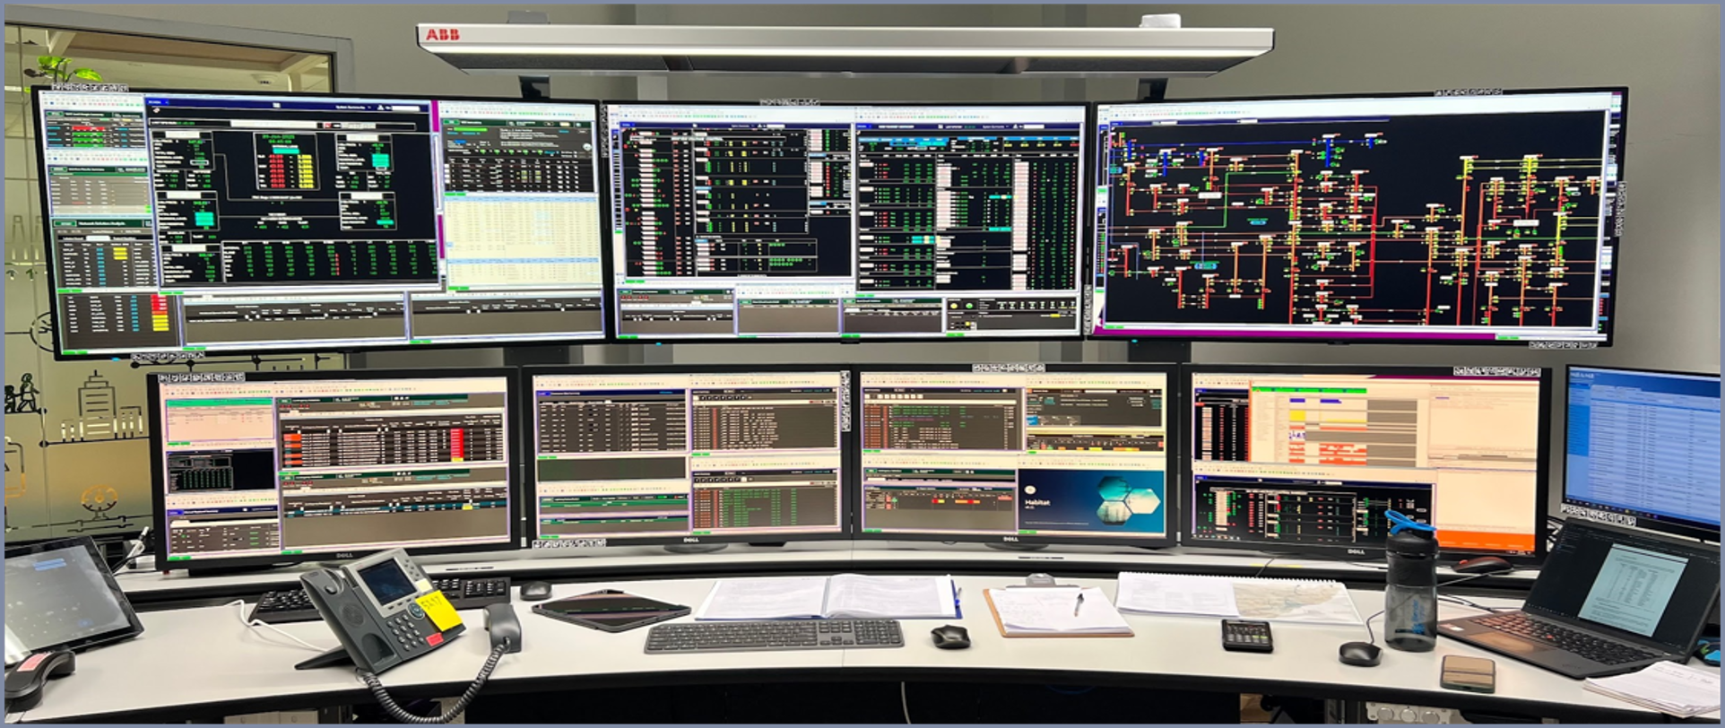
Figure 1: One operator’s workstation at AEMO in the training environment. Each workstation has the same seven-screen set up. In addition, each has a keyboard, mouse, a telephone and a smaller screen (see right above laptop). Some operators also have access to a laptop and/or tablet. In the training room there is a second phone as one is the training phone, the other is used if the room is converted to a live control room.
In this research we focused on better understanding the operator’s use of the applications on the seven-screen set up that is consistent for all desks, and we observed their interactions with the surrounding environment, e.g. phone, keyboard etc. We chose to record the training environment for operator eye movement because these scenarios induce stress intensive workloads and the use of many applications can be investigated through different scenarios. This is necessary as the majority of business-as-usual daily operations does not always include stress intensive work where situational awareness and rapid decision making is vital. Recording the training scenarios therefore provides a richer and more detailed dataset to investigate operators' workflows in a variety of situations. We balanced this training room focus with further observations in the live control rooms and discussions with operators and control room management. However, there may be aspects of operator use within real-time operations (especially in situations that have not previously occurred) that differ between the two environments that cannot easily be reproduced in research studies. To ensure the results of this research are valid and applicable to AEMO control rooms and wider control room scenarios we discussed the insights and results with AEMO throughout the project.

Connection to Research Roadmap
Stage 5 research specifically falls in the Operator and Human Factors pillar shown in green in Figure 2-1 from the AR-PST 2021 Roadmap (see Figure 2); specifically, the interplay of data visualisation and the human-machine interface (HMI) for improved situational awareness and decision support (highlighted in yellow). However, the mixed method human-centred approach draws far more broadly across the other pillars of the CROF. The results of Stage 5 are therefore broad and cover several areas of the roadmap. The results take us a step closer in understanding how to reach the overarching CROF Vision “Operators are Effective Supervisors of a More Automated Australian Power System” and CROF Purpose at the top the figure:
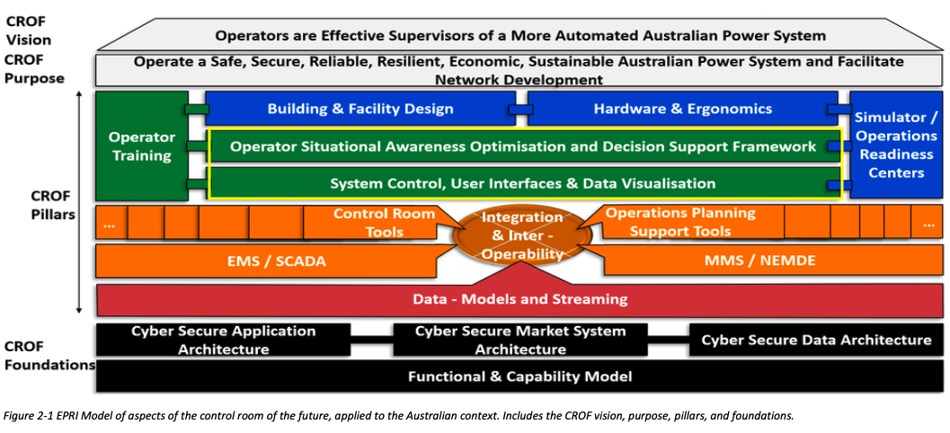
Figure 2: Replication of Figure 2-1 from Research Roadmap (Adrian Kelly et al., 2021, p. 13), with relevant sections for Stage 5 CROF highlighted.
The research outcomes of Stage 5 demonstrate the important interdependencies across and beyond the Operator and Human Factors pillar. The 10 recommendations (A-J, see Section 5.3) identified in Stage 5 have been mapped (in pink) into the 2021 roadmap for Operator and Human Factors research to ensure the recommendations are considered in future work (see Figure 3). Furthermore, the guidelines described in Section 5.4 help toward a consistent visualisation philosophy for CROF, with specified standards and guidelines and greater awareness of operators' workflows.

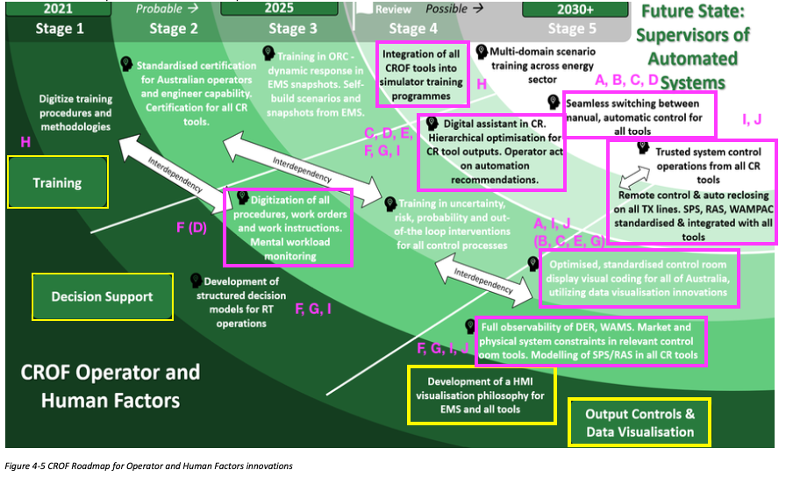
Figure 3: Replication of Figure 4-5 CROF Roadmap for Operator and Human Factors (Adrian Kelly et al., 2021), with relevant sections from Stage 5 CROF highlighted in yellow and impacted future work highlighted in pink with reference to the 10 recommendations described in Section 5.3

Project Team
The Stage 5 project team consists of 9 Monash academic researchers, with expertise in human-computer interaction, data visualisation, interaction design, decision support, optimisation, data science and explainable AI together with AEMO and CSIRO representatives.

The Monash team (Table 1) was led by Dr Sarah Goodwin, a Senior Lecturer in the Embodied Visualisation group, Australia’s largest and leading research group for visualisation. Dr Goodwin’s research focuses on energy data communication and has prior experience of control room design and recommendations (e.g., Afzal et al., 2022). This Stage 5 research builds on prior work and investigates to much finer detail the operator application use, interaction, interpretation and the visual communication as well as aligning these current practices into tangible future possibilities and directions. Table 1 outlines the members, position, expertise and contributions of the Monash research team.

The AEMO team was led by Tjaart van der Walt and Karin Rodrigues, with contributions from across their team including control room operators, trainers, data analysts, UX/UI specialists and more. The CSIRO team included: Mahathir Almashor, Thomas Brinsmead and Fatemeh Jalalvand, and contributions from Christian Schaefer and Liam Landman from GHD. Members of the Monash team met every week, often with AEMO, and have regular monthly meetings with CSIRO and GHD. Reports were delivered to the CSIRO project management team regularly for demonstrated progress.

Table 1: Monash Team Members: Name, position, expertise and contributions to the project.
Member | Expertise | Contributions
Dr Sarah Goodwin  (Senior Lecturer) | Energy visualisation, geospatial visualisation, data visualisation, human-centred mixed-methods | Project lead: field studies, observations, eye tracking analysis, AEMO and ARCNA workshops, thematic analysis, pain points, design vision principles, recommendations, visualisation guidelines, all stages of report writing, stakeholder coordination.
Dr Mor Vered (Senior Lecturer) | Explainable AI, data science, AI | Field study, support for thematic analysis, recommendations, XAI for smart alarm investigation. Final report writing
Dr Caddie Gao  (Senior Lecturer) | Information systems, decision support, cognition. | AEMO workshop, support for thematic analysis, report writing.
Dr Lee Lawrence  (Behavioural Lab Research Manager and Adjunct Research Fellow) | Behaviour science, cognition, eye tracking. | Eye tracking equipment and support eye tracking field study design and analysis, report writing.
Dr Benjamin Tag (Adjunct Senior Lecturer) | Human computer interaction | Field study, analysis.
Assoc. Prof. Michael Wybrow  (Associate Professor) | Data visualisation, graph network visualisation, dashboards, explainable AI | Field study, AEMO workshop, support for thematic analysis, recommendations, visualisation guidelines, final report writing
Assoc. Prof. Markus Wagner (Associate Professor) | Energy optimisation | Support throughout the analysis phase, final report writing.
Prof. Tim Dwyer (Professor) | Data visualisation, graph network visualisation, immersive visualisation, human-in-the-loop analytics | Support for eye tracking analysis, design vision principles, recommendations, visualisation guidelines, report writing
Dr Yidan Zhang (Postdoctoral Research Fellow) | Data visualisation, design and sensemaking, human-centred mixed-methods research | Field studies, eye tracking analysis, AEMO and ARCNA workshops, thematic analysis, pain points, design vision principles, recommendations, visualisation guidelines, all stages of report writing

Research Approach and Methodology
The Stage 5 research followed a flexible mixed-method human-centred methodology with a combination of quantitative and qualitative approaches during set tasks, as seen in Figure 4. The combination in utilising eye tracking observations (Phase 1A), and workshops (Phase 1B) allows for the capturing of high quality data to gain insights to understand the screen and application use of operators in both the micro and macro contexts. Phase 1A focuses on the more specific operational tasks, whereas Phase 1B particularly contributed to a macro understanding of the context given many contribute to the workings of the control room and have ideas, concerns or possibilities they may contribute to the future. Together, this ensures that the research and findings look to the future and are not hindered by current practice, allowing for future possibilities to be innovative and for personnel who are involved in control room operations, whether that is operators, trainers, managers, developers or more, are involved in discussions for the future.

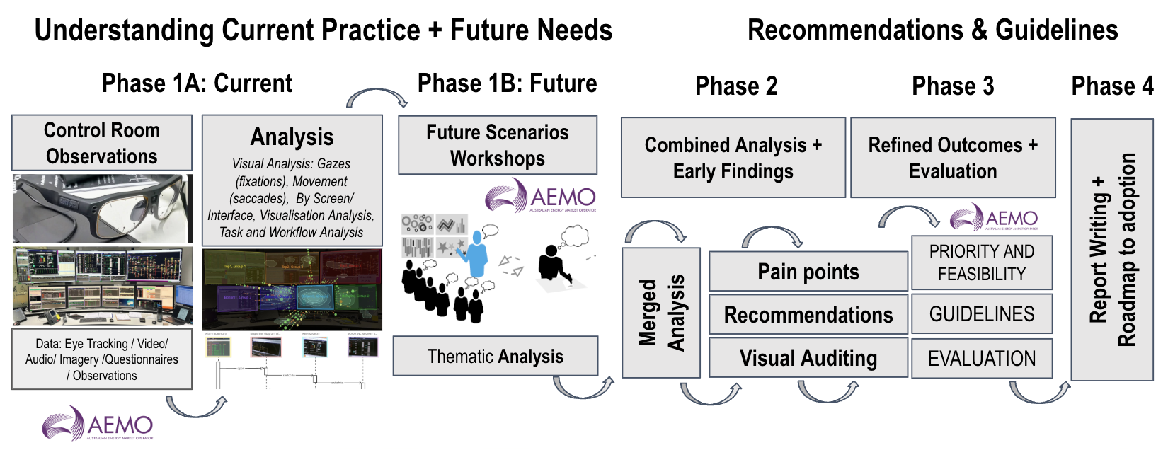
Figure 4: Research phases and methodology
The first phase consisted of data collection on current practices and future needs with early analysis from each. The second phase merged insights from 1A and 1B into combined analysis and early findings as well as initial auditing of the visual interfaces used in practice. The third phase gained feedback, clarity and evaluation from AEMO particularly on the identified recommendations and their prioritisation and feasibility. This stage also saw the continued development of the guidelines for visualisation in control rooms. Finally the 4th phase involved writing and mapping the findings to the roadmap for adoption. The first three phases are described in more detail below.

Phase 1A: Current Practice
Specifically, for capturing the current operations, Phase 1A (see Figure 4) includes monitoring the operators in their current environment (as described in Section 1.2). In this study we included the following data collection in training scenario operations:
- Eye tracking glasses (Tobii Pro glasses 3) to ensure limited intrusion on operators' work, but capturing detail of gaze, movement and video of the focused area.
- Photography of screen layouts at multiple periods, particularly start and end of scenarios, to use as for mapping the eye tracking and identification of application locations.
- Video from 2 angles in order to get the full capture of the workstation digitally, not just the eye tracked video, but also external video cameras with audio positioned on tripods near the workstation to record the full session and the operator’s interactions with screens and surrounding workspace. A separate video recording was captured of the entire room to ensure the full room discussions and operator movement was recorded.
- Questionnaires of both operator workloads and situational awareness after each scenario using standardised assessments: the NASA Task Load Index (NASA-TLX: 7 Likert-scale items) and the Situational Awareness Rating Technique (SART: 10 Likert-scale items). To enable synchronised and rapid responses, both questionnaires were combined into a single Google Form administered via iPad/tablet, taking participants approximately 5 minutes to complete.
- Researcher observations to ensure the researchers gathered further context of the scenarios and room, including structured notetaking and timestamping of notable events, interactions between operators.
Due to the confidentiality of live control room operations data, we did not digitally record in the control room in this study, but from live control room observations we did capture:
- Researcher observations through note taking and sketches to provide additional context, cross-comparison between training and control room operations and capture overviews of real-time visualisations without details.

The method of eye tracking, as well as observations in control room operations is non-intrusive, so the operators can continue their regular work or training activities, whilst participating in the study. We documented using observer notes the activity of operator interaction (e.g., discussions, phone calls, mouse, keyboard, note taking and so forth) as well as how they organise their workspace. In addition, in Phase 1A we included discussions and short interviews with participants to discuss operator or training tasks in more detail. The questionnaires were chosen because both are well-recognised for capturing multidimensional workload (the NASA‑TLX (Hart & Staveland, 1988)) and perceived situational awareness (SART, (Taylor, 2011)), and together provide complementary, validated measures particularly suitable for complex, multi-screen control room environments.

Phase 1B: Future Scenarios
The workshop for Phase 1B (see Figure 4) was designed using the “Creative Visualization-Opportunities Workshops” method (Goodwin et al., 2013, 2017; Kerzner et al., 2019), which has been tried and tested for over a decade. This workshop method is designed to enable experts in the field to creatively explore opportunities for data visualisation using structured activities and has been successfully implemented and tested in a number of different domains, including energy analysts (Goodwin et al., 2013) and constraint programmers (Goodwin et al., 2017). During the workshop we collectively explored the ideas, aspirations, barriers and possibilities for (AEMO) CROF. This method has been highly successful to elicit creative ideas for future data visualisation opportunities without getting stuck on present-day applications or possible implementation limitations. The method has shown to work well to elicit rich requirements whilst also gaining the trust of the participant and breaking down barriers of seniority, roles and responsibilities (Kerzner et al., 2019). The workshop was designed to include a variety of participants with differing knowledge and expertise to work together on the future goal, including operators, managers, trainers, software developers and more. The workshop included bringing together ideas, prioritising them based on the group’s understanding of critical needs. The method has led to immediately implementable results for improved energy data visualisation, such as those presented in Goodwin et al., 2013. The method produced a lot of artifacts for the researchers to sort, analyse and interpret. This involves thematic coding (categorising) of the ideas, and making the links between current practice and future possibilities.

Phase 2: Combined Analysis
Phase 2 (see Figure 4) brings together the Phase 1A and Phase 1B outputs through a combined analysis and the visual interface audit of the key applications used during the recorded scenarios. To audit the visualisation interfaces as part of our observations and analysis, we used a wide variety of visualisation literature and theory to provide guidelines for improved practice. There are several methods for exploring visualisations and their classifications and understanding their construction, for example, by data type and analytic task (Munzner, 2014), by dashboard layout and interaction patterns (Bach et al., 2022), or by display characteristics and structural properties (Roberts, 2000; Rodrigues et al., 2006). We also detected the encoding of the data in visualisations through monitoring for the appropriate and consistent use of visual channels in different applications. The ‘visual channel’ (Munzner, 2014) also known as ‘visual variable’ (Tufte & Graves-Morris, 1983) is the way in which the data is encoded, for instance data is encoded as ‘size’ in a bar chart, with the length of the bar changing depending on the data. Each visual channel (e.g., size, shape, colour hue or colour value/luminance), their use, and effectiveness of use is heavily dependent on the type of data (e.g., qualitative, quantitative) and if the information is being encoded as a point, line or area. Certain variables such as consistent use of colour hue have been shown to be beneficial in producing significantly faster reaction times and reducing perceived operator workload in control room tasks (Van Laar & Deshe, 2007).

In addition to identifying tasks and the visual interface, we investigated the operators’ workflow, and how applications are used collectively. For this, we can analyse the eye-tracking data using Gazealytics, a custom analysis toolkit (Chen et al., 2023). Visual analytics for eye-tracking data is itself an active and emerging research area (Blascheck et al., 2017). Raw gaze data is inherently dense, with thousands of fixations and saccades per scenario, making interpretable patterns difficult to extract. In this research, we use multiple eye tracking data signals, such as fixation distribution, saccade behaviour, and revisit sequences, to indicate levels of comprehension of the information visualisation (Gegenfurtner et al., 2011) and text (Raney et al., 2014). In addition to our prior cognitive load in control room work using eye tracking (Afzal et al., 2022), the team has rich experience in detecting mental fatigue from eye-tracking data in other domains (Tag et al., 2019). The eye-tracked data of application use is interpreted alongside all collected contextual data, such as questionnaire responses, observer notes, videos and task-event timestamps associated with the training scenarios to gain a broad understanding of operator comprehension. Analysis of the collected data, tasks, topics and themes in connection with decision-making and knowledge generation models and theories (Sacha et al., 2014) allows for current operator challenges and pitfalls to be identified. Through iterative team discussions with AEMO, the recurring themes from this synthesis were translated into pain points, design vision principles, and recommendations (see Sections 5.1–5.3).

Phase 3: Refined Outcomes
Phase 3 (see Figure 4) then takes these combined findings to AEMO through a structured feedback and prioritisation process, in which the research team and AEMO operators, trainers, and managers jointly reviewed, refined, and prioritised the resulting recommendations based on their operational value and feasibility (see Section 5.3.1). The continued development of the visualisation guidelines also occurred in this phase, drawing on the visualisation literature outlined above (see Section 5.4).

Data Collection and Preparation
In this section we describe the detailed data collection for Phase 1 A: Current Practice (Section 3.1) and B: Future Scenarios (Section 3.2) as well as the initial preparation and wrangling of the data for analysis. Further documentation, including Miro boards, are available in the supplementary material.

Current Operations
To capture current control room practices, we designed and conducted structured observations of control room training sessions using representative operational scenarios (Section 3.1.1). The operator training day recorded as part of this research study formed part of the participant’s mandatory operator training. The research study set up was designed to form best practice for the researchers as well as align with the training needs. During these observations we collected different types of data (eye-tracking, video, questionnaires, and observer notes) to capture operator behaviour, workflows, decision making and situational awareness. We undertook further live control room observations to contextualise training findings and identify differences between training and operational environments (Section 3.1.2).

We merged collected data and performed data wrangling to enable initial analysis of eye-tracking and observational datasets, including mapping gaze data to multi-screen workstations. This initiated the preliminary analytical artefacts (AOIs, TWIs, timelines, and sequence diagrams) to support continued analysis in later work phases (Section 3.1.3). Finally we compiled and validated a comprehensive list of applications and interfaces used by operators, including purposes and usage contexts.

Training Session Preparation and Observation
We conducted a one-day structured training study consisting of three scenarios, each lasting approximately one hour. This duration was chosen to align with prior work in the same control room (Afzal et al., 2022) where it was deemed comfortable for wearing the Tobii Pro glasses and sufficient to suit the equipment’s battery life. It also aligns with AEMO's standard scenario design of 60–90 minutes, which reflects realistic shift patterns and the typical duration of a critical operational event. While monitoring longer durations may be required to induce sustained fatigue, our focus was on capturing workload and situational awareness dynamics during ecologically valid operational scenarios, in particular on application use during this time.
These training scenarios were designed to simulate real operational conditions and were selected for this research study to capture a diverse range of application use and procedural contexts (see Table 2). The three scenarios were chosen from a library of pre-prepared simulation cases that AEMO recently used for assessments. Each scenario was run as a shared, collaborative exercise involving both participants together, reflecting how operators work as a team in the live control room. The complexity and seriousness of the scenario increased throughout the day and were chosen to illustrate varying events on the network, utilising both the Energy Management Systems (EMS) and Electricity Market Management Systems (EMMS). They are documented in the report as the following:
Table 2: Overview of the three training scenarios that formed part of the one-day structured training session for eye tracking analysis and observation
ID | Name | Description | Complexity and time requirement
S1 | General Duties Business as Usual | This scenario represents a typical day in the control room. Operators perform routine monitoring and checks while responding to common events such as minor outages, generator trips, or system alerts. It reflects the normal workflow and interactions with operational systems during day-to-day operations. | Demonstrate the base level of navigation and operational activity, without time pressure of a specific event.
S2 | NSW Reserve Management | This scenario focuses on market-based reserve management under tightening reserve conditions in the NSW region. Operators review information such as forecast demand, weather conditions, generator availability, and network outages to estimate reserve requirements and take actions to ensure sufficient reserves are maintained for the relevant period. | Require an extra level of investigation and operational activity to manage this type of event, generally with sufficient time to gather the required information, calculate and take action.
S3 | Responding to Credible / Non-Credible Events | This scenario simulates unexpected network events that require a faster response. Operators must quickly identify the issue, gather relevant information from different systems and sources, and take appropriate actions to maintain system stability. | Typically require a more urgent time response. The nature of these events can involve less familiar information sources and unpracticed actions, and require quick thinking and response.
The study involved two participants with contrasting levels of expertise, one control room operator with approximately 2 years’ experience (P1) and one specialist with 5 years’ experience (P2), reflecting standardised shift practice and, in turn, providing a possible comparison for different behaviour and strategies associated with expertise.
Before the training day the AEMO team provided the Monash research team with the training day notes as a run-through of the three scenarios for transparency and preparation. These notes were not available to the participants. The participants were provided a scenario name (see Table 2) and before each situation were briefed for network grid situational awareness in preparation for the training scenario with particulars such as the time of day and the weather conditions, for instance.
To ensure complete data collection and that each scenario was captured accurately, we followed a setup protocol at the start and prior to each scenario. The three scenarios each took approximately 1 hour to run, between each we had a break for discussions and refreshments / lunch. To ensure we captured all information accurately we explained to both participants and trainer prior to the recording how the recording would work. As we were concentrating on workstation analysis specifically, we chose to switch off the collaboration monitor on the wall (see Figure 5 left) for the data collection, because it could potentially distract from our observations. Notably, the wall screen in the training room displayed information that is ordinarily found on the screens at the operator workstations. During the one-day session, we collected multiple datasets as explained in Section 2. For each of the six recordings (P1 and P2 across scenarios S1-3, see Table 2), the following raw data was captured:
- Eye-tracking scene video (first-person view): ~1 hr, MP4, 1920×1080 with embedded audio.
- Gaze data: .gz archive containing gaze data in JSON format (2D and 3D gaze position, pupil diameter, and gaze direction).
- External videos: ~1 hr workstation video and ~1 hr room video, MP4.
- Observer notes: Excel file exported from Google Forms, containing timestamped notes from six researchers (270 entries in total across the day).
- De-identified workload and situational awareness questionnaires: NASA-TLX and SART, completed by both participants after each scenario via Google Forms (see Appendix).
After the data collection we also collected further qualitative data from the trainer and training manager during the day, as well as later in online meetings and emails to clarify and confirm information, such as: greater details of the training room setup, the training scenario information, the workflow of certain operator tasks and the names of applications and interfaces. An illustration of the data collection environment can be seen in Figure 5. The set up instructions and reflection from the team post study to gather some possible improvements for improved field trip collection is included as supplementary material with this report for future control room analysis.
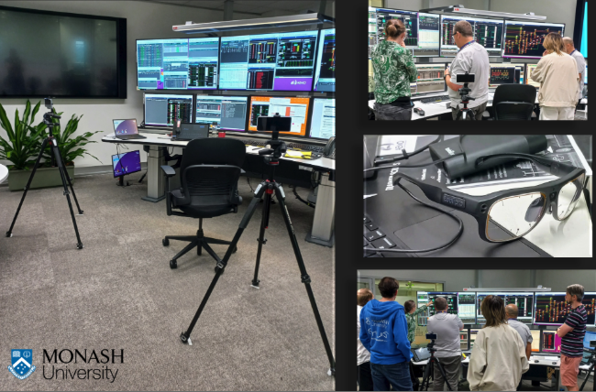
Figure 5: illustrating the data collection day, showing 2-way tripod video camera set up for recording the screens as the operators sat at the workstation (left), the Tobii Pro glasses v3 used for the eye tracking recording (right middle) and the researcher team discussing and observing components of the screen right (upper and lower).

Live Control Room Observation
Recognising that training scenarios do not fully replicate live operational environments (see Section 1.2, with differences discussed in Section 4.1.4), we also carried out a one-day observation in the live control room in June. During this session, we observed activities including a network outages handover, preparation for an outage study, an end-of-shift handover, and a one-hour observation with a short interview.
Data collected in this environment included observer notes, workspace sketches (see Appendix), and short interviews with operators. Recording of eye tracking and video was not possible in the live setting for confidentiality and legal reasons, this observation provided valuable contextual information about the control room layout, the applications in use, and the ways in which workflows differ from training.

Control Room Operations Data Wrangling and Analysis
In order to combine all the data sources, we stored and renamed raw data for each scenario together (see Section 3.1.1 for raw data collected), and used the combination of the mediums to help analyse the data and discover insights. In particular, we processed the eye tracking data and formed a list of applications used in the scenarios during this process as described below:
Prior to the eye tracking recording, we calibrated the Tobii eye-tracking glasses for each participant using a bullseye target provided with the glasses at the set distance used for calibration (around 60 centimetres). For checking distance and accuracy, after the calibration, we asked each participant to look at 6 different points before starting: top left uttermost screen, top right uttermost screen, bottom uttermost left, bottom uttermost right, and the bottom left and right of the top middle screen. Once calibrated the Tobii- eye trackers can be expected to generally maintain that calibration, and therefore a good level of accuracy for this study, even if the participant repositioned themselves. Notably, considering participants often were required to be somewhat close to the screens to be able to read letters and numbers on a screen, the likelihood of witnessing associated eye measurement errors caused by a participant looking at an object further away can be argued to be minimal or negligible. No manual recalibration or post-hoc adjustments to the gaze data were required.
The accurate mapping of eye tracked gaze data to the full workspace per scenario, per participant is essential for reliable analysis. For this, we used Tobii Pro Lab to map recorded eye tracking and video data (extracted from the Tobii Pro glasses) to the workstation photographs that we had captured (see Section 2.1) for this purpose for each scenario (see Table 2) in the data collection procedure. Thus, eye tracking mapping converts dynamically recorded eye tracking data from the eye tracking headset onto a single static image that can be analysed later. Although we had initially planned to completely map all six datasets fully to their workstation screenshots prior to our analysis we had to re-prioritise this stage of work due to the manual effort and time needed to amend the mapping. We had anticipated this as most eye tracking analysis software including Tobii Pro Lab, rely on feature-matching methods (Zhang et al., 2025), however, the repeated use of similar applications across multiple screens and overlapping interfaces during rapid switching of applications led to many mapped data location errors. As a result, extensive manual adjustment was required to compare and verify the actual gaze position (recorded via the eye tracking video) to the mapped gaze position. Whilst this ensured the accuracy of the eye tracking data mapping, it was a time consuming process.
As seen in Table 3 below, to prioritise our researchers time for the necessary analysis we fully mapped 3 of the 6 recordings (2 operators x 3 scenarios), which included a full comparison of both participants during a single scenario (i.e., P1 and P2 in S1) and one participant over two scenarios (i.e., P2 in S1 and S2) - both within scenario and across scenario were initially analysed for insights. For the remaining 3 recordings to identify the most important and interesting time periods of interest for critical decision-making we asked AEMO to identify approximate periods during the training scenarios, which would involve key actions and events. These were generally identified based on priority alarms across all three scenarios. We then manually mapped those time periods identified for the remaining scenarios and extracted these time periods for analysis. The shorter periods documented in Table 3 corresponded to critical events of interest that were unique to each scenario, minimising repetition of events/workflows already captured in previous scenarios, especially for S3.

Table 3: The overview of the full and partially mapped eye tracked data from first person view to full workspace
 | S1 | S2 | S3
P1 | Fully mapped  Total mapped: 60 mins  3 time periods: ~10 mins each  Total investigated: ~30 mins | Partially mapped  Total mapped: 14 mins  1 time period with 3 segments: 5.5 / 3 / 5.5 mins  Total investigated: 14 mins | Partially mapped  Total mapped: 5 mins  1 time period: 5 mins  Total investigated: 5 mins
P2 | Fully mapped  Total mapped: 60 mins  3 time periods: (~10 mins each  Total investigated: ~30 mins | Fully mapped  Total mapped: 60 mins  1 time period into 3 segments: 5.5 / 3 / 5.5 mins  Total investigated: 14 mins | Partially mapped  Total mapped: 5 mins  1 time period: 5 mins  Total investigated: 5 mins
We conducted the initial visual analysis of the mapped eye tracked data using Gazealytics - an open-source eye-tracking analysis tool (Chen et al., 2023). In this process, we manually defined Areas of Interest (AOIs) on the mapped eye tracking data in order to compute various eye tracking metrics for both static and temporal AOIs (as explained below). Whilst the mapped gaze data and positions of all AOIs were verified by the eye tracking video frame by frame, there may be some minimal positioning errors.
Static AOIs (applications that were constantly open on the participant’s screen throughout the scenario, and specifically that the application window did not open/close or move around during the scenario) at two levels: display level (the seven physical screens) and application level. At the display level, each respective screen was labelled as one of “Screen1-7”, and at the application level, the static AOIs were each given their own label associated with the high level application and the interface (see Figure 6). To ensure accuracy of applications and interface identification, in parallel we created a list of all applications and interfaces used across the recorded scenarios. This list includes application names, labels, purposes, and screenshots validated by AEMO operators and managers. The list was used for three purposes 1) to support the gaze analysis for the identification of tasks and a clearer understanding of scenario workflows; 2) to help develop timeline and sequence diagrams of identified events to illustrate application usage for certain tasks (explained in Section 4.1.3); 3) for our visualisation audit for visualisation consistency analysis, where each screenshot was surveyed for its use of visualisation types and visual channel (Munzner, 2014), in particular the identification of background and foreground colour. The audit is described in Section 4.2. The full application list is available as supplementary material for future research.
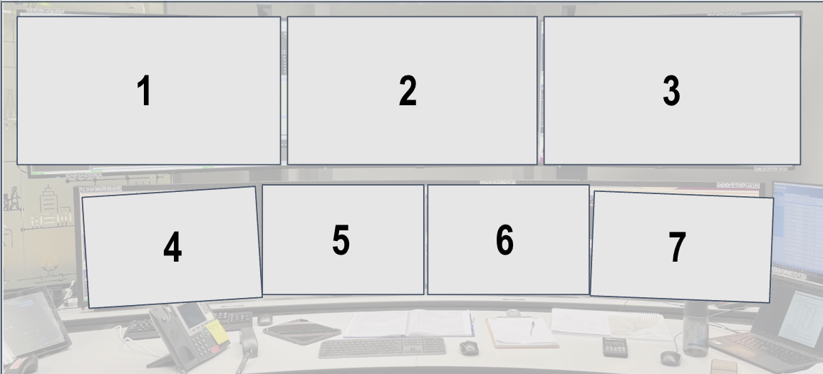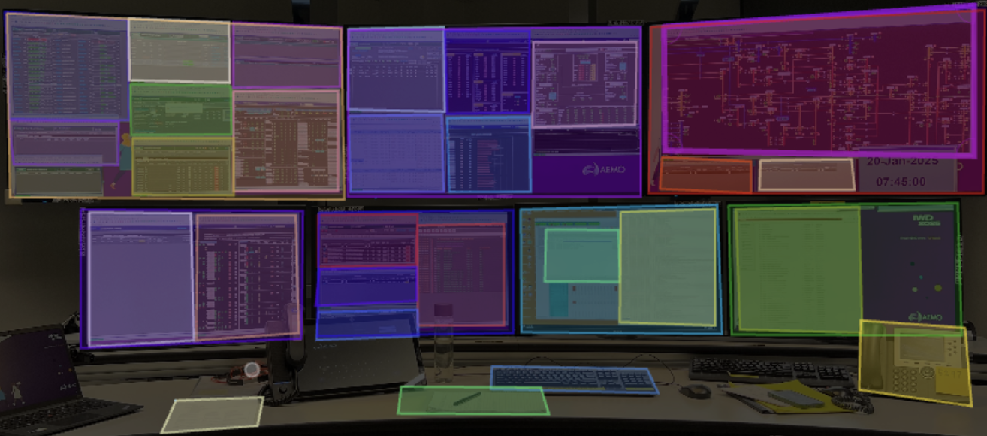
Figure 6: illustrating Screens 1-7 (left) and an example arrangement of applications (right) and other input or interaction devices (e.g., keyboard, notepad, phone). Applications were labelled using text based short names with application name and interface name documented in the list applications (see supplementary material)
Most notably, for control room analysis, we created temporal AOIs (TAOIs, see Abbreviations and Glossary of Terms) to allow us to specifically analyse metrics associated with dynamic applications that change overtime (application windows that were opened, closed, or moved during a scenario and therefore could not be captured by static AOIs alone). We also identified time windows of interest (TWIs) to enhance the analysis and ensure it was focused on critical event activities (as described earlier in this subsection when explaining the rationale for the data in Table 3, i.e., key moments were identified in consultation with AEMO, often starting at specific alarms).
Overall, this approach allowed us to have focused analysis without requiring the entire scenario to be processed frame by frame. This approach is not typical of standard eye tracking analysis where usually either AOIs or TWIs are analysed independently. To enable TAOIs analysis a specific feature in Gazealytics was created prior to this study in preparation, which included the ability to sync time-based notes from our field study observation and link them with the eye tracking analysis (Zhang et al., 2025). For each TAOI, we manually examined the eye-tracking video to identify when the application appeared and disappeared, and annotated its location at key transitions (e.g., when it was opened, moved, resized, or closed), so that gaze fixations could be attributed to the correct application as the workspace was reconfigured.

Future Control Room Scenarios
The aim of this phase was to understand the future needs of control rooms, building on the insights gained in Phase 1A about current practices and drawing on creative techniques for aspirational thinking and practice.

Workshop Structure and Data Preparation
In August 2025, we conducted an ideation workshop for the Control Room of the Future with AEMO to collaboratively and creatively explore how control room systems might evolve, with a focus on opportunities for new visualisations, interfaces, systems and tools needed to better support operators. The workshop was held online over 2.5 hours and followed the Creative Visualization-Opportunities (CVO) Workshop method (Goodwin et al., 2013; Kerzner et al., 2019), a structured approach to design-led foresight and ideation. Sixteen participants attended, including ten energy control room experts and internal stakeholders from the previously observed control room (operators, managers, and trainers), along with six researchers from the Monash research team. A few participants could not attend the full session. Activities were facilitated on a shared Miro board, where participants contributed digital post-its and sketches.
The workshop began with an icebreaker, followed by three main activities:
- Wishful Thinking: Participants individually recorded what they would like to know, do, and see in future control rooms.
- Barrier Identification: In a group discussion, participants explored barriers that might hinder these ideas.
- Storyboarding: Participants worked in four groups to create graphical narratives of envisioned future control rooms.
The workshop outputs included digital post-its, sketches, and storyboards capturing envisioned future control room concepts. Upon return, the research team performed initial qualitative analysis to cluster ideas, identify themes, and synthesise insights across activities. This identified key aspirations and challenges for future control rooms, highlighting opportunities for automation, AI-supported assistance, unified interfaces, and streamlined information presentation.
In addition, a complementary second workshop was held in October 2025 by two of the Monash research team and an additional team member at the Australian Control Room Network Association (ACRNA) annual conference. Although outside the Stage 5 AR-PST CROF research, this workshop followed the same structure as the AEMO workshop, but was held in-person with around 60 conference participants from across the control room network association. For this workshop, we split table discussions into identified themes, including sectors: electricity, gas, water, fire and rescue, as well as topics such as software, ergonomics.

Analysis
This section explains the analysis from the observations and tracking of control room practices (1A) as well as the workshopping of future possibilities.

Current Control Room Practice
This section presents highlights from the findings from the analysis of current control room practices, drawing on eye-tracking data, observational notes, and video recordings collected during the training sessions and live control room visit described in Section 3.1. The analysis focused on three key aspects of operator behaviour:
- screen use and application arrangements,
- in-room and remote collaboration, and
- patterns of application switching or cross-referencing that characterise complex operational tasks
We also highlight the differences between training and control room environments.

Screen Use and Applications
Our initial analysis of eye-tracking data from both participants produced around 4,700–7,600 fixations and saccades per fully mapped scenario (P1 S1: 7,578; P2 S1: 6,694; P2 S2: 4,737). We present an overview of the fully mapped data in Figure 7, focusing on Scenario 1 (S1), as we have both participant data fully mapped. Firstly, we note that eye fixations and movement occurred across the entire workspace. The majority of these concentrate across the central screens directly in front of the operator, especially Screen 6 (see Figure 6 for look up of screen) for both participants (Figure 7A and B). We also note more natural horizontal saccades dominating over vertical or diagonal ones for both participants (Figure 7B). Notable in this scenario, P1 showed comparatively more top-left to bottom-right and bottom-right to top-left saccades than P2.
A key finding from the analysis is that screen and application arrangements varied considerably between the two participants, reflecting the highly individualised nature of operator workspaces (Figure 7C). While both operators concentra ted the majority of their fixations on Screen 6 (P1: 31% and P2: 37% in S1, see Figure 7A), consistent with it being the primary action screen, the distribution of attention across the remaining screens differed substantially: P1 directed 17% of fixations to Screen 3, while P2 concentrated 26% on Screen 5.
This finding highlights both commonalities and differences in operator strategies. However, as each screen displayed multiple applications over time, these screen-level fixation distributions were complemented by Temporal Area of Interest (TAOI) analysis (see Section 3.1.3 for details) to capture how application use evolved dynamically within each scenario. For example, TAOI analysis revealed that P2 switched multiple times between different applications during tasks (see Section 4.1.3 for more details).

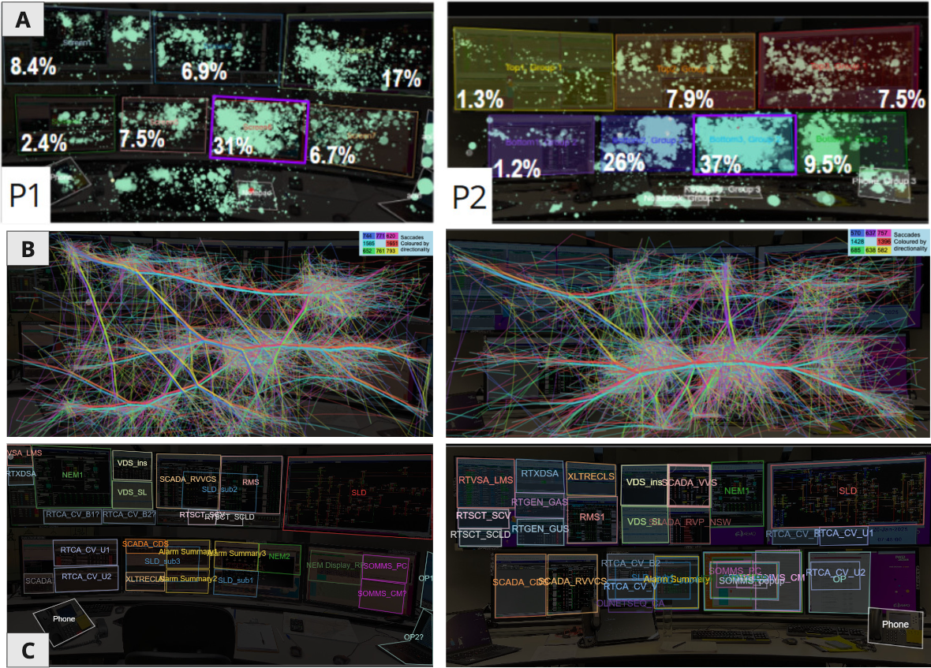
Figure 7: Overview of initial analysis of complete eye tracking data for Scenario 1 (S1) for both participants’ (P1 left, and P2, right). A: shows all fixation distributions (light green circle size increases for longer time periods) across the workstation and the total fixation percentage for each screen use; B) shows all eye movements (saccades) across the workstation throughout the scenario. To relieve some visual clutter the eye tracking data has been bundled together by direction of movement (shown by colour) in order to allow for visual identification of typical pathways; C: application arrangements at the end of the scenario.
Beyond screen-level attention, application arrangements also varied markedly between participants (as described in Section 1.2). Each operator positioned and sized applications differently across their workspace, with one preferring larger single-application views and the other relying on multiple smaller, co-visible windows, as observed in the recordings of the two participants (see Figure 7C). The participants tended to maintain their layouts for the majority of the scenarios. Whilst most of the participants' workload self-assessments were generally consistent. We found it interesting that the two participants differed substantially on physical demand: P1 consistently rated this higher than P2 across all three scenarios (P1: 7, 8, 8 vs. P2: 3, 3, 4 on the NASA-TLX 10-point scale; see Appendix: Table 7). While we cannot identify the specific cause from this study (more participants with more focused testing would be needed), P1's more interaction-heavy layout (small, co-visible windows across screens) may require more frequent cursor travel, window manipulation, and head movement across screens. These differences and further observations from the control room operations and interviews suggest that operators develop highly personalised spatial strategies shaped by their roles, experience, and preferred workflows. With only two participants, the underlying drivers cannot be fully explained from this study alone, and this is captured as Pain Point 1 (PP1, Section 5.1) and partly motivates Recommendation C: Adaptive and optimal profiles (Section 5.3.2), where investigating and identifying profile patterns at scale is flagged as a next step.
During application investigation it was evident through our analysis that many applications were used during each scenario, with certain applications more prominently used than others. Whilst the majority of application use and combinations of applications needed TAOIs analysis in our analysis, as described in Section 4.1.3 (most notably the alarm summary window, substation-level SLD views, the constraint management system), certain applications, such as the full single line diagram (SLD) remained constant throughout and therefore it was possible to map their use across the entire scenario. Figure 8 for instance, shows P2’s use of the SLD throughout S1 (Figure 8 above: timeline, and below: workspace). For a total of ~6 minutes over ~1 hour scenario, nearly the entire regional (stayed consistent for the entire period) SLD was scanned during short snippets of investigation.
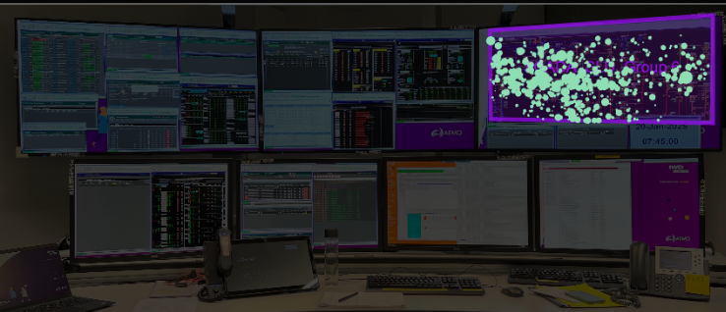
Figure 8: P2’s use of the SLD / single line diagram in S1 shown in purple. Circle sizes indicate longer fixation times. The timeline (above) indicates at which points during the 1-hour scenario the SLD was fixated upon. The grey in the timeline shows periods P2 looked at the rest of the workspace, whilst the black sections indicate periods of observation outside the view of the workspace screenshot.
During the application analysis, the procedural tasks were observed to be particularly time- and effort-intensive. Operators were required to manually locate and then navigate to relevant procedures, often switching between several interfaces to cross-reference steps, identify recommended actions, and confirm their applicability to the current situation. Whilst actual timings were not recorded, this behaviour was especially evident during constraints and event management tasks, where operators opened reference documents or procedure menus independently of the triggering system state, with no automated or context-aware linkage between the two. Verified from our discussions with AEMO and through background literature (Afzal, 2022), we note that in time-pressured scenarios, such manual efforts can contribute to slower response times and increased cognitive load.

Internal and External Control Room Collaboration
Collaboration in the control room was observed to take multiple forms: in-room exchanges between operators, remote coordination across internal control rooms, and communication with external partners. The latter frequently involved phone calls, which competed for operators’ attention alongside screen-based tasks. Our analysis therefore did not focus on collaboration with external partners, but rather on in-person and screen-mediated collaboration. The screen use during phone calls was not analysed as part of this collaboration discussion, but is examined in the analysis of key event periods alongside other screen-based tasks.
Eye-tracking and observational data captured notable instances of in-person collaboration throughout the sessions. For example, during one 3-minute period, two operators gathered at a single workstation (one looking over the other’s shoulder) to jointly assess an unfolding situation (see Figure 9, P1 and P2 gaze is shown in green and orange respectively). This behaviour appeared consistent with live control room observations, where operators were regularly seen pointing at shared screens, verbally briefing colleagues, or physically navigating to each other’s desks during complex or time-critical events. Handover observations further revealed the effort required to reconstruct situational context at shift transitions, often relying on informal verbal summaries and individually maintained notes.
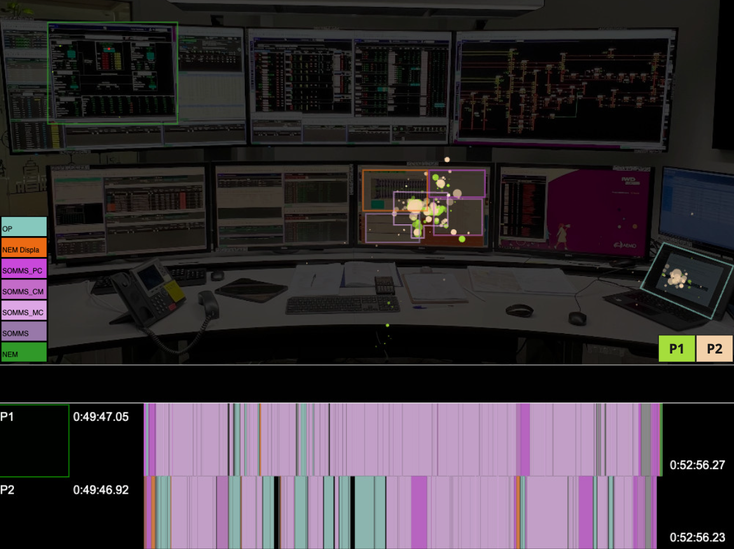
Figure 9: Both participants’ fixation distributions on P1’s workstation during the 3-minute period (top) and corresponding application-use timelines (bottom). P1 gaze fixations are shown in lime green, and P2 in pale orange. The larger circles indicate longer fixation times. The application positions used during the period are highlighted on the workstation with coloured rectangles matching the application legend on the left. The timelines below show how each participant viewed different applications at different times across the 3-minute window,.

Application Switching and Cross Referencing
Our early analysis quickly identified that much of the operators’ gaze was on Screen 6 (see Figure 6 and 7A-C), where there were heavy interaction and rapid attention switching between applications. To investigate this rapid application and interaction use over short periods of time, we created ‘workflow timeline and sequence’ diagrams and explored TAOI visual analysis using Gazealytics. This analysis revealed frequent switching between applications and dynamic rearrangement of interfaces during operational tasks.
Applications were frequently used in combination, for example the alarm summary window was frequently used in conjunction with several other key displays, specifically: the single-line diagram (SLD), the market summary, and the constraint management system. This combined display use with multiple interfaces opening and closing requires operators to manually memorise, coordinate and translate information across tools with differing visual conventions and layouts. Even within short events, operators must cross-reference multiple systems.
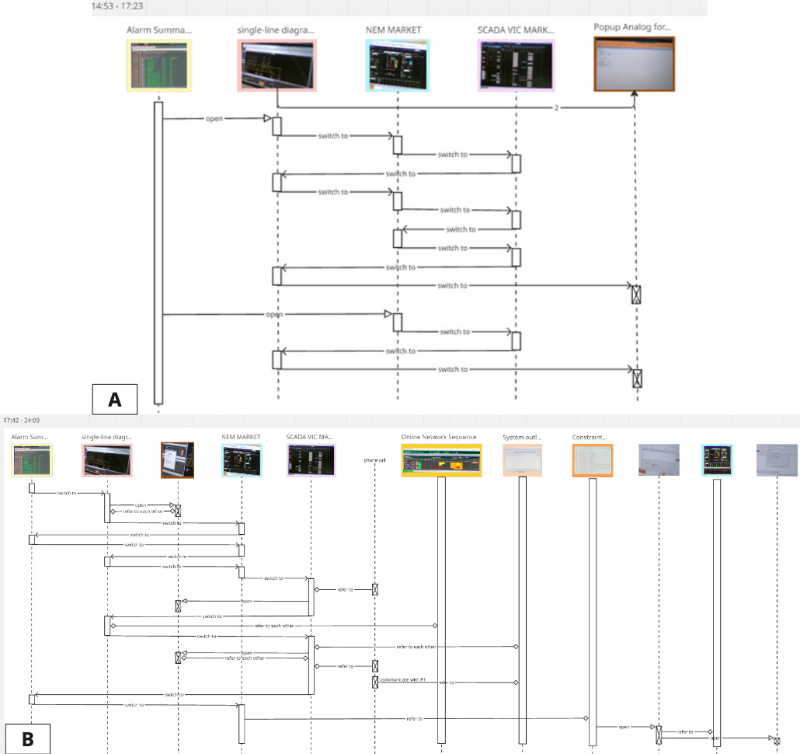
Figure 10: Timeline and sequence diagrams for A) a 2.5-minute alarm investigation task and B) a 6.5-minute combined alarm investigation and constraints task of P2 during Scenario 1. Both sequence diagrams use the same initial workflow from Alarm summary, Single Line Diagram, NEM Market and SCADA. See supplementary material for full diagrams.
To demonstrate these findings, we provide two examples. Firstly, detailed timeline and sequence diagrams (see Figure 10) were created to understand the workflow of operators and their movement between applications. Two TWIs in particular were finely documented in this manner from a single scenario (S1): a 2.5-minute (Figure 10A) alarm investigation for a line trip and a 6.5-minute (Figure 10B) combined alarm investigation and constraints task. Both TWIs showed a consistent pattern: four core applications, with operators’ attention switching frequently between them, as well as, the constant use of multiple overlapping windows interfaces throughout. The 2.5-minute alarm investigation involved four applications and ten interfaces (in separate application windows), resulting in fourteen switches. The 6.5-minute combined alarm investigation and constraints task, drew on the same four core applications but expanded to cross-reference an additional five interfaces, resulting in twelve switches.
This workflow diagram in Figure 10 is specifically referring to P2. Further visual analysis of the 2.5-minute alarm investigation TWI (same TWI as Figure 10A) using Gazealytics showed marked differences in combined application use by each participant. At this stage we created TAOIs for each participant and compared the use of applications and joint application use for the 2.5 minute time period (Figure 11). In this period of time, P1 relied on the following applications: SLD, NEM Market (SCADA), (Regional) Market Summary (limited use), and multiple small alarm summary windows (Figure 11A). By contrast, P2 worked with several SLD sub-views, extensive use of (Regional) Market Summary, and a single alarm summary window that occupied half a screen (Figure 11B). These results help to demonstrate that operator strategies for managing the same event can vary substantially, with implications for interface design. These differences likely reflect a combination of individual operator strategies as well as the division of responsibilities between roles during both training and operational activities (as described in Section 3.1.1, the training is collaborative. The roles, tasks and responsibilities are divided based on the situation and operator expertise resembling a live control room environment).
This analysis documents the difficulty of application analysis for control room research, given different application layouts and many temporal AOIs. We provide an overview of our detailed and time-intensive investigation in this sub-section. This work heavily informed Pain Point 3 and Recommendation E as described in Section 5.1 And 5.3.
Whilst we had planned for TAOI analysis, the heavy switching between applications needed further investigation. Our diagramming process for the creation of Figure 10 was manual and time intensive. This process helped us document, demonstrate, and quantify the sheer amount of switching between applications during short time periods. It was created by hand using a digital whiteboard in Miro. The supplementary material provides the full diagrams for Figure 10. For continued investigation of Recommendation E these diagrams could be programmatically created from mapped eye tracking, potentially as a feature in Gazealytics. Further investigation with more participants is needed in order to more deeply investigate optimal application arrangements, workflow strategies and interface use in greater depth.
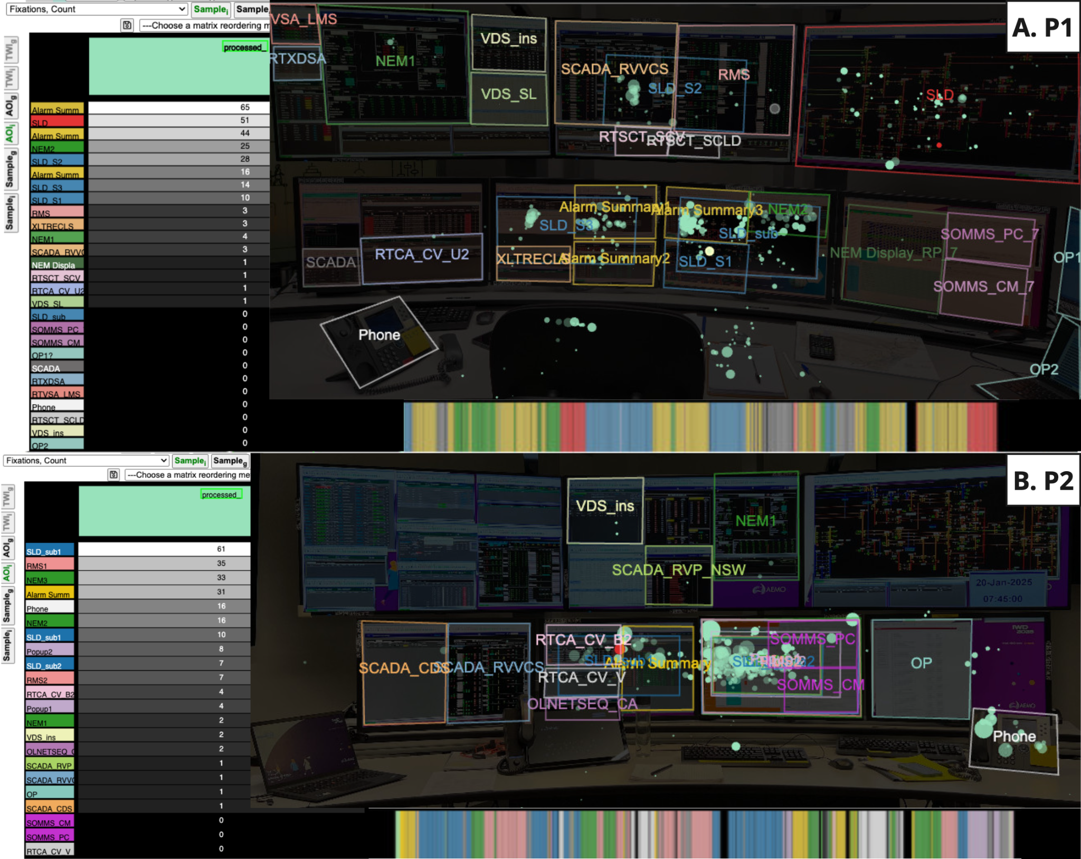
Figure 11: Both participants’ gaze and application use over time and workspace in the selected 2.5 minute time window of interest. For each participant (A. P1, B. P2): Left: a list of applications ranked by fixation count. Right: The workspace showing static AOIs and TAOIs representing all applications used during the time period. Each coloured rectangle / shape outlines an application’s position on the screen (or device such as laptop or phone). Each green circle represents the participant’s gaze, with large circles indicating longer fixation periods. The timeline at the bottom shows when and for how long each application was viewed, using the same colours between participants and workspace /timeline views. For a full list of applications see supplementary material.

Training Room vs. Live Control Room
From our observations of both the training room and the live control room (see Section 1.2 for details), we found that while the overall screen setup and most applications were consistent, the use of applications and workspace functionality differed due to the selected scenarios, lack of real-time applications such as the weather (which was dictated to the operators as part of the scenario briefing instead, see Table 2), and the reliance on remote desktop systems in the training environment.
In the training room, Screen 6 was the only screen where applications could be edited in the scenario via remote desktop, meaning all actions had to be performed there. Participants often opened different applications and moved them to Screen 6 for visual proximity of the investigation and decision making. Interestingly, observations and interviews in the live control room revealed that this aligns with operators’ common practices, as Screen 6 is also their primary screen for actions. Some real-time applications and an overview dashboard present in the live control room were not included in the training scenarios, which may influence how screens and applications are used in each setting.

Future Control Room Ideation
This section presents an overview of the findings from the AEMO workshop of future control rooms.
The wishful thinking exercise generated 62 post-its with a wide range of ideas for future control rooms. The barrier identification activity produced 30 post-its outlining perceived challenges, and participants synthesised earlier discussions into four storyboards. Internal and post-workshop analysis involved grouping aspirations and ideas into topics and themes. The early analysis of the workshop points to a strong interest in more automated, reliable, and streamlined systems, supported by unified interfaces, smarter search tools, and AI assistance, which include:
- Trial intelligent (AI-assisted) systems for defined tasks such as handovers, alarm filtering, and procedure recommendations, where automation can deliver clear value.
- Maintain human oversight, with AI positioned to support and enhance operator performance rather than replace human judgement.
- Redesign interfaces to reduce clutter, streamline information flows, and ensure that the most critical details are clearly highlighted and prioritised.
In total, 14 core themes were identified and grouped into 8 broader topics, as documented below:
Table 4: Topics and core themes emerging from the Control Room of the Future Workshop
Topics |  | Core Themes
1 | Automate routine tasks | - automate routine tasks, intervene efficiently when required
2 | Adaptive and personalised profiles and displays | - saved, adaptive but customisable profiles
2 | Adaptive and personalised profiles and displays | - personalised displays
3 | Event management | - centralised view for event management
3 | Event management | - contingency analysis
4 | Recommended actions | - recommended actions by AI suggestions
5 | Clear critical information | - critical information clearly and instantly
5 | Clear critical information | - zero click to critical info
5 | Clear critical information | - clear data/information
6 | Efficient, accurate and rapid actions using reliable tools | - execute actions quickly and reliably
6 | Efficient, accurate and rapid actions using reliable tools | - manage and deploy changes efficiently
7 | More contexts for insights | - consolidated information
7 | More contexts for insights | - system state and risks
8 | Future vision / high level goals | - other future vision / high level goals
The ACRNA workshop discussions related to automating routine tasks and recommended actions similar to topics 1,4,5,6,8. Topics 2,3,7 were not discussed, but some similar parallels mentioned like system integration and relevant information. The ACRNA workshop also identified ideals of remote operations using VR/MR, and considered further on training and simulation, real-time communications and operator wellbeing and ergonomics.

Combined Analysis and Visualisation Audit
We finalised the analysis phase with a multi-dataset thematic synthesis of recurring insights across eye-tracking and observation analysis of operator attention patterns and workflows, interview feedback, discussions and workshop thematic analysis. Key recurring themes that emerged across the data sources included: individualised workspaces and a desire for flexibility; frequent application switching and the need for unified workspaces; manual procedure-hunting and a desire for automation; streamlined collaboration and handover; and closer alignment between training and live environments.
In addition to the combined analysis, we carried out an audit of the 49 visual interfaces of the key applications used in the recorded scenarios. This analysis focused on identifying the visual elements used, such as tables, colours, and different charts. The majority of visualisation types across all visual interfaces were in the form of data tables, with text and values. Some had bars, some lines and colour was predominately used across all interfaces. Most of the interfaces provide dashboard-style layouts, where key information and metrics are consolidated and displayed in a single central location.
Drilling down to the ‘visual channels’ (defined and described in Section 2.2), i.e. the way in which data is presented on the visual interface, we note that colour hue (where colour hue is used to differentiate data values), colour value (or luminance, where the lighter colours indicate a lower (or higher) value compared to darker colours), size (where the size of a visual element is proportional to the data value such as the height of a bar in a bar chart), or position (where the position of the element provides the data value, such as values positioned on a line chart showing data points over time) are most prominent. Through this exploration we discovered at least 15 contrasting colours (with many more shades) used to highlight data points, as well as 5 distinct background colours, with multiple shades of ‘mid-grey’.
One visualisation occupies a particularly prominent role across the seven-screen workstations. Operators typically dedicate almost an entire large screen—most often Screen 2 or 3—to this display. This visualisation is the single-line diagram (SLD), a schematic representation of the complete electricity network and a critical data representation used across energy control rooms. Unlike most other interfaces, which rely on tabular displays and simple dashboard-style layouts, the SLD demands a much higher level of visualisation literacy—the ability to effectively read, interpret, and analyse visual representations of data. Reading and interpreting the SLD requires significant expertise, and within AEMO, memorising the SLD forms a fundamental part of operator training. The SLD combines multiple visual channels in its design, including colour hue, colour value, and variations in the size of nodes and lines to represent different components of the electricity network topology. It also incorporates motion-based cues, such as blinking alerts, to draw operators’ attention to critical events or anomalies.
The SLD was used throughout the scenarios as a quick look-up reference as well as in deep analytical investigations. In addition to the large network diagram, sub-diagrams were also opened quickly through either the full SLD or from the alarm summary interface, and explored during alarm investigations (e.g. see Section 4.1.3).
While the audit identified only a limited number of highly complex visualisations, it revealed a large number of applications and interfaces. These applications tend to always be used in combination with each other in operator decision making (as documented in Section 4.1.3). The lack of standards across these interfaces may affect the interpretation of the data, including the speed and certainty with which the decision is made. The perception of the information when interpreting data presented using different colour hues or shades, or on applications using completely different background colours can add strain to the interpreter and increase their working memory (Ware, 2021). This inconsistency may contribute to the reason for multiple switching between applications as detailed in Section 4.1.3.
In addition to the interfaces audited, several geospatial visualisations, such as those used for weather monitoring and geospatial alerts including fire locations, are also utilised in live control room operations. A detailed audit of these systems was not possible during the live control room observations conducted for this research study. This limitation was partly due to the infeasibility of recording images of live operational applications for post-study analysis. Nevertheless, observations indicated the extensive use of icons, colours, and numerous categorical indicators within these visualisations. Further investigation may identify opportunities for improvement.
This combined analysis and visual audit helped us identify a number of inconsistencies between interfaces and opportunities for visual improvements. This helped inform PP2, VP1, as well as Recommendation A in Section 5 and led to the continued work in providing guidelines for visualisation practice (G1-25) as documented in Section 5.4.
In summary, the analysis described in Section 4 is an overview of our major findings, with complementary workings, figures and insights provided in the appendix and supplementary material. Together, the combined analysis and visualisation audit provide the foundation for the pain points, design vision principles, recommendations and guidelines as described in the following Section.

Results
Through the mixed method approach described in Section 2 and documented in Section 3 and 4 we identified 7 key pain points, 5 design vision principles, 10 (+1 interim) recommendations and 25 CROF visualisation guidelines, as described in Sections 5.1-5.4 respectively.

Key Pain Points (PP1-7)
Drawing on the multi-dataset thematic synthesis and the visual interface audit described in Section 4.3, we translated recurring themes into pain points through iterative team discussions and feedback sessions with AEMO. The seven pain points presented below reflect themes that were both observed empirically and corroborated by operator and stakeholder input, giving confidence in their validity as targets for future control room design. The seven major pain points (PP) for current control room operations are identified as the following (note that these have no specific order):
- Individual preferences vary across roles, experience levels, and shifts;
- Inconsistent user interface (UI) patterns across applications increases visual load;
- Operators switch applications frequently and use different layouts;
- Slow support for decision making due to excessive manual effort and limited automation;
- Shared situational awareness lacks rapid digital collaboration tools;
- Disconnected systems and lack of centralisation;
- Training environment needs closer alignment with live control room
These pain points informed the framing of the CROF design visions and recommendations.

Design Vision Principles (VP1-5)
Building on the pain points (Section 5.1) and the future-focused aspirations identified through the creativity workshop(s) (Section 4.2), we identified 5 design vision principles (VP1-5) that capture the desired future-state experience of operators and the role of visualisation in supporting situational awareness and decision-making. The principles are not direct one-to-one mappings of individual pain points; rather, they synthesise common patterns across multiple pain points and workshop themes into higher-level design directions. Through iterative team discussions, redundant or overly granular draft principles were merged, and the resulting five principles are intended as a coherent and actionable set for guiding future control room design. Each principle is framed positively (as a future state to work toward), and informs the recommendations presented in Section 5.3. Again, there is no specific order.
- Flexible yet consistent: Interfaces adapt to tasks and individual preferences while maintaining shared, intuitive consistency across screens, operators, and contexts.
- Zero-click to critical: The system surfaces what matters without hunting.
- One model, many views: A consistent data model feeding every interface.
- Automate the known: Where facts are certain, automate by default. Enable intervention where necessary.
- Rapid explainable suggestions: Integrate AI recommendations with explainable interfaces, which enable operators to respond with caution.

These design vision principles (VP1-5) informed the framing of all recommendations and the guidelines.
These PPs and VPs are designed with AEMO and wider discussions with CSIRO and collaborators in the energy sector to be control room agnostic. We hope to see these seven PPs reduced as the AR-PST research continues and the VP1-5 used to inform continued Topic 3 research.

CROF Recommendations
We proposed 10 recommendation ideas that align with the Design Vision Principles. These were verified with AEMO and discussed and prioritised over 2 sessions with 3-4 AEMO personnel with broad experiences covering control room operations (as described in Section 5.3.1). The final terminology and descriptions were refined as Recommendation A-J in three groupings: Visualisation and Interaction, Unified Context-Aware Systems, and Integrated Context-Aware Solutions. An additional interim recommendation (K) was added during our discussions as requiring immediate attention. The final 11 recommendations are outlined in detail, and presented here in Section 5.3

Refinement and Prioritisation Process
The initial list was documented in a Miro board for the ease of collaborative discussion with descriptions, data sources and a blank 5 star rating for “Feasibility” and “Priority” (see Appendix: Figure 14). Each recommendation was read, discussed and refined with AEMO personnel during two feedback sessions using the Miro whiteboard for dynamic discussion and immediate editing. During the process we rated the recommendation priority and feasibility on a scale of 1-5 stars, where a maximum of 5 refers to highly feasible and/or highest priority. Highest feasibility was loosely defined by the AEMO representatives as weighting the possibility of money to implement in the current environment compared to gain, while also taking into account on-going support costs and resources. The initial star system became the following terms (in Table 5 Figure 12): 1 = low, 2 = low-mid, 3 = mid, 4 = mid-high; 5 = high.
Whilst 10 recommendations were initially identified, a further (11th) recommendation appeared as a distinct requirement during the discussion. This described the need for control room staff to be able to rapidly create context-ready (and standardised) dashboards for monitoring specific scenarios and event management, i.e. “Easy-to-build monitoring solutions”. We refer to this as “K”, whilst it is a distinct recommendation and need, K connects with Recommendation A (referencing visual load and interface standards) and G (event management portal).
After discussions with AEMO, we grouped the recommendations into themes / categories and re-coded them into recommendation A-K (see Table 5 and Figure 12). Continual refinement occurred throughout the remainder of the project. Together with mapping out the roadmap for the 11 recommendations, we determined that the lowest hanging fruit for our team to continue to explore, that also connected with the research roadmap goal of developing a visualisation philosophy, was to continue to explore recommendation “A: Visual load minimisation & Cross-system interface standards”, together with “K: Easy-to-build monitoring solutions” (see Section 5.4). An overview of each recommendation is provided in Table 5, with more detail in the following sections. These recommendations are based on various observations as described in the ‘source of recommendation’ column, which provides cross referencing to all seven pain points and all five design vision principles (VP) outlined above. These recommendations are verified at multiple stages in the research with AEMO. Most of them were also discussed in the ACRNA workshop for control room needs in general.
Table 5: Recommendations for the CROF, grouped into 3 categories (coloured to connect to Figure 12) with AEMO prioritisation based on priority and feasibility (mapped in Figure 12):
Recommendation |  | Description | Source of recommendation (with PP and VP references) | AEMO Priority & Feasibility (see Fig.12 for clarity)
Visualisation and Interaction
A | Visual load minimisation & cross-system interface standards | Standardise background colour across core tools rather than mixing white/grey/dark grey/black. Limit dense tables and flashing elements to reduce constant effort. Be consistent in the use of visual elements, such as colour, and limit the use of colour for aesthetics. Enable linked views where possible. | Observation: control room visual elements  Workshop: desire for managing fatigue  ACRNA workshop  Addresses:  PP2  VP1, VP3 | Low-Mid priority,  High feasibility.
B | Low-effort interaction patterns | Reduce repeated clicks and pointer travel by keeping common actions close at hand, using larger targets, and supporting simple keyboard shortcuts. Making actions fluid. | Observation and interview with operators  Workshop: desire for managing fatigue  ACRNA workshop  Addresses:  PP4  VP2 | Mid priority and feasibility.  Some security constraints. Unlikely to be easy to work on independently.  Try to combine with C, D, E, F or G.
C | Adaptive and optimal profiles | Allow operators to pick from simple preset profiles and switch in one click. Not standardising, removing personal preferences, but providing optimal and adaptable profiles. (Training may be required) | Eye-tracking: very different setups between participants  Workshop: "build my own displays"  Discussions and observations  Addresses:  PP1  VP1 | Low-Mid priority,  High feasibility
D | Fluid and effective collaboration & handover | Allow shared, digital workspace or notepads where operators can easily add or “drag and drop” information, images, and notes from all workstations to collaborate for smooth handover and event management. (Phone calls could be integrated). | Eye-tracking: frequent collaboration between operators  Observation: handover  Workshop: desire for smooth handover  ACRNA workshop  Addresses:  PP5 | Low-Mid priority,  Mid-High feasibility
Unified Context-aware Systems
E | Task-bundled workspaces | Grouping the usual application combinations needed for a task into one bundled view so operators avoid frequent switching between multiple interfaces. | Eye-tracking: frequent application switching/cross-referring, particularly under tasks like alarm investigation  Workshop: unified workspace  ACRNA workshop  Addresses:  PP3, PP6  VP2, VP3 | Mid priority,  Mid-High feasibility
F | Context-aware, explainable procedures | When an alarm is investigated, the system opens the relevant step menu automatically, highlights the exact step, recommended action (e.g. revoking constraint) and procedure. Operators still review and confirm. | Eye-tracking: frequent manual hunting within procedure documents  Workshop: zero-click / automate procedure look-up  ACRNA workshop  Addresses:  PP4:  VP2, VP4, VP5 | High priority,  Mid feasibility  Links to I (2)
G | Event management portal | For each event, present a case-centric portal showing what happened, what’s affected, recommended next steps, and links to the necessary tools. Opens required apps automatically. | Observation and discussions: current use of internal dashboards for event management  Workshop:  - "centralised system for event management",  - "one stop shop",  - "automatic pop-ups"  ACRNA workshop  Addresses:  PP4, PP6  VP2, VP3, VP4 | Mid priority,  High feasibility,
H | Training twin with scenario library | Keep training and live environments aligned. Build a smart library of past scenarios so operators can practice and compare approaches and the library is easy to maintain and keep up-to-date. | Eye-tracking and observation: very different setups between training room and live control room  Workshop: "provide accurate training environment with library of scenarios"  ACRNA workshop  Addresses:  PP7 | High priority,  Mid-High feasibility
Integrated Context-aware Solutions
I | Explainable guidance for AI integration | Whereever AI is implemented, the system must ensure the operator has short, human-readable detail of why that suggestion or guidance is being provided. Some examples based on our observations include:  (1) Smart Alarm Management where duplicate or cascading alarms are grouped and related (see Topic 3: Stage 2 and 3).  (2) Intelligent Procedure Search, where contextual information is recognised and relevant procedures are identified (connects with F). | Workshop: "have automatic suggestions to resolve alarms", automation  ACRNA workshop  Addresses:  PP4  VP4, VP5 | Mid-High priority,  Mid feasibility in general, but (1) and (2) are high priority.  Feasibility for (2) depends on the AI work.  (2) links to F.
J | Innovate relevant information on SLDs | The single-line diagram (SLD) is a crucial visualisation in the control room, but lacks full integration to provide complete situational awareness. Contextual data can be innovatively embedded into the SLD to provide fast and effective overviews and enable direct action. Some potential examples identified through our observations and discussions include:  1) Market constraint advisor: display and invoke constraints directly on the SLD with clear visual status and short explanations.  2) Natural hazard information: integrate topology with geospatial information so relevant natural hazard information can be rapidly reported and directly recognised.  3) Procedural information: document and action procedural information directly via the SLD.  4) Contingency violation: e.g. voltage, can be shown on the SLD. | Observation and interview: operator feedback "SOMMS hard to use, good to link it with SLD"  Workshop: desire for recommended actions  Addresses:  PP3, PP4, PP6  VP2, VP3 | 1-4)  Mid priority,  Mid feasibility.
Interim solution
K | Enable rapid creation of standardised dashboards. | An interim solution to Recommendation G would be allowing for easy and rapid creation of standardised (using Recommendation A) dashboards to integrate information and provide contextual information quickly for operators on the fly. | Recommendation prioritisation session and discussions on immediate need.  Addresses:  PP4, PP6  VP2, VP3 | Mid priority,  High feasibility.

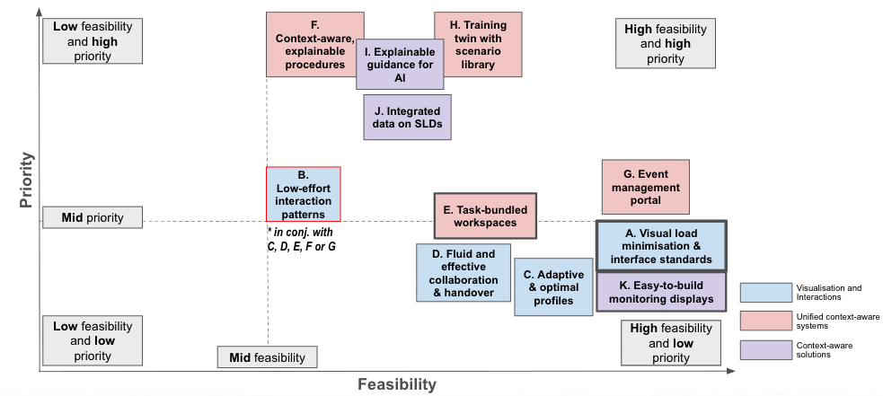
Figure 12: Mapping the Recommendations A-K onto two axes of low to high priority and low to high feasibility, with the usual “midway point” shifted left for ease of readability as everything is mapped above the midway point. All Recommendations are mid-high feasibility, ranking from low to high priority. The highly feasible A and K outlines in grey were deemed the most feasible for the continued work in the final phase of this research (Section 5.3.4).

Visualisation and Interaction Recommendations

A. Visual load minimisation & Cross-system interface standards
Our visualisation design analysis and on-site control room observations revealed that inconsistent visual design and unnecessary visual complexity across current tools impose substantial cognitive and visual load on operators, contributing to fatigue and reduced situational awareness during high-demand periods. Eye-tracking patterns showed frequent shifts between interfaces (Section 4.1.3) with markedly different colour palettes and layout structures (Section 4.3). Workshop feedback also highlighted the mental effort required to interpret dense tables, flashing alerts, and differing visual conventions across systems. To address these issues, we recommend establishing consistent visual and interface standards across core operational tools. This includes standardising the background colour across applications (rather than mixing white, grey, dark grey, and black), reducing reliance on dense tables and flashing elements that contribute to visual strain, and ensuring consistent use of visual elements, such as colour. Where feasible, tools should also support linked views to reduce cognitive effort when navigating between related information across systems.
Next steps: To move close to meeting the goals of Recommendation A, the Stage 5 research team continued to investigate this topic and have identified a number of guidelines for best practices as outlined in Section 5.4.

B. Low-effort interaction patterns
Our on-site observations and analysis of eye-tracking video revealed that operators often perform repetitive, high-frequency interactions, such as multi-step clicks, long pointer movements across large screens, and manual searching for key functions, that cumulatively increase both physical effort and cognitive load. While workshop participants did not explicitly highlight interaction mechanics, they consistently emphasised the need to manage fatigue. Therefore, we recommend adopting interaction patterns that minimise effort and make the actions fluid. This includes placing frequently used actions within easy reach, increasing the size and visibility of common interactive targets, and incorporating simple keyboard shortcuts where appropriate. Additionally, exploring “dock”-style launchers or control-tab-like quick-access mechanisms could significantly reduce the time and effort required to locate and switch between interfaces, supporting smoother workflows and helping reduce fatigue over long shifts. However, such patterns can take time to learn and may increase interface complexity. It is also important to ensure standardisation across systems.
Next steps: Although a lower priority and feasibility on its own, particularly due to security constraints this work was seen as interesting and likely of high benefit to reduce operator fatigue and increase comfort. This work is recommended to be approached in combination with either C, D, E, F or G.

C. Adaptive and optimal profiles
Eye-tracking analysis and on-site observations showed substantial variation in how operators configure and navigate their displays, with different individuals relying on personalised layouts to manage information load. Workshop discussions echoed this through comments such as “build my own displays,” highlighting a desire for flexibility rather than rigid standardisation. These insights suggest an opportunity to provide adaptive, purpose-driven starting points that reduce setup effort while supporting consistent situational awareness. We recommend enabling adaptive, optional interface profiles built around clear operational purposes, such as contingency management, market monitoring, or outage coordination, that operators can switch between with a single click. These presets should not enforce uniformity, instead, they should provide optimised, evidence-informed layouts that offer tangible benefits such as improved focus, reduced clutter, and faster access to critical information, while still allowing operators to customise and refine their environment as needed. Recent research in HCI has shown the importance of customisability of displays, emphasising that users with different personality traits require different presentations of data rather than a one size fits all design ethos. See Yanez et al. (2005) for a survey of literature on customisability of visualisation interfaces.
Next steps: Early insights into profile preferences can be identified from our two participants. To identify profile patterns similarities and differences would need to be identified within and between many operators, for instance through image recognition, and optimal profiling options tested and evaluated.

D. Fluid and effective collaboration & handover
Eye-tracking analysis and on-site observations demonstrated that collaboration between operators is both frequent and dynamic, often involving rapid exchanges of information, shared situation assessments, and, at times, operators physically gathering around a single workstation to work through complex events together. Handover observations further highlighted the effort required to reconstruct context at shift change, and workshop participants emphasised the importance of achieving smoother, more reliable handovers. To support this, we recommend enabling fluid, effective collaboration through shared digital workspaces or notepads that allow operators to easily add, organise, or “drag and drop” information, images, and notes from any workstation. Such tools would help maintain a clear event history, support rapid coordination, and ensure that critical information persists across shifts. This also presents an opportunity for the integration of AI and large language models (LLMs) to assist in digesting, summarising, and contextualising information in real time, helping operators maintain situational awareness during complex or evolving events. However, shared digital solutions should only be adopted if they function seamlessly and integrate cleanly with existing systems as unreliable or fragmented tools would add cognitive load rather than reduce it. Well-designed, unified collaboration features can significantly strengthen event management and handover consistency, reducing the risk of context loss and supporting more efficient teamwork.
Next steps: Explore alternative technical solutions for trialling in control room operations.

Unified Context-aware Systems

E. Task-bundled workspaces
Eye-tracking analysis showed that operators frequently switch between multiple applications, often in rapid succession, when performing complex tasks such as alarm investigation, event assessment, or constraints management (see Section 4.1.3, Figure 10). These sequences require constant cross-referencing across interfaces that use different data models, layouts, and visual elements, increasing cognitive load and slowing down decision-making (as noted in the prior literature Section 1.1). Workshop discussions also expressed interest in more unified workspaces that reduce the need to “hunt” across disparate tools. To address these workflow inefficiencies, we recommend developing task-bundled workspaces that group the applications and information commonly used together for specific operational tasks into a single, coherent view. By consolidating related tools into a unified workspace, operators can minimise context switching, maintain focus, and perform high-demand tasks with greater speed and confidence.
Next steps: Continue current analysis to explore workflow patterns and bundle task relevant visualisations together. Evaluate designs.

F. Context-aware, explainable procedures
Eye-tracking analysis revealed that operators spend considerable time manually searching for the correct procedures, steps, and displays when responding to alarms or system events. This “procedure hunting” often requires moving between multiple systems, opening reference documents, and cross-checking steps, efforts that slow response times during high-pressure situations. Workshop discussions highlighted interest in zero-click or low-effort automation, while still preserving operator judgment and authority. During AEMO discussions it was explained that one RAS procedure for instance, is approximately 170 pages long. Building on these insights, we recommend developing context-aware, explainable procedure support that automatically surfaces the relevant steps, displays, and recommended actions based on the alarm or operational context. For example, when an alarm is investigated, the system could open the associated procedure menu automatically, highlight the specific step and recommended action (such as invoking a constraint), and present related contextual information. Contextual information can be recognised via LLM for instance for suggested and relevant procedures to be identified as a result. Operators would retain full control, reviewing and confirming all actions before execution. This recommendation builds on the ‘collaborative and interactive procedures’ recommendation in prior control room research at AEMO presented in Afzal et al., (2022).
Next steps: Provide context and explainable interfaces, trial and test alternatives. (Connects to Recommendation I(2), which could be an initial step toward Recommendation F)

G. Event management portal
Observations and discussions during the workshop highlighted the need for a centralised, case-centric system to streamline event management, often described by participants as a “one-stop shop” with automatic guidance. Current practices, including the use of internal dashboards, require operators to manually cross-reference multiple applications and logs to understand an event, increasing cognitive load and slowing response. To address this, we recommend developing an event management portal that presents each event as a unified case, summarising what happened, what systems or assets are affected, and the recommended next steps. The portal would integrate with operational tools to automatically open relevant applications and populate contextual information, drawing on a recommender system trained on historical log data. When conditions arise, rather than solely alerts, the system could support the operators with the expected corresponding procedures, recommended actions, and linked displays, supporting faster, more accurate decision-making. By consolidating event information and providing actionable guidance in a single, centralised interface, operators can manage events more efficiently while reducing the effort required to track, interpret, and act on complex system events.
This recommendation connects to the Stage 3 research that identifies events by grouping related alarms and finding the most similar past event. This aligns with the event management portal "what happened" function. It also connects to the "what now" suggested actions feature, which was flagged as a next step in the Stage 3 research.
Next steps: Integration of the data is needed together with dashboard possibilities. Recommendation K gets you part of the way here. Build on Stage 3.

H. Training twin with scenario library
Eye-tracking analysis and on-site observations revealed substantial differences between the training room setups and the live control room environment, creating gaps in realism that limit operators’ ability to transfer skills effectively. Workshop participants similarly emphasised the need for a more accurate and representative training environment supported by a rich library of real-world scenarios. To address this, we recommend developing a training twin, a training environment that remains tightly aligned with the live control room’s tools, layouts, and workflows. This twin should include a scenario library built from past events, enabling operators to practice, replay, and compare different approaches to managing system conditions. Automating the creation of training scenarios from historical logs and operational data could further expand the library, ensure consistency with real-world operational patterns, and reduce manual authoring effort. In addition, insights generated from training interactions could inform improvements in broader control room design and human factors, including the refinement of adaptive presets and interface configurations (linking to Recommendation C).
Next steps: Further work into automated scenario library creation and richer training highlights.

Integrated Context-aware Solutions

I. Explainable guidance for AI implementation
Where AI is implemented, the system must ensure the operator has short, human-readable detail of why that suggestion or guidance is being provided. Two complementary forms of explainability are required for effective control room AI systems:
Explainable AI (XAI) approaches that focus on explaining how or why the AI model produced a result, including empirical information about the influence of inputs on outputs and XAI interfaces that focus on how AI outputs and XAI reasoning and guidance are communicated to operators, including tailoring explanations to the user’s expertise, visually presenting contributing factors and confidence levels, and enabling progressive disclosure from high-level summaries to more detailed reasoning
Ultimately XAI helps operators understand the basis of AI recommendations, while XAI interfaces ensure those explanations are usable, interpretable, and actionable in time-critical operational environments.
From our research, two recommendations for early XAI implementation were identified:
1) Smart Alarm Management where duplicate or cascading alarms are grouped and related using machine learning. This connects to the research for Topic 3: Stage 2 and 3: XAI approaches and interfaces are needed for smart alarm management implementation in order to supports the transparency, validation, and operator trust in AI-assisted alarm prioritisation and recommendations.
2) Intelligent Procedure Search, where contextual information can be recognised via LLM and suggested and relevant procedures identified as a result. If AI can assist in providing operators with support to see procedural overviews and provide context when needed, it could save precious time hunting through procedure documents. However, XAI approaches and interfaces would be needed in order to explain how the procedure is searched and why the presented results are shown. This supports the transparency of the AI recommendation. Such intelligent procedure search XAI guidance can be explored together with F.
Next steps: Continued work is needed to explore and test explainable AI interfaces.

J. Integrate relevant information into SLDs
The single-line diagram (SLD) is a crucial visualisation in the control room, but lacks full integration to provide complete situational awareness. Contextual data can be innovatively embedded into the SLD to provide fast and effective overviews and enable direct action. Some potential examples identified through our observations and discussions include: 1) Market constraint advisor: display and invoke constraints directly on the SLD with clear visual status and short explanations. 2) Natural hazard information: integrate topology with geospatial information so relevant natural hazard information can be rapidly reported and directly recognised. 3) Procedural information: document and action procedural information directly via the SLD. 4) Contingency violation: e.g. voltage, can be shown on the SLD.
Next steps: Continued work is needed to explore and test alternative representations for fast and effective integration of information into SLDs.

K. Easy-to-build monitoring solutions (Interim solution)
Enable the rapid creation of context-ready (and standardised) dashboards for monitoring specific scenarios and event management (Yanez, 2025). This interim solution is needed until we have systems and solutions that provide the wider context, such as Recommendation G. Standardised templates and colour schemes will need to be developed in order to ensure these dashboards can be both situationally driven but featuring best practice for visualisations to reduce visual overload, e.g. Recommendation A.
Next steps: Standards for visualisations in connection with AEMO’s current dashboard improvements work are provided as part of Stage 5 research, see Section 5.4.
Through our continued Stage 5 work we are moving towards visual standards and guidelines (i.e. recommendation A). We have identified insights that form early stages of work towards other recommendations such as C and E.

Guidelines for Control Room Visualisation
During the final stages of Stage 5 research, the Monash team took a deeper dive into AEMO’s new internal interfaces where new dashboards were being created. These guidelines support the implementation of Recommendations A and K. To gain further insights and ensure relevance, this stage of work also included discussions or interviews with operators, developers and the AEMO UX/UI team to understand the current practice and demonstrate the practice of current visualisation development and any relevant standards. The guidelines for CROF visual communication are provided with reference to academic literature to help develop best practice visualisations for control room interfaces to reduce visual load (Recommendation A) and aid the faster creation of dashboards (Recommendation K). There are also guidelines toward explainable AI (Recommendation I). The following table (Table 6) covers the detail of these guidelines, grouped into 4 categories of layout, typography and visual hierarchy, interaction and cognitive load:

Table 6: 25 Guidelines for CROF visualisation and explainable AI design, with a focus on dashboards and visual consistency
# | Guideline | Reference(s)
Layout consistency and alignments
G1 | Alignment: Maintain consistent alignment for labels, axes, legends, and table columns (e.g., text left-aligned, numerical columns right-aligned). | (Few, 2006) - alignment improves readability on dashboards
G2 | Consistent layout and encodings: Use consistent layout patterns, colour encoding, scales, and naming conventions across dashboards. | (Bach et al., 2022; Qu & Hullman, 2018) - emphasises consistent use of layout patterns to support interpretation
G3 | Layout grouping: Arrange visualisations such that most related charts and tables are aligned and as close to one another as possible. | (Bach et al., 2022) - proximal grouping supports reasoning and reduces search time.
G4 | Axes labeling: Always order axes labels in a consistent manner, e.g., Australian states (VIC, QLD, etc.). Avoid repeating labels across multiple visualisations if the visualisations are aligned, whether vertically (y axis) or horizontally (x axis). A single set of consistent labels can reduce screen space use, remove excess text and enable fluid comparison. | (Nussbaumer Knaflic, 2015) - consistent axes, ordered labels help the viewer interpret comparisons correctly
G5 | Fix aspect ratios or use responsive displays: For most effective readability of the data ensure all information is available at one time and fits in the available screen space or a single screen. Responsive displays allow modification on the fly without removing important information. Avoid crossing screen edges and forcing navigation. | (Bach et al., 2022; Wexler et al., 2017) - multiple scenario case studies emphasize screens that “tell the story” without forcing navigation.
G6 | Avoid scrolling: Building from #G5, avoid horizontal and vertical scrolling for primary operational views. If scrolling is unavoidable, ensure critical information remains visible without scrolling, including all legend information. | (Few, 2006) - dashboards should communicate at a glance (no scrolling)
G7 | Compound visualisations: Be careful of combining multiple axes in compound visualisations, i.e. avoid overlaying charts together in one visualisation. For example, a compound line and bar chart with different y-axis dimensions labeled on the left and right sides of the visualisation can take more time to read and comprehend than aligned charts positioned side-by-side, whether vertically or horizontally. In side-by-side charts both axes should be aligned in the screen layout (see #G1) and often can share a common axis to aid readability and comparison (see #G4). | (Qu & Hullman, 2018)  - Section 5.2: Nominal XY Scales: shared axes imply comparability, violating this expectation leads to misinterpretation.  (Wexler et al., 2017) - practical guidance on avoiding difficult dual‑scale interpretations and clashes
G8 | Visual centre: Place the most important information in the visual centre (just above the centre of the layout), following a top-left to bottom-right reading flow; position least critical information in the bottom-right. While the most important information is the most easily available, the operator can still access additional information where required, helping to mitigate availability bias. | (Borji & Tanner, 2016) - highlights the importance of visual-center bias.  (Bach et al., 2022) - dashboards commonly arrange views according to importance and reading order to guide attention
G9 | Avoid visual clutter: Minimise unnecessary visual elements such as excessive gridlines, borders, and separators etc. | (Ware, 2021) - visual clutter, (Tufte & Graves-Morris, 1983) - avoid chart junk and maximise data/ink ratio: data ink/pixels
Visual Weighting and Typography
G10 | Typographic hierarchy: Use a clear, consistent hierarchy of font sizes to distinguish different levels of information (such as primary operational values, secondary contextual values, supporting labels and annotations). | (Caldwell, 2019) - topography and visual weight
G11 | Visual balance: Avoid extreme size differences that disrupt visual balance and avoid large amounts of white space. | (Bach et al., 2022) - disproportionate elements distort attention and analytical balance  (Caldwell, 2019) - visual balance
G12 | Visual hierarchy with figure ground: Use desaturated grey scale colours for contextual information needed in the background (such as map layers) to allow the foreground to use saturated and bright colours for data saliency. | (Caldwell, 2019; Few, 2004; Ware, 2021) - visual weight and perception
Interaction and Cognitive Load
G13 | Limit use of working memory: Limit the items stored in the working memory by limited numbers of categories that can be plotted at one time and shown simultaneously; use aggregation, filtering, or interaction to reduce data to manage the complexity. | (Ware, 2021) - only a few objects can be stored in working memory at a time.  (Bach et al., 2022) - filtering and aggregation as mechanisms for managing dashboard complexity.
G14 | Provide details-on-demand: Provide hover, drill-down, or other on-demand interaction to reveal details without overloading the main view. | (Shneiderman, 1996) - Visual Information-Seeking Mantra: overview first, zoom and filter, then details on demand.
G15 | Interactive linked views: Link visualisations through interaction where possible, so associated or related data across panels to support contextual interpretation. I.e., filtering one filter or highlighting information in another. | (Bach et al., 2022) - coordinated views enable contextual linking across panels.
Visual Channels
G16 | Effective visual channels: Choose effective visual channels for the type of data (e.g. for numerical ordered data with magnitude, position on a common scale is most effective for cognition) utilising preattentive (subconscious) processing. Avoid redundant encoding where possible, e.g. where 2D Size (e.g. length of a bar in a bar chart) is used, the bars do not need to be coloured using a sequential scheme to present the data increasing. Use neutral limited palettes for aesthetics. | (Few, 2004; Munzner, 2014; Ware, 2021) - preattentive cues, effective visual (for magnitude and identify tasks) channels for ordered and categorical attributes.
G17 | Colour only for data: Use colour only for data where possible, and take care to use colour palettes that are suitable for the right data types, i.e. for numerical and ordered data use sequential or diverging schemes with one (or max two) hues varying by colour value (or luminance) and/or colour saturation. Maintain colour hue for categorical data (see also #G18, #G19 and #G20). Avoid the use of rainbow colour schemes (see also #G20). Avoid the use of colour for aesthetics (see also #G16). | (Munzner, 2014; Ware, 2021) - ranking of effectiveness of colour luminancy, saturation and hue. (Harrower & Brewer, 2003) - tested colour schemes for classes and continuous data, particularly for maps.  (Bach et al., 2022) - use colour carefully.
G18 | Consistent Colours: Ensure consistency of meaning of colours across multiple visualisations and interfaces (limit repeating colours with different meanings). Create and use standardised colour schemes to avoid inconsistency. Ensure background colours are consistent (see also #G20). | (Bach et al., 2022) - coordinated views enable contextual linking across panels.
G19 | Avoid Large legends: To avoid overloading the working memory, limit visualisations where there are many categories to plot at one time or values to connect manually (connected to #G13). Avoid legends that require scrolling (same as #G6) or excessive visual search. For categorical data using colour hue, limit these to tested schemes where differentiation is proven to be more effective. | (Ware, 2021) - working memory is limited after seven items.  (Harrower & Brewer, 2003) - provide tested colour schemes for numbers of classes and continuous data (particularly for maps but used throughout visualisation).
G20 | Ensure Sufficient Contrast: Ensure sufficient contrast for readability in both light and dark themes/background colours. Evaluate in different lighting and on different screens. | (Caldwell, 2019; Few, 2004; Harrower & Brewer, 2003; Ware, 2021) - maintain contrast between background and foreground colours to ensure saliency
G21 | Accessible Palettes: Around 8% of the male population and around 0.4% of women in Australia are colour vision deficient. Most prominently this is with red–green combinations (deuteranopia and protanopia). For increased accessibility of CROF interfaces, limit the reliance on red-green traffic light schemes within the same interfaces, in particular within the same visualisation. It is recommended to use contrasting and tested colours, such as orange with blue, or purple with green (see also #G18 and #G20). This factor is particularly a concern for maps and network diagrams (e.g. the SLD) where a lot of data elements are coloured and are close in their proximity.  Note: As red-green is commonly seen in current control rooms we note that this guideline may take longer to come into practice and will need trialling and testing for acceptance. Yet, accessible colour palettes are well recognised as important in visualisation literature to ensure inclusive and accessible data communication for decision making. If traffic light schemes continue, they should be used in conjunction with another visual channel repeating the same data encoding such as a consistent ‘position’ on the visualisation, or a meaningful ‘shape’, like driving where traffic lights and signals have combined meaning. | (Bach et al., 2022) (Munzner, 2014) - colour accessibility. (Harrower & Brewer, 2003) - colour-blind-safe palettes for maps.
Explainable AI (XAI) Interfaces
G22 | Use Visual Explanations: Represent prediction processes visually, such as feature importance bars, confidence indicators, or highlighting contributing factors to make reasoning more transparent. | (Barredo Arrieta et al., 2020) - use visual explanation techniques for human-interpretable displays
G23 | Communicate uncertainty explicitly: Instead of presenting single deterministic outputs, display confidence levels, prediction intervals, or uncertainty ranges to convey the AI’s certainty. | (Chiaburu et al., 2026; Das & Rad, 2020)
G24 | Tailor explanation: Adapt technical details to match the user’s knowledge and context; avoid overwhelming users with raw technical data unless necessary and understandable. | (Miller, 2019) - tailor the explanation to the specific person.
G25 | Progressive disclosure: Present high-level summaries by default, with the option to drill down into more detailed reasoning when needed. | (Muralidhar, 2024; Vered et al., 2020)

Conclusions
Stage 5 focused on the Operator and Human Factors pillar particularly with an emphasis on the interplay of the information visualisation and the human-machine interface for aiding operator situational awareness and decision support. Our mixed method human-centred research approach connected more broadly across many other pillars of the CROF. The results of Stage 5 are broad and cover a number of areas of the roadmap. They take us a step closer in understanding how to reach the overarching CROF Vision “Operators are Effective Supervisors of a More Automated Australian Power System” (see Figure 1).

We have closely analysed existing AEMO control room processes and identified 7 pain points, 5 design vision principles and 11 recommendations for CROF design. Whilst these were observed at AEMO, our prior practice, experience of the full team and our workshop at ACRNA clarify these are valid outcomes beyond AEMO specifically and generalisable beyond Australia and beyond energy to control rooms in other sectors. We also provide in-depth outcomes for two recommendations targeting AEMO interfaces, focusing specifically on information visualisation. These guidelines are also generalisable beyond AEMO and help toward a visualisation philosophy for the CROF.

The Stage 5 outcomes demonstrate the important interdependencies of the Operator and Human Factors innovations pillar and the sheer importance of human factors being considered in future work as informed data-driven decision-making is a crucial part of daily operations. Not only is there a need to ensure that the way we encode information visually is done consistently but also effectively for the type of data, and inclusively to ensure that as many people as possible can comprehend the information when needed. With the growing intelligence of systems, AI and modelling, human-in-the-loop analytics or Human-Machine Interfaces (HMI) this challenge is becoming increasingly important. For continued work in the area, we map the recommendations (see pink in Figure 2) to the 2021 roadmap for Operator and Human Factors research in anticipation that they be taken into account for future research.

To conclude, Stage 5 has identified many open and urgent Operator and Human Factors recommendations for the CROF that are mid-high priority and/or mid-high feasibility. These fall under three categories of Visualisation and Interaction (A-D), Unified Context-aware Systems (E-H), and Integrated Context-aware Solutions (I & J). Further innovative research is needed in: (F, E, J) providing context-aware interfaces, (I) intelligent yet explainable AI suggestions, (C & E) optimising profiles and workspaces, (B & D) enabling fast interaction patterns and rapid digital collaboration. Whilst Topic 3 CROF is extremely broad, the five principles for CROF vision identified during Stage 5: 1) Flexible yet Consistent, 2) Zero-click to Critical, 3) One model, many Views, 4) Automate the Known, and 5) Rapid Explainable Suggestions; should be taken into account during future Topic 3 research in order to reach the ultimate vision of “Operators are Effective Supervisors of a More Automated Australian Power System”.

Appendix
Table 7 : Table 1: Survey results for SART: Situational Awareness Rating Technique & NASA-TLX: NASA Task Load Index
 | S1 |  | S2 |  |  | S3
 | P1 | P2 | P1 |  | P2 | P1 | P2
SART: Situational Awareness Rating Technique Survey | 0 (Low) ---------------------------- 7 (High)
Instability of Situation: How changeable is the situation? Is the situation high unstable and likely to change suddenly (High) or is it very stable and straightforward (Low)? | 4 | 5 | 6 |  | 7 | 6 | 6
Complexity of Situation: How complicated is the situation? Is it complex with many interrelated components (High) or is it simple and straight-forward (Low)? | 4 | 4 | 7 |  | 6 | 6 | 6
Variability of Situation: How many variables are changing within the situation? Are there a large number of factors varying (High) or are there very few variables changing (Low)? | 5 | 5 | 6 |  | 7 | 6 | 6
Arousal: How aroused are you in the situation? Are you alert and ready for activity (High) or do you have a low degree of alertness (Low)? | 5 | 7 | 6 |  | 6 | 6 | 6
Concentration of Attention: How much are you concentrating on the situation? Are you concentrating on many aspects of the situation (High) or focused on only one (Low)? | 7 | 7 | 7 |  | 7 | 6 | 6
Division of Attention: How much is your attention divided in the situation? Are you concentrating on many aspects of the situation (High) or focused on only one (Low)? | 4 | 7 | 6 |  | 6 | 6 | 5
Spare Mental Capacity: How much mental capacity do you have to spare in the situation? Do you have sufficient capacity to attend to many variables (High) or nothing to spare at all (Low)? | 4 | 5 | 4 |  | 6 | 4 | 5
Information Quantity: How much information have you gained about the situation? Have you received and understood a great deal of knowledge (High) or very little (Low)? | 6 | 6 | 6 |  | 6 | 6 | 5
Information Quality: How good is the information you have gained about the situation? Is the knowledge communicated very useful (High) or is it not usable at all (Low)? | 6 | 5 | 6 |  | 6 | 6 | 4
Familiarity with Situation: How familiar are you with the situation? Do you have a great deal of relevant experience (High) or is it a new situation (Low)? | 5 | 7 | 5 |  | 5 | 6 | 7
NASA-TLX: NASA Task Load Index Survey | 0 (Low) ---------------------------- 10 (High)
Mental Demand: How mentally demanding was the task? | 9 | 6 |  | 10 | 8 | 8 | 8
Physical Demand: How physically demanding was the task? | 7 | 3 |  | 8 | 3 | 8 | 4
Temporal Demand: How hurried or rushed was the pace of the task? | 8 | 6 |  | 9 | 9 | 8 | 10
Performance: How successful were you in accomplishing what you were asked to do? | 8 | 10 |  | 8 | 10 | 8 | 9
Effort: How hard did you have to work to accomplish your level of performance? | 8 | 8 |  | 9 | 10 | 7 | 8
Frustration: How insecure, discouraged, irritated, stressed, and annoyed were you? | 4 | 3 |  | 7 | 7 | 5 | 5
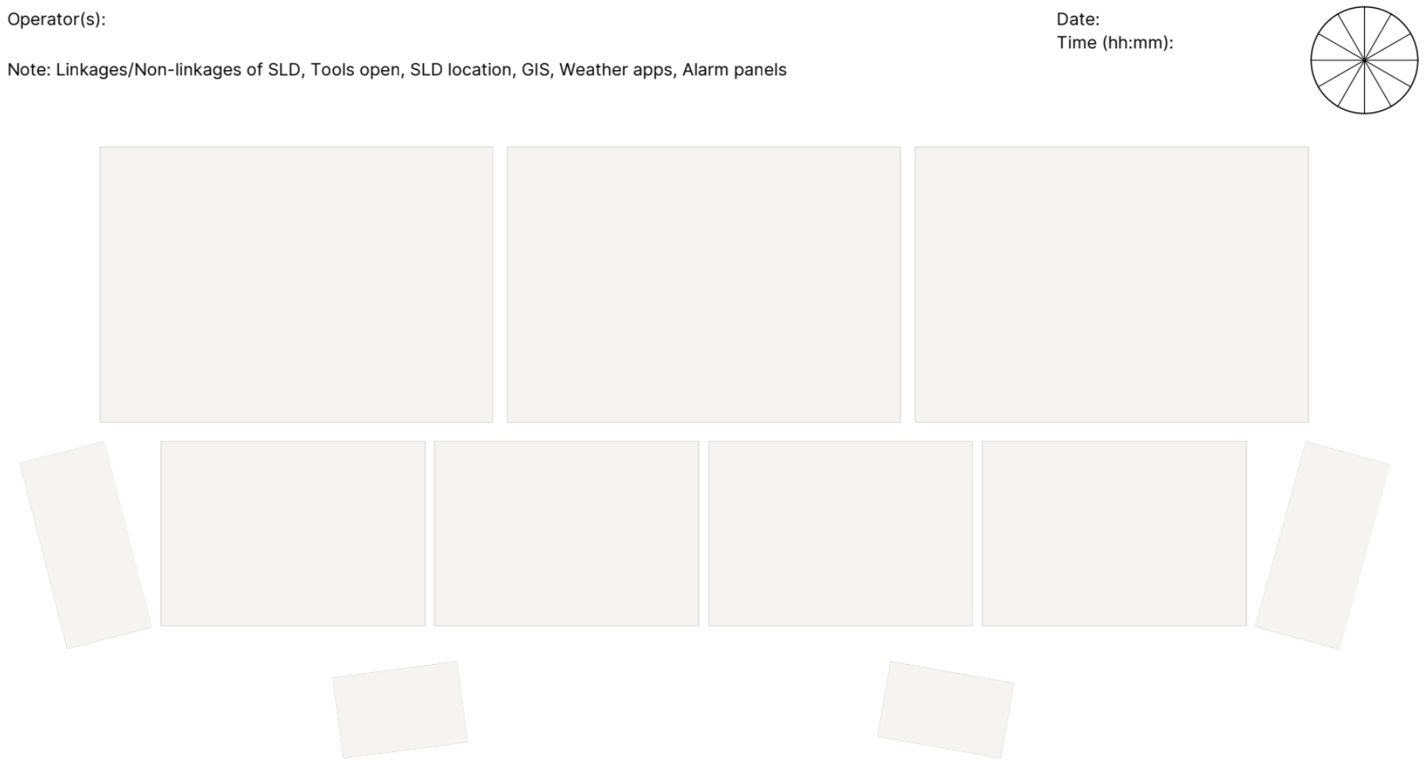
Figure 13: Live control room observation template
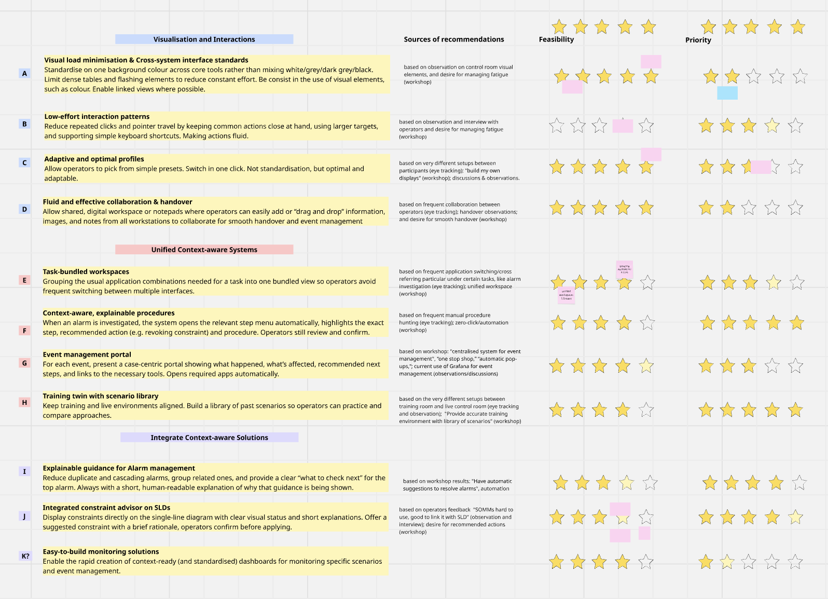
Figure 14: Overview of the 10 (A-K) recommendations, their categories and source of the recommendations, together with the initial ranking of feasibility and priority with AEMO.

Supplementary Material
The supplementary material provided together with this report provides full diagrams and working documents as well as notes on reproducibility.
This supplementary material is available at https://doi.org/10.26180/32692422
It contains:
- Full workflow diagrams
- Full Applications list and visual audit including codes for all Visualisations
- Miro boards from the online workshop
- Documentation of the reproducibility of Figures
- Study setup protocol, questionnaires and reflection for future improvements

References
Afzal, U., Prouzeau, A., Lawrence, L., Dwyer, T., Bichinepally, S., Liebman, A., & Goodwin, S. (2022). Investigating Cognitive Load in Energy Network Control Rooms: Recommendations for Future Designs. Frontiers in Psychology, 13, 812677. https://doi.org/10.3389/fpsyg.2022.812677
Bach, B., Freeman, E., Abdul-Rahman, A., Turkay, C., Khan, S., Fan, Y., & Chen, M. (2022). Dashboard Design Patterns. IEEE Transactions on Visualization and Computer Graphics, 1–11. https://doi.org/10.1109/TVCG.2022.3209448
Barredo Arrieta, A., Díaz-Rodríguez, N., Del Ser, J., Bennetot, A., Tabik, S., Barbado, A., Garcia, S., Gil-Lopez, S., Molina, D., Benjamins, R., Chatila, R., & Herrera, F. (2020). Explainable Artificial Intelligence (XAI): Concepts, taxonomies, opportunities and challenges toward responsible AI. Information Fusion, 58, 82–115. https://doi.org/10.1016/j.inffus.2019.12.012
Bartram, L. R., & Calvert, T. (1994). Evaluating the role of intelligent support in user interfaces to supervisory control systems. Proceedings of IEEE International Conference on Systems, Man and Cybernetics, 1, 717–722 vol.1. https://doi.org/10.1109/ICSMC.1994.399920
Bazazan, A., Dianat, I., Feizollahi, N., Mombeini, Z., Mohammad Shirazi, A., & Castellucci, H. I. (2019). Effect of a posture correction–based intervention on musculoskeletal symptoms and fatigue among control room operators. Applied Ergonomics, 76, 12–19.
Blascheck, T., Kurzhals, K., Raschke, M., Burch, M., Weiskopf, D., & Ertl, T. (2017). Visualization of eye tracking data: A taxonomy and survey. Computer Graphics Forum, 36(8), 260–284.
Borji, A., & Tanner, J. (2016). Reconciling Saliency and Object Center-Bias Hypotheses in Explaining Free-Viewing Fixations. IEEE Transactions on Neural Networks and Learning Systems, 27(6), 1214–1226. https://doi.org/10.1109/TNNLS.2015.2480683
Caldwell, C. (2019). Graphic Design For Everyone: Understand the Building Blocks so You can Do It Yourself. DK Publishing (Dorling Kindersley). https://www.readings.com.au/product/9780241343814/graphic-design-for-everyone--cath-caldwell--2019--9780241343814
Chen, K.-T., Prouzeau, A., Langmead, J., Whitelock-Jones, R. T., Lawrence, L., Dwyer, T., Hurter, C., Weiskopf, D., & Goodwin, S. (2023). Gazealytics: A Unified and Flexible Visual Toolkit for Exploratory and Comparative Gaze Analysis. 2023 Symposium on Eye Tracking Research and Applications, 1–7. https://doi.org/10.1145/3588015.3589844
Chiaburu, T., Bießmann, F., & Haußer, F. (2026). Uncertainty Propagation in XAI: A Comparison of Analytical and Empirical Estimators. In R. Guidotti, U. Schmid, & L. Longo (Eds.), Explainable Artificial Intelligence (pp. 390–411). Springer Nature Switzerland. https://doi.org/10.1007/978-3-032-08333-3_18
Das, A., & Rad, P. (2020). Opportunities and Challenges in Explainable Artificial Intelligence (XAI): A Survey (arXiv:2006.11371). arXiv. https://doi.org/10.48550/arXiv.2006.11371
Few, S. (2004). Show me the numbers: Designing tables and graphs to enlighten. Analytics Press.
Few, S. (2006). Information Dashboard Design: The Effective Visual Communication of Data. O’Reilly Media, Inc.
Gegenfurtner, A., Lehtinen, E., & Säljö, R. (2011). Expertise Differences in the Comprehension of Visualizations: A Meta-Analysis of Eye-Tracking Research in Professional Domains. Educational Psychology Review, 23(4), 523–552. https://doi.org/10.1007/s10648-011-9174-7
Goodwin, S., Dykes, J., Jones, S., Dillingham, I., Dove, G., Duffy, A., Kachkaev, A., Slingsby, A., & Wood, J. (2013). Creative User-Centered Visualization Design for Energy Analysts and Modelers. IEEE Transactions on Visualization and Computer Graphics, 19(12), 2516–2525.
Goodwin, S., Mears, C., Dwyer, T., de la Banda, M. G., Tack, G., & Wallace, M. (2017). What do Constraint Programming Users Want to See? Exploring the Role of Visualisation in Profiling of Models and Search. IEEE Transactions on Visualization and Computer Graphics, 23(1), 281–290. https://doi.org/10.1109/TVCG.2016.2598545
Harrower, M., & Brewer, C. A. (2003). ColorBrewer.org: An Online Tool for Selecting Colour Schemes for Maps. The Cartographic Journal, 40(1), 27–37. https://doi.org/10.1179/000870403235002042
Hart, S., & Staveland, L. (1988). Development of NASA-TLX (Task Load Index): Results of Empirical and Theoretical Research. Advances in Psychology, 52, 139–183. https://doi.org/10.1016/S0166-4115(08)62386-9
Hugo, J. (2005, October 15). The Semiotics of Control Room Situation Awareness. Proceedings of CybErg 2005. The Fourth International Cyberspace Conference on Ergonomics.
Karwowski, W., & Zhang, W. (2021). The discipline of human factors and ergonomics. In G. Salvendy & W. Karwowski (Eds.), Handbook of human factors and ergonomics. Wiley. https://doi.org/10.1002/9781119636113.ch1
Kerzner, E., Goodwin, S., Dykes, J., Jones, S., & Meyer, M. (2019). A Framework for Creative Visualization-Opportunities Workshops. IEEE Transactions on Visualization and Computer Graphics, 25(1), 748–758. IEEE Transactions on Visualization and Computer Graphics. https://doi.org/10.1109/TVCG.2018.2865241
Kelly, A, McGuinness, S, Pellow, M & O’Connell, B. (2021). Control Room of the Future Research Roadmap (Topic 3) Australian Research Planning for Global Power Systems Transformation, CSIRO, Electric Power Research Institute (EPRI), Pellow Energy Insights, Smarter Power Solutions. https://www.csiro.au/en/research/technology-space/energy/Electricity-transition/AR-PST/Stage-1
Miller, T. (2019). Explanation in artificial intelligence: Insights from the social sciences. Artificial Intelligence, 267, 1–38. https://doi.org/10.1016/j.artint.2018.07.007
Munzner, T. (2014). Visualization Analysis and Design (1 edition). A K Peters/CRC Press.
Muralidhar, D. (2024). The Effect of Progressive Disclosure in the Transparency of Explainable Artificial Intelligence Systems. 2024 IEEE Symposium on Visual Languages and Human-Centric Computing (VL/HCC), 382–383. https://doi.org/10.1109/VL/HCC60511.2024.00057
Nussbaumer Knaflic, C. (2015). Storytelling with Data: A Data Visualization Guide for Business Professionals. Wiley. https://www.amazon.com.au/Storytelling-Data-Visualization-Business-Professionals/dp/1119002257
Qu, Z., & Hullman, J. (2018). Keeping Multiple Views Consistent: Constraints, Validations, and Exceptions in Visualization Authoring. IEEE Transactions on Visualization and Computer Graphics, 24(1), 468–477. https://doi.org/10.1109/TVCG.2017.2744198
Raney, G. E., Campbell, S. J., & Bovee, J. C. (2014). Using Eye Movements to Evaluate the Cognitive Processes Involved in Text Comprehension. Journal of Visualized Experiments, (83), 50780. https://doi.org/10.3791/50780
Roberts, J. (2000). Display models: Ways to classify visual representations. CIDAC, 2(4), 242–250.
Rodrigues, J. F., Traina, A. J. M., De Oliveira, M. C. F., & Traina, C. (2006). Reviewing Data Visualization: An Analytical Taxonomical Study. Tenth International Conference on Information Visualisation (IV’06), 713–720. https://doi.org/10.1109/IV.2006.94
Sacha, D., Stoffel, A., Stoffel, F., Kwon, B. C., Ellis, G., & Keim, D. A. (2014). Knowledge Generation Model for Visual Analytics. IEEE Transactions on Visualization and Computer Graphics, 20(12), 1604–1613. https://doi.org/10.1109/TVCG.2014.2346481
Saraswati, P., & Devi, A. (2023). Mixed methods-research methodology an overview. Mathews Journal of Nursing and Health Care, 5(4), 1-3.
Shneiderman, B. (1996). The Eyes Have It: A Task by Data Type Taxonomy for Information Visualizations. Proceedings of the IEEE Symposium on Visual Languages, 336–343.
Stanton, N. A., Salmon, P. M., Jenkins, D. P., & Walker, G. H. (2013). Human factors in the design and evaluation of central control room operations. CRC Press.
Tag, B., Vargo, A. W., Gupta, A., Chernyshov, G., Kunze, K., & Dingler, T. (2019). Continuous Alertness Assessments: Using EOG Glasses to Unobtrusively Monitor Fatigue Levels In-The-Wild. Proceedings of the 2019 CHI Conference on Human Factors in Computing Systems, 1–12. https://doi.org/10.1145/3290605.3300694
Taylor, R. M. (2011). Situational Awareness Rating Technique (Sart): The Development of a Tool for Aircrew Systems Design. In Situational Awareness. Routledge.
Tufte, E. R., & Graves-Morris, P. R. (1983). The visual display of quantitative information (Vol. 2). Graphics press Cheshire, CT.
Van Laar, D., & Deshe, O. (2007). Color Coding of Control Room Displays: The Psychocartography of Visual Layering Effects. Human Factors: The Journal of the Human Factors and Ergonomics Society, 49(3), 477–490. https://doi.org/10.1518/001872007X200111
Vered, M., Howe, P., Miller, T., Sonenberg, L., & Velloso, E. (2020). Demand-driven transparency for monitoring intelligent agents. IEEE Transactions on Human-Machine Systems, 50(3), 264–275. https://doi.org/10.1109/THMS.2020.2988859
Ware, C. (2021). Information Visualization: Perception for Design. Morgan Kaufmann.
Wexler, S., Shaffer, J., & Cotgreave, A. (2017). The Big Book of Dashboards: Visualizing Your Data Using Real-World Business Scenarios eBook : 10.1002/9781119283089
Yanez, F., Conati, C., Ottley, A., & Nobre, C. (2025, February). The State of the Art in User‐Adaptive Visualizations. In Computer Graphics Forum (Vol. 44, No. 1, p. e15271)
Zakerian, S. A., Yazdanirad, S., Gharib, S., Azam, K., & Zare, A. (2018). The effect of increasing the illumination on operators' visual performance in the control-room of a combined cycle power plant. Annals of Occupational and Environmental Medicine, 30, Article 49. https://doi.org/10.1186/s40557-018-0267-3
Zhang, Y., Athukorala, N., Liang, Z., Qiao, Y., Simran, Yio, Y. X., Lawrence, L., Tag, B., Vered, M., Wybrow, M., & Goodwin, S. (2025). Streamlining Eye-Tracking and Observational Data for Field Study Visual Analysis. Proceedings of the 2025 Symposium on Eye Tracking Research and Applications, ETRA ’25, 1–9. https://doi.org/10.1145/3715669.3725880

As Australia’s national science agency,
CSIRO is solving the greatest challenges through innovative science and technology.
CSIRO. Creating a better future for everyone.
Contact us
1300 363 400
+61 3 9545 2176
csiro.au/contact
csiro.au

A research methodology that combines both qualitative and quantitative research approaches to gain a more comprehensive and nuanced understanding of a research problem (Saraswati & Devi, 2023).
This research was initiated as part of the Stage 4 funding round but due to unforeseen circumstances the project commencement was delayed until early 2025. For ease of management and documentation the research was renamed Stage 5 in mid 2025 to align with the other topics in the AR-PST program. Results are aligned with Stages 1-3 and can lead into future work for Stage 6.
https://www.tobii.com/products/eye-trackers/wearables/tobii-pro-glasses-3
Creative Visualization-Opportunities Workshops methods are available and documented here https://vdl.sci.utah.edu/CVOWorkshops/methods/. We based the workshop(s) on the example workshop, with amendments for time restrictions, and adapted for online facilitation and participation: https://vdl.sci.utah.edu/CVOWorkshops/example/.
The Gazealytics toolkit is openly available at: https://github.com/gazealytics/gazealytics-master
One-hour scenarios also align with practical constraints of the eye-tracking equipment, including battery life and the need to maintain calibration integrity across continuous recordings.
https://www.tobii.com/products/software/behavior-research-software/tobii-pro-lab
Gazealytics is available at: https://github.com/gazealytics/gazealytics-master?tab=readme-ov-file
Colour legend: 7A: saccades are coloured by direction of eye movement: Dark Blue (bottom-right to top-left) and Yellow (top-left to bottom-right); Purple (bottom to top) and Lime Green (top to bottom); magenta (bottom-left to top-right),Green (top-right to bottom-left); Cyan (right to left) and Red (left to right).
The Tobii glasses' stable calibration (see Section 3.1.3) meant that no recalibration or post-hoc data adjustments were required.
Recording start times were slightly offset between the two participants' devices, the timelines shown here have been aligned to a common reference for direct comparison.
The applications used in approximate fixation order are predominantly: SOMMS MC: Modify Constraints (pale magenta), OP: Operational Procedures (pale green), PC: Pending Constraints (magenta), CM: Constraint Management (mid magenta) and NEM Display (orange). All application codes and names are provided in the supplementary material.

