Australia’s National
Science Agency
AR-PST Topic 5 Stage 5
Restoration and Black Start

  - Final Report
Sorrell Grogan, Babak Badrzadeh, Nilesh Modi
May 2026

Australian Research in Power System Transition



Citation
Grogan, S., Badrzadeh, B., and Modi, N. (2026) AR-PST Topic 5 Stage 5 Restoration and Black Start. CSIRO, Australia.
Copyright
© Commonwealth Scientific and Industrial Research Organisation 2026. To the extent permitted by law, all rights are reserved and no part of this publication covered by copyright may be reproduced or copied in any form or by any means except with the written permission of CSIRO.
Important disclaimer
CSIRO advises that the information contained in this publication comprises general statements based on scientific research. The reader is advised and needs to be aware that such information may be incomplete or unable to be used in any specific situation. No reliance or actions must therefore be made on that information without seeking prior expert professional, scientific and technical advice. To the extent permitted by law, CSIRO (including its employees and consultants) excludes all liability to any person for any consequences, including but not limited to all losses, damages, costs, expenses and any other compensation, arising directly or indirectly from using this publication (in part or in whole) and any information or material contained in it.
CSIRO is committed to providing web accessible content wherever possible. If you are having difficulties with accessing this document, please contact csiro.au/contact.
Acknowledgement of Country
CSIRO acknowledges the Traditional Owners of the lands, seas and waters of the area that we live and work on across Australia and pays its respects to Elders past and present. CSIRO recognises that Aboriginal and Torres Strait Islander peoples have made, and will continue to make, extraordinary contributions to Australian life including in cultural, economic, and scientific domains.

Contents
Abbreviations 4
Acknowledgements 6
Executive Summary 7
1 Introduction 11
1.1 REZ Self-Energisation and Remote Hybrid Configurations (Milestones 1 & 2) 11
1.2 IBR technical standards for restart (Milestone 3) 12
1.3 Development of a GFM-BESS restart test plan template (Milestone 4) 13
1.4 Progress against the research roadmap 14
2 Methodology 17
2.1 REZ Model Development 18
2.2 Synchronous condensers 20
2.3 Plant Models developed 21
2.4 Analysis 21
3 Results and discussion 24
3.1 REZ Self-Energisation Challenges and Strategies 24
3.2 Remote Hybrid Configuration 53
3.3 Restart-Capable IBR Plant Standards 67
3.4 GFM BESS restart test plan template 74
4 Discussion 82
5 Insights 85
6 Future work recommendations 87
7 References 90
8 Appendix 95

Figures
Figure 1 REZ layout for this work 19
Figure 2 Sync-con ramping to speed and sync-check relay operation 27
Figure 3 Following grid voltage prior to synchronisation 28
Figure 4 Arbitrary REZ for energy consumption prediction testing 29
Figure 5 Simple two-site REZ forming a restart service 31
Figure 6 Unbounded resonance in early network restoration 35
Figure 7 Transformer associated with the black-start unit 35
Figure 8 Harmonic profile of early REZ network (left), early REZ network plus a centralised filter capacitor (right) 36
Figure 9 Simplified typical capability curves for synchronous machines (red) and BESS (blue) 37
Figure 10 Default transformer differential settings used for studies 37
Figure 11 High-level representation of network energised 38
Figure 12 High-level representation of network energised 40
Figure 13 Line energisation waveform oscillations 41
Figure 14 RMS oscillations following line energisation 41
Figure 15 External system restoration source arrangement 47
Figure 16 System voltages and frequency for a synchronous-machine (only) facilitated restoration 48
Figure 17 Connection of supporting REZ to the restarting synchronous machine 49
Figure 18 Comparison of system voltage and frequency with and without REZ support 50
Figure 19 Comparison of system voltage and frequency with and without REZ support with highly variable output 52
Figure 20 Graphical representation of extent of network used for remote hybrid configuration 1 55
Figure 21 Remote Hybrid Configuration 1 Results 56
Figure 22 Graphical representation of extent of network used for remote hybrid configuration 2 57
Figure 23 Remote Hybrid Configuration 2 Results 58
Figure 24 Overview of the multiple REZ islands to be used to form a single service 60
Figure 25 Overall performance of a multiple-island REZ forming a singular restart service with extreme active power variations 62
Figure 26 NSP areas of concern 76
Figure 27 NSP-suggested approach to live network testing for system restart 78

Tables
Table 1 Research progress 15
Table 2 Synchronous condenser parameters 20
Table 3 Plant models developed 21
Table 4 Line Energy Consumption 25
Table 5 Transformer Energy Consumption 26
Table 6 Synchronous Condenser Energy Consumption 26
Table 7 Arbitrary REZ Inventory and Energy Consumption 29
Table 8 Restarting REZ BESS energy storage requirements to wait at PoC for further instruction, with no additional power source 31
Table 9 Internal REZ energisation to the PoC results 33
Table 10 Internal REZ energisation to other REZ equipment results 33
Table 11 Energisation capability from a single GFM BESS 38
Table 12 Devices online 39
Table 13 Energisation capability from a semi-energised REZ 40
Table 14 Approximate switching times 42
Table 15 Plant readying times 43
Table 16 Single GFM BESS to PoC Timing 43
Table 17 Semi-energised REZ to PoC Timing (Area A) 44
Table 18 Semi-energised REZ to PoC Timing (Area B) 45
Table 19 Semi-energised REZ Further Timing Variability 46
Table 20 Scenario setup – Remote hybrid configuration 1 55
Table 21 Scenario setup – Remote hybrid configuration 2 57
Table 22 Adjustments and results 63
Table 23 Preferred sources to form a remote hybrid 65

Abbreviations

Abbreviation | Meaning
AEMO | Australian Energy Market Operator
AR-PST | Australian Research in Power System Transition
AVR | Automatic Voltage Regulator
BESS | Battery Energy Storage System
CB | Circuit Breaker
CSC | Centralised Synchronous Condenser
CT | Current Transformer
DER | Distributed Energy Resources
DFIG | Doubly Fed Induction Generator
dVOC | Dispatchable Virtual Oscillator Control
EHV | Extra High Voltage
EMT | Electromagnetic Transient
ERCOT | Electric Reliability Council of Texas
FAT | Factory Acceptance Test
GASTWD | Gas Turbine Governor Model (GASTWD)
GFL | Grid-Following
GFM | Grid-Forming
HIL | Hardware-in-the-Loop
HV | High Voltage
Hz | Hertz
IBR | Inverter-Based Resource
ISO | Independent System Operator
kV | kilovolt
kW | kilowatt
LOE | Loss of Excitation
LV | Low Voltage
MHI | Manitoba Hydro International
MPPT | Maximum Power Point Tracking
MV | Medium Voltage
MVAr | Megavolt-ampere reactive
MW | Megawatt
MVA | Megavolt-ampere
MWh | Megawatt-hour
NEM | National Electricity Market (Australia)
NESO | National Energy System Operator (UK)
NSP | Network Service Provider
OEM | Original Equipment Manufacturer
OOS | Out-of-Step
PCC / PoC | Point of Connection
PF | Power Factor
PMU | Phasor Measurement Unit
PPC | Power Plant Controller
PSCAD™ / EMTDC™ | Power Systems Computer Aided Design / Electromagnetic Transients including DC
PSS | Power System Stabiliser
Q | Reactive Power
REZ | Renewable Energy Zone
RMS | Root Mean Square
SCR | Short Circuit Ratio
SCADA | Supervisory Control and Data Acquisition
SG | Synchronous Generator
SoC | State of Charge
SyncCon | Synchronous Condenser
THD | Total Harmonic Distortion
TSO | Transmission System Operator
UPS | Uninterruptible Power Supply
V/Hz | Volts-per-Hertz Protection
VSD | Variable Speed Drive
VSM | Virtual Synchronous Machine
VT | Voltage Transformer
WA | Western Australia
WF | Wind Farm

Acknowledgements
The research presented in this report was funded by CSIRO, Australia’s national science agency, and carried out as part of CSIRO’s contribution to the initiatives of the Australian Power Systems Renewables transition. This research supports Australia's transition to a stable, secure and affordable power system and contributes to critical research identified by the Consortium required to accelerate the decarbonisation of our electricity grid.
The research presented in this report was supported by AusNet, who provided subject matter expertise towards the test plan template and practical operational strategies and timings for restart conditions.
The researchers wish to warmly acknowledge the expertise and efforts provided by Farid Mosallat from Manitoba Hydro International for his expert model development and tuning contributions.

Executive Summary
Australia’s rapid transition toward an inverter‑dominated power system is reshaping how black start and system restoration services must be delivered. Traditional synchronous generators, long the cornerstone of restart capability, are retiring rapidly, while new grid‑forming (GFM) and grid‑following (GFL) inverter‑based resources (IBRs) are becoming the dominant form of generation in Renewable Energy Zones (REZs). Despite strong technical progress in recent years, industry confidence in IBR‑based restart remains low, driven by concerns over energy limitations, protection behaviour, and uncontrolled system dynamics during restoration.
Stage 5 of AR‑PST Topic 5 builds directly on the previous four stages, delivering a comprehensive assessment of a REZ’s ability to self‑energise, form stable islands, support existing system restoration pathways, and provide a credible black start service using GFM Battery Energy Storage System (BESS) as the primary restart asset. This stage also provides quantitative energy consumption metrics, extensive Electromagnetic transient (EMT)‑based validation of restoration strategies, an assessment of remote‑hybrid configurations, and guidance for plant standards and field test planning.
Key Findings
- A single GFM BESS can self‑energise a REZ and reach the transmission network Point of Connection.
Detailed EMT studies show that a 400 MVA GFM BESS is capable of energising the internal High Voltage network of a REZ, including large transformers up to 1500 MVA, provided the restoration sequence carefully manages:
  - Reactive power headroom, particularly for long 500 kV transmission lines where line charging dominates reactive power consumption, and
  - Passive resonance avoidance, especially low‑frequency resonances excited by early energisation steps.
  - A strategically energised harmonic filter can enable progress past early resonance points, after which it may be safely removed to preserve reactive headroom.
- Energy reserve requirements for restart are smaller than commonly assumed.
Using measured energisation data from EMT simulations for lines, transformers, synchronous condensers and plant auxiliaries, the study found that:
  - A typical 200 MW / 400 MWh BESS operating within its normal State of Charge range (10 to 90%) inherently retains adequate energy to re‑energise a REZ and wait for instructions.
  - In a representative 2‑plant scenario, only 2 to 7% of stored energy capacity was required to restore supply to the REZ point of connection and hold it energised for 1 to 3 hours.
This directly challenges the common view that energy‑limited BESS cannot reliably provide black start, especially as it was also demonstrated that such a discharged BESS is capable of restoring supply to a nearby primary energy producing plant to begin the recharge process.
- A partially energised REZ can further energise portions of the external network, including hard-energising very large (1500 MVA) network transformers.
Once additional IBR generation within the REZ is online, forming a hybrid REZ island, its external restart reach capability increases, but less than proportionally to the amount of generation online within the REZ.
For a representative scenario with 1700 MVA of IBR online within a REZ, only 200 km of single-circuit 500 kV line could be reliably energised. Beyond this, excessive reactive absorption demands and protection maloperation become limiting factors, rather than the BESS’s dynamic performance or synchronisation method. This may be problematic given that REZs are typically located in remote areas. Notably however, it is not a limitation that applies only to IBR technology, as a similarly located synchronous machine would have similar, if not greater, challenges.
- Remote‑hybrid restart (GFM plus distant GFL generators) is viable without additional coordination layers.
A question entering Stage 5 was whether uncoordinated GFL wind or solar farms could participate in restart when energized remotely by a GFM BESS. Simulation results show:
  - No additional wide‑area coordination or special control schemes were needed.
  - Frequency and voltage settle naturally through droop mechanisms, similarly to synchronous systems.
  - Even intentional, artificially large, power variations (±80% of nameplate, step-changes) from wind and solar plants remained manageable.
The key requirements to enable this are:
  - Ability to trim/adjust BESS active power such that frequency is maintained at approximately 50 Hz.
  - Ensuring total GFL output never exceeds the BESS’s active power absorption headroom capacity.
  - Maintaining adequate State of Charge room for charging or discharging depending on system needs.
  - Terminal voltage control, in those circumstances where the GFL IBR is connecting behind appreciable impedance (e.g. wind turbines).
- Multiple IBR‑only islands can merge to form larger restart systems.
Two independently‑energised REZ islands (each using GFM BESS and variable IBR generation) were shown to:
  - Synchronise successfully, despite differing control modes for the GFM BESS (VSM vs droop).
  - Operate stably for extended periods and while being subjected to extreme transients arising from the energisation of external network components.
  - Maintain voltage within approximately 3% of nominal, and frequency within ±0.4 Hz, under extremely heavy and instantaneous active power variations.
- A partially re-energised REZ operating as a restoration support service can materially improve a restoration that is primarily driven by a synchronous machine.
When supporting an external synchronous‑machine‑led restart effort, a partially energised REZ:
  - Tightened voltage regulation across all energisation steps.
  - Improved frequency nadirs and recovery during transformer and load pickup.
  - Continued to provide stable support even under large active power variations within the REZ.
- Expected real‑world restoration timelines.
Typical network element switching times for a restart process are used for this example REZ topology:
  - Once BESS is ready, it will take approximately 17 to 45 minutes to energise POC.
  - Depending on staffing, parallelism and plant restart sequencing, for a REZ with multiple plant online, can take between 16 minutes to 3 hours to energise up to the PoC.
These estimates demonstrate that REZ-led restoration is comparable with timeframes expected from traditional synchronous-based strategies (human resource pending), despite the larger number of individual elements comprising the REZ to be restarted.
- Restart-capable plant standards.
  - System restart using inverter‑based resources requires explicit, purpose‑built technical standards, because conventional connection and access standards do not adequately capture the extreme conditions and restoration risks encountered during restoration of dead or very weak networks.
  - Restart capability must be defined by externally observable plant‑scale behaviours and testable performance outcomes, rather than inferred from labels such as “grid‑forming” or compliance with normal operating standards, in order to ensure technology‑neutral and verifiable assessment.
  - Effective IBR‑based restart depends on stable operation under very low system strength, current‑limited conditions, and complex energisation and load‑pickup events, with particular emphasis on voltage and frequency control, protection‑quality fault current, and ability to dampen oscillatory behaviour.
  - The proposed framework in this report provides a structured, repeatable basis for assessing restart‑capable IBRs at the plant scale, while clearly separating generic technical requirements from network‑ and location‑specific restoration planning and procurement considerations.
- Emerging needs for plant standards and field testing.
Industry remains hesitant to allow IBR to provide primary restart capability due to limited field experience and a perceived risk of damage to network equipment. Stage 5 therefore:
  - Identifies characteristics needed for restart‑capable IBR plant standards.
  - Provides a test plan template for a deep network restart from a GFM BESS, incorporating specific requirements on the following to minimise risk exposure:
- High-speed monitoring of key node voltages and energisation currents on the test path
- Real-time visibility of these quantities (as opposed to recording-only)
- Multi‑party rehearsals
- Peer-reviewed EMT studies by asset owners as well as operators
- Clear rollback mechanisms to quickly restore the system to a safe and stable state
Overall, the Stage 5 findings collectively demonstrate that:
- IBR‑based REZs that extensively use GFM BESS are technically capable of providing comprehensive system restart services.
- Energy storage requirements for BESS facilitating restart within a REZ are less than commonly assumed, while dynamic performance proved to be generally more well-regulated when compared synchronous machine-based restart.
- With appropriate planning and in-field test validation, REZ‑based black start can become a credible, scalable replacement for retiring synchronous technology.
These results represent a major step toward enabling real‑world trials and establishing robust restart capabilities for Australia’s inverter‑dominated future grid. This comes at a time where AEMO recently published a request for Type 2 Transitional Services, highlighting the urgent need in the industry to demonstrate black start capability using inverter-based resources including GFM BESS.

Introduction
The transition to an IBR-dominated NEM shows no sign of abating, along with over 12 GW of traditional synchronous generation forecast to retire by 2034. The NEM is fundamentally changing, and almost all aspects of planning, modelling, analysing and delivering the system services required must evolve – immediately. System restart capacity in the NEM is already becoming deficient owing to the early shutdown of traditional thermal restart sources, yet options for, and confidence in, relying on IBR restart sources are extremely low, largely due a lack of experience and data in what is a necessarily conservative industry. Hence, practical studies, requirements and solutions to enable IBR restart are required today.
Stage 5 of the topic 5 leverages the work completed by researchers in previous stages which demonstrated that there is ample, strong simulation-based evidence that GFM-BESS technology can perform well in system restart (and in many cases, better than synchronous machines). The work presented in this stage now focuses on demonstrations of IBR-based restart in realistic emerging scenarios in the NEM (e.g. REZs) and defining crucial technical and testing requirements to provide confidence to the industry that IBR can reliably play a leading role in system restart within the NEM to deliver quantitative insights into what have been largely anecdotal concerns. Additionally, the work extends the hybrid plant concept to multiple geographically diverse sites to determine whether energy reserve or export requirements of black-start sources can be met through a remote hybrid arrangement. Stage 5 of Topic 5 has four milestones which are briefly described following.

REZ Self-Energisation and Remote Hybrid Configurations (Milestones 1 & 2)
One of the most pressing concerns in the existing power system industry is the role of IBRs in system restart. Although synchronous generators have provided the service for over 100 years, they are decreasing in number, with new IBRs now dominating much of the grid in Australia. However, there remains great scepticism in the industry as to whether IBRs can play an effective role in restart. Although previous AR-PST research stages have answered many questions regarding the fundamental capabilities of IBR for restart (in particular, the use of GFM BESS), commonly cited concerns of the role of IBR include the energy-limited nature of BESS, and the unpredictability of energy generation from wind and solar sources.
Hence, this stage of the work sought to answer the following questions:
- How much energy does a BESS need to have available in storage if it is to be a primary black starter?
- How much energy do the key network elements consume when being energised?
- How can the primary BESS be recharged if it doesn’t have enough energy to restart the grid?
- Can a REZ be self-energised, and then go on to provide a restart service for the greater grid?
  - Can the BESS do it on its own? What else may be required?
- How much further into the power system could an IBR-based REZ energise? And what are the limiting factors?
- What happens when the primary energy resources in the REZ are varying due to weather? Is the system still controllable?
- How long would it take to restore a REZ, given its complexity?
- If a REZ is not given the role as a primary restart source, could it alternatively provide restoration support such as voltage and frequency control to a system being restored?
- What additional control mechanisms are required in a REZ to coordinate the devices contributing to the system restoration?
Milestone 1 (REZ Self-Energisation Challenges and Strategies) and Milestone 2 (Remote Hybrid Configurations) answers these questions, delivering quantitative metrics wherever feasible to help inform the discussion on the pragmatic capability of IBR-based REZs in restoring the power system.

IBR technical standards for restart (Milestone 3)
The purpose of this work is to establish an initial technical basis for industry discussion and to support a more standardised approach to defining, assessing and verifying restart-capable inverter-based plant, while aligning, where appropriate, with current and emerging restart procurement and demonstration frameworks, including AEMO initiatives relating to black start capability from inverter-based resources. The requirements developed address operating conditions that are materially more onerous than those typically examined in conventional connection studies and conventional access standard assessments. These requirements provide a plant-scale technical reference to support, rather than replace, existing and emerging restart procurement frameworks, including SRAS and Type 2 Transitional Services, and to inform future evolution of those frameworks towards inverter-based restart participation.
Conventional connection standards generally assume that a plant connects to a power system with an established voltage waveform, well-characterised operating conditions, and a surrounding network within familiar limits. System restart conditions are materially different; they may involve dead network energisation, very low and rapidly changing fault levels, uncertain and discontinuous load pickup, sparse damping, and heightened risks of interaction with passive network elements, protection systems, and other controls. In this context, the key technical question is not only whether the plant can remain connected, but whether the proposed system restart generator can provide a stable source during early restoration and can be assessed against defined plant-scale performance outcomes.
Restart-capable performance should therefore not be inferred solely from conventional grid-connection compliance, nor assumed from a grid-forming label. Intentional participation in system restart is a distinct service capability that requires explicit technical requirements. These requirements should be stated in terms of externally observable plant behaviour and measurable plant-scale outcomes, rather than internal control architecture, original equipment manufacturer terminology, or open-ended assumptions about future network configuration.
The requirements presented in this milestone is intentionally technology-neutral and does not define compliance by reference to grid-following or grid-forming labels. Instead, it focuses on the plant-scale capabilities and externally observable behaviours required for restart service. Some restart duties, particularly dead-network energisation, establishment of a stable voltage and frequency reference, and sustained islanded operation as a primary source, are likely to require voltage-forming behaviour. The requirements therefore remain neutral on implementation while specifying the required performance outcomes.
The requirements focus on whether the plant can:
- Energise and stabilise a dead network section,
- Establish and maintain a controlled local island,
- Operate under very low and varying system strength within a defined test envelope,
- Remain compatible with protection and supervisory control systems, and
- Avoid unacceptable oscillatory or power-quality risks during restoration.
They also address restart-specific performance requirements, including transformer energisation, line charging, load pickup, operation under unbalanced conditions, behaviour at current limits, and orderly transitions between defined restoration stages.

Development of a GFM-BESS restart test plan template (Milestone 4)
Milestone 4 focuses on bridging the gap between desktop based EMT studies and the practical, operational steps required to validate inverter based black start capability in the real power system. While earlier milestones assessed technical feasibility through modelling, Milestone 4 addresses the core challenge raised by Network Service Providers (NSPs), being industry hesitation to be the first to expose high value assets to an unproven IBR driven restart process.
Despite strong technical results from Stages 1–5 of Topic 5, NSPs contacted and spoke with as part of this work consistently expressed that no amount of simulation alone can replace the confidence gained from carefully controlled, in field network energisation trials. AEMO’s subsequent release of the Type 2 Transitional Services – Black Start Capability from IBR further reinforces the national need for a validated pathway to safely test GFM BESS restart capability. This milestone develops that pathway by:
- Developing a test plan template for a GFM BESS to perform deep network energisation, i.e., energising elements beyond the point of connection.
- Embedding controls, monitoring, and test procedures to ensure asset protection during testing.
- Reflecting the operational concerns and expectations of NSPs, derived from targeted discussions and stakeholder engagement.
- Providing a template that can directly support AEMO’s Type 2 service trials for IBR based restart.
This milestone acknowledges the industry environment that “while confidence in GFM BESS is growing, stakeholders require a predictable, peer reviewed, and risk managed testing process before committing to live trials”. This test plan template is written from the perspective of both the GFM BESS operator and the network operator, ensuring alignment of technical capability, asset protection, and operational processes.

Progress against the research roadmap
Table 1 provides progress update against the research roadmap. It highlights details of each stage, tasks carried out during each stage to address research gap and deliverables.
Note that as this research has evolved, elements which may have seemed complete or near complete in previous stages may have been reclassified as less complete as new information and discoveries come to light.
Table 1 Research progress
Roadmap Major Tasks | Original Roadmap Tasks | Roadmap changes  (if any) | Stage 2 planned tasks | % | Stage 3 tasks | % | Stage 4 tasks | % | Stage 5 tasks | %
1. Treatment of IBR during system restoration | 1-1 Grid-following inverters |  | Assessed capabilities of GFL IBR (BESS, solar, wind) being restarted by GFM BESS, SG, and SyncCon + GFL BESS black starters. Determined SCR withstand limits and Generator Restart Size Ratios via hundreds of PSCAD™/EMTDC™ studies on simplified power island model. | 50% | Investigated stability boundaries of restarted islands with multiple GFL support devices (up to 1:10 GFM:GFL ratio). Assessed impact of GFL frequency and voltage droop settings on island stability. Studied GFL BESS fault ride-through re-strike behaviour. | 65% | Evaluated alterations to GFL IBR operational and operator accessible settings to enhance stability during 100% IBR system restoration. | 85% | A wide variety of GFL-IBR devices were evaluated for stability during IBR-only based restart, including clustering effects from a REZ and highly variable input energy sources. Different terminal control algorithms were explored, and it was noted that terminal voltage control can aid in stability. | 100%
1. Treatment of IBR during system restoration | 1-2 Grid-forming inverters |  | Assessed GFM BESS as black starter using two vendor-specific OEM EMT models. Found GFM BESS outperforms SG and SyncCon + GFL BESS. Virtual inertia, damping, and fault current parameters had insignificant impact on stability. GFM islanded mode used for all studies. | 33% | Determined 1:10 GFM:GFL ratio as upper stability limit. GFM frequency droop, inertia, and damping sensitivities analysed on wide-area network. GFM BESS location studies: proximity to SGs enables soft energisation of large transformers. Rise and settling time analysis for fault response. | 60% | EPRI GFM BESS model used. GFM BESS readily accommodates uncontrolled DER export. Aggressive frequency droop (<3%) increases instability; manual active power biases preferred over aggressive closed-loop control. Slower voltage recovery from GFM BESS increases DER tripping during transformer energisation vs SG. | 80% | Explored the use of multiple GFM algorithms and synchronisation of multiple GFM-based islands. Evaluated GFM BESS capability to enhance a synchronous restart. Evaluated the ability of GFM to supplement restarting synchronous islands and found no adverse interactions should droop characteristics be present. Found that once again GFM BESS performance is strong during restart conditions and in many cases superior to synchronous machines. | 100%
1. Treatment of IBR during system restoration | 1-3 Distributed energy resources | Scope expanded in Stages 3 and 4 | DER PSCAD™ model not available from AEMO at this stage. Deferred to later stages. | - | Commenced DER impact analysis using AEMO composite load model and DER model. 20%+ aggregated DER disconnected following faults. No control interactions observed. DER/load reconnect ramp functionality identified as critical model gap. | 35% | EPRI DER model with inner/outer inverter control loops used. GFM BESS accommodates uncontrolled DER export well (reconnection, disconnection, source variations). DER more prone to tripping on undervoltage during transformer energisation with IBR restart source vs SG. Studies ~80% complete. | 65% | Not addressed in this stage. | 65%
1. Treatment of IBR during system restoration | 1-4 Role of synchronous generators and condensers in IBR dominated system |  | Compared SG, GFM BESS, SyncCon + GFL BESS as black starters. SyncCon + GFL least capable (distance sensitivity, collective voltage/frequency control limitations). SG tripped due to negative-sequence and V/Hz relay in one wide-area fault scenario. SG inertia had insignificant impact. | 65% | Island synchronisation between SG-only and IBR-only islands studied: viable with manageable transients, no sustained oscillations. SG operating mode switchover (isochronous to droop, PSS engagement) assessed during restoration. SG transformer energisation assessed with varied GFM sizes. |  | Compared SG and GFM BESS as restart sources for DER impact: GFM BESS superior for accommodating DER power variations but slower voltage recovery on transformer energisation causes more DER tripping. SG-based restart benchmarked against IBR-based restart. | 100% | Not addressed in this stage. | 100%
2. Impact on network control and protection systems | 2-1 Impact on control systems (SVCs, STATCOMs, emergency control schemes) |  | SVCs included in wide-area NQREZ model. Reactive power capability identified as key limiting factor for successful energisation. Existing line and substation reactors required to manage reactive power loading. Dynamic reactive support essential for distant restoration paths. | 30% | Two site-specific SVCs modelled (230 MVA and 150 MVA). SVC reconnect feature validated. Reactive power management confirmed as critical throughout restoration. IBR full reactive power at no-load capability identified as important. | 50% | Not specifically addressed in current milestone scope. Recommended as future priority: evaluate whether SVCs, STATCOMs, and series-compensated devices need alteration for 100% IBR restart. | 50% | Not addressed in this stage. | 50%
2. Impact on network control and protection systems | 2-2 Impact on protection systems |  | Distance and differential line protection relays included in PSCAD™ models. Assessed potential maloperation under low fault level conditions. SG negative-sequence and V/Hz relay operation observed during wide-area faults. Generator protection (LOE, OOS) not assessed due to generic SG models. | 15% | Protection relay behaviour noted during studies but not the primary focus. Recommended protection relays, network protection schemes as key future research priority. | 20% | Parameterisation of network protection relay models specific to limited-area network; studies of relay operation in 100% IBR restart scenarios including multiple transformer energisations in series. | 40% | Generic protection relays included in all REZ studies showed behaviour consistent to previous stages and continued to show evidence that GFM-based restart options are likely to have less spurious protection tripping compared to synchronous machines. However, it is possible that the limit of offline simulation capabilities has been reached for generic protection relay evaluation, and that next stages should consider HIL setups. | 50%
2. Impact on network control and protection systems | 2-3 Assessing the need for modifications |  | Widened GFL protection settings improved stability outcomes in some scenarios. Identified that system normal settings may be too restrictive for restoration. | 15% | Voltage and frequency protection settings suitable for system restart without alteration from system normal. Frequency droop adjustments provide additional benefit. Standard settings do not present immediate instability. | 25% | Investigated whether protection relays remain fit for purpose with IBR-only restart. Analysis of relay settings matched to network component characteristics. | 40% | Refinement of previous findings only, limited by generic nature of protection models. | 50%
2. Impact on network control and protection systems |  | 2-4 New Task: Operational strategies for existing GFL fleet (Stage 4) | Not addressed in this stage. | - | Not addressed in this stage. | - | PPC open-loop mode identified as stabilising strategy. Fixed active/reactive power commands at inverter terminals recommended. Minimise internal hybrid plant power exchange. Frequency band management essential for GFL synchronisation during restart. | 80% | Application of previous Stage 4 findings to a REZ found that recommendations held across new IBR-only restart topology types | 85%
3. Tools and techniques | 3-1 Power system modelling and simulation tools |  | Developed simplified PSCAD™ power island model with vendor-specific EMT models (GFM BESS x2, GFL BESS, wind, solar, SG, SyncCon). Built wide-area NQREZ EMT model with AEMO. Frequency-dependent line models used. Vendor-specific protection relay models included. | 20% | Enhanced merged wide-area model with breaker-node substation modelling. Frequency-dependent (phase) transmission line models for all restart paths. Jiles-Atherton transformer hysteresis model. Surge arrester models at all substations. Detailed SG models with full control/protection. | 30% | Developed limited-area EMT model (300 km primary restart path) that is realistic but not real, suitable for sharing with research community. Includes EPRI GFM BESS, DER, and wind models; OEM solar/battery/hybrid models; online harmonic visualisation tools. Models to be released. | 70% | Developed fully open REZ model including variety of new GFL and GFM models and protection models (via MHI Protection Library).  Developed a highly detailed, generic test plan template for GFM BESS to participate in a physical power system restart test. | 90%
3. Tools and techniques | 3-2 Decision support tools for control centres | Deprioritised (Stage 3) | Not addressed in this stage. | - | Not addressed. Deprioritised relative to other research areas. Depends on GPST Topic 3 (Control Room of the Future) progress. | - | Deprioritised. | - | Deprioritised | -
4. Technical and regulatory requirements | 4-1 Grid code specifications and IBR performance requirements for restoration |  | Developed high-level functional specifications for GFM and GFL IBR during restoration based on hundreds of PSCAD™ studies. Assessed trade-off between system normal and black start performance (NER S5.2.5.5 and S5.2.5.13). | 15% | GFM:GFL ratio of 1:10 recommended as upper limit. System normal voltage/frequency protection settings suitable without alteration. Frequency droop adjustment and inertia/damping optimisation recommended. Key GFM characteristics identified for black start suitability. | 30% | Milestone 4: developing analytical screening tool to estimate GFM BESS procurement needs as thermal plant retires across NEM. High-level procurement timeline tool. AEMC System Restart Standard review directly informed by this research. | 50% | Recommended grid codes for IBR devices wishing to participate in system restart developed based on recent ISO experiences. | 65%
4. Technical and regulatory requirements | 4-2 Cost and timeframes for system restoration | 4-2 New Task: Planning for replacement of synchronous restart sources with GFM sources. Stage 4. | Not addressed in this stage. | - | Not addressed in this stage. | - | Procurement timeline tool under development: estimating quantity and timing of IBR-based SRAS procurement as conventional plant retires. Based on published retirement dates and GFM BESS restart capability research. | 50% | Further development of specific findings limited by need to maintain confidentiality. | 65%
5. End-to-end system restoration with high share of IBR | 5-1 Bottom-up restoration and island synchronisation | New focus area from Stage 3 | Not addressed in this stage. | - | Island synchronisation studied: SG-only and IBR-only islands synchronised viably with significant but manageable transients. No sustained oscillations post-synchronisation. GFM black start device location near SGs enables soft energisation option. | 50% | 100% IBR restart scenarios studied with realistic limited-area model. Restart sequences optimised. Transformer energisation challenges identified (large network transformers >1 GVA from IBR). REZ restart capability recommended as future priority. | 60% | Restoration from REZ explicitly investigated, including the ability of the REZ to restart itself, and the extent of the network a REZ is likely to restore. Included investigation of energy storage requirements from GFM BESS and how input source variability can be accommodated. | 75%
5. End-to-end system restoration with high share of IBR | 5-2 Restoration from distribution network and microgrids |  | Not addressed in this stage. | - | DER and composite load model impact on bottom-up restoration assessed. Voltage management during DER energisation identified as key challenge. Reconnect ramp functionality needed in models. | 30% | DER impact from distribution system investigated with EPRI model. Delaying restart to avoid daylight DER output discussed as NEM concern. Research directly addresses AEMC Reliability Panel concerns. | 65% | Restoration and synchronisation of two REZ micro-islands investigated, including investigation of coordinating mechanisms required to maintain stability from variable IBR sources | 70%

Methodology
Following provides high level methodology for each milestone.
- Milestone 1 - REZ Self‑Energisation:
  - Milestone 1 focused on assessing whether a Renewable Energy Zone (REZ) can be self‑energised using inverter‑based resources, with a grid‑forming battery energy storage system (GFM‑BESS) acting as the primary restart source. The methodology was centred on detailed electromagnetic transient (EMT) simulations, which are essential for capturing fast dynamic interactions between inverter controls, network impedances, transformer saturation, harmonic phenomena, and protection behaviour under weak‑grid conditions.
  - A representative, yet non‑site‑specific, REZ network model was developed in PSCAD™, inspired by contemporary Australian REZ topologies. The model included realistic transmission line geometries, large power transformers, switching stations, synchronous condensers, and multiple inverter‑based generation types. All major plant protection functions remained enabled throughout studies to ensure outcomes reflected operable system conditions.
  - The energisation process was investigated step‑by‑step, beginning with BESS self‑start and progressing through internal line energisation, transformer energisation (including worst‑case residual flux conditions), and establishment of stable voltage and frequency across the REZ. Key evaluation metrics included voltage magnitude and distortion, frequency response, harmonic behaviour, controller stability, transformer inrush performance, and protection relay operation.
  - Furthermore, the energy required to energise and maintain each network component was recorded such that approximate values for BESS energy storage could be determined to better inform the quantity of additional storage reserve that must be maintained by a BESS participating in system restoration.
  - This methodology ensured that conclusions drawn for REZ self‑energisation were technically robust, operationally relevant, and transferable to a wide range of Australian REZ scenarios.
- Milestone 2: Remote Hybrid Configurations
  - Milestone 2 extended the Milestone 1 methodology to assess remote hybrid restart configurations, in which a GFM-BESS initiates restoration, and geographically distant grid-following (GFL) wind or solar plants provide supplementary energy once energised. The objective was to determine whether these arrangements could remain stable without pre-coordination or bespoke control schemes, or whether additional schemes are needed to maintain REZ dynamic stability.
  - The same EMT modelling environment was retained, with additional network corridors and voltage transformations introduced to represent electrical distance between restart sources and remote generation. Multiple configurations were studied, varying electrical distance, voltage level transitions, GFM/GFL capacity ratios, and inverter control modes. Remote generation was subjected to intentionally conservative, and extreme, variations in active power (up to ±80%) in order to stress frequency and voltage regulation capability under worst‑case conditions.
- Milestone 3: Restart-Capable IBR Plant Standards
  - Milestone 3 focuses on the survey and development of suggested plant technical standards for IBR devices that are intending to participate in system restart. This work is largely based on the analysis and synthesis of other requirements developed locally and internationally (including those developed by these authors in other works), tailored to meet the needs of IBR participating in restart in the Australian power system. It draws heavily on the authors’ experiences and recommendations based on the current state of the art.
- Milestone 4 - GFM‑BESS Restart Test Plan Template
  - Milestone 4 develops a suggested test plan template for a GFM BESS intended to participate in a live network test. Drawing on the researchers’ previous experience, deep involvement of system restart tests and in consultation with a network service provider, it is written from multiple perspectives (both the GFM BESS operator and network operator) to consider the needs of each party to protect their assets whilst still delivering a meaningful test to prove the capability of the prospective system restart provider.
  - Inputs to the methodology included lessons learned from Milestones 1 and 2, international system operator practices, and AEMO test plan frameworks. It leverages and heavily augments the already refined AEMO test plan template, building on its key components to deliver a template tailored for restart tests that address the most common concerns of asset owners.
  - The test plan template was structured to be modular, enabling NSPs and plant operators to tailor it to site‑specific constraints while preserving core safety principles. This methodological approach recognises that successful restart testing is not purely a control or modelling problem but a socio‑technical process.
  - By embedding operational reality into the test framework, the aim is to provide a credible pathway for transitioning GFM‑BESS restart capability from simulation to real‑world deployment under AEMO Type 2 Transitional Service trials.

REZ Model Development
Underpinning the work completed for Milestones 1 and 2 of this work is the development and use of an PSCAD™ EMT model of a REZ. This model allows for the exploration of phenomena for IBR devices providing system restart services and provides a testbed for ideas and solutions to issues encountered. The REZ network model was developed specifically for this work and is made available to the greater research community to use and improve as needed.
The REZ topology developed was inspired by the Central West Orana REZ in New South Wales as currently being developed by EnergyCo and its partners. Note that this does not mean that the REZ model developed in this work is accurately representative of the CWO REZ, however it helped steer the development decisions. This REZ was chosen as inspiration because:
- It is a radially connected modern REZ, simplifying studies.
- It has been the subject of much consultation and analysis, meaning that there is sufficient data in the public domain to inform estimations of the topology and components of the REZ.
- It consists of the most common types of equipment likely to be deployed in an Australian REZ, predominately solar, wind and BESS equipment.
- It connects to a 500 kV network, allowing the consideration of challenges associated with line charging during system restart.
CWO layouts and site equipment were available from [1], which informed the topological arrangement seen in Figure 1 below (numbers in the nodes denote MW of generation).
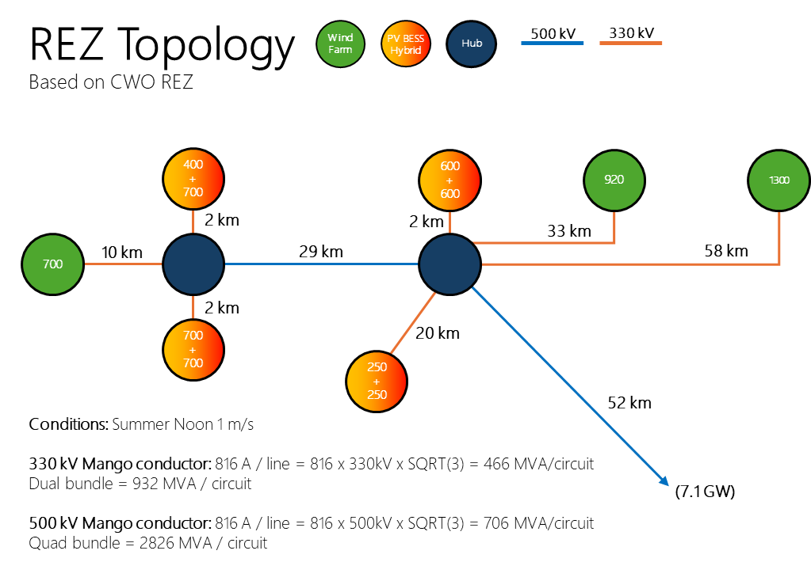
Figure 1 REZ layout for this work
The remaining details of the REZ network were informed largely by the researchers’ previous experience in connections and planning roles in the NEM, with regards to:
- Typical tower size, spacing, cable selection and bundling arrangements.
- Typical transformer sizes and impedances used in generation-rich areas.
- Typical breaker layouts of terminal stations.
- Protection settings for transformer differential and line distance relays.

Software used
The following software was used in the development of models and production of results:
- PSCAD™/EMTDC™ version 5.0.2
  - Including the Manitoba Hydro International (MHI) Protection Library add-on.
- Intel® Fortran Compiler Classic 2021.11.0 (64-bit).

Synchronous condensers
Many new REZs include synchronous condensers within their grid connection infrastructure, often located at central hubs. These units provide critical system strength, voltage support, inertia, and fault current, some of which may be limited in grid-following inverter-based renewable generation. Such characteristics makes them a common design feature in REZs despite increasing evidence that most of these elements can be readily provided by grid-forming inverter technologies.
Regardless, for restart scenarios, synchronous condensers can be valuable. They provide additional reactive power control to help regulate voltage along cranking paths and where flywheels are added, can supply appreciable inertia to stabilise frequency as the system is progressively restored. Their ability to enhance short-circuit strength is especially important in REZs dominated by inverter-based resources (which are inherently current-limited), where energising transformers or starting large motors may require the supply of large inrush currents.
During this work a suite of synchronous condensers with parameters outlined in Table 2 were used.
Table 2 Synchronous condenser parameters
Characteristic | Quantity
Rating | 100 MVA to 250 MVA
Inertia constant | 1.0 s to 7.0 s
Losses at synchronous speed | 2%
Excitation system | Static
Pony motor size | 2.2 MVA
Pony motor connection | Variable speed drive
The synchronous condenser (SyncCon) parameters adopted for these studies in this report are not sourced from any specific, existing installation. Instead, they are intentionally defined as realistic but not real, meaning they are closely aligned with values commonly observed in field‑deployed synchronous condensers, without representing proprietary or site‑specific data. This approach ensures technical credibility while avoiding any implication that results are directly transferable to a particular asset.
As shown in Table 2, the assumed SyncCon ratings (100–250 MVA), inertia (time) constants (1.0–7.0 s), losses (~2%), and excitation systems are all consistent with values typically specified for modern transmission‑connected synchronous condensers used for system strength, voltage control, and restoration support. The inertia range captures both low‑inertia designs (optimised for reduced mechanical stress and faster run‑up) and higher‑inertia designs representative of installations intended to deliver stronger inertial response during weak‑grid or restoration conditions. Similarly, the use of a static excitation system reflects prevailing industry practice for achieving fast and well‑damped voltage control.
The inclusion of a pony motor of approximately 2.2 MVA, driven by a variable speed drive, aligns with common installations in the NEM where reliable self‑start capability is required independent of grid conditions. Loss levels and auxiliary consumption are also consistent with publicly reported performance of large synchronous condensers, ensuring that the energisation energy and steady‑state consumption assessed in this work are representative of real‑world operation.

Plant Models developed
As part of the work completed during this stage, the models listed in Table 3 following were either developed or substantially modified from other sources, in PSCAD™ format, to support the studies completed. Note that not all models were necessarily required for the studies completed, but all are made available as part of this work regardless.
Table 3 Plant models developed
Class | Type | Notes
Generation | Grid-Forming BESS | A virtual synchronous machine-based GFM BESS model was developed and is included for release as part of this package.
Generation | Type IV wind turbine | Sourced from the public PSCAD™ application library, but with substantial modifications to the pitch controller, voltage controller feedback loop, and control system parameters, to allow correct operation in lower strength grids such as the NEM.
Generation | Type III wind turbine
Generation | Hybrid GFL PV-GFM BESS | GFL PV sourced from EPRI’s publicly available models, with changes to PPC and inverter inner control loop parameters for operation at lower strength grids in the NEM. Augmented with EPRI’s GFM BESS model to produce a hybrid GFM-GFL BESS-PV solution.
Generation | Pumped Hydro with DFIG | Developed based on the above type III wind turbine model
Generation | Synchronous condenser | Developed based on realistic machine data and generic excitation system settings, including a variable speed drive for ramp-up
Generation | Hybrid Type IV wind and GFL BESS
Protection | Line distance protection | Based on the additional PSCAD™ Protection library add-on, available from MHI.
Protection | Transformer differential protection
Protection | Generators point of connection protection | Based on commonly implemented voltage and frequency protection settings for the Automatic Access Standard in the NEM

Analysis
The following outlines both the techniques and reasoning used to establish the simulation cases used for this work, and the methods for analysing the output to determine whether a case is robust and stable, or what specific conditions had led to the failure.

Metrics
Evaluation of the performance of the system under test was completed using both qualitative and quantitative metrics, drawing on the experience of the researchers in evaluating real system restart performance studies.
The following metrics were evaluated within the studies:
- Plant protection relay operation (or pickup), indicating failure to ride through a given disturbance or self-protection operation due to excessive unstable behaviour or voltage and frequency beyond acceptable bounds.
- Network protection relay operation and internal measurement quantities, such as transformer differential protection and line distance protection. These can be categorised as follows:
  - A true positive, that the system state is beyond what is allowable for the assets in operation (e.g., voltage and/or frequency beyond bounds, asset current beyond acceptable levels), or
  - A false positive, that the input signal quantities on which the protection relays operate upon are insufficient / have been corrupted enough to falsely trigger the relay (e.g., excessive voltage or current harmonics results in a miscalculation of system state, resulting in a false trip of the relay).
  - A false negative, where a disturbance that should result in operation of protection relays fails to do so, resulting in possible damage to primary equipment (e.g., fault current is insufficient to trigger overcurrent-based relays).
- Stability of plant output, ensuring that the active and reactive power of each plant rapidly returns to an equilibrium, within its capability profile, without excessive or unbounded oscillations.
- Transmission system voltage response, ensuring that disturbances does not result in excessive overvoltages which could be likely to activate protection mechanisms, and that any undervoltages are consistent with the disturbance applied and not instead due to the inability of online plant to meet system voltage support needs.
- System frequency response, ensuring that the system’s response to disturbances does not result in excessive frequency variations likely to have operated plant or network protection relays. Ideally, frequency should remain within the operational frequency tolerance band (49.0 to 51.0 Hz) or at least within the extreme frequency excursion tolerance limit (47.0 to 52.0 Hz) as per the Frequency Operating Standards of the NEM.
- Surge arrester (absorbed) energy, where a sudden, large increase is indicative of conduction and hence an unacceptably high system peak voltage, indicating potential damage to primary equipment.
- Controller references (direct current: Id_{ref}, quadrature current: Iq_{ref}, PLL frequency) that are internal to the inverters, when major, fast instabilities are observed in resultant quantities. These quantities are strong indicators of inner-controller instability within individual inverters (as opposed to outer, slow controllers of the PPCs) and are strongly correlated with low system strength conditions.
- For transformer energisation studies, current waveforms into the transformer and their harmonic components are monitored, to identify whether an energisation has completed successfully or if instead insufficient overcurrent availability from the system has resulted in a “stalled” energisation that causes extended undervoltages and an inability to establish a stable and balanced flux in the transformer core.
- System voltage harmonics, measured at key buses (most notably at the point of connection of the black-start unit) online and continuously throughout the simulation. Sustained harmonics can be an indicator of:
  - A system that has failed to return to equilibrium.
  - A network or controller instability that has been excited.
  - The system lacking a characteristic (e.g., overcurrent) that is required to allow the energisation of assets with minimal sustained distortion.
While some limited level of harmonics are ever-present in a real system (especially during disturbances), the decay of harmonics following a change of state gives insight into the ability of the system to recover quickly, and hence of its robustness.

Results and discussion

REZ Self-Energisation Challenges and Strategies

Energy Consumption of REZ Network Components
This section presents the results of energy consumption associated with the energisation and steady-state operation of lines, transformers, and synchronous condensers, within the REZ. The intent of producing these quantitative figures is to demonstrate that the approximate sizing of the energy reserves of a GFM-BESS black starter that are required to meet REZ network energisation needs can be readily calculated; individual components of an arbitrary REZ configuration can be cross-referenced to these tables to determine their energy requirements, both initially and ongoing, and aggregated to provide a calculation of total energy reserves required.
For the following components, active power measurements were taken at the AC point of connection of the black-start source (GFM BESS) and were converted to an energy reading by simple integration over time of the power value before being converted to a MWh figure.

Unloaded Line Energisations
The following summarises the energy consumption results of the transmission lines tested. These figures are only for the unloaded line, as the additional energy lost through conduction losses can be readily calculated as I²R.
Note that:
- The amount of active power energy required only to energise the line was so small that it could not be reliably reported, and furthermore generally, unloaded transmission lines consume very small amounts of power, despite potentially requiring ample reactive power absorption.
- 330 kV conductors are Mango conductors in a full geometric line model, dual bundle arrangement.
- 500 kV conductors are Mango conductors in a full geometric line model, quad bundle arrangement.
- Surge arresters of an appropriate voltage are included on both ends of the line.
For each line, it was assumed that it is, unloaded, one of two circuits on a dual-circuit line and energised at the peak of the Phase A voltage waveform.
Table 4 describes the results.
Table 4 Line Energy Consumption
Voltage [kV] | Length [km] | Energisation Time* [ms] | kWh / minute (online)
330 | 5 | < 100 | 0.8
330 | 10 | < 100 | 0.9
330 | 20 | < 100 | 1.1
330 | 50 | < 100 | 1.6
330 | 100 | < 100 | 2.9
500 | 10 | < 100 | 0.5
500 | 20 | < 100 | 0.9
500 | 50 | < 100 | 2.2
500 | 100 | < 100 | 4.8
500 | 200 | < 100 | 12.6
* From the closure of the breaker until the voltage THD reduces below 5%

Transformer Energisation
The following outlines the energy consumption results of the transformers tested. These figures are for only the unloaded energy consumption of the transformer, as the energy lost through conduction can be readily calculated through known copper loss figures.
These energisation studies also reinforced the findings of AR-PST Stage 4 Topic 5 findings that energisation of such large transformers is entirely possible with a GFM BESS that is smaller in rated power than the unit being energised. This includes hard energisation at the worst possible moment with respect to flux remanence, and without tripping transformer differential protection.
In completing these studies, it was found that passive resonance frequencies must be checked before attempting to energise a transformer. Harmonic filters may aid with shifting or reducing the harmonic profile such that resonances and overvoltages are avoided, but this must be studied in advance of restarting to confirm it does not worsen the resonance.
Each transformer unit, regardless of size was modelled as having:
- 0.5% eddy current losses.
- 0.3% magnetising current.
- Air-core reactance double that of the primary energy path leakage reactance.
- Flux remanence of 0.8/-0.8/0.0 (see footnote)
Table 5 describes the results.
Table 5 Transformer Energy Consumption
MVA | Energisation Time [s]* | MWh (energisation)* | kWh/minUTE (online)
500 | 25.7 | 0.022 | 42
750 | 26.4 | 0.032 | 63
1000 | 27.1 | 0.042 | 84
1250 | 27.6 | 0.053 | 102
1500 | 28.2 | 0.065 | 120
* Energisation here refers from the moment the circuit breaker is closed until the voltage total harmonic distortion at its terminals has decayed below 5%
Note that the above transformer energisation figures assume this is the first transformer to be energised in a sequence. Subsequent transformer energisations may result in different figures, especially if the preceding transformer is pushed back into a core-saturated state.

Synchronous Condensers (SyncCon)
Given that the line-to-line voltage at the output of a synchronous condenser cannot be as high as HV network voltages, it was assumed that the SyncCon is connected to the network via the tertiary winding of a REZ network transformer, with a nominal voltage of 22 kV. Once the hosting transformer was energised, and transients had decayed such that the voltage THD was below 5%, the (simulated) SyncCon was allowed to spin up to its rated synchronous speed of 3000 rpm (50 Hz) using a pony motor driven by a variable speed drive controller. Once synchronous speed was reached, the excitation system was ramped to the same voltage as the network supply. With speed and voltage matching, a sync-check relay closed the main breaker between the machine and the system and signalled for the pony motor to disengage.
Each SyncCon unit, regardless of size was modelled as:
- ramping to rated speed using a 2.2 MVA pony motor driven through a variable speed drive.
- Having 2% friction and windage losses at rated speed.
- Having 50 kW auxiliary system losses.
Table 6 describes the results.
Table 6 Synchronous Condenser Energy Consumption
MVA | Inertia [s] | Ramp Time* [s] | MWh (ramp)* | MWh/minute (online)
100 | 1.0 | 292 (≈5 min) | 0.064 | 0.042
100 | 7.0 | 1,964 (≈33 m) | 0.43 | 0.043
150 | 1.0 | 446 (≈7 m) | 0.098 | 0.062
150 | 7.0 | 3,012 (≈50 m) | 0.66 | 0.063
200 | 1.0 | 609 (≈10 m) | 0.135 | 0.083
200 | 7.0 | 4,131 (≈69 m) | 0.916 | 0.083
250 | 1.0 | 779 (≈13 m) | 0.174 | 0.103
250 | 7.0 | 5,325 (≈89 m) | 1.190 | 0.103
* including time for excitation ramp-up and synchronisation to the grid

Variable speed drive (VSD) control
Due to the continual variation of the frequency and voltage during restart, it was noted that both the final speed target for the VSD and the voltage target for the SyncCon exciter will need to be adjustable, and to be actively adjusted on the day.

Speed Control
For example, assuming the GFM BESS performing the restart is controlled in frequency-power droop-mode, the load drawn by the pony motor during the SyncCon startup (along with other active power draw within system) will result in the system frequency to be noticeably off-nominal. In the example below, the system frequency sat at 49.95 Hz during sync-con ramping to a nominal speed of 3000 rpm. Once the SyncCon excitation system was energised, the difference between grid and SyncCon frequencies was enough to prevent the sync-check relay from closing. To resolve this, manual intervention was required to reduce the VSD speed target down to 2997 rpm.
Figure 2 Sync-con ramping to speed and sync-check relay operation

Excitation Control
During SyncCon spin-up, the exciter is disabled as it serves no purpose to the power system until the SyncCon has reached rated speed. Only once synchronous speed is reached, will the exciter then be enabled. However, due to the relatively weak nature of the power system used for our simulations, grid voltages are likely to deviate substantially from nominal, as elements are energised and loads are brought online. Even the power draw of the SyncCon itself prior to grid synchronisation may be sufficient to materially reduce voltages from their nominal targets.
As such, the SyncCon target voltage must be intentionally aligned with the grid voltage to allow the synchronising check relay across the PoC breaker to close. Only after synchronisation has been achieved, can the voltage setpoint of the SyncCon exciter be permitted to return to nominal. Figure 3 shows an example of this strategy, whereby the setpoint voltage of the SyncCon is first set to align with the grid voltage (approximately 0.96 pu), and once synchronisation has been achieved, is returned to its nominal 1.0 pu setpoint.
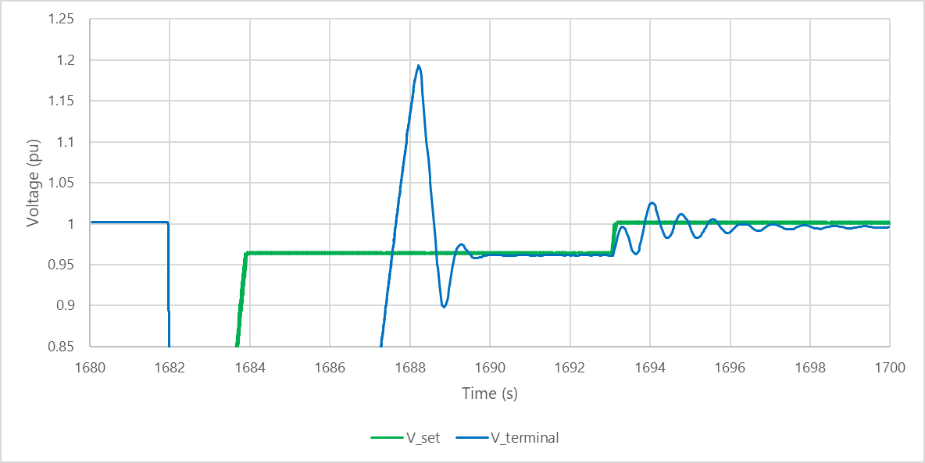
Figure 3 Following grid voltage prior to synchronisation

Generator equipment
The energy consumption of generators (including their reticulation networks) that form part of the REZ is challenging to generalise. The following conservative approximations were used to estimate the power consumption required for each generating plant, with unit consumption figures based on publicly available information from manufacturers.
- Reticulation network (underground 33 kV)
  - Reactive power: 10.2 MVAr for 53 km = 0.2 MVAr/km, 0 MW unloaded
  - Active power: 8.4 MW for 53 km = 0.16 MW/km fully loaded
- Wind generators
  - For each 8 MW wind turbine, 60 kW of power consumption per turbine.
- Solar generators
  - 5 MW inverter unit = 50 kW per unit [2]
- Battery energy storage
  - 10 MW converter unit = 100 kW per unit

Test case
To test whether the above energy requirements are applicable to a generalised network topology, a new and entirely arbitrary REZ network topology was developed in simulation and energised. The topology, (intentionally) arbitrarily designed, was as shown in Figure 4.

D
Starting Unit
20 km
30 km
30 km
10 km
20 km
5 km
C
B
A

20 km
10 km
10 km
E
PoC 1
PoC 2
HUB 1
HUB 2

Figure 4 Arbitrary REZ for energy consumption prediction testing
In Figure 4:
- Circles labelled A to E are clusters of IBRs.
- Hub 1 and Hub 2 are the switching stations within the REZ.
- The grey circles represent synchronous condensers, with the circle entirely within the orange section referring to a 330 kV-connected device, and the circle on the line between the orange and yellow referring to a SyncCon straddling both voltage levels by being connected to a 500/330 kV transformer delta.
Predictions, through high level analytical calculations, were made as to the amount of energy each component would likely consume, and the length of time required for each component needs to reach its energised and synchronised state. Such predictions were based on aligning the following proportionally to the predetermined values from Table 4 to Table 6 above:
- Line lengths and voltages
- Transformer sizes
- Synchronous condenser sizes
The energisation of the REZ was conducted in EMT simulations using a single 400 MVA VSM BESS using the same strategies described later in this report. The results are shown in Table 7.
Table 7 Arbitrary REZ Inventory and Energy Consumption
Element | Details | Energisation  MWh | Online  MWh/min | Delay between element energization [s] | Cumulative Time [s] | Predicted energy for runtime [MWh] | Cumulative measured energy for runtime [MWh]
Starting Unit – Hub 1 line | 330 kV 30 km |  | 0.0013 | 1 | 1 | 0.026 | 0.00000
Hub 1 – A line | 330 kV 10 km |  | 0.0009 | 1 | 2 | 0.018 | 0.00002
Hub 1 – PoC 1 line | 330 kV 30 km |  | 0.0013 | 1 | 3 | 0.026 | 0.00008
Hub 1 – B line | 330 kV 10 km |  | 0.0009 | 1 | 4 | 0.018 | 0.00014
Hub 1 – C line | 330 kV 5 km |  | 0.0008 | 1 | 5 | 0.016 | 0.00022
Hub 1 500/330 TRX | 800 MVA | 0.032 | 0.063 | 28 | 33 | 1.257 | 0.05310
Hub 1 Sync Con | 150 MVA H=1.0s | 0.098 | 0.062 | 450 | 483 | 0.839 | 0.99900
Hub 1 – Hub 2 line | 500 kV 20 km |  | 0.0009 | 1 | 484 | 0.011 | 1.00260
Hub 2 – D line | 500 kV 10 km |  | 0.0005 | 1 | 485 | 0.006 | 1.00530
Hub 2 – PoC 2 line | 500 kV 20 km |  | 0.0009 | 1 | 486 | 0.011 | 1.00890
Hub 2 500/330 TRX | 500 MVA | 0.022 | 0.042 | 26 | 512 | 0.504 | 1.09440
Hub 2 – E line | 330 kV 20 km |  | 0.0011 | 1 | 513 | 0.013 | 1.09710
Hub 2 Sync Con | 200 MVA H=1.0s | 0.135 | 0.083 | 610 | 1123 | 0.242 | 3.13020
Total run time and energy (predicted) |  |  |  |  | 1200 s | 3.0 MWh | 3.4 MWh
The result showed that the total predicted energy required was within 15% of the measured energy required from simulation, although the estimates for individual components show significant divergence. Noting that the tables above used to create this prediction do not factor in the conduction losses (while the measured energy in simulation does), this is still a reasonable prediction which factors in many different aspects of a REZ energisation process.

REZ Energy Storage Reserve Requirements
The following synthesises the information collected on energy consumption requirements and investigates how material is the contention that if a BESS were to provide a valuable system restart service, it would need to constantly reserve too large of a state of charge to be a viable restart option.
The specifics of the REZ and external network to be restored will heavily dictate the energy storage requirements to facilitate a system restart from within the REZ. It is hence challenging to provide specific advice as to precisely how much energy in total a restart-capable GFM BESS must always maintain in order to be considered viable for a system restart service, especially if the amount of network and load to be restored beyond the point of connection is undefined. However, using the findings of this and further sections of the report, approximate estimates can be developed to describe the amount of energy that the GFM BESS within the REZ must hold in order to restore a portion of the REZ up to its point of connection before awaiting further instruction from the system operator.
The following assumptions will apply to this analysis:
- The BESS unit is typically not discharged below 10% during normal operation, as many battery manufacturers require state of charge to remain between 10% to 90% (or 20% to 80%) to prevent premature degradation of cells [3]. However, in exceptional circumstances, discharge to lower values (e.g., 2-3%) can be permissible, provided that it is not a frequent occurrence.
- As the motivation for BESS installation is increasingly to act as a longer-term solar soak, an energy to power ratio of at least 2:1 is increasingly common (although not fixed) [4]. This means for a 200 MW battery, approximately 400 MWh of storage can be assumed, as will be used here.
Combining these assumptions and the worst-case findings from the later Section 3.1.4 (including restart switching timelines requiring up to three hours) and Section 3.2 (using a wind farm as a remote hybrid configuration) for a simple two-plant remote hybrid REZ topology shown in Figure 5, the results in Table 8 can be generated. Any additional energy required beyond REZ energisation “to the point of connection” can simply be added to the figure calculated below as a general requirement from the network operator, calculated through their own system restart studies.

HYB1
WF1
HUB A
HUB B
500 kV
52 km
29 km
4 km
10 km
1 circuit
Figure 5 Simple two-site REZ forming a restart service
Note that in this configuration it is assumed that:
- WF1 reticulation and turbines are energised (with 42 turbines), and are each turbine is consuming 60 kW auxiliary power while waiting to be ready for energy export, however no energy export from the turbines occurs.
- There are several hundred kW of secondary station load likely required for protection, control and cooling mechanisms (included within the 20% energy storage safety margin in the table below).
- A synchronous condenser was not required to provide either voltage control or system strength services, given the relatively close location of the wind farm to the GFM BESS.
Table 8 Restarting REZ BESS energy storage requirements to wait at PoC for further instruction, with no additional power source
 | MWh/min | MWh (1 hour) | MWh (3 hours)
HYB1-HUBA 330 Line | 0.0008 | 0.048 | 0.144
WF1-HUBA 330 Line | 0.0009 | 0.054 | 0.162
WF1 50% Online* | 0.043 | 2.59 | 7.77
HUB A Transformer | 0.084 | 5.04 | 15.12
HUB A – HUB B 500 Line | 0.0011 | 0.066 | 0.198
HUB B – POC | 0.0022 | 0.132 | 0.396
Raw totals |  | 7.93 MWh | 23.79 MWh
20% safety margin |  | 9.52 MWh | 28.55 MWh
Percentage of 400 MWh BESS state of charge required |  | 2.38% | 7.14%
Note that for this scenario, these energy requirements are within the lower margin of state of charge reserve that a BESS typically holds to prevent cell degradation. Furthermore, as soon as any additional primary energy producing source becomes available for export, the pressure on storage reserves will ease.
The calculation of these figures is straightforward once the underlying consumption quantities are known (and as were provided earlier in this section) and can be readily performed and refined in a load-flow tool. However, the primary point of this exercise is to demonstrate that, although depending on the specific configuration required, the storage requirement from a BESS for system restart within a REZ may be relatively low and can be accommodated within existing typical BESS margins of storage reserves.
Until figures have been calculated providing evidence to the contrary, it is contended that it is a reasonable starting assumption that a restart-capable GFM BESS will be able to provide a useful restart service without necessarily holding an additional energy reserve buffer that would be materially detrimental to its energy arbitrage business case.

Internal REZ Network Energisation Capabilities
The following tables highlight some (limited) success or failure results of various configurations of GFM BESS devices attempting to energise from their individual point of connection to the REZ point of connection on the 500 kV network. While important to validate whether a GFM BESS can restart portions of the internal REZ network, it is also important to recall that multiple AR-PST studies have already shown that a GFM BESS can restore considerable portions of a power system network [5] [6] [7], including large transformers. Hence, although many scenarios were evaluated (all available in the Appendix), the following summarises only those aspects that differ from previous work with regard to the inclusion of alternative REZ elements, rather than it being a comprehensive sensitivity analysis of every type of GFM BESS’s ability to restore a network (as this would be a duplication of previous work).

To the Point of Connection
The results shown in Table 9 highlight that although a GFM BESS is capable of restoring a single circuit pathway from its individual point of connection to the REZ point of connection on the 500 kV network, a more sensitively critical aspect of restoration strategy is:
- Passive resonance avoidance, which is explored further in the section on Passive harmonic resonance avoidance [8].
  - Interestingly, inclusion of additional equipment which presents a low equivalent impedance to the network (i.e., SyncCon) which was thought may have been able to dramatically shift the network’s resonance profile, did not sufficiently mitigate the effect of the passive resonance.
- Reactive power headroom, whereby the extra high voltage (EHV) nature of REZ connection networks (i.e., 500kV lines) will inherently result in a capacitive effect, pushing equipment to operate towards the reactive absorption / underexcited limits.
  - Once such reactive absorption limits are reached, connected equipment will lose any ability to adequately control voltage, and the restoring network is likely to experience high overvoltages, and ultimately to trip on protection.
Table 9 Internal REZ energisation to the PoC results
Case ID | BS Configuration | Notes | Result
Energy Case N | Single  400 MVA  VSM  GFM BESS | * Single circuit from HYB1 to the PoC. No parallel paths or generator energisations.  * Harmonic filter enabled.  * No shunts or SyncCons.  * All protection enabled. | Fail  Due to instability & overvoltage following 500 kV line to PoC energisation.
Energy Case O | Single  400 MVA  VSM  GFM BESS | * Single circuit from HYB1 to the PoC. No parallel paths or generator energisations.  * Harmonic filter enabled initially to reduce HUB A TRX resonance, then removed.  * No shunts or SyncCons.  * Protection enabled. | Pass
Energy Case P | Single  400 MVA  Droop  GFM BESS | * Single circuit from HYB1 to the PoC. No parallel paths or generator energisations.  * Harmonic filter enabled.  * No shunts or SyncCons.  * Protection enabled. | Pass  Note this configuration did not suffer the same instability seen in Energy Case N.
Energy Case M | Single  400 MVA  VSM  GFM BESS | * Single circuit from HYB1 to the PoC. No parallel paths or generator energisations.  * One 150 MVA H=7.0 synchronous condenser energised at each * HUB (two total).  * Harmonic filter enabled.  * No shunts.  * Protection enabled. | Fail  Due to instability & overvoltage following 500 kV line to PoC energisation.

Extent of internal network
With a pathway from the GFM BESS point of connection to the REZ 500 kV point of connection established, the next area of investigation was to determine how much of the REZ network internally could a single GFM BESS additionally energise, i.e., energising the network up to the point of connection of other primary energy producing plant.
The challenge during energisation was once again identified to be:
- Maintaining sufficient reactive power headroom throughout the system to offset the line charging in what is a lightly loaded system.
- Avoiding passive network resonances in the skeleton network.
A comprehensive set of studies is available in the Appendix, with Table 10 highlighting the more interesting results that illustrate the fundamental challenges identified above.
Table 10 Internal REZ energisation to other REZ equipment results
Case ID | BS Configuration | Notes | Result
Energy Case I | Single 400 MVA dVOC GFM BESS | - Energising all internal network (330 & 500 kV) up to each generator’s PoC (not beyond), including parallel paths.  - One 1500 MVA 500/330 kV transformer energised at each hub, worst-case energisation with protection enabled.  - HUB B to PoC 500 kV lines energised later.  - No shunts, SyncCons or harmonic filters in service. | Fail  Due to instability & overvoltage following 500 kV line to PoC energisation. Pass until this point.
Energy Case J | Single 400 MVA dVOC GFM BESS | - Energising all internal network (330 & 500 kV) up to each generator’s PoC (not beyond), including parallel paths.  - One 1500 MVA 500/330 kV transformer energised at each hub, worst-case energisation with protection enabled.  - HUB B to PoC 500 kV lines energised later.  - One HUB B SyncCon in service (attempt to aid with Q absorption).  - No harmonic filters in service. | Fail  Due to instability & overvoltage following 500 kV line to PoC energisation. Pass until this point. SyncCon was insufficient to address Q problem.
Energy Case K | Single 400 MVA VSM GFM BESS | - Energising all internal network (330 & 500 kV) up to each generator’s PoC (not beyond), including parallel paths.  - One 1500 MVA 500/330 kV transformer energised at each hub, worst-case energisation with protection enabled.  - Two HUB B to PoC 500 kV lines energised later.  - One HUB B SyncCon in service (attempt to aid with Q absorption).  - No shunts or harmonic filters in service. | Fail  Due to instability & overvoltage following 500 kV line to PoC energisation. Pass until this point. GFM BESS synchronisation type had little bearing on result.
Energy Case K1 | Single 400 MVA Droop GFM BESS | - Energising all internal network (330 & 500 kV) up to each generator’s PoC (not beyond), including parallel paths.  - One 1500 MVA 500/330 kV transformer energised at each hub, worst-case energisation with protection enabled.  - Two HUB B to PoC 500 kV lines energised.  - One HUB B SyncCon in service (attempt to aid with Q absorption).  - No shunts or harmonic filters in service. | Pass  Key aspect is not GFM synchronisation type, but combined reactive headroom to absorb sufficient reactive power.
Combining the findings from the above two sections, it can be concluded that for the topology explored, a single 400 MVA GFM BESS can energise the major HV network of a REZ to the point of connection of each primary energy producer. This is provided that sufficient reactive absorption headroom can be maintained, and that the network has been analysed to identify passive resonances and strategies have been devised to avoid such resonance excitation. Additionally, it may be necessary to energise only single circuit pathways to avoid excessive line charging. Doing so both may limit the acceptable amount of generation to be online at any one point (i.e., subject to a single contingency) and may reduce the provision of system strength to any GFL plant from the GFM BESS source.

Passive harmonic resonance avoidance
As discussed, it was noted - when performing initial energisation of the REZ network - that resonant conditions occurred, causing unbounded oscillations that ultimately resulted in a trip of all equipment on overvoltage protection. A time-domain example of such a phenomenon is shown in Figure 6.
Figure 6 Unbounded resonance in early network restoration
A subsequent passive harmonic scan of the REZ network only (i.e., no generators or external system connected) revealed a resonance condition at approximately 16 Hz when the following elements were connected:
- The step-up transformer associated with the 890 MVA black-starter unit (see Figure 7).
- 330 kV line between the black start unit and HUB A.
- The 1000 MVA 500/330/22 kV HUB A-1 transformer.
Figure 7 Transformer associated with the black-start unit
Despite the limited number of components, the resonance frequency both is well within the controller bandwidth and is of a magnitude such that it is easily excitable by transients that would occur through the normal process of network element energisation. A scan at the HUB A 330 kV bus showed the profile shown on the left of Figure 8.
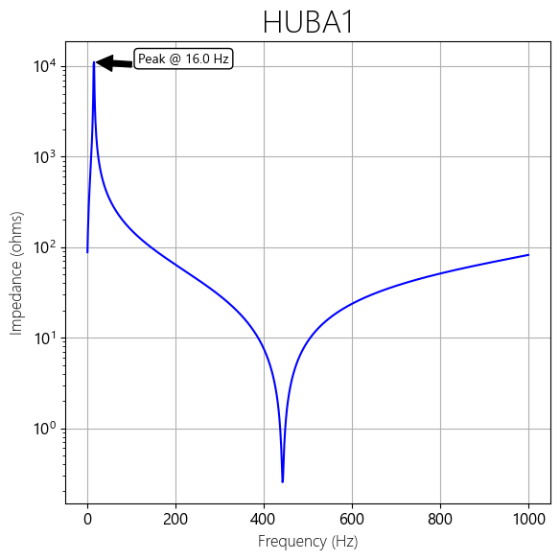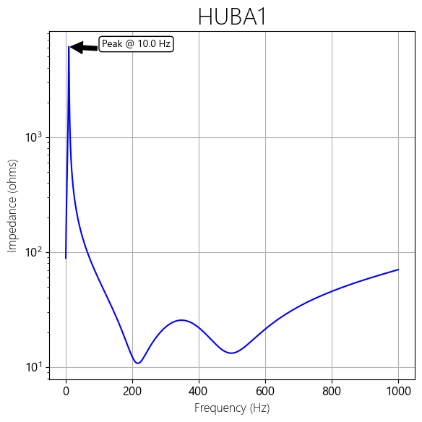
Figure 8 Harmonic profile of early REZ network (left), early REZ network plus a centralised filter capacitor (right)
This resonance prevented any further energisation of the REZ, and a solution was sought that used operational techniques rather than redesigning primary equipment.
It was found subsequently that the inclusion of centralised C-type harmonic filters at the HUB A 330kV bus resulted in a halving of the overall magnitude of the resonance impedance (along with a slight reduction in the resonant frequency itself), allowing the restoration to proceed, despite the filter introducing an additional requirement of ≈100 MVAr of reactive power to be provided by the black start source. The resultant impedance frequency profile - of the passive network with the filter energised - is shown on the right of Figure 8.
This simple remedial action represents an operational change that can be made on the day of restart to improve the likelihood of restoration success. Furthermore, it was found that, once that energisation step had been passed and additional network elements have been brought online, the passive harmonic impedance profile of the network had shifted enough such that the filter capacitor solution could be de-energised without fear or re-introducing the resonance to the system. This approach, once identified, was used extensively throughout the rest of the studies in this stage.
The harmonic resonance profiles of the REZ network presented here demonstrate that they should be considered step-by-step in any restart plans developed. This is because switching arrangements can have a material and dramatic effect on network resonances, and these may ultimately impact the dynamic performance if the resonance frequencies reach the operational bandwidth of IBR controllers.
It is also worth noting that in such a circumstance, that is enabling large filter capacitors in a weak network, BESS devices hold a distinct advantage over many synchronous generators, in that their reactive absorption capability envelope is less restricted than many synchronous machines (which can be e.g., constrained due to minimum field current requirements, end-region heating, etc.). Typically, the P-Q capability of an IBR device is constrained only by its current magnitude limit. This means that any additional reactive power supplied from the network (via unloaded lines, filters etc.) can be readily absorbed without change to dynamic performance of the BESS, provided it falls within the (larger) capability curve of the BESS. Figure 9 shows stylised but typical active and reactive power capability curves for synchronous machines (red) and BESS (blue), highlighting the additional capability in yellow that allow BESS to have superior reactive power absorption capability for the same operating quadrant as synchronous machines.
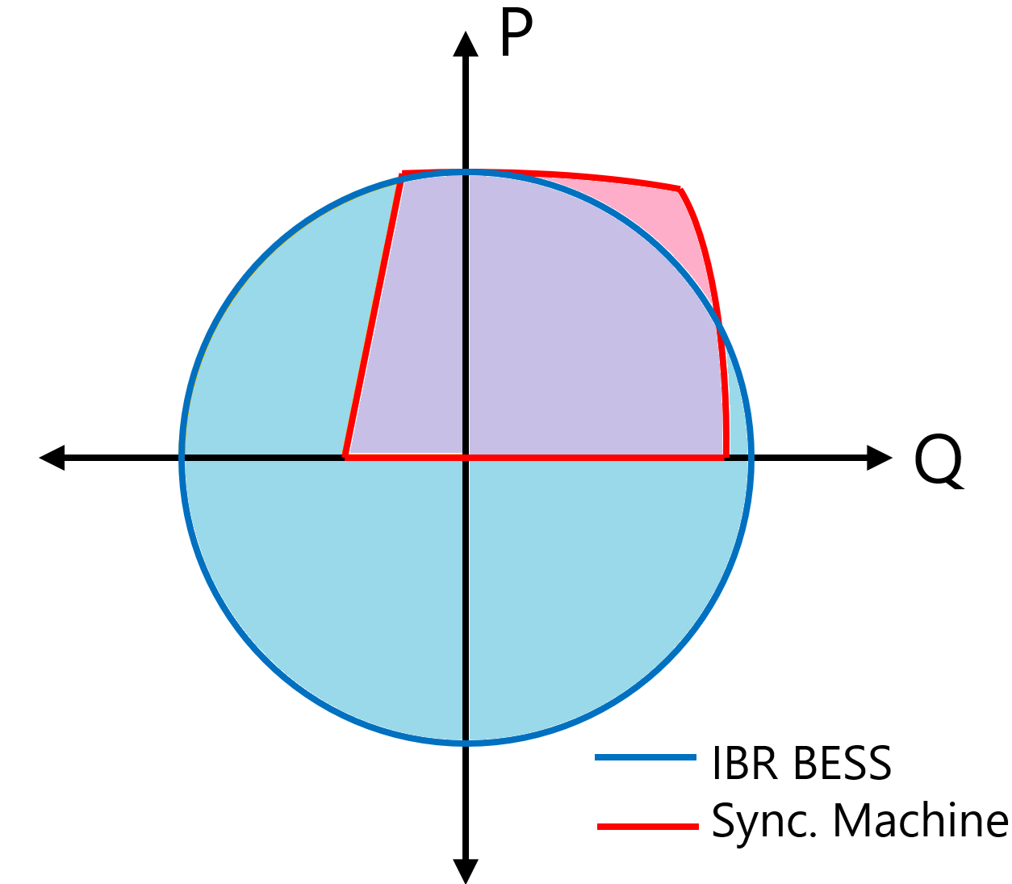
Figure 9 Simplified typical capability curves for synchronous machines (red) and BESS (blue)

External Network Energisation Capabilities
The following summarises the results for how much of a network external to the REZ can be energised based on the components online within the REZ. Given the possibility for many combinations of equipment to be energised externally to the REZ, these scenarios simplify the representation of all such equipment as a single transmission line and a single transformer (located at the end of the transmission line). The line and transformer are energised sequentially (i.e., not simultaneously).
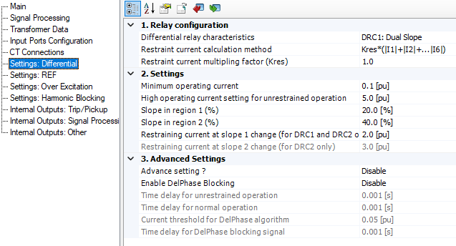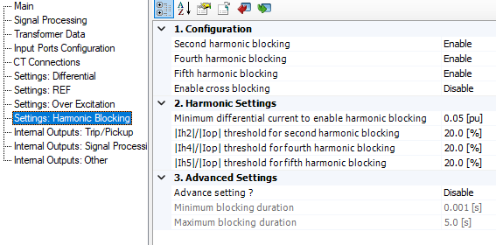
Figure 10 Default transformer differential settings used for studies

Single GFM BESS Source
A restart case study was investigated for a single, 400 MVA, VSM GFM BESS (H=10.0 s) source energising the following REZ and external-to-REZ components:
- Single 330 kV circuit from HYB1 (VSM GFM BESS unit) to HUB A (Switching station).
- A 1500 MVA 330/500 kV transformer at HUB A (Switching station).
- A 500 kV line from HUB A (Switching station) to HUB B (Switching station).
- A 500 kV line from HUB B (Switching station) to the external network (energisation target) PoC.
The following additional system configuration notes apply:
- Distance protection is enabled for each line (including the external line under test), and differential protection is enabled for both the REZ internal 1500 MVA transformer with the hubs and the transformer under test.
- There are no harmonic filters, 500 kV line-shunts or SyncCons in service.
- It is assumed the network to the PoC has already been energised and transients settled, not re-run from zero state. This has been shown to be possible in Section 3.1.2 and hence this strategy is used to avoid excessive simulation runtimes.
From the REZ PoC onwards, two elements are sequentially (not simultaneously) energised:
- A section of single-circuit 500 kV transmission line of varying length (with distance protection enabled).
- At the end of that line, a single 500/330 kV transformer of varying size (with differential protection enabled). This transformer unit is energised at the worst possible moment relative to the flux remanence (Phase A negative to positive crossing).
500 kV, 1 circuit
500 kV, 1 circuit
52 km
500 kV, 1 circuit
29 km
Variants under test
PoC
HUB B
HUB A
HYB1

Figure 11 High-level representation of network energised
Note that the red boxes above represent circuit breakers.
Table 11 Energisation capability from a single GFM BESS
 | No Line (A) | 10 km (B) | 50 km (C) | 100 km (D) | 200 km (E) | 300 km (F)
No TRX (1) | Pass | Pass | Pass | Fail²
250 MVA (2) | Conditional Pass¹ | Pass | Pass | Fail²
500 MVA (3) | Pass | Pass | Pass
750 MVA (4) | Pass | Pass | Pass
1000 MVA (5) | Pass | Pass | Pass
1500 MVA (6) | Pass | Pass | Pass
¹ TRX under test differential protection minimum operating current increased to 20% (up from 10%).
² Insufficient reactive absorption headroom capacity from the HYB1 unit to keep network within acceptable voltage bounds.
Columns indicate length of external line to be energised, rows indicate capacity of transformer to be energised
The above table shows that the energisation of large, remote transformers is not the limiting factor, but rather insufficient reactive absorption headroom capacity for line energisation. This observation is useful as it implies that a very general approximate “rule of thumb” initial assessment of the extent of external network that a GFM BESS-based REZ can energise could be determined by a simple load flow study.

Semi-established REZ
A case study was investigated for a REZ which has already been partially restored internally using a combination of GFM BESS and GFL devices (a remote-hybrid arrangement). Table 12 shows devices that are already online and generating, forming a singular hybrid REZ. The active power outputs from the GFL devices are purposely set to vary over time, both heavily and randomly, such that a challenging, uncoordinated power balance management scenario is achieved. No synchronous condensers were brought online, as sufficient system strength was provided by the two GFM BESS comprising the primary restart service.
Table 12 Devices online
Location | Type | Size | Notes
HYB1 | VSM GFM BESS | 400 MVA | Terminal voltage control mode.
WF1 | Type 4 GFL Wind | 352 MVA | Two of four collector feeders online.  Subject to random active power variations.
HYB4 | Droop GFM BESS | 250 MVA | Terminal voltage control mode.
HYB4 | GFL Solar Farm | 250 MVA | Subject to random active power variations.  Controlled by PPC, power factor mode (1.0).
WF2 | Type 3 GFL Wind | 516 MVA | Two of four collector feeders online.  Subject to random active power variations.
GFM:GFL ratio |  | 1: 1.72
PoC

HYB1
WF1
WF2
HYB4
HUB A
HUB B
500 kV, 2 circuits
52 km
29 km
4 km
10 km
33 km
20 km
1 circuit
Variants under test
Figure 12 High-level representation of network energised
The following additional system configuration notes apply:
- Distance protection is enabled for each line (including the line under test), and differential protection is enabled for both the REZ internal 1500 MVA transformers and the transformer under test.
- There are no harmonic filters, 500 kV line-shunts or SyncCons in service.
- It is assumed the network to the PoC has already been energised and transients settled, not re-run from zero state. This has been shown to be possible in Section 3.1.2 and hence this strategy is used to avoid excessive simulation runtimes.
From the REZ PoC onwards, two elements are sequentially (not simultaneously) energised:
- A section of single-circuit 500 kV transmission line of various alternative lengths (with distance protection enabled).
- At the end of that line, a single 500/330 kV transformer of various alternative sizes (with differential protection enabled). The transformer unit is energised at the worst possible moment relative to the flux remanence (Phase A negative to positive crossing).
Table 13 Energisation capability from a semi-energised REZ
 | No Line (A) | 10 km (B) | 50 km (C) | 100 km (D) | 200 km (E) | 300 km (F)
No TRX (1) |  |  | Pass | Pass | Pass | Conditional Pass³
250 MVA (2) |  |  | Pass | Pass | Pass¹ | Fail²
500 MVA (3) |  |  | Pass | Pass¹ | Fail² | Fail²
750 MVA (4) |  |  | Pass | Pass¹ | Fail²
1000 MVA (5) |  |  | Pass | Pass¹ | Fail²
1500 MVA (6) |  |  | Pass | Pass¹ | Fail²
¹ HUB B Transformer differential relay pickup (but not trip) on test transformer energisation
² Transformer under test differential protection trip
³ Large, damped oscillations throughout the system following line energisation, but ultimately returns to a steady state.

Note 1: For a relay to pick up a fault condition but not trip, this means that the relay observed behaviour in the power system that would have caused a trip if the behaviour had persisted for long enough, but that the power system state returned to a sufficiently acceptable region before the time required to trip was reached.
Note 2: For the conditional pass condition, un-desired voltage oscillations occurred following line energisation, in the order 13 Hz. However, they are damped and did not result in the tripping of any protection mechanisms. Note that these oscillations are unlikely to be a function of the line energisation characteristics but are more likely to be instead either due to a controller instability or due to resonance within the REZ including its associated connected plant. These are shown in Figure 13 and Figure 14 below.
Figure 13 Line energisation waveform oscillations
Figure 14 RMS oscillations following line energisation

Restart Switching Sequence Timelines
In EMT simulations, the (simulated) time periods between switching events are much shorter than they would be in practice. This is because EMT simulations have high temporal resolution and are consequently very computationally intensive. Attempting to simulate realistic waiting times at EMT simulation temporal resolution would take days to complete each run. Hence, the simulated time of switching events is reduced to a bare minimum, typically seconds apart, to minimise compute time [9].
But this leads to the question: Just how long would it take in real time to have a REZ self-restart and be ready at its point of connection?
For the following exercise, it is assumed that the network switching commands for system restart are initiated from a remote centralised control room (such as AEMO). For this to occur, it is further assumed that private telecommunication networks, between the control room and the switchable asset are viable, and that the switching stations hold sufficient energy reserve (battery and/or backup diesels) both to maintain local control and monitoring systems, and to actuate the primary assets (breakers). Should this not be the case, human attendance on site would be required, and this circumstance has far too many unknown variables to be able to reasonably estimate a restart switching timeline.
Table 14 outlines representative time periods required for switching in various power system assets during a system black event, including preparation and confirmation. These figures are based on time periods provided by interviewed personnel who have operated NSP control rooms and who are trained on protocols and procedures for real system black events.
Table 14 Approximate switching times
Switching action | Time (minutes)
Energise a line | 5
Energise a bus | 2
Energise a transformer | 10
Energise a station load | 5
Energise a passive filter | 5
Energise a reactive compensation plant | 15
De-energise a passive filter | 2
Achieve synchronisation on SynchroCheck relay | 10
Note that many of these figures are not representative of the time required to undertake the primary switching action (which can occur in seconds or less), but rather are reflective of the process an operator must use to:
- Confirm the viability of the item to be switched (i.e., confirm breaker and isolator states)
- Coordinate and confirm the proposed action with the asset owner.
- Perform the action.
- Confirm the success or failure of the requested action.
- Log the action.
- Monitor that transients have decayed, and the system has reached a tenable steady state.
Table 15 outlines representative times for plant to ready itself to begin energy export following re-energisation of its point of connection. It is assumed that each plant was off supply for an hour, and that its internal systems are fault-free and the plant can be remotely controlled and re-energised (i.e., without the need for staff to attend site). These figures are based on average contemporary plant black start procedures for equipment installed in the NEM.
It is worth noting that there are many variables that can affect the restart time period of a plant, including whether it was generating immediately prior to the system black event or not, the time period that it has been off supply, and ambient temperatures. Additionally, the size of the plant (both geographically and of the units it comprises) can have a major impact: geographically concentrated plant such as BESS will be among the fastest to be restored, and wind farms that are spread over hundreds of square kilometres will be among the slowest.
Hence, the following is not a definitive statement of timing requirements, but instead provides a possible general range of time periods that is realistic.
Table 15 Plant readying times
Plant type | Time
Battery Energy Storage | 15 to 30 minutes for entire plant
Solar Farm | 25 to 45 minutes for entire plant
Wind Farm | 20 minutes to restart centralised equipment, plus 5 to 15 minutes per turbine thereafter
Such figures imply a requirement that the plant has a UPS available for critical control and secondary systems which can withstand a 1-hour outage (7-8 hour withstand requirements are commonly reported in local black start procedures). Beyond this 1-hour timeframe, start-up times may dramatically increase to 7+ hours to days because attendance onsite will be required to confirm correct startup of all systems following a return of supply.
Combining the figures from Table 14 and Table 15 with the following scenarios, overall total time periods for a REZ to re-energise up to its point of connection are calculated as follows. For each of the following, time zero is defined as when the GFM BESS is ready for export, which is understood to be as little as 10 minutes following a system black event (providing internal UPS systems functioned correctly).

Scenario 1: GFM BESS to PoC
A restart timing case study was investigated that is reflective of Energy Case O described in Section 3.1.2, where a single 400 MVA GFM BESS in VSM mode singlehandedly energises a single-circuit path to the point of connection, without energising other primary energy producing plant or synchronous condensers. This is the fastest likely timing for a REZ to be able to restore voltage at its point of connection to the broader network.
Table 16 Single GFM BESS to PoC Timing
Step | Description | Low | Avg. | High | Notes
1 | Energise a line | 2 | 3.5 | 5 | 330 kV breaker at PoC
2 | Energise a bus | 1 | 1.5 | 2 | Incoming line to 330kV bus at HUB A
3 | Energise a line | 2 | 3.5 | 5 | Outgoing line to HYB2 (unintentional)
4 | Energise a passive filter | 2 | 3.5 | 5 | Energise the passive filter to reduce transformer resonance
5 | Energise a transformer | 2 | 6 | 10 | Energise a HUB A 330/500 kV 1500 MVA transformer
6 | Energise a bus | 1 | 1.5 | 2 | Energise the HUB A 500 kV bus
7 | Energise a line | 2 | 3.5 | 5 | Energise the 500 kV line from HUB A to HUB B
8 | De-energise a passive filter | 1 | 1.5 | 2 | De-energise the filter now that the transformer is active (improve Q headroom)
9 | Energise a bus | 1 | 1.5 | 2 | Energise the HUB B 500 kV bus from incoming line
10 | Energise a line | 2 | 3.5 | 5 | Energise the 500 kV line from HUB B to the point of connection
11 | Energise a bus | 1 | 1.5 | 2 | Energise the 500 kV PoC bus
Total time required: |  | 17 | 31 | 45 | Minutes
Hence, this restart sequence switching scenario is likely to be achieved within 17 (optimistic) to 45 (pessimistic) minutes.

Scenario 2: Semi-energised REZ to PoC
A restart timing case study was investigated that is reflective of the semi-established REZ case described in Section 3.1.3, where there are four of seven primary energy producers online with a combined potential nameplate output of >1.7 GVA, namely:
- 400 MVA GFM BESS (black starter 1)
- 352 MVA GFL Wind Farm (Type IV, total installation capacity of 700 MVA)
- 250 MVA GFM BESS (black starter 2)
- 250 MVA GFL Solar Farm
- 516 MVA GFL Wind Farm (Type III, total installation capacity of 920 MVA)
Unlike the example immediately preceding this one, this re-establishment process aims to restore substantially more (both number and output capacity of) generation sources, including primary energy producing generators, in order to boost the level of effective capacity of the black starter to exceed the largest single synchronous generating unit in the NEM (Kogan Creek @ 750 MW / 833 MVA). Excluding wind farms (due to the potential for needing an extended time frame for them to return to service, see Table 14), this scenario will deliver 900 MVA of combined capacity within the timelines listed below. (Note that for this example, there were no synchronous condensers brought online as they were not required to maintain stability).
Table 17 Semi-energised REZ to PoC Timing (Area A)
Step | Description | Low | Ave. | High | Notes
1 | Energise a line | 2 | 3.5 | 5 | 330 kV breaker at PoC (Black Starter 1)
2 | Energise a bus | 1 | 1.5 | 2 | Incoming line to 330kV bus at HUB A
3 | Energise a line | 2 | 3.5 | 5 | Outgoing line to HYB2 (unintentional)
4 | Energise a passive filter | 2 | 3.5 | 5 | Energise the passive filter to reduce transformer resonance
5 | Energise a transformer | 2 | 6 | 10 | Energise a HUB A 330/500 kV 1500 MVA transformer
6 | Energise a bus | 1 | 1.5 | 2 | Energise the HUB A 500 kV bus
7 | Energise a line | 2 | 3.5 | 5 | HUB A 330 to Wind Farm 1
8 | Energise a transformer | 2 | 6 | 10 | Wind Farm 1 PoC Transformer
9 | Wind Farm (Central Energise) | 20 | 20 | 20 | Wind Farm 1 startup procedure (no turbines)
10 | Energise a line | 2 | 3.5 | 5 | Energise the 500 kV line from HUB A to HUB B
Time required (Area A) |  | 36 | 52.5 | 69 | Minutes
Table 18 Semi-energised REZ to PoC Timing (Area B)
Step | Description | Low | Ave. | High | Notes
1 | Solar Farm | 25 | 35 | 45 | Energise the co-located solar farm next to the GFM BESS
2 | Energise a line | 2 | 3.5 | 5 | 330 kV breaker at PoC (Black Starter 2) to HUB B
3 | Energise a bus | 1 | 1.5 | 2 | Incoming line to 330kV bus at HUB B
4 | Energise a bus | 1 | 1.5 | 2 | Energise another section of the HUB B 330 kV bus
5 | Energise a line | 2 | 3.5 | 5 | Energise the line to Wind Farm 2 (unintentional)
6 | Energise a transformer | 2 | 6 | 10 | Energise a HUB B 330/500 kV 1500 MVA transformer
7 | Synchronise | 2 | 6 | 10 | Synchronise between both the HUB A and HUB B sites over the 500 kV line
8 | Energise a bus | 1 | 1.5 | 2 | Energise the HUB B 500 kV bus
9 | Energise a transformer | 2 | 6 | 10 | Wind Farm 2 PoC Transformer
10 | Wind Farm (Central Energise) | 20 | 20 | 20 | Wind Farm 2 startup procedure (no turbines)
11 | Energise a line | 2 | 3.5 | 5 | Energise the 500 kV line from HUB B to the point of connection
12 | Energise a bus | 1 | 1.5 | 2 | Energise the 500 kV PoC bus
Time required (Area B) |  | 61 | 89.5 | 118 | Minutes
In this scenario, timing subtleties arise regarding the re-energisation of both Areas A and B. Specifically:
- Whether there are sufficient personnel and technical resources available to allow two areas within the single REZ to be simultaneously restored, or whether the restoration process must remain sequential.
- Wind turbine energisation aside (as it is already excluded), whether
  - (1) the restoration process should continue while (other) primary energy producers (PEP) are coming online after energisation, or
  - (2) whether the system should wait for PEPs to complete their startup processes before the system is subjected to further network switching transients.
As a result, the total restart sequence switching time periods for this scenario have further variability:
Table 19 Semi-energised REZ Further Timing Variability
Parallel restoration possible | Wait for PEP startup (see Table 15) | Low | Average | High
û | ü | 97 | 142 | 187
ü | ü | 61 | 89.5 | 118
û | û | 32 | 67 | 102
ü | û | 16 | 34.5 | 53
Hence, the total switching timing of this restart scenario could vary substantially, with a total timing of between 16 minutes to 3 hours being possible (with a median of 78 minutes) depending on personnel and resource availability, and the timing needs of the individual plant comprising the service.
Nevertheless, although these figures are highly variable, with sufficient planning they could be deterministic.

Service provision
Given the ability of a partially energised REZ to restore network elements beyond its point of connection (as discussed in Section 3.1.3), it follows that a REZ may be capable of providing additional services, or support, to an external network that is rebuilding the system during system restoration. That is, if the REZ is not a primary restart source for a region, could it synchronized to the network and connect to the unit that is restoring the network as the primary source, and subsequently provide voltage and frequency services to improve the overall operational envelope, and improve tolerances, for the restarting system.

Baseline
To demonstrate whether such service provision is a potential opportunity for REZs, a simple test was conducted. A case was developed whereby a 250 MVA synchronous machine (an open-cycle gas turbine) is to restore a small portion of network that contains appreciable lengths of high-voltage (330 kV) transmission lines, as well as transformers, and bulk loads. This arrangement is shown in Figure 15. Note that there is:
- A 250 MVA synchronous machine with an AC1-type AVR and a GASTWD governor (isochronous mode).
- 200 km of 330 kV line between the generator HV bus and LoadBus1.
- 50 km of 330 kV line between LoadBus1 and LoadBus2.
- A 150 MVA 330/66/22 kV transformer at LoadBus1 and LoadBus2.
- 60 MW of load on the 66 kV side of the transformers at LoadBus1 and LoadBus2.
Figure 15 External system restoration source arrangement
As a baseline, the performance of the synchronous machine alone, with respect to maintaining network voltages and frequency, was evaluated through a time-domain EMT study, as each of six circuit breakers shown above was sequentially energised (with ample time left for the system transient response to settle before the next breaker operation). Several combinations of network elements were chosen for transient performance assessment. These were:
- Unloaded high-voltage transmission line energisation, which tests the system’s ability for reactive power absorption (BRK1 and BRK4).
- Transformer energisation, which tests the system’s ability for rapid reactive power production and harmonic mitigation (BRK2 and BRK5).
- Load pickup, which tests the system’s ability for rapid active power production and frequency regulation (BRK3 and BRK6).
The response of the system to the restoration capability of the synchronous machine alone is shown in Figure 16. As can be seen, there are appreciable over-voltages that occur on line energisation, undervoltages on transformer and load pickup, and sustained underfrequency for load pickup (for time periods of underfrequency that are likely to not satisfactorily fall within the ‘wait-to-connect’ bands of many devices that are to be reconnected to the system, unless manual adjustment occurs to adjust the frequency closer to nominal value).
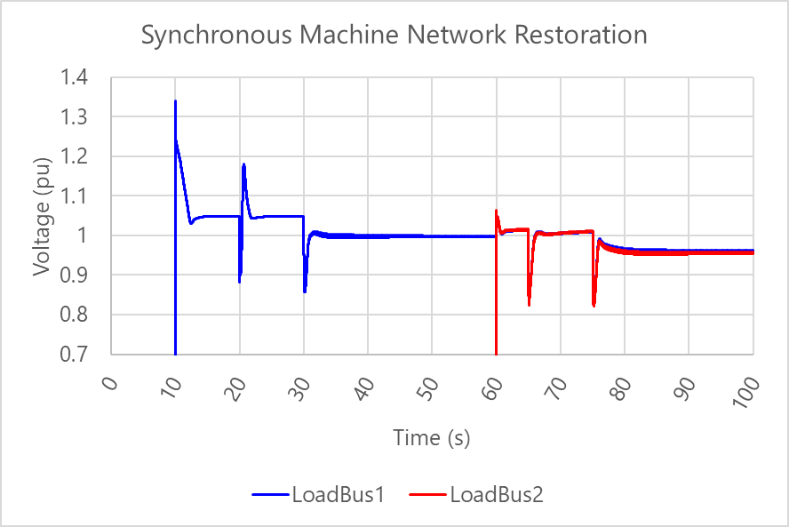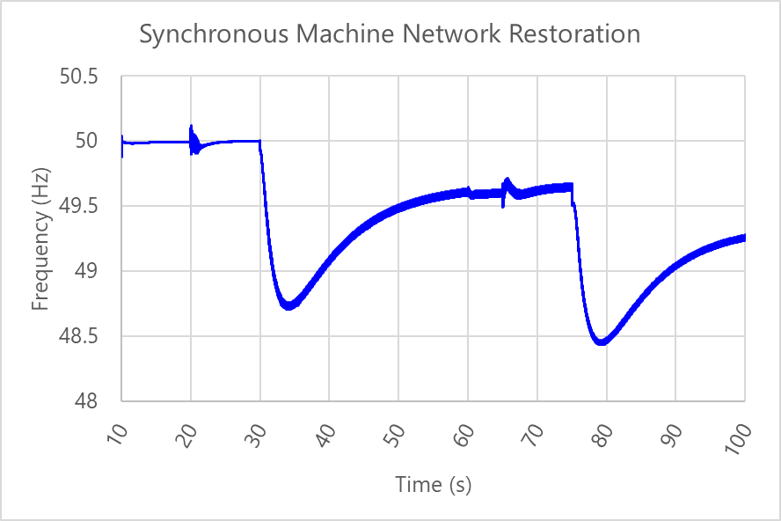
Figure 16 System voltages and frequency for a synchronous-machine (only) facilitated restoration
Note that it is not of interest in this case study whether the response of the synchronous machine’s system restoration is acceptable. Rather, the purpose is to investigate whether the presence of a REZ improves the overall system response during each energisation step, by providing voltage and frequency control.

Addition of supporting REZ
For the next stage of investigation, the partially re-energised REZ described in Section 3.1.3 was introduced, with a 500 kV to 330 kV transformation at the point of connection (500 MVA transformer), connecting to the synchronous generator’s HV 330 kV point of connection (shown in Figure 17) through 50 km of overhead 330 kV transmission line. Given the studies previously conducted in Section 3.1.3, it was assumed that the partially energised REZ would successfully reach this point of connection of the synchronous generator and be able to re-synchronize without issue.
The sequence of network restoration described in Section 3.1.3 was then repeated to determine whether the presence of the REZ would aid in tightening the voltage and frequency behaviour envelopes within the portion of the system under restoration.
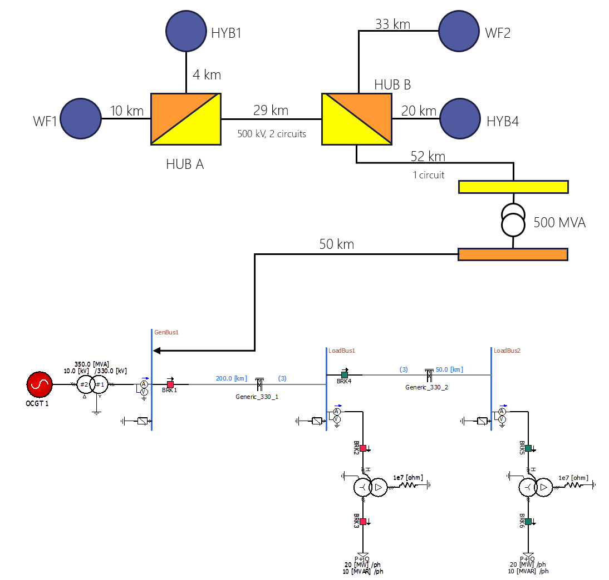
Figure 17 Connection of supporting REZ to the restarting synchronous machine
The results in Figure 18 (overlayed on the synchronous machine only results) show an improvement in the voltage and frequency performance of the system being restored, particularly for frequency nadirs and steady-state regulation [10]. This indicates that a REZ can provide a valuable voltage and frequency control service to a restoring system should it not be chosen as a primary restart provider.
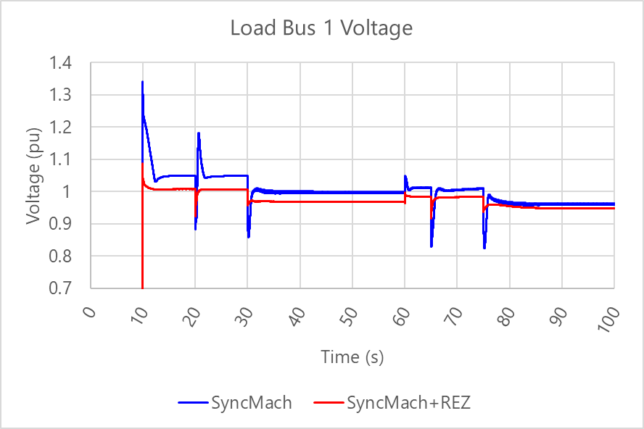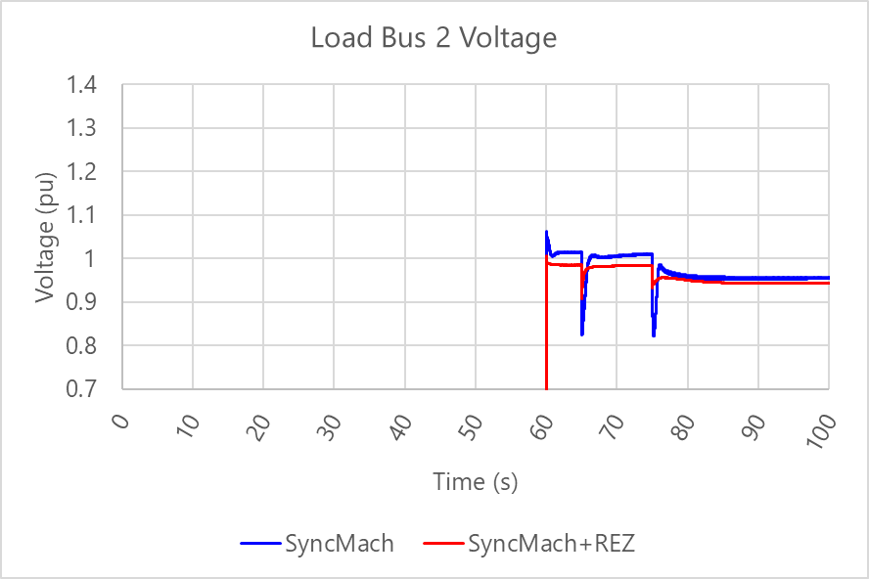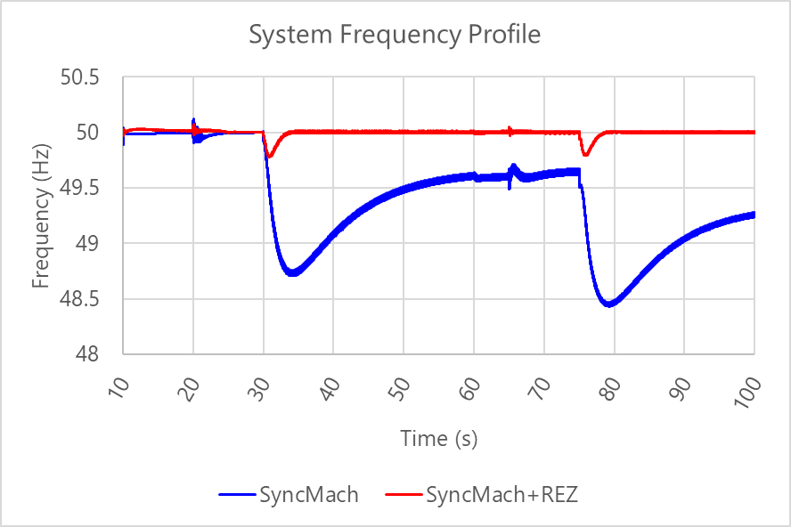
Figure 18 Comparison of system voltage and frequency with and without REZ support

Energy source power variations
This scenario was then further expanded to evaluate the situation where active power within the REZ is randomly and rapidly fluctuating. This is assumed to be due to changing energy source availability for wind and solar plants, resulting in the voltage and frequency variations (as will be explored further in Section 3.2.1 and 3.2.3). Here, wind speed and solar irradiance was purposely varied up to 80% to observe how the change in output power from primary energy producing equipment (e.g., due to wind or irradiance variations) affected the ability of the REZ to provide voltage and frequency control services to the external network.
The results are shown in Figure 19. What can be seen is that, despite the highly variable output from each of the primary energy producing plant, the voltage and frequency control in this arrangement with the REZ nevertheless has again tighter regulation capability. This indicates that the REZ is highly capable of providing beneficial voltage and frequency services during system restart, even with highly variable output.
Note that such variations could be reduced should the cumulative output of the REZ be curtailed below the net power available from the primary energy sources (e.g., wind or solar) such that the AC output of each plant within the REZ is more constant than the example shown here. However, the result of this scenario evaluation demonstrates that even in the face of extreme variability, the system, as a whole, remains stable and within reasonable operational limits.
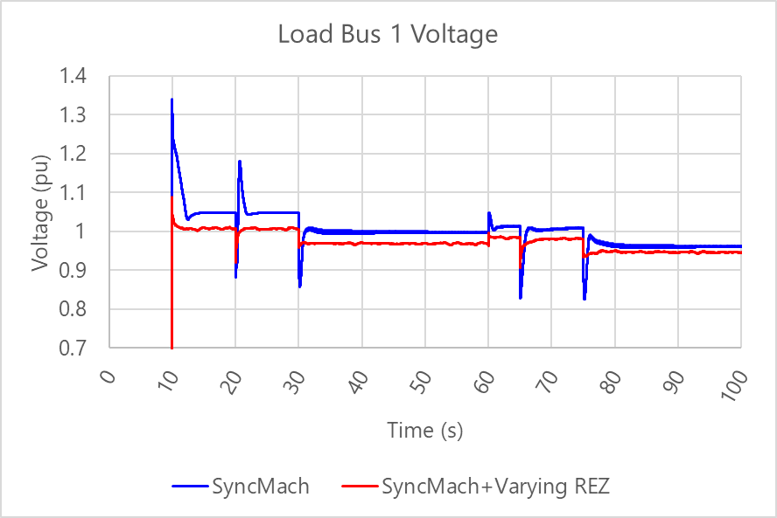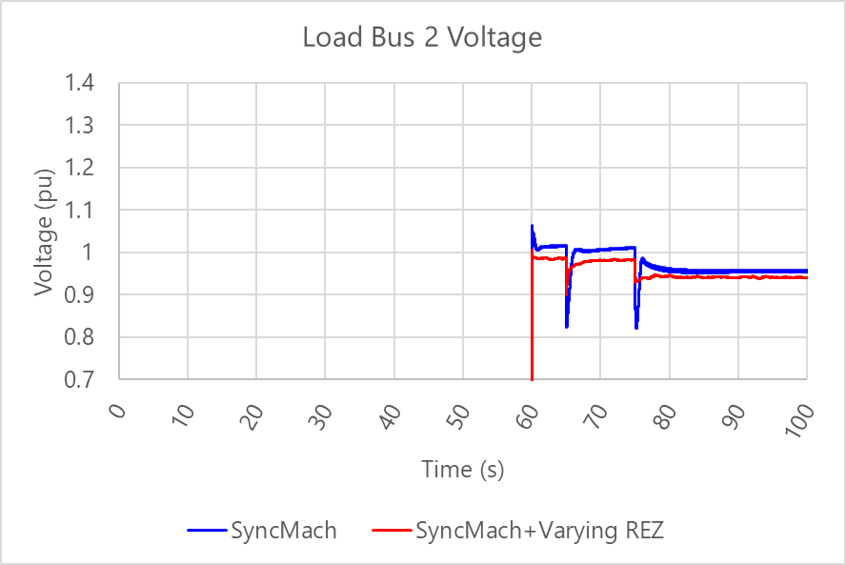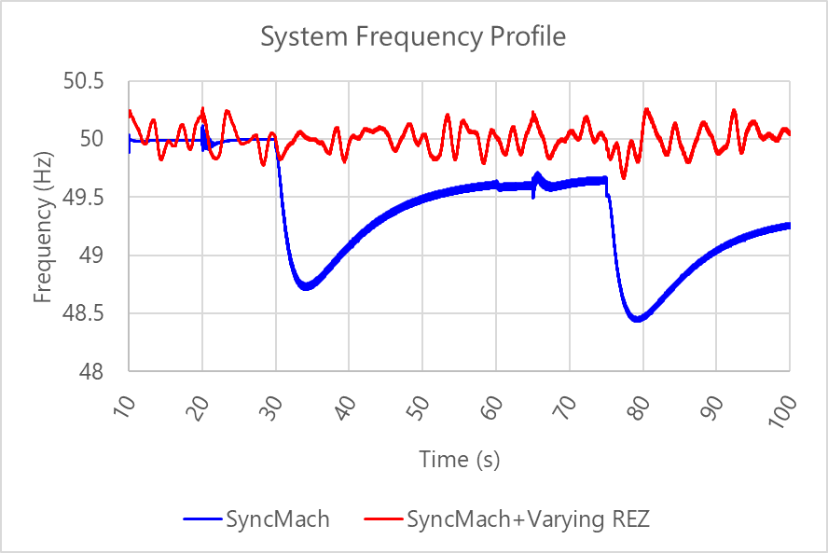
Figure 19 Comparison of system voltage and frequency with and without REZ support with highly variable output

Remote Hybrid Configuration
Although the use of a BESS to restart a portion of a system has been shown, through multiple stages of AR-PST work, to be entirely possible, the effectiveness this approach is dependent on the battery’s state of charge when it is required for restart. Specifically:
- If the battery is not adequately charged, it may lack the energy capacity to energise both the network and the auxiliaries of other primary power producing plant, to initiate the restart.
- Although less onerous, if the battery is fully charged, there is no absorption headroom to allow primary energy supply units to come online (without load pickup) in order to form part of the broader REZ system that is actuating the restart process.
In order to investigate how BESS energy constraints can be overcome to provide system restart services, this section considers the possibility of a “remote hybrid” (GFM and GFL) arrangement. A remote hybrid is different from a typical coordinated AC- or DC-hybrid arrangement, in that it considers the use of multiple AC-connected plant that:
- Consist of one GFM BESS black starting unit and at least one other inverter-based GFL primary energy production unit (e.g., solar PV, wind farm), to be used together to deliver a primary restart service,
- Do not share the same connection point,
- May have appreciable network (including both transmission lines and transformers) between the units’ connection points, and
- Are not intentionally designed to operate as a single coordinated unit, and instead are reliant on their own existing control mechanisms.
By investigating whether such an arrangement is possible to implement within a REZ, without explicit pre-coordination prior to a system black event, it is shown below that a GFM BESS can indeed lead the provision of a primary system restart service with primary energy top-up provided by a (remotely connected) “third-party” source as required.
The following sections present the work completed to identify which combinations of GFM BESS and GFL sources work best, and whether additional coordination and control mechanisms are required to implement such a remote-hybrid arrangement.

General Recommended Strategies
In attempting to self-restart a REZ, the following general recommendations were found:
- Start with voltages slightly below nominal (e.g. 0.92 – 0.95 pu) to minimise the effect of line charging and transformer inrush.
- Tap settings on large transformers should be selected to present the most amount of turns to the winding being energised. For example, if the tap-changer is on the HV side of a transformer, move the tap to the highest position.
- Where sufficient existing energisation power is available, energise large transformers before picking up additional GFL equipment that may otherwise have trouble riding through disturbances in weak grid scenarios.
- Using the terminal voltage control of inverters, and performing bulk reactive compensation using centralised plant, may prevent PPCs from contributing to instabilities.
- harmonic filters may be useful also for reducing sub-synchronous resonances, depending on the precise topology and configuration, at a cost of increased reactive power absorption required.
  - N.B. A SyncCon is not necessarily an option for addressing undesirable resonances and may make the situation worse. Harmonic scans are required to determine which option is optimal.
- In addition to system strength provision, SyncCons may be useful to dissipate excess energy from a BESS while waiting for instructions to reconnect to the system.

Coordination and Control
An initial hypothesis regarding the remote-hybrid arrangement was that REZ self-energisation may require additional layers of coordination and control, beyond those typically employed under normal operating conditions, to maintain dynamic stability. Specifically, it was anticipated that multiple, uncoordinated GFL devices providing power to the building system - with no coordinated control - may result in instability, and protective mechanisms would be required.
However, these simulation results have demonstrated that provided some modest assumptions, described below, were true, the REZ achieved stable self-energisation without the need for complex supplementary control schemes. Frequency transients were well regulated by one or more of the GFM BESS that were underpinning restoration, while voltage was successfully maintained by plant-level devices which were assumed to operate under local voltage control.
Assumptions:
- The main restarting GFM source can accept MW offset commands to trim the frequency such that the time average frequency sits at 50 Hz. This is:
  - Required to meet the “wait to connect frequency bands” of GFL IBR equipment.
  - Analogous, for a synchronous machine in traditional restart scenarios, to operating in isochronous mode.
- Units which connect behind considerable reticulation network impedances (e.g., wind turbines) have terminal voltage control (in addition to any centralised voltage control from PPCs, which in these studies, were excluded).
  - N.B. For modern wind turbines, this is a reasonably common feature.

Remote hybrid example 1
An example of a remote (64 km away, with two network voltage transformations: from 330 to 500 kV and 500 to 330 kV) hybrid scenario is shown in Figure 20. In this scenario, a GFM BESS is used to initialise the REZ restart process, including the restoration and synchronisation of a synchronous condenser at HUB B to aid with voltage control, before a remote type 4 wind farm is energised (the start-up times of the turbines are neglected - they were assumed to be ready immediately, for ease of simulation).
Figure 20 Graphical representation of extent of network used for remote hybrid configuration 1
In this scenario, the GFM BESS proceeded with initial restoration of the network, between itself and the remote hybrid (i.e., the wind farm), before energising the type 4 wind farm and allowing it to initialise (in a highly condensed timeframe to allow reasonable simulation runtimes). Once the wind farm was online, it was intentionally subjected to large variations in active power to emulate a worst-case scenario whereby energy source variability results in large changes to grid-side active power injection. Note that this is intentionally worse than would ever be likely to occur in practice, to demonstrate accommodation of rapid variations in active power by the GFM BESS.
Once the remote hybrid arrangement was fully established, the 500 kV lines from HUB B to the REZ point of connection were then energised (one at a time). Table 20 describes the salient aspects of the setup. Note that the type 4 wind turbines were under turbine-scale voltage control only, with the park voltage controller set to open loop control mode (i.e., a target voltage reference is sent by the park controller, but the control is implemented locally by the turbines at their terminals).
Table 20 Scenario setup – Remote hybrid configuration 1
Plant | Name | Description
1 | GFM BESS | 400 MVA  VSM mode
2 | Type IV GFL Wind Farm | 230 MVA  64 km and two network transformations (330à500, 500à330) from plant 1  Terminal voltage control mode  Up to 80% instantaneous active power variations  Accelerated start
3 | SyncCon | 150 MVA, H=7.0s  Located at HUB B (31km and two network transformations from plant 1)
The results of this scenario are shown in Figure 21. Notably, the system remained in a controlled state throughout the simulation until the energisation of the second 500 kV line from HUB B to the PoC at t=290s. At this time, the reactive headroom of the BESS was exhausted, and the system experienced large voltage oscillations, resulting in overvoltages and ultimately tripping all equipment on overvoltage protection.
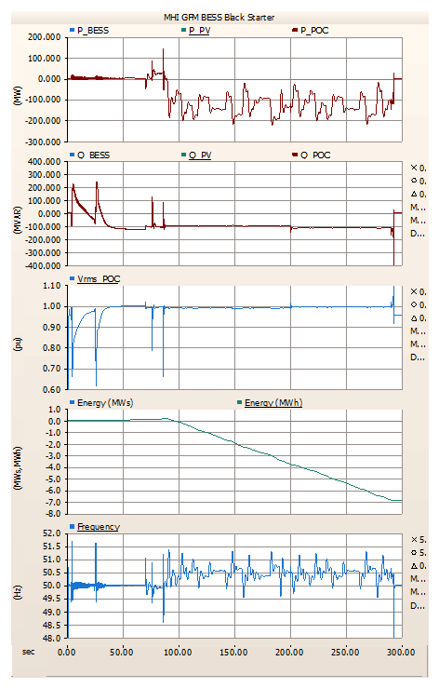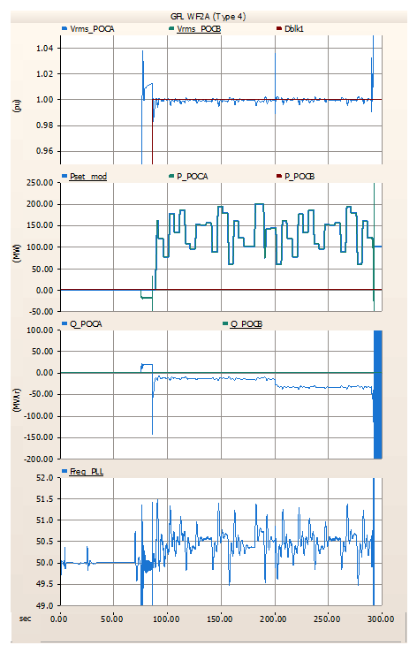
Figure 21 Remote Hybrid Configuration 1 Results
Until the point of overvoltage tripping however:
- System voltage variations were well bounded.
- Frequency transients were well bounded, although there was a steady-state offset once the primary energy source (i.e., wind farm) was brought online. This offset would require a MW trim command to be implemented by the GFM BESS (i.e., absorb more MW) to bring frequency back to an average of 50.0 Hz.
- Frequency offsets notwithstanding, there was no further overarching coordination or control required. The system remained stable even with continual severe active power variations.

Remote hybrid example 2
The approach described above was repeated for a nearby hybrid arrangement. This arrangement was deliberately made simpler to determine whether improved performance could be achieved by eliminating the multiple network transformations (and hence, eliminating additional impedances) between the GFM source and the primary energy producing equipment (i.e., the wind farm).
The arrangement studied is shown in Figure 22. Note that a 150 MVA synchronous condenser is online in HUB A.
Figure 22 Graphical representation of extent of network used for remote hybrid configuration 2
Table 21 describes the salient aspects of the setup. Again, the type 4 wind turbines were under turbine-scale voltage control only, with the park voltage controller mode set to open loop (i.e., voltage target is sent by a park controller, but control implemented locally at individual turbine terminals).
Table 21 Scenario setup – Remote hybrid configuration 2
Plant | Name | Description
1 | GFM BESS | 400 MVA  VSM mode
2 | Type IV GFL Wind Farm | 350 MVA  14 km and no network transformations from plant 1 (i.e., all 330 kV)  Terminal voltage control mode  Up to 80% instantaneous active power variations  Accelerated start
3 | SyncCon | 150 MVA, H=7.0s  Located at HUB A
The results of this scenario are shown in Figure 23. Once again, the system remained in a controlled state throughout the simulation until the energisation of the second 500 kV line from HUB B to the PoC at t=200s. At this point in time, the reactive headroom of the BESS was once again exhausted, and the system experienced large voltage oscillations, resulting in overvoltages, and again ultimately tripping all equipment on overvoltage protection.
Figure 23 Remote Hybrid Configuration 2 Results
Further studies were completed for various remote hybrid arrangements with large variations in energy resources, with results available in Appendix 2. Notably, it was found that the inclusion of the synchronous condenser did not have a large impact on the overall outcome, but nevertheless improved voltage regulation such that voltage variations were smaller than without the synchronous condenser.

Required restrictions on remote hybrid configurations
The conclusion from this evaluation is that a remote hybrid arrangement is achievable within the REZ, with dynamic stability being maintained without the need for additional coordinating control mechanisms, provided the following aspects are maintained:
- An ability to adjust (trim) the setpoint for active power on a battery to bring frequency average close to the nominal 50.0 Hz
  - This is needed to meet the requirements of the “wait to connect” bands, as identified in Topic 5 Stage 4 work.
- Maximum possible total output from primary energy producing plant is to be below the absorption combined headroom of the GFM BESS(s) providing the primary restart source(s) and other BESS(s) providing frequency control.
- Sufficient energy headroom and legroom in the BESS playing a role in the REZ restart, such that it can always either absorb or produce energy to keep the system balanced.
Notably, the above requirements apply only to the active power dispatch control of individual devices, rather than dynamic performance of the controlled coordination of disparate individual plant. Indeed, the only notable recommendation that applies to global dynamic stability is that improved performance is observed where individual energy producing plant operate in droop voltage control mode, in order to maintain voltages both internally to their systems, and at their point of connection, at a reasonable value. REZ-wide coordinated voltage control was not required, as a restarting system will be lightly loaded, and there is no imperative to maximise the efficiencies of each operating plant through reactive support that is optimal. Furthermore, the amount of active power that is transferred to the point of connection is relatively low, so that the REZ network is not under stress, and hence compensation for line voltage drop was not required.
These findings regarding the coordination of devices in a power system are intuitively reasonable, as they are similar to experiences in small, historically early, synchronous power systems, which also did not require operation at high efficiencies:
- Frequency droop control will ensure that devices comprising a power system will settle at an equilibrium, and at an operating point that shares the frequency regulation burden among devices.
- Voltage droop control will result in network voltages settling at an acceptable equilibrium, that shares f the voltage regulation burden among devices.
Even if one unit is voltage and/or frequency insensitive (e.g., operating in power factor control and/or constant power mode, respectively), provided some units in the system are not, and there is sufficient flexibility capacity jointly across all the flexible units, the system will likely find its equilibrium.
In an IBR-dominant network, provided the system also has one or more leading units to establish and control the voltage waveform (i.e., GFM BESS, or to a far lesser extent, SyncCons), the above is expected to also apply to what is effectively (at least initially) a smaller islanded power system, as represented by a restarting REZ.

Multiple Island Synchronisation and Operation
Further case studies looked at the potential for multiple disconnected areas within a single REZ to be simultaneously and independently energised, then merged, and then go on to energise a sequence of network areas towards the connection point, i.e., two islands are independently energised, then synchronised.
During these studies the output of the primary energy sources (wind and solar) were intentionally set up to vary randomly and heavily with time, in order to test the ability of the system to absorb such variations, without exceeding the active power absorption capability of the local GFM BESS that forms the island.
It was noted that, so long as frequency could be brought to near-nominal values, no additional external coordination is required to maintain a viable island up to the point of connection, despite the large and random variations of power being supplied from the variable energy sources and across various alternative GFM synchronisation methodologies (i.e., VSM vs. Droop). The following aspects were carefully considered [11], however:
- The variable energy sources within each island were capped such that their maximum possible instantaneous power output was always below the maximum active power absorption limit the (local) BESS can accommodate.
- A resonance at HUB A that arises upon transformer energisation can be reduced if the harmonic filter at HUB A is energised. However, the harmonic filter should be removed from service prior to further network energisation, in order to discourage the VSM GFM BESS that is forming the grid in Area A from running out of reactive power absorption headroom (as during the simulation this has been found to be a precursor for instability and can cause collapse).
- Where particular GFL equipment is especially sensitive to disturbances, it is best to energise network equipment that will cause such disturbances (e.g. transformer hard energisations), allowing time for those disturbances to settle, prior to energisation of the sensitive plant. (This approach was used for WF1 energisation in Area A).
In the following, examples are provided for two REZ islands (within the same REZ), first energising their individual network areas and nearby plants, and then connecting them to form a larger island, before move on to energise the REZ to the connection point. Protection relays were present and enabled for these studies. Figure 24 shows the graphical representation of the system in coarse detail.
AREA B
AREA A
Figure 24 Overview of the multiple REZ islands to be used to form a single service
Area A had the following setup:
- Black Starter: 250 MVA GFM BESS (HYB1), in VSM mode (H = 2.0 s), with a 0.95 pu voltage setpoint.
- Variable Source 1: 350 MVA GFL Wind Farm (WF1), type IV wind turbines, with terminal voltage control (1.0 pu), 200 MW dispatch cap, up to 75% random power variations below this cap, two (of four) aggregate feeders energised, PoC transformers are hard energised with flux remanence at the worst-case values.
- HUB A transformers: only one 1500 MVA transformer energised (330 → 500 kV), saturation enabled with (0.8/-0.8/0.0) flux remanence and hard-energised at the worst point, differential protection enabled with 20% blocking thresholds on 2nd, 4th, and 5th harmonic.
- HUB A Harmonic Filters: One 100 MVA harmonic filter in service in HUB A, switched IN prior to and switched OUT after, HUB A transformer energisation.
- Others: No synchronous condensers in service, no 500 kV shunts in service, sync-check relay located at HUB A to HUB B 500 kV line #1 (HUB A side), only a single 500 kV line between HUB A and HUB B was energised.
Area B had the following setup:
- Black Starter: 250 MVA GFM BESS (HYB4_BESS) in frequency droop Mode (3%), with 2% voltage droop, 0.95 pu setpoint.
- Variable Source 1: 250 MVA GFL Solar Farm (HYB4_SF), co-located with the GFM BESS that is providing black start, PPC enabled, PF control mode (target PF = 1.0), MPPT mode, no output constraint, export whatever the irradiance allows, irradiance variations up to 60 MW, random.
- Variable Source 2: 230 MVA GFL Wind Farm, type IV turbines, terminal voltage control (1.0 pu), no PPC, one (of four) aggregate feeders energised, 100 MW output dispatch cap, up to 75% random power variations below this cap, PoC transformers are hard energised with flux remanence at the worst-case phase.
- HUB B transformers: Only one 1500 MVA transformer energised (500 → 330 kV), saturation enabled with (0.8/-0.8/0.0) flux remanence and hard-energised at the worst point, differential protection enabled with 20% thresholds on 2nd, 4th, 5th harmonic blocking, as above.
- Others: No synchronous condensers in service, no harmonic filters in service, no 500 kV shunts in service, two of four 500 kV circuits to the PoC were energised.
Each island was re-energised step-by-step, component by component (i.e., it was not assumed that the energisation of either island would be successful). Active power variations from primary energy producing plant were present from the moment of their energy export, and as previously described, were conservatively large. There are no overarching control mechanisms – each plant is operated in isolation and without coordination.
Figure 25 shows representative results from this arrangement, with greater detail and plots available in Appendix 2.

Voltages throughout the system
Area A GFM BESS output | Area B GFM BESS output
Figure 25 Overall performance of a multiple-island REZ forming a singular restart service with extreme active power variations
The results indicated that steady-state voltage variations were within the range of ±3% due to large power variations from the variable sources. Frequency variations were in the order of ±0.4 Hz following the synchronisation of the two islands, with a ≈+0.6 Hz offset (50.6 Hz). Such a frequency offset and variation is an aspect that may need improvement for a viable restart service to be tendered; however, it is noted that the random power variations established in this case are conservatively extreme and are likely to be less severe in the field.
Given the intentionally extreme variations in active power, this can still be considered viable in both a dual-island and in a single-island arrangement, that showed no sign of instability.
These studies were repeated while changing settings and/or arrangements in each of the REZs. Table 22 summarises the results, with further details provided in Appendix 2.
Table 22 Adjustments and results
Name | Description | Result
Improved frequency offset | A frequency offset controller was added to the GFM BESS in Area A to attempt to reduce the frequency offset in the system. It operated on the moving average of the system frequency. | The frequency of the system was corrected to average around 50.0 Hz rather than the 50.6 Hz seen previously. However, it also resulted in the Area A GFM BESS shouldering a greater active power absorption burden, leaving the Area B GFM BESS underutilised.
Adding Synchronous Condensers | In addition to the frequency offset controller, a 150 MVA, H=7.0s, synchronous condenser was energised at each hub (i.e., HUB A and HUB B) to see whether the additional inertia would reduce the extent of the frequency swings seen. | There was not a reduction in the extent of the frequency variations seen, as the variations ultimately were occurring slower than the inertial response of the synchronous condensers. However, there was a material improvement in voltage regulation performance, with variations reducing to below 1% across the system, down from the 3% seen without synchronous condensers.
Increasing VSM inertia constant | The Area A GFM BESS had its inertia constant increased from 2.0 to 10.0 seconds. | The frequency variation seen remained at approximately ±0.4 Hz during “steady state”, and the frequency was centred around 50.0 Hz. Consistent with the inclusion of the synchronous condensers, the increase in virtual inertia had minimal effect on the frequency deviations, suggesting that the variations are occurring more slowly than the inertia timeframe.
The above findings suggest that management of the frequency variations are best handled either by ensuring the primary energy producing plant minimise their active power output variations or by using a dedicated frequency trim control mechanism. The inclusion of SyncCons into the system, aside from providing additional system strength, will also provide improved voltage regulation throughout the network. However, it may not aid in frequency control should frequency variations be occurring outside the inertial constant timeframes of the devices.
Overall, these results indicate that it is entirely possible for one or more IBR islands to be connected to form a single system restart service, even with a variety of uncoordinated technologies online. By extension, this suggests that multiple REZs could possibly cooperate to form a restart service should there be sufficient need.
Additional information on these studies is available in Appendix 2.

Energy reserve requirements
The energy reserve required by the BESS forming this GFM/GFL hybrid arrangement largely depends on whether a load external to the REZ is being serviced. If a BESS within the hybrid system is close to 50% charge and primary energy producing equipment is online and generating, this would represent the most flexible scenario to respond to contingencies. This is because - if the REZ must wait for further instructions - a 50% charge level allows headroom for the continued absorption of energy from primary energy producing plants (especially if these plants have minimum active power export requirements), yet - should the REZ begin reenergising the external power system – it will also allow for the BESS to supply energy to the load it is servicing as required. The challenges, however, becomes more nuanced, depending on the timing requirements, both before energisation of the external system, and for the energisation of the primary energy producing plant comprising the REZ. Note the following considerations.
For no load being serviced (i.e., REZ is energised and waiting at the PoC for further instructions):
- The BESS in the system may need to absorb energy from the semi-energised REZ and thus must have charging headroom available.
- Primary energy producing plant that have minimum active power export requirements to remain online (such as wind farms) must be accommodated by this energy absorption headroom to be able to keep the devices online.
  - Where sufficient system strength permits it, a device being online and at minimum active power is more desirable than having the device offline. This is because an online device can assist with reactive power control and with current provision for the energisation of network elements. An offline device, obviously, cannot.
- Where multiple BESS are present in the system, the BESS will not necessarily share equally in the absorption of energy from the primary energy production sources.
  - Unless the BESS are identical in operation and settings, or otherwise coordinated, differences such as frequency droop, frequency offset correction setpoints etc. will contribute to the share of power absorption being uneven.
- GFM BESS providing frequency offset correction to a semi-energised REZ as mentioned in Section 3.2.1 will likely require the highest energy absorption headroom of the case studies considered, as the primary energy production plants must have a sink for their energy output.
Where an external load is being serviced:
- It is good practice to match the active power output of the primary energy producing devices to the demand of the load, such that BESS within the REZ have changes to their state of charge minimised (i.e., as close to 0 MW export as possible).
  - In this way, the BESS is well positioned to provide a contingency supply, or absorption should there be a sudden loss of generation or load, respectively.
  - However, further provisions should be made such that undercharged BESS are able to recharge, and overcharged BESS are able to discharge.
- Where multiple BESS are present in the system, it is not necessarily a correct to assume that the BESS will equally share the energy production burden from the primary energy production sources.
  - Unless the BESS are identical in operation and settings, differences such as frequency droop, frequency offset correction setpoints etc. will result in this uneven share of power absorption.
Note that for planning purposes, this can be readily evaluated in RMS simulations and does not require EMT temporal resolution to determine headroom requirements.

Preferred IBR sources for remote hybrid arrangements
An area of investigation originally identified was to determine whether certain types of primary energy production sources are preferred over others, for the purposes of forming a remote hybrid solution on the day that is tolerant to rapid changes in system demands (e.g., active power changes). However, the tests completed in Section 3.2.1 indicated that even the most extreme dynamic variations from primary energy production sources were readily accommodated by the GFM BESS comprising the primary restart source, so long as (i) those variations (in total) did not exceed the nameplate rating of the GFM BESS and the (ii) ratio of GFL to GFM online capacity is such that system strength is adequate to support correct operation of fast-controllers. These results imply that almost all IBR primary energy production sources could be accommodated without adversely affecting dynamic stability, and that selection of a primary energy production source that is optimal will more likely depend on other criteria such as energy availability, time to restart, and output capacity flexibility.
Instead of dynamic stability considerations, Table 23 looks at some additional properties of technology which could comprise a REZ, and provides a ranking based on these other factors. Additionally, although the varying energy sources investigated in Section 3.2.1 were all viable, good engineering practice recommends that energy sources which minimise the following aspects are likely to have a greater dynamic stability:
- Reticulation network (less reticulation reduces the amount of charging to be accommodated and reduces the diversity of responses seen by different units comprising the plant, i.e., the responses are more consistent from plant to plant).
- Layered controllers (the less closed loop control there is to interact with the weak system, the more likely a stable response will be seen).
- Remote voltage sensing (i.e., if the units are in terminal voltage control mode, measurement and processing delays, which can lead to instabilities, should be minimised).
Table 23 Preferred sources to form a remote hybrid
Rank | Type | Pro | Con
1 | GFL BESS | Fastest to be restored  No, or very small, reticulation network  Often located close to point of connection (minimal reticulation)  Possibly operated by single controller  Ability to aid in frequency and voltage regulation | Not a primary energy production source  Energy limited
2 | Pumped Hydro | Controllable and consistent output  Can act as load or generator as required  Usually deep storage  Synchronous variants may provide system strength | Possibly energy limited  Geographically limited - Not as common as wind or solar  DFIG types subject to low system strength concerns  Variable start-up times, depending on installation
3 | Solar Farm | Moderate reticulation network  Relatively simple park controllers  Curtailable to near-zero output | Possibility of energy variations  Only usable during daylight hours
4 | Wind Farm | Possibly available day and night  (Likely) most mature centralised and unit controller systems  Curtailable | Slowest to be restored  Possibility of energy variations  Large reticulation network  Complex controllers  Minimum active power export requirements
5 | Hybrid GFM BESS and GFL solar or wind | Possibility of smoothed output  Overcome solar or wind limitations, to the extent the battery has storage | Most problematic park controllers / highest risk of park controller instability [5]  Highest risk for unknown plant interactions
However, in a practical sense, any remote hybrid solution that will be devised on the day of a system black event will likely be dictated by numerous factors such as the weather, diurnal cycle and storage levels. However, it is worthwhile knowing that almost all combinations of units are possibly viable.

Restart-Capable IBR Plant Standards
This section sets out proposed requirements for restart-capable IBR plants, emphasising clearly defined, testable criteria that can be assessed for a nominated restart-capable generator. It distinguishes plant-level requirements from obligations more appropriately addressed within system restoration plans, ensuring practical and repeatable verification. Core capability focuses on establishing and maintaining stable islanded operation under weak-grid conditions, alongside predictable behaviour during energisation, load changes and fault events. The requirements also address protection performance, power quality, dynamic stability and current-limited operation. A consolidated requirements matrix is provided to summarise key capabilities, rationale and indicative verification approaches.

Plant-level requirement versus network restoration plan
A key drafting principle of any restart-capable IBR plant standards or requirements is that any proposed requirements should be capable of assessment for a nominated proposed SRAS generator. This means the requirement should be testable using defined plant settings, representative test circuits and agreed energisation or load pickup duties. It should not require the proponent to prove, as a generic plant standard, that the plant can support all possible future restoration network configurations or arbitrary island growth pathways.
On that basis, items that are mainly obligations of a restoration plan or procurement specification have been excluded from the generic requirements matrix. In particular, generic island growth and reconfiguration, resynchronisation of separate islands, and positive damping for nominated network modes should not be default plant-standard requirements. They may still be specified for a particular SRAS service, location, or restoration path, but they should be treated as application-specific requirements rather than universal criteria for all proposed SRAS generators.
Similarly, behaviour under changing network conditions remains relevant, but should be represented through a defined assessment envelope. For example, the plant can be assessed against specified Thevenin impedance, X/R ratio, passive plant switching, energisation and load-mix cases. This preserves the practical intent of the requirement while keeping it amenable to repeatable assessment by the proponent and the system operator.

Core restart capability
At the centre of the requirements in the need for a restart-capable inverter-based resource be able to establish and maintain a stable electrical island under low-inertia and low-strength conditions. This goes well beyond the ordinary requirement to support voltage and frequency in an already energised system. The plant must be capable of creating and regulating the local voltage waveform, tolerating substantial uncertainty in the ratio between active and reactive power, and maintaining stable control while energising representative network components and picking up load in a staged, possibly discontinuous manner.
For a restart standard for generic plant, the relevant assessment question is not whether the plant can deliver a complete network restoration plan on its own. The relevant question is whether the proposed SRAS generator can meet defined, observable behaviours at its connection point and within a bounded restoration test envelope. This includes initial island establishment, sustained islanded operation, passive element energisation, load pickup and rejection, current-limited behaviour, protection-quality fault response, and provision of a model that is of sufficient quality to verify those behaviours.
The requirements also recognises that restart conditions often expose the plant to weak grid conditions that are not well identified by ordinary short-circuit-ratio screening alone. During early restoration stages, effective system strength may be extremely low, highly non-linear, and strongly dependent on the evolving network topology and the status of passive equipment. A restart-capable plant is therefore required to demonstrate not only survival under weak-grid conditions, but stable, predictable and useful performance as a source of voltage and power under a defined set of weak-grid and passive-network test conditions. This requires a layered assessment approach in which broad screening metrics are supplemented by detailed EMT and interaction studies using representative in-service settings and credible test envelopes.

Protection, controls and power quality
Protection and control system interaction requirements form another essential part of the requirements. Restoration islands formed or supported by inverter-based plants may produce fault and disturbance responses that differ materially from those associated with conventional synchronous systems, including lower and more tightly controlled fault currents, non-conventional current-angle characteristics, or dynamic current limitations. These differences can affect the performance of feeder, transformer, line, directional and frequency-based protection, as well as interactions with plant-level supervisory functions and anti-windup or mode-transition logic.
The requirements should therefore include a specific need for protection-quality fault-current response. The intent is not to require the proposed SRAS generator to guarantee the operation of every legacy relay in every possible network. Rather, it is to ensure that, for defined fault cases and plant operating states, the fault-current contribution has attributes that are suitable for protection assessment: sufficiently distinguishable magnitude and time profile, coherent sequence quantities, bounded phase-angle behaviour, acceptable waveform quality, a predictable apparent-impedance trajectory and repeatable behaviour across equivalent events.
The indicative requirements proposed include sustained and clearly distinguishable fault current, for example:
- At least 1.2 pu RMS where feasible
- Limited fast decay or oscillation
- Negative-sequence current that remains coherent with terminal negative-sequence voltage during unbalanced faults
- Bounded fault-current phase-angle movement
- Essentially fundamental-frequency contribution without problematic subharmonic, interharmonic or DC artefacts, and
- An apparent R-X trajectory that is physically consistent with forward and reverse fault direction.
Numerical values should remain provisional until validated against relay performance, OEM capability, semiconductor duty and restoration needs.
The same principle applies to power-quality and harmonic performance. Restoration conditions can heighten the risk of voltage distortion, resonance, and poorly damped harmonic interactions, particularly when lightly loaded lines, transformers, capacitor banks, harmonic filters and electronically dominated loads are energised in a weak and evolving island. A restart-capable inverter-based resource is therefore assessed not only for fundamental-frequency stability, but also for its ability to operate without creating unacceptable voltage waveform distortion or adverse resonance behaviour under defined energisation and switching cases.
Dynamic stability and oscillatory behaviour also require explicit treatment. A restart-capable plant may encounter, or itself excite, a range of poorly damped modes under restoration conditions, including plant-scale control oscillations, converter-network interactions and sub-synchronous phenomena. At a minimum, the requirements should require oscillation-neutral behaviour across the defined restoration test envelope, meaning that the plant must not reduce damping or introduce unstable or poorly damped oscillations. Where a location-specific service requires a contribution to positive damping, that should be specified directly as part of the service procurement or operational restoration plan, not assumed as a default generic plant requirement.

Behaviour under stress and during energisation
A further key issue is IBR plant behaviour at its limit of output current. Many of the most challenging restoration scenarios are precisely those in which the inverter is headroom-constrained or driven into current saturation, and this is often the region in which plant behaviour changes most materially. If plant restart requirements are silent on acceptable performance in that region, they leave ambiguity at the point where clarity is most needed. The requirements outlined in Section 3.3.4 therefore define the minimum acceptable behaviour during current-limited operation, including acceptable degradation of performance, control-priority changes, and transitions into and out of the current-limited region.
This is particularly important because the current limitations can also affect the protection-quality fault current. A plant that provides voltage-forming behaviour during normal islanded operation may still be of limited restoration value if its response during faults is too small, too variable, poorly phased, rich in non-fundamental components or inconsistent with the assumptions needed for protection assessment. The requirement should therefore consider faulted current-limited behaviour as part of the restart capability, not as a separate or optional topic.
The requirements also consider energisation of passive network elements and load pickup in greater detail. Transformer inrush, line and cable charging, cold-load pickup and load rejection events can all drive large voltage and frequency excursions in weak restoration islands and may interact strongly with inverter controls. A restart-capable plant is therefore required to demonstrate that it can energise representative passive elements and tolerate credible block loading and shedding while maintaining stable, recoverable operation within agreed performance envelopes. It is noted that within section 3.2.2 of [12] it is reported that GFM IBR may struggle with transformer pickup due to its current limited nature, and hence soft starting may be a requirement. The AR-PST research to date has found that although GFM IBR cannot supply the same magnitude of inrush current as synchronous machines, overall, GFM BESS IBR has a higher success rate of energising transformers without tripping differential protection (see Stage 4 research). Hence, the requirements put forward in this document simply suggest that the ability to energise passive elements should be proven, rather than specifically requiring the use of soft-starting (which, notably, can only ever be applied to the first transformer on the restoration path).

Outcome and use of the requirements
Overall, the outcome of this work is an initial discussion draft of a set of requirements for restart-capable inverter-based resources. It provides a structured technical basis for stakeholder engagement by identifying the principal capability areas, clarifying why ordinary access standards are not sufficient on their own, and outlining the performance expectations and verification philosophy needed for credible restart participation under the revised System Restart Standard.

Indicative requirements matrix
Table 24 presents a summary of proposed plant-level requirements, rationale and indicative verification methods. Numerical fault-current values are provisional discussion values and should be validated through OEM engagement, relay assessment and EMT studies before being adopted as binding thresholds.
Table 24 Summary of proposed plant-level requirements, rationale and indicative verification methods
Topic | Proposed requirement | Technical rationale | Indicative verification method | References
Island establishment | The plant shall be capable of energising a dead or near-dead network section and establishing a stable voltage and frequency reference without reliance on an external strong source. | Restart duty requires more than grid support in an already energised system. The proposed SRAS generator must be capable of initiating and holding a local island in its own right. | EMT studies of dead-network energisation using defined source, transformer, line/cable and auxiliary load test cases, demonstrating acceptable voltage and frequency excursions and recovery. | [13] [14] [15] [16]
Sustained islanded operation | The plant shall remain stable and adequately controlled during sustained islanded operation under low-inertia, low-strength conditions and credible active and reactive power imbalances within a defined assessment envelope. | Early restoration islands are weak and may experience substantial imbalance during load pickup. This is a direct plant capability and should be assessable without needing to model all possible future island growth paths. | EMT time-domain studies across defined dispatch, imbalance, headroom and minimum-strength cases, including limited damping and representative plant settings. | [14] [15] [16] [17]
Low system strength operation | The plant shall operate in a stable and predictable manner under very low and varying effective system strength represented by specified Thevenin impedance, X/R ratio and fault-level test envelopes. | Ordinary SCR-based screening may be insufficient for restart duty, but the requirement should remain bounded and repeatable for a nominated proposed SRAS generator. | SCR screening supplemented by EMT studies and, where useful, impedance-based assessment across agreed weak-grid test cases and sensitivity ranges. | [17] [18] [19]
Passive element energisation | The plant shall be capable of energising specified transformers, lines, cables and other passive elements without unacceptable loss of control or damaging transient behaviour. | Transformer inrush, line charging and reactive surges are central restoration challenges and are directly testable using representative plant-level energisation cases. | EMT studies of transformer, line and cable energisation, with assessment of transient voltage, current, flux/inrush behaviour, overvoltage, control stability and recovery. | [14] [15] [19]
Load pickup and rejection | The plant shall tolerate credible block loading, cold-load pickup effects and load rejection events while remaining stable and recoverable. | Load uncertainty is inherent in restoration and can drive large frequency and voltage excursions. This should be specified as defined load-step duties rather than open-ended island growth. | EMT studies of block loading and rejection scenarios, including active/reactive load composition, motor load sensitivity where relevant, and acceptance criteria on deviation and recovery. | [14] [16]
Current-limited performance | The plant shall exhibit defined minimum acceptable behaviour when operating at or near current saturation, including acceptable control-priority changes and transitions into and out of the current-limited region. | Severe restart events often drive the inverter into current limit, precisely where behaviour may change most materially. This affects stability, voltage control and protection-quality fault current. | EMT studies of severe disturbances, load steps, energisation events and fault-clearing sequences with headroom-constrained operation, including assessment of stability, recovery and control mode transitions. | [20] [21] [18]
Voltage and frequency control quality | The plant shall maintain voltage and frequency within defined operational or recovery bounds during energisation, load pickup and credible internal island contingencies. | Restart success depends on maintaining control quality sufficient to support ongoing restoration and avoid collapse or instability. | EMT assessment against agreed performance envelopes for deviation, overshoot, settling, steady-state regulation and recovery from credible disturbances. | [14] [16] [18]
Protection-quality fault current: magnitude and time profile | For defined fault cases, the plant shall provide a fault-current contribution that is distinguishable from load current, stable in time and sustained for the relevant protection operating duration. Indicative discussion value: at least 1.2 p.u. RMS where feasible, sustained after the first 1-2 cycles up to the required clearing time, with limited fast decay, ramping or oscillation. | Protection schemes need a stable and recognisable signal. Very low, rapidly decaying or strongly oscillatory current can undermine overcurrent supervision, distance relay operation, fault identification and backup coordination. | EMT fault simulations for three-phase and unbalanced faults at defined locations and operating states, with RMS magnitude, duration, ramping, decay and oscillation assessed against provisional protection-quality criteria. | [21] [22] [17]
Protection-quality fault current: sequence and angle behaviour | For unbalanced faults, the plant shall provide sequence-current behaviour that is coherent, bounded and suitable for protection assessment. Indicative discussion values include negative-sequence current leading terminal negative-sequence voltage by approximately 90-100 degrees where applicable, consistent frequency alignment between negative-sequence voltage and current, and a study-informed target I2/I1 range, for example 20-50% where feasible. | Directional elements, fault identification logic and some impedance-based functions rely on coherent negative-sequence magnitude and angle. Current-limited IBR behaviour can otherwise produce insufficient, poorly phased or unstable sequence quantities. | EMT studies of line-to-ground, line-to-line and double-line-to-ground faults, with assessment of I2 magnitude, I2/I1 ratio, negative-sequence voltage-current angle, frequency coherence and relay measurement stability. | [21] [22] [23]
Protection-quality fault current: phasor stability, waveform and impedance trajectory | During defined fault conditions, the plant fault-current phasor and waveform shall remain suitable for relay measurement. Indicative discussion values include operate-current/polarising-angle deviation within about +/-30 degrees of the pre-fault reference where applicable, essentially fundamental-frequency contribution, THD within relay immunity envelopes, and no material subharmonic, interharmonic or DC artefacts. The apparent R-X trajectory should remain physically consistent with forward and reverse fault direction. | Distance, directional, differential and fault-identification functions can be affected by phase-angle drift, harmonics, interharmonics, DC content and non-physical impedance movement. These attributes are critical to protection-quality current, not only current magnitude. | EMT fault simulations with relay-style filtering and measurement windows, including R-X trajectory plots, harmonic/interharmonic assessment, phasor-angle tracking and checks against representative relay immunity and measurement characteristics. | [21] [22] [17]
Protection, compatibility, and information requirements | The plant shall not create unacceptable protection coordination issues during restoration and shall provide sufficient information and validated models to support protection assessment under low fault current, weak-grid and current-limited conditions. | Legacy protection assumptions may not hold in inverter-dominated restoration islands. The plant standard should not guarantee every network relay outcome but should require behaviour and information that make protection assessment credible. | Protection coordination review using EMT fault simulations, relay models or relay-style measurement post-processing, including unbalanced faults, low-fault-current cases, current-limited behaviour and relevant plant protection settings. | [21] [22] [17] [24]
Interaction with supervisory controls | The plant and any associated PPC, BESS management system or supervisory control system shall remain coordinated during restoration, including under abnormal events, saturation and recovery. | Poor coordination between fast converter controls and slower supervisory functions can cause oscillations, delayed recovery, erroneous set-point changes or repeated mode transitions. | Detailed control-interaction assessment in EMT, including review of anti-windup, mode-transition, current-priority and set-point management behaviour. | [17] [18] [24]
Operation under unbalance | The plant shall remain stable and adequately controlled under credible unbalanced operating conditions and faults, with behaviour that does not compromise restoration security or protection performance. | Unbalance may be more pronounced during restoration due to asymmetrical loading, faults, transformer connections and single-phase effects. It also directly affects protection-quality fault current. | EMT studies of unbalanced faults and asymmetrical loading, including assessment of sequence behaviour, healthy-phase voltage, current limitation and protection implications. | [21] [23] [18]
Power quality during restoration | The plant shall not introduce unacceptable voltage distortion, flicker or adverse waveform-quality effects during credible restoration operations. | Energisation of weak islands can exacerbate waveform-quality issues beyond those seen in normal service, especially with electronically dominated loads and lightly loaded passive equipment. | EMT studies of energisation, switching and load-step events, with power-quality assessment under representative restoration stages and defined performance envelopes. | [23] [25] [19] [14]
Harmonic stability and resonance | The plant shall remain stable in the presence of credible harmonic and resonance conditions represented by specified passive-network test circuits and sensitivity cases. | Harmonic filters, capacitor banks, transformers and weak networks can create resonant conditions during restoration. The generic requirement should be assessed using defined test circuits, not unlimited future topology variations. | Harmonic impedance scans, resonance screening and EMT studies of critical energisation and switching cases using agreed passive-network and load sensitivity cases. | [23] [25] [19] [14]
Oscillation-neutral performance | The plant shall not degrade damping or introduce unstable or poorly damped oscillatory modes across the defined restart assessment envelope. | A restart source must not undermine the dynamic stability of the restored system. Positive damping for nominated network modes may be required in some applications but should be specified separately where needed. | Small-signal, impedance-domain and EMT studies, as appropriate, across defined restoration stages, operating points and interacting plant configurations. | [18] [23] [17]
Model quality and validation | The plant shall be represented by models of sufficient fidelity to assess restart-relevant behaviour, using representative in-service settings and supported by suitable validation evidence. | Restart-relevant behaviours are highly control-sensitive and cannot be assessed credibly with oversimplified models. Protection-quality fault current also requires sufficiently accurate fault and current-limited behaviour. | EMT model review, benchmark studies, validation against test evidence or documented engineering evidence, settings verification and, where required, relay or HIL testing using EMT outputs. | [17] [24] [14]

GFM BESS restart test plan template
As IBRs rapidly become the dominant contributor to new generation capacity in the NEM, they have been displacing traditional synchronous machines that have long underpinned critical grid services such as system restart. Although this shift brings with it numerous benefits, it also introduces significant uncertainty, particularly in black start capability. Despite the growing prevalence of IBRs, there remains a concerning lack of real-world experience in deploying IBR technologies for system restart scenarios that involve energising substantial portions of the network. In particular, the gap in operational evidence is conspicuous even for the industry’s likely preferred IBR restart source, GFM BESS.
However, the energy industry is rightly inherently cautious. The consequences of failed system restoration require restart process to be provably reliable, and new technologies must earn trust through rigorous validation. Network service providers in particular have voiced concerns about the risks associated with relying solely on IBR and GFM BESS for restart. These include, in particular, uncertainties about the correct operation of protection relays, and the dynamic stability of the system under restart conditions. Without clear, tested pathways to demonstrate that GFM BESS can safely and effectively perform these functions reliably, scepticism will persist.
To address this challenge and to foster greater confidence in the role of GFM BESS in system restart, the authors have developed a test plan template specifically tailored for extended network testing (i.e. energizing network elements beyond the connection point) of GFM BESS in restart scenarios. This template is not intended to be prescriptively final; rather, it outlines key processes and considerations that stakeholders should evaluate when planning and executing such tests. It is also intended to support the Type 2 services program recently announced by AEMO, which has a branch specifically looking at the use of IBR resources for system restoration.
The full template is provided as a separate document [26], while the following section presents a synthesis of the discussions conducted with network service providers, which have been instrumental in shaping the focus areas of the test plan and in ensuring its relevance to real-world operational concerns.

A note on deep-network tests and international practices
Extended or deep network tests go beyond verifying that a black‑start unit can self-start and electrically reach to the connection point. They demonstrate whether it can energise wider parts of the transmission system, including lines, transformers, remote busbars, and potentially next restart generators. ISOs/TSOs value this type of testing because it validates real‑world restart capability under true system conditions, revealing operational issues that modelling alone cannot capture. However, while these tests are widely recognised as the most reliable validation method, most system operators struggle to perform them due to the difficulty of securing necessary network outages, with ERCOT noted as one of the few operators able to conduct such testing routinely [27].
Internationally, system operators show diverse approaches to deep network testing. ERCOT (system operator of Texas) conducts the most comprehensive regime including energising lines, picking up load, and starting next restart generators. This is supported by strict compliance and penalties. NESO (system operator for the UK) requires providers to energise multiple network elements, including remote busbars, with structured testing cycles. EirGrid (Ireland) mandates annual and triennial tests focused on unit and station performance, though extended testing is limited by outage constraints. AEMO WA carries out testing every two years that may include partial network energisation, while AEMO NEM includes network energisation as an optional, less frequently used component. Across various system operators, outage access rather than technical capability is the primary constraint. That is to say, the primary constraint on the testing frequency is not the necessarily the technical capability of the organisations to run tests, but rather it is constrained by the challenge of finding appropriate times to de-energising and disconnect a portion of the network for restoration testing.
Best practice for extended network testing includes prioritising real‑world testing of energisation paths, integrating load pickup and next restart generator trials, and validating protection systems under true system conditions [28]. Leading operators treat deep testing as indispensable because it repeatedly uncovers issues that would otherwise remain hidden. Common themes include the need for frequent testing, reliable staffing and communication systems, validated EMT‑based models, and contractual obligations tied to real‑world performance. The extended network testing is vital for confidence in restart plans, especially as IBR penetration increases and traditional synchronous resources decline.

Asset Protection
The fundamental concern highlighted from the NSP interviewed was the possibility of asset damage resulting from restart testing, especially where the technology being evaluated has not been proven in an Australian context or where there are open questions about its compatibility with existing network protection relay paradigms. Although NSPs do understand the urgent need for testing (given the rapid retirement rate of existing restart options), they wish to have reasonable assurance that their assets will be as well protected as reasonable during testing. Figure 26 highlights the major areas of concerns for testing leading to asset damage, as described by the NSPs.

Figure 26 NSP areas of concern
The nature of testing is to both confirm what has been predicted, and to tease out uncertainties. As such, there will always be an inherent risk to the network during testing. Although not all possibilities can be foreseen, controls can be put in place to minimise the possibility of damage.
The following outlines some specific concerns raised, regarding network elements affected by in-field deep network testing.

Transformers
Sensitive, high value, long acquisition lead-time assets, such as large network transformers, are of the highest priority for damage minimisation. Limited spares may be available, and the size and complexity of installation of the asset implies that, should damage occur, the cost and the timeframe to repair the asset may be great, leading to periods of extended disruption for the network and the electricity market.
Furthermore, assets with magnetic cores such as transformers may have experienced changes to their saturation profile over time, particularly if they are old or have been exposed to more extreme operating conditions. Where simulations are initially used to determine the viability of a network restoration pathway, and in the absence of any other information, the simulation may have assumed that the saturation profile of the asset has remained unchanged since initial factory testing. In such scenarios, the potential for material differences in asset performance, and hence damage to the asset, is far greater.
Asset owners also report that transformer overfluxing during test scenarios could cause severe heating, insulation damage, and premature asset failure. Overfluxing can also occur under ‘system normal’ conditions when terminal voltages remain excessive for extended periods. During system restart, this risk may increase because frequency can remain below nominal while voltage is elevated. Since flux density depends on the voltage-to-frequency ratio, this combination can increase the likelihood of damaging overfluxing.
An NSP interviewed suggested a pragmatic approach where the situation allows: If transformers are to be energised as part of testing, it is recommended to use units which are near to their end of life so that if failure occurs, replacements are already in the pipeline of being delivered.

Protection relays
NSPs surveyed remain uncertain about the behaviour of some network protection relays during IBR-based restart, which were designed for a fundamentally different paradigm (i.e., synchronous-dominated). False negative scenarios (i.e., failure to detect an abnormal condition) is the most undesirable condition, which could lead to asset damage, by allowing a fault to persist on the system longer than the design of the primary asset allows. This issue is under active investigation by researchers, particularly those conducting studies for AR-PST Topic 1 (Inverters).
Compounding this issue is that network protection relay behaviour is still a relatively unstudied aspect of EMT-based system restart studies, unless hardware-in-loop systems are used to include actual protection relays. Offline models of EMT protection relays from manufacturers are still emerging, and where network protection relay models are included, they tend to be generic in nature, noting that implemented detection algorithms are highly manufacturer specific.

Surge arresters and insulators
NSPs expressed concern regarding test situations where inadequate reactive power control or failure of protection relays to operate can result in high overvoltages applied to line-ends resulting in:
- Activation of surge arresters for extended periods of time, possibly resulting in degradation of the asset which is known to have a limited life / absorption capability before breakdown will occur.
- Stressing of insulators and possibility of flashover in extreme cases.
Although short periods of overvoltages can be accommodated, extended periods of uncontrolled and unmonitored overvoltages are likely to unduly stress these network elements.

Restart testing control measures
Discussions with the interviewed NSP indicated that they fully understood the need for deep network testing to prove that IBR resources are capable of offering or supporting system restart. Yet, they also have an obligation to strongly advocate for, and minimise any possible damage to, their assets. Discussions indicated that the controls NSPs contacted would like to see to prevent damage during testing are:
- Extensive real-time and high-speed monitoring of conditions.
- Communication, with confirmatory feedback at each step.
- Agreed roll-back plans.
- Adequate and well-trained staff physically present on site.
- Effective multi-party rehearsals.
- Peer-reviewed simulations.
Items 1 to 4 are considered in the test plan template supplied in the appendix, with additional commentary on item 1 provided below, along with discussions on items 5 and 6 which are prerequisites for any in-field testing.
Further Figure 27, synthesises these risk controls within a high-level process to be followed that intends to minimise the chance for problems that would result in asset damage to occur during testing.

Figure 27 NSP-suggested approach to live network testing for system restart

Monitoring
Once highly specialised and commensurately expensive, real-time high-speed monitors are becoming more capable, flexible and affordable. There are monitoring options available today that are:
- Multifunctional, combining event recorders, real-time monitors, phasor-measurement units, power quality monitors and other monitoring and control functions into a single unit.
- Certified to accuracy levels beyond what Australian Standards require for monitoring fidelity.
- Have extremely high bandwidth, capable of accurately capturing and storing records of phenomena into the hundreds of kilohertz.
- Have numerous and flexible analogue and digital quantities for monitoring in a single unit and support a variety of terminations and compensations for CTs and VTs.
- Can be patched into existing communication networks or use encrypted communications over the 4G/5G public telephone network.
- Provide online web-based ecosystems for coordination, control, alerting and monitoring, removing the need for deployment of in-house IT solutions to use the devices.
- Provide all the above for under AUD 15,000 per device.
Hence, there exists a much greater ability to deploy real-time high-speed monitoring in the field, even temporarily, for minimal cost and logistical complexity compared to even ten years ago. As such, NSPs are keen to capitalise on this shift in monitoring capabilities to develop a network of temporary real-time monitors during testing, augmenting traditional monitoring tools such as SCADA, to ensure that each stage of a test is not causing harm to their assets, and to be able to see and hence intervene should abnormal conditions arise.
NSPs suggested the following as a minimum requirement for deep network testing:
- High-speed, real-time, voltage and current monitoring at the point of connection of the IBR device under test.
  - RMS values remotely viewable by the coordinating control room.
  - Event waveform data stored for later review.
  - Graphical output required to identify patterns or oscillatory behaviour (i.e., not simply displaying the latest value).
- High-speed, real-time, voltage and current monitoring on the incoming transformer
  - Ideally located at the terminals, but at a minimum, at the connecting bus for voltage.
  - RMS values remotely viewable by the coordinating control room.
  - Event waveform data stored for later review.
  - Graphical output required to identify patterns or oscillatory behaviour (i.e., not simply displaying the latest value).
- Derived values not acceptable (e.g., inferred transformer voltage based on input current and a hysteresis curve)
- Voltage measurements at all line-ends and buses that are to be energised.
  - Real-time high-speed monitors recommended, but SCADA acceptable.
- View of protection relay status of assets under energisation.
  - Event waveform data to be stored by the protection relay.
  - SCADA acceptable.
- Circuit breaker status, including failure indicators.
  - SCADA acceptable.

Peer-reviewed EMT simulations
Prior to any in-field testing occurring, EMT studies should be a mandatory prerequisite to understand the gamut of possible phenomena which may occur, and, of course, to confirm the ability of the unit under test to deliver the service. However, although all simulations are undoubtedly conducted in good faith and to the utmost abilities of the operator, there are possible shortfalls in any approaches taken, which NSPs would aim to avoid.
From this, discussions with NSPs suggest that such simulations must include:
- Vendor-specific models of the GFM BESS under test, including:
  - Ideally, switched converter representation (as opposed to average representation) [Not mandatory]
- This will allow the impact of higher-order harmonics on the broader system to be assessed throughout the simulation, if any.
  - Fast inner control loops
- A general necessity for EMT studies as the stability of such control loops, which operate on waveform data, in extremely weak grid scenarios (i.e., SCR = 0) is imperative to understand.
  - Accurate DC-side representation
- Transients that may occur on the DC side can affect the performance of the AC side. Furthermore, poor coordination between the DC and AC side controllers has been known to result in instabilities in IBR plant, and such interactions should be accounted for in the studies.
  - Protection functions
- Inclusion of all relevant protection mechanisms will allow operational limits of the device under test to be identified and catered for in actual testing.
- Transformer models
  - Step-up, network HV-HV autotransformers, HV-MV step-down transformers
- Using correct winding configurations, including differentiating between autotransformer and galvanically isolated transformers.
  - Correct representation of core arrangement (e.g., 3x single phase vs. 3- or 5-limb cores)
  - Saturation profile consistent with that measured during FAT.
  - Energisation at the worst possible moment with regard to flux remanence.
- Geometric line models
- Surge arrester models
- Network protection relay models (including VT & CT profiles where available)
  - It is difficult (if not impossible) to obtain OEM EMT models of protection relays. Site-specific settings that characterise the minimum performance specifications of installed protection relays applied to generic models will suffice.
- Large load models (if applicable)
  - Induction motor loads
  - Variable speed drive loads
  - Other inverter-based loads
- The need to have results peer-reviewed by an impartial party is strongly recommended to determine the correctness of the study itself and the interpretation of results.
- If parallel circuits on a common tower are to be used (where one circuit is the black-starter path and the other will remain in service for the duration of the test) it is crucial to include induction effects to determine how cross-coupling will affect the system under test.

Rehearsals
Although typically conducted for whole-of-system restart events, rehearsals for deep network testing are not common practice (predominately because such testing seldom occurs in the NEM). However, rehearsals for system restart testing can help simulate steps and communications that will be required both on the day of testing, and in a real event.
Conditions during rehearsals should reflect how situations will be established on the day of testing. If some teams are remote and others in person, this should be reflected in the rehearsal. Teams will be able to observe how systems, processes, and people interact under near real‑world conditions, and can identify process gaps which may need remediation ahead of actual testing, such as issues related to timing, communication, and rapid decision‑making. Where possible, it is valuable to simulate physical dependencies such as equipment access, environmental conditions, or manual interventions required.
These rehearsals build confidence and clarify roles across organisations. Clarifying questions should be asked, assumptions should be challenged, and procedures should be refined based on how the rehearsal plays out.

Discussion

- A detailed set of network energy consumption parameters were generated in the course of this work, which can provide a reasonable estimate of the amount of energy required to be reserved by batteries that form a primary restart source.
- Under normal operating conditions, grid‑scale batteries typically maintain their state of charge within a mid‑range band to maximise efficiency and minimise cell degradation. Although the theoretical operating range is 0% to 100% SoC, most large battery energy storage systems routinely operate between 10% and 90% SoC, with many operators targeting an even narrower 20% to 80% band. Operating outside these levels is technically feasible but generally avoided because it increases stress on the cells and shortens asset life. For a large‑scale BESS rated above 200 MW with a 2:1 energy-to-power ratio (i.e., around 400 MWh of storage), these energisation studies show that maintaining this typical SoC band means the system will almost always have a material amount of stored energy available. As a result, in a discharged state, even without deliberately holding additional reserve, such a BESS would normally retain enough energy to restore at least a small portion of a REZ network and to energise a nearby generator during system restoration conditions. So long as the BESS can restore at least one nearby primary energy producing plant that has the prospect for energy export at the time of the restart event, the probability is very high that the REZ can form a viable system for the restoration of additional network and plant.
- When restoring the initial stages of the REZ (i.e., the first few lines, transformers and reticulation networks), passive network resonances can be particularly problematic, with resonance frequencies possibly falling well within controller bandwidths, resulting in uncontrollable oscillations and instability. It is crucial to identify the resonance frequencies likely to be excited, along with strategies to mitigate them, and fortunately these can be readily identified during the REZ planning stages via EMT modelling.
  - For the topology studied in this work, it was shown that, although requiring additional reactive power absorption, large, centralised network harmonic filters could alter the passive impedance profile of the network sufficiently to avoid the excitation of resonant frequencies during the early stages of system restoration.
- For the REZ topology studied, a single 400 MVA BESS was capable of re-energising from itself to its point of connection to the REZ and then go on to hard-energise (up to) a 1500 MVA transformer 50 km away from the REZ’s point of connection on a 500 kV network. Beyond this distance of line or size of transformer, network protection relays began maloperating (false positive operation) upon element energisation. Although this is an impressive feat for what is a relatively small single source of supply, because REZs tend to be located in areas that are very remote, this nevertheless may be insufficient network energisation for the REZ to reach a node in the network to materially assist with restart.
Instead, a partially re-energised REZ was needed to re-energise beyond this extent of network. With an extra 1300 MVA of additional IBR online within the REZ, the external network able to be re-energised was increased to a maximum of 200 km of single-circuit 500 kV line, at the end of which a 250 MVA transformer was energised. Attempting to energise lines beyond this length resulted in instability throughout the REZ, and although larger transformers could be energised at distances closer to the REZ point of connection, any transformer larger than 250 MVA beyond 200 km of 500 kV line would result the maloperation of network protection relays both externally and internally to the REZ. This demonstrates that the external network energisation capability of a REZ is less than proportional to increasing generation capacity and amount of support equipment online within the REZ.
These results further show that, although a GFM-supported REZ can provide a credible alternative to synchronous machines for system restart, it remains constrained by the same underlying system physics. In particular, excessive line charging can rapidly exhaust reactive absorption headroom and lead to severe instability, as can also occur with synchronous generators during restart.
- The VSM GFM BESS maintained voltage and frequency within acceptable operating envelopes, even under extreme active power variations from primary energy-producing plant. For example, near-instantaneous changes of up to 80% of plant rating—well beyond expected cloud-cover or wind-driven variations—still kept system voltage within 90–110% and frequency within 49.85–50.15 Hz.
  - Including SyncCons in the REZ topology improved voltage regulation and system strength compared with cases without them. However, for the random wind and solar active power variations studied, SyncCons did not materially improve frequency regulation. The GFM BESS provided most of the fast active power response.
- In order to maintain the stability of the REZ in an ad-hoc remote hybrid configuration, adding external control was not required, so long as there is a “frequency trim” capability of the GFM BESS to remove any frequency offsets and restore the average frequency to 50 Hz. This is often available simply in the form of a MW target overlay setting.
- The REZ studied was readily capable of providing both voltage and frequency control services to an external network undergoing restoration from a synchronous machine source. In particular, frequency regulation was markedly improved compared to the frequency control being provided by the synchronous machine governor alone. This improvement also holds where primary energy plant within the REZ may be experiencing high variation of output due to variable energy inputs. Despite the instantaneous variation of REZ component generators output being greater, the voltage and frequency transient responses are more tightly controlled during large load energisations than without REZ connection and was regulated back to the nominal 50.0 Hz more readily in general.
- Based on suggested time ranges provided by an NSP for the operation of sequential switching actions during black start, it was determined that for the topology studied, a REZ could re-energise to its point of connection within:
  - 17 (optimistic) to 45 (conservative) minutes for a single GFM BESS source behind two network transformations of voltage, following the GFM BESS itself being ready for export.
  - 16 (optimistic) to 187 (conservative) minutes for a semi-established REZ to be ready for export, following the GFM BESS itself within the REZ being ready for export.
Although these ranges are large, they account for numerous different assumptions and depend on the arrangement and staffing of the REZ on the day. Details and suggested values for operation planning exercises are provided earlier in this report.
- Two IBR-only REZ islands were readily able to synchronise to one another to form a single system restart source, without the need either for additional overarching control, or for adjustments to operational settings, of the equipment providing the energy to each island. This was achievable provided each island employs standard droop control mechanisms for frequency and voltage (which is a common requirement on most new connections). Such synchronisation capability and ongoing stability was achievable even with highly variable outputs from primary energy producing plant.
- The development of a test plan template suitable for field testing of the capability of a GFM BESS to restore a portion of a network in the NEM highlighted that the fundamental concern that NSPs have with such testing is the potential for damage to their assets due to:
  - Protection Maloperation (false negatives)
  - Insufficient Monitoring
  - Improper Personnel Coordination
  - Unanticipated Unit Performance
  - Insufficient or inexpert studies
That is, there are not only concerns about possible technical limitations or unproven capabilities of equipment selected to suit the new paradigm, but there are also concerns regarding human interactions and insufficient real-time visibility of impacts to assets. This is largely driven by the highly infrequent testing of network restoration paths as part of system restart testing in the NEM.
Despite this, the NSP surveyed also strongly supported the idea of deep network testing for system restart scenarios, citing their own concerns regarding insufficient practical experience using next-generation technology for restart and an overreliance on simulations which have not been subject to peer review.

Insights
The research highlights that energy requirements for a restarting REZ to re-energise other plant and reach its point of connection may be well within typical battery discharge reserve margins. Because large BESS typically operate within 20-80%, or even 10-90% SoC bands, they almost always retain enough stored energy to energise initial REZ components and bring at least one primary energy source online, even without dedicated energy reservation for system restoration purposes.
Early stages of restoration may be limited by passive network resonances, which can fall within inverter controller bandwidths and cause instability. Operational strategies (e.g. temporarily energising harmonic filters) can mitigate these resonances and enable restoration to progress. However, it is worth noting that attempts to use synchronous condensers as broad reducers of network impedance (and hence harmonic resonant points) were not successful. Hence, it remains a critical step in the evaluation of REZ black start capability to determine the passive harmonic resonant profiles for each stage of network component energisation.
A single 400 MVA GFM BESS studied showed ample capability to energise the REZ’s primary network and to hard‑energise large transformers several times its nameplate rating up to 50 km away. However, its ability to energise the wider external network is restricted primarily by reactive absorption headroom and protection maloperation. Reactive headroom (for reactive power absorption) was the most prominent limiting factor but was still generally superior to the reactive power absorption capability of a synchronous machine. Furthermore, a partially re‑energised REZ with additional IBR capacity extends the reach to about 200 km of 500 kV line, but more distant energisation remains infeasible due to protection and system‑strength limits.
The system demonstrates strong robustness to large active‑power variations from wind and solar (up to 80% of nameplate), maintaining good voltage and frequency control. The GFM BESS comprising the central element of the restart effort is particularly responsive to frequency deviations due to active power variations for all the GFM algorithms studied, and readily and rapidly accommodated active power variations. SyncCons, conversely, improve voltage regulation but showed limited impact on frequency regulation under these conditions, other than to slow the variation profile (due to their inertia).
Remote‑hybrid configurations (GFM + remote GFL generation) are shown to be dynamically stable without additional coordination layers, provided the GFM BESS can adjust frequency (via MW set‑point adjustments) and maintain average operation near 50 Hz. This behaviour mirrors traditional synchronous‑era droop‑based coordination. This extends to the synchronisation of multiple REZ islands, so long as each island has a GFM BESS capable of both restarting the island and maintaining adequate frequency control.
Restart timing estimates show a REZ can reach its point of connection in 17 to 45 minutes using a single GFM BESS, or 16 minutes to 3 hours for a semi‑established REZ depending on staffing, sequencing, and restart strategy. While the net timing to re-establish supply to a point of connection is highly variable and dependent on the specific circumstances of the REZ, it does clearly show that with sufficient forethought and resourcing, a REZ could rapidly provide a system restoration service that meets or exceeds the speed of traditional synchronous machines.
The Restart-Capable IBR Standards work developed a structured set of requirements, emphasising testable, plant-level requirements rather than broad system-wide obligations. It highlights the importance of distinguishing between generic standards and application-specific restoration plans, ensuring requirements remain measurable within defined technical envelopes. It emphasised that IBR plants must be able to establish and/or sustain stable electrical islands under weak-grid, low-inertia conditions while managing voltage, frequency, and power imbalances, along with the importance of detailed assessment methods (e.g., EMT studies) to evaluate performance under common restart scenarios such as passive element energisation, load pickup, and current-limited operation. The requirements also elaborate on the need for protection-quality fault response and coordinated control behaviour.
For real system testing of GFM resources for system restart, the fundamental concern highlighted from the NSP interviewed was the possibility of asset damage resulting from restart testing. The NSP fully understood the need for deep network testing to prove that IBR resources are capable of offering or supporting system restart given the rapid retirement of synchronous machines, but care must be taken to prevent such damage. Hence, the following priority items were identified as key focus areas to resolve and maintain before any network testing occurs:
- Extensive real-time and high-speed monitoring of conditions.
- Communication, with confirmatory feedback at each step.
- Agreed roll-back plans.
- Adequate and well-trained staff physically present on site.
- Effective multi-party rehearsals.
- Peer-reviewed simulations.

Future work recommendations

The output from multiple researchers across multiple years in this field has been consistent: EMT studies show that inverter-based plant is entirely capable of providing a system restart service, particularly where GFM BESS devices are used as the primary restart plant. Furthermore, these studies have shown that the operation of existing asset protection relays may remain viable, based on generic models. It is recommended that focus now shifts to hardware trials of inverter-driven restart and improved evaluation of actual, physical protection relay responses to high IBR scenarios (due to the unavailability of manufacturer-specific EMT models). To that end, the following areas are recommended research priorities:
- Support the Type 2 trials through operational studies: Supporting the upcoming Type 2 trials in the NEM will require targeted exploratory operational studies using real network and plant data provided by NSPs, OEMs, and AEMO. These studies serve two purposes: validating the robustness of the proposed restart strategies under realistic system conditions and identifying any gaps between simulation‑based expectations and field‑level operational behaviour. Because Type 2 trials will involve new and untested combinations of IBR technology, protection frameworks, and operational constraints, having accurate data is essential for modelling variations in network impedance, plant controller responses, auxiliary load behaviour, and protection relay timing. These studies will help refine energisation sequences, define acceptable operating envelopes for GFM BESS, and assess interoperability between different vendor technologies. They will also allow researchers to develop pragmatic guidance for operators on risk management, contingency behaviour, and fallback strategies. Overall, this work will provide the empirical grounding needed for credible trial design, ensuring that the first demonstration tests in the NEM are safe, technically robust, and aligned with the operational realities of network operators.
- Testing of protection relays in hardware‑in‑loop: Future work should include comprehensive hardware‑in‑loop testing of protection relays to verify whether the conclusions drawn from simulation‑based assessments also apply to physical manufacturer‑specific devices commonly deployed in the NEM. Testing of physical network protection relays within a hardware-in-loop setup to confirm the conclusions made through the network protection relay investigations conducted in this Stage 4 period apply to manufacturer-specific devices commonly used in the NEM.
  - Where hardware-in-loop studies are conducted, a comparison of the conclusions between offline EMT studies and HIL studies should be performed to confirm the validity of the simulation tools used for analysis.
  - HIL testing allows the protection system to interact with real‑time simulated electrical conditions, including high‑frequency harmonics, non‑sinusoidal waveforms, inrush signatures, and low‑fault‑current scenarios characteristic of IBR‑driven restoration. It is essential to confirm whether relay pickup thresholds, harmonic blocking, differential restraint behaviour, and distance‑protection characteristics align with simulation predictions. This work will help identify vulnerabilities such as false positives, false negatives, slow or erratic responses, or unexpected interactions with inverter controllers.
- Investigate protection behaviour in restoration islands: Protection in restoration islands with low fault currents, including exploration of what constitutes protection-quality fault current, and whether there are additional fault current requirements that are specific to system restoration. As the NEM transitions toward greater reliance on IBRs, many restart pathways will exhibit dramatically reduced fault‑current availability compared to synchronous‑machine‑based systems. This shift raises fundamental questions about what constitutes “protection‑quality” fault current and whether additional requirements must be defined specifically for system restoration conditions. Future work should characterise fault‑current waveforms from different GFM implementations, understand how these currents interact with existing relay technologies, and determine whether relays can still reliably discriminate between faults and normal transient behaviour. Studies should explore whether conventional pickup thresholds, harmonic blocking logic, or directional elements behave correctly in weak networks, or whether new settings, relay types, or grid‑forming control parameters are needed.
- Assess system restoration with large inverter‑based loads (data centres, electrolysers): As large inverter‑based loads such as data centres and electrolysers proliferate, understanding their impact on system restoration becomes an urgent research priority. Assessing what system restoration involves in the presence of large inverter-based loads, such as data centres and electrolysers, and how their electrical behaviour may influence restoration outcomes. During restoration, such loads may draw significant inrush currents, exhibit tight voltage/frequency tolerances, or shut down abruptly if system conditions deviate even slightly from nominal. Future work should examine how these behaviours influence energisation sequences, stability margins, and GFM BESS control requirements. Studies must also determine whether additional support in the form of local voltage regulation, staged reconnection, or dedicated ramp‑rate limits etc are necessary to integrate these loads safely during restart. This will ensure that future networks with high concentrations of power‑electronic demand remain restorable.
- Assessing the role of forecasted gas-fired generation capacity in supporting system restoration and determining optimal locations and capacities for system restart sources in future coal-free scenarios across each region, considering both existing and projected gas-fired generation.
- Optimal sizing and strategic locations of system restoration sources in future coal-free scenarios: Identifying the optimal sizing and geographic placement of future system restoration sources is essential as the NEM transitions toward a coal‑free generation mix.
  - System studies should explore various grid‑forming, gas‑fired, pumped hydro, and hybrid IBR configurations to determine the minimum and optimal levels of restart capability needed in each region. This work must consider factors such as network topology, transmission constraints, REZ locations, protection system behaviour, and expected patterns of renewable availability.
- Investigate retro‑fitting of gas‑fired plant for restart capability: Investigate possible opportunities for retro-fitting existing gas-fired generation to enable system restart capability to support future coal-free scenarios across each region. Research should evaluate technical feasibility, costs, operational requirements, and reliability implications of such upgrades. It should also consider hybrid configurations where gas units provide backup energy or fault current while a co‑located GFM BESS forms the grid during early restoration. Understanding these pathways will expand the portfolio of viable restart sources and reduce pressure on newly‑built assets.
- Examine the role that future hydro and gas-fired generation, as projected by the ISP, can play in system restoration for future coal-free scenarios. Future work should examine how these resources can be best integrated into system restoration frameworks, particularly in regions with limited synchronous generation. Hydro units often provide valuable inertia, fault current, and stable voltage control, but may have operational constraints such as water head levels or environmental restrictions. Gas‑fired units, meanwhile, can start rapidly and provide flexible output but may have limited dynamic strength compared to synchronous plant. Studies should evaluate how these resources complement GFM BESS‑led restart strategies and determine their optimal contribution to regional restoration plans.

References

[1] | EnergyCo, “Central-West Orana Renewable Energy Zone,” 2024. [Online]. Available: https://www.energyco.nsw.gov.au/our-projects/central-west-orana-renewable-energy-zone. [Accessed Jul 2025].
[2] | Sungrow, “https://en.sungrowpower.com/blog-detail/6289/central-inverter-for-utility-scale-solar-systems-the-key-to-efficient-power-generation,” March 2025. [Online].
[3] | “TLS news & blogs,” 2025. [Online]. Available: https://www.tls-containers.com/tls-blog/maximizing-bess-performance-the-importance-of-an-optimal-soc-range.
[4] | “Battery energy storage in the NEM: Key trends in 2025,” 2025. [Online]. Available: https://modoenergy.com/research/en/battery-energy-storage-key-trends-nem-2025-bess.
[5] | S. Grogan and B. Badrzadeh, “Topic 5 Stage 4 Restoration and Black Start Final Report,” CSIRO, Australia, 2025.
[6] | N. Crooks and B. Badrzadeh, “The Role of Inverter-Based Resources During System (G-PST Stage 3),” Aurecon, CSIRO, Melbourne, 2024.
[7] | N. Crooks and B. Badrzadeh, “The Role of Inverter-Based Resources During System Restoration (G-PST Stage 2),” Aurecon, CSIRO, Melbourne, 2023.
[8] | J Johnson, “Evaluation of Grid-Forming Controls in Low-Short-Circuit Conditions,” IEEE Trans. Power Delivery, 2019.
[9] | CIGRE TB, “Black Start and Restoration with Inverter-Based Resources,” 2023.
[10] | Milano, “Foundations and Challenges of Low-Inertia Systems,” IEEE Trans. on Power Systems, 2020.
[11] | G. Denis, ““Grid-Forming Control for Power Converters: A Review,” 2021.
[12] | UNIFI Consortium, “UNIFI Specifications for Grid-forming Inverter-based Resources Volume 3,” NREL, 2026.
[13] | Reliability Panel, Australian Energy Market Commission, “System restart standard – effective 1 July 2027,” Dec. 2025. [Online]. Available: https://www.aemc.gov.au/sites/default/files/2025-12/System%20restart%20standard%20-%20effective%201%20July%202027%20%281%29.pdf.
[14] | Australian Energy Market Operator, “SRAS Guideline: System Restart Ancillary Services Incorporating Boundaries of Electrical Sub-Networks, version 3.0, draft, effective Jul. 1, 2027,” May 2026. [Online]. Available: https://www.aemo.com.au/-/media/files/stakeholder_consultation/consultations/nem-consultations/2026/system-restart-ancillary-services-guideline-consultation/second-stage/sras_guideline_2025-2027_draft.pdf.
[15] | CIGRE Working Group C2.26, “Power system restoration accounting for a rapidly changing power system and generation mix, CIGRE Technical Brochure 911,” 2023. [Online]. Available: https://www.e-cigre.org/publications/detail/911-power-system-restoration-accounting-for-a-rapidly-changing-power-system-and-generation-mix.html.
[16] | North American Electric Reliability Corporation, “White Paper: Grid Forming Functional Specifications for BPS-Connected Battery Energy Storage Systems,” Sep. 2023. [Online]. Available: https://www.nerc.com/globalassets/our-work/white-papers/white_paper_gfm_functional_specification.pdf.
[17] | North American Electric Reliability Corporation, “Reliability Guideline: Recommended Practices for Performing EMT System Studies for Inverter-Based Resources,” Dec. 2024. [Online]. Available: https://www.nerc.com/globalassets/who-we-are/standing-committees/rstc/irps/reliability_guideline_recommended_practices_for_emt_studies_for_ibr_approved.pdf.
[18] | Australian Energy Market Operator, “Grid-forming Technology Access Standards: Approach Paper,” Aug 2025. [Online]. Available: https://www.aemo.com.au/-/media/files/stakeholder_consultation/consultations/nem-consultations/2025/grid-forming-technology/grid-forming-technology-access-standards-approach-paper.pdf.
[19] | North American Electric Reliability Corporation, , “Reliability Guideline: Improvements to Interconnection Requirements for BPS-Connected Inverter-Based Resources,” Sep 2019. [Online]. Available: https://www.nerc.com/globalassets/who-we-are/standing-committees/rstc/irpwg/reliability_guideline_ibr_interconnection_requirements_improvements.pdf.
[20] | N. Baeckeland, D. Chatterjee, M. Lu, B. Johnson, and G.-S. Seo, “Overcurrent limiting in grid-forming inverters: A comprehensive review and discussion,” IEEE Transactions on Power Electronics, vol. 39, no. 11, pp. 14493-14517, 2024.
[21] | Etik Energy Pty Ltd, “Grid-forming and grid-following inverter fault current contribution,” report prepared for Australian Energy Market Operator, public release version 2.1,” Nov 2025. [Online]. Available: https://www.aemo.com.au/-/media/files/initiatives/engineering-framework/2025/grid-forming-and-grid-following-inverter-fault-current-contribution.pdf.
[22] | CIGRE Working Group B5.48, “Protection for developing network with limited fault current capability of generation, CIGRE Technical Brochure 896,” 2023. [Online]. Available: https://www.e-cigre.org/publications/detail/896-protection-for-developing-network-with-limited-fault-current-capability-of-generation.html.
[23] | ENTSO-E Technical Group on High Penetration of Power Electronic Interfaced Power Sources, “"High penetration of power electronic interfaced power sources and the potential contribution of grid forming converters", Technical Report,” 2020. [Online]. Available: https://eepublicdownloads.entsoe.eu/clean-documents/Publications/SOC/High_Penetration_of_Power_Electronic_Interfaced_Power_Sources_and_the_Potential_Contribution_of_Grid_Forming_Converters.pdf.
[24] | North American Electric Reliability Corporation, “Reliability Guideline: Electromagnetic Transient Modeling for BPS-Connected Inverter-Based Resources—Recommended Model Requirements and Verification Practices,” Mar 2023. [Online]. Available: https://www.nerc.com/globalassets/who-we-are/standing-committees/rstc/irps/reliability_guideline-emt_modeling_and_simulations.pdf.
[25] | University of Wollongong, “Harmonic Study – Large Renewable Energy Generators,” Public Report, Australian Renewable Energy Agency,” May 2022. [Online]. Available: https://arena.gov.au/assets/2022/05/harmonic-study-large-renewable-energy-generators-report.pdf.
[26] | Bespoke Energy, “GFM BESS System Restart Network Testing | Test Plan Template,” Bespoke Energy Pty Ltd, Melbourne, Australia, 2026.
[27] | ISON, “International System Restoration Review,” 2025.
[28] | CIGRE Technical Brochure, “System Restart—Current Practices & Future Trends,” 2018.

Appendix
Due to document sizes, appendices are supplied as separate files.
Filename | Description
Appendix - Milestone 1 | Appendices relevant to the development of the wide area EMT REZ model and studies conducted under Milestone 1
Appendix - Milestone 2 | Appendices relevant to the studies conducted under Milestone 2
Appendix 3 - GFM BESS Test Plan Template | The GFM Test Plan Template formulated from the work conducted in Milestone 4

Additionally, all PSCAD™ files developed and used for these studies are freely and publicly available from the Bespoke Energy website: https://bespokeenergy.au/arpst
As Australia’s national science agency,
CSIRO is solving the greatest challenges through innovative science and technology.
CSIRO. Creating a better future for everyone.
Contact us
1300 363 400
+61 3 9545 2176
csiro.au/contact
csiro.au
For further information
CSIRO Energy
Mr Chris Knight
chris.knight@csiro.au
csiro.au/en/research/technology-space/energy/Electricity-transition/AR-PST

Deep network restart refers to energising network elements beyond the connection point of the generator, into the surrounding network connecting the generator to the rest of the grid.
See more at https://www.aemo.com.au/energy-systems/electricity/national-electricity-market-nem/nem-forecasting-and-planning/transition-planning/transitional-services---type-2-services/black-start-capability-from-ibr
https://www.aemc.gov.au/sites/default/files/2024-01/Frequency%20Operating%20Standard.pdf
Mango is a specific type of ACSR (Aluminium Conductor Steel Reinforced) (Aluminium Conductor Steel Reinforced) conductor used in high-voltage overhead transmission lines, often identified by its 431 mm² cross-section and 54/3.00 stranding (54 aluminium wires over 7 steel wires).
See section 4.3.2 of Topic 5 Stage 4 Restoration and Black Start report
This notation refers to 80% of nominal in the first limb (phase A), -80% of nominal in the second limb (phase B), and 0% in the third limb (phase C). More information is available in section 4.3.2 of Topic 5 Stage 4 Restoration and Black Start report.
Between 20 to 100% of device rating as a step change every two seconds, using the built-in PSCAD™ random number generation tool with a randomly chosen seed.
At the time of external element testing. A harmonic filter was initially enabled at HUB A to change a resonance profile at initial network startup.
This aspect of control is out of scope of the work considered here, which is predominantly focused on the dynamic stability timeframe.
See Topic 5 Stage 3 conclusions
Relative to the ideal 50% point previously mentioned.
Relative to the ideal 50% point previously mentioned.
See https://www.aemo.com.au/energy-systems/electricity/national-electricity-market-nem/nem-forecasting-and-planning/transition-planning/transitional-services---type-2-services/black-start-capability-from-ibr
The discussions were with experienced control room staff and operational planning specialists in an in-person workshop with follow-up clarification calls. These were free-form discussions focusing on the general concerns that come to mind when considering the use of inverter-based equipment in system restart and on the challenges with the existing testing regimes.
For example: https://ctlab.com/
Should the mating VTs/CTs bandwidth allow.
Noting the concerns from the NSPs surveyed that this may have altered over the lifetime of the transformer
Partial REZ re-energisation, compared to full re-energisation, is required not due to system strength limitations, but rather that some equipment such as wind turbines will have minimum active power export requirements. Should there not be a battery or absorbing load readily available to offtake this (cumulatively, considerably large amount of) energy, the system will likely trip on an overfrequency event. Hence, only partial REZ re-energisation is required and recommended.

