

Australia’s National
Science Agency
Stage 5 Research Program Summary Report
Australian Research in Power Systems Renewable Transition Research Roadmap
August 2026

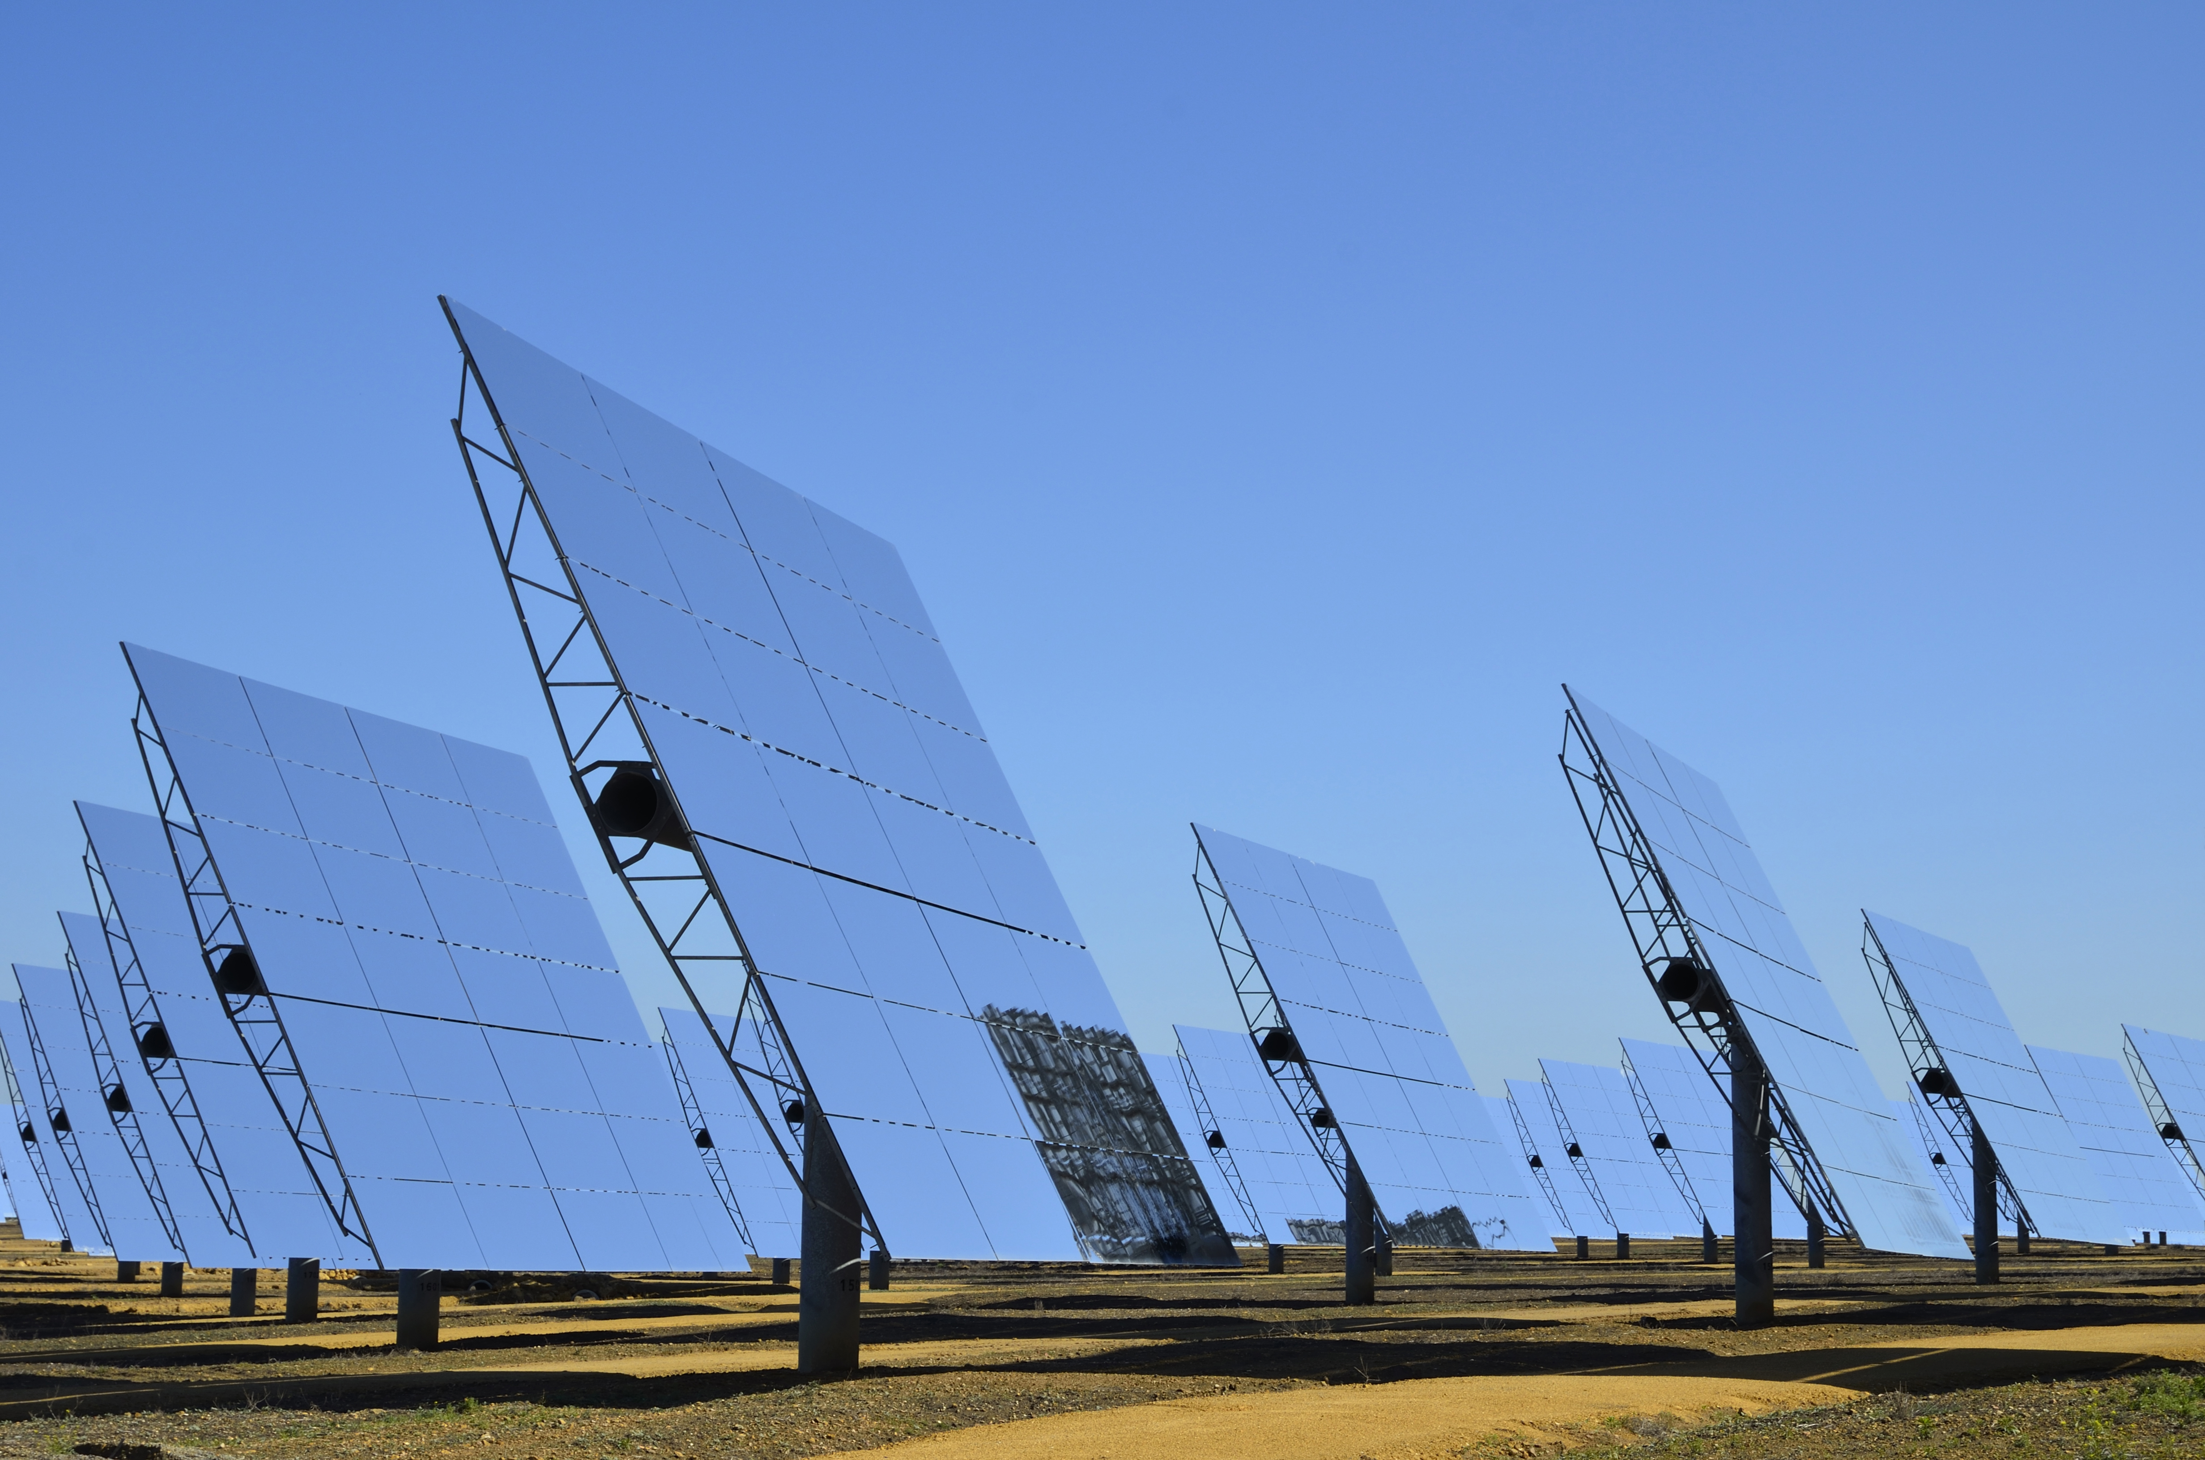

Energy Research Unit
Citation
CSIRO (2026) Stage 5 Research Program Summary Report for the Australian Research in Power Systems Transition (AR-PST) Research Roadmap. CSIRO, Australia.
Copyright
© Commonwealth Scientific and Industrial Research Organisation 2026. To the extent permitted by law, all rights are reserved and no part of this publication covered by copyright may be reproduced or copied in any form or by any means except with the written permission of CSIRO.
Important disclaimer
CSIRO advises that the information contained in this publication comprises general statements based on scientific research. The reader is advised and needs to be aware that such information may be incomplete or unable to be used in any specific situation. No reliance or actions must therefore be made on that information without seeking prior expert professional, scientific and technical advice. To the extent permitted by law, CSIRO (including its employees and consultants) excludes all liability to any person for any consequences, including but not limited to all losses, damages, costs, expenses and any other compensation, arising directly or indirectly from using this publication (in part or in whole) and any information or material contained in it.
CSIRO is committed to providing web accessible content wherever possible. If you are having difficulties with accessing this document, please contact csiro.au/contact.
Table of Content
Acknowledgments 5
Acronym glossary 7
List of Figures 9
List of Tables 9
Executive summary 10
1 Introduction 13
1.1 Overview 13
1.2 Australian Research in Power Systems Renewable Transition 15
1.3 CSIRO Power System Research Roadmap 16
2 Background 18
3 Inverter-based resource stability and protection 21
3.1 Topic 1-1: Inverter Design - ​ Advanced Fault Response Analysis and System Integration Requirements for Inverter-Based Generation and Load Technologies 21
3.2 Topic 1-2: Inverter Standards - GFM Converter Standard Development 24
3.3 Topic 2: ​Evaluation of Small and Large Disturbance Voltage Stabilities for Power Systems with a High Penetration of Inverter-based Resources 26
3.4 Topic 6-1: Protection challenges in IBR rich networks 29
4 Power system planning and operation 32
4.1 Topic 3: Human-Centred Information Visualisation for Improved Situational Awareness and Critical Decision Making in Energy Control Rooms 32
4.2 Topic 4: Integrated Energy System Planning - Resource Adequacy, Risk and Resilience in Low-Carbon Energy System Planning: Methods, Tools and Metrics 35
5 Essential system services and power system restoration 40
5.1 Topic 5-1: Restoration and black start 40
5.2 Topic 5-2: System restoration and black start 44
5.3 Topic 6-2: System Services - Characterisation of Load for Essential Services 47
6 Consumer Energy Resources & Electric Vehicle Integration 50
6.1 Topic 8: ​The intersection of Dynamic Operating Envelopes and Vehicle-to-Grid Technology 50
6.2 Topic 9-1: CER and stability 53
6.1 Topic 9-2: Securing DER Stability via Trusted Sovereign Monitor (TSM) 56
7 Accelerating the decarbonisation of our electricity system 59
7.1 Research Highlights 59
7.2 Open source information 63
7.3 Research publications 64
7.4 Next steps: Priority research tasks 65
7.4.1 Advanced Fault Response Analysis and System Integration Requirements for Inverter-Based Generation and Load Technologies (Topic 1-1) 65
7.4.2 Inverter Design – GFM Converter Standard Development (Topic 1-2) 65
7.4.3 Evaluation of Small and Large Disturbance Voltage Stabilities for Power Systems with a High Penetration of Inverter-based Resources (Topic 2) 66
7.4.4 Control Room of the Future (Topic 3) 66
7.4.5 Resource Adequacy, Risk, and Resilience in Low-Carbon Energy System Planning: Methods, Tools, and Metrics (Topic 4) 66
7.4.6 Restoration and black start (Topic 5-1) 67
7.4.7 System restoration and black start (Topic 5-2) 67
7.4.8 Protection Challenges in IBR Rich Networks – Interim Report (Topic 6-1) 68
7.4.9 Characterisation of Load for Essential Services (Topic 6-2) 68
7.4.10 Dynamic Operating Envelopes (Topic 8) 69
7.4.11 DER and stability (Topic 9-1) 70
7.4.12 Trusted Sovereign Monitor (Topic 9-2) 70
7.5 Getting involved 71
8 The power system research ecosystem 72

Acknowledgments
The work summarised in this report would not have been possible without the funding, technical guidance, and oversight of the Commonwealth Scientific and Industrial Research Organisation (CSIRO). Similarly, the contributions and guidance of the Australian Energy Market Operator (AEMO) have been invaluable.
Acknowledgement of project partners
This report summarises and provides insights into the AR-PST research roadmap. We would like to thank all the partner organisations for their efforts in implementing this year’s research:
- Bespoke Energy for Topic 1-1 – Advanced Fault Response Analysis and System Integration Requirements for Inverter-Based Generation and Load Technologies (Nilesh Modi, Nathan Crooks, Babak Badrzadeh),
- BES for Topic 1-2 – Grid Forming Converter Standard Development (Alex Baitch),
- Federation University for Topic 2 – Evaluation of Small and Large Disturbance Voltage Stabilities for Power Systems with a High Penetration of Inverter-based Resources (Prof. Nima Amjady, A/Prof. Rakibuzzaman Shah, A/Prof. Rabiul Islam, Dr Nabil Mohammed, Dr Mahbubur Rahman Kiran, Dr Biplob Hossain, Md Sazal Miah, Muhammad Usman Aslam),
- Monash University for Topic 3 – Control Room of the Future – Human-Centred Information Visualisation for Improved Situational Awareness & Critical Decision Making in Energy Control Rooms (Dr Sarah Goodwin, Dr Mor Vered, Dr Caddie Gao, Dr Lee Lawrence, Dr Benjamin Tag, Dr Michael Wybrow, Dr Markus Wagner, Dr Tim Dwyer, Dr Yidan Zhang),
- The University of Melbourne for Topic 4 – Resource Adequacy, Risk, and Resilience in Low-Carbon Energy System Planning: Methods, Tools, and Metrics (Tim Kopka, Muhammad Yasirroni, Pablo Apablaza, Bastian Moya, Sleiman Mhanna, Pierluigi Mancarella),
- Bespoke Energy for Topic 5-1 – Restoration and Black Start (Sorrell Grogan, Babak Badrzadeh, Nilesh Modi),
- The University of Tasmania for Topic 5-2 - System Restoration and Black Start​ (Prof. Michael Negnevitsky, Dr. Pooyan Alinaghi Hosseinabadi, Dr. Waqas Hassan, A/Prof. Evan Franklin, Prof. Saad Mekhilef, Prof. Mehdi Seyedmahmoudian, Prof. Kashem Muttaqi),
- Amplitude for Topic 6-1 – Protection Challenges in IBR Rich Networks (Alex McLeod),
- Advitech for Topic 6-2 - Characterisation of Load for Essential Services (Glenn Platt, Jemima Jackson, Öleg Fina, Abby Yates),
- Elentar for Topic 8 – ​The intersection of Dynamic Operating Envelopes and Vehicle-to-Grid Technology (Andrew Fraser, Benjamin Weise, Kim Blackmore, Phillipa Watson, Laura Jones, Yeliz Simsek),
- The University of NSW for Topic 9-1 - DER and stability during system restoration and disturbances (Georgios Konstantinou, Yumeng Tian, Shang Jiang, Sidharth)
- Edith Cowan University for Topic 9-2 - Securing DER Stability via Trusted Sovereign Monitor (TSM) (Helge Janicke, Ahmad Mohsin, Mohi Ahmed, Asma Aziz, Md Iqbal Sarker).
We would also like to thank AEMO for their partnership and support under the ISON consortium, especially Luke Robinson and Kevin Cryan for their efforts in the project coordination and enabling the sharing of AEMO operational information, and acknowledge John Ward, Chris Knight, and Thomas S Brinsmead from CSIRO for their leadership and technical guidance.
Also, we acknowledge the many AEMO and CSIRO topic and report reviewers for sharing their time and expertise: Mahathir Almashor, Biswajit Bala, Felicity Barnfather-Splatt, Julio Braslavsky, Edward Burstinghaus, Sid Chau, Akram Hameed, Daniel Hugo, Shakil Khan, Mohsen Khorasany, Leon Kwek, , Nariman Mahdavi Mazdeh, Mohammad Mohammadi, Ghulam Mohy-Ud-Din, Rajesh Nighot, Nanduni Nimalsiri, Liz Ratnam, Karin Rodrigues, Isaac Saccaro, Dean Sharafi, Darren Spoor, Cheng Tan, Tjaart Van Der Walt, Taru Veijalainen, Yunqi Wang, and Thomas Wearne.
Finally, CSIRO especially acknowledges the efforts of Christian Schaefer (editor) as well as Kelly Patterson and Liam Landman in both summarising the work reported herein and its project management and administration.

Acronym glossary

AEMO | Australian Energy Market Operator | G-PST | Global Power Systems Transformation
AR-PST | Australian Research in Power Systems Transition | GW | Gigawatt
AI | Artificial Intelligence | HESS | Hybrid Energy Storage System
APM | Analytical Predictive Algorithm | HiL | Hardware in Loop
APRC | Adaptive Power Reference Control | HILP | High Impact Low Probability
BESS | Battery Energy Storage System | IEC | International Electrotechnical Committee
BPNN | Back propagation neural network | IEEE | Institute of Electrical and Electronic Engineers
CCT | Critical Clearance Time | ISON | International System Operators Network
CER | Consumer Energy | LWR | Last Worst Regret
CRoF | Control room of the future | LWWR | Least Worst Weighted Regret
CSIRO | Commonwealth Scientific and Industrial Research Organisation | LSTM | Long-short term memory
DER | Distributed Energy Resources | MBSE | Model Based System Engineering
DNSP | Distribution Network Service Provider | ML | Machine Learning
DOA | Domain of Attraction | MVA | Mega Volt-Amp
DOL | Direct on-line (starting) | NEM | National Electricity Market
DSM | Demand Side Management | NEMDE | NEM Dispatch Engine
DSO | Distribution System Operator | NPV | Net Present Value
DPV | Distributed Photovoltaic | NQREZ | North Queensland Renewable Energy Zone
DR | Demand Response | NZE | Net Zero Emissions
EMS | Energy Manag | OE | Operating envelope
EMT | Electromagnetic Transient | OEM | Original Equipment Manufacturer
EPRI | Electrical Power Research Institute | OPF | Optimum Power Flow
EV | Electric Vehicle | PDT | Phasor Domain Transient
ESS | Energy Storage Systems | PoC | Point of Connection
EVCI | Electric Vehicle Charging infrastructure | PSA | Power System Architecture
FCAS | Frequeny Control Ancillary Services | PV | Photovoltaics
GFL | Grid Following (Inverter) | RES | Renewable Energy Source
GFM | Grid Forming (Inverter) | TDIM | Transmission-Distribution Interface Mechanisms
REZ | Renewable Energy Zone | TSM | Trusted Sovereign Monitor
RoCoF | Rate of Change of Frequency | UEP | Unstable equilibrium point
RPC | Reactive Power Control | UFLS | Underfrequency Load Shedding
SCADA | Supervisory, Control and Data Acquisition | ULS | Ultra-large scale
SCR | Short Circuit Ratio | V/Hz | Volt per Hertz
SEP | Stable Equilibrium Point | VPP | Virtual Power Plant
SFR | System Frequency Response | V2G | Vehicle to Grid
SOM | Self-organising map | VSG | Virtual Synchronous Generator
SynCon | Synchronous Condenser

List of Figures
Figure 0-1: Research areas of the CSIRO AR-PST Roadmap 11
Figure 1-1: Energy system – past and future state 14
Figure 1-2: Contributors to the CSIRO AR-PST Research Roadmap and Stage 1-5 implementation. 16
Figure 2-1: Research focus areas across the electricity supply chain 20
Figure 4-1 Replication of Figure 2-1 from Research Roadmap (Adrian Kelly et al., 2021, p. 13), with relevant sections for Stage 5 CROF research are highlighted in yellow. 34
Figure 4-2: Detailed progress of the CROF Pillar Operator Training for Topic 3 after the completion of Stage 5, pink highlighted tasks reflecting Stage 5 achievements (recommendations for enhancement of CR visualisation) 35
Figure 4-3: General overview of the NEM reliability suite architecture 37
Figure 5-1: Barriers and Capability Factors for Industrial Demand Response Participation 48
Figure 6-1: Threat Modelling Approach 56
Figure 7-1: Highlights and breakthroughs of the AR-PST Stage 5 research 59
Figure 8-1: CROF model associated with human factors and operator interaction with the software systems and data in the control room 65
Figure 9-1: Other critical Australian energy sector research activities and their linkage to the AR-PST 72

List of Tables
Table 1: Progress against Topic 1 Research Roadmap 24
Table 2: Year 2 effort and estimated completion timeline for the Standards Development of Topic 1-2 of the AR-PST 26
Table 3: Topic 2 progress against the critical tasks identified in the Research Roadmap 29
Table 8: Topic 6-1 research progress against the Roadmap 31
Table 5: Progress of the Research Roadmap for Topic 4 after the completion of Stage 5 (highlighted tasks reflect Stage 5 achievements) 38
Table 6: Topic 5-1 research progress against the Roadmap 43
Table 7: Topic 5-2 research progress against the Roadmap 46
Table 8: Topic 6-1 research progress against the Roadmap 49
Table 8: Topic 8 progress made during Stage 5 against the tasks of the AR-PST Roadmap 52
Table 11: Topic 9-1 research progress made against the Roadmap in Stage 5 55
Table 10: Research topic input data and tools 62

Executive summary
Australia’s energy system is undergoing one of the most significant transformations in its history. As we progress towards a net-zero future, the electricity sector is rapidly evolving through the large-scale integration of renewable energy, distributed energy resources, battery storage, and electrification of transport, industry and households. At the same time, coal-fired generation continues to retire and to operate less frequently, while new renewable energy and storage projects are being delivered across the National Electricity Market (NEM) of the east coast and the Wholesale Electricity Market (WEM) of Western Australia.
This transition is creating a cleaner, more flexible and increasingly resilient, energy system. However, it also requires a fundamental shift in how we plan, operate and secure the power system. Many of the frameworks, processes and technologies that have underpinned Australia’s affordable and reliable electricity supply for decades were designed around the large synchronous generators that are now being replaced.
As inverter-based resources, including wind, solar, batteries, and consumer energy resources, become the dominant source of generation and system support, new challenges emerge in maintaining or rethinking system strength, inertia, voltage control, frequency performance and system resilience. Addressing these challenges is essential to ensuring the transition remains orderly and delivers the outcomes Australians expect: a power system that is secure, reliable, resilient, affordable and sustainable. Through proactive planning, innovation and investment in essential system services, Australia can continue to lead the transition while maintaining the high standards of electricity supply that underpin our economy and communities.
To support and accelerate the energy sector transformation, the Commonwealth Scientific and Industrial Research Organisation (CSIRO) in 2022 published the Australian Research Planning for Global Power Systems Transformation (the Research Roadmap). This roadmap outlines areas of research that will enable renewable energy generation to successfully power Australia and, more broadly, the world. In 2025, the Global Power System Transformation (G-PST) initiative evolved, with the CSIRO and Australian Energy Market Operator (AEMO) led research program now operating as the Australian Research in Power Systems Transition (AR-PST), focusing on supporting energy research that will drive Australia’s energy transition and deliver ongoing benefits to the Australian energy sector.
While many aspects of our transforming electricity system require attention, the Research Roadmap focuses on four key areas, with two or more specific research priorities in each:
- Inverter-based resource stability and protection covers multiple aspects of new power electronic-based energy conversion technology used in utility-scale wind and solar farms. These range from improving the stability of individual devices, and assessing the stability of interaction among large numbers of such systems, to managing large power systems that have very high levels of penetration of inverter-based resources (IBR).
- Power system planning and operation research focuses on developing effective planning, and operating, methods - and tools - to enable Australia to deliver a secure, affordable, and sustainable electricity system that is planned the way it is operated, and operated the way it was planned. Research has continued to expand the expansion planning assessment in view of exogenous influences that require increased resilience from our grid and the beneficial impact that high levels of CER can have on system reliability. Concurrently, power system operation has continued to invest in the Control Room of the Future concept and investigating the control operator requirements to manage power systems that are increasingly complex.
- Essential system services and system restoration are already being challenged at these early stages of the electricity network transformation. System strength, inertia, and minimum demand already occupy our system operators, and operating the power system of the future will require appropriate essential system services and an advanced control room to securely and reliably manage our electricity network in real time. A further aspect to the essential system services and control room operator facilities concepts being investigated is the ability to restore our electricity networks following a region wide blackout, such as occurred in South Australia in 2016. Presently, we use synchronous generators to restart the network, but with many of our synchronous generators already - or soon to be - retired, new sources will have to be found, and methodologies developed, to restart our system in case of widespread outages.
- Consumer energy resources and electric vehicle integration investigates the dynamical characteristics of solar rooftop inverters, electric vehicles, battery storage systems, and inverter-based loads in power system simulations. This understanding is required to develop aggregate models of large numbers of these devices, models that are needed to calculate stability limits and stable operating points. Research also includes other semi-operational considerations such as how to optimally dispatch the growing number of active consumer energy resources in our distribution networks through the use of dynamic operating envelopes, in order to maximise the utilisation of distribution network assets.
The four broad areas outlined above and the research priorities within them, illustrated diagrammatically in Figure 0-1, are those that many system operators consider are most critical to resolve right now.
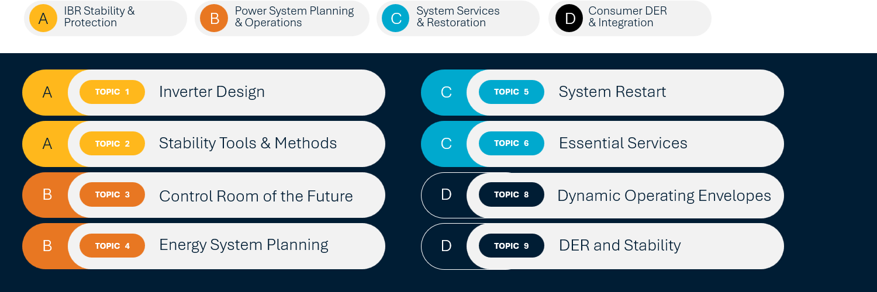
Figure 0-1: Research areas of the CSIRO AR-PST Roadmap
During the past twelve months, in the fourth year of implementation of the CSIRO Research Roadmap, and the fifth since its inception, a selection of Australia’s brightest minds supported by international experts have contributed their expertise to designing power systems for the future as part of this CSIRO funded initiative:
- Topic 1-1 (Bespoke Energy) – Inverter Design: Advanced Fault Response Analysis and System Integration Requirements for Inverter-Based Generation and Load Technologies.
- Topic 1-2 (BES) – Inverter Design: Grid Forming Converter Standards Development.
- Topic 2 (Federation University) – Stability tools: Evaluation of Small and Large Disturbance Voltage Stabilities for Power Systems with a High Penetration of Inverter-based Resources.
- Topic 3 (Monash University) – Control Room of the Future: Human-Centred Information Visualisation for Improved Situational Awareness & Critical Decision Making in Energy Control Rooms.
- Topic 4 (University of Melbourne) – Integrated energy system planning: Resource Adequacy, Risk, and Resilience in Low-Carbon Energy System Planning: Methods, Tools, and Metrics.
- Topic 5-1 (Bespoke Energy) – Restoration and Black Start, including test procedure development.
- Topic 5-2 (The University of Tasmania) – System Restoration and Black Start, including hardware in the loop testing.
- Topic 6-1 (Amplitude) – System services: Protection Challenges in IBR Rich Networks.
- Topic 8 (Elentar) – The Intersection of Dynamic Operating Envelopes and Vehicle-to-Grid Technology.
- Topic 9-1 (University of New South Wales in collaboration with University of Wollongong) – DER and stability during system restoration and disturbances.
- Topic 9-2 (Edith Cowan University) Securing DER Stability via Trusted Sovereign Monitor (TSM)
The topics outlined above represent the highest priority items identified in the Roadmap, and this 2026 report presents the key outcomes and major insights achieved by the research teams. Full detailed reports are available on the CSIRO AR-PST website. The website also hosts the roadmap itself and the outcomes of the previous three stages of research.

Introduction

Overview
The transition from the past electricity grid to the future energy system represents one of the most significant infrastructure transformations since the original development of modern power systems. Traditionally, electricity grids have been built around large, centralised power stations—predominantly coal, gas and hydro generation—that supplied electricity through a one-way flow of power from generators, through transmission and distribution networks, to passive (load only, relatively homogeneous) consumers. This model provided reliable electricity for decades but was designed for a world with relatively predictable demand patterns and limited concerns about greenhouse gas emissions.
Today, the drivers of climate change, technological innovation, and changing consumer expectations are accelerating a transition towards a cleaner, smarter, and more resilient - energy system. Central to this transition is the increasing deployment of renewable energy resources such as wind and solar generation, supported by energy storage technologies, including batteries and pumped hydro. The future grid is evolving into a highly interconnected and dynamic system with two-way power flows, where consumers can also be producers - through rooftop solar, home batteries, and Vehicle-to-Grid enabled electric vehicles. Advanced digital technologies, real-time monitoring, and automated control systems are becoming essential to manage the increasing complexity of power system operations.
This transformation is closely aligned with global climate objectives established under the Paris Agreement. The Agreement has become a key driver of national decarbonisation strategies and electricity sector reforms around the world. In Australia, this transition is reflected in commitments to net-zero emissions by 2050 and significant growth in renewable energy generation. Electricity networks are being strengthened and expanded to connect Renewable Energy Zones, integrate distributed energy resources, and support the electrification of transport, industry and buildings. Future power systems must continue to provide customers with energy, and hence to enable essential services such as system strength, inertia, frequency control and black start capability while maintaining affordability and reliability. The end result will be an electricity grid that is cleaner, more flexible, more resilient, and capable of supporting both economic growth and long-term climate objectives (Figure 1-1). Although we may be in the middle of the transition between past and future, there is much research underway to accelerate and stabilise the transition.
In 2022, the Commonwealth Scientific and Industrial Research Organisation (CSIRO) published the Australian Research Planning for Global Power Systems Transformation (the Research Roadmap). The Research Roadmap outlines a strategy for research in critical areas of our electricity network, with a vision for a bold and accelerated energy transition to support Australian power grids achieving our renewable energy transition.
In 2025, the Australian Global Power System Transformation (G-PST) initiative was reimagined to focus on delivering targeted and practical solutions for application to the Australian power system. The CSIRO research program now operates as the Australian Research in Power Systems Transition (AR-PST) under the continued leadership of CSIRO and the Australian Energy Market Operator (AEMO). This evolution facilitates a more focused research effort in Australia’s energy sector and its unique challenges, and in support of the future requirements of AEMO to operate the Australian power system of the future.
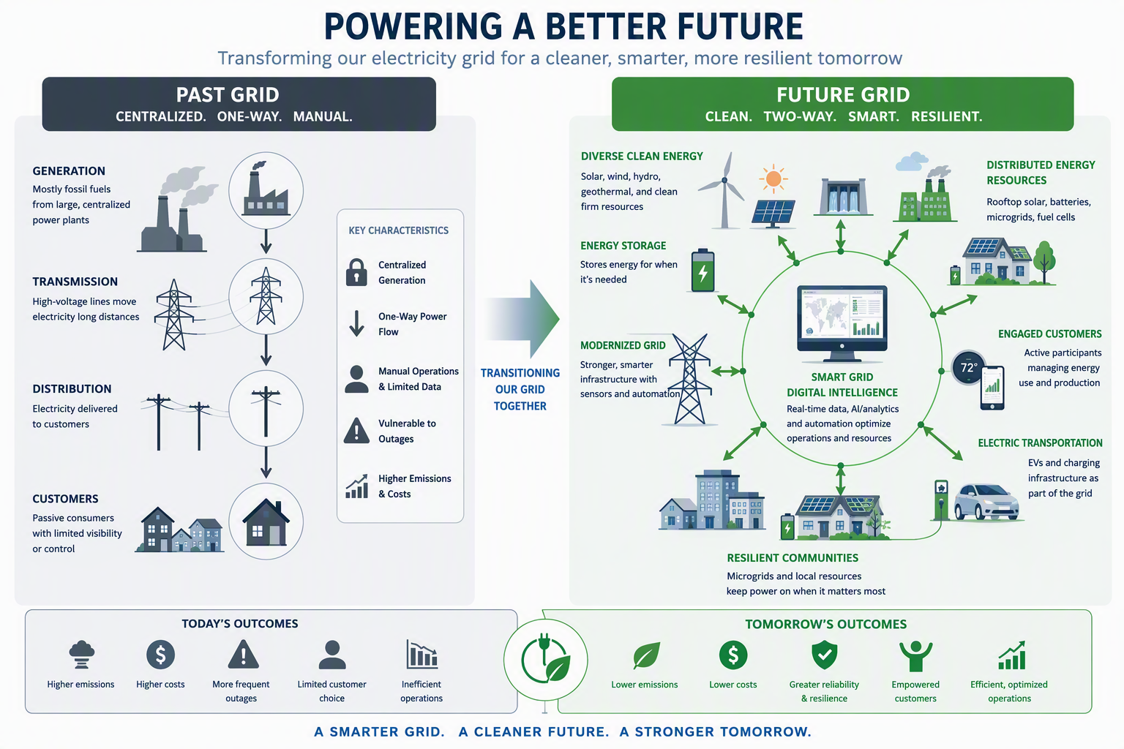
Figure 1-1: Energy system – past and future state

Building on the outcomes and insights of the past years of G-PST and AR-PST research and development, this report outlines the findings of the research undertaken during Stage 5 (2025-26 financial year). The next steps for the CSIRO energy sector research are also described. More detail, including full reports produced by the researchers who have contributed to all four research implementation Stages 2 to 5, can be found on the CSIRO AR-PST website alongside the Research Roadmap. With the initial three stages of research implementation and the original roadmap conceptualisation and concept development completed, the Roadmap now looks towards increased implementation and the realisation of research outcomes.
Notably, the research outlined is being undertaken for an Australian context considering specifically Australian challenges, such as world-leading rates of rooftop photovoltaic energy uptake and secure planning and operation of one of the longest transmission systems in the world. However, CSIRO’s vision for the application of this research is not confined to Australia. It is intended for collaboration and knowledge sharing with power system experts around the world.

Australian Research in Power Systems Renewable Transition

In 2025 CSIRO and AEMO reimagined the renewable integration research previously conducted as part of the broader G-PST consortium work, bringing a closer focus on the research that Australia will need to transition our energy system to one that is renewable, decentralised, and electrified. The new initiative that continues the research and energy sector investigation was branded as the Australian Research in Power Systems Transition (AR-PST).
Australia faces unique challenges given the combination of being one of the longest interconnected grids in the world with one of the highest penetrations of solar rooftop photovoltaic. Coupled with an ageing fleet of thermal generation, massive uptake of utility scale batteries, and operating an energy only market, there are both risks and opportunities in power system development, operation, and consumer energy resources.
Consequently, the focus of the AR-PST research continues to be on four broad areas of the power sector, with a close collaboration between CSIRO and AEMO to design solutions particularly needed here in Australia, but also applicable globally:
- Inverter based resource stability and protection that covers multiple aspects of power electronic-based energy conversion technology used in battery storage systems, utility-scale wind and solar farms, and inverter connected loads e.g., data centres. Whereas in previous years, the focus was on improving the stability of individual devices and assessing the stable interaction between large numbers of such systems, attention is now being directed towards establishing research on the capability and grid interaction of grid-forming inverters, particularly the impact that increased penetration of IBR will have on protection systems.
- Power system planning and operation are a critical duality of energy security. Together, effective planning and operation enable the delivery of a secure, affordable, and sustainable electricity grid for consumers. As the power system evolves, close alignment of planning and operational practices will remain critical to achieving Australia’s energy, economic, and climate objectives. We should plan the power system the way we will operate it, and operate the way we planned it. To support the many changes underway, planning has expanded to encompass the assessment of resilience to exogenous influences and the beneficial impact that coordinated CER can have on grid expansion, while operations research is continuing to develop the Control Room of the Future, developing the tools that our power system operators will need to control the energy system of the future.
- Essential system services and system restoration are important aspects of secure power system operation that must be planned well in advance to ensure they are available when needed. Historically, many system services and restoration were incidental byproducts of energy generation by synchronous power stations. As our energy system transitions to one dominated by IBR, these services from synchronous generators can no longer be guaranteed. We must consider how batteries, renewable energy zones, and other sources can provide these services in the future. Research continues to investigate the effectiveness of grid-forming and grid-following batteries, synchronous condensers, and large aggregations of renewable generation can provide black start capability for our grids, and what incentivisation large loads may require so as to offer certain types of essential system services.
- Consumer Energy Resources and electric vehicle integration considers the performance, management, and security of what is now the largest generating technology in Australia. Rooftop solar installation now exceeds 28 GW, and is predicted to grow further, as will the uptake of home batteries and electric vehicles. Understanding how to aggregate and control CER, how to predict its behaviour to system disturbances, and whether there are cybersecurity risks that this web connected technology is exposed to, is the focus of the fourth area of research.

CSIRO Power System Research Roadmap
CSIRO, supported by AEMO, has engaged leading subject matter experts from Australian universities, engineering companies, and consultancies (Figure 1-2) to undertake research that is critical to the energy transition in Australia and, more broadly, around the world, allowing Australia to become a leader in the fields of technology and research being studied. With the broad spectrum of academic, industrial, and engineering knowledge and experience presented by the researchers that have been engaged over the five-year course of this research program, CSIRO seeks to ensure that the energy sector knowledge and applications being developed are relevant, pragmatic, and implementable for the long-term benefit of all Australians.
Figure 1-2: Contributors to the CSIRO AR-PST Research Roadmap and Stage 1-5 implementation.
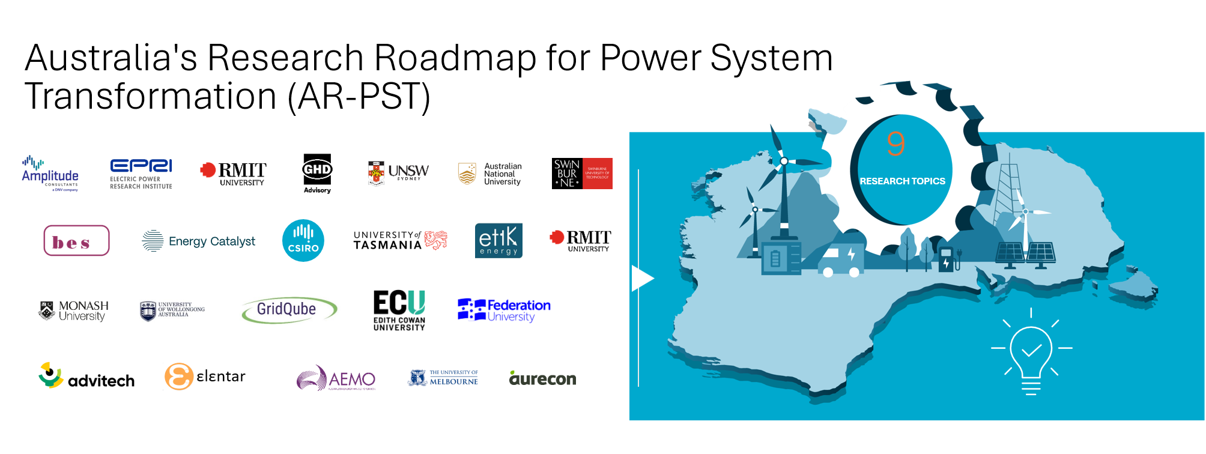
The work summarised in this report presents Stage 5 of CSIRO’s Australian AR-PST Research Roadmap:
- Stage 1 of the research program was the 2022 development of the research roadmap itself, identifying the highest priority tasks in each of the previously described research areas.
- Stage 2 was the first stage of research and focused on the highest priorities identified in the research roadmap.
- Stages 3 and 4 continued the research undertaken in Stage 2 while considering factors such as new technologies and the changing priorities in the energy sector.
- The current Stage 5 continues to investigate the key areas identified through the original roadmap in the areas of IBR stability and protection, power system planning and operation, ESS and power system restoration, and CER and EV integration.
Energy sector research is being undertaken in parallel by many other research organisations and system operators outside of the AR-PST, and the CSIRO sponsored research seeks to exploit synergies to accelerate the development of solutions to the challenges we face. In particular, the AEMO Engineering Roadmap and the AEMO Operations Technology Program are related to the objectives of the Research Roadmap and there is ongoing and continuous engagement between AEMO and CSIRO, and the researchers implementing the Roadmap. Work being undertaken by other research organisations - or including CSIRO as a partner - also supports the outcomes of research topics highlighted in the Research Roadmap. This includes the Commonwealth funded, and industry-led, RACE for 2030 program.

Background
In Australia’s National Electricity Market, renewable generation capacity continues to increase rapidly, thereby lifting the amount of energy supplied, particularly from wind and solar. Additionally, expansion of firming capacity is expanding, in the form of battery energy storage systems that thereby support the uplift in variable renewable energy production. During the first quarter of 2026, renewables including distributed PV and hydro, supplied 46.5% of NEM energy demand, up from 43.0% during the previous year’s first quarter.
Similarly, the maximum instantaneous penetration of renewable energy sources during a single 30-minute trading interval also increased to set a new summer record of 78.6%. That is, for a half hour period on 11 October 2025, 78.6% of the NEM’s energy requirement was supplied from renewable sources, including utility hydro, wind, and solar, as well as rooftop solar installations. Such records are predicted to continue being broken with AEMO also reporting that there was already sufficient renewable energy availability for 100% of our demand to have been supplied from renewable sources during the third and fourth quarter of 2024. Even more notable is the anticipated uptake of utility scale battery energy storage, which is projected to increase, from present levels of around 5.8 GW, to almost 18 GW by 2029.
While such progress in our energy transition is remarkable, the challenges associated with operating such an electricity grid are also daunting. En masse installation of utility scale wind and solar generation, proliferation of rooftop solar, home batteries, and electric vehicle installations in our distribution systems, and the withdrawal of synchronous generation that is replaced with grid-forming batteries, creates a paradigm shift in the way we operate our electricity networks. New technology, new electricity system phenomena, and the challenges associated with both that were becoming increasingly familiar, led to the original establishment of the CSIRO supported G-PST research program in 2021.
This CSIRO work is complementary to research being conducted by AEMO and other system operators as part of the International System Operator Network initiative (ISON), as well as AEMO’s own internal research and engineering programs. The ISON is a consortium of power system operators collectively focusing on developing real-world, practical solutions to enable the operation of reliable, secure, high-renewable power systems.
There are many areas of power system design and operation where system operators are now experiencing technical challenges. The original G-PST activities, which were subsequently also commenced by CSIRO in Australia, initially included six specific research topics that the G-PST’s founding system operators, including AEMO, considered most critical to resolve. These six initially identified topics were:
- Topic 1 – Inverter Design: Development of capabilities, services, design methodologies and standards for inverter-based resources (IBR) such as wind and solar generation, and batteries.
- Topic 2 – Stability Tools and Methods: Development of new tools and methods, as well as modifications or supplements to existing tools and methods, required to ensure reliability, security, and stability in power systems.
- Topic 3 – Control Room of the Future: Development of new technologies and approaches for enhanced real-time visibility and analysis in power system operator control rooms.
- Topic 4 – Planning: New planning metrics, methods, and tools to capture the characteristics and influence of a changing resource mix.
- Topic 5 – Black start and restoration: Creating new procedures for black starting and restoring a power system with high or 100% IBR penetration.
- Topic 6 – Services: developing new techniques and models to manage voltage and frequency control in transitioning power systems.
In Australia, given the rapid and ongoing uptake of rooftop solar photovoltaics and other consumer energy resources, the need to manage uncertainty in the development of our transmission and distribution networks, as well as ensuring the safe and secure operation of the future electricity system, relevant questions from an Australian energy system context have been grouped into an additional three topics:
- Topic 7 – Power System Architecture: Conceptualisation and development of an overarching power system architecture that brings together critical layers of power system design
- Topic 8 – Distributed Energy Resources (DER) Orchestration: Establishment of tools and methods to better coordinate DER and optimise their integration into, and operation within, the distribution system
- Topic 9 – Distributed Energy Resources (DER) and stability: Development of mathematical models for composite loads, DPV, and DER, based on laboratory testing, suitable for all forms of power system analysis, including dynamic and electromagnetic transient simulations.
For each year of the AR-PST program, CSIRO, in consultation with AEMO, has selected projects to support with funding to deliver research in the nine described topic areas. In some instances, CSIRO has selected more than one project where value was seen in two or more projects advancing the roadmap concurrently.
In addition to the rebranding of the CSIRO research program, Topic 7 was transitioned from the AR-PST to the RACE for 2030 program in 2025. The power system architecture research area with its focus on distribution system development, markets, and consumer participation was observed as fitting ideally into the industry led RACE for 2030 program.
The eight topics included in Stage 5 of the AR-PST can be broadly arranged into four areas, as shown in Figure 2-1:
- IBR stability and protection, covering aspects of inverter fault response, voltage and frequency stability, and protection challenges in high IBR penetration networks, as well as development of grid forming inverter standards.
- Essential system services and power system restoration, including investigation of grid forming inverter capabilities to initiate a system restart, and the characterisation of load for essential services provision.
- Power system planning and operation, which delivers practical tools to support the system operators’ real-time management of the future power system, as well as investigation of resource adequacy, risk and resilience in Low-Carbon Energy System Planning.
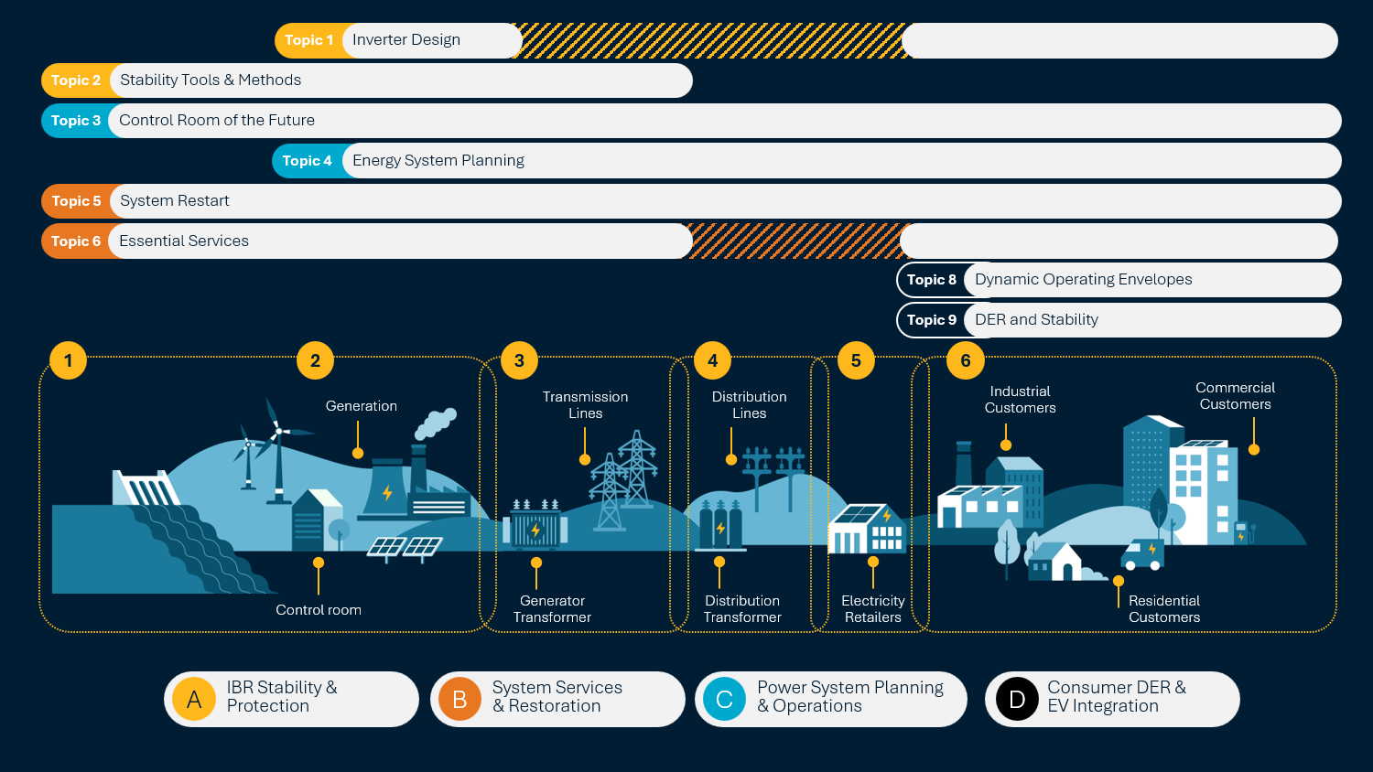
- CER and electric vehicle integration focuses on investigating of the intersection of Dynamic Operating Envelopes and Vehicle to Grid technology, CER stability, and CER cybersecurity.
Figure 2-1: Research focus areas across the electricity supply chain
Topics are broadly grouped across the four research areas, and as shown in the above figure, and the research topics cover the full breadth of the electricity supply chain, from transmission to distribution, including generation, network owners, retailers, and consumers. This strategic arrangement allows research priorities to be tracked across the supply chain and included in the upcoming year’s research project lists.
Twelve projects were funded by the AR-PST program in Stage 5. These projects are described in more detail in Sections 3 to 6. The research project full research reports are available on the CSIRO website.

Inverter-based resource stability and protection
Inverter-based resources (IBRs) are becoming the foundation of Australia’s electricity system generation and are critical to achieving the nation’s decarbonisation and energy security objectives. IBRs include: solar photovoltaic systems, wind farms, battery energy storage systems, and many distributed energy resources; that connect to the grid through power electronic inverters rather than traditional synchronous generators. As Australia retires coal-fired generation and rapidly expands renewable energy, successful integration of IBRs is essential to maintaining a secure, reliable, and affordable power system.
Australia’s power system is uniquely positioned to lead the world in IBR integration due to its high penetration of rooftop solar, large-scale renewable energy developments, and extensive battery deployment. However, this transition changes the fundamental behavioural characteristics of the grid. Traditional generators inherently provide inertia, system strength, voltage control, and fault current. In contrast, inverter-based technologies must be carefully designed and operationally controlled to provide equivalent or improved services through advanced control systems and grid-forming capabilities.
The integration of IBRs enables greater utilisation of Australia’s abundant wind and solar resources, reducing emissions and electricity costs while supporting economic growth and energy independence. Advanced inverter technologies can enhance system stability, provide synthetic inertia, support frequency and voltage control, assist in system restoration, and improve the resilience of the National Electricity Market. Research programs such as AR-PST are developing the tools, standards, and operational methods needed to support a future grid with very high levels of inverter-based generation.
Ultimately, effective IBR integration is not simply a technical challenge—it is a national priority that underpins Australia’s transition to a low-carbon energy system while ensuring power remains secure, reliable, and affordable for consumers and industry.
For Stage 5 of the Research Roadmap, CSIRO funded four research projects in the area of inverter-based resource application and integration that will contribute to the electrical industry’s body of knowledge and will support Australia’s energy transition:
- Advanced Fault Response Analysis and System Integration Requirements for Inverter-Based Generation and Load Technologies (Bespoke Energy)
- Inverter Standards - GFM Converter Standards Development (Baitch Engineering Services)
- Evaluation of Small and Large Disturbance Voltage Stabilities for Power Systems with a High Penetration of Inverter-based Resources (Federation University)
- Protection challenges in IBR rich networks (Amplitude DNV)

Topic 1-1: Inverter Design - ​ Advanced Fault Response Analysis and System Integration Requirements for Inverter-Based Generation and Load Technologies
For Topic 1-1, Stage 5 of the Australian Research in Power Systems Renewable Transition (AR-PSRT) continues to progress the assessment into the challenges of operating a power system that is rapidly shifting towards inverter-based resources (IBR).
Where the previous stages focused on developing IBR control systems to support stable operation, Stage 5 expands the Roadmap implementation by investigating the effect that displacing synchronous generators (SGs) by IBR will have on fundamental aspects of power system operation including fault current characteristics, system strength and voltage behaviour, and protection system performance.
Research has been arranged in three parts:
- Investigation of IBR capability to suppress unbalanced faults using negative sequence current control.
- Development of technical standards for grid-forming inverters with respect to impact on protection.
- Inverter-based Load (IBL) interface specification for mapping both model structure and performance.
These tasks and the key outcomes and insights are described below. Full details of the Bespoke Energy Report for Topic 1-1, including simulation results and analysis of outcomes can be found on the CSIRO AR-PST Stage 5 website.
Part 1 of the research investigates the behaviour of inverter-based resources (IBRs), investigating both grid-following (GFL) inverters and grid-forming (GFM) inverters during negative-sequence voltage conditions. These conditions generally arise during asymmetrical faults and pose challenges for control system stability and protection in grids increasingly dominated by IBRs rather than synchronous machines.
The presence of negative-sequence current during power system disturbances is critical for accurate fault detection, particularly for protection schemes that rely on it to indicate the fault direction. The phasor relationship between negative-sequence voltage and negative-sequence current is important for accurate operation of directional relays. GFL inverters require explicit control to inject negative-sequence current, while GFM inverters could emulate voltage source behaviour to provide negative-sequence current.
Based on the power system study carried out, the researchers made the following observations:
- A system with higher share of synchronous machines provides a stable and desired phasor relationship (particularly negative-sequence phasors) during the unbalanced system condition. This was as expected and aligned with the established knowledge and understanding of a system with a high share of synchronous machines.
- As inverter‑based resources (IBRs) replace synchronous generation, the magnitude of negative‑sequence current decreases and the phase angle difference between negative-sequence voltage and negative-sequence current phasors deviates from the ideal 90° leading. This is more pronounced with IBRs lacking negative-sequence control.
In summary, the transition to inverter-based resources is redefining system behaviour during faults and challenging traditional protection concepts.
To ensure system stability and protection reliability in an IBR-rich grid, the industry should adopt standardised design targets, harmonise international requirements, and prioritise robust negative-sequence control across all technologies. Suggested practical design targets and recommendations are presented below as guiding principles for industry to consider:
- During the fault negative-sequence current should lead the negative-sequence voltage by approximately 90° (± 10° tolerance) to support accurate detection of the direction of the fault.
- To avoid continuous response for minor unbalances, a deadband of 2 to 3% of unbalance should be used.
- The direction of negative-sequence current should be from IBR towards the grid during the fault, to reduce unbalance of the system.
- If the control system design is using k-factor approach, then the value should between 2 and 6. For a control system using a virtual impedance approach, the effective negative-sequence impedance should be close to the effective positive-sequence impedance, to support phase balancing.
- Consider a proportional reduction in sequence currents or impedance fold-back to maintain voltage source behaviour during the current limiting situation.
In Part 2 the researchers examined how the increasing penetration of IBR, particularly GFM and GFL inverters, is fundamentally changing power system fault behaviour and challenging the assumptions underpinning traditional protection schemes e.g., distance protection of transmission lines.
A central finding of the research is that negative-sequence current behaviour is critical for protection performance. Directional relays, faulted-phase selectors, and permissive schemes depend on both sufficient magnitude and a predictable phase angle relationship (typically a ~90° leading angle of negative-sequence current relative to voltage). Simulation results indicate that many IBRs without explicit negative-sequence control provide insufficient or poorly phased current, resulting in delayed operation, misdirection, relay chattering, or failure to operate. These issues become more pronounced as synchronous generation is displaced and system strength declines.
Network-scale studies confirm that protection challenges are system-wide rather than device-specific. Key observations from network-level studies include:
- As IBR penetration increases, the aggregate magnitude and coherence of negative-sequence current decrease, unless a sufficient proportion of IBRs actively provide correctly phased current injection support.
- Weak grids and high diversity in inverter behaviour increase variability in relay performance across fault types and locations.
- Enabling negative-sequence control across multiple IBRs improves overall performance but does not fully restore the robustness observed in synchronous-dominated systems.
Critically, system studies show that only well-tuned implementations (e.g., site-specific GFL with negative-sequence control or properly designed GFM systems) achieve both acceptable phasor alignment and stable current contribution.
A key outcome of Part 2 is the need to treat negative-sequence behaviour as a protection-critical requirement, rather than an optional control feature. Existing Australian requirements (e.g., NER) do not explicitly define key parameters such as negative-sequence current magnitude, phase angle, or current-limiting behaviour. In their report, the researchers present key design requirements for negative sequence current contributions by IBR.
The researchers warn that without some measure of requirement specification, increasing IBR penetration will lead to a progressive erosion of protection dependability, posing a risk to system security. Conversely, with well-defined standards and robust implementation, GFM and GFL inverters can provide protection-compatible fault response and thereby support reliable operation of future power systems.
In the third and final Part 3 of Topic 1-1 research, a technology‑neutral, modular, modelling framework for IBL is established, which can enable consistent and credible representation of their behaviour in each of phasor‑domain transient (PDT) and electromagnetic transient (EMT) simulations. Modern IBL, such as data centres, electrolysers, EV fast chargers, and industrial drive systems, are increasingly dominated by power electronics and supervisory logic, leading to complex disturbance responses and recovery behaviours that are not captured by traditional static load models. Part 3 addresses this gap by focusing on externally observable behaviour at the point of connection, rather than internal vendor‑specific design details, ensuring model applicability across diverse technologies and confidentiality requirements.
In their report, Bespoke Energy lays out a scalable, vendor‑independent, modelling foundation that reflects the real drivers of IBL disturbance and recovery behaviour. It supports consistent study practices, enables credible assessment of IBL impacts across network conditions, and provides the basis for future guidance and coordination frameworks without imposing prescriptive performance requirements.
The continuation of research into IBR during Stage 5 has continued to progress the AR-PST Roadmap for Topic 1, as shown in Table 1.
Table 1: Progress against Topic 1 Research Roadmap
Roadmap Major Tasks | Roadmap Tasks | Stage 3 Tasks | Progress¹
4. Protection and Reliability | 4.3: Assessment and enhancement of IBRs reliability | - Task-1: Transient stability analysis of multi-IBR systems considering a wide-area network  - Task-2: Development of analysis tool to conduct transient stability studies for multi-IBR systems | 80%
4. Protection and Reliability | 4.2: Enhancing IBR response during and subsequent to faults | - Task-3: Investigation into the impact of alternative GFM inverter controls (e.g., Grid Forming (GFM) controls, current limiting, frequency freezing, and PLL loop K-factor) on the transient stability of inverters conforming to IEEE P2800 Negative Sequence current requirement.  - Task-3: Study of the impact of NS current allocation on protection, conducted either through a literature review, or, if relay models are available, one or two case studies.  - Task-4: Enhancing transient stability of current-limited grid-forming control by implementation in non-BESS IBRs | 90%
4. Protection and Reliability | 4.3: Assessment and enhancement of IBRs reliability | - Task 2: Sensitivity analysis of GFM inverter stability with respect to parameter variation and fault profile.  - Task 3: Extension to Multi-IBR Systems.  - Task 4: Development of Tuning and Design Guidelines. | 90%
5. Trending Topics | 5.2: Grid-forming capability for HVDC stations and wind and solar farms | - Task-4: Enhancing transient stability of current-limited grid-forming control by implementation in non-BESS IBRs² | 20%
¹ Progress to date against roadmap tasks.
² Stage-3 Task-4 contributes to both Roadmap tasks 4.2 and 5.2 as it addresses IBRs’ stability-enhancing response as well as grid-forming capability for wind turbines.

Topic 1-2: Inverter Standards - GFM Converter Standard Development
Very high shares of IBR without grid-forming technology pose critical threats to power system reliability. This is evident in the form of grid and IBR equipment instabilities, unwanted grid oscillations, poor power quality and even local and region-wide blackouts. A deliberate framework of demonstrations, requirements and incentives to be deployed quickly is required so the energy transition can continue to accelerate and so that power system operators can manage the increasingly aggressive global commitments required to address climate change.
Concurrently a great deal of research and development is being undertaken internationally in multiple areas to both properly understand the technical issues that are being faced to ensure stable and proper operation of GFM inverters, with a view to development of a consistent international standard that can be developed to define the requirements of such systems. With significant effort evident internationally in developing GFM inverter capability and system integration, standardisation of GFM requirements is no longer optional—it is a prerequisite for safely scaling high-penetration renewable grids. Without standardisation, GFM equipment design divergence and inconsistent grid behaviour will only increase integration risk and cost. This is further underscored by the observation that GFM inverters are effectively a functional replacement for synchronous machines in future grids.
Topic 1-2 Grid Forming Standard Development is the continuation of a project that was initiated in July 2024 of Stage 4 of the AR-PST program. The objective is to complement the technical research that is being undertaken in the field of IBR by leading research groups, including within the AR-PST, and coordinating the development of consistent international standards associated with Grid Forming Converters. The intention is to provide leadership and coordination on the joint standards development effort with the major players in this space. The proposed standard is being developed as a joint effort of the Institute of Electrical and Electronic Engineers (IEEE) and the International Electrotechnical Commission (IEC).
Multiple challenges are faced when developing a new technical standard in an area that is still immature and under development. The objective of producing a standard document at the early phase of the maturity of the technology and definition of requirements is to establish a consistent foundation at an early stage in order to provide some direction to manufacturers, while at the same time seeking not to limit technological development.
During the course of the 2025-26 and 2026-27 calendar years the major development work of a Working Draft is being undertaken. This process is now well underway with the objective that by June 2026 progress is to reach 70 % completion. While it is recognised that the most demanding and challenging activities to achieve completion are the last 10 to 20%, there is a level of confidence that this will be achieved.
Two significant input documents are being used as the input to the specification development. These are:
- Universal Interoperability for Grid-Forming Inverters (UNIFI) consortium Specification for Grid-Forming Inverter Based Resources V3 Oct 2025
- European Network of Transmission System Operators for Electricity (ENTSO-E) Grid Forming Capability of Power Park Modules, Final Report on Technical Requirements, Final | 3 October 2025
The challenge currently being faced is to find alignment between the approaches used in the work of UNIFI (essentially representing USA industry practice), and ENSTO-E which represents European industry organisations. While governance and alignment between the IEC and IEEE requirements and inputs are largely solved, some challenges remain, including:
- Misalignment between UNIFI GFM structure and the IEEE 2800 recommended practices, and ENTSO-E modelling vs IEEE/UNIFI approaches.
- GFM technology still evolving and hence, it is risky to define overly constraining requirements too early, as well as creating a risk of locking in suboptimal design requirements into a standard.
- Existing GFM inverter specifications are largely descriptive and there is a need for normative ranges that can apply to GFM technology, as well as measurable criteria for testing the veracity of requirements.
While technical alignment between the IEEE and IEC requirements remains to be fully resolved, a working draft of the GFM standard is expected to be completed by the end of the 2026 calendar year.
Key tasks identified by the Topic 1-2 researchers, progress made during the second year of implementation, as well as the planned timeline for completions, are shown in Table 2.
Table 2: Year 2 effort and estimated completion timeline for the Standards Development of Topic 1-2 of the AR-PST
Activity | Year 1  2024-25 | Year 2  2025-26 | Year 3  2026-27 | Year 4  2027-28
Development of Strategy for Joint Project IEC IEEE | 80%  0% | 100%
Conversion of Proposed Work Item to a New Work Item Proposal IEC | 10% | 100%
Define co-operation arrangement IEC IEEE | 30%  0% | 100%
Development of Working Draft for IEC and IEEE | 20% | 60%  0% | 100%
Process Committee Draft through approval stages within IEC |  | 10% | 70%  0% | 100%
Review and process with IEC and IEEE through Committee draft stages |  | 10% | 70%  0% | 100%

Topic 2: ​Evaluation of Small and Large Disturbance Voltage Stabilities for Power Systems with a High Penetration of Inverter-based Resources
The Australian power system continues to undergo a rapid transformation due to the increasing installation of inverter-based resources (IBRs), and the emergence of high-density, converter-dominated loads, such as AI data centers, and green hydrogen plants. These changes introduce fast, control-system dominated dynamics, reduced system inertia, and unfamiliar voltage and frequency behaviour, which challenge traditional stability assessment methods.
The Topic 2 project seeks to assess and address some of the aforementioned challenges by developing and implementing advanced tools and methodologies to assess both small- and large-disturbance voltage stability in modern power systems, and by proposing enhancement solutions and recommendations. There are three key aspects to the research carried out by Federation University for Stage 5:
Small-signal stability has been investigated in two parts:
- Evaluation of small-signal stability of power systems with different controls of grid-following (GFL) and grid-forming (GFM) inverters. Through their analysis the researchers have provided:
  - A comprehensive literature review of methods, test systems, and software tools for small-signal stability analysis of IBR-dominated systems.
  - A evaluation of three alternative voltage control strategies for grid-forming inverters, namely Fixed Voltage Control (FVC), Primary Voltage Control (PVC), and Automatic Voltage Regulator (AVR) control, in both frequency and time domains under very weak, weak, and strong grid conditions, showing that AVR-controlled inverters generally have lower stability margins than conventional generating plant.
  - An AVR-based GFM inverter stability enhancement method that uses a virtual impedance loop and adaptive tuning of the AVR integral controller sensitive to grid SCR to improve stability performance.
- Modelling and behaviour assessment of inverter-based systems have been assessed using both white-box and black-box approaches:
  - Eigenvalue and mode analysis was conducted using DIgSILENT PowerFactory models of GFL inverters, droop-controlled GFM inverter, and virtual synchronous machine (VSM) controlled GFM inverters under varying SCR conditions to identify dominant modes, key states, and control parameters.
  - The IEEE 39-bus system used in the first part was modified by replacing three synchronous generators with virtual synchronous machine controlled GFM inverters to evaluate small signal stability under different inverter operating points.
  - A Gaussian Process Regression (GPR) and Eigensystem Realization Algorithm (ERA) -based data-driven time-domain method was developed for small signal stability assessment, enabling accurate response prediction and eigenvalue estimation without requiring detailed OEM models.
Combined, these tools and assessment methods present an expanded toolset to analyse small signal disturbances and stability.
As part of the practical implementation of the Topic 2 research, the researchers presented a range of stability indices that can be used to qualify the relative stability of a power system. These indices form part of an integrated performance assessment framework that can characterise the dynamic behaviour of modern power systems under both large and small disturbances. These indices, determined offline, assess post-fault voltage performance by capturing both short- and long-term stability while distinguishing between oscillatory and non-oscillatory responses, thereby overcoming limitations of conventional scalar metrics in systems with high penetration of inverter-based resources and dynamic loads. Federation University defined three separate indices:
- Dynamic Voltage Resilience Index (DVRI and sysDVRI)
- A vector-based Dynamic Voltage Resilience Index (DVRI) and its system-scale extension (sysDVRI) that were subsequently used to determine the impact of increasing renewable integration and dynamic loads.
- A statistical waveform classification method that distinguishes between oscillatory and non-oscillatory voltage recovery behaviour, without requiring waveform-based analysis.
- Small-Disturbance Voltage Performance Index (SDVPI)
- A Small-Disturbance Voltage Performance Index (SDVPI) based on the adaptive continuation power flow (ACPF) method.
- A mathematical framework was established to determine proximity to the voltage stability boundary and identify weak operating conditions.
- Scenario-based voltage stability assessment was performed using a modified 39-bus system in DIgSILENT PowerFactory under different generation and load conditions.
- Small-Signal Stability Index (SSSI – SSOASI)
- A Small-Signal Operating Area Security Index (SSOASI) was developed to evaluate oscillatory stability based on minimum acceptable modal damping.
- A small-signal stability assessment framework was established to evaluate the impact of generation mix, network topology, load variation, and contingencies.
- System security assessment was conducted under different generation scenarios using the modified 39-bus system to demonstrate the effectiveness of the proposed index.
For the final part of the Topic 2 investigation, the researchers assessed the short-term and long-term system dynamics of small- and large-disturbance voltage stability, as well as the system impact of large power electronic controlled loads.
For large disturbance assessment, the researchers considered the impact of a severe fault followed by transmission element outages and the subsequent dynamic voltage recovery of the power system. The researchers carried out several forms of analysis, including:
- Large-disturbance voltage stability (LDVS) was evaluated to assess the system’s ability to maintain acceptable voltages following severe disturbances such as faults, line outages, or generator trips.
- Time-domain simulations using DIgSILENT PowerFactory, with AEMO composite load models, were performed to capture dynamic load behaviour, particularly induction motors, and the impact on transient stability of power systems. Adaptive continuation methods were applied to quantify voltage stability margins and identify critical contingencies and weak buses.
- Both short-term voltage stability (STVS) and long-term voltage stability (LTVS) were analysed to provide a comprehensive understanding of immediate and delayed voltage responses in high-IBR systems.
Concurrently to the large disturbance work, for small disturbance assessment the following work was conducted:
- Small-disturbance voltage stability (SDVS) was evaluated to assess the system’s ability to maintain voltages under small perturbations, such as incremental load or generation changes.
- The impact of IBR penetration reduced reactive power support from IBRs, and interactions with dynamic loads (e.g., residential induction motors) was analysed to determine system loadability and voltage collapse limits.
- Adaptive continuation power flow (adaptive P–V curve) studies were performed to identify critical loading conditions and maximum permissible loads, providing practical inputs for stability screening and operational planning.
Lastly, large load behaviour, and the impact this can have on power system stability, was assessed using a modified composite load model that captures the behaviour of power electronic interfaced equipment.
- Large-load modelling was developed using the Composite Load Model (CMLD) framework, where generic models capturing converter behaviour, ride-through capability, and redundancy were created for RMS studies.
- The developed models were validated against simulation results, and their integration into IBR-dominated networks was assessed to evaluate their impact on voltage and small-signal stability.
- A Dynamic Model Acceptance Test (DMAT) framework was developed with AEMO to provide standardized testing procedures, enabling robust planning and risk assessment for emerging large loads.

With the work completed to date, Stage 5 of the Topic 2 Research Roadmap progressed several of the critical tasks identified (Table 3).
Table 3: Topic 2 progress against the critical tasks identified in the Research Roadmap
Roadmap Major Tasks | Roadmap Tasks | Stage 5 Tasks | Progress
1. Stability margin evaluation | 1.1 Identifying the nature of oscillations and damping in IBR-dominated grids  1.2 Online identification of system strength  1.3 Online identification of system strength | Evaluating controllability, observability, and eigenvalues of power-controlled GFL inverters, droop-controlled GFM inverters, and VSG-controlled GFM inverter.  SMIB (Single Machine Infinite Bus), modified IEEE 39-Bus System (with power-controlled GFLIs and VSG-controlled GFM inverters), and Australian 14-Generator System.  Development of data-driven time-domain method for evaluation of small-signal stability of grid following and grid forming inverters connected to SMIB testing system. | 95%  0%
2. Small signal stability screening methods | 2.1 Stability margin evaluation of GFM inverters in frequency domain | Performance evaluation of GFM inverters in frequency domain for different voltage controls (FVC, PVC, AVR) under different grid strengths and investigating enhancement strategies for the AVR method. | 95%  0%`
3. Voltage stability boundary | 3.1 Voltage stability boundary  3.2 Voltage control, recovery, collapse | Developed a mathematical model of a new dynamic resilient metric for large disturbance voltage stability evaluation.  Implemented an adaptive continuation algorithm using a Python script and ran it in DIgSILENT PowerFactory on a test case.  Assessing short-term and long-term voltage stability in high-IBR systems and evaluating the impact of varying control parameters. | 60%  0%`
4. Model and model validation | 4.2 Modelling and model validation  4.3 Voltage and reactive power management | Identified the required parameters for large load model development, modeling requirements of large load for transmission system studies.  Aggregated large load models are developed for dynamic validation testing.  Investigated the impact of a large disturbance (e.g., a 3-phase symmetrical fault) and fault location on healthy buses (considering their electrical distances from the faulty bus) in terms of voltages for different levels of renewable integration.  Computation of new local and global dynamic resilient index to quantify the system's overall dynamic signature | 30%  0%`

Topic 6-1: Protection challenges in IBR rich networks
The transition of the Australian power system toward high penetration of inverter-based resources (IBR) is also fundamentally reshaping the design and operation of protection systems. Industry experience across Network Service Providers (NSPs), equipment manufacturers, system operators, and research organisations indicates that these changes are not merely theoretical, they are already being encountered in operational environments and are driving a coordinated, practical response.
Many existing protection philosophies, stability assessment techniques, and compliance frameworks were developed for systems dominated by synchronous generation with high short-circuit strength and predictable fault behaviour. As IBRs increasingly displace synchronous plant, protection systems must operate under reduced fault levels, faster electromagnetic and control dynamics, non-linear control interactions such as current saturation, and greater uncertainty in system topology and operating conditions. These issues are particularly pronounced in distribution networks with high DER penetration and VPP aggregation, as well as in remote or isolated power systems where inherent system strength margins are limited.
For Stage 5 of Topic 6-1, Amplitude DNV implemented a structured research program of industry engagement, technical review, and research synthesis across several interrelated tasks. These tasks include:
- direct engagement with Australian NSPs to understand challenges in the field and current mitigation practices;
- assessment of emerging system architectures such as VPPs and their implications for protection and system strength;
- evaluation of new technologies and advanced protection strategies proposed by original equipment manufacturers (OEMs);
- review of Australian academic research and international projects;
- investigation of protection issues in remote systems and microgrids; and
- targeted analysis of voltage, active power, and reactive power - instability detection relevant to compliance with National Electricity Rules (NER) clause S5.2.5.10.
The researchers reported consistent findings across industry stakeholders that traditional protection approaches, particularly those reliant on fault current magnitude and predictable network behaviour, are progressively losing reliability. Inverter-based resources typically deliver limited and highly variable fault current, often influenced by proprietary control strategies, resulting in reduced sensitivity and increased uncertainty in fault detection. This behaviour challenges the foundational assumptions of conventional protection schemes, including time-current grading, directional elements, and distance protection.
Despite these challenges, established protection technologies remain in widespread use, but their application is becoming increasingly selective and context dependent. Line current differential protection is broadly recognised as the most reliable primary scheme in weak-grid environments where communication infrastructure is available. However, in many distribution and remote systems, practical constraints necessitate continued reliance on conventional protection methods, adapted through modified settings, mode dependent operation, and simplified coordination approaches.
Aligned with the outcomes of the surveys and interviews, is the stakeholder perception that a critical barrier is the lack of transparency and standardisation in inverter fault response behaviour. Limited access to reliable data on fault current magnitude, duration, and phase characteristics constrains protection design, coordination, and validation. This issue is compounded by the increasing use of software-defined control strategies, which introduce variability across manufacturers and across operating conditions.
Overall, there is broad consensus that future protection systems must transition from purely measurement-based approaches toward behaviour sensitive frameworks. This shift requires enhanced understanding of inverter control dynamics, improved system observability, and the development of methods to interpret dynamic system behaviour during disturbances. While artificial intelligence and data-driven approaches are under investigation, their application in primary protection remains limited due to requirements for determinism, transparency, and validation.
The convergence of industry experience and academic research highlights a clear set of priorities for the next phase of development, including:
- Establishment of standardised inverter fault-response characteristics
- Improved inverter model transparency and access to high-resolution operational data
- Validation of protection approaches through EMT simulation and hardware-in-the-loop testing
- Development of frameworks for incorporating control-system dynamics into protection decision-making
- Evolution of regulatory and standards frameworks to support these changes
In the researchers’ conclusion, the industry is not undergoing a disruptive replacement of protection systems, but rather a gradual and pragmatic evolution. Existing protection methodologies continue to provide the foundation of system security, while new techniques are incrementally introduced to address the challenges posed by inverter-dominated networks.
However, the key finding is that protection in future power systems will require integration of traditional electrical measurements with an understanding of control-system behaviour, supported by enhanced data, improved standards, and coordinated industry research collaboration.
On completion of Stage 5, the researchers identified progress against the tasks of the updated research roadmap for Topic 6-1 is as shown in Table 8.
Table 8: Topic 6-1 research progress against the Roadmap
Roadmap Major Tasks | Roadmap Tasks | Stage 5 Tasks | Progress
N/A | New task for Topic 6 | DNSP interviews | 100%
N/A | New task for Topic 6 | Virtual Power Plants and future trends | 85%
N/A | New task for Topic 6 | New technologies | 95%
N/A | New task for Topic 6 | Advanced protection strategies | 100%
N/A | New task for Topic 6 | Academic research | 95%
N/A | New task for Topic 6 | Innovative global projects | 90%  %
N/A | New task for Topic 6 | Remote systems and microgrids | 90%  %
N/A | New task for Topic 6 | NER S5.2.5.10 / Subsynchronous oscillations | 100%

Power system planning and operation
Successful power system planning and operation are fundamental to Australia’s economic prosperity, energy security, and successful transition to a low-emissions future. As Australia rapidly increases the share of renewable generation from wind, solar, battery energy storage, and consumer energy resources, the electricity system is becoming more complex and dynamic. Effective planning ensures that transmission networks, generation resources, storage systems, and supporting infrastructure are developed in a coordinated manner to meet future demand while maintaining affordability, reliability, and resilience. Planning frameworks, including long-term system plans and network investment processes, help identify the most efficient investments needed to support population growth, electrification, industrial development, and decarbonisation.
Power system operation is equally important because it ensures the electricity grid remains secure and stable in real time. System operators must continually balance supply and demand, manage system strength and inertia, maintain frequency and voltage within acceptable limits, and respond to unexpected events such as equipment failures, extreme weather, or rapid changes in renewable output. As conventional synchronous generators retire, new operational tools, technologies, and market mechanisms are required to maintain reliability and resilience while integrating high levels of inverter-based renewable resources.
Together, effective planning and operation enable Australia to deliver a secure, affordable, and sustainable electricity system. They support investment confidence, facilitate renewable energy integration, strengthen essential system services, and ensure consumers and businesses continue to receive reliable electricity throughout the energy transition. As the power system evolves, the close alignment of planning and operational practices will remain critical to achieving Australia’s energy, economic, and climate objectives.
CSIRO’s AR-PST research program has funded two important Stage 5 projects that provide a greater understanding of the changing needs, provide new tools and methods for the way we plan and operate our energy system, and consider these new influences as we look to develop the power system of the future:
- Human-Centred Information Visualisation for Improved Situational Awareness and Critical Decision Making in Energy Control Rooms (Monash University)
- Integrated Energy System Planning - Resource Adequacy, Risk and Resilience in Low-Carbon Energy System Planning: Methods, Tools and Metrics (University of Melbourne)

Topic 3: Human-Centred Information Visualisation for Improved Situational Awareness and Critical Decision Making in Energy Control Rooms
Day to day operations of our energy system are managed by centralised control rooms. The operators of these control rooms are required to cognitively manage numerous visual and audio alerts while executing a broad range of tasks under significant time pressure. Operator tasks use multiple applications, often distributed across multiple screens, with limited automated integration between software systems, and inconsistencies in the visual design of information. With advancing technologies, the volume and complexity of data being monitored in control rooms is growing exponentially. Consequently, operators must manually coordinate fragmented visual information from disparate sources, translate inconsistencies, and handle increased data volumes. This is increasing the operators' cognitive load, reducing efficiency, and impairing decision-making, especially during critical situations where time is of the essence and prudent decisions are paramount.
To investigate such emerging challenges further, the Control Room of the Future (CROF) Stage 5 research focuses on human-centred visualisation of information for control room operations, particularly for improved situation awareness and critical decision making. Energy control room operators are often required to cognitively manage numerous visual and audio alerts while executing a broad range of tasks under significant time pressure. These operator tasks tend to use multiple specialised applications, often distributed across multiple screens. These applications have multiple interfaces (different tabs, packages or dashboards from within an application) and tend to be licensed from a number of different software companies. Although organisations have some ability for configurable design, the integration between software systems tends to be limited, and there are inconsistencies in the visual design of information. Consequently, operators must manually coordinate fragmented visual information from disparate sources and translate inconsistencies, increasing cognitive load, reducing efficiency, and impairing decision-making, especially during critical situations where time is of the essence.
In partnership with AEMO, a team of academics from Monash University Faculty of Information Technology with expertise in visualisation, human factors, decision support, interaction, explainable AI, and optimisation, combined their skills in human-centred computing to implement a mixed-method research approach to deeply investigate the existing control room operations, and concurrently to ideate with AEMO on future control room possibilities. The research used cutting edge eye-tracking glasses to monitor operator eye movement during operator training scenarios. This was analysed for software application use, task identification, and workflow behaviour. Additionally, surveys and observation notes, as well as interactive workshops, were used to produce data sets of operator preferences, behaviours, and workflows while engaged in the control room
Research followed a flexible, mixed-method, human-centred methodology with a combination of quantitative and qualitative approaches during set tasks. The combination of utilising eye tracking observations and stakeholder workshops allowed for the capturing of high-quality data to gain insights to understand the screen use and software application use of operators in both the micro and macro contexts. The initial research focuses on the specific operational tasks, followed by assessment into macro understanding of the context given many contribute to the workings of the control room and have ideas, concerns or possibilities they may contribute to the future.
The study produced a structured, evidence-based, framework for modernising energy control rooms, including:
- 7 validated pain points in existing operations including e.g., slow support for decision making due to excessive manual effort and limited automation;
- 5 design vision principles defining the desired future state experience of operators and the role of visualisation in supporting situational awareness and decision-making;
- 11 prioritised recommendations spanning improved visualisation, enhanced automation systems, and implementation of AI;
- 25 practical visualisation guidelines for enhancing control room dashboards and operator interfaces; and
- A human-centred methodology combining eye-tracking analysis of operators, observations and interviews, and workshops on future scenarios
These outputs collectively establish a “visualisation philosophy” and roadmap for the Control Room of the Future (CROF). Full details of all pain points, design vision principles, recommendations and guidelines are available in the Topic 3 report available on the CSIRO website.
The researchers conclude that the study demonstrates that operator cognitive load and fragmented systems are the primary risks to effective control room operation. Furthermore, they note that the path forward is clear to move from multi-application, manually coordinated, workflows to integrated, context-aware, human-centred systems with explainable AI support. They explain that such a shift is essential to enable operators to act as “Effective supervisors of a more automated power system.”
With the completion of Stage 5 of the Topic 3 investigation, the researchers report on overall progress tracked against the objectives of the CSIRO Research Roadmap as illustrated in Figure 4-1 and Figure 4-2. Progress is reported for research implementation during Stage 5.

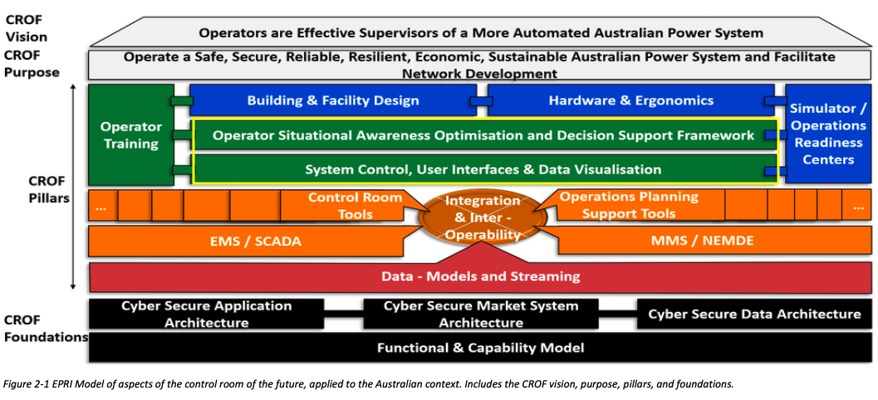
Figure 4-1 Replication of Figure 2-1 from Research Roadmap (Adrian Kelly et al., 2021, p. 13), with relevant sections for Stage 5 CROF research are highlighted in yellow.

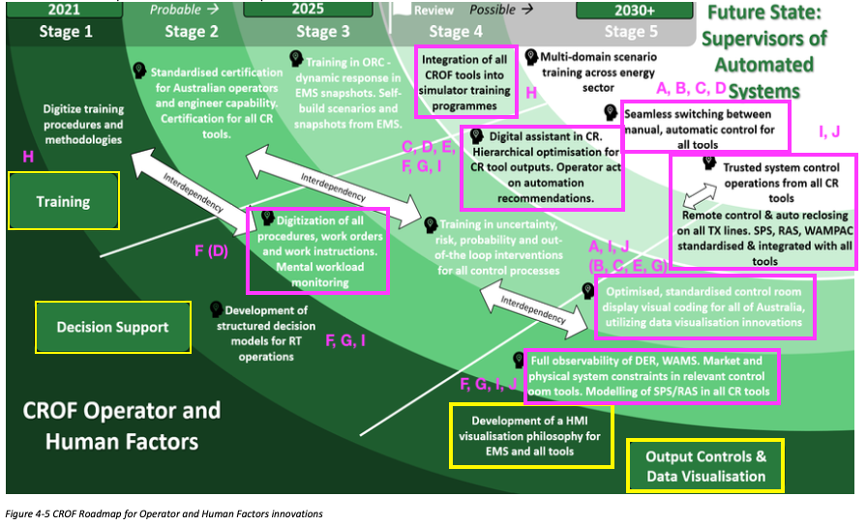
Figure 4-2: Detailed progress of the CROF Pillar Operator Training for Topic 3 after the completion of Stage 5, pink highlighted tasks reflecting Stage 5 achievements (recommendations for enhancement of CR visualisation)

Topic 4: Integrated Energy System Planning - Resource Adequacy, Risk and Resilience in Low-Carbon Energy System Planning: Methods, Tools and Metrics
As the supply side of Australian power systems becomes more weather-dependent and energy-constrained due to the growing integration of variable renewable energy (VRE) and energy-limited resources (ELR), existing resource adequacy (RA) frameworks risk becoming unfit for purpose. This is partly due to their reliance on deterministic parameters, average-focused metrics, and simplified operational representations of system components that are becoming increasingly dominant, such as energy storage systems (ESS) and distributed energy resources (DER).
Simultaneously, reliability risks are becoming increasingly concentrated in infrequent yet high-impact weather-related events, rather than in isolated component failures under normal conditions. Growing exposure to extreme weather, such as heatwaves and thunderstorms, increases the likelihood of common-mode failures, thereby requiring a fundamental transformation in the methodologies used to evaluate adequacy and resilience.
The Stage 5 Topic 4 research prepared by the University of Melbourne examines how resource adequacy, reliability risk, and system resilience should be assessed in Australia’s National Electricity Market (NEM) as it transitions to a low-carbon, renewable-dominated, system. Key challenges that were reported by the researchers are:
- The system is shifting from firm, dispatchable (thermal) generation to weather-dependent renewables (VRE) and energy-limited resources (storage, DER).
- Existing planning frameworks—based on deterministic assumptions and average metrics—are increasingly insufficient.
This research in Stage 5 of the Power System Planning topic for the Australian Research in Power Systems Transition (AR-PST) initiative was centred around five complementary tasks:
- Develop an open-source modelling and implementation framework, including models and datasets, to efficiently perform resource adequacy and resilience studies of the NEM with system operability considerations (Planning roadmap – Research project R2S1P1).
- Investigate the methodological and modelling steps for developing a time-sequential framework for resource adequacy and resilience assessments with operability considerations, addressing the complexities of temporal variation in renewable output and the management of energy storage (Planning roadmap – Research project R3S4P1).
- Propose a planning-oriented model for integrating and assessing the role of CER and DER in resource adequacy and resilience assessment frameworks (Planning roadmap – Research projects R3S4P2, R5S3P2).
- Analyse the changing reliability risk profile of the NEM across various scenarios through relevant metrics, addressing an ultra-deep penetration of VRE, energy storage and DER/CER (Planning roadmap – Research projects R3S1P1, R3S3P2).
- Determine the methodological steps, relevant drivers, and assumptions, for developing suitable scenarios to plan for resilience under deep penetration of VRE, storage and DER (Planning roadmap – Research projects R1S2P1, R3S2P1).
The first of the key outcomes of the research is the fully open-source modelling framework used for the planning assessment. This was developed as a transparent, reproducible, modelling suite (“NEM-reliability-suite”), which enables probabilistic adequacy assessment, time-sequential operational modelling, and scenario testing (weather, outages, DER, storage behaviour). The general overview, built from publicly available software is shown Figure 4-1. According to the researchers, the benefit of the open-source planning tool is that it provides a consistent, industry-relevant, platform for reliability and resilience analysis. The tool and its availability is detailed in the full Topic 4 report accessible on the CSIRO website.
The second task studies how the operation and representation of storage facilities impact resource adequacy assessments, as storage becomes increasingly widespread and a relevant contributor to system reliability. Unlike conventional firm generation, storage systems cannot contribute to resource adequacy purely by virtue of their installed capacity. Their contribution also depends on whether sufficient energy is available during critical periods, and hence whether they have been charged in advance, which depends on how they respond to different market signals, and the degree of operator foresight and risk aversion regarding future system conditions.
The assumptions behind the modelling of storage operation are therefore critical for modern power systems and an emerging risk factor for future resource adequacy studies. If storage is assumed to preserve energy for reliability events or high demand periods, it may incorrectly appear to provide substantial firming value. However, if the same resource is operated according to economic principles under limited foresight, it might begin critical operating periods with a lower-than-expected state of charge, potentially contributing less to reliability.

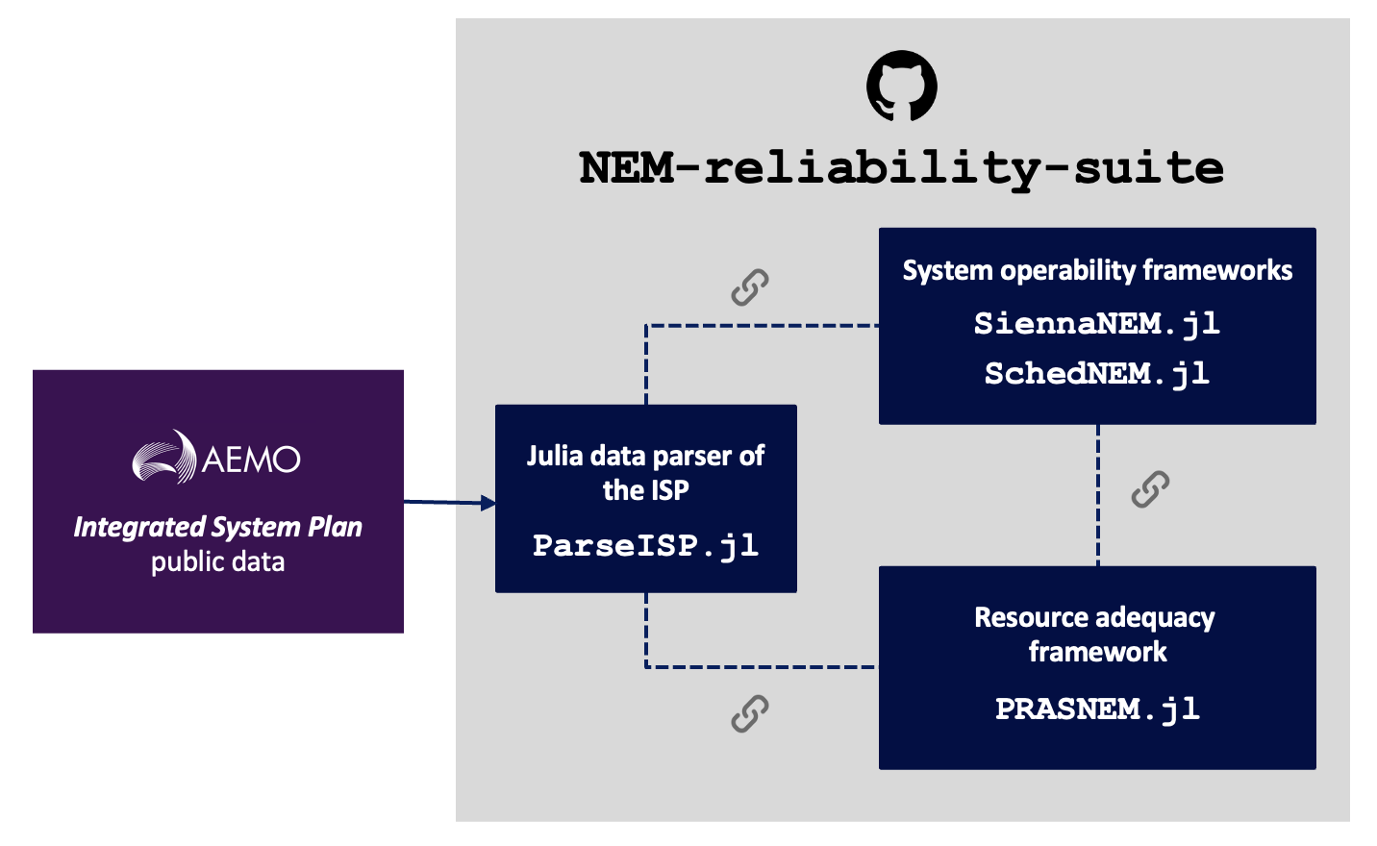
Figure 4-3: General overview of the NEM reliability suite architecture
The first key finding in this task is that storage operation assumptions become increasingly relevant as storage emerges as a dominant part of the resource mix. Before 2030, as shown in Error! Reference source not found., the differing assumptions between storage modelling approximations have a relatively limited effect on resource adequacy metrics (the expected value and the 95%-CVaR of the unserved energy, respectively). After 2030 however, as thermal capacity retires and storage systems make up a larger share of the capacity mix, such an extended range of assumptions could begin to materially affect reliability studies.
Full results are available in the Topic 4 research report. Overalland , the assessment of storage availability and treatment highlights a direct link between reliability planning assumptions and operations closer to real time. If reliability planning studies assume an adequacy-oriented storage behaviour, but market incentives lead storage to discharge earlier or later, or to maintain lower states of charge, a system dominated by storage may require more frequent operational interventions than expected at the planning stage. Conversely, if storage is expected to provide reliability support, market design, reliability obligations, capacity mechanisms, or operational tools, may be needed to align storage behaviour with resource adequacy needs.
The third task assessed how consumer energy resources (CER) and distributed energy resources (DER) could contribute to resource adequacy in a future NEM in which these assets constitute a significant share of the resource mix. This task advanced understanding of the opportunities, benefits, and risks associated with DER for resource adequacy, as well as of the modelling choices needed to realistically study their contribution. The focus is on DER with material relevance at the system-operation level, including rooftop PV, electric vehicles (EV), distributed storage aggregated through virtual power plants (VPPs), and demand-side participation.
This analysis is motivated by a central planning challenge: as the NEM transitions toward higher shares of VRE, storage, and DER, resource adequacy will increasingly depend not only on installed capacity, but also on whether flexible resources are available, visible, coordinated, and operationally aligned with system needs. DER can provide a material reliability contribution, but it depends on the type of technology, location, energy availability, consumer willingness to participate, network constraints, and the extent to which resources can be coordinated and respond during critical periods.
A key insight from the literature is that DER observability and controllability (broadly grouped as coordination) are fundamental to unlocking the value of DER for resource adequacy. Without these features, DER may contribute to only local supply or support peak load shaving, and may not necessarily respond during system scale critical periods with a suitable contribution. Furthermore, the results of the analysis show that supply-side resources alone may be insufficient to maintain resource adequacy in later planning years, particularly after 2030, as dispatchable (thermal) capacity retires, and the system becomes increasingly dependent on VRE and storage. The researchers observed strong increases in average unserved energy across the planning horizon after 2030.
The fourth task consolidates developments from previous tasks to provide a structured and transparent characterisation of the NEM’s reliability risk profile through 2040. Results show that the NEM meets the reliability standard on average (over time) in the first instance, but the reliability risk profile shows important changes in both its shape and the magnitude of events, and the underlying reliability risk becomes increasingly weather-driven.
In summary, the post-2030 NEM is likely to be characterised by weather-driven and storage-dependent reliability risks, with outcomes becoming increasingly sensitive to operational and regulatory decisions. Robust system planning, therefore, requires adequacy assessments across a range of assumptions for storage operating regimes, reliability frameworks that extend beyond assessing only peak-demand periods, and recognition that policy settings, particularly those shaping storage incentives and behaviour, can directly influence system reliability. The main actionable insights from the reliability risk profile of the NEM can be summarised as follows:
- Employ a range of plausible approximations to storage operations in adequacy assessments. No single representation of the storage operating regime captures all implications for system reliability, and comparing different operating assumptions helps identify the range of possible reliability outcomes and the required mitigation measures.
- Extend reliability assessment frameworks for determining mitigation and operational measures beyond peak-demand periods. Reliability risks could increasingly emerge during early mornings, nighttime hours, and periods of moderate demand, requiring more flexible operational triggers and potential intervention capabilities.
- Treat storage operating regimes as a policy and market design issue. Mechanisms such as capacity obligations, visibility of state-of-charge (SoC), or minimum SoC requirements, might reduce the exposure to - and materialisation of - tail risks while also improving the confidence of stakeholders in resource adequacy assessments.
The final tasks develops a structured methodology to represent external drivers of risk in resilience studies. The framework presented translates exogenous weather hazards into endogenous system parameters. The framework explicitly distinguishes between drivers (underlying hazard conditions), triggers (instantaneous outage initiators), and events (cascading consequences), enabling transparent, evidence-based design of scenarios. The full report includes a detailed resilience case study focused on an extreme heatwave scenario for the Australian east coast in 2040 using high-resolution meteorological data.
With the completion of Stage 5 of the Topic 4 investigation, the researchers report progress tracked against the objectives of the CSIRO Research Roadmap as illustrated in Table 5. Progress is reported for the Stage 5 implementation since publication of the Roadmap. The full progress map is included in the Topic 4 research report available on the CSIRO website.
Table 5: Progress of the Research Roadmap for Topic 4 after the completion of Stage 5 (highlighted tasks reflect Stage 5 achievements)
Roadmap Major Tasks | Roadmap Tasks | Progress of Research Roadmap Tasks to date | Progress
1. Long-term uncertainty | Climate change impact on individual power system components performance (R1S1P1) | TASK E: Modelling of climate change for power system planning purposes (different types of events, spatio-temporal representation, probabilities, correlation, etc.). | 20%  0%
2. Power system operation | Power System operation: Steady state modelling (R2S1P1) | TASK A: Modelling the steady-state operation of the system considering the trade-off between computational efficiency and model precision. | 40%  0%
3. Reliability and resilience | Reliability and resilience metrics (R3S1P1) | TASK D: Developing new metrics to quantify the benefits to reliability and resilience associated with the investment in new system assets | 30%  0%
3. Reliability and resilience | Impact of climate change (R3S2P1) | TASK E: Assessing the reliability and resilience of power system considering the impact of climate change and extreme weather conditions on its infrastructure/components. | 10%  0%
3. Reliability and resilience | Credible and non-credible contingencies (R3S3P2) | TASK D: Profiling power system risks under various contingencies and indistinct events for future low-carbon grid with high penetration of IBR/DERs. | 20%  0%
3. Reliability and resilience | DER/IBR response to different events (R3S4P1)(R3S4P2) | TASK B: Modelling and analysing the impact on planning from IBR (including and in particular batteries) response to credible contingencies and high impact low probability (HILP) events.  TASK C: Modelling and analysing the impact on planning from DERs and distribution network assets response to credible contingencies and high impact low probability (HILP) events | 10%  0%  20%  0%
5. Distributed Energy Systems | Distributed energy resources impact (R5S3P2) | TASK C: Modelling and analysing the contribution of DERs to system reliability (security and adequacy) and resilience. | 30%  0%

Essential system services and power system restoration
Essential system services are the technical capabilities of modern power systems that keep Australia’s electricity grid secure, stable, and reliable, while enabling the transition to a low-emissions energy future. As the National Electricity Market (NEM) and Western Australia’s South-West Interconnected System (SWIS) evolve, increasing levels of wind, solar, batteries, electric vehicles, and other consumer energy resources are changing how the power system operates. Essential system services are those that are required to ensure that this more complex grid continues to function safely and efficiently. These services are critical for maintaining system frequency, voltage, stability, and resilience, during both normal operations and major disturbances.
Besides the traditional control of system frequency (for active power balance), two of the essential system services that are emerging as apparently the most important during the energy transition are system strength and inertia. System strength refers to the ability of the power system to maintain a stable voltage waveform and support the reliable operation of generators, networks, and inverter-based resources. Strong systems provide a robust electrical environment that allows renewable energy technologies to connect and operate securely. Inertia is the stored kinetic energy in synchronous machines that automatically resists rapid changes in system frequency following disturbances such as generator outages or transmission faults. As traditional coal and gas generators retire, maintaining adequate inertia (or inertia-like behaviour) and system strength have become increasingly important and requires new and traditional solutions such as synchronous condensers, grid-forming batteries, and advanced inverter technologies.
Another critical service is system restart capability (often called black start services). These services enable sections of the grid to be re-energised following a partial or complete blackout, restoring electricity supply in a coordinated and safe manner. Together, system strength, inertia, and restart services form a strong foundation for a secure and resilient electricity grid, supporting Australia’s energy transition while maintaining reliability for consumers and industry.
Advancement of research into Essential System Services, including system restarting, has been supported by CSIRO in Stage 5 for three separate initiatives:
- Restoration and black start (Bespoke Energy)
- System restoration and black start (University of Tasmania supported by University of Wollongong and Swinburne University)
- System Services - Characterisation of Load for Essential Services (Advitech)

Topic 5-1: Restoration and black start
System wide black outs are rare events whereby a power system suffers a partial or complete collapse of system voltages at all locations in the network. Such a scenario requires the system to be restored or “black started” using self-restart capable generators that can energise the nearby network infrastructure, load, and other generators in the blacked-out region that are not capable of-black start themselves.
Australia’s rapid transition toward an inverter‑dominated power system is reshaping how black start and system restoration services must be delivered. Australia’s thermal power stations, long the cornerstone of restart capability, are anticipated to be almost completely retired by the mid-2030’s, while new grid‑forming (GFM) and grid‑following (GFL) inverter‑based resources (IBRs) are becoming the dominant form of generation in Renewable Energy Zones (REZs). Despite strong technical progress in recent years, industry confidence in IBR‑based restart remains low, driven by concerns over energy limitations, protection behaviour, and uncontrolled system dynamics during restoration.
Stage 5 of AR‑PST Topic 5 builds directly on the previous four stages, delivering a comprehensive assessment of a REZ’s ability to self‑energise, form stable islands, support existing system restoration pathways, and provide a credible black start service using GFM Battery Energy Storage System (BESS) as the primary restart asset. This stage also provides quantitative energy consumption metrics, extensive Electromagnetic transient (EMT)‑based validation of restoration strategies, an assessment of remote‑hybrid configurations, and guidance for plant standards and field test planning.
Although previous AR-PST research stages have answered many questions regarding the fundamental capabilities of IBR for restart (in particular, the use of GFM BESS), commonly cited concerns of the role of IBR include the energy-limited nature of BESS, and the unpredictability of energy generation from wind and solar sources. Hence, this stage of the work sought to answer key questions regarding the possibility of BESS to restart a network and what role a REZ can play in the process, including:
- The required state of charge for BESS to be a primary black starter.
- Whether a REZ can be self-energised, and then go on to provide a restart service for the greater grid?
- How far into the power system could an IBR-based REZ energise? And what are the limiting factors?
In addition to detailed technical analysis, the research conducted by Bespoke Energy proposed an initial IBR technical standard for black starting to support a more standardised approach to defining, assessing, and verifying, restart-capable inverter-based plant, while aligning, where appropriate, with existing and emerging restart procurement and demonstration frameworks, including AEMO initiatives relating to black start capability from inverter-based resources.
Lastly, the Bespoke Energy work focuses on bridging the gap between desktop based EMT studies and the practical, operational steps required to validate inverter based black start capability in the real power system. While earlier research activities assessed technical feasibility through modelling, the final task addresses the core challenge raised by Network Service Providers (NSPs), that being industry hesitation to be the first to expose high value assets to an unproven IBR driven restart process.
Despite strong technical results from Stages 1–5 of Topic 5, NSPs contacted and spoken with as part of this work consistently expressed that no amount of simulation alone can replace the confidence gained from carefully controlled, in-field, network energisation trials. AEMO’s subsequent release of the Type 2 Transitional Services – Black Start Capability from IBR further reinforces the national need for a validated pathway to safely test GFM BESS restart capability. This last task develops that pathway by:
- Developing a test plan template for a GFM BESS to perform deep network energisation, i.e., energising elements beyond the point of connection.
- Embedding controls, monitoring, and test procedures to ensure asset protection during testing.
- Reflecting the operational concerns and expectations of NSPs, derived from targeted discussions and stakeholder engagement.
- Providing a template that can directly support AEMO’s Type 2 service trials for IBR based restart.
In their final report, available on the CSIRO AR-PST website, the Bespoke Energy team reported key findings including:
- A single GFM BESS can self‑energise a REZ and reach the transmission network Point of Connection.
- BESS energy reserve requirements for restart are smaller than commonly assumed.
- A partially energised REZ can further energise portions of the external network, including hard-energising very large (1,500 MVA) network transformers.
- Remote‑hybrid restart (GFM plus distant GFL generators) is viable without additional coordination layers.
- Multiple IBR‑only islands can merge to form larger restart systems.
- A partially re-energised REZ operating as a restoration support service can materially improve a restoration that is primarily driven by a synchronous machine.
- REZ-led restoration is comparable with timeframes expected from traditional synchronous-based strategies.
- System restart using inverter‑based resources requires explicit, purpose‑built, technical standards.
- Providing a test plan template for a deep network restart from a GFM BESS, incorporating specific requirements on the following to minimise risk exposure.
Overall, the Stage 5 findings collectively demonstrate that:
- IBR‑based REZs that extensively use GFM BESS are technically capable of providing comprehensive system restart services.
- Energy storage requirements for BESS facilitating restart within a REZ are less than commonly assumed, while dynamic performance proved to be generally more well-regulated when compared synchronous machine-based restart.
- With appropriate planning and in-field test validation, REZ‑based black start can become a credible, scalable replacement for retiring synchronous technology.
In completing Stage 5, the researchers advised that the research Roadmap has been progressed as shown in Table 6.

Table 6: Topic 5-1 research progress against the Roadmap
Roadmap Major Tasks | Roadmap Tasks | Stage 5 Tasks | Progress
Task 1.1 | Grid Following Inverters | A wide variety of GFL-IBR devices were evaluated for stability during IBR-only based restart, including clustering effects from a REZ and highly variable input energy sources. Different terminal control algorithms were explored, and it was noted that terminal voltage control can aid in stability. | 100%  0%
Task 1.2 | Grid Forming Inverters | Explored the use of multiple GFM algorithms and synchronisation of multiple GFM-based islands. Evaluated GFM BESS capability to enhance a synchronous restart. Evaluated the ability of GFM to supplement restarting synchronous islands and found no adverse interactions should droop characteristics be present. Found that once again GFM BESS performance is strong during restart | 100%  0%
Task 2.2 | Impact on Protection Systems and assessing the needs for modifications | Generic protection relays included in all REZ studies showed behaviour consistent to previous stages and continued to show evidence that GFM-based restart options are likely to have less spurious protection tripping compared to synchronous machines. However, it is possible that the limit of offline simulation capabilities has been reached for generic protection relay evaluation, and that next stages should consider HIL setups. | 50%  0%
Task 2.3 | Assessing the need for modifications | Refinement of previous Stages’ findings only, limited by generic nature of protection models. | 50%  0%
Task 2.4 | Additional / New Task: Operational strategies for existing GFL fleet (Stage 4) | Application of previous Stage 4 findings to a REZ found that recommendations held across new IBR-only restart topology types | 85%
Task 3-1 | Power system modelling and simulation tools | Developed fully open REZ model including variety of new GFL and GFM models and protection models (via MHI Protection Library).  Developed a highly detailed, generic test plan template for GFM BESS to participate in a physical power system restart test. | 90%  %
Task 4-1 | Grid code specifications and IBR performance requirements for restoration | Recommended grid codes for IBR devices wishing to participate in system restart developed based on recent ISO experiences. | 65%  0%
Task 5-1 | Bottom-up restoration and island synchronisation | Restoration from REZ explicitly investigated, including the ability of the REZ to restart itself, and the extent of the network a REZ is likely to restore. Included investigation of energy storage requirements from GFM BESS and how input source variability can be accommodated. | 65%  0%
Task 5-2 | Restoration from distribution network and microgrids | Restoration and synchronisation of two REZ micro-islands investigated, including investigation of coordinating mechanisms required to maintain stability from variable IBR sources | 70%

Topic 5-2: System restoration and black start
Increasing penetration of inverter-based resources (IBRs) not only reduces grid inertia but also results in weaker grid conditions, potentially increasing the likelihood of blackouts. At the same time, generators which until now have typically provided black start services (large synchronous generators with on-site auxiliary power supply) are exiting the power system. To maintain power system resilience, fast and robust restoration strategies are required, utilising the capabilities of modern IBRs.
This project addressed these challenges by enhancing black-start capabilities explicitly under low-system-strength and restoration-stressed operating scenarios within Australia’s National Electricity Market (NEM). The project developed new methods and procedures, which were validated experimentally using real-world data, realistic scenarios, advanced testbeds, and Hardware-in-the-Loop (HiL) methodologies. The research focused on both existing system conditions and anticipated future scenarios within the NEM, including Integrated System Plan (ISP) scenarios in which the system is fully powered by IBRs, ensuring adequate black-start readiness in response to blackout events. The outcomes assist industry stakeholders, including AEMO, in establishing robust and adaptive procedures for system restoration following blackouts.
The main objectives of the University of Tasmania research activities included assessing the self-start capability of Renewable Energy Zones (REZs) as System Restart Ancillary Service (SRAS) sources, evaluating the dynamic behaviour of critical system elements during restoration, developing innovative solutions that address both technical and regulatory requirements, and validating these solutions using testbeds and HiL platforms, alongside EMT dynamic simulations of feasible future NEM scenarios.
Accordingly, the main research objectives and key outcomes reported by the researchers are as follows., with all results and processes describe in the full report available on the CSIRO AR-PST website:
1 – Determine the possibility for REZs to serve as future SRAS sources
- The study found that voltage-ramp control using the GFM voltage controller is the most suitable method for GFM plant transformer energisation during black-start and restoration scenarios.
- Active damping and virtual impedance may be required to support reliable coordination between multiple GFMs, particularly when several inverter-based sources operate together in an islanded restoration network.
- GFM-PV operation requires power-curtailment control to balance AC-side and DC-side power, and EMT-based analysis is important for capturing multi-GFM transient interactions that may not be visible in RMS-type studies.
2 – Investigate the feasibility of hybrid GFM BESS and IBRs as SRAS sources under weak grid conditions
- The study showed that GFM-BESS dynamic performance is strongly affected by the short-circuit ratio (SCR) and X/R ratio of the network.
- Grid connection in stronger or higher-X/R network conditions can produce larger current and frequency transients, and more prolonged oscillations, while large load pickup and island interconnection under low-SCR conditions can be more vulnerable because the GFM source must supply a larger share of the transient and inrush current.
- These findings highlight the need for careful restoration sequencing, current-limit coordination, and DC-link control design when hybrid GFM BESS and IBRs are used as SRAS sources.
3 – Evaluate the Impact of Distributed Energy Resources (DERs) on the Black Start Process
- For the studied 75 MVA GFM-supported island, stable operation was maintained under the applied 75 MW load-disturbance scenario at DER levels up to 40 MW.
- Increasing DER penetration to 60 MW, approximately 80% of the local GFM rating, eroded the stability margin and led to voltage distortion and GFL PLL loss of synchronisation.
- HiL validation showed that advanced GFL DER control can significantly improve transient stability, allowing up to 90% penetration under strong-grid conditions (SCR = 10), while the corresponding stability boundary reduced to 70% under low-system-strength conditions (SCR = 1).
4 – Assess Technical Requirements for Inverter-Based Black Start Solutions to Inform System Restart Standards
- The review identified broad international alignment around key inverter-based restoration functions, including dead-bus energisation, inrush-current management, autonomous islanded operation, dynamic power sharing, and multi-GFM synchronisation.
- The review also identified major gaps, including the absence of a unified definition of GFM capability, fragmented treatment of black-start and self-start capability, and lack of standardised performance metrics.
- Additional gaps were identified in behavioural standardisation, interoperability and multi-vendor coordination, testing and validation frameworks, and integration between technical standards and market arrangements.
5 – Evaluate GFM and GFL Inverter Performance During System Restoration
- The EMT simulations demonstrated that a single GFM anchor could maintain stable operation for a multi-inverter restoration island up to an approximate GFM-to-GFL capacity ratio of 1:11.
- Instability emerged as the GFM-to-GFL capacity ratio approached 1:12, mainly due to reduced effective system strength and GFL PLL loss of synchronisation.
- The study showed that stable sequential load pickup, GFL integration, and island-to-grid resynchronisation are achievable when restoration actions are carefully coordinated.
6 – Assess Advanced Control, Protection, and AI-Driven Tools for Black Start and System Restoration
- The proposed PSO-FSMC method significantly improved cascaded voltage and current control performance of GFM inverters during off-grid to grid-tied transitions, which are critical during restoration-related reconnection.
- Compared with droop-PI and VSM-PI benchmarks, the proposed controller reduced transient deviations, improved damping, and expanded the stable operating range of GFM inverters.
- The proposed controller maintained improved performance under weak, strong, ultra-strong, and low-damping grid conditions, demonstrating its potential to support robust black-start and system-restoration operation.
In completing Stage 5, the researchers advised that the research Roadmap has been progressed as shown in Table 7. Note that these were based on the researchers own work and have not been combined with outcomes of Topic 5-1 on the same subject matter.

Table 7: Topic 5-2 research progress against the Roadmap
Roadmap Major Tasks | Roadmap Tasks | Stage 4 Tasks | Progress
Task 1.1 | Grid Following Inverters | Evaluated GFL/DER behaviour during restoration, including DER penetration limits, PLL loss-of-synchronisation mechanisms, GFM–GFL interaction, and the maximum stable GFM ratio during sequential restoration. | 55%  0%
Task 1.2 | Grid Forming Inverters | Assessed GFM-BESS capability for transformer and network energisation, multi-GFM coordination, GFM–PV operation, hybrid GFM BESS with realistic DC-link dynamics, and advanced GFM voltage/current control for restoration-related reconnection. | 35%  0%
Task 1.3 | Impact of DER | Extended DER studies by quantifying stability boundaries under different DER penetration levels and local system-strength conditions. The work showed that high DER penetration can reduce the transient stability margin and trigger GFL PLL loss of synchronisation during major disturbances. | 80%
Task 2.2 and Task 2.3 | Impact on Protection Systems and assessing the needs for modifications | Made indirect progress by identifying restoration conditions that may lead to inverter current limits, overcurrent trips, inrush-related stress, and severe synchronisation transients. However, detailed relay-level HiL testing remains a future research need. | 45%  0%
Task 3 | Tools and techniques (expanded in Stage 5) | Advanced the use of EMT simulation and HiL validation for restoration studies, including component-level GFM-BESS testing, DER/GFL stability-envelope assessment, and GFM/GFL restoration-island studies. These activities support the roadmap need for validated modelling and simulation tools. | 35%  0%
Task 4 | Technical and regulatory requirements | Developed a structured review of emerging Australian and international requirements for IBR-based black start, including dead-bus energisation, inrush-current management, autonomous islanded stability, dynamic response, power sharing, and multi-GFM synchronisation. The work also identified gaps in GFM definitions, performance metrics, behavioural standardisation, interoperability, testing, and market integration. | 80%
Task 5 | End-to-end restoration in systems with high IBR share (expanded in Stage 5) | Developed representative restoration studies including REZ-based SRAS assessment, staged transformer and transmission-line energisation, sequential GFL integration, load pickup, island interconnection, and island-to-grid resynchronisation. Full NEM-scale restoration and operational decision-support integration remain future work. | 30%  0%

Topic 6-2: System Services - Characterisation of Load for Essential Services
In Stage 5 of Topic 6-2 Advitech has investigated the possibility for existing mid-sized industrial companies in the Hunter Valley region of NSW to provide system services into the National Electricity Market (NEM), to identify the barriers that constrain this potential, and to define the implementation pathways through which it could be realised.
The provision of services that help maintain critical operating parameters, including voltage stability, frequency regulation, and overall power quality, is fundamental to the reliable operation of any electricity network. Historically, these services have been delivered by centralised thermal generators such as coal-fired power plants. As Australia's power system shifts toward a distributed architecture, with large-scale renewable generation displacing synchronous plant, the question of how system services will be maintained is one of the central engineering challenges. Industrial loads, given their scale and geographic distribution, represent a significant and largely untapped resource for meeting this challenge.
Due to limited understanding however, industrial demand-side participation has remained a minor fraction of the assets and services under active management in the NEM. A persistent gap exists between the benefits that have been anticipated from demand-side management and what has been commercially realised. Closing this gap requires a clearer understanding of the commercial, organisational, and operational barriers that prevent access to that capability in addition to the technical capabilities of industrial loads.
This project addresses that need directly by delivering:
- A first-of-kind characterisation of industrial load flexibility among mid-sized companies in a representative Australian regional economy;
- A structured taxonomy of industrial load types and their inherent demand response suitability;
- A systematic assessment of the barriers and capability factors that determine a site's practical capacity to participate in Demand Response (DR) programs;
- A set of findings and recommendations intended to inform power system planners, market operators, regulators, and future researchers; and
- Publicly available information that can directly support ongoing industry and regulatory discussions about the future structure and operation of the NEM.
Central to Topic 6-2 research is the recognition that a business’ capacity to participate in DR is not determined by a single factor, but by the interplay between conditions that constrain participation and conditions that enable it. The study therefore adopts a dual-axis analytical framework, distinguishing between barriers: factors that reduce the likelihood or feasibility of DR participation, and capabilities: factors which reflect characteristics that enhance a site's practical ability to respond. Critically, these two sets of factors are not independent: removing a barrier can unlock a latent capability, and building a capability can neutralise a barrier. A company lacking in-house energy expertise, for example, faces both an educational barrier and a data deficiency; addressing the former through targeted support can directly improve the latter, creating a compounding improvement in DR readiness.
Six (6) barrier and five (5) capability factors were identified through the stakeholder engagement process and structured into a weighted scoring framework applied consistently across 22 participating companies. The barriers, ranging from continuous process constraints, which received the highest (negative) weighting, through to labour cost considerations, reflect conditions that are largely structural and may require targeted intervention to address. The capability factors, led by existing DR participation and dynamic operational flexibility, reflect conditions that are more immediately actionable and that signal a company's proximity to active participation. In addition to these binary assessments, the framework incorporates a graduated score for a company's minimum required notice period prior to a curtailment event, acknowledging that response speed is as operationally significant as response availability.
Figure 5-1 presents this conceptual framework schematically. The framework is described in full, with the weighting rationale of its application across the participant cohort in the full research report, available on the CSIRO AR-PST website.

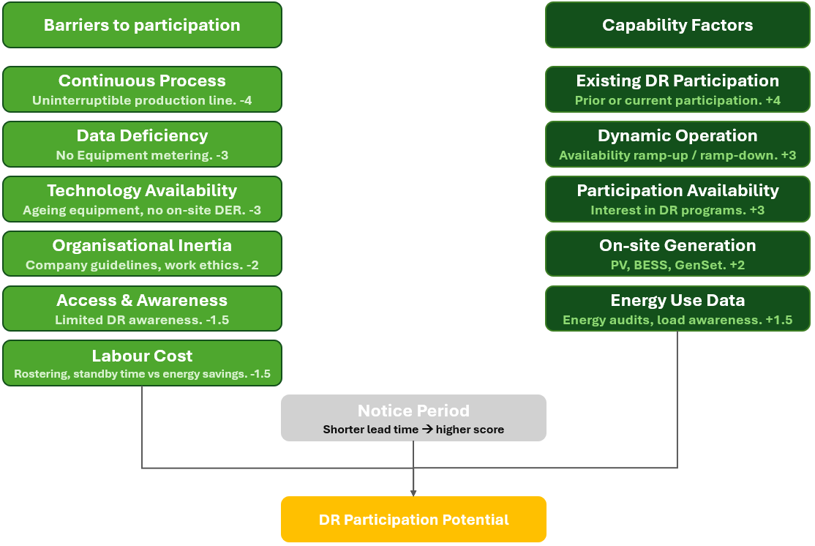
Figure 5-1: Barriers and Capability Factors for Industrial Demand Response Participation

In Figure 5-1, the left column identifies the six (6) barriers assessed for each participating company, each associated with a negative weighting, reflecting its materiality as a constraint. The right column identifies the five (5) capability factors; each associated with a positive weighting. The notice period assessment, in the centre, provides a graduated score based on the minimum lead time a company requires before a demand response event can be initiated. These three inputs are combined into a composite raw score, which is subsequently normalised to produce a relative index of DR participation potential across the cohort. The scoring weights are not arbitrary: they reflect considered judgements about the relative significance of each factor to actual DR outcomes, informed by the engagement process and validated against participant responses.
On completion of Stage 5, the researchers identified progress against the tasks of the updated research roadmap for Topic 6 is as shown in Table 8.

Table 8: Topic 6-1 research progress against the Roadmap
Roadmap Major Tasks | Roadmap Tasks | Stage 4 Tasks | Progress
N/A | Load Flexibility and Characterisation | Directly addressed through the engagement of industrial stakeholders and developed a taxonomy across the industrial participants. | 85%
N/A | Industrial taxonomy of load and service classification | Taxonomy of 53 load types across 9 categories developed; operational characteristics and flexibility potential rated for each. | 80%
N/A | Barriers to demand-side participation | Development of a scoring framework for barriers and capabilities and applied across the full participant cohort. | 100%
N/A | Quantification of Industrial demand-response capacity | The level of DR potential from each participant was assessed via normalised scoring, and the aggregated capacity characterised by sector and load type. | 75%
N/A | Incentives and implementation | Identified through stakeholders’ engagement; forms the basis for the recommended future research work. | 50%  0%

Consumer Energy Resources & Electric Vehicle Integration
Consumer Energy Resources (CER) and Electric Vehicles (EVs) are becoming increasingly important to Australia’s energy transition, energy security, and decarbonisation efforts. CER includes rooftop solar, home batteries, smart appliances, and EVs that generate, store, or manage electricity at the consumer level. Australia already has one of the highest rates of rooftop solar adoption in the world, with more than 4.4 million system installed as of mid-2026 contributing directly to electricity generation. This shift is transforming consumers from passive energy users into active participants in the energy system.
The importance of CER lies in its ability to reduce electricity costs, improve grid resilience, and support the integration of renewable energy. By generating and storing energy locally, households and businesses can reduce reliance on centralised power stations and expensive network upgrades. Smart management of distributed resources can also help balance supply and demand, and improve reliability while lowering emissions.
Electric vehicles play a dual role in this transition. Beyond reducing transport emissions and dependence on imported fuels, EVs represent a significant and rapidly growing energy storage resource. Australia’s EV fleet has expanded quickly and, when equipped with bidirectional charging technologies, can provide electricity back to homes or the grid through Vehicle-to-Grid (V2G) services. This capability can help manage peak demand, support renewable energy integration, and defer costly network investments.
Together, CER and EVs are helping create a more decentralised, flexible, and resilient energy system. As Australia continues to electrify transport and increase renewable generation, these technologies will be essential for delivering affordable, secure, and sustainable energy while supporting national emissions reduction targets and long-term economic growth.
To support this consumer led aspect of our energy transition, CSIRO supported three projects that were targeting CER integration:
- The intersection of Dynamic Operating Envelopes (DOE) and Vehicle-to-Grid (V2G) technology (Elentar and Australian National University)
- CER and stability (University of NSW)
- Securing DER stability via Trusted Sovereign Monitor (TSM) (Edith Cowan University)

Topic 8: ​The intersection of Dynamic Operating Envelopes and Vehicle-to-Grid Technology
V2G, or Vehicle-to-Grid, is a CER technology that allows electric vehicles (EVs) to send energy back to the electricity grid. The concept of V2G has been discussed in Australia for years, and by 2026, it is becoming real, with pilot programs running in the ACT, SA, and Queensland and regulatory frameworks being established. Concurrently, the market for bidirectional EV chargers is beginning to take shape, with several brands announcing products either already available to order, in use through exemptions, or confirmed for release this year. However, most bidirectional chargers are still undergoing review, and many remain in trial or R&D stages.
For Topic 8 the researchers investigated the integration of V2G technology into our grids and how this technology will impact dynamic operating envelopes (DOEs) used by network operators as a constraint management mechanism to allocate time varying exports and import limits to CER. Elentar and ANU’s work was delivered through a multi-methods project with three integrated work packages
- Evidence collection via literature review and industry engagements, the latter including four stakeholder workshops (~80 participants) and twelve industry interviews;
- Technical modelling using Cadium, a purpose-built scenario tool; and
- Synthesis, integrating the findings from the previous two work packages.
The final research report notes that DOEs that manage exports are broadly compatible with V2G. Modelling confirms that daytime DOE constraints, driven by solar export, leave sufficient evening headroom for V2G export, with only minor impact on V2G discharge behaviour (8.4% overlap of high price intervals and DOE limitations in model example). In interviews, stakeholders voiced concerns about aspects of export DOEs such as the relatively low 10 kW fixed maximum inverter capacity limits imposed by some networks, which challenged the installation of a V2G charger with an existing solar system or battery. DOEs that manage import of energy (loads) are far more uncertain. Stakeholders also communicated that managing load with import DOEs was different to managing generation with export DOEs, with an implication that a different assessment and allocation framework was needed for import operations.
Technical modelling by Elentar shows that import DOEs can remove peak demand impacts through EV charging and V2G activity. This in turn could limit pressure on electricity supply and with it limit related issues. However, without clear evidence of householder acceptance, allocation frameworks, regulatory structures, and impact measurement approaches, it is unclear that this of reduction in demand will be possible in practice. This challenge is exacerbated by a lack of clear value propositions for householders that would convince them to engage with import restrictions. For generation the enticement of a usually larger export limit creates value in export DOEs. From the householder’s perspective, import DOEs do not offer additional network capacity like export DOEs do, instead they offer a potential impost on householder’s daily lives.
ANU’s research showed a consistent theme emerging from their stakeholder interviews in that consumer interest appears to lean more strongly toward Vehicle-to-Home (V2H) functionality than full V2G participation. Coupled with the relatively large power capacity of V2G chargers, peak demand events may shift to around the boundaries of lower price energy periods.
To advance how fairness and impacts of DOEs on EV users should be considered, the researchers applied Nussbaum and Sen's Capability Approach (Nussbaum, 2011; Sen, 1999). This approach provides a framework for evaluating DOE impacts on EV and energy users. Where standard DOE equity frameworks are focused on allocation of energy and ask how much capacity each connection receives, the capability framework applied by the project asks whether the allocation provided enables people to do what they have reason to value, including being mobile, caring for dependents, and managing their household. Notably there are many framework approaches, differing in means of inclusion of social licences as well as efficiency. The approach taken here is one particular application.
Lastly, the idea of a 'charge now' scenario — an EV user with an urgent need to use their car— was explored to better understand capability (end user outcomes). ‘Charge now’ modelling identified that DOE limits set to avoid peak demand increases from EV charging could render user’s ‘charge now’ buttons ineffective at the times they are most likely to need to use them. However, if peak demand limits were raised by even a relatively modest amount, the ‘charge now’ performance recovered to a level close to that expected from unconstrained operation. This provides initial insights toward an fairness framework for import DOEs.
Full assessment processes and findings are detailed in the researchers’ report available on the CSIRO Stage 5 website, include accessibility to the Cadmium open-source software. In summary though, the researchers identified seven key barriers to uptake and integration of V2G into the Australian electricity network, described below.

Barrier 1 | No load-side equivalent of the export DOE approach. Key gaps: no allocation methodology, visibility mechanism, or settled definition of what a dynamic import envelope regulates.
Barrier 2 | No assessment framework for load-side (import) DOEs. Existing metrics measure unserved energy; they cannot capture when end users cannot be ‘flexible’ with energy use or when a DOE impost becomes unacceptable.
Barrier 3 | There is an export DOE value proposition that does not transfer to import DOEs. Compliance with import DOEs requires active device optimisation and a customer incentive that does not yet exist.
Barrier 4 | Distribution network service providers lack confidence that customers might accept anything beyond equal allocation, limiting more efficient approaches being tested, despite their recognised technical benefits.
Barrier 5 | DOE–V2G approaches are poorly equipped for high-impact, low-frequency events that reshape mobility needs unpredictably, including emergencies, weather events, and community disruptions.
Barrier 6 | Customer acceptance of import (load) envelopes is largely untested and will be conditional; constraints on mobility-critical assets carry higher welfare stakes than export curtailment.
Barrier 7 | Practical information limits related to energy use mean DOEs cannot distinguish discretionary from essential use: DNSPs cannot see device state, urgency, or mobility context.

Progress made against the AR-PST Roadmap has been described by the researchers as shown in Table 8.
Table 8: Topic 8 progress made during Stage 5 against the tasks of the AR-PST Roadmap
Roadmap Major Tasks | Roadmap Tasks | Stage 5 Tasks | Progress
RQ0.1 | What data flows (DER specifications, measurements, forecasts, etc.) are needed to ensure AEMO has enough visibility of DER/net demand to adequately operate a DER-rich system in different time scales (mins to hours)? | This project modelled V2G operation within the DOE framework and assessed its visibility to DNSPs and AEMO, including the similarities to and differences from stationary storage. | 80%
RQ1.1 | For each of the potential technical frameworks for orchestrating DERs in Australia (e.g., based on the OpEN Project), what is the most cost-effective DER control approach to deal with the expected technological diversity and ubiquity of DERs? | Investigate expectations of intermediaries for V2G exports and the assumptions applied by DNSPs for V2G user behaviour | 70%
RQ1.2 | For each DER control approach, what is the most adequate decision-making algorithm (solution method)? | The project's modelling formulated site control as an economic optimisation, which lets behaviours emerge from price and cost factors rather than being enumerated in advance. | 15%  0%
RQ1.3 | What is the role of DER standards in concert with the future orchestration of DERs? | Standards are central to this project, which examines the application of V2G within CSIP-AUS and provides explicit recommendations to ensure V2G alignment and benefit; it also considers AS/NZS 4777.2 and DNSP connection standards. | 75%
RQ2.1 | For each of the potential technical frameworks for orchestrating DERs and the corresponding decision-making algorithms, what is the most cost-effective communication and control infrastructure? | The project surveyed current V2G offerings from energy retailers and hardware/software providers, characterising their maturity, expected improvements and key adoption challenges. | 55%
RQ4.1 | What are the minimum requirements for a DER-rich distribution network equivalent model to be adequate for its use in system planning studies? | The project considered how DOEs and hosting capacity feed into network planning, and the particular characteristics V2G introduces relative to stationary BESS due to its primary mobility requirement. | 80%
RQ5.1 | What are the necessary organisational and regulatory changes to enable the provisioning of ancillary services from DERs? | The project investigated whether ancillary services are a core consideration for current V2G products. | 70%
RQ5.2 | What are the necessary considerations of establishing a distribution-level market (for energy and services)? | The research investigates through stakeholder views on the need for and value of distribution-level markets for energy and services. | 35%  0%

Topic 9-1: CER and stability
With a continuing growth in Inverter Based Resources (IBRs) distribution networks are becoming more dynamic, and more closely coupled to the stability, behaviour and characteristics of the transmission system. The growth of consumer energy resources (CERs), initially with solar photovoltaic (PV) systems and - more recently - with residential battery energy storage systems (BESS), is changing how distribution networks respond to disturbances. At the same time, declining synchronous generation which results in lower system strength, and increasing inverter-based demand, mean that CERs can no longer be treated as passive, small-scale devices and instead are actively interacting with the whole network. Motivated by the concerns about operational limits of CERs in evolving network conditions, Stage 5 of Topic 9 investigates the responses of CER with new laboratory testing under disturbances, especially considering weak-grid conditions.
UNSW’s Topic 9-1 research has advanced beyond the original Roadmap objectives, uncovering key insights and addressing emerging gaps along the way. Its findings from previous stages lay a strong foundation for future grid planning, the evolution of equipment standards, and the development of operational strategies, supporting a reliable and resilient power system as the sector moves confidently toward a distributed, renewable energy future. In this vein, Stage 5 delivers systematic experimental evidence of CER (consumer energy resources) behaviour under weak-grid conditions, extending prior stages focused on strong-grid assumptions. The Stage 5 research provides a high-fidelity laboratory test derived dataset covering:
- Point-on-wave disturbance response,
- Weak-grid oscillatory behaviour,
- Reconnection dynamics, and
- Single-phase grid-forming (GFM) feasibility.
To examine these operation conditions, comprehensive laboratory testing were conducted by UNSW using multiple inverters under varying network strengths, impedance characteristics, operating conditions, and control configurations. The laboratory setup was configured to emulate weak-grid conditions by adjusting the effective grid impedance and operating point of the grid emulator. Stage 5 saw fourteen different inverter devices tested to represent a broad group of NEM installed
For each test condition, the voltage and current waveforms, including grid current harmonics, grid voltage harmonics, and oscillation characteristics, are recorded. The measurements can be used to determine correlations between SCR level, inverter configuration, impedance characteristics, control firmware, and stability margins. This structured testing approach enables identification of inverter-specific interactions and control mechanisms, such as Volt-VAr and Volt-Watt control responses, which may contribute to harmonic amplification and low-frequency oscillatory behaviour in weak-grid environments.
Full results, including measurement waveforms including harmonic spectra, as well as data analysis, are found in the research report of Topic 9-1 available on the CSIRO website. The key findings drawn from the laboratory tests and analysis for each of the four areas include:
- Point-on-Wave (PoW) Disturbances:
- CER inverter response is sensitive to the instant within the voltage waveform that a disturbance occurs.
- Different inverters exhibited markedly different PoW sensitivities.
- Large voltage phase angle jumps (VPAJs) increase the likelihood of curtailment or disconnection for CER.
- PoW testing identifies overlooked behaviours that are also difficult to infer from standard tests.
- PoW sensitivity has implications for weak-grid operation.
- Weak-Grid Behaviour
- Low-frequency oscillations were observed under weak-grid conditions.
- Operating power quantity affects stability margins.
- SCR strongly affects inverter stability and oscillatory behaviour.
- Network impedance characteristics affect inverter response.
- Volt-VAr and Volt-Watt functions can contribute to oscillatory behaviour.
- Inverter behaviour varies significantly by manufacturer, firmware, control design, and the standards followed.
- Good compliance under strong-grid conditions does not guarantee acceptable weak-grid performance.
- Reconnection Behaviour
- Reconnection behaviour varies across inverters.
- Weak-grid conditions can affect reconnection quality.
- Frequency-dependent reconnection behaviour remains important.
- Reconnection may interact with weak-grid oscillatory behaviour.
- Aggregate reconnection behaviour may present system-level risks.
- Single-Phase Grid-Forming (GFM) behaviour
- Single-phase GFM control is not a direct simplification of three-phase GFM control.
- Distribution-network impedance characteristics strongly affect single-phase GFM behaviour.
- Quadrature signal generation introduces additional dynamics.
- Current limiting is a critical design constraint.
- Droop and VSG-based implementations can provide grid-support functions, but with different dynamic trade-offs.
- Single-phase GFM has potential to support weak distribution networks, but deployment value depends on tuning, current limiting, protection coordination, and interaction with nearby GFL devices.
Key implications of the four areas researched by UNSW are:
- GFM at CER scale is promising but not deployment-ready without further validation.
- Weak-grid performance must be assessed as a multi-parameter interaction problem, not a single threshold.
- Reconnection must be integrated into system recovery and stability assessments, especially for high CER penetration.
- Disturbance testing frameworks must include time-domain variability, not just magnitude-based criteria.
When considered together, results from Stage 5 shift the evaluation question, from whether individual CER devices can meet individual requirements related to disturbance tests, to where their acceptable operating regions lie - and how this region may overlap with network conditions. The inverters examined during Stage 5 represent technologies with significant deployment in the Australian market and hence may have significant implications on grid operation.
The work supports future assessment frameworks that combine weak-grid test envelopes, stability maps, impedance or frequency-domain characterisation, reconnection behaviour, and multi-inverter validation. The results indicate that compliance with AS/NZS 4777 does not necessarily demonstrate stable operation across the full range of operating conditions in high-DER distribution networks. It also reinforces the value of high-resolution laboratory datasets for model validation, standards development, and operational guidance.
Following the completion of Stage 5, Topic 9-1 researchers note that they have progressed the original Research Roadmap as shown in Table 11.
Table 11: Topic 9-1 research progress made against the Roadmap in Stage 5
Roadmap Major Tasks | Topic 9-1 Research Roadmap Tasks for Stage 5 | Progress
Point-on-Wave disturbance characterisation | Advanced the roadmap by showing that inverter disturbance response depends on the point within the voltage waveform at which the event occurs. This provides a more realistic basis for understanding CER vulnerability to phase-angle disturbances and highlights limitations in tests that apply disturbances only at nominal or zero-crossing conditions. | 100%  0%
Weak-grid performance and oscillatory behaviour | A major contribution of Stage 5 was the systematic assessment of CER inverters under reduced SCR, different impedance characteristics, varying power levels, and different grid-support function settings. The work identified low-frequency oscillatory behaviour and showed that inverter stability depends on the combined influence of SCR, X/R ratio, operating point, and control settings. | 100%  0%
Reconnection under weak-grid conditions | Stage 5 expanded the roadmap by examining how inverters reconnect under strong and weak-grid conditions, including cases involving frequency variation. This work links inverter compliance behaviour with post-disturbance recovery and system restoration concerns, especially where many CER devices may reconnect within a short period. | 100%  0%
Single-phase GFM control for distribution networks | Stage 5 provided an important foundation for assessing whether single-phase CER can provide grid-forming support. The work clarified that single-phase GFM requires dedicated treatment because of power oscillations, quadrature signal generation, current-limiting constraints, and stronger coupling between control and feeder impedance. | 100%  0%
Standards and future testing requirements | The Stage 5 findings provide empirical support for extending testing frameworks beyond strong-grid assumptions. They point toward the need for weak-grid test envelopes, practical SCR and R/X guidance, assessment of grid-support function interactions, and more representative disturbance tests that reflect the conditions expected in high-CER distribution networks. | 100%  0%

Topic 9-2: Securing DER Stability via Trusted Sovereign Monitor (TSM)
The uptake of CER over the past decade has been almost exponential. At the end of 2025 AEMO estimated that the NEM has approximately 28.3 GW of installed rooftop solar capacity, making up for around 25% of total generation capacity and consistently outproducing thermal generation during daytime hours. Although this is a renewable uptake success story, this also creates a growing need to secure Australia’s energy infrastructure as the power system becomes increasingly dependent on renewable and distributed energy resources (DER). A central concern is the cybersecurity and sovereign control implications of this transition, concerns that will grow further with the uptake of more rooftop solar, and increasingly home batteries and electric vehicles.
The particular focus of Edith Cowan University’s Topic 9-2 research is on electric vehicle charging infrastructure (EVCI), as these are high-power assets with multiple digital connections and the possibility to cause physical disruption and affect the stability of Australia’s electricity grid. A key issue examined by the researchers in this work is Australia’s reliance on third parties and foreign nations in the operation of its evolving power system with the objective of developing a Trusted Sovereign Monitor (TSM) architecture for EVCI.
Most consumer-owned energy resources, including EV chargers, are not made in Australia. They are supplied, and in some cases partly operated or controlled, by original equipment manufacturers (OEMs) located overseas, predominantly in China and the Europe. In a power grid projected to exceed 80 per cent DER penetration by 2030, this dependency has direct implications for national security, operational resilience, and Australia’s ability to maintain effective control of critical infrastructure without the cooperation of other nation-states.
Guided by an overarching scientific exploratory methodology, the project is structured into four interrelated phases:
- Phase 1- EVSE Threat Modelling
The first project phase established the analytical foundation of the overall methodology by conducting a structured, domain-driven threat modelling and risk assessment of Electric Vehicle Supply Equipment (EVSE) as a cyber–physical DER. The modelling approach is illustrated in Figure 6-1.
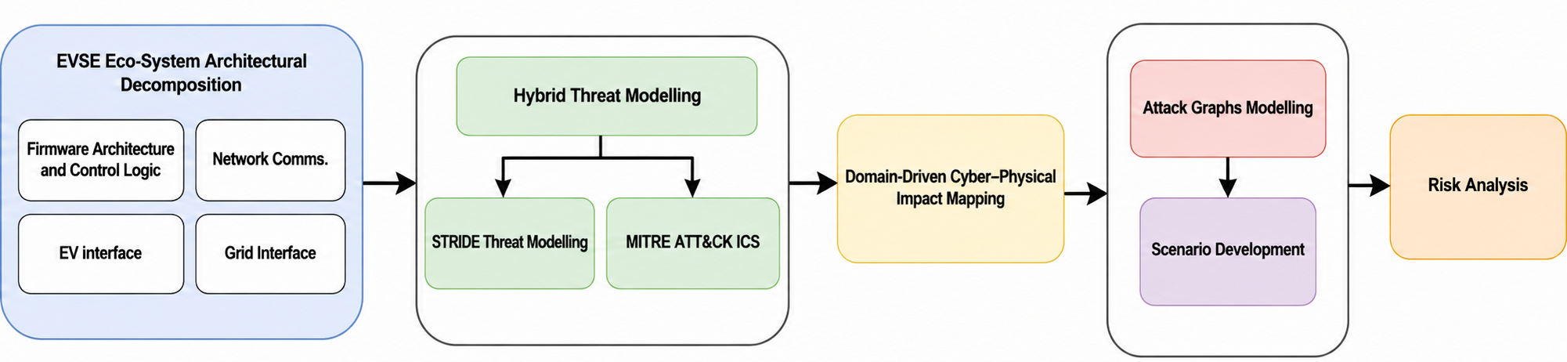
Figure 6-1: Threat Modelling Approach
- Phase 2- TSM Reference Architecture Design
Following the completion of structured threat modelling and vulnerability–risk analysis, the project transitioned from risk identification to risk containment through architectural enforcement. To rigorously evaluate the cyber–physical stability implications of EVSE firmware compromise, a high-fidelity co-simulation environment was developed using a HELICS-based federation architecture.
- Phase 3- Cyber–Physical Co-Simulation Platform Development
The third project phase developed the methodological framework used to implement, integrate, and evaluate the TSM within the EVSE–grid co-simulation environment. The methodology formalizes the TSM security model, enforcement algorithms, operational state supervision, and controlled adversarial evaluation strategy. The objective is to demonstrate deterministic security enforcement without degrading operational stability.
- Phase 4- Policy recommendations and dissemination
The final phase of the project extends the technical and experimental findings toward policy implementation and sector-wide adoption. Building on the architectural validation and enforcement assessment conducted earlier, this stage aims to develop a practical roadmap for integrating TSM-enabled DER devices into Australia’s energy system.
The four project phases are designed to move from analytical modelling to empirical validation, ensuring that architectural design decisions are grounded in measurable grid stability behaviour rather than theoretical cybersecurity assumptions.
Full details of the methodology, analysis and results found in the Topic 9-2 report are available on the CSIRO website. The research of Topic 9-2 confirms that electric vehicle charging infrastructure presents a significant cyber risk to Australia’s future energy system. The project identified and assessed a range of threats affecting EVCI in Australia and internationally. These threats were systematically analysed using established cybersecurity methods and publicly available material. The work shows that vulnerabilities in these devices and their associated digital ecosystems can be exploited in ways that may lead to disruption at both the device and grid scale.
The project also established a capability to simulate the behaviour of compromised DER devices and assess the impact on the power grid. A co-simulation environment was designed and developed to study cyber-attacks against DER devices and observe their operational consequences. This provides a practical platform for testing attack scenarios, assessing mitigation approaches, and evaluating security interventions in a controlled environment.
Taken together, these findings show that the Trusted Sovereign Monitor solution provides a viable pathway to address a growing security and sovereignty gap in Australia’s future electricity system. The work points to two practical next steps: the development of a standard that supports verifiable integration by OEMs, and the establishment of a national authority responsible for core security functions for DER devices with potential critical impact on grid stability.
AR-PST Topic 9 (DER and Stability) has made significant progress in advancing dynamic modelling, inverter behaviour analysis, and weak-grid performance assessment, thereby strengthening the physical stability foundations of Australia’s high-DER transition. However, as DER ecosystems become increasingly digitalised, cybersecurity must be recognised not simply as an information technology issue, but as a material driver of dynamic system stability. The research completed in Topic 9-2 was not previously a specific objective of the RoadMap, but has expanded and recognised new requirements for the CER integration area of research. As such there is no specific progress made against previously registered tasks of the Roadmap, but rather a new tasks added that:
- systematically integrates advanced threat modelling, cyber-physical security analysis, and resilience within stability assessment and planning frameworks, discussed in the following subsections.
Subsequent stages of the AR-PST can build on this cybersecurity assessment of CER, and future updates to the Roadmap will include this important aspect of CER integration.

Accelerating the decarbonisation of our electricity system
CSIRO’s initiation of the Australian AR-PST (formally G-PST) Research Roadmap began in 2021. CSIRO had a focus on decarbonising the energy sector in Australia while also focusing on ensuring system security, reliability, and affordability. Working with AEMO and leading Australian and international engineering, scientific, and research institutions, the Roadmap was published in 2022 as Stage 1 of the AR-PST. It was developed as a long-term investment to contribute to power system transformation for the energy transition.
“Our energy mission is for Australia to lead the world in the development of technologies and knowledge creation that drive low-cost electrification and decarbonisation of our major industries and exports in a competitive low-carbon global economy.”
— CSIRO Energy, 2026
Stage 2 of the Roadmap commenced in May 2022 and was the first stage of research. This stage had a focus on the high priorities identified at the time, especially in areas of power system planning and operation, the integration of DER, and new energy technologies.
Stages 3 and 4 of the Roadmap built on research in Stage 2, with shifting priorities where appropriate based on the energy transition and technologies.
This Stage 5 report outlines the key research that has been done over the past year. This stage has a focus on practical implementation and pilot projects where appropriate. For some topics this research builds on the last three years of research to finalise key research activities.
Stage 5 also sought to identify new high priority areas that may not have been relevant when the Roadmap was initiated in 2021 and adapting the Roadmap and future research to suit the needs of the energy system and technologies of the present and future.

Research Highlights
There has been major progress made in Stage 5 of the AR-PST over the past twelve months and some notable break throughs in all of the research projects being undertaken. Stage 5 introduced a stronger focus on implementation and pilot projects, with a key objective of delivering tools and outcomes that can be applied to the Australian energy system now. Highlighted below (Figure 7-1) are some key achievements that reflect the importance of the research being supported by CSIRO and AEMO.

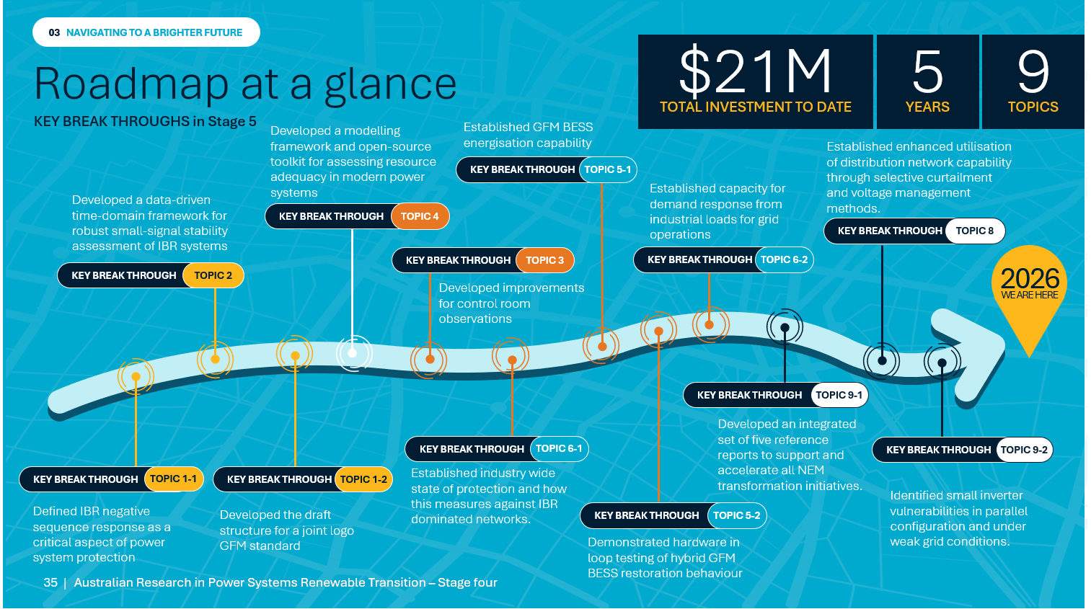
Figure 7-1: Highlights and breakthroughs of the AR-PST Stage 5 research

Topic 1-1
Part I provided useful information on how inverter-based resources behave during asymmetric faults. Using detailed EMT simulations across a wide range of modelled real and generic devices, it showed that the phasor relationship between negative sequence current and voltage, the roughly 90 degree leading angle that directional protection relies on, steadily breaks down as inverters displace synchronous machines. This is worst for inverters that have no negative sequence control. Just as importantly, it demonstrated that either a well-tuned grid following inverter with negative sequence control, or a properly designed grid forming inverter, can both synchronous machine-like behaviour. On this foundation, the research set out concrete, quantifiable, design targets covering phase angle, deadband, current direction, k factor, impedance symmetry and smooth current limiting.
Part II then reframed negative sequence response as a protection critical requirement rather than an optional feature, which is a genuine gap in the existing rules. The research tied specific inverter behaviours to real protection failures such as misdirection, relay chattering, and failure to operate, and proposed draft technical standards be verified against EMT models and international practice.
Part III delivered a technology neutral, modular modelling framework for representing inverter-based loads in system studies.
Topic 1-2
The AR-PST Stage 5, Topic 1-2 -Inverter Design – GFM Converter Standard Development project continued into the second year of a multi-year project in the joint development of a dual logo international standard between the IEC and IEEE. Collaboration on development of a framework standard on Grid Forming converters has continued. The present challenge is to identify the alignment between the work of US based UNIFI document and the approach by the European industry organisation ENSTO-E.
Topic 2
Stage 5 Topic 2 develops a data-driven time-domain framework for robust small-signal stability assessment of inverter-based systems, using Gaussian Process Regression and an eigensystem realization algorithm that outperform ANN and SVM methods. It also examines AI data centre impacts on voltage stability, evaluates limitations of existing inverter-based load models, and proposes a Dynamic Voltage Resilience Index to better capture short- and long-term stability.
Topic 3
The research for Topic 3: Stage 5 translated detailed control room observations and structured stakeholder ideation into an set of recommendations for the Control Room of the Future, validated by AEMO, ranked by priority and feasibility, and mapped onto the AR-PST 2021 Research Roadmap. It also delivered 25 generalisable visualisation guidelines that establish the foundation for a consistent control room visualisation philosophy.
Implementation: Although no technical implementation occurred, the final phase of Stage 5 research focused on two of the recommendations: Recommendations “A” (visual load minimisation and cross-system interface standards) and “K” (rapid standardised dashboard creation). For these were developed a set of 25 visualisation and explainable AI interface guidelines for control rooms, now and into the future. These new guidelines are designed to aid AEMO's ongoing internal interface and dashboard upgrades, and are openly available for use across all energy control rooms, and beyond into other sectors.
Topic 4
This project develops a modelling framework and open-source toolkit for assessing resource adequacy in modern power systems with high penetrations of renewables, storage, and distributed energy resources. Applied to the Australian east coast power system, it delivers a forward-looking characterisation of the reliability risk profile, studying how storage operation under limited foresight, DER coordination, and extreme weather, reshape the risks and opportunities for system adequacy.
Topic 5-1
During a power system restart, GFM BESS can independently energise REZs and reach the grid point of connection, with far lower energy reserves than typically assumed. Hybrid and multi-island operation are stable without complex coordination. Restart capability is limited mainly by network constraints, rather than BESS performance. With proper standards and in-field testing, IBR-based black start is technically viable and scalable.
Topic 5-2
Stage 5 has advanced understanding of inverter-led black-start, from offline simulation toward validated operating envelopes for the NEM. It demonstrated HiL-tested hybrid GFM-BESS restoration behaviour, quantified DER and GFM-GFL stability limits, defined practical reconnection risks, and showed that advanced PSO-FSMC voltage/current control can expand GFM inverter stable transition performance under challenging grid conditions.
The research has been implemented through EMT simulation and HiL-based validation workflows that de-risk future inverter-based SRAS trials, with clear next steps toward PHiL testing, protection coordination, and AEMO Type 2 Transitional Services-aligned field demonstrations.
Topic 6-1
Industry survey results indicate that electrical protection in inverter dominated networks is shifting from reliance on fault current toward adaptive, frameworks that are sensitive to IBR behaviour, which is determined by power controller dynamics. Differential schemes are preferred where feasible, while conventional methods are being modified and supplemented. Protection that is sensitive to IBR control systems is not yet deployable, but is identified in this study as a key research direction addressing emerging performance limitations.
Topic 6-2
The Advitech AR-PST Stage 5 project identified very significant amounts of capacity for industrial demand response from mid-scale industrial loads that could assist grid operations and facilitate higher penetration of variable renewable energy generation. The project found that this capacity could be cheaper to harness than residential demand response capacity. That said, barriers such as a absence of both energy literacy across mid-scale industrial operators and business executives, and of technical standards, will need to be overcome if we're to unlock the capacity identified.
Topic 8
The AR-PST project, Dynamic Operating Envelopes (DOE) for Vehicle to Grid (V2G), investigated the intersection between V2G and DOEs. Key findings are
- Developed an open source modelling tool and applied DOEs to V2G using the tool. Using simplified assumptions on EV usage, it was found that there was a grid risk of co-incident peaks from V2G, but that DOEs may be an effective way to manage them
- Energy and V2G experts were interviewed. Participants saw regulatory and customer acceptance of (particularly import) DOEs, and technical interoperability as key barriers that modelling was unable to answer.
- A key barrier in existing modelling is recognition justice: It assumes, in effect, that the energy usage requirements of all customers have the same social significance, when in reality they do not. This is one reason why modelling does not fully resolve concerns around customer acceptance. We found the human capability social justice framework may help resolve this problem. We used a "charge now" button as a case study to initially explore the use of this framework. Future work is required to fully explore how it might feed into just and socially acceptable DOE frameworks, that manage consumption from devices like EV charging.
Topic 9-1
UNSW’s key Stage 5 breakthrough was in identifying and characterising oscillatory behaviour in CER under weak distribution-grid conditions. Experimental testing demonstrated how SCR, network impedance, power level, and inverter controls, in combination, can trigger or amplify low-frequency oscillations with possible network-wide impacts. Together with the identification of vulnerable point-on-wave conditions for CER, the work provides practical guidance for future CER requirements and revisions to relevant standards.
The key breakthroughs highlighted above outline the important research that has been done as part of Stage 4 of the Roadmap. For certain topics, the highlights include practical implementation and pilot projects, as the research topics have matured from Stage 1 to Stage 4. These research breakthroughs were key focuses due to the priorities determined by the Roadmap. As technology and circumstances change with the fast-moving energy sector, priorities shift and will be captured through the work of the Roadmap to ensure that the research topics adapt appropriately and there is a continued focus on the highest priority areas.
Topic 9-2
ECU’s key breakthrough for stage 5 was the development and validation of a Trusted Sovereign Monitor (TSM), a firmware governance architecture for electric vehicle charging infrastructure. Integrated within a cyber-physical co-simulation platform, the TSM demonstrated how sovereign trust enforcement can prevent compromised firmware from propagating into grid instability, providing a practical pathway for securing Australia's future DER ecosystem.
A proof-of-concept Trusted Sovereign Monitor was implemented within a cyber-physical simulation platform integrating electric vehicle charging infrastructure with power distribution network models. Experimental evaluation demonstrated real-time firmware validation, policy enforcement, and mitigation of coordinated cyber-attacks while maintaining grid stability under representative DER operating scenarios.

Open source information
CSIRO has a focus on sharing information and allowing the research to be more broadly beneficial to assist the global energy transition. Sharing the outcomes and input information allows others to replicate and expand on the completed research, and contributes overall to accelerating the energy transition and decarbonisation of the energy sector. As such, the full research reports, as well as recording and slides from interim and final progress presentations given by each of the Stage 5 researchers, are publicly available on the CSIRO website. Similarly, all of the non-confidential data, tools, and processes used by the researchers are made available on either the CSIRO website or the researchers’ own website as detailed below.
Table 10: Research topic input data and tools
Topic | Data and information
Topic 1-1 – Advanced Fault Response Analysis and System Integration Requirements | Data/model contained on CSIRO website: https://data.csiro.au/
Topic 2 – Evaluation of Small and Large Disturbance Voltage Stabilities | Data/model contained on CSIRO website: https://data.csiro.au/
Topic 4 – Integrated Energy System Planning | Main outputs of research are found in the UoM GitHub repository:  https://github.com/ARPST-UniMelb
Topic 5-1 – Restoration and black start | Data/model contained on CSIRO website: https://data.csiro.au/
Topic 5-2 System restoration and black start | The project simulation files and models can be found on the UTAS CREPS site:  https://www.utas.edu.au/research/institutes-and-centres/centre-for-renewable-energy-and-power-systems/projects/blackouts-and-system-restoration
Topic 8 – Dynamic Operating Envelopes and Vehicle-to-Grid Technology | The Cadmium software can be found in the Elentar GitHub repository:  https://github.com/elentar-energy/cadium-oss
Topic 9-1 – DER and Stability | Main outputs of research, including measurement data and analysis, and test procedures are available in the UNSW repository: http://pvinverters.ee.unsw.edu.au/
Topic 9-2 – Trusted Sovereign Monitor | Data/model contained on CSIRO website: https://data.csiro.au/

Research publications
In addition to the final Stage 5 reports by each of the research topics, several academic and technical papers have been published, or are undergoing review or preparation. These papers describe in further detail the theories and outcomes of the research topics. A selection of these are shown below:
Topic 2
- N. Mohammed, R. Shah, and N. Amjady, “Impact of Different Voltage Control Strategies on Small-Signal Stability of Grid-Forming Inverters,” in 2025 IEEE International Conference on Energy Technologies for Future Grids (ETFG), 2025, pp. 1–6, doi: 10.1109/ETFG61999.2025.11402309.
- S. Miah, M. Usman Aslam, Rakibuzzaman Shah, Nima Amjady, Nabil Mohammd, and Md Rabiul Islam, “Small-disturbance Voltage Stability Assessment of Power Systems with High Inverter-based Resources Penetration and Data Center Loads,” in IEEE Industry Applications Society Annual Meeting, 2026.
- M. Usman Aslam, S. Miah, Rakibuzzaman Shah, Nima Amjady, Nabil Mohammd, and Md Rabiul Islam, “Large-disturbance Voltage Stability Assessment for Power Systems with High penetration and Composite Loads,” in IEEE Industry Applications Society Annual Meeting, 2026.
- Md Biplob Hossain, Md. Rabiul Islam, Rakibuzzaman Shah, Nabil Mohammed, and Nima Amjady, “System Level Dynamic Voltage Resilience Index for Assessment of Large Disturbance Voltage Stability in Renewable Rich Power System,” Energy Conversion and Manaement X, vol. 31, p. 102122, 2026
Topic 5-2
- Arjita Pal, Pooyan Alinaghi Hosseinabadi, Bijaya Ketan Panigrahi, Hemanshu R Pota, “A Black Start Solution for Voltage-Controlled Inverters with Chattering-Free Fixed-Time Sliding Mode Power Synchronization Control,” in IEEE Transactions on Industry Applications, vol. 61, no. 5, pp. 8015-8026, Sept.-Oct. 2025, doi: 10.1109/TIA.2025.3559033.
- Pooyan Alinaghi Hosseinabadi, Michael Negnevitsky, Marif Daula Siddique, Saad Mekhilef, Hemanshu Pota, John Anthony Rossiter, “PSO-tuned fixed-time sliding mode voltage and current controllers for grid-forming inverters,” in 2025 IEEE International Conference on Energy Technologies for Future Grids (ETFG), 2025, pp. 1–6, doi: 10.1109/ETFG61999.2025.11401144.
- Pooyan Alinaghi Hosseinabadi, Marif Daula Siddique, Michael Negnevitsky, Saad Mekhilef, Mehdi Seyedmahmudian, “PSO-Tuned Predefined-Time Sliding-Mode Control of a Grid-Forming Inverter,” in 2025 IEEE International Conference on Energy Technologies for Future Future Research

Next steps: Priority research tasks
With the completion of the Stage 5 research, Stage 6 is about to commence. Stage 6 will involve continuation of the Research Roadmap and the research undertaken in previous phases of the AR-PST, taking into consideration evolving technologies and changing priorities in the power sector, as well as translating research into practical pilot projects.
As part of the Stage 5 works, researchers were asked to review the Research Roadmap and consider whether there were any changes necessary to the tasks and goals to keep up to date with contemporary the technology and priorities. This is necessary as the Research Roadmap aims to address the most critical and highest priority research in the Australian power sector.
As the research topics outlined in the Research Roadmap are long term investments, the research implementation being undertaken in Stage 6 will continue to contribute to accelerating the decarbonisation of the energy sector and ensuring reliability, security, and affordability, as we transition to a 100% renewable energy grid.
This report has provided a summary of the fourth year of research investment, as the fifth stage of the Roadmap. The researchers of the Stage 5 projects recommended appropriate future research focus areas, based on their progress and insights gained through their Stage 5 work as follows.

Advanced Fault Response Analysis and System Integration Requirements for Inverter-Based Generation and Load Technologies (Topic 1-1)
Future Topic 1 research priorities recommended by the researchers to further progress the Roadmap, complete outstanding matters or to further enhance the developed tools include:
- Validation of model performance under high IBR-penetration or similar conditions to verify accuracy and applicability of Stage 5 research recommendations.
- Integration of relevant protection relay models into system studies.
- Development of a dedicated screening methods for IBL to select the minimum modelling detail needed.
- Conduct interaction studies to explore combined dynamics of IBRs and IBLs under weak-grid conditions.

Inverter Design – GFM Converter Standard Development (Topic 1-2)
Project 1-2 will be focussing on the continued development of the content of a Joint IEC IEEE standard on Grid Forming Converters. For the coming year work will focus on the drafting of the joint standard.

Evaluation of Small and Large Disturbance Voltage Stabilities for Power Systems with a High Penetration of Inverter-based Resources (Topic 2)
The third year of small signal stability assessment has advanced the high priority Roadmap tasks significantly. However, the researchers note that more work remains and, in their conclusion, they recommend that subsequent stages of Topic 2 research should consider further work, including:
- Developing new joint time- and frequency-domain analysis methods for more effective small signal stability assessment.
- Establishing a Small-Disturbance Voltage Assessment Index (SDAI) through development of a Linear–Nonlinear Framework and a network-wide propagation analysis.
- Performing STVS assessment considering network topology changes using an effective data-driven approach with adequate learning capability to capture spatio-temporal characteristics of the large-disturbance voltage stability problem.
- Expand small disturbance techniques through integration of physics informed neural networks, machine learning processes, and uncertainty aware AI techniques.

Control Room of the Future (Topic 3)
This line of research for Topic 3 commenced late in Stage 4, during the second quarter of 2025. Research focused on the Human Factors and Operator Interaction pillar of the CRoF Roadmap (Figure 15).
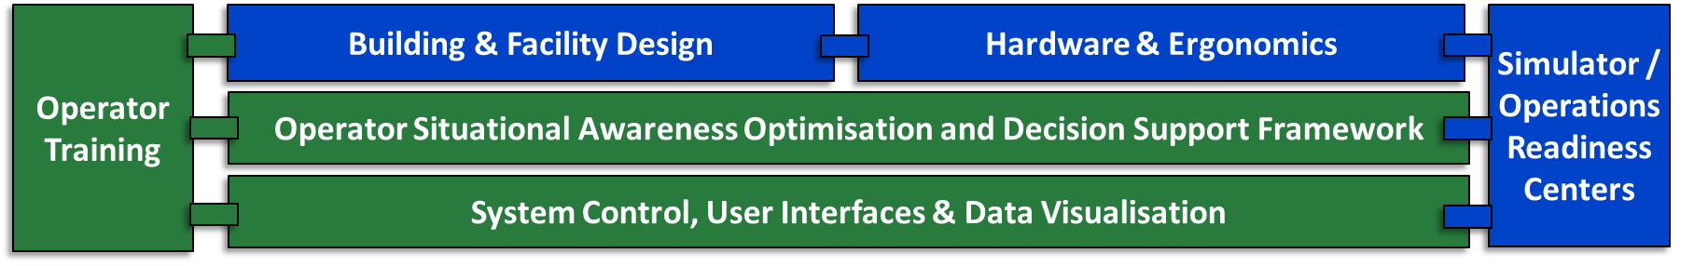
Figure 8-1: CROF model associated with human factors and operator interaction with the software systems and data in the control room
Research proposed for Stage 6 and beyond is recommended to focus on a number of specific tasks that will implement the highest priority Stage 5 recommendations:
- Develop context-aware, explainable procedures for operator alarm investigations.
- Align control-room training twin with the training scenarios to keep training and live environments aligned with each other. Build a smart library of past scenarios so that operators can practice and compare approaches and the library is easy to maintain and keep up-to-date.
- Creation of standardised dashboards to integrate information and provide contextual information quickly for operators on the fly.

Resource Adequacy, Risk, and Resilience in Low-Carbon Energy System Planning: Methods, Tools, and Metrics (Topic 4)
There is increasing focus on bridging research and real-world applications in engineering, planning, and system operability. In particular, under the “Planning” topic, there is significant interest in advancing methodologies and developing open-source, scalable, and computationally efficient - tools for adequacy and strategic planning studies. These efforts should aim to address the operational challenges of an increasingly weather-dependent energy system with high levels of storage and DER integration. Moreover, these priorities are aligned with previous recommendations, and the long-term research strategy outlined for Topic 4. Based on this, the focus should be on the following research activities from the original research plan:
- Infrastructure planning of integrated electricity and gas systems to ensure reliability of supply and system operability.
- Development and assessment of planning strategies for the secure integration of large flexible loads into the Australian energy system.

Restoration and black start (Topic 5-1)
The output from multiple researchers across multiple years in this field has been consistent: EMT studies show that inverter-based plant is entirely capable of providing a system restart service, particularly where GFM BESS devices are used as the primary restart plant. Furthermore, these studies have shown, based on generic models, that the operation of existing asset protection relays may remain viable. It is recommended that focus now shifts to hardware trials of inverter-driven restart and improved evaluation of actual, physical protection relay responses to high IBR scenarios (due to the unavailability of manufacturer-specific EMT models). To that end, the following areas are recommended research priorities:
- Supporting the upcoming Type 2 trials in the NEM with targeted exploratory operational studies using real network and plant data provided by NSPs, OEMs, and AEMO.
- Future work should include comprehensive hardware‑in‑loop testing of protection relays to verify that the conclusions drawn from simulation‑based assessments also apply to physical manufacturer‑specific devices commonly deployed in the NEM.
- Protection in restoration islands with low fault currents, including exploration of what constitutes protection-quality fault current, and whether there are additional fault current requirements that are specific to system restoration.
- As large inverter‑based loads such as data centres and electrolysers proliferate, understanding their impact on system restoration becomes an urgent research priority.
- Assessing the role of forecasted gas-fired generation capacity in supporting system restoration and determining optimal locations and capacities for system restart sources in future coal-free scenarios across each region, considering both existing and projected gas-fired generation.
- Identifying the optimal sizing and geographic placement of future system restoration sources is essential as the NEM transitions toward a coal‑free generation mix.
- Investigate possible opportunities for retro-fitting existing gas-fired generation to enable system restart capability to support future coal-free scenarios across each region.
- Examine the role that future hydro and gas-fired generation, as projected by the ISP, can play in system restoration for future coal-free scenarios.

System restoration and black start (Topic 5-2)
Research of Topic 5-2 expands the overall Topic 5 area, and recommendations of the researchers are to focus future work on tasks including:
- Conduct Power Hardware-in-the-Loop (PHiL) tests to validate real-time interaction between simulated networks and physical power hardware (e.g., inverter controllers, representative inverter interfaces, protection IEDs where feasible).
- Develop and validate a NEM Digital Twin (initially at regional sub-network level, scalable) incorporating representative protection relay settings and logic.
- Develop a transmission-distribution (T-D) framework that integrates high fidelity transmission dynamics with detailed distribution network models to capture the bidirectional propagation of voltage and frequency disturbances during restart.
- Assess control strategies for synchronising multi-IBR islands without synchronous generation
- Design a real-time unified stability index (USI) that combines online inertia, available fault current, and reactive power margin into an intuitive indicator for control room operators.

Protection Challenges in IBR Rich Networks – Interim Report (Topic 6-1)
This being the first stage following a revamped Services Roadmap, there is extensive potential for additional technical needs to be assessed for power system protection. Further work may include:
- As DER penetration increases at the distribution level address protection challenges arising from the fact that traditional fuse-based protection faces significant challenges under low fault-current conditions from high IBR penetration.
- Gain insights from stakeholders into how grid-forming inverter capabilities affect protection system design and coordination. As grid-forming solutions, advanced relays, STATCOMs, active filters, and virtual power plants emerge as technologies to enhance system strength and protection performance, research should focus on their interaction with existing protection schemes, operational safety (i.e. residential CER grid forming while grid connected) and optimal integration approaches.
- Develop standardised frequency-domain methodologies for screening and assessment of sub-synchronous oscillation risks, building on AEMO's Generator Insights Screening Tool (GIST) implementation. Research should address the inadequacy of traditional Short Circuit Ratio (SCR) metrics for predicting Sub-Synchronous Control Interaction (SSCI) risks in high-IBR networks.
- Validate and refine adaptive protection schemes that can respond to changing network conditions. The use of communication-based setting groups to maintain selectivity amid large fault level swings between islanded and grid-connected operation has shown promising results in microgrid applications. Research should extend these approaches to broader network applications and investigate machine learning methodologies for protection system optimisation.
- Support the evolution of protection standards and operational practices through evidence-based recommendations. As the work identifies gaps for future research, it should prioritise areas requiring further technical development or standards evolution, helping shape the next phase of research and regulatory development.

Characterisation of Load for Essential Services (Topic 6-2)
The findings of this study identify a set of research priorities that extend directly from its results and limitations. Three areas of future work are proposed, each addressing a specific gap identified through the stakeholder engagement and analysis conducted at this stage. Together, they form a coherent and sequenced program: characterising what exists in the system, understanding how individual sites can be activated, and establishing the standardised foundations that make activation scalable and reliable across the NEM.
- Discovery and Estimation of Demand-Side Inertia Sources in the NEM, since the NEM currently lacks a verified, spatially and temporally resolved understanding of where demand-side inertia exists, how much is available, and how it behaves under real system disturbance conditions.
- There is a clear need for a small number of deep, customer-specific, engagements that move beyond characterisation into implementation: conducting Level 2 Energy Audits under AS 3598.2 to replace self-reported consumption data with independently verified load profiles; quantifying the technical and economic potential for demand flexibility at the site scale; developing tailored education and capability-building frameworks to address the awareness and access barriers identified in this study; and producing replicable case studies and toolsets that can be applied across the broader industrial population.
- The most structurally significant finding of this study is that the barriers hindering industrial DR participation are not primarily technical; rather, they are compounded by the absence of a consistent, standardised framework that would make industrial load participation accessible, measurable, and reliable at scale. To resolve these challenges a critical future research priority is the foundation for an Industrial Demand Response Standard In the NEM.

Dynamic Operating Envelopes (Topic 8)
Looking ahead, the researchers recommend further work in the following areas to continue to grow the body of knowledge:
- Stakeholders were generally comfortable with export DOEs and their application to V2G, corroborated by modelling which showed that export DOEs had a relatively small impact on the financial value of V2G. Import DOEs are a different matter. Stakeholders were considerably less certain about how import DOEs should be designed and applied, and identified a set of interconnected gaps that this project was not scoped to resolve.
- As key initiatives and V2G projects begin to enter their delivery phase, and more V2X products enter the market, industry experience is likely to increase rapidly. Revisiting industry stakeholder perspectives in 1-2 years will enable a more nuanced understanding of v2G behaviour grounded in real experience.
- Development of a more user- or behaviour-centric formulations to the optimisation of preferences would limit the ability of the system to respond to more complex objectives but would arguably more closely emulate the expectations of real-world users.
- In comparison to the already broad range of optionality that exists for constructing scenarios, research has kept the options for network allocation relatively simple, in line with presently operating systems. As DNSPs grow more comfortable with operations at scale, and possibly look for improvements in network utilisation, more allocation methods may be incorporated into the tool. These could incorporate network characteristics more deeply, and possibly include lesson from previous pilot projects that have investigated more complex allocation and reallocation strategies.
- Validated data on actual user behaviour for EV charging (both standard charging and V2G-enabled) is very scarce. Over time it is anticipated that trends will emerge that may be incorporated into richer models of EV usage and charging behaviour. Additionally, new forms of operating models may emerge (for example, more VPP alternatives, EV leasing models) that can be incorporated in the tool.
- Net System Load Profiles were used as a means of synthesising load models to match daily and seasonal trends, including weather effects. Alternative models may be incorporated, either to provide more accurate - or more geographically precise - household profiles, or to account for other types of users – for example commercial and industrial. Further work may develop a broader modular model to enable a diversity of data sources as inputs, possibly expanding into forward-looking data sets as well.
- Further explore use of the human capability social justice framework to embed fairness in energy system frameworks

DER and stability (Topic 9-1)
Future activities should focus on advancing the experimental validation, interaction assessment, and system-level integration of emerging GFM capabilities while continuing to strengthen DER / CER testing frameworks. The following research priorities have been identified to support the next phase of the AR-PST Research Roadmap.
- Continued testing DER / CER performance, aligned with previous AR-PST Topic 9 work, to ensure accurate characterisation of inverter behaviour, improve model fidelity, and validate control capabilities under evolving grid conditions.
- Full study of GFM control, including pure GFM and hybrid GFM / GFL control, simulation and experimentation of weak-grid behaviours, and assessment of stability and interactions.
- Laboratory-scale evaluation of GFM–GFL interactions, including single-phase scenarios considering commercially available DER / CER, and weak-grid emulation to validate model assumptions and identify adverse dynamics.
- Feeder-scale demonstration of GFM capability, assessing operational performance, stability improvements, and integration challenges in realistic distribution network environments.
- Aggregate studies of GFM / GFL interactions, examining behaviours across multiple customers or devices and their possible implications for hosting capacity and system stability.

Trusted Sovereign Monitor (Topic 9-2)
Future work should first focus on maturing the concrete project outputs developed in this program:
- A key priority is the progression of the Trusted Sovereign Monitor (TSM) prototype to higher technology readiness levels through iterative refinement, hardware integration, and field-facing evaluation. This includes direct engagement with EVSE OEMs, aggregators, operators, and government partners to conduct a pilot deployment that assesses real-world performance, operational constraints, and economic considerations associated with embedding sovereign trust anchors into DER fleets.
- Building on project-specific activities of Stage 5, broader research under Topic 9 should address the systemic and operational challenges associated with managing very large fleets of heterogeneous DER devices under conditions of uncertainty, compromise, or attack.
- Although the TSM already provides a technical means of enforcing device-level trust and compliance, integrating such capabilities into grid operations, market structures, and critical-infrastructure governance frameworks requires sustained effort.
- Development of technical standards and international best practice, beginning with the formation of a Standards Australia working group to lead the translation of TSM concepts into globally recognised device-security specifications, benefiting partners such as the US Department of Energy and European regulators.
- Topic 9 research should also explore how future national infrastructures, such as the emerging DER registry, and national PKI ecosystem, can incorporate device-level attestation and trust signals to strengthen whole-of-system visibility.
- Finally, as Australia approaches very high levels of DER penetration, there is a need for research into incident management, coordinated response strategies, and graceful degradation of DER fleets during cyber-physical disruptions. Understanding how to contain compromised devices, to operate securely in degraded states, and to recover swiftly after coordinated disturbances, will be essential to achieving the Roadmap’s long-term vision of a stable, resilient, and secure high-renewables grid.

Getting involved
The CSIRO Australian AR-PST Research Roadmap is a multi-year and multi-disciplinary program. It envisages energy sector research that provides an opportunity to engineering organisations, research institutes, universities, and others, to be involved and to contribute to, or to learn from, the research conducted and insights provided. The Roadmap is intended to be flexible and adaptable to changes in research priorities, and has included reviews of the most needed research as defined by CSIRO, AEMO, feedback from the Australian and international research community, and Australian government agencies.
The first five stages of the Roadmap have now been successfully completed and have:
- Established a research pathway to help Australia’s energy transition for the benefit of all consumers.
- Initiated high-priority research tasks critical to the success of our energy security.
- Completed critical tasks of research to support system operators and industry in negotiating the energy transition.
- Progressed real-world applications and learnings in several topics to enhance power system capability, security, and resilience.
- Facilitated engagement with a wider range of stakeholders through technology workshops with Australian and international researchers, government agencies, and system and market operators.
Concurrently, given the pace of energy sector developments and evolution, the Roadmap has been reviewed annually at the beginning of each stage of research by the appointed researchers to ensure that the highest priority tasks are progressed, new tasks are added to reflect changes in technology, government policy,
However, there is a substantial body of work still ahead, and although expressions of interest for Stage 6 closed in June 2026 and research projects have been appointed for the FY 26/27, the program is expected to continue to provide critical energy research to assist the Australian (and global) energy transition and to provide tangible benefits to electricity consumers in the years to come.
To ensure the ongoing success of the CSIRO AR-PST Research Roadmap, CSIRO welcomes feedback from research organisations, equipment manufacturers, policy makers, system operators, and other stakeholders on the program and its insights, as well as engaging with interested parties to explore future research opportunities and pilot projects of completed research.
CSIRO continues to share he outcomes of the research via the annually published interim progress reports, the final annual reports, research project presentations, and all data, software, and tools developed through the research. All of this material is available on the CSIRO AR-PST website. To review this information or to get in contact, visit the CSIRO AR-PST website: Australia's Research Roadmap for Power System Transformation - CSIRO

The power system research ecosystem
The work completed under the CSIRO funded AR-PST Research Roadmap does not exist in isolation. Energy sector research in Australia is being progressed through many separate initiatives, whether these are through government mandates, academic research, or driven by existing or expected needs of network and system operators. There are several other key research programs underway that add to the knowledge base of assisting our energy transition. Some of the Australian research programs and initiatives related or closely linked to many of the CSIRO AR-PST Research Roadmap topics include:
- The National Consumer Energy Resource (CER) Roadmap – Powering Decarbonised Homes and Communities with a focus on CER integration. This is linked to the research of AR-PST Topic and 9.
- RACE for 2030: RACE for Networks with a strong focus on societal expectations and uses of behind-the-meter energy sources, and development of standardised methods for integrating CER, this aspect of RACE for 2030 has integrated the previous Topic 7 of the AR-PST and with its inclusion of CER and EV research and projects can be closely linked to Topics 8 and 9 of the AR-PST.
- AEMO Engineering Roadmaps to 100% Renewables are “…are ongoing bodies of work which identify and prioritise the critical engineering actions required to advance operational capability of Australia’s largest power systems to securely and reliably operate at times of high renewables contribution.” Future focussed, there is strong connection to several of the AR-PST Topics, particularly to Topics 8 and 9, but also to the Topic 3 CRoF concept being pursued through the AR-PST.
- AEMO Operations Technology Program (OTP) is an initiative of the Australian system operator to uplift technical capability in the NEM, WEM, and Gas Control Rooms, operations support, and market systems. OTP built on work conducted by EPRI and Strategen for CSIRO in 2021 in the foundational work of the AR-PST.
- International System Operator Network (ISON) collaboration focuses on operational technology and process enhancements and relates strongly to the foundational six research topics of the AR-PST, this encompasses Topics one to six of Figure 0-1.
- ARENA funded projects and research in the energy sector, from CER integration to system security, are related to much of the AR-PST areas of interest.
Additionally, there are focused energy research centers operating in many Australian Universities, includes some of those that have participated in the AR-PST of the past five years. These energy research centers have numerous energy sector related research projects underway including doctoral or post-doctoral research. These research activities contribute significantly to the overall body of knowledge that is needed for our energy system transition.
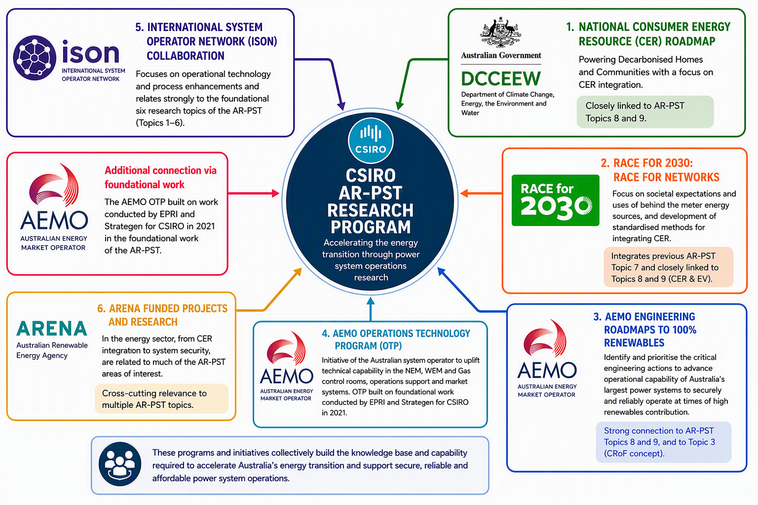
Figure 9-1: Other critical Australian energy sector research activities and their linkage to the AR-PST

Additional to the Australia research collaboration and connections, the CSIRO AR-PST research progress and outcomes have been shared internationally. CSIRO has hosted research workshops and led delegations made up of AR-PST researchers to further close collaboration and knowledge sharing with our South-East Asian neighbours for the past two years. Concurrently, CSIRO has also hosted a large group of South-East Asian system operators and market operators for AR-PST research workshops in Melbourne for a two-day event.
“The energy transition needs us to build new pathways, and to achieve this we need a good dose of science.”

“Science and technology are essential to the energy transition: we need to invest in them.”
Dr Cathy Foley
Australia’s Chief Scientist
The collaboration and knowledge sharing enabled through the CSIRO initiated research embodies the spirit of the AR-PST to accelerate the decarbonisation of our energy systems globally, and the fundamental values of CSIRO, such as research collaboration across disciplines and boundaries. Looking ahead, the subsequent stages of the AR-PST will broaden the engagements and interaction further to provide more opportunities for participation to Australian researchers, and to leverage the outcomes to further advance Australia’s achievement of our renewable targets.
As Australia’s national science agency and innovation catalyst, CSIRO is solving the greatest challenges through innovative science and technology.
CSIRO. Unlocking a better future for everyone.
Contact us
1300 363 400
+61 3 9545 2176
csiro.au/contact
csiro.au
For further information
Energy Research Unit
Thomas Brinsmead
+61 2 4960 6143
Thomas.brinsmead@csiro.au
csiro.au/energy

https://www.csiro.au/en/research/technology-space/energy/g-pst-research-roadmap
CSIRO | Implementation of Australia’s Global Power System Transformation (Stage 5)
CSIRO | AR-PST Roadmap
https://www.csiro.au/en/research/technology-space/energy/electricity-transition/ar-pst
G-PST | Global Power System Transformation initiative
CSIRO | Australian Research in Power Systems Transition
AEMO | Engineering Roadmaps
AEMO | Operations Technology Program
2030 CRC | RACE for 2030
https://www.aemo.com.au/-/media/files/major-publications/qed/2026/qed-q1-2026.pdf
https://www.aemo.com.au/-/media/files/electricity/nem/national-electricity-market-fact-sheet.pdf
These occurrence were time specific rather than reflecting an average renewable energy production over the two quarters, such that there have been multiple and successive 5-minute market intervals during the second half of 2024 during which the energy produced by renewable sources was able to supply 100% of demand.
AEMO’s projection includes “committed” and “anticipated” project quantified on the system operator’s Generation information page
International system operator collaboration
The ISON priorities have also continued to focus on similar energy system topics, as outlined in their priorities list: ISON - System Operator Transitional Priorities
Topic 1 at Australian Research in Power Systems Transition (AR-PST) Stage 5 - CSIRO
The CSIRO website which includes the Stage 1 Roadmap and reports and reports and information links of Stage 2 to 5 can be found at: https://www.csiro.au/en/research/technology-space/energy/Electricity-transition/AR-PST
DCCEEW | National Consumer Energy Resources Roadmap
RACE for 2030 | Race for Networks
AEMO | Engineering Framework
AEMO | Operations Technology Roadmap
AEMO | International system operator collaboration
Indonesia and Australia Advance Low-Emissions Energy Transition | Partnerships for Infrastructure
Workshop on Managing system security and reliability with increased renewable generation - CSIRO

