Shortened forms
AEM | airborne electromagnetics
AHD | Australian Height Datum
APSIM | Agricultural Production Systems Simulator
AWRC | Australian Water Resources Council
CGE | Computable General Equilibrium
CSIRO | Commonwealth Scientific and Industrial Research Organisation
CSO | community service obligations
DEM | digital elevation model
DSM | digital soil mapping
EC | electrical conductivity
EM | electromagnetic
ENSO | El Niño – Southern Oscillation
FSL | full supply level
FTEs | full-time equivalents
GAB | Great Artesian Basin
GCM-ES | global climate model output empirically scaled to provide catchment-scale variables
GCMs | global climate models
IDAS | Integrated development assessment system
IPCC AR4 | the Fourth Assessment Report of the Intergovernmental Panel on Climate Change
IQQM | Integrated Quantity-Quality Model – a river systems model
IRR | internal rate of return
Landsat TM | Landsat Thematic Mapper
mEGM96 | Earth Gravitational Model 1996
MODIS | Moderate Resolution Imaging Spectroradiometer
NABSA | North Australia Beef System Analysis
NPV | net present value
NQIAS | North Queensland Irrigated Agriculture Strategy
NRM | natural resource management
ONA | the Australian Government Office of Northern Australia
OWL | the Open Water Likelihood algorithm
PAWC | plant available water capacity
PE | potential evaporation
Sacramento | a rainfall-runoff model
SALI | the Soil and Land Information System for Queensland
SGG | soil generic group
SLAs | statistical local areas
SRTM | shuttle radar topography mission
Zeu | euphotic depth
Zsml | surface mixing layer

Geological timeline
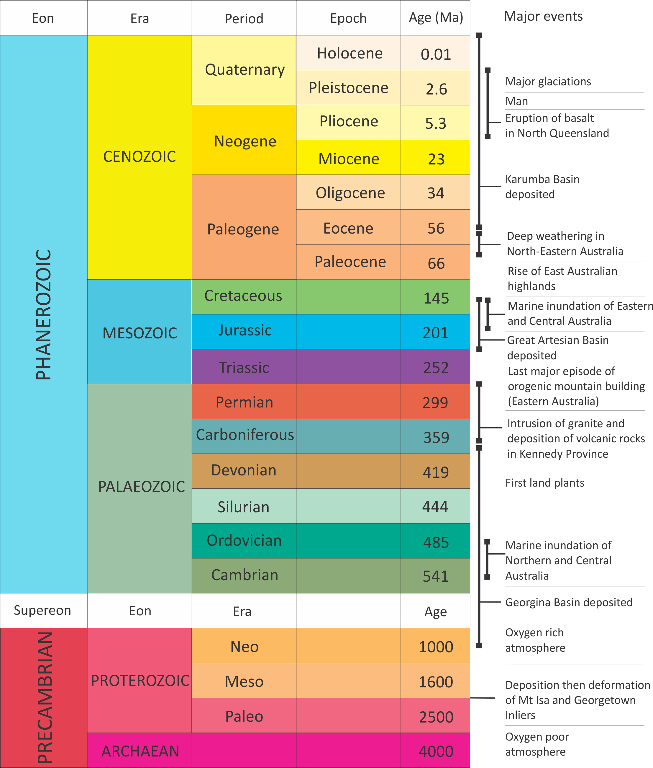

Units
MEASUREMENT UNITS | DESCRIPTION
BP | before present
GL | gigalitres, 1,000,000,000 litres
keV | kilo-electronvolts
kL | kilolitres, 1000 litres
km | kilometres, 1000 metres
kPa | kilopascal
L | litres
m | metres
Ma | million years
MB | megabyte
mAHD | metres above Australian Height Datum
mEGM96 | Earth Gravitational Model 1996 geoid heights in metres
MeV | mega-electronvolts
mg | milligrams
ML | megalitres, 1,000,000 litres

Data sources and availability
The Flinders and Gilbert Agricultural Resource Assessment obtained a range of data for use under licence from a number of organisations, including the following:
- State of Queensland (Department of Natural Resources and Mines)
  - Groundwater database, data dictionary and standards. Version 7. Revision Date: 13/12/2011
  - Attributable acknowledgement: Based on or contains data provided by the State of Queensland (Department of Natural Resources and Mines), 2012. In consideration of the State permitting use of this data you acknowledge and agree that the State gives no warranty in relation to the data (including accuracy, reliability, completeness, currency or suitability) and accepts no liability (including without limitation, liability in negligence) for any loss, damage or costs (including consequential damage) relating to any use of the data. Data must not be used for direct marketing or be used in breach of the privacy laws.
- State of Queensland (the Department of Science, Information Technology, Innovation and the Arts ; Queensland Herbarium)
  - Queensland’s Regional Ecosystem Description Database
  - Conditions of use statement: Technical descriptions have been developed from information published by the State of Queensland (acting through the Department of Science, Information Technology, Innovation and the Arts) and remain the property of the State of Queensland. While every effort has been made to ensure the information presented is as reliable as possible, the State of Queensland accepts no liability and gives no assurance in respect of its accuracy and shall not be liable for any loss or damage arising from its use. Technical descriptions are based on a combination of quantitative and qualitative information and should be used as a guide only. Technical descriptions are not to be used as a substitute for reference sites. Descriptions are subject to review and are updated as additional data becomes available.
  - <http://www.ehp.qld.gov.au/ecosystems/biodiversity/re_introduction.html>
- Geoscience Australia
  - GEODATA Topo 250K Series 3 – spatial data for mapping
  - Attributable acknowledgement: This Assessment report (Agricultural resource assessment for the Flinders catchment) incorporates Product which is © Commonwealth of Australia 2006. The Product has been used in Agricultural resource assessment for the Flinders catchment with the permission of the Commonwealth. The Commonwealth has not evaluated the Product as altered and incorporated within Agricultural resource assessment for the Flinders catchment, and therefore gives no warranty regarding its accuracy, completeness, currency or suitability for any particular purpose.
  - <https://www.ga.gov.au/products/servlet/controller?event=GEOCAT_DETAILS&catno=63999>
- Science Delivery Division of the Department of Science, Information Technology, Innovation and the Arts (DSITIA)
  - SILO climate data – an enhanced climate data bank containing datasets which are based on historical climate data provided by the Bureau of Meteorology. SILO contains Australian climate data from 1889 (current to yesterday), in a number of ready-to-use formats, suitable for research and climate applications. In addition, SILO provides users with access to climate change projections data for 2030 and 2050 in a daily format.
  - Attributable acknowledgement on any created products or images: Based on or contains data provided by the State of Queensland (Department of Science, Information Technology, Innovation and the Arts) [2013]. In consideration of the State permitting use of this data you acknowledge and agree that the State gives no warranty in relation to the data (including accuracy, reliability, completeness, currency or suitability) and accepts no liability (including without limitation, liability in negligence) for any loss, damage or costs (including consequential damage) relating to any use of the data. Data must not be used for direct marketing or be used in breach of the privacy laws.
  - <http://www.longpaddock.qld.gov.au/silo/>
- Esri
  - World Imagery Map Service – map service of satellite imagery for the world and high-resolution imagery for the United States and other areas around the world. Imagery is sourced from GeoEye IKONOS, Getmapping, AeroGRID, IGN Spain, IGP Portugal, i-cubed, USGS, AEX, Aerogrid, Swisstopo and by the GIS User Community.
  - <http://www.arcgis.com/home/item.html?id=10df2279f9684e4a9f6a7f08febac2a9>

Glossary and terms
Anthropogenic: a human impact on the environment.
Aquifer: a permeable geological material that can transmit significant quantities of water to a bore, spring, or surface water body. Generally, ‘significant’ is defined based on human need, rather than on an absolute standard.
Aquitard (confining layers): a saturated geological unit that is less permeable than an aquifer, and incapable of transmitting useful quantities of water. Aquitards often form a confining layer over an artesian aquifer.
Artesian: a general term used when describing certain types of groundwater resources. Artesian water is underground water confined and pressurised within a porous and permeable geological formation. An artesian aquifer has enough natural pressure to allow water in a bore to rise to the ground surface. Sub-artesian water is water that occurs naturally in an aquifer, which if tapped by a bore, would not flow naturally to the surface. Artesian conditions refer to the characteristics of water under pressure.
Basement: the crust below the rocks of interest. In hydrogeology it means non-prospective rocks below accessible groundwater. Commonly refers to igneous and metamorphic rocks which are unconformably overlain by sedimentary beds or cover material, and sometimes used to indicate ‘bedrock’ (i.e. underlying or encasing palaeovalley sediments).
Benthic: the ecological region at the lowest level of a body of water such as an ocean or a lake, including the sediment surface and some sub-surface layers.
Current development: the level of surface water, groundwater and economic development in place as of 1 July 2013. The Assessment assumes that all current water entitlements are being fully used.
Development: see entries for ‘current development’ and ‘future irrigation development’.
Drainage division: the area of land where surface water drains to a common point. There are 12 major drainage divisions in Australia. At a smaller scale, surface water drainage areas are also referred to as river basins, catchments, or watersheds.
Drawdown: the lowering of groundwater level resulting from the extraction of water, oil or gas from an aquifer.
Ecosystem services: the contributions that ecosystems make to human wellbeing.
Eutrophication: the ecosystem response to the addition of artificial or natural substances, such as nitrates and phosphates, through fertilizers or sewage, to an aquatic system. One example is an ‘algal bloom’ or great increase of phytoplankton in a water body as a response to increased levels of nutrients.
Environmental flows: describe the quantity, timing and quality of water flows required to sustain freshwater and estuarine ecosystems and the human livelihoods and well being that depend on these ecosystems.
Flow regime: the entire pattern of flow in a river – from how long it lasts, to how frequently it flows and how large it is.
Fecundity: the potential reproductive capacity of an individual or population.
Future irrigation development: is described by each case study storyline (see chapters 8 to 10); river inflow and agricultural productivity are modified accordingly.
Geological basin: layers of rock that have been deformed by mega-scale geological forces to become bowl-shaped. Often these are round or oblong with a depression in the middle of the basin.
Geological formation: geological formations consist of rock layers that have common physical characteristics (lithology) deposited during a specific period of geological time.
Groundwater (hydrogeology): water that occurs within the zone of saturation beneath the Earth’s surface. The study of hydrogeology focuses on movement of fluids through geological materials (e.g. layers of rock).
Groundwater basin: a groundwater basin is a non-geological delineation for describing a region of groundwater flow. Within a groundwater basin, water enters through recharge areas and flows toward discharge areas.
Groundwater divide: a divide that is defined by groundwater flow directions that flow in opposite directions perpendicular to the location of the divide.
Groundwater flow (hydrodynamics): within a groundwater basin, the path from a recharge area to a discharge area is referred to as a groundwater flow system, where travel time may be as short as days or longer than centuries, depending on depth. The mechanics of groundwater flow – the hydrodynamics – are governed by the structure and nature of the sequence of aquifers.
Groundwater flow model: a computer simulation of groundwater conditions in an aquifer or entire groundwater basin. The simulations are representations based on the physical structure and nature of the sequence of aquifers and rates of inflow – from recharge areas – and outflow – through springs and bores.
Groundwater level: in this report refers to the elevation of equivalent freshwater hydraulic head at 25 °C
Groundwater recharge and discharge: recharge occurs where rainfall or surface water drains downward and is added to groundwater (the zone of saturation). Discharge occurs where groundwater emerges from the Earth, such as through springs or seepage into rivers.
Hydrodynamics: the study of liquids in motion
Lithology: the character of a rock; its composition, structure, texture, and hardness.
Net present value: a standard method for using the time value of money to appraise long-term projects by measuring the differences between costs and revenues in present value terms.
Palaeochannel: refers to the main channel of ancient rivers, sometimes called the ‘thalweg’, the lowest point of incision along the river bed where coarser sediments are commonly deposited. Former river channels that are recognised in the surface (from aerial or satellite images) or subsurface (typically in aerial electromagnetic surveys or drilling).
Permeability: a measurement describing the ability of any fluid (water, oil) to pass through a porous material. Values vary widely, with higher values corresponding to aquifers (i.e., highly permeable) and lower values corresponding to aquitards (i.e. less permeable).
Refugia: habitat for species to retreat to and persist in.
Regolith: weathered upper layer.
Riparian: of, on, or relating to the banks of a watercourse. A riparian zone is the area of land immediately adjacent to a stream or river. Plants found within this zone are collectively known as riparian vegetation. This vegetation frequently contains large trees that stabilise the river bank and shade part of the river.
River reach: an extent or stretch of river between two bends.
Streamflow: is the flow of water in rivers and other channels (creeks, streams etc.). Water flowing in channels comes from surface runoff, from groundwater flow, and from water discharged from pipes. There are a variety of ways to measure streamflow – a gauge provides continuous flow over time at one location for water resource and environmental management or other purposes; it can be estimated by mathematical equations. The record of flow over time is called a hydrograph. Flooding occurs when the volume of water exceeds the capacity of the channel.
Triple-bottom-line: an accounting framework that incorporates three dimensions of performance: social, environmental and economic.
Watertable: the surface where the groundwater level is balanced against atmospheric pressure. Often, this is the shallowest water below the ground.

