FLINDERS AND GILBERT AGRICULTURAL RESOURCE ASSESSMENT

Design flood hydrology for selected dam sites in the Flinders and Gilbert catchments
A technical report to the Australian Government from the CSIRO Flinders and Gilbert Agricultural Resource Assessment, part of the North Queensland Irrigated Agriculture Strategy
Ahrim Lee1, Sanne Voogt1, Paul Harding2, Alex Loy1
1Department of Science, IT, Innovation and the Arts. Queensland Government
2CMP Engineers Pty Ltd

December 2013

Water for a Healthy Country Flagship Report series ISSN: 1835-095X
Australia is founding its future on science and innovation. Its national science agency, CSIRO, is a powerhouse of ideas, technologies and skills.
CSIRO initiated the National Research Flagships to address Australia’s major research challenges and opportunities. They apply large scale, long term, multidisciplinary science and aim for widespread adoption of solutions. The Flagship Collaboration Fund supports the best and brightest researchers to address these complex challenges through partnerships between CSIRO, universities, research agencies and industry.
Consistent with Australia’s national interest, the Water for a Healthy Country Flagship aims to develop science and technologies that improve the social, economic and environmental outcomes from water, and deliver $3 billion per year in net benefits for Australia by 2030. The Sustainable Agriculture Flagship aims to secure Australian agriculture and forest industries by increasing productivity by 50 percent and reducing carbon emissions intensity by at least 50 percent by 2030.
For more information about Water for a Healthy Country Flagship, Sustainable Agriculture Flagship or the National Research Flagship Initiative visit
<http://www.csiro.au/flagships>.

Citation
Lee A, Voogt S, Harding P and Loy A (2013) Design flood hydrology for selected dam sites in the Flinders and Gilbert catchments. A technical report to the Australian Government from the CSIRO Flinders and Gilbert Agricultural Resource Assessment, part of the North Queensland Irrigated Agriculture Strategy. CSIRO Water for a Healthy Country and Sustainable Agriculture flagships, Australia.

Copyright
© Commonwealth Scientific and Industrial Research Organisation 2013. To the extent permitted by law, all rights are reserved and no part of this publication covered by copyright may be reproduced or copied in any form or by any means except with the written permission of CSIRO.

Important disclaimer
CSIRO advises that the information contained in this publication comprises general statements based on scientific research. The reader is advised and needs to be aware that such information may be incomplete or unable to be used in any specific situation. No reliance or actions must therefore be made on that information without seeking prior expert professional, scientific and technical advice. To the extent permitted by law, CSIRO (including its employees and consultants) excludes all liability to any person for any consequences, including but not limited to all losses, damages, costs, expenses and any other compensation, arising directly or indirectly from using this publication (in part or in whole) and any information or material contained in it.

Flinders and Gilbert Agricultural Resource Assessment acknowledgments
This report was prepared for the Office of Northern Australia in the Australian Government Department of Infrastructure and Regional Development under the North Queensland Irrigated Agriculture Strategy <http://www.regional.gov.au/regional/ona/nqis.aspx>. The Strategy is a collaborative initiative between the Office of Northern Australia, the Queensland Government and CSIRO. One part of the Strategy is the Flinders and Gilbert Agricultural Resource Assessment, which was led by CSIRO. Important aspects of the Assessment were undertaken by the Queensland Government and TropWATER (James Cook University).
The Strategy was guided by two committees:
- the Program Governance Committee, which included the individuals David Crombie (GRM International), Scott Spencer (SunWater, during the first part of the Strategy) and Paul Woodhouse (Regional Development Australia) as well as representatives from the following organisations: Australian Government Department of Infrastructure and Regional Development; CSIRO; and the Queensland Government.
- the Program Steering Committee, which included the individual Jack Lake (Independent Expert) as well as representatives from the following organisations: Australian Government Department of Infrastructure and Regional Development; CSIRO; the Etheridge, Flinders and McKinlay shire councils; Gulf Savannah Development; Mount Isa to Townsville Economic Development Zone; and the Queensland Government.
This report was reviewed by Mr John Ruffini (Queensland Government), Dr Cuan Petheram (CSIRO) and Dr Peter Stone (CSIRO).

Director’s foreword

Northern Australia comprises approximately 20% of Australia’s land mass but remains relatively undeveloped. It contributes about 2% to the nation’s gross domestic product (GDP) and accommodates around 1% of the total Australian population.
Recent focus on the shortage of water and on climate-based threats to food and fibre production in the nation’s south have re-directed attention towards the possible use of northern water resources and the development of the agricultural potential in northern Australia. Broad analyses of northern Australia as a whole have indicated that it is capable of supporting significant additional agricultural and pastoral production, based on more intensive use of its land and water resources.
The same analyses also identified that land and water resources across northern Australia were already being used to support a wide range of highly valued cultural, environmental and economic activities. As a consequence, pursuit of new agricultural development opportunities would inevitably affect existing uses and users of land and water resources.
The Flinders and Gilbert catchments in north Queensland have been identified as potential areas for further agricultural development. The Flinders and Gilbert Agricultural Resource Assessment (the Assessment), of which this report is a part, provides a comprehensive and integrated evaluation of the feasibility, economic viability and sustainability of agricultural development in these two catchments as part of the North Queensland Irrigated Agricultural Strategy. The Assessment seeks to:
- identify and evaluate available soil and water resources
- quantify the productivity and scale of opportunities for irrigated agriculture
- quantify development costs and benefits and their distribution amongst different users.
By this means it seeks to support deliberation and decisions concerning sustainable regional development.
The Assessment differs from previous assessments of agricultural development or resources in two main ways:
- It has sought to ‘join the dots’. Where previous assessments have focused on single development activities or assets – without analysing the interactions between them – this Assessment considers the opportunities presented by the simultaneous pursuit of multiple development activities and assets. By this means, the Assessment uses a whole-of-region (rather than an asset-by-asset) approach to consider development.
- The novel methods developed for the Assessment provide a blueprint for rapidly assessing future land and water developments in northern Australia.
Importantly, the Assessment has been designed to lower the barriers to investment in regional development by:
- explicitly addressing local needs and aspirations
- meeting the needs of governments as they regulate the sustainable and equitable management of public resources with due consideration of environmental and cultural issues
- meeting the due diligence requirements of private investors, by addressing questions of profitability and income reliability at a broad scale.
Most importantly, the Assessment does not recommend one development over another. It provides the reader with a range of possibilities and the information to interpret them, consistent with the reader’s values and their aspirations for themselves and the region.

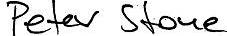
Dr Peter Stone, Deputy Director, CSIRO Sustainable Agriculture Flagship

The Flinders and Gilbert Agricultural Resource Assessment team

Project Director Peter Stone
Project Leaders Cuan Petheram, Ian Watson

Reporting Team Heinz Buettikofer, Becky Schmidt, Maryam Ahmad, Simon Gallant, Frances Marston, Greg Rinder, Audrey Wallbrink
Project Support Ruth Palmer, Daniel Aramini, Michael Kehoe, Scott Podger
Communications Leane Regan, Claire Bobinskas, Dianne Flett2, Rebecca Jennings
Data Management Mick Hartcher

Activities
Agricultural productivity Tony Webster, Brett Cocks, Jo Gentle6, Dean Jones, Di Mayberry,
Perry Poulton, Stephen Yeates, Ainsleigh Wixon
Aquatic and riparian ecology Damien Burrows1, Jon Brodie1, Barry Butler1, Cassandra James1,
Colette Thomas1, Nathan Waltham1
Climate Cuan Petheram, Ang Yang
Instream waterholes David McJannet, Anne Henderson, Jim Wallace1
Flood mapping Dushmanta Dutta, Fazlul Karim, Steve Marvanek, Cate Ticehurst
Geophysics Tim Munday, Tania Abdat, Kevin Cahill, Aaron Davis
Groundwater Ian Jolly, Andrew Taylor, Phil Davies, Glenn Harrington, John Knight, David Rassam
Indigenous water values Marcus Barber, Fenella Atkinson5, Michele Bird2, Susan McIntyre-
Tamwoy5
Water storage Cuan Petheram, Geoff Eades2, John Gallant, Paul Harding3, Ahrim Lee3, Sylvia Ng3, Arthur Read, Lee Rogers, Brad Sherman, Kerrie Tomkins, Sanne Voogt3
Irrigation infrastructure John Hornbuckle
Land suitability Rebecca Bartley, Daniel Brough3, Charlie Chen, David Clifford, Angela Esterberg3, Neil Enderlin3, Lauren Eyres3, Mark Glover, Linda Gregory, Mike Grundy, Ben Harms3, Warren Hicks,
Joseph Kemei, Jeremy Manders3, Keith Moody3, Dave Morrison3, Seonaid Philip, Bernie Powell3, Liz Stower, Mark Sugars3,
Mark Thomas, Seija Tuomi, Reanna Willis3, Peter R Wilson2
River modelling Linda Holz, Julien Lerat, Chas Egan3, Matthew Gooda3, Justin Hughes, Shaun Kim, Alex Loy3, Jean-Michel Perraud, Geoff Podger

Socio-economics Lisa Brennan McKellar, Neville Crossman, Onil Banerjee, Rosalind Bark, Andrew Higgins, Luis Laredo, Neil MacLeod,
Marta Monjardino, Carmel Pollino, Di Prestwidge, Stuart Whitten, Glyn Wittwer4

Note: all contributors are affiliated with CSIRO unless indicated otherwise. Activity Leaders are underlined. 1 TropWATER, James Cook University,
2 Independent consultant, 3 Queensland Government, 4 Monash University, 5 Archaeological Heritage Management Solutions, 6University of Western Sydney

Shortened forms

AEP | annual exceedance probability
AMTD | adopted middle thread distance
APSIM | Agricultural Production Systems Simulator
ARR | Australian Rainfall and Runoff
BOM | Bureau of Meteorology
CMIP | Coupled Model Intercomparison Project
CRC-FORGE | Cooperative Research Centre – Focussed Rainfall Growth Estimation
CSIRO | Commonwealth Scientific and Industrial Research Organisation
DAF | decay amplitude factor
DEM | digital elevation model
DSITIA | Department of Science, Information Technology, Innovation and the Arts (Queensland Government)
EL | elevation level
ENSO | El Niño Southern Oscillation
FSL | full supply level
GS | gauging station
GTSMR | Generalised Tropical Storm Method (revised)
IEAust | The Institute of Engineers Australia
MAF | moisture adjustment factor
MIRORB | MapInfo Runoff Routing program
NQIAS | North Queensland Irrigated Agriculture Strategy
ONA | the Australian Government Office of Northern Australia
PE | potential evaporation
PMF | Probable Maximum Flood
PMP | Probable Maximum Precipitation
PPD | patch point data
RORB | Runoff Routing program
SILO | database of climate data provided by BOM and hosted by DSITIA
SRTM-H | Shuttle Radar Terrain Model
TAF | topographic adjustment factor

Units

MEASUREMENT UNITS | DESCRIPTION
GL | gigalitres, 1,000,000,000 litres
keV | kilo-electronvolts
kL | kilolitres, 1000 litres
km | kilometres, 1000 metres
L | Litres
m | Metres
mAHD | metres above Australian Height Datum
MeV | mega-electronvolts
mg | milligrams
MJ/m2 | megajoules per metre square
ML | megalitres, 1,000,000 litres
mm | millimetres

Preface

The Flinders and Gilbert Agricultural Resource Assessment (the Assessment) aims to provide information so that people can answer questions such as the following in the context of their particular circumstances in the Flinders and Gilbert catchments:
- What soil and water resources are available for irrigated agriculture?
- What are the existing ecological systems, industries, infrastructure and values?
- What are the opportunities for irrigation?
- Is irrigated agriculture economically viable?
- How can the sustainability of irrigated agriculture be maximised?
The questions – and the responses to the questions – are highly interdependent and, consequently, so is the research undertaken through this Assessment. While each report may be read as a stand-alone document, the suite of reports must be read as a whole if they are to reliably inform discussion and decision making on regional development.
The Assessment is producing a series of reports:
- Technical reports present scientific work at a level of detail sufficient for technical and scientific experts to reproduce the work. Each of the 12 research activities (outlined below) has a corresponding technical report.
- Each of the two catchment reports (one for each catchment) synthesises key material from the technical reports, providing well-informed but non-scientific readers with the information required to make decisions about the opportunities, costs and benefits associated with irrigated agriculture.
- Two overview reports – one for each catchment – are provided for a general public audience.
- A factsheet provides key findings for both the Flinders and Gilbert catchments for a general public audience.
All of these reports are available online at <http://www.csiro.au/FGARA>. The website provides readers with a communications suite including factsheets, multimedia content, FAQs, reports and links to other related sites, particularly about other research in northern Australia.
The Assessment is divided into 12 scientific activities, each contributing to a cohesive picture of regional development opportunities, costs and benefits. Preface Figure 1 illustrates the high-level linkages between the 12 activities and the general flow of information in the Assessment. Clicking on an ‘activity box’ links to the relevant technical report.
The Assessment is designed to inform consideration of development, not to enable particular development activities. As such, the Assessment informs – but does not seek to replace – existing planning processes.
Importantly, the Assessment does not assume a given regulatory environment. As regulations can change, this will enable the results to be applied to the widest range of uses for the longest possible time frame.
Similarly, the Assessment does not assume a static future, but evaluates three distinct scenarios:
- Scenario A – historical climate and current development
- Scenario B – historical climate and future irrigation development
- Scenario C – future climate and current development.
As the primary interest was in evaluating the scale of the opportunity for irrigated agriculture development under the current climate, the future climate scenario (Scenario C) was secondary in importance to scenarios A and B. This balance is reflected in the allocation of resources throughout the Assessment.
The approaches and techniques used in the Assessment have been designed to enable application elsewhere in northern Australia.

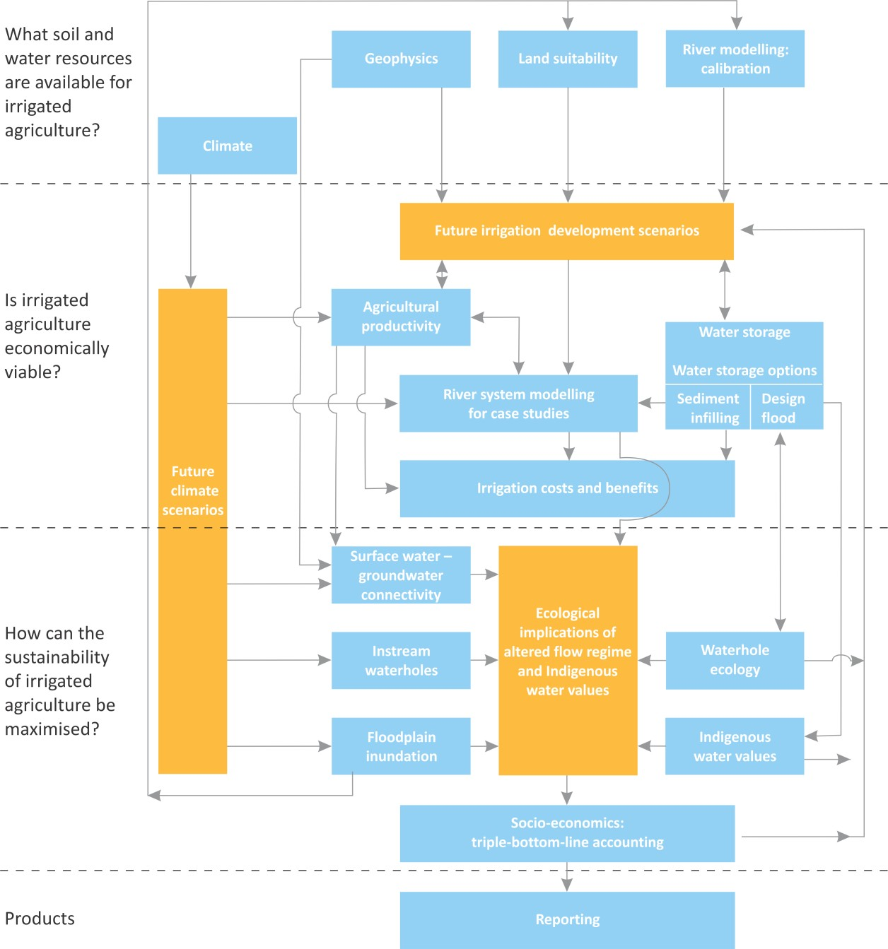

Preface Figure 1 Schematic diagram illustrating high-level linkages between the 12 activities (blue boxes)

The orange boxes indicate information used or produced by several activities. The red oval indicates the activity (or activities) that contributed to this technical report. Click on a box associated with an activity for a link to its technical report (or click on ‘Technical reports’ on <http://www.csiro.au/FGARA> for a list of links to all technical reports). Note that some activities have multiple technical reports – in this case the separate reports are listed under the activity title. Note also that these reports will be published throughout 2013, and hyperlinks to currently unpublished reports will produce an ‘invalid publication’ error in the CSIRO Publication Repository.

Executive summary

Design floods are hypothetical floods (such as “one in a hundred year floods”) used for planning and floodplain management investigations. The primary objective of this study was to estimate design flood discharges at three potential dam sites in the Flinders and Gilbert catchments: the Dagworth dam site on the Einasleigh River, Greenhills dam site on the Gilbert River, and Cavehill dam site on the Cloncurry River. The design flood discharges will be used to develop conceptual arrangements for potential dams at these locations. The purpose of this technical report is to document the methods undertaken for this analysis, present the fitted model results and report on a flood frequency analysis undertaken at each site.
To undertake the design flood discharge analysis, suitable hydrological models for the potential dam sites were developed using the RORB (runoff-routing) program and calibrated against observed historical streamflow data. As part of this process simulated flood hydrographs were fitted to observed hydrographs by modifying the two model parameters that control flood routing (the non-linearity exponent, m, and the routing parameter, kc) and the initial loss parameter. The continuing loss values were calculated using RORB once the other parameters were assigned.
Design rainfall estimates were computed for six different durations using the Probable Maximum Precipitation (PMP) method (BOM 2003a), CRC-FORGE method (Nandakumar et al. 1997) and the method of interpolation between regional estimates of rare rainfalls and PMP (IEAust 1998). To compute the design flood discharges, the RORB models were run with the calibrated routing parameters, recommended initial and continuing loss value for probable maximum flood (PMF) computations (IEAust 1998), storage and spillway configuration information and the aforementioned design rainfall estimates.
The design flood estimates obtained in this study were comparable to design flood estimates made in similar size catchments elsewhere using the same methods. They are, however, considerably larger than design flood estimates made by other studies in these catchments, which were undertaken in the 1970s and 1980s. This is a well-known consequence of changes to the recommended methods for estimating PMP (BOM 2003b). Checks were also undertaken on the peak and total flood volumes, taking into account quantity of rainfall and catchment area.
The design flood estimates provided in this report will be used by the water storage activity to assist in developing conceptual arrangements for the three potential dam sites, including the sizing of spillways and embankments. This will be reported in the companion technical report on water storage (see Preface Figure 1).

Contents

Director’s foreword
i
The Flinders and Gilbert Agricultural Resource Assessment team
i
The Flinders and Gilbert Agricultural Resource Assessment team
ii
Shortened forms
iv
Units
v
Preface
vi
Executive summary
viii

Figures x
Tables xi

1
Introduction
1
2
Catchment descriptions
2
  - Dagworth and Greenhills in Gilbert River catchment 2
  - Cavehill in Flinders River catchment 2

3
Methods
5
4
Available data
7
  - Streamflow data 7
  - Rainfall data 9
    - Pluviograph Data 9
    - Patch point Data (PPD) 9
  - Storage and spillway rating curves 11
  - The RORB runoff-routing model 14
5 Runoff-routing model 14
  - RORB model layout 14
  - Data used for model calibration 27
  - RORB model calibration 28
  - Design rainfall estimation techniques 30
6 Design rainfall 30
  - Design rainfall – probable maximum precipitation (PMP) 30

  - Design rainfall – CRC-FORGE 31
  - Design rainfall – interpolation between CRC-FORGE and PMP 32
  - Design flood estimation and results 36
7 Design event modelling 36
  - Comparison to other studies 39
8
Flood frequency analysis
40
9
Conclusion
43
10
References
44

Appendix A | RORB model calibration hydrographs | 46
Appendix B | PMP calculations | 50
Appendix C | Temporal pattern files | 56
Appendix D | Design inflow and outflow hydrographs | 59
Appendix E | Fitted distribution and confidence limit flood frequency curves | 69

Figures
Figure 2.1 Dagworth and Greenhills catchments, streamflow gauging stations and location of potential
dam sites 3
Figure 2.2 Cavehill catchment area, streamflow gauging station and location of potential dam site 4
Figure 5.1 MapInfo representation of the Dagworth RORB model 15
Figure 5.2 MapInfo representation of the Greenhills RORB model 19
Figure 5.3 MapInfo representation of the Cavehill RORB model 23
Figure 6.1 Plot to determine the AEP of the PMP based on catchment area (IEAust 1998) 32
Figure 6.2 Equation and plot demonstrating the interpolation between CRC-FORGE and PMP design
rainfall (IEAust 1998) 33
Figure A.1 Comparison of Modelled and Gauging Station Flow for Dagworth Peak 2 46
Figure A.2 Comparison of Modelled and Gauging Station Flow for Dagworth Peak 5 47
Figure A.3 Comparison of Modelled and Gauging Station Flow for Greenhills Peak 2 47
Figure A.4 Comparison of Modelled and Gauging Station Flow for Greenhills Peak 3 48
Figure A.5 Comparison of Modelled and Gauging Station Flow for Cavehill Peak 2 48
Figure A.6 Comparison of Modelled and Gauging Station Flow for Cavehill Peak 3 49
Figure A.7 Comparison of Modelled and Gauging Station Flow for Cavehill Peak 6 49
Figure D.1 Dagworth – AEP 1 in 1,000 Years – 120 hour 60
Figure D.2Dagworth – AEP 1 in 10,000 Years – 120 hour 61

Figure D.3 Dagworth – AEP 1 in 55,556 Years – 48 hour 62
Figure D.4 Greenhills – AEP 1 in 1,000 Years – 36 hour 63
Figure D.5 Greenhills – AEP 1 in 10,000 Years – 36 hour 64
Figure D.6 Greenhills – AEP 1 in 90,909 years – 36 hour 65
Figure D.7 Cavehill – AEP 1 in 1,000 Years – 36 hour 66
Figure D.8 Cavehill – AEP 1 in 10,000 Years – 36 hour 67
Figure D.9 Cavehill – AEP 1 in 166,667 Years – 36 hour 68
Figure E.1 Dagworth flood frequency plot 69
Figure E.2 Greenhills flood frequency plot 70
Figure E.3 Cavehill flood frequency plot 70
Tables
Table 4.1 Stream gauging stations used for RORB model calibration 8
Table 4.2 Pluviograph data stations used for RORB model calibration 9
Table 4.3 Patch Point Data stations used for checking of pluviograph data 10
Table 4.4 Potential Dagworth dam spillway rating curve 11
Table 4.5 Potential Greenhills dam spillway rating curve 12
Table 4.6 Potential Cavehill dam spillway rating curve 13
Table 5.1 RORB subcatchment areas - Dagworth 16
Table 5.2 RORB node information – Dagworth 17
Table 5.3 RORB reach information – Dagworth 18
Table 5.4 RORB subcatchment areas – Greenhills 20
Table 5.5 RORB node information – Greenhills 21
Table 5.6 RORB reach information – Greenhills 22
Table 5.7 RORB subcatchment areas – Cavehill 24
Table 5.8 RORB node information – Cavehill 25
Table 5.9 RORB reach information – Cavehill 26
Table 5.10 Streamflow data used for RORB model calibration 27
Table 5.11 Specific peak flow events used for RORB model calibration 27
Table 5.12 Rainfall data used in model calibration 28
Table 5.13 Adopted model parameters for each catchment 29
Table 5.14 Comparison of recorded and calculated peak discharges 29
Table 6.1 Final PMP estimates for each catchment 31
Table 6.2 Standard areas corresponding to the catchments 31
Table 6.3 Description of terms for equation shown above 34
Table 6.4 Design catchment rainfall for Dagworth 34
Table 6.5 Design catchment rainfall for Greenhills 35

Table 6.6 Design catchment rainfall for Cavehill 35
Table 7.1 RORB simulation results of design floods for Dagworth 37
Table 7.2 RORB simulation results of design floods for Greenhills 37
Table 7.3 RORB simulation results of design floods for Cavehill 38
Table 7.4 Comparison of PMP design flood results to other PMP studies 39
Table 8.1 Annual series of recorded maximum discharge used in flood frequency analysis 40
Table 8.2 Flood frequency analysis results - Dagworth (GS 917106A) 41
Table 8.3 Flood frequency analysis results - Greenhills (GS 917001D) 42
Table 8.4 Flood frequency analysis results - Cavehill (GS 915203A) 42

- Introduction

The main objective of the study was to estimate design flood discharges based on design rainfall estimates of various durations to assist in the preliminary design of dams at three potential dam sites in the Flinders and Gilbert catchments: the Dagworth dam site on the Einasleigh River, Greenhills dam site on the Gilbert River, and Cavehill dam site on the Cloncurry River.
Suitable hydrological models for the study catchments were developed using the RORB (runoff- routing) program and calibrated against available historical streamflow data. A comprehensive review of both pluviograph data and Patch Point Data (PPD) (SILO 2013) within the study catchments was undertaken prior to model development. Design rainfall estimates were calculated for a number of different durations using the Probable Maximum Precipitation (PMP) method (BOM 2003a), CRC- FORGE (Nandakumar et al. 1997) and the method of interpolation between regional estimates of rare rainfalls and PMP (using the method described in Australian Rainfall and Runoff, Volume 1, Book VI (IEAust 1998)). In order to obtain the design flood discharges, the RORB models were run with the calibrated routing parameters, storage and spillway configuration information and the aforementioned design rainfall estimates.
This report describes the methods of using the RORB Runoff-Routing models and design rainfall estimates to simulate the design floods. Observed versus simulated flood peaks are presented and flood frequency analyses are reported.

- Catchment descriptions

  - Dagworth and Greenhills in Gilbert River catchment

The greater Gilbert River catchment is located in north-west Queensland with the headwaters being on the western side of the Great Dividing Range and draining north into the Gulf of Carpentaria. One of the main tributaries is the Einasleigh River on which the potential Dagworth dam site is located.
The RORB model for the Dagworth catchment was calibrated to recorded streamflow at the gauging station at the township of Einasleigh on the Einasleigh River (917106a). The catchment area to the gauging station is 8,244 km2. The potential dam site is further downstream on the Einasleigh River and has a total catchment area of 15,318 km2 (see Figure 2.1). The mean annual rainfall experienced in the Dagworth catchment varies across the catchment from 650 to 800 mm. The potential dam site of Greenhills is located on the Gilbert River to the west of the Dagworth catchment. The RORB model was calibrated to the flow recorded at Rockfields gauging station on the Gilbert River (917001d). The catchment area to the gauging station is 10,987 km2. For Greenhills, the potential dam site is upstream of the gauging station with a catchment area of 8,400 km2 (see Figure 2.1). The mean annual rainfall received in different parts of the Greenhills catchment varies from 650 to 750 mm.

  - Cavehill in Flinders River catchment

The greater Flinders River catchment is located in north-west Queensland and boasts the longest river in the state. The river runs from the Burra Range on the western side of the Great Dividing Range and Hughenden in the east to Cloncurry and the Selwyn Ranges in the west. One of the principal tributaries is the Cloncurry River on which the potential Cavehill dam site is located. The RORB model for the Cavehill catchment was calibrated to the streamflow recorded at Cloncurry gauging station on the Cloncurry River (915203b). The catchment area to the gauging station is 5,859 km2. For the Cavehill catchment, the potential dam site is upstream of the gauging station on the Cloncurry River with a catchment area of 5,265 km2 (see Figure 2.2). The mean annual rainfall received in different parts of the Cavehill catchment varies from 350 to 400 mm.

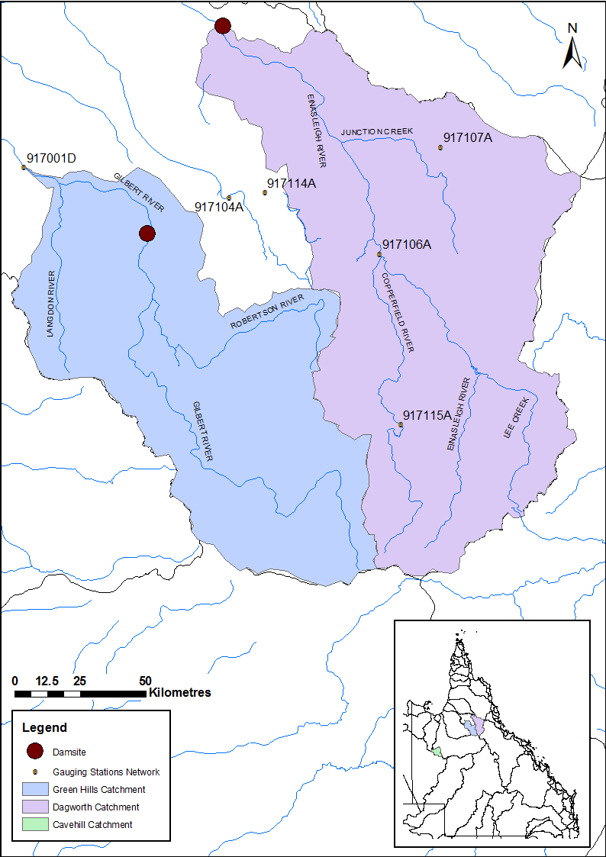

Figure 2.1 Dagworth and Greenhills catchments, streamflow gauging stations and location of potential dam sites

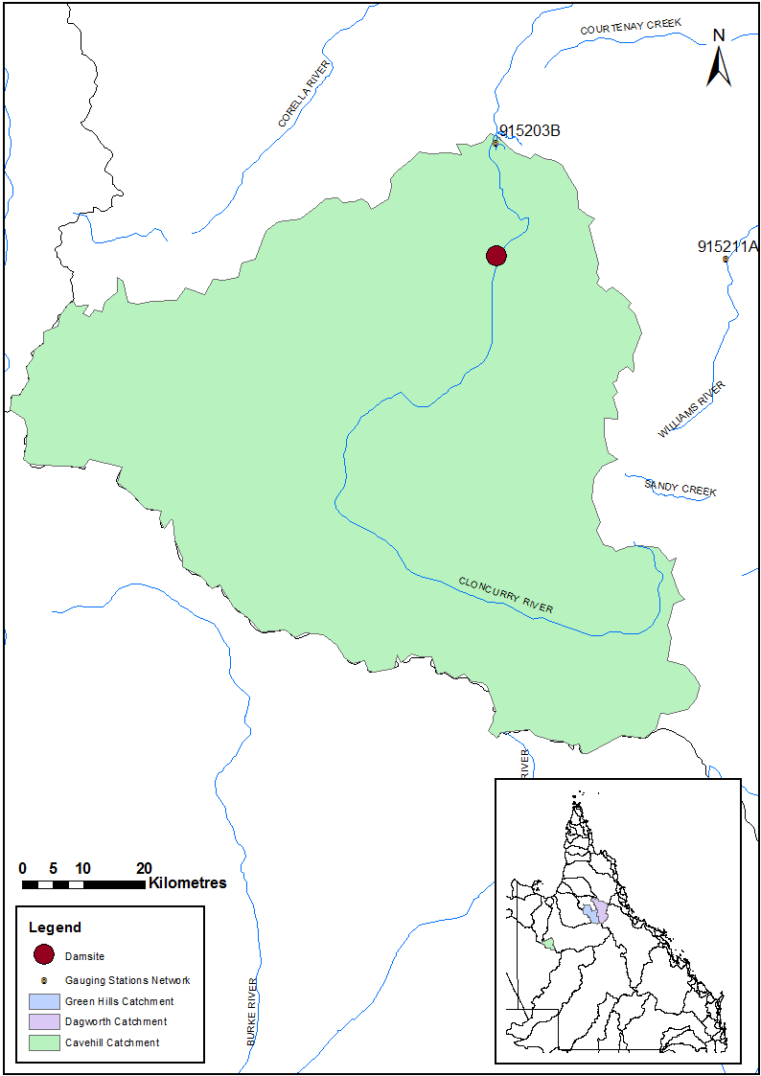

Figure 2.2 Cavehill catchment area, streamflow gauging station and location of potential dam site

- Methods

The RORB modelling and design flood estimation for the Dagworth, Greenhills and Cavehill catchments was undertaken using a consistent set of methods. A systematic approach was adopted, which included the following steps:

Comprehensive review of the data
- Extraction of available streamflow data at the relevant gauging stations (917106a, 917001d and 915203b) and selection of the six highest peak flow events at each station against which to calibrate. Review of the quality of the recorded data for the selected periods.
- Extraction of pluviograph data and PPD and extensive review of the quality and validity of the rainfall data.
- Comparison of period of available data between selected peak flow events and rainfall data.
- Review of the storage-discharge characteristics of the three potential dams.

Model construction
- Design of RORB catchments including subareas, inflow nodes and reach links using MiRORB. MiRORB is a tool which uses the functionality of the GIS package MapInfo to generate RORB catchment files (SKM 2010).
- Exportation of RORB catchment files from MiRORB and allocation of appropriate output locations and calibration points (i.e. gauging stations and potential dam sites – see Section 2).

Model calibration
- Selection of peak streamflow events for calibration. As mentioned above, the six highest streamflow events were extracted for each of the gauging stations. Due, however, to lack of rainfall data for a number of the peak streamflow events, the models were calibrated to either two or three events. Dagworth and Greenhills both had two peak streamflow events against which to calibrate. Cavehill had three peak streamflow events. The peak streamflow events are discussed further in Section 5.
- Preparation of streamflow data for calibration.
- Generation of storm files for input into RORB for the selected peak events. The rainfall data used for calibration was predominantly pluviograph data, however in some cases the pluviograph data had to be scaled by rainfall observed at PPD stations (SILO 2013) due to low quality or incorrect data. That is, the pluviograph data were used to provide the sub-daily temporal pattern to the PPD (see Section 0 for the description of cases for which rainfall had to be scaled).
- Calibration of the RORB model against the peak historic flood events by adjusting routing model parameters (kc and m).

Design flow discharge estimation:
- Design rainfalls of varying AEPs (annual exceedance probabilities) were estimated for each catchment. The annual exceedance probability is defined as “the probability that a given rainfall total accumulated over a given duration will be exceeded in any one year” (BOM 2013). The following design rainfalls were estimated:
  - 1 in 1,000 year AEP (CRC-FORGE)
  - 1 in 2,000 year AEP (CRC-FORGE)
  - 1 in 10,000 year AEP (interpolation between CRC-FORGE and PMP)
  - PMP

Methods | 5

- Inclusion of storages in RORB models using storage dimension and discharge information from a companion technical report.
- Running of calibrated RORB models (including storage) for each catchment with the estimated design rainfall mentioned above (except the 1 in 2,000 year AEP) for the following duration design storms:
  - 24 hour
  - 36 hour
  - 48 hour
  - 72 hour
  - 96 hour
  - 120 hour
- Selection of a critical duration flood based on maximum modelled storage outflow (m3 per second).

- Available data

Data required for this study included hydro-meteorological data for calibration of the runoff-routing models as well as storage dimension and spillway information for the three potential dams. Historical streamflow and rainfall data were collected for the selected peak streamflow events for the three catchments, and storage information was obtained from the companion technical report on water storages (see Preface Figure 1) and computed using the hydrologically corrected Shuttle Radar Terrain Model (SRTM-H).

  - Streamflow data

Historical streamflow records for three gauging stations were used for the calibration of the three runoff-routing models. The gauging stations to which each of the three RORB catchments were calibrated are mentioned in Section 2. Details for these gauging stations are provided in Table 4.1.

Available data | 7

Table 4.1 Stream gauging stations used for RORB model calibration

CATCHMENT | STATION NUMBER | LOCATION | LATITUDE | LONGITUDE | AMTD (KM) | CATCHMENT AREA (KM2) | PERIOD OF RECORD | HIGHEST GAUGED HEIGHT (M) & DATE OF GAUGING | HIGHEST GAUGED DISCHARGE (M3/S) & DATE OF GAUGING
Dagworth | 917106A | Einasleigh River at Einasleigh | -18.50 | 144.10 | 276 | 8,244 | 10/12/1966 – Current | 11.3  15/02/1968 | 3,455  15/02/1968
Greenhills | 917001D | Gilbert River at Rock Fields | -18.20 | 142.87 | 276 | 10,987 | 14/01/1967 – Current | 6.1  22/03/2012 | 1,413  22/03/2012
Cavehill | 915203B | Cloncurry River at Cloncurry | -20.70 | 140.49 | 327.6 | 5,859 | 01/10/1994 – Current | 1.7  18/03/1997 | 28.4  02/12/1999

Rainfall data

Quality rainfall data is crucial for calibrating runoff-routing models as the temporal variation in rainfall is one of the most significant factors defining the shape and magnitude of the flood hydrographs. Due to the importance of spatial and temporal variation of rainfall depths over each of the catchments, both pluviograph and PPD were collected and checked thoroughly. In particular, comparisons were made between the pluviograph data and the rainfall observed at the PPD stations. This provided an additional quality check of the rainfall depths observed in the pluviograph data and in some cases highlighted periods during which the quality of pluviograph data were poor.

PLUVIOGRAPH DATA

Pluviograph data stations across Queensland record continuous rainfall during storm events. For this study, three stations were used for the model calibrations (see Table 4.2). Pluviograph data for these stations were extracted in six minute intervals and then summed to hourly intervals. The six minute interval rainfall data had to be converted to hourly interval data in order to match the hourly timestep of the streamflow data. A description of the exact rainfall used for the three RORB calibrations is provided in Section 0.

Table 4.2 Pluviograph data stations used for RORB model calibration

CATCHMENT | STATION NUMBER | STATION NAME | LATITUDE | LONGITUDE | START DATE | END DATE
Dagworth | 30014 | Einasleigh Township | -18.519 | 144.091 | Dec-65 | Sep-08
Greenhills | 30112 | North Head | -18.824 | 143.253 | Aug-94 | Sep-06
Cavehill | 29141 | Cloncurry Airport | -20.666 | 140.505 | Feb-97 | Aug-12

PATCH POINT DATA (PPD)

There are a number of rainfall PPD stations managed by the Bureau of Meteorology (BoM) located within the study catchment areas. Daily data from some of the PPD stations were extracted and compared to the (summed daily) pluviograph data. These comparisons were then used to infill or scale the pluviograph data in instances where pluviograph data were missing or values were of poor quality. Details of the rainfall stations used for the comparisons in this study are provided in Table 4.3. Highlighted stations were those that were ultimately used for scaling or infilling of rainfall data (see Section 0 for further information).

Table 4.3 Patch Point Data stations used for checking of pluviograph data (highlighted stations were used for scaling or infilling of final model calibration rainfall)
CATCHMENT
STATION
NUMBER
STATION NAME
LATITUDE
LONGITUDE
START DATE END DATE

 | 30030 | Lyndhurst Station | -19.204 | 144.37 | Apr-1886 | Present
Dagworth | 30073 | Van Lee | -17.85 | 143.703 | Mar-68 | Feb-09
 | 30103 | Eveleigh Station | -18.223 | 143.97 | Jan-40 | Present

Cavehill
Greenhills | 30019 | Gilberton | -19.261 | 143.686 | Apr-18 | Present
 | 30090 | Bagstowe Station | -19.196 | 144.001 | Apr-64 | Present
 | 30107 | Robin Hood Station | -18.838 | 143.709 | Oct-66 | Present
 | 29161 | Brightlands Station | -21.073 | 140.281 | Nov-87 | Present
 | 29129 | Devoncourt Station | -21.215 | 140.233 | Feb-1887 | Present

29136 Farley Station -21.366 140.499 Jan-77 Present

Storage and spillway rating curves

Information on the storage characteristics of three potential dams were obtained from the companion technical report on water storage (see Preface Figure 1). This information included the storage curve data and the spillway discharge rating curve for the three potential dams. The spillway rating curves had to be extended for the three potential storages as the maximum floods were higher than the maximum heights provided in the discharge curve. While the storage height and volume relationship was available for these high water levels, the storage discharge (in cubic metres per second) had to be extrapolated using the equation for flow over a weir. The spillway discharge curves for the potential storages are shown in the Table 4.4, Table 4.5 and Table 4.6 for Dagworth, Greenhills and Cavehill respectively. The highlighted cells indicate the discharge values that were extrapolated. These are the final storage spillway rating curves used in the RORB modelling.

Table 4.4 Potential Dagworth dam spillway rating curve

HEIGHT ABOVE FSL (M) | HEIGHT (M) | STORAGE VOLUME (M3) | DISCHARGE (M3/S)
0 | 227 | 498,187,110 | 0
1 | 228 | 558,931,902 | 500
2 | 229 | 623,766,894 | 1,430
3 | 230 | 692,650,030 | 2,700
4 | 231 | 765,549,646 | 4,260
5 | 232 | 842,584,306 | 6,100
6 | 233 | 923,772,894 | 8,230
7 | 234 | 1,009,121,050 | 10,640
8 | 235 | 1,098,557,438 | 13,310
9 | 236 | 1,192,115,574 | 16,250
10 | 237 | 1,289,969,370 | 19,480
11 | 238 | 1,392,205,826 | 22,980
12 | 239 | 1,499,110,966 | 26,770
13 | 240 | 1,610,785,678 | 30,180
14 | 241 | 1,727,272,114 | 33,730
15 | 242 | 1,848,491,870 | 37,400
16 | 243 | 1,974,609,698 | 41,216
17 | 244 | 2,105,546,942 | 45,140
18 | 245 | 2,241,380,182 | 49,181
19 | 246 | 2,382,063,830 | 53,335
20 | 247 | 2,527,680,158 | 57,601
21 | 248 | 2,678,336,334 | 61,975
22 | 249 | 2,834,281,826 | 66,454

Table 4.5 Potential Greenhills dam spillway rating curve

HEIGHT ABOVE FSL (M) | HEIGHT (M) | STORAGE VOLUME (M3) | DISCHARGE (M3/S)
0 | 253 | 227,197,062 | 0
1 | 254 | 271,348,014 | 330
2 | 255 | 321,325,878 | 950
3 | 256 | 377,597,294 | 1,780
4 | 257 | 440,551,010 | 2,820
5 | 258 | 510,793,434 | 4,030
6 | 259 | 588,657,794 | 5,440
7 | 260 | 674,330,326 | 7,030
8 | 261 | 767,759,534 | 8,800
9 | 262 | 869,409,506 | 10,740
10 | 263 | 979,874,096 | 12,880
11 | 264 | 1,099,909,887 | 15,190
12 | 265 | 1,230,099,321 | 17,700
13 | 266 | 1,365,128,121 | 19,950
14 | 267 | 1,500,156,921 | 22,300
15 | 268 | 1,635,185,721 | 24,700
16 | 269 | 1,770,214,521 | 27,232
17 | 270 | 1,905,243,321 | 29,824
18 | 271 | 2,040,272,121 | 32,494
19 | 272 | 2,175,300,921 | 35,240
20 | 273 | 2,310,329,721 | 38,058
21 | 274 | 2,445,358,521 | 40,948
22 | 275 | 2,580,387,321 | 43,907
23 | 276 | 2,715,416,121 | 46,934
24 | 277 | 2,850,444,921 | 50,028
25 | 278 | 2,985,473,721 | 53,188
26 | 279 | 3,120,502,521 | 56,410
27 | 280 | 3,255,531,321 | 59,696
28 | 281 | 3,390,560,121 | 63,043
29 | 282 | 3,525,588,921 | 66,450
30 | 283 | 3,660,617,721 | 69,917
31 | 284 | 3,795,646,521 | 73,442

Table 4.6 Potential Cavehill dam spillway rating curve

HEIGHT ABOVE FSL (M) | HEIGHT (M) | STORAGE VOLUME (M3) | DISCHARGE (M3/S)
0 | 224 | 248,067,069 | 0
1 | 225 | 301,554,081 | 425
2 | 226 | 361,343,569 | 1,240
3 | 227 | 426,562,329 | 2,340
4 | 228 | 496,630,105 | 3,700
5 | 229 | 571,880,769 | 5,301
6 | 230 | 652,855,893 | 7,170
7 | 231 | 740,395,821 | 9,250
8 | 232 | 834,847,989 | 11,310
9 | 233 | 935,075,123 | 13,500
10 | 234 | 1,041,268,979 | 15,810
11 | 235 | 1,153,625,049 | 18,240
12 | 236 | 1,272,235,975 | 20,780
13 | 237 | 1,397,389,041 | 23,430
14 | 238 | 1,522,542,107 | 26,190
15 | 239 | 1,647,695,173 | 29,040
16 | 240 | 1,772,848,239 | 32,000
17 | 241 | 1,898,001,305 | 35,046
18 | 242 | 2,023,154,371 | 38,184
19 | 243 | 2,148,307,437 | 41,410
20 | 244 | 2,273,460,503 | 44,721
21 | 245 | 2,398,613,569 | 48,117
22 | 246 | 2,523,766,635 | 51,595
23 | 247 | 2,648,919,701 | 55,152
24 | 248 | 2,774,072,767 | 58,788
25 | 249 | 2,899,225,833 | 62,500
26 | 250 | 3,024,378,899 | 66,287
27 | 251 | 3,149,531,965 | 70,148
28 | 252 | 3,274,685,031 | 74,081
29 | 253 | 3,399,838,097 | 78,085

- Runoff-routing model

The RORB runoff-routing model

For this study, the RORB (runoff-routing) model was used to simulate design floods. The models were calibrated to recorded historical streamflow data using historical rainfall records, routing parameters and catchment loss parameters. MiRORB was used to generate the catchment files required for RORB. The layout of the RORB model for each catchment is provided in Section 5.2.

RORB model layout

The model layout of the pre-dam RORB calibration model for Dagworth is shown in Figure 5.1. The RORB model characteristics are tabulated in Table 5.1 (subcatchment areas), Table 5.2 (inflow node information) and Table 5.3 (reach information).
The model layout of the pre-dam RORB calibration model for Greenhills is shown in Figure 5.2. The RORB model characteristics are tabulated in Table 5.4 (subcatchment areas), Table 5.5 (inflow node information) and Table 5.6 (reach information).
The model layout of the pre-dam RORB calibration model for Cavehill is shown in Figure 5.3. The RORB model characteristics are tabulated in Table 5.7 (subcatchment areas), Table 5.8 (inflow node information) and Table 5.9 (reach information).

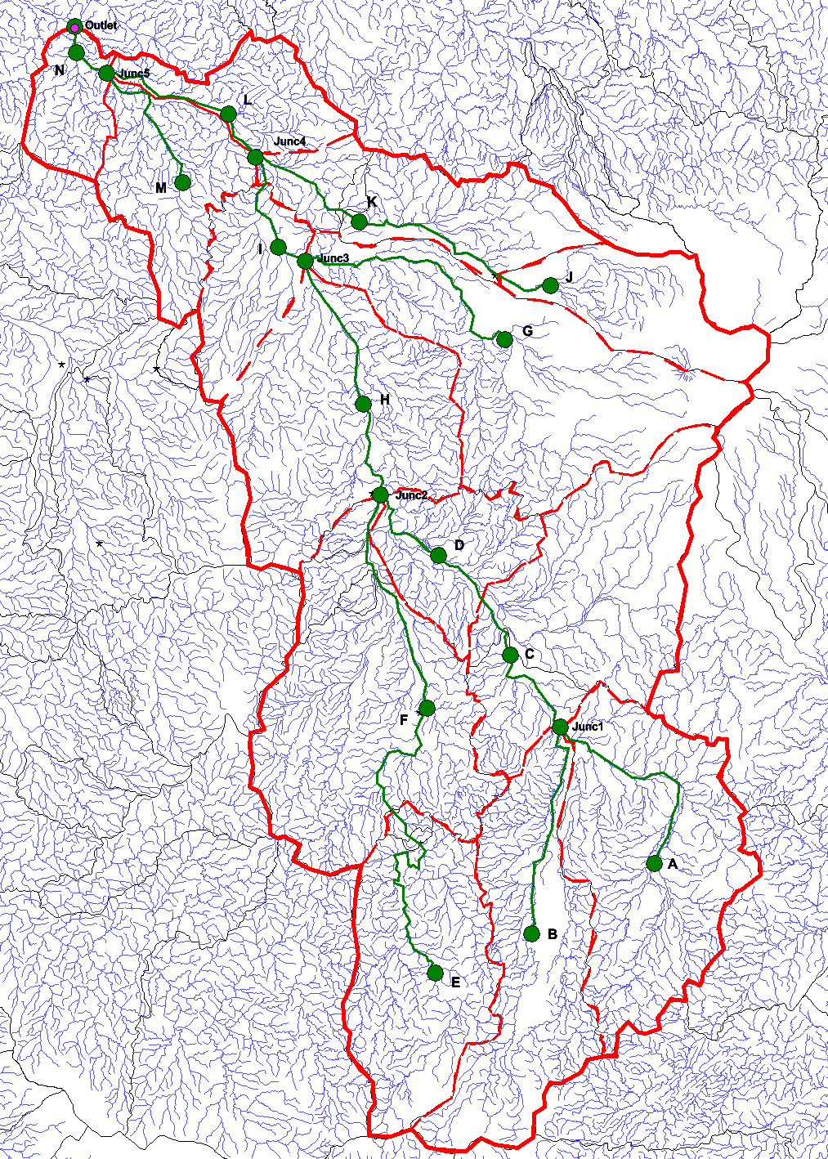

Figure 5.1 MapInfo representation of the Dagworth RORB model

Table 5.1 RORB subcatchment areas - Dagworth

SUBAREA ID | AREA (KM2)
A | 1,589
B | 1,314
C | 1,625
D | 593
E | 1,252
F | 1,888
G | 1,771
H | 1,594
I | 543
J | 657
K | 900
L | 490
M | 750
N | 352

Table 5.2 RORB node information – Dagworth

NODE | LATITUDE | LONGITUDE | ELEVATION (M)
A | -19.119 | 144.582 | 565
B | -19.237 | 144.365 | 610
Junc1 | -18.890 | 144.417 | 515
C | -18.769 | 144.329 | 490
D | -18.602 | 144.201 | 465
E | -19.303 | 144.195 | 725
F | -18.858 | 144.181 | 505
Junc2 | -18.501 | 144.098 | 435
H | -18.349 | 144.069 | 380
G | -18.240 | 144.318 | 435
Junc3 | -18.109 | 143.966 | 335
I | -18.085 | 143.917 | 330
J | -18.150 | 144.399 | 485
K | -18.043 | 144.061 | 350
Junc4 | -17.934 | 143.877 | 280
L | -17.862 | 143.829 | 260
M | -17.978 | 143.748 | 285
Junc5 | -17.793 | 143.614 | 210
Outlet | -17.715 | 143.557 | 200

Table 5.3 RORB reach information – Dagworth

REACH |  | REACH LENGTH (KM) | ELEVATION (M | ) | SLOPE (%)
From Node | To Node |  | Start of Reach E | nd of Reach
A | Junc1 | 42.67 | 565 | 515 | 0.117
B | Junc1 | 43.34 | 610 | 515 | 0.219
Junc1 | C | 20.06 | 515 | 490 | 0.125
C | D | 24.56 | 490 | 465 | 0.102
D | Junc2 | 18.55 | 465 | 435 | 0.162
E | F | 72.24 | 725 | 505 | 0.305
F | Junc2 | 43.90 | 505 | 435 | 0.159
Junc2 | H | 19.71 | 435 | 380 | 0.279
H | Junc3 | 29.83 | 380 | 335 | 0.151
G | Junc3 | 50.29 | 435 | 335 | 0.199
Junc3 | I | 5.76 | 335 | 330 | 0.087
I | Junc4 | 19.61 | 330 | 280 | 0.255
J | K | 41.87 | 485 | 350 | 0.322
K | Junc4 | 24.74 | 350 | 280 | 0.283
Junc4 | L | 10.10 | 280 | 260 | 0.198
L | Junc5 | 25.80 | 260 | 210 | 0.194
M | Junc5 | 29.32 | 285 | 210 | 0.256
Junc5 | N | 7.08 | 210 | 205 | 0.071
N | Outlet | 5.01 | 205 | 200 | 0.100

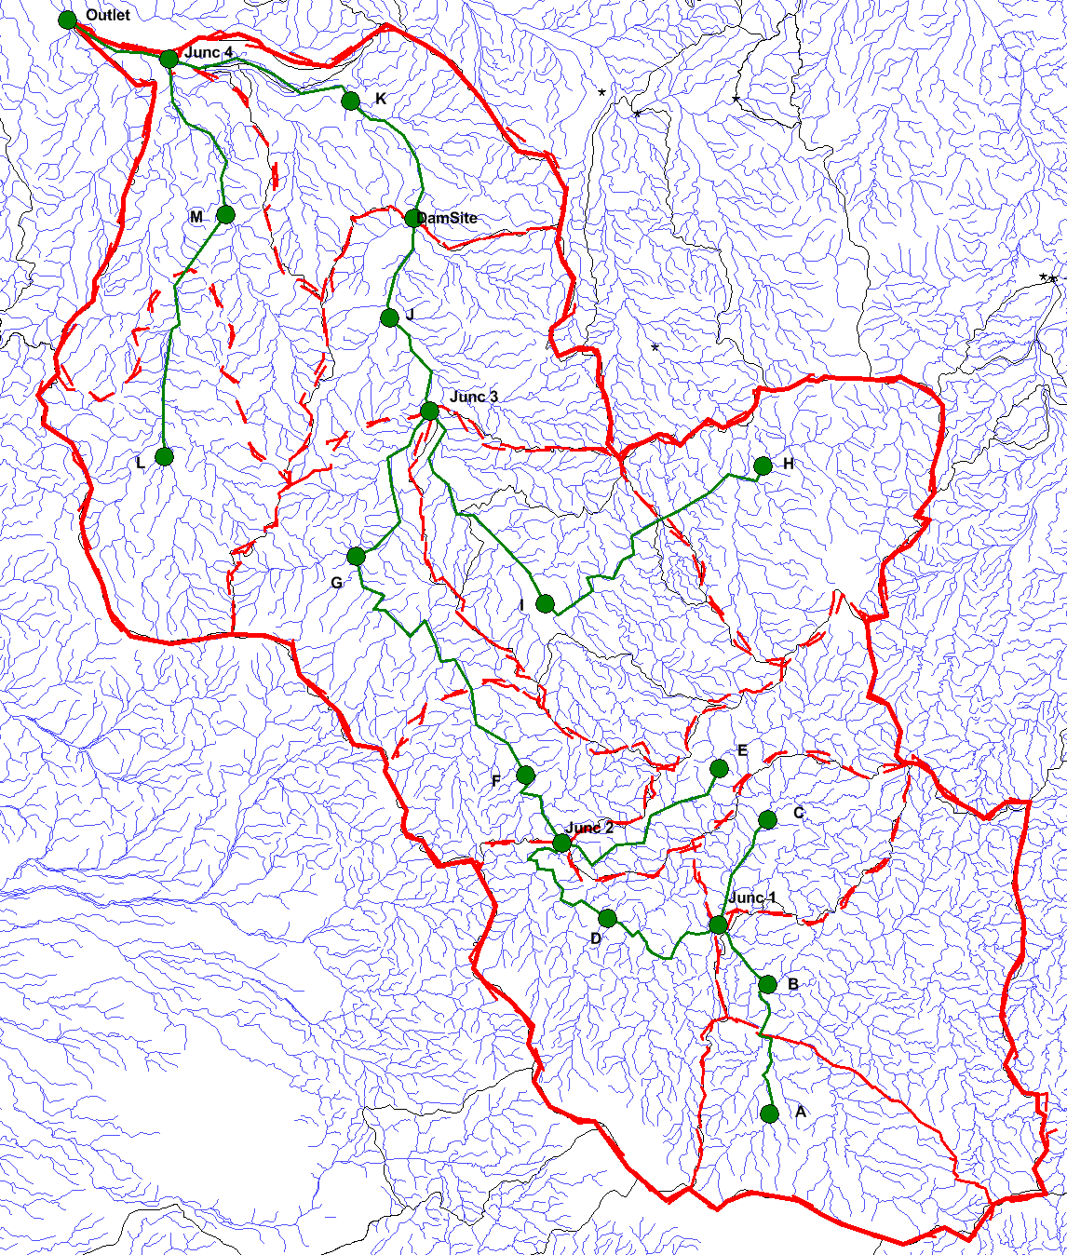

Figure 5.2 MapInfo representation of the Greenhills RORB model

Table 5.4 RORB subcatchment areas – Greenhills

SUBAREA ID | AREA (KM2)
A | 638
B | 1,254
C | 437
D | 995
E | 535
F | 543
G | 863
H | 996
I | 1,206
J | 933
K | 918
L | 878
M | 891

Table 5.5 RORB node information – Greenhills

NODE | LATITUDE | LONGITUDE | ELEVATION (M)
A | -19.485 | 143.744 | 670
B | -19.334 | 143.742 | 515
C | -19.139 | 143.741 | 545
D | -19.256 | 143.542 | 440
E | -19.079 | 143.681 | 520
F | -19.087 | 143.440 | 385
G | -18.829 | 143.229 | 305
H | -18.722 | 143.735 | 420
I | -18.885 | 143.464 | 325
J | -18.548 | 143.270 | 250
K | -18.292 | 143.222 | 215
L | -18.711 | 142.989 | 260
M | -18.426 | 143.066 | 220
Junc1 | -19.263 | 143.681 | 490
Junc2 | -19.167 | 143.485 | 440
Junc3 | -18.657 | 143.321 | 270
Junc4 | -18.243 | 142.996 | 190
Damsite | -18.43 | 143.301 | 235
Outlet | -18.197 | 142.870 | 170

Table 5.6 RORB reach information – Greenhills

REACH |  | REACH LENGTH (KM) | ELEVATION (M | ) | SLOPE (%)
From Node | To Node |  | Start of Reach E | nd of Reach
A | B | 20.25 | 670 | 515 | 0.765
B | Junc 1 | 10.29 | 515 | 490 | 0.243
C | Junc 1 | 15.47 | 545 | 490 | 0.356
Junc1 | D | 19.47 | 490 | 440 | 0.257
D | Junc 2 | 21.41 | 440 | 440 | 0.000
E | Junc 2 | 28.23 | 520 | 440 | 0.283
Junc 2 | F | 13.52 | 440 | 385 | 0.407
F | G | 44.58 | 385 | 305 | 0.179
G | Junc 3 | 24.56 | 305 | 270 | 0.143
H | I | 40.97 | 420 | 325 | 0.232
I | Junc 3 | 33.49 | 325 | 270 | 0.164
Junc 3 | J | 14.59 | 270 | 250 | 0.137
J | Damsite | 14.01 | 250 | 235 | 0.107
Damsite | K | 20.16 | 235 | 215 | 0.099
K | Junc 4 | 26.67 | 215 | 190 | 0.094
L | M | 34.46 | 260 | 220 | 0.116
M | Junc 4 | 23.75 | 220 | 190 | 0.126
Junc 4 | Outlet | 14.64 | 190 | 170 | 0.137

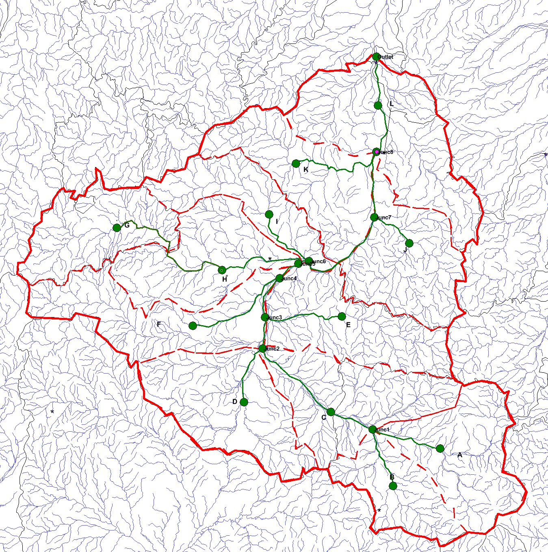

Figure 5.3 MapInfo representation of the Cavehill RORB model

Table 5.7 RORB subcatchment areas – Cavehill

SUBAREA ID | AREA (KM2)
A | 496
B | 313
C | 541
D | 574
E | 512
F | 544
G | 428
H | 505
I | 347
J | 497
K | 508
L | 716

Table 5.8 RORB node information – Cavehill

NODE | LATITUDE | LONGITUDE | ELEVATION (M)
A | -21.418 | 140.622 | 365
B | -21.487 | 140.529 | 355
Junc 1 | -21.382 | 140.488 | 330
C | -21.350 | 140.405 | 315
D | -21.331 | 140.232 | 290
Junc 2 | -21.232 | 140.270 | 275
E | -21.173 | 140.427 | 300
Junc 3 | -21.174 | 140.274 | 270
F | -21.190 | 140.131 | 305
Junc 4 | -21.102 | 140.303 | 255
G | -21.009 | 139.980 | 335
H | -21.087 | 140.189 | 275
Junc 5 | -21.075 | 140.341 | 250
I | -20.984 | 140.282 | 270
Junc 6 | -21.070 | 140.362 | 245
J | -21.037 | 140.561 | 245
Junc 7 | -20.989 | 140.492 | 225
K | -20.890 | 140.336 | 255
Junc 8 | -20.868 | 140.496 | 215
L | -20.782 | 140.499 | 200
Outlet | -20.692 | 140.496 | 185

Table 5.9 RORB reach information – Cavehill

REACH |  | REACH LENGTH (KM) | ELEVATION (M | ) | SLOPE (%)
From Node | To Node |  | Start of Reach E | nd of Reach
A | Junc1 | 14.98 | 365 | 330 | 0.234
B | Junc1 | 12.80 | 355 | 330 | 0.195
Junc1 | C | 9.63 | 330 | 315 | 0.156
C | Junc2 | 19.84 | 315 | 275 | 0.202
D | Junc2 | 12.77 | 290 | 275 | 0.117
Junc2 | Junc3 | 6.56 | 275 | 270 | 0.076
E | Junc3 | 16.81 | 300 | 270 | 0.178
Junc3 | Junc4 | 9.39 | 270 | 255 | 0.160
F | Junc4 | 22.46 | 305 | 255 | 0.223
Junc4 | Junc5 | 5.40 | 255 | 250 | 0.093
G | H | 31.16 | 335 | 275 | 0.193
H | Junc5 | 18.74 | 275 | 250 | 0.133
Junc5 | Junc6 | 2.36 | 250 | 245 | 0.212
I | Junc6 | 14.72 | 270 | 245 | 0.170
Junc6 | Junc7 | 20.55 | 245 | 225 | 0.097
J | Junc7 | 9.44 | 245 | 225 | 0.212
Junc7 | Junc8 | 13.85 | 225 | 215 | 0.072
K | Junc8 | 21.90 | 255 | 215 | 0.183
Junc8 | L | 11.02 | 215 | 200 | 0.136
L | Outlet | 10.34 | 200 | 185 | 0.145

Data used for model calibration

In order to calibrate the RORB models for each study area, historical hourly instantaneous streamflow was extracted for the three relevant gauging stations and the model calibrated to two peak events for Dagworth and Greenhills and three peak events for Cavehill. Periods of streamflow data used for the calibration are summarised in Table 5.10, and Table 5.11 provides the actual timing of the flood peak events used for calibration. The historical rainfall data used to create the storm file input to the RORB models are summarised in Table 5.12.

Table 5.10 Streamflow data used for RORB model calibration

DAM SITE | STREAMFLOW GAUGING STATION | CATCHMENT AREA (KM2) | CALIBRATION PEAK ID |  | CALIBRATION PERIOD  Start End
Dagworth | 917106a | 15,316 | Peak 2 |  | 10/02/2002 | 23/02/2002
 |  |  | Peak 5 |  | 01/01/1981 | 23/01/1981

Greenhills 917001d 11,086
Peak 2 22/01/2009 29/01/2009

Peak 3 12/02/2002 19/02/2002

Cavehill | 915203b | 5,981 | Peak 2 |  | 01/01/2009 | 13/01/2009
 |  |  | Peak 3 |  | 10/01/2004 | 22/01/2004
 |  |  | Peak 6 |  | 05/02/2009 | 17/02/2009

Table 5.11 Specific peak flow events used for RORB model calibration

DAM SITE | STREAMFLOW GAUGING STATION | CALIBRATION PEAK ID | MAXIMUM FLOW (M3/S) | ACTUAL PEAK START | ACTUAL PEAK END | ACTUAL TIME OF PEAK
Dagworth | 917106a | Peak 2 | 4,535 | 13/02/2002 | 04/03/2002 | 16/02/2002 13:00
 |  | Peak 5 | 3,466 | 03/01/1980 | 25/03/1980 | 21/01/1981 08:00
Greenhills | 917001d | Peak 2 | 6,373 | 20/01/2009 | 31/01/2009 | 27/01/2009 21:00
 |  | Peak 3 | 5,702 | 16/02/2002 | 19/02/2002 | 17/02/2002 00:00
 |  | Peak 2 | 3,645 | 06/01/2008 | 13/01/2009 | 08/01/2009 16:00
Cavehill | 915203b | Peak 3 | 3,545 | 11/01/2004 | 30/01/2004 | 16/01/2004 05:00
 |  | Peak 6 | 3,345 | 07/02/2009 | 27/02/2009 | 10/02/2009 10:00

Table 5.12 Rainfall data used in model calibration

DAMSITE | CALIBRATION PEAK ID | STREAMFLOW USED FOR CALIBRATION PERIOD  Start End |  | PLUVIOGRAPH STATION NUMBER | NUMBER OF RAINFALL BURSTS IN RORB STORM FILE | COMMENT ON RAINFALL USED FOR PEAK CALIBRATION
Dagworth | Peak 2 | 10/02/2002 | 23/02/2002 | 30014 | 3 | Unaltered pluviograph rainfall data were used for calibration
 | Peak 5 | 1/01/1981 | 23/01/1981 | 30014 | 2 | Unaltered pluviograph rainfall data were used for calibration

Peak 2 22/01/2009 29/01/2009 30112 2
Unaltered pluviograph rainfall data were used for calibration

Greenhills
Peak 3 | 12/02/2002 | 19/02/2002 | 30112 | 3
Peak 2 | 1/01/2009 | 13/01/2009 | 29141 | 2
Peak 3 | 10/01/2004 | 22/01/2004 | 29141 | 1
Peak 6 | 5/02/2009 | 17/02/2009 | 29141 | 1

Unaltered pluviograph rainfall data were used for the first burst of rainfall
The pluviograph data were scaled by rainfall station 30107 for the second burst of rainfall (rainfall in pluviograph was low compared to PPD rainfall stations in the catchment and recorded flow) The pluviograph data were scaled by rainfall station 30090 for the third burst of rainfall (rainfall in
pluviograph was high compared to PPD rainfall stations in the catchment and recorded flow)

Cavehill
Unaltered pluviograph rainfall
data were used for the first burst of rainfall
The pluviograph data were scaled by rainfall station 29161 for the second burst of rainfall (rainfall in pluviograph was low compared to PPD rainfall stations in the catchment and recorded flow)
Unaltered pluviograph rainfall data were used for calibration
Unaltered pluviograph rainfall data were used for calibration

RORB model calibration

The RORB model calibration was undertaken using the calibration periods and selected peak events provided in Table 5.10 and Table 5.11. In order to calibrate the RORB model, two parameters which control flood routing (the non-linearity exponent, m, and the routing parameter, kc) and the initial loss parameter were systematically altered to attempt to match the historical flood data and mimic the flood routing characteristics of each catchment. A value of 0.8 was used for the exponent m. This value was judged to be a reasonably conservative value for estimating extreme floods in all three catchments (IEAust 1998). An initial loss of 5 mm was used in the model run and this was found to be satisfactory based on the matching starting times of the modelled and recorded hydrographs for each catchment. The parameter kc was then adjusted in order to calibrate the modelled flow to the historical floods. Once the other parameters were

assigned, the continuous loss was calculated by RORB based on a mass balance in the model. The continuous losses were calculated for each burst of rainfall and they were generally found to be reasonable for all peaks. Those bursts that have high continuous losses demonstrate rainfall which is inconsistent (i.e. too high) with the streamflow recorded during the flood event. Table 5.13 shows the adopted values of kc, m and losses for each catchment as a result of the model calibration.

Table 5.13 Adopted model parameters for each catchment

DAMSITE
CALIBRATION
PEAK ID
KC
M
INITIAL LOSS
(MM)
NUMBER OF
BURSTS
CONTINUOUS LOSS
(MM/H)
Peak 2
3
Dagworth 275 0.8 5
Peak 5 2
Burst 1 - 9.61
Burst 2 - 5.02
Burst 3 - 1.99
Burst 1 - 2.03
Burst 2 - 3.52

Greenhills

Peak 2

100 0.8 5
2 Burst 1 - 4.79
Burst 2 - 1.98
Burst 1 - 12.85

Peak 3 3
Burst 2 - 34.30
Burst 3 - 4.86

Peak 2
2
Cavehill
Peak 3
70
0.8
5
1
Burst 1 -10.19
Burst 2 - 4.30
Burst 1 - 6.19
Peak 6
1
Burst 1 - 7.97

The calibrated model performance for all three catchments is shown in the hydrograph plots of recorded versus calculated runoff in Appendix A. The comparisons of recorded and modelled peak discharges are given in the Table 5.14.

Table 5.14 Comparison of recorded and calculated peak discharges
DAMSITE
STREAMFLOW
GAUGING STATION
PEAK DISCHARGE (M3/S)
CALIBRATION
PEAK ID

Recorded | Modelled
Peak 2 4,535  Dagworth 917106A  Peak 5 3,466 | 4,569  4,202
Peak 2 6,373  Greenhills 917001D  Peak 3 5,702 | 6,632  5,500
Peak 2 3,645 | 3,652
Cavehill 915203B Peak 3 3,581 | 3,623
Peak 6 3,345 | 3,123

- Design rainfall

Design rainfall estimation techniques

Three approaches to estimating design rainfall were used for this study. The approaches are as follows:
- PMP – a deterministic method to estimate extreme catchment rainfall based on meteorology and local catchment factors (BOM 2003a).
- CRC-FORGE point rainfall estimates for 1 in 1,000 year design rainfall (Nandakumar et al. 1997).
- Interpolation between the PMP and CRC-FORGE estimates to obtain a 1 in 10,000 year design rainfall estimate (IEAust 1998).

Design rainfall – probable maximum precipitation (PMP)

PMP has been defined by the World Meteorological Organisation (1986) as “the greatest depth of precipitation for a given duration, meteorologically possible for a given storm area at a particular location at a particular time of year, with no allowance made for climatic trends”. This method of design rainfall estimation was used to determine the probable maximum flood (PMF) for each of the catchments and also to allow for estimation of 1 in 10,000 year design rainfall (explained in Section 6.3). The specific PMP method was chosen according to the catchment location – in this case, all catchments lie in the Generalised Tropical Storm Coastal Zone. The Guidebook to Estimation of PMP (BOM 2003a) outlines the steps required to obtain PMP depths using the Revised Generalised Tropical Storm Method (GTSMR) (revised in 2002).
First of all, catchment areas for each of the three study catchments were obtained and raw PMP depths calculated based on these catchment areas. Raw depths were calculated for storm durations of 24, 36, 48, 72, 96 and 120 hours. The next step comprised of obtaining average catchment adjustment factors such as the Moisture Adjustment Factor (MAF), the Decay Amplitude Factor (DAF), and the Topographic Adjustment Factor (TAF). This was achieved by overlaying study catchment layers on grids of each of the factor values and calculating an average. Following this, the raw PMP depths for each standard duration (24 to 120 hour) were multiplied by the three catchment factors. The preliminary PMP estimates were then plotted to ensure the enveloping curve had no discontinuities or other issues (see Table 6.1 for the final PMP depths). As the TAF was similar across the catchments, it was decided that having a uniform spatial rainfall pattern across the catchments was appropriate. Once the PMP depths were deemed appropriate, design temporal distributions (based on the standard area of the catchment) for each storm duration were applied to the PMP depths. This resulted in hourly rainfall (in millimetres) for each of the six durations for each of the three catchments. The standard areas used to determine the temporal patterns are shown in Table 6.2. The worksheets completed as part of the PMP estimation process (BOM 2003a) are shown in Appendix B, while Appendix C contains the temporal pattern files used based on the corresponding standard area of each catchment.

Table 6.1 Final PMP estimates for each catchment

DURATION (HOURS) |  | FINAL PMP ESTIMATES (MM)
 | Dagworth | Greenhills | Cavehill
24 | 670 | 720 | 840
36 | 800 | 850 | 980
48 | 920 | 980 | 1,110
72 | 1,130 | 1,190 | 1,340
96 | 1,280 | 1,360 | 1,530
120 | 1,330 | 1,420 | 1,610

Table 6.2 Standard areas corresponding to the catchments

CATCHMENT AREA (KM2) | STANDARD AREA (km2)
1 - 300 | 100
300 - 750 | 500
750 - 1,750 | 1,000
1,750 - 3,750 | 2,500
3,750 - 7,500 | 5,000 | Cavehill
7,500 - 15,000 | 10,000 | Greenhills
15,000 - 30,000 | 20,000 | Dagworth
30,000 - 50,000 | 40,000
50,000 - 80,000 | 60,000
80,000 - 125,000 | 100,000
125,000 + | 150,000

Design rainfall – CRC-FORGE

CRC-FORGE is a database for Queensland and Border areas which provides estimates of rare rainfall events at individual stations using regional data. CRC-FORGE is a regional method that uses statistical methods to determine estimates of extreme rainfall events. For the purpose of this study, 1 in 1,000 AEP and 1 in 2,000 AEP rainfall events were extracted from FORGE for the six durations (24 to 120 hour). The temporal patterns described above (and shown in Appendix C) were applied to the 1 in 1,000 year AEP rainfall estimates for each of the three catchments to give design rainfall for each duration and catchment. The 1 in 2,000 year AEP design rainfall was only used for the interpolation between the CRC-FORGE and PMP estimates as described below.

  - Design rainfall – interpolation between CRC-FORGE and PMP

For the purpose of this study, an estimation of 1 in 10,000 year design rainfalls was required. ARR Book VI (1998) suggests a method for obtaining such an estimate by determining an approximation of the AEP of the PMP and then interpolating between this value and the CRC-FORGE design rainfall estimates. Due to the magnitude of uncertainty involved in PMP estimates, IEAust (1998) suggests that the AEP of PMP be computed based on catchment area (see Figure 6.1). The 1 in 10,000 year AEP design rainfall was then calculated by interpolating between the CRC-FORGE and PMP estimates; the method for this estimation is outlined in ARR Book VI and the interpolation equation is shown in Figure 6.2 (IEAust 1998). A description of the terms in the equation and how they apply to this study are provided in Table 6.3. Once design rainfall had been estimated for a 1 in 10,000 year event, the temporal pattern described above (and shown in Appendix C) was applied to the design rainfall for each of the six durations. The final design rainfall estimates for all four AEPs and all six durations are shown in Table 6.4 for Dagworth, Table 6.5 for Greenhills and Table 6.6 for Cavehill. Only the 1 in 1,000, 1 in 10,000 and PMP estimates were required in this study for RORB modelling to determine design flood estimates.

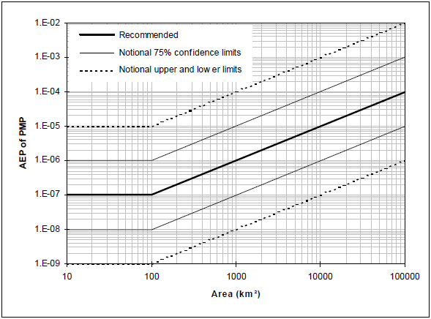

Figure 6.1 Plot to determine the AEP of the PMP based on catchment area (IEAust 1998)

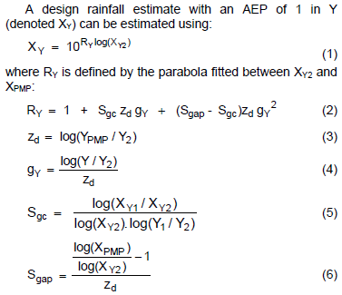

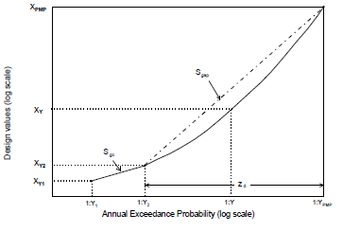

Figure 6.2 Equation and plot demonstrating the interpolation between CRC-FORGE and PMP design rainfall (IEAust 1998)

Table 6.3 Description of terms for equation shown above

VARIABLE | DESCRIPTION | VALUES USED FOR THIS STUDY
Y1 | AEP of lower value than starting point of interpolation | CRC-FORGE (1,000)
Y2 | AEP which is the starting point of interpolation | CRC-FORGE (2,000)
Y | AEP of interest | 1 in 10,000 years
YPMP | AEP of the PMP | Determined from Figure 6.1
XY1 | Design rainfall with AEP of 1 in Y1 | CRC-FORGE design rainfall (1 in 1,000 years)
XY2 | Design rainfall with AEP of 1 in Y2 | CRC-FORGE design rainfall (1 in 2,000 years)
XY | Design rainfall with AEP of 1 in Y (design rainfall of interest) | Calculated using equation shown in Figure 6.2 and terms described in this table
XPMP | Design rainfall with AEP of 1 in YPMP | PMP design rainfall (as described in Section 6.2 above)

Table 6.4 Design catchment rainfall for Dagworth

DURATION (HOURS) | CRC-FORGE (MM)  1 in 1,000 AEP 1 in 2,000 AEP |  |  | INTERPOLATION BETWEEN CRC- FORGE AND PMP RAINFALLS (MM)  1 in 10,000 AEP |  | PMP (MM)  1 in 55,556 AEP
24 | 267 | 295 |  | 403 |  | 670
36 320 358 494 800

48 374 | 421 |  | 584 |  | 920
72 | 469 | 539 | 758 | 1,130
96 | 527 | 609 | 861 | 1,280
120 | 576 | 664 | 927 | 1,330

Table 6.5 Design catchment rainfall for Greenhills

CRC-FORGE METHOD (MM)
INTERPOLATION BETWEEN CRC-
FORGE AND PMP RAINFALLS
PMP (MM)
DURATION
(HOURS)
1 in 1,000 AEP 1 in 2,000 AEP 1 in 10,000 AEP 1 in 90,909 AEP
24
277
295
402
720
36 327 358 486 850

48 376 | 421 |  | 570 | 980
72 468 539 740 1,190

96 526 | 609 |  | 847 | 1,360
120 579 664 927 1,420

Table 6.6 Design catchment rainfall for Cavehill

P (MM)
DURATION (HOURS) | CRC-FORGE METHOD (MM) INTERPOLATION BETWEEN CRC- PM  FORGE AND PMP RAINFALLS
 | 1 in 1,000 AEP | 1 in 2,000 AEP 1 in 10,000 AEP 1 in 166,667 AEP
24 | 264 | 295 389 | 840
36 | 314 | 358 464 | 980
48 | 364 | 421 539 | 1,110
72 | 427 | 539 631 | 1,340
96 | 459 | 609 684 | 1,530
120 | 489 | 664 725 | 1,610

- Design event modelling

  - Design flood estimation and results
The RORB models with calibrated routing parameters were used to estimate the design flood discharges for the study catchments at storm durations ranging from 24 to 120 hours using design rainfall estimates for the CRC-FORGE 1 in 1,000 AEP, interpolated 1 in 10,000 AEP, and PMP values. The potential storages were included in the RORB models and were assumed to be full at the start of the simulation. This assumption is based on the high likelihood of the storages being full during the wet season when rare and extreme flood events occur. Also, the aim is to be conservative in determining design flood estimates for preliminary planning purposes. For these reasons, it is appropriate to adopt a full reservoir level at the start of the simulation (IEAust 1998). Conservative values of initial loss (0 mm) and continuing loss (1 mm per hour) were used for the design flood simulations. These values were selected in the absence of any flood loss data for the area, and taking into account the recommendations in the relevant sections of the Australian Rainfall and Runoff guidelines (IEAust 1998). Rare and extreme floods are larger than the recorded floods, and this supports the use of low loss values. The output of RORB shows the peak and total flow of the storage inflow and storage outflow, as well as the storage level for the peak discharge event. The RORB design flood results for the three types of design rainfall estimates for each catchment are provided in Table 7.1, Table 7.2 and Table 7.3 for Dagworth, Greenhills and Cavehill respectively.
As can be seen in the result tables, the critical storm duration (that is, the design storm generating the highest design outflow peak) for the Greenhills and Cavehill catchments was 36 hours for all three design rainfall types. The critical duration for Dagworth was slightly more complicated. The critical storm duration resulting in the highest design flood peak for the 1 in 1,000 and 1 in 10,000 year AEP design storms was 120 hours. For the PMP design rainfall, the 120 hour storm resulted in the second highest peak discharge (57,038 m3/s), with the critical storm (48 hour) having a peak discharge that was slightly higher (57,554 m3/s) (see Table 7.1). Hydrograph plots of the design storage inflow and outflow at the three potential dam sites, for each critical design flood peak event are provided in Appendix D.

Table 7.1 RORB simulation results of design floods for Dagworth

DURATION | AEP 1 IN 1,000 YEARS  INFLOW HYDROGRAPH OUTFLOW HYDROGRAPH |  | AEP 1 IN 10,000 YEARS  INFLOW HYDROGRAPH OUTFLOW HYDROGRAPH |  | PMP (AEP 1 IN 55,556 YEARS)  INFLOW HYDROGRAPH OUTFLOW HYDROGRAPH
 | PEAK  DISCHARGE TOTAL FLOOD  3  (M3/S) VOLUME (M ) | PEAK EL (M) OF  DISCHARGE PEAK TOTAL FLOOD  3  (M3/S) DISCHARGE VOLUME (M ) | PEAK  DISCHARGE TOTAL FLOOD  3  (M3/S) VOLUME (M ) | PEAK EL (M) OF  DISCHARGE PEAK TOTAL FLOOD  3  (M3/S) DISCHARGE VOLUME (M ) | PEAK  DISCHARGE TOTAL FLOOD  3  (M3/S) VOLUME (M ) | PEAK EL (M) OF  DISCHARGE PEAK TOTAL FLOOD  3  (M3/S) DISCHARGE VOLUME (M )
24 15,680 3,740,000,000 |  | 14,205 235.30 3,740,000,000 | 27,166 5,830,000,000 | 24,753 238.47 5,830,000,000 | 52,434 9,950,000,000 | 46,448 244.32 9,950,000,000
36 18,459 4,380,000,000 |  | 16,851 236.19 4,380,000,000 | 32,974 7,050,000,000 | 30,010 239.95 7,050,000,000 | 61,048 11,800,000,000 | 54,304 246.23 11,800,000,000
48 20,132 5,010,000,000  72 20,150 6,100,000,000  96 20,360 6,630,000,000 |  | 18,695 236.76 5,010,000,000  19,437 236.99 6,100,000,000  19,536 237.02 6,630,000,000 | 36,075 8,260,000,000  36,325 10,500,000,000  37,481 11,800,000,000 | 33,323 240.89 8,260,000,000  35,075 241.37 10,500,000,000  35,950 241.60 11,800,000,000 | 63,266 13,400,000,000 | 57,554 246.99 13,400,000,000
 |  |  |  |  | 57,705 16,300,000,000  59,469 18,200,000,000 | 55,630 246.54 16,300,000,000  56,987 246.86 18,200,000,000
120 21,581 7,100,000,000 |  | 20,463 237.28 7,100,000,000 | 39,651 12,400,000,000 | 37,198 241.94 12,400,000,000 | 61,310 18,600,000,000 | 57,038 | 246.87 18,600,000,000

Table 7.2 RORB simulation results of design floods for Greenhills

DURATION | AEP 1 IN 1,000 YEARS  INFLOW HYDROGRAPH OUTFLOW HYDROGRAPH |  |  |  |  | AEP 1 IN 10,000 YEARS  INFLOW HYDROGRAPH OUTFLOW HYDROGRAPH |  |  |  |  | PMP (AEP 1 IN 90,909 YEARS)  INFLOW HYDROGRAPH OUTFLOW HYDROGRAPH
 | PEAK DISCHARGE (M3/S) | TOTAL FLOOD VOLUME (M3) | PEAK DISCHARGE (M3/S) | EL (M) OF PEAK DISCHARGE | TOTAL FLOOD VOLUME (M3) | PEAK DISCHARGE (M3/S) | TOTAL FLOOD VOLUME (M3) | PEAK DISCHARGE (M3/S) | EL (M) OF PEAK DISCHARGE | TOTAL FLOOD VOLUME (M3) | PEAK DISCHARGE (M3/S) | TOTAL FLOOD VOLUME (M3) | PEAK DISCHARGE (M3/S) | EL (M) OF PEAK DISCHARGE | TOTAL FLOOD VOLUME (M3)
24 | 24,088 | 2,140,000,000 | 15,160 | 263.99 | 2,140,000,000 | 37,109 | 3,200,000,000 | 23,117 | 267.34 | 3,200,000,000 | 70,590 | 5,890,000,000 | 46,063 | 275.71 | 5,890,000,000
36 | 24,619 | 2,460,000,000 | 16,387 | 264.48 | 2,460,000,000 | 38,746 | 3,810,000,000 | 25,670 | 268.38 | 3,810,000,000 | 71,273 | 6,890,000,000 | 49,978 | 276.98 | 6,890,000,000
48 | 18,519 | 2,780,000,000 | 14,965 | 263.9 | 2,780,000,000 | 29,932 | 4,410,000,000 | 23,854 | 267.65 | 4,410,000,000 | 54,846 | 7,880,000,000 | 44,722 | 275.27 | 7,880,000,000
72 | 17,686 | 3,350,000,000 | 14,001 | 263.49 | 3,350,000,000 | 29,610 | 5,650,000,000 | 23,477 | 267.49 | 5,650,000,000 | 49,780 | 9,450,000,000 | 40,547 | 273.86 | 9,460,000,000
96 | 18,049 | 3,640,000,000 | 14,452 | 263.68 | 3,640,000,000 | 31,352 | 6,350,000,000 | 24,773 | 268.03 | 6,350,000,000 | 53,349 | 10,700,000,000 | 42,959 | 274.68 | 10,700,000,000
120 | 18,532 | 3,940,000,000 | 15,007 | 263.92 | 3,940,000,000 | 32,293 | 6,850,000,000 | 25,471 | 268.30 | 6,850,000,000 | 52,568 | 11,000,000,000 | 41,604 | 274.22 | 11,000,000,000

Table 7.3 RORB simulation results of design floods for Cavehill

DURATION | AEP 1 IN 1,000 YEARS  INFLOW HYDROGRAPH OUTFLOW HYDROGRAPH |  |  |  |  | AEP 1 IN 10,000 YEARS  INFLOW HYDROGRAPH OUTFLOW HYDROGRAPH |  |  |  |  | PMP (AEP 1 IN 166,667 YEARS)  INFLOW HYDROGRAPH OUTFLOW HYDROGRAPH
PEAK DISCHARGE (M3/S) |  | TOTAL FLOOD VOLUME (M3) | PEAK DISCHARGE (M3/S) | EL (M) OF PEAK DISCHARGE | TOTAL FLOOD VOLUME (M3) | PEAK DISCHARGE (M3/S) | TOTAL FLOOD VOLUME (M3) | PEAK DISCHARGE (M3/S) | EL (M) OF PEAK DISCHARGE | TOTAL FLOOD VOLUME (M3) | PEAK DISCHARGE (M3/S) | TOTAL FLOOD VOLUME (M3) | PEAK DISCHARGE (M3/S) | EL (M) OF PEAK DISCHARGE | TOTAL FLOOD VOLUME (M3)
24 | 15,332 | 1,270,000,000 | 10,122 | 231.42 | 1,270,000,000 | 24,712 | 1,920,000,000 | 15,822 | 234.00 | 1,920,000,000 | 61,146 | 4,300,000,000 | 37,490 | 241.78 | 4,300,000,000
36 | 14,775 | 1,470,000,000 | 10,891 | 231.80 | 1,470,000,000 | 23,478 | 2,260,000,000 | 17,031 | 234.50 | 2,260,000,000 | 54,708 | 4,980,000,000 | 39,157 | 242.30 | 4,980,000,000
48 | 12,387 | 1,670,000,000 | 9,746 | 231.24 | 1,670,000,000 | 19,739 | 2,590,000,000 | 15,222 | 233.75 | 2,590,000,000 | 44,626 | 5,600,000,000 | 34,061 | 240.68 | 5,600,000,000
72 | 11,053 | 1,870,000,000 | 8,913 | 230.84 | 1,870,000,000 | 17,151 | 2,950,000,000 | 14,022 | 233.23 | 2,950,000,000 | 38,248 | 6,680,000,000 | 32,169 | 240.06 | 6,680,000,000
96 | 10,753 | 1,920,000,000 | 8,319 | 230.55 | 1,920,000,000 | 17,248 | 3,100,000,000 | 13,257 | 232.89 | 3,100,000,000 | 42,677 | 7,560,000,000 | 32,649 | 240.21 | 7,560,000,000
120 | 11,279 | 2,000,000,000 | 8,290 | 230.54 | 2,000,000,000 | 18,344 | 3,220,000,000 | 13,221 | 232.87 | 3,220,000,000 | 46,265 | 7,870,000,000 | 31,963 | 239.99 | 7,860,000,000

  - Comparison to other studies
The design flood estimates obtained in this study were found to be comparable to design flood estimates made elsewhere using the same methods. Table 7.4 shows the storage peak inflow and peak outflow resulting from PMP design rainfall for seven other catchments in Queensland. The results in the table are ordered by catchment area and it can be observed that the peak flows determined for Cavehill, Greenhills and Dagworth are comparable to the other studies listed.

Table 7.4 Comparison of PMP design flood results to other PMP studies

DAM | RIVER | CATCHMENT AREA (KM2) | PEAK INFLOW (M3/S) | PEAK OUTFLOW (M3/S) | REFERENCE
Rifle Creek | Rifle | 90 | 3,332 | 2,685 | SMEC - Rifle Creek Dam Failure Impact Assessment - Draft Report, October 2009
Corella | Corella | 331 | 8,540 | 7,730 | GHD - Corella Dam Failure Impact Assessment
Tinaroo | Barron | 545 | 8,497 | 6,580 | SunWater - Tinaroo Falls Dam Spillway Capacity Upgrade - Draft Report (Commercial in Confidence)
Leichardt River | Leichhardt | 1,213 | 13,241 | 12,455 | SMEC - Leichhardt River Dam Failure Impact Assessment - Final Report, December 2010
Julius | Leichhardt | 3,806 | 44,625 | 42,550 | SunWater - Julius Dam Failure Impact Assessment, July 2012 (Commercial in Confidence)
Cavehill | Cloncurry | 5,265 | 54,708 | 39,157 | DSITIA - Design flood hydrology for selected potential dam sites in the Flinders and Gilbert catchments (this study)
Greenhills | Gilbert | 8,400 | 71,273 | 49,978 | DSITIA - Design flood hydrology for selected potential dam  sites in the Flinders and Gilbert catchments (this study)
Dagworth | Einasleigh | 15,318 | 63,266 | 57,554 | DSITIA - Design flood hydrology for selected potential dam  sites in the Flinders and Gilbert catchments (this study)
Paradise | Burnett | 30,591 | 106,863 | 104,451 | Burnett Dam Alliance - Burnett River Dam Detail Design Report: Section 3 - Hydrology
Burdekin Falls | Burdekin | 114,654 | 129,400 | 112,200 | SunWater - Burdekin Falls Dam Comprehensive Risk Assessment, November 2009 (Commercial in Confidence)

The design flood estimates in this study would be considerably larger than those made by studies undertaken in the 1970s and 1980s as a result of changes to the PMP estimation methods. Revision of the PMP estimation method has increased estimates of PMP depths for individual catchments. This is due to the utilisation of greater amounts of data and better techniques for PMP estimation (BOM 2003b). The larger design PMF estimates are a direct result of the progressively higher estimates of PMP depths.

| 39

- Flood frequency analysis

Flood frequency analysis for the study catchments was undertaken using streamflow data from streamflow gauging stations 917106A for Dagworth, 917001D for Greenhills and 915203A for Cavehill. The details of the three streamflow gauging stations are summarised in Table 4.1.
For each streamflow gauging station annual maximum discharges were extracted between the years 1967 and 2013. The resulting series of annual maximum discharges were used in the flood frequency analysis. Table 8.1 lists the annual maximum discharges for the three selected gauging stations. The analysis was undertaken based on the water year (July to June).
As the Log Pearson type III distribution is widely used for flood frequency analysis, this flood frequency analysis was undertaken by fitting Log Pearson III distributions to the series of recorded annual maximum discharges at the three gauging stations using a computer program called FLIKE (Kuczera 1999).
Flood frequency analysis results are provided in Table 8.2, Table 8.3 and Table 8.4 for Dagworth, Greenhills and Cavehill, respectively. The fitted distribution and confidence limit flood frequency plots are provided in Appendix E.

Table 8.1 Annual series of recorded maximum discharge used in flood frequency analysis

EHILL
DAGWORTH  EINASLEIGH RIVER AT EINASLEIGH GS 917106A |  | CAV  K FIELDS CLONCURRY RIV GS 91
Date | Peak Flow (m3/s) | Date Peak Flo | w (m3/s) Date Peak Flow (m3/s)
15/02/1968 | 3,261.4 | 16/02/1968 3,998.6 24/12/1969 |  |  |  | 788.6
18/01/1969 | 25.8 | 26/02/1969 41 | 2.7 05/03/1971 |  |  | 3,437.8
23/12/1969 | 154.3 | 25/12/1969 1,993.3 07/03/1972 |  |  |  | 2,848.9
09/02/1971 | 1,211.4 | 10/03/1971 2,530.1 28/03/1973 |  |  |  | 3,272.3
08/03/1972 | 3,419.8 | 12/01/1972 1,907.4 31/01/1974 |  |  |  | 2,862.7
23/02/1973 | 642.7 | 09/02/1973 2,002.9 25/02/1975 |  |  |  | 1,242.8
23/01/1974 | 7,225.0 | 23/01/1974 13,984.9 13/12/1975 |  |  |  | 544.2
15/01/1975 | 1,723.7 | 17/01/1975 2,726.4 25/01/1977 |  |  |  | 1,955.8
07/02/1976 | 2,261.7 | 26/03/1976 1,917.5 27/01/1978 |  |  |  | 439.7
06/02/1977 | 486.5 | 02/03/1977 56 | 6.0 23/02/1979 |  |  | 406.8
24/12/1977 | 138.0 | 22/12/1977 87 | 9.3 05/01/1980 |  |  | 406.8
10/03/1979 | 3,179.3 | 03/02/1979 3,804.1 22/01/1981 |  |  |  | 1,418.0
06/01/1980 | 3,038.7 | 11/02/1980 75 | 6.9 25/01/1982 |  |  | 356.6
21/01/1981 | 3,473.9 | 21/01/1981 3,893.0 20/03/1983 |  |  |  | 1,090.7
25/11/1981 | 489.0 | 22/01/1982 35 | 8.7 15/02/1984 |  |  | 2,317.2
30/04/1983 | 667.6 | 11/03/1983 71 | 8.4 19/12/1984 |  |  | 342.1
10/02/1984 | 1,423.0 | 16/02/1984 3,703.8 14/11/1985 |  |  |  | 237.9
24/01/1985 | 135.1 | 25/02/1985 63 | 2.0 28/01/1987 |  |  | 1,814.9

ER AT CLONCURRY 5203A

08/02/1986 | 670.6 | 22/01/1986 | 741.0 | 16/12/1987 | 577.7
07/03/1987 | 356.6 | 31/01/1987 | 1,499.9 | 27/12/1988 | 378.3
13/02/1988 | 1,091.0 | 13/02/1988 | 1,163.6 | 22/11/1989 | 2,032.0
15/03/1989 | 872.1 | 16/03/1989 | 1,516.2 | 14/01/1991 | 3,425.6
06/03/1990 | 1,491.2 | 06/03/1990 | 1,065.9 | 28/02/1992 | 1,803.9
13/01/1991 | 4,383.3 | 01/07/1990 | 1.5 | 16/02/1993 | 378.1
27/02/1992 | 471.9 | 07/02/1992 | 399.2 | 26/03/1994 | 0.1
19/02/1993 | 930.7 | 07/01/1993 | 746.3 | 19/01/1995 | 590.1
07/03/1994 | 191.2 | 21/04/1994 | 0.3 | 05/03/1996 | 544.6
10/03/1995 | 1,167.6 | 02/12/1994 | 35.1 | 02/03/1997 | 6,482.1
09/01/1996 | 324.8 | 25/01/1996 | 288.3 | 15/12/1997 | 341.9
04/03/1997 | 1,522.5 | 05/03/1997 | 1,601.7 | 02/01/1999 | 3,001.1
13/01/1998 | 602.2 | 05/03/1998 | 1,389.7 | 25/12/1999 | 779.4
15/01/1999 | 543.3 | 16/02/1999 | 1,137.8 | 17/12/2000 | 1,323.9
08/04/2000 | 1,753.2 | 27/12/1999 | 1,114.9 | 16/12/2001 | 194.8
01/01/2001 | 2,845.6 | 01/01/2001 | 1,978.5 | 28/02/2003 | 619.6
16/02/2002 | 4,539.5 | 16/02/2002 | 5,714.0 | 16/01/2004 | 3,584.1
02/03/2003 | 982.9 | 01/03/2003 | 1,007.4 | 06/01/2005 | 1,753.9
15/01/2004 | 504.4 | 15/01/2004 | 881.0 | 06/04/2006 | 1,000.0
24/01/2005 | 2,307.6 | 25/01/2005 | 2,034.2 | 18/06/2007 | 321.9
30/01/2006 | 1,246.5 | 30/01/2006 | 1,385.7 | 23/12/2007 | 179.6
05/02/2007 | 540.4 | 05/02/2007 | 784.9 | 08/01/2009 | 3,651.4
14/01/2008 | 2,240.4 | 11/02/2008 | 2,651.6 | 08/01/2010 | 1,095.0
27/01/2009 | 4,269.6 | 27/01/2009 | 6,389.4 | 12/03/2011 | 1,478.6
30/01/2010 | 1,044.4 | 30/01/2010 | 1,663.6 | 28/01/2012 | 904.4
05/02/2011 | 2,278.5 | 11/03/2011 | 2,912.9 | - | -
20/03/2012 | 2,730.1 | 21/03/2012 | 3,649.0 | - | -

Table 8.2 Flood frequency analysis results - Dagworth (GS 917106A)

ANNUAL EXCEEDENCE PROBABILITY (%) | AEP (1 IN X YEARS) | PEAK DISCHARGE (M3/S) | MONTE CARLO 90% QUANTILE PROBABILITY LIMITS (M3/S)
10 | 10 | 881 | 617 | 1,312
5 | 20 | 1,297 | 890 | 2,163
2 | 50 | 1,908 | 1,222 | 3,871
1 | 100 | 2,400 | 1,427 | 5,758
0.5 | 200 | 2,906 | 1,581 | 8,294
0.2 | 500 | 3,585 | 1,723 | 12,972
0.1 | 1000 | 4,096 | 1,800 | 17,757

Table 8.3 Flood frequency analysis results - Greenhills (GS 917001D)

ANNUAL EXCEEDENCE PROBABILITY (%) | AEP (1 IN X YEARS) | PEAK DISCHARGE (M3/S) | MONTE CARLO 90% QUANTILE PROBABILITY LIMITS (M3/S)
10 | 10 | 5,850 | 4,366 | 8,156
5 | 20 | 7,941 | 5,964 | 11,150
2 | 50 | 10,547 | 7,959 | 15,295
1 | 100 | 12,341 | 9,305 | 18,579
0.5 | 200 | 13,963 | 10,502 | 21,874
0.2 | 500 | 15,837 | 11,831 | 26,177
0.1 | 1000 | 17,060 | 12,649 | 29,395

Table 8.4 Flood frequency analysis results - Cavehill (GS 915203A)

ANNUAL EXCEEDENCE PROBABILITY (%) | AEP (1 IN X YEARS) | PEAK DISCHARGE (M3/S) | MONTE CARLO 90% QUANTILE PROBABILITY LIMITS (M3/S)
10 | 10 | 3,746 | 2,960 | 4,866
5 | 20 | 4,730 | 3,796 | 6,134
2 | 50 | 5,796 | 4,715 | 7,783
1 | 100 | 6,441 | 5,263 | 8,942
0.5 | 200 | 6,965 | 5,696 | 10,037
0.2 | 500 | 7,505 | 6,113 | 11,368
0.1 | 1000 | 7,820 | 6,327 | 12,299

- Conclusion

This report describes a design flood study for potential dam sites at Dagworth and Greenhills in the Gilbert River catchment and Cavehill in the Flinders River catchment. The study included the development and calibration of RORB runoff-routing models, estimation of design rainfall, model simulation of design floods and flood frequency analysis at each of the sites.
Three methods were used to estimate design rainfall. These were, CRC-FORGE (1 in 1,000 years and 1 in 2,000 years AEP) (Nandakumar et al. 1997), an interpolation between CRC-FORGE and PMP (1 in 10,000 years AEP) (IEAust 1998) and the PMP method (BOM 2003a). The calibrated models were used in conjunction with the design rainfall estimates to compute the design flood discharges at the potential dam sites.
The design flood estimates obtained in this study were found to be comparable to design flood estimates made elsewhere using the same methods. They would be, however, considerably larger than design flood estimates made by studies undertaken in the 1970s and 1980s as a result of changes to the PMP estimation method (BOM 2003b). Checks were also undertaken on the peak and total flood volumes, taking into account quantity of rainfall and catchment area.
These design flood estimates will be used in the companion technical report on water storages (see Preface Figure 1) to assist in developing conceptual arrangements for the three potential dam sites, including the sizing of spillways and embankments.

- References

Bureau of Meteorology (2003a). Guidebook to the Estimation of Maximum Precipitation: GENERALISED TROPICAL STORM METHOD, Hydrometeorological Advisory Service, November 2003. Commonwealth of Australia.
Bureau of Meteorology (2003b). Revision of the Generalised Tropical Storm Method for Estimating Probable Maximum Precipitation, Hydrology Report Series No. 8, August 2003. Commonwealth of Australia.
Bureau of Meteorology (2013). Australian Water Information Dictionary. Retrieved from: http://www.bom.gov.au/water/awid/id-703.shtml.
Burnett Dam Alliance (no date). Burnett River Dam Detail Design Report: Section 3 – Hydrology. Report excerpt received from: Department of Energy and Water Supply (Queensland Government) – Dam Safety group
DNRM&W (2008). Flinders River basin: IQQM Calibration Report. Department of Natural Resources Mines and Water. Brisbane, Government of Queensland
GHD (no date). Corella Dam Failure Impact Assessment. Report excerpt received from: Department of Energy and Water Supply (Queensland Government) – Dam Safety group
IEAust (1998). Australian Rainfall and Runoff. A Guide to Flood Estimation. Book VI, Estimation of Large and Extreme Floods, Nathan, R.J and Weinmann, P.E (Ed.s), Revised Edition, Institution of Engineers Australia.
Kuczera, G. (1999). Comprehensive At-site Flood Frequency Analysis Using Monte-Carlo Bayesian Inference. Water Resources Research 35(5):1551-1558.
Nandakumar, N., P. E. Weinmann, R.G. Mein, and R.J. Nathan (1997). Estimation of extreme rainfalls for Victoria using the CRC-FORGE method (for rainfall durations 24 to 72 hours). CRC Research (Report 97/4, Melbourne, Cooperative Research Centre for Catchment Hydrology.
SKM (2010). MiRORB software. Available: http://www.globalskm.com/Services/Natural-resource- management/MiRORB.aspx
SILO (2013). SILO Climate Database. Available: http://www.longpaddock.qld.gov.au/silo/
SMEC (2009). Rifle Creek Dam Failure Impact Assessment - Draft Report, October 2009. Report excerpt received from: Department of Energy and Water Supply (Queensland Government) – Dam Safety group
SMEC (2010). Leichhardt River Dam Failure Impact Assessment - Final Report, December 2010. Report excerpt received from: Department of Energy and Water Supply (Queensland Government) – Dam Safety group
SunWater (no date). Tinaroo Falls Dam Spillway Capacity Upgrade - Draft Report (Commercial in Confidence). Report excerpt received from: Department of Energy and Water Supply (Queensland Government) – Dam Safety group
SunWater (2009). Burdekin Falls Dam Comprehensive Risk Assessment (Commercial in Confidence), November 2009. Report excerpt received from: Department of Energy and Water Supply (Queensland Government) – Dam Safety group
SunWater (2012). Julius Dam Failure Impact Assessment (Commercial in Confidence), July 2012. Report excerpt received from: Department of Energy and Water Supply (Queensland Government) – Dam Safety group

World Meteorological Organization (1986) Manual for Estimating Probable Maximum Precipitation. Operational Hydrology Report No. 1 (second edition). WMO – No. 332, Geneva

Appendix A RORB model calibration hydrographs

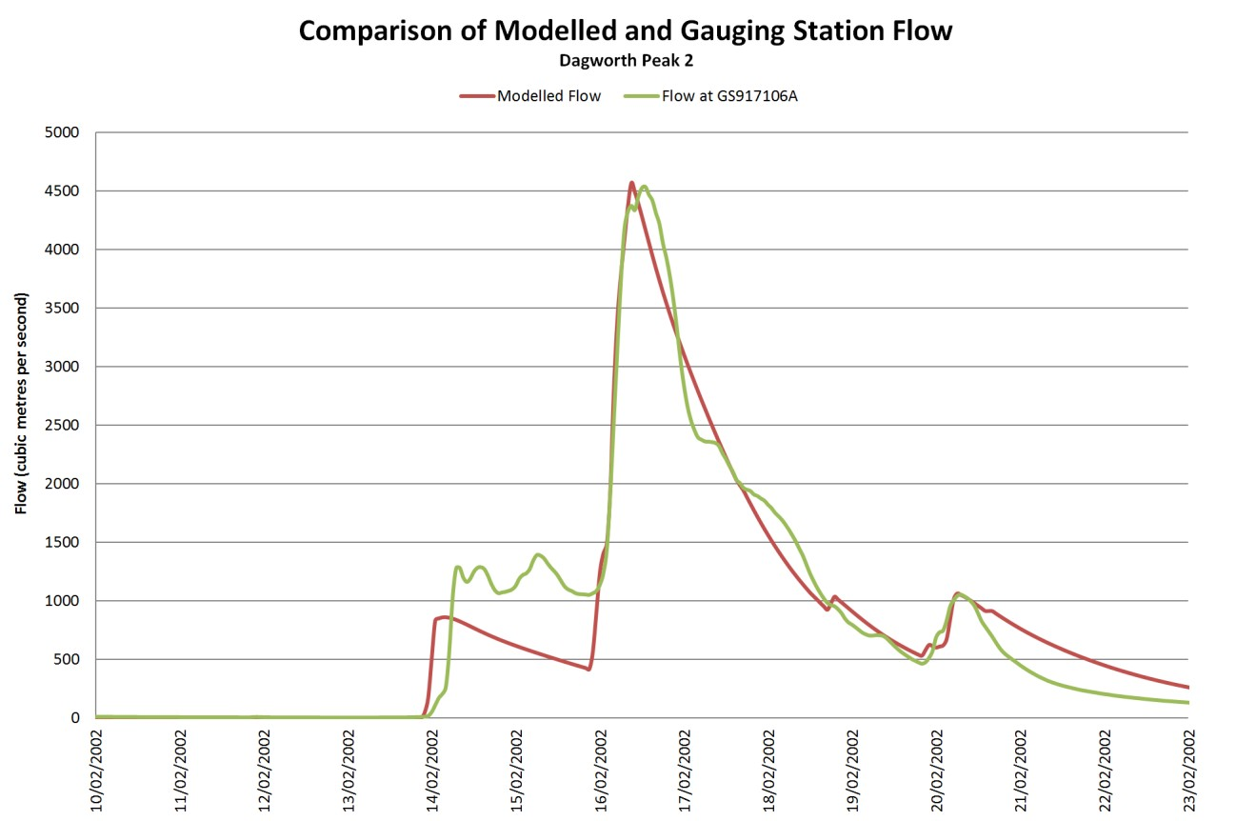
Figure A.1 Comparison of Modelled and Gauging Station Flow for Dagworth Peak 2

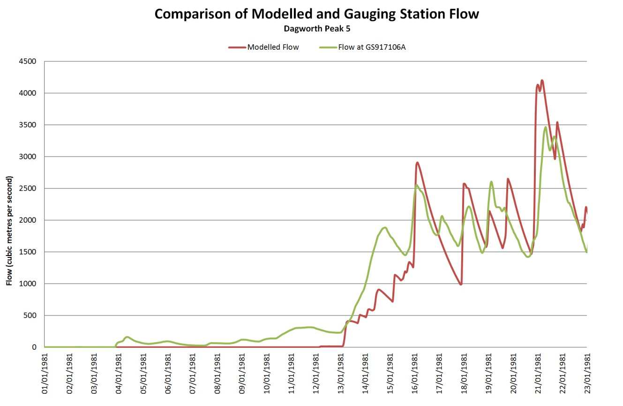

Figure A.2 Comparison of Modelled and Gauging Station Flow for Dagworth Peak 5

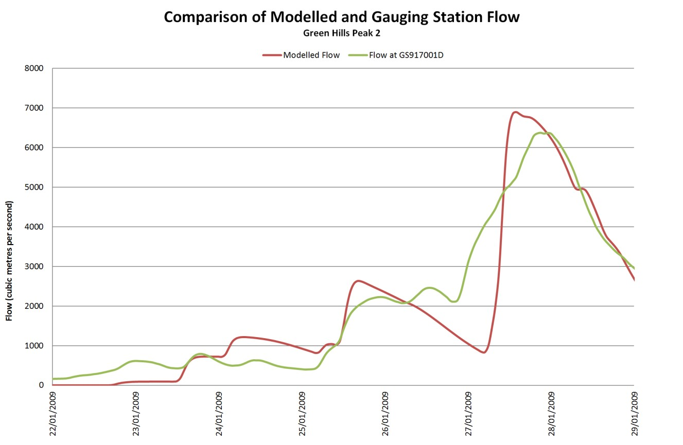

Figure A.3 Comparison of Modelled and Gauging Station Flow for Greenhills Peak 2

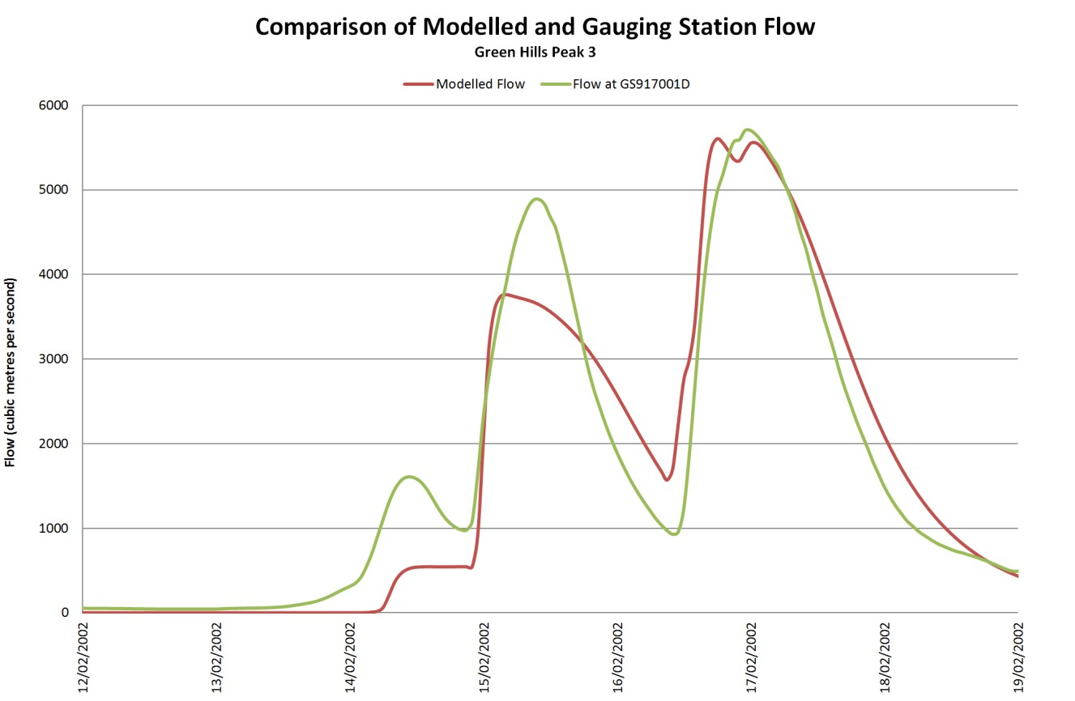

Figure A.4 Comparison of Modelled and Gauging Station Flow for Greenhills Peak 3

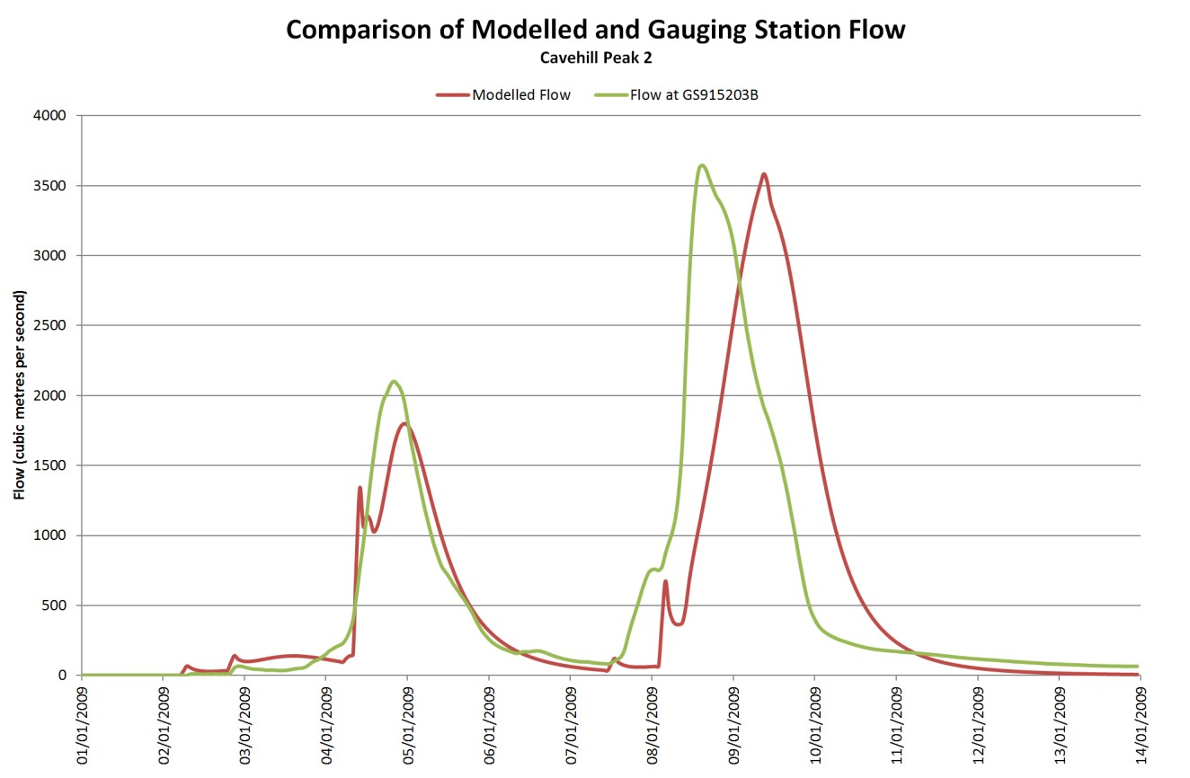

Figure A.5 Comparison of Modelled and Gauging Station Flow for Cavehill Peak 2

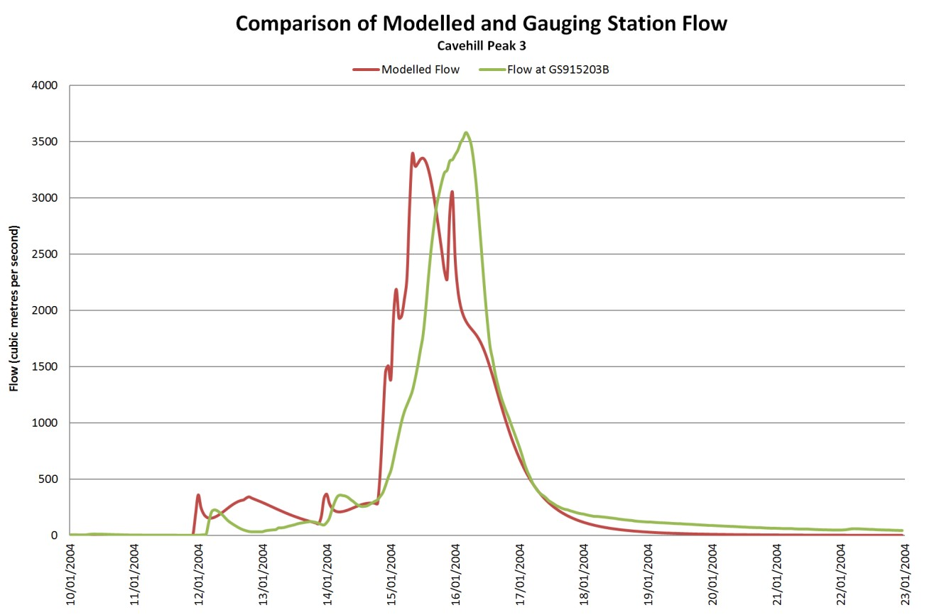

Figure A.6 Comparison of Modelled and Gauging Station Flow for Cavehill Peak 3

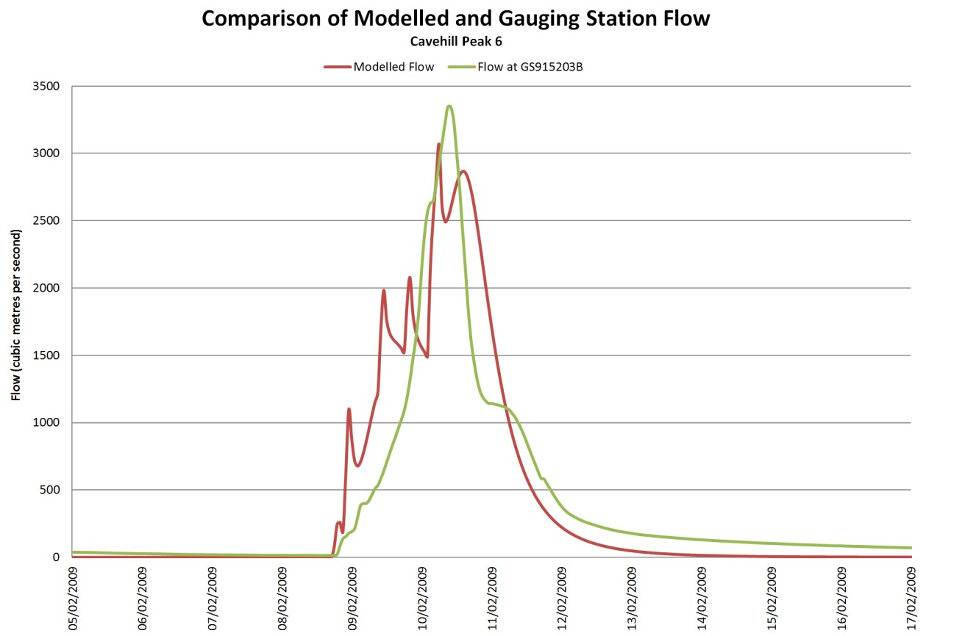

Figure A.7 Comparison of Modelled and Gauging Station Flow for Cavehill Peak 6

Appendix B PMP calculations

B1. WORKSHEET 1 PMP method selection

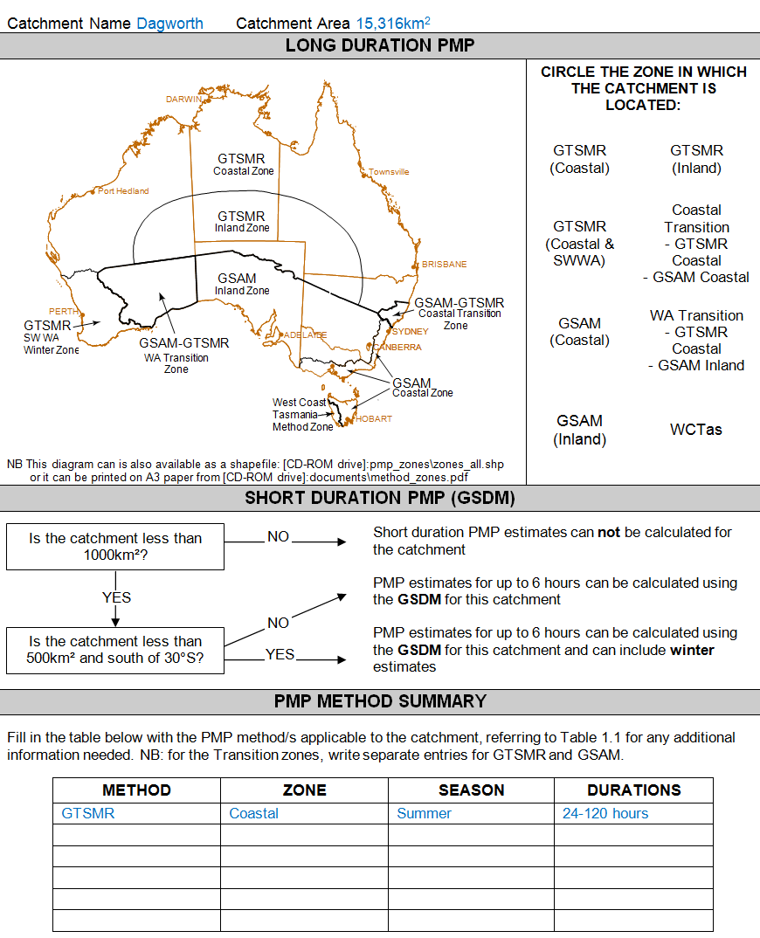

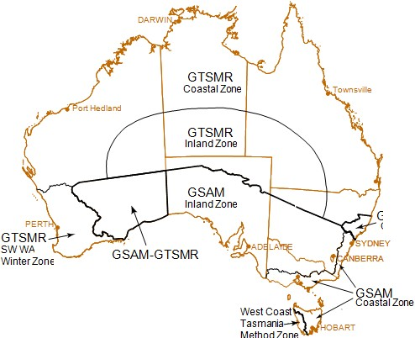
METHOD | ZONE | SEASON | DURATIONS
GTSMR | Coastal | Summer | 24-120 hours

Catchment Name Green Hills Catchment Area 11,086km2
LONG DURATION PMP
BRISBANE  GSAM-GTSMR  CoastalTransition  Zone  WA Transition Zone  NB This diagram can is also available as a shapefile:[CD-ROM drive):pmp_zones\zones_all.shp or it can be printed on A3 paper from[CD-ROM drive):documents\method_zones.pdf | CIRCLE THE ZONE IN WHICH THE CATCHMENT IS LOCATED:  GTSMR GTSMR  (Coastal) (Inland)  Coastal  GTSMR Transition  (Coastal& - GTSMR  SWWA) Coastal  - GSAM Coastal  GSAM WA Transition  (Coastal) - GTSMR Coastal  - GSAM Inland  GSAM WCTas  (Inland)
SHORT DURATION PMP (GSDM)
Is the catchment less than _ NO _ Short duration PMP estimates can not be calculated for 1000km2? the catchment
I PMP estimates for up to 6 hours can be calculated using
YES the GSDM for this catchment
NO
PMP estimates for up to 6 hours can be calculated using
Is the catchment less than
500km2 and south of 30°S? YES _. the GSDM for this catchment and can include winter
estimates
PMP METHOD SUMMARY
Fill in the table below with the PMP method/s applicable to the catchment, referring to Table 1.1 for any additional information needed. NB for the Transition zones , write separate entries for GTSMRand GSAM.

PMP calculations I 51

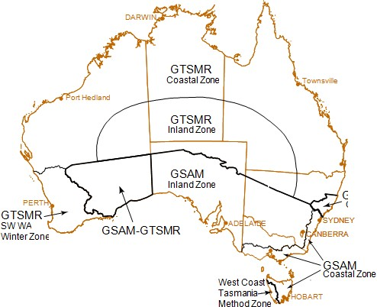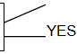
METHOD | ZONE | SEASON | DURATIONS
GTSMR | Coastal | Summer | 24-120 hours

Catchment Name Cavehill Catchment Area 5,981km2
LONG DURATION PMP
BRISBANE  GSAM-GTSMR  CoastalTransition  Zone  WA Transition Zone  NB This diagram can is also available as a shapefile:[CD-ROM drive]:pmp_zones\zones_all.shp or it can be printed on A3 paper from[CD-ROM drive]:documents\method_zones.pdf | CIRCLE THE ZONE IN WHICH THE CATCHMENT IS LOCATED:  GTSMR GTSMR  (Coastal) (Inland)  Coastal  GTSMR Transition  (Coastal& - GTSMR  SWWA) Coastal  - GSAM Coastal  GSAM WA Transition  (Coastal) - GTSMR Coastal  - GSAM Inland  GSAM WCTas  (Inland)
SHORT DURATION PMP (GSDM)
_ NO _
Is the catchment less than Short duration PMP estimates can not be calculated for
1000km2? the catchment
I PMP estimates for up to 6 hours can be calculated using
YES the GSDM for this catchment
NO
Is the catchment less than PMP estimates for up to 6 hours can be calculated using
500km2 and south of 30°S? the GSDM for this catchment and can include winter estimates
PMP METHOD SUMMARY
Fill in the table below with the PMP method/s applicable to the catchment, referring to Table 1.1 for any additional information needed. NB for the Transition zones , write separate entries for GTSMRand GSAM.

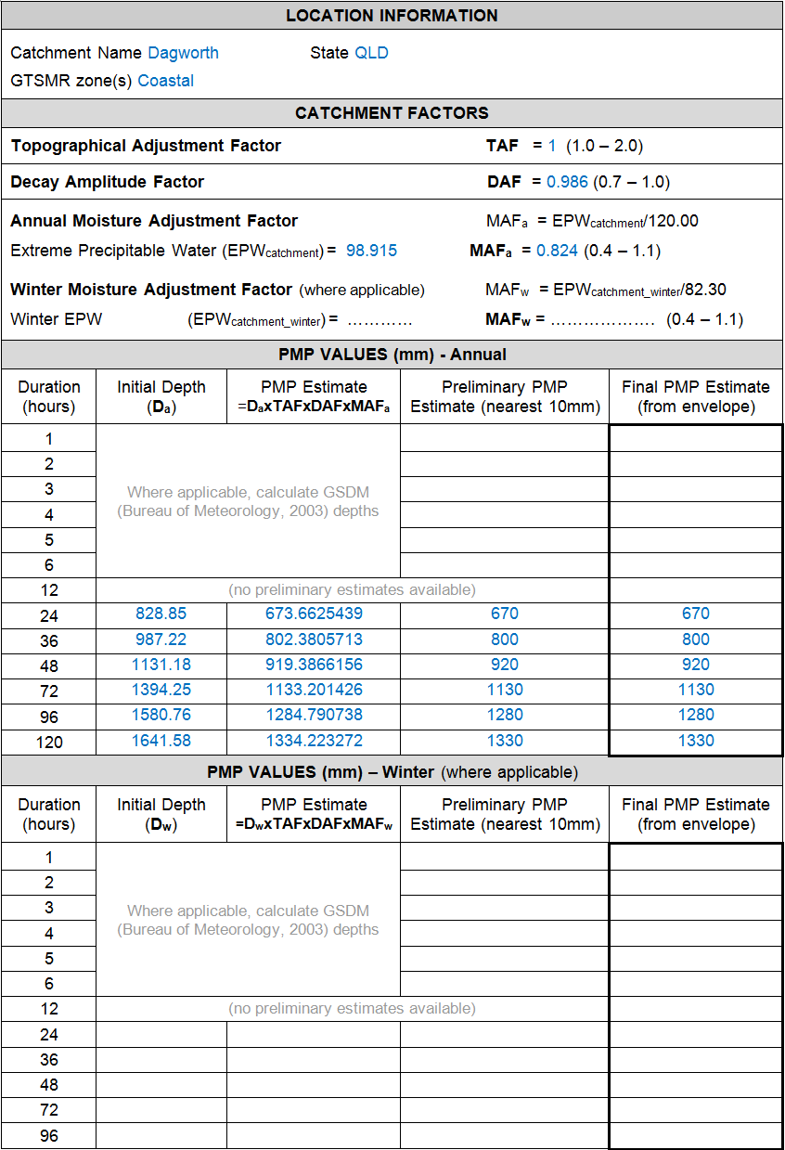B2. WORKSHEET 2 Generalised Tropical Storm method revised (GTSMR)

PMP calculations | 53

LOCATION INFORMATION
Catchment Name Greenhills State QLD GTSMR zone(s) Coastal
CATCHMENT FACTORS
Topographical Adjustment Factor TA F = 1 (1.0 - 2.0)
Decay Amplitude Factor OA F = 0.955 (0.7 - 1.10)
Annual Moisture Adjustment Factor MAFa = EPWcatchment/120.00 Extreme Precipitable Water (EPWcatchment)= 101.059 MAFa = 0.842 (0.4 - 1.1)
Winter Moisture Adjustment Factor (where applicable) MAFw = EPWcatchment_winter/82.30 Winter EPW (EPWcatchment_winter) = ............ MAFw = ................... (0.4 - 1.1)
PMP VALUES (mm)·Annual
Duration (hours) | Initial Depth (Ca) | PMP Estimate  =DaxTAFxDAFxMAFa | Preliminary PMP Estimate (nearest 10mm) | Final PMP Estimate (from envelope)
1 | Where applicable, calculate GSDM (Bureau of Meteorology, 2003) depths
2
3
4
5
6
12 | (no preliminary estimates available)
24 | 899.53 | 723.336802 | 720 | 720
36 | 1063.15 | 854.908142 | 850 | 850
48 | 1215.00 | 977.0149015 | 980 | 980
72 | 1484.43 | 1193.670971 | 1190 | 1190
96 | 1687.96 | 1357.33504 | 1360 | 1360
120 | 1767.08 | 1420.957607 | 1420 | 1420
PMP VALUES (mm) - Winter (where applicable)
Duration (hours) | Initial Depth (Ow) | PMP Estimate  =DwxTAFxDAFxMAFw | Preliminary PMP Estimate (nearest 10mm) | Final PMP Estimate (from envelope)
1 | Where applicable, calculate GSDM (Bureau of Meteorology, 2003) depths
2
3
4
5
6
12 | (no preliminary estimates available)
24
36
48
72
96

LOCATION INFORMATION
Catchment Name Cavehill State QLD GTSMR zone(s) Coastal
CATCHMENT FACTORS
Topographical Adjustment Factor TA F = 1.066 (1.0 - 2.0)
Decay Amplitude Factor OA F = 0.960 (0.7 - 1.0)
Annual Moisture Adjustment Factor MAFa = EPWcatchment/120.00 Extreme Precipitable Water (EPWcatchment)= 95.473 MAFa = 0.796 (0.4 - 1.1)
Winter Moisture Adjustment Factor (where applicable) MAFw = EPWcatchment_winter/82.30 Winter EPW (EPWcatchment_winter) = ............ MAFw = ................... (0.4 - 1.1)
PMP VALUES (mm)·Annual
Duration (hours) | Initial Depth (Da) | PMP Estimate  =DaxTAFxDA FxMAFa | Preliminary PMP Estimate (nearest 10mm) | Final PMP Estimate (from envelope)
1 | Where applicable, calculate GSDM (Bureau of Meteorology, 2003) depths
2
3
4
5
6
12 | (no preliminary estimates available)
24 | 1026.92 | 836.6688489 | 840 | 840
36 | 1198.11 | 976.1435308 | 980 | 980
48 | 1356.30 | 1105.026643 | 1110 | 1110
72 | 1640.44 | 1336.525773 | 1340 | 1340
96 | 1872.18 | 1525.332729 | 1530 | 1530
120 | 1970.68 | 1605.584240 | 1610 | 1610
PMP VALUES (mm) - Winter (where applicable)
Duration (hours) | Initial Depth (Ow) | PMP Estimate  =DwxTAFxDAFxMAFw | Preliminary PMP Estimate (nearest 10mm) | Final PMP Estimate (from envelope)
1 | Where applicable, calculate GSDM (Bureau of Meteorology, 2003) depths
2
3
4
5
6
12 | (no preliminary estimates available)
24
36
48
72
96

i>Mi> calculations I SS

Appendix C Temporal pattern files

TIME (HOURS) | TIME (%) | DAGWORTH: STANDARD AREA OF 20,000km2  INCREMENTAL CUMULATIVE RAINFALL (%) RAINFALL (%) |  | GREENHILLS: STANDARD AREA OF 10,000km2  INCREMENTAL CUMULATIVE RAINFALL (%) RAINFALL (%) |  | CAVEHILL: STANDARD AREA OF 5,000km2  INCREMENTAL CUMULATIVE RAINFALL (%) RAINFALL (%)
24 HOURS
3 | 12.5 | 7.15 | 7.15 | 6.96 | 6.96 | 8.71 | 8.71
6 | 25 | 9.01 | 16.16 | 11 | 17.96 | 6.77 | 15.47
9 | 37.5 | 15.44 | 31.61 | 17.2 | 35.15 | 17.15 | 32.62
12 | 50 | 22.2 | 53.8 | 22.93 | 58.08 | 24.98 | 57.61
15 | 62.5 | 12.72 | 66.53 | 12.39 | 70.47 | 11.91 | 69.52
18 | 75 | 11.26 | 77.79 | 4.99 | 75.46 | 4.89 | 74.41
21 | 87.5 | 17.06 | 94.85 | 15.82 | 91.28 | 14.7 | 89.11
24 | 100 | 5.15 | 100 | 8.72 | 100 | 10.89 | 100
36 HOURS
3 | 8.33 | 6.62 | 6.62 | 7.18 | 7.18 | 7.13 | 7.13
6 | 16.67 | 10.28 | 16.91 | 5.12 | 12.31 | 3.03 | 10.16
9 | 25 | 7.95 | 24.85 | 4.53 | 16.83 | 5.19 | 15.35
12 | 33.33 | 2.31 | 27.17 | 3.17 20 |  | 4.65 20
15 | 41.67 | 6.06 | 33.22 | 5.79 25.79 |  | 9.29 29.29
18 | 50 | 5.38 | 38.6 | 5.36 31.15 |  | 5.76 35.04
21 | 58.33 | 12.44 | 51.05 | 7.77 38.92 |  | 9.97 45.02
24 | 66.67 | 17.86 | 68.91 | 17.48 56.4 |  | 18.05 63.07
27 | 75 | 13.6 | 82.51 | 11.87 68.27 |  | 11.52 74.59
30 | 83.33 | 9.53 | 92.04 | 9.28 77.55 |  | 5.34 79.93
33 | 91.67 | 4.31 | 96.35 | 12.4 89.95 |  | 12.39 92.32
36 | 100 | 3.65 | 100 | 10.05 100 |  | 7.68 100
48 HOURS
3 | 6.25 | 4.76 | 4.76 | 2.25 | 2.25 | 2.24 | 2.24
6 | 12.5 | 4.32 | 9.07 | 5.18 | 7.43 | 3.78 | 6.02
9 | 18.75 | 4.79 | 13.86 | 5.94 | 13.36 | 6.5 | 12.52
12 | 25 | 9.22 | 23.08 | 8.07 | 21.43 | 5.65 | 18.17
15 | 31.25 | 15.39 | 38.47 | 14.77 | 36.21 | 15.46 | 33.63
18 | 37.5 | 6.01 | 44.49 | 2.62 | 38.82 | 5.17 | 38.79
21 | 43.75 | 2.68 | 47.17 | 3.88 | 42.7 | 3.81 | 42.6
24 | 50 | 1.83 | 48.99 | 7.44 | 50.14 | 8.13 | 50.73
27 | 56.25 | 7.22 | 56.21 | 5.52 | 55.65 | 4.41 | 55.14
30 | 62.5 | 8.32 | 64.53 | 3.26 | 58.91 | 2.62 | 57.77
33 | 68.75 | 3.94 | 68.47 | 3.58 | 62.5 | 1.61 | 59.38
36 | 75 | 10.93 | 79.4 | 10.38 | 72.87 | 8.9 | 68.27
39 | 81.25 | 7.71 | 87.11 | 8.71 | 81.58 | 9.64 | 77.91
42 | 87.5 | 5.96 | 93.07 | 9.39 | 90.97 | 11.01 | 88.92
45 | 93.75 | 3.91 | 96.98 | 6.39 | 97.36 | 7.6 | 96.52
48 | 100 | 3.02 | 100 | 2.64 | 100 | 3.48 | 100
72 HOURS
3 | 4.17 | 2.29 | 2.29 | 1.44 | 1.44 | 1.19 | 1.19
6 | 8.33 | 3.94 | 6.23 | 4.62 | 6.06 | 6.18 | 7.37
9 | 12.5 | 8.36 | 14.6 | 6.76 | 12.81 | 5.13 | 12.51
12 | 16.67 | 10.1 | 24.69 | 7.02 | 19.83 | 4 | 16.51
15 | 20.83 | 7.39 | 32.08 | 5.54 | 25.37 | 3.24 | 19.75
18 | 25 | 5.39 | 37.48 | 7.75 | 33.11 | 5.57 | 25.33
21 | 29.17 | 3.41 | 40.88 | 3.44 | 36.55 | 6.8 | 32.12
24 | 33.33 | 4.24 | 45.12 | 4.13 | 40.68 | 7.62 | 39.74
27 | 37.5 | 7.05 | 52.17 | 1.45 | 42.14 | 3.58 | 43.32
30 | 41.67 | 4.84 | 57.02 | 6.33 | 48.47 | 8.2 | 51.52
33 | 45.83 | 5.93 | 62.95 | 5.05 | 53.52 | 4.54 | 56.06
36 | 50 | 2.87 | 65.82 | 9.93 | 63.45 | 7.13 | 63.19
39 | 54.17 | 2.45 | 68.27 | 3.99 | 67.44 | 3.8 | 67
42 | 58.33 | 1.59 | 69.86 | 2.93 | 70.37 | 1.87 | 68.86
45 | 62.5 | 2.06 | 71.92 | 2.21 | 72.58 | 1.62 | 70.48
48 | 66.67 | 1.86 | 73.78 | 2.66 | 75.24 | 4.28 | 74.77
51 | 70.83 | 6.5 | 80.29 | 2.86 | 78.1 | 2.52 | 77.29
54 | 75 | 3.76 | 84.05 | 1.66 | 79.76 | 1.37 | 78.66
57 | 79.17 | 4.75 | 88.8 | 4.31 | 84.06 | 2.92 | 81.58
60 | 83.33 | 2.88 | 91.68 | 4.79 | 88.86 | 10.48 | 92.05
63 | 87.5 | 2.43 | 94.11 | 2.75 | 91.6 | 2.65 | 94.71
66 | 91.67 | 1.16 | 95.27 | 2.11 | 93.72 | 0.98 | 95.68
69 | 95.83 | 1.48 | 96.75 | 3.9 | 97.62 | 2.05 | 97.74
72 | 100 | 3.25 | 100 | 2.38 | 100 | 2.26 | 100
96 HOURS
3 | 3.13 | 0.9 | 0.9 | 1.99 1.99 |  | 1.79 | 1.79
6 | 6.25 | 1.15 | 2.05 | 4 5.99 |  | 1.07 | 2.86
9 | 9.38 | 4.1 | 6.15 | 3.51 9.5 |  | 3.21 | 6.07
12 | 12.5 | 2.18 | 8.33 | 1.66 11.16 |  | 1.92 | 7.99
15 | 15.63 | 5.6 | 13.93 | 5.16 16.32 |  | 4.37 | 12.36
18 | 18.75 | 6.35 | 20.28 | 4.29 20.61 |  | 4.03 | 16.39
21 | 21.88 | 8.52 | 28.8 | 5.92 26.53 |  | 5.6 | 21.99
24 | 25 | 5.86 | 34.66 | 6.79 33.32 |  | 6.77 | 28.76
27 | 28.13 | 3.18 | 37.84 | 3.72 37.04 |  | 3.39 | 32.14
30 | 31.25 | 2.6 | 40.44 | 2.78 39.82 |  | 2.97 | 35.12
33 | 34.38 | 3.69 | 44.13 | 1.42 41.24 |  | 1.34 | 36.46
36 | 37.5 | 2.1 | 46.23 | 3.21 44.45 |  | 4.75 | 41.2
39 | 40.63 | 3.89 | 50.12 | 6.2 50.65 |  | 5.82 | 47.03
42 | 43.75 | 6.94 | 57.06 | 7.93 58.58 |  | 7.98 | 55.01
45 | 46.88 | 5.09 | 62.15 | 5.74 64.32 |  | 6.2 | 61.21
48 | 50 | 2.78 | 64.93 | 4.68 69 |  | 3.85 | 65.05
51 | 53.13 | 1.65 | 66.57 | 0.85 69.85 |  | 0.45 | 65.5
54 | 56.25 | 1.44 | 68.01 | 1.05 70.9 |  | 0.82 | 66.32
57 | 59.38 | 4.58 | 72.59 | 2.77 73.67 |  | 2.18 | 68.51
60 | 62.5 | 3.29 | 75.88 | 3.2 76.87 |  | 2.79 | 71.3
63 | 65.63 | 3.52 | 79.4 | 1.21 78.08 |  | 2.35 | 73.65
66 | 68.75 | 1.73 | 81.13 | 3.96 82.03 |  | 2.52 | 76.17
69 | 71.88 | 2.98 | 84.11 | 2.22 84.25 |  | 5.26 | 81.42
72 | 75 | 1.83 | 85.95 | 1.39 85.64 |  | 3.57 | 84.99
75 | 78.13 | 0.85 | 86.79 | 0.75 86.39 |  | 2.11 | 87.09
78 | 81.25 | 1.26 | 88.05 | 2.04 88.43 |  | 1.76 | 88.86
81 | 84.38 | 3.08 | 91.13 | 2.72 91.15 |  | 1.48 | 90.34
84 | 87.5 | 1.39 | 92.52 | 0.96 92.11 |  | 1.08 | 91.42
87 | 90.63 | 1.16 | 93.69 | 1.13 93.24 |  | 2.71 | 94.13
90 | 93.75 | 1.75 | 95.43 | 2.31 95.56 |  | 2.03 | 96.16
93 | 96.88 | 2.65 | 98.08 | 2.91 98.47 |  | 2.58 | 98.74
96 | 100 | 1.92 | 100 | 1.53 100 |  | 1.26 | 100

| 57

TIME (HOURS) | TIME (%) | DAGWORTH: ST  OF 20,0 INCREMENTAL RAINFALL (%) | ANDARD AREA  00km2  CUMULATIVE RAINFALL (%) | GREENHILLS: STANDARD AREA OF 10,000km2  INCREMENTAL CUMULATIVE RAINFALL (%) RAINFALL (%) |  | CAVEHILL: STAN  5,000  INCREMENTAL RAINFALL (%) | DARD AREA OF  km2  CUMULATIVE RAINFALL (%)
120 HOURS
3 | 2.5 | 0.23 | 0.23 | 1.38 | 1.38 | 1.44 | 1.44
6 | 5 | 2.81 | 3.04 | 1.54 | 2.92 | 0.45 | 1.9
9 | 7.5 | 2.97 | 6.01 | 2.77 | 5.69 | 0.73 | 2.63
12 | 10 | 0.86 | 6.87 | 1.44 | 7.13 | 0.65 | 3.27
15 | 12.5 | 2.42 | 9.29 | 1.66 | 8.79 | 2.1 | 5.38
18 | 15 | 2.59 | 11.88 | 2.53 | 11.32 | 3.57 | 8.94
21 | 17.5 | 4.6 | 16.47 | 4.1 | 15.43 | 2.57 | 11.51
24 | 20 | 1.7 | 18.17 | 2.67 | 18.09 | 1.01 | 12.52
27 | 22.5 | 3.16 | 21.33 | 4.51 | 22.6 | 1.93 | 14.45
30 | 25 | 7.38 | 28.71 | 5.85 | 28.46 | 6.73 | 21.18
33 | 27.5 | 8.36 | 37.07 | 3.01 | 31.47 | 1.82 | 23
36 | 30 | 2.19 | 39.26 | 2.45 | 33.92 | 1.64 | 24.64
39 | 32.5 | 1.58 | 40.84 | 1.3 | 35.22 | 1.53 | 26.17
42 | 35 | 1 | 41.84 | 3.76 | 38.98 | 2.74 | 28.91
45 | 37.5 | 6.39 | 48.22 | 3.35 | 42.33 | 2.52 | 31.44
48 | 40 | 3.56 | 51.79 | 2.03 | 44.36 | 4.72 | 36.16
51 | 42.5 | 5.5 | 57.29 | 9.42 | 53.77 | 7.39 | 43.55
54 | 45 | 4.93 | 62.23 | 7.35 | 61.13 | 9.39 | 52.95
57 | 47.5 | 3.37 | 65.59 | 2.24 | 63.36 | 3.07 | 56.02
60 | 50 | 1.84 | 67.43 | 0.96 | 64.32 | 2.44 | 58.46
63 | 52.5 | 4.09 | 71.53 | 6.33 | 70.65 | 5.48 | 63.94
66 | 55 | 3.78 | 75.3 | 3.24 | 73.89 | 1.32 | 65.26
69 | 57.5 | 0.69 | 75.99 | 1.01 | 74.9 | 0.26 | 65.52
72 | 60 | 1.1 | 77.09 | 0.66 | 75.56 | 0.9 | 66.42
75 | 62.5 | 0.33 | 77.42 | 0.5 | 76.07 | 1.37 | 67.79
78 | 65 | 1.47 | 78.89 | 0.83 | 76.9 | 5.08 | 72.87
81 | 67.5 | 0.81 | 79.7 | 1.2 | 78.1 | 1.06 | 73.93
84 | 70 | 5.89 | 85.59 | 5.54 | 83.63 | 3.33 | 77.26
87 | 72.5 | 1.18 | 86.77 | 1.91 | 85.55 | 4.21 | 81.47
90 | 75 | 1.43 | 88.2 | 1.03 | 86.58 | 2.25 | 83.72
93 | 77.5 | 1.75 | 89.95 | 0.77 | 87.35 | 1.2 | 84.93
96 | 80 | 0.75 | 90.7 | 0.74 | 88.09 | 0.53 | 85.46
99 | 82.5 | 1.87 | 92.57 | 4.99 | 93.08 | 2.94 | 88.4
102 | 85 | 1.22 | 93.79 | 1.74 | 94.82 | 3.79 | 92.18
105 | 87.5 | 2.14 | 95.93 | 3.6 | 98.43 | 6.17 | 98.36
108 | 90 | 0.41 | 96.34 | 0.37 | 98.8 | 0.43 | 98.78
111 | 92.5 | 0.62 | 96.96 | 0.2 | 99 | 0.16 | 98.94
114 | 95 | 0.56 | 97.52 | 0.14 | 99.14 | 0.12 | 99.06
117 | 97.5 | 0.12 | 97.65 | 0.27 | 99.41 | 0.35 | 99.41
120 | 100 | 2.35 | 100.00 | 0.59 | 100.00 | 0.59 | 100

Appendix D Design inflow and outflow hydrographs

Design inflow and outflow hydrographs | 59

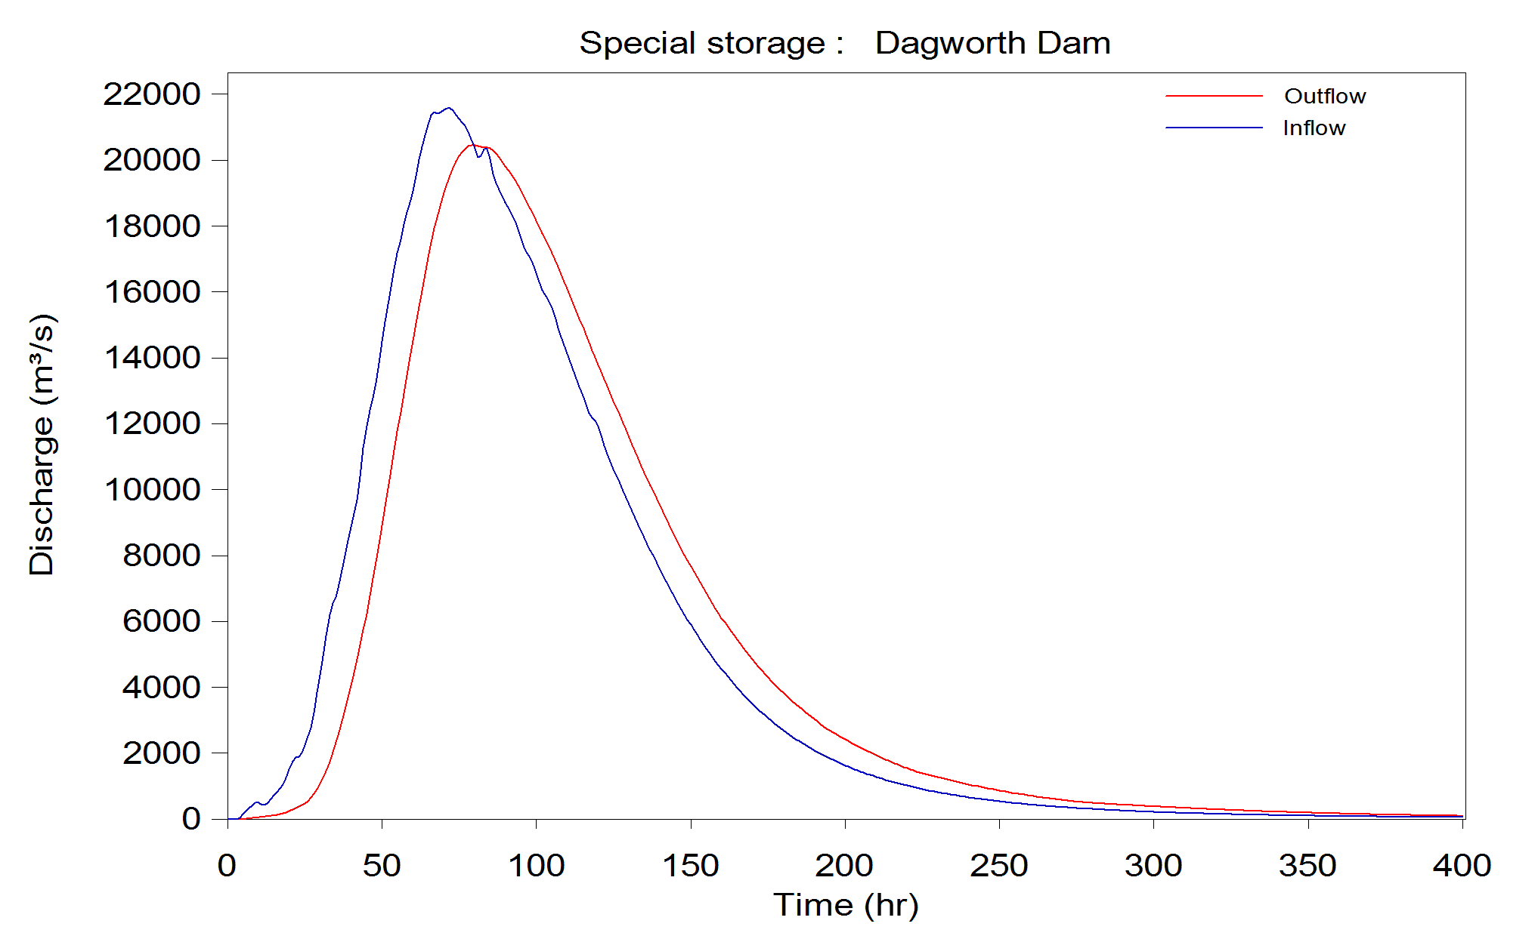

Figure D.1 Dagworth – AEP 1 in 1,000 Years – 120 hour

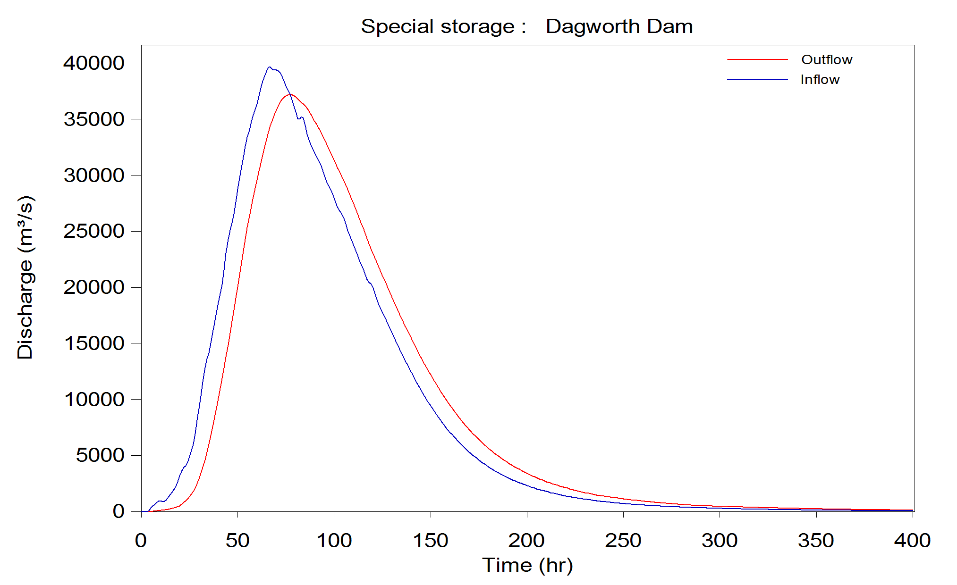

Figure D.2Dagworth – AEP 1 in 10,000 Years – 120 hour

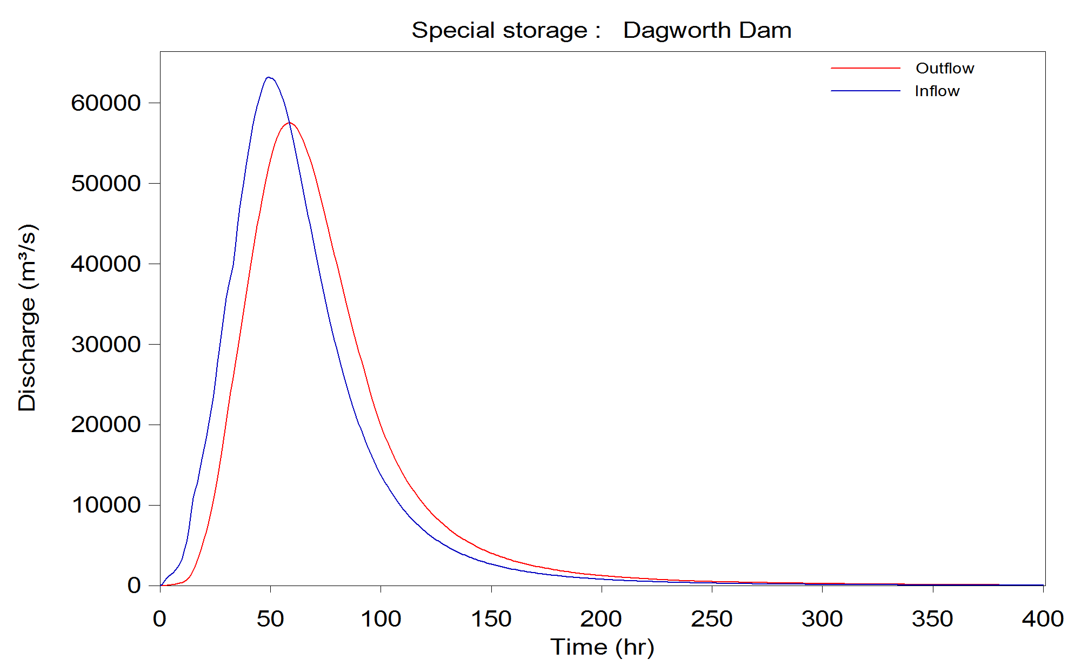

Figure D.3 Dagworth – AEP 1 in 55,556 Years – 48 hour

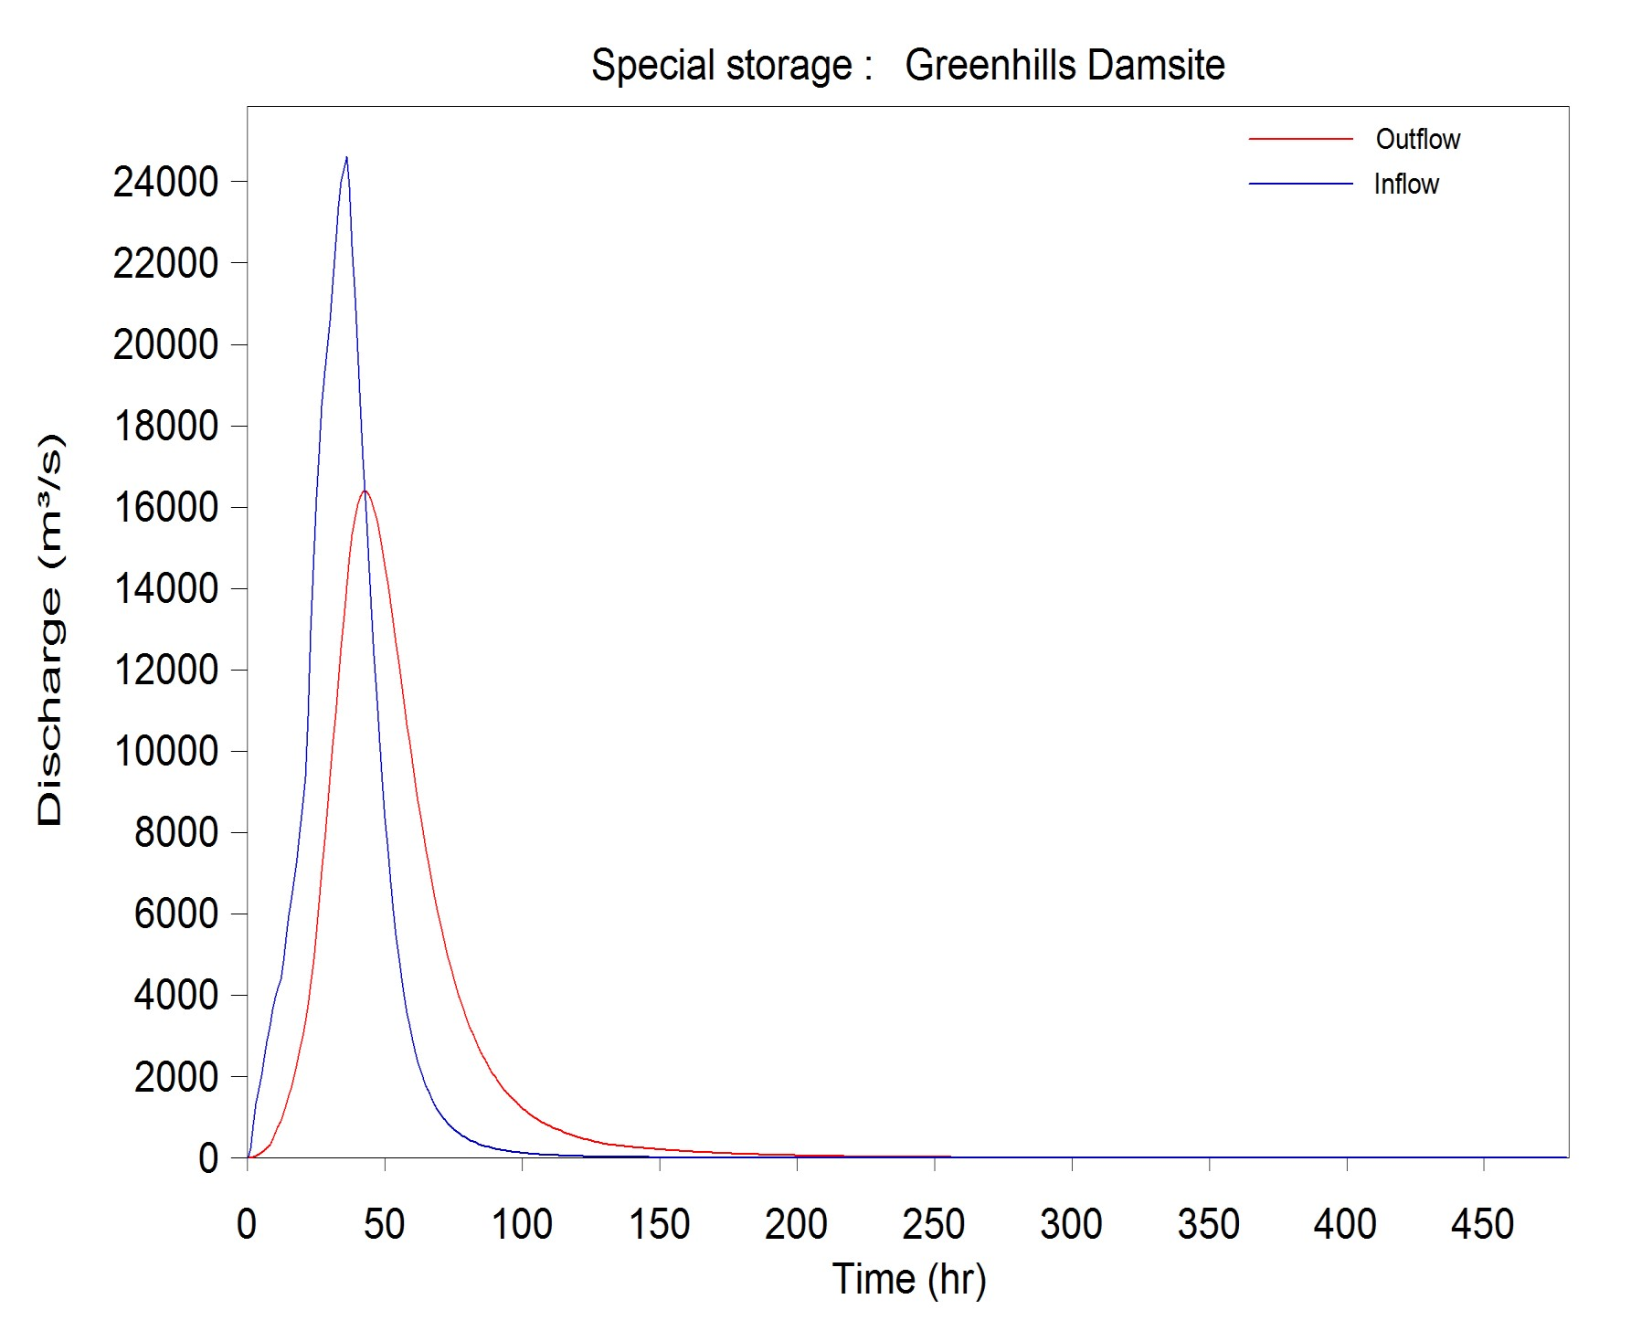

Figure D.4 Greenhills – AEP 1 in 1,000 Years – 36 hour

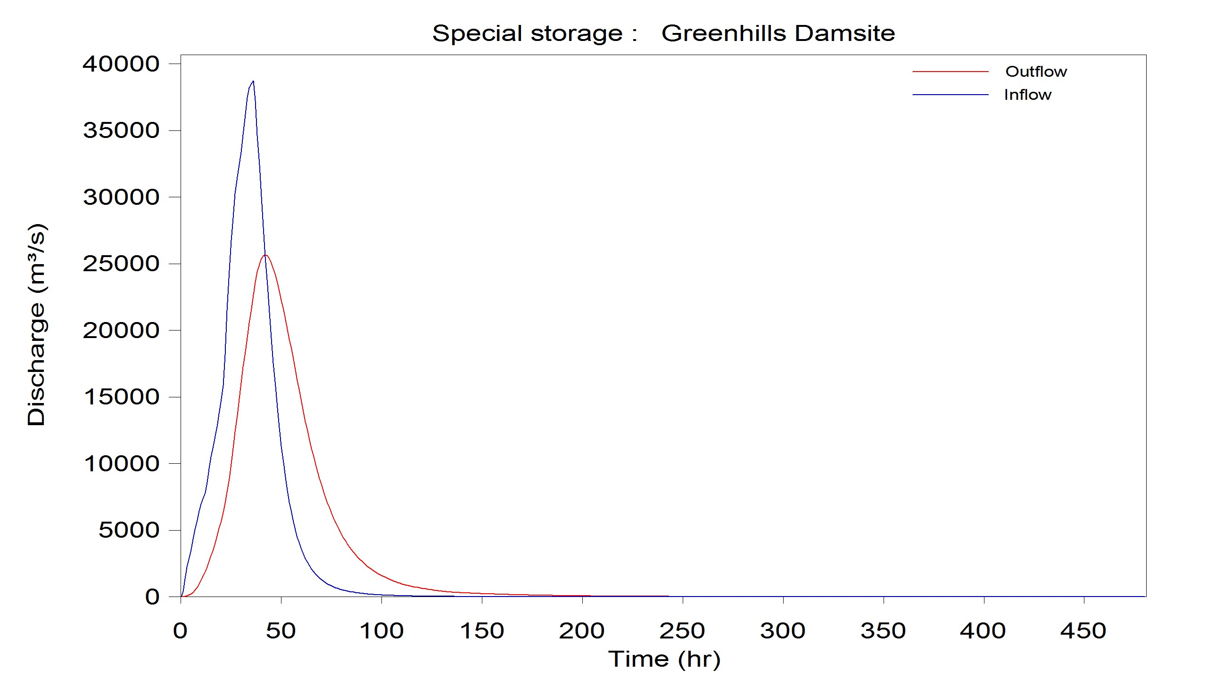

Figure D.5 Greenhills – AEP 1 in 10,000 Years – 36 hour

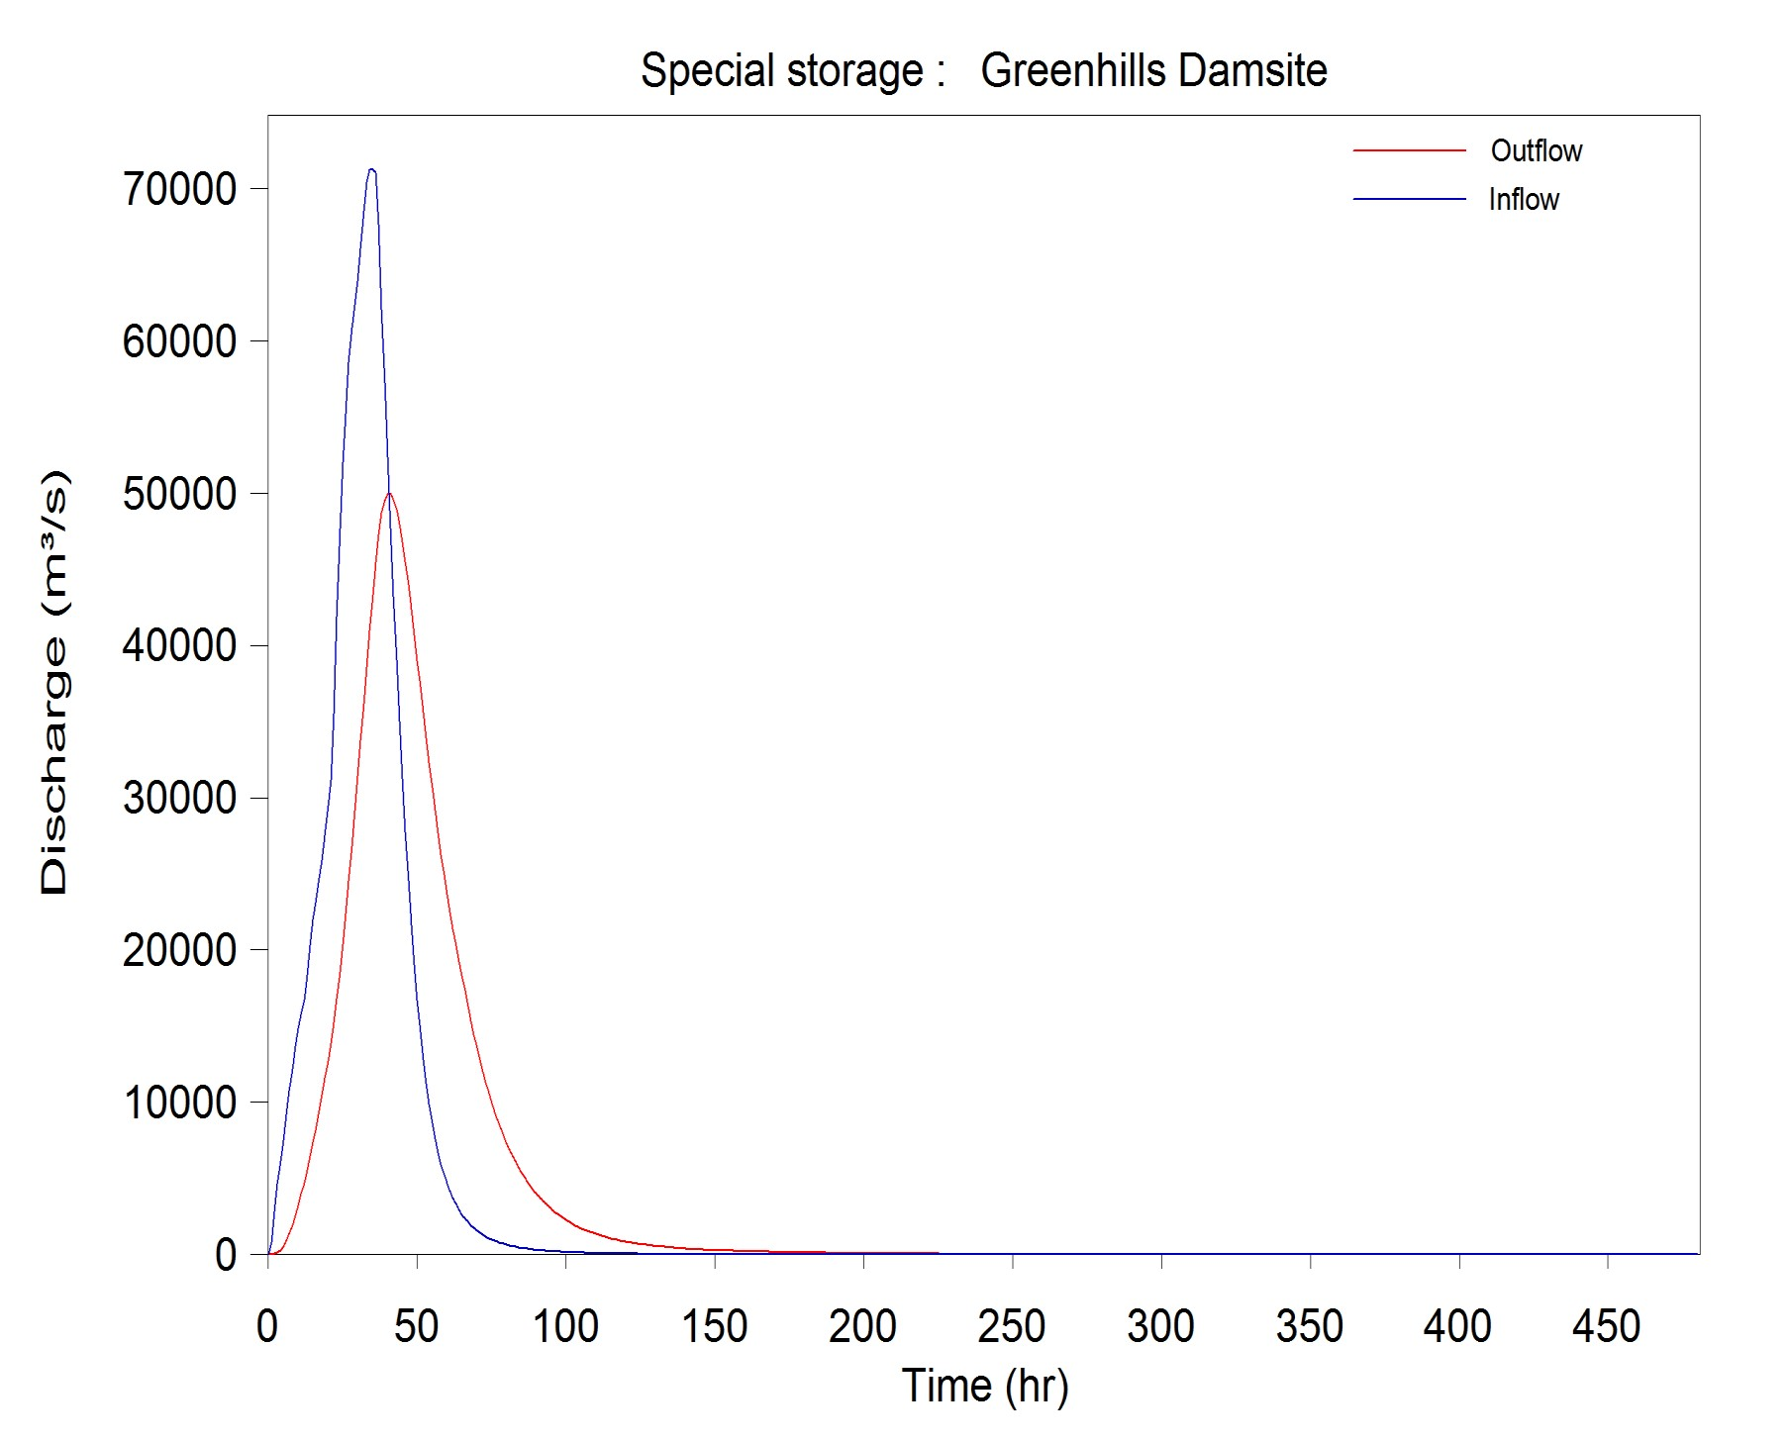

Figure D.6 Greenhills – AEP 1 in 90,909 years – 36 hour

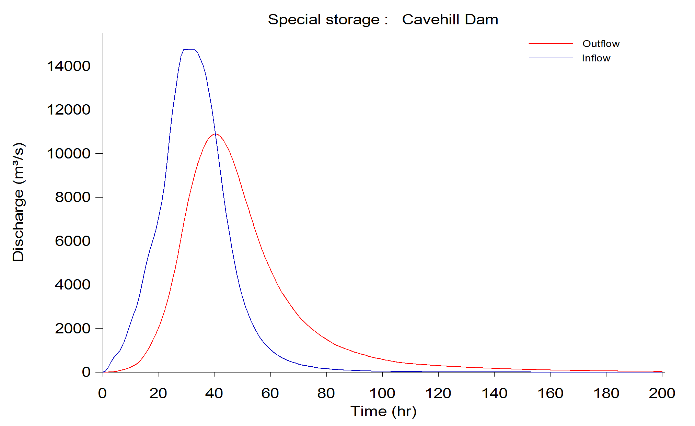

Figure D.7 Cavehill – AEP 1 in 1,000 Years – 36 hour

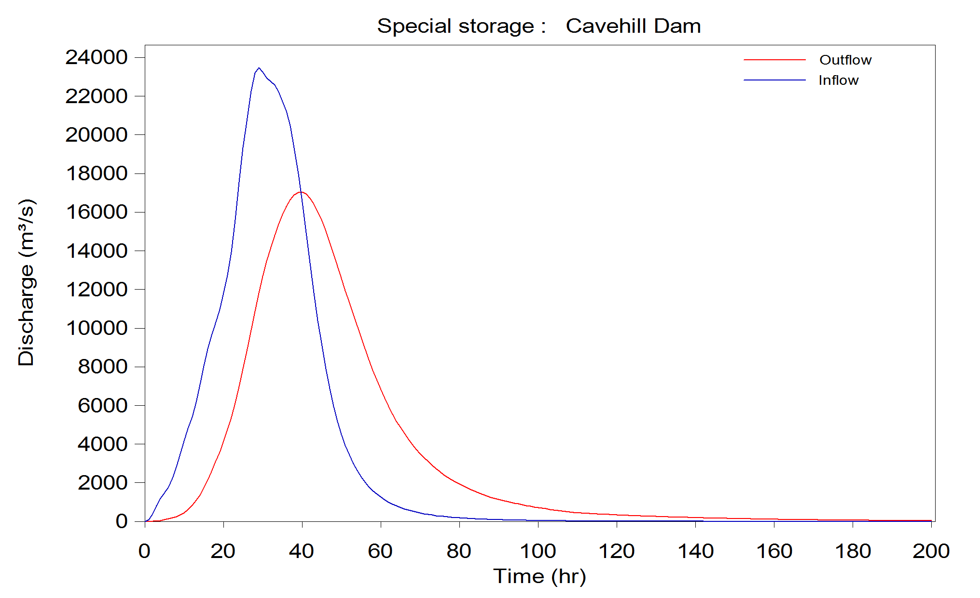

Figure D.8 Cavehill – AEP 1 in 10,000 Years – 36 hour

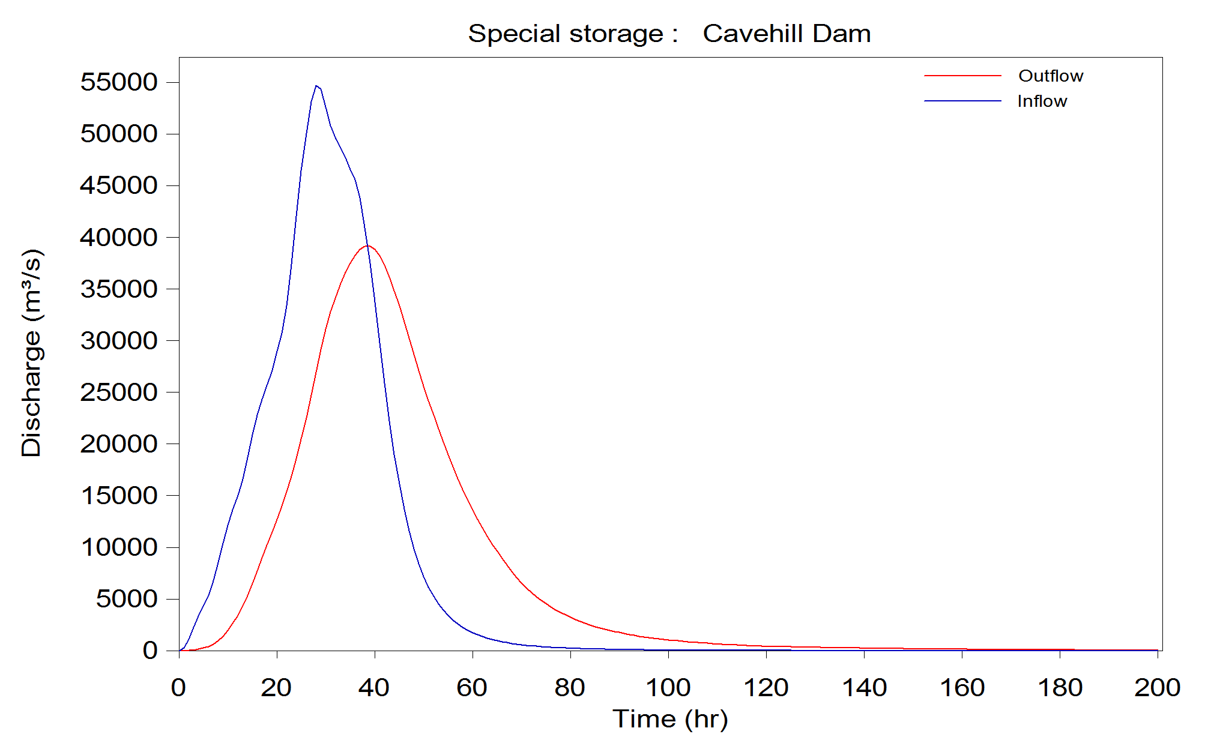

Figure D.9 Cavehill – AEP 1 in 166,667 Years – 36 hour

Appendix E Fitted distribution and confidence limit flood frequency curves

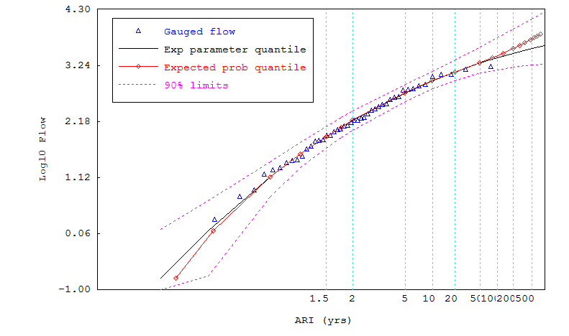
Figure E.1 Dagworth flood frequency plot

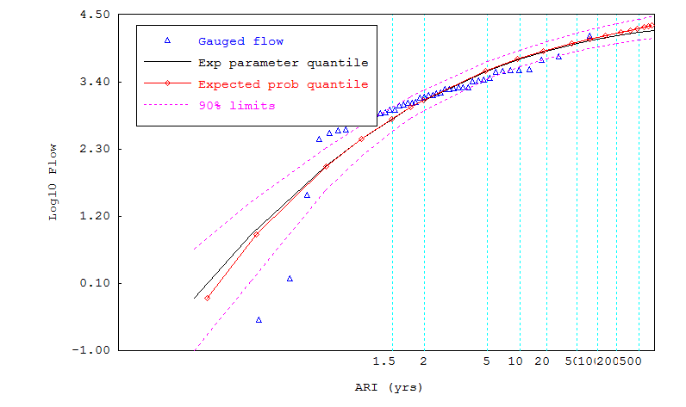

Figure E.2 Greenhills flood frequency plot

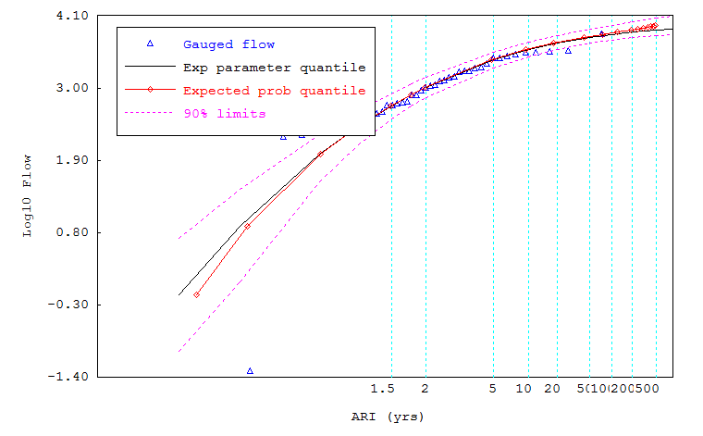

Figure E.3 Cavehill flood frequency plot

CONTACT US

72 | Design flood hydrology for selected dam sites in the Flinders and Gilbert catchments
t 1300 363 400
+61 3 9545 2176
e enquiries@csiro.au
w www.csiro.au

YOUR CSIRO
Australia is founding its future on science and innovation. Its national science agency, CSIRO, is a powerhouse of ideas, technologies and skills for building prosperity, growth, health and sustainability. It serves governments, industries, business and communities across the nation.
FOR FURTHER INFORMATION
Water for a Healthy Country Flagship
Cuan Petheram
t +61 2 6246 5987
e Cuan.Petheram@csiro.au
w www.csiro.au/org/WfHC

Sustainable Agriculture Flagship
Dr Ian Watson
t +61 7 4753 8606
e Ian.Watson@csiro.au
w www.csiro.au/Organisation-Structure/Flagships/ Sustainable-Agriculture-Flagship.aspx

Sustainable Agriculture Flagship
Dr Peter Stone
t +61 7 3833 5659
e Peter.Stone@csiro.au
w www.csiro.au/Organisation-Structure/Flagships/ Sustainable-Agriculture-Flagship.aspx

