strategy, market vision and innovation
High Pressure Processing
RESEARCH IMPACT EVALUATION

May 2018

Contents
1 Executive Summary 2
The challenge 2
The response 2
The impacts 2
2 Purpose and audience 4
3 Background 4
4 Impact Pathway 6
Project Inputs 6
Activities 7
Outputs 8
Outcomes 10
Impacts 12
5 Clarifying the Impacts 14
Counterfactual 14
Attribution 15
6 Cost Benefit Analysis 16
Modelling approach 16
7 Results and Sensitivity analysis 23
8 Limitations and Future Directions 25
9 References 26

1 Executive Summary

The challenge
Consumer’s demand for high quality products with natural and fresh appearance, flavour, texture, taste and nutritional value has been growing over the last decade. Product safety is imperative, and natural products without additives such as preservatives are desirable. To satisfy the demand of ‘fresh like’ food products, without compromising the safety of the products and at the same time improve shelf life, High Pressure Processing (HPP) was identified as an alternative to thermal processing decades ago, and is now becoming an established technology in the food industry.

The response
HPP was established at CSIRO in 2001 with support from the Victorian Government Strategic Technology Infrastructure grant developing emerging technology applications for the food and beverage industry. CSIRO’s HPP research has and continues to improve the understanding of HPP technology use on a commercial scale.

CSIRO has worked for almost 17 years as one of the few agencies capable of providing research and development for potential HPP products to be brought to market. CSIRO’s research, through improving the use of HPP technology in commercial food and beverage production, has led to the introduction of various products treated by HPP onto the market. CSIRO are world leaders in the development and implementation of HPP technology across a range of food products such as meat, poultry, seafood, fruit and vegetable products, meal solutions, dips and sauces. CSIRO has demonstrated that carefully and rigorously tested HPP products can have an increased shelf life of up to five fold with minimal adverse effects on quality, taste and nutrition.

The impacts
CSIRO’s contribution to HPP food and beverage production in Australia has been significant. CSIRO has incubated companies from their own world leading pilot plant, also aiding them in establishing operator owned HPP facilities for commercial production. CSIRO has enabled the growth of many SMEs, assisting them to establish their position in the market. Benefits of HPP include a competitive advantage for products in terms of shelf-life, packaging optimisation and food safety. The result is improved food quality attributes, such as flavour, texture, nutrient content and colour.
By examining three applications in juice, dips and meat products, our estimates suggest that:
- aggregate net present value (NPV) to the Australian community over the next 10 years with a mid-range estimate of $356.4m (real PV at 7% discount rate);
- a benefit- cost ratio (BCR) for the HPP program as a whole with a mid-range estimate of 2.3; and
- a BCR specific to CSIRO’s contribution with a mid-range estimate of 3.9 .

This case study uses the evaluation framework outlined in the CSIRO Impact Evaluation Guide. The results of applying that framework to the HPP case study are summarised in Figure 1.1.
Uptake and adoption
- Commercialisation and scale up of HPP technology to Moira Mac’s, Preshafood, Longfresh
- NSW Safefoods approved facilities with a HPP quality assurance program
Awards – was there specific awards??
Economic impact
- Improved business performance
- Higher retail prices
- Increase in quality and consistency of product

Environmental impact
- Reduction in food wastage

Social impact
- Improved food safety

Understanding of HPP effects on various commercial food products:
- Recommendations for best practice to control HPP water activity
- Established shelf life parameters
- Packaging guidelines
- Patents and pending patent application
- Publications

- CSIRO investment
- DIRE funding
- In kind support
HPP research
Literature and IP survey
- Assess the safety and quality of various food products
- Test packaging optimisation
- Capacity building of HPP implementation

Testing of potential for HPTP technology use

INPUTS
ACTIVITIES
OUTPUTS
OUTCOMES
IMPACT
Figure 1.1: Impact Pathway for HPP Food and Beverage Project

2 Purpose and audience
This evaluation is being undertaken to demonstrate to a range of stakeholders the positive impacts arising from CSIRO’s research into HPP of food and the potential for high pressure thermal food processing. This case study can be read as a standalone report or aggregated with other case studies to substantiate the impact and value of CSIRO’s activities relative to the funds invested in these activities.
This case study is proposed for accountability, reporting, communication and continual improvement purposes. Audiences for this report may include the Business Unit Review Panel, Members of Parliament, Commonwealth Departments, CSIRO and the general public.

3 Background
Consumer demand for high quality products with natural and fresh appearance, flavour, texture, taste and nutritional value has been growing over the last decade. Product safety is imperative, and natural products without additives such as preservatives are desirable. To satisfy these demands of ‘fresh like’ food products, without compromising the safety of the products and at the same time improve shelf life, HPP has been identified as an alternative to thermal processing decades ago (Heinz and Buckow, 2010), and is now becoming an established technology in the food industry. Australia is accepted by many international markets and domestic customers as a producer of “good quality”, “natural”, “clean and green” raw materials and food products; therefore many opportunities exist for Australia to exploit the increasing demand for these “natural” foods.
HPP technology has been a revolutionary food preservation method. Utilising high pressure at or below room temperature, it allows the food to retain properties such as nutritional value, colour and taste, as opposed to traditional pasteurisation techniques requiring heat. HPP is also referred to as high hydrostatic pressure, ultra-high pressure processing, or Pascalization after Blaise Pascal. Early research by Hite and Bridgman was fundamental, exploring the effect of pressure on harmful micro-organisms in foods such as milk and vegetables. With more recent advances in HPP machinery and technology, Japan first began commercialising the technology in the 1990’s, soon spreading to European and US markets. Steady global growth has been driven by a demand for healthier, preservative-free foods that also taste good (Technavio, 2017).
As a food processing parameter, pressure behaves very differently to temperature. Pressure is instantaneously applied to all points within a pressure vessel due to the isostatic principles, unlike in heat treatment where heat transfer relies on conduction and/or convection. In HPP technology food items, usually in their final consumer packaging, are placed in a cylindrical pressure vessel, water is added and the vessel is closed (see Figure 3.1). In commercial HPP systems the vessel contents is pressurized to up to 600 MPa (87,000 psi). Once the maximum required pressure is achieved, it is sustained for a specific time period then released and removed. (Meat and Livestock Australia, 2003).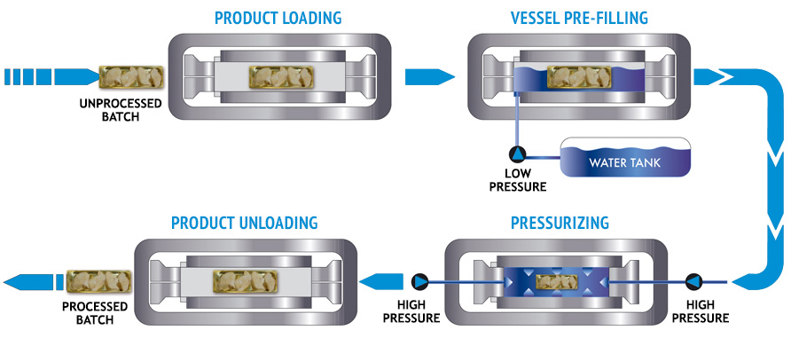Figure 3.1: Diagram of high pressure processing
Source: Carole Tonello Samson, Hiperbaric, Spain
HPP technology was established at CSIRO in 2001 with support from the Victorian Government Strategic Technology Infrastructure grant developing emerging technology applications for the food and beverage industry. CSIRO’s HPP research has improved the understanding of HPP technology use on a commercial scale. Successful establishment of local HPP industry currently has an estimated $30M p.a. in HPP premium food and beverage products, with a strong growth trajectory.
During this early period of HPP research, Australian High Pressure Processing Limited (AHPP Ltd) unsuccessfully attempted to establish a commercial HPP facility in Australia. The facility was aimed to focus on raw oysters with the view to use space capacity for contract processing. AHPP Ltd had a number of strengths, including a core team dedicated to the development of the technology, excellent technical support provision from equipment supplier, a technology which in time proved to be capable of producing a range of commercial high, quality, safe export products. Despite this, they were unable to achieve commercialisation of the technology largely due to lack of research and development of the process, product evaluation studies and a poor business model. Within 3 years they were forced to cease trading.

CSIRO has undertaken HPP process and product development trials with numerous companies, resulting in the successful establishment of several owner-operated industrial HPP facilities in Australia. This included new company incubations and existing small and medium-sized enterprises (SME) investment to establish a point of competitive difference in the market.

More recently, CSIRO has undertaken next generation HPP product development in meat, meals, beverage and vegetables to enable future HPP industry growth. This research has led the development of thermal HPP or high pressure thermal processing (HPTP). Whilst HPP is a mature technology, its main application is in cold preservation of food and this alone is not able to inactivate bacterial spores. It has been shown that microbial spores show synergistic inactivation when high pressure and temperature is combined. Currently most commercial treatments are carried out when the initial temperature is in the range of 5-25°C (considered a cold process), the HPTP process is carried out at 60°C and over.

An economist would ask whether funding of CSIRO research in this area did not crowd out private research. Evidence from UK (Haskel et al 2015) shows that public funding for university science research “crowded in” private sector investment on domestic and foreign R&D activities in the UK. The paper also found evidence that the interaction between the public sector science funding and private sector investment in R&D raised private sector productivity. These findings suggests a complementary relationship between industry and public sector R&D. Drawing on UK evidence, it could be argued that the likely risk of “crowding out” effect by CSIRO is difficult to quantify, but should be low.

4 Impact Pathway

Project Inputs
The research on HPP food production began as a collaboration between government and CSIRO. The program began in 2001 when a $3 million Science and Technology (STI) grant from the Victoria Government’s Department of Innovation, Industry and Regional Development established the Innovative Foods Centre, at Food Science Australia (FSA). The centre was established with the purpose of conducting research and supporting commercialisation of emerging food technologies. FSA invested in HPP infrastructure, implementing vessels ranging from laboratory and pilot scale to semi commercial. DIRD made further investment of $3.5 million over the period 2005-08.
In addition to government funding, the program has received an estimated total of $4.8m (2007/08 to 2012/13) as seen in Table 4.1 from various industry partners. These include but are not limited to: Mars Europe, Meat Livestock Australia, Food Futures, SPC Ardmona, Horticulture Australia, Moira Mac’s, Kraft Foods, Mead Johnson, Heinz and Preshafood.

Table 4.1: Cash and in-kind support for HPP program between 2007/08 and 2018/19 (nominal, $million)
CSIRO research expenditure 1998-2003 | 7.5
CSIRO research expenditure 2004-2008 | 16.0
CSIRO research expenditure 2009-2013 | 10.0
CSIRO research expenditure 2014-2018 | 6.0
CSIRO research expenditure 2014-2019 | 4.2
DIRE funding 2001-2004 | 2.3
DIRE funding 2005-2008 | 2.6
Other externals 2007-2012 | 4.0
Total | 52.5
Source: CSIRO
HPP systems were introduced at the inception of the Innovative Food Centre in 2001, Table 4.2 outlines CSIRO’s current HPP system capabilities.

Table 4.2: CSIRO HPP system capabilities
HPP systems at CSIRO
2 mL kinetic, (700 MPa) and temp
300 mL, pressure (900 MPa) and temp
3.7 L, pressure (800 MPa) and temp
35 L, pressure (690 MPa) and temp

Activities
Early research was aimed at determining the quality advantage of HPP technology and improving product shelf life time over a range of products. This led to research into how HPP affects microbial stability, enzyme activity and other quality parameters over storage time to determine whether the process was able to meet safety regulations for shelf-stable products.
HPP research
CSIRO’s work is largely centred on investigating the full spectrum of what HPP technology can offer, while also assessing the safety and quality of various food products for commercial viability.
Some of the key activities undertaken include:
- Testing food and beverages to varying HPP conditions: temperature, time lengths and pressures;
- Recording the effect of HPP on the quality of the product, including visual attributes and taste;
- Testing the shelf life length post-HPP compared to a control product not treated with HPP or other conventional preservation processes;
- Conducting pathogen microbe studies where laboratory-scale experiments assess for pathogen levels such as Listeria, Salmonella and coliforms;
- Testing packaging optimisation under HPP conditions;
- Cost-benefit analysis; and
- Capacity building of HPP technology implementation in Australia.

HPTP research
Where HPP technology is unsuccessful in eliminating microbial spores, HPTP provides an opportunity to create safer final-products. HPTP used conventional HPP machines, but adds a new heated canister technology. Temperature is an important factor to inactivate some microbes. Whilst the HPTP research is yet to be adopted commercially, CSIRO’s research provides an important fundamental understanding of the process. The research has also included the development of novel methods and techniques for undertaking HPTP, which has previously required a specialised processing vessel.
Some of the key activities which are undertaken across a range of food products include:
- Testing temperatures pre-HPTP and during-HPTP, and the effect of differing pressures with varying initial heat levels.
- Recording the effect of HPTP on the quality of the product, including visual attributes and taste.
- Testing the shelf life length post-HPTP compared to a control product treated with other conventional preservation processes.
- Conducting pathogen microbe studies where laboratory-scale experiments assess for pathogen levels such as non-proteolytic Clostridium botulinum spores.
- Testing packaging optimisation under HPTP conditions and containers used for HPTP.

Outputs
Research in HPP has significantly contributed to both fundamental and applied understanding of its effects on various commercial food products. This understanding has been applied across various food groups – to understand the commercial potential through evaluating the safety and shelf life under HPP treatment.
Specific outputs of the research include:
- Process for heating a composition at a temperature, pressure and time effective for reducing the number of microorganisms and spores. In particular, relating to producing vacuum packed or modified atmosphere packed chilled food products;
- Computational Fluid Dynamics (CFD) modelling for the prediction of temperature distribution and flow for design and characterisation of HPP and HPTP process;
- Development of a “Diving Bell” for the simultaneous processing of product by heat-only and by high pressure and heat in a HPP vessel to identify synergistic spore inactivation; and
- Pressure resistant temperature loggers, which can be used as part of a system for recording temperature profiles in different locations of a high pressure vessel to evaluate HPTP performance.

HPTP Canister
CSIRO has developed a container and system for elevated temperature HPP. Conventional canning produces safe but low-quality products due to the need to significantly overheat the outside of cans for an extended period to ensure adequate heat treatment of the material. The patented canister provides a multilayer container for elevated temperature HPP. The specially selected properties of the layers have similar or better compression heating than the material and insulates the material from temperature loss during processing. The canister is being licensed but is yet to be commercially adopted.

Publications
The science output and profile of CSIRO’s HPP research have been significant, as evident from the number of publications from 2004 – 2018 (Figure 4.1). In total, starting in 1973, there have been 180 publications, including journal articles, books, conference papers and reports.

Figure 4.1. CSIRO’s HPP publications
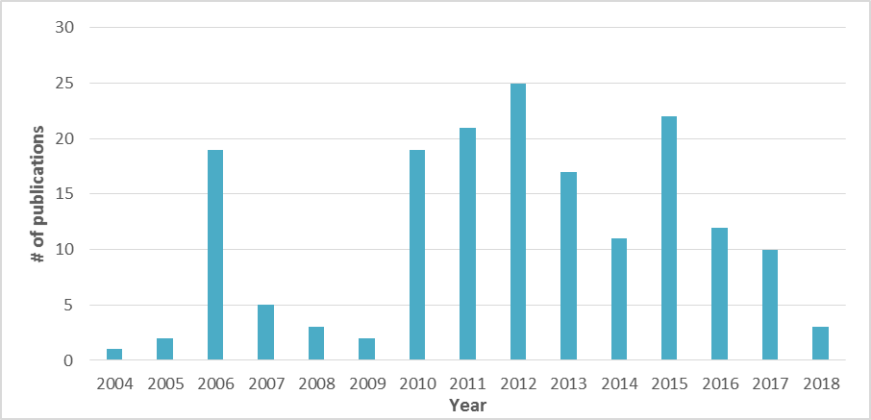
Source: CSIRO Research Publications Repository

Patents

Table 4.2: CSIRO HPP Patents
TITLE | REGISTRATION # | STATUS
Kraft-CSIRO joint patent on HPTP spore inactivation  “Process for reducing spore levels in compositions” | US 8993023 B2 | Granted
 | AU 2007/339844 | Granted
HPTP canister patent  “Container for use in food processing” | AU 2016/310416 | Granted

Awards
2009 Drinktec International Best Beverage Award - Preshafruit
Australian food and beverage company Preshafood beat entries from beverage giants PepsiCo and Coca-Cola at the prestigious 2009 International Beverage Innovation Awards held at Drinktec in Germany. Drinktec is the premier event showcasing global innovations in beverage and liquid food technology and the Beverage Innovation Awards are the Oscars equivalent for the beverage industry (Food Processing, 2017). Preshafruit the flagship product of Preshafood, which uses HPP technology developed in consultation with the CSIRO’s Food Science Australia, took out first prize in the Best New Juice or Juice Drink. It also took out the overall award across the 24 award categories, Best New Beverage Concept, selected as the best beverage from over 340 entries from 40 countries.

Outcomes
The outcomes of the project relate to:
- Rates of adoption along the value chain; as an indication of the technology’s cost effectiveness;
  - Number of plants with CSIRO HPP technology installed;
  - Producers, processors and end user involved in the project; and
  - HPP products being marketed.
- Improved and consistent HPP product quality (fresh, natural, healthy and convenient).

The primary potential users of the research outcomes are participants in the Australian Food and Beverage Industry. The outcomes achieved in CSIRO’s various HPP projects allows for more efficient production and safer HPP food and beverage products. The potential for further research into the discoveries of the HPTP research signals for greater innovation in pressure-heat one-step technology.
CSIRO has both the infrastructure and scientific capability to manage testing and fundamental research requirements for food and beverage product commercialisation. HPP process and product development trials with four companies has resulted in the successful establishment of owner-operated industrial HPP facilities in Australia. The four companies are Moira Mac’s, Preshafood, Fresh Produce Alliance and Austchilli.
In addition to this, CSIRO’s HPP research has been delivered through numerous research projects in conjunction with other industry partners such as Mars Food Europe, Kraft Foods, MLA, AMPC, Mead & Johnson, SPC Ardmona, Gardiner Foundation, and H. J. Heinz. These research projects underpin the feasibility of these new products, playing a crucial step in ensuring quality whilst meeting food safety regulations. These companies have since gone on to produce the products through toll processing facilities or already established internal facilities.

Figure 4.2. CSIRO’s HPP technology Client Research Funding (2007-12)
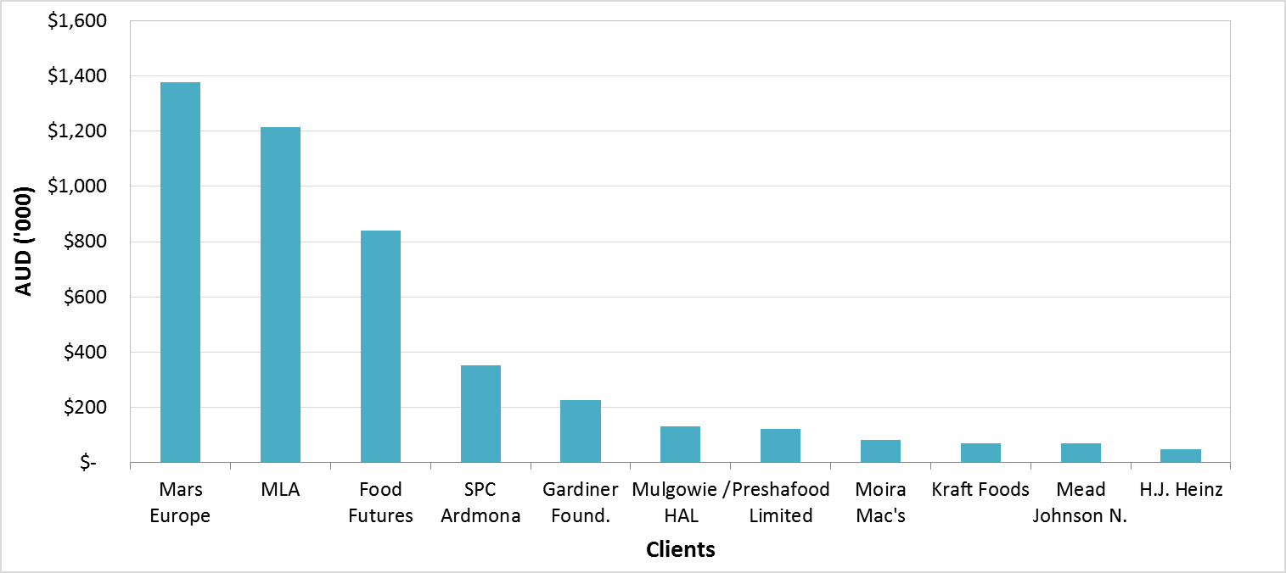
Box 1 Establishment of HPP Industry in Australia
CSIRO has been instrumental in the development of the HPP industry in Australia, playing a pivotal role in establishing food safety and quality for various food products and bringing the technology to a commercial reality. Despite early efforts in the early 2000s by Australian High Pressure Processing Limited to establish a commercial high pressure processing facility in Australia, it wasn’t until 2006 that this became a reality. Preshafruit, at the time known as Donny Boy Fresh Food, launched as the first Australian company offering high quality HPP preserved fruit for yogurt, with CSIRO playing a pivotal role in making the venture feasible. Initially operating within CSIRO as a start-up incubation, Preshafruit later transferred to a new purpose built state-of-the art HPP and food processing facility. Owing to CSIRO’s research on HPP and product development, Preshafruit juices retain the taste, colour and fresh-like characteristics of fruit juices and can be stored up to five times longer than other chilled juices.

Since, the company has expanded into seasonal juice blends, smoothies and vegetable juices using HPP, which are sold in supermarkets nationally. They are also increasing their sales in Asia, where the consumer demand for premium Australian food and beverages is high and there are few similar quality juice products. Now the largest HPP operation in Australia, they have created new jobs and sales growth and having proven the benefits of the new technology to other food manufacturers, are offering toll processing services.
Source: CSIRO

HPP Meat Industry

The “Red meat under pressure” workshop program showcased how HPP can add value and enhance the quality, shelf-life, safety and tenderness of meat products. This was achieved through recently completed MLA-funded research in HPP, as well as a demonstration of the CSIRO Food Innovation Centre HPP plant and product concept demonstration and tasting.

The channels of adoption include state based red meat processors. The WA Foodservice channel red meat products were sourced by mining camps. NSW Safefoods produced red meat products with a 16 week chilled shelf life. The prolonged shelf-life produced through HPP removed the need for frozen supply. NSW Safefoods approved facilities with a HPP quality assurance program to operate. Also, although Longfresh ended the project early they relaunched a variety of red meat HPP products including burgers, added value to beef topside and outside flats and lamb leg and shoulder portions. The burgers were derived from beef 85-90CL trimmings, a lower-grade of beef not previously used for burgers. The distributor and mining camp kitchens expressed they found benefit in chilled product over frozen in both storage and ease of use to prepare meals (Meat and Livestock Australia, 2014).

Barriers
One major drawback of using HPP is the fact that it is a batch process. Modern commercial vessels can have a capacity of more than 500 Litres and such systems can produce two or more tons of product per hour per system, depending upon the vessel utilization and packaging conﬁguration. Production rates can be increased if multiple systems are used in parallel. However, this will still not give the same output that can be achieved with other methods, for example heat pasteurization in continuously operating heat exchangers, which can add to the unit cost of pressure-treated foods.

Assuming the manufacture decides to pass on the cost of the HPP to the end users in full or in part, there is current “unknown” of how much more the end user will be willing to pay for a HPP product. There is a need for a straightforward and clearly articulated education communications platform which explains to the end-user/consumer why the HPP product has a significantly longer shelf-life than they would normally expect from the product (MLA 2014). It is likely that for the foreseeable future HPP will mainly be used commercially for high value products, where it gives a unique advantage over other technologies and where any additional processing cost can be justiﬁed.

In addition, the overall benefits of the HPP projects depend crucially on the approval and endorsement of HPP by all state and federal food regulatory agencies. All state and federal food regulators also needs to promote the existence, benefits and availability of HPP technology in Australia, and to strategically assist in the positive promotion of HPP product categories.

The next major development in the technology will likely be the ability to produce chill-stable or even shelf-stable low acid foods through the use of HPTP. Experimental HPP systems are available, which are capable of operating at temperatures of more than 100°C and pressures up to 700 MPa, however there is yet to be commercial adoption. Further research is required before this will be commercially feasible. This includes the need for sufﬁcient experimental data to validate the microbiological safety of the foods produced in this way; and in particular engineering research to enable commercial scale HPTP.

Impacts
High-pressure-treated foods represent only a small share of the market, compared to foods processed by heat. However, the use of the technology has been steadily providing unique advantages over existing methods.

The impact or success of a food or beverage product treated with HPP technology can affect a range of stakeholders, from farmers, food processors to individual consumers through extended shelf-life, higher retail prices delivered and improved business performance. The use of HPP also has some widespread environmental benefits in particular through a reduction in food wastage. This is particularly important for perishable foods such as fresh fruit and vegetables in comparison to shelf-stable products which inherently have low wastage.
HPP has also improved the livelihood of growers of fresh produce, such as those growing apples and avocados. The application of new value-add products such as juices and dips have created greater confidence through the addition of new value-add products.

Using CSIRO’s triple bottom line impact classification approach, Table 4.4 summarises the nature of the existing and potential impacts.

Table 4.4: Summary of HPP food and beverage project impact
type | category | indicator | description
Economic | Trade and competitiveness | Improved business performance of food manufacturers | Food manufacturers such as Preshafood, Austchilli, as the first Australian movers to process food using HPP technology, may have experience financial and brand benefits. More generally, any major manufacturers currently adopting HPP could have similar benefits from bringing an innovative product to the market first. In economics terms this could be measured as increased sales and value added as compared to other products in food manufacturing business.
 | New products & services | Higher retail prices delivered | Applied to various fresh produce, it enhances the quality, flavour and appearance compared to other conventional processing methods.  Due to the improved sensory properties of the processing technology, cold pressed product can be sold at a higher price compared with otherwise equivalent product on the market. The impact is a result of the consumers’ willingness to pay for their own improved health outcomes, assuming that no premium is paid for any of the other properties of the product such as appearance.
 | Productivity and efficiency | Quality and consistency of product | The use of HPP may significantly reduce the elimination of the risk of microbiological contamination, leading to a consistently high-quality product. It may also reduce the burden on Quality Assurance staff.
Environmental |  | Reduced waste reduction | Increased shelf-life of fresh food and fruit, which is generally very perishable, results in a reduction of food spoilage and wastage. This will also see a reduction in the number of recalls.
Social | Resilience | Income and employment | The use of HPP technology potentially gives fruit growers and processers improved capacity to be competitive and profitable. The use of HPP technology may contribute to greater consistency in production, employment and therefore stability in regional communities.

5 Clarifying the Impacts

Counterfactual
Given that CSIRO had not undertaken both fundamental and applied research to support commercial opportunities for various food processing, there are 3 potential scenarios discussed below:
- Import of HPP products
With HPP production having already been well-established in many countries before arriving in Australia, it is likely that HPP products would have been imported in the absence of CSIRO’s research. New Zealand due to their geographical proximity and growing HPP industry are likely to have been the main exporter to Australia. This would have mainly been of fruits and vegetables in a variety of final forms.
Although importing is a viable option, it is unlikely to have similar uptake with the Australian consumer market comparative to Australian made products. Roy Morgan Research (2017) findings indicated that 89% of Australian consumers are more likely to purchase locally grown/processed food. This strong Australian consumer preference means establishing a product and creating a consumer base will be more difficult for the same product given it was imported. Additionally, due to the strict regulations and food safety concerns around imported meats, it is unlikely that we would see ready to eat meats being imported. In which case alternate, more conventional methods of processing would need to be used by Australian producers.
- Alternate methods of food preservation
It is likely that Australian producers would have continued to use traditional methods of food preservation or explored other emerging technologies. There are many other options for food processing that can be seen below in Table 5.1. It is important to note that due to quality standards in the food industry, not all processes would be as widely used across a variety of food products.

Table 5.1: Alternative pasteurization methods to HPP
Method | Thermal/ Non Thermal | Time | Description
Salt/Chemical preservation | Non- thermal | various | Substance or chemical added to food products to prevent spoilage. Can affect physical attributes of food.
Low Temperature Long Time Pasteurization (LTLT) | Thermal: 60°C – 70°C | 30 – 60 minutes | Conventional method with undesirable quality changes due to the process. Requires separate sceptic packaging, requires large volumes to be economically viable.
High Temperature Short Time (HTST) | Thermal: 70°C – 90°C | 15 -60 seconds - | Widely used nowadays, but due to heating nutritional value, taste and colour breaks down. Requires separate sceptic packaging, requires large volumes to be economically viable.
Pulsed Electric Field (PEF) | Non-thermal | < 1 seconds | PEF uses lower temperatures than thermal pasteurization, in combination with a pulsed high voltage (25,000 Volts) across a gap through which the food flows. This allows for lower temperatures than thermal pasteurization.
High Pressure Processing (HPP) | Non-thermal | 2-5 minutes | Through the use of extremely high pressures (500-600 MPa) for usually about 2-5 minutes, the microbes are “crushed” to death.

- Use of other research providers
Whilst CSIRO is considered to be an expert in HPP, there are other organisations who are able to provide a similar service globally. Key leaders in the industry include Avure Technologies, Hiperbaric and MULTIVAC. These companies both specialise in the manufacturing of vessels as well as food testing. More recently, they have increased their influence in the Australian market, aiding the establishment of toll processing centres.
On this basis and in consultation with the CSIRO research team, in the counterfactual scenarios it is therefore assumed that the benefits of the HPP research in Australia would have emerged between 5 and 10 years later. The next section discusses the detailed assumptions and estimates underlying the ‘with’ and ‘without’ project scenarios.

Attribution
The focus of this CBA is to estimate the broader net benefit to society generally, and globally from the technology as a whole, as identified above, and to estimate that part of the net benefits attributable specifically to CSIRO. This requires a methodology to estimate how much of the overall net benefit would not have been realised in the absence of CSIRO’s involvement in this program in order to disaggregate the shares of net benefits attributable to CSIRO on the one hand, and the other collaborators in the program from the food industry. In practice, this requires that we make a judgement about the value of CSIRO’s contribution to the project outcomes, as distinct from CSIRO’s contribution to the technology, which has facilitated the uptake.
The expected benefits from the implementation of HPP technology can, to a significant extent be attributed to CSIRO. Food manufacturers have played an important role by providing co-finance and access to trial sites and facilities, without which development of the application of the technology would not have been possible. The distinct knowledge contributions of each partner within ‘HPP’ are recognised as attributable to establishment of a viable business for commercialisation of the HPP technology.
As this CBA assumes that in absence of CSIRO, the technology would have still been developed in Australia, but at least 10 years later, it could be argued that the full benefit of bringing forward the new technology by at least 10 years can justifiably be attributed to CSIRO. On the other hand, since both CSIRO and collaborators were considered necessary to achieve the ultimate objective of developing an effective method by 2017, it is considered more appropriate to apportion the benefits on the basis of their respective shares of total costs. It was estimated that CSIRO’s share of total expenditure on the HPP research and development program was approximately 76%.
Based on the above, this case study will attribute total impacts as follows:
• CSIRO – 76%
• Food manufactures and others – 24%

6 Cost Benefit Analysis

Modelling approach
Quality-enhancing research has become increasingly important. However, compared with the number of studies undertaken to assess the economic benefits from cost-reducing research, economic analysis of research that aims to improve the desirable characteristics of a commodity has not been widely covered in the literature. In addition, there is some debate about how to model research-induced quality improvements.
There are a number of options for quantifying the benefits from improved quality.
Demand –side option: one approach is to represent quality improvements as a change in demand for these products, so that an improvement in the quality of the product can be shown to result in an increase in demand (Unnevehr, 1986).
- An approximation of the gain from this increased demand is the initial increase in retail price reflecting the new level of consumer willingness-to-pay. This is sometimes called “incremental profit” approach (Griffith et al 2009).
- These gains from the increase in consumer expenditure are distributed to participants along the value chain in relation to additional costs incurred at each stage of the chain and the scope for those in the chain to pass on those costs to each other.
Supply-side option: an alternative approach is to view quality-enhancing research as a change in supply — as a new product.
- In this approach an improved eating quality for beef is defined as a different product. A technical change that leads to a change in quality is modelled as a shift in the supply rather than a shift in demand.
- A common assumption in this approach is that there is no or limited substitution in demand between the different qualities (e.g. HPP juice and thermal treated juice would be treated as two separate, even if highly substitutable commodities).
- This is clearly not the case for juice where processors and retailers attempt to move consumers between quality categories on the basis of a combination of price and non-price promotion.
In this analysis, we will adopt the “incremental profit” approach based on demand-side option. This approach is measuring the premium that wholesalers, food service processors, retailers and final consumers are willing to pay to have a HPP product.

Defining the “with” and “without” Scenarios
This analysis examines two types of impacts; economic and non-economic. Economic impacts are considered to be impacts that have a dollar value such as an increase in sales and retail prices, reduction in costs expended to product recalls. More specifically, improved levels and consistency of food quality should lead to the following impacts compared to the case that would exist without CSIRO’s HPP technology (the counterfactual):
- Increase in consumers’ willingness to pay for the juice, dips and meat product reflected by premiums paid for the HPP product;
- Increase in demand for juice, dips and meat product; and
- Additional value generated at retail level which is then expected to be passed back down the chain.
Non-economic impacts are those qualitative impacts such as improved environmental or social outcomes. The benefits calculated in the analysis are the net benefits from the program, that is, the difference between the ‘with’ and ‘without program’ scenarios. The analysis is equivalent to carrying out separate analyses for the ‘with program’ and ‘without program’ scenarios and calculating the difference between them. It should also be noted that the costs and benefits of the HPP R&D and deployment were estimated, where quantification is possible at two levels: for the entire research program and for that part of the research program that can be attributed to CSIRO.
While, in close consultation with the CSIRO research team, reasonable and conservative assumptions have been made throughout the analysis, the results should be treated with due caution. Particularly important are the assumptions about the uptake/adoption rates as the basis for projections. Table 6.1 summarises the ‘with’ vs ‘without’ scenarios on which this CBA is based.

Table 6.1: Value of CSIRO’s HPP project
 | Price premium | Increased sales |  | Waste reduction
- With CSIRO HPP (A) | X% higher retail prices (juice) |  | New product sales (dips, meat) | X% waste (meat)
- Without CSIRO ( B) | No change |  | No sales | Y% waste
- Benefit (C= A-B)

Perspective and stakeholders
Given the global nature of the industry the affected stakeholders are not limited to Australia but include those in other countries as well. However, for most CSIRO research, measuring the national costs and benefits is appropriate, rather than measuring any international impacts.

As the CBA needs to be conducted from an Australian societal perspective, it does include not only those economic costs and benefits arising from and attributable to CSIRO’s interventions in Australia. Costs and benefits to other potential stakeholders of this project will be taken into consideration, including:
- Farmers, food processors, retailers and other players in the supply chain;
- Consumers and the broad community; and
- Governments

Time period
While CSIRO’s HPP program is an ongoing activity, it is necessary to define a particular period for the CBA. Given the history of the project, the analysis is based on research activity since 1998.
In the program, there are lags between the research and development of the technology platform and products needed, and the realisation of benefits after adoption by the food industry. Market entry of HPP in the food industry was realised in 2007. On that basis, the benefits are measured from 2014 onwards. In the analysis, the costs from 1998 are included.
A conservative approach is adopted where it is assumed that benefits are measured to 2028. This is consistent with our prior assumption that in the counterfactual scenario the development and adoption of the technology would be delayed by at least 10 years.
Thus the analysis involves a small component of ex-post analysis (relating to the costs and benefit in the period 1999 to 2018), but also a large component of ex-ante analysis forecasting the benefits flowing from the research activities over the period 2018 to 2028.

Benefits to 2028
The steps taken in quantifying the gains from the program were as follows:
- Estimate the price premium, additional sales and waste reduction in each year in order to estimate the total benefit in that year and all subsequent years.
- Estimate environmental benefits each year and all subsequent years for the program as a whole (where these benefits are not incorporated into market prices).
- Attribute a proportion of the total benefits to CSIRO based on their share of historic research expenditure.
- All costs and benefits are discounted at real discount rates ranging from 4%-10%.

While there is insufficient data to determine the social outcomes such as employment and improved food safety, it could be argued that a share of the increase in employment proportionate to the increase in HPP products could also be attributed to the HPP R&D.

Costs
Establishing the costs involved throughout the entire pathway from inputs to impact is an important part of any cost-benefit analysis. This includes estimating the input costs incurred by both CSIRO and its collaborators, as well as any usage and adoption costs borne by clients, external stakeholders, intermediaries, and end users. For HPP technology, these costs include trials and implementation (capital and operating costs). It was estimated that CSIRO and its research partners would have contributed approximately $161 million ($2017/18) to the research between 1998 and 2018 in real terms discounted at 7%.
Dead weight costs of government taxation
Given that the national HPP research is mainly funded by the Australian and state governments, the cost of the funds that it has used for the research program should reflect on the rest of the economy. Assuming that it is realistic to assume that CSIRO HPP funding has been obtained through income taxation, there will have been negative effects on the private sector in the form of deadweight loss. It has been argued by a number of authors that research costs should be increased by about 20% to reflect the deadweight loss of income tax-based funding, although many Australian cost-benefit studies omit it.
Table 6.2 summarises the total costs for researching and developing the HPP technology as well as the social costs such as emissions.

Table 6.2: Summary of the total project costs ($2017/18)
Costs | $ millions, real, discounted | % contribution to total costs
HPP capital | 21.7 | 8.1%
HPP operating | 67.3 | 25.2%
HPP R&D (CSIRO) | 122.9 | 46.0%
HPP R&D (Others) | 38.2 | 14.3%
Emissions | 0.9 | 0.3%
Dead weight costs of government taxation | 15.9 | 6.0%
Total costs | 267 | 100%

CBA Assumptions
As there is some uncertainties in relation to the realised and expected benefits of the HPP R&D, a range of assumptions have been considered in three applications. The three applications relative to the counterfactual, include:
- Price premiums for applications in the juice processing;
- Increased demand for avocado products; and
- Increased demand and reduced waste for the meat products
Due to the limited information on HPTP technology, it has not been included in this CBA.

Benefit of Price premiums for application in the juice processing
Consumers recognise the improvement in the quality and consistency of the HPP juice product and therefore they are willing to pay higher prices for it. In this application, it is assumed that CSIRO brought forward the commercialisation of HPP juice by ten years and the HPP juice is assumed to substitute other type of juice without increased demand for juice product in general. Giving an average 20% retail price premium, net of additional costs, (derived in Table 6.3 below) and given an annual production of 11.2 million litres, the additional retail values to the industry is calculated according to Table 6.3.

Table 6.3: Impact calculation for price premium
Measure |  | Value | Source
With CSIRO research (HPP Juice)
A_{R} | Volumes of HPP Juice Sold (liter per annum) | 11,200,000 | Preshafruit CEO interview
B_{R} | Retail price premium (%) | 20% | Preshafruit CEO interview
C_{R} | Unit HPP processing cost (U$per litre) | 0.107 | Sampedro et al 2014
D_{R} | Unit HPP capital cost (U$per litre) | 0.031 | Sampedro et al 2014
E_{R} | Exchange rate (AUD/USD) | 0.76 | RBA 2017
F_{R} | Indicative retail value ($per annum) | = A_{R} * (C_{c*} (1+B_{R} ) –(C_{R+}D_{R})/ E_{R})
Counterfactual (chilled juice using thermal pasteurization)
A_{c} | Unit pasteurization processing cost(U$per litre) | 0.015 | Sampedro et al 2014
B_{c} | Unit pasteurization capital cost (U$per litre) | 0.0008 | Sampedro et al 2014
C_{c} | Retail price ($ per litre) | 2.8 | Woolworth Online accessed April 2018
D_{c} | Indicative retail value ($per annum) | = A_{R} * (C_{c*} - (A_{c} + B_{c})/ E_{R} )
Impact | World with CSIRO research – counterfactual
 | Additional retail value before tax ($ per annum) | =F_{R -} D_{c}

Benefits of increased demand for avocado products (e.g. avocado pulp, halves or guacamole)
Processed avocado propositions benefit from HPP in various ways including respecting the freshness of the original fruit ingredient, extending the microbial shelf life and, perhaps even more importantly, extending the commercial shelf life by preventing browning of the product. It is assumed that CSIRO brought forward the HPP research by 10 years and consumers are increasing their demand for the HPP avocado and the industry is extracting more retail value out of the market compared to a scenario without the HPP technology. Giving an annual production of 73,529 kg, net of additional costs, (derived in Table 6.4 below), the additional retail values to the industry is calculated according to Table 6.4.

Table 6.4: Impact calculation for additional value at retail
Measure |  | Value | Source
With CSIRO research (HPP dips)
A_{R} | Volumes of HPP Juice Sold (liter per annum) | 73,529 | Retail World 2012
B_{R} | Retail price ($ kg) | 34 | Woolworth Online accessed
C_{R} | Unit HPP processing cost (A$per litre) | 0.4 | CSIRO
D_{R} | Unit HPP capital cost (U$per litre) | 0.031 | Sampedro et al 2014
E_{R} | Exchange rate (AUD/USD) | 0.76 | RBA 2017
F_{R} | Indicative retail value ($per annum) | = A_{R} * (B_{R} -C_{R}-D_{R}/ E_{R} )
Counterfactual (fresh avocado)
A_{c} | Unit processing cost ($per litre) | 0
B_{c} | Unit capital cost (U$per litre) | 0
C_{c} | Retail price ($ per litre) | 7 | Woolworth Online accessed April 2018
D_{c} | Indicative retail value ($per annum) | = A_{R} * C_{c}
Impact | World with CSIRO research – counterfactual
 | Additional retail value before tax ($ per annum) | =F_{R -} D_{c}

Benefit of increased demand and reduced waste for the meat products
Meat products have been the main drive of HPP technology in the last years. HPP is the most viable step to extend shelf-life of cooked meats, maintaining high sensorial and nutritional qualities and improving food safety without the need of additives or artificial preservatives. In this application, it is assumed that CSIRO brought forward commercialisation of HPP meat products by ten years. It is also assumed that the industry is extracting more retail value out of the market at the combination of increased demand and reduced waste for meat products compared to a scenario without the HPP technology. Giving an average induced demand of 2% and reduced waste of 2%, net of additional costs, (derived in Table 6.5 below), the additional retail values to the industry is $ million by 2027. The calculation for this impact is presented in Table 6.5.

Table 6.5: Impact calculation for increased demand and reduced waste
Measure |  | Value | Source
With CSIRO research (HPP meat)
A_{R} | Induced demand (%) | 2%
B_{R} | Unit HPP processing cost (A$per kg) | 0.4 | MLA 2014/CSIRO
C_{R} | Unit HPP capital cost (U$per kg) | 0.031 | Sampedro et al 2014
D_{R} | Waste ratio (%) | 0% | MLA 2014
E_{R} | Exchange rate (AUD/USD) | 0.76 | RBA 2017
F_{R} | Indicative retail value ($per annum) | = A_{c} (1+A_{R} ) * (D_{c}-B_{R}-C_{R}/ E_{R} )
Counterfactual (Retort processing meat )
A_{c} | Volumes of poultry meat sold (kg per annum) | 90,909 | Retail world 2012
B_{c} | Unit retort processing cost(A$per kg) | 0.258 | MLA 2014
C_{c} | Unit retort capital cost (U$per kg) | 0.0008 | Sampedro et al 2014
D_{c} | Retail price ($ kg) | 33 | Woolworth Online accessed April 2018
E_{c} | Waste ratio (%) | 2%
F_{c} | Indicative retail value ($per annum) | = A_{R} *(1- E_{c} )*(D_{c} - B_{c} - C_{c}/ E_{R} )
Impact | World with CSIRO research – counterfactual
 | Additional retail value before tax ($ per annum) | =F_{R -} F_{c}

Market penetration analysis
We have fitted a Gompertz adoption curve to simulate juice, dips and meat HPP products’ penetration of the Australian market, in order to estimate the additional revenues to the food industry enabled by the CSIRO project on a year-by-year basis over the next 10 years. For the calibration exercise, the parameters of the curve were chosen based on the followings assumptions. The curves are shown in Figure 6.1-6.3.
Table 6.6: Market penetration analysis for HPP Juice, Dips and Meat
Application | Current market share(%) in  2017-18 | Target market share (%) in 2027-28 | Market size ($m 2017-18)
HPP Juice | 8% | 16% | 490
HPP Dips | 1% | 3% | 200
HPP Meat | 2% | 4% | 160
Source: Retail World 2012 and CSIRO
Figure 6.1-6.3: Market penetration analysis
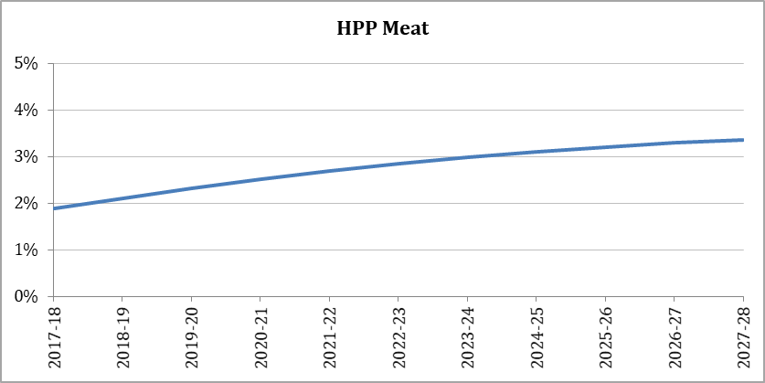
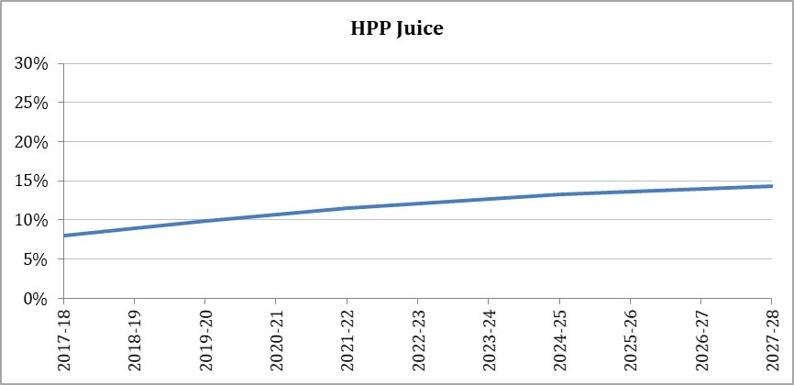
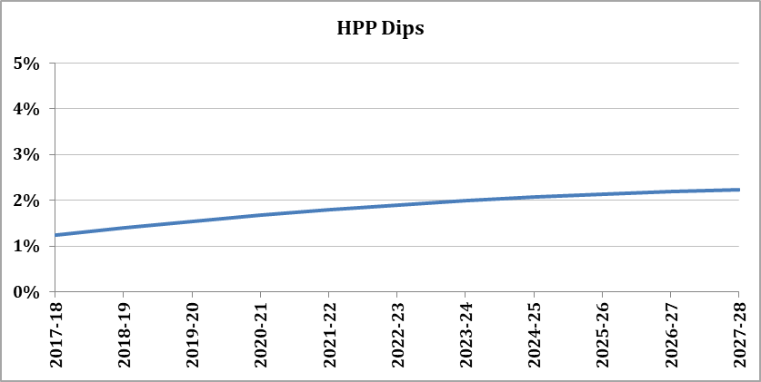

7 Results and Sensitivity analysis
This section presents the results of the CBA, comparing the performance of options using the two key metrics:
- NPV: which is the Present Value (PV) of economic benefits delivered by the HPP technology less the PV of economic costs incurred; and
- BCR: which is the ratio of the PV of economic befits to PV of economic costs over the appraisal period.
The NPV measures the expected benefit (or cost) to society of adopting the technology relative to base line (counterfactual scenario), expressed in monetary terms, whereas the BCR provides the benefit per unit of cost relative to a scenario without HPP technology.
Results of the CBA are summarised in Table 7.1 based on the “most likely” assumptions applied in the analysis for costs and benefit items using a real discount rate of 7%. The results show net costs and benefits of with CSIRO case relative to without CSIRO case over the appraisal period, 2018/19 – 2038/39 following the methodology discussed in the previous section.
Table 7.1 CBA Analysis Results (costs and benefits)
Costs | $ millions, real, discounted
HPP capital | 21.7
HPP operating | 67.3
HPP R&D (CSIRO) | 122.9
HPP R&D (Others) | 38.2
Emissions | 0.9
Dead weight costs of government taxation | 15.9
Total costs | 267.0
Benefits | $ millions, real, discounted
Additional revenue from manufacturing HPP juice | 377.5
Additional revenue from manufacturing Dips | 95.6
Additional revenue and reduced waste from retailers (ready-to-eat poultry) | 150.2
Total benefits | 623.4
Table 7.2 CBA Analysis Results (NPV and BCR)
Program | 7% (central estimate)
Benefit cost ratio = present value of benefits / present value of costs | 2.3
Net present value ($ millions, real 2017 dollars) = present value of benefits - present value of costs | 356.4
CSIRO

Benefit cost ratio = present value of benefits / present value of costs | 3.9
Net present value ($ millions, real 2017 dollars) = present value of benefits - present value of costs | 352.7
Note: CSIRO BCR can be also be interpreted as Social Rate of Return on Investment (SROI): CSIRO’s contribution to Australian society is defined as the ratio of social returns (economic benefits) to the resources contributed by CSIRO alone.
Please note that the overall impact is the sum of all three applications. The underlining assumption in this approach is that there is no or limited substitution between the different application (e.g. juice and meat products would be treated as two separate non-substitutable products).
These estimates suggest that the program expenditure of approximately $267m ($2017/18 discounted) could lead to:
• an aggregate net present value (NPV) to the Australian community over the next 10 years with a mid-range estimate of $356.4m (real PV at 7% discount rate);
• a benefit- cost ratio (BCR) for the HPP program as a whole with a mid-range estimate of 2.3; and
• a BCR specific to CSIRO’s contribution with a mid-range estimate of 3.9.
In light of the assumptions underlying the estimated potential benefits that might be delivered by the HPP research program, it can be expected that the benefits will exceed the total costs of the research, from the perspectives of the program as a whole.
However, it needs to be stressed that the economic benefits of HPP technology over the period from 2018 to 2028 cannot be predicted with accuracy due to the complexity of the market conditions. The overall benefits of the technology depend crucially on the adoption profile and actual achievement of the economic, social and environmental benefits. Consequently there is considerable variability in the reported results for the BCRs due to the wide range of assumed input values employed in the model as well as the lack of detailed historical data.
The CBA is necessarily based on a series of assumptions that mean that there is a degree of uncertainty around the results. Sensitivity testing has been undertaken to clarify which assumption can materially change the results. Sensitivity analysis has been undertaken on the key parameters including:
- Discount rate;
- Changes in price premiums; and
- Changes in attribution ratio.
The results of the sensitivity analysis are outlined in Table 7.3.

Table 7.3: Sensitivity test results (CSIRO only)
Variables | NPV | BCR
No changes | 352.7 | 3.9
Discount @ 4% | 286.9 | 4.4
Discount @ 10% | 445.3 | 3.5
Increase price premium by 10% | 496.8 | 5.0
Decrease price premiums by 10% | 208.7 | 2.7
Increase CSIRO attribution to 80% | 375.8 | 4.1
Decrease CSIRO attribution to 60% | 251.1 | 3.0

From the results it is evident that a decrease in price premiums and CSIRO attribution will have the most significant impact in reducing the NPV, while an increase in discount rate would improve the NPV.
While the parameters used in this analysis seemed reasonable in the light of current realities, it is nevertheless important to test the robustness of our conclusions to variations in these assumptions. The low and high alternative assumptions used in the above sensitivity analysis were brought together to estimate the benefit and cost streams under pessimistic and optimistic scenarios by combining changes across all variables jointly. The results under these different assumptions are summarised in Table 7.4.

Table 7.4. Optimistic and pessimistic scenarios results
Scenario | Variables | NPV ($m) | BCR
Optimistic scenario | Discount rate: 10%  Price premiums: 30%  CSIRO attribution: 80% | 684.4 | 4.8
Pessimistic scenario | Discount rate: 4%  Price premiums: 10%  CSIRO attribution: 60% | 116.1 | 2.4

8 Limitations and Future Directions
This evaluation uses a mixed methodology to evaluate the research impact arising from the HPP project. It combines quantitative and qualitative methods to illustrate the nature of the technology’s economic, environmental, and social impacts. In cases where the impacts can be assessed in monetary terms, a CBA is used as a primary tool for evaluation. As a methodology for impact assessment, CBA relies on the use of assumptions and judgments made by the authors in conjunction with the research team. This relates primarily to the economic indicators for impact contribution, attribution, and the counterfactual. These limitations should be considered when interpreting the results presented in this case study.
Given the scope and budget for the analysis, we acknowledge that there are some limitations with regard to the evidence base of impacts. For example, the uptake and adoption rate of HPP from 2018 onward was based on estimates only as there is no reliable data to indicate expected rates. In addition, some environmental and social benefits were not quantified, but were treated as potential impacts, owing to a lack of reliable data.

9 References
Bridgman, P. W. (1912). Water in the liquid and five solid forms under pressure. Proceedings of the American Academy of Arts and Science, XLVII(13), 441-558.
CSIRO (2017). Dairy: creating new opportunities for industry. Retrieved 6 December 2017, from http://www.csiro.au/en/Do-business/Partner-with-our-Business-Units/Do-business-Agriculture-Food/Food-innovation-centre/Our-expertise/Dairy
CSIRO (2017). Food Safety | Shelf life. Retrieved 7 December 2017, from https://www.csiro.au/en/Research/Health/Food-safety/Shelf-life
Heinz, V. and Buckow, R. (2010). Food preservation by high pressure. Journal of Consumer Protection and Food Safety, 5(1), 73-81. http://doi.org/10.1007/s00003-009-0311-x
Hite, B. H. (1899). The effects of pressure in preservation of milk. West Virgina Agricultural Experiment Station Bulletin, 58, 15-35.
Austchilli (2017). HPP Contact, Austchilli. Retrieved 6 December 2017, from http://austchilli.com.au/hpp-contact
Haskel J, Goodridge P, Hughes A, Wallis Get al. (2015), The contribution of public and private R&D to UK productivity growth, Publisher: Imperial College Business School.
Industrial High Pressure Processing Equipment. (2017). Hiperbaric High Pressure Processing, pp.1. Available at: http://www.hiperbaric.com/media/uploads/equipos/documentos/triptico_Gama_ENG_online2.pdf [Accessed 6 Dec. 2017].
International best beverage award goes to Australian company Preshafruit. (2017). Food Technology | Food Processing. Retrieved 6 December 2017, from http://www.foodprocessing.com.au/content/training-education/news/international-best-beverage-award-goes-to-australian-company-preshafruit-119193884
IP Australia (2017). AU 2007/339844 - Process for reducing spore levels in compositions. IP Australia: AusPat. Retrieved 8 December 2017.
IP Australia (2017). AU 2016/310416 - Container for use in food processing. IP Australia: AusPat. Retrieved 8 December 2017, from http://pericles.ipaustralia.gov.au/ols/auspat/applicationDetails.do?applicationNo=2016310416
Juffs, H., & Deeth, H. (2017). Scientific Evaluation of Pasteurisation for Pathogen Reduction in Milk and Milk Products. Food Standards Australia New Zealand. Retrieved 7 December 2017, from http://www.foodstandards.gov.au/code/proposals/documents/Scientific%20Evaluation.pdf
Knoerzer, K., (2016). Nonthermal and Innovative Food Processing Technologies. Reference Module in Food Science. DOI: https://doi.org/10.1016/B978-0-08-100596-5.03414-4
Longfresh | High Pressure Processing. (2017). Longfresh.com.au. Retrieved 5 December 2017, from http://www.longfresh.com.au/
Meat and Livestock Australia, (2003). A financial evaluation of high pressure processing of small goods. Retrieved from: https://www.mla.com.au/download/finalreports?itemId=2099
Meat and Livestock Australia, (2014). High Pressure Processing (HPP) – Prontier red meat development Project. Retrieved from: https://www.mla.com.au/download/finalreports?itemId=3150
Moira Mac's: revolutionising supermarket cooked meats. (2017). CSIRO. Retrieved 5 December 2017, from http://www.csiro.au/en/Research/AF/Areas/Food/Making-safer-foods/Safer-cooked-meats
Preshafruit - high pressure juices. (2017). CSIRO. Retrieved 6 December 2017, from http://www.csiro.au/en/Research/AF/Areas/Food/Preshafood-juices
QFP 350L–600 High Pressure Processing System. (2007). [PDF] Avure Technologies, pp.1-2. Available at: http://www.chiefup.com.tw/data/high_pressure/qfp_350l-eu-may-2007.pdf [Accessed 6 Dec. 2017].
Sevenich, R., 2016. High-Pressure Thermal Sterilization. Reference Module in Food Science. DOI: https://doi.org/10.1016/B978-0-08-100596-5.03101-2
Technology | Cold Pasteurisation. (2017). Moira Mac's Poultry | Bendigo, Victoria, Australia. Retrieved 5 December 2017, from https://www.moiramacs.com.au/technology
US 8993023 B2 - Process For Reducing Spore Levels In Compositions. (2017). The Lens. Retrieved 8 December 2017, from https://www.lens.org/lens/patent/US_8993023_B2

CONTACT US  t 1300 363 400  +61 3 9545 2176  e enquiries@csiro.au  w www.csiro.au  At CSIRO we shape the future  We do this by using science to solve real issues. Our research makes a difference to industry, people and the planet.  As Australia’s national science agency we’ve been pushing the edge of what’s possible for over 85 years. Today we have more than 5,000 talented people working out of 50-plus centres in Australia and internationally. Our people work closely with industry and communities to leave a lasting legacy. Collectively, our innovation and excellence places us in the top ten applied research agencies in the world.  WE ASK, WE SEEK AND WE SOLVE |  | For further information  Strategy, Market Vision and Innovation  Dr Anne-Maree Dowd  Executive Manager  t +61 7 3327 4468  e anne-maree.dowd@csiro.au  w http://my.csiro.au/impact

It should be noted that the measurement of the BCR in this and other CSIRO CBA reports differs from the conventional measure. It measures the ratio of net benefits per $ of CSIRO research and development expenditure rather than the ratio of gross benefits per $ of gross costs (i.e. incurred by both CSIRO and industry). Applying this formula leads to BCRs with a significantly higher value than what would normally be expected. CSIRO BCR can be also be interpreted as Social Rate of Return on Investment (SROI): CSIRO’s contribution to Australian society is defined as the ratio of social returns (economic benefits) to the resources contributed by CSIRO alone.
This business model allows any food or beverage manufacturer to have access to industrial HPP equipment without the need of directly investing capital in the purchase of HPP technology. Instead, they simply pay for the use of existing HPP industrial plants offering this service on a fee or toll basis.
See footnote 1 for clarification on the definition and measurement of BCRs in this report.

