

Australia’s National  
Science Agency

Program and Eligibility Guidelines

Version 2 - December 2019

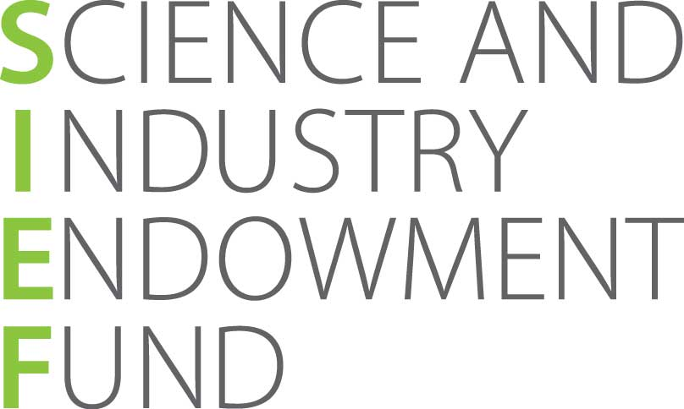SIEF Ross Metcalf STEM+ Business Fellowship Program

Contents

1 Introduction 2

2 Eligibility 3

3 Funding limits 4

4 Reporting requirements 5

5 Application process 5

6 Assessment process 5

About Ross Metcalf

The late Ross Metcalf lived and worked in Western Australia where, following studies at UWA, his skills as an industrial chemist were applied with great benefit to the mining industry. Ross was a life-long lover of science and an inventor who sought practical solutions to chemical, mechanical and electrical challenges. SIEF Ross Metcalf STEM+ Business Fellowships are supported by his generous Gift to the Science and Industry Endowment Fund. In line with Ross’s wishes the SIEF Ross Metcalf STEM+ Business Program will strive to “foster a sustainable future for the country and interesting careers for future generations” while advancing areas of research with a “realistic chance of commercial payback”.

# Introduction

#### The SIEF Ross Metcalf STEM+ Business Fellowship Program is an industrial research program, which supports the collaboration of early-career researcher (ECR) Fellows, employed by Australian universities or research organisations, with Australian small and medium-sized enterprises (SMEs) to work on technical projects that improve the SME’s competitive advantage. SIEF Ross Metcalf STEM+ Business Fellows work full-time for two-to-three years on a research project identified and led by the SME. The ECR Fellow is supported by the expertise of their resident university or research organisation.

#### The objectives of the program are to:

#### • build deep connection and collaboration between universities/research organisations and SMEs that allow for knowledge flow between research and industry sectors

#### • accelerate the adoption of new ideas and technologies by Australian SMEs

#### • fast track solutions to increase the competitiveness of Australian SMEs

#### • elevate the significance of science, technology, engineering and mathematics (STEM) disciplines as skills and capabilities central to industrial competitiveness

#### • provide practical experience in industry for ECRs, creating and sustaining a cohort of researchers capable of addressing national challenges

#### SIEF Ross Metcalf STEM+ Business Fellowships are provided through funding from the Science and Industry Endowment Fund (SIEF) supported by a generous Gift from the late Ross Metcalf and are administered by CSIRO’s SME Connect team. The program provides grant funding up to a maximum of $115,000 per annum (excluding GST) for full-time engagement of the ECR Fellow with the project. The SME is required to make an annual cash contribution to the project that is equal to, or greater than, the grant amount. Both the grant and the SME contribution is to be paid directly to the collaborating university, research agency or research-focused institute.

#### NOTE: The latest version of this document and the accompanying SIEF Ross Metcalf STEM+ Business Fellowship Program - Funding Application Form can be found on CSIRO’s SME Connect site at: <http://www.csiro.au/en/Do-business/Solutions-for-SMEs/Researcher-placements/STEM-Plus-Business>

#### All enquiries regarding eligibility and applications should be directed to the SME Business Manager:

#### Jason Barkla

#### SME Business Manager

#### CSIRO SME Connect

#### +61 3 9545 8246

#### <jason.barkla@csiro.au>

# Eligibility

An application for the SIEF Ross Metcalf STEM+ Business Fellowship Program may only be made for eligible projects. To be eligible, a proposed Fellowship must satisfy ALL of the following eligibility criteria:

An eligible SME must:

* have completed an AusIndustry Innovation Connections grant supported project prior to commencement of a SIEF Ross Metcalf STEM+ Business project

AND

* have had an annual turnover, income or expenditure of $1 million to $100 million in the last financial year.

The SME must have an ACN, be solvent, and also be a for profit company that is non tax-exempt and registered for GST. Trading activities must be the majority of the SME’s overall activities.

Furthermore, the SME must be prepared to support the following:

* participation of the ECR Fellow in 6 business meetings per annum that provide the ECR Fellow with business context.

This may be achieved through:

* SIEF Ross Metcalf STEM+ Project meetings at which the broader commercial and business context of the project is discussed and/or the SME’s other business and research activities beyond the direct scope of the SIEF Ross Metcalf STEM+ Project; OR
* Discrete non-project meetings such as those with customers or internal meetings about strategy, marketing or other business activities.
* professional development of the ECR Fellow (e.g. allowing them to publish their research outcomes, without sharing sensitive IP).

An eligible ECR Fellow must:

* have completed a PhD in a STEM subject (Science, Technology, Engineering or Maths) OR have a Bachelor’s degree in Engineering / Master’s degree by Research in other STEM disciplines with relevant research experience that brings their capabilities to a PhD equivalent level
* have no more than 6 years relevant experience since conferral of the most recent degree
* be employable by an eligible university, research agency or research-focused institute
* have the required research skills to achieve the deliverables of the project.

An eligible university or research organisation must:

* be an Australian university, publicly-funded research agency, or research-focused institute
* employ an eligible ECR Fellow for the duration of the project.

An eligible project must:

* be led by an eligible Australian SME
* involve research whereby outcomes cannot be determined in advance on the basis of current knowledge, information or experience, but can be determined by applying a systematic progression of work based on principles of established science
* be a new research project which the SME would be unlikely to commence without the matched support of a SIEF Ross Metcalf STEM+ Business Fellowship grant
* not be more effectively delivered by the private sector, i.e. by professional engineering / scientific consultancies or in-house staff
* involve activities that do not form a normal part of doing business for the SME
* support the professional development of the ECR Fellow
* be aligned to the SME’s strategy and be expected to result in commercial outcomes
* be 2 to 3 years in duration
* ensure the ECR Fellow is 100% allocated to the project with a target of over 10% of time engaged with the SME
* have a nominated Research Supervisor with expertise relevant to the project and who is employed by the university or research organisation
* have a nominated Mentor from within the SME, such as an experienced company manager, who can provide guidance and business context to the ECR Fellow.

# Funding limits

SIEF Ross Metcalf STEM+ Business projects are to be co-funded by the SME and SIEF. In-kind contributions from the collaborating research organisation are encouraged.

The eligible project is to be costed by the research organisation based on agreed research outcomes discussed with the SME, deducting any in-kind contributions by the research organisation to determine the annual cost of research delivery to be shared by the SME and SIEF*.

SIEF will dollar-match the SME cash contribution up to a maximum of $115,000 per annum. For projects with an annual cost of delivery under $230,000, the SME and SIEF are expected to co-fund an equal share. For projects with an annual cost of delivery over $230,000, SIEF will fund a maximum of $115,000 per annum and the SME will be expected to fund the remaining balance.

It is suggested that participating SMEs will be invoiced on a quarterly basis, in advance, by the research organisation.

*Please note that certain costs are not fundable by SIEF, particularly those that do not directly support the research project in question. Examples of non-fundable items include capital works or infrastructure costs and professional membership fees.

# Reporting requirements

### All grant recipients are required to participate in reporting to CSIRO SME Connect, which will include written reports. There will also be a requirement for regular meetings between all participants on at least a quarterly basis, ideally to coincide with the invoicing cycle.

### SIEF Ross Metcalf STEM+ Business grant funds will be paid via CSIRO to the participant research organisation upon acceptance by CSIRO of written reports from SIEF Ross Metcalf STEM+ Business Program participants at 6 months, 12 months, 24 months and 36 months (where applicable) from the project commencement date. The research organisation will be required to show evidence that the matching SME funds have been received prior to the payment of the grant funds by CSIRO.

### Through involvement in the program, the participants’ name and logo, as well as the project title and grant amount awarded, may be used publicly.

# Application process

Applications are lodged by completing the SIEF Ross Metcalf STEM+ Business Fellowships Program - Funding Application Form and emailing a scanned copy to:

Jason Barkla

SME Business Manager

CSIRO SME Connect

+61 3 9545 8246

<jason.barkla@csiro.au>

The form can be submitted by the SME or the research organisation and must be signed by authorised representatives of both parties. The researcher, if known, will also be required to sign the application. ECRs cannot apply directly for a SIEF Ross Metcalf STEM+ Business Fellowship but can apply for Fellowship positions advertised by a participant research organisation.

# Assessment process

Applications will be assessed by a panel of three members of CSIRO’s SME Connect team. Decisions will be based on satisfying all eligibility criteria and the quality of the responses to the questions in the Project details and Evaluation criteria sections of the application. Applicant SMEs will be advised of the outcome of the assessment within 10 working days of the fully signed application being received by SME Connect’s SME Business Manager.

Successful applicant SMEs will be contacted with a letter of offer which will advise on subsequent actions required. Unsuccessful applicant SMEs will be advised either to amend and re-submit the application, or that the application is not eligible and on what grounds. The assessment panel’s decision is not subject to appeal; appeals against administrative processes may be considered.

|  |
| --- |
| As Australia’s national science agency and innovation catalyst, CSIRO is solving the greatest challenges through innovative science and technology.  CSIRO. Unlocking a better future for everyone.  Contact us  1300 363 400  +61 3 9545 2176  csiroenquiries@csiro.au  www.csiro.au  For further information  CSIRO SME Connect  Jason Barkla +61 3 9545 8246  jason.barkla@csiro.au  csiro.au/en/Do-business/Solutions-for-SMEs/About-SME-Connect |
|  |