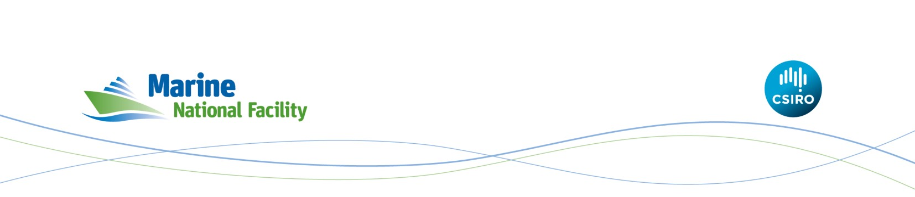Review of the Marine National Facility Access Framework
Terms of Reference

Background
Funded by the Australian Government and owned and operated by CSIRO under direction of an independent Steering Committee, the Marine National Facility (MNF) provides a marine research capability to the Australian scientific community and their international collaborators. At the core of the MNF is the state-of- the-art research vessel—RV Investigator.
Since its commissioning in 2014, Investigator has operated at sea for between 180 and 210 days each year. The 2018 Federal budget included announcement of additional annual funds to increase merit-based access to Investigator to utilise the vessel to its full capacity of approximately 300 research days per year.
As part of transitioning to full year operations, the MNF, with endorsement and directions from the MNF Steering Committee, is commissioning an independent Review of its access framework, which governs decisions about allocation of time on Investigator. The Review is intended to ensure that the utilisation of Australia’s only dedicated blue water research vessel over the coming 10-15 years is geared to deliver maximum value to the nation.

The MNF access framework comprises of:

- MNF Principles of Access—which allows for three types of use, i.e. merit-based granted voyages; user-funded research, and commercial use; and
- Assessment of MNF Granted Voyages—which defines ‘merit’ criteria and sets out how applications for merit-based granted voyages are assessed and voyage schedules determined.
Both documents are available at https://mnf.csiro.au/en/About/Policies

Objective and Scope
Through the Review, the MNF aims to ensure that decision-making in relation to allocation of sea time is:

- actively aimed at delivering high impact and high quality science and data in line with national strategic priorities—for example, as identified in the National Marine Science Plan 2015-25—and consistent with existing investment in national marine infrastructure and programs;
- geared towards an optimal utilisation of the MNF integrated capabilities and resources, in the context of available cost effective alternatives, including existing and planned publicly-funded marine research platforms and commercially available platforms;
- equitable and transparent, in line with the underpinning principle of the 2016 National Research Infrastructure Roadmap that “all researchers across academia, government and industry should be able to access national research infrastructure, including landmark facilities, equitably with priority provided to meritorious research”; and
- efficient for MNF users, assessors and the MNF.

Guided by the objectives above, the Review will make recommendations on:

- Access criteria that provide for fair and equitable opportunity for merit-based access across all the relevant research types, institutions, disciplines and impact areas that rely upon access to blue-water science capabilities.

- Access allocation models that facilitate the optimal utilisation of MNF resources, the delivery of high quality science and data, and a strong and sustained alignment with national priorities. This should include consideration of:
  - relevant national infrastructure and programs;
  - whether and how MNF should continue to allow access for user-funded and/or commercial use of Investigator;
  - the use of alternative, fit for purpose marine research platforms;
  - the flexibility required to address the logistic constraints associated with full year operations.
- Approach to schedule development that is fit for purpose, efficient and effectively integrated with the consideration of overriding logistical constraints.

- Any other issue that is an impediment to meeting the objectives above, including barriers to apply for and/or access MNF sea time.

Out of Scope
The need for better coordination across marine research facilities and for integration across research funding mechanisms has been recently identified through a number of strategic planning and review processes (National Marine Science Plan 2015-25; 2016 Research Infrastructure Roadmap; Australian Antarctic Science Program Governance Review). These are not matters of specific focus for this Review, although they should be considered as important context, particularly with respect to how access allocation models might evolve into the future.

While the MNF includes all data collected on MNF vessels, matters pertaining to access to data are not part of this Review.

Consultation
The Review will be based on consultation across the science community, government and industry users and other relevant stakeholders, including other research vessel operators within Australia and overseas. The specific approach to consultation will be developed by the Reviewer with sign off by the MNF and may include individual meetings, workshops and a survey/questionnaire.

Review process, outputs and timing
The Review will be conducted by an independent Reviewer, selected on the basis of suitable qualifications, knowledge and experience. The MNF will provide administrative support.

The Reviewer will present interim results and recommendations to the MNF Steering Committee in April 2019 for feedback on outstanding questions or issues. A Final Report will be submitted to the MNF Director by 15 May 2019.

