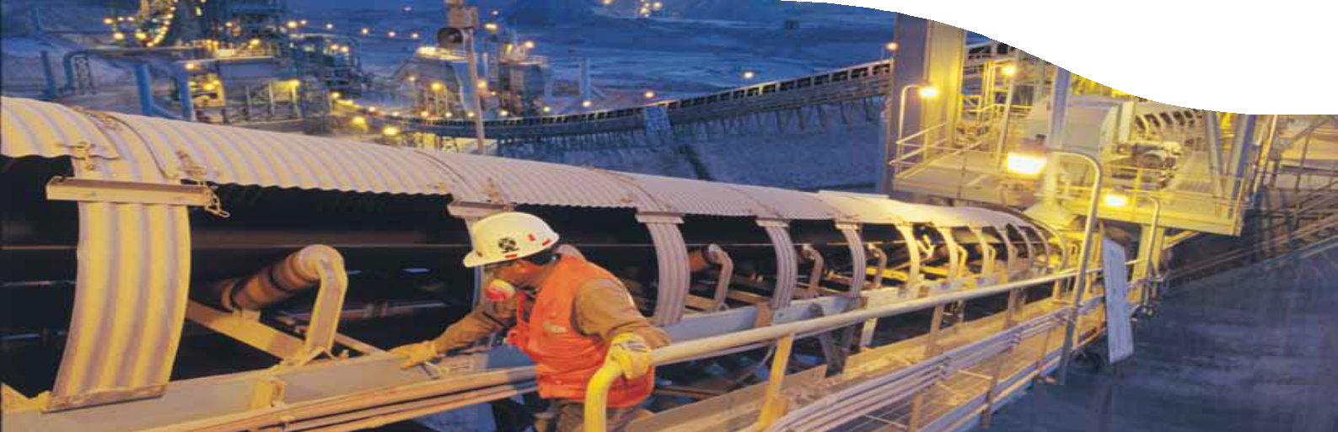NORTHERN NODE

www.csiro-chile.cl

CSIRO Chile Centre of Excellence

Delivering world-class applied research in mining and mineral processing

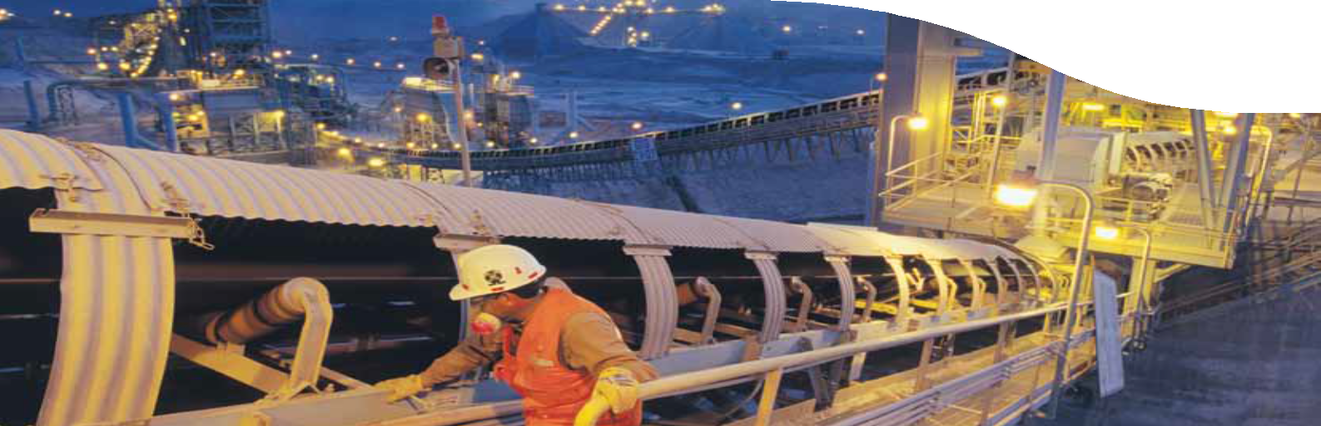Contents

1

Foreword 2
CSIRO Chile Centre of Excellence: Committed to education 4
CSIRO making an impact
in northern Chile 5
Our researchers 6

Foreword
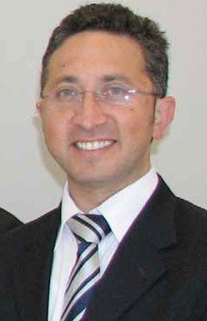It is a great pleasure and privilege to work closely with our research and industry partners in Chile, including our local research partners in the north of Chile – CICITEM and the University of Antofagasta.
Through these partnerships and engaging the mining and minerals cluster in Antofagasta the CSIRO Chile International Centre of Excellence in Mining and Mineral Processing will deliver high quality scientific and technology outcomes for the minerals industry and the mining equipment, technology and service sectors.
The CSIRO Chile Centre of Excellence will create innovative solutions to key challenges facing the Chilean minerals industry. The Northern Node in particular, will be a hub for dedicated project development that will enhance human capital in the region and boost the education and training of students and engineers.
We are proud supporters of the University of Antofagasta’s Process Engineering in Mining Doctorate Program, which in an exciting new step for the University will create unique opportunities for Chilean students both in Chile and internationally.

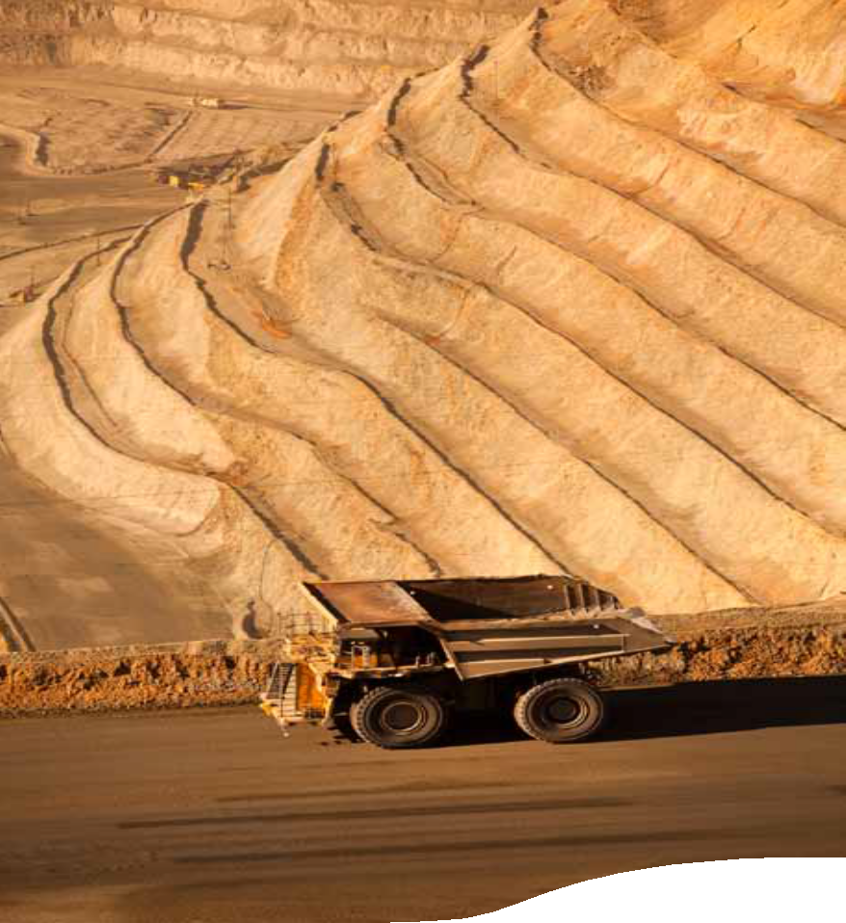

We strongly believe that by building a network of researchers, technicians
and dedicated staff in the north we will undeniably contribute to the development and expansion of Antofagasta’s capabilities in the minerals sector. The Northern Node will reinforce Antofagasta’s reputation as a centre of world-leading minerals research and technology development and it will have a significant economic impact not only for the region, but for the nation.

Mr Eric Schmidt
Manager, Northern Node
CSIRO Chile International Centre of Excellence in Mining and Mineral Processing

CSIRO Chile Centre of Excellence: Committed to education

CSIRO is dedicated to the pursuit of excellence in science and strongly supports the education and development of students, engineers and scientists.

The CSIRO Chile Centre of Excellence is collaborating with the University of Antofagasta on education solutions for Antofagasta and northern Chile.
The acclaimed Process Engineering in Mining Doctorate Program aims to strengthen local capacity through education. The program’s recent step towards internationalisation will create opportunities for University of Antofagasta students to live, work and study internationally.
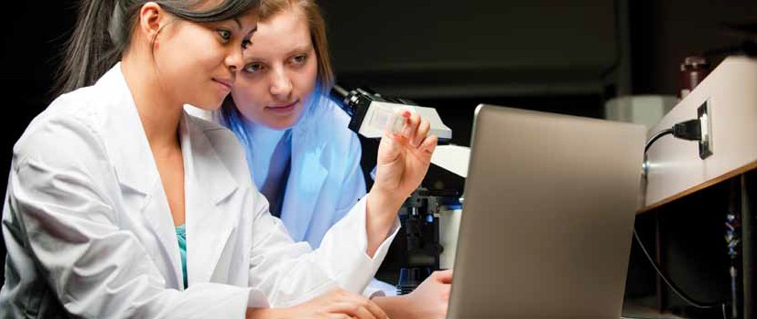CSIRO currently employs two postdoctoral fellows and two PhD students from the program, who represent the beginning of a strong and enduring relationship between CSIRO and the University of Antofagasta. The program is also strongly supported by Xstrata Copper and Minera Esperanza, Antofagasta Minerals PLC Group.

CSIRO making an impact

in northern Chile

Chile is the largest copper producer in the world, making up 35 per cent of the global
market and within Chile, the north is responsible for 80 per cent of the nation’s production.

With the Chilean Government aiming to invest US$91 billion by 2020 in the minerals industry, it is an exciting and important time for CSIRO to be collaborating with Chilean industry bodies and research organisations in the minerals sector.
The Northern Node of the CSIRO Chile Centre of Excellence is well placed to establish connections with industry within the northern region and will be an integral part of CSIRO’s vision to engage with industry bodies to solve major global challenges together.
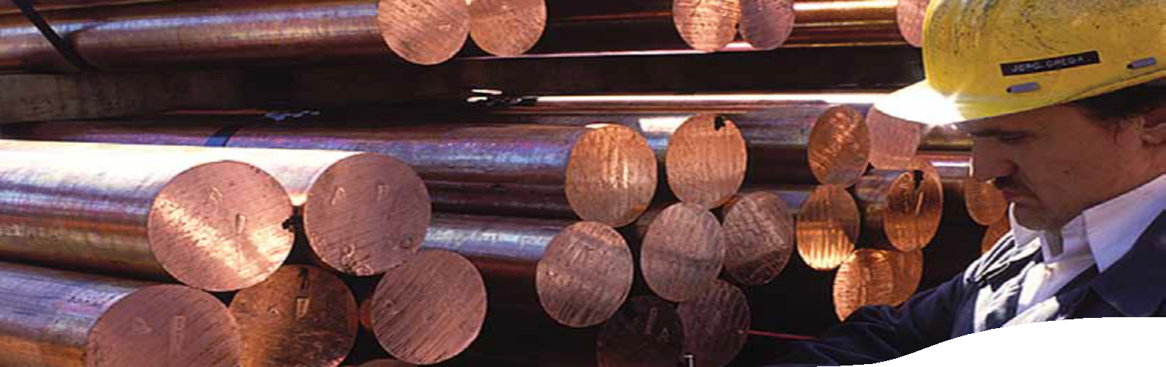The Northern Node currently employs 30 staff from Antofagasta and our five leading researchers are the driving force of two of the Centre’s key research programs: Water, Energy and Environmental Impact, and Mineral Processing and Metallurgical Systems.

Our researchers

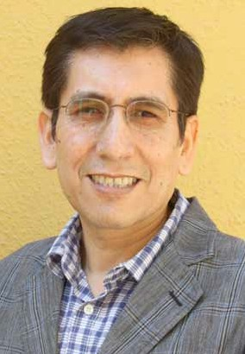Dr Luis A Cisternas

Program Leader, Water, Energy & Environmental Impact
Professor Luis A Cisternas holds a PhD in Chemical Engineering from the University of Wisconsin–Madison in the United
States of America and a Bachelor of Science from the Catholic University of Northern Chile.
Prior to joining the CSIRO Chile Centre of Excellence, Professor Cisternas worked as the Executive Director of CICITEM (Associate Dean of Research) and as the Director of the Graduate School at the University of Antofagasta.
His principal area of interest is the development of systematic methods to solve issues in the modelling, optimisation, synthesis, design and analysis of mineral processes.
Dr Cisternas has had more than 60 peer reviewed journal articles published in addition to two books, 20 book chapters and over 70 conference papers.

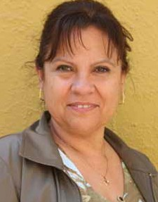Dr M Elisa Taboada Meneses

Project Leader, Water Efficiency and Substitution Water, Energy and Environmental Impact Program
Dr María Elisa Taboada Meneses specialises in the crystallisation, phase equilibrium and separation processes of minerals.
She holds a PhD in Engineering Science and a Bachelor of Science. She has worked as the Director of the Research and Graduate School at the University of Antofagasta and is
a Member of the Academy of Sciences.
Dr Taboada Meneses has overseen 65 research projects at the University of Antofagasta and has had numerous peer reviewed ISI journal articles published.

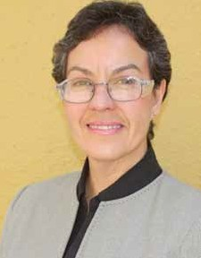Dr Jacqueline Cuevas

Project Leader, Advanced Materials Characterisation Mineral Processing and Metallurgical Systems Program
Dr Jacqueline Cuevas holds a PhD in Inorganic/Organometallic Chemistry from the Catholic University of Chile and a Bachelor of Science.
In 2002 she joined the University of Antofagasta as an academic and researcher and has devoted herself to researching cleaner mineral production.
During her time at the University of Antofagasta she has worked in close collaboration with the mining industry. Between 2009 and 2011 Dr Cuevas was a Postdoctoral Fellow at CSIRO.

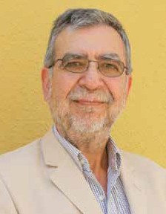Dr Gerardo Fuentes

Project Leader, Leaching Technologies
Mineral Processing and Metallurgical Systems Program
Dr Gerardo Fuentes is currently an Associate Professor at the Catholic University of Northern Chile.
His key areas of research are hydrometallurgy and leaching technologies, in particular the leaching of copper concentrates, ammonia leaching and bacterial leaching.
Dr Fuentes holds a PhD in Chemistry from the University
of Barcelona in Spain and a Masters in Engineering Science.
Prior to joining the CSIRO Chile Centre of Excellence
Dr Fuentes worked with the University of Chile for 24 years.

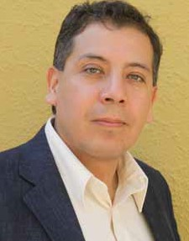Dr Mario Grágeda

Project Leader, Dry Processing of Copper Ores
Mineral Processing and Metallurgical Systems Program
Dr Mario Grágeda holds a PhD in Engineering Sciences
from the University of Chile and a Masters in the Technology of Metal Forming Processes from the National University
of Science and Technology in Moscow, Russia.
Dr Grágeda’s PhD involved working on two industrial applications for copper: electrometallurgy and electrodialysis.
Currently, he is working on a new process, which uses membrane separation technology to obtain lithium compounds with high purity and battery grade.

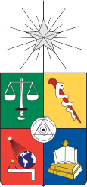Our partners

Research and development partners

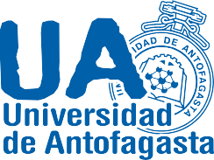

Major industry partners

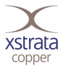

CSIRO Chile Centre of Excellence

Manager, Northern Node
Mr Eric Schmidt
Eric.Schmidt@csiro.au

General enquiries
CSIROChile@csiro.au

