CSIRO IMPACT SCIENCE

Assessing the potential for a step change in energy, water and resource efficiency,   
2010–2050



Report for the Australian National Outlook 2015

Timothy M. Baynes

Citation

Baynes TM (2015) *Assessing the potential for a step change in energy, water and resource efficiency, 2010–2050*. Report for the Australian National Outlook 2015. CSIRO, Canberra.

Copyright

© Commonwealth Scientific and Industrial Research Organisation 2015. To the extent permitted by law, all rights are reserved and no part of this publication covered by copyright may be reproduced or copied in any form or by any means except with the written permission of CSIRO.

Important disclaimer

CSIRO advises that the information contained in this publication comprises general statements based on scientific research. The reader is advised and needs to be aware that such information may be incomplete or unable to be used in any specific situation. No reliance or actions must therefore be made on that information without seeking prior expert professional, scientific and technical advice. To the extent permitted by law, CSIRO (including its employees and consultants) excludes all liability to any person for any consequences, including but not limited to all losses, damages, costs, expenses and any other compensation, arising directly or indirectly from using this publication (in part or in whole) and any information or material contained in it.

Contents

Executive summary 7

1 Introduction 9

2 Methods and Assumptions 10

2.1 General Methods 10

2.2 Stock flow model of asset turnover 10

2.3 Logistic approximation of efficiency uptake 12

2.4 Statistical methods for estimating future trends 12

2.5 Expectation of future efficiency gains 13

3 Energy 15

3.1 Historical data 15

3.2 Current Trends 15

3.3 Step Change 18

4 Water 21

4.1 Historical data 21

4.2 Current Trends 21

4.3 Step Change 22

5 Supplementary information 24

Acronyms 27

References 28

Figures

Figure 1: Simplified representation of the stock flow model. 11

Figure 2: Form of the logistic function where the parameter k = 1, in the model k = 10/width where “width” is an estimate of the time for the transition to take place equal to 30 years. 13

Figure 3: Multiplier for expected future energy efficiency beyond that achieved at 2020 14

Figure 4: Residential energy intensities for different end uses from Energy use in the Australian residential sector 1986–2020 (DEWHA, 2008). 18

Figure 5: Estimations of Current Trends in energy intensity for 7 aggregate sectors of the Australian economy to 2050. 19

Figure 6: Estimations of Step Change in energy intensity for 7 aggregate sectors of the Australian economy to 2050. 21

Figure 7: Industrial water intensity under Current Trends. 23

Figure 8: Industrial water intensity under Step Change. 24

Figure 9: Weibull distributions of life expectancies for all stock types where data available 26

Figure 10: Simple extrapolations of gross value add by sector. 28

Tables

Table 1: Projected energy and water savings by 2020 compared to 2011 efficiencies. 8

Table 2 Projected energy and water savings by 2050 compared to 2011 efficiencies. 8

Table 3: Data derived (for a sample of all businesses) from IEEDAP used to define the “Base” or Current Trend efficiency changes in selected non-agricultural industries. 16

Table 4: Assumptions of residential dwelling type mix and floor space in the Current Trends scenario. 17

Table 5: Data derived (for a sample of all businesses) from IEEDAP used to define the future Step Change efficiency changes in selected non-agricultural industries. 19

Table 6: Assumptions of residential dwelling type mix and floor space in the Step Change scenario. 19

Table 7: Percentage change in water efficiency (GL/AUD$ Billion value add) expected by 2050 under the Current Trends scenario. 21

Table 8: Percentage improvements in water efficiency (GL/AUD$ Billion value add) expected by 2050. 23

Table 9: Expected lifetimes of different assets used in productive sectors of the economy. These values were used in Equation 1 to produce the distributions in Figure 9. 25

Acknowledgments

This work is dominantly about collecting research and knowledge from a number of sources and applying it to the question of what is the long-term future efficiency of the Australian non-agricultural economy. I am particularly grateful to ClimateWorks for the early access they provided to the database and analysis of future potential energy savings. I would also like to thank Stephen McFallan, CSIRO for directing me to information on machine failure and failure analysis and the use of Weibull distributions.

A graph appearing at the end of Supplementary Information uses long-term projections of gross value add by sectors of the Australian economy. These are outputs from the Monash CGE model provided by Kevin J Hanslow from Monash University. Mike Smith from Australian National University was commissioned to perform a literature review and I acknowledge Rebecca McCallum and Michelle Rodriguez for editorial input and general guidance.

This work was funded entirely through the Australian National Outlook Project at CSIRO.

Executive summary

This report is based on analysis undertaken in 2013 for the first CSIRO Australian National Outlook report (Hatfield-Dodds et al., 2015). This analysis was competed as part of stage 2 of the project logic and has contributed to a research paper accepted for publication in the *Journal of Cleaner Production* (Schandl et al., in press).

One of the central issues explored in the National Outlook project is the consequence of different outlooks for energy and water use, including a potential step change in energy and water use efficiency. This report outlines the data and methods used to estimate implications of a continuation in current trends in energy and water intensity over the period to 2050, and the potential impact of widespread uptake of cost effective efficiency measures. Energy and water intensity refers to energy and water use (in physical units) per dollar of real value added (adjusted for inflation), for major economic sectors. The analysis focuses on non-agricultural energy and water use.

The analysis of the continuation of existing trends suggests modest continuing reductions in the energy and water intensity of most sectors, and the economy as a whole (excluding agriculture). The difference in overall energy use compared with today’s efficiency applied to the same output at 2050 is small (2.5%). By the same comparison, there are more significant cumulative water savings of 20.5% (2097 GL/year) by 2050. These trend improvements are small relative to projected economic growth, however, and total energy and non-agricultural water use will continue to increase.

The analysis of a potential step change finds that there is significant potential for improving the efficiency of energy and water use. The data and methods that underpin these estimates are focused on identifying realistic savings with a three to five year payback period for any additional capital costs involved in achieving these physical efficiency gains, after which the efficiency measures can be interpreted as saving money and improving overall productivity, as well as reducing the use of energy, water and other resources. The largest absolute savings identified are in Transport (681 PJ/year) and Manufacturing (469 PJ/year) for energy, and in the Commercial and Services (1993 GL/year) and Residential (1764 GL/year) sectors for water. In these sectors and the Water supply and waste services sector, the water efficiency savings are larger than projected trend growth in value added, resulting in absolute decreases in water use to 2050.

Overall, as shown in Table 1 and Table 2, the analysis suggests that achieving a step change in energy and water efficiency would reduce the demand for water and energy resources by up to 20% and 2% in 2020, and 48% and 17%, respectively, in 2050, relative to current efficiencies. Figures 5 to 8 in the main report show the time profile of these trends.

It is important to note that these estimates are of potential savings assuming a continuation of existing trends, or widespread adoption of cost effective efficiency measures. Achieving substantial improvements in energy efficiency would require actions by households, businesses and governments. Useful reviews of barriers to the uptake of energy efficiency, and potential constructive responses to these barriers, are provided in reports by ClimateWorks, Energetics and others (Energetics, 2004; Rickwood et al., 2008; Petchey, 2010; ClimateWorks Australia, 2013).

Table 1: Projected energy and water savings by 2020 compared to 2011 efficiencies.

|  |  |  |  |  |
| --- | --- | --- | --- | --- |
|  | Projected savings to 2020 | | | |
|  | Energy (PJ/year) | | Water (GL/year) | |
|  | *Current Trends* | *Step Change* | *Current Trends* | *Step Change* |
| Mining | 0.8 (0.11%) | 2.5 (0.36%) | -4 (-0.6%) | -3 (-0.4%) |
| Manufacturing | 4.2 (0.28%) | 10.1 (0.68%) | -59 (-8.2%) | -46 (-6.4%) |
| Construction | 0.0 (0.10%) | 0.3 (1.2%) | 2 (7.7%) | 2 (7.7%) |
| Transport | 3.4 (0.18%) | 100.8 (5.3%) | 0 (0%) | 0 (0%) |
| Commercial and services | 0.0 (0%) | 6.4 (1.7%) | 129 (8.51%) | 165 (10.9%) |
| Residential | 5.3 (0.96%) | 21.1 (3.8%) | 634 (30.6%) | 843 (40.7%) |
| Water supply and waste services | 0.0 (0.13%) | 0.04 (~0%) | 435 (26.7%) | 436 (26.8%) |
| Electricity generation | 0.0 (0%) | 0.0 (0%) | 14 (4.2%) | 14 (4. %) |
| **TOTAL (cumulative savings)** | **14 (0.19%)** | **141 (2.0%)** | **1151 (16.5%)** | **1412 (20.2%)** |

NOTE: Projections are based on the simulation of changes to intensities (resource use/gross value add) and projections of gross value add. Absolute and % difference in annual consumption is reported with respect to values at 2011.

Table 2 Projected energy and water savings by 2050 compared to 2011 efficiencies.

|  |  |  |  |  |
| --- | --- | --- | --- | --- |
|  | Projected savings to 2050 | | | |
|  | Energy (PJ/year) | | Water (GL/year) | |
|  | *Current Trends* | *Step Change* | *Current Trends* | *Step Change* |
| Mining | 34.8 (3.1%) | 127.2 (11.3%) | -8 (-0.75%) | 53 (5.0%) |
| Manufacturing | 154.9 (8.3%) | 468.6 (25.0%) | -93 (-10.2%) | 383 (41.9%) |
| Construction | 1.2 (3.0%) | 3.3 (8.2%) | 13 (28.3%) | 13 (28.3%) |
| Transport | 166.3 (5.2%) | 681.1 (21.1%) | 0 (0%) | 0 (0%) |
| Commercial and services | 0.0 (0%) | 315.3 (48.9%) | 273 (10.7%) | 1993 (77.7%) |
| Residential | -98.8 (-11.4%) | 202.0 (23.4%) | 1242 (38.3%) | 1764 (54.4%) |
| Water supply and waste services | 0.6 (3.9%) | 1.9 (13.3%) | 645 (33.4%) | 691 (35.8%) |
| Electricity generation | 0.0 (0%) | 0.0 (0%) | 25 (5.3%) | 25 (5.3%) |
| **TOTAL (cumulative savings)** | **259 (2.5%)** | **1800 (16.9%)** | **2097 (20.5%)** | **4921 (48.1%)** |

NOTE: Projections are based on the simulation of changes to intensities (resource use/gross value add) and projections of gross value add. Absolute and % difference in annual consumption is reported with respect to values at 2011.

# Introduction

Historical data on water and energy use and projections of future trends in efficiency have been collated and developed for the Australian National Outlook project. The Material and Energy Flow Integrated with Stocks (MEFISTO) approach employs an accounting structure that parallels established data bases hosted by the Australian Bureau of Statistics (ABS) and Bureau of Resources and Energy Economics (BREE).

We have been fortunate to gain early access to the Industrial Energy Efficiency Analysis Tool (ClimateWorks Australia, 2013) originally developed by ClimateWorks[1] in the context of the Industrial Energy Efficiency Data Analysis Project (IEEDAP). From this tool we have acquired ‘Current Trend’ and more ambitious ‘Step Change’ potential energy efficiency targets, self-identified by industry.

Projections of future energy and water efficiency in the following eight non-agricultural industry sectors and the residential sector are based on dynamic models of stock turnover driven by attrition and replacement of old stock. The sectoral definitions are based on the Australian and New Zealand Standard Industrial Classification (ANZSIC) Industry Divisions[2].

* Mining (Division B)
* Manufacturing (Division C)
* Construction (Division E)
* Transport (Division I)
* Commercial and Services (Divisions F, G, H, J, K, L, M, N, O, P, Q, R, S)
* Residential
* Water supply and waste services (part of Division D)
* Electricity generation(part of Division D)
* Gas Supply (part of Division D)

The focus on intensive variables of energy and water intensity measured with respect to AUD$ Billion in value add (Petajoules (PJ) or Gigalitres (GL) per AUD$ Million), is deliberate as these are to be used with a CGE model that generates projections of future economic output by sector. Combined, we can produce extensive results on future total water and energy consumption in the non-agricultural economy.

Currently MEFISTO has a national resolution and simulates ‘futures’ from 2012 having 2011 as a base year for most data sources. Two scenarios of future water and energy efficiency were developed: a ‘Current Trends’ and a ‘Step Change’ scenario.

# Methods and Assumptions

## General Methods

It’s important to note that in this analysis there is often a separation between the inputs of the magnitude of change in energy or water intensity, and the simulation of the nature or form of that change.

In general, the continuation of Current Trends and Step Change scenarios use: 1) a model of stock turnover to estimate the form of transitions in energy efficiency, where data is available; 2) if stock data is not available, but there are data for magnitudes of sector-level efficiency change, a logistic function is used to approximate the uptake of more efficient technologies and; 3) lacking both stock data and information on efficiency change, an extension of historical efficiency is estimated based on a statistical approach that defines three classifications (increasing, decreasing or flat) of trends in observed time series data. This is more generally the case with estimating future water efficiencies. What follows is detail on these different approaches.

## Stock flow model of asset turnover

### Components of the model

A stock flow model was developed to provide a basis for transitions from current year (2011) to simulated future efficiencies at some time point “*t*”. This relied on two or three key inputs depending on the availability of data and linkages to other models (refer to Figure 1).

Firstly, a database of the current “legacy” assets is required to characterise the asset types used by industry sectors. This database initialises the “existing stock” of assets. It would be advantageous to have age-structure of asset stock in this database but, understandably, businesses are not forthcoming about the age of plant that constitutes their core capacity and potentially their competitive (dis)advantage. In the absence of age-structure data, a uniform distribution across age brackets has been assumed. This will underestimate the potential rate of turnover in stock and, thereby, the speed at which new efficiencies are introduced.

Figure one provides a visual model of a cycle of stock flow using one dimentional cylinders to represent a variety of stocks contributing to the flow and one directional arrows to indicate flow direction. Details of flow are described in the figure caption. 


Figure 1: Simplified representation of the stock flow model.

NOTE: Legacy assets begin the cycle of stock attrition moderated by a failure rate that produces a flow of discarded stock, which defines the magnitude of the flow of new stock to replace it. The aggregate efficiency of existing stock is characterised by the blend of efficiencies in legacy and new stock (barrels represent stocks, tubes are flows and hexagons are parameters of the model).

Secondly, a yearly “failure rate” parameter needs to be specified for the expected failure in the population of assets according to those assets’ expected lifetime and using Weibull distributions of machine failure (Weibull, 1951). Weibull distributions are commonly used statistical models in engineering failure studies and lifetime analysis (Kececioglu, 2002; IEEE Standards Coordinating Committee 37 on Reliability Prediction, 2003; Lawless, 2003)

### Weibull distributions

Two-parameter Weibull distributions have the mathematical form as in Equation 1 below:

Equation 1

In this work, the variable *t* refers to simulated future time. Please note: unless otherwise stated, “*t”* refers to the time *interval* between the future date and the base year of 2011, e.g. at 2020, *t* = 9. *k* is the shape parameter and *L* is the scale parameter of the distribution. We used a different Weibull distribution for each stock type defined by different scale parameters.

Given the assumption of a uniform age-structure distribution for a stock type, we may treat the time dimension as effectively the “time to failure” for the population of stock of a given type. In this case, Equation 1 gives a distribution for which the failure rate is proportional to a power of time. The shape parameter, *k*, is that power plus one, and where *k* > 1, this indicates that the failure rate increases with time. This is characteristic of an ageing process, or where parts are more likely to fail as time goes on. For all stock types, *k* was chosen to be equal to 5. The life expectancies of different stock types were used as the scale parameter, *L*.

Note that in this exercise we do not need to apply the Weibull distribution repeatedly over time to simulate successive generations of new plant. The first generation of new plant is assumed to have an energy efficiency representing the trend or Step Change scenario. Thereafter any new or replacement plant has the same efficiency as the preceding generation.

Another way of saying this is: we *could* have used the Weibull distribution repeatedly to get a sense of the timing of a 2nd or 3rd generation of new plant, but this would not give us any further information on the transition to new efficiencies. They would have already been achieved in the first generation. Second generation efficiencies are modelled according to the logic of Section 2.5.

Refer to Figure 9 in the Supplementary information for a graph of Weibull distributions and Table 9 for life expectancies, for all stock types where data was available. These were used to define the failure rate component of the stock turnover model.

### Limitations of the model

The model is partially empirical – starting from databases on stock characteristics of industry sectors – and partially statistical – relying on a failure rate assumed from a distribution function. A more precise, though possibly no more accurate, model could represent processes in the industry sectors to arrive at a more bottom-up calculation of changes to efficiency.

A third possible key input to the stock flow model is shown in Figure 1 the dotted flow variable “new demand for stock” flow and its connection to existing stock. This is not currently part of the industrial stock flow model though it does feature in the estimation of residential dwelling water and energy use. This does not alter the magnitude of potential industrial efficiency changes but its omission may underestimate the speed at which those changes occur.

New demand for stock would ideally be driven by output from an economic model. Very likely there would be a circular relationship between improvements in efficiency, reduced costs of production, increased profitability and an increasing demand for new, more efficient, stock. This is a system feedback that would imply the link to an economic model would be an iterative one for each time step in simulation. This is an ambitious technical integration that is deferred to future work.

## Logistic approximation of efficiency uptake

Where there were no stock data but there existed information on the future magnitude of change to sectoral energy or water efficiency, then a logistic curve was used to estimate the timing and form of the transition to the new efficiency. The logistic curve in has been commonly observed in diffusion of innovation and technology uptake (Mansfield, 1961; Grübler, 1990) and has the mathematical form as below:

Equation 2

…where *k* is a parameter that modifies the scale but not the general form of the logistic function. As shown in Figure 2, where the value of *k* = 1, the logistic curve extends from 0 to 1 for practical purposes over an interval of 10 (from *t* = -5 to 5). In our use of the logistic function we assumed a transition to take place over an interval of 30 years hence we used a value of *k* = 1/3 with the variable time, *t* in years.

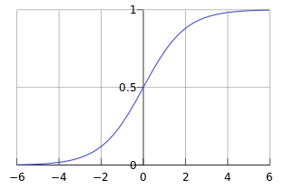

Figure 2: Form of the logistic function where the parameter k = 1, in the model k = 10/width where “width” is an estimate of the time for the transition to take place equal to 30 years.

## Statistical methods for estimating future trends

Where there were no data on existing stock use in sectors and no data on the future energy or water efficiency, some estimate of future trends was developed from historical data. This approach used a statistical model based on trends in the data rather than a logistic curve or model based on the use and turnover of stock. As such, it was used exclusively for the calculations of the Current Trends scenario.

Historical time-series data up to 2011 on energy use by economic sectors (Stark et al., 2012) or water use (ABS, 2000; 2004; 2006; 2009; 2011), were divided by gross value add (GVA) time-series data from the Australian National Accounts (ABS, 2012). For the residential sector the value of home ownership was used instead of GVA.

These historical intensity data were inspected for coarse level trends under three classifications of observed time series data: an increasing, decreasing or flat trend.

A ‘flat’ trend is observed when the average over all historical data is adequate approximation to all points in that time series. Increasing trends are fitted by a linear regression or power law whichever best describes the historical data. A decreasing trend may also be fitted with a regression unless this produces unrealistic (negative energy use) future results, in which case an exponential decrease is assumed to some saturating value which is *c* % less than the efficiency observed at the end of history (i.e. at 2011).

Equation 3

By differentiating this function and evaluating at *t* = 2012, we may solve for *c* so that the gradient of *F(t)* matches that of the gradient of the decreasing historical trend in the last 5 years of records, *m* as in Equation 4:

Equation 4

## Expectation of future efficiency gains

The possible future energy efficiencies identified in the literature we surveyed are for 2020 but we wish to simulate to 2050. We assume that further efficiency gains are possible in decades beyond 2020 according to the following formula where *t* = a future year date:

Equation 5.

The effect of this formula is to produce an efficiency gain of 50% for the decade 2020 to 2030 and subsequently a 25% improvement in efficiency for 2030 to 2040 and an additional 12.5% gain for 2040 to 2050. A graph of this multiplier for energy efficiencies at 2020 from Equation 5 is shown in Figure 3.

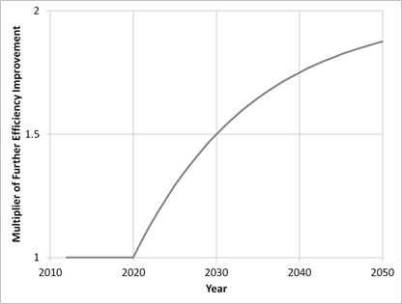

Figure 3: Multiplier for expected future energy efficiency beyond that achieved at 2020

Generally, further changes to efficiency are assumed to become available after 2020 producing a compound effect but with subsequent decades only being able to achieve 50% of the relative efficiency gains of the preceding decade. The exceptions to the above, formalised expectations are in the Mining sector and the Manufacturing sector.

Processes that are heavily used in the Manufacturing sub sectors of ferrous and non-ferrous metals production and cement production are assumed to be already close to their thermodynamic limit and no further efficiency gains beyond those specified in are possible.

Three main processes involved are: blast furnaces, furnaces/ kilns and electrolytic processes. The end use of energy by the capital stock of these processes is dominated (>95%) by ferrous and non-ferrous metals production and cement production and constitutes approximately 20% of energy use in the Manufacturing sector, nationally. It is assumed this part of the Manufacturing sector is not open to increasing efficiency gains beyond those identified for 2020 in Table 3 and Table 5.

# Energy

All sectors except Electricity Generation are considered here. The future efficiency of the Electricity Generation sector is the topic of the Energy Sector Model (ESM) that operates independently of MEFISTO elsewhere in the *Australian National Outlook* (ANO) project. Unless elsewhere defined, ‘energy use’ is synonymous with ‘energy consumption’ and is defined as in the Energy Statistics Tables from BREE[3] as: “Total net energy consumption is equal to the consumption of all fuels minus the production of derived fuels.” Residential energy intensity is treated differently to other sectors being measured initially in Gigajoules per dwelling (GJ/dwelling) then that is multiplied by a projected national total need for dwellings according to population forecast developed specifically for this project (ABS, 2013a).

## Historical data

Detailed data from is available from BREE as the Australian Energy Statistics Tables and was aggregated to the sectors represented in MEFISTO. Detail on energy end-use in the Residential sector was sourced from Appendix G of the report *Energy use in the Australian residential sector 1986–2020* (DEWHA, 2008) and totals cross checked with the data from the Australian Energy Statistics’ Table F (Stark et al., 2012).

## Current Trends

We have had privileged access to the Industrial Energy Efficiency Analysis Tool (ClimateWorks Australia, 2013) originally developed by ClimateWorks[4] in the context of the Industrial Energy Efficiency Data Analysis Project (IEEDAP). From this tool we have acquired the base assumptions about Current Trend energy efficiency improvements self-identified by industry – see Table 3.

The absolute numbers of energy use in Terajoules (TJ) in are not equivalent to the total energy use in those sectors as the data in IEEDAP is a sample. However relative measures of efficiency improvement were assumed to apply across the whole of the respective sector.

Several ANZSIC sectors are missing from the IEEDAP analysis, specifically those that we have represented in our Commercial and Services sector. Potential energy efficiency improvements in that sector were estimated from the data available on star rated commercial buildings from the National Australian Built Environment Rating System (NABERS[5]). Based on NABERS’ records the average commercial building would rate around 3.5 stars or an average energy intensity of 550 MJ/m². The Current Trend for the Commercial and Services sector is flat and so this spatial efficiency would remain until 2050.

Table 3: Data derived (for a sample of all businesses) from IEEDAP used to define the “Base” or Current Trend efficiency changes in selected non-agricultural industries.

|  |  |  |
| --- | --- | --- |
| 2020 Projected Energy Savings | Current Energy Use  (TJ) | Base %  changein use |
| Coal mining | 13,962 | 2.90% |
| Oil and gas extraction | 22,301 | 2.00% |
| Metal ore mining | 34,023 | 3.90% |
| Non-metallic mineral mining and quarrying | 1,697 | 1.90% |
| Exploration and other mining support services | 878 | 5.10% |
| **Mining subtotal** | **72,862** | **3.10%** |
| Food product manufacturing | 15,391 | 2.40% |
| Beverage, tobacco and textile | 2,167 | 3.10% |
| Wood, pulp, paper and printing | 9,564 | 2.80% |
| Petroleum and coal product manufacturing | 27,331 | 10.00% |
| Basic chemical and chemical product manufacturing | 66,070 | 6.80% |
| Polymer product and rubber product manufacturing | 233 | 2.10% |
| Mineral product, primary metal and metal product | 72,178 | 4.20% |
| Fabricated metal product manufacturing | 226 | 1.80% |
| Other manufacturing | 665 | 1.70% |
| **Manufacturing subtotal** | **193,824** | **5.10%** |
| **Water and waste services** | **1,017** | **2.10%** |
| **Construction** | **1,080** | **1.60%** |
| **Transport** | **27,842** | **2.80%** |
| **TOTAL** | **296,625** | **4.20%** |

Residential energy intensity is treated differently to other sectors in being measured in Gigajoules per dwelling (GJ/dwelling) initially. This per dwelling intensity is then multiplied by numbers for dwellings in Australia in a given future year to estimate total residential energy end use.

Change in the residential energy end use for Current Trends was based on the report *Energy use in the Australian residential sector 1986–2020* (DEWHA, 2008). The trends to 2020 were common across the Current Trends and Step Change scenarios and are shown for different residential end uses of energy in Figure 4. The extensions of water heating, cooking and appliance energy use per dwelling trends to 2050 were calculated as in Section 2.4. The projection of space heating and cooling energy is a function of the projected mix of dwelling types (proportion(t)type) paired with assumptions that the trend of increasing dwelling floor space (floor space(t)type) continues to 2050 – refer to Equation 6 and Table 4..

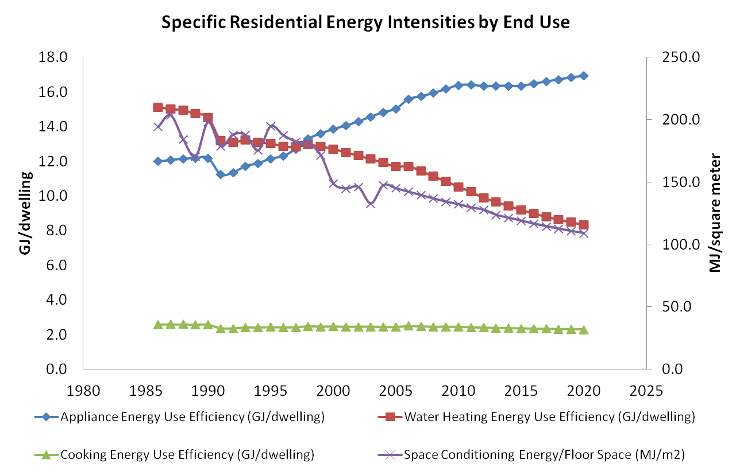

Figure 4: Residential energy intensities for different end uses from Energy use in the Australian residential sector 1986–2020 (DEWHA, 2008).

Equation 6: here TC is the Current Trends total energy for space heating, S is the specific space conditioning intensity (MJ/m2), D(t) is the total number of dwellings at time, t and proportion(t)type and floor space(t)type are the proportion of total dwellings, and the average floor space of dwellings of types listed in Table 4, respectively.

Table 4: Assumptions of residential dwelling type mix and floor space in the Current Trends scenario.

|  |  |  |  |  |
| --- | --- | --- | --- | --- |
|  | Proportion of all dwelling types | | Floor Space of New Dwelling (m2) | |
|  | 2012 | 2050 | 2012 | 2050 |
| Separate house | 78.8% | 78.8% | 257 | 394 |
| Semi-detached | 9.6% | 9.6% | 157 | 241 |
| Apartment | 11.6% | 11.6% | 157 | 241 |

Using all the assumptions, methods and estimations referred to above, shows the projected change in energy intensity (PJ/AUD$ Billion GVA) for the Step Change scenario across eight non-agricultural sectors of the Australian economy.

Using all the assumptions, methods and estimations referred to above, Figure 5 shows the projected change in energy intensity (PJ/AUD$ Billion GVA) for the Step Change scenario across 7 non-agricultural sectors of the Australian economy referred to in the Introduction..

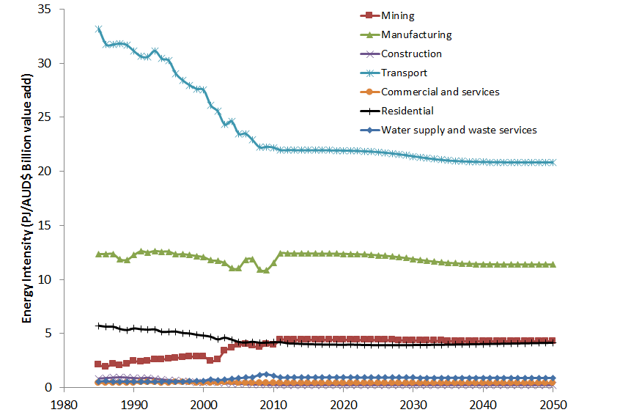

Figure 5: Estimations of Current Trends in energy intensity for 7 aggregate sectors of the Australian economy to 2050.

## Step Change

The Step Change assumptions also derive from the Industrial Energy Efficiency Analysis Tool (ClimateWorks Australia, 2013) – see Table 5 on the following page. Again, the absolute numbers of energy use in Terajoules (TJ) are not equivalent to the total energy use in those sectors as the data in IEEDAP is a sample. However relative measures of efficiency improvement were assumed to apply across the whole of the respective sector.

As with the Current Trends scenario, potential energy efficiency improvements rely on data available on star rated commercial buildings from the National Australian Built Environment Rating System (NABERS[6]).

In the Step Change scenario the Commercial and Services sector is assumed to improve in efficiency by relatively the same amount as if all new, or progressively retrofitted commercial buildings were 6-star (average energy intensity based on NABERS’ records of 300 MJ/m²). This is nearly a 50% decrease in energy intensity across the sector. This is brought in over a 30 year period according to the logistic approach discussed in Section 2.3.

Table 5: Data derived (for a sample of all businesses) from IEEDAP used to define the future Step Change efficiency changes in selected non-agricultural industries.

|  |  |  |
| --- | --- | --- |
| 2020 Projected Energy Savings | Current Energy Use  (TJ) | Step %  change in use |
| Coal mining | 13,962 | 6.70% |
| Oil and gas extraction | 22,301 | 9.20% |
| Metal ore mining | 34,023 | 8.50% |
| Non-metallic mineral mining and quarrying | 1,697 | 7.30% |
| Exploration and other mining support services | 878 | 12.30% |
| **Mining subtotal** | **72,862** | **8.30%** |
| Food product manufacturing | 15,391 | 10.80% |
| Beverage, tobacco and textile | 2,167 | 39.20% |
| Wood, pulp, paper and printing | 9,564 | 13.00% |
| Petroleum and coal product manufacturing | 27,331 | 24.00% |
| Basic chemical and chemical product manufacturing | 66,070 | 15.60% |
| Polymer product and rubber product manufacturing | 233 | 8.20% |
| Mineral product, primary metal and metal product | 72,178 | 9.60% |
| Fabricated metal product manufacturing | 226 | 8.10% |
| Other manufacturing | 665 | 13.60% |
| **Manufacturing subtotal** | **193,824** | **12.80%** |
| **Water and waste services** | **1,017** | **4.90%** |
| **Construction** | **1,080** | **7.30%** |
| **Transport** | **27,842** | **11.20%** |
| **TOTAL** | **296,625** | **11.10%** |

The Step Change for the Residential sector also assumes a progressive transition to 6 star homes (a 40% reduction on the current average) and also assumes that the trend of increasing dwelling floor space ceases at 2015 and the floor area of new dwellings, of all types, is frozen at that level until the end of simulation. The proportions of dwellings, of different types, transitions to approximately those observed in the Australian city with the highest incidence of apartment living (Sydney), currently: 60% of separate dwellings: 20% semi-detached: 20% apartments – see p 42 of *State of Australian Cities 2010* (Infrastructure Australia, 2010).

Table 6: Assumptions of residential dwelling type mix and floor space in the Step Change scenario.

|  |  |  |  |  |
| --- | --- | --- | --- | --- |
|  | Proportion of all dwelling types | | Floor Space of New Dwelling (m2) | |
|  | 2012 | 2050 | 2012 | 2050 |
| Separate house | 78.8% | 60.0% | 257 | 268 |
| Semi-detached | 9.6% | 20.0% | 157 | 164 |
| Apartment | 11.6% | 20.0% | 157 | 164 |

Using all the assumptions, methods and estimations referred to above, Figure 6 shows the projected change in energy intensity (PJ/AUD$ Billion GVA) for the Step Change scenario across 7 non-agricultural sectors of the Australian economy referred to in the Introduction.

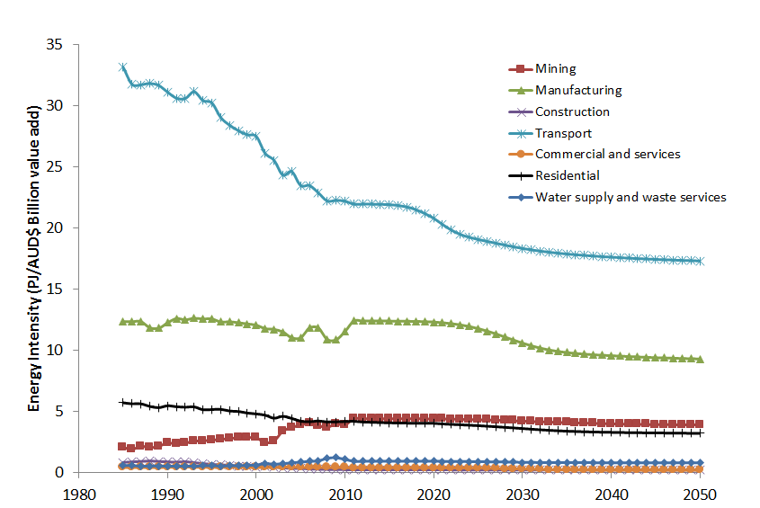

Figure 6: Estimations of Step Change in energy intensity for 7 aggregate sectors of the Australian economy to 2050.

# Water

## Historical data

Historical data was collected from the ABS Water Accounts Cat 4610.0[7] (ABS, 2000; 2004; 2006; 2009; 2011). These do not provide a continuous time series and some interpolation was required between the years 1998–2001 and 2006–2009.

## Current Trends

In the absence of stock data on the water intensity of different stock used by industry, this series of estimations relied on regression fitting to historical trends as discussed in Section 2.4. The resulting values for future change in water intensity (measured as GL/AUD$ billion gross value add) are shown in Table 7 and the graph of simulated future transitions is in Figure 6.

Residential water efficiency in this scenario was paired with assumptions that the current mix of dwelling types (separate house, semi-detached, apartment) remains until 2050 as in Table 4.

An implicit assumption behind the Electricity Generation water intensity for Current Trends is a continuation of the use of existing generation technologies. In future work this would be an opportune place to couple MEFISTO with outputs from the ESM to guide the water intensity of the sector with respect to new or alternative technologies.

Table 7: Percentage change in water efficiency (GL/AUD$ Billion value add) expected by 2050 under the Current Trends scenario.

|  |  |
| --- | --- |
| 2050 Projected Water Intensity Decrease for Current Trends | Current Trends % Change |
| Mining | -1% |
| Manufacturing | -10% |
| Construction | 28% |
| Transport | 0% |
| Commercial and services | 11% |
| Residential | 38% |
| Water supply and waste services | 33% |
| Electricity generation | 5% |
| Gas supply | 0% |

NOTE: A negative efficiency change is an *increase* in water intensity e.g., for Mining and Manufacturing.

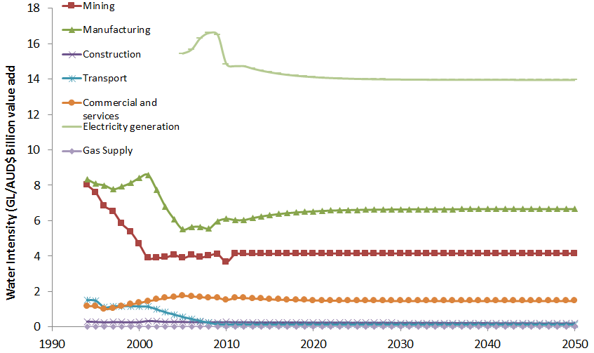

Figure 7: Industrial water intensity under Current Trends.

NOTE: There is only reliable data for Electricity Generation after 2005 and the water intensity of both the Water Supply and Residential sectors is an order of magnitude greater than the results and is not shown

## Step Change

Data on potential industrial water efficiency gains are rare and we sourced some input from technical appendices of the report *Waste Not, Want Not: The Potential for Urban Water Conservation in California*. (Gleick et al., 2003)[8]. As some years have passed since the publication of this work, it is certainly possible that efficiency standards have already been raised and implemented, it does, however, provide order-of-magnitude estimates on technically feasible water efficiency improvements.

There is some information on the improvements to water intensity in Australia during the last drought. From Chapter 2 of the *Information Paper: Towards the Australian Environmental-Economic Accounts* (ABS, 2013b) we know *“the water supply, sewerage and drainage industry has decreased its water intensity by 53% from 2008–09 to 2010–11 by consuming 32% less water while increasing its GVA by over 40%*.” We suggest that this could be further improved by another 50% reduction on 2011 water intensity by 2050.

Water intensity for the Commercial and Services sector is assumed to be an attribute of commercial and institutional buildings and hotels. Of these types of buildings reported in The NABERS[9] database, the average water consumption is 0.85kL/m² (~3.5-star rating). The Step Change scenario assumes that by 2050 all buildings in the Commercial and Services sector can be built or renovated to a 6-Star water rating standard or ~0.12 kL/m² (averaging over existing 6 star buildings). This represents a dramatic simulated 85% decrease in water intensity, which may in reality be limited by legacy infrastructure in older buildings.

Residential water efficiency in this scenario was paired with assumptions that the proportional mix of dwelling types (separate house, semi-detached, apartments) transitions from a national average of 78.8 : 9.6 : 11.6 to 60 : 20 : 20. Research on areas of different dwelling types has found that per-dwelling use in high and medium density areas is approximately 57% of the water used in areas where there are entirely separate houses (Troy et al., 2005). We attribute this saving to the semi-detached and apartment dwelling categories. As such, the future mix of dwelling types has an effect on residential water use.

The transition to the Step Changes shown in Table 8 were simulated using the logistic function (Section 2.3)

Table 8: Percentage improvements in water efficiency (GL/AUD$ Billion value add) expected by 2050.

|  |  |
| --- | --- |
| 2050 Projected Water Intensity Decrease for Step Change | Step Change % |
| Mining | 5% |
| Manufacturing | 37% |
| Construction | 0% |
| Transport | 0% |
| Commercial and services | 85% |
| Residential | 50% |
| Water supply and waste services | 50%* |
| Electricity generation | Depends on technology output from ESM |
| Gas supply | 5% |

*Note the ambitious 50% improvement in water efficiency for the Water supply and waste services sector rests on the assumption that the difference between water extracted and mains water supplied is reduced by 50%.This takes into account recent water efficiency improvements during the last drought (2006–2010) and does not assume the elimination of evaporative losses.

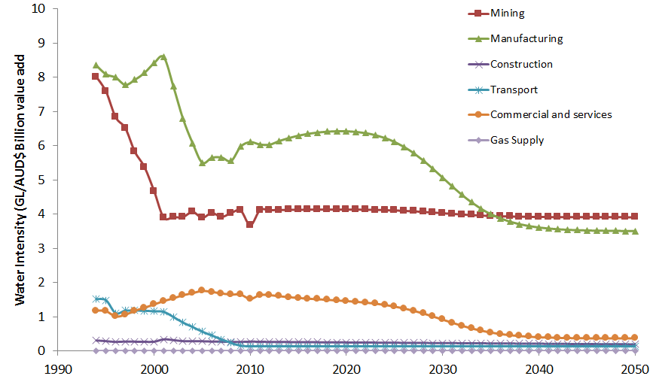

Figure 8: Industrial water intensity under Step Change.

NOTE: Water intensity for the Water supply and waste services sector is an order of magnitude greater than other results and is not shown.

# 

# Supplementary information

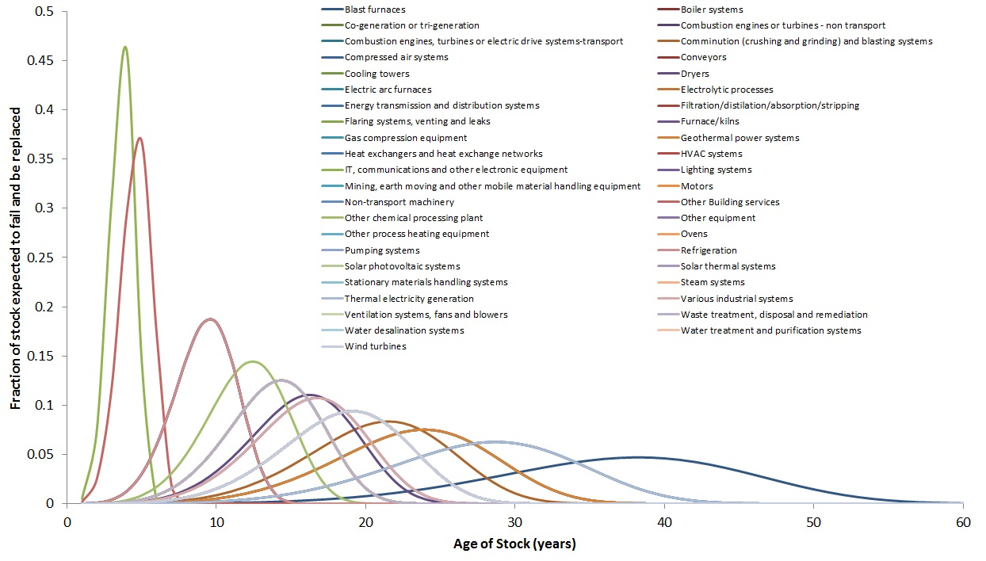

Figure 9: Weibull distributions of life expectancies for all stock types where data available

Table 9: Expected lifetimes of different assets used in productive sectors of the economy. These values were used in Equation 1 to produce the distributions in Figure 9.

|  |  |
| --- | --- |
| Technology process | Lifespan  (years) |
| Blast furnaces | 40 |
| Boiler systems | 20 |
| Co-generation or tri-generation | 30 |
| Combustion engines or turbines - non transport | 25 |
| Combustion engines, turbines or electric drive systems-transport | 10 |
| Comminution (crushing and grinding) and blasting systems | 22.5 |
| Compressed air systems | 15 |
| Conveyors | 20 |
| Cooling towers | 20 |
| Dryers | 17 |
| Electric arc furnaces | 10 |
| Electrolytic processes | 20 |
| Energy transmission and distribution systems | 25 |
| Filtration/distillation/absorption/stripping | 15 |
| Flaring systems, venting and leaks | 25 |
| Furnace/kilns | 17.5 |
| Gas compression equipment | 15 |
| Geothermal power systems | 25 |
| Heat exchangers and heat exchange networks | 30 |
| HVAC systems | 10 |
| IT, communications and other electronic equipment | 4 |
| Lighting systems | 10 |
| Mining, earth moving and other mobile material handling equipment | 20 |
| Motors | 15 |
| Non-transport machinery | 20 |
| Other Building services | 5 |
| Other chemical processing plant | 13 |
| Other equipment | 15 |
| Other process heating equipment | 20 |
| Ovens | 15 |
| Pumping systems | 20 |
| Refrigeration | 10 |
| Solar photovoltaic systems | 20 |
| Solar thermal systems | 20 |
| Stationary materials handling systems | 20 |
| Steam systems | 20 |
| Thermal electricity generation | 30 |
| Various industrial systems | 17.5 |
| Ventilation systems, fans and blowers | 15 |
| Waste treatment, disposal and remediation | 15 |
| Water desalination systems | 20 |
| Water treatment and purification systems | 20 |
| Wind turbines | 20 |

Figure 10: Simple extrapolations of gross value add by sector.

# Acronyms

|  |  |
| --- | --- |
| Acronym | Definition |
| ABS | Australian Bureau of Statistics |
| ANO | Australian National Outlook project |
| ANZSIC | Australian and New Zealand Standard Industrial Classification |
| BREE | Bureau of Resources and Energy Economics |
| ESM | Energy Sector Model |
| GL | Gigalitres |
| GVA | Gross value add |
| IEEDAP | Industry Energy Efficiency Data Analysis Project |
| m2 | Metres squared |
| MEFISTO | Material and Energy Flows Integrated with Stocks |
| MJ | Megajoules |
| NABERS | National Australian Built Environment Rating System |
| PJ | Petajoules |
| TJ | Terajoules |

# References

Australian Bureau of Statistics (ABS) (2012) *Australian National Accounts: National Income, Expenditure and Product, Catalogue No. 5206.0*. Australian Bureau of Statistics, Canberra.

Australian Bureau of Statistics (ABS) (2000) *Water Account for Australia 1993–94 to 1996–97, Catalogue No. 4610.0.* Australian Bureau of Statistics, Canberra.

Australian Bureau of Statistics (ABS) (2004) *Water Account Australia 2000-01, Catalogue No. 4610.0.* Australian Bureau of Statistics, Canberra.

Australian Bureau of Statistics (ABS) (2006) *Water Account Australia 2004-05, Catalogue No. 4610.0.* Australian Bureau of Statistics, Canberra.

Australian Bureau of Statistics (ABS) (2009) *Water Account Australia 2008-09, Catalogue No. 4610.0.* Australian Bureau of Statistics, Canberra.

Australian Bureau of Statistics (ABS) (2011) *Water Account Australia 20010-11, Catalogue No. 4610.0.* Australian Bureau of Statistics, Canberra.

Australian Bureau of Statistics (ABS) (2013a) *Customised report: CSIRO commissioned population projections, March 2013*. Australian Bureau of Statistics, Canberra.

Australian Bureau of Statistics (ABS) (2013b) *Towards the Australian Environmental-Economic Accounts, Catalogue No. 4655.0.55.002*. Australian Bureau of Statistics, Canberra.

ClimateWorks Australia (2013) Industrial Energy Efficiency Data Analysis. ClimateWorks Australia, Melbourne.

Department of the Environment Water Heritage and the Arts (DEWHA) (2008) *Energy use in the Australian residential sector 1986–2020.* Commonwealth of Australia, Canberra.

Energetics (2004) *NFEE: Energy Efficiency Improvement Potential Case Studies – Industrial Sector March 2004.* Report for the SEAV, Ref: J105548 & J105600. Energetics Pty Ltd, Sydney.

Gleick P, Haasz D, Henges-Jeck C, Srinivasan V, Wolff G, Kao-Cushing K and Mann A (2003) *Waste Not, Want Not: The Potential for Urban Water Conservation in California.* A Report of the Pacific Institute for Studies in Development, Environment, and Security, Oakland, California.

Grübler, A. (1990) *The Rise and Fall of Infrastructures: Dynamics of Evolution and Technological Change in Transport.* Heidelberg and New York: Physica-Verlag.

Hatfield-Dodds S, Adams P, Brinsmead TS, Bryan BA, Chiew F, Finnigan J, Graham P, Grundy M, Harwood T, McCallum R, McKellar LE, Newth, D, Nolan M, Schandl H and Wonhas A (2015) *Australian National Outlook 2015: Economic activity, resource use, environmental performance and living standards*, 1970–2050. CSIRO, Canberra.

IEEE Standards Coordinating Committee 37 on Reliability Prediction (2003) *IEEE Guide for Selecting and Using Reliability Predictions 1413.1.* The Institute of Electrical and Electronics Engineers, Inc.: New York, NY.

Infrastructure Australia (2010) *State of Australian Cities 2010.* Commonwealth of Australia, Infrastructure Australia, Major Cities Unit, Canberra.

Kececioglu D (2002) *Reliability and Life Testing Handbook.* Vol. 1. Lancaster, PA: Destech.

Lawless JF (2003) *Statistical Models and Methods for Lifetime Data.* 2nd ed. Hoboken, New Jersey: John Wiley & Sons.

Mansfield E (1961) Technical Change and the Rate of Imitation. *Econometrica* 29(4): 741–766.

Petchey R (2010) *End use energy intensity in the Australian economy*. Australian Bureau of Agricultural Resources Economics–Bureau of Rural Science, Research Report 10.08, Canberra.

Rickwood P, Glazebrook G and Searle G (2008) Urban Structure and Energy – A Review. *Urban Policy and Research* 26: 57–81.

Schandl H, Hatfield-Dodds S, Wiedmann T, Geschke A, Cai Y, West J, Newth D, Baynes T, Lenzen M and Owen A (in press) Decoupling global environmental pressure and economic growth: scenarios for energy use, materials use and carbon emissions. *Journal of Cleaner Production*. Published online July 2015. *doi:10.1016/j.jclepro.2015.06.100*

Stark C, Penney K and Feng A (2012) *2012 Australian Energy Update*, BREE, Canberra, August.   
Source: [*http://www.industry.gov.au/Office-of-the-Chief-Economist/Publications/Pages/Australian-energy-statistics.aspx#*](http://www.industry.gov.au/Office-of-the-Chief-Economist/Publications/Pages/Australian-energy-statistics.aspx)

Troy P, Holloway D and Randolph B (2005) *Water Use and the Built Environment: Patterns of Water Consumption in Sydney.* City Futures Research Centre, University of New South Wales, Sydney.

Weibull W (1951) A statistical distribution function of wide applicability. *Journal of Applied Mechanics* 13: 293–297.

|  |  |  |
| --- | --- | --- |
|  | | |
| CONTACT US  t 1300 363 400  +61 3 9545 2176  e enquiries@csiro.au  w www.csiro.au  At CSIRO we shape the future  We do this by using science to solve real issues. Our research makes a difference to industry, people and the planet.  As Australia’s national science agency we’ve been pushing the edge of what’s possible for over 85 years. Today we have more than 5,000 talented people working out of 50-plus centres in Australia and internationally. Our people work closely with industry and communities to leave a lasting legacy. Collectively, our innovation and excellence places us in the top ten applied research agencies in the world.  WE ASK, WE SEEK AND WE SOLVE |  | For further information  Land and Water/Sustainable Consumption and Production  Tim Baynes t +61 2 9490 8824  e tim.baynes@csiro.au  w www.csiro.au/en/Research/LWF |

1. <http://www.climateworksaustralia.org/>
2. <http://www.innovation.gov.au/SCIENCE/INTERNATIONALCOLLABORATION/ACSRF/Pages/ANZSICCodes.aspx>
3. http://www.industry.gov.au/Office-of-the-Chief-Economist/Publications/Pages/Australian-energy-statistics.aspx
4. <http://www.climateworksaustralia.org/>
5. <http://www.nabers.gov.au/public/WebPages/Home.aspx>
6. <http://www.nabers.gov.au/public/WebPages/Home.aspx>
7. <http://www.abs.gov.au/ausstats/abs@.nsf/mf/4610.0>
8. [www.pacinst.org/reports/urban_usage/](http://www.pacinst.org/reports/urban_usage/)
9. [www.nabers.gov.au/public/WebPages/Home.aspx](http://www.nabers.gov.au/public/WebPages/Home.aspx)