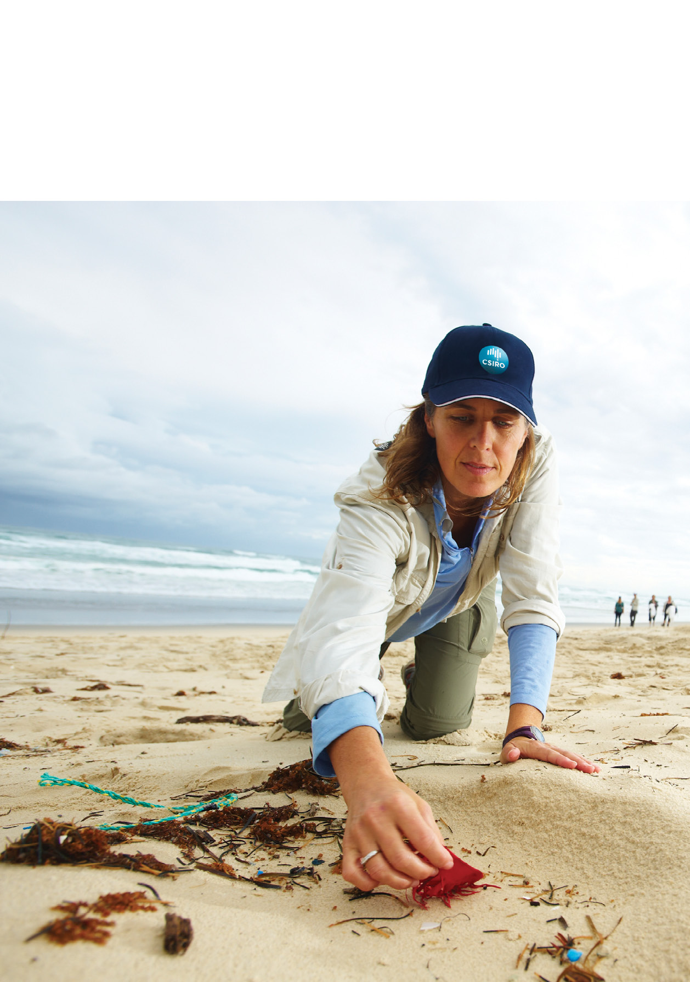Marine debris

Australia’s National  
Science Agency

Sources, distribution and fate   
of plastic and other refuse –   
and its impact on ocean and   
coastal wildlife

Marine debris is a globally recognised environmental issue of increasing concern

Marine ecosystems worldwide are affected by human-made refuse, much of which is plastic.

Marine debris comes from both land and sea-based sources and can travel immense distances. It can pose a navigation hazard, smother coral reefs, transport invasive species and negatively affect tourism. It also injures and kills wildlife, has the potential to transport chemical contaminants, and may pose a threat to human health.

CSIRO has completed a survey of sites approximately every 100 km along the Australian coastline. Parts of this research engaged with thousands of students, teachers and Shell employees and has reached more than one million Australians, helping to educate them about, and increase their understanding of, the problems of marine debris.

What is marine debris?

Marine debris is defined as any persistent solid material that is manufactured or processed and directly or indirectly, intentionally or unintentionally, disposed of or abandoned into the marine environment.

Marine debris includes consumer items such as glass or plastic bottles, cans, bags, balloons, rubber, metal, fibreglass, cigarettes, and other manufactured materials that end up in the ocean and along the coast.

It also includes fishing gear such as line, ropes, hooks, buoys and other materials lost on or near land, or intentionally or unintentionally discarded at sea.

Did you know?

CSIRO has developed an online national marine debris database where you can contribute data you collect about litter at your local beach. Together, we can contribute to the improved understanding of the types, amounts and sources of debris that arrives on Australia’s coastline. See [www.csiro.au/marine-debris](http://www.csiro.au/marine-debris)

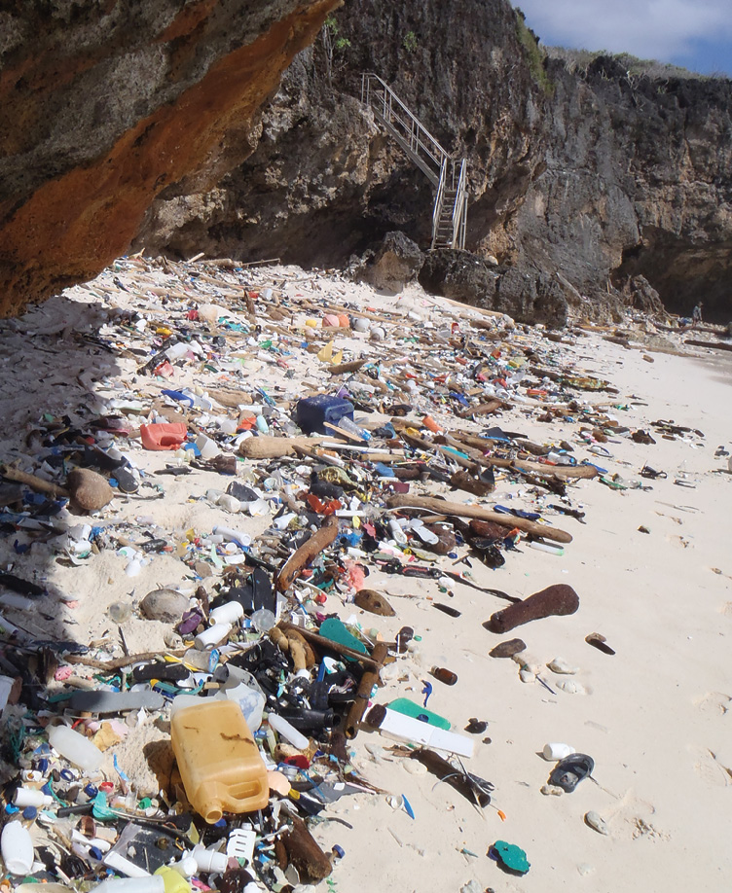

What does CSIRO’s research tell us?

CSIRO surveyed coastal sites approximately every 100 km around the continent of Australia. This body of work represents the largest scale, integrated, rigorous data to have been collected anywhere in the world aimed at addressing the marine debris issue.

1. What are the sources, distribution, and ultimate fate of marine debris?

We found that within Australia, approximately three‑quarters of the rubbish along the coast is plastic. Most is from Australian sources, not from overseas, with debris concentrated near urban centres. In coastal and offshore waters, most floating debris is plastic. The density of plastic ranges from a few thousand pieces of plastic per square kilometre to more than 40,000 pieces of plastic per square kilometre. Debris is more highly concentrated around major cities, suggesting local sources.

2. What is the exposure of marine wildlife to debris?

Litter impacts wildlife directly through entanglement and ingestion and indirectly through chemical affects. As the quantity of debris increases in the marine environment, so does the likelihood of impacts from debris to marine animals. Plastic production rates are intensifying, and the volume of refuse humans release into marine systems is growing at an exponential rate. Even toothpaste and personal care products can have plastic microbeads in them. These microplastics can be mistakenly eaten by a range of marine species.

3. Why do animals ingest debris, and what is the effect on marine wildlife populations?

Globally, approximately one third of marine turtles have likely ingested debris, and this has increased since plastic production began in the 1950s. Most items eaten by turtles are plastic and positively buoyant. Smaller oceanic turtles are more likely to ingest debris than coastal foragers; herbivores are more likely to ingest debris than carnivorous species; oceanic leatherback turtles and green turtles are at the greatest risk of ingested marine debris effects; and benthic turtles show a strong selectivity for soft, clear plastic that resembles natural prey such as jellyfish.

Around the world, nearly half of all seabird species are likely to ingest debris. Birds eat everything from balloons to glow sticks, industrial plastic pellets, hard bits of plastic, foam, metal hooks and fishing line. CSIRO researchers and colleagues found that 43 per cent of short-tailed shearwaters have plastic in their gut. Young birds were more likely to ingest debris and ate more pieces of debris than adult birds. A global hotspot for seabird impacts exists in the Tasman Sea south of Australia. CSIRO predicts that plastics ingestion in seabirds may reach 95 per cent of all species by 2050, taking into account the steady increase of plastics production.

4. What is the effect on marine wildlife populations that become entangled by debris?

Seabirds, turtles, whales, dolphins, dugongs, fish, crabs and crocodiles and numerous other species are killed and maimed through entanglement. We estimate that between 5,000 and 15,000 turtles have been killed in the Gulf of Carpentaria after becoming ensnared by derelict fishing nets, mostly originating from overseas. For pinnipeds in Victoria, the majority of seal entanglements involved plastic twine or rope, and seals become entangled in green items more than in any other colour. In general, young seals are entangled in greater numbers than adults.

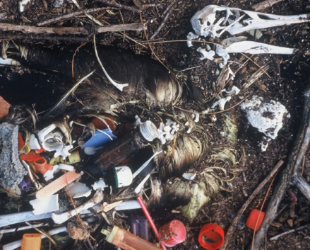

© BD Hardesty

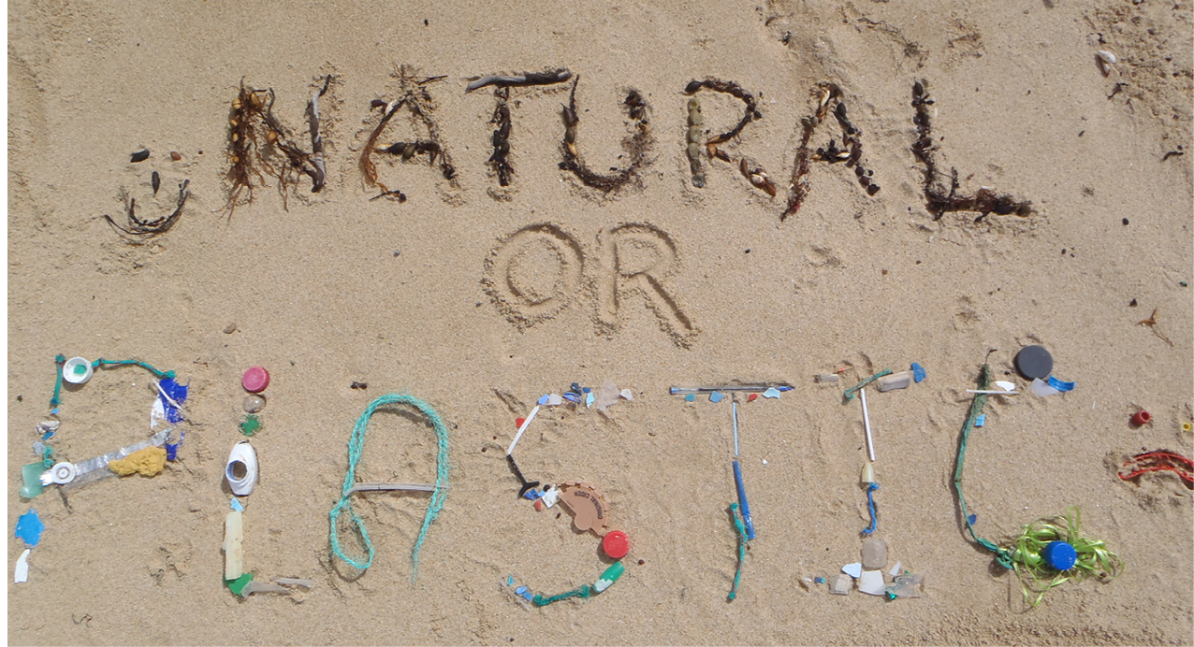What can be done?

By garnering the information needed to identify sources and hotspots of debris, we can better develop effective solutions to tackle marine debris.

The most effective way to reduce and mitigate the harmful effects of marine debris is to prevent it from entering the marine environment in the first place. This requires incorporating understanding of debris into local, regional and national decision‑making; improved waste management efforts; education and outreach activities; development of technology solutions; anti-dumping campaigns; reducing losses of fishing gear at sea; and incentives to reduce debris, such as South Australia’s container deposit scheme (which has reduced the number of beverage containers, the dominant plastic item in the environment, by a factor 3).

Working together, scientists, industry, coastal managers and citizen scientists can make significant strides to reduce marine debris impacts in coastal areas and in the marine environment.

Acknowledgements

The research was co-funded by Shell Australia’s National Social Investment Program and CSIRO’s Oceans and Atmosphere Flagship. TeachWild is an innovative national partnership between Earthwatch, CSIRO and Founding Partner Shell Australia to gather the data needed to bridge the information gap and tackle the global issue of marine debris.

For further information

Oceans and Atmosphere

Britta Denise Hardesty

+61 3 6232 5276

denise.hardesty@csiro.au

csiro.au/marine-debris

Contact us

1300 363 400

+61 3 9545 2176

csiroenquiries@csiro.au

csiro.au

As Australia’s national science agency   
and innovation catalyst, CSIRO is solving   
the greatest challenges through   
innovative science and technology.

CSIRO. Unlocking a better future for everyone.