CSIRO OCEANS & ATMOSPHERE

Australian fisheries stocks under climate change

Over the next twenty years Australia’s marine ecosystems are expected to exhibit some of the largest climate-driven changes in the Southern Hemisphere. These changes will extend from the ecosystems to the local communities and businesses of the Australian fisheries sector. The CSIRO and its collaborators have pulled together all available information on how climate may affect fished species in Australia – identifying those most sensitive to climate. This information helps highlight those species that may be at risk and those that might benefit, allowing fisheries to be better prepared.

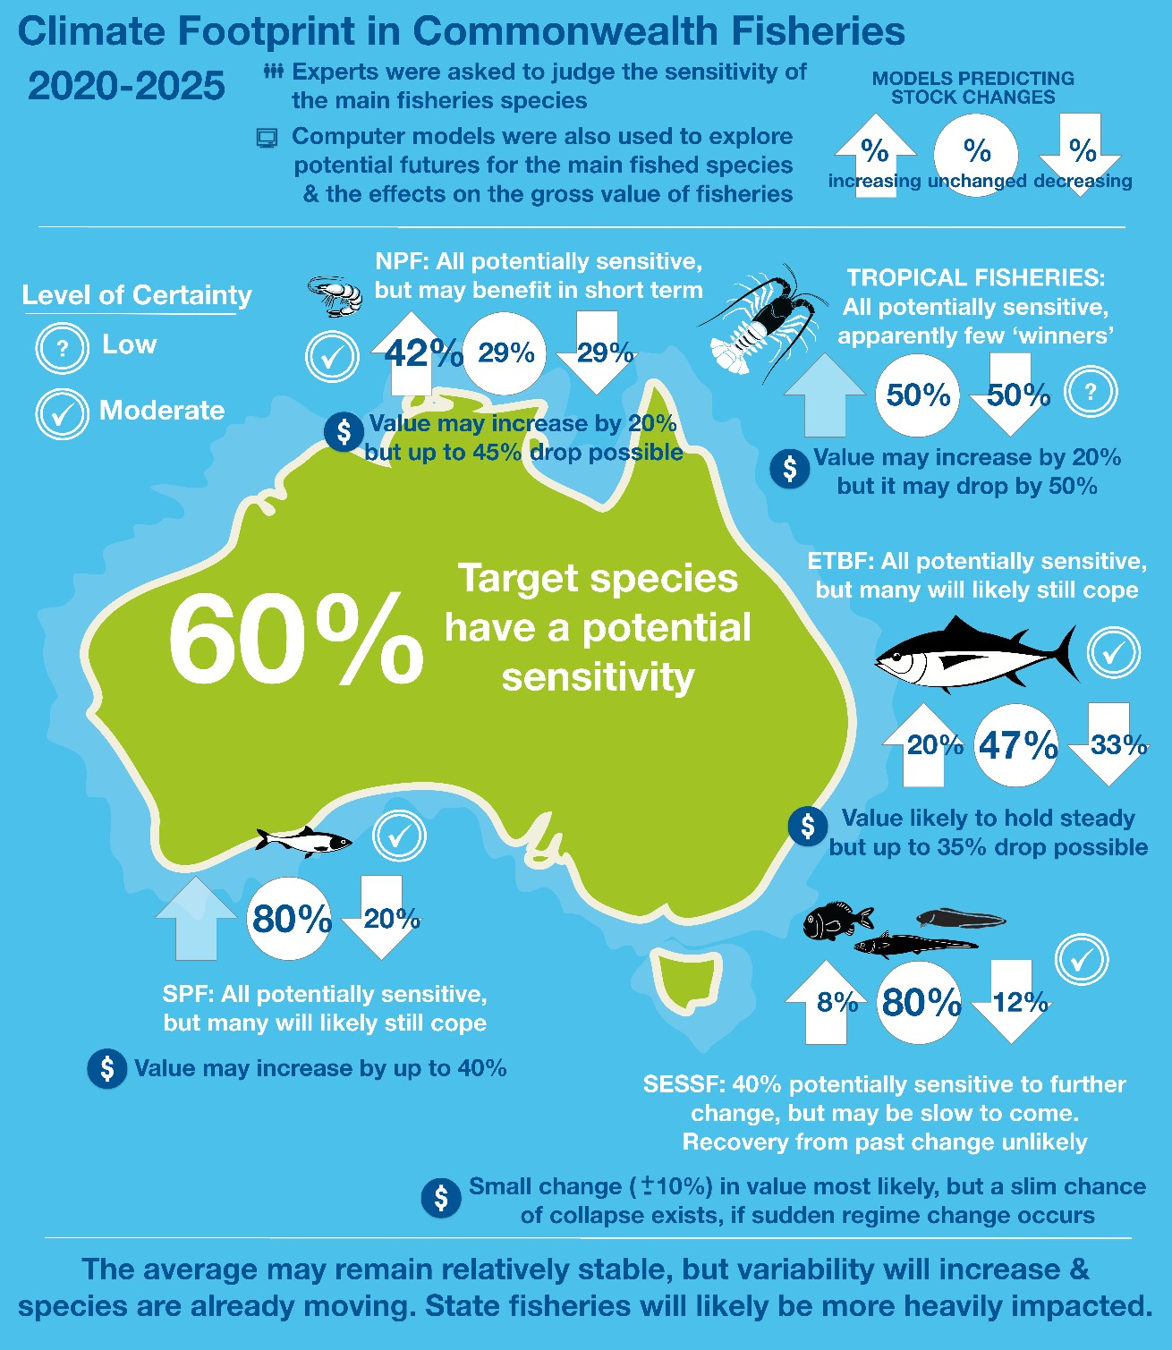

Climate change in Australian Waters

Australia's oceans are undergoing rapid change, warming much more rapidly than most of the world’s oceans.
Australian waters off south-east and south-west Australia are particular hotspots, while even Australia’s tropical ocean is also warming almost twice as fast as the average for the rest of the world. It is important to understand what this means for the ecosystems in these warming waters if we are to continue to sustainably manage Australian fisheries. Understanding the changes and being climate ready is important for both industry and management, because it allows them to plan their operations to avoid or mitigate negative impacts and to make the most of new opportunities that arise.

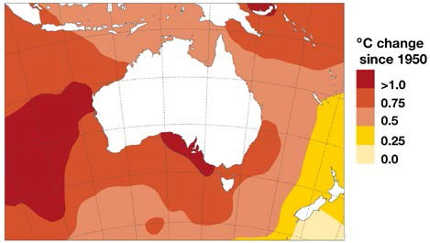Water temperature change around Australia since 1950. Image updated from BOM data. These temperature increases mean water temperatures are often record-breaking.

Australian fish species have already begun to move. Over 100 Australian marine species have already started migrating south towards cooler southern waters. There have also been a series of marine heatwaves and other extreme events that have harmed Australia’s seagrass, kelp forests, mangroves and coral reefs. These changes in the distribution, abundance and species composition in Australia’s marine ecosystems mean that Australia’s commercial fisheries are being affected by climate change. It is unavoidable. The ocean also has a long memory, which means that the effects of past and present human activities have already locked the world in to a further 0.5-1 oC warming. This is why fisheries managers (e.g. at AFMA) have asked for a rapid and thorough update of information so that they can base their strategic planning on the latest and best information.

Sensitivity of Australian Fisheries Target Species
Australian fisheries catch more than 100 species. There is not enough data or resources available to perform fine scale assessments for each species. Instead experts on the fisheries and target species were asked to identify the key target species in State and Commonwealth fisheries. The experts then had to rank each species in terms of how sensitive it was to climate change. This sensitivity was judged in terms of factors that affect:
- abundance (how old they are when they mature, how often they reproduce, number of eggs, diet and habitat needs);
- movement and spatial distributions (distance they can move, how widely spread they are already, available habitats);
- behaviour (needing special triggers for reproduction or migration, having special behaviours that only happen for short periods)
Across all Australia 70% of all key target species are have moderate to high sensitivity in one of these factors. Within the AFMA managed fisheries at least 50% of the target species per fishery are moderately to highly sensitive and in many AFMA managed fisheries all the target species are sensitive in one way or another.
Most species were sensitive to factors determining their distribution or behaviour, while only about 25% were sensitive in terms of factors that directly influence abundance. The greatest sensitivity to the timing of key behaviours was along the coastline of eastern Australia (north and south), while shifts in distribution are the most likely responses in the west and in the tropical north. Invertebrates had higher sensitivity scores than other species. As a consequence, dive – and other gears targeting invertebrate – show the highest sensitivities. Purse seine fisheries for small pelagic species has the lowest sensitivities.
The sensitivity analysis suggests that fisheries should first consider how changes in distribution and the timing of key events affect them and their management and then consider potential than changes in abundance.
The south east region of Australia already has some species that may have undergone a shift in productivity (e.g. warehou, morwong, redfish, ling), although the experts think the sensitivity of these species to further change is low. The implications of the potential regime shift in the region (identified using models) are also uncertain as such an event might take the region into conditions that sit outside observations and expert experience.

Sensitivity of Species Targeted by Australian Fisheries
Summary of sensitivity per fishery. Low sensitivity is for those species with a low rating across all 3 factors – abundance, distribution and behaviour. Moderate sensitivity indicates that a species had 1 factor that was scored as being moderately sensitive to climate change. High sensitivity covered both the case where a species was rated as having a factor that was highly sensitive to climate change or they had multiple factors rated as moderately sensitive. Sensitivity does not automatically indicate a likely decline it indicates the potential for change (including possible increases).

Commonwealth Fishery Low sensitivity Moderate sensitivity High sensitivity
Bass Strait Scallop Scallops: behaviour and
distribution
Coral Sea Coral trout: distribution and
abundance
Eastern Tuna and Billfish Behaviour of all target species
Northern Prawn Behaviour and distribution of
all target species

South and Eastern Scalefish and Shark
Species already showing shifts (warehou, morwong, redfish, ling) show low sensitivity to further climate driven change
Gemfish: abundance. Trevalla, flatheads, and whiting behaviour.
All/majority of properties of squids, sharks, blue grenadier and orange roughy.

Small Pelagics Behaviour of sardine and
blue mackerel
Jack mackerel and red bait behaviour and distribution

Torres Strait All properties of tropical rock
lobster

State Fisheries
New South Wales, Victoria, South Australia

Behaviour of snapper, tuna and some small pelagics.

Many small pelagic, estuarine and invertebrate species (mainly via behaviour and distribution). All properties of sharks and blue grenadier.

Queensland Behaviour of estuarine
and shelf fish, as well as Spanish mackerel and billfish.
Behaviour and distribution of all reef fish. All properties of the majority of invertebrates and sharks.

Gulf of Carpentaria (Queensland and Northern Territory)
Bream and sharks Majority of mackerels,
estuarine fish and mangrove associated species (due to a mix of factors).
All/majority of properties of snappers, emperors and all valuable invertebrate species (prawns, lobster, sandfish).

Northern Territory and Western Australia
Many sharks, estuarine and large pelagic fish
Large sharks: abundance. Behaviour or distribution of fish non-reef shelf fish
All/majority of properties of reef associated fish and all invertebrates.

Western Australia Distribution or behaviour of herring, reef associated predators, some abalone,
octopus and sandfish.
All/majority of properties of prawns, crabs, many small pelagics, some abalone, oysters, bream and dhufish.

Fisheries projections
The second approach used to consider the future climate change effects on Australia’s fisheries was to take existing models of Australian marine ecosystems (which together cover the entire EEZ) and run them under the conditions that might exist over the next 40 years. The results of these models were then used to see how species abundance and distribution might change and how ecosystems might restructure.
The modelling work found that the different ecosystems around Australia face different types and levels of climate change – including temperature changes, changes in rainfall patterns, ocean acidification, shifting ocean oxygen levels and differing levels of sea level rise and associated impacts on low lying areas. For fisheries as large as the SESSF, different parts of a fishery will be undergoing different levels of change. In most instances, larger changes in the climate led to larger model responses. The tropics, however, might see some large changes despite only small shifts because those shifts will influence the productivity of phytoplankton that supports the entire food web and because inundation due to sea level rise has the potential to influence coastal processes.
Those models that only look at the physical environments preferred by species predicted there would be reasonably large declines for the majority of fish populations around Australia. However, once all the other processes that occur in ecosystems (e.g. feeding, movement, habitat use) were included in the models the picture is more complicated – some species decline, but others benefit and grow in abundance, though perhaps living in new locations.
The models also predict that ecosystem production will become more variable. The Tasman Sea, for example, could have strings of very productive years interspersed by series of years with exceptionally low production. This variability is reflected across the entire food web, with many of the species shifting their distributions in response – seeking out desirable habitats and food sources.
For many species the different models are in agreement, increasing confidence in the robustness of results. When the models disagree this highlights uncertainty and the need for more information. Many of the species ranking highly in the sensitivity analysis also show enhanced responses to climate change in the models. In the short term, many of the models predict little further change for most species (noting that this means that already depleted species do not show signs of recovery). Further in to the future (30-40 years), things become more uncertain, with the different models not always agreeing on whether species will increase or decrease in abundance. This is because simple physical responses alone may not dictate a species response to climate change. As abundances change, predation and competition within food webs will also change. This means that new or novel food webs may form, changing ecosystems unexpected ways. In some regions (such as south eastern Australia) the ecosystem may eventually shift into a new state that is quite different to today, though this will be dependent on exactly how the physical climate drivers interact with the many different responses of all the species making up the food web and habitats in that region.

Implications of Climate Change
It is clear from the changes that have already occurred, and what the sensitivity and models predict, that there will be strong differences in the level of effects and responses across different species and food webs. Demersal food webs, those species that live near to or amongst habitats on the seabed, appear to be more strongly affected by climate change.
Invertebrates, who are amongst Australia’s most valuable target species, are particularly sensitive. Pelagic food webs, where species live up in the water column, appear less sensitive and may even benefit from the environmental changes.
This is a concerning finding as much of Australia’s seafood is sourced from species that are members of demersal food webs or reliant upon them. Individuals in shallower (more affected) waters, or already living on the edge of what they can tolerate, will be the first to respond and will show the greatest magnitude of response. Some of these changes have already begun. The decline of species such as abalone associated with marine heatwaves and tens of species already observed to be moving south (e.g. into Tasmania and other places where they have not previously been recorded).
Invertebrates may be among the most heavily impacted species. They are often highly productive, but with relatively short life spans; meaning they can respond quickly, but often have little buffering capacity (they cannot ride out many poor years before suffering significant decline at the population level). Many invertebrates also have specific habitat requirements.
Altogether these characteristics mean that invertebrates are more volatile and are quite sensitive to variation in climate and extreme events.

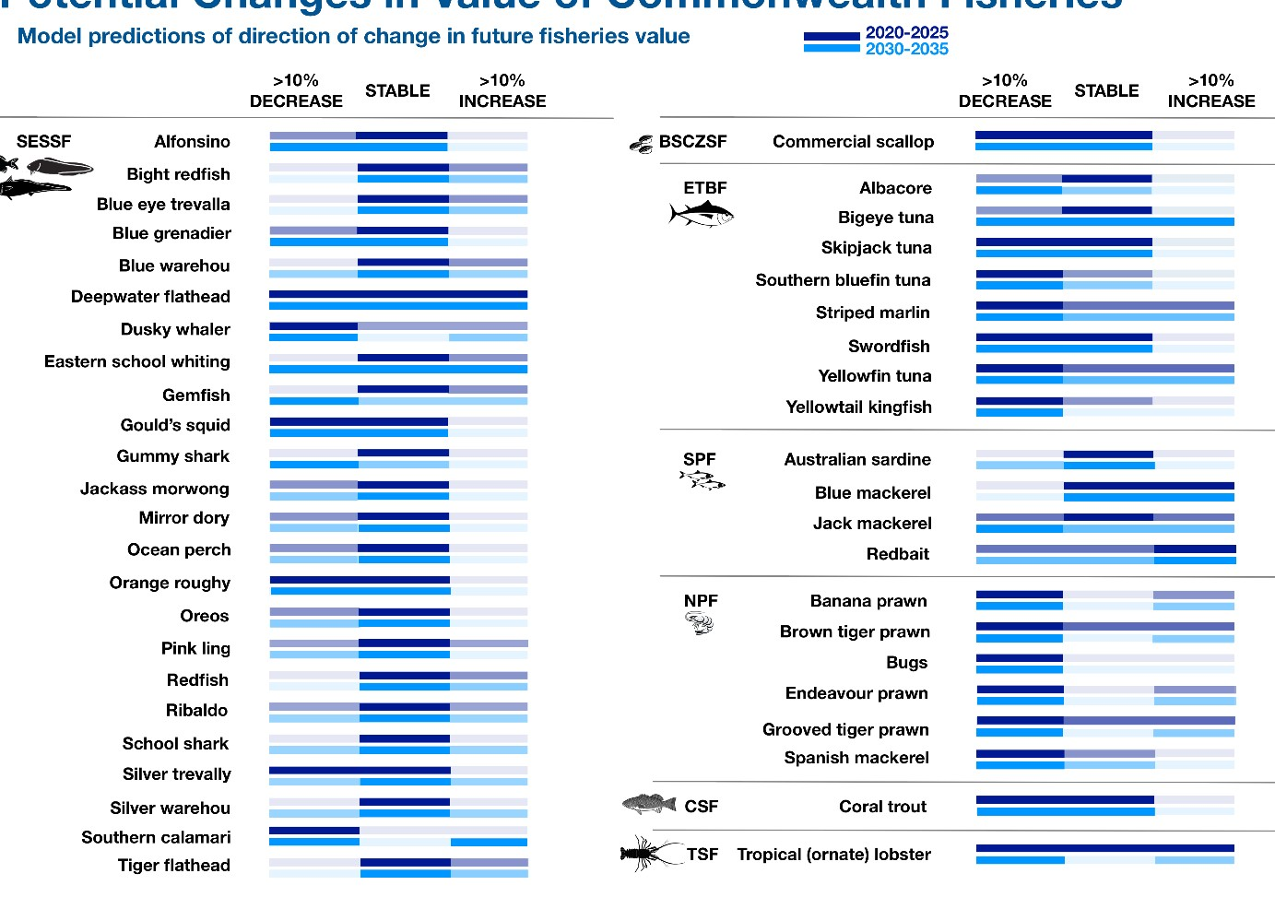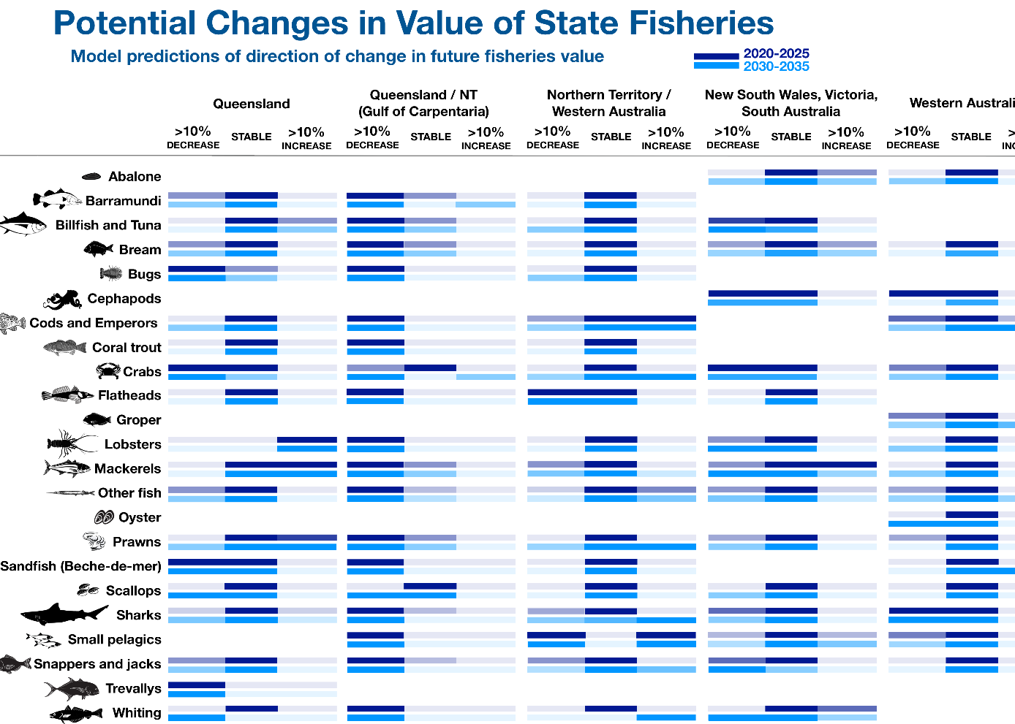
Both Commonwealth and State fisheries will face changes in gross value as a result of climate change effecting both the fish stocks and (potentially) the behaviour of the fishers. While the majority of the model results suggest little change in the short (10 yr) term, some simulations did suggest that larger changes (both positive and negative) were possible. This plot shows the possible spread of outcomes in the short and medium (20 year) term. The bars indicate the range of outcomes and the darker the bar the more models predicted this outcome.

Ecosystem responses will not only respond to changes in temperature, precipitation or to ocean acidification. Variability in primary production (i.e. production by the plants and algae at the bottom of the food web) will also be important. For instance, if there is little change in primary production then ecosystems will likely show little change (so long as temperatures do not shift beyond what many species can physically tolerate). Unfortunately, it is not yet clear what future primary productivity will look like around Australia – as some important processes are still not completely understood. This means that understanding and predicting future changes in primary production remains an active area of research and updates will be provided as rapidly as possible.
Many mechanisms can lead to changes in ecosystems – whether through behaviour, distribution or abundance of the species and habitats in them. The drivers causing the changes can be different species to species. For some it will be due to changes in environmental conditions, this can cause the timing of seasonal events (like spawning) to move which can affect the success of those behaviours. If environmental conditions move beyond preferred ranges species will move to more favourable conditions or dwindle in abundance. For many species, change will result from a loss (or shift) in habitat. For others, the changes will occur because of the availability of their prey changes. For still other species, it could be due to a shift in what their predator(s) are doing. For example, if a predator moves away, the prey abundance might grow, whereas if a predator remains and starts to eat more of the prey (due to a shift in diet) then the prey population might decline. As frustrating as it may be for managers, industry and researchers looking for simple explanations and a way to make things more straight forward, it will likely come down to a case-by-case basis (which may even vary spatially across a species’ geographic range).
Human responses to all these changes could also complicate things. Well informed decisions are one of the best ways of avoiding negative outcomes and maximising opportunities. A nested approach – where models and vulnerability assessments are used to identify the most at risk species and locations – appears to be the best way of targeting monitoring and management responses.
Given existing understanding of ecosystems, climate change and the sensitivities highlighted in this project, a small set of management recommendations can be made:
- A staged response might be necessary, where fishing activities are first adjusted due to shifts in behaviour (e.g. changing the timing of seasonal closures to make sure they continue to line up with seasonal behaviours like spawning or migrations), before looking to respond to changes in spatial distributions.
- Not all fisheries and operators will be exposed to the same level of change. Likewise, not everyone will have the same capacity to adapt. This will compound the differential outcomes seen across species and fisheries. One option is to simply accept uneven social and economic consequences. A more attractive alternative is to have information services (websites, newsletters, radio updates) to help explain what is going on, what the options are and the need for change as well as to provide support mechanisms to help those that are struggling to adjust.
- Successful management will require a diverse set of good scientific tools. No single approach will be sufficient due to existing uncertainty and the interplay of climate and fishing with the ecosystem components and processes. New management and assessment tools will also be needed. The complexity of possible species responses and the increasing importance of environmental drivers means that current models used in stock assessments to advise on acceptable catch levels maybe insufficient for understanding stock patterns under climate change. Key interactions and dependencies may need to be included to better reflect how the species is responding. This means that models used in fisheries assessments will likely need to be extended along the lines of the approach known as “MICE”, which are models that not only include the target species but also the most important environmental (and other) drivers that set the context for the species’ responses.
- Existing management strategies and objectives must be reviewed in terms of whether they help or hinder long term ecological and resources management objectives. Are they likely to deliver as desired into the future, if a stock is depleted can they rebuild it or help to recover degraded ecosystems? These considerations must go beyond focusing on fisheries to think about the structure of the whole ecosystem and which species are needed to maintain ore rebuild them. Such a rethink will require a greater coordination between conservation and fisheries management.
- Fisheries policy, management and assessment methods need to allow for the concept of regime shifts and extreme events and for contextual management decision making. This means fundamental changes in fisheries management will likely be required. The concept of B0, virgin biomass and associated classical fishery methodologies are likely to become meaningless. New approaches to management need to be developed. As a
first step, taking lessons from locations that have already faced such challenges suggests that indicators that can track what state the environment is in can be used to let managers know when they need to adjust acceptable levels of fishing pressure and protection.
- Fisheries management methods should be made as flexible as possible, so they can change as rapidly as need to respond to changing system state. The speed of change means a no (or at least minimal) regrets approach to management needs to be taken, with updates as new information comes to light. Management instruments may also need to be adapted. Reference points defining an overfished state or a desirable state for target species might

need to be modified if there is a regime shift in ecosystem state or stock productivity. Fisheries closures may need to be based on water bodies (large areas of water of a specific temperature) rather than simply relying on the protection of fixed geographic locations.
- Management decision making will need to (i) more explicitly prioritize resources and awareness around vulnerable/ sensitive species and fisheries or (ii) have a clear discussion around whether some species are beyond management (as the environment has made it impossible for the species to recover). Such decisions can’t be taken lightly but might be necessary if large environmental changes occur.
- Australia-wide coordination of management will be imperative as species shift or environmental changes span State and Commonwealth boundaries. Without such coordination (or centralised management) local stress for fishing communities could become significant and new opportunities will likely be missed.
- Fisheries management will need to interlink with the management of other uses of the marine environment – that is Australia will need to use integrated marine management. The number of uses of the marine environment is rapidly expanding and growing to a scale not seen before in the oceans. Mining, energy generation, transport, aquaculture (farming), recreation etc. are now all competing for space and resources in the oceans and along increasingly crowded coastlines. It is important for fisheries to see themselves in the context of all of this activity so they respond appropriately given that bigger picture.
Providing information to industry operators and managers so they can address all these changes will require good data sources. There are still many things we do not know about Australia’s ecosystems and how they respond. Fishers and managers (and the scientists helping them) will require as much information as possible if they are to understand what is happening and act wisely to mitigate undesirable outcomes and make the most of any new opportunities. Such a climate robust approach to fisheries will require the combination of a number of different sources of information, including:
- Improved understanding and prediction of shifts in primary production around Australia – this is fundamental to understanding the potential changes to rest of the ecosystem but is currently highly uncertain. This will require improved process understanding.
- Greater knowledge of how species are adapting to the changed conditions – this information will provide insight into whether species are robust to change (acclimating to the new conditions, or responding via evolution or changed behaviour), or whether they are simply being overwhelmed.
- Measurements and forecasts of the physical environment (temperature, salinity, rainfall, storm patterns), extending what is already provided by the Bureau of Meteorology. Sharing the data from net sensors (for example) can help provide a more accurate picture of the current conditions and the conditions fish prefer.
- Satellite images of ocean colour (which can be used to estimate how much plankton is in the water) can help predict where fish will be and can also forewarn of coming issues with stock productivity and recruitment. Plankton recorders voluntarily mounted on ships (e.g. tankers) can also help collect very useful information about what is happening at the bottom of the food web (this can help us understand how that effects the rest of the food web including those fish that are targeted by fisheries).
- Good quality catch and effort data is the longest and one of the best sources of information on target species in Australia.
- Survey data is also important as it helps give a more complete picture of what is going on. Catch data is very useful but having a second set of information from surveys helps to be sure about what is going on – catches don’t always reflect what the fish are doing, especially of the fishers have changed their behaviour in response to markets (for example).
- Citizen science data collected by Australians using smart phones and cameras represents a new source of potential data. Nearly every Australian citizen now owns a ‘smart phone’ which has sensors and an on-board computer that is more powerful than what was available to scientists as little as a decade ago. Data collected via photographs and voluntary reporting can be a very valuable source of information once it has been processed and scientifically collated. Australians see themselves as an ocean loving people so we shouldn’t turn down any help they are eager to provide.

Looking Forward
Australian fisheries are in the midst of a period of rapid environmental change. This change is going to continue into the future and will differ place to place around Australia. Fishers and managers will need to be flexible if they are to cope with these changes. A failure to do so will bring economic (and likely social) hardship. Management will need to allow for spatial shifts and potentially for shifts in targeting and relevant management reference points. Management that is coordinated across State and Commonwealth fisheries and that links with the other users of marine waters is likely to do better than if those links are ignored. Healthy fisheries will also require good information services that are updated regularly with the

latest understanding of what Australia’s climate, fish, ecosystems and fisheries are doing. This is the summary of the latest (2018) update. If you would like more information please contact us (details below) or check out the websites listed below.

Useful Websites
Redmap (Range Extension Database & Mapping project) – www.redmap.org.au – this website invites the Australian community to spot, log and map marine species that are uncommon in Australia, or along particular parts of our coast. This helps keep everybody up to date on how Australia’s species are moving. The website includes useful summarise on what climate change is and what it means for Australia’s oceans.
BOM – www.bom.gov.au/climate – this website has a long list of climate time series and updates, including annual reports on what Australia’s climate is doing.

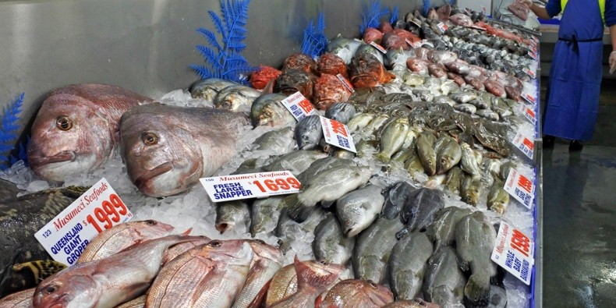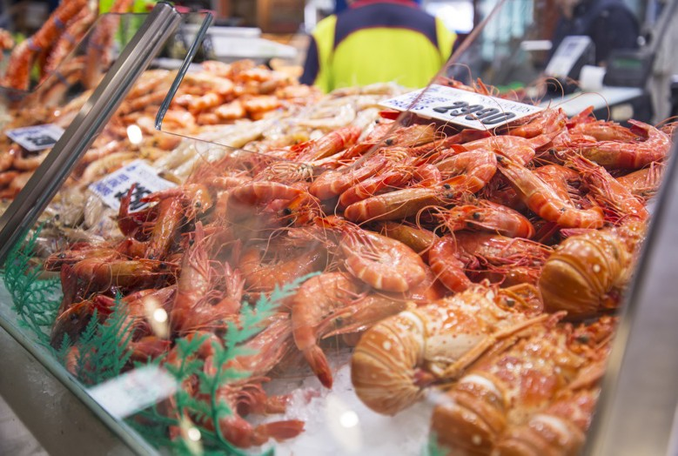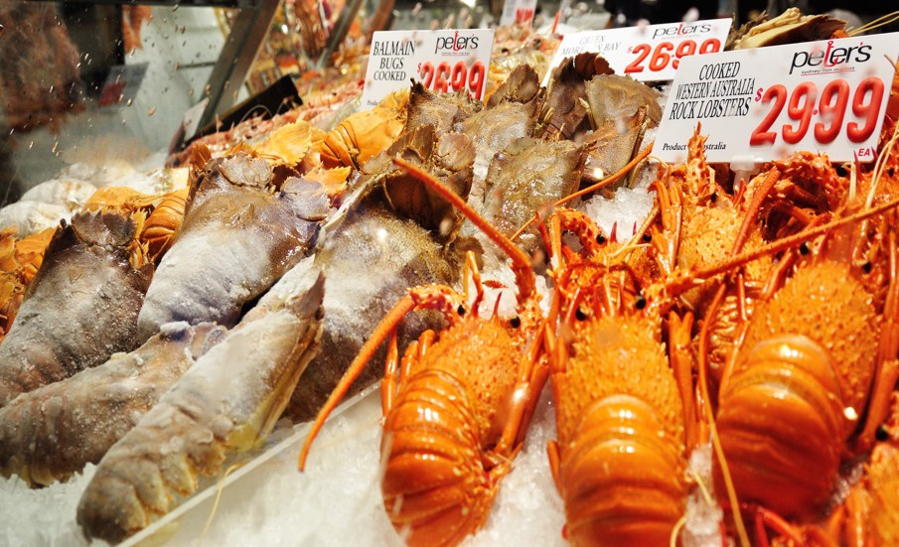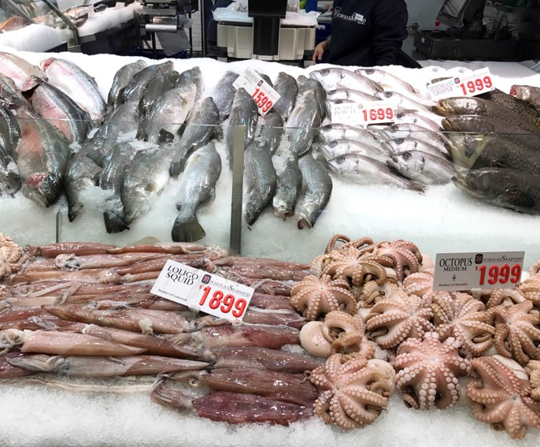

Images: Shutterstock.com

CONTACT US
t 1300 363 400
+61 3 9545 2176
e csiroenquiries@csiro.au
w www.csiro.au
AT CSIRO, WE DO THE EXTRAORDINARY EVERY DAY
We innovate for tomorrow and help improve today – for our customers, all Australians and the world.
We imagine. We collaborate. We innovate.
FOR FURTHER INFORMATION
CSIRO Oceans and Atmosphere
Beth Fulton or Alistair Hobday
t +61 3 6232 5222
e beth.fulton@csiro.au
w www.csiro.au

